Extra questions on Cell structure and magnification calculations

**Q1.**          The drawing shows an electron micrograph of parts of epithelial cells from the small intestine.

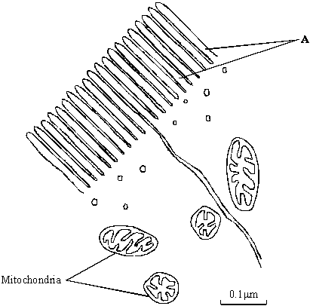

(a)     (i)      Name the structures labelled **A**.

.............................................................................................................

**(1)**

(ii)     Explain how these structures help in the absorption of substances from the small intestine.

.............................................................................................................

.............................................................................................................

**(1)**

(b)     (i)      The scale bar on this drawing represents a length of 0.1μm. Calculate the magnification of the drawing. Show your working.

Magnification .............................................

**(2)**

(ii)     Explain why an electron microscope shows more detail of cell structure than a light microscope.

.............................................................................................................

.............................................................................................................

.............................................................................................................

**(2)**

(c)     The length of mitochondria can vary from 1.5 μm to 10 μm but their width never exceeds 1μm. Explain the advantage of the width of mitochondria being no more than 1μm.

......................................................................................................................

......................................................................................................................

**(1)**

**(Total 7 marks)**

**Q2.**          (a)     Cells of multicellular organisms may undergo differentiation.  What is meant by differentiation?

......................................................................................................................

......................................................................................................................

**(1)**

(b)     The drawing shows part of a plant cell as seen with an electron microscope.

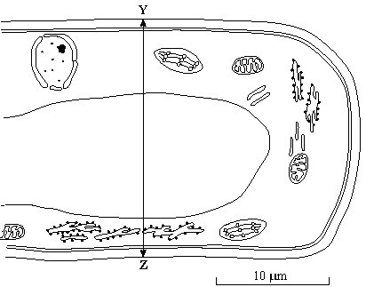

(i)      Give **two** features shown in the drawing which are evidence that this cell is eukaryotic.

1 ..........................................................................................................

.............................................................................................................

2 ..........................................................................................................

.............................................................................................................

**(2)**

(ii)     Calculate the actual width of the cell from **Y** to **Z**. Give your answer in micrometres (µm) and show your working.

Answer ..................................... µm

**(2)**

(iii)     Give **one** way in which a typical animal cell differs from the cell shown in the drawing.

.............................................................................................................

.............................................................................................................

**(1)**

**(Total 6 marks)**

**Q3.**          The electron micrograph shows part of a chloroplast.

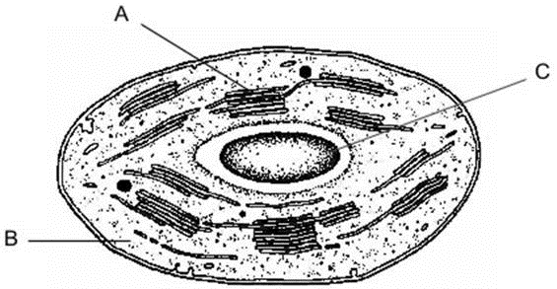

(a)     Name the parts labelled **A** and **B** and, for each, describe **one** role in the process of photosynthesis.

**A** Name ........................................................................................................

   Role ...........................................................................................................

**(2)**

**B** Name ........................................................................................................

   Role ...........................................................................................................

**(2)**

(b)     (i)      Name the main substance present in the part labelled **C**.

.............................................................................................................

**(1)**

(ii)     How is this substance formed?

.............................................................................................................

.............................................................................................................

**(1)**

**(Total 6 marks)**

**Q4.**          The diagram shows part of an animal cell as seen through an electron microscope.

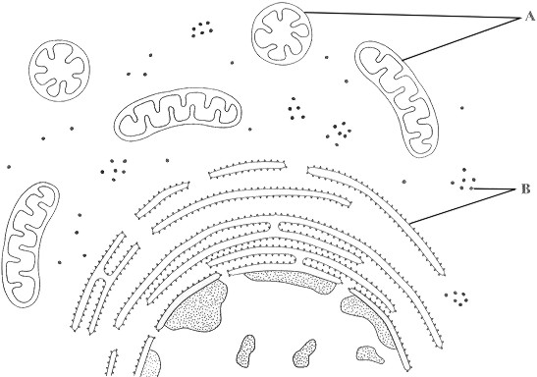

(a)     Name the organelles labelled **A** and **B**.

**A** …..............................................................................................................

**B** ..................................................................................................................

**(2)**

(b)     Explain why the shapes of the two organelles labelled **A** appear different.

......................................................................................................................

......................................................................................................................

......................................................................................................................

......................................................................................................................

**(2)**

(c)     Give the function of organelle **B**.

......................................................................................................................

......................................................................................................................

**(1)**

(d)     The epithelial cells of the small intestine have large numbers of organelle **A**.  
Explain how this is an adaptation for the function of these cells.

......................................................................................................................

......................................................................................................................

......................................................................................................................

......................................................................................................................

......................................................................................................................

......................................................................................................................

**(3)**

**(Total 8 marks)**

**Q5.**          The diagram shows a bacterium.

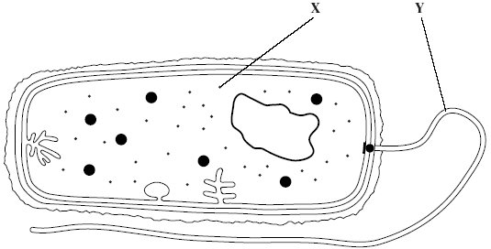

(a)     Give the function of

(i)      organelle **X**;

.............................................................................................................

(ii)     organelle **Y**.

.............................................................................................................

**(2)**

**S**       (b)     (i)      Give **two** ways in which the structure of this bacterium is similar to the   
         structure of a cell lining the human small intestine.

1 ..........................................................................................................

.............................................................................................................

2 ..........................................................................................................

.............................................................................................................

**(2)**

(ii)     Give **two** ways in which the structure of this bacterium differs from the structure of a cell lining the human small intestine.

1 ..........................................................................................................

.............................................................................................................

2 ..........................................................................................................

.............................................................................................................

**(2)**

**(Total 6 marks)**

**Q6.**          (a)     The diagram shows a bacterial cell.

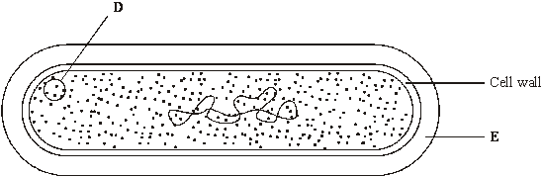

(i)      Name the parts labelled **D** and **E.**

**D** .........................................................................................................

**E** .........................................................................................................

**(2)**

(ii)     Give **one** function of the cell wall.

.............................................................................................................

.............................................................................................................

**(1)**

(b)     Name **two** structures present in eukaryotic cells that are not present in the cells of prokaryotes.

1 ...................................................................................................................

2 ...................................................................................................................

**(2)**

(c)     Several small pieces of a saprophytic fungus were placed on a starch agar plate. After 48 hours the iodine solution was poured over the starch agar. The result is shown in the diagram below.

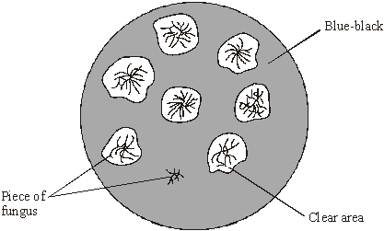

(i)      Explain why there is a clear area around most of the pieces of fungus.

.............................................................................................................

.............................................................................................................

.............................................................................................................

.............................................................................................................

**(2)**

(ii)     Suggest why one piece of fungus has no clear area round it.

.............................................................................................................

.............................................................................................................

**(1)**

**(Total 8 marks)**

**Q7.**          Read the following passage.

In a human, there are over 200 different types of cell clearly distinguishable from each other.  
What is more, many of these types include a number of different varieties. White blood cells,  
for example, include lymphocytes and granulocytes.

Although different animal cells have many features in common, each type has adaptations.

5       associated with its function in the organism. As an example, most cells contain the same  
organelles, but the number may differ from one type of cell to another. Muscle cells contain  
many mitochondria, while enzyme-secreting cells from salivary glands have particularly large  
amounts of rough endoplasmic reticulum.

The number of a particular kind of organelle may change during the life of the cell. An

10      example of this change is provided by cells in the tail of a tadpole. As a tadpole matures into  
a frog, its tail is gradually absorbed until it disappears completely. Absorption is associated  
with an increase in the number of lysosomes in the cells of the tail.

Use information from the passage and your own knowledge to answer the following questions.

(a)     Explain the link between.

(i)      mitochondria and muscle cells (lines 6 - 7);

.............................................................................................................

.............................................................................................................

.............................................................................................................

.............................................................................................................

.............................................................................................................

**(3)**

(ii)     rough endoplasmic reticulum and enzyme-secreting cells from salivary glands   
(lines 7 - 8).

.............................................................................................................

.............................................................................................................

.............................................................................................................

.............................................................................................................

**(2)**

(b)     Use information in the passage to explain how a tadpole’s tail is absorbed as a tadpole changes into a frog.

......................................................................................................................

......................................................................................................................

......................................................................................................................

......................................................................................................................

**(2)**

(c)     Starting with some lettuce leaves, describe how you would obtain a sample of undamaged chloroplasts. Use your knowledge of cell fractionation and ultracentrifugation to answer this question.

......................................................................................................................

......................................................................................................................

......................................................................................................................

......................................................................................................................

......................................................................................................................

......................................................................................................................

......................................................................................................................

......................................................................................................................

......................................................................................................................

......................................................................................................................

**(6)**

**(Total 13 marks)**

**Q8.**          Liver was ground to produce a homogenate. The diagram shows how fractions containing different cell organelles were produced from the filtered homogenate.

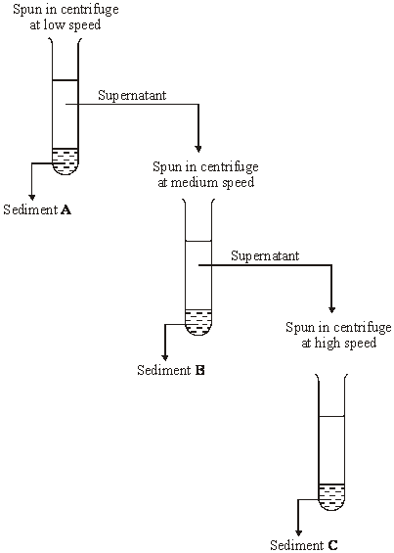

(a)     Explain why the homogenate was filtered before spinning at low speed in the centrifuge.

......................................................................................................................

......................................................................................................................

......................................................................................................................

......................................................................................................................

**(2)**

(b)     The main organelles present in sediment **B** were mitochondria. Suggest the main organelles present in

(i)      sediment **A**;

.............................................................................................................

**(1)**

(ii)     sediment **C**.

.............................................................................................................

**(1)**

(c)     What property of cell organelles allows them to be separated in this way?

......................................................................................................................

......................................................................................................................

**(1)**

(d)     Explain why the organelles in sediment **C** could be seen with a transmission electron microscope but not with an optical microscope.

......................................................................................................................

......................................................................................................................

......................................................................................................................

......................................................................................................................

**(2)**

**(Total 7 marks)**

**Q9.**          The diagram shows the outer layers of three different cells, **A**, **B** and **C**.

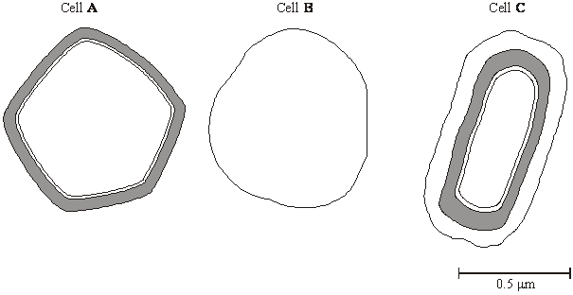

(a)     What is the evidence from the diagram that

(i)      cell **B** is an animal cell,

.............................................................................................................

.............................................................................................................

**(1)**

(ii)     cell **C** is a prokaryotic cell?

.............................................................................................................

.............................................................................................................

**(1)**

(b)     Explain how you would calculate the magnification of cell **C**.

......................................................................................................................

......................................................................................................................

**(1)**

(c)     Cell **A** is a plant cell. Name a polysaccharide which may be found in cell **A** but would not be found in the animal cell.

......................................................................................................................

**(1)**

(d)     Penicillin is an antibiotic. It prevents the formation of bacterial cell walls. As a result, bacterial cells that have been treated with penicillin swell and burst as water enters.

(i)      Explain how water enters a bacterial cell.

.............................................................................................................

.............................................................................................................

.............................................................................................................

.............................................................................................................

**(2)**

(ii)     Suggest why penicillin has no effect on plant cells.

.............................................................................................................

.............................................................................................................

**(1)**

**(Total 7 marks)**

**Q10.**          (a)     Small samples of plant tissue were placed in a cold, isotonic solution and then treated to break open the cells to release the organelles. The different organelles were then separated. Describe a technique that could be used to

(i)      break open the cells;

.............................................................................................................

.............................................................................................................

(ii)     separate the organelles.

.............................................................................................................

.............................................................................................................

**(2)**

(b)     One group of organelles was placed in a hypotonic solution. The diagram shows one of these organelles seen under an electron microscope before and after it was placed in the hypotonic solution.

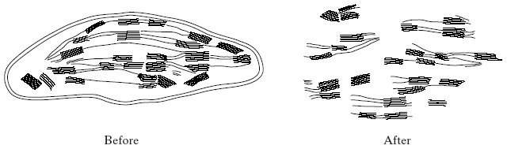

(i)      Name the organelle.

.............................................................................................................

**(1)**

(ii)     Describe and explain the effect on the organelle of placing it in the hypotonic solution.

.............................................................................................................

.............................................................................................................

.............................................................................................................

.............................................................................................................

.............................................................................................................

.............................................................................................................

.............................................................................................................

.............................................................................................................

**(4)**

**(Total 7 marks)**

**M1.**          (a)     (i)      microvilli; (*reject brush border*)

**1**

(ii)     increased surface area (for diffusion);

**1**

(b)     (i)       principle of ;

*(15 –17 tolerance)*

160000;

*(correct answer award 2 marks)*

**2**

(ii)     electron microscope has a greater resolving  
power / objects closer   
together can be distinguished;   
electron (beams) have a shorter wavelength;

**2**

(c)     short diffusion pathway / short pathway to the centre / large SA:V ratio  
for faster, more diffusion;

**1**

**[7]**

**M2.**          (a)     cells become specialised / change to carry out a particular function;

**1**

(b)     (i)      named organelle e.g. nucleus / nuclear envelope; vacuole;  
chloroplast; RER; mitochondrion; no membrane bound organelles;

*(only award if no organelles named)  
(reject ribosomes, cell membrane, cell wall)*

ref to large(r) size

**2 max**

(ii)     

20.4 – 21.8

*(correct answer 2 marks)*

**2**

(iii)     no cell wall (permanent) / (large) vacuole / chloroplasts / smaller;

*(accept microvilli)*

**1 max**

**[6]**

**M3.**          (a)     A – granum / thylakoid;  
chlorophyll molecules to trap light / light absorbing pigments /   
light dependent reaction / part of light dependent reaction;

**2**

B – stroma;  
(contains enzymes for) carbon dioxide fixation / light-independent reaction /   
part of light-independent reaction;  
*(allow ribosome role of protein in photosynthesis)*

**2**

(b)     (i)      C – starch;

**1**

(ii)     from glucose in a condensation / polymerisation reaction / many  
glucose molecules joined together;

**1**

**[6]**

**M4.**          (a)     A mitochondria;  
B ribosomes (*accept ribosomes and rER*)

**2**

(b)     idea of sections or cuts;  
idea of mitochondria orientated differently or in different positions / description of 3D structure of mitochondria, e.g. sausage-shaped;

**2**

(c)     translation / protein / polypeptide synthesis;

**1**

(d)     provide / produce energy or ATP (*reject* *create energy*);  
(*disqualify first mark if* ‘*for* *respiration*’)  
high respiration (rate) (*accept lots*) for active uptake / transport  
(*accept description*);  
absorption of digested food / substances / products / correctly named product

*(only accept monosaccharides, amino acids, dipeptides);*

**3**

**[8]**

**M5.**          (a)     X protein synthesis / translation;  
Y movement;

**2**

(b)     (i)cytoplasm;  
ribosomes;  
phospholipid membranes / cell membrane / semipermeable  
membrane;

*(accept folded membrane for two marks)*

**2 max**

(ii)     *(it = bacterium)*cell wall;  
capsule;  
flagellum;  
mesosome;  
no nucleus / nuclear membrane / DNA free;  
no mitochondria;

*(accept ‘no membrane-bound organelles’ if neither nucleus nor mitochondria mark scored)*

no microvilli;  
no Golgi;  
no ER;  
70S / smaller ribosomes;

**2 max**

**[6]**

**M6.**          (a)     (i)      **D** plasmid / ribosome(s) / cytoplasm / storage granules;

*(accept any sensible structure)*

**E** (slime / mucous) capsule

*OR*

slime / mucous layer;

**2**

(ii)     protection / maintain shape / prevent lysis / strength / support;

**1**

(b)     two of the following:

nucleus;

OR

nuclear envelope / mitochondria / chloroplasts / sER / rER /

golgi apparatus / 80s ribosomes

linear DNA / chromosomes / lysosomes / vacuole / vescicles /   
cellulose cell wall;

**2 max**

(c)     (i)      starch digested / broken down;

by amylase / carbohydrase;

**2**

(ii)     any sensible suggestion e.g. no secretion of amylase /   
functional amylase /

piece of fungus might have died;

*(accept carbohydrase / enzyme for amylase)*

*(reject “no digestion” without qualification)*

**1**

**[8]**

**M7.**          (a)     (i)      Mitochondria site of respiration;  
Production of ATP / release of energy;  
For contraction;

*Do not award credit for making or producing energy.*

**3**

(ii)     Enzymes are proteins;  
Proteins synthesised / made on ribosomes;

**2**

(b)     Lysosomes produce / contain enzymes;  
Which break down / hydrolyse proteins / substances / cells of tail;

**2**

(c)     1. Chop up (accept any reference to crude breaking up);  
2. Cold;  
3. Buffer solution;  
4. Isotonic / same water potential;  
5. Filter and centrifuge filtrate;  
6. Centrifuge supernatant;  
7. At higher speed;  
8. Chloroplasts in (second) pellet;

**max 6**

**[13]**

**M8.**          (a)     removes debris / intact cells / sand;  
which would contaminate sediment A / interfere with the results;

**2**

(b)     (i)      nuclei;

**1**

(ii)     ribosomes / endoplasmic reticulum / membrane / Golgi;

**1**

(c)     density / size / mass / weight;

**1**

(d)     an electron microscope has a higher resolution;  
electrons with shorter wavelength;

**2**

**[7]**

**M9.**          (a)     (i)      no cell wall / only has (plasma) membrane;

**1**

(ii)     has capsule / slime layer;

**1**

(b)     correct approach which makes use of scalebar; *ignore* reference to units.

**1**

(c)     cellulose / starch / amylose / amylopectin;

**1**

(d)     (i)      water potential lower / more negative in cell;  
(water enters by) osmosis;

**2**

(ii)     plant cell wall made of a different substance / cellulose / penicillin  
does not affect cellulose;

**1**

**[7]**

**M10.**          (a)     (i)      homogeniser / blender / pestle and mortar / description  
e.g. grind with sand;

**1**

(ii)     centrifuge / description e.g. spin at high speeds;

**1**

(b)     (i)      chloroplast;

**1**

(ii)     (outer) membrane breaks down / inner membranes / grana separate;  
solution has a higher / less negative water potential;  
*(accept description of relative concentrations)*water moves into organelle / chloroplast by osmosis / from higher to  
lower water potential / into more concentrated solution; (*reject into cell*)  
organelle swells / increase in pressure and bursts;

**4**

**[7]**