**Q1.**             Gorter and Grendel investigated the structure of the surface membrane of cells. They extracted the phospholipids from the surface membranes of red blood cells in 1 cm3 of blood and placed them in the apparatus shown in **Figure 1**.

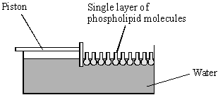

**Figure 1**

The piston was pushed across the surface of the water until the phospholipid molecules were tightly packed into a single layer. The area covered by the phospholipid molecules was measured. This area was compared with the estimated surface area of the red blood cells from which phospholipids were extracted.

Gorter and Grendel obtained the data shown in the table.

|  |  |
| --- | --- |
| Number of red blood cells per cm3 of blood | 4.74 × 109 |
| Estimated mean surface area of one red blood cell | 99.4 μm2 |
| Surface area of membrane phospholipids extracted from 1cm3 of blood | 0.92 m2 |

(a)     Explain what these data suggest about the arrangement of phospholipids in the surface membranes of red blood cells. Support your explanation with suitable calculations.

Show your working.

......................................................................................................................

......................................................................................................................

......................................................................................................................

......................................................................................................................

......................................................................................................................

......................................................................................................................

**(3)**

(b)     **Figure 2** shows a red blood cell and a white blood cell.

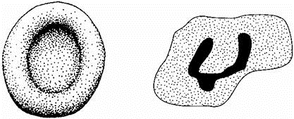

Red blood cell                                  White blood cell

**Figure 2**

Explain why red blood cells were used in this investigation rather than white blood cells.

......................................................................................................................

......................................................................................................................

......................................................................................................................

......................................................................................................................

**(2)**

**(Total 5 marks)**

**Q2.**          Cholera is a water-borne disease caused by the intestinal pathogen, *Vibrio cholerae*. The pathogen produces an exotoxin which acts specifically on the epithelial cells of the small intestine causing changes in membrane permeability. Individuals with cholera suffer from severe diarrhoea which may result in death.

(a)     Suggest **two** precautions which could be used to prevent the transmission of cholera.

1 ...................................................................................................................

2 ...................................................................................................................

**(1)**

**S** (b)     Suggest why the cholera exotoxin is specific to the epithelial cells of the small intestine.

......................................................................................................................

......................................................................................................................

......................................................................................................................

......................................................................................................................

**(2)**

**S** (c)     The cholera exotoxin affects the movement of ions through the intestinal wall. It causes the loss of chloride ions from the blood into the lumen of the small intestine. This prevents the movement of sodium ions from the lumen of the small intestine into the blood.

(i)      Describe how sodium ions normally enter the blood from the cells of the intestinal wall against a concentration gradient.

.............................................................................................................

.............................................................................................................

.............................................................................................................

.............................................................................................................

**(2)**

(ii)     Use the information provided to explain why individuals with cholera have diarrhoea.

.............................................................................................................

.............................................................................................................

.............................................................................................................

.............................................................................................................

**(2)**

**(Total 7 marks)**

**Q3.**          (a)     Oxygen and water move through plasma membranes into cells. Describe **two** ways in which these movements are similar.

1 ...................................................................................................................

......................................................................................................................

2 …................................................................................................................

......................................................................................................................

**(2)**

The graph shows the effect of concentration on the rate of uptake of magnesium ions by root hair cells.

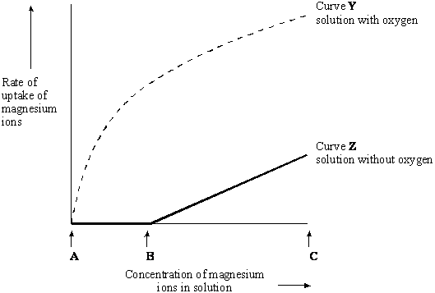

(b)     For curve **Y** name the process the cells are using to absorb magnesium ions between concentrations **A** and **B**. Use information in the graph to explain your answer.

Name of process ..........................................................................................

Explanation ...................................................................................................

......................................................................................................................

......................................................................................................................

**(2)**

(c)     In the solution without oxygen, explain why no magnesium ions are taken up between concentrations **A** and **B**.

......................................................................................................................

......................................................................................................................

**(1)**

(d)     For curve **Z** explain why the rate of uptake increases between **B** and **C**.

......................................................................................................................

......................................................................................................................

**(1)**

**(Total 6 marks)**

**Q4.**            Penstemon plants have mechanisms that regulate the amount of nectar produced by their flowers. Nectar is a solution containing sucrose which attracts insect pollinators. The diagram shows a section through a penstemon flower.

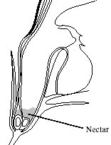

To investigate these mechanisms the volume of nectar produced was determined. A thin strip of filter paper was dipped into the nectar until all the nectar was absorbed. The distance the nectar moved up the paper was measured. The actual volume of nectar was found by reading the value from a calibration curve on a graph. A sucrose solution similar to nectar was used to produce this calibration curve.

(a)     (i)      The solution contained 22% by mass of sucrose. Describe how you would make 50 cm3 of this solution.

.............................................................................................................

.............................................................................................................

.............................................................................................................

**(1)**

(ii)     Describe how you would use the solution to produce the calibration curve.

.............................................................................................................

.............................................................................................................

.............................................................................................................

.............................................................................................................

**(2)**

In one experiment the effect of removing nectar at regular intervals was investigated. First all the nectar was removed from two penstemon flowers. From one flower (**A**) all the nectar produced was removed each hour for the next six hours. In the second flower (**B**) the nectar was allowed to accumulate for six hours. Each time the nectar was removed, the sugar was extracted from the strip of filter paper and its mass was measured. The graphs show the results.

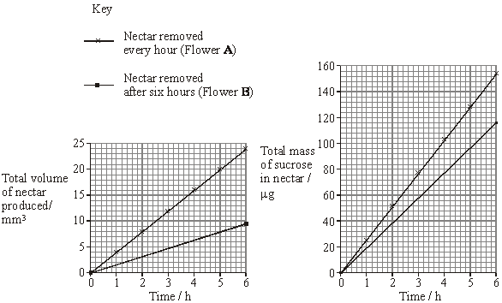

(b)     (i)      Describe the effects on nectar production and on sucrose secretion of removing the nectar every hour compared with removing it after 6 hours.

.............................................................................................................

.............................................................................................................

.............................................................................................................

.............................................................................................................

**(2)**

(ii)     How would the nectar collected after 6 hours from plant **B** differ from that collected after 6 hours from plant **A**.

.............................................................................................................

.............................................................................................................

**(1)**

(iii)     Pollinating insects such as bees visit flowers and collect nectar. Suggest **one** advantage for penstemon flowers of the response to regular removal of nectar.

.............................................................................................................

.............................................................................................................

.............................................................................................................

.............................................................................................................

**(1)**

(c)     In a different experiment the nectar was removed from two penstemon flowers. In one flower the nectar was replaced with 5 mm3 of a solution containing a total of 120 µg of sucrose. The second flower was left empty as a control. The two flowers were protected from insects. After three hours the nectar solutions in the flowers were removed. The table shows the results.

|  |  |  |  |  |
| --- | --- | --- | --- | --- |
|  | **Volume of solution / mm3** | | **Mass of sucrose in solution / µg** | |
| **Time / h** | **Experimental** | **Control** | **Experimental** | **Control** |
| 0 | 5.00 | 0.00 | 120 | 0 |
| 3 | 5.75 | 1.65 | 104 | 20 |

Describe the effect of the addition of sucrose solution on the volume of nectar produced and on the movement of sucrose.

......................................................................................................................

......................................................................................................................

......................................................................................................................

......................................................................................................................

......................................................................................................................

......................................................................................................................

**(3)**

(d)     Nectar is formed by specialised cells in the flower which synthesise sucrose.  
Describe how sucrose is moved against a concentration gradient from these cells into the nectar.

......................................................................................................................

......................................................................................................................

......................................................................................................................

......................................................................................................................

**(2)**

**(Total 12 marks)**

**Q5.**          Six cylinders of a standard size were cut from a single large potato. One cylinder was placed in distilled water and the others were placed in sucrose solutions of different concentrations. The length of each cylinder was measured every 5 minutes for the next 50 minutes.

The graph shows the changes in length at each sucrose concentration.

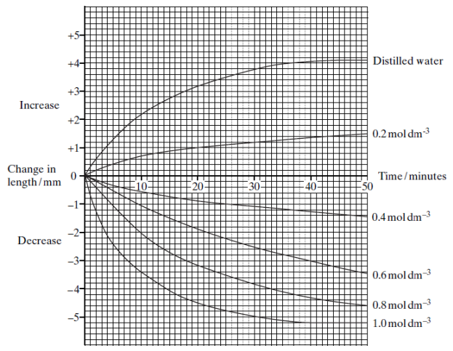

(a)     Explain why

(i)      the potato cylinder in distilled water increased in length;

.............................................................................................................

.............................................................................................................

.............................................................................................................

.............................................................................................................

**(2)**

(ii)     the potato cylinder in the 1.0 mol dm–3 sucrose solution showed no further decrease in length after 40 minutes.

.............................................................................................................

.............................................................................................................

.............................................................................................................

.............................................................................................................

**(2)**

(b)     (i)      Describe the difference in the rate of decrease in length during the first 10 minutes between the cylinder in the 0.4 mol dm–3 and the cylinder in  
the 0.8 mol dm–3 solution.

.............................................................................................................

.............................................................................................................

**(1)**

(ii)     Use your knowledge of water potential to explain this difference.

.............................................................................................................

.............................................................................................................

**(1)**

(c)     After 45 minutes the potato cylinder in the 0.8 mol dm–3 solution was removed and blue dye added to this solution. Some of this blue-stained solution was drawn into a syringe. A drop was then released, slowly, halfway down a test tube of fresh 0.8 mol dm–3 sucrose solution as shown in the diagram. The blue drop quickly moved to the surface of the liquid in the test tube.

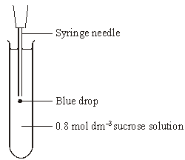

(i)      The density of a solution depends on its concentration. The more concentrated the solution the greater its density. Explain why the blue drop had a lower density and therefore moved up.

.............................................................................................................

.............................................................................................................

.............................................................................................................

.............................................................................................................

**(2)**

(ii)     A sucrose solution of concentration 0.3 mol dm–3 has a water potential which is equivalent to that of the potato cells. Describe and explain what would happen to the blue drop from this solution.

.............................................................................................................

.............................................................................................................

.............................................................................................................

.............................................................................................................

**(2)**

**(Total 10 marks)**

**Q6.**          The diagram shows part of a cell surface membrane.

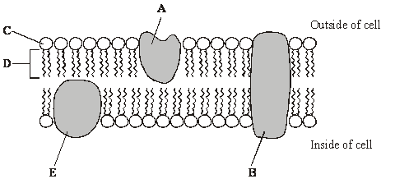

a)     Complete the table by writing the letter from the diagram which refers to each part of the membrane.

|  |  |
| --- | --- |
| **Part of membrane** | **Letter** |
| Channel protein |  |
| Contains only the elements carbon and hydrogen |  |

**(2)**

(b)     Explain why the structure of a membrane is described as *fluid-mosaic*.

......................................................................................................................

......................................................................................................................

......................................................................................................................

......................................................................................................................

**(2)**

(c)     When pieces of carrot are placed in water, chloride ions are released from the cell vacuoles. Identical pieces of carrot were placed in water at different temperatures. The concentration of chloride ions in the water was measured after a set period of time. The graph shows the results.

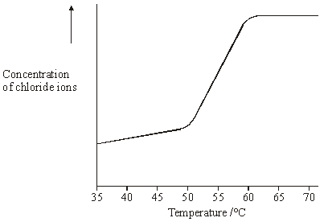

Describe and explain the shape of the curve.

......................................................................................................................

......................................................................................................................

......................................................................................................................

......................................................................................................................

......................................................................................................................

......................................................................................................................

**(3)**

**(Total 7 marks)**

**Q7.**          Glasswort is a plant that grows in salt marshes. The plants are covered by seawater at each high tide. The roots grow in mud which contains a high concentration of salt. The drawing shows a shoot of the plant.

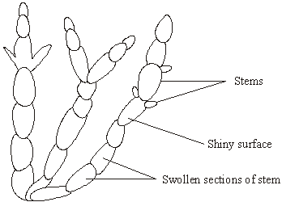

In glasswort cells, sodium ions are transported from the cytoplasm outwards across the cell surface membrane and also into the cell vacuole. The concentration of sodium ions is greater inside the vacuole than in the intercellular fluid, which is the fluid between the cells in tissues. High sodium ion concentrations would disrupt metabolic processes in the cytoplasm. This information is summarised in the diagram below.

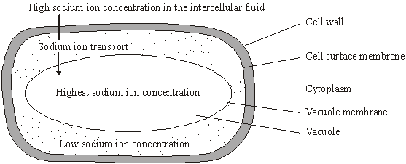

**S**       (a)     The total concentration of all ions in the cytoplasm is higher than in the intercellular fluid. Explain how this allows the cell to take up water.

......................................................................................................................

......................................................................................................................

......................................................................................................................

......................................................................................................................

**(2)**

**S**       (b)     (i)      Explain how sodium ions are transported through the membranes.

.............................................................................................................

.............................................................................................................

.............................................................................................................

.............................................................................................................

**(2)**

(ii)     There is a higher concentration gradient between the cytoplasm and the vacuole than between the cytoplasm and the intercellular fluid. Suggest how the vacuole membrane maintains this higher concentration gradient.

.............................................................................................................

.............................................................................................................

.............................................................................................................

.............................................................................................................

**(2)**

**(Total 6 marks)**

**Q8.**          An investigation was carried out to compare the uptake of sulphate ions by barley roots in aerobic and in anaerobic conditions. The results are shown in the graph.

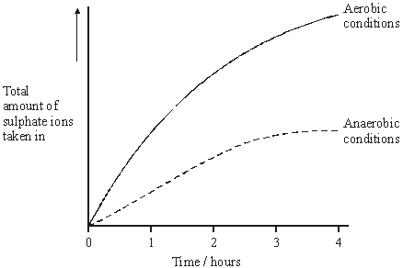

(i)      Explain the evidence from the graph that active transport is involved in the uptake of sulphate ions.

......................................................................................................................

......................................................................................................................

......................................................................................................................

......................................................................................................................

**(2)**

(ii)      Suggest why the uptake of sulphate ions by the roots in anaerobic conditions stopped after 3 hours.

......................................................................................................................

......................................................................................................................

**(1)**

**(Total 3 marks)**

**Q9.**          Two samples of the roots of pea plants were placed in solutions containing potassium ions. An inhibitor to prevent respiration was added to one solution. The concentrations of potassium ions in the two solutions were measured at regular intervals. The graph shows the results.

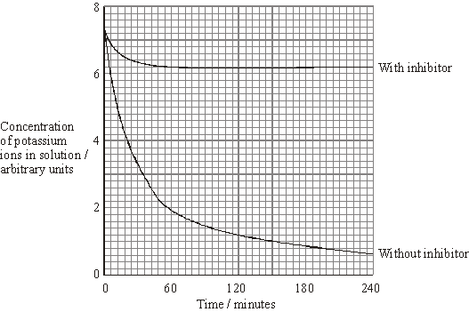

(a)     Explain the decrease in the concentrations of potassium ions in the two solutions between 0 and 30 minutes.

(i)      With inhibitor

.............................................................................................................

.............................................................................................................

.............................................................................................................

.............................................................................................................

**(2)**

(ii)     Without inhibitor

.............................................................................................................

.............................................................................................................

**(1)**

(b)     Explain why there is no further decrease in the concentration of potassium ions in the solution with the inhibitor after 60 minutes.

......................................................................................................................

......................................................................................................................

......................................................................................................................

......................................................................................................................

**(2)**

(c)     The substance malonate is an inhibitor of respiration. It has a structure very similar to the substrate of an enzyme that catalyses one of the reactions of respiration. Explain how malonate inhibits respiration.

......................................................................................................................

......................................................................................................................

......................................................................................................................

......................................................................................................................

**(2)**

**(Total 7 marks)**

**Q10.**          (a)     The diagram shows the fluid-mosaic model of a cell surface membrane.

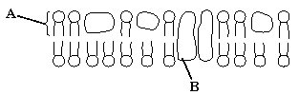

(i)      Name the molecules labelled **A** and **B**.

**A** .........................................................................................................

**B** .........................................................................................................

**(1)**

(ii)     How does the bilayer formed by substance **A** affect entry and exit of substances into and out of a cell?

.............................................................................................................

.............................................................................................................

.............................................................................................................

.............................................................................................................

**(2)**

(b)     A dialysis machine contains artificial membranes which enable urea to be removed from the blood of a person with kidney failure. The diagram shows a dialysis machine.

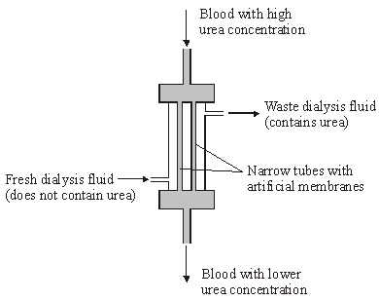

(i)      By what process does urea pass from the blood into the dialysis fluid?

.............................................................................................................

**(1)**

(ii)     Suggest **two** reasons for keeping the fluid in the dialysis machine at 40 °C rather than room temperature.

1 .................................................................................................…….

.............................................................................................................

2 ...........................................................................................................

.............................................................................................................

**(2)**

(iii)     The blood and the dialysis fluid flow in opposite directions in the dialysis machine. Explain the advantage of this.

.............................................................................................................

.............................................................................................................

.............................................................................................................

.............................................................................................................

**(2)**

(iv)    Blood flows through the dialysis machine at a rate of 200 cm3 per minute.  
Calculate the total volume which passes through the machine in 5 hours.  
Give your answer in dm3 and show your working.

Answer .................................... dm3

**(2)**

**(Total 10 marks)**

**M1.**          (a)     phospholipids in a double layer / area covered is twice total surface area of red blood cells;   
evidence of calculation of number × surface area (4.74 × 109 × 99.4 μm2 ) /

calculation of area of 1 cell 

0.471 m2 ≈ 0.5 × 0.92 m2 / 194 μm ≈ 2 × 99.4;

**3**

(b)     EITHER feature + explanation  
red blood cells do not contain organelles / nucleus;   
so only surface membrane / no internal membranes in macerate;  
OR  
red blood cells have simple / regular / spherical shape;  
so easy to calculate surface area;  
OR  
*any two features, e.g.*simple / regular shape;  
all same size;

**2**

**[5]**

**M2.**          (a)     effective water / sewage treatment / prevent water contamination / improved hygiene / vaccination / quarantining of affected area;

*(any two)*

**1**

(b)     receptor / proteins on membrane;  
complementary shape of exotoxin;

**2**

(c)     (i)      active transport;  
 using ATP / carrier proteins; **2**

(ii)     higher solute concentration / water potential lowered in  
small intestine; osmotic loss of water;

**2**

**[7]**

**M3.**          (a)     passive / do not require energy / ATP;  
movement down a concentration gradient / by diffusion;  
go through phospholipid (bilayer) / not by protein / carriers;

*(not by active transport gains mark if no other mark awarded)*

**2 max**

(b)     active transport;

**1**

occurs when oxygen present because energy / respiration required,   
or against a concentration gradient because there is no uptake in  
curve **Z**;

**1**

(c)     concentration inside cells higher than surrounding solution;

**1**

(d)     diffusion is proportional to the concentration gradient;

**1**

**[6]**

**M4.**          (a)     (i)      11g sucrose dissolved in water (and made up to) 50 cm3 / 50g;

**1**

(ii)     make a series of volumes of 22% sucrose solutions;  
measure how far each travels up the chromatography paper;

**2**

(b)     (i)      both (volume) of nectar and (mass) of sucrose / sugar increased by  
regular removal;  
(proportionately) greater effect on nectar than sucrose;

**2**

(ii)     nectar from flower B has greater concentration of sugar;

*(accept references to figures (A has 6.2 – 6.6 μg mm–3,  
B has 12 – 12.4 μg mm–3))*

**1**

(iii)     nectar always available for insects;

**1** (c)     (adding sucrose solution) decreases nectar secretion / less nectar  
 produced than control;

*(allow correct processed figures)*

**1**

adding sucrose solution results in reabsorption of sugar *(gains 2 marks);;*

*(BUT adding sucrose solution reduces secretion  
of sugar in nectar / sugar moved out gains 1 mark);*

**2**

(d)     via (intrinsic) proteins;

*(reject channel proteins)*

using ATP / active transport / energy;

**2**

**[12]**

**M5.**          (a)     (i)      potato more negative water potential / hypertonic;

*(accept more concentrated)*

water enters by osmosis causing cells to extend / become turgid;

**2**

(ii)     little / no water remaining in potato / fully plasmolysed /   
all water has moved out;  
cell wall prevents further shrinkage / sucrose solution moves in;

or, water potentials are equal / equilibrium / isotonic;  
no net movement of water / no further osmosis;

**2**

(b)     (i)      faster rate (of decrease) in 0.8 mol dm–3;

**1**

(ii)     bigger water potential gradient / greater difference in water potentials (between potato and surrounding solution);

**1**

(c)     (i)      water moved into the solution from the potato;  
solution diluted / becomes less concentrated;

**2**

(ii)     no net movement of water (in or out);  
drops move up / less dense;

or, no net movement of water (in or out);

drop would not move / densities the same;

**2**

**[10]**

**M6.**          (a)     B;  
D;

**2**

(b)     idea of molecules / named molecules moving = Fluid;  
idea of both proteins and phospholipids = Mosaic;

**2**

(c)     slow rise, sharp rise, levelling off (*reject ‘becomes constant’*);  
diffusion rate increases / description of diffusion rate,  
e.g. increase in kinetic energy increases loss of ions;

**1**

sharp rise / above 50oC proteins are denatured;  
levelling off due to concentration of chloride ions in water becoming  
equal / maximum loss of Cl- ions;

**2 max**

**[7]**

**M7.**          (a)     cell has lower water potential than external medium;  
so, water enters by osmosis;

**2**

(b)     (i)      active transport;  
by specific carrier proteins / pumps;

**2**

(ii)     sodium ions transported more into vacuole (than to outside);  
because more sodium carrier proteins / pumps in vacuole membrane;  
*or*vacuole membrane less permeable to sodium ions / allows slower  
sodium ion diffusion (back out);  
membrane has fewer sodium channels;

**2 max**

**[6]**

**M8.**          (i)      (graph shows) greater uptake (of ions) in aerobic (conditions);  
aerobic respiration / conditions releases more energy / ATP  
(for active transport);

*(reject produces / makes energy)*

**2**

(ii)      ATP / energy limiting;  
active transport stops;  
diffusion gradient lost / equal concentrations of ions / no net  
movement of ions;

*(do not allow store of ATP runs out)*

**1 max**

**[3]**

**M9.**          (a)     (i)      absorbed by diffusion;  
no energy / ATP available / active transport requires energy / ATP;

**2 max**

*(disqualify energy made)*

*(allow energy reference in either (i) or (ii))*

(ii)     absorbed by active transport;

**1**

(b)     (absorption by) diffusion no longer occurs / diffusion / movement  
of ions equal in both directions;  
because no concentration / diffusion gradient / reached equilibrium;

**2**

(c)     malonate fits into / blocks active site of enzyme / complementary to active site;  
(prevents fitting neutral)  
competes with substrate / is a competitive inhibitor / prevents substrate  
forming enzyme-substrate complex;

**2**

**[7]**

**M10.**          (a)     (i)      **A** = phospholipid

**B** = protein;

*(both correct)*

**1**

(ii)     allows movement of lipid soluble / non-polar molecules / named  
e.g. water / gases;  
prevents movement of water soluble / polar molecules / named  
e.g. ions / amino acids;  
idea of selection / membrane partially / differentially permeable /   
large molecules do not move through, small molecules do;

*(accept semi-permeable)*

**2 max**

(b)     (i)      diffusion

*(reject facilitated)*

**1**

(ii)     higher rate of exchange / diffusion;  
prevents cooling of the blood / prevents increase in viscosity;

**2**

(iii)     concentration gradient maintained / equilibrium never achieved;  
blood always meets fluid with lower concentration of urea;  
diffusion / exchange along the whole length of surface;

**2 max**

(iv)    0.2 × 60 = 12 dm3 h-1;

*(principle: volume per hour)*

12 × 5 = 60 dm3;

*(correct answer 2 marks)*

**2**

**[10]**

**E1.**          (a)     A majority of candidates did not attempt to calculate the total surface area of the red blood cells. Most of those who made the attempt had difficulty with units or with standard form, consequently only a handful successfully completed the calculation and were able to make the correct deduction from the data.

(b)     Most candidates obtained at least one of the two marks, but relatively few could relate the feature they described to measurement of membrane surface area.

**E2.**         There were some excellent answers to this question with the most able candidates gaining maximum marks.

(a)     This caused few problems with the vast majority of candidates correctly suggesting two precautions which could be used to prevent the transmission of cholera. Most answers referred to effective water and sewage treatments, although specific references to improved hygiene were frequently mentioned. Only a few candidates referred to vaccination.

(b)     Proved more difficult as many candidates struggled to express their ideas clearly or used inappropriate scientific terminology. A significant number of candidates referred to ‘active sites’ rather than to receptor sites or used ‘same shape’ rather than complementary shape. Despite this, there were several correct answers which displayed a good understanding of this synoptic material.

(c)     (i)      The majority of candidates obtained both marks for correctly referring to the use of active transport and ATP. A significant minority of candidates provided descriptions of facilitated diffusion.

(ii)      Many candidates gained one mark for stating that the water potential would be lowered in the small intestine. However, only better candidates linked this to the osmotic loss of water. The least able students often misinterpreted the information provided and were confused concerning the direction of movement of the ions and water.

**E3.**          (a)     The majority of candidates gave correct answers, but some candidates gave diffusion, and a description of it, as two separate points. Very few identified the route through the membrane as a similarity.

(b)     Active transport was named by the majority of candidates but most failed to use information from the graph to support their explanation, commonly omitting the need for the presence of oxygen and referring only to the requirement for energy or respiration.

(c)     This was a good discriminator. Weaker responses tended to refer to lack of active transport rather than differences in concentration and uptake by diffusion.

(d)     A very small minority of candidates showed any appreciation of how a concentration gradient can influence rate of diffusion and therefore rate of uptake.

**E4.**          Whilst a full range of marks was seen on this question, few candidates gained twelve marks and zero was rarely seen. Even the best candidates seemed to find it hard to score more than eight or nine marks. These candidates usually did well on parts (b) and (c), (data interpretation), but lost marks in part (a), (practical techniques).

(a)     Not many correct answers were seen in part (i). The most common answer was ‘dissolve 11cm3 of sucrose in 39cm3 of water’. In general, there was a disappointing failure to use mass rather than volume in this context. There were a reasonable number of correct responses in part (ii). The most common errors involved references to colorimetry or chromatography. Often, candidates referred to different concentrations of sucrose rather than different volumes.

(b)     In part (i), the majority of candidates obtained one mark for references to increased nectar and sucrose production, but only a small minority referred to the greater effect on nectar secretion. Only a minority of candidates provided the correct answer in part (ii), the majority opting for a lower concentration of sucrose in B. A majority of students correctly suggested that increased nectar production might lead to more frequent visits by pollinators in (iii).

(c)     Most candidates obtained two marks, for references to less nectar and a lower mass of sucrose. Quite a large number obtained the third mark, for reference to reabsorption. This question discriminated very well.

(d)     Most candidates obtained one mark with references to active transport, or the use of ATP. Only a minority made reference to protein being involved, and some of these failed to gain the second mark, because of references to ‘channel’ proteins.

**E5.**          (a)     This question was well answered with many candidates confident in the use of the appropriate water potential terminology. Weaker candidates, however, referred to high/low water concentrations or less/more water potential. Only more able candidates were able to link equilibrium with no net movement of water in part (ii).

(b)     Although the majority of candidates had the right idea, many described the difference in terms of more movement of water rather than faster rate of movement and then failed to link the water potential values to differences in gradient, referring only to size.

(c)     Those students who understood osmosis gave clear logical answers linking dilution of the blue solution with the movement of water in relation to the potato and were able to score full marks. Weaker candidates described the movement of the blue drop and gained one mark but failed to relate this to movement of water into or out of the potato in the initial experiment.

**E6.**          (a)     The channel protein was correctly identified as **B** by the majority of candidates, but the second part of the table was less well answered. A significant number gave **C** as the answer, showing a lack of understanding about the structure of phospholipids. A number left this section of the table blank.

(b)     There were many poor responses to this question. The concept of the fluidity of the membrane appears difficult for candidates. There were many vague references to the membrane moving and a lack of clarity about the individual components. Mosaic is also not well understood.

(c)     This proved a difficult question for candidates and few gained all the marks. Many gained some reward for realising an increase in temperature increased the energy and subsequent diffusion rate of the ions. The data were often misinterpreted and answers relating to enzyme action were frequently given. Other candidates attempted explanations in terms of osmosis. Marks were missed for incomplete descriptions of the graph and because of a failure to appreciate the effect of temperature on the structure of membranes. Few were able to explain adequately the level section of the graph, with some answers suggesting that all the ions had left the cell, or that no more movement was taking place.

**E7.**          (a)     It was very pleasing to find that the vast majority of candidates correctly explained the uptake of water into the cell in terms of water potentials and osmosis.

(b)     (i)      Many candidates obtained one mark here for identifying active transport as the means by which sodium ions are transported across the membrane. Quite a few got a second mark for linking this to carrier proteins. Some candidates failed to get the second mark because they got confused between carrier proteins and channel proteins.

(ii)     Only the better candidates scored one or two marks for this question. About equal numbers of those who did score opted for arguments based upon the number of carrier proteins, or a reduced permeability to sodium ions.

**E8.**          (i)      The graph was well used by the majority of candidates. They correctly spotted the greater uptake of mineral ions when oxygen is present and then made a relevant link between the presence of oxygen and aerobic respiration. Few went on further to give a reason why the uptake is greater under these conditions. Some candidates lost this mark when the reason they gave stated energy is “produced” in respiration. It was difficult for examiners to determine whether this reflected poor communication or a misconception about a law of thermodynamics. Some candidates believe no energy is released in anaerobic respiration.

(ii)      Some misconceptions featured in quite a few answers given to this question: for example, plant tissue is poisoned by the lactate produced in anaerobic respiration, and plants without any ATP can survive but are unable to take up mineral ions. This was the most difficult section of the question for many candidates, but it was often answered well by candidates from the upper range of ability.

**E9.**          (a)     (i)      Candidates found this question the most difficult with very few achieving good marks and a significant number only managing to gain marks in part (c).

(ii)     Many candidates were unable to link respiration with the uptake of potassium ions. Many appeared to believe that potassium ions are necessary for respiration or attempted to explain the data by suggesting that potassium ions act as the inhibitor of respiration by blocking active sites. Candidates recognising that inhibition of respiration prevented active transport often failed to explain the decrease in concentration of potassium ions in the presence of an inhibitor as diffusion. The decrease was often attributed to the presence of a store of ATP which allowed some active transport to occur. Weaker candidates misread the data assuming that it referred to the concentration in the roots and tried to explain it in terms of loss of potassium ions. Others simply described the curves without providing an explanation.

(b)     This proved to be the most demanding question in the paper. Candidates only performed well on this question if they had understood part (a). A number did recognise that the equilibrium had been reached but very few were able to explain that there was no net diffusion of ions due to the absence of a concentration gradient.

(c)     This was better answered. Many candidates understood and were able to explain competitive inhibition, although a lack of clarity due to poor expression did penalise some. A minority lost marks by describing non-competitive inhibition.

**E10.**          (a)     The molecules in the membrane were well identified with many candidates qualifying the type of protein present. There was some confusion in (ii) over the distinction between the movement of water-soluble molecules and water itself with some candidates failing to appreciate that water can move across the membrane in the same way as other very small molecules such as oxygen. A small number of candidates still referred to the membrane as *semi-permeable* and should be encouraged to follow the Institute of Biology recommended terminology of *partially permeable* whenever possible.

(b)     This question produced a wide spread of marks. Most candidates identified the process of diffusion and went on to recognise an increase in rate related to temperature but very few referred to the cooling effect on the blood. Only more able candidates were able to apply the principles of countercurrent flow to the novel situation and gain both marks in part (iii). Many candidates correctly related volume to time in the calculation but were then unable to express this in the correct units, indicating problems with cm³ and dm³.