**Q1.**            A medical officer investigated the effectiveness of five different types of influenza vaccine. A total of 1350 people agreed to be vaccinated. The medical officer divided these into five groups. The number who suffered from influenza in the following year was recorded. The results are shown in the table.

|  |  |  |  |  |
| --- | --- | --- | --- | --- |
|  | **Number of people vaccinated** | | | |
| **Type of influenza vaccine** | **Suffered from influenza** | **Did not suffer from influenza** | **Total** | **Proportion suffering from influenza** |
| I | 43 | 237 | 280 | 0.15 |
| II | 52 | 198 | 250 | 0.21 |
| III | 25 | 245 | 270 | 0.09 |
| IV |  |  | 260 | 0.18 |
| V | 57 | 233 | 290 | 0.20 |

(a)     Complete the spaces in the table for the people vaccinated with type IV vaccine.

**(1)**

(b)     The medical officer used a statistical test to assess the effectiveness of the five different vaccines.

(i)      What would be the null hypothesis?

.............................................................................................................

.............................................................................................................

**(1)**

(ii)     The statistical test gave a probability of less than 0.05. What conclusion can be drawn from this?

.............................................................................................................

.............................................................................................................

**(1)**

(c)     It was suggested that the raw data showed that the type III vaccine was the most effective. Give **two** reasons why this conclusion may not be reliable.

1 ....................................................................................................................

......................................................................................................................

2 ....................................................................................................................

......................................................................................................................

**(2)**

**(Total 5 marks)**

**Q2.**          (a)     Changes to the protein coat of the influenza virus cause antigenic variability. Explain how antigenic variability has caused some people to become infected more than once with influenza viruses.

......................................................................................................................

......................................................................................................................

......................................................................................................................

......................................................................................................................

**(2)**

(b)     The drawings show the changes in a B lymphocyte after stimulation by specific antigens.

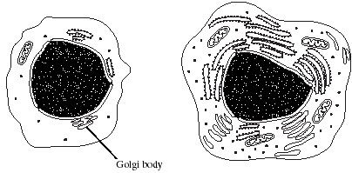

B lymphocyte before stimulation        B lymphocyte after stimulation

(i)      Describe the role of macrophages in stimulating B lymphocytes.

.............................................................................................................

.............................................................................................................

**(1)**

       (ii)     Explain how the changes shown in the drawings are related to the function of B lymphocytes.

.............................................................................................................

.............................................................................................................

.............................................................................................................

.............................................................................................................

.............................................................................................................

.............................................................................................................

.............................................................................................................

.............................................................................................................

**(4)**

**(Total 7 marks)**

**3.**          (a)     Whooping cough is a childhood respiratory disease caused by a bacterium.  
The graph shows the incidence of whooping cough in Central Europe from 1969 to 1999.

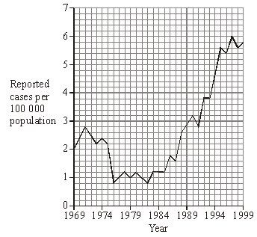

(i)      Calculate the percentage change in the incidence of whooping cough from 1982 to 1999. Show your working.

Answer ............................................

**(2)**

(ii)     Suggest **one** reason for the trend in the number of cases of whooping cough since 1982.

.............................................................................................................

.............................................................................................................

**(1)**

(b)     Whooping cough bacteria prevent the normal functioning of cilia in the respiratory tract. Explain how this effect is linked to the persistent coughing associated with the disease.

......................................................................................................................

......................................................................................................................

......................................................................................................................

......................................................................................................................

**(2)**

**(Total 5 marks)**

**Q4.**         The graph shows the number of new cases of two diseases which occurred in two different human populations.

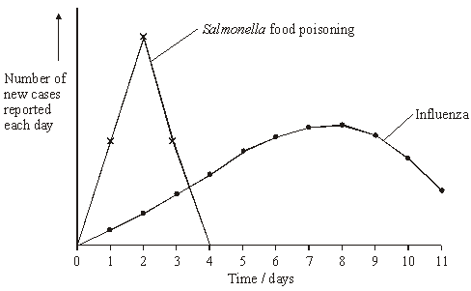

Explain the shape of the curve for

(i)      *Salmonella* food poisoning;

......................................................................................................................

......................................................................................................................

**(1)**

(ii)     influenza.

......................................................................................................................

......................................................................................................................

**(1)**

**(Total 2 marks)**

**Q5.**          (a)     The graph shows the number of deaths from influenza per year in a developed country.

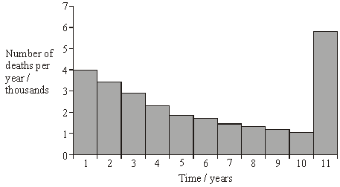

(i)      Suggest an explanation for the change in the number of deaths from influenza during the first 10 years.

.............................................................................................................

.............................................................................................................

**(1)**

(ii)     Suggest an explanation for the large increase in the number of deaths from influenza in year 11.

.............................................................................................................

.............................................................................................................

.............................................................................................................

.............................................................................................................

**(2)**

(b)     The diagram shows some of the structures on the outside of an influenza virus.

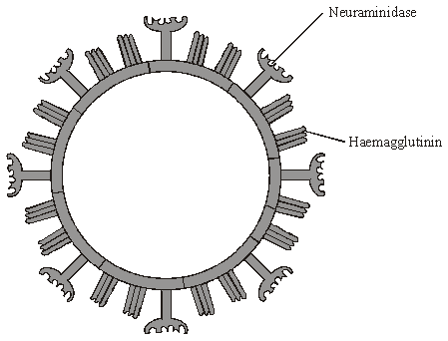

Haemagglutinin and neuraminidase are protein molecules. Haemagglutinin binds to receptor molecules on the surface of epithelial cells in the breathing system.  
Neuraminidase is an enzyme which breaks down molecules in the surface membrane of epithelial cells and allows the viruses to be released from the cells.

(i)      Describe how T lymphocytes recognise and respond to the influenza virus.

.............................................................................................................

.............................................................................................................

.............................................................................................................

.............................................................................................................

**(2)**

(ii)     Describe how B lymphocytes respond to the influenza virus.

.............................................................................................................

.............................................................................................................

.............................................................................................................

.............................................................................................................

**(2)**

(c)     New drugs have recently become available for treating influenza. One type is a neuraminidase inhibitor. Explain how this type of drug would act as a treatment for influenza.

......................................................................................................................

......................................................................................................................

......................................................................................................................

......................................................................................................................

**(2)**

**(Total 9 marks)**

**Q6.**          (a)     Describe how each of the following parts of the body is protected to prevent microorganisms entering living cells.

(i)      Skin

.............................................................................................................

.............................................................................................................

**(1)**

(ii)     Lungs

.............................................................................................................

.............................................................................................................

**(1)**

(iii)     Eyes

.............................................................................................................

.............................................................................................................

**(1)**

(b)     Describe how macrophages help to prevent the spread of microorganisms that enter the blood and other tissues.

......................................................................................................................

......................................................................................................................

......................................................................................................................

......................................................................................................................

**(2)**

**(Total 5 marks)**

**Q7.**          (a)     *Salmonella typhimurium* causes food poisoning in humans but not in other mammals. Explain why these bacteria attach to human cells but not to the cells of other mammals.

......................................................................................................................

......................................................................................................................

......................................................................................................................

......................................................................................................................

**(2)**

       (b)     Salmonella bacteria release toxins that cause the body temperature to rise. Although a small increase in body temperature can be beneficial, a large increase can cause serious harm.

Explain how a large increase in a person’s body temperature can cause harm.

......................................................................................................................

......................................................................................................................

......................................................................................................................

......................................................................................................................

**(2)**

  (c)     Some species of bacteria, which live in soil and decompose organic material, release exotoxins. Suggest how the release of exotoxins benefits the bacteria.

......................................................................................................................

......................................................................................................................

**(1)**

(d)     Washing hands with anti-bacterial soap reduces the risk of transmission of the bacteria that cause food poisoning. Tea tree oil is a plant extract used in soaps. It is claimed to have anti-bacterial properties. Outline a method for investigating this claim.

......................................................................................................................

......................................................................................................................

......................................................................................................................

......................................................................................................................

......................................................................................................................

......................................................................................................................

......................................................................................................................

......................................................................................................................

**(4)**

**(Total 9 marks)**

**Q8.**          (a)     An antigen in a vaccine leads to the production of antibodies. Describe the part played by B lymphocytes in this process.

......................................................................................................................

......................................................................................................................

......................................................................................................................

......................................................................................................................

......................................................................................................................

......................................................................................................................

......................................................................................................................

**(4)**

      (b)     Hepatitis B vaccine contains a viral antigen produced by genetically modified bacteria. Describe how the isolated gene that codes for a protein in the virus’s coat could be transferred to the bacterial cells.

......................................................................................................................

......................................................................................................................

......................................................................................................................

......................................................................................................................

......................................................................................................................

......................................................................................................................

......................................................................................................................

**(3)**

**(Total 7 marks)**

**Q9.**          (a)     Give **two** factors, other than cost, that should be considered when selecting an antibiotic to treat a bacterial disease.

1 ...................................................................................................................

......................................................................................................................

2 ...................................................................................................................

......................................................................................................................

**(2)**

       (b)     The table describes the effects of two antibiotics on bacteria.

|  |  |
| --- | --- |
| **Antibiotic** | **Effect** |
| Tetracycline | prevents tRNA binding |
| Chloramphenicol | prevents peptide bonds forming |

(i)      Explain how each of these antibiotics slows down the rate of growth of bacteria.

Tetracycline ........................................................................................

.............................................................................................................

.............................................................................................................

.............................................................................................................

Chloramphenicol .................................................................................

.............................................................................................................

.............................................................................................................

.............................................................................................................

**(4)**

(ii)     Suggest why tetracycline has no effect on human cells.

.............................................................................................................

**(1)**

**(Total 7 marks)**

**Q10.** Read the following passage.

Malaria is a disease so deadly that it has devastated armies and destroyed great civilisations.  
It has been estimated that in the course of history malaria has been responsible for the death of one out of every two people who have ever lived. Even today, with all the advantages of modern technology, it is still responsible for some three million deaths a year.

5     The first half of the twentieth century was a time of hope for malarial control. The drugs

chloroquine and proguanil had just been discovered and there seemed a real possibility of a malaria-free world. Unfortunately, this honeymoon ended almost as soon as it had started, with the emergence of drug-resistant parasite populations. Scientists now accept that whatever new drug they come up with, it is likely to have a very limited effective life. As a result, they are increasingly looking at combinations of drugs.

The approach to malaria control which holds the best hope is the production of a vaccine. One of these is being developed by a researcher in South America. His vaccine is based on a small synthetic polypeptide called SPf66 which is dissolved in a saline solution and given as an injection. A series of early trials on human volunteers produced confusing results.

In one trial the effectiveness of the vaccine was claimed to be 80% while, in others, the results were

statistically insignificant. Not only were the results inconclusive but the methods used were challenged by other scientists. In particular, the controls were considered inappropriate.

Another, possibly more promising, approach has been the development of a DNA-based  
vaccine. In theory, all that is required is to identify the DNA from the parasite which encodes

20   key antigens. Unfortunately, scientists have hit snags. Although they have succeeded in

sequencing the human genome, the genome of the malarial parasite has created major  
difficulties. This is partly because of the very high proportion of the bases adenine and  
thymine. In some places these two bases average 80%, and on chromosomes 2 and 3 nearly  
100% of the bases present are adenine and thymine. Because of this, it has proved impossible

25   to cut the relevant DNA with the commonly available restriction enzymes into pieces of a

suitable size for analysis.

          Use information from the passage and your own knowledge to answer the following questions.

(a)     Explain how a resistant parasite population is likely to arise and limit the life of any new anti-malarial drug (lines 8 - 9).

......................................................................................................................

......................................................................................................................

......................................................................................................................

......................................................................................................................

......................................................................................................................

......................................................................................................................

**(3)**

(b)     A person has a 1 in 500 probability of being infected by a chloroquine-resistant strain of malarial parasite and a 1 in 500 probability of being infected by a proguanil-resistant strain. Use a calculation from these figures to explain why scientists are “increasingly looking at combinations of drugs” (lines 9 - 10).

......................................................................................................................

......................................................................................................................

......................................................................................................................

......................................................................................................................

**(2)**

(c)     (i)      Explain why trials of the SPf66 vaccine needed a control.

.............................................................................................................

.............................................................................................................

**(1)**

(ii)     The controls for the SPf66 vaccine trials were considered inappropriate (line 17).

Suggest how the control groups in these trials should have been treated.

.............................................................................................................

.............................................................................................................

.............................................................................................................

.............................................................................................................

**(2)**

(d)     In some of the DNA of a malarial parasite, the proportion of adenine and thymine bases averages 80% (lines 22 - 23). In this DNA what percentage of the nucleotides would you expect to contain

(i)      phosphate; ..........................................................................................

(ii)     guanine? .............................................................................................

**(2)**

(e)     (i)      Use your knowledge of enzymes to explain why restriction enzymes only cut DNA at specific restriction sites.

.............................................................................................................

.............................................................................................................

.............................................................................................................

.............................................................................................................

.............................................................................................................

.............................................................................................................

**(3)**

(ii)     Restriction enzymes that can cut the DNA of chromosomes 2 and 3 produce pieces that are too small for analysis. Explain why these restriction enzymes produce small DNA fragments.

.............................................................................................................

.............................................................................................................

.............................................................................................................

.............................................................................................................

**(2)**

**(Total 15 marks)**

**Q11.** Read the following passage.

The life cycle of the malarial parasite consists of a number of stages. Some of these stages  
occur in humans and some occur in mosquitoes. At each stage, the parasite has different  
antigens on the surface of its cells. Attempts have been made to extract some of these antigens  
and use them to make vaccines to combat the disease. A trial has recently been carried out

5      with one of these vaccines. An injection of the vaccine was given to a group of people chosen  
at random at the start of the trial. Another injection was given 30 days later.

Blood samples were taken at regular intervals throughout the trial. After the first injection,  
the concentration of antibody in the blood rose slowly then fell quickly. After the second  
injection, the concentration rose quickly. It reached a maximum concentration of

10    approximately twice the concentration it reached after the first injection.

Use information from the passage and your own knowledge to answer the following questions.

(a)     What is meant by *antigens* (line 3)?

......................................................................................................................

......................................................................................................................

......................................................................................................................

......................................................................................................................

**(2)**

(b)     (i)      Use information from the passage to sketch a graph to show the effects of the two injections on the concentration of antibody in the blood.

**(3)**

(ii)     Suggest **one** reason why it was necessary to give two injections of the vaccine   
(line 6).

.............................................................................................................

.............................................................................................................

**(1)**

(iii)     Although this vaccine is made from antigens from malarial parasites, it does not cause malaria. Explain why this vaccine does not cause malaria.

.............................................................................................................

.............................................................................................................

.............................................................................................................

.............................................................................................................

**(2)**

(c)     The blood from those taking part in the trial was also examined under the microscope at the beginning of the trial. Explain how this would enable those who had malaria to be identified.

......................................................................................................................

......................................................................................................................

**(1)**

**(Total 9 marks)**

**Q12.**          An antigen called PSA is present in the blood of men in the early stages of prostate cancer.

There is a blood test for PSA. The test uses monoclonal antibodies to PSA. The stages in the test are shown in the diagram.

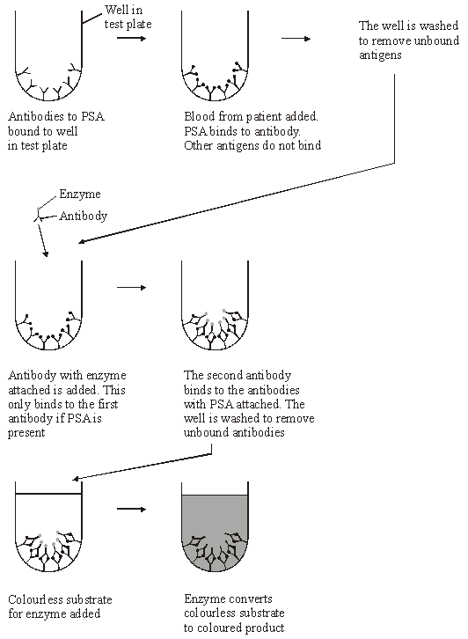

(a)     (i)      What is an antigen?

.............................................................................................................

.............................................................................................................

.............................................................................................................

.............................................................................................................

**(2)**

(ii)     What is a *monoclonal* antibody?

.............................................................................................................

.............................................................................................................

.............................................................................................................

.............................................................................................................

**(2)**

(b)     (i)      Explain why this test detects prostate cancer, but not any other disease.

.............................................................................................................

.............................................................................................................

.............................................................................................................

.............................................................................................................

**(2)**

(ii)     Explain why there will not be a colour change if the blood sample does not contain PSA.

.............................................................................................................

.............................................................................................................

.............................................................................................................

.............................................................................................................

**(2)**

**(Total 8 marks)**

**Q13.**          Some strains of the bacterium that causes gonorrhoea are resistant to antibiotics. This makes the disease difficult to treat. One way of testing the effectiveness of antibiotics is to use discs of paper soaked in antibiotic. These are placed in the centre of an agar plate covered by bacteria. A clear zone forms around the disc if the antibiotic is effective.

The table shows some results of an investigation into the effect of four different antibiotics on gonorrhoea bacteria.

|  |  |  |
| --- | --- | --- |
| **Antibiotic** | **Diameter of clear zone / mm** | **Minimum diameter of clear zone if antibiotic is effective / mm** |
| **A** | 47 | 52 |
| **B** | 30 | 28 |
| **C** | 22 | 40 |
| **D** | 33 | 34 |

(a)     Give **two** reasons why it would be important to use sterile techniques during this investigation.

1 ...................................................................................................................

......................................................................................................................

2 ...................................................................................................................

......................................................................................................................

**(2)**

(b)     (i)      The antibiotic reached the bacteria by diffusion. Suggest why an effective antibiotic may produce only a small clear zone.

.............................................................................................................

.............................................................................................................

**(1)**

(ii)     Which antibiotic used in the investigation would be most useful for treating gonorrhoea? Explain your answer.

Antibiotic ...............................................................

Explanation .........................................................................................

.............................................................................................................

**(2)**

**(Total 5 marks)**

**Q14.**          (a)     What is an antigen?

......................................................................................................................

......................................................................................................................

......................................................................................................................

**(2)**

(b)     Describe how B-lymphocytes respond when they are stimulated by antigens.

......................................................................................................................

......................................................................................................................

......................................................................................................................

......................................................................................................................

......................................................................................................................

......................................................................................................................

......................................................................................................................

......................................................................................................................

**(4)**

(c)     The diagram shows some components of a human immunodeficiency virus (HIV).

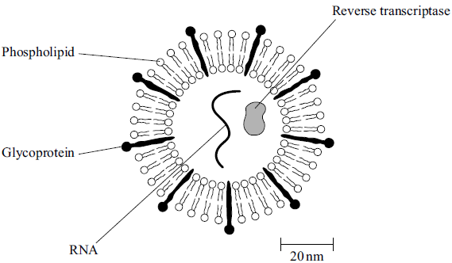

(i)      Suggest which labelled component of the virus is most likely to act as an antigen. Give a reason for your answer.

Component .........................................................................................

Reason ...............................................................................................

.............................................................................................................

**(1)**

(ii)     A cell that HIV infects is 15 µm in diameter. Calculate how many times larger in diameter this cell is than an HIV particle. Show your working.

Answer ...................................... times larger

**(2)**

**(Total 9 marks)**

**Q15.**          Measles is an infectious disease that can cause serious complications in children. In countries where measles is uncommon a combined measles, mumps and rubella vaccine (MMR) is given at 15 months. In a country where measles is common a single measles vaccine (MV) may be given at 9 months, followed by MMR at 15 months. In an investigation, the efficiency of the two vaccination programmes was compared in a country where measles is common. The amount of measles antibody in the blood of children before vaccination and after completing vaccination were measured. The graph shows the results. All difference are statistically significant.

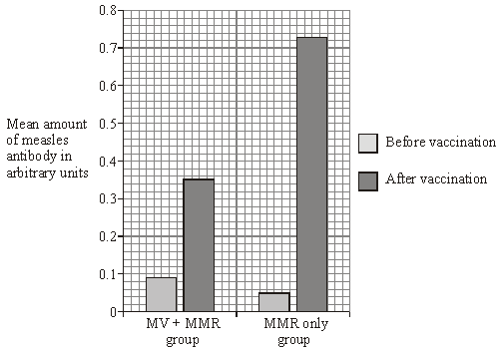

(i)      What was the effect of vaccination in the MMR only group? Express your answer as the percentage increase in the amount of measles antibody in the MMR group after vaccination. Show your working.

Percentage increase ...................................... %

**(2)**

(ii)      The MV  +  MMR group had more measles antibodies in their blood before vaccination than the MMR only group. Suggest an explanation for this.

......................................................................................................................

......................................................................................................................

**(1)**

**(Total 3 marks)**

**M1.**          (a)     47 213;

**1**

(b)     (i)      there is no difference in the proportion / number of influenza cases  
between the 5 vaccines;

*(reject vaccinated versus no vaccinated)*

**1**

(ii)     significant difference in proportion / number of cases of influenza  
between the vaccines / the null hypothesis should be rejected;

**1**

(c)     sample size small;  
possible differences in exposure to infection;  
exposure to different strains / mutants;  
possible differences in existing immunity;  
possible differences in sex / age;  
possible differences in socio-economic status;

**2 max**

**[5]**

**M2.**          (a)     memory B / T cells do not recognise (new antigens);  
antibodies previously produced are not effective  
as shape not complementary to new antigen;

**2**

(b)     (i)      antigen in membrane presented to lymphocytes /   
produce cytokinins;

**1**

(ii)     mitochondria provide (more) ATP / energy;  
(more) RER / ribosomes synthesise proteins;  
(more) Golgi body secretes / modifies or packages proteins /   
produces glycoproteins;  
(B lymphocytes) produces antibodies;

**4**

**[7]**

**M3.**          (a)     (i)      principle of calculating percentage change; 6.25%;

*(correct answer gains 2 marks)*

**2**

(ii)     decrease in number of vaccinations / vaccination ineffective /   
side effects of vaccination / resistance to antibiotics /   
new strains / mutants;

**1**

(b)     cilia move mucus / bacteria / debris;  
(build up of) mucus / irritants stimulates coughing /   
coughing to remove mucus;

**2**

**[5]**

**M4.**          (i)     single source of infection / one incubation period /   
not transmitted from one individual to another;

**1**

(ii)     transmitted from individual to individual /   
several incubation periods;

**1**

**[2]**

**M5.**          (a)     (i)      fall in deaths due to rise in number of people with immunity / better care / targeting vaccination at vulnerable;

**1**

(ii)     mutation of virus / new strain;  
mutant form not recognised by memory cells (*allow antibodies*);

**2 max**

(b)     (i)      T lymphocyte receptors recognise shape of haemagglutinin /   
neuraminidase / viral antigen;  
clone (*once only*);  
destroy virus;

**2 max**

(ii)     clone (*once only*);  
produce antibodies;  
effect of antibody e.g. stimulation of phagocytosis /   
precipitation of toxins;

**2**

(c)     alter shape of active site of neuraminidase / block active site;  
virus unable to leave host cells;

**2**

**[9]**

**M6.**          (a)     (i)      dead cells / keratin as barrier;

*(sweat and sebum neutral)*

*(accept (commensal) skin flora kill / compete with microbe)*

*(accept skin acidity kills microbes)*

**1**

(ii)     mucus traps microorganisms;

*(cilia neutral)*

**1**

(iii)     tears contain lysozyme / contain enzymes which kill microbes;

*(accept bactericide)*

**1**

(b)     move to site of infection;  
phagocytosis / engulf bacteria;

*(digest neutral)*

stimulate (T)-lymphocytes / B cells / T cells;

**2 max**

**[5]**

**M7.**          (a)     bacteria have ligands / antigens / proteins / glycoproteins / polysaccharides (on membrane / wall);

**1**

complementary to receptors / fits / binds / attaches to specific receptor

**1**

(b)     enzymes denatured / tertiary / secondary structure altered / altered  
active sites / breaks hydrogen bonds;

**1**

prevents named chemical reactions / metabolic pathways;

**1**

(c)     inhibits / kills other bacteria / fungi / decomposers / reduces competition;

**1**

(d)     1       prepare a bacterial lawn / culture / sample;  
         *(accept mix bacteria with agar / medium)*2with oil and one with control / water / range of concentrations;  
3       appropriate method of standardising how sample applied,  
         e.g. discs / wells;  
4       appropriate measure of effectiveness / size / diameter of clear zone;  
5       the larger the zone the greater the effectiveness;  
6       use of aseptic technique;

*(ignore haemocytometer)*

**4 max**

**[9]**

**M8.**          (a)     1       macrophages present antigens to B lymphocytes;  
2       antigen binds to / is complementary to receptors on lymphocyte;  
3       binds to a specific lymphocyte;  
4       lymphocytes become competent / sensitised;  
5       (B) lymphocytes reproduce by mitosis / (B) lymphocytes cloned;  
6       plasma cells secrete antibodies;

**4 max**

(b)     1       restriction enzyme / endonuclease;  
2       to cut plasmid / to form sticky ends in plasmid;  
3       (use) ligase(to join) gene to plasmid;  
4       culture bacteria with (in medium containing) plasmids  
5       to allow uptake of plasmids / transformation;  
6       use of cold shock / chemical treatment (to enhance uptake) / heat  
         shock;  
*(ignore bullets / electroporation / microinjection)*

**3 max**

**[7]**

**M9.**          (a)     side effects / allergic reactions / low toxicity to cells;  
interaction with other drugs / effective in conditions of use / reasonably stable;  
should only act on the problem bacteria / narrow spectrum;  
how much resistance the bacteria have built up;

**2 max**

(b)     (i)      tetracycline  
prevents tRNA binding to ribosomes / amino acid / mRNA;

**1**

amino acids not available / brought / picked up;

**1**

chloramphenicol  
prevents amino acids being joined / prevents primary structure forming;

**1**

no enzymes / no structural proteins formed;

*(accept cell wall formation if qualified) (prevents protein synthesis gains one mark in either section, once only)*

**1**

(ii)     only prevents tRNA binding to 70S / prokaryotic / bacterial  
ribosomes / human ribosomes are different sizes / shapes / structure;

**1**

**[7]**

**M10.**          (a)     Presence of resistant and non-resistant varieties / mutation produces resistant variety;  
Resistant ones survive / non-resistant ones killed by treatment;  
These will reproduce and produce more resistant parasites / pass on resistance allele;

**3**

(b)     Likelihood of being infected (by strain resistant to both drugs) is less;  
1/500 × 1/500/1/250 000;  
Drug has longer effective life;

**max 2**

(c)     (i)      As comparison / to show that nothing else in the treatment was responsible;

**1**

(ii)     Given injections of saline / injection without SPf66;  
(otherwise) treated the same as experimental group;

**2**

(d)     (i)      100%;

**1**

(ii)     10%;

**1**

(e)     (i)      Different lengths of DNA have different base sequences / cut at specific sequence;  
Results in different shape / different shape of active site;  
Therefore (specific sequence) will only fit active site of enzyme;

**3**

(ii)     Recognition sites contain only AT pairs;  
Which would occur very frequently;

**2**

**[15]**

**M11.**          (a)     molecule (on cell surface);  
that triggers immune response;

**2**

(b)     (i)      axes right way round and labelled;  
2nd peak drawn higher;  
steeper gradient on second rise;

**3**

(ii)     because one dose does not give a high enough level of  
antibody to be effective / because the antibody falls after a while;

**1**

(iii)     antigens are only single molecules / part of parasite;  
do not actually cause disease;

**2**

(c)     malaria sufferers would have parasites in red blood cells;

**1**

**[9]**

**M12.**          (a)     (i)      protein / glycoprotein / glycolipid / polysaccharide / molecule;  
on surface / membrane (of cell);  
causes immune response / description / triggers antibody  
production;

**max 2**

(ii)     reference to hybrid cell from tumour / cancer and  
B-lymphocyte / hybridoma;  
antibodies all the same / from one type of plasma cell;  
specific to / complementary to / fits only one antigen;

**max 2**

(b)     (i)      antibodies specific / only binds to PSA;  
PSA only associated with prostate cancer / not with other  
diseases;

**2**

(ii)     antibody with enzyme only attaches if PSA present / washed  
away if no PSA;  
no colour change without enzyme;

**2**

**[8]**

**M13.**          (a)     To prevent contamination of apparatus with other microorganisms / bacteria;  
To prevent personal contact with bacteria;  
To prevent release of bacteria into air;

**max 2**

(b)     (i)      Diffuses slowly;

**1**

(ii)     B;  
Produces inhibition zone greater than the minimum diameter;

**2**

**[5]**

**M14.**          (a)     molecule / part of molecule / protein / glycoprotein / named molecule;  
that stimulates an immune response / eq;

**2**

(b)     divide by mitosis / form clones; produce plasma cells; (plasma cells)   
make antibodies;  
(plasma cells) produce memory cells;

**4**

(c)     (i)      glycoprotein AND  
different shape to body proteins / RNA and reverse transcriptase  
inside virus / phospholipids same as body’s / on the surface  
of the virus;

**1**

(ii)     187.5;;

*Accept 187 – 188*

*1 mark for HIV = 80nm;*

**2 max**

**[9]**

**M15.**          (i)      1360 = 2 marks  
(general principle 0.68 ÷ 0.05 x 100 gains 1 mark)

**2**

(ii)      still have maternal antibodies;

**1**

**[3]**

**E1.**          Whilst a full range of marks was seen on this question, five marks were very rarely awarded. Most candidates’ powers of expression were not up to the task of explaining what they meant in part (b). Most candidates scored between one and three marks.

(a)     The majority of candidates obtained this mark.

(b)     Relatively few obtained the mark in part (i). Most candidates misunderstood the basic purpose of the study and wrote about vaccination (versus no vaccination) having no effect on the number of influenza cases. Many merely turned the stem of the question around and stated ‘there is no difference in effectiveness of the vaccines’. More candidates scored a mark in part (ii) by writing about the rejection of the null hypothesis.

(c)     This discriminated quite well. Good candidates usually obtained two marks, average candidates often failed to gain one mark for vague references along the lines of ‘it not being a fair test’, and weak candidates gave answers such as ‘there were a different number of people in each group’.

**E2.**          This question produced a wide range of marks and proved to be an effective discriminator.

(a)     Answers to this question were rather disappointing, often lacking the precise details expected at Advanced level. Although some candidates referred to ‘memory cells’, many did not specify that these are T or B cells (lymphocytes). Better candidates did mention antibodies but they often failed to explain that antibodies previously produced were ineffective or that it takes time to produce new effective antibodies following infection by a new strain of the influenza virus.

(b)     In part (c)(i), although many candidates appreciated that macrophages engulf pathogens, few candidates precisely described that the antigen is then displayed on the macrophage cell membrane. An alternative mark point credited was the role of macrophages in producing cytokinins which stimulate B lymphocytes. Part (c)(ii) was generally well answered with most candidates obtaining at least two marks. Many candidates explained that the mitochondria provide ATP and that the RER or ribosomes are involved in protein synthesis. Although some candidates then linked protein synthesis to antibody production, only the best candidates provided a correct function of the Golgi body in terms of packaging and/or secreting proteins or glycoproteins.

**E3.**          Although only a few candidates obtained maximum marks on this question, most candidates were able to gain between two and four marks.

(a)     Very few candidates were able to calculate the correct percentage change in part (a)(i), often due to using incorrect figures from the graph. However, a significant number of candidates gained one mark for applying the correct principle in their attempted calculation. Most candidates answered part (a)(ii) correctly. These responses often referred to a decrease in the number of vaccinations or to new strains being resistant to antibiotics. A common error amongst candidates failing to gain a mark was to suggest that an increase in the size of the population caused the increase in the number of cases of whooping cough.

(b)     The vast majority of candidates were able to obtain both marks, displaying a good understanding of the role of cilia in the respiratory tract. Even the weakest candidates were able to gain one mark although some of these referred to the cilia producing mucus or moving it down towards the lungs.

**E4.**         Rather surprisingly in part (i), very few candidates explained the shape of the curve in terms of either a single source of contamination or as evidence that Salmonella was not transmitted from one individual to another. Most candidates provided answers relating to infectivity and to the number of bacteria required to cause food poisoning. Although still disappointing, there were more correct responses in part (ii) where a number of candidates did appreciate the contagious nature of influenza. However, many candidates misinterpreted the graph and attempted to explain the shape of the curve in terms of an immune response.

**E5.**          (a)     (i)      Build up of immunity in the community or advances in care were examples of acceptable responses. Again, ‘vaccination’, unqualified, was the most common answer and, again, this received no credit.

(ii)     Most candidates gained one mark for stating that a mutant form or new strain was involved. Relatively few went on to complete the explanation in terms of non-recognition by memory cells.

(b)     Weaker candidates continue to confuse the actions of T and B lymphocytes. However, even these candidates know that both types of cell clone in response to infection. References to phagocytosis by T lymphocytes were, unfortunately, quite common.

(c)     Few candidates read the information given and therefore answered in terms of viruses being unable to enter cells. Those who answered correctly in terms of leaving the cell could rarely explain inhibition, rather merely re-stating that it would occur.

**E6.**          This was a high scoring question for most candidates.

(a)     (i)      Most candidates gave acceptable answers but some responses that mentioned keratin or dead cells omitted the role as a barrier, and vice versa.

(ii)     Most candidates were aware of the role of mucus in trapping microbes, but some weaker candidates insisted that this was the role of cilia.

(iii)     Most candidates were aware of the role of lysozyme, but many weaker candidates referred only to the washing role of tears.

(b)     Very few candidates mentioned that macrophages migrate to the site of infection, whereas many were aware of their role as phagocytes. This was by far the most common response. Some candidates went on to state their role in antigen presentation to lymphocytes or their subsequent activation to achieve maximum marks. Typically, most candidates scored one mark in this question for mentioning phagocytosis.

**E7.**          (a)     Answers were generally good but some candidates confused the position of ligands and receptors. Some candidates did not know that humans are mammals.

(b)     Most candidates gained the mark for enzymes being deactivated but then failed to describe a specific relevant effect.

(c)     Some candidates appreciated the use of exotoxins. Incorrect responses suggested that they digested organic material as an aid to nutrition.

(d)     This question was well answered across the whole ability range. Most candidates had seen or done a similar experiment and described the method well.

**E8.**          Most candidates gained at least four marks in this question.

(a)     The majority of answers lacked detail and a clear understanding of the correct sequence of events. Candidates had to select the facts needed to answer the question. Many gained a mark for replication by mitosis/cloning. All the other marking points were seen, with stronger candidates gaining all the marks. Few mentioned the importance of specific B lymphocytes, or differentiation resulting in plasma cells that release antibodies.

Antigen, antibody and receptor were often confused. Many mentioned memory cells and T cells.

Many candidates gained more than half the marks because there were six points on the mark scheme.

(b)     A large number of students wasted time describing how to isolate the gene. The gene had already been isolated. Marks were gained for references to restriction endonuclease, plasmid and ligase. Few suggested how to transfer plasmid into bacteria.

**E9.**          Many candidates gained at least five marks in this question with weaker candidates scoring at least three.

(a)     Most candidates gained one mark. Cost was rarely mentioned. Answers were often vague and lacked precision.

(b)     (i)      Most identified protein synthesis. Candidates tended to just give the sequence of events rather than what would happen if they stopped. Weaker candidates just repeated the question. Some candidates were confused between transcription and translation and others wrote about DNA replication and mRNA production.

(ii)     There were many good answers but some just said ‘different sizes’.

**E10.**          (a)     Many candidates understood the basic principles of natural selection underlying this part of the question and better answers related these to the development of resistance in malarial parasites. Responses, however, were frequently marred by imprecise use of terms. Thus malarial parasites were variously described as developing resistance, immunity or, in some cases, allergies to the drugs concerned, while resistance was described as taking place in bacteria, the disease or even in the human population.

(b)     Evidence from BYA5 suggests that many candidates understand that probabilities are combined by multiplication. However, they were unable to apply this principle to the example in this part of the question. The most frequent response was to add the two figures. The resulting value of 1/250 then proved difficult to explain, and the simple idea that the probability of being infected by a strain of malarial parasite resistant to both drugs was much lower eluded most.

(c)     The concept of a control proved surprisingly unfamiliar to most candidates and even the best seldom progressed beyond explaining that a control offered a standard against which to compare the effectiveness of the vaccine. This idea should have given rise, in part (ii), to injection with saline only in an otherwise identically treated control group. Answers ranged from those who clearly failed to appreciate the nature of a control and discussed issues which were largely ethical in nature, to responses which were in varying degrees incomplete. Such responses included making sure that both groups “lived in the same place” or “were the same age”, ignoring the fact that these were only part of a whole range of factors which should have been kept constant. Evidence from this question and from the coursework suggests that the issue of controls is one that needs to be addressed by centres.

(d)     Better candidates experienced little apparent difficulty in identifying the correct percentages here. Incorrect answers fell into no set pattern and most responses which could conceivably be given arose at least once.

(e)     Many candidates were obviously of the opinion that restriction enzymes function in a way that is totally different from other enzymes, and attempted to explain their specificity in part (i) in terms of base pairing. Others clearly understood the principles involved but neglected to relate their understanding of enzyme action to this particular question. A lack of precision characterised many of the answers to part (ii). Thus there were frequent references to adenine and thymine but not to these bases forming the restriction sites. However, most candidates were able to equate the frequency of cutting to the small size of the resulting fragments.

**E11.**          (a)     This was poorly answered, despite the fact that similar questions have been set on many previous BYA3 papers. Many candidates simply stated that an antigen was a marker on a cell, without indicating its molecular nature. Few referred to its role in producing an immune response, simply limiting their answer to cell recognition.

(b)     In part (i) many candidates started both lines at the same point on the axes. Some who did this also failed to indicate which was the first injection and which was the second. In part (ii) many candidates thought the second injection was a test to see if the first injection worked. Some thought memory cells were not produced until the second injection. There were also references to antigens changing and malaria having two hosts. In (iii) it was very clear that most candidates did not understand what an antigen is. Most candidates thought that the vaccination was attenuated and made with a weakened strain of malaria which cannot cause disease. There were also frequent references to the antigens having been killed.

(c)     Many candidates suggested looking for burst/damaged red blood cells, or looking for the antigens or antibodies in the blood. Only a minority of candidates correctly realised that parasites would be visible under the microscope.

**E12.**          (a)     Definitions of antigens and monoclonal antibodies indicated some confusion and there were many references to bacteria, foreign structures, one substance attacking another, or the body fighting off disease. Precise accounts were infrequent.

(b)     Again imprecise answers abounded, showing lack of understanding. In part (ii), candidates were required to explain that the enzyme had to be present and why it would not be. This needed extensive linguistic skills which were not always apparent. Some did make good use of the diagrams.

**E13.**          In part (a), there were large numbers of answers which lacked specificity, such as preventing the bacteria escaping. There were the inevitable references to ‘fair tests’ and suggestions that bacteria entering the dish might somehow negate the effect of the antibiotics. In (b)(i), many poor answers were seen. Few commented on slow diffusion. Many simply stated that an antibiotic with a small clear zone could still be effective. In part (ii), most candidates identified **B** and gave a suitable answer. A few candidates chose **A** because it had the biggest clear zone, and some even gave a named antibiotic such as streptomycin or chloramphenicol.

**E14.**          (a)     This generally proved a good opening question, but weaker responses were less specific about the nature of the ‘chemical’, or just referred to a ‘substance’ that stimulates an immune response.

(b)     It was not uncommon to see all marks achieved. Better candidates appreciated that the B-lymphocytes would divide by mitosis, or produce clones, and then produced an accurate description of the production of antibody-secreting plasma cells and memory cells. Weaker responses discussed the role of T-lymphocytes, pathogens, plasmids or assumed that memory cells already existed.

(c)     While many could correctly identify the glycoprotein as the component, the reason provided was often unconvincing. At a simple level, glycoproteins were on the surface of the virus -not the cell - but few identified that difference in shape, from body proteins, would enable recognition of the antigen. An accurate calculation was rarely seen with few able to achieve both marks and some did not attempt it. Lack of clear working meant that it was not possible to award any credit in many cases.

**E15.**          (i)      Only a minority of candidates was able to perform a percentage increase calculation. The most common error was to divide the final mean amount (0.73) by the original amount (0.05), failing to subtract.

(ii)      Only the more able could suggest antibodies in the mother’s milk, or placental transfer of antibodies as methods. Weaker candidates frequently stated that the antibodies were inherited.