**Q1.**          (a)     When first hatched, the young of some species of fish are less than 2 mm long.  
Explain how these young fish get enough oxygen to their cells without having gills.

......................................................................................................................

......................................................................................................................

......................................................................................................................

......................................................................................................................

**(2)**

(b)     Mackerel are fast swimming fish whereas toadfish only swim slowly. The table shows some features of the gills of these fish.

|  |  |  |
| --- | --- | --- |
|  | **Thickness of lamellae / µm** | **Number of lamellae per mm of gill length** |
| Mackerel | 5 | 32 |
| Toadfish | 35 | 8 |

Use evidence from the table to explain how mackerel are able to swim faster than toadfish.

......................................................................................................................

......................................................................................................................

......................................................................................................................

......................................................................................................................

......................................................................................................................

**(3)**

**(Total 5 marks)**

**Q2.**          (a)     Describe and explain how fish maintain a flow of water over their gills.

......................................................................................................................

......................................................................................................................

......................................................................................................................

......................................................................................................................

......................................................................................................................

......................................................................................................................

......................................................................................................................

......................................................................................................................

...................................................................................................................... (4)

(b)     Describe and explain how the structure of the mammalian breathing system enables efficient uptake of oxygen into the blood.

......................................................................................................................

......................................................................................................................

......................................................................................................................

......................................................................................................................

......................................................................................................................

......................................................................................................................

......................................................................................................................

......................................................................................................................

......................................................................................................................

......................................................................................................................

......................................................................................................................

......................................................................................................................

**(6)**

**(Total 10 marks)**

**Q3.**          (a)     The photograph shows part of the gill of a fish as seen through a light microscope. It is magnified × 400.

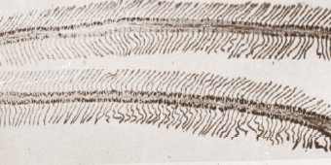

(i)      Explain how the structure of the gill makes oxygen uptake efficient.

.............................................................................................................

.............................................................................................................

.............................................................................................................

.............................................................................................................

**(2)**

(ii)     Water containing dissolved oxygen flows over the gill in the opposite direction to the blood flow inside. Explain why this arrangement is important for efficient oxygen uptake.

.............................................................................................................

.............................................................................................................

.............................................................................................................

.............................................................................................................

**(2)**

(b)     There is a one-way flow of water over the gills of a fish whereas there is a two-way flow of air in the lungs of a mammal. Suggest **one** advantage to a fish of this one-way flow of water over its gills.

......................................................................................................................

......................................................................................................................

**(1)**

**(Total 5 marks)**

**Q4.**          The electron micrograph shows a section through a fish gill. The directions of flow of water and of blood are indicated by arrows.

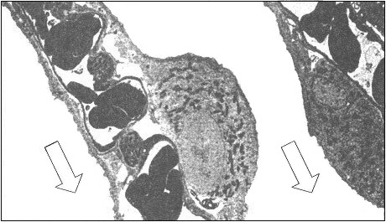

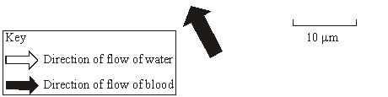

Source: www.ucdavis.edu/mjguinan

(a)     Calculate the minimum distance that a molecule of oxygen would have to travel from the water to a red blood cell. Give your answer in micrometres and show your working.

Answer .......................................... µm.

**(2)**

(b)     Explain how the relationship between the direction of flow of water and of blood shown in the micrograph is useful to a fish.

......................................................................................................................

......................................................................................................................

......................................................................................................................

......................................................................................................................

......................................................................................................................

......................................................................................................................

**(3)**

**(Total 5 marks)**

**Q5.**          (a)     Describe the features of fish gills that give them a large surface area.

......................................................................................................................

......................................................................................................................

......................................................................................................................

......................................................................................................................

**(2)**

The graph shows the relationship between gill surface area and body mass for three species of fish.

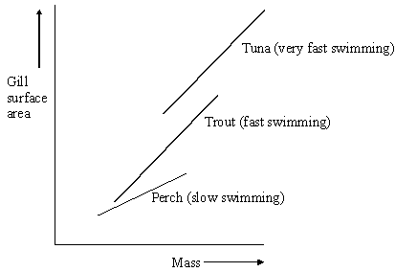

(b)     (i)      Describe the relationships between gill surface area, mass and swimming speed shown in the diagram.

.............................................................................................................

.............................................................................................................

**(1)**

(ii)     Explain the relationship between gill surface area and swimming speed.

.............................................................................................................

.............................................................................................................

.............................................................................................................

.............................................................................................................

**(2)**

**(Total 5 marks)**

**Q6.**          (a)     The diagram represents the flow of water and blood through the gills of a fish. The figures give relative oxygen concentrations.

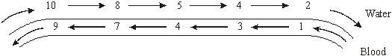

Use the information in diagram to explain the advantage of the countercurrent flow.

......................................................................................................................

......................................................................................................................

......................................................................................................................

......................................................................................................................

......................................................................................................................

**(2)**

(b)     In the ventilation cycle of a fish, water enters the mouth cavity and then passes through the gills into the opercular cavity. The graph shows the difference in pressure between the mouth cavity and the opercular cavity.

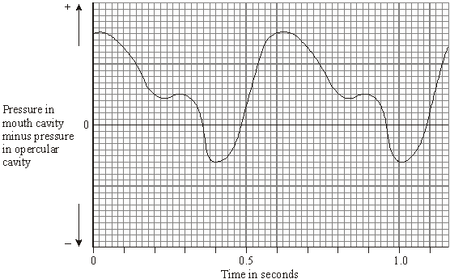

Calculate the number of ventilation cycles per minute of the fish. Show your working.

**(2)**

**M1.**          (a)     exchange / diffusion across body surface / skin;  
short diffusion pathway / distance / large SA:V ratio;

**2**

(b)     large numbers of lamellae so large SA;  
lamellae thin so short (diffusion) pathway to blood / capillaries;  
high rate of oxygen uptake for respiration / energy release;

*(accept more oxygen)*

**3**

**[5]**

**M2.**          (a)     1. mouth opens, operculum / opercular valve shuts;  
2. floor of mouth lowered;  
3. water enters due to decreased pressure / increased volume;  
4. mouth closes, operculum / opercular valve opens;  
5. floor raised results in increased pressure / decreased volume;  
6. high / increased pressure forces / pushes water over gills;

**4 max**

(b)     1. alveoli provide a large surface area;  
2. walls of alveoli thin to provide a short diffusion pathway;  
3. walls of capillary thin / close to alveoli provides  
    a short diffusion pathway;  
4. walls (of capillaries / alveoli) have flattened cells;  
5. cell membrane permeable to gases;  
6. many blood capillaries provide a large surface area;  
7. intercostal / chest muscles / diaphragm muscles / to ventilate lungs /   
    maintain a diffusion / concentration gradient;  
8. wide trachea / branching of bronchi / bronchioles for efficient  
    flow of air;  
9. cartilage rings keep airways open;  
    (*reject moist and thin membranes*)

**6 max**

**[10]**

**M3.**          (a)     (i)      one feature;

then linked Explanation;

(many) filaments / lamellae / secondary lamellae;

so large surface area;

large number of capillaries; (NOT “good blood supply”)

maintains a diffusion gradient / removes oxygen;

thin epithelium / lamellae wall;

short diffusion pathway;

**2**

(ii)     maintains diffusion / concentration gradient / equilibrium  
not reached;

diffusion occurs across whole length (of lamellae / gill);

**2**

(b)     less energy needed / continuous flow of water or O2;

**1**

**[5]**

**M4.**          (a)     ;

= 1.25 to 1.5;

*allow 1 mark if correct working shown*

**max 2**

(b)     Maintains concentration gradient (over whole length of gill) / diffusion  
can occur over whole gill;  
More oxygen enters blood ( / more CO2 leaves);  
More (aerobic) respiration / more energy release in muscle / for  
swimming; *‘more’ needed ONCE only*

**3**

**[5]**

**M5.**          (a)     (gills have) lamellae on filaments;  
lots of both;

**2**

(b)     (i)      all 3 go up;

*Accept converse*

**1**

(ii)     more oxygen can be supplied;  
for more respiration;

*Accept answer relating to CO2*

**2**

**[5]**

**M6.**          (a)     (diffusion) gradient will be maintained all the way along the gill / the amount of oxygen in the water is always higher than in the blood / the numbers in the water are always higher than in the blood;  
more oxygen will diffuse into the blood;

**2**

(b)     100 cycles per minute;

*(principle of 60 / x or 0.6 seen gains one mark)*

**2**

**[4]**

**E1.**          (a)     Many candidates scored one mark most commonly for recognition of the short diffusion pathway, which was often related to the SA:V ratio. Surprisingly few answers then went on to relate this to exchange occurring across the body surface.

(b)     Again, only the very weakest candidates failed to gain the surface area mark, usually omitting to link the increased surface area to number of lamellae present. Only the better candidates explained fully the short diffusion pathway in relation to the blood capillaries. Poor expression with reference to respiration and ‘synthesising energy’ appeared in a number of weaker answers.

**E2.**          (a)     There was a large range of answers to this question., including some excellent, detailed descriptions, which achieved full marks. A frequent mistake was to misinterpret the question and give a detailed but irrelevant explanation of the counterflow mechanism. Some candidates were unclear about the structure of the gills and produced confused accounts of the roles and functions of the buccal cavity and operculum. Some clearly did not understand the principle of ventilation at all.

(b)     Answers to this question proved disappointing. Many candidates understood the basic structure and function of the lungs but did not produce detailed accounts, using appropriate AS terminology. Answers tended to concentrate on surface area of alveoli and short diffusion pathways, or to give detailed descriptions of lung structure and the mechanism of breathing, without linking this to the uptake of oxygen.

**E3.**          The quality of the answers here were very centre-specific.

(a)     Candidates frequently scored high marks in part (i), but some candidates failed to mention a specific feature. The most common answer was that filaments or lamellae increased the surface area. In part (ii), the idea of maintaining the gradient was often recognised, but not over the whole length of the gill.

(b)     There was only an occasional reference to energy or that there would be a continuous flow. There were many vague answers to ‘it being less efficient’.

**E4.**          (a)     Most candidates were unable to choose the minimum distance to measure on the photograph between the water and a red blood cell in the fish gill. Calculations based on an incorrect initial measurement still gained some credit.

(b)     While most were able to write at length about how counterflow maintained the oxygen concentration gradient, only some went on to point out that the benefit to the fish was that it would obtain more oxygen from the water and hardly any explained that the extra oxygen would be useful to a fish since it would result in a higher rate of respiration.

**E5.**          (a)     Despite the straightforward nature of this question very few candidates scored both of the marks available. Clearly candidates had limited knowledge of the basic structure of fish gills. Over 50% of the responses referred to lamellae and gill plates as the two principal structures rather than describing the presence of lamellae on filaments.

(b)     This part was well answered and better candidates often implied causation in their responses, with statements such as “as gill surface area increases, so do mass and swimming speed”.

Most of the better candidates scored both marks here. Less able candidates often failed to give an explanation of what the increased oxygen uptake was for.

**E6.**          There were mixed responses to this question on ventilation in fish.

(a)     Few candidates gained full marks. Many of them simply stated that the diffusion gradient was maintained, or failed to appreciate that the fish obtain more oxygen.

(b)     Many candidates gained two marks for the number of ventilation cycles in a minute. The most common mistake was 2 cycles per minute.