**Q1.**Environmental factors can affect the density of stomata in the lower epidermis of leaves of plants of the same species.

Scientists investigated how growing plants at different temperatures affected the density of stomata in the lower epidermis of leaves. They grew plants of the same species from seeds.

Their method is outlined below.

•        They took 8 trays containing soil and planted 50 seeds in each tray.

•        They put each tray in a controlled environment at a different temperature.

•        When the plants had grown from the seeds, they selected 20 fully grown leaves from the plants in each tray.

•        They determined the mean number of stomata per mm2 in the lower epidermis for each group of leaves.

Their results are shown in the graph.

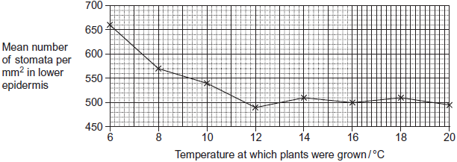

(a)     Give **three** environmental variables, other than temperature, that the scientists would have controlled when growing the plants.

1 .....................................................................................................................

2 .....................................................................................................................

3 .....................................................................................................................

**(3)**

(b)     The scientists used a range of temperatures from 6 to 20 °C.  
Using their data, explain why they did not use temperatures above 20 °C.

........................................................................................................................

........................................................................................................................

........................................................................................................................

**(1)**

(c)     The scientists only selected fully grown leaves from the plants.

Suggest why.

........................................................................................................................

........................................................................................................................

........................................................................................................................

**(1)**

(d)     The plants grown at higher temperatures had a lower number of stomata per mm2.  
This would be an advantage to the plant because the transpiration rate increases as the temperature increases.Explain why the transpiration rate increases when the temperature increases.

........................................................................................................................

........................................................................................................................

........................................................................................................................

........................................................................................................................

........................................................................................................................

**(2)**

**(Total 7 marks)**

**Q2.**          (a)     The table shows the transpiration rate of a group of plants exposed to different humidities at a temperature of 25°C.

|  |  |
| --- | --- |
| **Humidity / %** | **Transpiration rate / arbitrary units** |
| 20 | 26.0 |
| 40 | 21.0 |
| 50 | 16.5 |
| 60 | 11.0 |
| 70 | 9.5 |

Describe and explain the relationship between humidity and transpiration rate.

......................................................................................................................

......................................................................................................................

......................................................................................................................

......................................................................................................................

......................................................................................................................

......................................................................................................................

**(3)**

(b)     The diagrams show a section through a typical leaf and a section through a leaf from a xerophytic plant. The xerophytic leaf has a lower transpiration rate than the typical leaf.

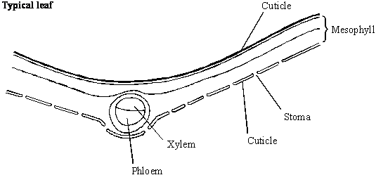

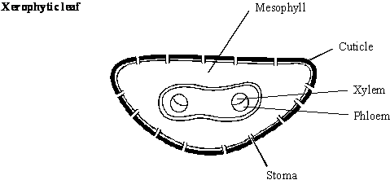

Describe **two** features shown in the diagram of the xerophytic leaf which reduce transpiration rate. Explain how each of these features contributes to a lower transpiration rate.

Feature 1 ......................................................................................................

Explanation ...................................................................................................

......................................................................................................................

Feature 2 ......................................................................................................

Explanation ...................................................................................................

......................................................................................................................

**(4)**

**(Total 7 marks)**

**Q3.**          (a)     Describe how water is moved through a plant according to the *cohesion-tension* hypothesis.

......................................................................................................................

......................................................................................................................

......................................................................................................................

......................................................................................................................

......................................................................................................................

......................................................................................................................

......................................................................................................................

......................................................................................................................

**(4)**

(b)     The mass of water lost from a plant was investigated. The same plant was used in every treatment and the plant was subjected to identical environmental conditions. In some treatments, the leaves were coated with a type of grease. This grease provides a waterproof barrier. The results of the investigation are given in the table.

|  |  |
| --- | --- |
| **Treatment** | **Mass lost in 5 days / g** |
| No grease applied | 10.0 |
| Grease applied only to the upper surface of every leaf | 8.7 |
| Grease applied to both surfaces of every leaf | 0.1 |

(i)      What is the advantage of using the same plant in every treatment?

.............................................................................................................

.............................................................................................................

**(1)**

(ii)     Why was it important to keep the environmental conditions constant?

.............................................................................................................

.............................................................................................................

**(1)**

(iii)     What is the evidence that the grease provides a waterproof barrier?

.............................................................................................................

.............................................................................................................

**(1)**

(c)     (i)      Calculate the mass of water lost in 5 days through the upper surface of the leaves.

Answer ................................................................

**(1)**

(ii)     Use your knowledge of leaf structure to explain why less water is lost through the upper surface of leaves than is lost through the lower surface.

.............................................................................................................

.............................................................................................................

.............................................................................................................

.............................................................................................................

**(2)**

**(Total 10 marks)**

**Q4.**          (a)     Explain how xylem tissue is adapted for its function.

......................................................................................................................

......................................................................................................................

......................................................................................................................

......................................................................................................................

......................................................................................................................

......................................................................................................................

......................................................................................................................

......................................................................................................................

**(4)**

(b)     The graph shows the flow rate in the xylem in the trunk of a tree.

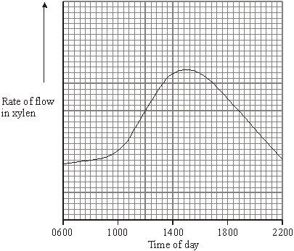

(i)      Explain the increase in the flow rate between 1000 and 1400 hours.

.............................................................................................................

.............................................................................................................

.............................................................................................................

.............................................................................................................

**(2)**

(ii)     The diameter of the trunk decreased during the same period, reaching its minimum when the flow rate was highest. Use your knowledge of the cohesion-tension theory to suggest an explanation for this decrease.

.............................................................................................................

.............................................................................................................

.............................................................................................................

.............................................................................................................

**(2)**

**(Total 8 marks)**

**Q5.**Students investigated the effect of removing leaves from a plant shoot on the rate of water uptake. Each student set up a potometer with a shoot that had eight leaves. All the shoots came from the same plant. The potometer they used is shown in the diagram.

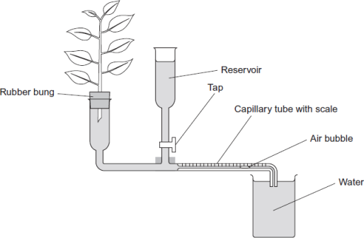

(a)     Describe how the students would have returned the air bubble to the start of the capillary tube in this investigation.

........................................................................................................................

........................................................................................................................

........................................................................................................................

**(1)**

(b)     Give **two** precautions the students should have taken when setting up the potometer to obtain reliable measurements of water uptake by the plant shoot.

1......................................................................................................................

2......................................................................................................................

**(2)**

(c)     A potometer measures the rate of water uptake rather than the rate of transpiration. Give **two** reasons why the potometer does **not** truly measure the rate of transpiration.

1......................................................................................................................

2......................................................................................................................

**(2)**

(d)     The students’ results are shown in the table.

|  |  |  |
| --- | --- | --- |
|  | **Number of leaves removed from the plant shoot** | **Mean rate of water uptake /  cm3 per minute** |
|  | 0 | 0.10 |
|  | 2 | 0.08 |
|  | 4 | 0.04 |
|  | 6 | 0.02 |
|  | 8 | 0.01 |

Explain the relationship between the number of leaves removed from the plant shoot and the mean rate of water uptake.

........................................................................................................................

........................................................................................................................

........................................................................................................................

........................................................................................................................

........................................................................................................................

........................................................................................................................

*(Extra space)*..................................................................................................

........................................................................................................................

........................................................................................................................

**(3)**

**(Total 8 marks)**

**Q6.**(a)     Describe the mass flow hypothesis for the mechanism of translocation in plants.

........................................................................................................................

........................................................................................................................

........................................................................................................................

........................................................................................................................

........................................................................................................................

........................................................................................................................

........................................................................................................................

........................................................................................................................

*(Extra space)* ................................................................................................

........................................................................................................................

**(4)**

Scientists measured translocation in the phloem of trees. They used carbon dioxide labelled with radioactive 14C.

They put a large, clear plastic bag over the leaves and branches of each tree and added 14CO2. The main trunk of the tree was not in the plastic bag.

At regular intervals after adding the 14CO2 to the bag, the scientists measured the amount of 14CO2 released from the top and bottom of the main trunk of the tree. On the surface of the trunk of these trees, there are pores for gas exchange.

The following figure shows the scientists’ results.

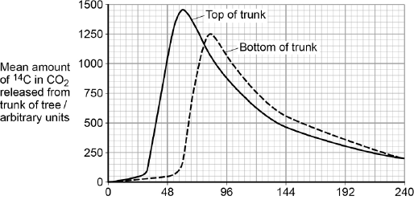  
                               Time after 14C labelled CO2 given / hours

(b)     Name the process that produced the 14CO2 released from the trunk.

........................................................................................................................

**(1)**

(c)     How long did it take the 14C label to get from the top of the trunk to the bottom of the trunk? Explain how you reached your answer.

........................................................................................................................

........................................................................................................................

........................................................................................................................

........................................................................................................................

**(2)**

(d)     What other information is required in order to calculate the mean rate of movement of the 14C down the trunk?

........................................................................................................................

........................................................................................................................

**(1)**

**(Total 8 marks)**

**M1.**(a)     Any **three** from:

1.      Light;

2.      Carbon dioxide;

3.      Type of soil;

4.      Minerals / nutrients;

*Accept named example*

5.      Water (in soil);

6.      Humidity (of air);

7.      pH (of soil)

8.      Planting density;

*Idea of equally spaced*

**3 max**

(b)     Already levelled out (before 20 °C);

**1**

(c)     Young leaves (may) have different number of stomata (per mm2) / number of stomata (per mm2) changes during development (of leaf);

*Accept reference to density of stomata*

**1**

(d)     Any **two** from:

*Points 1 and 2 need context of ‘more’*

1.      Molecules have more kinetic energy;

*Accept KE*

2.      Faster diffusion of water / more evaporation of water (as temperature increases in leaf);

*For this point, diffusion must relate to movement of water*

3.      For this point, diffusion must relate to movement of water

**2 max**

**[7]**

**M2.**          (a)     increased humidity leads to decreased transpiration;  
high humidity means more water in the air / increased saturation /   
increased water potential;  
reduced diffusion gradient / water potential gradient;  
slower rate of water loss / less evaporation;

**3 max**

(b)     thick cuticle;   
impermeable to water / waterproof;

sunken stomata;   
reduces water diffusion gradient;

shape of leaf / rounded / small surface area;  
small surface area : volume ratio;

*(explanation must be linked to feature)*

**4 max**

**[7]**

**M3.**          (a)     1. water evaporates / transpires from leaves;  
2. reduces water potential in cell / water potential / osmotic gradient across  
    cells *(ignore reference to air space)*;  
3. water is drawn out of xylem;  
4. creates tension *(accept negative pressure, not reduced pressure)*;  
5. cohesive forces between water molecules;  
6. water pulled up as a column;

**4 max**

(b)     (i)      same surface area of leaf / number of leaves / age / thickness of  
cuticle;

**1**

(ii)     (environmental conditions) affect rate of transpiration / evaporation;

**1**

(iii)     presence of grease reduces water loss;

**1**

(c)     (i)      1.2 / 1.3g;

**1**

(ii)     more stomata on the lower surface;  
(thicker) waxy cuticle on the upper surface;

**2**

**[10]**

**M4.**          (a)     long cells / tubes with no end walls;

continuous water columns;

no cytoplasm / no organelles / named organelle;

to impede / obstruct flow / allows easier water flow;

thickening / lignin;

support / withstand tension / waterproof / keeps water in cells;

pits in walls;

allow lateral movement / get round blocked vessels;

**4 max**

(b)     (i)      increase in transpiration rate / evaporation due to  
increase in temperature ;

increased (kinetic) energy of water molecules;

*OR*

increase in light (intensity) increases transpiration rate / evaporation;

greater stomatal aperture / more stomata open so increase in flow  
rate due to cohesion / attraction of water molecules;

**2 max**

(ii)     adhesion / attraction of water molecules to walls of xylem;

results in tension as water pulled up stem;

pulling in walls;

**2**

**[8]**

**M5.**(a)     Open / use tap / add water from reservoir;

**1**

(b)     1.      Seal joints / ensure airtight / ensure watertight;

*Answer must refer to precautions when setting up the apparatus*

*Ignore: references to keeping other factors constant*

2.      Cut shoot under water;

3.      Cut shoot at a slant;

4.      Dry off leaves;

5.      Insert into apparatus under water;

6.      Ensure no air bubbles are present;

7.      Shut tap;

8.      Note where bubble is at start / move bubble to the start position;

**2 max**

(c)     1.      Water used for support / turgidity;

*Accept: water used in (the cell’s) hydrolysis or condensation (reactions) for one mark. Allow a named example of these reactions*

2.      Water used in photosynthesis;

3.      Water produced in respiration;

4.      Apparatus not sealed / ‘leaks’;

**2 max**

(d)     As number of leaves are reduced (no mark),

*Accept: converse arguments*

1.      Less surface area / fewer stomata;

3.      Less evaporation / transpiration;

4.      Less cohesion / tension / pulling (force);

**3**

**[8]**

**M6.**(a)     1.      In source / leaf sugars actively transported into phloem;

2.      By companion cells;

3.      Lowers water potential of sieve cell / tube and water enters by osmosis;

4.      Increase in pressure causes mass movement (towards sink / root);

5.      Sugars used / converted in root for respiration for storage;

*Accept starch*

**4 max**

(b)     Respiration;

**1**

(c)     1.      (About) 30 hours;

2.      Time between peak 14C at top of trunk and bottom;

**2**

(d)     Length of trunk (between top and bottom);

**1**

**[8]**