**Q1.**          The drawings show two dogwhelks taken from two different populations. Dogwhelk **A** came from a sheltered shore and dogwhelk **B** from a shore exposed to heavy wave action. The dogwhelks attach themselves to rocks with a muscular foot which comes out through the aperture. The shell length : aperture length ratios (L/A) were calculated. The mean and standard deviation for each population are shown under the drawings.

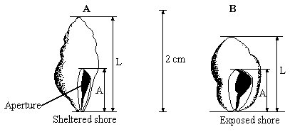

         mean L/A ratio          = 1.91                       mean L/A ratio          = 1.78  
standard deviation    = 0.19                       standard deviation    = 0.10

(a)     Describe how you would collect a random sample of each population.

......................................................................................................................

......................................................................................................................

......................................................................................................................

......................................................................................................................

......................................................................................................................

......................................................................................................................

**(3)**

(b)     What do the standard deviations tell you about the two populations of dogwhelks?

......................................................................................................................

......................................................................................................................

......................................................................................................................

......................................................................................................................

**(2)**

(c)     Suggest how the effect of wave action on the two populations of dogwhelks could result in differences between

(i)      the mean L/A ratios;

......................................................................................................................

......................................................................................................................

......................................................................................................................

......................................................................................................................

(ii)     the standard deviations.

......................................................................................................................

......................................................................................................................

......................................................................................................................

......................................................................................................................

**(4)**

**(Total 9 marks)**

**Q2.**          Some birds feed on animals found in mud in estuaries. The drawing shows the heads of three species of these birds and their prey.

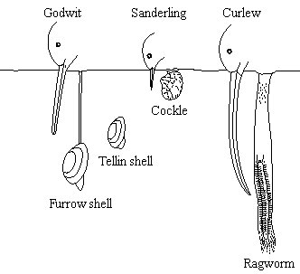

(a)     Use the information in the drawing to explain how interspecific competition between the birds is reduced.

......................................................................................................................

......................................................................................................................

......................................................................................................................

......................................................................................................................

......................................................................................................................

**(2)**

(b)     Explain how competition might have played a part in the evolution of the long curved beak of the curlew.

......................................................................................................................

......................................................................................................................

......................................................................................................................

......................................................................................................................

......................................................................................................................

......................................................................................................................

......................................................................................................................

......................................................................................................................

**(4)**

(c)     Mud higher up the shore receives fresh water draining from the land. Ragworms are able to survive in this mud because they can tolerate the absorption of water into their tissues. Explain what causes a ragworm to absorb water when higher up the shore.

......................................................................................................................

......................................................................................................................

......................................................................................................................

......................................................................................................................

**(2)**

**(Total 8 marks)**

**Q3.**          Zooplankton are very small animals which feed on algae (green protoctists) found in lakes. The chart shows the mean depth of zooplankton populations in four lakes, **P** to **S**, during the day and the night. It also shows the standard deviations of the means. The depth at which the light intensity is 1% of the surface light intensity is also shown.

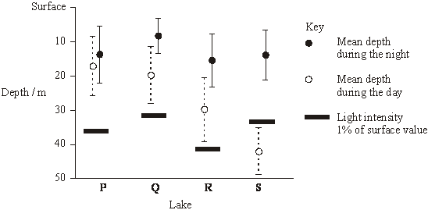

**S**       (a)     Explain the evidence that the zooplankton feed at night.

......................................................................................................................

......................................................................................................................

......................................................................................................................

......................................................................................................................

**(3)**

(b)     Predatory fish, which hunt by sight, are present in some of the lakes. These fish have been present in the lakes for different lengths of time.

|  |  |
| --- | --- |
| **Lake** | **Estimated length of time predatory fish have been present / years** |
| **P** | 0 |
| **Q** | 5 |
| **R** | 25 |
| **S** | Over 1000 |

(i)      Describe the relationship between the depth of the zooplankton during the day and the length of time predators have been present in the lake.

.............................................................................................................

.............................................................................................................

**(1)**

**S**       (ii)     Suggest how the differences in behaviour of the zooplankton populations in the four lakes might have evolved.

.............................................................................................................

.............................................................................................................

.............................................................................................................

.............................................................................................................

.............................................................................................................

.............................................................................................................

**(3)**

**(Total 7 marks)**

**Q4.**          The graph shows the variation in length of 86 Atlantic salmon.

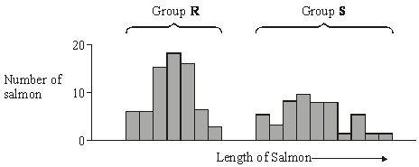

(a)     Give **two** possible causes of this variation that result from meiosis during gamete formation.

1 ...................................................................................................................

......................................................................................................................

2 ...................................................................................................................

......................................................................................................................

**(2)**

(b)     When comparing variation in size between two groups of organisms, it is often considered more useful to compare standard deviations rather than ranges. Explain why.

......................................................................................................................

......................................................................................................................

......................................................................................................................

......................................................................................................................

**(2)**

**(Total 4 marks)**

**Q5.**          Finches are small birds. Fourteen species of finch are found on the Galapagos Islands.

(a)     What is a species?

......................................................................................................................

......................................................................................................................

......................................................................................................................

......................................................................................................................

**(2)**

(b)     Measurements were made of the beak depth of two species of finch (species **A** and species **B**) on different islands. Species **A** is found on island 1, species **B** is found on island 2. Both species are found on island 3. They are thought to have colonised island 3 from islands 1 and 2 respectively. The graphs show the ranges of beak depths of the two species on the different islands.

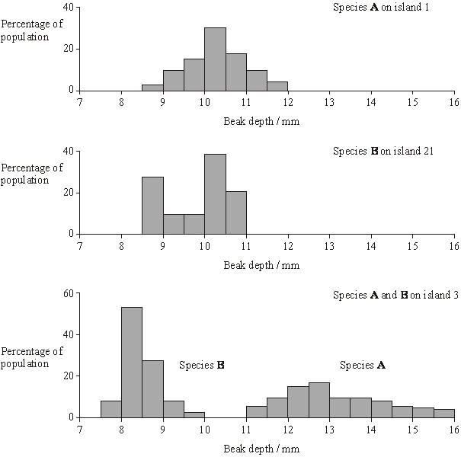

What type of natural selection took place in the populations of both species after they had colonised island 3? Explain your answer.

......................................................................................................................

......................................................................................................................

......................................................................................................................

......................................................................................................................

......................................................................................................................

**(3)**

**(Total 5 marks)**

**Q6.**          (a)     What information is required to calculate an index of diversity for a particular community?

......................................................................................................................

......................................................................................................................

......................................................................................................................

**(1)**

(b)     Farmers clear tropical forest and grow crops instead. Explain how this causes the diversity of insects in the area to decrease.

......................................................................................................................

......................................................................................................................

......................................................................................................................

......................................................................................................................

......................................................................................................................

......................................................................................................................

**(3)**

Farmers manage the ditches that drain water from their fields. If they do not, the ditches will become blocked by plants. Biologists investigated the effects of two different ways of managing ditches on farmland birds.

•        Ditch **A** was cleared of plants on both banks

•        Ditch **B** was cleared of plants on one bank.

The graph shows the number of breeding birds of all species along the two ditches, before and after management.

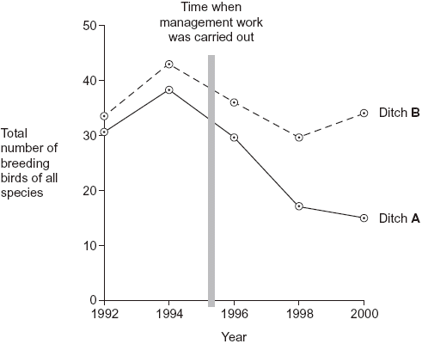

(c)     (i)      The points on the graph have been joined with straight lines rather than with a smooth curve. Explain why they have been joined with straight lines.

.............................................................................................................

.............................................................................................................

.............................................................................................................

**(1)**

(ii)     It would have been useful to have had a control ditch in this investigation. Explain why.

.............................................................................................................

.............................................................................................................

.............................................................................................................

**(1)**

(d)     A farmer who wanted to increase the diversity of birds on his land read about this investigation.

He concluded that clearing the plants from one bank would not decrease diversity as much as clearing the plants from both banks. Evaluate this conclusion.

......................................................................................................................

......................................................................................................................

......................................................................................................................

......................................................................................................................

......................................................................................................................

......................................................................................................................

**(3)**

**(Total 9 marks)**

**Q7.**          Costa Rica is a Central American country. It has a high level of species diversity.

(a)     There are over 12 000 species of plants in Costa Rica. Explain how this has resulted in a high species diversity of animals.

......................................................................................................................

......................................................................................................................

......................................................................................................................

......................................................................................................................

......................................................................................................................

**(2)**

(b)The number of species present is one way to measure biodiversity. Explain why an index of diversity may be a more useful measure of biodiversity.

......................................................................................................................

......................................................................................................................

......................................................................................................................

......................................................................................................................

......................................................................................................................

**(2)**

(c)     Crops grown in Costa Rica are sprayed with pesticides. Pesticides are substances that kill pests. Scientists think that pollution of water by pesticides has reduced the number of species of frog.

(i)Frogs lay their eggs in pools of water. These eggs are small. Use this information to explain why frogs’ eggs are very likely to be affected by pesticides in the water.

.............................................................................................................

.............................................................................................................

.............................................................................................................

.............................................................................................................

.............................................................................................................

**(2)**

(ii)An increase in temperature leads to evaporation of water. Suggest how evaporation may increase the effect of pesticides on frogs’ eggs.

.............................................................................................................

.............................................................................................................

**(1)**

**(Total 7 marks)**

**Q8.**(a)     A student investigated the diversity of plants at several sites on a golf course. At each site she took a large number of random samples.

(i)      Explain the importance of taking a large number of samples at each site.

...............................................................................................................

...............................................................................................................

...............................................................................................................

**(1)**

(ii)     Explain the importance of taking samples at random.

...............................................................................................................

...............................................................................................................

...............................................................................................................

**(1)**

The student collected data from one part of the golf course and calculated an index of diversity.

The table shows her data.

|  |  |  |
| --- | --- | --- |
|  | **Species** | **Number of plants per m2** |
|  | Sheep’s fescue | 11 |
|  | Creeping buttercup | 6 |
|  | Clover | 5 |
|  | Dandelion | 2 |
|  | Sheep’s sorrel | 1 |
|  | Lady’s bedstraw | 7 |
|  | Stemless thistle | 4 |

The index of diversity can be calculated from the formula



where

*d*  =  index of diversity  
*N*  = total number of organisms of all species  
*n*  =  total number of organisms of each species

(b)     Use the formula to calculate the index of diversity for the plants on this part of the golf course. Show your working.

                                             Answer .....................................................

**(2)**

(c)     The golf course was surrounded by undeveloped grassland from which it had been produced.  
The golf course had

•        some areas of very short grass which was cut frequently

•        some areas of longer grass which was cut less frequently

•        some areas of long grass and shrubs which were never cut.

The index of diversity for the insects on the golf course was higher than that for the surrounding undeveloped grassland.

Explain the effect of developing this golf course on the index of diversity of insects.

........................................................................................................................

........................................................................................................................

........................................................................................................................

........................................................................................................................

........................................................................................................................

........................................................................................................................

*(Extra space)* .................................................................................................

........................................................................................................................

........................................................................................................................

**(3)**

**Total 7 marks)**

**Q9.**(a)     Genes for antibiotic resistance can be transmitted between bacteria. **Table 1** shows features of gene transmission.

Complete **Table 1** by putting a tick in the box if the statement is correct for vertical or horizontal gene transmission.

|  |  |  |  |
| --- | --- | --- | --- |
|  | **Table 1** | | |
|  | **Statement** | **Vertical gene transmission** | **Horizontal gene transmission** |
|  | Gene is replicated |  |  |
|  | Gene can be passed to other species of bacteria |  |  |
|  | Involves conjugation |  |  |

**(2)**

(b)     (i)      The antibiotic tetracycline binds to ribosomes in bacterial cells.Explain how this causes the death of bacterial cells.

...............................................................................................................

...............................................................................................................

...............................................................................................................

...............................................................................................................

**(2)**

Scientists determined the amino acid sequences of two forms of a protein, **A** and **B**, found in two types of the same species of bacterium. They used these amino acid sequences to find the DNA base sequences that code for these proteins.

**Table 2** shows their results for the same region of proteins **A** and **B**.

**Table 3** shows DNA triplets that code for different amino acids.

|  |  |  |  |  |  |  |  |  |
| --- | --- | --- | --- | --- | --- | --- | --- | --- |
|  | **Table 2** | | | | | | | |
|  | **Protein A** | | | | | | | |
|  | Amino acid sequence | Lys | Ser | Pro | Cys | Leu | Gly | Ala |
|  | DNA base sequence | TTT | TCA | GGT | ACG | GAA | CCA | CGA |

|  |  |  |  |  |  |  |  |  |
| --- | --- | --- | --- | --- | --- | --- | --- | --- |
|  | **Protein B** | | | | | | | |
|  | Amino acid sequence | Lys | Ser | Pro | Trp | Pro | Trp | Cys |
|  | DNA base sequence | TTT | TCA | GGT |  |  |  |  |

**Table 3**

|  |  |  |
| --- | --- | --- |
|  | **Amino acid** | **DNA bases that code for this amino acid** |
|  | Trp | ACC |
|  | Pro | GGT or GGA |
|  | Cys | ACA or ACG |

The amino acid sequence of protein **B** was the result of a mutation. A single base was added within the DNA sequence coding for protein **A**.

(ii)     Use the information provided to complete the DNA base sequence that codes for protein **B**.

**(1)**

(iii)     Complete the box to show which DNA base was added.



**(1)**

(iv)     Tetracycline can enter a bacterium through protein **A**. This protein is found in the plasma membrane.

Suggest how a change in the amino acid sequence of this protein could make a bacterium resistant to tetracycline.

...............................................................................................................

...............................................................................................................

...............................................................................................................

...............................................................................................................

**(2)**

**(Total 8 marks)**

**M1.**          (a)     generation of random co-ordinates;  
use of 10 or more quadrats;  
collection of all dog whelks in quadrat;

**3**

(b)     greater variation for sheltered population / population A;  
range / spread around the mean;

*(or converse)*

**2**

(c)     (i)      smaller ratio means relatively larger foot / population B has  
relatively large foot;  
better able to grip;  
larger / longer shells have greater area exposed / are subject  
to greater force;

(ii)     wave action limits the max. L / A ratio / extremes;  
valid point about age, e.g. greater age range on sheltered  
shore / live longer on sheltered shore;

*(allow shell size marking point in either (c)(i)  
or (c)(ii) but only credit once)*

**4 max**

**[9]**

**M2.**          (a)     description of interspecific competition / competition between species / birds with beaks of different lengths;  
link length of beaks to different positions of prey / reference to named bird with particular prey e.g. curlews with longer beaks able to feed on ragworms;

**2**

(b)     variation in beak length in curlews / one species;  
longer / more curved beaked curlews outcompete / at advantage /   
suggested advantage e.g. larger / curled beaks access more food;  
reproduction;  
genes passed on (to offspring);

**4**

(c)     body has lower water potential;  
water diffuses along a water potential gradient / by osmosis;

**2**

**[8]**

**M3.**          (a)     zooplankton nearer surface at night;

algae only found at surface;

photosynthetic;

no / little light below 30 / 40m;

**3**

(b)     (i)      with increasing time predators have been present in the lake, the

greater the depth at which the zooplankton occur during the day;

**1**

(ii)     variation in migration behaviour;

vertical migration reduces chance of predation / prey can’t be seen in

low light intensity;

those that migrated more likely to reproduce;

genes / alleles (for behaviour) passed to next generation;

increase in frequency of gene / allele in population;

**3 max**

**[7]**

**M4.**          (a)     (i)     Continuous variation – range of values / not discrete categories / many  
categories / no gaps;

**1**

(ii)     Crossing over / chiasmata;  
Random segregation / independent assortment;  
In meiosis I and meiosis II;

**max 2**

(b)     Range influenced by single ‘outlier’ (*accept anomaly*) /   
converse for S.D.;  
S.D. shows dispersion / spread about mean / range only shows highest  
and lowest values / extremes;  
Or  
S.D. allows statistical use;  
Tests whether or not differences are significant;

**max 2**

**[4]**

**M5.**          (a)     group of organisms with similar features;  
can (interbreed to) produce fertile offspring;

**2**

(b)     directional selection;   
*any TWO from*selection against one extreme / for one extreme;  
against broadest beaks in B and narrowest beaks  
in **A** / for narrowest in **B** and broadest in **A**;  
whole distribution / range / mean / mode / median is  
shifted towards favoured extreme;

**3 max**

**[5]**

**M6.**          (a)     Number of a / each (species);

*Accept answers expressed differently providing they convey this information.*

*Ignore extra information if it does not contradict answer.*

**1**

(b)     1.      Lower diversity of plants / few species of plants / less variety  
of plants / few plant layers;

2.      Few sources / types of food / feeding sites; / few habitats / niches;

3.      Fewer (species of) herbivore so few (species of) carnivores;

**3**

(c)     (i)      Cannot predict / do not know intermediate values;

**1**

(ii)     To see what would happen / compare with no management work / to see if numbers fell anyway / To show that it was not a factor;

*Management as a term not required. Allow explanations.*

**1**

(d)     1.      Total number of birds along ditch B / ditch with one side cleared greater than along ditch A / ditch with both sides cleared;

2.      But only gives data for all birds / does not give data for species / data not about diversity;

3.      Single ditch / single occasion / not repeated / no control;

*Principles:*

*Correct from evidence*

*Total number not diversity*

*Flaws in technique*

**3**

**[9]**

**M7.**          (a)     Greater variety / different foods;

More habitats / niches;

*Answers only referring to ‘more food’ should not be credited but allow ‘more food sources’.*

**2**

(b)     Also measures number of individuals in a species / different proportions of species;

Some species may be present in low / high numbers;

*First marking point can only be awarded if there is a reference to species.*

**2**

(c)     (i)     Large surface area to volume (ratio) / permeable / thin (outer layer); Correct reference to diffusion;

*Accept (Eggs) cannot move (out of water) for 1 mark*

**2**

(ii)     Concentration (of pesticide) is increased;

**1**

**[7]**

**M8.**(a)     (i)      Produces a more reliable mean / average / makes sure sample was representative / reduce effect of extreme values / identify anomalies;

*Ignore references to chance*

**1**

(ii)     Removes bias;

**1**

(b)     Two marks for correct answer of 5.8;

One mark for incorrect answer that clearly shows denominator as 216;

**2**

(c)     1.      Increase in variety of plants / shrubs / grass;

2.      More habitats / niches;

3.      Greater variety of food sources / more food sources;

*Answers only referring to 'more food' should not be credited*

**3**

**[7]**

**M9.**(a)

|  |  |  |  |
| --- | --- | --- | --- |
|  | **Statement** | **Vertical** | **Horizontal** |
|  | Gene is replicated | ✓ | ✓ |
|  | Gene can be passed to other species of bacteria |  | ✓ |
|  | Involves conjugation |  | ✓ |

*One mark for each correct* ***column***

**2**

(b)     (i)      1.      Prevents protein synthesis;

*Accept: ribosomes produce proteins / chains of amino acids / polypeptides*

*Reject: ribosomes produce amino acids*

2.      (So) enzymes not produced / any named process involving proteins / enzymes is inhibited;

*Accept: no (DNA) replication*

*Accept: cannot form a cell wall*

*Reject: no mitosis*

*Neutral: no growth / repair*

**2**

(ii)     **ACC GGA ACC ACG;**

**1**

(iii)    **C;**

*Accept: ‘cytosine’*

**1**

(iv)    1.      Different tertiary structure / tertiary shape;

*Neutral: 3D structure*

2.      (So tetracycline) does not fit / bind / is not complementary / does not enter / pass through (protein / into cell);

***Q*** *Reject: any reference to ‘active site’, ‘enzyme-substrate complex’ or (tetracycline) not fitting / binding to an enzyme*

*Accept: (so) more tetracycline pumped out of cell*

**2**

**[8]**