Enzymes

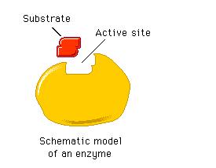

Structure

Key terminology

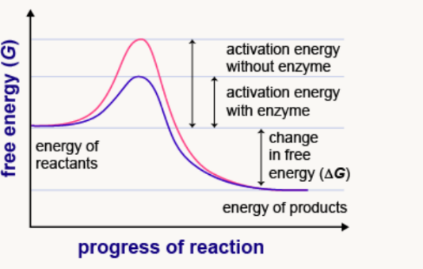

Action

Theories of action

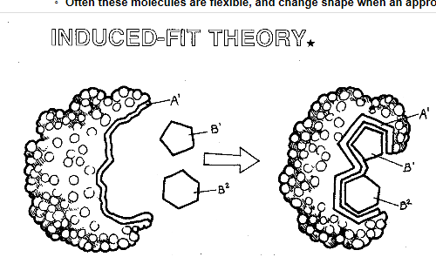

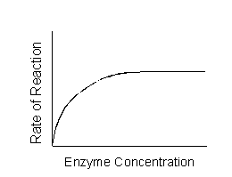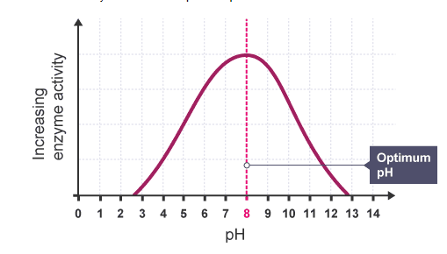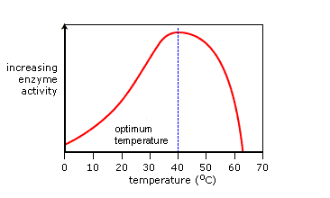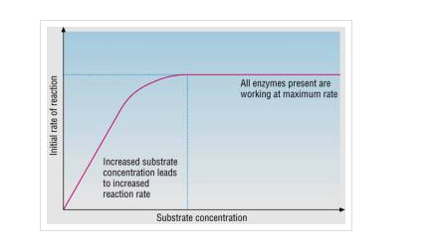The effect of substrate concentration, enzyme concentartion, pH, temperature on enzyme activity

Describe and Explain

Describe and Explain

Describe and Explain

Describe and Explain

**Temperature pH Substrate concentration Enzyme concentration**

**Action of competetive and non competetive inhibitors**

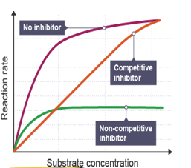**[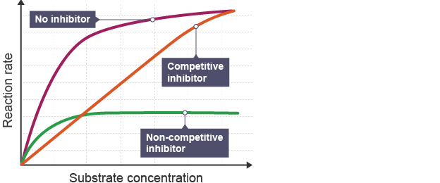](http://www.google.co.uk/url?sa=i&rct=j&q=&esrc=s&source=images&cd=&cad=rja&uact=8&ved=0ahUKEwjn_4GR69fMAhVKaRQKHUVuCRsQjRwIBw&url=http://www.bbc.co.uk/education/guides/zwnffg8/revision/3&psig=AFQjCNGPmjo5SF0jp45A9CiVMjCn8-aOww&ust=1463255818619874)**

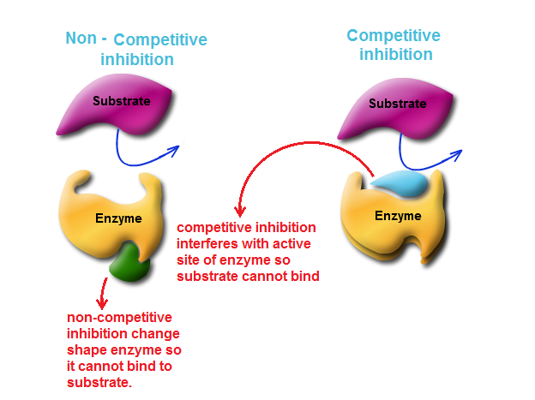

What is an enzyme control experiment?

Describe and Explain Competitive inhibition

Describe and Explain Non Competitive inhibition