19th Century glass plate photo

Painted behind to produce colour

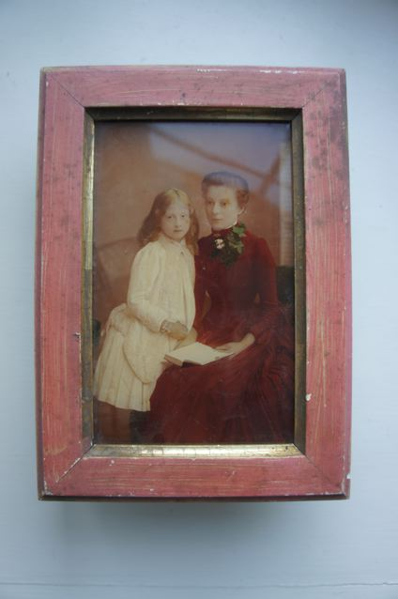

As seen from front

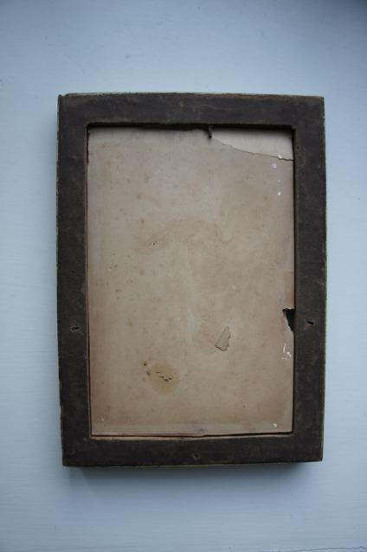

Back of frame

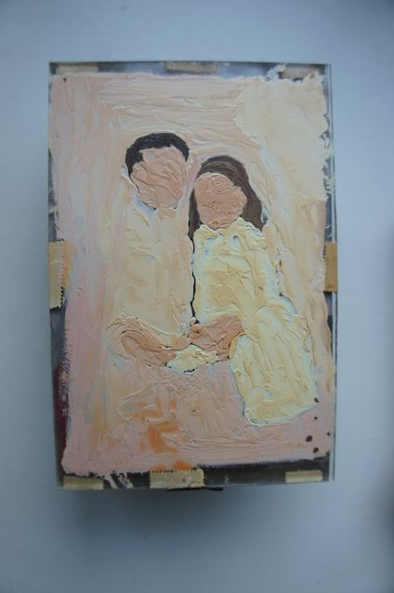

Reverse of bottom layer of glass 'underpainted'

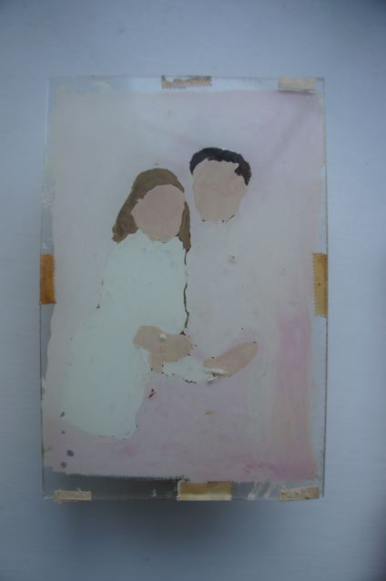

Front view of rear sheet of glass showing 'underpainting'

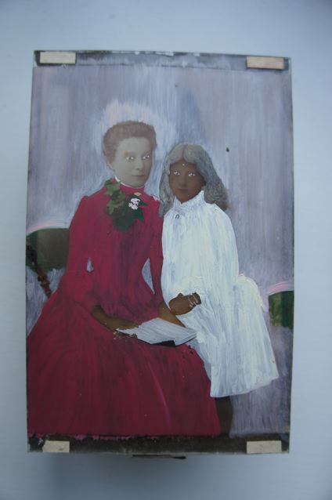

Reverse of glass plate photo with colour applied

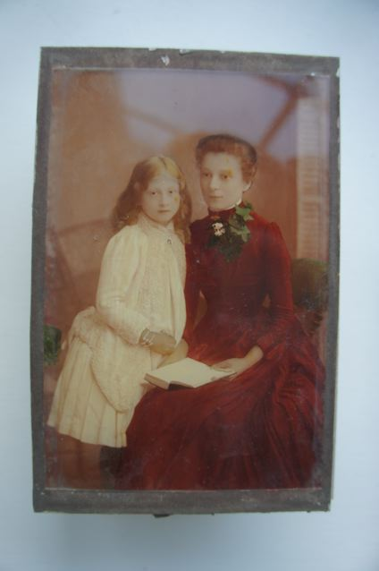

View of the layered effect seen from front