**Unit 1 – The Wars of the Roses and the Reign of Henry VII**

**Topics 1&2- The background to the Wars 1445-1450**

**& The early actions of the Duke of York 1450 - 1455**

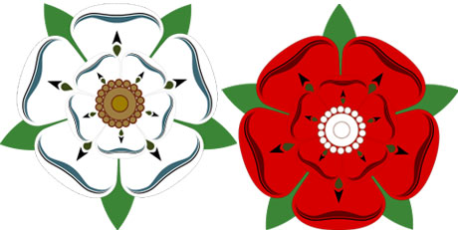

**What do I need to know**

|  |  |  |
| --- | --- | --- |
|  | The background to the Wars and Henry V | Page 5-9 |
|  | The personality and actions of Henry VI | Page 10-14 |
|  | **The impact of the ending of the Hundred Years’ War** | **Page 15- 18** |
|  | **Problems caused by government Debt, opposition to the kings council and the fall of Suffolk** | **Page 19-23** |
|  | **The background and impact of Richard, Duke of York** | **Page 24-28** |
|  | **Henrys 1st bout of Insanity and Margaret of Anjou** | **Page 29-30** |
|  | **Bastard Feudalism and the role of the Nobility** | **Page 31-35** |
|  | **Impact of the York Somerset feud and the outbreak of the wars** | **Page 36-38** |

**Exam Style questions:**

**The first part of Unit 1 are 2 source based questions. You will be given three sources and asked questions like this:**

1: Use your knowledge of the outbreak of the wars of the roses to assess how useful source C is as evidence of the cause of the 1st battle of St Albans

2 Using these three sources in their historical context assess how far they support the view that the weakness of the crown was the main reason for the outbreak of the Wars of the roses.

**Key issues which the questions might explore:**

1: How far were military defeats in France responsible for the outbreak of civil conflict in England in1455?

2: How far were local rivalries among the nobility responsible for the outbreak of civil

conflict in England in 1455?

3: How far does the weakness of royal power explain the outbreak of conflict in England in 1455?

4: To what extent was the financial weakness of the crown responsible for the outbreak of civil conflict in 1455?

5: How far were over-mighty subjects responsible for the outbreak of civil conflict in England in 1455?

**Reading list**

These texts are available in the History Department and in the ILC.

1. England 1445 – 1509 OCR textbook Lancastrians, Yorkists and Henry VII – Nicholas Fellows & Sharon Littler
2. The Wars of the Roses – Ian Dawson
3. ‘The Wars of the Roses and Henry VII: Britain 1450-1509 – Roger Turvey
4. Lancastrians and Yorkists: The Wars of the Roses – David Cook
5. The Wars of the Roses and Henry VII England 1459 – c1513 – Colin Pendrill
6. The Wars of the Roses Politics and the constitution – Christine Carpenter (this is a bit harder but very useful if you use it in sections).

**Articles**

Go on the History Today website, and search their archive. You can do this via the library link on Godalming online.

**OCR AS Mark Schemes**

**Unit 1 – British Period Study**

**Section A, Question 1 (10 marks)**

***Use your knowledge of (specified historical context) to assess how useful source (…) is as evidence of…***

|  |  |  |
| --- | --- | --- |
| **Level 1** | This answer is on the wider topic area, but not on the detail of the question. There is a very basic evaluation of the source, with very limited use of very generalised knowledge of historical context that is specified in the question, in order to engage with the source in a very limited way to attempt a very simple analysis of its utility. This analysis may primarily take the form of drawing information from the source, and it will be considered more as evidence for the wider topic area than the specific issue in the question. | **1-2** |
| **Level 2** | The answer has only limited focus on the question. There is a generalised evaluation of the source, with use of limited knowledge of the historical context that is specified in the question, in order to engage with the source and produce a basic analysis of its utility as evidence for the issue in the question | **3-4** |
| **Level 3** | The answer is partially focused on the question. There is partial evaluation of the source, with use of some knowledge of the historical context that is specified in the question, in order to engage with the source and produce a partial analysis of its utility as evidence for the issue in the question. | **5-6** |
| **Level 4** | The answer is mostly focused on the question. The source is evaluated, using both provenance and generally relevant knowledge of the historical context that is specified in the question, in order to engage with the source and produce an analysis of its utility as evidence for the issue in the question. The use of provenance may not be developed. | **7-8** |
| **Level 5** | The answer has a good focus on the question. The source is evaluated, using both provenance and relevant knowledge of the historical context that is specified in the question, in order to engage with the source and reach a supported analysis of its utility as evidence for the issue in the question. | **9-10** |

**Section A, Question 2 (20 marks)**

***How far do the three sources support the view…?***

|  |  |  |
| --- | --- | --- |
| **Level 1** | This answer is on the wider topic area, but not on the detail of the question. The sources are evaluated in a very basic way, primarily being used as a source of information with understanding of them being only partial. A very generalised knowledge of historical context is used in a very limited way to engage with the sources and to attempt a very simple analysis of them in relation to the question. | **1-4** |
| **Level 2** | The answer has only limited focus on the question. Evaluation of the sources is very general. There is limited use of generalised knowledge of historical context to engage with the sources and produce a basic analysis of them in relation to the question. | **5-8** |
| **Level 3** | The answer is partially focused on the question. There is partial evaluation of the sources, with use of some knowledge of their historical context, in order to engage with the sources and produce a partial analysis of them in relation to the question. | **9-12** |
| **Level 4** | The answer is mostly focused on the question. The sources are evaluated, using both provenance and generally relevant knowledge of their historical context, in order to engage with the sources and produce an analysis of them in relation to the question. The use of provenance may not be developed. | **13-16** |
| **Level 5** | The answer has a good focus on the question. The sources are evaluated, using both provenance and relevant knowledge of their historical context, in order to engage with the sources and reach a supported analysis of them in relation the issue in the question. There may be some imbalance in the analysis between use of provenance and use of knowledge | **17-20** |

**The Plantagenet Family Tree**

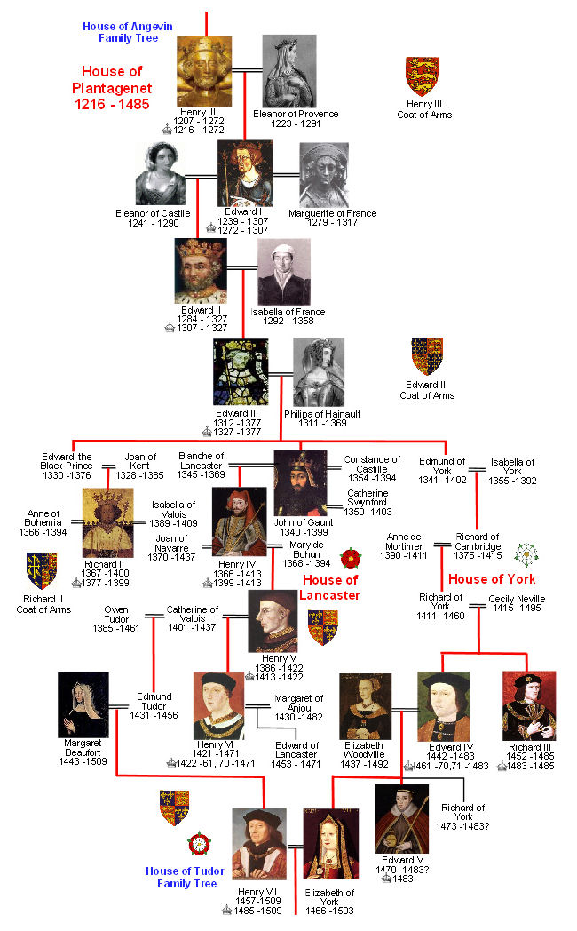

To understand how and why the Plantagenets fought amongst themselves for the crown during the Wars of the Roses it is necessary to go back to Edward III and his sons. Although none of Edward III’s sons became king, the descendants of four of them eventually became kings. In the table below, write the names of the kings descended from each son of Edward III.

|  |  |
| --- | --- |
| **Sons of Edward III** | **Kings** |
| **Edward the Black Prince** |  |
| **John of Gaunt** |  |
| **Edmund, Duke of York** |  |

**Name four Lancastrian kings.**

**Why do we call them Lancastrian?**

**Name three Yorkist kings.**

**Why do we call them Yorkist?**

**Which House, Yorkist or Lancastrian, had the strongest claim to the throne and why?**

**Find Richard Duke of York on the family tree. How strong was his claim to the throne compared to his monarch’s, Henry VI?**

**Fill in the gaps in the table below.**

|  |  |  |  |
| --- | --- | --- | --- |
| **King** | **Dates of reign** | **Length of reign** | **Yorkist or Lancastrian?** |
| Henry V | 1413-1422 |  |  |
| Henry VI | 1422-1461 |  |  |
| Edward IV | 1461-1469 |  |  |
| Henry Vl | 1470-1471 |  |  |
| Edward IV | 1471-1483 |  |  |
| Edward V | April – June 1483 |  |  |
| Richard III | 1483-1485 |  |  |
| Henry VII | 1485-1509 |  |  |

**What general trend can you identify in terms of the length of reigns from 1422 to 1485?**

**How might you explain this trend?**

**Henry V, 1413-1422**

Henry V was impressive. He seemed to have every quality expected of a monarch. He led English armies into France, won a famous victory at Agincourt in 1415 and became a national hero. He conquered half of France, married Catherine, daughter of the French king, was acknowledged as King of France by the Duke of Burgundy and became regent and heir to the French king, Charles VI. Despite the amount of time he spent in France he maintained his authority in England and the country was ruled well.

Unfortunately he died unexpectedly of dysentery in 1422 whilst still in France. He was only 34 years old and he left as his heir his 9 month old son, Henry VI.

|  |  |
| --- | --- |
| **http://uk.wrs.yahoo.com/_ylt=A0WTf2lOWK1K5vAAmSFWBQx./SIG=13eo855tn/EXP=1252960718/**http%3A/blogs.trb.com/news/politics/blog/obama%2520with%2520mic%2520jan%252018%25202008.jpgWhich characteristics and attributes do we require in our 21st century leaders?** | http://uk.wrs.yahoo.com/_ylt=A0WTf2rVWK1KmlMB_VVWBQx./SIG=12m5bn59k/EXP=1252960853/**http%3A/www.royalforestofdean.info/images/monmouthshire/Henry-V.jpg  **Which characteristics would a successful king in the fifteenth century display?** |
|  |  |
|  |  |
|  |  |
|  |  |
|  |  |

**Chivalry and Betrayal on estream start on 29 Mins (#8863)**

**1**: What were Henry V’s last instructions before dying

2: How old was Henry VI when he became king in 1522

3: Who took control to act for Henry

4: Who was Joan of Arc?

5: How did Bedford respond to the correlation of the Dauphin as Charles VII

6: What happened to Joan of Arc

7: Why was it getting harder to hold France in the 1430s

8: What happened to Bedford in September 1435

9: What soon became apparent about the young Henry VI

10: What was Henry VI only really interested in.

11: Why did he not want to defend his realm?

12: How did he try to bring peace to France?

13: What did he give away in the Truce of Tours

14: What did Charles Capture in 1450 after the English defeat at the battle of Formigny

15: What was the reaction in England.

16: Where did the English make their last stand.

**How was England governed in 1445: Read P 8, 9 & 10 and fill out the roles of the different people/groups in the table below**

|  |  |
| --- | --- |
|  | **Role** |
| **The King** |  |
| **The Nobility** |  |
| **The Kings Household** |  |
| **Parliament** |  |

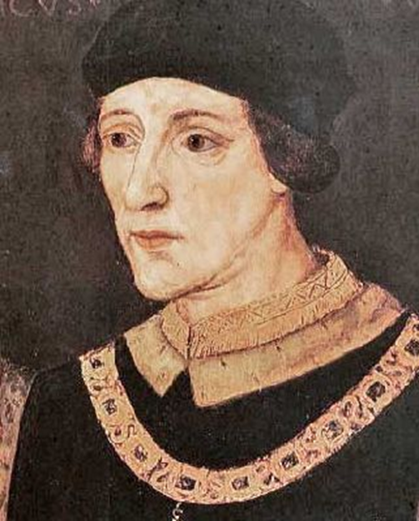**Henry VI’s mistakes**

1. Henry’s unwise distribution of patronage (land and jobs) reduced his independence and increased rivalry between his nobles - those who were in the king’s favour and those who were not.
2. Henry VI failed to maintain law and order and to settle quarrels between his nobility and in many cases his actions simply made these worse. For instance he did not resolve the tensions between the Duke of York and the Beaufort family and as these became more extreme England began the descent into civil war. The nobility came to exploit the laws for their own benefit and to take the law into their own hands because they could not rely on the king to act fairly when it came to resolving their disputes. For instance there was a great deal of enmity between Sir William Bonville and the Earl of Devon in the south west. Bonville was the steward of Cornwall but in 1441 Henry gave this position to Bonville’s enemy the Earl of Devon. This decision was bound to worsen the enmity between the two men. A further example of his inability to act fairly came in 1437 when he pardoned seven men from Devon who had blinded, mutilated and murdered a church employee. No reason was given for the pardons.
3. Henry was vindictive. His uncle and heir, Humphrey Duke of Gloucester, was opposed to the king’s policy in France – peace at any price. Gloucester was not opposed to peace but wished to negotiate from a position of strength. The king and William de la Pole, Duke of Suffolk, were behind a scandal which resulted in Gloucester’s second wife, Eleanor Cobham, being accused of witchcraft in 1441. She was arrested, found guilty and sent into exile. The marriage was annulled and although Gloucester was not implicated he was seriously discredited. Gloucester continued to oppose Henry’s policies in France especially when rumours began to circulate about the surrender of Maine. In February 1447 Parliament was summoned to Bury St Edmunds, an area where Suffolk had influence so that Gloucester could be condemned for treason. When he arrived he was arrested and five days later he was found dead. There were widespread rumours of murder. His death left Richard Duke of York as heir.
4. Henry was very pious and seemed devoted to religion. He lacked interest in government and worldly affairs. He was naïve and unrealistic. He mistook Cardinal Beaufort’s offer to lend him substantial sums of money as friendship rather than as a means to control him. By 1444, Beaufort had lent the crown various sums in excess of £200,000, only part of which had been repaid. Henry also misunderstood the seriousness of the bitter rivalry that grew between Richard Duke of York, and Edmund Beaufort, Duke of Somerset. His failure to heal the rift and pacify the two dukes contributed to the outbreak of civil war.
5. Henry was mentally weak and unfit to rule. His first mental breakdown occurred in 1453, after he received news of the loss of Gascony, and lasted until the end of 1454. His son, Prince Edward, was born during this time and he was so ill that he was not even able to acknowledge this. During this period Richard Duke of York acted as Protector because the king was catatonic.

Henry VI was an **undermighty** **monarch** who failed to control his **overmighty subjects**. York and other members of the nobility wanted greater land, wealth and power. Edmund Beaufort, Duke of Somerset; William de la Pole, Duke of Suffolk; and Humphrey, Duke of Gloucester were all competing for royal patronage and if this had been distributed fairly then this would have worked to the advantage of the king who lacked a standing army, a civil service and a police force. However, Henry’s favouritism, weakness and indecisiveness enabled some nobles to become too powerful. Henry was unable to control them and they in turn allowed their political rivalry to spill over into armed conflict.

**Henry VI’s Favourites**

The Crown’s financial problems affected relations between the nobility and led to a very tense situation. The King could no longer dispense patronage (*gifts of property, money, title or office*) lavishly to reward loyalty and good service and so there were many who felt aggrieved by this. However there were those who still seemed to be benefiting from the king’s generosity and these were his favourites like Edmund Beaufort, Duke of Somerset, Cardinal Henry Beaufort and William de la Pole, Duke of Suffolk. These favourites seemed to be doing rather well and of course this led to hatred and resentment from those who were not doing so well. Needless to say, York was not one of those who received patronage.

Opposition to the king’s favourites or ‘evil councillors’ as they came to be known soon turned into a demand for their removal. People were not willing to oppose the King but only remove those who were advising the King and were considered to be damaging the King and the country. It was this feeling which led to Cade’s rebellion in 1450.

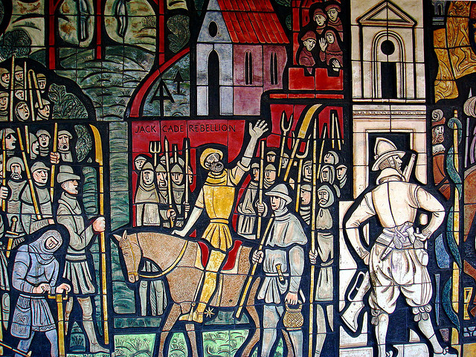

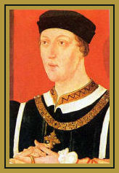**Henry Vl – His Characteristics and Failings**

Use P 6& 7 to fill in this table

|  |  |
| --- | --- |
| **Characteristics and Failings** | **Examples/Evidence** |
|  |  |
|  |  |
|  |  |
|  |  |
|  |  |
|  |  |
|  |  |
|  |  |
|  |  |
|  |  |
|  |  |

**Source Task**

**A description of king Henry VI by John Blacman. Blacman was Henry VI’s confessor and later a monk**.

He was a man simple and upright although fearing the lord god and departing from evil. He was a simple man without any crook of craft or untruth…

He was both upright and just, always keeping to the straight line of justice in his acts. Upon none would he wittingly inflict any justice. To God and the almighty he rendered most faithfully that which was his, for he took pains to pay in full the tithes and offerings due to God and the Church: and this he accompanied with devotion…

A diligent and sincere worshipper of God was this king, more given to God and to devout prayer than to handling worldly and temporal things or practising vain sports and pursuits: these he despised as trifling and was continually occupied either in prayer or the reading of the scriptures or of chronicles….

I would have you know that he was most eminent for that virtue of humility. This pious prince was not ashamed to be a diligent server to a priest celebrating his presence… He did so commonly even to me a poor priest.

**–** *John blacman’s memoir, written during the reign of Henry VII.*

1. **Use your knowledge of Henry VI to assess how useful this source is as evidence of the personal qualities of Henry VI**
2. **How far does the information in this source support the view Henry was a good king?**
3. **Blacman’s memoir was written at the time when Henry VII was trying to get Henry VI made a saint. Does this mean we can’t believe what he says?**

**The ending of the Hundred Years War, 1453**

The war in France was very costly in financial terms as well as in the damage it did to the image and prestige of the English crown. Medieval kings were expected to be warriors but this certainly did not apply to Henry VI. The loss of Henry V’s lands in France may partly explain Henry VI’s first mental breakdown in 1453. This followed news of the loss of Gascony.

Henry V had defeated the French at Agincourt in 1415 and succeeded in conquering large parts of Northern France. The Treaty of Troyes of 1420 made Henry V heir to the French throne and he married the daughter of Charles VI. Unfortunately Henry V died less than two years later and this encouraged the French to start fighting again.

During Henry VI’s minority the war was conducted with some success by his uncle, John Duke of Bedford. The English were able to contain the French and in 1431 Henry VI aged 10, travelled to Paris to be crowned King of France. He is the only king ever to have been crowned King of England and King of France.

By 1429 England ruled large parts of France (see map below)

[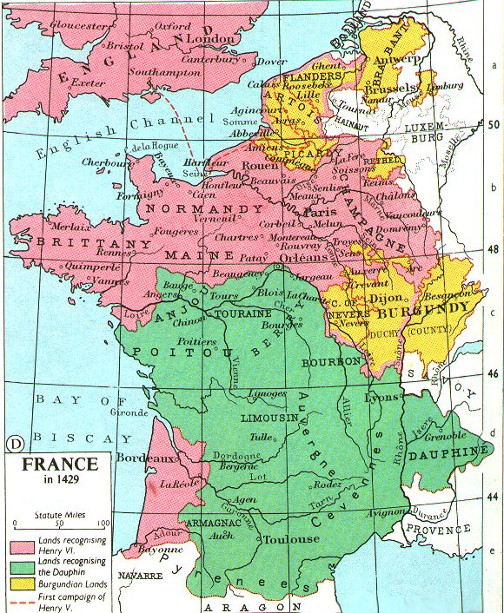](http://www.google.co.uk/url?sa=i&rct=j&q=&esrc=s&frm=1&source=images&cd=&cad=rja&docid=xd68y5rUUxSx1M&tbnid=eXKNsCY8HHDPjM:&ved=0CAUQjRw&url=http://www.awesomestories.com/assets/france-in-1429&ei=Bw0fUq7cC4Sg0QWox4HYDQ&bvm=bv.51495398,d.ZGU&psig=AFQjCNF0Up78ZEv_Ko-O0gax-ipGxODqfg&ust=1377853060843743)

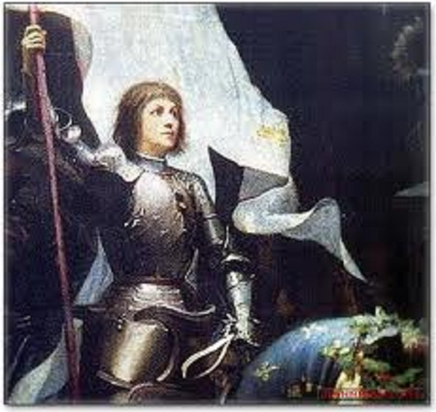However, even before the coronation, the military situation had begun to turn against the English, partly as a result of the inspirational leadership of the teenage **Joan of Arc** from 1429 and partly as a result of growing French military strength and sense of nationalism. Joan of Arc led the French to victories in 1429 and enabled Charles VII to be crowned King of France in the same year. She was captured and then burnt by the English in 1431.

The Duke of Bedford’s death in 1435 left a vacuum in the leadership of the war which the Duke of York came to fill being appointed lieutenant-general in 1440. By this point Henry VI and his closest advisors, Cardinal Beaufort for example, were determined on a policy of peace. In 1444 the Truce of Tours was agreed between the two countries. The peace was to last for 21 months and the negotiations led to the marriage of Henry VI to **Margaret of Anjou**, the niece of the French king. Her dowry was arranged at 20,000 francs but she arrived in England in 1445 for her marriage without her dowry. It was never paid and this became another source of resentment for those who opposed the policy of peace which Margaret represented and for those who were worried about the crown’s financial situation. Margaret was only 15 years old so her influence over the king at this stage was minimal.

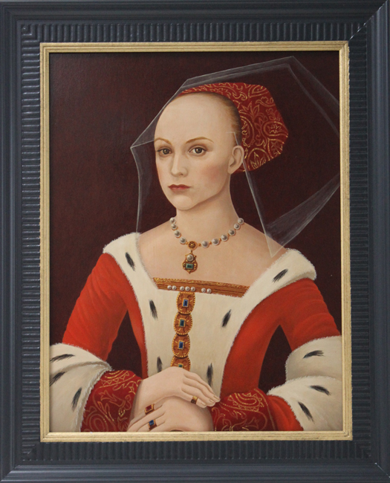However, she did symbolise the truce and Henry’s hopes for peace and she undoubtedly helped him to maintain his determination to continue this policy. Opposition was led by Humphrey Duke of Gloucester. The Duke of York was also against this policy especially when rumours began to circulate in 1445 that Henry had secretly agreed to surrender Maine to the French in order to maintain peace. This was considered by Gloucester and York as a sign of great weakness on the King’s part. The army was demoralised and refused to leave Maine until faced by a massive French army in 1448.

Probably it was the Truce of Tours and the cession (surrender) of Maine in 1448 which turned York against Henry’s principal adviser, the Duke of Suffolk. Relations deteriorated and Gloucester’s death in 1447 can only have added to York’s fears. York was recalled to England in 1445 and Henry attempted to silence him by appointing him lieutenant of Ireland in 1447. York refused to go for two years. By treating him as an enemy, Henry and his advisers were turning York into an enemy.

Henry and Suffolk restarted the war in 1449. In just sixteenth months the English were forced out of Normandy (following the Battle of Formigny in 1450) and in 1453 the English lost Gascony after the battle at Castillon. The only remaining land left to the English was Calais. This was all that was left of Henry V’s French Empire.

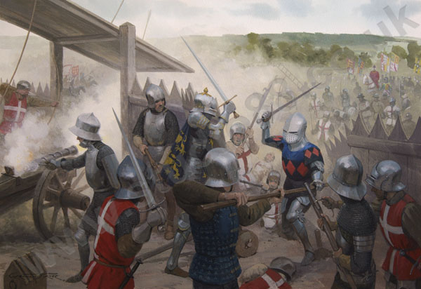

Battle of Castillon 1453

**The ending of the French Wars – an indirect cause of the Wars of the Roses**

Did defeat in France in the 1450’s lead directly to the Wars of the Roses? The answer is ‘no’ although the government of Henry VI was discredited in the eyes of his subjects. Defeat was seen as a national disgrace and there was outrage at government ineptitude. Events in France also led to a deadly feud developing between York and Beaufort which did contribute to the outbreak of the Wars of the Roses in 1455. York blamed the loss of France on his replacement as commander, Edmund Beaufort, Duke of Somerset. The situation was made worse because Somerset’s expenses whilst he was in France were repaid whilst York’s expenses amounting to over £38,000 were not.

The veterans’ return was greeted with pity and provided a reminder of government ineptitude. It was inevitable that the government would be the target of bitter criticism and, since this could not be openly aimed at the king, those councillors held responsible would suffer. For instance, at the meeting of parliament on 6th November 1449, after the Norman capital of Rouen had just surrendered, members of the Commons blamed Suffolk and demanded his immediate imprisonment.

The main responsibility for the losses in France must lie with Henry. His genuine desire for peace with France (a desire encouraged by his French wife) had led to the handing over of the province of Maine to the French king Charles Vll in 1448. From this, England gained nothing. As a direct result, the king’s counsellors were confused and his forces in France disheartened and demoralised. Somerset had the same unrealistic hopes of peace as Henry and did as little to discourage Charles Vll from the conquest of Normandy. He presided over humiliating surrender after surrender as French troops overran the traditional territories of English France.

Henry lacked to ability to foresee the wider political implications of his decisions. This is not to deny that the effective defence of English territory in France was very difficult to fund. The French were growing in military strength, confidence and an increasing sense of nationalism that would have made it very difficult for any English king to defend his land.

The fall of Normandy did not destroy the Lancastrian government, but it may well have sparked the Cade rebellion (1450) which started in Kent the area nearest to France and where the defeated soldiers landed but the government recovered and in 1451 and 1452, Henry showed unusual vigour and commitment to rule. Nevertheless within a month of the final loss of Gascony in 1453 Henry VI experienced his first mental breakdown from which he never fully recovered.

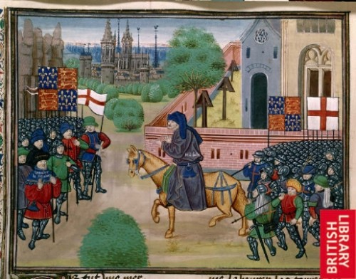

Jack Cade’s rebellion

The argument that the loss of Normandy and Gascony was a direct cause of the Wars of the Roses can be rejected. The defeat was an indirect cause in the sense that it provided the Duke of York with further justification for his attacks on Henry’s councillors and had stimulated his hatred of Somerset. In addition Henry’s weaknesses and inability to rule effectively had been clearly demonstrated.

**Questions**

1. Identify the main treaties and events of the war against France between 1422 and 1453. Make a list of these or draw a timeline.
2. In your own words write a paragraph or two to describe in detail what happened in France between 1422 and 1453.
3. Why were the English defeated? List all the reasons.
4. Add in the failings of Henry VI in France to the table on page 8.

**Questions on Wars of the Roses ‘A bloody crown’ from 13:00 (#8502)**

1 Who became prominent members of the king’s council?

2 When did Henry VI assume power?

3 Which 2 nobles were rapidly promoted by Henry?

4 What are the two different historical views on what Henry’s favourites were trying to do? (pause for time to write this down and discuss on 16:30)

5 Why did Richard Duke of York come to hate the Dukes of Somerset and Suffolk?

6: What happened to the Duke of Suffolk?

7: What was Cade’s rebellion a reaction to?

8: What were the rebels’ demands?

9: Where was Henry during the rebellion and what does it show us?

10: What was York trying to do when he returned to England?

11: Why did private wars start between the nobility?

12: Which 2 powerful families came to blows?

13: Who was born in 1453?

14: What position was York appointed to in 1454?

15: Why had the Neville family supported York?

16: What happened at the end of 1454?

17: Why did the Yorkists march on St Albans in 1455?

18: What was the result of the Battle and who died?

19: What was St Albans a battle for?

**How well did Henry manage his financial resouces?**

By 1455 the crown was virtually bankrupt. The king was unable to repay loans he had taken and the crown was losing its ability to act independently when it was in so much debt to others.

Many of the financial problems were caused by the Hundred Years War with France, war being the most expensive activity any government can be involved in. The country was prepared to pay high taxes for the war when it was successful but the failures of the 1430s, 40s and 50s led to great reluctance to contribute further war funds.

Defeat and failure in France – the loss of Normandy in 1450 and Gascony in 1453 – affected morale back in 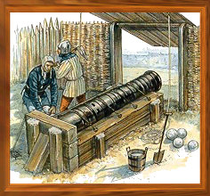England and also the incomes of a large number of noble families. When the war was being successfully fought Henry V had been able to reward his nobility with massive grants of French land and they had enjoyed the wealth which this brought. Under Henry VI these lands were lost and some of the nobility like Humphrey, Duke of Gloucester, and Richard Duke of York became increasingly disillusioned with their king who was expected to lead armies into battle and win victories.

It has been calculated that by 1450 the Crown was in serious debt owing about £370,000 (over £168 million in today’s money). Henry VI owed more than £38,000 (£17 million today) to Richard Duke of York for his services and expenses in France. York was very resentful of this especially when the Duke of Somerset’s expenses were repaid but not his own.

Additionally, the regular annual income of the crown had fallen from a high of £120,000 a year (£55 million today) in the reign of Henry IV during the early years of the fifteenth century, to as little as £45,000 (21 million today) for Henry VI. This sharp drop in income and rising level of debt were due to a number of factors:

1. A reduction in income from customs duties because of a trade depression
2. A reduction in income from Crown lands partly due to inflation and partly due to arrears in payment of rents
3. An increase in spending on the war in France
4. An increase in loans and interest payments from Italian bankers and merchants.
5. Henry continued to grant away crown lands in England which he could not afford to do (N.B. Parliament passed Acts of Resumption in 1450 and 1451 to deal with this problem).

This collapse in royal finances severely limited the authority and actions of the crown. Henry was increasingly dependent on his nobility and the growing financial potential of Parliament. Henry was unable to tax the country without the agreement of parliament and so Parliament came to be in a position where it could place conditions on the king in return for taxation – hence the Acts of Resumption.

**TASK**

1. Governments tend to be unpopular when they lack money. Give three reasons for this.

(i)

(ii)

(iii)

1. Why is war so expensive?
2. Read P 17 & 18 in the textbook and do the activity on the sources.

**Events in England leading up to the outbreak of the Wars of the Roses, 1450-1455**

1. **The Fall of Suffolk, 1450**

England suffered catastrophic defeats in France after 1449 leading to the loss of Normandy and Gascony. Suffolk and Somerset were blamed for the defeats and when Henry VI again called on parliament to raise money to finance war the commons not only refused but also charged (impeached) Suffolk with treason. He was accused of misgovernment, mismanaging the war and financial corruption. He was saved by Henry VI who intervened and banished him from England for five years. On his way to France, his ship was intercepted by his enemies and Suffolk was beheaded.

It was at this point that the commons passed the first Act of Resumption (1450). The king had again demonstrated his weakness in the handling of the case involving Suffolk and he now felt further humiliated by Parliament since the Act of Resumption clearly questioned his authority and right to distribute patronage. There was discontent in parliament over the way in which he was governing the country and also outside Parliament as shown by the peasants involved in Cade’s Rebellion.

The self-confidence of the court and the government was being shaken.

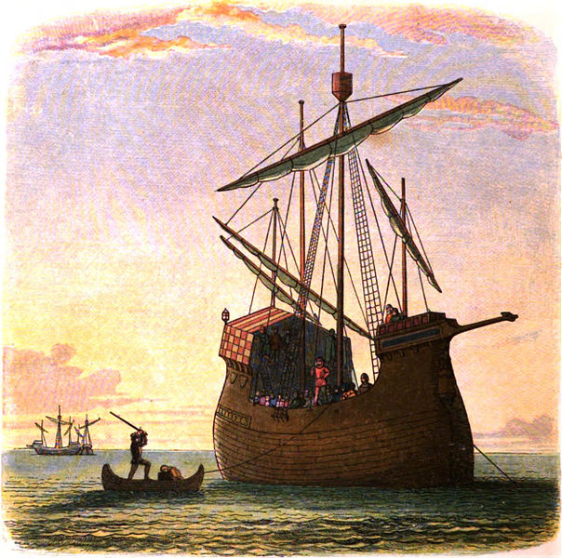

**TASK:**

1: List the reasons covered so far as to why opposition to the government was growing in 1445- 1450?

2: Do the activity on P25 using sources P & Q

**Cade’s Rebellion, May 1450**

The rising led by Jack Cade, took place in Kent, Surrey, Middlesex and parts of Sussex. The rebels were from all classes except the magnates (nobles). They marched to Blackheath in London. York does not seem to have been involved in the rebellion at all and he did not return to London from Ireland until two months after the revolt had ended. The rebels demanded that York and other members of the wider royal family, such as the Dukes of Buckingham and Exeter should be given their rightful position on the council. They also called for an enquiry into whether the growing disaster in France was the result of treason. **They did not regard themselves as disloyal** to the king but instead wished to remove from the king those councillors and members of the royal household who, they alleged, had impoverished the crown, corrupted the judicial system and lost Normandy. **Their intention was never to depose Henry.**

Henry took flight and left London to the rebels. Cade executed the Treasurer of England, Lord Saye, and William Cromer, a sheriff of Kent, for their alleged corruption in Kent itself.

Margaret of Anjou stayed at Greenwich and she proposed that the rebels be offered a free pardon if they left London which they did. Cade was later captured and executed.

**Significance of the rebellion**

The rebellion demonstrated the depth of discontent with the corruption and failings of the faction-led Lancastrian government. It also demonstrated Henry Vl’s inability to make sound political decisions and his possible lack of physical courage. Cade’s rebellion therefore reflects underlying factors that led to the Wars of the Roses.

**Homework Task**

Read P26 and 27 on Cade’s rebellion in the OCR textbook and do the Study skills activity on pages 29, 30 and 31.

**Richard Plantagenet, Duke of York, 1411-60**

[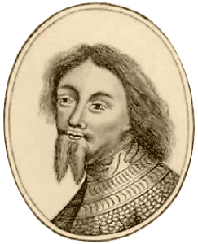](http://www.google.co.uk/url?sa=i&rct=j&q=&esrc=s&frm=1&source=images&cd=&cad=rja&docid=wSq_foMqHXLhDM&tbnid=6oXVz12nnVj-tM:&ved=0CAUQjRw&url=http://www.luminarium.org/encyclopedia/richardyork.htm&ei=GvEmUtbvCI200QWri4G4Bw&bvm=bv.51495398,d.ZGU&psig=AFQjCNEsuKBSaqHOyYyItXsrhpE1ja6CLw&ust=1378370195666234)

1411 Only son of Richard, Earl of Cambridge. Paternal grandson of Edmund, fifth son of King Edward III

1415 Succeeded his uncle, Edward Plantagenet, as third Duke of York

1425 Inherited the possessions of his uncle, Edmund de Mortimer, fifth Earl of March

1436-7 Served as a soldier in France

1438 Married Cecily, daughter of Ralph Neville, first Earl of Westmorland

1440-5 Served as Henry VI’s lieutenant in France

1447-50 Served as Henry VI’s lieutenant in Ireland

1452 Retired from politics after failing to remove the king’s chief adviser, Duke of Somerset

1453-4 Returned to politics and became Lord Protector during the king’s first bout of mental illness

1455 Removed from position when the king recovered and forced out of power. Responded with an armed rising to defeat royal forces at St Albans

1456 Lord Protector during the king’s second bout of mental illness

1457 Removed again when the king recovered

1458-9 Driven out of government and took refuge in Wales. Left Wales for Ireland and returned with an army to claim the crown

1460 Killed in battle at Wakefield

Richard of York did much to influence politics and the way in which the Wars of the Roses began. He was ambitious and after first trying, and failing, to control and rule through the king, he turned eventually to claim the crown for himself. York was a good soldier but he lacked political judgement. Queen Margaret of Anjou did not trust York and she became his most implacable enemy. On his death, his cause was taken up by his son and heir, Edward of York, also known as the Earl of March.

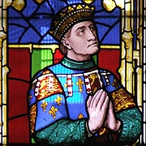**The Exclusion and Resentment of Richard Duke of York**

*(from The Wars of the Roses and Henry VII: Britain 1450-1509 – Roger Turvey)*

As the king’s closest living male relative, Richard Duke of York, expected to be included in decision making at court. Not only did he have a claim to the throne but he was one of the most powerful and wealthiest men in the country having inherited from his father, his uncle Edward Duke of York, who died at Agincourt and from his mother’s family the Mortimers. When he came of age in 1432 he was the richest landowner in the kingdom. He remained heir presumptive until 1453 when Henry’s son Prince Edward was born, and the fact that he was excluded from the centre of power became a burning source of resentment for him.

His exclusion was due to three factors:

1. The king’s advisors, namely William de la Pole, Duke of Suffolk, and Edmund Beaufort, Duke of Somerset. They dominated the court and monopolised royal patronage which gave them enormous power. They did not wish to share this with York.
2. The queen, Margaret of Anjou, did not like or trust York because of his forcefulness, his blood relationship with the king and his claim to the throne. Her suspicions of York deepened after the death of Henry VI’s uncle, Humphrey Duke of Gloucester, in 1447 when York became heir presumptive. Her hatred was intensified after the birth of her son, Edward, in 1453 because she was so determined to protect her son’s inheritance and keep York away from influence at court.
3. York was his own worst enemy in that he was too arrogant, stubborn and demanding. Instead of being patient and trying to make friendships he was confrontational and challenging.

York had served as the king’s military commander in France – 1436-7 and 1440-45 - and he was infuriated when he was removed and replaced by Edmund Beaufort, Duke of Somerset, in 1445. This was the beginning of a deadly feud between the two men. York suspected that Beaufort had ambitions to be king since, like York himself, he was descended from Edward III. York complained to the king that Suffolk and Somerset were not sufficiently able to command the French armies in France effectively but his advice was not listened to. York was also angry that the personal money he had spent in France keeping the war effort going was not repaid. During his time there he had spent over £38,000. Beaufort’s expenses were repaid but not York’s.

In an effort to silence York and remove him from court, Henry VI appointed him as Lieutenant of Ireland in 1447. York initially refused to go but he did leave to take up his post in 1449. His debts remained unpaid and it seems that he suffered considerable financial hardship. He had to sell some of his properties and accept financial help from friends.

He returned from Ireland in September 1450. He wished to disassociate himself from Cade’s rebellion and protect his position as heir presumptive. He can only have felt resentment at the treatment of Somerset, his replacement as commander in France. Somerset had presided over the loss of France and yet on his return to England had rejoined the Council and been made constable of England. York’s financial position was still very weak. York may also have been afraid that Henry might recognise Somerset as his heir.

He prepared two petitions for the king. The first was concerned with his fears regarding his position as heir, his debts and the fact that his advice had been ignored. The second one combined his own grievances with those expressed in Parliament and in Cade’s Rebellion (1450). York was appealing for public sympathy and support yet he did possess serious defects as a political leader. He was proud, reserved and self-interested.

York found himself isolated and distrusted. Henry had shown his confidence in Somerset by making his Captain of Calais, thereby giving him control of the largest military garrison England possessed. Henry had no intention of acting on York’s criticisms and suggestions and this left York with no alternative but to try to impose himself by force in 1452. He had still not been officially recognised as heir apparent. He tried to impose himself on the government by force but had minimal support and so had to submit to the king and took an oath of allegiance to him in St Paul’s Cathedral. At this stage he was completely isolated.

**TASK**

Use the sources on page 21 of the OCR textbook to find evidence of the origins of the York Somerset feud.

How convincing are these sources?

**TASK**

Imagine you are Richard Duke of York and write a letter from Ireland setting out why you think you have been treated unfairly by the king and his council.

**Exam Practice**

**1: Use your knowledge of the opposition to the king to assess how useful source C is as evidence of growing discontent in England (10)**

**2: Using these three sources in their historical context, how far do they support the view that Henry VI was the main cause of the growing unrest in the years 1445 - 1450. (20)**

**Source A: Jack Cade gives his views about the government of England in an appeal to the people**:

The King should surround himself with men of his true blood from his royal realm, that is to say, the high and mighty prince, the Duke of York, exiled from our sovereign lord’s person (the King) by suggestions of those false traitors the Duke of Suffolk and his affinity

*Adapted extract from the demands of Cade’s rebels (1450) according to Stow’s memoranda.*

**Souce B: Pope Pius II (1458 – 64) expresses his opinion of Henry in his memoirs**

Henry was more timorous than a woman, utterly devoid of wit or spirit who left everything in his wife’s hand. – *Commentaries of Pius II on the memorable events of his times.*

**Source C: Two farmers are accused of speaking treasonable words against Henry VI:**

John Merfeld and William Merfeld of Brightling in Sussex in the open market on Sunday 26th July falsely said that the king was a fool and would often hold a staff in his hands with a bird on the end, playing therewith as a fool, and that another king must be ordained to rule the land, saying that the king was not a person who was able to rule the land. – *Adapted from proceedings of the court of King’s bench 1450.*

**The Duke of York and events of 1453-5 ( Pendrill textbook pages 16-18)**

1. Who were the Neville family and which side did they take in the Wars of the Roses?

2. What is meant by ‘heir presumptive’?

3. What role did the Duke of York play during Henry’s mental breakdown? Why was this?

4. Who was Somerset? Whose side was he on and what became of him?

5. What two developments in 1453 undermined York’s power?

**1453 The Insanity of Henry VI: Richard of York as Protector**

In **August 1453**, Henry VI had a complete mental breakdown. He would not or could not speak or communicate in any way with anyone and even the birth of his son, Prince Edward in **October 1453** brought no response from him.

Task use sources H and I on page 41 and answer the following questions

1: What can we learn from the sources about the nature of Henry’s illness?

2: With reference to sources H and I how useful are letters as sources of information on events in the 15th Century.

It is possible that the King’s breakdown was caused by the news from France. The English lost Gascony in 1453 and the commander John Talbot, Earl of Shrewsbury had been killed at the decisive battle of Castillon. It may also have been hereditary from his maternal grandfather Charles VI of France who believed he was made of glass and would shatter if touched!

**Henry’s breakdown can be seen as another cause of the Wars of the Roses.**

**The immediate impact of the king’s illness:**

* Open violence at a local and regional level. Corruption in government was widespread and Henry’s favourites and their servants and dependents were responsible for much of the intimidation, illegal retaining, embracery and maintenance. Once it became obvious that the king was completely incapacitated, some magnates took the opportunity to sort out rivalries by full-scale armed conflict. For instance, in August 1453, several hundred Percy retainers ambushed a party of Nevilles near York. This was dangerous lawlessness but NOT a fight for the throne.
* Henry’s incapacity led to a struggle between Queen Margaret and the Duke of York which can certainly be seen as a direct cause of the Wars of the Roses since it propelled York into claiming the throne.

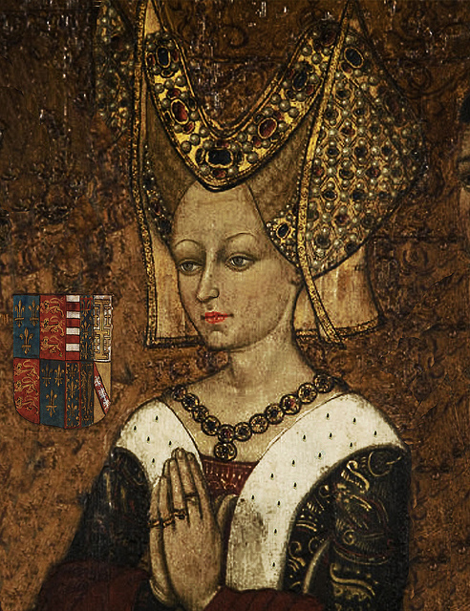**Margaret of Anjou**

* Margaret of Anjou was the daughter of the Count of Anjou. She married, Henry VI in 1445 as part of negotiations between England and France to end the One Hundred Years War and has been described as, ‘the notorious she-wolf of France’. Her nationality combined with her combative character, compared to that of her husband, made her a divisive personality at court and one who certainly contributed to the outbreak of the Wars in 1455.

**Divisive in Court**

* Margaret quickly became associated with the ‘peace party’ at court, encouraging the King to sue for peace with France. Here she was supported by the Duke of Somerset.
* This riled others at court, most notably the Duke of York. He had invested much in the French campaign and was reluctant to see all of this come to nothing.
* By 1453 the English had been expelled from France, except for Calais. This was a disaster for Henry’s regime. Whilst it would be difficult to argue that Margaret was the direct cause of this military defeat her presence at Court inevitably meant that she became a focus for opposition forces.

**Task**

Read p. 43 – 45 in the OCR textbook.

1 What is Margaret trying to achieve in source M

2 To what extent does source N confirm that Margaret was right to be worried about the situation in England.

**Bastard Feudalism**

**Bastard feudalism, the nobility and the escalation of private feuds.**

[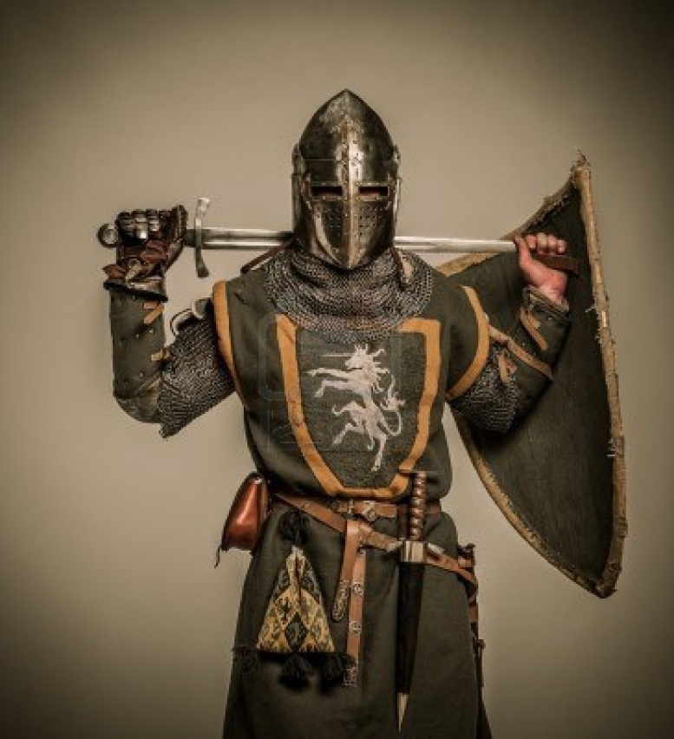](http://www.google.co.uk/url?sa=i&rct=j&q=&esrc=s&frm=1&source=images&cd=&cad=rja&docid=jzQFM99sRd4RtM&tbnid=KYEJNl3it2bLMM:&ved=0CAUQjRw&url=http://www.123rf.com/photo_15599718_medieval-knight-with-a-sword.html&ei=6PImUqqMBoiJ0AWkpoDoBg&bvm=bv.51495398,d.ZGU&psig=AFQjCNG1khiWedMizpo5qfYPNxMNXYiwCQ&ust=1378370645575429)

**Bastard feudalism** was not in itself a corrupt system. A strong king would be able to control it as well as his nobility and the system could be beneficial to the stability of the country as the lord would be able to keep peace amongst his retainers.

One of the chief functions of the king’s council was to arbitrate between nobles when they quarrelled. If the king’s council ceased to become impartial and if the legal system was no longer respected and the laws no longer enforced by the crown then bastard feudalism flourished and came to undermine the authority of the crown. It was in the nobles interests to have large retinues of men so that they could protect themselves from their peers if the king’s council failed to do so.

From the accession of Henry Vl in 1422, there was increasing lawlessness and the crown did not intervene. Bastard feudalism was encouraged by the lawlessness and weak crown because everyone, and especially those who had property, needed the protection of his own ‘good lord’. If a man could no longer rely on the king’s courts for protection and justice and his enemy had powerful friends, then it would be necessary to have a patron or a lord whose influence matched that of his enemy. Therefore men were keen to be retained by a great lord on account of the protection he could provide rather than the pension paid. The lord benefitted too.

**Bastard feudalism was a symptom and a cause of the breakdown of royal authority.**

**Task**

*Draw 2 diagrams 1**to explain Feudalism and the other to show the differences with Bastard Feudalism*

**Bastard Feudalism as a cause of the Wars of the Roses**

There was a collapse of law and order generally in England. Private feuds developed in the 1440s and 1450s as nobility could no longer rely on Henry VI to settle these on their behalf and give them fair and impartial justice. Increasingly the nobility felt they had to resort to taking the law into their own hands. As private feuds became more intense the participants began to look for wider support and eventually came to ally with either the court party (Lancastrians and supporters of Henry VI) or with the opposition to the court party (this was led by Richard Duke of York).

**Examples of private feuds**

1. Lord Cobham took his men to fight against the men employed by Lord Wiltshire,
2. Lord Cromwell’s men fought the men of the Duke of Exeter. (Henry Holland, Duke of Exeter supported the Lancastrians and Lord Cromwell came to support the Yorkists) In Derbyshire the Duke of Buckingham was finding it difficult to keep the peace and a large scale conflict between a number of prominent local landowners including the Blounts, the Gresleys, the Vernons and the Longfords was getting out of hand.
3. In 1450-1 an inheritance dispute between the Talbots and the Berkeleys was causing what has been likened to a private war in Gloucestershire.

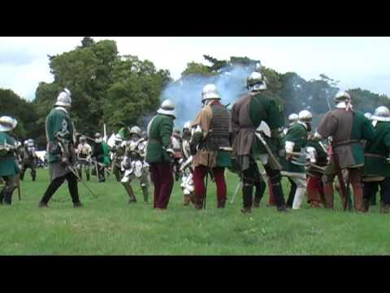

1. In Bedfordshire there was a feud between Lords Stanhope and Grey; in Oxfordshire there was a quarrel between the Stafford and Harcourt families. There was disorder in towns and cities such as York, Norwich and Hereford. The crown did not intervene to settle any of these issues. Therefore bastard feudalism was encouraged and men looked for the protection of a “good lord”. There was a growing number of petitions to the king concerning disorder and maintenance and in 1450 Cade’s rebellion took place.

Settling noble quarrels was one of the single most important tasks of the king’s council. There was increasing factional tension in Henry Vl’s council and peers increased the size of their retinues. Henry let the council fall into the grasp of a faction led by the Beauforts and Suffolk and so nobles could not rely on receiving impartial justice. Henry’s favourites made decisions which benefited them and their own retainers.

Nobles (magnates) with enemies in the council attached themselves to the natural leader of the opposition to the royal court, the Duke of York. Gentry, who lacked confidence in the processes of law, attached themselves to lords who could give them protection against their enemies and in return they supported their lords in private wars with their peers. These hostilities resulted in the nobility joining one of the major political rivals and thus their retainers were also drawn into the conflict of Lancaster and York.

1. In the 1450s there was a feud in the West Country between Thomas Courtenay, Earl of Devon, and Lord Bonville. On a national level, Courtenay was allied to the Duke of York, and Bonville to the opposing ‘court’ party.

In 1455 Bonville switched allegiance to York’s victorious party and by reaction the Courtenays became members of the Lancastrian ‘court’ party.

1. In the north of the country there was an ongoing feud over land between the two leading families, the Nevilles (Earl of Salisbury and his son the Earl of Warwick) and the Percies (Earl of Northumberland). Conflict broke out in the summer of 1453 because of the marriage between the Earl of Salisbury's second son, Sir Thomas Neville, and Maud Stanhope, niece and joint-heiress of Lord Cromwell. Under the terms of the marriage agreement the manor and castle of Wressle was to pass permanently to a member of the Neville family. Wressle, had previously been held by Thomas Percy and it was one of the properties the Earl of Northumberland (Percy) wanted to recover. The prospect of the permanent loss of this small but highly desirable manor to a member of the Neville family seems to have been the final straw and violence erupted.

The Nevilles came to support York because the Earl of Warwick (Neville’s oldest son and also Richard of York’s brother in law) had held lands in Glamorgan, Wales, since 1450 but in 1453 these were granted to the Duke of Somerset. Warwick very much resented these being given to the Beaufort family and so he naturally came to support the main opponent to Beaufort power at court. This is an example of Henry Vl’s very unwise use of patronage in that he exacerbated rivalry between his nobles. The Percy family therefore allied with the Lancastrians because they were enemies of the Nevilles and were looking for extra support in their power struggle in northern England.

This is a classic example of a private feud helping to escalate tension leading to civil war. Many historians have seen the rivalry between the Percies and Nevilles as the critical element in converting factionalism at court into civil war in the kingdom at large. It was Neville backing which effectively secured the protectorate for York in March 1454 and it was this backing which enabled York to have a side when challenged by the Lancastrians.

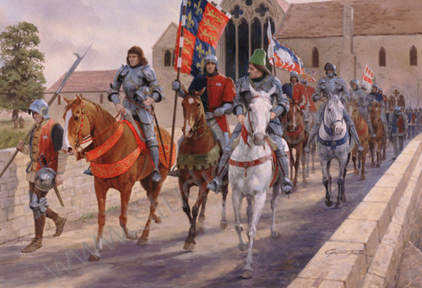

**The civil wars were the outcome of this collapse of law and order throughout the country because it was in these conditions of insecurity that the noble retinues were built up to the proportions of small armies.**

According to R.L. Storey, the Wars of the Roses were “the outcome of an escalation of private feuds”. Gentry, who lacked confidence in the processes of law, attached themselves to lords who could give them protection against their personal enemies and in return they supported their lords in private wars with their peers. Noble hostilities similarly resulted in the contestants aligning themselves with the major political rivals, and thus drawing their retainers into the conflict of Lancaster and York.

**The basic cause of increased bastard feudalism and the Wars of the Roses was the weakness of the crown**. The king and his council failed to administer justice with vigour and impartiality. The council was dominated by faction and was unable to arbitrate between the lords. The same faction corrupted the administration of justice for the benefit of its retainers.

**Bastard feudalism was a cause and a consequence of the Wars of the Roses.**

**Task**

1. In your own words describe what you understand by the ‘feudal system’.
2. Why did bastard feudalism develop from the original system?
3. Did bastard feudalism encourage corruption or can you see some advantages in it?
4. What did Henry Vl’s council fail to do in relation to quarrels between the nobility?
5. Why did the council fail to do this?
6. How did the common people feel about Henry Vl’s system of justice and law and order in general?
7. What did the common people do to protect themselves?
8. What is Livery and Maintenance?
9. How did the system of retaining help the nobility in their quarrels with their peers?
10. How and why did these quarrels develop into faction fighting and then dynastic warfare?
11. Was bastard feudalism and abuses within the system a direct or indirect cause of the Wars of the Roses? Give reasons for your answer.

**The Neville Family**

When Henry VI had his first breakdown in 1453, Margaret of Anjou hoped she would become Regent during the king’s illness. This idea appalled the nobility who could not accept that a woman (and a French woman at that) should hold this position and many of them were gradually coming to support York’s right to be Regent or Protector as he was Henry’s closest adult male relative. The most important noble family to support York’s right were the Nevilles. Their on-going feud in the North with the Percies inevitably meant that eventually they would come to associate with either the court party or York for support. It was Neville backing which effectively secured the Protectorate for York in 1453.

It was the Earl of Warwick, Richard Neville and son of the Earl of Salisbury, who made the final decision. When he married, he had gained lands in the midlands, the south and the southern Wales as well as his title of Warwick. He had held the Marcher Lordship of Glamorgan (South Wales) since 1450 but in early 1453 Henry granted this to his favourite Somerset. This is an example of Henry’s very unwise use of patronage and the effect was to convince Warwick and the rest of the Nevilles that they should support Somerset’s greatest enemy, York.

In addition, York was married to a member of the Neville family. Cecily Neville was sister to the Earl of Salisbury and aunt of the Earl of Warwick.

Once the Nevilles had decided to support York, the Percies (Earls of Northumberland) came down firmly on the side of the court party. The Nevilles gained the instant advantage they sought from the alliance with York. The Duke of Exeter (Henry Holland) assisted by Lord Egremont (son of the Earl of Northumberland) rebelled against York’s authority as Protector. York marched North, accompanied by the Earl of Salisbury, the new Chancellor of England, to crush their enemies which they succeeded in doing until the end of 1454 when Henry VI recovered his senses and York’s position as Protector came to an end.

York and Salisbury were now exposed to their enemies. Somerset, Exeter and the Earl of Northumberland were restored to their positions at court. York and the Nevilles withdrew and immediately started to plan how to regain their positions. The two sides met at St Albans in May 1455. **This is clear evidence of how factions at court into led to civil war.**

NB At this stage York did not wish to take the crown but only to regain his rightful place in court.

**Build up to St Albans Role Play**

|  |  |  |  |
| --- | --- | --- | --- |
|  | In the Kings Camp | Outside or opposed to the kings camp | Explanation of events |
| Stage 1 |  |  |  |
| Stage 2 |  |  |  |
| Stage 3 |  |  |  |
| Stage 4 |  |  |  |
| Stage 5 |  |  |  |
| Stage 6 |  |  |  |

**Start of the Wars**

* 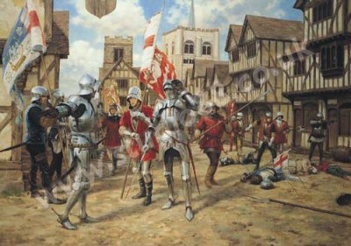Stung by this reversal of fortunes, York resorted to force. He and the Nevilles had fled North where they decided to impose their will on the king by force if necessary. Margaret and Somerset probably convinced Henry that they were plotting treason and he summoned them to appear before a Great Council at Leicester, in the heart of Lancastrian territory. Together with the Nevilles he raised troops and marched south. The King and his advisors were taken by surprise. There was an attempt at negotiation but this was not successful and the fighting started. The Lancastrians were defeated **at St. Albans in May 1455.**
* Crucially, Somerset and Northumberland were killed leaving their heirs to plot revenge.
* The two sides, originally simply different court factions, had now solidified into opposing warring forces and the stage was set for the start of the Wars.
* Margaret was a key factor in the escalation of tension and the outbreak of war. She was a divisive figure, a strong character, capable of eclipsing her husband, and inevitably became associated with the so-called Peace Party within Henry’s court. This did her no favours. Crucially, her role as a major player in the outbreak of the conflict intensified as a result of Henry’s illness and she was thrust further into the limelight when she gave birth to the heir to the throne, Edward. Whilst it would be difficult to argue that she was the single most important factor in the outbreak of the wars she was certainly a significant one whose presence at court served to polarise the factions. Their antipathy towards one another broke out into outright violence at St. Alban’s in 1455.

**The political significance of the Battle of St Albans was considerable**

* Blood had been spilt and the sons and other relations of Somerset and Northumberland were going to find it very difficult to accept any form of long-term compromise with York. They wanted revenge. Rivalry between factions was intensified.
* Queen Margaret was now more convinced than ever that only the complete destruction of York would safeguard her son’s inheritance. There is real doubt over whether Henry VI ever regained his mental health sufficiently to be able to act independently for the rest of his reign. This meant that, more than ever, politics meant the struggle to control the king. The leadership of the Lancastrian party fell upon a ruthless and uncompromising woman with every intention of persuading her husband to crush the Yorkists completely. **The importance of this cannot be overstated.**

York had made no claims to the throne and Henry was perfectly safe with him. Henry did suffer a further breakdown in the autumn of 1455 and York again became Protector**.** This lasted until February 1456 by which time Henry had made something of a recovery.

**Task: Read the sources on P51 and do the tasks on p52 and 53**

**The Key Events in the Build Up to the Wars of the Roses**

Weakness of Henry VI Loss of French territory



The ambition or alienation of Richard Duke of York Over mighty Subjects and Feuds between the nobility

**GLOSSARY**

|  |  |
| --- | --- |
| **Attained** |  |
| **Bastard Feudalism** |  |
| **Dowrey** |  |
| **Factions** |  |
| **Feudalism** |  |
| **Live off his own** |  |
| **Minority** |  |
| **Nobility** |  |
| **Patronage** |  |
| **Regent** |  |
| **Solvent** |  |
|  |  |
|  |  |
|  |  |
|  |  |
|  |  |
|  |  |
|  |  |
|  |  |
|  |  |
|  |  |
|  |  |
|  |  |
|  |  |
|  |  |
|  |  |
|  |  |
|  |  |
|  |  |
|  |  |
|  |  |
|  |  |
|  |  |