**Unit 1 – The Wars of the Roses and the Reign of Henry VII**

**Topic 2 – The downfall of the Lancastrian dynasty**

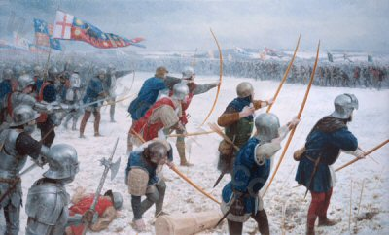

**What I need to know:**

The impact of the battle of St Albans

What happened after the battle?

The effects of the Parliament of Devils and Battle of Northampton

How the Act of Accord increased the stakes for both sides

The events and outcome of the Battle of Wakefield

The downfall of the Lancastrian dynasty at the battle of Towton

Who was responsible for the Lancastrian downfall?

**Key issues which the questions might address:**

How far were the ambitions of Richard Duke of York responsible for the instability in England in the years 1455–60?

How far were Lancastrian political and military mistakes responsible for the victory of the Yorkists?

To what extent were Henry VI and Margaret of Anjou responsible for Lancastrian failures in the years 1455–61?

**Reading list**

These texts are available in the History Department and in the ILC.

1. England 1445 – 1509 OCR textbook Lancastrians, Yorkists and Henry VII – Nicholas Fellows & Sharon Littler
2. The Wars of the Roses – Ian Dawson
3. ‘The Wars of the Roses and Henry VII: Britain 1450-1509 – Roger Turvey
4. Lancastrians and Yorkists: The Wars of the Roses – David Cook
5. The Wars of the Roses and Henry VII England 1459 – c1513 – Colin Pendrill
6. The Wars of the Roses Politics and the constitution – Christine Carpenter

**Articles**

Go on the History Today website, and search their archive. You can do this via the library link on Godalming online.

**OCR AS Mark Schemes**

**Unit 1 – British Period Study**

**Section A, Question 1 (10 marks)**

***Use your knowledge of (specified historical context) to assess how useful source (…) is as evidence of…***

|  |  |  |
| --- | --- | --- |
| **Level 1** | This answer is on the wider topic area, but not on the detail of the question. There is a very basic evaluation of the source, with very limited use of very generalised knowledge of historical context that is specified in the question, in order to engage with the source in a very limited way to attempt a very simple analysis of its utility. This analysis may primarily take the form of drawing information from the source, and it will be considered more as evidence for the wider topic area than the specific issue in the question. | **1-2** |
| **Level 2** | The answer has only limited focus on the question. There is a generalised evaluation of the source, with use of limited knowledge of the historical context that is specified in the question, in order to engage with the source and produce a basic analysis of its utility as evidence for the issue in the question | **3-4** |
| **Level 3** | The answer is partially focused on the question. There is partial evaluation of the source, with use of some knowledge of the historical context that is specified in the question, in order to engage with the source and produce a partial analysis of its utility as evidence for the issue in the question. | **5-6** |
| **Level 4** | The answer is mostly focused on the question. The source is evaluated, using both provenance and generally relevant knowledge of the historical context that is specified in the question, in order to engage with the source and produce an analysis of its utility as evidence for the issue in the question. The use of provenance may not be developed. | **7-8** |
| **Level 5** | The answer has a good focus on the question. The source is evaluated, using both provenance and relevant knowledge of the historical context that is specified in the question, in order to engage with the source and reach a supported analysis of its utility as evidence for the issue in the question. | **9-10** |

**Section A, Question 2 (20 marks)**

***How far do the three sources support the view…?***

|  |  |  |
| --- | --- | --- |
| **Level 1** | This answer is on the wider topic area, but not on the detail of the question. The sources are evaluated in a very basic way, primarily being used as a source of information with understanding of them being only partial. A very generalised knowledge of historical context is used in a very limited way to engage with the sources and to attempt a very simple analysis of them in relation to the question. | **1-4** |
| **Level 2** | The answer has only limited focus on the question. Evaluation of the sources is very general. There is limited use of generalised knowledge of historical context to engage with the sources and produce a basic analysis of them in relation to the question. | **5-8** |
| **Level 3** | The answer is partially focused on the question. There is partial evaluation of the sources, with use of some knowledge of their historical context, in order to engage with the sources and produce a partial analysis of them in relation to the question. | **9-12** |
| **Level 4** | The answer is mostly focused on the question. The sources are evaluated, using both provenance and generally relevant knowledge of their historical context, in order to engage with the sources and produce an analysis of them in relation to the question. The use of provenance may not be developed. | **13-16** |
| **Level 5** | The answer has a good focus on the question. The sources are evaluated, using both provenance and relevant knowledge of their historical context, in order to engage with the sources and reach a supported analysis of them in relation the issue in the question. There may be some imbalance in the analysis between use of provenance and use of knowledge | **17-20** |

**The Battle of St Albans, May 1455**

York left court early in 1455 following Henry’s recovery. He felt that all he could do was to use armed force against his enemies, particularly Margaret of Anjou and the Duke of Somerset. York did not consider Henry Vl an enemy and York still protested his loyalty to the king. There was a skirmish at St Albans – it hardly merits the name of a battle but Somerset and the Earl of Northumberland were killed and Henry came under York’s control.

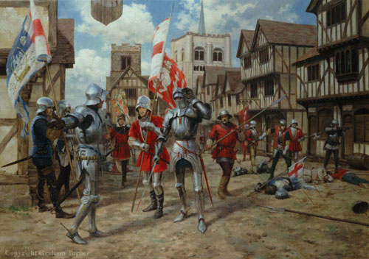

The political significance of this was considerable

1. Blood had been spilt and the sons and other relations of Somerset and Northumberland were going to find it very difficult to accept any form of long-term compromise with York. They wanted revenge. Rivalry between factions was intensified.
2. The fact that the three members of the nobility who were killed, Somerset, Northumberland and Clifford were the three enemies of York and the Nevilles made it look like they had been specifically targeted and murdered. Distrust between the nobility increasingly meant that they turned up to meetings with large armed groups of followers.
3. Queen Margaret was now more convinced than ever that only the complete destruction of York would safeguard her son’s inheritance. There is real doubt over whether Henry VI ever regained his mental health sufficiently to be able to act independently for the rest of his reign. This meant that, more than ever, politics meant the struggle to control the king. The leadership of the Lancastrian party fell upon a ruthless and uncompromising woman with every intention of persuading her husband to crush the Yorkists completely. **The importance of this cannot be overstated.**

York had made no claims to the throne and Henry was perfectly safe with him. Henry did suffer a further breakdown in the autumn of 1455 and York again became Protector**.** This lasted until February 1456 by which time Henry had made something of a recovery.

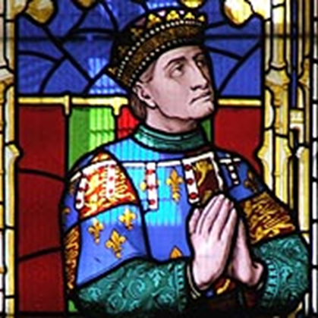What happened after St Albans 1455 - 1458

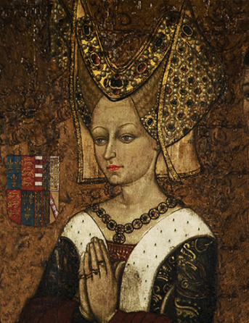

Who won and who died at the battle of St Albans (OCR p55 – 56)

What happened to Henry within 2 weeks of the battle (p57 OCR)

What was the impact of this on York? (OCR p 57)

What was the impact on Margaret and what did she now do? (OCR p57, 60, 61 & 62)

Give some examples of how this simmering feud was leading to a breakdown in law and order in England (OCR p63 – 65)

What was Loveday? How realistic was this as an attempt to bring about peace? (P65 OCR textbook)

**Source Task on Margaret**

**Source D:** A piece of Yorkist propaganda, published a year after Edward IV took the throne, presents a critical view of Margaret of Anjou’s role in Henry VI’s government.

As Scripture says ‘woe be to that region

Where the king is unwise or innocent’.

Moreover it is a great perversion

For a woman of a land to be a regent-

Queen Margaret, who has always meant

To govern all England with might and power,

And to destroy the lawful line of her intent. *A ballad 1462*

**Source E**: A London letter writer, John Bocking, writes about Margaret of Anjou.

A great and intensely active woman, for she spares no pains to pursue her business towards an end and conclusion favourable to her power

*The Paston Letters 1456*

Source F: An anonymous chronicler, writing shortly after Edward IV seized the throne in 1461, criticises Henry VI’s government.

The Queen and such as were of her affinity ruled the realm as she like gathering riches. The officers of the realm, especially the Earl of Wiltshire, treasurer of England, to Enrich himself, fleeced the poor people and disinherited rightful heirs who did many wrongs. The Queen was defamed and denounced, that he who was called prince was not her son but a bastard gotten in adultery; wherefore she, dreading that he should not succeed his father in the crown of England, sought the alliance of all the knights and squires of Cheshire to have their goodwill… and making secret approaches to some of the lords of England to stir the king that he should resign the crown to her son; but she could not bring her purpose about.

*An English Chronicle written in the early 1460s*

**1: What can we learn from Margaret from sources D, E and F**

**2: Does the fact that source D is a piece of propaganda mean that it is not useful as a source on this period?**

**3 Do the sources show that Margaret helped to cause the conflict? Fill in the table to help you reach this decision**

|  |  |  |  |  |
| --- | --- | --- | --- | --- |
| **Source** | **Evidence in support** | **Evidence against** | **Reliability** | **Mark out of 10** |
| **D** |  |  |  |  |
| **E** |  |  |  |  |
| **F** |  |  |  |  |

**Next Steps:**

By 1459 Margaret of Anjou and the Duke of Buckingham appear to have convinced the king that York and Warwick were plotting against him. In June 1459 York was accused of Treason an act which caused York and his supporters to mobilise their forces again. The Yorkists under Salisbury won a victory at Blore Heath however following the desertion of Yorkist Troops York was forced to flee to Ireland while Salisbury, Warwick and York’s eldest Son Edward Earl of March fled to Calais.

**The Parliament of Devils**

In November 1459, from her powerbase in Coventry Margaret convened what became known as the Parliament of Devils. This Attained (took) all the Yorkists goods and Land back into the possession of the crown. It also named the Yorkists Traitors and condemned them to death. Finally it disinherited the heirs of the Yorkists meaning they could not inherit their titles and estates. This appears to have had a number of effects:

* It gave the Yorkists little option but to fight to retain their power.
* It may well have been seen as harsh by other members of the nobility giving York more support. Many were worried that the disinheritance could then happen to them
* It is seen by some historians as one of the big mistakes made by the Lancastrians and Margaret. Taking the lands of a noble who is imprisoned can work very well as Henry VII later showed, however in this case it was a foolish provocation as the Yorkists were respected by many in the kingdom and still in positions of power.

**The Yorkist invasion of 1460**

In June 1460 Warwick and York’s son Edward Earl of March returned to England from Calais with around 2000 men. They received the blessing of the Archbishop in Canterbury and marched on London gathering support as they went. The Lord Mayor of London accepted them into the city forcing a number of Lancastrian nobility to take shelter in the tower. They then marched north to meet the king’s army at Northampton.

Use Page 70 of the OCR textbook to fill out the CV below with Warwick’s activities between 1455 and 1460 to say why you are an appropriate Yorkist commander.

Warwick’s CV

Full Name:

Background:

Job Experience:

**The Battle of Northampton**

Under the command of Warwick and the promising young Edward, Northampton was a stunning success for the Yorkists. Margaret’s key supporter the Duke of Buckingham was killed and, even more importantly, Henry VI was captured by the Yorkists.

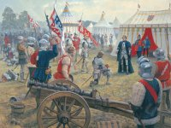

**The Act of Accord**

With Henry under their control the Yorkists seemed to be going from strength to strength however at this point York committed an act which seemed to have even surprised his supporters. He chose this moment to try to claim the crown for himself.

The 15th Century chronicler Whethamstede wrote:

“ On entering the palace he marched straight through the great hall until he came to the solemn chamber where the king is wont to hold his parliament and commons. And when he came there he walked up to the kings throne putting his hand on the cushion, as a man taking possession of his own, and kept it there for a short space. At length withdrawing it he turned his face towards the people and, standing quietly under the royal cloth of state, awaited the applause of the onlookers. While he stood, Master Thomas Bourchier, Archbishop of Canterbury, approached him, and with due reverence asked him whether he wished to come see the lord king. To which he answered thus “ I mind me of no one in this kingdom to whom it is not more fitting that he should come to see me than I to him” Then the duke withdrew to the principal chambers in the whole palace (as the king occupied the queens apartment), and the bolts having been broken and the doors forcibly opened, he took up his abode there for some time in the manner of a king rather than a duke”

**Task**

What does the above source show us about:

A - The Duke of York and his motives?

B – The reaction of the rest of the nobility?

York did not succeed in persuading the lords to depose the king but they did agree to a settlement known as the **Act of Accord**. This disinherited Henry’s son Edward from the Throne and Stated York and his sons would inherit the throne on Henry’s death.

**Task:** In pairs discuss and make notes on why the Act of Accord would not really satisfy either side. Make notes below on who in particular would be furious with this?

**The Battle of Wakefield:**

The act of accord had upped the stakes of the Wars of the Roses. Pickering suggests, it had turned a struggle for control of government into a struggle for the dynastic future of the crown itself[1]. The Lancastrians rallied under Margaret in Hull and marched south towards London in November 1460. This appears to have taken York by surprise. Leaving Warwick to safeguard London he marched north to confront Margaret and a battle was fought outside York’s castle at Sandal near Wakefield.

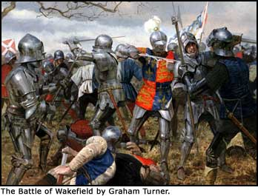

*Documentary* **War of the Roses: A bloody crown (1:00 – 1:10)**

**Why did York head for Wakefield?**

**What explanation do they offer for why York left the safety of the castle?**

**What happened to York and Salisbury and York’s second son**

**What further insult was added to the Yorkists**

**Why did this further escalate the war?**

**Why this could be seen as good for the Yorkists.**

**What did Margaret’s army now do.**

Having defeated York Margaret had both his and his second son Edmund’s heads put on spikes on the gates of York with the final insult of having a paper crown placed on York’s head.

**The Second Battle of St Albans**

Margaret’s Army now marched south ravaging towns and villages as they passed. Whole towns swapped allegiance from the Lancastrians to the Yorkists because of this. Margaret’s army met Warwick’s at St Albans on the 17th February 1461 and won another victory forcing Warwick to flee. Even more importantly Warwick had taken Henry VI with him, resulting in Margaret’s victory reuniting her with her husband. How far Henry was aware of this is debateable. Contemporary accounts state he spent the battle sitting under an oak tree laughing and singing.

Margaret should have now been able to recapture London however the actions of her army on the march south had worried the Londoners to such an extent that they barred the gates and took up arms. Perhaps understanding the need to keep her army in check Margaret withdrew.

**The Rise of Edward IV**

With his Father dead York’s 18 year old son Edward Earl of March took up the leadership of the Yorkist cause. Fresh from a victory at Mortimer’s Cross Edward entered the capital on February 27th and seems to have been welcomed. He proclaimed himself Edward IV with the support of the Lords in parliament. The Act of Accord had declared York’s descendants would be heirs to the throne and it seemed Edward intended to use this even though Henry was still alive. With the support of Warwick Edward now marched north to confront the Lancastrians.

*Documentary:* **The downfall of the Lancastrians start 1:10 – 1:27:30**

**What supposedly happened during the battle of Mortimer’s cross and why did this seem significant?**

**Why did Edward seem like a strong Yorkist Leader?**

**Why didn’t the Londoners let Margaret into the city?**

**How did Edward and the Yorkists capitalise on this?**

**Roughly how many men fought at Towton and how many died?**

**How many of the English nobility took part?**

**How did the weather help the Yorkists?**

**Whose arrival tipped the balance of the battle in the Yorkist favour and caused the Lancastrians to Rout?**

**What did Henry, Margaret and Somerset do once they realised the Lancastrians had lost?**

**Why were the Lancastrians unable to hold onto the crown? Write the key events on this Graph from the board**

**Yorkist**

**Triumph**

**Yorkist**

**Optimism**

**Uncertainty**

**1455 1456 1457 1458 1459 1460 1461**

**Yorkist**

**Pessimism**

**Yorkist**

**Despair**

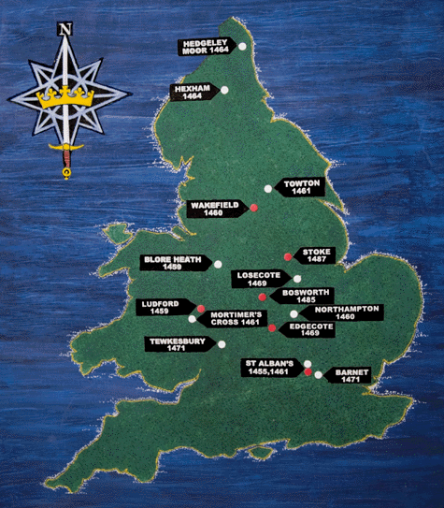

**THE KEY BATTLES IN THE WARS OF THE ROSES 1455-1461**

|  |  |  |  |  |
| --- | --- | --- | --- | --- |
| **DATE** | **NAME** | **Importance of the Battle** | **WHO WON?** | **WHO DIED?** |
| MAY 1455 | St Albans |  |  |  |
| July 1460 | Northampton |  |  |  |
| Dec  1460 | Wakefield |  |  |  |
| February 1461 | 2nd St Albans |  |  |  |
| March 1461 | Towton |  |  |  |

Finish with the activity on page 75 using the sources on page 76.

**GLOSSARY**

|  |  |
| --- | --- |
|  |  |
|  |  |
|  |  |
|  |  |
|  |  |
|  |  |
|  |  |
|  |  |
|  |  |
|  |  |
|  |  |
|  |  |
|  |  |
|  |  |
|  |  |
|  |  |
|  |  |
|  |  |
|  |  |
|  |  |
|  |  |
|  |  |
|  |  |
|  |  |
|  |  |
|  |  |
|  |  |
|  |  |
|  |  |

1. Pickering P24