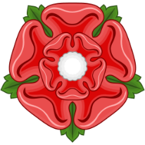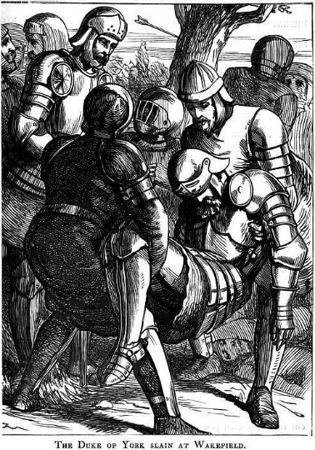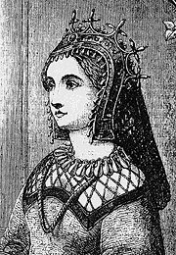The Rose

Written by Becca and Helen

**Bloody defeat at Towton**

In March of 1461 the Yorkists savagely and ruthlessly slaughtered every Lancastrian that they could get their hands on in one of the bloodiest battles England has ever seen, the Battle of Towton. To read more go to page 3

**York is dead!**

After York falsely claimed the Crown and was named our esteemed King Henry’s heir he went to Wakefield to face our Queen Margaret leaving Warwick to safeguard London. However when he arrived he faced more than he was expecting as the Lancastrian army overwhelmed the Yorkists and as a result York was killed. Queen Margaret proudly displayed his head on a spike at the gates of York, adorned with a paper crown; a symbol of his pathetic power. Although York still has three sons who remain alive the Yorkist power has been weakened severely meaning it is time for the Lancastrians to take back their legitimate claim to the throne…continued on page 6

**2nd Battle of St Albans**

After the Yorkist defeat in Wakefield Margaret and her army headed for London. Queen Margaret then met Warwick once more in the major town of St Albans. The two armys have met before in the same place which ended in an unfortunate Lancastrian defeat however God was with the Lancastrian army that day as Warwick’s army was defeated and they fled in fear. One of their leaders, Lord Bonville was captured and executed. In addition the York army carelessly left our beloved King Henry behind so he was finally reunited with him wife and son…more on page 7

**Queen Margaret refused entry to London**

Our Queen has been through much with King Henry’s illness and her son still being an infant when they were thrown out of London and yet the hardships still continue as the Londoners refuse to let their Queen into the capital. After she left London, Queen Margaret created her own Parliament in Coventry, labelled the ‘Parliament of Devil’s’ by the Yorkists. She has been building up support for the Lancastrians for years in an attempt to reclaims her son’s rightful position as the heir to the throne. She has been joined by many of the nobles including: the Dukes of Exeter and Devon, both of whom had made an enemy of York, and of course the new Somerset, Northumberland and Clifford, all of whom held York responsible for the deaths of their fathers…for more go to page 4

