**In the first major conflict in the month of May 1455, the glorious and magnanimous leaders of the House of York have prevailed over the evil advisors of the Good King Henry.**

INSIDE!

£5 OFF ALL ARMOUR FROM TOPKNIGHT

***THE SUNNE***

IN SPLENDOUR

The Lancastrians, under the command of the villainous Duke of Somerset, had set up defensive positions in the town of St Albans, where they prepared for the advance of the Duke of York and his ally Richard Neville, Earl of Warwick.

The fighting was vicious but ultimately short-lived. The Yorkists, who enumerated about 5000 valiant and loyal men, were of course, victorious and managed to achieve a decisive win with the loss of merely 60 men of York.

In contrast the ranks of Lancaster were gutted of leaders. The Duke of Somerset, the Earl of Northumberland and Lord Clifford all lay dead on the bloodied streets at the end of the day’s fighting.

[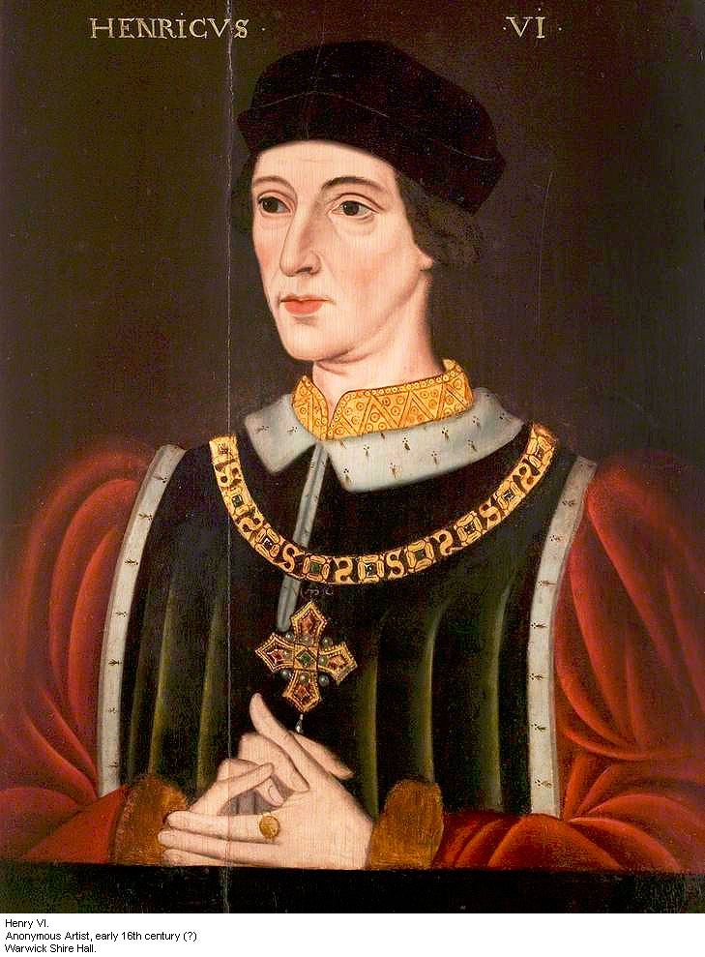](http://www.google.com/url?sa=i&rct=j&q=&esrc=s&frm=1&source=images&cd=&cad=rja&uact=8&ved=0CAcQjRxqFQoTCPiZ5_T188gCFcTsFAodxGIGzw&url=http://www.luminarium.org/encyclopedia/henry6.htm&psig=AFQjCNFqQALpj1zaGpsgmdrQJSjheEi8Lg&ust=1446628623550874)Thankfully, for the fate of the country, the King is now liberated from the influence of such scoundrels and charlatans now York is re-instated as chief advisor to His Majesty. And never again would anyone stand between the Duke, the King’s most loyal servant, and Henry.

HENRY AND YORK RE-UKNIGHTED!!!

[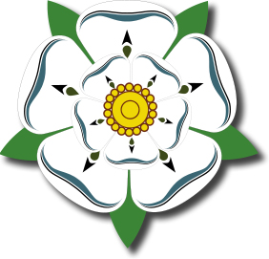](http://www.google.com/url?sa=i&rct=j&q=&esrc=s&frm=1&source=images&cd=&cad=rja&uact=8&ved=0CAcQjRxqFQoTCJCH67j288gCFcRGFAodRC0KnA&url=http://www.jewelsdujour.com/2013/05/princess-mathilde-bonapartes-vanderbilt-rose-brooch/&bvm=bv.106379543,d.d24&psig=AFQjCNF9E32BHzsdv0t4nJUaQweQKTeHnA&ust=1446628806896160)

**December 1460 will always be remembered as a tragic month for all who hold the safety and reputation of England as sacrosanct. The forces of the noble House of York were beaten ignominiously by the vile hordes of Lancastrians outside Sandal Castle.**

ED, NEW LEADER OF YORK, OUT TO AVENGE BROTHER

Lancaster outnumbered York by two men to one. Not only were the good men of York numerically inferior, but they were tricked and deceived by the wicked forces of Lancaster, who disguised themselves as the Earl of Warwick’s men to bait York and his forces from the safety of their castle.

[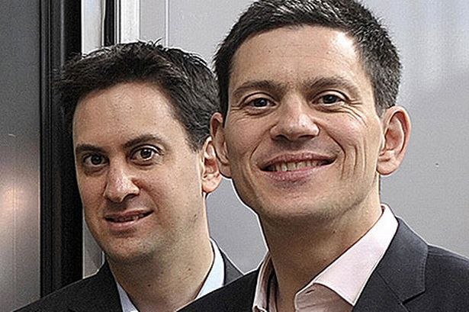](http://www.google.com/url?sa=i&rct=j&q=&esrc=s&frm=1&source=images&cd=&cad=rja&uact=8&ved=0CAcQjRxqFQoTCLCUmvf788gCFUtxFAodW2wCQQ&url=http://www.mirror.co.uk/news/uk-news/david-miliband-only-knew-eds-134328&psig=AFQjCNGkyfic7VS-ZokMVopHADaI8AIuXQ&ust=1446630287168462)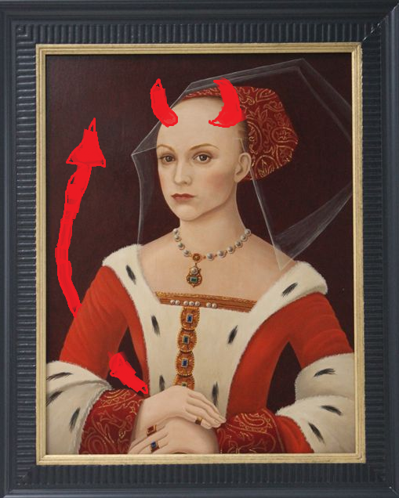Worse yet for the House of York were the deaths that befell them that wretched day. Richard, Duke of York (rightful King of England) was chopped down alongside his son Edmund and ally Salisbury.

To add insult to injury, the witch Margaret of Anjou, who claims to be Queen, put the heads of those brave, dead men on the gates of York (the Duke with a paper crown upon his head). This act of opprobrium is symptomatic of the crude and devilish ways of the House of Lancaster: the forces of the She-wolf have raped and pillaged on their march southwards and this reporter warns all men of London to lock their doors to this vile woman.

SALIS-BURIED AFTER BATTLE OF WAKEFIELD

Edward of York is to pick up the mantle of the true Yorkist King after the death of his brother and father. Ed is, as you can see, a dashing and noble prince who will serve York valiantly and gloriously. An inspiring leader of men, things are looking bright for York.

God showed his favour for Edward’s rightful claim to the throne today, on the battlefield of Towton. Outnumbered 80,000 to 33,000 on a field that contained half of all the nobility Ol’ Big Ed still triumphed.

GRAND OLD DUKE OF YORK BECOMES KING OF ALL ENGLAND…

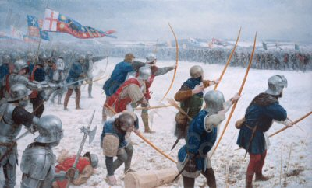

…AND MARGARET OF ANJOU WALKS 500 MILES AND 500 MORE TO FLEE TO SCOTLAND

The wind, surely sent by the almighty hand of Providence, blew the arrows of York onwards to rain a hellish blaze of misery over the infidels of Lancaster. This same gale made the arrows of Lancaster more impotent than Mad King Henry.

EDITORS: Owen Gorringe and Joseph Hettrick

Credit must also go to the Duke of Norfolk for his timely cameo to swing the balance of power even more firmly to York.

Because of this amazing victory the future of England is safe with a dazzling new King… Edward, Fourth of that name since the conquest.