**Henry VII – Foreign Policy, 1485-1509**

**Europe in 1485**

[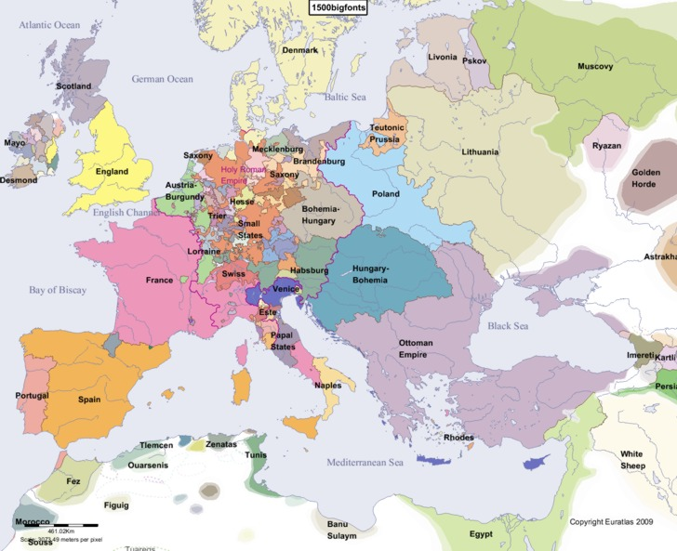](http://www.google.co.uk/url?sa=i&rct=j&q=&esrc=s&frm=1&source=images&cd=&cad=rja&uact=8&ved=0ahUKEwiVvJPoiO3KAhWKPxQKHWImBYAQjRwIBw&url=http://www.euratlas.net/history/europe/1500/&psig=AFQjCNE0ZWdsjiUetNihZzL8QMb7VITdQQ&ust=1455189324011180)

Task:1If you were in Henry VII’s position which countries would you prioritise in your foreign policy?

Who are potential threats and who are potential allies?

Use the textbook to research who are the rulers of: Spain, Scotland, Burgundy, Holy Roman Empire and France.

**Task 1 - Bearing in mind the fact that Henry VII was a usurper with a very weak claim to the throne what do you think the aims of his foreign policy would have been?**

**1:**

**2:**

**3:**

**Henry VII’s Foreign Policy, 1485-1488**

Notes from ***‘The Wars of the Roses and Henry VII: Britain 1450-1509’ – Roger Turvey***

In the first three years of his reign, Henry’s actions were deliberately designed to give him time to consolidate his position. He preferred to make truces because it was temporary, could be extended and did not tie him down to any long-term promise of commitment.

1. The French negotiated a one year truce Henry in 1485 because they had helped finance his expedition to seize the throne. This truce was extended for another three years until 1489.
2. With Scotland, Henry agreed a three year truce from 1486. The assassination of James III in 1488 and the accession of the 15 year old James IV disrupted relations but the truce held firm.
3. Brittany was not regarded as a threat, more a long term trading partner, which is why Henry was prepared to negotiate a long-term treaty rather than a temporary truce. As a consequence, the treaty signed in 1486 was more commercial that political and involved favourable trade agreements that benefited England.

Henry was playing for time. He had avoided confrontation and had established important contacts with foreign powers. However, he failed in his primary aim, which was to prevent a foreign invasion. The Simnel rebellion of 1487 had Irish and Burgundian support.

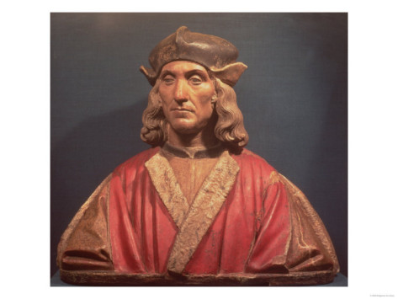

1. **Brittany and France**

France had helped to finance the expedition which led to Bosworth and Henry was initially keen to maintain good relations with her. On his accession he immediately negotiated a one year truce with France and this was later extended to January 1489.

**The first major foreign policy problem of the reign concerned Brittany and France.** France’s resources in terms of manpower and revenue were about three times those of England and the French were expansionist and aggressive. They had ambitions to take over Brittany which was an independent duchy ruled over by Duke Francis. The duke was not expected to live long and he had a daughter to succeed him The French plan was that Charles VIII of France should marry the Duke’s daughter Anne and in that way Brittany would be incorporated into the kingdom of France. The Duke was prepared to resist French plans but in 1488 a French army marched into Brittany. The Duke asked Henry for help and this put Henry in a very difficult position.

Henry felt that he ought to help Brittany.

1. He had spent most of his exile in Brittany so felt a certain amount of loyalty to the Bretons.
2. He did not wish the French to take over the area as that would mean that they would control more of the coastline facing England and so would more easily be able to launch an invasion.
3. On the other hand it had been with French help that Henry had been able to win the Battle of Bosworth and he did wish to remain on good terms with them. He had negotiated a truce with the French.
4. Henry could not afford an aggressive and expensive foreign policy whilst he was still insecure on his throne.

Therefore he compromised by sending several hundred volunteers unofficially to fight on behalf of the Bretons. In July 1488 the Bretons were decisively defeated in battle by the French. The Duke signed a treaty in which he promised that his daughter would not marry without the permission of the French king. Three weeks later he died and his daughter became Duchess at the age of 12. The French immediately claimed custody of her and it looked as if their takeover was imminent.

Henry was once again in an awkward position. The acquisition of Brittany by France would make England’s main rival even more powerful. It would give valuable bases for an invasion of England, or for the French to attack merchant ships and disrupt English trade. Yet Henry couldn’t afford war and in any case he did not want to give France an excuse to support the various claimants to the English throne. He tried to use diplomacy to save the situation by finding sufficient allies to deter the French from going to war. He renewed the peace treaty he had made with Maximilian, Duke of Burgundy in 1487, and, more importantly, he made a new alliance with Spain in the **Treaty of Medina del Campo in 1489.** A treaty was also made with Brittany at Redon in February 1489 in which the Bretons promised to pay the cost of 6,000 men Henry agreed to send to them. This was a small number and Henry was emphasising that he was only working to defend England’s interests and had no intention of taking French land.

Six thousand English soldiers were sent to defend Brittany but Henry was let down by his allies, Maximilian and Ferdinand of Spain. Finally in December 1491 the Bretons accepted defeat and the Duchess Anne was married to Charles VIII of France. Their marriage spelled the end of the independence of Brittany.

Henry was now faced with one of the most difficult decisions of his reign. He had to choose between attempting to liberate Brittany by conquering France or simply leaving Brittany to French control. **He knew that to withdraw without some show of force would appear weak and would lose him credibility at home and abroad.** He could not afford war but an aggressive move might be of benefit. It would enhance his reputation and have enough nuisance-value to persuade the French to buy him off.

In addition to this Perkin Warbeck had arrived in France by 1492 and had support from Charles VIII because of Henry’s involvement in Brittany.

Henry announced his intention to assert his claim to the French crown and in October 1492 a large force of 26,000 men crossed the Channel and besieged Boulogne. He had delayed his departure until late in the campaigning season (wars were not usually fought over the winter months) and so it did mean that if Henry had to fight then it would not be for long. He was reckoning on the fact that Charles would want to make peace as his real ambitions were to invade Italy and not to fight the English on French soil. Henry was proved right because nine days after he set foot on French soil Charles offered peace and the **Treaty of Etaples** **was agreed in 1492.**

Charles’ only concerns were to keep Brittany and get rid of Henry. He promised:

1. To give no further aid to English rebels, particularly Warbeck.
2. To pay Henry’s costs for the intervention in Brittany as well as pay an annual pension of about £5,000 a year. This was approximately 5% of the king’s annual income.

Henry had not won a glorious victory, for Brittany’s independence was lost forever and the whole of the southern side of the channel, apart from Calais, was in French hands. However there were some positive achievements:

1. He had prevented Charles Vlll from helping Perkin Warbeck.
2. He had secured a sizeable annual pension from the French.
3. He had made a valuable alliance with Spain (Treaty of Medina del Campo, 1489).
4. He had shown that England under a Tudor king could not be completely overlooked in continental affairs.

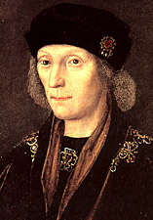**Task 2**

1. How was Henry’s involvement in France different from that of his predecessors?
2. List the successes and failures of the campaign.
3. Was the outcome brought about by the successes of Henry’s policies or by circumstances?
4. What do these events tell us about Henry’s skills and objectives in foreign policy?
5. **Spain, The Treaty of Medina del Campo (1489) and the marriage alliance (1501)**

Notes from ***‘The Wars of the Roses and Henry VII: Britain 1450-1509’*** – Roger Turvey

Both Spain and England shared an enmity with France.

Spain was a major European country especially after the marriage between Isabella of Castile and Ferdinand of Aragon. This strengthened the country and made their rulers very well respected. The Spanish ruling family was one of the oldest royal families in Europe and so it was a considerable achievement for Henry VII to marry his son to Catherine of Aragon bearing in mind that Henry VII was a usurper with a very weak claim to the throne.

It was early in 1488 that Henry suggested a marriage between his eldest son, Prince Arthur, and Ferdinand and Isabella’s daughter, Catherine of Aragon. The negotiations lasted a long time but eventually the **Treaty of Medina del Campo** was agreed in 1489.

1. Spain would offer no aid to any English rebels or pretenders to the English throne.
2. Catherine’s dowry would be double that initially offered. The Spanish agreed to pay 100,000 crowns.
3. Both nations became trading partners.
4. If either country found itself with war with France, the other was to intervene immediately.

The Spanish did little to help Henry in his efforts to secure Brittany’s independence but Henry seemed satisfied with his relationship with Spain and continued his pro-Spanish policy throughout his reign.

The alliance with Spain was finalised in November 1501 with the marriage between Prince Arthur and Catherine of Aragon. Following Arthur’s death in April 1502, Henry entered into fresh negotiations to keep the alliance and in September 1502 it was agreed that Catherine should marry Prince Henry.

In 1504 Isabella of Castile died. She left her country to her eldest daughter, Joanna, who was married to Philip, Archduke of Burgundy. Her death therefore deprived Ferdinand of much of his power and influence as his kingdom of Aragon was much smaller and poorer than Castile.

Consequently, Henry VII was not so anxious to maintain a marriage alliance between the two countries and so he claimed that the proposed marriage between Catherine and Prince Henry could not be justified as his son was under age at the time of the agreement. This led Ferdinand to make an alliance with Louis XII of France and he married the French king’s niece in 1506.

Philip of Burgundy and Joanna were on their way to Castile in 1506 when they were forced by storms to land at Weymouth. Henry VII entertained them in England for three months during which time he negotiated the Treaty of Windsor. Philip agreed to return the Earl of Suffolk, Edmund de la Pole, to England and to make a trade agreement. The trade agreement came to be known as the ‘Malus Intercursus’ (the ‘evil settlement’) because it was so favourable to English merchants and not to the Burgundians. In return, Henry recognised Philip and Joanna as King and Queen of Castile and agreed to help them financially to gain control of their kingdom.

Philip reached Spain but died there later in 1506. Joanna apparently became mad with grief and this gave Ferdinand the opportunity to take over the regency of Castile and so regain control there. As he was now in a much stronger political position, Henry VII was now keen for the marriage between Catherine of Aragon and Prince Henry to take place. However, Ferdinand was content with his French alliance and did not need English support.

Henry therefore tried to make marriage alliances for himself and his son with Burgundy and with France in an attempt to isolate Ferdinand, but he achieved nothing and in fact was side-lined as the centre of international affairs was now in Italy.

**Task 3** - Why was the Treaty of Medina del Campo such an achievement for Henry VII? (Think about his foreign policy aims.)

1. **England’s Relations with Burgundy**

(*Notes from Flagship History,* ***England 1485-1603***)

Burgundy (also referred to as the Netherlands or the Low Countries) was essential to England’s economy as the chief trading partner. Woollen cloth was England’s major export and the chief market for this was Burgundy where both English wool and woollen cloth were finished off into good quality textiles.

Nevertheless, Margaret of Burgundy (Dowager Duchess and sister to Edward lV and Richard lll) was a constant supporter of Yorkist plots against Henry. Her son-in-law, Maximilian, who ruled Burgundy for his son Philip in the 1480s and early 1490s, was also untrustworthy and was prepared to plot against Henry if it was in his best interests to do so.

In 1493 Philip took over direct rule of Burgundy when Maximilian became Holy Roman Emperor. Henry protested to Philip over Margaret of Burgundy’s support for Perkin Warbeck. Philip disregarded Henry’s protests and so Henry retaliated by placing an **embargo** on trade. This meant that all ships were forbidden to trade with Burgundy.

**This action was very damaging to both countries but it is clear that Henry’s priority was the safety of his throne and that England’s economy was of secondary importance to him.**

The embargo lasted from **1493 until 1496**. Warbeck had left Burgundy in 1495 and so the two sides could reach an agreement.

The **Magnus Intercursus** (Great Settlement) removed all the barriers between the two countries and trade improved.

However, diplomatic relations between Philip, Maximilian and Henry remained difficult (see notes on **Relations with Spain** and remember that Philip supported Edmund de la Pole).

**Task 4**

1. What do you understand by the term trade embargo?
2. What does the fact that henry imposed an embargo tell us about his priorities?
3. When and why did the embargo come to an end?
4. **Scotland**

[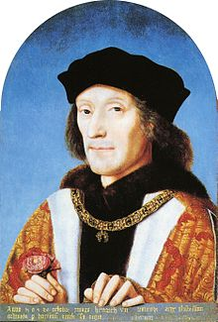](http://www.google.co.uk/url?sa=i&rct=j&q=Henry+VII&source=images&cd=&cad=rja&docid=ZQ6epjpVknVSiM&tbnid=p_3wiJYbrxFvfM:&ved=0CAUQjRw&url=http://en.wikipedia.org/wiki/Henry_VII_of_England&ei=7JYwUZPGMoaH0AW9v4HgDQ&bvm=bv.43148975,d.d2k&psig=AFQjCNG3YvqGvQUILQRb7QDhO7EQ_6wLGA&ust=1362225084079207)*(Notes from Flagship History,* ***England 1485-1603****)*

Anglo-Scottish relations were traditionally difficult but in 1486 neither Henry VII nor James III wanted trouble and so a three year truce was agreed. However, in1488 James III was assassinated and he was succeeded by the 15 year old James IV. The men ruling Scotland on behalf of the young king and in fact James IV himself were hostile to the English and keen to maintain the ‘auld alliance’ with France. Henry viewed this as a threat to England.

James IV wanted war and the arrival of Perkin Warbeck in Scotland in 1495 encouraged him. It is uncertain how far, if at all, James was taken in by Warbeck but he gave him a generous pension and married him to his cousin, Katherine Gordon. These actions greatly offended Henry and endangered his proposed marriage alliance with Spain. Ferdinand and Isabella were reluctant to allow their daughter Catherine of Aragon to travel to England to marry Prince Arthur when the Tudor dynasty still seemed so insecure.

In 1496 James IV launched a massive border raid into England with Warbeck but it achieved nothing as Warbeck received no support there. (N.B. This raid is indirectly linked with the Cornish rebellion of 1497.)

By the autumn of 1497 James IV was ready to make peace with Henry and made the Truce of Ayton. James agreed not to attack England but he maintained the French alliance.

The Truce of Ayton was a great achievement for Henry as there had been no worthwhile treaty between England and Scotland since 1328. This truce, a temporary agreement to peace, only became a full treaty of peace after Warbeck’s execution in 1499. It was finally confirmed in 1502 and was badly misnamed the ‘Treaty of Perpetual Peace’. Henry’s efforts were completed with the marriage of his daughter Margaret to James IV in 1503. This marriage was to have far reaching consequences for the English monarchy and was a notable achievement for Henry as another sign that the Tudors were acceptable to other kings.

From 1497 Henry VII enjoyed peace with Scotland but the continued Scottish friendship with France remained. This was always seen as a potential threat leaving England open to invasion through the ‘back door’ i.e. her northern border with Scotland.

**Task 5**

1. Why was Scotland seen as a threat by Henry?
2. Why was 1496 such a difficult year for Henry?
3. What was the significance of the Truce of Ayton? Consider Henry VII’s foreign policy aims.
4. What was the significance of the marriage alliance between James IV and Margaret? (Again consider Henry’s foreign policy aims).

**The Final Years**

Notes from ***‘The Wars of the Roses and Henry VII: Britain 1450-1509’*** – Roger Turvey

After 1502 and following the deaths of Prince Arthur (1502) and Elizabeth (1503) Henry’s foreign policy became less effective and Henry’s health began to decline. England became increasingly isolated in Europe and it was at this time that Edmund de la Pole fled abroad. Pole’s intentions were to revive the Yorkist claim to the throne and to seek foreign aid against Henry. Although he failed to do this (Treaty of Windsor, 1506) he certainly added to Henry’s concerns.

Henry’s desire to safeguard his dynasty led to him considering the possibility of remarrying even considering Joanna of Castile, widow of Philip of Burgundy and daughter of Ferdinand of Aragon. In the event he never did remarry.

By this time, Ferdinand had turned against Henry. Ferdinand had opposed Henry’s support of his son-in- law’s, Philip of Burgundy’s, claim to Castile and was definitely against Henry’s later consideration of marriage to Joanna after Philip’s death in 1506 as this would give Henry himself a claim to Castile through his wife.

Henry persuaded Louis XII of France to join him in an alliance against Ferdinand and the League of Cambrai was initially formed as an anti-Spanish alliance. However just before the treaty was signed, Louis XII changed his mind and decided not to join with Henry. When the League of Cambrai was formally agreed and the treaty signed in December 1508 it was an alliance against Venice between the Pope, Louis XII, Maximilian and Ferdinand. Henry was left isolated although England’s interests were not in danger since the members of the league were focused on Italy.

In the final analysis, Henry’s death came at a time when his foreign policy was in danger of collapse because it was bereft of ideas.

**Task 6** – Complete the timeline on GOL and then upload it for marking.

*Colour code your entries in the table so that you can easily distinguish which of the four main areas the events relate to – Brittany and France, Spain, Burgundy, Scotland.*

**Task 7** - Complete the Foreign Policy chart on GOL. This will provide you with a good summary. Upload for marking when you have finished.

**Task 8**

|  |  |  |
| --- | --- | --- |
| **DESCRIPTION OF HENRY VII’S FOREIGN POLICY** | **EVIDENCE FOR** | **EVIDENCE AGAINST** |
| Cautious/wary |  |  |
| Defensive |  |  |
| Pragmatic  Practical/sensible |  |  |
| Realistic |  |  |
| Forward thinking/  Strategically sound |  |  |
| Unambitious |  |  |
| Opportunistic |  |  |
| INSERT YOUR OWN DESCRIPTION HERE! |  |  |

**Past exam questions**

To what extent was Henry VII’s foreign policy a success?

“Marriage agreements were the most successful part of Henry VII’s foreign policy” How far do you agree with this statement?

How successful was Henry VII in achieving his foreign policy aims?

“The avoidance of war was the most important aim of Henry VII’s foreign policy.” How far do you agree with this statement?

“Henry VII’s foreign policy achieved little” How far do you agree with this statement?

“The need to secure his throne his throne dominated the foreign policy of Henry VII.” How far do you agree with this statement?