Henry VII Securing the Kingdom and Dealing with Rebellions

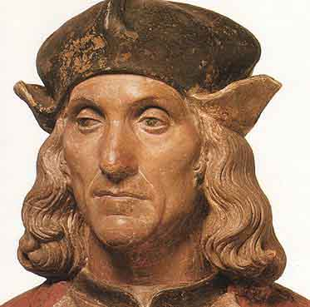

**Past exam questions and further reading – Page 2**

**Henry Tudor’s early life – Page 3**

**Reasons for Henry Tudor’s victory at Bosworth: Pages 4 - 5**

**Winter King questions - Page 6**

**Henry’s actions following Bosworth – Page 7**

**Rebel roleplay – Page 8**

**Overview of the rebellions – Pages 9 - 11**

**Lovell’s rising – Page 11**

**Danger levels of the rebellions: 12**

**Simnel and Warbeck – Pages 13 – 16**

**De La Pole the Earl of Suffolk – Page 17**

**Jez Ross article on the rebellions: Pages 18 - 22**

**Old OCR exam questions on rebellions and securing the throne**

How effective was Henry VII in dealing with the Yorkist challenges to his Throne? (2009)

How effectively did Henry VII deal with England’s domestic problems (2010 Also Nobility and Finance topic)

How serious a threat to Henry’s rule was the Yorkist challenge? (2010 June)

How successfully did Henry VII deal with the problem of the Yorkists (Jan 2012)

How successfully did Henry deal with the domestic problems he faced?

How dangerous were Yorkist plots to Henry VII (Jan 2013)

**Edexcel Spec questions (not your exam board but it gives you an idea of other issues which could possibly be addressed)**

How accurate is it to say that the Yorkists remained a serious threat to Henry VII’s

security throughout his reign?

How far had Henry VII consolidated his hold on the throne by 1489?

How accurate is it to say that Lambert Simnel and Perkin Warbeck were both serious

threats to Henry VII’s security?

How accurate is it to say that Henry VII’s weak claim to the throne was the most

important reason for the rebellions and challenges that were mounted against him?

**Further Reading**

Nicholas Fellows – England 1445 – 1509 Lancastrians Yorkists and Henry VII (OCR textbook

Thomas Penn – Winter King

Roger Turvey – Lancastrians, Yorkists and the Wars of the Roses

David Rogerson – The Early Tudors

Colin Pendrill – The Wars of the Roses and Henry VII

Derrick Murphy – England 1485 – 1509

**HENRY TUDOR’S EARLY LIFE AND THE STAGES BY WHICH HE BECAME KING**

|  |  |
| --- | --- |
| 1457 | Henry Tudor was born in Pembroke, North Wales. His father had been captured by Yorkists and had died in prison a couple of months before his birth and his mother, Margaret Beaufort, was only 13 years old. Henry and his mother were cared for by his uncle, Jasper Tudor. |
| 1461 | At the age of four Henry was placed in the care of William Herbert, a Yorkist supporter.  *Consider who was king at the time and the reasons why Henry, a Lancastrian, should be placed in the care of a Yorkist.* |
| 1471 | Henry Vl died and Henry Tudor fled to Brittany.  *Why had Henry Tudor’s position now become so dangerous that he had to leave the country?* |
| 1483 | Richard lll was King of England by this time but there were many amongst the nobility who were no longer prepared to support him.  *What had Richard done which made him increasingly unpopular in the country?*  The Duke of Buckingham wrote to Henry and encouraged him to invade England from Brittany and take the crown from Richard lll. Henry attempted this whilst Buckingham and his allies rebelled at home. The attempt failed. Buckingham was arrested and executed and Henry returned to Brittany having not even landed in England. However Henry continued to gain more and more support from English nobles and he declared that if he became King he would marry the daughter of Edward lV.  *How would this help him win even more support and what other advantages would it bring?* |
| 1485 | Richard lll attempted to capture Henry when the Duke of Brittany became ill. Henry learnt of the plan and escaped to France. The King of France, Charles Vlll, gave him money, a fleet of ships and some mercenary soldiers which he could use to invade England.  *What reasons would there be for the French King to support a rival for the English crown?* |
| August,  1485 | On 1st August, Henry’s small fleet of ships set sail from France; they landed on the Welsh coast a week later.  On the 22nd August Henry met Richard lll at Bosworth and a battle was fought there. Henry’s army was only about half the size of Richard’s and Henry had never led an army into battle before, but against all the odds he won. Richard lll was killed and Henry became King Henry Vll. |

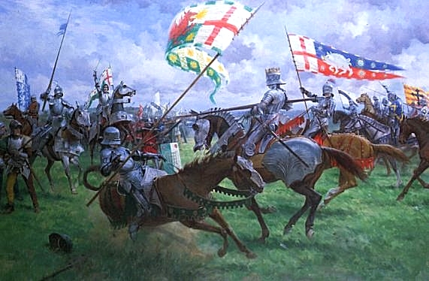

**REASONS FOR HENRY TUDOR’S VICTORY AT BOSWORTH IN 1485**

In 1485 Richard lll was the crowned king of England; he had a good position on the battlefield at Bosworth and a much larger army than the challenger, Henry Tudor. The latter had a weak claim to the throne and spent almost all his early life in exile so he was virtually unknown to the English nobility so why was he able to seize the crown in 1485?

1. **Richard lll’s claim to the throne was never generally accepted.**

Edward V was only 12 years old in 1483 and it was easy for Richard to keep him and his brother in the Tower of London and to seize the throne. Richard claimed that they were illegitimate because their father had been precontracted to marry Eleanor Butler and so was not free to marry their mother Elizabeth Woodville. If this argument were accepted it would mean that Richard himself was the rightful heir of Edward lV. Most people did not believe this story.

1. **Richard lll had an evil reputation**.

He executed his own former supporters and relatives of Edward V. Lord Hastings, Earl Rivers, Sir Thomas Grey and the Duke of Buckingham all died without a trial.

He was considered by many to be a usurper and in addition he was suspected of murdering his two young nephews.

1. **Richard lll was unpopular in the South.**

He spent most of his life, up to 1483, in the North. Most of his supporters were therefore from the midlands and the North and the southerners’ resentment of this was shown by the fact that rebellion broke out in every county south of London in the autumn of 1483. Richard retaliated by giving land and power to his northern supporters in the South. This made him even more unpopular.

As far as we know no southern nobles fought for Richard at Bosworth.

1. **Richard lll was not supported by the nobility**.

Richard is supposed to have been very popular in the North yet the two most powerful northern families, The Stanleys and the Percies failed to support him at Bosworth.

1. **Lack of loyalty and treachery on the battlefield at Bosworth**

At a decisive point in the battle Sir William Stanley intervened on Henry Tudor’s side.

1. **Richard lll’s strategic errors on the battlefield**.

At a crucial stage in the battle Richard left his vantage point on the top of Ambien Hill. This made him vulnerable.

1. **Legacy of the Wars of the Roses.**

After 30 years of civil conflict fewer than half of the English nobility and gentry were prepared to commit themselves to either side. Respect and loyalty to the monarch had declined since the 1450s. The crown was weak and could not command the loyalty of the nobility. There had been frequent changes of monarch in recent years.

1. **Henry Tudor had French support**.

Charles Vlll of France gave Henry the money and the army he needed to invade England in 1485. Henry attracted little English support before Bosworth as most nobles refused to commit themselves until they knew who had won so his army was mainly French.

1. **Henry Tudor had some Yorkist support.**

He had promised to marry Elizabeth of York, the daughter of Edward lV, once he was king. Other Yorkists joined him.

1. **Henry Tudor had a claim to the throne**.

He was the only surviving male heir. His claim was very weak but all other male Lancastrians were dead.

1. **Richard lll was killed during the battle.**

Of those who were loyal to Richard many were also killed including the Duke of Norfolk.

**Task 1**

* Put this list of reasons for Henry Tudor’s victory in order of priority and explain your choices.
* Divide the list into long term factors and short term factors.

**Thomas Penn Winter King Estream 9099: Up to 21 mins**

[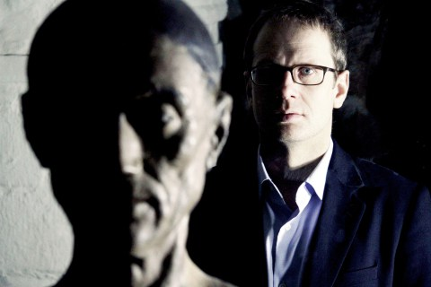](http://www.google.co.uk/url?sa=i&rct=j&q=&esrc=s&source=images&cd=&cad=rja&uact=8&ved=0ahUKEwiQiZDatqvKAhUJbBoKHWGEDVIQjRwIBw&url=http://www.thetudorbookblog.com/2013/06/two-reviews-for-penns-henry-vii-winter.html&psig=AFQjCNGgeKeElzYV3yQKU2hAR9Rdv44Ehw&ust=1452933891466737)

1: Where did Henry Tudor land with his Army?

2: Why did he chose this location?

3: Where did he head next?

4: What was the name of the place where his Army met Richard’s?

5: What was the significance of the Stanley family in the battle?

6: What happened to Richard?

7: What would Henry struggle to do for the rest of his life?

8: When was Henry crowned king?

9: How did Henry use parliament to rewrite history and make his position more secure?

10: What did this mean for those who fought against him?

11: Who did Henry now marry?

12: Why was this important?

**Task 2: HENRY Vll’S FIRST STEPS TO SECURE THE THRONE**

|  |  |  |
| --- | --- | --- |
| **DATE** | **ACTION** | **SIGNIFICANCE** |
| **21st August 1485** | Henry declared that his reign had begun the day before the Battle of Bosworth. |  |
| **30th October, 1485** | This was the date of Henry’s coronation ceremony. Only after this did he summon Parliament. |  |
| **From August 1485 onwards** | Henry restored Lancastrian nobles who had lost land and titles under Richard lll. |  |
| **January 1485** | Henry married Elizabeth of York. |  |
| **Spring 1486** | Henry went on a progress to the North of the country. |  |
| **September**  **1486** | Prince Arthur was born. |  |

**Task 3**

**If you were involved in the planning of a rebellion against Henry VII what would you consider to be essential to your success?**

|  |  |
| --- | --- |
| **1** |  |
| **2** |  |
| **3** |  |
| **4** |  |
| **5** |  |
| **6** |  |
| **7** |  |
| **8** |  |

**Henry VII, security and rebellions; Brief overview of the key events:**

**Bosworth 1485**

Although Henry had won the throne in battle his claim was weak and he faced a number of challenges to his rule. He took some steps to help consolidate his power. These included marrying Elizabeth of York (Jan 1486), having a son (Arthur Sept 1486), locking the young earl of Warwick in the Tower (due to his claim to the throne), replacing the closest of Richard’s advisors on the council but keeping the majority the same, getting the backing of the pope and declaring his reign started one day before the battle to legitimise himself and put pressure on those who fought against him. Nevertheless it was not long before Henry faced problems.

**1486 Lovell and the Staffords**

Since the defeat at Bosworth Lord Lovell and the Stafford brothers had been in sanctuary with the church in Colchester. When Henry went on a royal progress in the north in spring 1486 the conspirators broke sanctuary. Lovell headed north to ambush the king and the Stafford brothers travelled to Worcester to stir up a rebellion. Henry learnt about the rising and sent an armed force to confront Lovell. His rebels dispersed and he fled to Burgundy. The Stafford brothers were captured. Humphrey was executed but the younger Thomas was pardoned and stayed loyal thereafter. Henry’s policy was to be strict with the ringleaders but pardon the followers.

**1487 Simnel**

[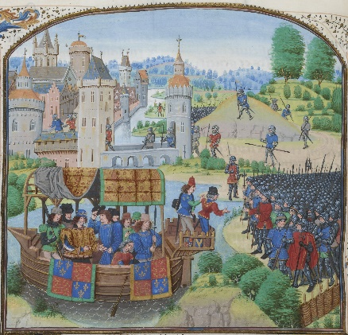](https://www.google.co.uk/url?sa=i&rct=j&q=&esrc=s&source=images&cd=&cad=rja&uact=8&ved=0ahUKEwjF_LSYuKvKAhUEfxoKHeE2CpUQjRwIBw&url=https://en.wikipedia.org/wiki/Economics_of_English_towns_and_trade_in_the_Middle_Ages&bvm=bv.112064104,d.d2s&psig=AFQjCNE-zGxI2W3PDH9IHadwTlzZHwZuow&ust=1452934291622479)The plot seems to have originated from Simnel having a resemblance to the young sons of Edward IV. However as this failed to take off he then impersonated the young Earl of Warwick imprisoned in the tower. Funded by sympathetic Yorkists Simnel was sent to Ireland. (This had been a Yorkist stronghold since Richard Duke of York had been Lord Lieutenant there in the 1450s.) The Earl of Kildare and some other prominent Irish leaders seem to have decided to take advantage of the situation and proclaimed Simnel king in Dublin. Edward IV’s sister, Margaret of Burgundy, then took advantage of this sending a force of 2000 German mercenaries to Ireland. Henry displayed the real Warwick in London to try to diffuse the situation but the damage had been done. By May 1487 other Yorkists like Lincoln had fled to join Lovell in Burgundy. Lovell and Lincoln then joined the mercenaries in Ireland. This led to the battle of **Stoke** in 1487 Henry had 12000 men and the rebels 8000. Henry won however the battle highlighted the danger to him. Simnel was pardoned and put to work in the kitchen. (probably because he was 10 and recognised as a Yorkist pawn.) Lincoln died and Lovell disappeared (probably killed). Simnel was a danger as there were still other heirs to the throne around. The army itself was defeated fairly easily but it could have been very different. However by pardoning Simnel and playing this down Henry did not create a martyr or focal point for other rebels.

**1489 The northern tax rebellion.**

In 1489 Henry was trying to raise money to deal with the Brittany situation. People in Yorkshire and Durham refused probably because they saw Brittany as a southern problem and the Earl of Northumberland was murdered while trying to enforce the payment. The ringleaders of this rebellion were some former supporters of Richard III formed around Sir John Egremont. Henry and the earl of Surrey rode north, the ringleaders were hanged however Egremont fled to Burgundy.

**Warbeck 1491 – 1499**

Warbeck was a danger mostly due to the length of time he was at large and his foreign support. He showed that it took time for those who stood against Henry to give up on thoughts of restarting the civil war. However most historians would either see Bosworth in 1485 or Stoke in 1487 as the last battles of the Wars of the Roses.

1491 – Warbeck arrived in Ireland and claimed to be Richard Duke of York. Evidence is scarce but some historians have suggested that the key player backing him was Margaret of Burgundy. However most Irish lords refused to back him (had Henry taught them a lesson with Simnel?) so Warbeck traveled to France when Henry sent troops to Ireland.

1492 – Warbeck was in France with Charles, however Henry dealt with this in the Treaty of Etaples so Warbeck fled to Burgundy.

1493 – 1495 Warbeck was in Burgundy. This prompted Henry to announce a trade embargo in 1493. During this time however Warbeck was recognised by the new Holy Roman Emperor Maximilian, further evidence the main danger from Warbeck was his foreign links.

1495 Warbeck Landed at deal in Kent, failed to get support and fled to Ireland and then Scotland. James IV married Warbeck to his cousin Lady Catherine Gorden and supported an unsuccessful invasion of England.

1497 Truce of Ayton was signed by Henry with Scotland so Warbeck landed in Cornwall via Ireland to try to profit from the Cornish Rebellion. However he received little support and was captured.

1499 Warbeck was executed for treason. Henry also executed Warwick at the same time for conspiring with Warbeck. This may be true, or opportunism by Henry.

Stanley Radcliffe and Fitzwalter 1495

Henry’s intelligence network identified the above as plotting treason. Henry was probably particularly sensitive at this time due to Warbeck. All three were executed. William Stanley in particular is surprising as his help had probably saved Henry at Bosworth. Records show that he said “if Warbeck was Edward IV’s son he would not take up arms against him”. This could be used as evidence for Henry seeing the Warbeck plot as serious.

Cornwall 1497

In some ways the geographical reverse of the northern tax rebellion Cornwall was a refusal by those in the 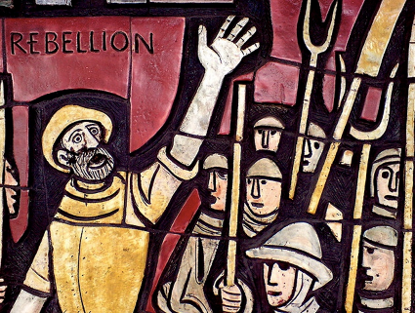south west to finance war with Scotland over Warbeck’s invasion. Some 15000 rebels reached London and were confronted by the Earl of Oxford. The leaders were executed and the rest treated with clemency. This was not as direct a threat to Henry as events like Stoke, however it did act as a reminder that he needed to take care in his foreign policy.

De La Pole 1499 - 1506

Following Warwick’s execution in 1499 the only remaining Yorkist with a reasonable claim to the throne was Edmund de la Pole Earl of Suffolk. As the brother of the Earl of Lincoln (killed at stoke) he was treated with suspicion. He fled to Burgundy in 1499. It is not clear what prompted this, possibly something surrounding Warbeck or Warwick, however it seems to have surprised Henry as well. Henry persuaded Suffolk to return (an example of ‘keep your enemies closer’ perhaps?). Nevertheless Suffolk fled again in 1501. This time Henry acted more decisively and imprisoned Suffolk’s relations in England and in 1504 passed acts of attainder on those with links to him. As part of the Treaty of Windsor in 1506 Henry got Suffolk back from Burgundy in return for a promise not to harm him. Henry VII kept this promise however Henry VIII had him executed in 1513.

Therefore it was not really until 1506 that the Yorkist threats were effectively ended. However there are levels of threat and, arguably, after Stoke the immediate threats were gone and after Warbeck and Warwick’s execution the most persistent threats were ended.

**MINOR RISING, 1486**

Henry Vll faced a minor rising within months of his accession.

Since Bosworth, Francis Lord Lovell, one of Richard lll’s most loyal supporters, and the Stafford brothers, Thomas and Humphrey, had been in sanctuary at Colchester. (Sanctuary is the Church’s protection from the law.)

As Henry travelled North on his progress in April 1486, they broke sanctuary in order to raise rebellion. Lovell headed north and the Staffords travelled westwards to Worcester. Henry sent an armed force to meet Lovell and the rebels dispersed. Lovell fled to Burgundy which was a centre of Yorkist support as Edward lV’s and Richard lll’s sister Margaret was married to the Duke of Burgundy. The Staffords went into sanctuary again but this time they were arrested and sent to the Tower. Humphrey was executed but Thomas was pardoned and remained loyal for the rest of his life. This was an example of Henry calculating the value of showing mercy to some individuals.

***What do you learn about the state of England from this rising?***

***Measure this rising against your list of key ingredients for a successful rebellion and give it a mark out of 10 for the level of danger it posed to Henry Vll. 10 indicates a very high level of danger.***

**Danger levels of each rebellion**

For a rebellion to succeed certain factors need to be in place. Use the Grid like this on GOL to evaluate the extent to which these were indeed in evidence for each rebellion Henry faced.

|  |  |  |  |  |  |
| --- | --- | --- | --- | --- | --- |
| **For a rebellion to succeed you need:** | The Lovell rebellion (1486) | Lambert Simnel’s rebellion (1487) | Tax riots in Yorkshire (1489) | Perkin Warbeck’s rebellion (1491-9) | Cornish revolt (1497) |
| 1. An army |  |  |  |  |  |
| 1. Foreign backing |  |  |  |  |  |
| 1. A good claim |  |  |  |  |  |
| 1. The support of the Church |  |  |  |  |  |
| 1. Acceptance and support from nobles. |  |  |  |  |  |
| 1. Discontent with the current ruler. |  |  |  |  |  |
| 1. Luck |  |  |  |  |  |
| **Totals** |  |  |  |  |  |

**Lambert Simnel**

Oxford was traditionally Yorkist and a priest there, 28 year old Richard Symonds noticed a striking resemblance between one of his pupils and the murdered sons of Edward IV. Initially he thought the ten year old Lambert Simnel, son of an organ maker, should pretend to be Richard the younger of the two, but rumors emerged that the Earl of Warwick had died in the Tower and Symonds decided that might be an easier impersonation.

Symonds took Simnel to Ireland where he was crowned in Dublin. The pretender was supplied by Edward IV’s sister, Margaret, Dowager Duchess of Burgundy, with a force of 2,000 German soldiers. (note Ireland and Burgundy acting in a hostile fashion to Henry’s government).

Henry reacted by displaying the real Earl of Warwick in London, arresting a few Yorkist nobles and putting his mother-in-law in a nunnery. He failed to catch John de la Pole, who despite his vows of loyalty, fled to join Lovell at Margaret’s court in Burgundy. He knew Simnel was a fraud but possibly he judged that they would win and then he could put his own claim forward.

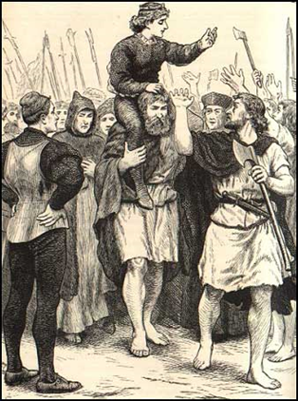

The invaders arrived in Lancashire and marched south, but got substantially less support than they had expected. People were fed up with fighting and wanted to give Henry a chance. On 16th June 1487 Lincoln’s force, numbering about 8,000 met up with Henry’s force of about 12,000 near Stoke. The trained Germans and daredevil Irish gave the royal troops a hard time, but after three hours the Yorkists were divided and surrounded. Lincoln was killed, and Lovel probably was as he was never seen again. Symonds and Simnel were and Symonds was sentenced to life imprisonment in a bishop’s prison out of respect for his clerical position. Simnel was made turnspit in the royal kitchen and later promoted to become the king’s falconer as a reward for his good service.

**The Career of Perkin Warbeck**

**Track Warbeck’s travels on this map**

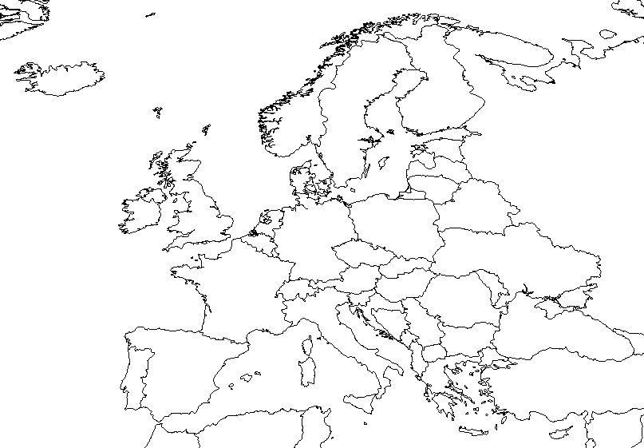

***Complete the table and then answer the questions which follow.***

|  |  |  |  |
| --- | --- | --- | --- |
| **Date** | **Location** | **What support did Warbeck receive and why?** | **Henry VII’s reaction** |
|  |  |  |  |
|  |  |  |  |
|  |  |  |  |
|  |  |  |  |
|  |  |  |  |
|  |  |  |  |
|  |  |  |  |

1. What methods did Henry use to prevent support for Warbeck developing?
2. Where did the most long lasting support for Warbeck come from? Why?
3. What do you consider the best evidence for Henry’s concern over the dangers from Warbeck?
4. Does Henry’s conduct of foreign policy to 1499 suggest that he was following a preconceived plan or that he was simply reacting to events?

**Debate – Simnel v Warbeck; Who was the greater threat to Henry Vll?**

|  |  |  |
| --- | --- | --- |
| **Simnel** | **Factors for debate** | **Warbeck** |
|  | A strong cause which would unite the rebels |  |
|  | A charismatic leader with a strong, genuine claim to the throne. |  |
|  | Support from the nobility |  |
|  | Foreign support |  |
|  | Money and financial backing |  |
|  | Arms, weapons |  |
|  | Organisation and good strategy |  |
|  | Dislike, disapproval of current ruler. |  |
|  | Any other factors. |  |

**The Earl of Suffolk**

Edmund De La Pole, Earl of Suffolk

Following Warwick’s execution in 1499 the only remaining Yorkist with a reasonable claim to the throne was Edmund de la Pole, Earl of Suffolk. As the brother of the Earl of Lincoln (killed at Stoke) he was treated with suspicion and he fled to Burgundy in 1499. It is not clear what prompted this (possibly something surrounding Warbeck or Warwick) however it seems to have surprised Henry as well. Henry persuaded Suffolk to return (an example of ‘keep your enemies closer’ perhaps). Nevertheless Suffolk fled again in 1501. His brother Richard went with him and they sought refuge with the Emperor Maximilian in Burgundy. This time Henry acted more decisively and imprisoned Suffolk’s relations in England and in 1504 passed acts of attainder against those with links to him. In 1506 a storm forced Archduke Philip of Burgundy (Maximilian’s son) and his wife, Joanna of Castile, to take shelter in Weymouth, Dorset. Henry made the Treaty of Windsor with Philip and Suffolk was returned from Burgundy in return for a promise not to harm him. Henry agreed to support Philip in his attempt to become King of Castile. Henry VII kept this promise regarding Suffolk however Henry VIII had him executed in 1513.

Therefore it was not really until 1506 that the Yorkists’ threats were effectively ended. However there are levels of threat and, arguably, after Stoke the immediate threats were gone and after Warbeck and Warwick’s execution the most persistent threats were ended.

**Task 11 - Deaths in the Family**

|  |  |  |
| --- | --- | --- |
| **Date** | **Event** | **Significance** |
| 1500 | Henry Vll’s third son, Edmund died |  |
| 1502 | Prince Arthur died. Prince Henry was only 10 years  old |  |
| 1503 | Queen Elizabeth died |  |

**Henry VII, Pretenders and Rebellions by Jez Ross | Published in History Review2012**

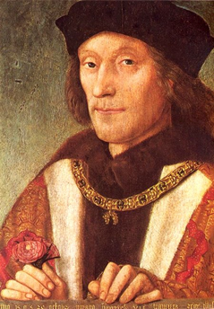

**Jez Ross argues that Henry VII was more secure than he realised**

Henry VII was never in serious danger of losing his throne to either a rebellion or a conspiracy. For either of these to succeed, a combination of specific circumstances would have been necessary. First, those seeking the throne needed to be credible and viable alternatives to him. Second, Henry VII had to be isolated and there needed to be enough domestic support for an invasion to ensure that it did not look like a self-interested act of political speculation by either foreign powers or isolated English malcontents. Third, foreign powers possessed of the requisite military and financial muscle had to be prepared to support an invasion. These circumstances never fully materialised.

**The Claimants**

For Henry VII to be seriously threatened by any of the challenges he faced, these needed to be mounted in support of a viable alternative claimant. Viability in this context does not just mean having a decent claim to the throne. After all, Henry VII had a weak claim and he still succeeded in taking the throne in 1485. In fact, historians tend to set too much store by Henry’s weak claim in terms of measuring his security in 1485-87 and have overlooked what really made the difference for him. This was the fact that he was not the political pawn of a narrow self-interested clique as were Lambert Simnel and Perkin Warbeck (both of whom served the narrow interests of die-hard Yorkists out of step with the prevailing political mood of reconciliation).

Instead, Henry Tudor was the embodiment of the rapprochement between York and Lancaster and the means by which the unpopular Richard III could be overthrown. Hence Henry’s political importance transcended the weakness of his claim. This is not, of course, to argue that he won the backing of the entire political nation; but he did win vital support from Lancastrians and most of Edward IV’s supporters. This was important both in mobilising the crucial military support en route to Bosworth which brought him victory there and in terms of securing the regime upon sufficiently broad support amongst the political nation in the subsequent short and long term. Of course, for the rest of his reign he remained a usurper with limited claim on the natural obedience owed to the legitimate monarch by his nobility (on which, with a very few obvious exceptions, even as disastrous and incompetent a king as Henry VI could rely). However, this did not necessarily make him vulnerable, even in the early years of his reign. The point needs to be remembered that, unlike Edward IV in 1461 and, most obviously, Richard III in 1483, Henry VII did not overthrow a ‘legitimate’ monarch but, rather, another usurper and, indeed, one whose means of seizing the throne was conspicuous for its bloodletting even in an age weaned on violence.

So, Henry’s role in 1485 was very different from that played by pretenders such as Simnel in 1486-87 and Warbeck in 1491-97. They were clearly political pawns (albeit that Warbeck quickly became a free agent) in the hands of ambitious politicians (John de la Pole, earl of Lincoln, and Sir William Stanley) or unscrupulous foreign powers (Margaret of Burgundy, Maximilian of Habsburg and James IV of Scotland). In other words, their role was nothing more than to satisfy the dubious interests of their backers: they were certainly not the means by which erstwhile enemies could be reconciled and a regicidal usurper could be ousted.

Henry VII’s Popularity

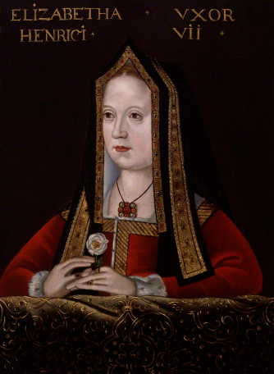The first Tudor monarch was never sufficiently weak or unpopular to support the view that he was vulnerable to being overthrown. Of course, there were times when he may well have been unpopular – and the events of 1489 and 1497, especially this latter year, seem to bear this out – but it would be difficult to argue that he was weak enough to be an easy target for a usurper since he enjoyed a position of relative strength. Neither of his uncles, Jasper Tudor, duke of Bedford, or Thomas Stanley, earl of Derby, were ‘Kingmakers’ proper; the childless widower Richard III was dead and unmourned by the vast majority of the political nation (especially in the heartland counties of the south where the intrusion of his northern clients had caused so much offence); and there were very few ‘super nobles’ capable of offering significant support to a rival claimant (for example, Edward Stafford, duke of Buckingham, was seven years old in 1485). Henry VII, by virtue of his multiple inheritances – from Richard III, Edward IV, Elizabeth of York and so on – was infinitely more powerful in terms of land than any of his predecessors had been and any of his nobility were (and the extent of these landholdings enabled him to extend the range and size of local crown affinities). Furthermore, he had received early recognition of his right to rule by the pope, who issued a bull warning those who refuted the legitimacy of Henry VII’s claim that they would be excommunicated.

On the surface, this does not seem to square with the fact that in 1487 Henry was obliged to fight a pitched battle at Stoke, with all of its obvious attendant risks, in what looks like a ‘Bosworth mark II’, in order to keep his throne. Indeed, Professor Loades argues in Politics and the Nation that Henry’s victory was by no means a foregone conclusion, stating that ‘there had been an ominous reluctance to join the royal standard, and even on the field itself a part of the army held back as though unwilling to be committed’. Yet this does not prove that Henry was weak and vulnerable. Given that he enjoyed overwhelming superiority in numbers (with an army at Stoke of 12,000 men, a much larger force than assembled for Richard III at Bosworth) and that the forces arrayed against him included some 4,000 semi-naked ‘wild Irish’ kerns wielding clubs, is it not more likely that only his vanguard was engaged because he had no need to commit his other forces?

Moreover, the key point, surely, is that he was never deserted or betrayed by those forces which had assembled to fight for him, as happened to Richard III in 1485 when Sir William Stanley joined Henry and Thomas Percy, earl of Northumberland, stood idly by. It may, indeed, be Northumberland to whom Professor Loades was referring when he wrote of ‘an ominous reluctance to join the royal standard’ since, according to Susan Brigden, ‘The earl of Northumberland, with the largest private army in England, moved, not south to aid the King, but north’. Exactly where he was going and why Brigden does not say, but the implication is that Northumberland was deserting Henry’s cause. However, this is not necessarily so, for two reasons. First, there was no subsequent fall from grace: Northumberland continued to occupy the militarily sensitive role of Warden of the East and Middle Marches, which would not have been the case had he betrayed his king. Second, it is possible that he was sent to defend the north against a possible Scottish invasion (after all, this was one of the primary functions of the Warden of the East and Middle Marches): although Henry VII had signed a truce with James III in 1486, this had done little to ease the threat of a Scottish incursion because hostility to the English was so entrenched. Henry VII, then, was not in a weak or isolated position.

Popular Enthusiasm

There was little support within the political nation for a rebellion against Henry. During the Wars of the Roses there had been a declining interest from the nobility and leading gentry in engaging in 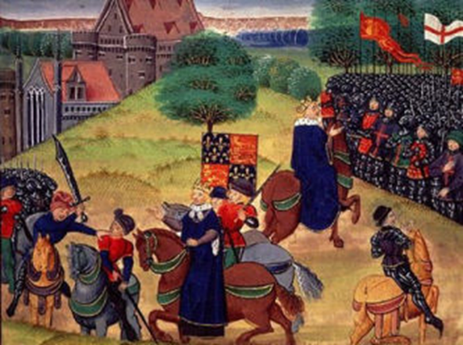factional conflict and struggles for the crown: the risk of backing the wrong side meant that there was too much to lose. From the high point of 1459-61 when some 55 noble families had been engaged in the conflicts, 18 fought in 1471 and only 12 at Bosworth. Given this sharp decline, it is hard to see where the domestic support for a usurper might have come from. Of course, John de la Pole, earl of Lincoln, rejected Henry’s attempts to reconcile him (despite being a Yorkist and a supporter of Richard III he had been made a councillor in 1485) and joined the conspiracy bankrolled by Margaret of Burgundy, Edward IV’s sister and a committed Yorkist, to put Lambert Simnel on the throne as ‘Edward VI’; but he failed to rally any support from nobles and their retainers (Lord Lovell, the other main noble conspirator, had joined the conspiracy before Lincoln).

Conversely, when Henry VII fought at Stoke, he could rely upon the retinues of his core supporters, the duke of Bedford, the earl of Derby and the earl of Oxford, as well as a multitude of Midlands gentry. Of course, Henry VII did face a serious rebellion in 1497. However compelling is the case of Ian Arthurson that the Cornish Rebellion was less about taxation than a conspiracy to overthrow Henry and less about Cornwall than a more general rising against Henry’s government (which, according to Arthurson, extended north to Devizes, south to Dorchester and east to Winchester), the fact remains that only one noble, James Lord Audley, and 22 gentry were on the side of the rebels. By contrast, the retinues of 18 nobles, more than one third of the nobility, fought at Blackheath for their king and crushed the rebellion.

The only time when significant elements of the political nation became embroiled in a conspiracy against Henry VII was in 1493-95 when Sir William Stanley (Henry’s Chamberlain) and others such as Sir Simon Mountford (a leading Warwickshire gentleman) became implicated in a plot in support of Perkin Warbeck (who claimed to be ‘Richard IV’, the youngest son of Edward IV). However, Henry’s agents quickly unravelled the plot and the malcontents were speedily arrested, subjected to a series of ‘show trials’ and executed in early 1495. Although any conspiracy which involved men who had free access to Henry was a very serious matter, the fact remains that the plot posed no threat to Henry. Whereas in 1487 he was taken completely by surprise by Lincoln’s flight, he knew of the involvement of Stanley and others and the real identity of Warbeck before the plot became serious. Indeed, it had been Lincoln’s betrayal that made him more vigilant and led to the creation of a network of agents who were able to protect him from conspiracies. As a result of the work of these agents (and the fact that Warbeck was a political pawn with a desultory claim to be the younger of the ‘princes in the Tower’), when Warbeck attempted his landing at Deal in Kent in July 1495, in an expedition supported by Margaret of Burgundy and Maximilian of Habsburg, the duke of Burgundy, he was beaten off by local levies. Indeed, this failure to make any headway against a secure Henry VII convinced the Habsburgs that Henry’s sharp trade embargo against their increasingly resentful merchants (imposed between 1493 and 1496 to force Maximilian to bring Margaret under control) was too high a price to pay for an objective that had no chance of being achieved. This is why he dropped Warbeck who was then obliged to turn for support to even weaker powers, such as James IV’s Scotland (and the Scottish invasion of September 1496 on his behalf was little more than a glorified border raid).

Foreign Powers

Foreign backing from a strong power such as France was a vital component for any realistic attempt on the throne (as Henry’s own experience in 1485 made clear) – but only if there was also domestic support and a claimant who was a credible alternative to an unpopular incumbent. (Lambert Simnel had significant foreign support in 1487 but no domestic support because he was not a credible alternative to Henry VII.) Nevertheless, had the French been committed to replacing Henry VII then doubtless the plots against him would have assumed greater significance than they did. However, although Charles VIII contemplated supporting Warbeck to prevent Henry from aiding Brittany against his plans to annex it, by the Treaty of Étaples of October 1492 Henry recognised Charles’s claim to the duchy in return for a promise that the French would not support his enemies. More important than Henry’s diplomacy, however, was the fact that Charles became preoccupied with pursuing his claim to the kingdom on Naples after 1494.

Without the backing of Europe’s major power, would-be kings of England such as Warbeck were forced to rely on the scraps fed to them by the impoverished Habsburgs, the Scots and Margaret of Burgundy (whose resources never seem to have recovered after supporting Lincoln’s rising in 1487). Of these, the most serious problem had been Margaret of Burgundy. Yet the strength of Henry’s position by 1495, combined with the impact of the trade embargo, persuaded Maximilian that he had better rein in Margaret’s independence (which she enjoyed as a result of her dowager lands). The Intercursus Magnus of 1496 stipulated that neither government would support the other’s pretenders and that if Margaret did not follow this directive she would lose her lands. In fact, it was not until 1498 that she made a genuine reconciliation with Henry, writing to him in September to ask his forgiveness for supporting his enemies. Subsequently, Margaret devoted herself to her proxy Habsburg grandchildren and great-children. Thus it was that Margaret ceased to be politically active five years before her death in November 1503, although news of her demise was doubtless received in England with some sense of relief.

Reducing Regional Power

Henry VII’s troubles were still not entirely over. In 1501 Edmund de la Pole, earl of Suffolk (and Lincoln’s brother), fled to the Continent to seek the support of Philip of Habsburg against Henry. Again, though, the strength of Henry’s position prevailed. Firstly, his financial muscle was enough to keep Maximilian’s successor on his side (for example in 1505 he gave a ‘loan’ of £138,000 to Philip). Secondly, he made sure to neutralise Suffolk’s power-base in East Anglia in order to eliminate any risk of a rising by his tenantry. As a result, Suffolk’s attempts to rouse his tenants to rebellion were completely extinguished by the earl of Oxford in the autumn of 1501 with large numbers of his adherents being forced to swear bonds for their good conduct. In fact, many de la Pole clients changed their allegiances after 1501 and the region was brought under even closer royal control as many of these sought service with Thomas Howard, earl of Surrey.

Not satisfied with these measures, Henry VII targeted Suffolk’s relations: there were a number of executions, including that of Sir James Tyrell, some imprisonments and 17 attainders in the 1504 parliament. Finally, in 1506, by dint of good fortune, a storm blew Philip of Habsburg into seeking the protection of an English port, whereupon Henry was able to press him successfully for the deliverance to the Tower of de la Pole. There he languished until 1513 when, as a security measure in response to Henry VIII’s departure on campaign to France, he was executed.

Conclusion

Although Henry continued to face challenges almost up until the end of his reign, he was never truly threatened and from 1499 onwards he had little to fear. This raises the question of why it was, from about this time, that he began his assault upon the English nobility through the arbitrary imposition of bonds and recognizances. Although there is not the space here to address this in much detail, the suggestion is that it came about from a combination of factors. First, there was the realisation that the Cornish rebellion was not just about resentment against an unpopular tax in a distant region. Arthurson has shown how investigations into the causes of the rebellion continued into the early sixteenth century, a sure sign that the government was nervous. Second, his heir, Prince Arthur, died in 1502. Finally, there was the revelation of the ‘Calais Conspiracy’ of 1504, when captains of the garrison discussed the virtues of Edward Stafford, duke of Buckingham, and Edmund de la Pole, earl of Suffolk, as worthy successors to Henry VII but not Henry, Prince of Wales, coupled with Henry own illness after 1504. Paradoxically, then, it was at the time when he was most secure from conspiracies that the ever vigilant Henry VII felt the most vulnerable.

Issues to Debate

•What combination of factors might have led to Henry VII losing his throne?

•Which conspiracy was most troublesome to Henry?

•By what measures did Henry VII secure his throne against pretenders and conspiracies?