**Henry VII’s government**

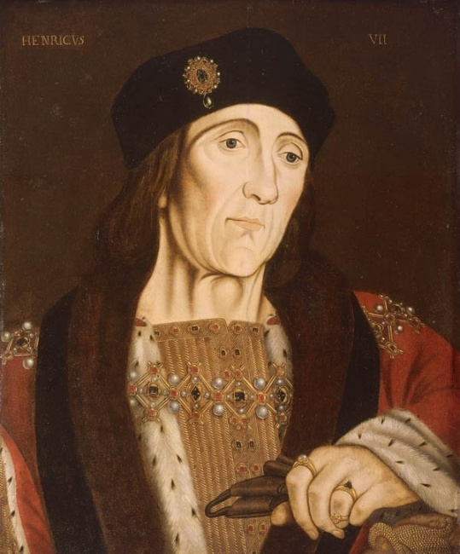

**Topics 3 (1 Rebellions and securing the kingdom 2 Foreign policy)**

The final topic relates to the nature of royal power in the late 15th century and of the crucial role of the nobility in the localities. This can be addressed through examples of Henry’s use of the nobility and his methods to control and limit their potential to challenge royal authority through such instruments as bonds and the regulation of retaining.

It also relates to Henry’s administration of justice and royal finance. Students should understand the ways in which these did or did not contribute to Henry’s control. Was Henry successful in law enforcement? The growth in royal revenue was clearly central to the revival of royal power and this process might be illustrated by his revenue-raising (ordinary and extraordinary) at home, his use of the Exchequer and the Chamber to collect revenue, and through the careers of Reginald Bray and latterly Empson and Dudley

**Topic 2 - Henry and his nobles**

Henry’s relations to the nobility were conditioned by two principal factors. First and foremost Henry knew he was a usurper himself and if he could take the throne by force, what was to stop someone else. Secondly the Wars of the Roses had kept reviving for over 30 years so while this in a way helped him (most of the people were sick and tired of the fighting) this also showed it was always possible that someone would justify a challenge.

North/North /east

Richard, Duke of Gloucester

The Percys – Earls of Northumberland.

**Noble Power blocs pre 1483**

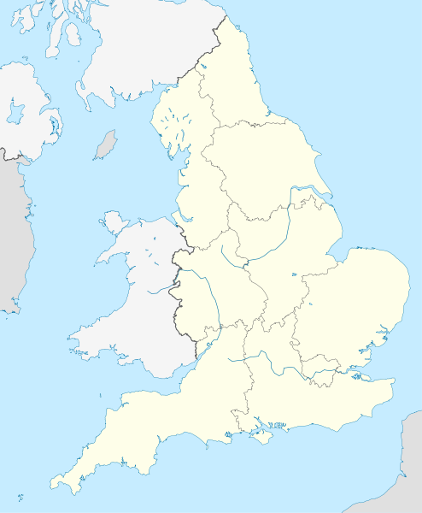

West Midlands

Thomas Grey

Marquis of Dorset

South East

The King

West country

De la Poles and Courtneys

East Anglia

Duke of Norfolk

North Midlands

Lord Hastings

Wales and the Marches

Earl Rivers

Cheshire

Stanleys

As the nobility’s feudal overlord, Henry had to be sure of securing their loyalty. Without this he could never be secure. 15th century society saw government as a co-operative effort between the king and nobles. The King relied on the nobles for help running the country. They had been entrusted with areas on which in fact they imposed law and order. (The king did not have a standing army or a police force). Nobles often had large numbers of retainers that could be used in armies when necessary. During the reigns of Edward IV and Richard III the nobility had undoubtedly gained in power. This was due in no small part to Edward’s use of the nobility as a means of controlling large areas of England. The map above shows the power blocs that Edward established. They continued the long established practise of relying on nobles for advice and counsel. Traditional historians used to think that the nobles had been very much reduced by the wars, (through death) but recent historians have shown that the nobility retained its position and importance. However, some changes did occur to Henry’s advantage.

|  |  |  |  |  |
| --- | --- | --- | --- | --- |
|  | **No of peers** | | **No of major peers** | |
|  | **Start of reign** | **End of reign** | **Start of reign** | **End of reign** |
| **Edward IV** | 42 | 46 | 7 | 12 |
| **Henry VII** | **50** | 35 | 16 | 10 |

Most significant is the reduction of ‘overmighty’ magnates or what Grant (*Henry VII)* called ‘super nobles’. i.e. nobles who combined the lands and inheritances of several major families. Although such nobles did still exist (e.g. the Stafford Dukes of Buckingham and the Percy Earls of Northumberland) there was no one to compare with the Dukes of Clarence and Gloucester under Edward IV. In this Edward was fortunate. Nevertheless as a feudal lord, it was vital for Henry both to sustain and use his nobles, but also to control them.

**Task 1**

1. **Why did kings feel they needed nobles?**
2. **Why did they also constitute a threat?**

**Roleplay activity on dealing with the nobility after Bosworth**

**Henry’s ‘carrot and stick’ policy**

**The Carrots**

|  |  |  |  |
| --- | --- | --- | --- |
| Method | How it worked | Examples/Evidence | How successful? |
| Patronage | Rewarding them with land or titles, and maybe a good job. | Rewarded those who gave him loyal service at Bosworth such as the Earl of Oxford, and Jasper Tudor, who was made Duke of Bedford. |  |
| Order of the Garter | Significant order reserved for the king’s closest servants. | Henry created 37 Knights of the Garter, more than half of these were his closest associates in war and government, e.g. Earl of Oxford, Reginald Bray. |  |
| King’s Council | Position as king’s councillor was a sign of the king’s confidence. | 2 Chancellors retained their positions for long periods; John Morton (1486-1500) and William Warham (1504-09).  His five key councillors had all aligned themselves with Henry before Bosworth. |  |
| Great Council | Meetings called by the king to discuss high matters of state. Useful form of control as they were a way of gaining the agreement and support of his most important subjects. | Five meetings of the Great council.  1485 – for the calling of Parliament and announcing Henry’s marriage.  1487 – re Lambert Simnel  1488 – re campaign in Brittany  1491 – to authorize war in France  1496 to grant loan for war v Scotland. |  |

**The Sticks**

|  |  |  |  |
| --- | --- | --- | --- |
| Method | How it worked | Examples/evidence | How successful? |
| Acts of Attainder | Dated back to 14th century when a disloyal family lost their lands. Importantly they were reversible. | Henry used these in a cat and mouse sort of way – would take land away but if good behaviour was demonstrated that it was possible to win it back. Duke of Norfolk lost his lands and position, but regained land and earldom. (Became a duke again after Flodden under Henry VIII) |  |
| Bonds and recognisances | Bonds were agreements in which people promised to pay a sum of money if they failed to carry out their promise.  Recognisances were a formal acknowledgement of a debt of obligation. | Thomas Grey, Marquis of Dorset was required to transfer all his land to trustees, give a recognisance for a £1,000 and find others who would give recognisances worth £10,000 on his behalf. When he proved his loyalty putting down the Cornish rebellion in 1499 these agreements were cancelled.  Between 1485 and 1509 36 out of 62 noble families gave bonds and or recognisances to Henry which compares to only one during Yorkist rule. |  |
| Feudal dues | Wardship where the king took control of the estates of minors.  Marriage where the king could profit from arranged marriages.  Livery, where the king was paid in order for someone to recover land from wardship.  Relief: where the King received money as land was inherited a form of inheritance tax.  Escheats: payments made when land reverted to the Crown. | Duchess of Buckingham was fined £7,000 in 1496 for marrying without the King’s licences.  Money from these dues increased from £350 in 1487 to £6,000 in 1507. |  |
| Retaining | Noble practise of recruiting gentry followers. | Henry passed laws to prevent people from doing this in excess. |  |
| Crown lands | A subtle ‘stick’ was Henry’s determined policy to bring back as much land as possible into the hands of the Crown. | Lands formerly held by Warwick and kept by Clarence and Gloucester were all retained by Henry. 1486 Act of Resumption recovered for the Crown all property granted away since 1455. |  |

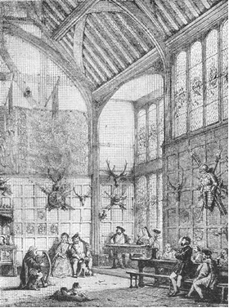**ARISTOCRACY AT ARM’S LENGTH**

The measures taken by Henry indicate that he remained distrustful of the nobility and that his distrust worsened as the reign went on. In terms of court ceremonial as well, one can see that the aristocracy were largely kept at arm’s length. Where Edward IV mixed freely with men at council and at table, Henry VII maintained a high degree of ceremonial and stressed the king’s remoteness.

This remoteness and royal isolation was dramatically reflected in a serious change to the layout of the king’s court after the arrest and execution of Sir William Stanley in 1495. He had been the King’s chamberlain and had daily access to the king as the man who organized court life. After his disgrace the authority of the Chamberlain was restricted and the king increasingly withdrew to his private or privy chamber. He spent his days working on his papers in the privy chamber attended by a relatively small number of servants which meant that the privy chamber became one of the most important centres of government.

Without access to the king, the nobility were forced to react to events rather than shaping them. It certainly meant an end to the aristocratic faction fighting that had helped to destabilise previous regimes.

**Christine Carpenter - Henry’s men**

The men whom Henry really trusted were not the nobility, but certain officials who owed almost everything to him and who became the real powers in the land. Mostly they were of gentry origin. Many of them trained in the law and most of them h ad been with Henry in exile under Richard III and some like Giles Daubigny, John Risley and Richard Guildford had served Edward IV. The presence of such men at the hub of government was not new but they had unprecedented influence…. It is appropriate in this reign to start talking about a council in the sense of a more or less formal body which helped the king make and execute policy and to refer to its members as councillors…. What gave them their power was not so much their institutional focus as the fact that they were the king’s most trusted advisers and executive officers.

They were first of all known to be among the most powerful people in the realm. **Reginald Bray** for instance, a former servant of Henry’s mother, perhaps the most influential of them all until his death in 1503 was used frequently by landowners in such capacities as executor of their wills because he had such influence with the king. Secondly they were given land in the localities which enhanced their authority as the king’s men. Often this was from the redistribution of confiscated estates. Thirdly they were often employed by the king in the supervision of the localities and of the nobles and gentry whose power dominated the localities… The fact that the council was the fount of their power was significant because it reflected Henry’s intense personal control. Some of this control was achieved through placing trusted associates in the main local offices of sheriff and JP. For instance, James Hobart, the king’s attorney general was the most frequent attender at peace sessions in Suffolk and consequently a large number of indictments about royal rights come from that county.

**Law and order**

It is in fact in the sphere of internal order where he is so often held up as a paragon, usually to the disadvantage of his predecessors that closer inspection shows Henry’s record to have been particularly weak. Traditional conclusions rest on the assumption that the key to good order lay in legislation ad above all, in the king’s being prepared to wield a harsh discipline over landowners, especially the nobility. There is no doubt either of the discipline, exercised, especially through the Council or the legislative enthusiasm. Henry was responsible for no less than 21 statutes concerning the powers and responsibilities of JPS….. “As justice was necessary to political control, so political control was necessary to justice”. Legislation then, as now follows rather than creates good social order and medieval legislation on the law must be seen as propaganda. Harshness was only effective when occasional and exemplary, and that order was normally best secured by co-operation.

Henry’s mistrust of his nobles and of local societies as a whole, seems to have been bad for order. It must be stressed that we still know little about what really happened under Henry. The problem seems to have been lack of judgement over how to delegate and to whom. On the one hand Henry was relatively relaxed about giving a licence to those he trusted. The Stanleys in Cheshire for example. These men and others like them were not only given the lands, offices and sometimes licences to retain that made them powerful but they were protected against the consequences of the misuse of that power. Humphrey Stanley for instance was never brought to book for murder. Robert Belingham, a rather lowly member of Henry’s household was able to abduct and marry a Warwickshire heiress and not only keep her, but be promoted to the Warwickshire commission of the peace where he sat in judgement over considerably more abiding neighbours. On the other hand, the king would not give overall control to anyone in either the north midlands or the north-west in the way that Hastings had held sway over the north midlands in Edward IV’s name.

The result in both the north-west and the north midlands was feuding among the king’s favoured men, sometimes of an extremely violent nature, combined with concept for the law and the legal processes. In the absence of the single ruling figure, nobody had the authority to bring all this under control. The **Pilkington-Ainsworth conflict**, about which we are well informed, because a long document by one of the participants survives, ultimately enmeshed the hitherto amicable Savages and Stanleys in mutual antagonism. Both sides played fast and loose with the law and all efforts to get the affair settled from the centre failed because of the power both the Savages and Stanleys had in the king’s counsels. It was still going on at the end of the century. In the north midlands in the first decade of Henry’s rule there was disorder on a scale not seen since the worst period under Henry VI and there was the same sort of exploitation…. In the north-east Archbishop Savage and the fifth earl of Northumberland had to be brought before the king’s council to make mutual peace-keeping bonds.

What is apparent is that in this interlinked sphere of magnate and shire management, Henry VII’s policies look superficially like Edward IV’s in his second reign but where actually very different. Both kings used their families; both used nobles, but intervened extensively in the locality and both relied heavily in court men of the household to do so. But Edward started from a premise of trust in both nobles and localities.

**Task; Willoby de Brooke activity to see Henry’s control in action**

1. What is a magnate and why didn’t Henry trust them?
2. Carpenter says that his reputation for good law and order is wrong. Why does she suggest that it was not good under Henry?

**Summary overview of Henry’s relations with his nobles**

The King needed his nobles to help him rule, but he also needed to ensure they did not threaten him. How did he reconcile these two aims?

What methods did he use to control them? (5 points)

Why did Henry need his nobles? (5 points)

**Hypothesis: ‘Henry had nothing to fear from the nobility.’**

Look at the statements in the table below. Evaluate each one and give some evidence to support your view.

|  |  |  |
| --- | --- | --- |
|  | TRUE (T) OR  FALSE(F) | EVIDENCE |
| Henry had no ‘overmighty subjects’ to contend with. |  |  |
| Henry could not rule the country without the  nobility. |  |  |
| Most nobles were keen for stability |  |  |
| Henry gave out land to keep the nobility happy. |  |  |
| Henry showed loyalty to those nobles who were loyal to him. |  |  |
| No nobles joined conspiracies against Henry. |  |  |
| Henry became more suspicious of his nobility as his reign continued. |  |  |
| Henry’s policy towards the nobility was fair and just. |  | . |
| Henry felt secure enough to include nobles in decision making. |  |  |
| Henry was quick to punish nobles who showed disloyalty. |  |  |

**Discussion point** – how successful was Henry in controlling the nobles?

**Topic 3 - Seeking solvency: Henry’s financial policy**

**Evidence Look at Access pages 59 – 73 on GOL**

|  |  |  |
| --- | --- | --- |
| **Fact** | **Supporting evidence/ explanation** | **Good/Bad for finances** |
| From 1487 Henry began to restore the Chamber system. |  |  |
| The King appointed loyal and efficient servants such as:  Sir Thomas Lovell  Sir John Heron – who were they and why are they so regarded? |  |  |
| Sir Reginald Bray was considered an important contributor to Henry’s financial success – why?  http://www.richardiiiworcs.co.uk/images/greatmalvern/6201768.jpg |  |  |
| Why did the Duchy of Lancaster play such an important part in transforming Henry’s income? |  |  |
| How much money did Henry make from attainders? |  |  |
| Edmund Dudley – very efficiently prosecuting anyone who fell behind in payments on bonds  [http://t0.gstatic.com/images?q=tbn:6nRIA9ShCU9-mM:http://i.dailymail.co.uk/i/pix/2009/05/18/article-0-04FEEBC2000005DC-226_148x201.jpg](http://images.google.co.uk/imgres?imgurl=http://i.dailymail.co.uk/i/pix/2009/05/18/article-0-04FEEBC2000005DC-226_148x201.jpg&imgrefurl=http://www.dailymail.co.uk/news/article-1184344/As-Speaker-Martin-faces-axe-beheaded-.html&usg=__GH7Y0GNUu-ei3pyzJ2cen2skHCs=&h=201&w=148&sz=19&hl=en&start=12&um=1&itbs=1&tbnid=6nRIA9ShCU9-mM:&tbnh=104&tbnw=77&prev=/images?q=Dudley+and+Empson&um=1&hl=en&sa=N&rls=com.microsoft:en-gb:IE-SearchBox&rlz=1I7HPIA_en&tbs=isch:1) |  |  |
| Richard Empson – worked with Dudley  http://i.dailymail.co.uk/i/pix/2009/05/18/article-0-04FEEBC2000005DC-419_148x201.jpg |  |  |
| Medieval Woodcut of a Bishop  What was Morton’s fork? |  |  |
| How much did Henry leave to his son? Was this very successful? |  |  |

*Read pp 61and 62 in your* ***Flagship*** *text book – How successful was Henry Vll’s financial policy?*

1. What myth has recently been dispelled through modern historical research?
2. Describe the function of the exchequer.
3. What was the more streamlined method of managing the royal estates introduced by Edward lV?
4. How did the Chamber operate?
5. Why did Henry Vll at first revert to using the Exchequer for handling his finances and what were the consequences of this?
6. Henry adopted the chamber method within a year. What did the Exchequer continue to control?
7. List the reasons for Henry’s financial success.

**The Structure of Henry VII’s Government**

The structure of government in the fifteenth century was very different to what we are used to today. Parliament was used infrequently often for writs, issued by the King to suit himself (usually when he needed money!).

Although it was the King who would call parliaments and establish councils, this did not mean that he had absolute, arbitrary rule. It was accepted that the King was subject to the laws of the land, and for that reason, those who were ruled by Henry VII, and the other Tudors for that matter, considered **constitutional law supreme**. This idea went right back to the Magna Carta of 1216.

**Parliament**

tri

Point of contact for local centre and localities.

**Secretary**

Represent localities

Councils chosen by Henry

Great Councils chosen by Henry

**Exchequer**

**The Royal Household**

This was the centre of government. It is sometimes referred to as the King's court – but it's the same thing. Henry appreciated the need to make his own household a majestic and glittering court. Where he was frugal with money in other areas of government, he spent enormous amounts of money on his court.

Every noble would have had a household for the administration of their property and the localities over which they presided. This was the highest household in the land, and many nobles would have spent much of their time at court, rather than in their own households, especially if they had a central role in the running of the country. It was mobile, following the King wherever he went, but for most of the time the court was in one of the palaces in London.

As the King owned much of the land in the Kingdom, he had to administer the collection of rents and other dues. The household had another role in that it was where the informal business of government took place. Many issues would have been discussed along the corridors of the palace, and these informal chats could have a significant impact on legislation and cases brought before the numerous courts. This aspect of the Royal household also made it a melting pot for political intrigue and faction.

**The Councils and Great Councils**

A council was a group of individuals (councillors) who met on a regular basis to provide advice to the King, to be the centre of national administration, and to be a judicial court. It supervised the economic and religious life of the country also. (To a limited extent Henry already had a council when he became King as he had a number of advisors who had been resident at his court in Brittany, and who helped him win the backing of the French King for his invasion of England.) For most of the time the court was involved with day-to-day mundane tasks, only occasionally was it the centre of high politics.

Historians writing earlier in the Twentieth century held the view that Henry's councils constituted a new way of governing the country, however, nowadays, most historians are agreed that there are not many differences between the councils of Edward IV and Henry VII. Nevertheless, one of the differences was that Henry created offshoots form the main council to deal with specific areas of administration, thereby increasing effectiveness. An example of one of these was the 'Council Learned in Law' established in 1495.

Henry's councils were large (here we see continuity with councils of the past). He had over 240 councillors. Not all of these would meet at one time. Attendance records show that around 24 would meet at any one sitting.

The **Great Councils** were used later on in Henry's reign. These were more carefully selected men, and they would discuss issues at the heart of policy-making, like how much taxation to levy, foreign affairs and military campaign tactics. The notion of a Great Council, while not Henry's own idea, was a medieval institution that had fallen out of use by fifteenth century monarchs. Towards the end of his reign he ruled with the **Council Learned** only. John Guy maintains that this was 'personal monarchy at its height'.

**The Court of Star Chamber**

This was so called because the room that this group met in had stars on the ceiling. The role of this group was to preside over the hearings of poor men's legal suits, known as 'requests'. The role of the Court of Star Chamber was increased in Henry's reign to include two tribunals, one of 1487, and the other of 1495. The 1487 court dealt with laws against rioters and the likes. The court of 1495 was set up to deal with offences of perjury. Neither of these tribunals survived Henry's death.

**Parliament**

**Parliament had the crucial role of being a point of contact between the Royal household and the localities.**

* Local representatives would sit in parliament to petition the king with grievances.
* Parliament would also levy taxation. The members were in an ideal position to know how much money their constituency was able to raise.
* The role of parliament was to pass laws that would go into the Statute Book.

However, it was not a permanent institution. Remember that it met only when the King summoned it. Typically, they were used by all of the Tudor monarchs when the King or Queen was short of money. This gave to parliament what historians call 'the power of the purse'. In all, the parliaments of Henry VII met 7 times, and for a total of 24 weeks out of a reign of 24 years. It was an institutionused far more at the beginning of his reign than later on. This was not crucial to Henry since he was careful with money, and he did not pursue an aggressive foreign policy.

**What historians say about Henry's use of parliament:**

S.B. Chrimes: "Little or nothing of much significance occurred in the history of parliament in the reign of Henry VII...The precedents already set over the previous century or so were followed."

R.L. Storey: "The history of parliament in Edward IV's reign is very similar to what it was in Henry's."

J. Loach: "The parliaments of Henry VII's reign, and indeed, those of Henry VIII before 1529, were very like those of the Yorkists...Henry VII's parliaments were much more concerned with the needs of the monarch and his greater subjects than they were with the good of the country as a whole."

M.A.R. Graves: "Chrimes might dismiss the legislative record of Henry VII's parliaments because few of the 192 Acts were of major importance to the crown. Yet their intrinsic significance should not be denied. Over twenty Acts restored attainted persons. The lawyers' hands were writ large in legal reforms concerning murder, abduction, bail, fraud and counterfeit"

Task – Using your Unit 2 skills try to sum up the different views about parliament presented here.

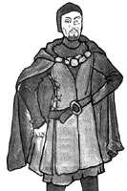**Local Government**

Henry inherited a robust system of local government from his Yorkist predecessors and spent a great deal of time and effort restoring the structure ad authority of Yorkist predecessors. He took personal interest in appointing JPs and sheriffs to ensure they would govern efficiently and serve the Crown loyally. They key feature of his method of control was supervision from the centre. He and his councillors directed operations from London with the aim of bringing royal government and justice closer to the people.

The sheriff and the justice of the peace were the two most important royal officials in each county. As the power of the Justice of the Peace increased that of the sheriff declined but under the Tudors the sheriffs were given a new lease of life as:

* They became the Crown’s representative in every county throughout Egland. In effect they became the “eyes and ears” of the monarch.
* Sheriffs took on greater responsibility for the conduct and management of parliamentary elections.

Justices of the Peace were given the power to:

* Replace suspect members of juries
* Act in cases of non-capital offences without a jury
* Reward their informers.

**Consolidation task – please look at Turvey Access chapter 7 Henry VII Governing the Kingdom (on GOL or printed off) and answer the following questions: pages 143 - 152**

1. Do historians still think that Henry VII was a new type of monarch?
2. Who were the elite that Henry trusted?
3. What office was Henry compelled to create in 1497 because of the burden of work?
4. What example set by his Yorkist predecessors did Henry also follow?
5. What was the Council Learned in the Law and why did it become so unpopular
6. Who were the men most associated with this body’s unpopular measures?
7. What class of men did Henry VII appoint to serve in his government?
8. Explain what historians mean by “new men serving a new monarchy”.
9. How was regional government organised under Henry VII?
10. Who was Sir Reginald Bray
11. How did Henry deal with Ireland?
12. What were Justices of the Peace and why did the Tudor monarchs find them so useful?
13. How did Henry VII extend the power of the Crown into the localities?
14. Why did Henry VII call so few parliaments?

**Now go on to study an article that gives an overview and answer the questions after it.**

**Henry and the Shaping of the Tudor State**

*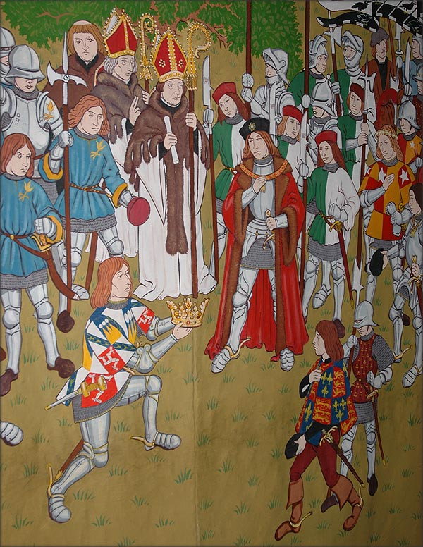***Sean Cunningham highlights the importance of 'rule by recognisance' in the reign of the first Tudor monarch**

**Henry VII: A Traditional View**

In William Shakespeare's *King Richard III* the victorious Henry Tudor, earl of Richmond, has a surprisingly undeveloped role as the saviour of England from Richard's tyranny. Looking back from 1597, Shakespeare saw the fruits of the Tudor victory, and he captured the significance of the battle of Bosworth with the lines:

*All that divided York and Lancaster  
United in their dire division.  
O now let Richmond and Elizabeth,*  *The true succeeders of each House,  
By God's fair ordinance conjoin together,  
And let their heirs - God, if his will be so -  
Enrich the time to come with smooth-faced peace.*

Generations of historians agreed that Henry Tudor's marriage in January 1486 to Princess Elizabeth, heir to the Yorkist king Edward, heralded a new period of English kingship that swept clean many defects of medieval government. The overmighty nobles and private armies of the fifteenth century were put under the king's control. The monarchy broke away from a reliance on parliament for money. The crown by-passed the local influence of noble landholders and placed power in the hands of junior men, lawyers, and professional administrators to begin a revolution in the way England was ruled. Henry VII's reign was traditionally seen as the first step in a period of rapid change in the ancient ruling structures of medieval England. The ruthless grip on power he achieved was the key factor in creating conditions for later sixteenth-century developments to thrive. While not exciting enough for Shakespearean drama, Henry VII's reign nevertheless was the pivotal point between medieval and more modern forms of English government.

**Assessments of Henry VII**

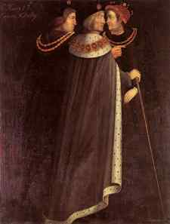Shakespeare's later Tudor view of Henry VII changed very little between the first study of the reign by Francis Bacon in 1622 and Henry's last academic biography, by Stanley Chrimes, in 1973. Both emphasised his focus on security, government, and the law, but neglected the politics and personalities of this fascinating period at the end of the Wars of the Roses. This established view remained unchallenged until very recently, perhaps because medieval and Tudor historians each have their own sources, techniques and approaches that do not easily cross the boundary that 1485 has become.   
   
Yet a revival of interest in Henry VII has occurred. This has challenged the established view of Henry as an innovator. Christine Carpenter has developed Geoffrey Elton's arguments that the early Tudor period was one of evolution not revolution in government. She suggests that because Henry's lack of royal skill forced him to continue the policies of fifteenth-century kings he was locked into an existing process of growing royal power. His isolated exile in Brittany and France between May 1471 and August 1485 gave him little understanding or experience of how English government worked. Henry Tudor could not understand the problems he faced, and was essentially a bad medieval king. He could only have changed their policies after he had learned how to be an effective king. However, this interpretation takes little account of Henry's particular circumstances in 1485. It was precisely because of his unique upbringing and disconnection from England that Henry Tudor was able to bring new ways of doing things to his kingdom. Between about 1480 and 1520 England was certainly transformed from what Nicholas Pronay described as the 'merry but unstable England ruled by Edward IV to the tame, sullen and tense land inherited by Henry VIII'.

**Inexperience and Innovation**

When Henry VII took the crown from Richard III he inherited all of the authority and royal resources that previous kings had enjoyed. Yet his exile meant that, unlike many of his knights and lords, he did not have the practical experience of running manorial estates or of managing a complex network of servants (called an affinity or retinue). Henry lacked sufficient knowledge of how English government worked. This restricted how he could exercise his authority, especially in the reform of government departments and processes. For example, many lords, knights and gentlemen were familiar with what sheriffs did to control a county, or how taxation was collected and paid to the Exchequer, because they were part of the elite who did those tasks year-after-year. Changing the way that these and many other important jobs were done would have brought administrative chaos when the king's political control was also weakest.   
   
What Henry VII did have great expertise in also grew from the circumstances of his exile. Henry had watched how the Breton and French courts worked. More specifically, he had learned how people could be manipulated by reward and coercion into doing what rulers wanted; how faction and political conspiracy operated; and how attention to detail was vital to a king's security. It was control of personal relationships and mental attitudes among the people who represented the king that Henry VII saw as the key to forcing change upon the medieval ruling structures he inherited.  
   
Many of the specific policies, such as a reliance on bonds, recognisances and obligations as tools to control behaviour, did not survive beyond 1509. But their effect on how England was ruled did. In fact the novelty of Henry VII's rule created a backlash that in August 1510 condemned to the block its two leading officers, Edmund Dudley and Richard Empson. The success of Henry's shake-up of the relationship of the crown with its leading subjects may have set back the acceptance of change for many years. Henry VIII's early years, with a vibrant youthful court and military glory in France and Scotland, were certainly more like those of Edward IV's second reign (1471-83) than the more sombre final years of Henry VII's. It was only in the 1530s that a new generation of officials was prepared to implement revolutionary policies on a grand scale.   
   
Clearly Henry VIII did not share his father's interest in fine-tuning the minute details of policy. He was able to neglect the mundane aspects of his royal duties because Henry VII had done the hard work in developing the administrative structure that allowed the departments of state - the royal council, chancery, Exchequer and the state paper office - to be run without the king's constant intervention. That Henry VIII became such a gross figure of monarchy must be due partly to the freedom given to ministers like Cardinal Wolsey and Thomas Cromwell to direct royal policy. While Henry hunted, jousted and worried about the royal succession, his top bureaucrats ruled semi-autonomously. But this was done strictly for the benefit of the state and the crown's control over it. This was an extension of exactly the type of role that Empson and [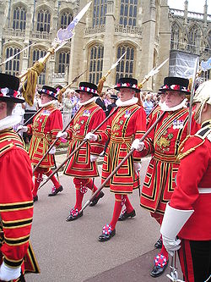](http://en.wikipedia.org/wiki/File:Yeomen_of_the_Guard.JPG)Dudley had enjoyed in the previous reign.

**Ideology and Allegiance**

What seems to be different about Henry VII was his attempt to create and enforce a new ideology of service and loyalty to the crown that enhanced the medieval concept of allegiance to an immediate lord, the king and the nation. This stood alongside Tudor restructuring of existing institutions, to transform the mentality of the ruling elites. It is also a practical example of what Philip Corrigan and Derek Sayer have called the 'moral regulation of the state'. In the conditions attached to the thousands of bonds issued during the reign, Henry demonstrated his authority (through the demand for payments), defined acceptable behaviour, and enforced an obligation of loyalty upon the powerful figures of the nation. This attitude was universal: it was applied against pardoned political suspects as well as allies commanding important castles or occupying official posts. By emphasising his royal supremacy, Henry VII also began to free the crown from the direct influence of the aristocracy.   
   
Fifteenth-century kings, dukes and earls were royal cousins with a common descent from Edward III (1327-77). They held a shared elite outlook. Henry VII arrived from relative obscurity in 1485 and began to rule more like a landlord than the first among aristocratic equals. His management of the crown lands, royal patronage, the creation of peers, and the punishment of offenders, began to elevate the position of the king above the ruling elite from which previous English rulers had emerged. This change allowed the king to dominate the structures of the state rather than to share in their development as part of the ruling class. But it did not force the king to rule personally. Rather, it allowed him to function like the chairman of a massive modern corporate business. Henry managed strategically, while well-trained and closely allied bureaucrats projected royal power under his watchful eye.   
   
Henry VII stayed closely involved in the daily tasks of ruling because he had a suspicious personality and was obsessed with the security of his Tudor dynasty. He chose to do this despite developing a framework that allowed him to withdraw physically and administratively from the process of ruling. In 1493-95 the treason of the leading officers in his household, the chamberlain Sir William Stanley and the steward John, Lord FitzWater, prompted Henry to create the privy chamber. This office was staffed by very junior grooms who served the king in his private time. It removed the politically active gentry from the king's personal chambers, although over time figures such as the groom of the stool, Hugh Denys, became important because they had the ear of the king. The great figures of the kingdom had previously surrounded the monarch and projected his power into the counties where they held their land and dominated local society. After 1495, the day-to-day isolation of the lords and leading knights from the king meant that their main role became part of the pageantry and magnificence of court life. They remained close to the crown as an institution when they sat in the royal council or on local commissions, but Henry began to select his servants for their ability, flexibility, and loyalty. Rank and prestige no longer ensured a natural right to be close to the king.

**Tudor Support**

Henry's permanent adult exile separated him entirely from England's ruling elite, both literally and in terms of his outlook and experiences. On the one hand, this gave Henry an opportunity to unlock the closed network of personal service that had surrounded medieval royal heirs as Princes of Wales or royal nobles. On the other, it created a great dependence upon the advice and skills of others. Some, like Sir Giles Daubeney and Sir Edward Poynings, had joined Henry after 1483 in opposition to Richard III. Others, like John de Vere, earl of Oxford, followed Henry because he was the only chance they had of recovering their lands and influence. Henry could not fully trust them to remain loyal if political circumstances changed again.   
   
Henry's power base of support did cut across existing and inherited allegiances. This was an advantage if it could be transformed into Tudor loyalty. As a result it was fundamentally important to Henry's success in establishing a stable regime. Henry used his skills to overcome previous vested interests as the Tudor regime stabilised and then flourished. There were some uncomfortable periods when the nature of his support actually allowed conspiracy to reach the heart of the regime. This was most obvious with the pretender Perkin Warbeck's call upon the loyalty of former servants of Edward V for most of the 1490s. Henry did try to heal the factionalism that had prevented a harmonious resolution of the civil wars in earlier reigns, and he did this by reshaping the political loyalties of the ruling classes.

**The Law**

The way English government worked had always been defined by the king's power in relation to the law. Although Henry was keenly aware of the weakness of his claim to the throne through descent - which explains the often-gaudy display of Tudor imagery and heraldry - he certainly did not underestimate the hereditary rights of the monarch. Henry pressed these prerogative rights to the very edge of the law, and many subjects complained of injustice. But the ability of the crown to intervene in their life became much more apparent. Pressure on local networks was increased by greater challenges to the manipulation of justice. Offences like embracery (corruption of juries) and maintenance (interference in legal cases by those otherwise uninvolved) were confronted. Members of regional political communities managed the interaction of the law and society at this local level. By regulating their roles as JPs, sheriffs, escheators and jury members, the Tudor crown further encroached upon the political and social freedoms of the ruling elite. Under weak leadership in Henry VI's reign (1422-61), they had been partly responsible for the descent into lawlessness and civil war. The Tudor king sought to remedy both deficiencies.

**Lordship**

Henry created few new nobles and was reluctant to promote or reward his servants excessively. There were some restorations on the king's terms, such as Thomas Howard, earl of Surrey, and Henry Percy, earl of Northumberland, but rebellion and attainder after 1485 further reduced the pool of leading peers. Henry also kept the personal estates of the crown (the demesne lands) in his own hands. With little royal family to endow, it was easier for him to make the royal lands work harder for the crown rather than to give them away. Where land was granted, it was primarily as stewardships or leases. Henry deliberately split up forfeited estates, such as those of the rebel Sir Humphrey Stafford after 1486. This prevented the build up of blocks of concentrated power even among his own followers. It also disrupted the traditional means of lordship, and is seen by Christine Carpenter as Henry's failure to understand the system of medieval lordship and the king's place within it.   
   
Yet this policy sharply defined the network of king's supporters in the regions and created a clear role for royal stewards and officers. In many cases it conflicted with traditional arrangements for effecting local rule through gentry retinues. Conflicts between the Lancashire Stanley family and Sir Thomas Butler, or the earl of Northumberland and Sir John Hotham in East Yorkshire, emerged for this reason as the king's servants were promoted against noble power. The king's men soon learned that they could still wield great power: Sir Thomas Lovell's retinue, based on a number of scattered crown stewardships, was as large as any noble connection during this period. But Henry's knights were closely monitored. In another case, the king was willing to sacrifice Sir Richard Guildford's influence in Kent, when it became clear after 1504 that he could no longer represent the crown's interests effectively.  
   
Towards the end of Henry VII's reign, members of the elite were competing for office and influence within a clearly defined structure of crown service. They were not challenging independently for resources of land and men that could threaten Tudor stability. Nobles could still be great landowners, courtiers or commissioners, like the restored earl of Surrey in the north before 1500. They were, however, obliged to be the king's loyal men. They were important because Henry allowed them a degree of power suitable for the role he expected of them. By about 1506, noble title, status or inherited rights were no longer enough to command major influence within a region. When the Stanley family was given stewardships and mining rights in Lancashire in 1504, the grant was limited by strict conditions that included tax collection. This emphasised that Stanleys were answerable to the crown. The king's control of this system of lordship became more centralised and structured than it had been. It was also policed in a new way.

**Bonds and Recognisances**

Henry VII's reliance on the policies of his Yorkist predecessors is well known. It is most obvious in his reliance on the royal chamber as the financial engine house of the reign. In his use of bonds Henry also followed existing practice but expanded this normal legal procedure to become the foundation on which all other reforms were built.  
   
Most historians agree that the reliance on these instruments increased after 1500, when they helped to enforce Henry's feudal superiority. Bonds were accepted as part payment of fines upon inheritance to aristocratic lands, to buy the king's pardon or favour, or to secure lucrative grants. Bonds were aimed specifically at the nobility only because they had the strongest feudal connection to the crown. Yet by 1500, most of the major political crises had been overcome and the Tudor dynasty seemed secure: bonds enforced rather than achieved security. No historian has so far explained how Henry VII gained a foothold on power long enough to exploit the few advantages he held in 1485, or how he withstood the very serious early threats to his dynasty. My research in analysing hundreds of new bonds begins to explain how Henry's regime came to be successfully established, despite its shaky start.  
   
Henry VII began to use these tools on a large scale to enforce loyalty during the conspiracies of the first decade of Tudor rule. The backlash to the Tudor accession arose in the heartland of Richard III's support in Yorkshire. Initially, Henry had to rely on the experience of those who had served his enemy. When the leaders of this group, such as Sir John Conyers, flirted with rebellion after 1485, they were deprived of local office and hauled before the king. Conyers and many of his gentry friends were placed under massive bonds with restrictive conditions. Re-admittance of suspected men to the local networks they had previously dominated depended on observance of oaths of loyalty; forced residence in the royal household; and reporting of conspiracy to the king's councillors. To keep their status these men became agents of the Tudor crown.   
   
Bonds were effective because the crown screened the selection of other men to guarantee that conditions were met. These sureties were not only other suspected conspirators, but also the crown officials, stewards and constables newly installed around the country. For example, the king's constables at Sheriff Hutton, Pontefract and Penrith castles became entangled in a mesh of shared responsibility after three rebellions emerged in Yorkshire by 1489. Henry quickly acted on forfeitures and called in the enormous fines when necessary. When this happened, payments were scaled down to ensure that offenders were restored on the king's terms. Thomas Metcalfe, Richard III's leading administrator in Yorkshire, forfeited and paid over £650 in 1488. By 1493 he was a Justice of the Peace and loyal Tudor servant.   
   
This system was also self-perpetuating. As more people within a community became responsible for their own collective loyalty, the links of marriage, service and landholding, which created that community in the first place, soon forced it to remain loyal. If people were provoked into rebellion they did so in increasing isolation. Sir John Egremont's attempt to raise a rebellion in Yorkshire after the earl of Northumberland's murder in 1489 attracted no prominent supporters because most possible rebels had too much to lose once Henry's bonds threatened their estates. Many of these bonds were also never cancelled. Sureties were replaced often decades after the original agreement.   
   
This system had rational and straightforward rules. If all parties obeyed the conditions of the bonds then they were free to develop careers as crown servants. If the system worked as Henry VII intended it to, then little revenue would be generated from this source. The extent to which this aspect of the use of bonds was developed has been hidden from most Tudor historians. It has been overlooked because of the emphasis on Edmund Dudley's use of barely-legal obligations in the search for feudal income and lapsed fines that marked Henry's vulnerable reign after the queen's death in 1503. The existence of this more constructive use of bonds to shape allegiance proves that Henry VII's successes in reforming government were hard earned by effort and vigilance within a clear programme.   
   
This evidence of an early Tudor ideology of absolute loyalty provides an excellent opportunity to look again at Henry VII's reign as the basis of more modern forms of government. The peace he achieved may have been 'smooth-faced' but it required constant awareness, a vast personal knowledge of landholders and their connections, and a mastery of archived documents at a level not reached by previous rulers. Henry VII's reign therefore remains an intriguing period to study. With several historians now working exclusively on Henry, we can expect a major growth in our level of understanding of the first Tudor reign in the near future.

**Issues to Debate:**

In what ways did Henry VII's experiences before 1485 influence the ways he ruled England?  
o To what extent do you think Henry VII introduced a specifically Tudor ruling ideology after 1485?  
o How did Henry VII try to ensure his own security through the use of bonds and recognisances?

**Further Reading:**

C. Carpenter, *The Wars of the Roses: Politics and the Constitution in England, c.1437-1509* (CUP, 1997)  
P. Corrigan and D. Sayer, *The Great Arch: English State Formation as Cultural Revolution* (Blackwell,1985)  
S. Cunningham, 'Henry VII and Rebellion in North-Eastern England, 1485-92: Bonds of allegiance and the establishment of Tudor authority', *Northern History*, vol. 32 (1996)  
G.R. Elton, *England under the Tudors* (3rd edn Routledge,1991)  
S.J. Gunn, 'The Courtiers of Henry VII', *English Historical Review*, 108 (1993)  
M. Horowitz, '"Agree with the King": Henry VII, Edmund Dudley and the Strange Case of Thomas Sunnyff', *Historical Research* (forthcoming).  
N. Pronay, 'The Chancellor, the Chancery and the Council at the End of the Fifteenth Century' in H. Hearder and H. R. Lyon, eds., *British Government and Administration: Studies Presented to S.B. Chrimes* (Cardiff, 1974)  
J.L. Watts, '"A New Ffundacion is the Crowne": Monarchy in the Age of Henry VII', in B. Thompson (ed.), *The Reign of Henry VII* (Paul Watkins, Stamford, 1995)

Questions on the Cunningham article

1. Why was Henry able to bring new ways of doing things to England?
2. Who were Empson and Dudley?
3. What prompted Henry to create a privy chamber?
4. What were the advantages of Henry living in exile and detached from the ruling elite?
5. What did Henry do with power?
6. What are bonds and recognisances.
7. Were bonds and recognisances an effective method of maintaining his power?

**Exam Essays**

How successful was Henry VII in strengthening royal finances?

How successfully did Henry VII deal with the domestic problems he faced (rebellions part of this)

How effectively did Henry VII handle the nobility?

The handling of royal finances was Henry VII’s most successful domestic achievement, how far do you agree.