**The Reign of Richard III, 1483-1485**

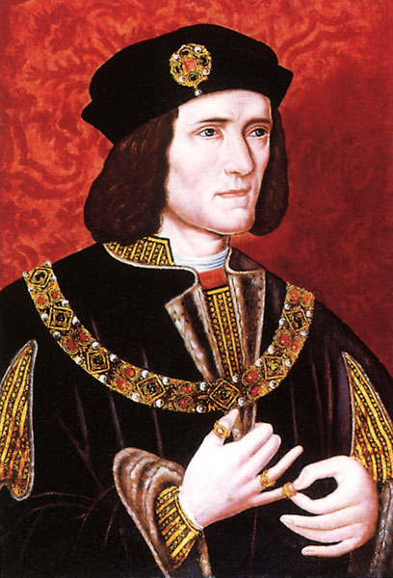

**Contents**

**Introduction to Richard Plantagenet page 2**

**Usurpation page 4 – 5**

**Richard’s government page 6 – 7**

**What happened to the princes? Page 7 – 9**

**Buckingham’s rebellion page 10 – 11**

**Evaluation of Richard’s achievements page 11 – 13**

**Documentary Battlefield walks about**

**Bosworth – questions page 14 - 16**

**Possible questions on this topic:**

It was the weaknesses of Edward IV’s reign rather than the personal ambitions of Richard III which led to the usurpation of the crown in 1483.”How far do you agree with his statement in explaining the events of 1483?

Why was Richard III’s reign so shortlived?

Was Richard responsible for his own insecurity?

How far was the unpopularity of Richard III responsible for the success of Henry Tudor’s challenge in 1485?

How accurate is it to say that Henry Tudor was able to seize the crown primarily because of Richard III’s inability to secure the support of the great nobles of England?

**Reading list:**

These texts are available in the History Department and in the ILC.

Nicholas Fellows and Sharon Littler; England 1445 – 1509 Lancastrians, Yorkists and Henry VII (OCR textbook)

Ian Dawson; The Wars of the Roses

Charles Ross; Richard III

**Mark Scheme**

*AO1: Demonstrate, organise and communicate knowledge and understanding to analyse and evaluate the key features related to the*

*periods studied, making substantiated judgements and exploring concepts, as relevant, of cause, consequence, change, continuity,*

*similarity, difference and significance.*

**Generic mark scheme for Section B, Questions 3 and 4: Essay [20]**

**Level 5**

17–20 marks

There is a mostly consistent focus on the question. Generally accurate and detailed knowledge and understanding is demonstrated through most of the answer and is evaluated and analysed in order to reach substantiated judgements, but these are not consistently

well-developed.

There is a well-developed line of reasoning which is clear and logically structured. The information presented is relevant and in the

most part substantiated.

marks

Level 4

13–16 marks

The question is generally addressed. Generally accurate and sometimes detailed knowledge and understanding is demonstrated

through most of the answer with evaluation and some analysis, and this is used appropriately to support the judgements that are

made.

There is a line of reasoning presented with some structure. The information presented is in the most-part relevant and supported by

some evidence.

**Level 3**

9–12 marks

The question is partially addressed. There is demonstration of some relevant knowledge and understanding, which is evaluated and

analysed in parts of the answer, but in places knowledge is imparted rather than being used. The analysis is appropriately linked to

the judgements made, though the way in which it supports the judgements may not always be made explicit.

The information has some relevance and is presented with limited structure. The information is supported by limited evidence.

**Level 2**

5–8marks

The focus is more on the topic than the specific demands of the question. Knowledge and understanding is limited and not well used,

with only limited evaluation and analysis, which is only sometimes linked appropriately to the judgements made.

The information has some relevance, but is communicated in an unstructured way. The information is supported by limited evidence

and the relationship to the evidence may not be clear.

**Level 1**

1–4marks

The answer relates to the topic but not the specific question. The answer contains only very limited relevant knowledge which is

evaluated and analysed in a very limited way. Judgements are unsupported and are not linked to analysis.

Relevant knowledge is limited, generalised and poorly used; attempts at argument are no more than assertion.

Information presented is basic and may be ambiguous or unstructured. The information is supported by limited evidence.

0 marks No evidence of understanding and no demonstration of any relevant knowledge.

**Introduction**

Richard was the youngest son of Richard, Duke of York, and had grown up in the household of Warwick “the kingmaker”. He married Anne Neville in 1472 and they had a son, Edward, in 1473. He was very loyal to Edward lV in both reigns and in fact, fled with him when Warwick and Clarence usurped the throne in 1470. He and his older brother Edward had endured hard times together in Holland and Edward was very grateful and trusted him totally. For this reason he was rewarded with the marriage he wanted to Warwick’s daughter Anne, and enormous power in the North where he had been extremely successful imposing law and order on the region. In gratitude Edward had granted him a palatinate comprising Cumberland and Westmorland. Gloucester thereby became the most powerful northern baron of the middle ages. He also managed to obtain acceptance among the other leading nobles in the region. Evidence that displays how his pre-eminence was accepted is shown by the large number of private disputes submitted to him for jurisdiction.

He was allowed to keep an army to defend the North and led the campaign against the Scots in 1481-3. However he had been offended by Edward’s over generous patronage to the Woodvilles and was critical of his brother’s self-indulgence so that in the last few years of Edward’s reign Richard did not attend court in the south but preferred to stay up in his home, Middleham Castle, in Yorkshire.

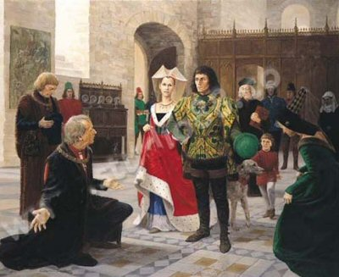

**When precisely did Richard decide to usurp the throne?**

Edward IV was aware of the hostility and rivalry between his more powerful nobles, but he had expected to live longer and contain it through his personal strength and vigour. When it became apparent that he was dying he attempted a death-bed reconciliation between Lord Hastings (one of Edward’s most trusted advisers and his chamberlain) and the Marquess of Dorset (Elizabeth’s son by her first marriage – Thomas Grey and therefore Edward’s stepson), but their display of forgiveness and affection was nothing but a show. As soon as Edward actually died all restraint was removed and a ruthless power struggle ensued. It can be argued that the smoothness of the process indicates long term planning but this is most unlikely. Before 1483, Richard had been totally loyal to his brother. In addition, no-one expected Edward to die in 1483. Richard probably decided on the usurpation after becoming Protector.

**Why did Richard usurp the throne?**

One of the explanations is ambition and desire for power, and Richard was possibly encouraged in this by his early successes in removing the Woodvilles. In addition, he and the Woodvilles were old rivals and inevitably he would fear what would be the effects on his future if the Woodvilles had control of the young Edward V. The Woodvilles had already proved that they had hoped to exclude him from being Protector by failing to inform him of his brother’s illness or his will wherein he had said Richard should be Protector in the event of his death. Therefore, Richard’s action was probably an opportunistic step inspired by ambition and self-preservation. **Look at page 72 in your Pendrill text book .**

1. **What evidence is there that Richard was loyal to his brother?**
2. **What might have prompted him to betray his brother once he had died?**

**Strengths & Weaknesses of Richard’s regime**

**Use your Pendrill text book to complete the following strengths of the regime (pp77-82)**

|  |  |  |
| --- | --- | --- |
| **Strength** | **Evidence** | **Evaluation of importance** |
| **Opposition was limited (p77)** |  |  |
| **Royal Progresses (p77)** |  |  |
| **Patronage (p78)** |  |  |
| **Support from nobility (p78)** |  |  |
| **Competent Governance (p79)** |  |  |
| **Propaganda and the creation of a ‘cult of personality around HVI (p80/1)** |  |  |

**Weaknesses of the Regime (pp76-7)**

|  |  |  |
| --- | --- | --- |
| **Weakness** | **Evidence** | **Evaluation of importance** |
| **Richard’s claim to the throne was weak (p76)** |  |  |
| **Buckingham’s rebellion (p76/7)** |  |  |
| **Support was regional (p77)** |  |  |
| **Financial difficulties (p80)** |  |  |

**The Princes in the Tower**

[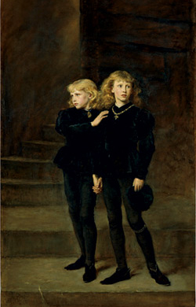](http://upload.wikimedia.org/wikipedia/commons/c/c0/Princes.jpg)No-one knows exactly what happened to the two princes. There are many stories but most are pure legend. Most historians think that all things considered, Richard probably did order the murder of his nephews. Just as Parliament had declared them illegitimate, he must have known that Parliament could reverse its decision and they could become a focus for revolt. It is probable that they were murdered late August 1483 because they were never seen alive after that time, and rumours of their murder were soon circulating in the early autumn. It is noteworthy that Richard made no attempt to disprove or reject those rumours. Also later in 1483, Elizabeth Woodville agreed to a plan for her daughter to marry Henry Tudor, a distant Lancastrian claimant. She would not have agreed to this if she believed either of her sons was still alive. Finally, no other usurper in the Middle Ages left rivals alive for long, for example, Edward IV had ordered the death of Henry VI in 1471. The man most likely to have carried out Richard’s orders for the deaths of the princes was Sir James Tyrell, who apparently confessed and was executed in 1502. Some details of his confession can be corroborated. In 1674, two skeletons were found in the Tower but no-one has been able to prove that these are the bones of the two children.

**Activity: We will examine the evidence and hold a trial.**

**Potential suspects are:**

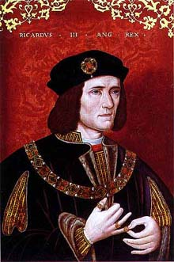**Richard III - The usurping monarch – a man with a motive?**

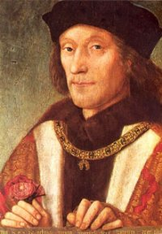

**Henry VII – did he stitch up the evidence after his accession?**

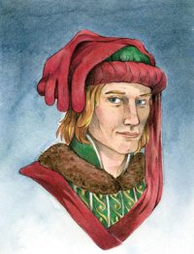**Henry Stafford, Duke of Buckingham** had the strongest claim to the throne, but he had to get past Richard once the princes were declared bastards. Furthermore, he’d married a Woodville, and while it has been rumoured he hated his wife and the Woodvilles, there is no contemporary evidence to support that claim.

     As Constable of England, Buckingham would have ready access to the princes and some suggest he may have killed them and then started the rebellion in October of 1483 to overthrow Richard--ostensibly in Henry Tudor's behalf, but as Richard executed him in that rebellion, his designs are unknown.

**THE HISTORIANS’ VIEW OF RICHARD lll**

Richard’s was a short reign of two years, but he was a very controversial figure. Modern historians are able to make use of a variety of sources, some reliable, others less so. The earliest sources dated back to the late fifteenth century and therefore are contemporary. For example, Dominic Mancini was an Italian visitor to England. He wrote an account of events as they occurred in the autumn of 1483. His picture of Richard is objective and critical. ). The most important single source for the reign is the C*royland Chronicle,* probably written by the Bishop of Lincoln who was Chancellor to Richard which certainly gives him insight into what Richard’s perspective on things was even though he very much disapproved of the usurpation.

By the early sixteenth century, more sources were available but it should be remembered they were written under the successful Tudor dynasty who had usurped Richard. For example, Sir Thomas More who wrote a very hostile report of Richard’s rule under his successor Henry VII. The Italian, Polydore Vergil, wrote a more objective appraisal of Richard and his reignin Henry VIII’s reign and Shakespeare used these sources for his play where Richard is presented as a deformed and completely evil murderer.

It is important remember both More and Shakespeare were Tudor subjects and Shakespeare was an entertainer who would enjoy making a play more dramatic and interesting and therefore had a reason to cast Richard as a villain. Both men were producing Tudor propaganda which would justify Henry Vll and his heirs taking the throne from the Yorkist Richard. By the nineteenth century some historians were challenging Shakespeare’s view and presented Richard as a heroic figure. Such a view remained popular among twentieth century novelists such as Josephine Tey in her novel ‘Daughter of Time’.

|  |  |
| --- | --- |
| **Historian** | **View of Richard and provenance for their evidence (or why they might say what they say?!!)** |
| Sir Thomas More |  |
| Polydore Vergil |  |
| Shakespeare |  |
| Pendrill |  |

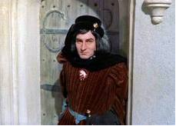**False Legends**

Richard was accused of many murders that he did not commit. He did not murder Prince Edward who died at the Battle of Tewkesbury; he did not murder Henry VI; he did not murder his wife Anne Neville, who probably died of TB; he did not murder his brother Clarence who was executed on the orders of Edward IV; he did not have a hunchback.

**The question is – why do we have this distorted picture?**

**The Truth about Richard – what we know for sure**

It is true that Richard had been very loyal to Edward before 1483. It is also true that he had great power in the north before 1483. He had been allowed to keep a private army and had waged war against the Scots on behalf of his brother. In his own reign he adopted some similar policies to his brother including some wise administrative policies. However, in 1483 he did betray his brother’s trust.

He usurped the throne and was almost certainly responsible for the death of his nephews. No-one else had as much to gain from their deaths and he made no attempt to defend himself against these accusations. On the other hand he did vigorously deny accusations of murdering his wife. He ruthlessly removed many critics and opponents like Lord Hastings. He also used false arguments to damage both his brother’s and his mother’s reputations. The result of this is a picture of a ruthless and ambitious man but also one who feared for his own safety.

***Now read pages 65-69 in Cook and answer the questions below.***

1. How does Shakespeare present Richard lll in his play of the same name?
2. On which sources did Shakespeare rely and how reliable were these sources?
3. Which was the most reliable early source and why can we believe much of what the author wrote?
4. Who was the author John Russell and why is his account of events valuable?
5. For what reasons could it be argued that Richard had to usurp the throne?
6. Why did contemporaries, and now modern historians, condemn Richard’s usurpation?
7. In what ways was Richard a hypocrite?
8. What achievements do his defenders praise?
9. Why was Richard never able to win the full support of his contemporaries?

**Division in 1483**

Once Richard had usurped the throne he was insecure. There was a possible threat from the Woodvilles who were either in sanctuary or had fled into exile and he soon had to face a threat from the last remaining Lancastrian claimant, Henry Tudor. The latter had a weak Lancastrian claim through his mother Margaret Beaufort. He had gone into exile in 1471 to Brittany but had made no attempt to claim the throne in Edward lV’s reign. Within weeks of Richard’s coronation in July it was widely rumoured that the princes had been put to death by their uncle and as a result in the autumn there was a widespread but disorganised rebellion. It began with plans for a rising to rescue Edward V and his brother before it was too late. A particularly ominous aspect of this rebellion was that in virtually every affected region, prominent knights and gentlemen with careers and connections in the personal service of Edward IV and in his household acted as leaders. The influence of men such as Sir John Fogge and Sir Thomas Brown in Kent, Sir John Cheyne in Wiltshire, Sir William Stonor in Oxfordshire is particularly important because while Edward had ruled these men had acted as a vital prop to stable royal authority. Only two major peers were involved. Thomas Grey, Marquis of Dorset(the queen’s oldest son) helped lead the rebellion in the west. The other peer was a surprise. Henry, Duke of Buckingham had helped Richard, informing him of the king’s death and helping him to capture Edward V at Stoney Cross. What was the reason for his betrayal?

Richard tried to strengthen his position by rewarding his allies. According to Sir Thomas More he granted gifts to guarantee friendship. It was a short-sighted and unwise policy as it made enemies of those who received no patronage. It was also unwise because he had given away valuable crown land and so lost revenue.

He soon discovered that he had offended some of his former allies, especially the Duke of Buckingham. The latter may have been alienated because he did not receive all the land he wanted in return for his support of Richard in the time leading up to the usurpation. This may explain why Buckingham helped to lead a rebellion against Richard in 1483. Other reasons for the revolt include the fact that Buckingham himself had a distant claim to the throne and he we therefore jealous of Richard’s success in taking it. It is also possible that although he had initially supported Richard’s actions he did not realise that Richard intended to make himself king and murder the two princes. He may have believed at first that Richard simply wanted to safeguard his position as Protector.

**Buckingham’s Rebellion, 1483**

A plan was formed in the summer of 1483 to release the Princes from the Tower but the plans changed with the rumour that the princes had been murdered. The aim seems to have been then to put Henry Tudor on the throne and the plan was encouraged by Margaret Beaufort, Henry Tudor’s mother. Perhaps at this point Buckingham himself hoped that he might be able to become king. The rebellion was supported by Elizabeth Woodville which clearly indicates that she believed her sons were dead. She would never otherwise have supported a plan to put a Lancastrian on the throne. The rebellion was easily put down by Richard because it started prematurely in Kent and Henry Tudor made an unsuccessful attempt at invasion on the south coast. He returned quickly to Brittany where he had been in exile when it was clear that the rebellion would fail. Buckingham was captured and executed.

**Results of the Rebellion**

The rebellion had been mainly centred in the southern counties and had attracted southern gentry. Richard treated these southern rebels very severely and this increased his evil reputation. He also rewarded his northern allies who had come to his help. In 1484, 97 rebels mainly in the south had their land confiscated. Some were later pardoned but most of their estates were given as rewards to Richard’s northern allies. For example, Sir Richard Ratcliffe became a major landowner in the south-west. The new owners of the land were expected to live on their estates and keep order there. The result was an apparent occupation by northern nobles and gentry of southern areas. It was a good way to prevent renewed plotting but it was very provocative and alienated neutral opinion. It helps to explain why in 1485 Richard received little support from southern gentry and nobles.

**Richard’s achievements**

His reign was too short to identify long term plans but there are some interesting achievements. On the whole it was very similar to Edward IV’s. Some historians argue that if he had reigned longer he would have had good results and proved an effective ruler; others however argue that the fact that he did not reign longer is proof of his failure and weakness as a leader.

1. He was religious and founded ten chantries to say prayers for the dead.

***What are chantries and why would he do this?***

1. He thought education was important, sponsored four fellows in Queen’s college Cambridge and surrounded himself with humanist scholars.

***What are humanist scholars?***

1. He was a builder and constructed a fine new Great Hall at Nottingham and in his favourite Castle of Middleham. He also contributed to the completion of King’s College Chapel in Cambridge.
2. He worked hard at government.

***Explain using page 79 Pendrill.***

1. He showed a succinct grasp of Propaganda.

***Explain using P. 80 Pendrill.***

1. After the revolt, he extended the powers of the Council of the North and gave it more control over **law and order**. He put it under the control of his nephew, John de la Pole, Earl of Lincoln. It appears to have worked well and prevented disorder in the north. He certainly had a lot of loyalty from those in the North who later lynched Thomas Percy, Earl of Northumberland for his treachery at the Battle of Bosworth. He made great use of his northern allies on the royal council and like his brother made use of the gentry on the council.
2. He had a similar financial policy to Edward IV, he used the Chamber and encouraged trade but unlike his brother he wisely avoided asking for benevolences (gifts in the form of taxation). Nevertheless there is evidence that the Crown was facing serious financial problems by 1485.

**Evaluation**

It is difficult to form a clear picture of how competent Richard was as a king. According to Cook he was an energetic and efficient administrator but Lander is far more sceptical and has cast doubt on his abilities. He has certainly had a blackened reputation for his seizure of power but is it fair to call him a tyrant?

**Was Richard lll a tyrant?**

Give a definition of the word ‘tyrant’ below:

|  |  |
| --- | --- |
| **Yes**, Richard was a tyrant | **No**, Richard lll was **not** a tyrant |
|  |  |

**The Battle of Bosworth - Questions from Battlefield walks.**

1. What did Richard III say about the Battle of Bosworth?
2. Which “plain fact” suggests that Richard might have murdered his nephews?
3. What was Henry Tudor’s claim to the throne?
4. Who supported him?
5. Richard’s over-reliance on Ratcliffe, Catesby and Lovell provoked which popular rhyme?
6. Who funded Henry’s invasion of England?
7. Who formed the bulk of his army?
8. Why did he land in Wales
9. Where was the Stanley’s power base?
10. What was their attitude to Richard?
11. Why was Richard suspicious of Lord Stanley?
12. How big was Henry’s army and why did this put him at a disadvantage?
13. What could he not win without?
14. Why was Richard a worried man?
15. Whom do Richard’s supporters blame for his evil reputation?
16. Who were the most trusted nobles on each side?
17. Which noble was Richard not sure of and what did his soldiers show?
18. What evidence is there that the battle may have been turning against him even before his attack on Henry?
19. Whom did Richard succeed in killing?
20. What did Sir William Stanley then do, and what was the effect of this?
21. What did Lord Stanley do?
22. What was the significance of the Battle of Bosworth in English history?
23. How was Richard’s body treated after his death?
24. How did the outcome of the battle affect the way the story of it was written afterwards?