**GODALMING COLLEGE HISTORY DEPARTMENT**

**Course Information: Democracy and Dictatorship AS and A-level**

The Democracy and Dictatorship A-level course is predominantly a modern history course. You will study 4 units – 2 in the lower sixth year and 2 in the upper sixth year. We follow the OCR exam syllabus: <http://www.ocr.org.uk/qualifications/as-a-level-gce-history-a-h105-h505-from-2015/>

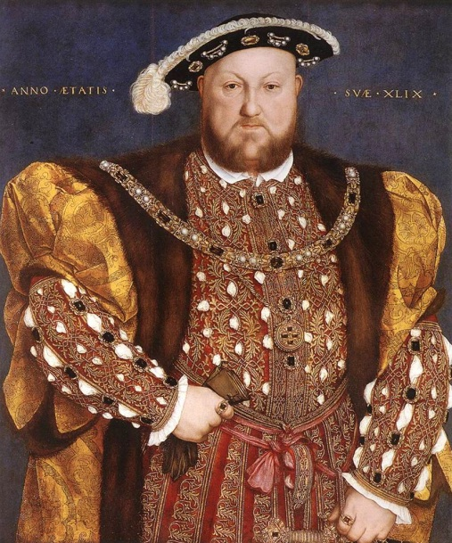**Unit 1: Y106: England 1485-1558: the Early Tudors (Enquiry Topic: Mid Tudor Crises 1547-1558)** (25% of total A level or 50% of AS level)

The Period Study element of the unit is assessed by essays, which will allow learners to develop their use and understanding of historical terms, concepts and skills. The Enquiry is a source-based study involving the critical use of evidence.

You will study:

* **Henry VII**, including his government, rebellions and threats to his rule and foreign policy
* **Henry VIII**, including his personality, his role in government to 1529, the impact of Wolsey, his divorce from Catherine of Aragon, the Reformation and religious change, foreign policy and the rise and fall of Thomas Cromwell
* The stability of the monarchy, religious changes and rebellion and unrest under **Edward VI and Mary Tudor.**

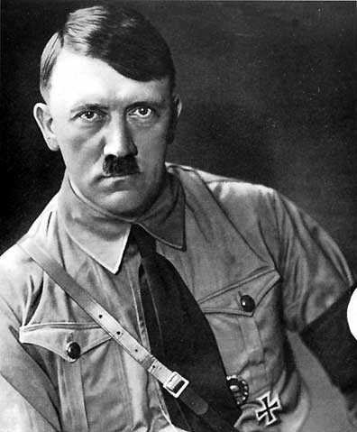**Unit 2: Y221: Democracy and Dictatorships in Germany, 1919-1963** (15% of total A-level or 50% of AS level)

At AS level, you will be required to answer a traditional ‘Period Study’ essay and to evaluate an historical interpretation relating to one of the topics studied.

At A level, you will be required to answer a traditional ‘Period Study’ essay and a shorter question assessing the significance of two events.

You will study:

* **The Weimar Republic, 1919-1933**, including the impact of WW1 and the Treaty of Versailles, Stresemann and the ‘Golden Years’, the impact of the Great Depression, the rise and appeal of Nazism
* **The Nazi dictatorship 1933-1939**, including Hitler’s consolidation of power, the role of propaganda and terror, economic policies, social policies towards women and youth, racial policies
* **The impact of war and defeat on Germany, 1939-49**, including the war economy, racial policies and the Final Solution, the Berlin Blockade and post war division of Germany
* **Divided Germany 1949-1963**, including the constitution and economic miracle in West Germany, foreign policy, the GDR and the building of the Berlin Wall

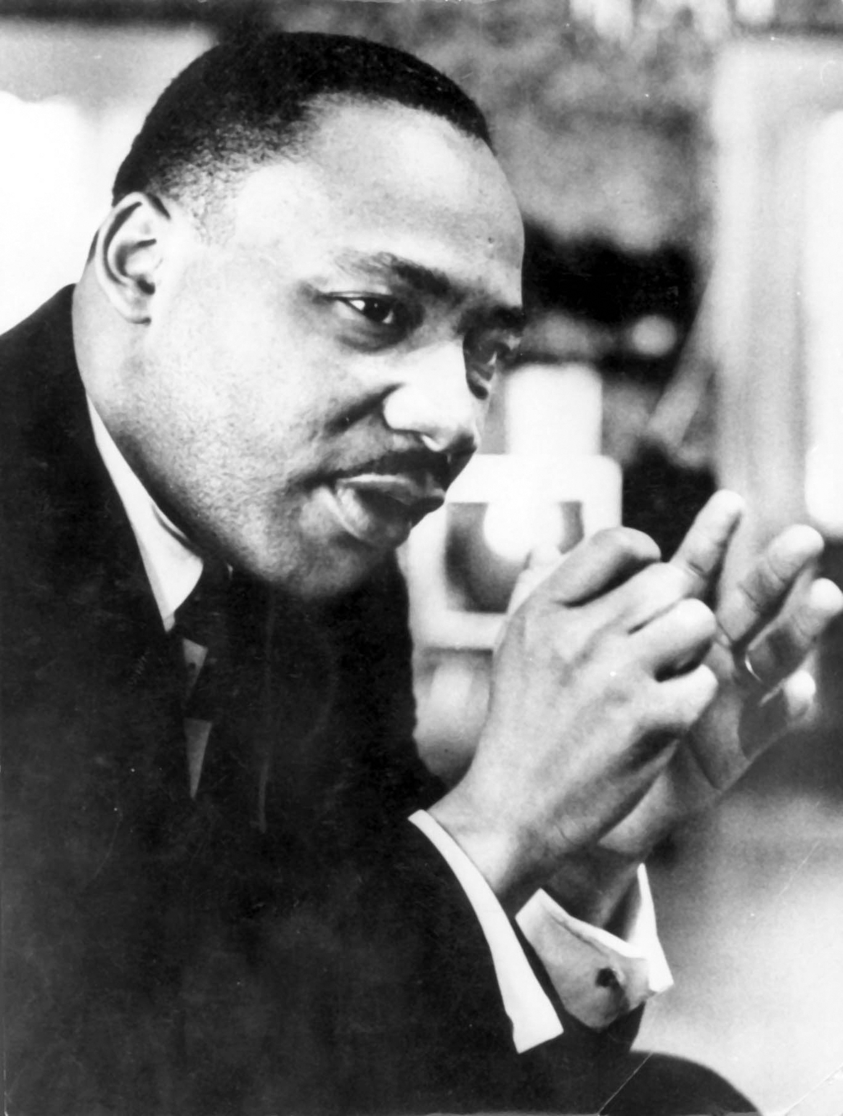**Unit 3: Y319: Civil Rights in the USA, 1865-1992** (40% of A-level)

This unit tests your ability to examine a theme over the period studied. You will also study three in-depth topics, and you will use your knowledge of these to evaluate historical interpretations.

You will study:

* **The African-American struggle for civil rights**, including the abolition of slavery, Reconstruction, white discrimination, the role of African-Americans in gaining civil rights (e.g. Martin Luther King, the Black Panthers), the roles of the federal and state governments.
* 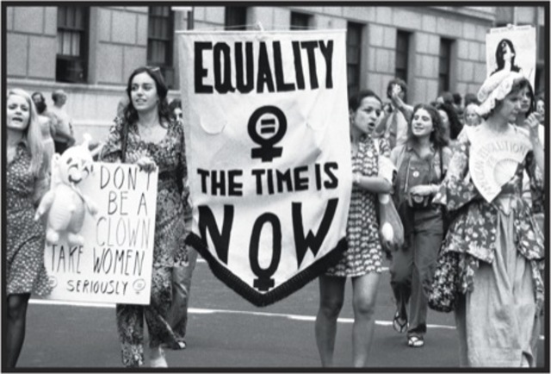**Trade union and labour rights**, including the impact of New Immigration on union development, the role of the federal government, the impact of the World Wars on labour rights, Chavez and the UFW, Reagan.
* **Native American Indian rights**, including the impact of the Plains Wars and Dawes Act, the New Deal, the American Indian Movement in the 1960s and 70s and the Supreme Court
* **The women’s liberation movement**, including the impact of the campaign for prohibition, the campaign for women’s suffrage, the New Deal and the World Wars, the rise of feminism and Roe v Wade, changing employment opportunities.

**Unit 4: Coursework** (20% of A-level)

This comprises one 3000-4000 word essay and it will normally be on a topic you have already studied.