[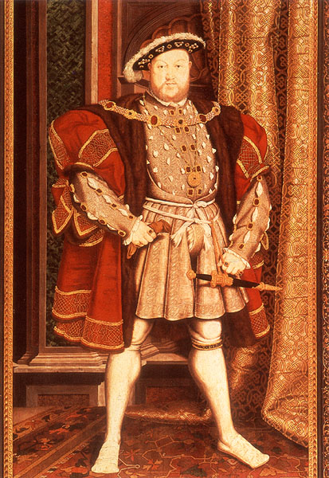](http://www.google.co.uk/url?sa=i&rct=j&q=&esrc=s&source=images&cd=&cad=rja&uact=8&ved=0CAcQjRxqFQoTCIHRmMPb2scCFYXtFAodN_IAew&url=http%3A%2F%2Fwww.tudorplace.com.ar%2FaboutHenryVIII.htm&psig=AFQjCNFgQMQuncsybRvD8qayDFPvfgFqLQ&ust=1441364543827229)

[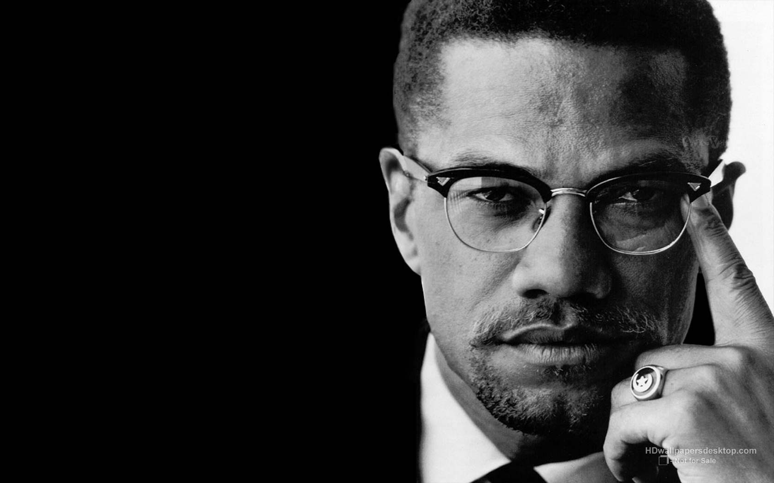](http://www.google.co.uk/url?sa=i&rct=j&q=&esrc=s&source=images&cd=&cad=rja&uact=8&ved=0CAcQjRxqFQoTCJ-N1JPc2scCFQs7FAodo3cJZg&url=http%3A%2F%2Fartsandsciences.colorado.edu%2Fctp%2F2015%2F02%2Frussell-kirk-on-malcolm-x%2F&psig=AFQjCNEBLWcXU9gftv7PrvY-fvS_q0TvzA&ust=1441364718873698)



**Democracy and Dictators Library Search**

1: Go to the magazine rack & find an article which is relevant to the content of the Democracy and Dictators history course. You can use *History Today*, *The History Magazine* or *The Historian.*

Note the name of the journal, which issue, author & title.

**Find the German History section.**

2: What does the picture on page 37 of *Hitler, appeasement and the road to war* by Graham Darby show?

3: Find the name of a book by Christopher Browning.

**Find the Tudor History section**

4: What does the picture show on page 100 of *The Early Tudor*s by Rogerson Ellsmore and Hudson?