**OCR AS HISTORY**

**UNIT 1 REVISION BOOKLET**

**ENGLAND 1485-1558: THE EARLY TUDORS**

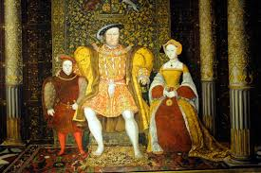

**AS History - Democracy and Dictatorship**

**Revision Checklist**

**UNIT 2: Germany, 1919-1963**

**WEDNESDAY 25TH MAY (pm)**

**UNIT 1: The Early Tudors, 1485-1558**

**WEDNESDAY 18TH May (pm)**

Use the following checklist to structure your revision and ensure that all aspects of the course are covered. When you have finished revising an individual topic you should test your understanding of this by attempting a selection of timed exam question. These can be found in your lesson materials and the OCR approved textbook for each Unit, both of which can be found on [www.dawsonera.com](http://www.dawsonera.com)

|  |  |
| --- | --- |
| **UNIT 1: The Early Tudors, 1485-1558** | |
| **Topic 1: Henry VII** | **Tick when revised** |
| Background to Henry VII and the Wars of the Roses – Claim to the throne |  |
| Rebellions and Pretenders – Yorkist opposition, Lambert Simnel, Perkin Warbeck |  |
| Foreign Policy – Brittany, France, Spain and the Holy Roman Empire |  |
| Domestic government – Crown finances, relationship with nobility, Parliament tax rebellions |  |
| **Topic 2: Henry VIII and Wolsey** | **Tick when revised** |
| Henry VIII’s personality and aims as king – Imperial and Warrior King |  |
| Foreign Policy up to 1529 – War with France, Treaty of London, Charles V and Francis I |  |
| Domestic Government under Wolsey – finances, law and social reforms |  |
| Henry’s need for an annulment by 1529 and the fall of Wolsey |  |
| **Topic 3: Henry VIII after 1529** | **Tick when revised** |
| The break with Rome – Causes, Acts of the Reformation Parliament, role of key figures |  |
| The dissolution of Monasteries – Causes and process, 1535-1540 |  |
| Opposition to religious changes – Key figures, Carthusian monks, Pilgrimage of Grace |  |
| Religious change and faction after 1534 – Ten Articles, Six Articles, Fall of Cromwell |  |
| Henry’s Final years – War with Scotland and France, Faction, Succession |  |
| **Topic 4: Edward VI, 1547-1553** | **Tick when revised** |
| Stability of his reign – Minority reign, rule of Somerset and Northumberland, the Devise |  |
| Religious change – Act of Uniformity, dissolution of Chantries, extent of change by 1553 |  |
| Rebellion and Unrest – the Western (Prayer book) and Kett’s rebellions of 1549, Lady Jane Grey 1553 |  |
| **Topic 5: Mary, 1553-1558** | **Tick when revised** |
| Stability of her reign – A female monarch, marriage to Philip, factional fighting |  |
| Religious change – support for opposition to religious changes, Catholic restoration/persecution |  |
| Rebellion and Unrest – Wyatt’s rebellion |  |

**THE STRUCTURE OF THE AS LEVEL EXAM**

The exam lasts **1 hour 30 minutes** (1 hour 52 minutes if you have extra time).

Section A carries 30 marks, Section B only 20 so you should spend roughly 54 minutes on Section A (the source questions) & 36 minutes on Section B (the essay question).

**Section A** is on the reigns of Edward VI and Mary (the mid-Tudor Crisis 1547-58) and consists of 2 compulsory source questions:

Question 1 (10 marks) asks you to evaluate the usefulness of one source.

Question 2 (20 marks) asks you to write an essay based on 3 sources including the one you have already evaluated.

**Both questions require detailed own knowledge.**

In **Section B** you have a choice of 2 essays on Henry VII or Henry VIII, worth 20 marks each, of which you do one.

**How to approach essays**

***Follow this basic approach when writing an answer to an essay question:***

1. Start with an **introduction**. The main function of an introduction is to show the examiner that you understand the question and the debate within it. A good introduction should be **concise, balanced** (i.e. indicate both sides of the debate) and the best introductions will establish the **line/view you are going to argue**.
2. The **main part** of your essay needs to be **balanced** i.e. needs to address both sides of the argument, equally. More guidance follows about question types and appropriate structures to use.
3. End with a **conclusion**. A conclusion should always be longer than an introduction. It should be **balanced**, i.e. sum up both sides of the argument you have addressed, but also reach a **decisive judgement** – no sitting on the fence.

The most important thing for your exams is to **read the exam question carefully** and to work out **exactly what it is asking you to do**. The following is a **guide** to **some** **typical question types** and the **approach you should use when tackling them**.

1. **Factors questions**

By this we mean questions which require you to identify a range of reasons for something happening, and to reach a judgement about the most important reason.

***‘Assess the reasons for…’***

In questions such as these it is important that you look at a **range of different factors** that can be used to **explain why the event in the question happened**. Deciding **how important each of these factors were**, putting them into a **hierarchy** and basing your conclusion about **which ones were most important** will enable you to develop your analysis.

Examples:

1. Assess the reasons for the fall of Thomas Wolsey in 1529.
2. Assess the reasons for Wolsey’s rise to power.
3. Assess the reasons for the break with Rome.
4. Assess the reasons for opposition to the religious changes during the reign of Henry VIII.

***‘To what extent was x responsible for y/does x explain y…/was x the main reason for y…’***

In questions such as these you need to **assess the importance of the factor stated in the question first** and you should do this in **significant detail**, and then you need to **explain a range of other factors** (2 or 3) and **weigh them in relation to the specified factor**.

***A statement identifying a cause***

A similar approach to above. In questions such as these you need to **assess the importance of the factor in the statement first** and you should do this in **significant detail**, and then you need to **explain a range of other factors** (2 or 3) and **weigh them in relation to the specified factor**.

1. “The most important reason for Wolsey’s fall from power was his failure to obtain a divorce for Henry VIII”. How far do you agree?
2. “Wolsey’s lack of noble support was the most important reason for his fall from power”. How far do you agree?
3. **Extent of success/change questions**

This type of question requires you to reach a judgement about the **extent of success/degree of change.** A ‘yes/no’ approach is the simplest approach to this type of question but more sophisticated analysis will be seen if you **identify themes** to address and reach judgements about these.

***‘How successful was x…./how effective was x…/how serious was x…’***

Examples:

1. How effectively did Henry VII deal with England's domestic problems?
2. How serious a threat to Henry VII's rule was the Yorkist challenge?
3. How successful was Henry VII in achieving his foreign policy aims?
4. How effectively did Henry VII handle the nobility?
5. How successfully did Henry VII deal with the problem of the Yorkists?
6. How dangerous were Yorkist plots to Henry VII?
7. How successful was Henry VII in strengthening royal finances?
8. How successful was Henry VIII in achieving his aims as king 1509-29?
9. How successful was English foreign policy in the period 1509-29?
10. How successful were Wolsey’s domestic policies?
11. How successful was Henry VIII in achieving his aims in foreign policy in the period 1509-29?
12. How serious was opposition to Henry VIII’s religious charges?

***A statement asking you how far you agree***

Example:

1. “Marriage agreements were the most important achievement of Henry VII's foreign policy". How far do you agree?
2. "The handling of finances was Henry VII's most successful domestic achievement". How far do you agree?
3. “The avoidance of war was the most important aim of Henry VII's foreign policy". How far do you agree?
4. "Henry VII's foreign policy achieved little". How far do you agree?
5. "The need to secure his throne dominated the foreign policy of Henry VII". How far do you agree?
6. “Henry VIII failed to achieve his aims as king in the period 1509-29”. How far do you agree?
7. “Henry VIII’s foreign policy 1509-29 brought little benefit for England”. How far do you agree?

**General Advice**

* **Make sure that you read every word in the question. Every word is there for a reason!** Make sure you understand exactly what the question is asking before you start planning & writing. You need to understand whether the question is asking you to reach a judgement about the extent of change or success, for example, or whether it is asking you to assess factors that brought about change.
* **Make sure you understand the significance of the time period in question.** The dates are there for a reason, and the examiner will want to see a range of examples that fully spans the time period.
* **Explain your points**. The general pattern should be **(‘PEEL’)**:

1. Make the **P**oint.

2. Give an **E**xample.

**3. E**xplain it.

4. **L**ink it back to the question

* **Get your timing right**! For the Tudors paper, spend about 40 minutes on the essay (20 marks). Make sure you leave enough time (at least 5 minutes) to write a good conclusion – one that will really convince the examiner you know what you’re talking about! It’s better to bullet point the paragraph BEFORE the conclusion than to leave out the conclusion entirely.
* **Plan your answer.** It is worth spending 5 minutes to do this – to ensure that you have thought through the question properly & have considered what needs to be addressed.

**Finally, some dos and don’ts for exam success:**

**Do:**

* Get your **timing right**
* Support your points with **evidence**
* **Obey command words** and focus like a laser on the question. Try to repeat key words in the question in your own answer so that the examiner is aware that you have the question in mind. In the best answers the one thing they all have in common is that they have addressed the question directly and conclude with a specific answer to the question (believe it or not, not all candidates do this!).
* **Study past papers and mark schemes**. Even if you’re not sitting at your desk you can still run through potential questions in your head. It all helps!
* **Practise questions** under exam conditions (your teacher will always be happy to look through your work).
* **Answer the question on the paper** and not the one you hoped for!

**Don’t:**

* Write down all you know about a topic – instead, apply what you know to answer the question you have been asked.
* Just regurgitate answers that you have pre-prepared. Examiners never ask exactly the same question twice: you need to think through carefully exactly what they’re asking for.

**QUESTIONS ON HENRY VII FROM THE OLD OCR SPECIFICATION**

We are advised that these are a good guide to what you’ll be asked in the New Specification.

1. To what extent was Henry VII's foreign policy a success?
2. How effective was Henry VII at dealing with the Yorkist challenges to his throne?
3. How effectively did Henry VII deal with England's domestic problems?
4. 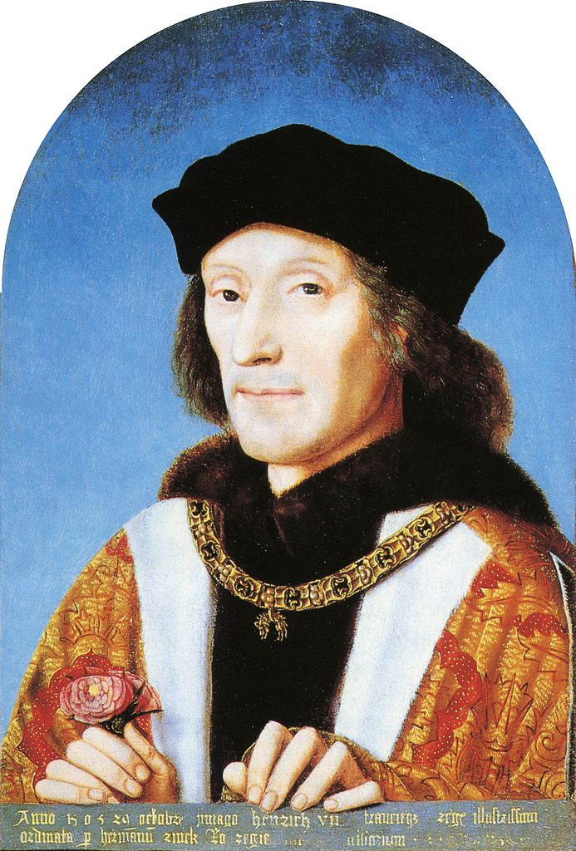Marriage agreements were the most important achievement of Henry VII's foreign policy". How far do you agree?
5. How serious a threat to Henry VII's rule was the Yorkist challenge?
6. "The handling of finances was Henry VII's most successful domestic achievement". How far do you agree?
7. How successful was Henry VII in achieving his foreign policy aims?
8. How effectively did Henry VII handle the nobility?
9. How successfully did Henry VII deal with the problem of the Yorkists?
10. How successfully did Henry VII deal with the domestic problems he faced?
11. How dangerous were Yorkist plots to Henry VII?
12. The avoidance of war was the most important aim of Henry VII's foreign policy". How far do you agree?
13. How successful was Henry VII in strengthening royal finances?
14. "Henry VII's foreign policy achieved little". How far do you agree?
15. "The need to secure his throne dominated the foreign policy of Henry VII". How far do you agree?

Unit 1 Revision Work Sheet 1

Henry Vll, 1485-1509

Securing the Kingdom: Rival claimants and rebels

**Your task** is to produce an attractive document or series of Powerpoint slides or timelines or mind maps to help you to revise.

You must decide what is the best way for you to learn but **simply sitting down and reading** **the booklet is not an option**.

You are to upload the notes you make on the relevant place on GOL for your tutor to assess.

The booklet is on GOL if you have lost it.

**Focus for Revision/Tasks**

1. Why was Henry Tudor’s claim to the throne so weak?
2. Who was alive in 1485 with a stronger claim to the throne than Henry Tudor?
3. List the reasons Henry was able to win the Battle of Bosworth.
4. Produce a timeline covering all the threats to Henry’s rule. Include the Stafford Rising in 1486, Lambert Simnel, Perkin Warbeck, William Stanley and Edmund de la Pole. Include an extra column on your timeline which will enable you to evaluate the threat that each of them posed to Henry. Which was the most serious threat to Henry and why?
5. Plan answers to these exam questions:
6. How accurate is it to say that Lambert Simnel and Perkin Warbeck were both serious threats to Henry Vll’s security?
7. To what extent was Henry Vll’s weak claim to the throne the most important reason for the rebellions and challenges that were mounted against him?

The link to the OCR text book for this course (England 1485-1603) is on GOL. Please read it online. Don’t download it as this is expensive. There are other recommendations for reading in your booklet and on GOL.

Unit 1 Revision Work Sheet 2

Henry Vll, 1485-1509

Foreign Policy

**Your task** is to produce an attractive document or series of Powerpoint slides or timelines or mind maps to help you to revise.

You must decide what is the best way for you to learn but **simply sitting down and reading** **the booklet is not an option**.

You are to upload the notes you make on the relevant place on GOL for your tutor to assess.

The booklet is on GOL if you have lost it.

**Focus for Revision/Tasks**

1. What were Henry Vll’s aims in Foreign Policy?
2. You should already have completed a foreign policy timeline and a foreign policy chart as part of your classwork. If you know you have done these then it would be good idea to check that all the information is correct and add more using your booklets and the text book.

If you have not completed these exercises then do them now.

Upload onto GOL.

Plan answers to these exam questions:

* How far was Henry Vll’s foreign policy directed towards achieving dynastic security?
* How far were Henry Vll’s relations with other powers determined by his dynastic insecurity?
* To what extent was Henry Vll’s foreign policy successful?

Further reading (Copies available in the ILC):

*Henry Vll* – Caroline Rogers, Access to History series

*The Wars of the Roses and Henry Vll: Britain 1450-1509* – Roger Turvey

The link to the OCR text book for this course (England 1485-1603) is on GOL. Please read it online. Don’t download it as this is expensive. There are other recommendations for reading in your booklet and on GOL.

Unit 1 Revision Work Sheet 3

Henry Vll, 1485-1509

Domestic Policy

**Your task** is to produce an attractive document or series of PowerPoint slides or timelines or mind maps to help you to revise.

You must decide what is the best way for you to learn but **simply sitting down and reading** **the booklet is not an option**.

You are to upload the notes you make on the relevant place on GOL for your tutor to assess.

The booklet is on GOL if you have lost it.

**Focus for Revision - Control of the nobility**

1. Did Henry wish to eliminate the nobility or simply limit their power? Explain your answer.
2. You should have made a carrot and stick diagram of the ways in which Henry controlled his nobility. Revise all the methods Henry used by going back to your diagram or do it again so that you can learn which were the most effective methods used by the king.

**Focus for Revision – Financial Policies**

1. How did Henry manage to increase his revenue? Which were the most effective methods?
2. What was the difference between using the Exchequer and the Cahmaber for managing the Crown’s finances?

**Focus for Revision Government, Law and the Maintenance of Order**

Draw a diagram to show how Henry ruled England and maintained law and order. Include as much detail as you can.

**Past Exam Questions**

1. How far do you agree that the nobility never posed a serious threat to Henry VII’s rule?
2. How far did Henry deliberately attempt to reduce the power of the nobility during his reign?
3. How far was Henry’s personal supervision of financial administration the key to his financial success?
4. To what extent were Henry VII’s financial policies designed to control the nobility?
5. How far did his financial policies strengthen the power of the monarchy?
6. To what extent was the financial position of the crown improved during the reign of Henry VII?
7. To what extent was Henry VII successful in enforcing respect for the law among both nobles and commoners?

**Further reading (Copies available in the ILC**):

*Henry Vll* – Caroline Rogers, Access to History series

*The Wars of the Roses and Henry Vll: Britain 1450-1509* – Roger Turvey

The link to the OCR text book for this course (England 1485-1603) is on GOL. Please read it online. Don’t download it as this is expensive. There are other recommendations for reading in your booklet and on GOL.

Unit 1 Revision Work Sheet 4

Henry VllI and Wolsey 1509-1529

The Early years

**Your task** is to produce an attractive document or series of Powerpoint slides or timelines or mind maps whichever help you best to revise. The booklet is on GOL if you have lost it.

**Focus for Revision/Tasks**

1. What was Henry VIII like?
2. Who was Thomas Wolsey?
3. What was his background?
4. How did Wolsey enable Henry to go to war?
5. What were relations with France like in the early years of Henry’s reign?: Battle of Spurs, Tournai, marriage contract
6. What was the Treaty of London – 1518?
7. What happened at the Field of the Cloth of Gold 1520?
8. Why did Henry sign the Treaty of Bruges on Charles V’s side?
9. Why did the Battle of Pavia in 1525 cause the Amicable Grant?
10. Why was the Amicable Grant bad for Wolsey?
11. What did Wolsey do to make people think he was a good Chancellor?
12. What did Wolsey do about Enclosure and what was enclosure?
13. What did Wolsey do about money to obtain it for the king and why was there never enough?
14. What did Wolsey do about the church and what were the complaints about the Church at this time. Refer to the Hunne affair, Nepotism, Pluralism, Simony etc
15. What is the difference between Leviticus and Deuteronomy that gave Henry pause for thought about his marriage to Catherine?
16. Why was it so hard to get a divorce from Catherine of Aragon?
17. Why did Anne Boleyn hate Wolsey?
18. Why did Wolsey fall?

The link to the OCR text book for this course (England 1485-1603) is on GOL. Please read it online. Don’t download it as this is expensive. There are other recommendations for reading in your booklet and on GOL.

**Further reading (Copies available in the ILC)**

*The Tudor Century 1485 – 1603* Ian Dawson

*The Early Tudors England 1485 – 1558* David Rogerson, Samantha Ellsmore, David Hudson

*Henry VIII to Mary I: government and religion, 1509-58* Roger Turvey and Keith Randell

Unit 1 Revision Work Sheet 5

Henry VllI and the Reformation 1529-1547

The later years

**Your task** is to produce an attractive document or series of Powerpoint slides or timelines or mind maps whichever help you best to revise. The booklet is on GOL.

**Focus for Revision/Tasks**

* 1. What was “the King’s great matter”? Why did Henry use the book of Leviticus? Why did he ignore “Deuteronomy”?
  2. The Reformation Parliament opened in 1529. At first it had no intention of breaking with Rome, but it did tap into anti-clerical sentiment. Explain what we mean by “anti-clerical sentiment” and explain the measures they took.
  3. What is Convocation and what did it mean when it said it allowed that Henry was Head of the church “as far as God’s law allows”?
  4. Who was Thomas Cromwell? What was his background and what radical new ideas did he introduce?
  5. Who was Thomas Cranmer and why is he also important?
  6. Explain the impact of the important measures taken in 1534:
     1. Act of Succession (ii)Act of supremacy. (iii)Treason Law
  7. What kind of opposition to his reforms did Henry get? Why didn’t he get more? Explain the impact of the following:
     1. Elizabeth Barton(ii) Bishop Fisher (iii)Thomas More (iv) Carthusiasn monks
  8. How many religious houses were in England in 1530? What did the Valor Ecclesiasticus reveal about them in 1535? What was the impact of their dissolution?
  9. Explain the differences between the Act of 10 Articles in 1536 and the Act of Six Articles in 1539.
  10. Did Thomas Cromwell initiate a “revolution in government”? What is suggested by saying there was one?
  11. What are considered to have been the major causes of The Pilgrimage of Grace?
  12. Why did the Pilgrimage fail?
  13. To what extent was Henry in control of the factions? Ensure you know what a faction is and consider whether faction brought down Thomas Cromwell. Look at the attacks on Cranmer and Katherine Parr and show how the reform faction triumphed at the time of Henry’s death.
  14. What was the impact of Henry’s foreign policy in the 1540’s?

The link to the OCR text book for this course (England 1485-1603) is on GOL. Please read it online

**Further reading (Copies available in the ILC)**

*The Tudor Century 1485 – 1603* Ian Dawson

*The Early Tudors England 1485 – 1558* David Rogerson, Samantha Ellsmore, David Hudson

Unit 1 Revision Work Sheet 6

The Mid- Tudor Crisis 1547 - 1558

Edward and Mary

**Your task** is to produce an attractive document or series of Powerpoint slides or timelines or mind maps whichever help you best to revise. The booklet is on GOL.

**Focus for Revision/Tasks**

1. How did Edward Seymour, The Earl of Hertford manage to acquire the titles: Lord Protector, Duke of Somerset?
2. What was the situation Henry had left his son?
3. How did the Duke of Somerset rule England?
4. To what extent did Somerset make England protestant?
5. To what extent did religious change cause the rebellions in 1549?
6. To what extent did the rebellions threaten the government? Did they cause Somerset to fall?
7. What measures did Northumberland take to strengthen the government?
8. How Protestant did England become under Northumberland and Edward? Look at the 1552 prayer book.
9. What was Edward VI like and what impact did he have on government?
10. Why did Edward’s attempt to replace his sister with Lady Jane Grey fail?
11. Why was it deemed so threatening to have a female ruler?
12. Why was Mary’s marriage to Philip of Spain seen as confirming many prejudices and fears?
13. To what extent can it be seen as a mistake?
14. How popular was Mary’s intention to restore Catholicism?
15. To what extent was Wyatt’s rebellion driven by dislike of her Catholic intentions?
16. How threatening was Wyatt’s rebellion to Tudor rule?
17. What were the socio-economic problems in Mary’s reign?
18. What problems did she face in restoring the country to Catholicism?
19. What was the impact of the 285 burnings Mary imposed?
20. What can be described as successful achievements by Mary?

The OCR text book for this course (England 1485-1603) is on GOL. Please read it online

**Further reading (Copies available in the ILC)**

*The Tudor Century 1485 – 1603* Ian Dawson

*The Early Tudors England 1485 – 1558* David Rogerson, Samantha Ellsmore, David Hudson

*The Tudor Crisis* – a Historical Association pamphlet by Jennifer Loach

**How serious a threat to Henry VII’s rule was the Yorkist challenge?**

Serious

* The weak nature of Henry VII’s claim.
* The Stafford/Lovell rebellion in 1486 showed how insecure H was at the start of his reign & that marrying Elizabeth of York did not by itself dispose of the Yorkist threat.
* In themselves, Simnel and Warbeck presented little danger but they provided a focus for the plots of others in England and overseas, such as **Margaret of Burgundy**, who financed Simnel’s army at Stoke. H was never truly secure until she died in 1503.
* **Ireland** was also sympathetic to the Yorkists; most of Simnel’s army at Stoke was Irish.
* Simnel was supported by powerful **nobles** like Kildare, Lincoln & Lovell.
* Simnel was a threat because it forced the king into battle, which might have gone the same way as Bosworth. In fact **Stoke** was a bigger, bloodier & longer battle than Bosworth; 3,000 of H’s troops were killed & it could well have gone the other way if Simnel had had more than 2,000 German mercenaries.
* **Warbeck** was a threat as he received support from various times from France, Burgundy, the HRE & Scotland.
* H had to beat off a Scottish invasion in 1496 & his attempt to levy taxes to finance a war against **Scotland** in 1497 provoked the very serious Cornish tax rebellion.
* H had to impose a costly & unpopular **trade embargo** 1493-6 to stop Burgundy & the HRE supporting Warbeck.
* That **Sir William Stanley**, to whom H owed his throne & as Lord Chamberlain was responsible for H’s personal safety, should think it worthwhile to correspond with Warbeck showed what a threat he was.
* H’s decisions to **execute** Stanley in 1495 & Warbeck in 1499 shows he did not feel secure.
* The imprisonment & later execution of **Warwick** (& the fact that Simnel gained so much support by impersonating him) showed he was a threat.
* **Suffolk** posed a serious threat which H was lucky to be able to deal with (when Duke Philip of Burgundy was forced by a storm to land in England in 1506).

Not Serious

* The fact that R III was **killed** as well as defeated at Bosworth made the Yorkist threat much less serious than it would otherwise have been & forced the Yorkists to rely on impostors.
* Ross argues that H’s vanguard alone was sufficient to defeat Simnel at Stoke; H had more troops & they were more experienced.
* The Yorkshire tax rebellion in 1489 was not a serious threat & probably not connected to Yorkist claims to the throne anyway.
* Warbeck had to keep moving, successively to Ireland, Kent, France, Burgundy, the HRE, Scotland & Cornwall, reflecting his inability to get any **sustained** support either abroad or at home.
* The Scottish “invasion” of 1496 was little more than a border raid & Warbeck’s army in Somerset in 1497 fled without a battle, so H never had to fight seriously for his throne after Stoke.
* Warbeck’s failure to exploit the Cornish tax rebellion in 1497 (his army ran away when H’s appeared) shows that it had little to do with Yorkist claims to the throne.
* H’s sensible policies, e.g. his effective **spy network** which tracked Warbeck’s movements & discovered Stanley’s treason, reduced the threat as time went on.

CONCLUSION: Give a mark out of 10 for how serious the threat was & write a conclusion explaining this & incorporating at least 3 bullet points on each side. It should be decisive but balanced.

**How effective was Henry VII in dealing with the Yorkist challenges to his throne?**

It is likely that most answers will focus on the Simnel and Warbeck rebellions, but better answers might also consider the de la Pole threat, the Yorkshire tax rebellion and Suffolk. There might also be mention of the situation in Ireland and the general threat from Yorkist nobility who often found themselves under heavy financial burdens.

Effective

* Henry was successful as none of the challenges were able to remove him from the throne.
* The Yorkist cause was reduced to using pretenders.
* Dating the start of his reign to the day before Bosworth meant anyone who fought against him could be convicted of treason.
* Henry married the best Yorkist claimant, Elizabeth of York.
* Having defeated Simnel, Henry was able to show mercy and defuse the situation by parading the real Earl; the success of his policy can be seen when Warbeck rose and failed to gain support in Ireland, unlike the Simnel rising.
* It might be argued that the decline in rebellion after the defeat of Simnel provides evidence of his success and that Warbeck was never more than a nuisance that Henry was largely able to nullify.
* Henry, it can be argued, did deal very successfully with Warbeck as his attempts at invasion were pathetic failures, and he was also able to keep him on the move between European courts.
* H imprisoned Warwick until the conspiracies of other plots provided an excuse for his execution.
* H defeated the tax rebellions in 1489 & 1497.
* H ended foreign support for pretenders through the Treaty of Etaples 1492, the Intercursus Magnus 1496 & the Truce of Ayton 1497.
* H used military action to put pressure on the French & Scottish kings to stop supporting Warbeck.
* The execution of Sir William Stanley in 1495 helped H to control the nobility by showing that nothing less than 100% loyalty would be tolerated.
* Henry was able to hand on a secure throne to his son.

Ineffective

* The Simnel rebellion did force Henry into battle only two years after Bosworth and it was not impossible that a similar result might have occurred.
* Sir William Stanley’s disloyalty in 1495 showed H was not yet secure.
* Foreign support for the Pretenders, particularly from Margaret of Burgundy, made it more difficult for Henry as he was unable to deal with her.
* Henry had difficulty capturing Warbeck.
* H had to make tax concessions because of the rebellions in 1489 & 1497.

**WHAT WAS THE MOST IMPORTANT AIM OF HENRY VII’S FOREIGN POLICY?**

Securing the Throne

* Foreign policy was the most important way to secure his throne as most support for pretenders came from abroad, e.g. Simnel’s army in 1487 was financed by Margaret of Burgundy. H never forgot that he himself owed his throne to French support.
* Margaret of Burgundy was a constant threat until her death in 1503.
* Foreign support for pretenders was a problem throughout H’s reign; only after Burgundy surrendered Suffolk to him in 1506 was he fully secure.
* His willingness to impose trade embargoes 1493-6 & 1506 & to bribe Maximilian with huge sums of money to stop Burgundy & the Holy Roman Empire supporting Warbeck & Suffolk respectively shows that securing his throne was more important than financial or economic considerations.
* All other factors link back to securing his throne: marriages with Spain & Scotland were designed to gain international recognition of his dynasty & secure its future, while avoidance of war was designed to stop tax rebellions like those in Yorkshire in 1489 & Cornwall in 1497. Avoidance of war with France (Treaty of Etaples 1492) & Scotland (Truce of Ayton 1497) stopped support for Warbeck.

Marriages

* Marriages were important as they brought him European recognition, which was important because of his weak claim to the throne, and also gave him a Spanish alliance.
* The marriage of Arthur to Catherine of Aragon in 1501 was intended to cement H’s alliance with Spain & help secure Arthur’s succession to the throne.
* The marriage of H’s daughter Margaret to James IV in 1503 brought at least short term peace with Scotland.

Avoidance of War

* This helped H achieve other objectives like improving his finances & securing his throne. He could not have achieved financial success without avoiding war & raising taxes for war provoked rebellions in Yorkshire (1489) & Cornwall (1497). Avoiding war with France & Scotland enabled him to stop support for Warbeck.
* H’s invasion of France in 1492 might seem to contradict this but in fact he invaded in the autumn (too late for serious campaigning) & was clearly hoping to be bought off.
* H was unable to prevent a Scottish invasion in 1496 but the Truce of Ayton the following year showed his eagerness to avoid war with Scotland.
* H’s eagerness to avoid war with France & Scotland in the 1490s was motivated primarily by his desire to stop them supporting Warbeck.

Other Factors

* Knowing he had won power himself with French support, H tried until 1492 to stop France taking over **Brittany**, which could be used as a base from which to invade England.
* **Financial gain** was arguably the most important achievement given the nature of his finances and use the French pension to support this and also the development and protection of trade, which was secured by his treaties with Spain (Medina del Campo 1489), France (Etaples 1492), Burgundy (Intercursus Magnus 1496).

**To what extent was Henry VII’s foreign policy a success?**

Successes

* He gained international recognition through treaties with Spain, France, Burgundy & Scotland plus diplomatic marriages with Spain & Scotland.
* He forced Warbeck to keep moving in the 1490s from France to Burgundy to Scotland b/c he kept cutting off his foreign support; in the end H was able to capture him without a battle.
* H’s foreign policy was financially successful: he gained a French pension which added 5% to his annual income, avoided the expense of war after 1497 & boosted his customs revenue through trade agreements with France, Spain & above all Burgundy (Intercursus Magnus 1496).
* H was keen to avoid expensive wars and this was largely achieved; although he went to war against France over Brittany it was short-lived and Henry actually gained money through the French pension.
* By avoiding war & therefore taxation after 1497 he minimised the danger of rebellion.
* H succeeded b/c he set himself realistic objectives, focusing on security rather than glory (e.g. in negotiating the Treaty of Etaples in 1492).
* In the 1490s he was able to secure a trade agreement with France despite also maintaining good relations with Ferdinand & Maximilian through the Holy League.
* The Truce of Ayton was the first peace agreement between England & Scotland since 1328 & secured peace for the rest of H’s reign.
* The Treaty of Windsor in 1506 (securing custody of Suffolk) meant he & his heir were fully secure.

Failures

* He failed to cut off Burgundian support for Simnel in 1487, forcing him to fight the Battle of Stoke.
* He failed to prevent the French takeover of Brittany, partly b/c he was let down by his allies (Ferdinand & Maximilian).   This could be seen as a threat to English security.
* His attempts to raise taxes for wars against France & Scotland provoked tax rebellions in Yorkshire in 1489 & Cornwall in 1497.
* Margaret of Burgundy supported both Warbeck & Suffolk & was a constant threat until her death in 1503.
* This forced H to impose economically damaging trade embargoes on Burgundy 1493-6 & 1506 to stop support for Warbeck & Suffolk respectively. Although trade was restored the terms favoured Burgundy b/c H was so desperate to stop support for pretenders; he also spent huge sums bribing Maximilian to achieve this.
* He had to face a Scottish invasion in 1496 b/c he had failed to prevent support for Warbeck.
* H was not fully secure until 1506 when Burgundy handed over Suffolk into his custody.

**DOMESTIC POLICY ANALYSIS**

“Domestic policy” means:

1. Securing the throne & succession through domestic measures (as opposed to foreign policy) like the spy network, marrying Elizabeth of York, executions etc (see notes on this).
2. Financial policy.
3. Control of the nobility.

You might be asked a separate question on any of these or possibly a question on domestic policy more generally.

You could be asked a question on **which of the 3 was most crucial to H’s success**, which is difficult to answer b/c they overlapped. H himself always regarded securing his throne as the most important priority, e.g. his willingness to sacrifice trade to stop support for pretenders, & unless he kept the throne he obviously couldn’t have achieved anything else. He would have regarded financial success & control of the nobility as means to the end of securing his throne rather than as ends in themselves. On the other hand, if he couldn’t control the nobility or couldn’t afford to raise an army to fight pretenders, he would lose the throne anyway.

H himself said “the kings my predecessors, weakening their treasure, have made themselves servants to their subjects”. Foreign ambassadors (to whom H gave expensive gifts to show his wealth) noticed that H liked to be thought wealthier than he truly was b/c it would discourage people from supporting pretenders. H has often been accused of being greedy but this was b/c, as Alexander Grant has argued, he equated money with power.

Edmund Dudley noted “the King’s grace was much set to have many persons in his danger at his pleasure”; by “danger” he meant financial ruin b/c this (through the system of bonds & recogs. which Dudley enforced) was H’s favourite means of controlling the nobility. These are often seen as a money raising device but in fact their main purpose was to secure good behaviour, especially of former Yorkist nobles like Surrey & Dorset. In that sense control of the nobility was more important than finance.

**HOW SUCCESSFUL WAS HENRY VII IN STRENGTHENING ROYAL FINANCES?**

**Successes**

* The use of the **Chamber system** helped H to bring finance under his personal control; he took a keen interest in accounts, payments & income. This was quicker & more efficient than the Exchequer.
* He employed effective officials like **Bray, Empson & Dudley** to ensure that any money due to the Crown (e.g. fines & feudal dues) was thoroughly collected, e.g. a knighthood fee for his son Arthur & a dowry for his daughter Margaret.
* Bonds & recognisances were used to increase revenue, although their primary purpose was to ensure good behaviour.
* Compared with Edward IV (a financially successful king) H increased all revenues, especially crown lands (X4), benevolences (X2) parliamentary taxation (by 55%). Overall income was increased by 67%.
* He increased income from crown lands by seizing the estates of those who opposed him like Lincoln, Suffolk & Sir W Stanley. This plus H’s meanness with patronage & Acts of Resumption (taking back all lands given away by the Crown since the Wars of the Roses started in 1455) enabled him to quadruple revenue from **crown lands**.
* He retained his **French pension** for 17 years compared with Edward IV’s 7.
* He secured profitable trade agreements with Burgundy, France & Spain which boosted **customs** revenue, as did the new Book of Rates uprating them in 1507.
* He left a substantial **surplus** (estimated at around £100,000) for his son.
* H’s successes in raising other revenues (especially crown lands) enabled him to minimise parliamentary taxation after 1497, preventing any more tax rebellions.

**Failures**

* Raising **taxes** provoked rebellions in Yorkshire in 1489 & Cornwall in 1497, forcing H to limit them thereafter; Parliament met only once in the 2nd half of his reign.
* His success in raising income compared with Edward IV was least marked with customs revenue (hampered by **trade embargoes** against Burgundy 1493-6 & 1506), clerical taxation & his French pension.
* H’s desperation to cut off support for pretenders forced him to give huge sums to Maximilian (some estimates say around £300,000) to stop support for Warbeck & Suffolk.
* H’s greed, especially in the last years of his reign when Empson & Dudley extorted so much money by unfair methods, caused so much resentment that it might have provoked a **rebellion**. The execution of Empson & Dudley after H’s death showed this.

**HOW EFFECTIVELY DID HENRY VII HANDLE THE NOBILITY?**

**Successes**

* By dating his reign to the day before the Battle of Bosworth, H could threaten nobles who fought against him with acts of attainder (convicting them of treason) to keep them under control.
* By executing Sir William **Stanley** in 1495 he sent a clear signal to the nobility that nothing less than 100% loyalty would be tolerated.
* He **prevented the emergence of over-mighty subjects** (like Warwick in Edward IV’s reign).
* He used **bonds & recognisances** to limit the power of the nobility (e.g. Dorset was forced to show his loyalty by helping to crush the Cornish tax rebellion to get them lifted & in total 60% of the nobility were subjected to them at some stage during his reign) while at the same time winning their loyalty through the Order of the Garter.
* H was much more effective than previous kings at penalising **retaining**, e.g. Burgavenny was fined £70,000 in 1507.
* The Royal Council was used more effectively to exert control over the nobility, as were institutions like the Council Learned in the Law, Court of Requests, Star Chamber & the Councils of the North and Wales. H limited the power of the nobility by employing legally trained bishops (e.g. Morton, Lord Chancellor & Archbishop of Canterbury) & gentry (e.g. Sir Reginald Bray) in these institutions.
* He increased income from crown lands by seizing the estates of those who opposed him like Lincoln & Suffolk.
* H relied on **loyal nobles** to control parts of the country, like Bedford in Wales & Oxford in East Anglia. He also consulted them on issues like policy towards France in 1491-2. Oxford & Bedford fought with him at Bosworth & Stoke.
* He gained the support of some former **Yorkists**, e.g. Thomas Howard was restored to the earldom of Surrey for suppressing the Yorkshire tax rebellion in 1489.
* **Hardly any nobles supported rival claimants after the Simnel rebellion**; Warbeck had to rely on support from abroad.
* H’s meanness with **patronage** & Acts of Resumption (taking back all lands given away by the Crown since the Wars of the Roses started in 1455) enabled him to quadruple revenue from crown lands.
* The nobles might not have liked H but they **feared** him; he was in no danger of losing the throne as John & Richard II did b/c he was much more competent than them.

**Failures**

* The combination of Lincoln, Lovell & Kildare posed a serious threat to H in 1487, forcing him to fight a battle at **Stoke** which was bigger & bloodier than Bosworth (3,000 of his soldiers were killed).
* The failure of the nobility to prevent Simnel marching across the North in 1487 & the Cornish rebels marching across the South in 1497 shows their lack of loyalty to H.
* Some historians, notably Thomas Penn, have argued that the policies enforced by **Empson & Dudley** in his last years were so oppressive that they could have provoked a rebellion.
* H became harsher & more greedy in the 2nd half of his reign (he passed 51 acts of attainder 1504-9) **despite being more secure**; this inevitably provoked resentment.
* His excessive severity against the nobility (subjecting nearly 60% of them to **bonds & recogs.)** made him v unpopular. As Christine Carpenter has pointed out, he did not discriminate between those who were dangerous & those who were not.
* H abused his feudal rights, e.g. fining the Duke of Buckingham £7,000 in 1498 for entering his inheritance without licence before he was 21.
* The frequency of H’s acts against **retaining** (1485, 1487 & 1504) suggests they were ineffective.
* The limitations H placed on the nobility (there were only 35 nobles in England in 1509 compared with 50 in 1509) & his harshness even towards loyal supporters (he fined Oxford for retaining) made him so unpopular that there might have been a **revolt** if he had reigned much longer. Both John & Richard II were deposed b/c they treated the nobility so badly.

**OCR OLD SPEC QUESTIONS ON HENRY VIII & WOLSEY 1509-29**

* 1. How successful was Henry VIII in achieving his aims as king 1509-29?
  2. Assess the reasons for the fall of Thomas Wolsey in 1529.
  3. How successful was English foreign policy in the period 1509-29?
  4. How successful were Wolsey’s domestic policies? (twice)
  5. “Henry VIII’s foreign policy 1509-29 brought little benefit for England”. How far do you agree?
  6. “The most important reason for Wolsey’s fall from power was his failure to obtain a divorce for Henry VIII”. How far do you agree?
  7. How successful was Henry VIII in achieving his aims in foreign policy in the period 1509-29?
  8. “Henry VIII failed to achieve his aims as king in the period 1509-29”. How far do you agree?
  9. Assess the reasons for Wolsey’s rise to power.
  10. “Wolsey’s lack of noble support was the most important reason for his fall from power”. How far do you agree?

**ASSESS THE REASONS FOR WOLSEY’S RISE TO POWER**

* W rose despite his humble background through sheer ability, both intellectual & administrative, & an extraordinary capacity for hard work.
* For a poor boy with his academic ability the Church offered a valuable career ladder.
* Unlike his father H was bored by detailed financial & administrative work & was happy for W to take care of this for him, especially as W had the tact & charm to ensure that any discussion of govt. business was as short & agreeable as possible.
* W’s appointment as Almoner at the start of H VIII’s reign gave him a seat on the Royal Council.
* Recognising what H wanted, W argued in favour of war with France agt. more cautious councillors like Warham & Fox who advocated the continuation of H VII’s peace policy. This led to W replacing Warham as L Chancellor in 1515.
* The introduction of the subsidy in 1513 significantly boosted tax revenue & made it possible for H to win military glory in France.
* W’s diplomatic skill enabled H to pose as the peacemaker of Europe in the Treaty of London in 1518 & to consider offers from both Francis I & Charles V to ally with him 1520-1 before getting an alliance with C in 1521.

**‘Henry VIII’s foreign policy from 1509 to 1529 brought little benefit for England.’ How far do you agree?**

Candidates should consider what the achievements of Henry’s foreign policy were and can then use this as a basis to discuss their benefit. The territorial gains of Therouanne and Tournai brought little other than prestige and although they gave hope to Henry’s dream of obtaining the French throne, they were never built upon. In many ways victory at Flodden was more significant as it reduced the Scottish threat. There is likely to be some discussion of the benefits of the Treaty of London and the Field of the Cloth of Gold, which although they put England at the centre of the European stage and made her appear to be a major power, brought little of substance. Candidates may consider the alliances made at various stages with France and Spain and whether they brought any gain other than prestige and some might suggest that the number of times Henry was let down by allies was a reflection of England’s limited power and this was made very evident at the end of the period. It is possible that some will argue one achievement was having Wolsey made Cardinal and that even this brought no gain as he was unable to bring about the divorce. Candidates may conclude, as did much of the population by their refusal to pay the Amicable Grant, that there was little gain from Henry’s aggressive policy.

**HOW SUCCESSFUL WERE WOLSEY’S DOMESTIC POLICIES?**

Successes

* H obviously regarded him as a success b/c he gave him so much wealth & power (including promotion to Bishop of Winchester, Archbishop of York & Lord Chancellor with an annual income of £35,000) & kept him as chief minister for 14 years (1515-29); no one else ever achieved this.
* Peter Gwyn argues that he had a good relationship with the nobility, pointing out that many of them sent their sons to be brought up in his household & that Norfolk & Suffolk sometimes asked him to arbitrate in disputes between them. The nobility only professed hostility towards him after he lost the King’s favour over the annulment.
* As Lord Chancellor Wolsey improved the legal system, increasing the number of cases heard in Star Chamber, Chancery & Requests & therefore the availability of justice for all.
* Wolsey’s policy towards enclosures & engrossing showed a genuine desire to help the poor.
* The subsidy led to a significant increase in tax revenue, enabling H to win a prestigious victory in France.
* His policy of dissolving small, unviable monasteries to fund his college at Oxford & school at Ipswich showed his commitment to education & church reform.

Failures

* His power & wealth (coupled with his lowly social origins) inevitably attracted the jealousy of the nobility, especially as he tried to restrict the influence of the younger nobles through the Eltham Ordinances. This contributed to his downfall.
* 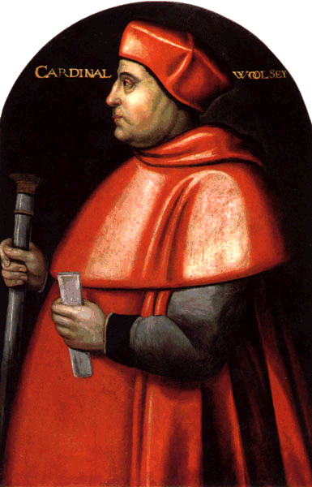The Amicable Grant provoked so much resistance that it had to be abandoned & Wolsey was blamed for its failure, which meant H missed the opportunity to exploit C V’s victory at Pavia. In general W could not raise enough money to enable H to win any significant victories in France.
* W’s policy towards enclosure achieved no lasting success & had to be abandoned b/c of lack of money.
* Similarly, the courts could not cope with the increase in their caseload which his policies helped to generate.
* W’s dissolution of a few small monasteries to fund his pet education projects was on too small a scale & arguably just an “ego trip”, missing an opportunity for much more fundamental reform.
* As a wealthy absentee pluralist who exploited the Church for financial & political gain, W exemplified everything which was wrong with the pre-Reformation Church. In fact the abuses he practised & his failure to secure the annulment discredited the Church in the eyes of H & the nobility & caused the attacks on it from 1529 onwards.
* His failure to secure the annulment resulted in him being seen as a failure by everyone (H, the nobility & both the Aragon & Boleyn factions) & led to his rapid fall from power.

**THE FALL OF WOLSEY**

Wolsey was sacked in 1529 & died in 1530 without ever regaining royal favour.

Unpopularity

* Supporters of Anne Boleyn were hostile to Wolsey because of his **failure** to secure the annulment and the fact that he was competing with Anne for the king’s attention.
* Supporters of Catherine of Aragon were hostile because he had **tried** to secure the annulment.
* Wolsey quarrelled with Henry over the foundation of his school in Ipswich & with Anne over who should be Abbess of Wilton.
* He also failed to gain support of the **nobles**, partly because he had introduced many policies that were very harsh against the nobles so many resented him and also because he had worked his way up from lowly origins so he was viewed by the nobles to have stolen their power from them. They resented his attempt to exclude them from power through the **Eltham Ordinances** in 1526.
* Wolsey was hated for the high **taxes** he imposed, especially the Amicable Grant.
* As a wealthy & corrupt churchman he attracted anticlerical resentment.
* In the **House of Commons**, gentry hated his prosecution of enclosures & common lawyers resented his encouragement of civil as opposed to common law which threatened their business.

Failure to get the Annulment

* This became **Henry’s main aim**, as it would enable him to get a male heir and create a dynasty as well as the fact that he had fallen in love with Anne Boleyn.
* After the **Sack of Rome** in 1527, The Pope was under the control of Charles, who was Catherine of Aragon’s nephew. For this reason, he would not allow the annulment to happen, as it would make his cousin illegitimate and dishonour his family name.
* As a Cardinal and a Papal Legate Wolsey was responsible for securing the annulment because it was a church matter & he had connections with the Pope.
* The first way that Wolsey tried to secure the annulment was through the Anglo-French alliance, because Francis was the only person that had the necessary resources to take on Charles. However the **Treaty of Cambrai** was agreed in 1529 between Francis and Charles which ended any prospect of France being able to free the Pope from Charles’s control.
* 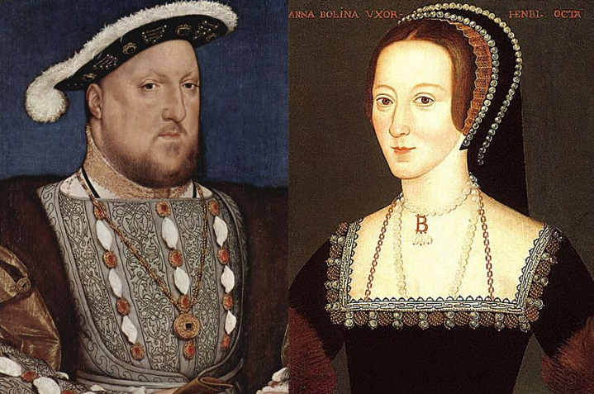Then Wolsey tried to use the **legatine court** by trying to persuade the Pope to let him preside over it in England. The Pope agreed to it being held in England, however he sent Campeggio to preside over it as well, and Campeggio would look out for the Pope’s own interests, just as Wolsey was looking out for Henry’s. This meant that the annulment would never happen as they would never be able to agree on anything.
* The failure to secure the annulment meant the king lost patience with him, it was the final straw for Henry which meant that Wolsey’s downfall was inevitable.
* Before 1529, most nobles (e.g. the Dukes of Norfolk & Suffolk) co-operated with Wolsey; **it was only after he lost Henry’s favour because of his failure to secure the annulment that everyone turned against him**.
* His unpopularity with both Catherine & Anne’s supporters was obviously connected with the annulment.

**HOW SUCCESSFUL WAS HENRY VIII IN ACHIEVING HIS AIMS IN FOREIGN POLICY IN THE PERIOD 1509-29?**

Successes

* Henry did make his mark on Europe and the defeat of the French at the Battle of the Spurs did give him glory & led to the capture of Tournai & Thérouanne. This was a victory for his policy of allying with Maximilian against France.
* H forced the French king Louis XII to pay him a pension & marry his sister Mary in 1514.
* H achieved a decisive victory at Flodden in 1513; James IV was killed, H’s sister Margaret became Regent of Scotland & there was no further threat from Scotland until the 1540s.
* H showed his desire to be a seen as a Renaissance king by favouring Erasmus & posing as the peacemaker of Europe in the Treaty of London in 1518.
* H secured the appointment of Wolsey as a cardinal in 1518.
* Henry also achieved his glory through the peace conferences that Wolsey organised, especially the Field of the Cloth of Gold in 1520. H enjoyed being able to choose whether to ally with Francis I or Charles V 1520-1.

Failures

* His aim to repeat the glories of Edward III & Henry V were not achieved; he never achieved any significant or lasting gains in France despite spending vast sums of money. The refusal to pay the Amicable Grant showed his subjects recognised this.
* He was let down by Ferdinand in 1512, leading to the failure of his invasion of France that year.
* The glory he got from the Battle of the Spurs was exaggerated & Tournai & Thérouanne had to be sold back after only 5 years for much less than it cost to capture & fortify them. Maximilian let H down despite the money he gave him.
* Louis XII’s marriage to Mary was shortlived & by allowing her to marry Suffolk H missed a chance to secure another diplomatically advantageous marriage.
* The most significant English victory in H’s reign was at Flodden in 1513 & he wasn’t even there.
* Peace was not H’s preferred policy so whatever prestige he got from the peace conferences Wolsey organised was limited. Neither the Treaty of London nor the Field of the Cloth of Gold produced any lasting results.
* His invasions of France 1522-3 were failures: C V was unimpressed & deserted H, so he got no compensation for the French pension he had lost & the proposed marriage between C V & H’s daughter Mary never took place.
* H was unable to take advantage of the French defeat at Pavia b/c of the failure of the Amicable Grant & C’s lack of interest in supporting him, forcing H to sign a treaty with France.
* In fact Charles’s victory at Pavia lessened Henry’s influence and also led to the final failure over his annulment.
* The appointment of Wolsey as Cardinal had little effect & H never succeeded in securing his election as Pope, which showed his lack of influence in Europe & contributed to his failure to obtain the annulment.
* All H’s efforts to secure papal consent for the annulment failed, both in terms of theological arguments & diplomatic efforts; the Treaty of Cambrai between F & C & the collapse of the legatine court, both in 1529, sealed his failure & the dismissal of Wolsey in the same year showed H recognised this.
* The Treaty of Cambrai showed how isolated & lacking in influence England truly was at the end of this period.

**HOW SUCCESSFUL WAS HENRY VIII IN ACHIEVING HIS AIMS AS KING 1509-29?**

|  |  |
| --- | --- |
| **SUCCESSES** | **FAILURES** |
| **Domestic**   * H showed that he was a very different king to his father through the execution of Empson and Dudley. * His anti-French foreign policy & generosity with patronage (e.g. the creation of the Dukes of Norfolk & Suffolk) won the allegiance of the nobility while at the same time the executions of Suffolk in 1513 & Buckingham in 1521 showed that he would not tolerate threats to his throne. * The introduction of the subsidy in 1513 was a significant boost to royal revenue. | **Domestic**   * H quickly wasted the surplus his father had so carefully accumulated. * The Amicable Grant in 1525 provoked so much opposition that it had to be abandoned. * H’s marriage was a failure, endangering the succession: Catherine produced only a daughter & H’s only son was illegitimate. |
| **Foreign**   * H showed his desire to be a seen as a Renaissance king by favouring Erasmus & posing as the peacemaker of Europe in the Treaty of London in 1518. * H secured the appointment of Wolsey as a cardinal in 1518. * Henry did make his mark on Europe and the defeat of the French at the Battle of the Spurs did give him glory & led to the capture of Tournai & Thérouanne. This was a victory for his policy of allying with Maximilian against France. * H forced the French king Louis XII to pay him a pension & marry his sister Mary. * H achieved a decisive victory at Flodden in 1513; James IV was killed, H’s sister Margaret became Regent of Scotland & there was no further threat from Scotland until the 1540s. * Henry also achieved his glory through the peace conferences that Wolsey organised, especially the Field of the Cloth of Gold in 1520. H enjoyed being able to choose whether to ally with Francis I or Charles V 1520-1. | **Foreign**   * His aim to repeat the glories of Edward III & Henry V were not repeated; he never achieved any significant or lasting gains in France despite spending vast sums of money. The refusal to pay the Amicable Grant showed his subjects recognised this. * He was let down by Ferdinand in 1512, leading to the failure of his invasion of France that year. * The glory he got from the Battle of the Spurs was exaggerated & Tournai & Thérouanne had to be sold back after only 5 years for much less than it cost to capture & fortify them. Maximilian let H down despite the money he gave him. * Louis XII’s marriage to Mary was shortlived & by allowing her to marry Suffolk H missed a chance to secure another diplomatically advantageous marriage. * The most significant English victory in H’s reign was at Flodden in 1513 & he wasn’t even there. * Peace was not H’s preferred policy so whatever prestige he got from the peace conferences Wolsey organised was limited. Neither the Treaty of London nor the Field of the Cloth of Gold produced any lasting results. * His invasions of France 1522-3 were failures: C V was unimpressed & deserted H, so he got no compensation for the French pension he had lost & the proposed marriage between C V & H’s daughter Mary never took plce. * H was unable to take advantage of the French defeat at Pavia b/c of the failure of the Amicable Grant & C’s lack of interest in supporting him, forcing H to sign a treaty with France. * In fact Charles’s victory at Pavia lessened Henry’s influence and also led to his final failure over his divorce. * The appointment of Wolsey as Cardinal had little effect & H never succeeded in securing his election as Pope, which showed his lack of influence in Europe & contributed to his failure to obtain the annulment. * All H’s efforts to secure papal consent for the annulment failed, both in terms of theological arguments & diplomatic efforts; the Treaty of Cambrai between F & C & the collapse of the legatine court, both in 1529, sealed his failure & the dismissal of Wolsey in the same year showed H recognised this. * The Treaty of Cambrai showed how isolated & lacking in influence England truly was at the end of this period. |

**OCR OLD SPEC QUESTIONS ON THE HENRICIAN REFORMATION 1529-47**

1. How far was the Church in England in need of reform in 1529?
2. Assess the reasons for the break with Rome.
3. Assess the reasons for opposition to the religious changes during the reign of Henry VIII.
4. How important was Thomas Cromwell in influencing religious policy in the 1530s?
5. How serious was opposition to Henry VIII’s religious charges?
6. How far did the religious changes in Henry VIII’s reign make England Protestant?
7. How effective was Henry VIII’s government at overcoming opposition to its religious changes?

**MODEL ESSAY: HOW SERIOUS WAS OPPOSITION TO HENRY VIII’S RELIGIOUS CHANGES?**

Henry VIII made several changes to religion in England with the break with Rome and the introduction of the royal supremacy, followed by the Dissolution of the Monasteries. Obviously this caused opposition but the religious changes were accepted for the most part.

The first opposition that Henry met was from the clergy who only accepted the royal supremacy in 1531 “as far as the law of Christ allows”. They did not approve of the break with Rome or the annulment of Henry’s marriage to Catherine of Aragon and Henry had to wait for Warham, Archbishop of Canterbury, to die so that he could appoint a new Archbishop (Cranmer) who would perform the annulment. It was something he wanted since 1527 but he had to wait until 1533 because of opposition from the clergy. However, other than Fisher, the bishops were kept in check through a combination of fear, loyalty and ambition, so even the most conservative bishops were seen to be supporting the royal supremacy from 1534 onwards. This means that, although initially opposition from the clergy was a serious issue, once Henry had established the royal supremacy and shown that he would not be merciful to opposition there was very little opposition from the clergy.

The individuals who did oppose the religious changes were very influential. Fisher and More were well known and the Carthusians and Observant Franciscans were renowned for their discipline. Fisher was the only one of those to speak out against it, so the opposition may not have been as serious as Henry made out when he had them executed or starved to death. Elizabeth Barton had a large following in Kent and was well respected as she claimed to have visions from the Virgin Mary. Her opposition could have been serious as she had the ability to start a rebellion but Henry forced her to confess that it was all a hoax before he had her executed. Most of the opposition came from individuals as the others were either intimidated, as 308 people were executed under the Treason Act for opposing the religious changes, or many did not care much, such as in the South where they had been either indifferent or sometimes hostile to the monasteries so they would not have minded seeing them dissolved. This means that although opposition came from a lot of individuals, there was not really a collective group working against the religious changes until the Pilgrimage of Grace.

The Pilgrimage of Grace is seen as the most serious (in fact the only) rebellion that Henry VIII faced. It started in Lincolnshire and spread over most of the North, initially provoked by the Dissolution of the Monasteries. People from all classes joined the rebellion and their forces outnumbered Henry’s 5:1. He recognised that it was a serious threat as he agreed to a truce, a pardon and a parliament in the North. He later executed 178 rebels and started dissolving the greater monasteries so it could not happen again, all of which shows that he saw the rebellion as being very serious. However, the rebels trusted Henry; their quarrel was with his “evil counsellors” and so they disbanded instead of marching to London, where they may have been able to reverse some of the religious changes. This allowed Henry to use another rebellion breaking out as an excuse to revoke the pardon, allowing him to execute the leaders. The rebels were also divided as they contained people from different classes who had disagreements over things such as enclosures and this caused a lot of people to get “rebellion fatigue” and go home. Therefore, although the Pilgrimage of Grace could have been very serious opposition which may have forced Henry to change some of his religious policies, their misguided trust in him and the splits within the rebels meant all it achieved was giving Henry an excuse to dissolve the greater monasteries.

Opposition also came from both religions. Obviously it was mostly Catholic as the changes were initially moving the Church in a more Protestant direction but Henry was not a Protestant and still believed in Catholic values such as clerical celibacy and transubstantiation. Lambert and Askew were both burnt for denying transubstantiation which shows that Henry’s religious policies were not approved of fully by either group. However, these were isolated cases and many of the people who took issue with the religious changes were deterred from rebelling by the Treason Act.

An area where opposition could have been serious was in Parliament where there were powerful nobles and gentry who had power over legislation, however the desire to agree with the King in order to gain power and avoid execution meant that they tended to support the royal supremacy. They also supported the Dissolution of the Monasteries as it allowed them to buy cheap land which meant that most opposition in this area where it could have been very serious was quelled. Although a few abbots & monks resisted the Dissolution, the great majority took their pensions and accepted it.

Overall, I do not think that opposition to Henry VIII’s religious changes was very serious because firstly, although the clergy pushed back the annulment, once Henry had replaced the Archbishop of Canterbury and established the royal supremacy there was little opposition from them. The opposition from devout Protestants was also limited and so was opposition in Parliament where it could have been very serious. Fisher, More, Elizabeth Barton, the Carthusians and the Observant Franciscans were all stopped and they were only individuals. The Pilgrimage of Grace could have been very serious but their mistakes allowed Henry to use them as an excuse for further religious changes. Therefore, there was not much opposition to the religious changes and where there was any Henry was able to get rid of it successfully.

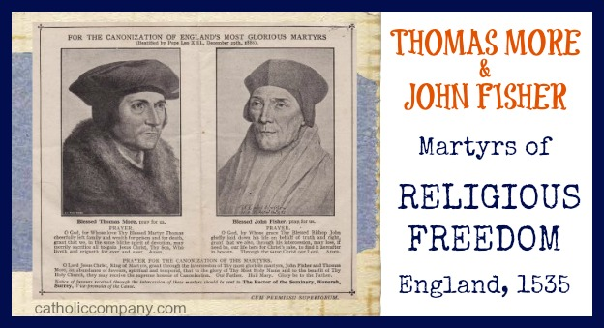

**How far was the Church in England in need of reform in 1529?**

Yes:

* AG Dickens claimed that ”anticlericalism had reached a new intensity by the early years of the 16th century” & cited the anticlerical legislation passed by Parliament in 1529 as evidence of this.
* A leading role was played in this legislation by common lawyers who resented competition for business from the church courts.
* The Hunne Case in 1514 provoked anticlericalism b/c Hunne was burnt as a heretic without being tried (his only offence was to refuse to pay burial fees to his local priest) & no one was prosecuted for his murder despite him being found hanged in a church prison.
* There were calls for reform from Colet, Melton & Fish; Colet, a respected scholar & preacher, said his fellow clergy were “drowned in the delights of this world” and “patronize those who cater for their pleasure”.
* Individuals like Wolsey were guilty of abuses like pluralism (at the end of his career he was Archbishop of York, Bishop of Winchester & Abbot of St Albans at the same time), non-residence (he was Archbishop of York for 16 years before he ever went there) & nepotism (he made his son an archdeacon). Wolsey was not unique: Thomas Magnus was an archdeacon, canon & master of 3 colleges or hospitals as well as holding 4 parish livings.
* Monastic life seems to have been stagnating, with a decline in the number of monks & nuns & in foundations of new monasteries & nunneries.
* As Dickens has pointed out, there was little enthusiasm for the papal supremacy even amongst bishops with conservative religious views like Gardiner.

No:

* People still volunteered money to the Church, for example in wills, and this allowed church building to continue up to the eve of the Reformation. The people of Louth in Lincolnshire spent £305 on their church spire, of which they were so proud that they rebelled in the Pilgrimage of Grace when they thought their church was under threat. Evidence of wills shows that the people of Morebath continued to spend money on church images right up to Elizabeth’s reign.
* Evidence from wills show increased lay investment in chantries & prayers for the dead in the early 16th century.
* The payment of tithes was not unpopular generally.
* Attendance at church courts was not unpopular & lay people used them voluntarily, e.g. to prove wills.
* The Church was satisfying the needs of most as Lutheranism and Lollardy found little support apart from a few Lollards in the Chiltern area of Buckinghamshire & a group of Cambridge academics interested in Lutheran ideas.
* The agricultural year was supported by the church calendar through events such as Rogationtide or Harvest Festival. The Church was also at the centre of parish social life like “church ales”. According to Haigh, “there is a very wide range of evidence to suggest that the ordinary religion of English parishes was in a healthy & vigorous state in the early 16th century”.
* In urban communities the number of guilds and the production of devotional literature shows that the church was still flourishing. The Primer, a collection of devotional works, went through 37 editions 1501-20 & even more (41) in the 1520s.
* There is no consistent evidence of a decline in clerical recruitment in the early 16th century.
* Complaints about the behaviour of the clergy were few & the situation was no worse than it had been, as shown by Chaucer or Langland who criticised the clergy in the 14th century.
* There is no evidence of clerical standards declining: an inspection of 260 parishes in Kent in 1511-2 concluded that only 4 clergy were ignorant.
* Anti-papalism was not strong as it was in Germany.
* Haigh argues that anticlericalism was not general & the legislation of 1529 owed much to govt. manipulation to put pressure on the Pope to grant the annulment & to justify the dismissal of Wolsey.
* Even where there was absenteeism this was often overcome by the use of curates (in the case of parish clergy) or suffragans (in the case of bishops).
* The Hunne case was exceptional & did not provoke any serious unrest at the time.

**ASSESS THE REASONS FOR THE BREAK WITH ROME**

* Historians like Elton & Dickens would argue that anti-clericalism within England and a desire to reform the Church were issues, but others like Haigh would dismiss this. Recent research suggests that historians like Dickens greatly exaggerated public anticlericalism & only a tiny minority of the population were Lollards or Lutherans. It is therefore clear that the break with Rome happened because **Henry** wanted it, not because the people of England did. In any case the changes 1529-34 affected the power & wealth of the Church, but not its religious doctrine; it became a **“Catholic Church without the Pope”**, not a Protestant Church.
* The most obvious reason was Henry’s desire for an **annulment**. By 1527 he had fallen in love with Anne Boleyn, as evidenced by his passionate love letters & poems to her & the length of time he was willing to wait before she would go to bed with him (probably not until 1532!). More importantly, Catherine of Aragon had not borne him a son & H was now convinced that she never would; she was now past childbearing age anyway. By questioning the legality of his marriage during the negotiations for a French marriage alliance in 1520, the French had sown seeds of doubt in H’s mind; he also convinced himself as a matter of conscience that his marriage was sinful b/c God had denied him a son. Most importantly of all, he recognised that one of his main duties as King was to secure the **succession** by having a legitimate son; he would never have contemplated marrying Anne if Catherine had given him a son.
* Anne’s **pregnancy** in 1532 (she calculated that by falling pregnant she could force H to marry her) was arguably decisive in provoking the annulment & remarriage of H early in 1533 which in turn led to the Act of Supremacy in 1534.
* It could be argued that Henry had a powerful **ego** and therefore the break with Rome was caused by his desire for supremacy in all matters. He had a knack of convincing himself that whatever he wanted was also morally right & a matter of conscience. The refusal of the pope to grant Henry his annulment simply provided Henry with the opportunity.
* **Money** could have been a motivation: H demanded that the clergy pay a £118,000 fine in return for being pardoned for their praemunire in 1531 & the Act of First Fruits & Tenths hugely increased the revenue H received from clerical taxation. On the other hand, the biggest financial windfall came later, from the dissolution of the greater monasteries in 1539.
* However, this argument is less convincing given the amount of time (6 years from 1527 to 1533) Henry spent trying to persuade the pope to grant the annulment. H broke from Rome only with **reluctance**, shown by the attempts at pressure that were put on the papacy, through the French alliance 1526-9, the legatine court in 1529, the anticlerical legislation of 1529 & the conditional nature of the first Act in Restraint of Annates in 1532..
* Ultimately, it was the **foreign** situation that prevented the Pope granting a divorce: the Pope had been under the control of Catherine’s nephew Charles V since 1527 & nothing happened subsequently to change this. Francis I’s decision to make the Treaty of Cambrai with Charles in 1529 confirmed this. However, Francis’s encouragement of H in 1532 to annul his Spanish marriage & marry Anne instead (with her French connections) was a factor in H’s decision to go through with the annulment in 1533.
* Thomas Cranmer, who became Archbishop of Canterbury in 1532, and Thomas Cromwell, who emerged as the king’s chief minister by 1532, were both **Protestant sympathisers** with agenda of their own, and between them these two men were able to offer Henry a means of getting what he wanted – an annulment. In addition, Anne Boleyn was acquainted with a group of reformist writers and Cambridge academics and had reformist sympathies herself and undoubtedly she influenced the king. George Bernard, however, argues that there was no “drift”; Henry knew what he wanted all along but it took time to overcome the opposition to the break with Rome.

**HOW IMPORTANT WAS THOMAS CROMWELL IN INFLUENCING RELIGIOUS POLICY IN THE 1530S?**

* G.R. Elton argued that H didn’t know how to annul his marriage with Catherine of Aragon until Crom. showed him how to break with Rome by passing acts through Parliament like the Acts of Appeals, Supremacy, Succession & Treason 1533-4.
* Crom. drafted the acts which separated England from Rome & passed them through Parliament.
* Crom. combatted opposition to the changes by imposing the oath in the Succession Act which led to the execution of Fisher, More & the Carthusians & the Treason Act which redefined opposition to the royal supremacy as treason. In total 308 people were executed 1532-40 for opposing the changes.
* He was the first English statesman to organise a government propaganda campaign, in his case in support of the religious changes, by authorising pamphlets & sermons arguing that H was the rightful Head of the Church; he also employed commissioners to exaggerate the corruption in the monasteries to justify the dissolution.
* He ordered bishops & JPs to report any opposition to the changes.
* He argued for an alliance with the German Prot. princes against Charles V, leading to the Cleves marriage in 1539.
* As Bernard has pointed out, even if Crom. was less Prot. than his reputation suggested, the fact that executing him in 1540 (accusing him of heresy in the Act of Attainder which led to the execution) was the easiest way for H to demonstrate his Prot. credentials to Charles V shows that he was **seen** as the driving force behind the religious changes. The Pilgrims of Grace certainly thought this, as did Norfolk & Gardiner.
* Cromwell’s more radical beliefs were important in influencing the king to dissolve the monasteries and introduce some more Protestant views, e.g. the 10 Articles, Injunctions, Bishops’ Book & above all the publication of the English Bible.

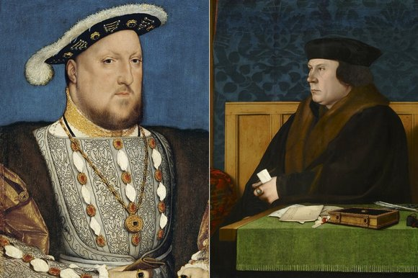**BUT:**

* Elton’s view is now discredited: some historians like Eric Ives argue Anne Boleyn’s role was decisive, while others, like Scarisbrick & Bernard, argue that H knew what to do but just needed an efficient “enforcer” like Crom. carry it out.
* It can be argued (e.g. by A.G. Dickens) that the condition of the Church and the need to reform in response to popular pressure was important.
* Bernard argues that Crom. was less committed to Prot. than his reputation suggested &, like his former master, Wolsey, had no choice but to put the King’s interests first, e.g. he justified the Dissolution of the Monasteries by promising to make Henry’ the richest man in Christendom’.
* Cromwell’s views were not important as once he displeased Henry and became too radical he was removed. H never shared Crom.’s Prot. sympathies & the burning of Lambert in 1538 & the passing of the Act of the 6 Articles in 1539 showed that he, not Crom., controlled religious policy.
* There were other more important factors and issues such as H’s desire for power over the Church, money (the Act of First Fruits & Tenths & the Dissolution of the Monasteries) & the foreign situation, especially the threat of a Catholic crusade by Francis I & Charles V against Henry VIII to restore England to the papal supremacy.
* The Pilgrims of Grace, Norfolk & Gardiner had no choice but to blame Crom. for the changes they disliked b/c the only alternative was to blame H.

**HOW FAR DID THE RELIGIOUS CHANGES IN HENRY VIII’S REIGN MAKE ENGLAND PROTESTANT?**

* The **break with Rome**, confirmed by the Act of Supremacy in 1534, laid the foundations for later changes.
* Later changes, especially the **Dissolution of the Monasteries** & the publication of the **English Bible**, indicate that by 1540, never mind 1547, the Church of England was more than just “a Catholic Church without the Pope”.
* Some **fundamental Catholic beliefs had been undermined**, e,g. the Dissolution of the Monasteries undermined belief in pilgrimage, salvation by good works & purgatory as well as monasticism as such. The 10 Articles rejected 4 of the 7 Catholic sacraments, while the Injunctions (both 1536 & 1538) criticised pilgrimage. The Bishops’ Book 1537 played down the importance of holy orders, the Mass & purgatory, while the act authorising the dissolution of the chantries in 1545 was a major attack on the doctrine of purgatory.
* [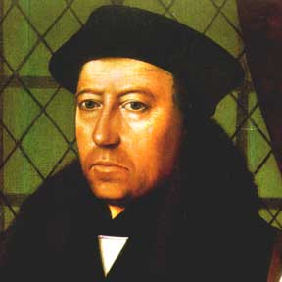](http://www.google.co.uk/url?sa=i&rct=j&q=&esrc=s&frm=1&source=images&cd=&cad=rja&uact=8&ved=0ahUKEwiO6vn2-LjKAhUDUhQKHaLWAsQQjRwIBw&url=http://www.virtueonline.org/sacramentalism-defined-anglicanism-and-divine-ordinances&psig=AFQjCNEMYcy7YBUw_X4g6YAj7OLA_pB-8A&ust=1453398346324502)An English Litany was published in 1544 & the Injunctions & even the relatively conservative King’s Book encouraged Bible based preaching, changes that would have a long term impact and eventually make England more Protestant.
* Henry appointed **Protestant tutors** like John Cheke for Edward VI and it was a Protestant dominated **Regency Council** that would emerge at the end of the reign, not least b/c of the fall of the religiously conservative Norfolk & Gardiner from H’s favour in 1546.
* Henry did support **Cranmer** (right) throughout the period and gave his backing to Catherine Parr when Gardiner attacked her.
* The influence of Protestant ideas from continental Europe had an impact on London & Kent, especially amongst **merchants, scholars & the young**.

**BUT:**

* [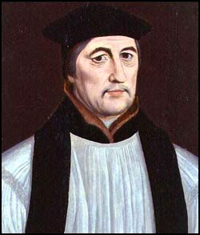](http://www.google.co.uk/url?sa=i&rct=j&q=&source=imgres&cd=&cad=rja&uact=8&ved=0ahUKEwj1tpXy-bjKAhUHvhQKHas7CO0QjRwICTAA&url=http://www.luminarium.org/encyclopedia/gardiner.htm&psig=AFQjCNG6q30e9snfybkpJffZyZ6Z3nwK-g&ust=1453398614244231)H never accepted most Prot. beliefs, as shown by the burnings of Lambert in 1538 & Askew in 1546 for denying **transubstantiation**. He believed so strongly in **clerical celibacy** that monks & nuns still had to observe their vows of chastity despite the Dissolution.
* Progress towards Prot. was halted 1539-40 by the **Act of the 6 Articles** followed by Cromwell’s execution.
* **Norfolk & Gardiner** (right) were in the ascendant in the early 1540s, shown by the Act for the Advancement of True Religion (which tried to restrict access to the English Bible) & the King’s Book (which defended the 6 Articles) in 1543.
* The doctrine & worship of the Church of England was still fundamentally Catholic, with the **Latin Mass**, communion in one kind for the laity, transubstantiation, clerical celibacy & confession to priests still being upheld.
* Although the monasteries were dissolved, **parish** churches (with the colourful images) had barely been touched & the chantries weren’t dissolved until after H’s death.
* The changes were mainly **legal** in character with little impact on religion at grassroots level, especially in the North & West. Even in London only 20% of wills were explicitly Prot. by 1547.
* The **Pilgrimage of Grace**, the only serious rebellion H ever faced, shows how strong opposition to the Reformation in the North was.

BY 1547 WAS THE C OF E (1) A CATHOLIC CHURCH, (2) A MAINLY CATHOLIC CHURCH WITH SOME PROTESTANT FEATURES, (3) 50/50, (4) A MAINLY PROTESTANT CHURCH WITH SOME CATHOLIC FEATURES OR (5) A PROTESTANT CHURCH?

**HOW SERIOUS WAS OPPOSITION TO HENRY VIII’S RELIGIOUS CHANGES?**

* Catherine of Aragon refused to go to a nunnery, forcing H to break with Rome to get his annulment.
* Opposition from the **clergy** delayed the break with Rome until 1534, e.g. in 1531 they would only accept the royal supremacy “as far as the law of Christ allows”. Not until Warham died in 1532 could H appoint an Archbishop of Canterbury who would support the royal supremacy.
* 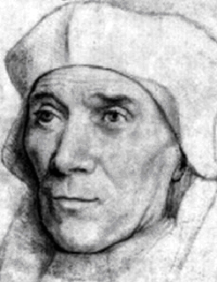The opponents of the royal supremacy were few but highly respected: the Pope made **Fisher** (right) a cardinal, **More** was renowned as both a scholar & a politician, the **Carthusians** & Observant (strict) Franciscans were admired for their holiness & strictness.
* Similarly, **Elizabeth Barton** had a significant following in Kent & her direct defiance of H (telling him to his face that he would lose his throne if he married Anne Boleyn) could not be ignored.
* The rebel army at Doncaster during the **Pilgrimage of Grace** numbered about 30,000, outnumbering the royal army by perhaps 5:1. The rebellion spread all over the North, from Lincolnshire to Cumberland, & was by far the most serious rebellion H ever faced. He was fortunate that they naively trusted his promises.
* Some **abbots**, like those of Reading, Colchester & Glastonbury, rejected both H’s threats & attempts to buy them off & refused to surrender their abbeys.
* The burnings of Lambert & Askew for denying transubstantiation shows that opposition to H’s policies came from **Prots.** as well as Caths.

**BUT:**

* There was very little opposition in **Parliament** to the religious changes, partly b/c Cromwell “managed” Parl. to ensure this. The gentry may have voted for the dissolution of the lesser monasteries in the hope of buying monastic lands.
* Apart from the Carthusians & Franciscans, opposition to the royal supremacy came only from **individuals** like More & Fisher, who was the only bishop to reject the royal supremacy.
* A combination of fear, loyalty & ambition persuaded all the **bishops** except Fisher to accept the royal supremacy. Stephen Gardiner’s ambition to be Lord Chancellor (like Wolsey) led him to write “On True Obedience” in defence of the royal supremacy despite his conservative religious views.
* 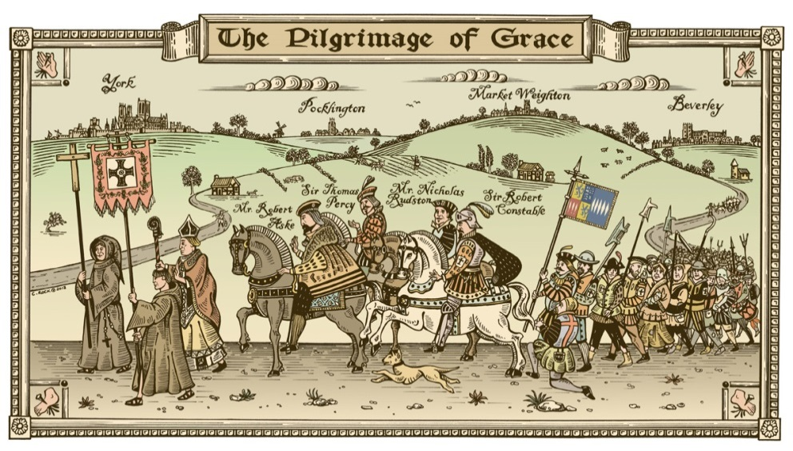The imposition of the oath in the Succession Act & the Treason Act were highly effective in intimidating potential opponents: 308 people were executed 1532-40 for opposing the religious changes.
* The fact that it took only about 300 **executions** out of a population of 2.5 million to deter opposition suggests there was not much of it.
* Despite its initial success, H was able to crush the Pilgrimage of Grace easily b/c of the rebels’ naïve willingness to trust his promises rather than march on London & their eagerness to go home (“rebellion fatigue”).
* The vast majority of abbots, monks & nuns took their pensions & accepted the **Dissolution** without resistance. The number of monks was declining even before the Dissolution.
* In the **South**, there was little opposition to the Dissolution b/c lay people were generally either indifferent to the monasteries or in some cases (like St Albans & Bury St Edmunds, both abbeys renowned as harsh landlords), perhaps even hostile to them.

**ASSESS THE REASONS FOR OPPOSITION TO THE RELIGIOUS CHANGES DURING THE REIGN OF HENRY VIII**

* Some, such as Fisher & Barton & politicians like Darcy & Hussey, were motivated by support for Catherine of Aragon as H’s rightful Queen. Catherine was widely seen as a virtuous woman who had been wronged & Anne as a whore who may even have seduced H by witchcraft.
* Fisher, More, the Carthusians & the Franciscans were strong supporters of the **papal supremacy**, in More’s case b/c it kept the universal Church together; he denied that Parliament had the power to break the unity of Christendom.
* Clergy resisted the royal supremacy b/c they rightly feared it would lead to an increase in **clerical taxation**, as the Act of First Fruits & Tenths showed.
* The merchants in the House of Commons showed reluctance to pass the Act of Appeals in 1533 b/c they feared it might damage **trade** with Flanders, which was ruled by the staunchly Catholic Charles V.
* Christopher Haigh (especially on Lancashire) & George Bernard have argued that the Pilgrimage of Grace was motivated mainly by the Dissolution of the **Monasteries**. Rather than being isolated from the community, Haigh has argued that the monks in Lancashire were “local boys” who provided valuable services in terms of hospitality, education & charity.
* In Lincolnshire the rebellion in 1536 started in Louth where the local people feared an attack on their parish church which they had invested a great deal of money in (they had spent £305 on a new spire) & were intensely proud of. The experience of seeing the lesser monasteries actually dissolved made the rumours that there would be a similar attack on the **parish** churches more believable.
* The Dissolution provoked more opposition than the royal supremacy b/c it had the potential to affect people’s everyday lives much more directly.
* The Pontefract Articles show that the dissolution of the lesser monasteries was seen as an attack on **Catholic belief** more generally, for example in pilgrimage, salvation by good works & purgatory. The rebels demanded that heresy be “annulled & destroyed”.
* 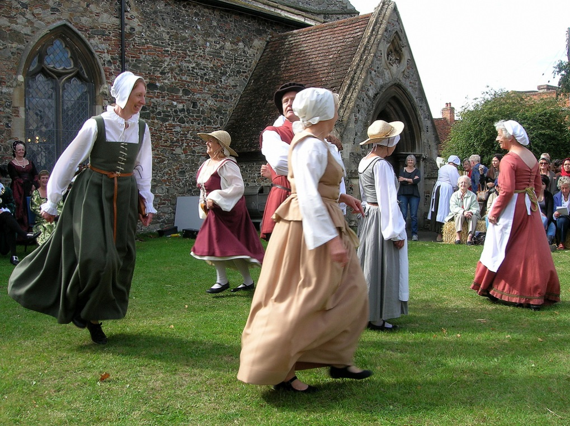There was strong public support for **prayers for the dead** b/c they found it emotionally comforting to pray for the souls of their loved ones. A lot of lay people’s money had been invested in this & such donations were rising in the pre-Reformation period.
* For many simply the fear of the unknown in a world where there was little certainty may have been enough to cause uncertainty and even resistance. Parish churches were also the focus of **community activities** like guilds, church ales, Rogationtide etc.
* Church festivals fitted in with the agricultural calendar & many of the peasants feared losing saints’ days as **holidays**. In that sense religious were linked with economic grievances.

**HOW EFFECTIVE WAS HENRY VIII’S GOVERNMENT AT OVERCOMING OPPOSITION TO ITS RELIGIOUS CHANGES?**

Evidence of Effectiveness

* Cromwell “managed” **Parliament**, e.g. by influencing elections & persuading key MPs to support govt. policy, to ensure the passage of legislation from the anticlerical acts of 1529 onwards.
* The imposition of the oath in the Succession Act & the **Treason Act** were highly effective in intimidating potential opponents: 308 people were executed 1532-40 for opposing the religious changes. H’s determination to execute even high profile opponents like More, Fisher & the Carthusians showed that he was not to be trifled with.
* On the other hand, the fact that it took only about 300 executions out of a population of 2.5 million to deter opposition shows how effective govt. policy was. Cromwell tried to detect opposition early by ordering bishops & JPs to report any evidence of it to him.
* Cromwell organised the first ever govt. organised **propaganda** campaign, through sermons & pamphlets, to persuade people that H was the rightful Head of the Church, that the monasteries deserved to be dissolved etc.
* Despite its initial success, H was able to crush the **Pilgrimage of Grace** easily by making false promises of a pardon, a Parliament at York etc & then ruthlessly crushing it when the rebels disbanded.
* The **piecemeal nature** of the changes helped to overcome opposition, e.g. the act dissolving the lesser monasteries praised the greater ones & H even founded 2 new monasteries to give the impression that the greater ones would not be dissolved.
* Through a combination of intimidation (with the rebellious Abbots of Reading, Colchester & Glastonbury being publicly hanged) & the offering of reasonably generous pensions, govt. policy succeeded in persuading the great majority of **monasteries** to surrender themselves “voluntarily”.

Evidence of Lack of Effectiveness.

* Opposition from the **clergy** delayed the break with Rome until 1534, e.g. in 1531 they would only accept the royal supremacy “as far as the law of Christ allows”.
* The fact that some of the **Carthusians** were starved to death rather than publicly executed suggests that H realised executing people so renowned for their holiness was damaging to his reputation
* The govt. failed to prevent the **Pilgrimage of Grace**, by far the most serious rebellion H ever faced. The rebel army at Doncaster during the Pilgrimage of Grace numbered about 30,000, outnumbering the royal army by perhaps 5:1. The rebellion spread all over the North, from Lincolnshire to Cumberland, & H was saved only by the naivety of the rebels in believing his promises & their desire to go home (“rebellion fatigue”).
* Some **abbots**, like those of Reading, Colchester & Glastonbury, rejected both H’s threats & attempts to buy them off & refused to surrender their abbeys.
* The burnings of Lambert & Askew for denying transubstantiation shows that opposition to H’s policies came from **Prots.** as well as Caths.

Other Reasons why there was not more Opposition

* Many thought that once Henry had his annulment and heir there would be a return to the Catholic fold and therefore the changes would be **short-lived**.
* The early changes (associated with the royal supremacy) would have made **little difference to religious life**. It was by no means clear that they would necessarily lead to further changes.
* In the South, there was little opposition to the Dissolution b/c lay people were generally either indifferent to the **monasteries** or in some cases (e.g. Bury St Edmunds) even hostile to them.
* The **gentry** may have voted for the dissolution of the lesser monasteries in the hope of buying monastic lands.

**AS History, Unit 1 The Early Tudors 1485-1558**

**How to approach the source questions in the exam**

In the Unit 1 exam you will answer questions from two sections. From Section A you will answer a 10 and 20 mark source based question. In Section B you will write one 20 mark own knowledge essay. In the exam, the Section A questions will always come from the period 1547-1558 – the Mid-Tudor Crisis Below is a guide to how to approach the two source-based questions.

**Section A, Question 1 – 10 Marks**

E.g. ***Use your own knowledge of the unrest in 1549 to assess how useful Source A is as evidence of the reaction of the government to rebellion.***



To answer this question you will need to use the following skills:

* Interpret the source. Understand what it is directly saying but also what it suggest or implies
* Explain the view of the source about the issue in the question
* Consider the provenance of the source (see separate box)
* Apply your **contextual knowledge** to the source to judge how useful it is. Note not reliability.

When writing this answer, remember that it is not an essay and does not need, therefore, a developed introduction, conclusion or analysis of a range of factors. **Instead you need to focus throughout at analysing the content and provenance of the source with your own knowledge to evaluate its usefulness in explaining the issue in the question.**

**How to analyse the provenance of sources**

The term provenance simply means ‘where did the source come from’. You need to use your understanding of the provenance to explain why a source has a certain view or whether it makes it more or less reliable. The following are things to examine the source for:

***PURPOSE*** – why has the source been written and what is it trying to achieve?

***AUTHOR*** – who wrote the source and what do you know about their role/views? Does this change your understanding of the content of the source?

***NATURE*** – what kind of source is it? You will get no credit for simply stating this but it could help to explain why a source has a particular view

***DATE –*** When was it written and what was happening at that time?

***AUDIENCE*** – Who was the source written for and does this explain what it does or doesn’t say?

***TONE*** – What is the tone of the author and does this make the content of the source more or less useful.

You will get no credit for simply stating that the source is a primary source (they all will be) and need to avoid simple statements about provenance e.g. “*It is a letter and therefore might be reliable…”*. The provenance should be used with your **own knowledge** and must be focused on the specific question.

You cannot use the term bias or biased. These are pointless terms as every source is contains the opinion of its author and using the term stops you analysing the source properly

In terms of structure, the answer can be written as one extended paragraph and will be around half to three-quarters of a side of A4. You should develop points which suggest that the source is both useful and is not useful.

**You should spend approximately 15 minutes on this question, including reading and thinking time.**

**Section A, Question 2 – 20 Marks**

E.g. ***Study the three sources and considering them in their historical context assess how far they support the view that enclosure was the most important cause of unrest in 1549***

To answer this question you will need to:

* Focus on the specific question throughout
* Evaluate all of the sources using both provenance and own knowledge
* Reach a judgement about the issue in the question by evaluating the sources

There are two ways to structure your answer to this question:

1. **Sequentially** – this means simply looking at each of the three sources in turn and spending one paragraph on each. This is the simplest way to structure your answer but you will need to be careful not to simply describe what each source says
2. **Grouping** – this means grouping ideas from the sources together around points that support and challenge the view in the question. This will involve more planning but can lead to a more analytical answer.

**Possible Structure (Grouping):**

**Introduction –** briefly summarise the views of the sources on the issue in the question and introduce any alternative point views they suggest

**1st Paragraph** – First way in which the sources support or challenge the view in the question

**2nd Paragraph** – Second way in which the sources support or challenge the view in the question

**3rd Paragraph** – Third way in which the sources support or challenge the view in the question

**Conclusion** – Give an overall judgement about the extent to which the sources support or challenge the view in the question

**Possible Structure (Sequential):**

**Introduction –** briefly summarise the views of the sources on the issue in the question and introduce any alternative point views they suggest

**1st Paragraph** – Source A: does it support the view in the question or does it challenge it or introduce other views?

**2nd Paragraph** – Source B: does it support the view in the question or does it challenge it or introduce other views?

**3rd Paragraph** – Source C: does it support the view in the question or does it challenge it or introduce other views?

**Conclusion** – Give an overall judgement about the extent to which the sources support or challenge the view in the question

There is no requirement to structure this essay in a set way but make sure you are aware of the strengths and weaknesses of each approach. Good answers will also naturally pick out similar and different views between the sources and you should at all times avoid simply describing the sources.

KEY POINTS:

1. When talking about the content or provenance you need to make sure this is directly linked to the specific question.
2. Use your **own knowledge** to evaluate the sources. Explain why they have certain views about the issue in the question
3. You must reach a judgement about the sources; this is the ‘how far’ part of the question. You need to judge explicitly how far they support the issue in the question.

**SOURCE EVALUATION GRID**

Read the description & evaluate how useful you think this source would be & why.

|  |  |
| --- | --- |
| Set of rebel demands which mentions only religious grievances at a time of social & economic unrest. |  |
| Letter from the Venetian ambassador to the Venetian Senate about rebellions in Cornwall & Norfolk. |  |
| Letter from Sir William Paget to Somerset in 1549 criticising his anti-enclosure policy & claiming it caused the rebellions by encouraging the peasants to take the law into their own hands. |  |
| Account by a Catholic gentleman about whether Edward VI or Northumberland was responsible for trying to exclude Mary from the succession in 1553. |  |
| Letter from the Privy Council, at a time when it was dominated by Northumberland, to Mary warning her that she was not the rightful heir. |  |
| Letter from the French ambassador to his master Henry II regarding a conversation he had with Northumberland about French intervention to stop Mary becoming Queen in 1553. |  |
| An account written by a Catholic priest in Yorkshire claiming that the restoration of Catholicism under Mary was enthusiastically welcomed by the common people. |  |
| Extracts from the churchwardens’ accounts in a parish in Berkshire recording the restoration of the Catholic altar, images etc in the local church. |  |
| Letter to Charles V from his ambassadors in England warning him that the restoration of Catholicism in England might be jeopardised unless the gentry are reassured that they will be allowed to keep monastic & chantry lands. |  |

**HOW SERIOUS WERE THE PROBLEMS CAUSED BY THE MINORITY OF EDWARD VI?**

Edward was 9 when he became King & only 15 when he died, so he never came of age as King.

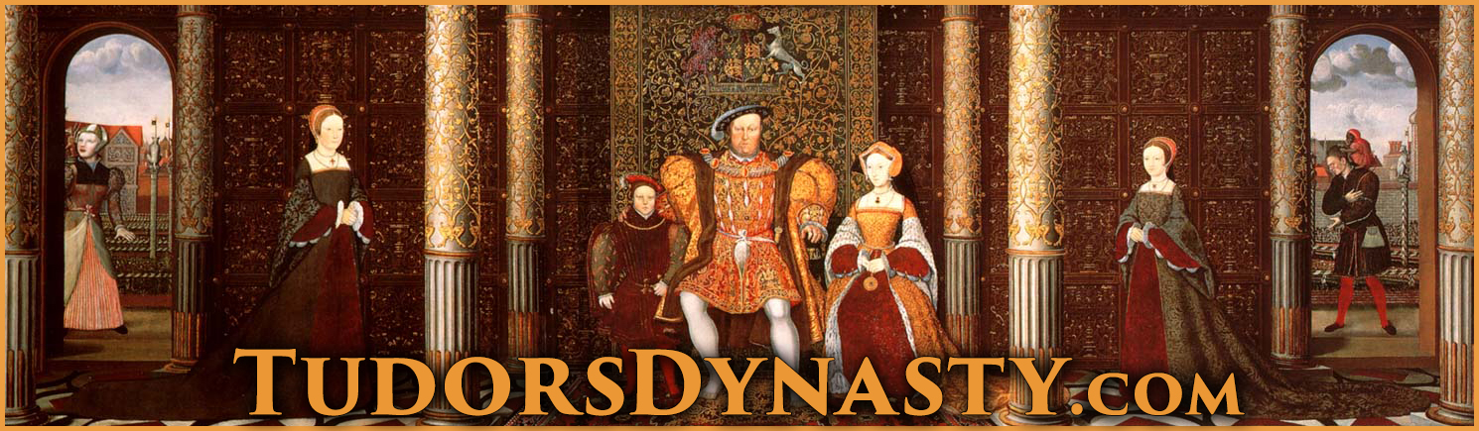He also never had children, so by the Succession Act of 1543 he was succeeded by his older sister Mary & (if, as happened, she had no children either) by his younger sister Elizabeth.

Serious

* Royal minorities had caused problems before: there had been civil wars in the reigns of both Henry III, who became King at the age of 9 in 1216, & Edward V, who became King at 12 in 1483. E V had lost the throne to his uncle Richard III after only 3 months & was almost certainly murdered by him.
* As a child king, E obviously did not have the authority his father had had, nor could he intimidate people as H had done through the Treason Act & over 300 executions for opposing the Reformation.
* This problem was compounded by Somerset’s decision to **repeal H’s Treason Act & the heresy laws**, which caused an upsurge of religious unrest.
* As **Lord Protector** Somerset did not have the same authority an adult king would have had, partly as his title went against H’s wishes (expressed in his will) for a balanced Regency Council.
* The outbreak of serious **rebellions** in the South West & Norfolk in 1549 which resulted in the fall of Somerset showed how govt. authority had been undermined.

Not Serious

* Henry III (1216-72), Richard II (1377-99) & Henry VI (1422-61) had all succeeded to the throne as minors but retained their throne into adulthood.
* E was not sickly until his final illness in 1553 so the general assumption was that he would live to become an adult king & have an heir as Henry III & Henry VI had done.
* Henry VII & VIII had established a **strong Tudor dynasty** by 1547 & no one challenged E’s right to the throne, including the rebels of 1549.
* As E’s uncle & following his victory over the Scots at Solway Moss it was logical that Somerset should be L Protector. In a country used to monarchy, it made sense to have a Protector rather than rule by a Regency Council which might have difficulty reaching agreement.
* The crisis of 1549, including the rebellions & the fall of Somerset, were caused more by **Somerset’s incompetence** & underlying **religious & economic problems** rather than by the royal minority as such.
* Following the crisis of 1549, **Northumberland** restored stability 1550-3 & there was no further unrest until it became clear that E was dying.

**CAUSES OF THE REBELLIONS & UNREST IN 1549**

|  |  |  |  |
| --- | --- | --- | --- |
|  | **Religious** | **Social & Economic** | **Political** |
| **Western** | In 1548 a Prot. archdeacon called William Body was murdered at Helston when he tried to enforce the destruction of images in local churches.  Traditionally known locally as the “Prayer Book Rebellion”, it started with demonstrations agt. the BCP in Bodmin (Cornwall) & Sampford Courtenay (Devon, where the priest was forced to read Mass instead). Most Cornish peasants at this time still spoke Cornish & the rebels said that they did not understand English.  The rebellion seems to have started by **priests** like Robert Welch who then persuaded Humphrey Arundell, a local gentleman with military experience, to lead them.  When the rebellion was crushed the priests involved were publicly hanged in their “popish” mass vestments.  The rebels’ initial **demands** have been lost but the 2nd set were predominantly religious. | Evidence of social & economic grievances in the initial rebel demands, in particular for the cancellation of the tax on sheep & cloth which hit Devon particularly hard because of the importance of sheep farming there.  Although Humphrey Arundell provided some gentry leadership, there is also much evidence that this was a rebellion of peasants against gentry: the Cornish rebels attacked & robbed the gentry at St Michael’s Mount & the Devon rebels at killed William Hellyons, a gentleman who tried to stop them & force them to go home.  The city authorities in Exeter denied access to the rebels & recruited guards from the wealthier elements of the population to hold the city; they feared that the poor within the city might support the rebels & bribed them with cheap food & poor relief to prevent them from doing so.  Even the commander of the royal army which defeated the rebels criticised the local gentry for making the peasants pay extortionate rents, abandoning the traditional concept of “good lordship”. | The downfall of the Courtenay family in 1538 created a power vacuum in Devon & Cornwall; with no dominant local noble, the gentry were leaderless. |
| **Norfolk** | Unlike the rebels in Devon & Cornwall, the Norfolk rebels seem to have been Prot. & anticlerical: they used the Book of Common Prayer in their camp at Mousehold Heath & made no demands for the restoration of Catholicism.  They demanded that the clergy preach the Word of God, teach poor children & be accountable to local peasants rather than the lord of the manor. They also demanded a reduction of tithes. | The unrest started in Attleborough & Wymondham as riots against enclosures, directed especially against a local lawyer, John Flowerdew. These riots started when the news reached Attleborough that Hales’ anti-enclosure commission would soon be coming to Norfolk, encouraging the peasants to take the law into their own hands.  There was peasant anger that gentry were grazing large flocks of sheep on common land, exhausting the land or even forcing the peasants off it.  As in Devon & Cornwall there were complaints about excessive rent rises.  Serfdom was still practised on some of the Duke of Norfolk’s estates.  The rebels demanded commissions elected by peasants to take control of local government from gentry JPs..  The depression in the cloth trade hit Norfolk, especially Norwich, more seriously than virtually anywhere else in England. | As in Devon & Cornwall, the political disgrace of the Duke of Norfolk in 1546 (not reversed until Mary’s reign) created a local power vacuum which left the local gentry leaderless |
| **General** | There is clear evidence of religious unrest, often led by priests, in Yorkshire (the Seamer rising), Oxfordshire, Hampshire & Northamptonshire. | There is clear evidence of unrest against enclosures in Lincolnshire, Hertfordshire, Cambridgeshire, Suffolk, Kent & even Surrey, where local peasants threw down enclosures at Witley before marching on Godalming!  John Guy has described the rebellions & unrest in 1549 as the nearest England has come to class warfare. | The King was only 11 & as Lord Protector Somerset did not have the same authority as a king.  In most counties local nobles, e.g. Arundel in Sussex, prevented unrest from escalating. |

**HOW SERIOUSLY DID THE 1549 REBELLIONS THREATEN THE GOVERNMENT & WHY WERE THEY DEFEATED?**

|  |  |  |
| --- | --- | --- |
|  | Serious | Not serious |
| Western | All attempts by local gentry to disperse the rebels failed; on 20 July Cornish rebels joined Devon rebels at Crediton, taking the govt. by surprise  The royal army was slow to reach Devon b/c it had to put down unrest in Oxfordshire & Buckinghamshire first  Somerset had to offer them a pardon but they still refused to disperse (they were not fooled like the Pilgrims of Grace). Troops had to be diverted from Scotland & mercenaries employed to put rebellion down.  It took at least 3 battles to defeat the rebellion; Lord Grey, who had fought in Scotland, said the battle at Clyst Heath was the most ferocious he had ever taken part in.  There were more executions than in Norfolk b/c the govt. saw the rebellion as a serious threat to its religious policy, hence the hanging of rebellious priests in their mass vestments. | The King’s position was not threatened.  There was virtually no gentry leadership (unlike the Pil. Of Grace).  The rebels failed to take Exeter (whereas the Norfolk rebels did take Norwich).  They made no attempt to march on London to gain more support despite widespread unrest elsewhere.  Once the govt..had enough troops available, the rebels were no match for them. |
| Norfolk | Strong leadership, not just from Kett but also other important men like Thomas Aldryche & the Mayor of Norwich, Thomas Cod  Norwich (then England’s 2nd city) captured  The rebels had an army of 16,000 men; the Marquis of Northampton was too intimidated to fight them.  Somerset had to offer them a pardon but they still refused to disperse (they were not fooled like the Pilgrims of Grace).  Troops had to be diverted from Scotland & mercenaries employed to put rebellion down. | The King’s position was not threatened; in fact the rebels called themselves “the King’s Commissioners”.  There was virtually no gentry leadership (unlike the Pil. Of Grace).  Kett made the mistake of moving from his well fortified camp at Mousehold Heath to Dussindale, where his.unwise decision to take on Warwick’s army led to defeat.  Once the govt..had enough troops available, the rebels were no match for them.  The fact that only 50 rebels were executed (fewer than in Devon & Cornwall) suggests they weren’t seen as a serious threat. |
| General | The King was a minor & as Lord Protector Somerset did not have the same authority an adult king would have had.  With wars against France & Scotland, there was a danger of a foreign invasion to coincide with the rebellions.  There was unrest in at least 26 counties in 1549, reflecting widespread religious & economic grievances.  The nobility were sufficiently concerned to support the overthrow of Somerset in October 1549, blaming him for provoking rebellions through his anti-enclosure policy & failing to suppress them.  Even after Somerset’s fall, there was further unrest in the South West, Nottinghamshire & Kent in 1550. | In most counties the unrest was contained, either by negotiation, as in Sussex where the Earl of Arundel persuaded the rebels to disperse by granting many of their demands, or by force, as in Northamptonshire where local gentry used their retainers to put down the unrest. The Earl of Shrewsbury contained the unrest in Shropshire, Derbyshire & Nottinghamshire. |

**TO WHAT EXTENT WAS ENGLAND A PROTESTANT COUNTRY BY THE DEATH OF EDWARD VI IN 1553?**

Protestant

* **Eng. became officially Prot. for the first time**; as David Loades has put it, “it was highly artificial & imposed by authority; nevertheless it was successfully imposed”. This was due to the influence of politicians like Somerset & Northumberland, bishops like Cranmer & Hooper & foreign reformers like Martin Bucer. According to Ronald Hutton, “The machinery of coercion and supervision deployed by the government was so effective that for most parishes passive resistance was simply not an option”.
* According to Ronald Hutton, the evidence of surviving churchwardens’ accounts suggest that the 1552 Book of Common Prayer was implemented within the timeframe set by Parl., including the replacement of stone altars (symbolising the real presence in communion) with wooden communion tables. Even the Cath. historian Eamonn Duffy says of the common people, “used to obedience, many of them accepted the changes, however unwelcome, as unavoidable”.
* Evidence from wills suggests that Prot. belief was stronger in **London, the South East & East Anglia** than in the North & West.
* It was most popular with people who were **young, educated or involved in trade** with the Netherlands or Germany.
* In some parts of the Thames Valley surviving traces of **Lollardy** ( a pre-Reformation heretical group who circulated extracts from the Bible in English) made some people more receptive to Protestantism.

Apathetic

The religious changes since 1529 seem to have left many clergy & laity confused, apathetic & indifferent, inclined neither to welcome the changes nor oppose them. Most of the clergy continued to serve under Henry VIII, Edward VI & Mary despite all the changes.

Catholic

* Edward was only King for 6 years & England officially Prot. for 4 (1549-53) before Mary restored Catholicism. The 1552 Act of Uniformity only lasted a year & E died before the 42 Articles could be imposed. There wasn’t enough **time** to make England truly Prot.
* Duffy has claimed that many parishes kept or hid as many **images** & as much church plate (silver cups for communion wine etc) as they could rather than destroying them. According to Hutton, “Catholic practices retained their vitality in the parishes until the moment they were proscribed … accounts suggest that Tudor parishioners were reluctant to implement any religious changes”.
* The fact that Hooper felt the need to urge his clergy to preach against salvation by good works, prayers for the dead, transubstantiation & the worship of saints & images suggests that such **Cath. beliefs** were still popular.
* The Prot. Martin Bucer admitted, “the bishops have not yet agreed on Christian doctrine, let alone the rules of the Church, and very few parishes have qualified clergymen. Sometimes the clergy read the service rapidly, so that the ordinary people have no more understanding of it than if it were in Latin rather than English”
* In 1550 Parliament complained that alongside the Book of Common Prayer “are still practised corrupt, untrue and superstitious ceremonies, which allow some to attack the order and meaning of the Prayer Book and encourage great diversity of opinion”. In 1552 Parl. made church attendance compulsory b/c “a great number of people in this realm wilfully and damnably refuse to come to their parish churches”.
* Sir William Paget (right) warned Somerset that “the use of the old religion is forbidden by a law, but the use of the new is not yet printed in the stomachs of 11 out of 12 parts of the realm”.
* Cath. belief was especially strong among **older, less educated people in the North & West**; but even in Kent only 8% of wills in E’s reign were explicitly Prot.
* Only 20% of the clergy **married** & there seems to have been hostility from many of the common people to married clergy & (even more so) their wives.

**HOW SERIOUSLY DID THE ATTEMPT TO ALTER THE SUCCESSION IN 1553 THREATEN THE SECURITY OF THE TUDOR DYNASTY?**

Seriously

* It could be argued that **Northumberland** (below right) acted as an “overmighty subject”, putting his own ambition & interests above the security of the Crown. He married Lady Jane Grey to his son Lord Guildford Dudley & then persuaded the dying 15 year old King to alter his “Device for the Succession” in Jane’s favour.
* Jane’s claim as the granddaughter of H’s sister Mary was clearly inferior to that of H VIII’s eldest daughter Mary; she knew this & did not want to be queen but was manipulated by Nthumb.
* 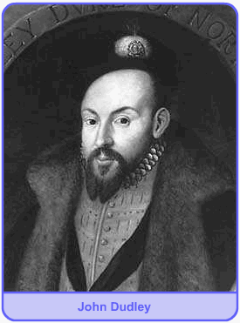Legally the Succession Act of 1543 clearly overruled the “Device” of a 15 year old king which was never approved by Parliament. It also superseded the acts of 1534 & 1537 (quoted by the Privy Council in a letter to Mary just after E’s death) which had excluded Mary from the succession.
* In June 1553, knowing E was dying, Nthumb. forced the Privy Council & other notable people to sign articles supporting Jane. When E died on 6 July Nthumb. kept his death secret for 2 days & forced leading London citizens to sign E’s “Device”.
* Conversely, it can be argued that it was **Edward** himself who threatened the security of his own dynasty by trying to interfere with the succession for religious reasons; he was quoted as saying, “if our sister Mary were to be queen, it would all be over for the religion we have established”.
* Similarly Archbishop **Cranmer** showed disloyalty to the dynasty he was appointed to serve for religious reasons & b/c he knew Mary would burn him as a heretic. His later claim that “I never liked” E’s will & “if by any means possible it had been in my power to have prevented the making of that Will, I would have done it” was an obvious lie.
* There was a real threat that the succession dispute in 1553 could have provoked not just a civil war but also a **foreign invasion**: Nthumb. discussed with the French ambassador the possibility of French military aid against the half-Spanish Mary, while Mary herself requested help from her nephew Charles V.

Not Seriously

* If Nthumb. was the main author of the attempt to interfere with the succession he was remarkably & uncharacteristically **incompetent** in how he set about it: he did not have an army available to support Jane (in fact he had disbanded his army in 1552), he failed to prevent Mary escaping to East Anglia & he also neglected to organise a propaganda campaign against her.
* The nobility & gentry had a vested interest in supporting the principle of **legitimate inheritance**, on which their right to their own property depended; it was therefore never likely that they would support Jane against Mary.
* **Mary** acted quickly & decisively to secure her rightful position by escaping to East Anglia, proclaiming herself Queen, sending letters to the Privy Council & important towns asserting her claim & quickly raising a large army.
* As soon as Nthumb. left London to confront Mary, the Privy Council went over to her & many of his soldiers deserted despite being offered higher pay, showing how strong **loyalty to the rightful heir** was. In fact so many of his army deserted that Nthumb. had to give up & declare Mary Queen himself instead of fighting her.
* The religious divisions in England mattered less than her legitimacy: she was greeted with enthusiasm in London despite the presence of many Protestants there. Some historians have argued that Mary herself underestimated the extent to which her success was due to her legitimacy rather than her religion.

**TO WHAT EXTENT DID THE CHALLENGES TO MARY THREATEN THE STABILITY OF THE MONARCHY?**

|  |  |  |
| --- | --- | --- |
|  | Stability threatened | Stability not threatened |
| Female Ruler | The last female monarch, Matilda, had provoked a civil war in the mid 12th century.  It was assumed that a female ruler would be too weak to control the nobility & would certainly not be able to lead an army into battle.  Mary’s marriage was only a problem b/c she was female: no one was worried about H VIII marrying foreign princesses like Catherine of Aragon b/c it was assumed that H, b/c he was a man, would be in charge, whereas when Mary married Philip it was feared that he would dominate her b/c in the 16th century a wife was expected to be subordinate to her husband.  B/c she was female, Mary could not win whomever she married: her marriage to Philip led to fears that Spain would dominate England, but if she had married an English noble like Edward Courtenay, the other nobles would be jealous & resentful. | The fact that M was clearly the rightful heir mattered more than her gender.  Mary acted promptly & decisively both against Jane in 1553 (when she fled to Norfolk & rallied support there) & against Wyatt in 1554 (when she wisely ignored the advice of her councillors & stayed in London to rally support there), showing that her gender mattered less than her determination & political skill.  M had good advisers, e.g. Winchester on finance & Pole on church reform. She was able to govern effectively despite her gender, as shown by the improvements in the Navy & the land defence system (Militia & Arms Acts) resulting from the French war. |
| Wyatt Rebellion 1554 | If all 4 of the rebellions against the Spanish marriage had taken place or if Wyatt had not delayed his march on London by besieging Cooling Castle (he did in any case reach the city gates in London) the Wyatt rebellion could have succeeded, either in forcing her to change her choice of husband or perhaps even replacing her with Elizabeth.  The fact that the London militia defected to Wyatt, shouting “we are all Englishmen!” showed how unpopular the Spanish marriage was.  Mary was only saved by the loyalty of a few nobles (like the Duke of Norfolk, by then in his 80s) & their retainers. Penry Williams has claimed, “a crucial episode in Tudor history was thus determined with most of the political nation standing aside”.  The fact that there were very few executions (except Northumberland) after the Grey conspiracy & fewer than 100 after Wyatt (compared with 178 following the Pilgrimage of Grace, which never got near London) suggests that Mary’s govt. did not feel strong enough to be as brutal as Henry VIII had been. | Mary acted promptly & decisively against Wyatt, wisely ignoring the advice of her councillors & staying in London to rally support there.  Memories of the Wars of the Roses in the previous century & the hatred towards the gentry shown by the 1549 rebels (in both the South West & Norfolk) made the gentry reluctant to support any rebellion for fear that it would lead to a breakdown of law & order, threatening both their property & their social status.  Despite the factional rivalry between Paget & Gardiner over the Spanish marriage, M’s Privy Council generally governed effectively, especially in terms of increasing royal revenue, & there were no further rebellions after Wyatt despite the bad harvests & trade depression. |

**TO WHAT EXTENT HAD MARY SUCCEEDED IN MAKING ENGLAND A CATHOLIC COUNTRY BY 1558?**

Successes

* In bringing back the Mass & Catholic doctrines like transubstantiation & clerical celibacy, Mary was returning to her father’s policy; in the history of religious policy 1529-58, it was the shortlived enforcement of Protestantism under E VI (from the first Act of Uniformity in 1549 until his death in 1553) which seems out of place. M therefore had a **strong base** on which to build.
* Robert Parkyn, a Cath. priest in Yorkshire, wrote, “from August 1553 in many places in **Yorkshire**, priests were very glad to say mass in Latin ... The English service was **voluntarily** laid aside”.
* It is not true that M relied solely on persecution to restore Catholicism. Cardinal Pole, her Archbishop of Canterbury, had **constructive plans for reform**, such as a crackdown on clerical abuses like pluralism & non-residence, a Cath. translation of the New Testament, a Cath. Book of Homilies (short sermons) & a seminary (priests’ training college) in each diocese (the area controlled by a bishop). There is no reason to doubt that these policies would have been successful if they had been given more time.
* In any case the **burnings may not have been as unpopular as is often assumed**. The local authorities in London ordered the burnings to be held in the mornings to reduce the crowds, but this may have been due to to a fear of the general disorder which often attends such large gatherings (e.g. pickpocketing) rather than fear of demonstrations in support of the victims.
* **Parliament** readily agreed to the restoration of the Mass in 1553 & the restoration of the heresy laws in 1554 was only delayed b/c MPs feared that the monastic lands many of them had purchased would have to be given back. Once that issue was resolved, the heresy laws were passed & the burnings could begin.
* Churchwardens’ accounts in different parts of the country (e.g. Stanford-in-the-Vale in Berkshire & Morebath in Devon) suggest that **parishes** were quick to restore altars, images, mass vestments etc despite the considerable cost of doing so.
* On balance the evidence suggests that **M’s policies were succeeding** & ultimately failed, not b/c her policies were unpopular or poorly thought out but b/c she died too early & failed to leave a Cath. heir, enabling Elizabeth to restore Prot. The length of time it took Elizabeth to make England truly Prot. (the whole 45-year reign as far as Lancashire was concerned, according to Christopher Haigh) emphasises how much M achieved in such a short time.

Failures

* Like the Prot. religious changes in E’s reign, M’s policies (especially Pole’s plans for long term reform) did not have enough **time** to make an impact before they were reversed.
* The determining factor in the English Reformation was **obedience** (based on a combination of loyalty & fear) to the monarch. M’s success in claiming the throne owed more to the fact that she was the legitimate heir than to her religion. England avoided the religious conflict which broke out in France or Germany b/c most people put obedience to the monarch first. This meant that most people complied with the restoration of Cath. under M but did not resist the enforcement of Prot. under Elizabeth. **M therefore failed to make England strongly enough Cath. by 1558 to prevent Elizabeth restoring Prot.**
* Just as Prot. sources admitted the lack of progress of Prot. in E’s reign, Cath. sources in M’s show the survival of Prot. in **London & the South East**. A royal messenger reported the hanging of a cat dressed as a Cath. priest in London, while even Charles V’s ambassador admitted, “the people of London are murmuring about the cruel enforcement of the recent Acts of Parliament against heresy … The haste with which the bishops have proceeded in this matter may well cause a revolt”. A Cath. priest in Essex reported to his bishop that Prots. “not only absent themselves from church services, but daily they lure away many others who had outwardly conformed”.
* M could restore the Mass, clerical celibacy, the papal supremacy etc but not the **monasteries or chantries** b/c the gentry who had bought their lands were determined to hold onto them.