**An introduction to the Reformation**

The Reformation is the name given to the religious changes which began during the reign of Henry VIII and were completed under Elizabeth I, which resulted in the ‘break from Rome’ and the papacy to establish England as an empire in which the monarch was head of both state and Church.

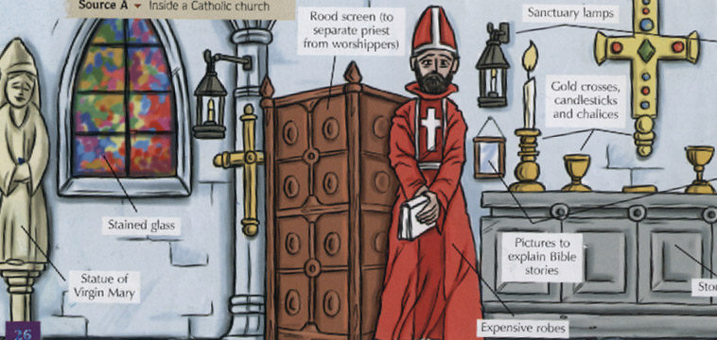**A Catholic church in this period:**

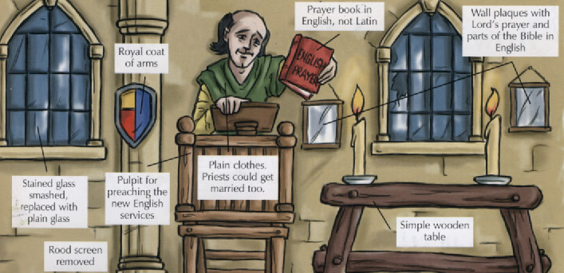**A Protestant church in this period:**

**What differences can you identify?**

**Task 1:**

Identify which of the following statements reflect Catholic beliefs, and which reflect Protestant beliefs. Mark each statement with a C or a P.

1. Bible in Latin
2. Purgatory: in order to go to heaven your soul had to be free from sin, purgatory was the halfway house between heaven and hell where you were purged of your sins
3. Pilgrimages were attacked
4. Images were forbidden, churches were plain, walls whitewashed
5. Transubstantiation or the real presence: the belief that in the Eucharist or mass the body and blood of Christ were present in the bread and wine
6. Priesthood of all believers, the laity could talk to God directly
7. Clergy could marry
8. Salvation was achieved through faith
9. Prayers for the dead: these would help reduce the amount of time the soul spent in purgatory
10. Saints days and some festivals were abolished
11. The Bible was the basis of belief, which as in English could be read and interpreted by the laity
12. Communion in one kind: the laity received only the bread
13. Communion in both kinds: the laity received bread and wine
14. Services in English
15. Clergy could not marry
16. Paintings and statues helped people pray, churches were therefore brightly coloured
17. Services were held in Latin
18. Salvation could be achieved through good works
19. Priest was essential as the link between the laity and God
20. Pilgrimages were essential
21. Church festivals and Saints days were upheld
22. Bible in English
23. Belief that only faith was needed to go to heaven – ‘justification by faith alone’
24. Church’s interpretation was the basis of belief
25. Eucharist was a service of remembrance
26. Prayers for the dead were unnecessary as faith alone was needed to go to heaven

**The traditional view asserts that the Reformation inevitably transformed England from a Catholic to a Protestant country**, arguing that the Roman Catholic Church in England was in very poor condition by 1529 and this, coupled with Protestant ideas coming in from the continent, led to a very strong dislike of the Catholic Church and its clergy. **However more recent interpretations have suggested that the Catholic Church was in fact in a healthy condition** and that the Reformation was imposed from the top (i.e. by Henry) rather than coming ‘from below’. Such interpretations have stressed the political causes of the Reformation, the absence of the inevitable triumph of Protestantism and the slow nature of the change in religious belief. The break from Rome was driven significantly by Henry’s desire for a divorce from Catherine of Aragon.

**Task 2:**

|  |  |  |
| --- | --- | --- |
| **Causes of dissatisfaction with the Catholic Church** | **Explanation/Definition**  **Use Armstrong**  **pp 19-20 if appropriate** | **Specific examples from sources D, E, F and G**  **(Armstrong pp18-19)**  **Use this column to cross reference the sources if relevant. Refer to sources separately and add quotes.** |
| Uneducated priests |  |  |
| Greed of the clergy for land, money, goods and power |  |  |
| Wealth of the church and clergy |  |  |
| Immoral behaviour and attitudes |  |  |
| Lack of reform in the Church |  |  |
| Simony |  |  |
| Pluralism |  |  |
| Non-residence |  |  |
| Nepotism |  |  |
| Sexual misconduct |  |  |
| Benefit of the clergy |  |  |
| The Hunne Affair |  |  |

**Task 3:**

Use the OCR textbook, p.70-71, to assess whether the Church was ‘rotten’ on the eve of the Reformation.

|  |  |
| --- | --- |
| **Evidence to suggest the Church was ‘rotten’ and ready for reform** | **Evidence to suggest the Church was ‘vigorous’ and still popular** |
|  |  |

**Which of the two views do you find most convincing? Explain your choice.**

**The Causes of the Break with Rome**

Henry’s wish for a **divorce from Catherine of Aragon** played a crucial role in the decision to break with Rome. The length of time Henry spent trying to persuade the papacy to grant him a divorce suggests that he was not against papal authority. Henry had first put forward his desire for a divorce in 1527, but it was not until 1533 when he made the momentous decision to sever ties with Rome and to declare, in the preamble to the Act in Restraint of Appeals, that ‘*this realm of England is an empire…governed by one supreme head and king having the dignity and royal estate of the imperial crown of the same, unto whom all sorts and degrees of people divided in terms of spirituality ad temporality, be bounden and owe to bear next to God a natural and humble obedience of the king’*.

The Act prevented any appeals to any authority outside England (i.e. the pope) on the list of issues mentioned in the Act, such as divorce. Therefore the Act prevented Catherine from appealing to the pope and allowed the new Archbishop of Canterbury, Thomas Cranmer, to pronounce on it.

Between 1934 and 1936 parliament abolished papal authority in England and the most significant change was brought about by the **1534 Act of Supremacy**, which recognised that **Henry was head of the Church of England**. This meant that the Church was now subject to lay control in its day-to-day running.

It could be argued that Henry had a **powerful ego** and therefore the break with Rome was caused by his desire for supremacy in all matters. The refusal of the pope to grant Henry his divorce simply provided Henry with the opportunity. However, this argument is less convincing given the amount of time Henry spent trying to persuade the pope to grant the divorce.

It could also be argued that Henry wanted the **wealth** of the Church- however, the chronology of events does not support this interpretation, because it was only with the dissolution of the greater monasteries in 1539 that Henry gained substantially. The acquisition of wealth was a bonus, not the cause.

Finally, it can be argued that the desire to bring about **doctrinal change** resulted in the break with Rome. **Thomas Cranmer**, Archbishop of Canterbury, and **Thomas Cromwell**, who emerged as the king’s chief minister by 1532, were both Protestant sympathisers with agendas of their own, and between them these two men were able to offer Henry a means of getting what he wanted – a divorce. In addition, **Anne Boleyn** was acquainted with a group of reformist writers and Cambridge academics and had reformist sympathies herself, and undoubtedly she influenced the king.

**Glossary:**

|  |  |
| --- | --- |
|  |  |
|  |  |
|  |  |
|  |  |
|  |  |
|  |  |