THE CAUSES OF THE PILGRIMAGE OF GRACE
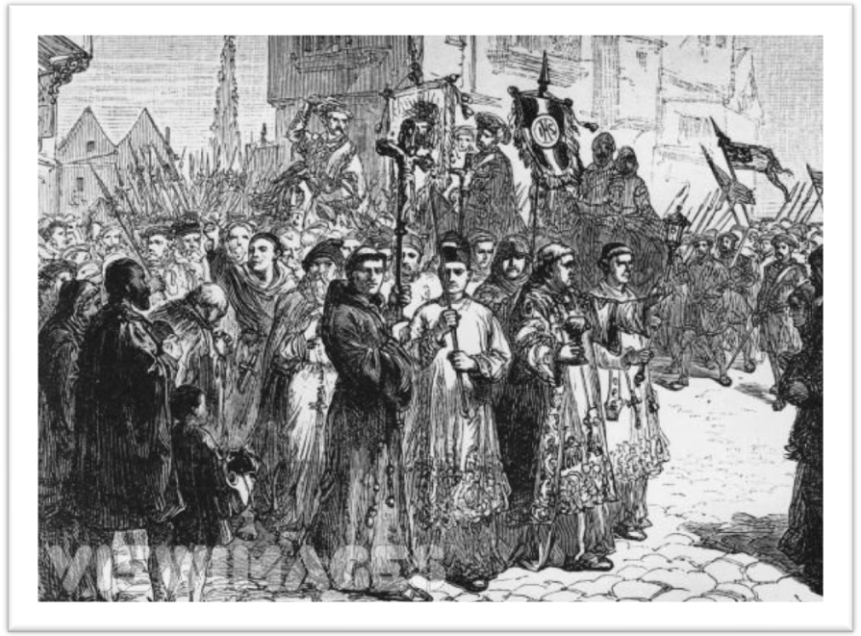

Timeline
1536 2 October Start of Lincolnshire rising. Bishop of Lincoln’s official seized at
Louth.
4 October Gentry assume leadership. Murder of Dr Raynes the Bishop’s chancellor, at Horncastle. Robert Aske crosses Humber to meet leaders.
6 October Hussey writes to Shrewsbury to sound him out.
8 October Hussey receives Shrewsbury’s reply ordering him to join him, which he does. 10,000 rebels march on Lincoln. List of grievances sent to the king.
10 October King’s reply repudiating grievances reaches Lincoln. Gentry involved in rebellion disperse.
13 October Rising in S. Yorkshire. Aske proclaimed ‘Grand Captain’ and speaks of a Pilgrimage.
16 October Rebel force under Aske enters York and is acclaimed by the citizens. Other risings in Northumberland, Durham and North Yorkshire. Barnard Castle surrenders to rebels, but Skipton resists. Contingents from Cumberland assemble at Penrith.
21 October Darcy surrenders Pontefract Castle to Aske. Henry orders Shrewsbury to advance towards Doncaster
27 October 30,000 strong Pilgrim army confronts royal army of 8,000 under Duke of Norfolk at Doncaster. Meeting between Norfolk and Pilgrim leaders, including Darcy on Doncaster Bridge. Agreement that two Pilgrims should carry petition to king at Windsor. Uneasy truce as king’s reply is awaited.
21 November Robert Bowes gives Pilgrim Council account of Windsor. Henry has requested clarification.
4 December Pilgrim Council at Pontefract issues detailed Articles.
6 December Second meeting at Doncaster between Norfolk and Pilgrim leaders. Norfolk agrees to general pardon and calling of Parliament to address grievances. Aske persuades Pilgrims to accept tears and tears off his Pilgrim badge. Henry delays confirmation of agreement.

1537 16 January Sir Francis Bigod leads new rising in Yorkshire. His forces enter Beverley but he fails to take Hull or Scarborough.
10 February Bigod is captured. Another rising in Cumberland fails to take Carlisle and is put down. Henry now has excuse he needs to punish original leaders. In the following months 178 Pilgrims are executed, including Darcy and Aske.

Notes taken from ‘Disorder and Rebellion in Tudor England’ – Nicholas Fellows

Key Issue – Was the Pilgrimage of Grace only a religious rising?

RELIGION

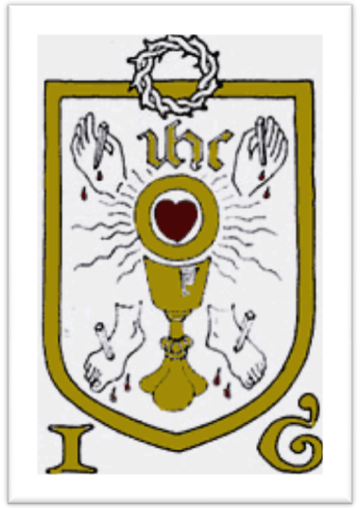
At first glance religion does seem to be the prime cause of the rebellion. Consider the name of the rising, also the banner that the rebels carried depicted the five wounds of Christ and seemed to show that the rebels fought for Christ’s cause. The oath that all the rebels took also contained the statement that they were undertaking the pilgrimage in the name of Christ.

The rising occurred immediately after the closure of some of the smaller monasteries and whilst commissioners were still working at closing others. This view is supported by historians such as John Guy and Christopher Haigh who showed that in Lancashire the first areas to rise and the last to be quietened were those around the dissolved houses. Religious grievances are at the top of the list of rebel demands and they make up 9 out of 24 of the demands issued at Pontefract.

The church had undergone massive upheaval in recent years, and now both monks and some clergy feared for their livelihoods. Many monks had been made homeless and unemployed. They were able to get a great deal of support from local society as very often they came from the local area and so would have been known to the inhabitants. At the same time many locals did not like the religious changes that were taking place. They loved and contributed to the maintenance of their parish church and they feared all of this was under threat. They would have disliked the abolition of Holy Days as they were holidays and the new taxes on baptism, burial and marriage. They were probably also worried by rumours of further religious changes which would have an even greater impact on their lives: there were stories circulating that some churches would be closed and that jewel and plate would be confiscated by the government.
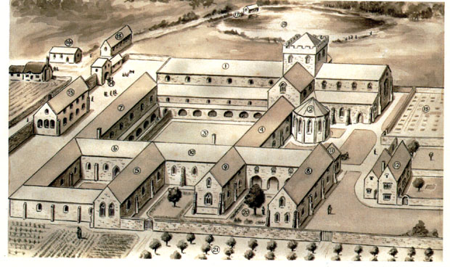
The locals would have been concerned about the closure of monasteries as often they provided the local place of worship and so their closure would have a direct effect on their ability to obtain salvation.

There is clear evidence that the doctrinal changes and apparent moves away from Catholicism were resented. The rebels’ grievances contain complaints against some of the reformist bishops who had been appointed, such as Cranmer whist there are also attacks against some of the European reformers such as Bucer and Melanchthon. It is very unlikely that the names of these reformers would have been heard of by the commons, and therefore they suggest that it was the more educated gentry who drew up the list of demands.

Aske may have made religion the central feature and main cause of the rising as it enabled him to rally a large section of the population behind him.
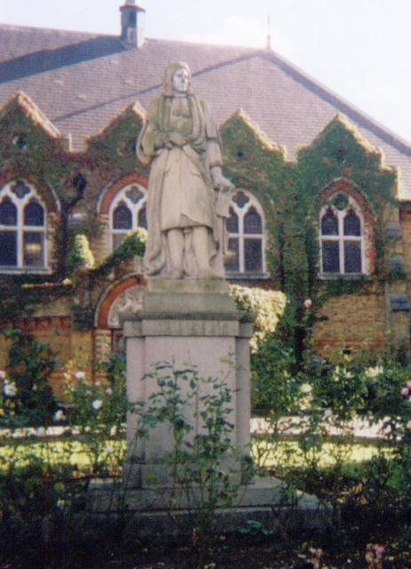

ECONOMIC CAUSES

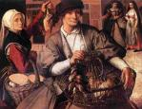
The north was suffering from poverty and hunger at this time. The harvest of 1535 was disastrous and that of 1536 little better. These problems were made worse by taxation. There were complaints against the 1534 subsidy that was being collected. This tax was traditionally only been collected in time of war but was now being levied in peace time. There were also rumours of new taxes on sheep and cattle.

Entry fines – These were taxes payable to the landowner on the death of a tenant and the succession of his heir. With prices rising landowners were increasing the amount payable.

Enclosure – this process only affected certain areas of the revolt. Enclosure had only recently been introduced in the north west and was causing a grievance in the communities of the West Riding of Yorkshire. In particular it was bringing about further hardships in the more densely populated areas for instance around York, where the process was putting pressure on the limited availability of land.

Statute of Uses – This measure had recently been introduced by the government. It may well have been a factor in gentry involvement as, prior to this statue, the gentry had distributed their land amongst trustees. This meant that they could avoid paying duty when their heir succeeded as the land was technically held by trustees and not by the heir. The Statute of Uses prevented this process and forced the gentry to pay their feudal dues. This factor would only have been relevant to the gentry and so it is perhaps another indication that the gentry were using the commons to help put across their own complaints.
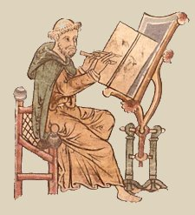
Monasteries did play a role in the local economy. For instance they did provide help and charity for suffering economic hardships. They also provided locals with employment on their estates.

In some areas monasteries were the only institution who could afford to carry out repairs to roads and bridges which were vital to the local economy. They also provided shelter for travellers, education and the safe deposit for valuable documents.

POLITICAL CAUSES

Geoffrey Elton first suggested that the Pilgrimage was caused by political factors. He stated that ‘the Pilgrimage originated in a decision by one of the court factions to take the battle out of the court into the nation, to raise the standard of loyal rebellion as the only way left to them if they were to succeed in reversing the defeats suffered at court and in parliament, and in forcing the king to change his policy’.

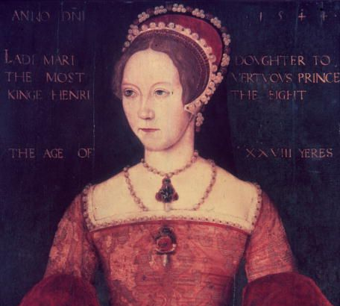
Elton argued that it was Henry’s attempt to end his marriage to Catherine of Aragon that started the problems. Northerners had been supporters of Henry’s first wife. These included Hussey, Aske, Darcy and Constable. There is evidence to suggest that they had a motive for rising against the government. As the power of central government grew under Cromwell so their influence in politics declined. They felt that the court was now dominated by the Boleyn faction and other men of low birth such as Cromwell and Richard Riche, who had no right to be advising the king on matters of policy. It appeared that all decisions were being made in the capital and that the north was being excluded: hence their call for a parliament in the North. The Percies had suffered a considerable loss of prestige. The king had put a great deal of pressure on Henry Percy to name the king as his sole heir, and as a result disinherit Thomas Percy. This family therefore played a large part in the rising. Aske himself had link with the Percy family. Hussey had been Princess Mary’s chamberlain and had lost his office and his wife was imprisoned in the tower when he was alleged to have resisted Cromwell’s demands that she fully accept the Royal Supremacy. These men realised that only a reversal of recent changes would restore their fortunes, and this is shown in the Pontefract Articles where there is a request for the restoration of Princess Mary’s legitimacy and restoration to the succession. This would represent a triumph for the conservative faction and their restoration to political predominance as it would require the removal of the Boleyn faction and all that it represented.
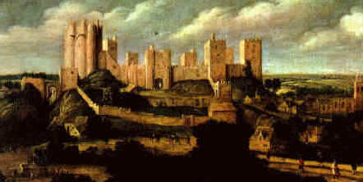

Darcy’s actions at Pontefract Castle suggest that they had been preparing to rise. The surrender of the castle was too easy and the sudden appearance of the Pilgrims’ badges suggests that the rising was not spontaneous but planned. However there are arguments against such a view. Some of the most active gentry in the rising had no connections with the Percy family and some actually had grievances against them. Also the Westmorland family did not play a part and Lord Dacre, who had nearly been charged with treason in 1534, had nothing to do with the rising.

CONCLUSION

The Pilgrimage was a rising that involved a wide range of social movements and groups, each with their own grievances and this was reflected in the demands made.
The rising was not one movement but a series of regional revolts each with its own particular emphasis. What can be said with certainty is that the whole of northern society was in turmoil.

Questions

- What would you say were the six main causes of the revolt?

- What was the Statute of Uses and why was it so unpopular?

- Was the Pilgrimage a rising of the commons aided by the gentry or of the gentry assisted by the commons?

- How serious do you think it was? Give reasons for your decision.

Activity
The York Articles. These grievances were written up by Aske and sent to the mayor of York on 15 October 1536.

- The suppression of so many religious houses…whereby the service of God is not well [maintained] but also the [commons] of your realm be unrelieved, the which as we think is a great hurt to the common wealth…
- That the act of uses may be suppressed because we think by the said act we your true subjects be clearly restrained of our liberties in the declaration of our wills concerning our lands, as well as for payment of our debts.
- [a tax on sheep and cattle] which would be an importunate charge to them considering the poverty that they be in all ready and loss which they have sustained these two years past.
- Your grace takes of your counsel and being about you such persons as be of low birth and small reputation which hath procured the profits most especially for their own advantage, the which we suspect to be the lord Cromwell and Sir Richard Riche…
- [We are] grieved that there be diverse bishops of England of your Grace’s late promotion that have… the faith of Christ, as we think, which are the bishops of Canterbury, the bishop of Rochester, the bishop of Worcester, the bishop of Salisbury, the bishop of Saint David’s, and the bishop of Dublin, and especially we think the beginnings of all the trouble of that… and the vexation that has been … of your subjects the bishop of Lincoln.

The Pontefract Articles. These demands were drawn up on 2-4 December 1536

1 … to have the heresies… within this realm to be annulled and destroyed.
2 . to have the supreme head of the church…restored unto the see of Rome.
3. …that the Lady Mary be made legitimate..
4. …to have the abbeys suppressed to be restored…
5. …to have the tenth and first fruits and tenths clearly discharged.
6. …to have the Observant Friars restored to their houses again.
7. …to have the heretics .. [have] punishment by fire.
8. …to have the Lord Cromwell, the Lord Chancellor, and Sir Richard Riche
[receive]punishment.
9. …that the lands…may be tenant right, and the lord to have at every change two
years gressom [entry fine] and no more…
10. …the statues of handguns and crossbows to be repelled…
11. …that doctor Ligh and doctor Layton..[receive] punishment for their extortions in
their time of visitations.
12. …Reformation for the election of knights of shire and burgesses…
13. …Statute for enclosures and intacks to be put into execution…
14. …To be discharged of the quindine [a form of tax] and taxes now granted…
15. .. To have the parliament in a convenient place at Nottingham or York…
16. …The Statue of the declaration of the crown by will… be repealed.
17. …That all the recognisances, statues, penalties now forfeited during this time of
commotion may be pardoned..
18. …The privileges and rights of the church to be confirmed…
19. …The liberties of the church to have their old customs…
20. …To have the statute that no man shall will his lands to be repealed.
21. …That the statues of treasons by for words .. [be]repealed.
22. …That the common laws may have place as was used in the beginning of your
grace’s reign…
23. …That no man upon subpoena [court writ] is from Trent north appear but at
York..
24. …A remedy against escheators [officers who collect land that reverts to the
Crown] for finding of false offices and extortions fees…

- Sort the rebel demands into different types of grievances
ECONOMIC | RELIGIOUS | POLITICAL | FEUDAL

- In the York articles which articles represent the interests of
- The nobility and the gentry
- The commons
- All social groups

- Which of these articles could the rebels realistically expect Henry to accept?

- What do they mean by talking of “the faith of Christ”?

- How useful are the York and Pontefract Articles for historians attempting to uncover the real motivation behind the rebellion?

- What was the Bigod uprising? How did it come about and why was it such a catastrophe?
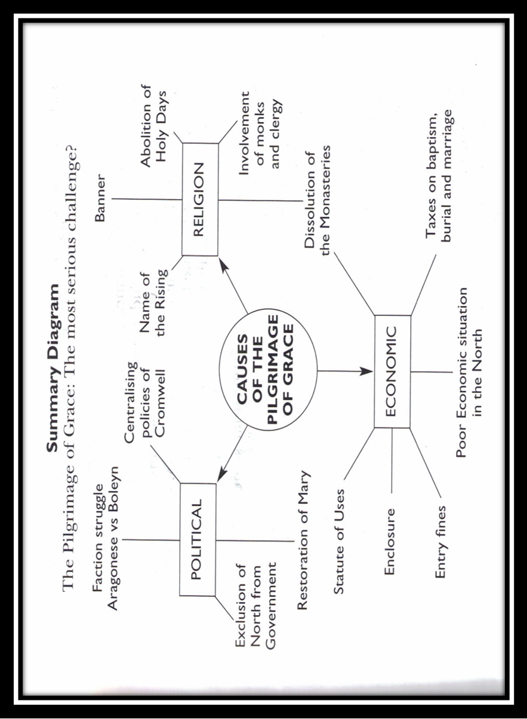

THE SIGNIFICANCE OF THE PILGRIMAGE OF GRACE
Key Issue – was the Pilgrimage of Grace a failure or did it change royal policy?

Failure?
The rebels failed in their aims
The dissolution of the monasteries continued.
Thomas Cromwell remained in power
Political power was still firmly based in London as the promised parliament in the north never met.

Success?

The rebels succeeded in raising a very large force. This was much larger than any other Tudor rebellion and could easily have defeated the royal forces, but that was never the aim of the leadership. The force was there to intimidate and pressurise the king. At a time when there was no other way to register protest, the pilgrimage represents large-scale dissatisfaction with the regime. It was a warning. The large numbers involved also enabled the rebels to put pressure on the king at a number of crucial moments. It was the pilgrims who chose to reach a negotiated settlement in both October and December. The settlement represented a massive climb-down for the government; they had suggested the second meeting because they did not have the force to challenge the rebels. The government was forced to allow a free and general pardon for all those who had taken part. There were no exceptions and so the king was unable to arrest and punish the ring-leaders.

There was the promise of a free parliament in the north and a promise that until it met nothing would be done to implement the policies to which the rebels objected. This meant that the smaller monasteries the pilgrims had restored were allowed to stand.

Further changes in religious policy followed. The bishops’ Book of 1537 restored many conservative practices. For instance it recognised the four lost sacraments that had been absent from the Ten articles of 1536. There was also an attack on the protestant practices of radical preaching and clerical marriage. It could be argued that any intended religious revolution had to be postponed until Edward Vl’s reign.

The pilgrims stopped the collection of the subsidy. Any further moves towards a revolution in government were abandoned. This may have weakened the position of another of the rebels’ major cause of complaint, Thomas Cromwell. He did not immediately fall from power but the two policies with which he was most closely associated, administrative reform and religious innovation were abandoned.

Rebels from Cumberland and Westmorland had objected to the increase in entry fines. This issue was now resolved in favour of the rebels with the cost being fixed at twice the rent. This was exactly the amount demanded by the rebels in the December petition.

M L Bush wrote in ‘The Pilgrimage of Grace’, ‘the formation of the pilgrim armies in October 1536 has to be appreciated not only as a spectacular achievement in itself but also as a major influence upon religious, political, fiscal and agrarian changes of the time.’

