**The Mid Tudor Crisis (part 1)**

This booklet deals with the problems caused by having a child inherit the throne Book two will deal with the second part of this tricky period when the country experienced their first crowned Queen. There were some serious problems in this period, and we need to consider whether these arise out of the fact that there is a regency and a queen who chose to marry the heir to the most powerful catholic country in Europe, or if this came about due to socio-economic factors such as poor harvests and a decline in the cloth industry.

**Edward VI 1547 – 1553**

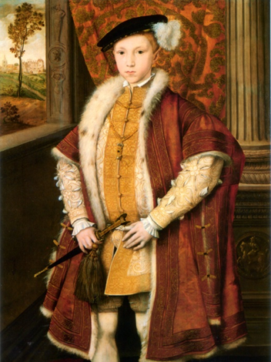 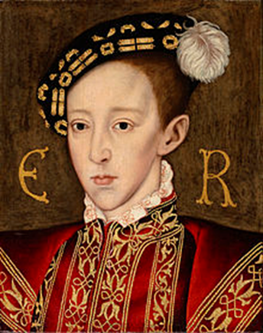

Edward had been taught to be a protestant in the home of his final step mother Katherine Parr and he seems to have been a convinced and rather earnest one. We are fortunate in finding out a lot about what he thought because he kept a journal. He inherited a dire situation from his father. The country was at war and in debt. Also as a child his father had planned that there should be a committee to run the country, but his uncle, Edward Seymour managed to seize power.

The first problem to consider is how Henry’s intentions for the succession were completely overturned. He wanted to have a council rule on behalf of his son, balanced with reform sympathizers and with Conservatives. He had assumed his instructions would be respected, but reformers had control of the “dry stamp” and could put his signature on instructions they called “the unfulfilled gifts’ clause”. This promoted the Earl of Warwick (Edward’s uncle) to become Duke of Somerset, and with this promotion he also declared himself “Lord Protector” which was in effect Regent, or ruler. He was very autocratic and did not use the Privy Council or Parliament, he issued 77 proclamations in his two years’ rule, which is more than Henry issued in his entire 38 years

Any monarch would have found Henry’s legacy challenging. He had been ruthless and controlling, and a child was clearly going to have less power. Henry had spent all the money he had gained from dissolving the Monasteries on war and defence in the 1540s. He had also debased the coinage, putting less silver in which had produced rampant inflation. This meant that food prices and rents had gone up, and with a rising population there was pressure on food and land. England was still at war with Scotland and technically with France when Henry died. It also has to be said, that the fundamental changes that had been brought about in England’s Churches had left the population confused and now that there were no monasteries there was nowhere to go when times were hard.

**Edward and Mary the unknown Tudors by Starkey** <http://www.youtube.com/watch?v=5mRFbmSga_4>

Or on E stream

1. Where was Edward born and how was it celebrated?
2. What did Henry decide about the succession in 1544?
3. What kind of teacher was Richard Cox?
4. What did Protestantism represent?
5. Why was Edward’s position awkward when he inherited the throne?
6. Why was Edward’s coronation so extraordinary?
7. What were most churches still like?
8. What was the rood and what replaced it?
9. Where did real power lie at the beginning of Edward’s reign?
10. Why did Edward Seymour execute his own brother?
11. What provoked the Western rebellion and what did they burn?
12. How did Edward regard the suppression of the rebellion?
13. What changed in October 1459?
14. What did Somerset hope would protect him?
15. How many charges were brought against Seymour?
16. What does Starkey think was “the real nub of the matter”? (26.50 -29.58)

**Task 1**

1. **What were the problems were left by Henry’s legacy?** (to answer this use page 2 of this booklet)

**(i)**

**(ii)**

**(iii)**

**(iv)**

**(v)**

**(vi)**

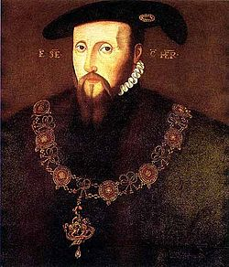In traditional history Somerset was regarded as the “good duke” because he was pushed out of power by the Duke of Northumberland and had made comments about helping the poor. He had been a successful general and continued Henry’s wars nearly driving the country into the ground and trying to pay for it by using money from the Church and continuing to debase the coinage. In addition his policy for dealing with the poor included bondage and branding!!!

**The Duke of Somerset**

**Edward Seymour**, was the eldest brother of Queen Jane Seymour, the third wife of King Henry VIII and mother of his heir Edward. This meant that he was uncle to the king and after a successful campaign in France and Scotland, was in great favour with the King in Henry’s final days. He was a reformer and very ambitious. When Henry died, Seymour and his close ally and secretary, William Paget, who had custody of the will, kept Henry’ death a secret while they gathered support for Seymour as leader of the Council. Henry died on the 28th January, but it was not announced until February 1 when Seymour and Paget summoned the nobility to announce that Seymour had been made leader of the Council and was now to be called Lord Protector, Duke of Somerset and to acquire lands to support his new position.

One of Somerset’s first actions was to get parliament to pass a new Treason Act in November 1547. This repealed the old heresy, treason and censorship law and the Act of Six Articles. The removal of the heresy laws allowed people to discuss religion freely and the ending of censorship encouraged a flood of magazines and pamphlets discussing religion. In the past this was seen as Somerset showing a breadth of mind and tolerance, but it can also be seen as the normal action of a new regime trying to gain popularity by abolishing repressive legislation of their predecessor. Closer examination suggests in fact, that the government was preparing for **more extreme religious reform.**

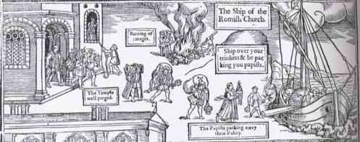

Whatever prompted the government to pass this new Treason Act it actually created new problems. Public meetings discussing religion frequently ended in disorder and riots and the repeal of the old laws meant the authorities had less power to stamp on this disorder.

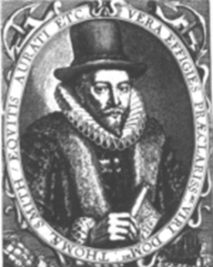Somerset’s principle aim seems to have been the unification of England and Scotland by marrying Edward and Mary (aged five in 1547). Unfortunately the Scots were not interested so Somerset personally led an army across the border and in September 1547, won the Battle of Pinkie Cleugh. He then built a chain of forts intended to keep Scotland subject, but this was appallingly expensive and he failed to blockade the Firth of Forth, with the result that the French were able to land an army and capture some of these forts – and take Mary back to France with them to marry the Dauphin. Somerset spent half a million pounds on his campaign in Scotland and provoked Henri II of France to attack Boulogne so Somerset found he had created a situation where there was war on two fronts.

The very expensive foreign policy meant that Somerset had to explore every possible avenue of extracting money. The dissolution of the chantries and the continued sale of crown and ex- monasteries was lucrative but the debasement and the wars meant that these resources could not keep up. Sir Thomas Smith wrote a very perceptive treatise on the economy which advised the restoration of the coinage but this would have reduced government income drastically in the short term, so Somerset preferred to blame enclosure and greedy landowners for inflation and kept on doing what he was doing.

Enclosure became such a big concern that he said he would set up a Commission under **John Hale** to investigate cases in the Midlands and in June 1548 he issued proclamations enforcing all previous statutes against enclosure. The policy was a failure, and managed to annoy both the gentry who felt attacked, and the poor who had their hopes raised only to be disappointed. Traditional historians felt that Somerset was genuinely driven by a desire to improve conditions for the poor. He did establish a court of requests at his home in Somerset House to hear the cases of the poor, and he criticised the wealthy (although he was so keen on money himself that he amassed a fortune while Lord Protector).

Modern historians such as Dale Hoak and Jennifer Loach have shown that he was ruthless and unwilling to listen to advice. Loach refers to the historical impression that he was an idealist but says he was “ruthless and cold-hearted”. She describes how he travelled around with two gilt maces borne before him, and took the royal jewels from Catherine Parr in order that his wife should wear them. He used Edward’s “coffers” to reward his own men and used “Edward’s government as a private fiefdom”. Even the traditional historian Pollard, found it hard to reconcile his execution of his brother with the kind man he tried to describe.

**Task 2 - Overview of Somerset’s policies** (use page 4 to answer the following questions)

1. Why did looser rules actually create problems for the government?
2. Why was his successful military campaign against the Scots actually a fiasco? (2 reasons)



1. What was Sir Thomas Smith’s sensible advice and why did Somerset ignore it?
2. Why do modern historians dispute the idea that he was the “good duke”?

**Task 3 – Source work**

**Source A**

**William Paget, a trusted advisor to Somerset, wrote to him criticising his conduct and the likely consequences, in May 1549**.

However it cometh to pass I cannot tell, but of late your Grace is grown in great angry fashions, whensoever you are contraried in that which you have conceived in your head. A king which shall give men occasion to discourage to say their opinions frankly receiveth thereby great hurt and peril to his realm. But a subject in great authority, as your Grace is, using such fashion is like to fall into great danger and peril of his own person, besides that to the well-being of the nation.

**Source B**

**A few weeks later Paget wrote again to Somerset July 1549/**

I told your Grace, the truth and was not believed: well now your Grace should see it, what does your Grace see? The King’s subjects out of all discipline and all obedience and care neither for you nor the King. What is the cause? Your softness, your wish to be good to the poor. It is a pity that your gentle approach should cause such evil as the rebels now threaten. A society is maintained by religion and law. Look carefully to see whether you have either law or religion, and I fear you shall find neither. I know that in the matter of your treatment of the common people every man in the Council dislikes your proceedings and wishes it were otherwise. Remember what you promised me in the gallery at Westminster as soon as the late king died. Remember what you promised immediately after, plotting with me to gain the place which you now occupy and that was to follow my advice in all your proceedings more than any other man’s. Which promise I wish your Grace had kept.

1. In Source A how does Paget’s letter help explain why there was criticism of Somerset?
2. Why has Paget written to Somerset?
3. Use your knowledge of the events of 1547-49 to assess how useful Source A is as evidence of criticism of Somerset’s rule.
4. Looking at the two sources together, what do you they tell you about Paget’s opinion of Somerset?
5. Do the letters contain similar views about Somerset?
6. In what ways is the second letter different from the first?
7. What does Paget blame for the disorder?
8. What was happening to affect how Paget thought about Somerset’s rule?
9. What does Paget claim Somerset had promised him? How might this affect the reliability of the letter?

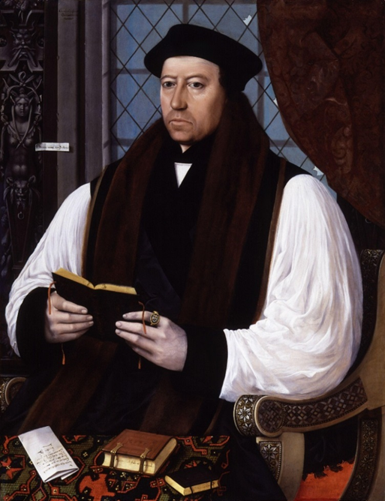**Steps to Protestantism under Somerset**

Having repealed the Treason Law, the government struggled to control the excesses of people let off a tight leash. Pamphlets were attacking the mass and some radicals were destroying images and alters and there are stories of dead animals being hurled into church services as an expression of disgust.

Early Changes 1547-9

In July 1547 Royal Injunctions ordered that:

* Copies of the Book of Homilies (which provided

the clergy with model sermons) & of Erasmus’s

Paraphrases (a summary of the New Testament translated into English) were to be placed in every parish church.

* Clergy must conduct their services in English, preach every Sunday & keep a copy of the English Bible in their church.
* “Superstitious” images must be removed (in February 1548 it was ordered that all images must be removed & it was further ordered in December 1549 that any remaining images must be destroyed).

In autumn 1547, Parliament passed an act dissolving the chantries, justifying this by claiming that belief in prayers for the dead & purgatory were superstitious. In total over 3,000 chantries were dissolved.

The repeal of the Treason Act in 1547 enabled more freedom of religious debate, with increasingly radical ideas circulating, including attacks on the Mass. In some places there were iconoclastic attacks on images on the grounds that they were idolatrous & superstitious.

Somerset issued a series of proclamations between January and April 1548 to restore order and limit who could preach. However it appears that the impact of these proclamations was limited. In September 1548 the Council had to ban all public preaching. In January 1549 they issued an Act of Uniformity stating that

* Sacraments now consisted of just communion, baptism, confirmation marriage and burial.
* Clergy could marry.
* Singing masses for the dead was not approved.
* Services were to be in English.
* Laity could receive both bread and wine at communion.

A few Catholic practices remained.

* Some Holy Days were still respected.
* The Catholic belief in purgatory was not condemned.

To help enforce these changes, bishops were ordered to carry out visitations (inspections) to check how many people in their dioceses (the area they were bishops of) knew the Lord’s Prayer & the 10 Commandments.

Limitations.

• Somerset himself was only a moderate Prot. & as Lord Protector did not have the same authority as a King.

• The bishops were divided, with many (especially Gardiner of Winchester) opposed to change.

• The lower clergy & common people were predominantly against change, especially in the North & West.

• Protestantism was not imposed until the passage of the Act of Uniformity in 1549.

• The main reason for the dissolution of the chantries was to raise money for the war against Scotland.

• Somerset feared that the increased freedom of debate & iconoclasm could cause disorder, so a series of proclamations (announcements) were made between January & April 1548 to restore order & limit those who could preach. When these had only a limited effect, the Privy Council (roughly equivalent to the modern Cabinet) felt compelled to ban all public preaching, even though this obviously restricted the spread of Prot. ideas.

• Fast & Holy Days remained & the veneration of saints was discouraged rather than banned.

• 5 of the 7 Catholic sacraments were retained.

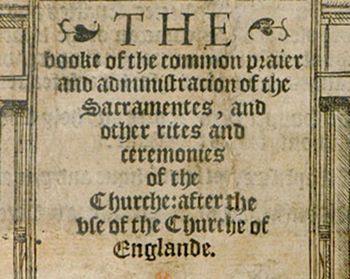• The new Book of Common Prayer was only moderately Prot., following Martin Luther’s belief in the real presence of the body & blood of Christ in the communion bread & wine rather than the more radical belief of the Swiss reformer Zwingli in a purely symbolic presence. The wording of the new communion service was so conservative that even Bishop Gardiner felt able (albeit reluctantly) to endorse it.

• In the diocese of Gloucester, only 50% of the clergy (never mind the

laity) knew the 10 Commandments.

• The changes provoked unrest in Yorkshire, Hampshire & Oxfordshire & outright rebellion in Devon & Cornwall; Somerset was forced out of power as a result of this. Many senior politicians feared the changes had gone too far: Sir William Paget warned Somerset that “the use of the old religion is forbidden by a law, but the use of the new is not yet printed in the stomachs of 11 out of 12 parts of the realm”.

**Source A**

“The bishops have not yet agreed on Christian doctrine, let alone the rules of the Church, and very few parishes have qualified clergymen. Sometimes the clergy read the service rapidly, so that the ordinary people have no more understanding of it than if it were in Latin rather than English. When these problems are presented to the bishops, they say they cannot correct them without an act of Parliament. ”

*The German Protestant reformer Martin Bucer, in a letter to the French Protestant reformer John Calvin, 1550.*

**Source B**

“The King has issued through Parliament a uniform, quiet and godly order of service called the Book of Common Prayer, which contains nothing but the very pure Word of God. However, alongside it are still practised corrupt, untrue and superstitious ceremonies, which allow some to attack the order and meaning of the Prayer Book and encourage great diversity of opinion. Therefore it is ordered that all books used for the old Mass be abolished, and any images of stone, timber or marble be defaced or destroyed”.

*Act for abolishing and putting away of images and various books, 1550*

**Source C**

In spite of the introduction of the First Common Prayer Book by Parliament, a great number of people in this realm wilfully and damnably refuse to come to their parish churches on Sundays and holy days. In future those who are absent shall be punished by the church courts. The First Common Prayer Book has produced doubts about the form of worship, so the King has ordered a Second Book of Common Prayer to replace it. Anyone who uses another form of worship shall be imprisoned for six months”.

*Second Act of Uniformity, 1552*

Study the three sources and then answer **both** questions on a separate piece of paper.

**1** Use your knowledge of the progress of the Protestantism in England during the reign of Edward VI to assess how useful Source A is as evidence of the problems faced by the government in trying to enforce the new religion.**[10]**

**2** Using these three sources in their historical context assess how far they support the view that England was a strongly Protestant country by 1553. **[20]**

**REBELLIONS IN 1549**

The changes provoked unrest in Yorkshire, Hampshire & Oxfordshire & outright **rebellion** in Devon & Cornwall. Many senior politicians feared the changes had gone too far: Sir William Paget warned Somerset that “the use of the old religion is forbidden by a law, but the use of the new is not yet printed in the stomachs of 11 out of 12 parts of the realm”. Two rebellions became very serious.

**The Western Rebellion, 1549**

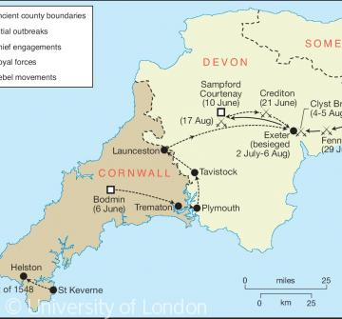

Most Cornish peasants at this time still spoke Cornish (a Celtic language like Welsh) & the rebels said that they did not understand English. There was evidence of religious tension in Cornwall even before 1549: in 1548 a Prot. archdeacon called William Body was murdered at Helston when he tried to enforce the destruction of images in local churches.

The trouble in June 1549 started in Bodmin, the county town of Cornwall, with a demonstration against the new Book of Common Prayer. But the main uprising started at Sampford Courtenay in Devon where on Whit Monday the congregation prevented the reading of the Book of Common Prayer & forced the priest to use the old Latin Mass instead.

The rebellion seems to have started by priests like Robert Welch who then persuaded Humphrey Arundell, a local gentleman with military experience, to lead them.

When the rebellion was crushed the priests involved were publicly hanged in their “popish” mass vestments.

The rebels’ initial demands have been lost but the 2nd set, as preserved in the libraries at Lambeth Palace & Corpus Christi College Oxford, were predominantly religious:

**Source C**

We demand the laws of Henry VIII concerning the Six Articles to be used again as they were during his reign.

We demand the Mass in Latin as it used to be & celebrated by the priest without anyone communicating with him (i.e. communion in one kind only for the laity).

We demand holy bread and holy water every Sunday, palms and ashes at the appropriate times and images to be restored in every church.

We will not have the new service because it is like a Christmas game, but we want our old service of Matins, Mass and Evensong and procession in Latin, not English.

We demand every preacher in his sermon and every priest at mass to pray for the souls in purgatory as used to be the case.

**Questions on Source C**

1. Why would the government be offended by the tone of these demands?
2. Who do you think wrote them?
3. How useful is this source to an historian trying to assess why the rebellion broke out?

**Source D** In a letter written for him by Somerset, Edward VI replied to the rebels as follows:

You say certain Cornishmen are offended because they do not have their service in Cornish, since they understand no English.

You object that religious changes were made without my knowledge. But I deny this and affirm that the Prayer Book is according to Scripture and the Word of God.

You demand that the tax granted to me by Parliament on cloth and sheep should be cancelled.

You complain of the shortage of food and other things.

**Questions on Source D**

1. How useful is this source to an historian trying to assess why the rebellion broke out?
2. How does this source compare with Source C in terms of what it says about the causes of the rebellion?

**Social & Economic Causes.**

As Source D shows, there is evidence of social & economic grievances in the initial rebel demands, in particular for the cancellation of the tax on sheep & cloth which would have hit Devon particularly hard because of the importance of sheep farming there.

Although Humphrey Arundell provided some gentry leadership, there is also much evidence that this was a rebellion of peasants against gentry:

• The Cornish rebels attacked & robbed the gentry at St Michael’s Mount & at Bodmin they shouted: “kill the gentlemen!”

• In Devon the rebels killed William Hellyons., a gentleman who tried to stop them & force them to go home. They also attacked & plundered Trematon Castle.

• The historian Barrett Beer has written of “a widening cleavage between the landowning gentry and the masses of working men and women”.

• The city authorities in Exeter denied access to the rebels & recruited guards from the wealthier elements of the population to hold the city against the rebels. One citizen described the rebels as “refuse, scum and the rascals of the whole county”. They feared that the poor within the city might support the rebels & bribed them with cheap food & poor relief to prevent them from doing so.

• Even the commander of the royal army which defeated the rebels criticised the local gentry for making the peasants pay extortionate rents, abandoning the traditional concept of “good lordship”.

**Political Causes.**

The downfall of the Courtenay family in 1538 created a power vacuum in Devon & Cornwall; with no dominant local noble, the gentry were leaderless.

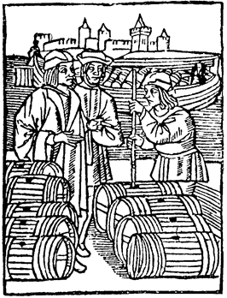

As we have seen - the chaos and disorder of the summer of 1549 was not just caused by religion. The strains of Somerset’s expensive wars and a series of bad harvests were putting serious pressures on people too. Food prices were three times as much as they had been for most of Henry’s reign.

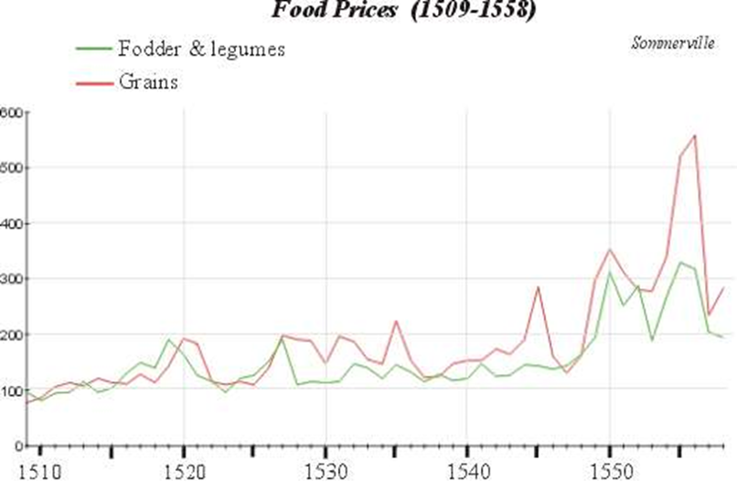

Indications were that the harvest of 1549 would be as poor as that of 1548 increasing the problems of inflation and helped spark rebellion. In Sussex, the public appearance of a nobleman (the Earl of Arundel) was sufficient to subdue the rebels. In Oxfordshire, in order to quell the mob a number of rioters were hanged. In the West Country Henry’s execution of many of the traditional nobles in 1538 had left the county without people that had traditional respect. In Norfolk, the Duke of Norfolk was still in the Tower from a falling out with Henry at the end of his reign and without a local magnate the locals became less easy to suppress.

**Kett’s Rebellion 1549**

This rebellion started with riots against enclosures at Attleborough in Norfolk but escalated into a full scale rebellion when Robert Kett, a prosperous local farmer, took over the leadership in early July. The rebellion was not crushed until the end of August.

**The Demands**

**These included:**

1. No Lord should pasture animals on the commons (a reference to an effect of enclosure).

2. Common land to be safeguarded against enclosures.

3. Rents & prices of copyhold land, meadowland and the marshes should be set at the 1485 level.

4. Land that was held in freehold should not be converted to copyhold (a form of tenancy which would benefit gentry at peasants’ expense).

5. No man worth £401 or over a year to keep cattle or sheep except for their own subsistence (a direct attack on gentlemen farmers).

6. Clergy should be resident in their parishes & be able to preach the Word of God; if not, they should be removed.

7. Lower the tax levied on the inheritance of the land.

8. If priests or vicars earn above £10 a year they should teach the poorer children.

9. Parishioners (not nobles or gentry) should have the right to choose their own priests.

10. A reduction in tithes (10% of his annual produce, paid by a peasant to his local priest or in some cases, following the Dissolution of the Monasteries, the lord of the manor).

11. An end to serfdom (a system whereby peasants were bound to work for a particular lord or gentleman) “for God made all free with his precious bloodshedding”.

12. The system of law enforcement by gentry acting as Justices of the Peace to be replaced by commissions elected by the peasants.

**Questions:**

**(a)** How do these demands compare with those of the rebels in Devon & Cornwall?

**(b)** Do they seem to you to be a more less useful guide to the true causes of the rebellion than those in Devon & Cornwall? Explain your answer**.**

**Social & Economic Grievances.**

• The unrest started in Attleborough & Wymondham as riots against enclosures, directed especially against a local lawyer, John Flowerdew.

• These riots started when the news reached Attleborough that Hales’ anti-enclosure commission would soon be coming to Norfolk. This, as opponents of Somerset’s anti-enclosure policy argued at the time, encouraged the peasants to take the law into their own hands.

• There was peasant anger that gentry were grazing large flocks of sheep on common land, exhausting the land or even forcing the peasants off it.

• As in Devon & Cornwall there were complaints about excessive rent rises.

• Serfdom was still practised on some of the Duke of Norfolk’s estates.

• There were local grievances like fishing rights, both in rivers & off the coast.

• There was resentment at the way that local gentry & lawyers (like Flowerdew) abused their positions of power in local govt. to enrich themselves at the peasants’ expense. This explains the demand for commissions elected by peasants to take control of local government.

• The depression in the cloth trade hit Norfolk, especially Norwich, more seriously than virtually anywhere else in England.

• In Norwich, where only 6% of the population owned 60% of the wealth, some rich men’s houses were set on fire.

• Several gentry were attacked & Lord Sheffield was beaten to death (like Hellyons in Devon.

• John Guy has described the rebellions & unrest in 1549 as the nearest England has come to class warfare.

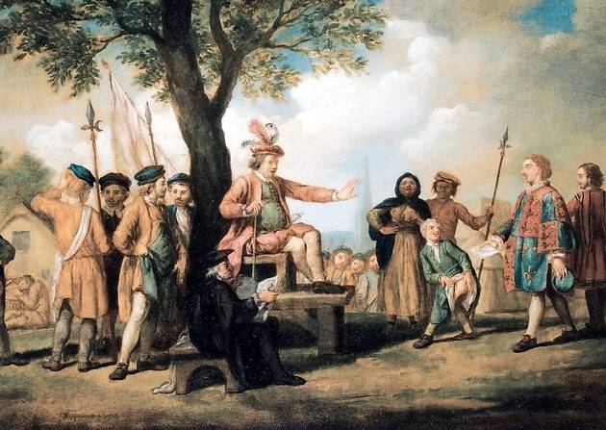

**The Tree of Reformation**

**Treatment of the Gentry.**

Calling themselves “the King’s Commissioners at Mousehold Heath”, the rebels set up a camp at Mousehold Heath just outside Norwich.

As this title suggests, they claimed to be acting in the King’s name & to maintain a system of discipline & justice in their camps at Mousehold Heath & elsewhere. They prefaced their demands with “We pray your Grace …” rather than “We will have …” as the rebels in Devon & Cornwall did. They issued promissory notes that they would pay for requisitioned food & drink in imitation of govt. practice. They put gentry who they claimed had acted illegally on trial before the “Tree of Reformation” on Mousehold Heath.

Nevertheless, there is no doubt that some gentry were ill treated & some wealthy citizens in Norwich had their houses plundered.

Kett & the other rebel leaders did not survive to tell their side of the story so the most detailed account we have is from “Commotion in Norfolk” written by a local gentleman called Nicholas Sotherton.

Here are 2 extracts:

**Source E**

Those gentlemen they captured they brought to the Tree of reformation where they asked the people what they wanted to do with them: some cried hang them and some kill them. Some, who were unable to hear, shouted like the rest and when asked why they did that, answered that they copied their fellows.They also pushed their weapons into the gentlemen in order to kill some of those brought to them and they did this with such malice that one Mr Wharton, who was being guarded by a line of men on both sides all the way from the tree to the city, was pricked with their spears and other weapons on purpose to kill him. Moreover, the rest of the gentlemen they imprisoned were bound with chains and locks and they appointed guards to prevent them from escaping.

**Source F**

They (the rebels) were so shameless and so desperate that the poor vagabond boys, trouserless and bare arsed, came among the thicket of the arrows and … most shamefully turned up their bare bottoms against those who did the shooting”.

**Evaluating these sources in their historical context, how useful do you think they would be to an historian studying the Norfolk Rebellion?**

**Religion**

Unlike the rebels in Devon & Cornwall, the Norfolk rebels seem to have been Prot. & anticlerical:

• They used the Book of Common Prayer in their camp at Mousehold Heath & made no demands for the restoration of Catholicism.

• They demanded that the clergy preach the Word of God, teach poor children & be accountable to local peasants rather than the lord of the manor. They also demanded a reduction of tithes.

**Political Causes.**

As in Devon & Cornwall, the political disgrace of the Duke of Norfolk in 1546 (not reversed until Mary’s reign) created a local power vacuum which left the local gentry leaderless.

**Source G**

**A clergyman identified some major economic grievances in his book *The Jewel of Joy* written in 1548. The author, Thomas Becon had been chaplain to Somerset.**

See how rich men, especially sheep owners, oppress the King’s subjects by enclosing the common pasture and filling it with their sheep. How many sheep they have! Yet when was wool so expensive, or mutton so great a price? If this goes on, the people will die of cold or starve to death. For these greedy wolves will either sell their wool and their sheep at their own high price, or else not at all. Other men buy up houses, even whole villages and then allow them to fall into ruin and decay.

**Source H. The economic problems of the time are discussed in an imaginary dialogue between a small farmer, a merchant and a knight in a book written by Sir Thomas Smith in 1549**

Small farmer: These enclosures ruin us all, for they make us pay more for our land so we have no money to put to ploughing.

Merchant: There is a shortage of all things which we grow in this land or which we buy from overseas, and food is more expensive. If enclosures are the cause then they should be removed.

Knight: Enclosures cannot be the cause of the shortage of cattle, for enclosures encourage and protect cattle. All things are more expensive now, but you can raise the price of goods you sell, whereas we gentlemen have nothing to sell and yet have to pay higher prices.

1. Use your knowledge of the economic developments of the period to assess how useful Source C is as evidence of the economic grievances of the peasantry.
2. Compare Source C and D as evidence for the economic problems of the mid sixteenth century.

**Source I – In about 1550 the thirteen year old Edward VI began to keep a journal of major political events. Here he writes of the trouble of 1549.**

The people began to rise up in Wiltshire, where Sir William Herbert did put them down, over-run and slay them. Then they rose up in Sussex, Hampshire, Kent and elsewhere, where by fair persuasions they were often satisfied, but again, because certain commissioners were sent to pull down enclosures they did then rise up again.

Because there was a rumour that he [as noted elsewhere Edward refers to himself as He in his chronicle] was dead, he rode through London.

After that they rose up in Oxfordshire, Devonshire, Norfolk and Yorkshire.

Once they were crushed the Privy Council, about nineteen of them, were gathered in London to meet the Lord Protector and to make him amend some of his disorders.

**Source J An ambassador from the Holy Roman Emperor writes to his master, Charles V about the risings of 1549.**

The revolt of the peasants has increased and spread, so that now they have risen in every part of England, asking for things just and unjust. They demand they may use the land that once used to be public property, and that land leased to them shall be considered to be of the same value now as in the time of Henry VII, who died in 1509. This last request is very difficult to meet. In Kent and Essex the risings ended when foodstuffs were taxed at a reasonable price. There is no mention of religion made among any of them except in Cornwall and Norfolk.

**Source K – The Venetian ambassador in England reports to the Senate of Venice in July 1549 of social and religious unrest and the English government’s response.**

There is news of major uprisings against the government in England and that the King has retreated to a strong castle outside London. The causes of this is the common land, as the great landowners occupy the pastures of the poor people. The rebels also require the return of the mass, together with the religion as it stood on the death of Henry VIII. The government wishing to apply a remedy put upwards of 500 persons to the sword sparing neither women nor children.

1. How useful are the sources as evidence of the causes of unrest in the summer of 1549?
2. Using these three sources and information in this section and the next, how far do you agree that economic problems were the main cause of unrest in 1549?

**THREAT LEVELS** (for additional help look at p. 22)

|  |  |  |  |  |  |  |
| --- | --- | --- | --- | --- | --- | --- |
|  | **How powerful and effective was the leadership** | **Did the rebels aim to depose the monarch** | **How widespread was support in England?** | **Were the rebels’ aims/requirements realistic?** | **Was there foreign support?** | **Was the danger increased by slow or weak reaction from the government?** |
| Prayer book rebellion | Humphrey Arundell – fairly good but made mistake note marching on London |  |  |  |  |  |
| Kett’s rebellion | Robert Kett very effective but made a mistake moving his troops out of Mousehold and into the vale of Dussindale |  |  |  |  |  |

**Using sources as a set**.

OCR – (your exam body) says that you need to practise this skill and that to succeed you need to do the following:

1. Keep a good focus on the question and don’t drift off into describing what the sources say.
2. Evaluate the sources – that is say how valid the evidence they give is. You can do this by looking at their provenance (PANDA – purpose, author, nature, date and audience). You can also do this by looking at what they say about the issue and testing it against your own knowledge.
3. You have to keep a balance. You should not write an essay on the topic in the question just by using your own knowledge, but you should not just explain what the sources say about the issue either. You need to apply some knowledge to all the sources to answer the question.

**Study the four sources and considering them in their historical context assess how far they support the view that enclosure was the most important cause of unrest in 1549.**

**Source L** The Privy Council in the name of Edward VI writes to the rebels in Norfolk July 18 1549

We have been informed that you have assembled in large companies in a very disordered fashion. You have forgotten the Bible which teaches obedience to the King. We have always been ready to address your grievances, and have sent commissioners to reform enclosures. You make humble petititon to us for further reform and we will ensure that rents are returned to their old levels. Other reforms will be discussed in the next parliament. We urge you now to return quietly to your homes.

**Source M** The Venetian ambassador, Matteo Dandolo, writing to the Senate of Venice, 20 July 1549.

There is news of major risings against the government in England, and that the King has retreated to a strong castle outside London. The cause of this is the common land, as the great landowners’ occupy the pastures of the poor people. The rebels also require the return of the mass, together with the religion as it stood on the death of Henry VIII. The government wishing to apply a remedy put upwards of 500 persons to the sword, sparing neither women nor children.

**Source N** Somerset writes to a close adviser, Philip Hoby 24 August 1549

Some rebels wish to pull down enclosures and parks; some want to recover their common land, others pretend religion is their motive. A number would want to rule for a time and do as gentlemen have done, and indeed all have a great hatred of gentlemen and regard them as their enemies. . The ruffians among them, and the soldiers, who are the leaders, look for loot, so the rebellions are nothing more than a plague and a fury among the vilest and worst sort of men.

**Source O** A gentleman from Devon explains the requests of the rebels in Devon and Cornwall, probably to William Cecil 1549.

I do now include the rebel articles. I was unable to do this before because they changed them so often and drew up so many. There were so many leaders among them that for every one there was a different article.

The priests all wanted a return to Rome; certain traitors wanted to bring Cardinal Pole back; a number of vagabonds would have no justice and a band of thieves wanted to get rid of gentlemen.

1. What is each source saying about enclosure.
2. Look at what each source is (letter, diary entry, instruction etc) and when it was written. Using the provenance consider whether the evidence of each source is reliable.
3. What knowledge do you have which might confirm or question the evidence which the source is offering?

Once you have written your answer use the checklist below

* Have I dealt with all four sources
* Have I picked out from each source the key points which relate to the question or have I just described the content.
* How much have I written about Provenance?
* How much knowledge have I used?
* Have I offered a clear view about the issue?

AS Focus

**Question: Use your knowledge of the unrest in 1549 to assess how useful Source M is as evidence for the reaction of the government to rebellion.**

**HOW SERIOUSLY DID THE 1549 REBELLIONS THREATEN THE GOVERNMENT & WHY WERE THEY DEFEATED?**

|  |  |  |
| --- | --- | --- |
|  | Serious | Not serious |
| **Western or Prayerbook** | All attempts by local gentry to disperse the rebels failed; on 20 July Cornish rebels joined Devon rebels at Crediton, taking the govt. by surprise  The royal army was slow to reach Devon b/c it had to put down unrest in Oxfordshire & Buckinghamshire first  Somerset had to offer them a pardon but they still refused to disperse (they were not fooled like the Pilgrims of Grace). Troops had to be diverted from Scotland & mercenaries employed to put rebellion down.  It took at least 3 battles to defeat the rebellion; Lord Grey, who had fought in Scotland, said the battle at Clyst Heath was the most ferocious he had ever taken part in.  There were more executions than in Norfolk b/c the govt. saw the rebellion as a serious threat to its religious policy, hence the hanging of rebellious priests in their mass vestments. | The King’s position was not threatened.  There was virtually no gentry leadership (unlike the Pil. Of Grace).  The rebels failed to take Exeter (whereas the Norfolk rebels did take Norwich).  They made no attempt to march on London to gain more support despite widespread unrest elsewhere.  Once the govt..had enough troops available, the rebels were no match for them. |
| **Norfolk or Ketts** | Strong leadership, not just from Kett but also other important men like Thomas Aldryche & the Mayor of Norwich, Thomas Cod  Norwich (then England’s 2nd city) captured  The rebels had an army of 16,000 men; the Marquis of Northampton was too intimidated to fight them.  Somerset had to offer them a pardon but they still refused to disperse (they were not fooled like the Pilgrims of Grace).  Troops had to be diverted from Scotland & mercenaries employed to put rebellion down. | The King’s position was not threatened; in fact the rebels called themselves “the King’s Commissioners”.  There was virtually no gentry leadership (unlike the Pil. Of Grace).  Kett made the mistake of moving from his well fortified camp at Mousehold Heath to Dussindale, where his.unwise decision to take on Warwick’s army led to defeat.  Once the govt..had enough troops available, the rebels were no match for them.  The fact that only 50 rebels were executed (fewer than in Devon & Cornwall) suggests they weren’t seen as a serious threat. |
| General | The King was a minor & as Lord Protector Somerset did not have the same authority an adult king would have had.  With wars against France & Scotland, there was a danger of a foreign invasion to coincide with the rebellions.  There was unrest in at least 26 counties in 1549, reflecting widespread religious & economic grievances.  The nobility were sufficiently concerned to support the overthrow of Somerset in October 1549 | In most counties the unrest was contained, either by negotiation |

**Reasons for Somerset’s Fall in October 1549**

* Somerset’s aggressive behaviour turned the **Privy Council** against him, including Sir William Paget, once his trusted adviser, & former supporters like the Earl of Warwick (later Duke of Northumberland). Paget warned him that “a king which shall give men occasion to discourage to say their opinions frankly receiveth thereby great hurt and peril to his realm. But a subject in great authority, as Your Grace is, using such fashion, is like to fall in great danger and peril of his own person, beside that to the well being of the nation”. **Warwick** (later the Duke of Northumberland) led the coup against him, alleging (according to Richard Grafton’s chronicle) that he “ignored the advice of his councillors” & “told untruths about the council to the king”.
* Paget also criticised Somerset’s handling of the social & economic problems England faced (“in the matter of your treatment of the common people every man in the Council dislikes your proceedings and wished it were otherwise”) & blamed him for the **rebellions**: “The King’s subjects out of all discipline and all obedience … What is the cause? Your softness, your wish to be good to the poor”. The King himself wrote that the 1549 risings began "because certain commissions were sent down to pluck down enclosures".
* Somerset’s **religious** policy provoked unrest in Yorkshire, Hampshire & Oxfordshire & outright rebellion in Devon & Cornwall; Paget warned Somerset that “the use of the old religion is forbidden by a law, but the use of the new is not yet printed in the stomachs of 11 out of 12 parts of the realm”.
* Som. even **executed his own brother** (Thomas Seymour, Baron Seymour of Sudeley) in 1549 for treason. Thomas had tried to manipulate Princess Elizabeth (by seducing her) & the King (by giving him pocket money); the final straw was trying to break into the royal apartments with a loaded pistol.
* Warwick brought Somerset down by allying with his enemies like the Earl of **Southampton**, a religious conservative who had always disliked Somerset.

**Why did political instability continue from October 1549 onwards?**

* Both Somerset and his supporters accused each other of treason & **armed their servants** so they could seize or retain power by force.
* Somerset tried to retain power by **kidnapping the King** & taking him to Windsor Castle, in effect imprisoning him in the hope that he could claim to act in the King’s name. This failed because Edward, despite being only 12 years old, refused to support him.
* Even after Somerset was forced to resign, there was **rivalry for power between Warwick & the religiously conservative councillors** led by the Earls of Arundel & Southampton.
* Warwick managed to outmanoeuvre his opponents by promoting his supporters, allying with the Protestants, including Som. (who was restored to the Privy Council in 1550) & winning the support of religiously uncommitted opportunists like Paget & Petre.
* Far from being grateful to Warwick for his restoration to the Privy Council, **Somerset** was still bitter at Warwick for engineering his downfall as L Protector in 1549 so he plotted against him. Warwick (who made himself Lord President of the Privy Council in 1550 & Duke of Northumberland in 1551) had Som. executed in 1552; according to a contemporary letter, he was accused of inciting rebellion & plotting to murder Northumberland; “the whole Council decided that they would no longer endure the excessive arrogance of the Duke of Somerset”.

**SOMERSET / NORTHUMBERLAND COMPARISON**

|  |  |  |
| --- | --- | --- |
|  | **Somerset 1547-9** | **Northumberland 1550-3** |
| Style of Government | Made himself Lord Protector & ruled arrogantly, often disregarding the views of the Privy Council, losing their confidence as a result. United Warwick (later Nthumb.) & the conservatives against him, leading to his downfall in 1549.  Paget accused him of bullying councillors. | Ruled as Lord President of the Privy Council & was careful to retain the confidence of his fellow councillors, especially moderates like Paget.  He outmanoeuvred the conservatives led by Southampton & then executed Somerset in 1552 when he tried to overthrow him. |
| Treatment of the King | Kidnapped E & took him in Windsor Castle; tried to manipulate him but had to resign when E refused to co-operate. | Encouraged E to participate in govt., e.g. by setting the agenda for Privy Council meetings, & his religious policy was influenced by E’s strongly Prot. views. |
| Rebellions | Accused by his Privy Councillors of encouraging the peasants to take the law into their own hands with his enclosure commissions & was therefore blamed for the rebellions & unrest in 1549, resulting in his downfall in October that year. | As Earl of Warwick Nthumb. gained credit for crushing the Norfolk Rebellion.  Prevented future rebellions (despite harvest failures 1549-51 & a crash in the cloth trade in 1551) by imposing the death penalty for unlawful assemblies of 12 or more people to overthrow enclosures or demand price or rent reductions & establishing a militia commanded by a lord lieutenant in each county.  He also passed laws to protect arable farming, relieve the poor & stop lending at extortionate interest rates. |
| Foreign Policy | Despite his victory over the Scots at Pinkie in 1547, Som. was unable to prevent Mary, Queen of Scots sailing to France in 1548 so she could marry the eldest son of the new French king Henry II rather than E VI.  His policy of continuing the wars agt. France & Scotland, including trying to hold Boulogne against the French, cost £1.3 million & bankrupted the Crown. | Ended the wars with France & Scotland, selling Boulogne back to the French for £140,000 & abandoning the betrothal of E to MQS.  The potential union of crowns between France & Scotland threatened England in the future but not immediately, especially as war broke out between Henry II & Charles V in 1551.  Strengthened the navy & England’s defences against both France & Scotland. |
| Finance | His aggressive foreign policy bankrupted the Crown despite desperate attempts to raise money by debasing the coinage (causing disastrous inflation which contributed to the unrest & rebellions in 1549) & selling monastic & chantry land (thereby virtually wiping out the potential benefit to the Crown of dissolving the monasteries & chantries). | Recognised the necessity of making peace with France & Scotland so he could end the debasement of the coinage & reduce the Crown’s debt.  By 1553 he had reduced it to below £200,000 by improving financial administration, reducing expenditure & selling crown & church land. |

**NORTHUMBERLAND**

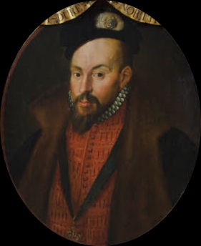

Although the unrest in the countryside was put down the ruling elite had been very concerned by the disorder. Somerset’s personal style of government also caused resentment and led to the formation of an anti-Somerset faction. This group had little in common except their dislike of Somerset’s methods and policies. The Earl of Warwick saw an opportunity.

**Source P** A contemporary relates the early stages of the successful plot against Somerset in 1549. Entry from Richard Grafton’s chronicle, 1549.

After these revolts were crushed, many of the lords and councillors secretly plotted to overthrow the Lord Protector. Each lord and councillor went through London armed, and had servants likewise armed. They assembled at the house of the Earl of Warwick. They then published a proclamation against him containing the following charges.

First that through his malicious and evil government, the Lord Protector had caused all the recent unrest in the country. Secondly, he was ambitious and sought his own glory. Third, that he had ignored the advice of the councillors. Fourth, that he told untruths about the Council to the King.

1. What evidence does the chronicle provide of instability in England?
2. What accusations are made against Somerset?
3. What evidence is there to support the claims against him?
4. What is the purpose of the proclamation against Somerset? How does that affect its reliability?

John Dudley, Earl of Warwick become **Lord President of the Council** having overthrown Somerset. He is normally referred to as Northumberland as he was raised to that dukedom in October 1551. He had seven key supporters on the Council, including Cranmer, who favoured further radical religious reforms. There were 14 Councillors who favoured a more conservative position and a deal with Emperor Charles V. The balance, however began to shift. The conservative, Wriothesley, accused of plotting a second coup, was dismissed from the Council together with his leading supporter the Earl of Arundel. Following struggle for a fierce struggle for power Warwick managed to get a majority behind him.

After the near bankruptcy brought about by Somerset, Warwick raised government revenue. He did sell Crown land, confiscate lead, coin bullion from Church plate and seize bishops’ lands, he was also more vigorous than his predecessor in collecting Crown debts, pruning government expenditure in setting up regular audits. Above all in March 1552 he set up a Royal Commission to investigate the work of the revenue courts. Thus men who were to include key servants of Elizabeth I such as William Cecil and Thomas Gresham cut their administrative teeth on what Elton has called ‘a genuine reform administration’.

|  |
| --- |
| **Northumberland’s Achievements** |
| **Government** |
| * Having inherited a failed government, Dudley set out to restore administrative efficiency and maintain public order to prevent renewed rebellion as seen in 1549. Northumberland was quite different from Somerset and Loach describes how he “**regularly consulted the privy council, whose President he was, sought and took advice** from his colleagues” and it is during his period in office, that William Cecil (later Elizabeth’s Lord Burghley) was appointed. * He created new laws "for the punishment of unlawful assemblies” he built a united front of landholders and Privy Council, the government intervening locally at any sign of unrest. * He returned to the ancient practice of granting licences to retain liveried followers and installed Lord Lieutenants that represented the central government and were to keep ready small bands of cavalry. * Whereas Somerset had neglected the Council, Northumberland revived it, giving it an influx of new blood. 12 Councillors were appointed in 1550 (naturally sympathetic to him). Provincial administration was improved through extending the network of Lord-Lieutenants, first appointed in 1549 following a precedent of Henry VIII to control the levies of troops in the shires. Thus the Earls of Huntingdon and Westmoreland enhanced their local standing through their Lieutenancies, but were rarely able to attend the Council. In these ways the administrative machine first expanded by Thomas Cromwell in the 1530s was revitalised and prepared for its role in keeping government going during the ups and downs of the next ten years. |
| **Foreign Policy**   * Impossible to continue in the way that Somerset had done, and Dudley quickly negotiated a withdrawal of the besieged English garrison at Boulogne. * The high costs of the garrison could thus be saved and French payments of redemption of roughly ₤180,000 were a most welcome cash income * **The peace with France was concluded in the Treaty of Boulogne in March 1550.** * There was both public rejoicing and anger at the time. Some historians have condemned the peace as a shameful surrender of English-held territory but in fact most modern historians recognise it was vital to give the country a chance to regroup. It was agreed in the peace that King Edward was to have a French bride, the six-year-old Elisabeth of Valois. * The threat of war with Scotland neutralized, England gave up some isolated garrisons in exchange. * In the peace treaty with Scotland of June 1551, a joint commission was installed to agree upon the exact boundary between the two countries. This matter was concluded in August 1552 by French arbitration * English defences were kept on a high level: nearly ₤200,000 p.a. were spent on the navy and the garrisons at Calais and on the Scottish border * War between France and Emperor broke out again in September 1551. Northumberland rejected requests for English help from both sides – again vital for English recovery even though it might have seemed less powerful. * Duke pursued a policy of neutrality, a balancing act that made peace between the two great powers attractive. * In late 1552 he undertook to bring about a European peace by English mediation. Moves taken seriously by rival resident ambassadors, but ended in June 1553, the continuance of war being more advantageous to them and aware also that Northumberland was not long to be able to control things. |
| **Financial policies**   * After the near bankruptcy brought about by Somerset, Northumberland raised government revenue. He did sell Crown land, confiscate lead, coin bullion from Church plate and seize bishops’ lands, he was also more vigorous than his predecessor in collecting Crown debts, pruning government expenditure in setting up regular audits. Above all in March 1552 he set up a **Royal Commission** to investigate the work of the revenue courts. Thus men who were to include key servants of Elizabeth I such as **William Cecil and Thomas Gresham** cut their administrative teeth on what Elton has called ‘a genuine reform administration’. * His financial policy would only work if he also ended the expensive wars. On Mary 24th 1550 England and France signed the Treaty of Boulogne, whereby France got to keep the town in return for £133,333. English troops left Scotland and no marriage was to take place between Mary Queen of Scots and Edward. The peace settlement was a bit humiliating, but it showed realism. |
| **Social and Economic policy**   * Revisionist historians have even praised Northumberland’s social policy has come in for praise. The background of the 1549 disturbances, three further poor harvests aggravated by bad weather, soaring wheat prices (from 9 shillings a quarter in 1548-9) to 15 shillings a quarter in 1549-50 and 19 shillings a quarter in 1551-2) and a slump In the cloth trade in 1551 struck fear into the government. * Northumberland realised that if disorder were to be avoided the authorities would have to show some concern for social justice and try to alleviate the effects of economic trends. * Prosecutions for driving tenants off their estates increased and in 1552 two Acts of Parliament were passed on social issues: one to protect arable farming and to stop usury (money lending), the other a new Poor Law to collect funds for the relief of the ‘deserving’ or ‘impotent’ poor. - Northumberland admitted to his colleagues that he found finance a puzzling thing + told Lord Treasurer Winchester to find other experts to deal with it. * Thomas Gresham's services were called upon. After the first good harvest in four years, by late 1552 the currency was stable, prices for foodstuffs had dropped, and a basis for economic recovery had been laid. A process to centralize the administration of Crown revenue was underway and foreign debt had been eliminated |

**Task 11**

1. In what ways was the administrative machine, first expanded by Thomas Cromwell in the 1530s revitalised?
2. Why do some historians criticise Northumberland’s foreign policies?
3. What measures did he take to stabilize the economy?
4. Do you think it was due to measures Northumberland took that there was no rebellion while he was in control?

**Starkey “The Unknown Tudors” 28 mins to 54 mins**

1. What particularly divided Edward from his sister?

*.*

1. What happened when the Holy Roman Emperor asked Edward for special dispensation for Mary to say mass.
2. What comes across strongly in Edward’s chronicle?

*.*

1. What was Edward’s most decisive move towards Protestantism?

*.*

1. What happened on the royal progress of 1552?

*.*

1. What showed how broke his government was?
2. What showed that Edward could enjoy himself?
3. What did Edward want to achieve?

*.*

1. What had happened by April 1533.

*.*

1. When he knew he was dangerously ill what worried him?

*.*

1. What did he do in his “device” for the succession?

However Northumberland has obtained a very bad reputation because in 1553 he was almost responsible – along with his master the king, for bringing down the Tudor dynasty altogether.

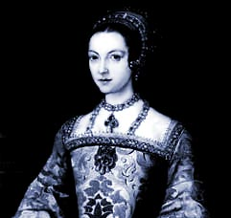**The Lady Jane Grey affair**

**Source Q – A medical student called John Banister who was at Greenwich involved in the care of Edward VI describes the decline in his health on 28 May 1553.**

In what concerns our King’s health be assured of this, that he is steadily declining. Today the Duke of Northumberland called the doctors together and asked them what the King’s chances were. With one voice they answered that since this seasons of the year is kindest to him, but it has not improved his condition, so, when the autumn comes it will end his life. The duke hearing this told them not to slacken their efforts nor stop praying to God that he will benefit from their treatment. Meanwhile Northumberland told them that “you will be paid your fees every month at a rate of one hundred crowns.”

According to the Succession Acts and Henry’s will the throne was to pass to Edward’s half sister Mary, however during the spring and summer a plot developed to alter the succession to exclude Mary. Most accounts of the events have suggested that the driving force behind the attempt was Northumberland as it was essential if he was to preserve his power. What supports this idea is that during this period he arranged for the marriage of his son, Guildford Dudley, to Lady Jane Grey – who was soon afterwards declared Edward’s successor.

**Source I**R Written by a Catholic gentleman from Suffolk in his book about Mary, written in 1553. He was called Robert Wingfield and was an ardent supporter of Mary.

The Duke of Northumberland was an ambitious man. After a notable victory outside Norwich in 1549 against the peasants, who had been stirred up against the better sort by idle men, Northumberland sought to control both the King and the kingdom. In 1553 the King showed signs of imminent death. He dared not make any protests, but fell in with the Duke’s wishes to alter the succession. The dying king spoke to the nobles and lawyers; “It is our resolve, with the agreement of our noblemen to appoint as our heir our dear cousin Jane. For if our sister Mary were to be queen, all would be over for the religion we have established.”

1. What does Wingfield’s account suggest were Edward’s reasons for altering the succession?
2. How might Wingfield’s religious beliefs influence his views?
3. How might this affect the reliability of this source?

There is in fact much evidence to suggest that the attempts to alter the succession were driven by Edward rather than Northumberland. Edward was certainly playing a much greater role in government attending Privy Council meetings and setting some agenda. Northumberland was astute enough o recognise Edward’s skills and involve him. Edward was also committed to Protestantism and it is possible that in order to preserve the religious reform he had brought in he wanted the succession to exclude Mary. In May 1553 Edward issued his “Devise for the Succession”.

**Source S letters patent set out by Edward for the succession in event of his death. Written in May and released June 21 1553.**

As Lady Mary and Lady Elizabeth are both illegitimate they have no claim to the crown. As half-blood to us, they would be barred by ancient law and custom of this realm and could not succeed us even if legitimate. Were the said Mary or Elizabeth to have the crown of England and marry a foreigner, he would practise his own country’s laws and customs within this realm. This would utterly subvert the good of the nation. We therefore declare that the crown shall, for lack of issue of our body, come firstly to the eldest son of Lady Frances Grey, or secondly, to the Lady Jane and her male heirs.

1. Why according to the devise would Mary and Elizabeth be excluded from the succession?
2. What is the purpose of the devise? How might this affect its reliability?
3. In what ways is the devise useful to a historian studying the succession crisis of 1553?

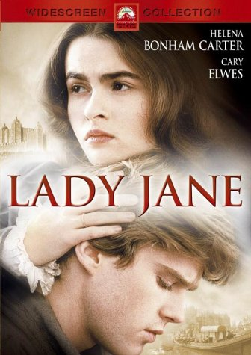

**SOURCES ON THE SUCCESSION CRISIS OF 1553**

**Source 1**

Most lamentably mourning and moaning himself unto you Highness, Thomas Cranmer, though unworthy to write to your Highness, am now obliged, with a most penitent heart, to ask mercy and pardon for my great and serious offence in upholding the last Will of our late Sovereign Lord, King Edward VI, which God knows I never liked. And if by any means possible it had been in my power to have prevented the making of that Will, I would have done it.

And whereas it is contained in two Acts of Parliament, as I understand, that I with the Duke of Northumberland did devise the deprivation of your Majesty from your Royal Crown, it is untrue. For the Duke never said anything to me to get me to agree to such a thing.

His heart was such toward me that he would never trust me in such a matter, or ever think I could be persuaded by him. It was others of the Council, as well as the King, that persuaded me, as the Duke was not present.

Letter from Thomas Cranmer, the Protestant Archbishop of Canterbury, to Mary, 1553.

**Source 2**

The Duke (Northumberland) said the King had told him that he had well considered the Act in which it was ordained that whoever recognised Mary, or Elizabeth her sister, as heir to the Crown were to be considered traitors, seeing that Mary had disobeyed the King her father and her brother and was, moreover, a chief enemy to the Word of God and that both were illegitimate. Therefore the King declared that he would disinherit them. Before his death, he commanded his Council that they should carry this into effect.

The Duke of Northumberland added that I was the heir nominated by his Majesty … On hearing this I remained stunned. Those present can witness that I fell to the ground weeping piteously and lamenting not only my own insufficiency but the death of the King.

Letter from Lady Jane Grey to Mary, August 1553.

**Source 3**

Today the Duke of Northumberland was executed.

As I hear, he confessed himself worthy to die because he was a great helper of this false religion … thanking God that he could now call himself a Christian, for this 16 years he had been none.

A great number turned with his words.

Letter from William Dalby, a London merchant, 22 August 1553.

1. How useful would Sources 1 & 2 be to an historian trying to assess who was responsible for the attempt to exclude Mary from the succession in 1553? Consider why Jane & Cranmer wrote what they did?
2. What would you infer from Source 3 about Dalby’s religious views?
3. What does this source suggest about Northumberland’s role in the attempt to exclude Mary?
4. Why would he have said what he did despite knowing he would die anyway?

**HOW SERIOUSLY DID THE ATTEMPT TO ALTER THE SUCCESSION IN 1553 THREATEN THE SECURITY OF THE TUDOR DYNASTY?**

Seriously

* It could be argued that **Northumberland** (below right) acted as an “overmighty subject”, putting his own ambition & interests above the security of the Crown. He married Lady Jane Grey to his son Lord Guildford Dudley & then persuaded the dying 15 year old King to alter his “Device for the Succession” in Jane’s favour.
* Jane’s claim as the granddaughter of H’s sister Mary was clearly inferior to that of H VIII’s eldest daughter Mary; she knew this & did not want to be queen but was manipulated by Nthumb.
* 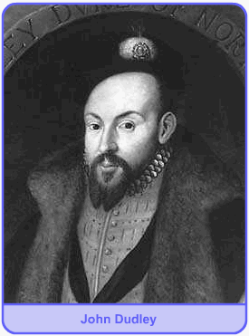Legally the Succession Act of 1543 clearly overruled the “Device” of a 15 year old king which was never approved by Parliament. It also superseded the acts of 1534 & 1537 (quoted by the Privy Council in a letter to Mary just after E’s death) which had excluded Mary from the succession.
* In June 1553, knowing E was dying, Nthumb. forced the Privy Council & other notable people to sign articles supporting Jane. When E died on 6 July Nthumb. kept his death secret for 2 days & forced leading London citizens to sign E’s “Device”.
* Conversely, it can be argued that it was **Edward** himself who threatened the security of his own dynasty by trying to interfere with the succession for religious reasons; he was quoted as saying, “if our sister Mary were to be queen, it would all be over for the religion we have established”.
* Similarly Archbishop **Cranmer** showed disloyalty to the dynasty he was appointed to serve for religious reasons & b/c he knew Mary would burn him as a heretic. His later claim that “I never liked” E’s will & “if by any means possible it had been in my power to have prevented the making of that Will, I would have done it” was an obvious lie.
* There was a real threat that the succession dispute in 1553 could have provoked not just a civil war but also a **foreign invasion**: Nthumb. discussed with the French ambassador the possibility of French military aid against the half-Spanish Mary, while Mary herself requested help from her nephew Charles V.

Not Seriously

* If Nthumb. was the main author of the attempt to interfere with the succession he was remarkably & uncharacteristically **incompetent** in how he set about it: he did not have an army available to support Jane (in fact he had disbanded his army in 1552), he failed to prevent Mary escaping to East Anglia & he also neglected to organise a propaganda campaign against her.
* The nobility & gentry had a vested interest in supporting the principle of **legitimate inheritance**, on which their right to their own property depended; it was therefore never likely that they would support Jane against Mary.
* **Mary** acted quickly & decisively to secure her rightful position by escaping to East Anglia, proclaiming herself Queen, sending letters to the Privy Council & important towns asserting her claim & quickly raising a large army.
* As soon as Northumberland left London to confront Mary, the Privy Council went over to her & many of his soldiers deserted despite being offered higher pay, showing how strong **loyalty to the rightful heir** was. In fact so many of his army deserted that Nthumb. had to give up & declare Mary Queen himself instead of fighting her.
* The religious divisions in England mattered less than her legitimacy: she was greeted with enthusiasm in London despite the presence of many Protestants there. Some historians have argued that Mary herself underestimated the extent to which her success was due to her legitimacy rather than her religion.

Study the three sources below and then answer **both** questions:

**1** Use your knowledge of political developments in the reign of Edward VI to assess how useful Source A would be to an historian trying to assess the causes of the succession crisis in 1553. **[10]**

**2** Using these three sources in their historical context, assess how far they support the view that the succession crisis of 1553 posed a serious threat to the stability of the Tudor dynasty. **[20]**

**Source A**

The Duke of Northumberland was an ambitious man. After a notable victory outside Norwich in 1549 against the peasants, who had been stirred up against the better sort by idle men, Northumberland sought to control both the King and the kingdom. In 1553 the King showed signs of imminent death. He dared not make any protests, but fell in with the Duke’s wishes to alter the succession. The dying king spoke to the nobles and lawyers; “It is our resolve, with the agreement of our noblemen to appoint as our heir our dear cousin Jane. For if our sister Mary were to be queen, all would be over for the religion we have established.”

Robert Wingfield, *The Life of Mary Queen of England*, 1553. Wingfield was a Catholic gentleman & ardent supporter of Mary.

**Source B**

We advise you that our Sovereign Lady Queen Jane is possessed of the crown, not only by good order of old ancient records of this realm, but also by the late King Edward’s letters signed with his own hand and sealed with the Great Seal of England, with nobles, councillors and judges agreeing to these letters. We must remind you that owing to the divorce between King Henry VIII and your mother, in accordance with the law of God and confirmed by Acts of Parliament (1534 and 1537) you are illegitimate and unable to inherit the crown.

Letter from the Privy Council, at that time dominated by Northumberland, to Mary, 9 July 1553.

**Source C**

After a while the Duke (Northumberland), speaking for all of them, thanked your Majesty very humbly for all the generous offers which you are pleased to make them. They desire to ask your aid and to employ your forces when occasion presents itself.

Letter from Antoine de Noailles, the French ambassador, to his master Henry II, 7 July 1553.

**GLOSSARY**

|  |  |
| --- | --- |
| **WORD** | **EXPLANATION** |
|  |  |
|  |  |
|  |  |
|  |  |
|  |  |
|  |  |
|  |  |
|  |  |
|  |  |
|  |  |
|  |  |
|  |  |
|  |  |
|  |  |
|  |  |
|  |  |
|  |  |
|  |  |
|  |  |
|  |  |
|  |  |
|  |  |
|  |  |
|  |  |
|  |  |
|  |  |
|  |  |
|  |  |
|  |  |
|  |  |
|  |  |
|  |  |
|  |  |
|  |  |
|  |  |
|  |  |
|  |  |
|  |  |
|  |  |
|  |  |