**Phases of the Edwardian Reformation – Protector Somerset 1547-1549**

**PHASE 1: DESTRUCTIVE**

During 1547 Catholicism came under attack. 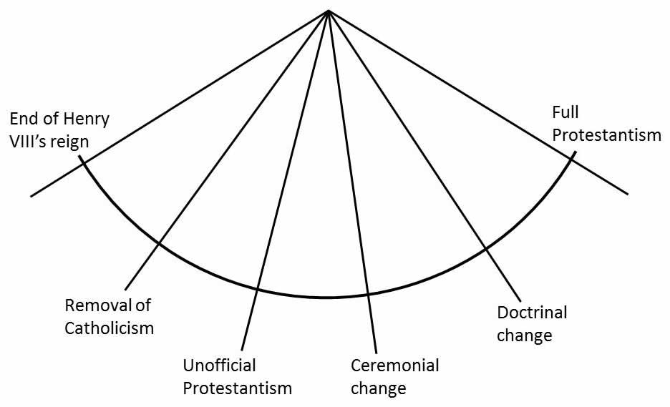

|  |  |  |  |  |
| --- | --- | --- | --- | --- |
| Date | Change | Explanation | Comment | Significance |
| 1547 | Royal visitation | Commissioners were sent to all bishoprics to examine the state of the clergy and the doctrine and practices of the Church. |  |  |
| July 1547 | Book of Homilies | It was ordered that the Book of Homilies (a collection of model sermons) was to be read out by clergy who were unable to preach themselves. | The book of Homilies contained some protestant sermons written by Cranmer, including one supporting the catholic belief of Justification by Faith alone. Bishops Gardiner and Bonner objected and were imprisoned. The book was in almost all parish churches by the end of 1549. |  |
| July 1547 | Royal Injunctions | Orders for all clergy to preach in English and have an English Bible and Protestant literature in every parish church.  Superstitious images were to be removed. |  |  |
| 4th Nov-24th Dec. 1547  Parl | Chantries Act | This Act of Dissolution was revived from Henry’s last Parliament (1545), but contained a crucial new preamble condemning all prayers for the dead. | The chantries played an important role in the lives of many local communities and the attack on them affected the parishes in a way that the destruction of the monasteries had not. 3,000 chantries were dissolved along with 90 colleges 110 hospitals. Some chantries were turned into schools or the money from their dissolution was redirected into the parishes but these were the exceptions.  The preamble to the act, ending prayers for the dead, has been described by W.K. Jordan in his book *Edward Vl* as ‘probably the most shattering and irreversible action of the reformation in England’. Catholics believed that prayers after they died would help their souls in Purgatory. Without prayers a catholic’s soul and salvation was in peril. The sudden dismissal of this crucial Catholic belief had a significant impact on the people. |  |
| 4th Nov-24th Dec. 1547  Parl | Parliament repealed the Act of Six Articles | The Act of Six Articles (1539) had re-established the key Catholic doctrines. | The repeal of this act left the Church effectively without an official doctrine. |  |
| 4th Nov-24th Dec. 1547  Parl | Treason Act repealed | This act removed the old heresy, treason, censorship laws. This allowed people to discuss religion freely without fear of arrest or imprisonment, and to print and publish freely. | Extremists (radicals) leapt on this opportunity to spread their views and in some cases destroy catholic images and altars. The government had stripped itself of the powers needed to curb these outbursts. Protestant pamphlets attacked the mass and Catholicism in general. |  |

**PHASE 2: STATE OF LIMBO**



The Acts of the previous Parliament had lef the church without an official doctrinal position and the lifting of the treason and heresy laws had unleashed a surge of radical Protestant actibvity which the Government struggled to control thorugh 1548.

|  |  |  |  |  |
| --- | --- | --- | --- | --- |
| Date | Change | Explanation | Comment | Significance |
| Jan-Mar  1548 | A series of proclamations was issued to dampen protestant unrest | The Privy Council declared that transubstantiation was still technically in force and that catholic practices had to be followed | The government was trying to restore order while Cranmer was still completing the new Prayer Book. |  |
| 11 Feb 1548 | All images were to be removed from churches |  | There was very little opposition to this. |  |
| 24 April  1548 | A proclamation stated that only authorised clergy could preach. |  | The government felt this was necessary because of the flood of unauthorised preachers that had followed the repeal of the treason and heresy laws. |  |
| 23 September 1548 | A proclamation - there was to be no preaching until a new liturgy was introduced. | A liturgy is the instructions setting out how a church service must be performed. | This is a clear sign that the government felt that the situation was slipping out of control. |  |

**PHASE 3: FORMATIVE**

A Protestant form of worship was established. 

|  |  |  |  |  |
| --- | --- | --- | --- | --- |
| Date | Change | Explanation | Comment | Significance |
| Dec 1548 | First Prayer Book | This was written by Cranmer outlining the liturgy (the form of worship) to be followed in services. | The Prayer book gave an ambiguous message. It was a document in which Cranmer outlined what he thought would be politically acceptable rather than what he personally believed. It satisfied few people. The Catholics viewed it as being Protestant and to the Protestants it appeared to be Catholic.  The Prayer book outlined the liturgy to be used in church services. It included the following:   1. Services in English 2. Sacraments – the eucharist, baptism, last rites, confirmation, marriage 3. Communion in both kinds (bread and wine for laity as well as clergy) 4. Purgatory – unclear 5. No prayers for the dead 6. Worship of saints was discouraged but not banned 7. Traditional robes (vestments) were to be worn by priests in church 8. Transubstantiation 9. Fasting and holy days remained |  |
| Jan 1549 | Act of Uniformity | This enforced the use of the Prayer Book. | It was effectively enforced, despite pockets of resistance. The most notable of these was the Western rebellion 1549. |  |

To be continued after the summer of rebellions