**OCR AS HISTORY UNIT 2 REVISION BOOKLET**

**DEMOCRACY & DICTATORSHIPS IN GERMANY 1919-63**

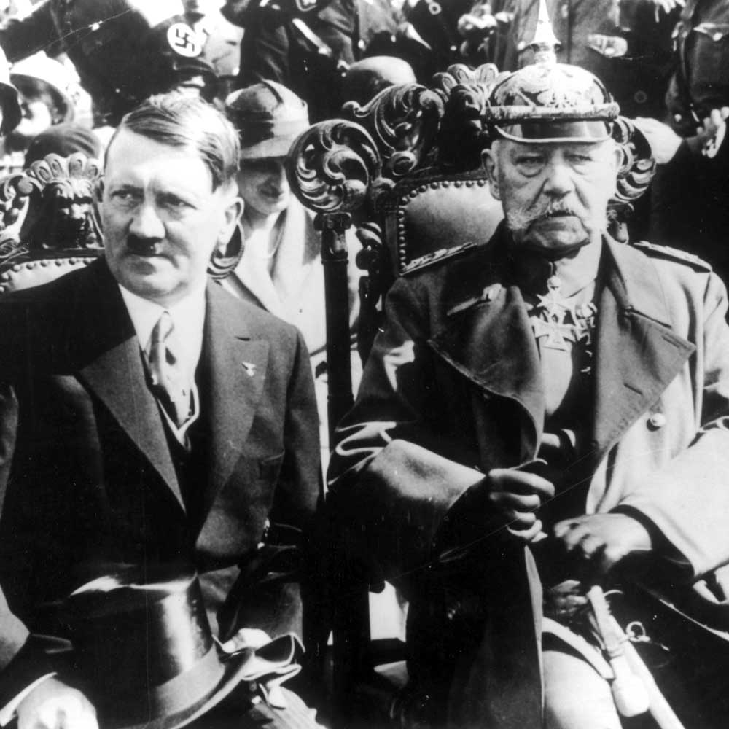

**AS History - Democracy and Dictatorship**

**Revision Checklist**

**UNIT 2: Germany, 1919-1963**

**WEDNESDAY 25TH MAY (pm)**

**UNIT 1: The Early Tudors, 1485-1558**

**WEDNESDAY 18TH May (pm)**

Use the following checklist to structure your revision and ensure that all aspects of the course are covered. When you have finished revising an individual topic you should test your understanding of this by attempting a selection of timed exam question. These can be found in your lesson materials and the OCR approved textbook for each Unit, both of which can be found on [www.dawsonera.com](http://www.dawsonera.com)

|  |  |
| --- | --- |
| **UNIT 2: Germany, 1919-1963** | |
| **Topic 1: Weimar Germany, 1919-1933** | **Tick when revised** |
| Formation of the Weimar Republic – Impact of WW1, Treaty of Versailles, Weimar Constitution |  |
| Challenges to Weimar – Kapp Putsch, Munich Putsch, invasion of the Ruhr, hyperinflation |  |
| ‘Golden Years’- economic recovery, political stability, cultural growth, how stable was the Weimar Republic? |  |
| Foreign Policy – Stresemann, Dawes and Young Plans, relations with the USSR |  |
| The Great Depression – economic impact on Germany, elections and governments 1928-33 |  |
| The rise of Nazism – role of leadership and propaganda, who supported it? |  |
| Nazi rise to power – the ‘backstairs intrigue’, Hitler’s appointment as Chancellor |  |
| **Topic 2: Nazi Germany, 1933-1939** | **Tick when revised** |
| Hitler’s consolidation of power – control of the centre (Reichstag Fire, March Elections, Enabling Act) control beyond the centre (*Gleichschaltung)*, control of the army (Night of the Long Knives) |  |
| Nazi System of Government – Hitler’s leadership, propaganda, religious policy, was Nazi government chaotic? |  |
| System of Terror – SS, SD, Gestapo, Kripo, concentration camps |  |
| Economic Policy – Schact’s New Plan, Goering’s Four Year Plan |  |
| Social Policy – Racial policy, policy towards women, education, youth, workers |  |
| **Topic 3: Impact of War and Defeat, 1939-1949** | **Tick when revised** |
| Wartime economy – Mobilisation, Albert Speer and Total War, impact of bombing |  |
| Racial policy – Ghettos, Madagascar Plan, the Final Solution |  |
| The Home Front – social impact, propaganda and morale, opposition to the regime |  |
| The Division of Germany – Wartime Conferences, Currency reform, Bizonia, political and economic developments |  |
| Berlin Blockade – causes, airlift, creation of GDR and FRG |  |
| **Topic 4: West Germany, 1949-1963** | **Tick when revised** |
| Creation of the FRG – constitution of the West |  |
| Economic Policy – ‘Economic miracle’, political and social stability |  |
| Foreign Policy – relations with France, NATO, relations with the USA, USSR and GDR |  |
| **Topic 5: East Germany, 1949-1963** | **Tick when revised** |
| Creation of the GDR |  |
| Economic and Social Policy – land reform, collectivisation, nationalisation, trade unions, education, youth |  |
| Berlin Crisis – 1958-1961, creation of Berlin Wall |  |

**THE STRUCTURE OF THE AS LEVEL EXAM**

The exam lasts **1 hour 30 minutes** (1 hour 52 minutes if you have extra time).

Section A carries 30 marks, Section B only 20 so you should spend roughly 54 minutes on Section A (the essay questions) & 36 minutes on Section B (the interpretation question).

In **Section A** you have a choice of 2 essays, worth 30 marks each, of which you do one. These can be on any topic.

**Section B** consists of a compulsory interpretation question worth 20 marks on either the Weimar Republic (1919-33) or the Impact of War & Defeat 1939-49.

**How to approach essays**

***Follow this basic approach when writing an answer to an essay question:***

1. Start with an **introduction**. The main function of an introduction is to show the examiner that you understand the question and the debate within it. A good introduction should be **concise, balanced** (i.e. indicate both sides of the debate) and the best introductions will establish the **line/view you are going to argue**.
2. The **main part** of your essay needs to be **balanced** i.e. needs to address both sides of the argument, equally. More guidance follows about question types and appropriate structures to use.
3. End with a **conclusion**. A conclusion should always be longer than an introduction. It should be **balanced**, i.e. sum up both sides of the argument you have addressed, but also reach a **decisive judgement** – no sitting on the fence.

The most important thing for your exams is to **read the exam question carefully** and to work out **exactly what it is asking you to do**. The following is a **guide** to **some** **typical question types** and the **approach you should use when tackling them**.

**Factors questions**

By this we mean questions which require you to identify a range of reasons for something happening, and to reach a judgement about the most important reason.

***‘Assess the reasons for…’***

In questions such as these it is important that you look at a **range of different factors** that can be used to **explain why the event in the question happened**. Deciding **how important each of these factors were**, putting them into a **hierarchy** and basing your conclusion about **which ones were most important** will enable you to develop your analysis.

Examples:

1. Assess the reasons for the survival of the Weimar Republic in the 1920s (Ja 09).
2. Assess the reasons for Hitler coming to power in January 1933 (Ja 13).
3. Assess the reasons for the lack of opposition in Nazi Germany (Ju 13).
4. Assess the reasons why 2 German states emerged 1945-9 (Ja 09).
5. Assess the reasons for West Germany’s economic “miracle” in the 1950s (Ju 09).
6. Assess the reasons why Adenauer retained power for so long after 1949 (Ja 10).
7. Assess the reasons for West Germany’s political stability in the 1950s (Ja 12).

***‘To what extent was x responsible for y/does x explain y…/was x the main reason for y…’***

In questions such as these you need to **assess the importance of the factor stated in the question first** and you should do this in **significant detail**, and then you need to **explain a range of other factors** (2 or 3) and **weigh them in relation to the specified factor**.

Examples:

1. To what extent do the weaknesses of Weimar democracy explain Hitler’s rise to power in 1933? (Ju 09)
2. To what extent was Hitler’s leadership the **main** reason why the Nazis came to power in 1933? (Ju 11)
3. To what extent were the actions of other political parties and their leaders responsible for the rise to power of Hitler and the Nazi Party? (Ja 12)
4. To what extent did Hitler’s consolidation of power after March 1933 depend on terror? (Ja 12)
5. To what extent was the Soviet Union responsible for the division of Germany 1945-9? (Ju 12)
6. To what extent was Adenauer personally responsible for West Germany’s growing strength in the 1950s? (Ju 11)
7. To what extent was Adenauer’s foreign policy the main reason why he maintained power 1949-63? (Ja 13)

***A statement identifying a cause***

A similar approach to above. In questions such as these you need to **assess the importance of the factor in the statement first** and you should do this in **significant detail**, and then you need to **explain a range of other factors** (2 or 3) and **weigh them in relation to the specified factor**.

1. “The Great Depression was the **main** reason for Hitler’s rise to power by January 1933”. How far do you agree? (Ju 10)
2. “Investment and support from foreign powers was the main reason why the Weimar Republic survived in the 1920s”. How far do you agree? (Ju 13)
3. “Their use of terror was the main reason why the Nazis retained control in Germany after 1933”. How far do you agree? (Ja 10)
4. “Economic recovery was the **main** reason why the Nazis stayed in power after 1933”. How far do you agree? (Ja 11)

**Extent of success/change questions**

This type of question requires you to reach a judgement about the **extent of success/degree of change.** A ‘yes/no’ approach is the simplest approach to this type of question but more sophisticated analysis will be seen if you **identify themes** to address and reach judgements about these.

***‘To what extent did x result in y…’***

Examples:

1. To what extent did the Weimar Republic overcome the problems it faced in the 1920s? (Ja 10)
2. To what extent did Gustav Stresemann’s policies bring stability to the Weimar Republic? (Ju 12)
3. To what extent did the Nazis achieve the aims of their social policies? (Ju 10)

***‘How successful was x…./how effective was x…’***

Examples:

1. How successful were the Nazis in their policy of Gleichschaltung (co-ordination) after 1933? (Ja 09)
2. How successful were Hitler’s economic policies to 1945? (Ju 09)
3. How successful were the Nazis in imposing their ideas about society on the German people? (Ju 12)
4. How successful was Adenauer’s foreign policy? (Ju 10)
5. How successful was Adenauer as Chancellor 1949-63? (Ju 13)
6. How effectively did Weimar governments deal with the problems they faced in the 1920s? (Ju 11)

***A statement asking you how far you agree***

Example:

1. “Hitler’s economic policies failed to prepare Germany for war”. How far do you agree? (Ja 13)

**General Advice**

* **Make sure that you read every word in the question. Every word is there for a reason!** Make sure you understand exactly what the question is asking before you start planning & writing. You need to understand whether the question is asking you to reach a judgement about the extent of change or success, for example, or whether it is asking you to assess factors that brought about change.
* **Make sure you understand the significance of the time period in question.** The dates are there for a reason, and the examiner will want to see a range of examples that fully spans the time period.
* **Explain your points**. The general pattern should be **(‘PEEL’)**:

1. Make the **P**oint.

2. Give an **E**xample.

**3. E**xplain it.

4. **L**ink it back to the question

* **Get your timing right**! For the Germany paper, spend about 50 minutes on the essay (30 marks). Make sure you leave enough time (at least 5 minutes) to write a good conclusion – one that will really convince the examiner you know what you’re talking about! It’s better to bullet point the paragraph BEFORE the conclusion than to leave out the conclusion entirely.
* **Plan your answer.** It is worth spending 5 minutes to do this – to ensure that you have thought through the question properly & have considered what needs to be addressed.

**Finally, some dos and don’ts for exam success:**

**Do:**

* Get your **timing right**
* Support your points with **evidence**
* **Obey command words** and focus like a laser on the question. Try to repeat key words in the question in your own answer so that the examiner is aware that you have the question in mind. In the best answers the one thing they all have in common is that they have addressed the question directly and conclude with a specific answer to the question (believe it or not, not all candidates do this!).
* **Study past papers and mark schemes**. Even if you’re not sitting at your desk you can still run through potential questions in your head. It all helps!
* **Practise questions** under exam conditions (your teacher will always be happy to look through your work).
* **Answer the question on the paper** and not the one you hoped for!

**Don’t:**

* Write down all you know about a topic – instead, apply what you know to answer the question you have been asked.
* Just regurgitate answers that you have pre-prepared. Examiners never ask exactly the same question twice: you need to think through carefully exactly what they’re asking for.

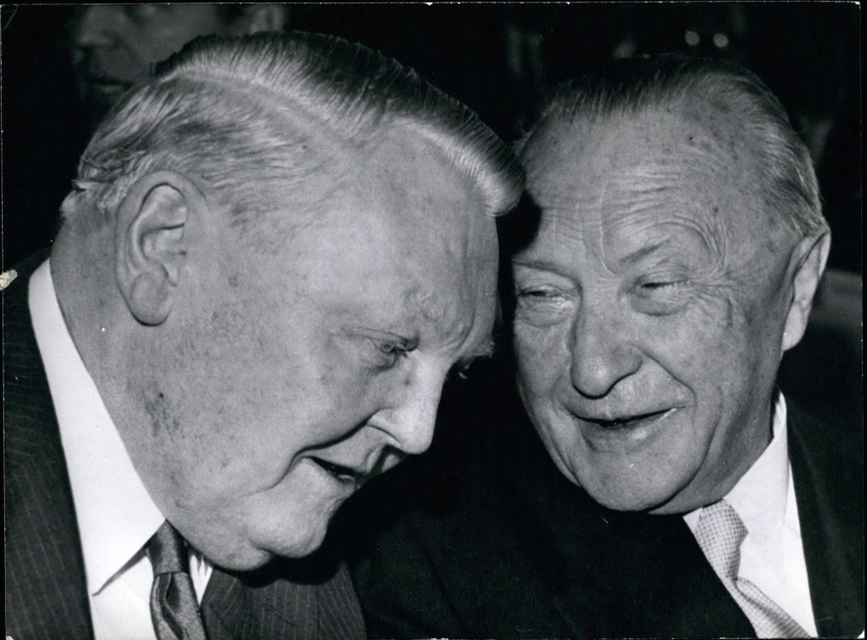

**How to answer an interpretation question**

* The question will be based around a short quote from a historian.
* The structure will always be – Interpret the strengths and weaknesses (or limitations) of the given quote making reference to other quotes you have studied.

|  |  |
| --- | --- |
| **Introduction: Explain the interpretation. Set the interpretation in the context of the wider debate. This is where you could bring in other interpretations. Be sure to link back to the quote. Don’t forget you are evaluating this quote within the context of the wider topic.** | |
| Strengths:  Use detailed and accurate knowledge to evaluate the strengths of the interpretation  What do you know which supports this viewpoint.  Make a range of points. The exam board have said that it is fine to do this using only historical knowledge, however, if you do know other historical interpretations which support the quote you can use them here  **Link back directly to the interpretation given. Do not forget you are evaluating the strengths of the interpretation not of the general topic.** | Limitations:  Use detailed and accurate knowledge to evaluate the weaknesses/limitations of the quote  What evidence goes against the quote?  What does the quote ignore or fail to address?  **Link back directly to the interpretation given.**  **Do not forget you are evaluating the weaknesses of the interpretation not of the general topic.** |
| **Conclusion: The exam board have identified that strong students will write a conclusion. This is a good idea as it will allow you to make a final judgement on the interpretation.** | |

**Skills being tested**

* Explain how the quotation fits into the wider debate on the topic
* Explain and evaluate the strengths using own knowledge
* Explain and evaluate the weaknesses using own knowledge.

Simplified mark scheme

|  |  |
| --- | --- |
| Level 5 clear A | Strong evaluation of the strengths and weaknesses |
| Level 4 ( C – low A ) | Evaluation of the strengths and weaknesses might be unbalanced |
| Level 3 (E – low C) | Limited Evaluation of the strengths and weaknesses |
| Level 2 (U) | Describes the topic or interpretation limited links |
| Level 1 (U) | Describes the interpretation |

**OCR OLD SPECIFICATION QUESTIONS ON THE WEIMAR REPUBLIC**

We are advised that these are a good guide to what you are likely to be asked in the new specification.

1. Assess the reasons for the survival of the Weimar Republic in the 1920s.
2. To what extent do the weaknesses of Weimar democracy explain Hitler’s rise to power in 1933?
3. To what extent did the Weimar Republic overcome the problems it faced in the 1920s?
4. “The Great Depression was the **main** reason for Hitler’s rise to power by January 1933”. How far do you agree?
5. How effectively did Weimar governments deal with the problems they faced in the 1920s?
6. To what extent was Hitler’s leadership the **main** reason why the Nazis came to power in 1933?
7. To what extent were the actions of other political parties and their leaders responsible for the rise to power of Hitler and the Nazi Party?
8. To what extent did Gustav Stresemann’s policies bring stability to the Weimar Republic?
9. Assess the reasons for Hitler coming to power in January 1933.
10. “Investment and support from foreign powers was the main reason why the Weimar Republic survived in the 1920s”. How far do you agree?
11. How successfully did Weimar governments deal with the problems they faced in the 1920s?

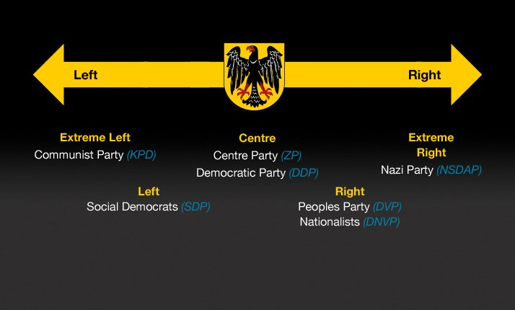

Unit 2 Revision Work Sheet 1

Weimar Germany

**Your task** is to produce an attractive document or series of Powerpoint slides or timelines or mind maps to help you to revise.

You must decide what is the best way for you to learn but **simply sitting down and reading** **the booklet is not an option**.

You are to upload the notes you make on the relevant place on GOL for your tutor to assess.

The booklet is on GOL if you have lost it.

The key themes to revise for this period are:

* Why the Weimar government managed to survive the crisis years of 1919-1923
* The extent of recovery and growth of stability in the mid-1920s
* The reasons why the Weimar government was able to survive the 1920s
* The impact of the Great Depression
* The reasons for the Nazi Party’s rise to power

**Focus for Revision/Tasks**

1. What problems were caused for the German government by a) the First World War b) the ‘stab in the back’ myth c) the Weimar constitution d) the Treaty of Versailles?
2. How serious was the political opposition faced by the Weimar government in the period 1919-1923?
3. Why did the government manage to survive the crisis years of 1919-1923? Identify 4 factors and rank these in order of importance.
4. How far did Germany recover economically and politically in the years 1923-29?
5. Explain the role of the following in the Nazi rise to power: a) the Great Depression b) the personal charisma of Hitler c) the strengths of the Nazi party d) the role of ‘backstairs intrigue’. Which factor was most significant in the Nazis’ rise to popularity? Which factor was most significant in the appointment of Hitler as chancellor?
6. Why did the government manage to survive the 1920s? Identify 4 factors and rank these in order of importance.

The link to the OCR text book for this course (Democracy and Dictatorships in Germany 1919-1963) is on GOL. Please read it online. Don’t download it as this is expensive. There are other recommendations for reading in your booklet and on GOL.

Unit 2 Revision Work Sheet 2

Nazi Germany 1933-9

**Your task** is to produce an attractive document or series of Powerpoint slides or timelines or mind maps to help you to revise.

You must decide what is the best way for you to learn but **simply sitting down and reading** **the booklet is not an option**.

You are to upload the notes you make on the relevant place on GOL for your tutor to assess.

The booklet is on GOL if you have lost it.

The **key themes** to revise for this period are:

* How successful were the Nazis in their policy of Gleichschaltung (co-ordination) after 1933?
* To what extent did the Nazis retain control in Germany because of (a) economic recovery, (b) terror, (c) propaganda or (d) other factors like foreign policy successes, restoring “order” after the “chaos of Weimar etc?
* Assess the reasons for the lack of opposition in Nazi Germany.
* How successful were the Nazis in achieving their economic aims: (a) reducing unemployment after the Depression, (b) preparing for war (rearmament and autarky), (c) excluding the Jews from the economy & (d) helping the Mittelstand (farmers & small business)?
* How successful were the Nazis in imposing their ideas about society on the German people? This would cover women, youth, religion, racial policy, workers etc.

**Focus for Revision/Tasks**

1. Why were (a) the Decree of the Reich President for the Protection of People and State, (b) the Enabling Act, (c) the banning of other parties & trade unions, (c) the abolition of the Länder, (d) the sidelining of the Cabinet & (e) the Night of the Long Knives & army oath crucial to the establishment & co-ordination of Nazi power?
2. How powerful was Hitler in relation to key institutions like the President (before 1934), the Cabinet, the Reichstag, the Länder, the civil service, the Army & the churches? Who posed the biggest threat and why?
3. To what extent did the Nazis rely on (a) economic recovery, (b) other policy successes, (c), propaganda & (d) terror to maintain control of the German people & prevent opposition? Put them in order of importance & write a sentence on each giving your reasons.
4. Give the Nazis a mark out of 10 for the extent to which they achieved their economic aims: economic recovery, rearmament, autarky and ideology (excluding Jews and helping the Mittelstand. In which areas were they most and least successful?
5. Give the Nazis a mark out of 10 (and write a sentence justifying it) for the success of their policies regarding (a) youth, (b) women, (c) workers, (d) the churches & (e) race. Which were their most & least successful policies?

The link to the OCR text book for this course (Democracy and Dictatorships in Germany 1919-1963) is on GOL. Please read it online. Don’t download it as this is expensive. There are other recommendations for reading in your booklet and on GOL.

Unit 2 Revision Work Sheet 3

War and Division 1939-49

**Your task** is to produce an attractive document or series of Powerpoint slides or timelines or mind maps to help you to revise.

You must decide what is the best way for you to learn but **simply sitting down and reading** **the booklet is not an option**.

You are to upload the notes you make on the relevant place on GOL for your tutor to assess.

The booklet is on GOL if you have lost it.

The **key themes** to revise for this period are:

* How successful were the Nazis in creating a war economy?
* To what extent did they succeed in maintaining public morale until the end of the war?
* How serious was opposition to the regime?
* When & why did the Nazis mass murder the Jews?
* Why was Germany divided in 1949?

**Focus for Revision/Tasks**

1. In evaluating Nazi success in creating a war economy, make notes on (a) the contrast between 1939-42 when Göring was in charge of the economy as Head of the 4 Year Plan & 1942-5 when Speer controlled it as Armaments Minister, (b) how well Germany performed in relation to her enemies, (c) the contrast between the quality and quantity of German armaments and (d) the extent to which the bombing limited the success of the Nazi war economy.
2. Write a conclusion summarising how successful the Nazis were in maintaining public morale during the war. Make sure you include in this (a) the reasons why morale declined as time went on, (b) why despite this the great majority of the population remained loyal to the regime and fought on till the end and (c) the extent to which the bombing dented morale.
3. Write a sentence summarising how effective each opposition group was in resisting the Nazi regime. Which was most & least effective and why?
4. Make notes on (a) the aims of Nazi policy before the Jews before the invasion of the USSR in June 1941, (b) why the invasion was a turning point, (c) the significance of the Wannsee Conference and (d) where you stand on the intentionalist v structuralist debate and why.
5. Allocate 10 marks between the Soviet, western and German responsibility for the division of Germany and write a sentence on each explaining your allocation.

The link to the OCR text book for this course (Democracy and Dictatorships in Germany 1919-1963) is on GOL. Please read it online. Don’t download it as this is expensive. There are other recommendations for reading in your booklet and on GOL.

Unit 2 Revision Work Sheet 4

East and West Germany 1949-63

**Your task** is to produce an attractive document or series of Powerpoint slides or timelines or mind maps to help you to revise.

You must decide what is the best way for you to learn but **simply sitting down and reading** **the booklet is not an option**.

You are to upload the notes you make on the relevant place on GOL for your tutor to assess.

The booklet is on GOL if you have lost it.

The **key themes** to revise for this period are:

* What were the main successes and failures of East German economic policy and why did the failures so heavily outweigh the successes?
* Did East German social policy succeed in creating a “workers’ paradise”?
* Why did West Germany enjoy an “economic miracle” 1949-63?
* To what extent did (a) the economic miracle and (b) the Basic Law contribute to the creation of political stability in West Germany?
* Why did Adenauer stay in power for so long?
* How successful was his foreign policy?

**Focus for Revision/Tasks**

1. Give East Germany a mark out of 10 for the success of its economic policy and write a sentence explaining this. Which would you say was the most important failure?
2. Put the reasons for East Germany’s economic failure in order of importance and write a sentence explaining why you put each factor where you did.
3. Give a mark out of 10 for the extent to which East Germany was a “workers’ paradise” and write a conclusion on this identifying the 3 points you think most significant on each side.
4. Identify the top 3 reasons for West Germany’s “economic miracle” and the least important one. In each case write a sentence explaining your judgement.
5. Explain whether you think the economic miracle or the Basic Law contributed more to West German political stability and explain why. You should include a comparison between West Germany and the Weimar Republic in your answer.
6. Put the reasons why Adenauer stayed in power for so long (the economic miracle and the “other reasons”) in order of importance and write a sentence on each explaining why you put it where you did.
7. Give a mark out of 10 for the success of Adenauer’s foreign policy and write a conclusion on this identifying the 3 points you think most significant on each side.

The link to the OCR text book for this course (Democracy and Dictatorships in Germany 1919-1963) is on GOL. Please read it online. Don’t download it as this is expensive. There are other recommendations for reading in your booklet and on GOL.

**WHY DID THE WEIMAR REPUBLIC SURVIVE IN THE 1920S?**

Weimar Strengths

* In **Ebert** (1919-25) the Republic had a President (unlike Hindenburg later) who was genuinely committed to democracy.
* Ebert used the **Army** to crush the Communist uprisings 1918-23 & the Munich Putsch in 1923. In crushing the Communists he was helped by his deal with General Gröner & the Freikorps.
* The determination of the workers to protect their gains under the Republic (8 hour day, co-determination, welfare benefits) led to the **general strike** which saved the Republic from the Kapp Putsch.
* The **SPD** remained by far the most popular party in Germany until 1932.
* The willingness of **moderate parties** like the Centre, DVP & DDP to work together was also crucial to enabling the Republic to survive.

Opponents’ Weaknesses

* The **Communist** threat to the Republic was more apparent than real, given their lack of charismatic leaders (following the deaths of Liebknecht & Luxemburg) & popular support (they never got more than 13% of the vote before 1930) plus the hostility of the Army & the Freikorps.
* The **conservative** opponents of the Republic also lacked popular support (the DNVP never got more than 20% of the vote) & charismatic leaders, as the failure of the Kapp Putsch in 1920 showed. They also preferred the Republic to Communism.
* The failure of the Munich Putsch showed that Hitler & the **Nazis** were not yet ready to seize power; they only got 2.6% of the vote in 1928 & did not achieve an electoral breakthrough until 1930.

Stresemann’s Policies

* Stresemann ended 4 years of political & economic crisis capped by invasion, hyperinflation and the Munich Putsch in 1923.
* He restored the value of the currency & ended hyperinflation by introducing the new **currency** (Rentenmark) at the end of 1923.
* He resolved the **Ruhr** Crisis by ending “passive resistance” & resuming the payment of reparations, which led to the French & Belgian withdrawal from the Ruhr in 1924.
* The **Dawes Plan** in 1924 rescheduled Germany’s reparations payments & provided US loans to help pay them & revive the German economy.
* The **Young Plan** in 1929 reduced Germany’s reparations payments & provided US loans to help pay them & revive the German economy. It also secured the departure of enemy troops from the Rhineland by 1930.
* The **Locarno** Treaties in 1925 improved Germany’s relations with the western powers & enabled her to join the League of Nations in 1926; this boosted trade with the West & encouraged US investment in Germany.
* At the same time Stresemann appeased nationalist opinion by refusing to accept Germany’s border with Poland & using League of Nations membership to speak up for the German speaking minorities in Poland & Czechoslovakia.
* By serving continuously as Foreign Minister 1923-9, Stresemann ensured continuity not just of foreign policy but to an extent domestic policy as well despite the frequent changes of Chancellor. He was the dominant personality in all the govts. he served in.

Economic Recovery

See above on the Dawes Plan, Young Plan, the subsequent foreign investment from the USA etc.

* Germany enjoyed a strong economic recovery 1924-9: industrial production trebled, real wages rose by 50% & only 1/10 as many days were lost through strikes as in 1921.
* Support for democracy grew 1924-9 b/c of this: SPD support rose 1924-8 while Nazi & DNVP support fell.

Investment & Support from Foreign Powers

See above on the Dawes Plan, Young Plan, the subsequent foreign investment from the USA and other European states (especially GB), the acceptance of Germany into the League of Nations and the Locarno Treaties.

The USA & GB were determined to help Germany survive b/c it was in their own economic interests to do so: trade with Germany was crucial to their prosperity & they recognised that Europe as a whole could not prosper unless Germany did. They also understood that economic prosperity was key to stabilising the Republic against political extremism.

**HOW EFFECTIVELY DID WEIMAR GOVERNMENTS DEAL WITH THE PROBLEMS THEY FACED IN THE YEARS 1919-29?**

Successes

* The Republic survived all attempts to overthrow it: the Army crushed the Communist uprisings in 1919, 1920, 1921 & 1923 & the Munich Putsch in 1923, while the Kapp Putsch in 1920 was brought down by a general strike.
* There was no serious political violence in Germany between 1923 & the early 1930s.
* 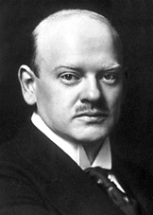Stresemann (right) ended the hyperinflation of 1923 by introducing a new currency (the Rentenmark).
* He resolved the Ruhr crisis by ending “passive resistance” & resuming reparations payments; this resulted in French & Belgian troops being withdrawn in 1924.
* Germany enjoyed a strong economic recovery 1924-9: industrial production trebled, real wages rose by 50% & only 1/10 as many days were lost through strikes as in 1921.
* Politics stabilised 1924-8, with the SPD gaining votes while the DNVP & Nazis lost them; in 1928 only 2.6% of Germans voted Nazi.
* The Dawes Plan in 1924 made it easier for Germany to pay reparations by rescheduling her payments & providing US loans.
* The Young Plan in 1929 made it easier for Germany to pay reparations by reducing her payments & providing US loans; it also secured an agreement that enemy troops would leave the Rhineland by 1930.
* The Locarno Treaties improved Germany’s relations with the West & enabled Germany to join the League of Nations in 1926, greatly improving her international position.
* At the same time Stresemann appeased nationalist opinion by refusing to accept Germany’s border with Poland & using the League of Nations to speak up for German speaking minorities in Poland & Czechoslovakia.
* Thanks to Stresemann’s foreign policy Germany received 7 billion marks more in US loans than she ever paid in reparations. The USA & GB recognised that their prosperity depended on trade with Germany & were therefore willing to invest in her economic recovery; they also realised that economic prosperity was the key to preventing the rise of political extremism in Germany.

Failures

* The Weimar Constitution failed to provide stable govt. b/c so few Germans really believed in democracy; the conservative elite was particularly hostile.
* The voting system (whereby voters voted for a party rather than individual candidates) meant that voters did not feel close to politicians.
* The conservative elite was fundamentally hostile to democracy, as shown by the Army’s refusal to oppose the Kapp Putsch & the judges’ leniency towards Hitler & Ludendorff in 1923. The same was true of big business, landowners & many teachers, clergy & journalists.
* The Treaty of Versailles disarmed Germany, damaged her economy & reduced her territory; it also left her diplomatically isolated. None of this (apart from some reduction & rescheduling of reparations payments) was alleviated in the 1920s & all of it was blamed on the Republic through the myths of the “stab in the back” & the “November criminals”.
* The Republic was threatened by Communist uprisings in 1918-19 in both Berlin & Munich; there were later uprisings in 1920, 1921 & 1923.
* There was right wing violence too: the Kapp Putsch in 1920, the assassinations of Erzberger (1921) & Rathenau (1922) & the Munich Putsch in 1923.
* Germany suffered almost continuously from high inflation & low living standards 1919-23, culminating in the hyperinflation of 1923.
* The failure to pay reparations led to the occupation of the Ruhr in 1923; the govt.’s decision to respond with “passive resistance” then caused hyperinflation.
* The economic recovery 1923-9 was fragile, resulting in collapse following the Wall St Crash in 1929. As Stresemann admitted, “Germany is dancing on a volcano. If the short-term credits are called in, a large section of our economy would collapse”. Even before 1929 there was a crisis in agriculture, rising unemployment & a balance of payments deficit.
* Despite the political stabilisation of 1924-9, anti-democratic parties (the KPD on the left & the DNVP on the right) still enjoyed significant support. The liberal DDP’s support steadily declined, leaving the SPD as the only major party totally committed to democracy.
* Stresemann’s foreign policy successes did not restore national pride as Hitler’s did later. Reparations were not ended, the Rhineland was not evacuated until 1930 & Stresemann had both to accept the loss of Alsace-Lorraine to France & to promise not to use force against Poland. 6 million Germans voted to reject the Young Plan in the “Liberty Law” of 1929.

**WHY DID THE NAZIS BECOME THE MOST POPULAR PARTY IN GERMANY IN 1932?**

The Weaknesses of the Weimar Republic

* The Weimar Constitution failed to provide stable govt.: Weimar govts. were **weak multi-party coalitions**. The voting system (whereby voters voted for a party rather than individual candidates) meant that voters did not feel close to politicians.
* Few Germans really believed in democracy; the **conservative elite** was particularly hostile & liberal DDP’s support steadily declined, leaving the SPD as the only major party totally committed to democracy.
* Nationalist resentment against the **Treaty of Versailles** ensured that Germans turned to Nazism rather than Communism when the Depression drove them to the political extremes. Stresemann’s foreign policy successes did not restore national pride as Hitler’s did later b/c they did not reverse most of the Treaty.
* **The economic recovery 1923-9 was fragile**, Germany’s dependence on US loans making her more vulnerable to the Wall St Crash than any other European country. Even before 1929 there was a crisis in agriculture, rising unemployment & a balance of payments deficit.
* In 1932, by voting either Nazi or Communist, most Germans signalled their **rejection of democracy**.

The Depression

* B/c of the Wall St Crash, industrial production declined by 42%, **unemployment** more than quadrupled, reaching nearly 6 million, wages declined by 1/3, 50,000 businesses went bankrupt 1930-2 & 5 major banks were forced to close in 1931.
* The **agricultural** depression had started earlier (in 1927) but the Depression made it worse: by 1932 18,000 farmers had gone bankrupt.
* Brüning’s **austerity** policy turned people against the Weimar Republic.
* W**ithout the Depression Hitler would never have come to power**: the Nazi vote rose from less than 3% to over 37% in only 4 years as a direct result of it & in July 1932 they overtook the SPD to become the most popular party in Germany. But **it did not by itself make the Nazi seizure of power inevitable**: Hindenburg was hostile to Hitler & wanted a more conservative govt. Given his hostility to Communism some form of right wing authoritarianism (anti-democracy) was probably inevitable but perhaps conservative & army-dominated rather than Nazi.

The Role of Hitler

* Hitler was an extremely effective **public speaker** who appealed to emotion rather than reason & restrict his ideas to a few simple slogans endlessly repeated which everyone could understand & remember.
* He had the **charisma** & ability to inspire faith that democratic politicians lacked: he alone satisfied the craving which Germans had for a strong leader to solve Germany's problems.
* There is no doubt that **the Nazis could never have risen to power without Hitler**. The chaos the Party fell into while he was in prison in 1924 clearly showed this; he had to refound it almost from scratch after his release.
* He was also an expert at **propaganda**. Learning from the Catholic Church, he turned Nazism into a substitute religion, with the swastika replacing the cross as an unmistakeable symbol
* Hitler also had the ability to be **“all things to all men”**. He could sound both radical & conservative as it suited him; his flexibility (based on indifference) on economic issues enabled him to appeal to both workers & the elite. No other politician or party could appeal to different types of German (in terms of age, gender, religion & social status) as Hitler & the Nazis could.

Nazi Ideas

Perhaps the most popular single Nazi idea was **Volksgemeinschaft** (people’s community), which meant all racially pure Germans (regardless of economic status, religion etc) should work together for the common good.

The Nazis had ideas to appeal to almost every type of German:

* They promised work & bread to every German & said they would prioritise them over reparations.
* They promised to free German workers from “Jewish” capitalism.
* They assured conservatives that they would restore law & order & traditional family values.
* They reminded the Mittelstand (shopkeepers & small businessmen) of the inflation & promised to protect them against competition from Jewish owned department stores.
* They promised to protect farmers from Jewish money lenders & from competition from imported food.
* They offered Hitler as a strong & charismatic leader who was Germany’s “last hope” & would solve all Germany’s problems.

**WHY WAS HITLER APPOINTED CHANCELLOR IN JANUARY 1933?**

There had been an attempt to bring Hitler into govt. before, partly to "tame" the Nazis & partly to use their mass support to help the conservative elite: Hitler was offered the Vice Chancellorship under Papen in August 1932 (following the Nazis' electoral success in July) but refused b/c he wanted to be Chancellor.

Paradoxically, Hitler was appointed Chancellor in January 1933 after his party's vote had started to fall. This wasn't entirely a coincidence: the fall in the Nazi vote in November 1932 made conservatives more confident that they could "tame" him; also the continued rise in the Communist vote made them more desperate to use him to crush the KPD.

Hitler was appointed b/c:

* By January 1933 it was clear that neither Papen's "Cabinet of Barons" nor Schleicher's attempt to split the Nazi Party could find a workable solution to Germany's problems.
* **Papen** was bitter at Schleicher for bringing him down as Chancellor & got his revenge by plotting with Hitler against him. According to Hindenburg's State Secretary, Otto Meissner, "Hindenburg was extremely hesitant, until the end of January to make Hitler Chancellor. He wanted Papen again as Chancellor. Papen finally won him over to Hitler with the argument that the representatives of the other right wing parties which would belong to the govt. would restrict Hitler's freedom of action. In addition Papen expressed his misgivings that, if the present opportunity were missed, a revolt of the National Socialists and civil war were likely".
* Hindenburg was also persuaded by other members of the**elite**. Hjalmar Schacht, Germany's foremost financial expert, & 23 leading industrialists headed by Krupp & Thyssen wrote to H'burg urging him to appoint Hitler. The meeting at a banker's house offering Hitler the Chancellorship in January 1933 was attended by members of the Reich Agrarian League (representing landowners), industrialists & President von Hindenburg's son Oskar.
* 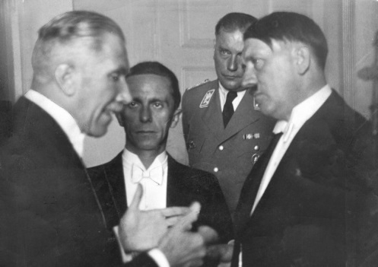**Hindenburg** was influenced by the fact that he was himself a landowner (an estate which his family had previously lost through bankruptcy was given back to him as a birthday present in 1927) & was infuriated by both Brüning & Schleicher's plans to redistribute the land of bankrupt landowners. He also wanted the Osthilfe scandal (showing that govt. help for landowners in eastern Germany, including to his own estate, had been misused) hushed up, which Hitler through Papen promised to do.
* **H'burg was persuaded that Hitler could be "tamed" & used as a blunt instrument to crush Communism in the interests of the conservative elite**. Papen (right) boasted, "We've hired him". Continued Communist success in the November 1932 election made this more urgent & despite the Nazis losing votes they still provided the conservatives' only access to mass support. As Ian Kershaw has put it, "Few (in the conservative elite) .. had Hitler as their first choice. But by January 1933, with other options apparently exhausted, most, with the big landowners to the fore, were prepared to entertain (consider) a Hitler government ... Hitler needed the elite to attain power. But in January 1933, they in turn needed Hitler as he alone could deliver the mass support required to impose a tenable (realistic) authoritarian solution to Germany's crisis".

**DID HITLER COME TO POWER LEGALLY & DEMOCRATICALLY?**

Hitler made no secret of his contempt for democracy & his desire to create a one-party dictatorship, but he did in fact come to power **legally**: he was appointed by Germany's legally elected President.

Whether he came to power **democratically** is less clear b/c the Nazis never won more than 37% of the vote in a free election & Hitler's govt. did not command a majority in the Reichstag until a fresh election was held in March 1933. **“Backstairs intrigue”** (Papen persuading Hindenburg) was clearly crucial to Hitler becoming Chancellor.

On the other hand, he did lead the most popular party in Germany & had more support in the Reichstag than any of the previous 3 Chancellors. It is often said that Germany's proportional representation system helped Hitler to power, but in fact his share of the vote in July 1932 was exactly the same as David Cameron won in the 2015 election in GB which enabled him to gain an overall majority in the House of Commons.

**MODEL INTERPRETATION ESSAY: ‘The Nazi rise to power was essentially linked to the Great Depression which was a world wide phenomenon and had little to do with the domestic conflict” (Holtferich.) Evaluate the strengths and limitations of this interpretation, making reference to other interpretations you have studied.**

The Great Depression of 1929, caused by the American Wall Street Crash, was an important contributing factor to the Nazi rise to power because it led to further hatred towards the Weimar Republic. However, it was not the most important factor because there were other options in finding an alternative to democracy; it was ‘backstairs intrigue’ from politicians like Franz von Papen that mainly contributed to the Nazi rise to power.

The Great Depression was a ‘worldwide phenomenon’ because it affected countries across the world, particularly Germany due to the substantial loans, set up by Gustav Stresemann within the Dawes Plan of 1924 and the Young Plan of 1929, America had to re-call following the Wall Street crash. Even Stresemann himself said Germany was ‘dancing on a volcano’ by relying so heavily on these loans. The Great Depression did play a vital role in the Nazi rise to power because it meant that an alternative to democracy had to be found although the current President Hindenburg, a former army commander, was not completely dedicated to democracy himself. The Depression affected nearly everyone in Germany; industrial production declined by 42%, exports halved, unemployment reached nearly 6 million by 1932, wages fell by 1/3, government income fell by 27% and German national income fell by more than twice as much as Great Britain or France. Unemployment reaching nearly 6 million by 1932 meant that, because Germany’s welfare state was designed to cope with up to 800,000 people, it couldn’t cater for all of the unemployed which led to Germans voting for extreme parties such as the Nazis who were promising ‘Arbeit und Brot’ (work and bread.) This was shown in the September 1930 election where the Nazi vote rose from 2.6% in 1928 to 18% in 1930 and, in the 1932 election, the Nazis gained 37% of the vote; the KPD and the Nazis had over 50% of the votes combined following the 1932 election. However, although the Great Depression did contribute to the Nazi rise to power because it meant that over 50% of Germans began voting for extremist parties such as the KPD and the Nazis, **it did not give the Nazis themselves over 50% of the votes and therefore wasn’t the most important factor in the Nazi rise to power**.

**Hitler** himself also contributed to the Nazi rise to power; he was an incredibly charismatic man who had the ability to convince every person in his audience that he was talking to them individually. ‘The personality of the Führer became a significant historical factor. [He had a] combination of demagogic gifts and political instinct” (Feuchtwanger). Hitler had learnt his public speaking skills in beer halls where he had to shout loudly in order to be heard over the huge crowds of drunk men so he would shout loudly, gesticulate wildly, appeal to emotion over reason, repeat a few simple slogans and ideas endlessly. These skills meant that Hitler could create hysteria in his audiences and show them that he was the strong leader Germany needed. Without Hitler, the Nazis would not have been able to come to power; this was shown when Hitler was imprisoned in 1924 following the Munich Putsch in 1923. The NSDAP were plunged into chaos without their leader and, upon Hitler’s release, he had to almost refound the party. Also, during the 1932 election, Hitler travelled to 20 cities in 7 days; this meant that the Germans living in these cities got to experience Hitler’s charisma and showed his dedication therefore, contributing to his increase in votes. Although Hitler himself did play a part in the Nazi rise to power he still never managed to get over 50% of the vote and therefore, his own personality was not the most important factor in the Nazi rise to power.

Another contributing factor was the **organisation and ideas of the Nazi party**. Hitler ensured that his party was effectively organised. Germany was divided into regions; each region had a Gauleiter (regional leader) who was entirely loyal to Hitler and would report back to him on public opinion towards the Nazis in that area. Nazi ideas and aims played a huge role in gaining votes because they had many different ideas that could appeal to almost everyone in Germany; one of the most effective ideas was the ‘Volksgemeinschaft’ (people’s community) which was the idea that all racially pure, Aryan, Germans should work together for the common good. Following the successful 1930 election the membership more than doubled to 800,000 in 1931 and the Party gained more income from individual sponsorship which helped towards the NSDAP’s particular success in July 1932 where they achieved 37% of the vote. Other popular and appealing Nazi ideas included the ‘Arbeit und Brot’ slogan for the unemployed, the promise to free German workers from ‘Jewish’ capitalism, the promise to conservatives that they would restore law and order and traditional family values, the promise to the Mittelstand to protect them against competition from Jewish owned stores, the promise to protect farmers from Jewish money lenders and competition from imported foods and the portrayal of Hitler as Germany’s ‘last hope.’ These different ideas managed to appeal to nearly everyone in Germany. Kolb’s interpretation refers to “the attitudes, aims and relative strength of the parties and individuals concerned,” which suggests that the Nazi ideas and aims helped contribute to their rise to power. However, even the appeal of Hitler and the Nazi party could not gain them a majority in the Reichstag and therefore, was not the main contributing factor to the Nazi rise to power.

Furthermore, there were other circumstantial factors that contributed to the Nazi rise to power. These included the fact that although many Germans had fond memories of Germany before WWI there was **not much demand for a return of the Kaiserreich**; there was more support for Hitler’s vision of the future. As well as this, the Army had been limited to 100,000 men by the Treaty of Versailles in 1919 therefore meaning that it was too small to impose a conservative military dictatorship and the SA, Hitler’s private army, outnumbered them 4:1. There was a huge **fear of Communism** from the upper middle class, leading them to vote for the Nazis as Hitler offered a more convincing alternative to democracy. Moreover, the KPD appealed mainly to young working class males and the unemployed; their appeal could never be as wide as the Nazis’ and the vote for the KPD rose much more slowly than the Nazis, reaching its peak of 17% in November 1932. Although these factors did help Hitler and the Nazi party to come to power, they were circumstantial and not enough on their own.

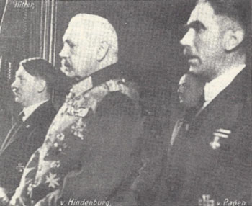 Finally, the main reason why Hitler and the Nazis came to power was due to **‘backstairs intrigue’** from politicians such as Franz von Papen *(right with Hindenburg in the middle & Hitler on the left)* who was the main contributor in convincing President Hindenburg to appoint Adolf Hitler as Chancellor of Germany in January 1933. Papen, who had accepted the Chancellorship in May 1932, was a conservative monarchist who made no secret of his wish to destroy democracy. Papen used Article 48, otherwise known as presidential decrees that stated that the President could pass laws without going through the Reichstag in an emergency, more than ever before because Papen’s government had less than 10% support in the Reichstag. Following the July 1932 election where the Nazis achieved 37% of the vote, their highest in a free election, and the SPD lost votes; the elite knew they had no alternative but to cooperate with Hitler as he was now the largest party in the Reichstag despite not having a majority but Hitler refused to join or support the government unless he was made Chancellor. In December 1932, General Kurt Von Schleicher reluctantly accepted the Chancellorship as he had persuaded Hindenburg to dismiss both Brüning and Papen. Schleicher attempted to split the Nazi party but his plan failed. Papen, as an attempt to ‘get back’ at Schleicher, persuaded Hindenburg that if he appointed Hitler as Chancellor and himself as Vice Chancellor as well as only having two other Nazi ministers in the Cabinet, they would be able to ‘tame’ him. Nicholls’ interpretation states “[Hitler’s] appointment was quite unnecessary … the Nazis could not have threatened the state if they had been denied power.” This shows that without ‘backstairs intrigue’ a Nazi rise to power would have been avoided and therefore, this interpretation suggest that this intrigue was the largest contributing factor to the Nazi rise to power. This ‘backstairs intrigue’ from Papen and Hindenburg allowed the Nazis to rise to power and, eventually, create a Nazi dictatorship in 1934 because Adolf Hitler was placed in a position of power due to Papen’s influence. **This was the largest contributing factor because no other factors gave Hitler a majority in the Reichstag and therefore, because he peaked with 37% of the vote in July 1932 and lost votes in November 1932**, it is unlikely that the Nazis would have been able to come to power democratically but, by legally appointing Hitler as Chancellor it allowed the Nazis to rise to power.

In conclusion, “the Nazi rise to power was essentially linked to the Great Depression which was a world wide phenomenon and had little to do with the domestic conflict” (Holtferich.) is a very limited interpretation because although the Great Depression did trigger a rise in votes for the Nazi party as well as, almost entirely ending democracy meaning that an alternative had to be found, Hitler and the Nazis could never have risen to power if he had not been placed there through the ‘backstairs intrigue’ of politicians like Franz von Papen and Hindenburg that was caused because the Nazi party had plurality (they were the largest party in the Reichstag but did not have a majority) which was gained through other factors such as Hitler’s own personal role, the organisation and propaganda of the Nazi party and other circumstantial factors. Overall, ‘backstairs intrigue’ was the largest and most important factor in contributing to the Nazi rise to power in 1933.

**OLD OCR QUESTIONS ON THE NAZI REGIME 1933-9**

1. How successful were the Nazis in their policy of Gleichschaltung (co-ordination) after 1933?
2. How successful were Hitler’s economic policies to 1945?
3. “Their use of terror was the main reason why the Nazis retained control in Germany after 1933”. How far do you agree?
4. To what extent did the Nazis achieve the aims of their social policies?
5. Economic recovery was the **main** reason why the Nazis stayed in power after 1933”. How far do you agree?
6. How successful was Hitler’s economic policy to 1945?
7. To what extent did Hitler’s consolidation of power after March 1933 depend on terror?
8. How successful were the Nazis in imposing their ideas about society on the German people?
9. “Hitler’s economic policies failed to prepare Germany for war”. How far do you agree?
10. Assess the reasons for the lack of opposition in Nazi Germany.
11. How effective was Hitler’s government in overcoming the economic problems it faced in the 1930s?

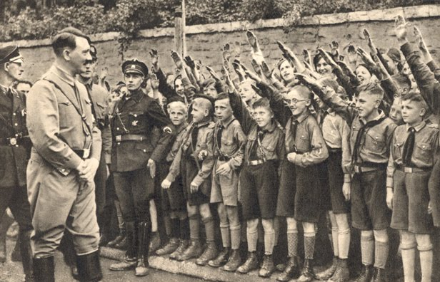

**How successful were the Nazis in their policy of *Gleichschaltung* (coordination) after 1933?**

The term *Gleichschaltung* as refers to the ways in which the Nazis sought to ensure control of the state by the (forcible) ‘coordination’ of all aspects of political and social life, especially in the first year of their rule.

Successes:

* The Decree of the Reich President for the Protection of the People & State plus their control of the police enabled the Nazis to terrorise & arrest their oppnents (especially the KPD & the SPD) without legal process.
* The Enabling Act in March 1933 enabled Hitler to pass laws without the Reichstag’s consent; a fresh election in November 1933 created a 100% Nazi Reichstag.
* The Länder were taken over by Reich Governors spring 1933 & abolished altogether in January 1934.
* The Law for the Restoration of a Professional Civil Service in 1933 removed Jews, married women & anti-Nazis.
* All other political parties were banned or forced to dissolve themselves by July 1933, when a law was passed banning new parties & making Germany a one-party state.
* 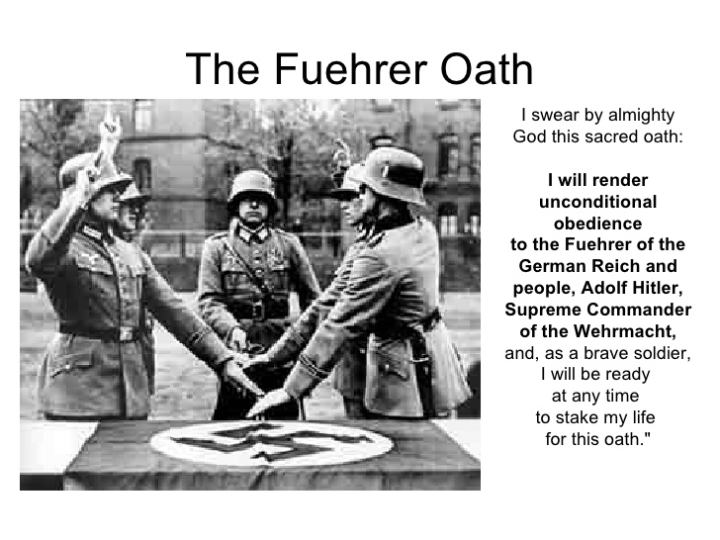Hitler made a Concordat in 1933 which led to the abolition of the Centre Party & the Catholic trade unions.
* Trade unions were banned in 1933 & all workers forced to join the DAF.
* The Night of the Long Knives & the death of Hindenburg led to the Army swearing an oath of allegiance (right) to Hitler in August 1934.
* Professional groups like lawyers & teachers had to join the Nazi organisation for their profession.
* The Hitler Youth gained increasingly control over young people, especially as church youth groups & schools were banned by 1936.

Failures:

* Hitler had to tolerate a predominantly conservative Cabinet & share power with the DNVP after only getting 44% of the vote in the March 1933 election.
* Hindenburg had the power to remove Hitler & intervened to exempt Jewish WW1 veterans from the Law for the Restoration of a Professional Civil Service.
* The takeover of Jewish businesses had to be delayed to preserve the jobs of their Aryan employees.
* Hitler’s attempt to control the Protestant churches failed & the churches remained independent from Nazi control.
* The Army had the power to overthrow Hitler & its leadership remained predominantly conservative.

**“THEIR USE OF TERROR WAS THE MAIN REASON WHY THE NAZIS RETAINED CONTROL IN GERMANY AFTER 1933”. HOW FAR DO YOU AGREE?**

Terror

* Control of the police & the Decree of the Reich President enabled the Gestapo & SS to arrest political opponents, especially Communists & Social Democrats, & put them in concentration camps like Dachau.
* The use of “protective custody” & new courts like the People’s Court enabled the Nazis to bypass traditional courts.
* The willingness of the general public to denounce their neighbours to the Gestapo created a climate of fear & compensated for the Gestapo’s lack of manpower.
* All other political parties, trade unions & strikes were banned.
* The Night of the Long Knives intimidated conservatives like Papen into silence.
* All professions like teachers, lawyers etc were forced to join Nazi organisations.

BUT:

* Johnson’s research shows that less than 20% of the population felt threatened by the Gestapo & that most people did not need to be terrorised b/c they supported the regime “voluntarily”.
* Gellately has shown the Gestapo couldn’t have operated without people being willing to denounce their neighbours.

Economic Recovery

* Unemployment fell from 6 million in 1932 to virtual full employment by 1938.
* Farmers’ incomes rose by 41% 1933-8.
* The trade of skilled craftsmen doubled 1936-9.
* Virtually all Aryans experienced an improvement in their standard of living.

BUT:

* The Nazi “guns over butter” policy limited the rise in living standards; workers worse off than before the Depression.
* The economic recovery under the Nazis was impressive only compared with the Depression: real wages didn’t reach their pre-Depression levels until 1938.
* The idea of “Volksgemeinschaft” was largely a propaganda myth; in reality Nazi policy favoured big business rather than the workers, widening economic inequality, & no worker ever got the Volkswagen he had paid for.

Other Policy Successes

* The Nazis were credited with restoring political stability & order after the chaos of the Weimar years; the KPD was suppressed & the SA tamed by the Night of the Long Knives.
* Hitler rearmed Germany & made her respected abroad, achieving a series of foreign policy successes like the remilitarisation of the Rhineland & the conquest of Austria & Czechoslovakia without war.
* Nazi social policies like the Strength through Joy programmed organised by the DAF, the Volkswagen scheme & the promotion of charities like the Winterhilfe created a sense of Volksgemeinschaft.

BUT it can be argued that propaganda was more important than policy successes b/c:

* Young people were easy to indoctrinate b/c they were impressionable.
* The Nazi reputation for restoring law & order was largely a propaganda myth; in fact, as the Night of the Long Knives showed, Hitler had destroyed the rule of law & no one was safe.
* Most of the victims of the Nazi terror were innocent people who posed no threat to society but Nazi propaganda convinced people that they were traitors, criminals & “asocials”.
* Many girls & women idolised Hitler despite the reduction in their rights & propaganda succeeded in persuading most women that they were better off than they really were.

Censorship & Propaganda

* Radio & newspapers were Nazi controlled & increasingly Nazi owned; editors censored themselves to avoid arrest.
* The sale of cheap radios (Volksempfänger) increased the reach of Nazi propaganda through radio.
* Films like Olympia & Jud Süss promoted Nazi ideology through an entertaining format.
* Youth were indoctrinated both through school & the Hitler Youth; by 1936 church schools & youth groups banned.
* The “Hitler myth” (Kershaw) meant Hitler got the credit for all the successes without being blamed for any failures.

BUT:

* If people hadn’t been genuinely better off (e.g. if there had still been 6 million unemployed) they wouldn’t have believed the propaganda.
* P’ganda “failed categorically” (Kershaw) to undermine support for the churches.
* Older workers who knew they were worse off than before the Depression were sceptical about the “Volksgemeinschaft” propaganda.

In general propaganda needed a firm base of genuine policy successes to work on & had little effect when it conflicted with people’s deeply held beliefs or real-life experiences. Leif Jerram has argued that the German people never really accepted Nazi ideas & only supported the regime for as long as it was successful.

**HOW SUCCESSFUL WAS NAZI ECONOMIC POLICY 1933-9?**

Employment & Economic Growth

* Hitler benefited from the work schemes introduced by Papen and Schleicher in 1932 and extended them.
* The RAD (Reich Labour Service)and government loans to private companies also created jobs.
* By 1938 Germany had full employment (compared with 6 million in 1932).
* Industrial production & national income nearly doubled 1933-8.
* By 1938 Germany had full employment (compared with 6 million in 1932).
* Price controls limited inflation despite rapid economic growth.

**But:**

* Nazi success in reducing unemployment was less than it seemed b/c Jews & married women were excluded from the figures.
* Despite the economic recovery, real wages did not reach their pre-Depression level until 1938 (though it could be argued that this shows the Nazis’ success in prioritising “guns” over “butter”).
* The economy grew too quickly, creating inflationary pressures & labour shortages by 1939.

Rearmament

* 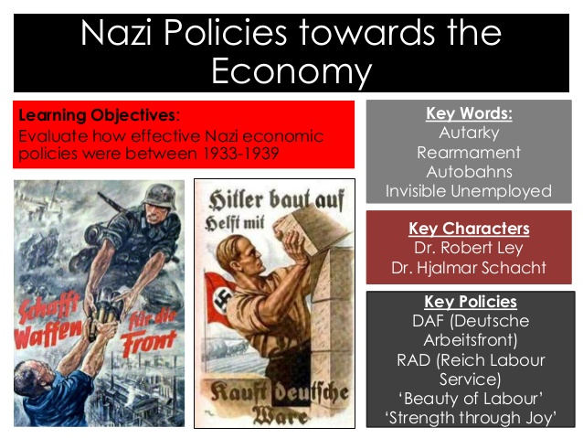Schacht’s New Plan in 1934 enabled Germany to get the raw materials she needed (e.g. oil from Romania) to fuel economic expansion & rearmament in return for German manufactured goods.
* Mefo Bills financed rearmament while limiting government debt.
* The 4 Year Plan prioritised rearmament (“guns” over “butter”) from1936 onwards so effectively that by 1939 29% of all economic activity in Germany was devoted to the armed forces compared with only 3% in 1914.
* The fact that wages as a % of national income fell 1933-8 shows Nazi success in prioritising “guns” over “butter”.
* Expenditure on rearmament increased x25 1932-8.
* The 4 Year Plan achieved significant increases in production of aluminium & explosives.

Autarky (Self Sufficiency)

* Germany was self sufficient in basic foodstuffs like bread, potatoes & sugar.

**But:**

* Autarky failed: by 1938 the trade deficit was 432 million RM.
* Germany was short of key raw materials like oil & rubber despite attempts to produce them artificially.
* Germany was not self sufficient in key foodstuffs like meat, vegetables, eggs & above all fats.

Ideology: Jews & the Mittelstand

* By the beginning of 1939 following Kristallnacht virtually all Jewish businesses had been Aryanised.
* The Reich Entailed Farm Law guaranteed that farmers could keep their farms & pass them on to their sons even if they fell into debt.
* Farmers’ incomes rose by 41% 1933-8.

**But:**

* Nazi attempts to protect small shops against competition from department stores failed & in general farmers & small business flourished less than big business.

**To what extent did the Nazis achieve the aims of their social policies?**

The Nazis’ vision was to create a ‘*Volksgemeinschaft*’, or people’s community, the desire to create a population indoctrinated with Nazi ideas that would lay the foundation for the thousand year Reich.

Youth & Education

* The vast majority of young people (82% of the entire 10-18 age group by 1939) were members of Nazi organisations.
* In 1939 there were only 2,000 Edelweiss Pirates in Germany compared with over 8 million HY members.
* Hitler Youth training made German youths physically fitter, better trained & more fanatical than their enemies.
* The Hitler Youth & BDM made young people feel important & gave them a sense of community.

BUT:

* As time wore on the Hitler Youth lost its “rebellious” appeal b/c of increasing regimentation in Nazi organisations.
* The very existence of alternative groups like the Edelweiss Pirates & swing groups was an act of rebellion.
* Nazi youth policy failed to break down social class differences.
* The anti-intellectual trend in Nazi educational policy led to a decline in scientific standards.

Women

* The birth & marriage rate rose, helped by Nazi incentives & improved maternity services.
* Child mortality fell & the number of women attending recuperation homes after childbirth doubled 1934-8
* By 1939 12 million women were members of Nazi organisations.
* The Nazis reversed the trend towards female emancipation during the Weimar Republic yet retained women’s support.

BUT:

* The rise in the birth & marriage rate owed more to economic recovery than Nazi policies; number of births per family fell.
* Because of the economic recovery, female employment rose, which limited the increase in the birth rate.
* There were more divorces from 1938 onwards.

Workers

* Unemployment fell from 6 million in 1932 to virtually zero in 1938 & young workers were grateful to have jobs.
* Compulsory labour through the RAD ended youth unemployment.
* Trade unions & strikes were banned & the vast majority of workers joined the DAF.
* 10 million people took part in Strength through Joy holidays in 1938.
* By 1939 70,000 companies had improved workplace facilities in line with the Nazi “Beauty of Work” policy.
* Remarkably little social unrest despite “guns over butter” policy & workers doing less well than other social groups.

BUT:

* Workers less pro-Nazi than any other social group, espec. older workers who knew better off before the Depression.
* Workers resented at having to work longer hours with only a slight increase in pay compared with the Depression.

The Churches

* Abolition of church schools & removal of religious instruction from curriculum reduced youth church attendance.
* By 1939 3.5 million people had left the churches to join the pro-Nazi “German Faith Movement”.
* The pro-Nazi “German Christians” won two thirds of the vote in the Protestant church elections in 1933.
* Church leaders either supported regime or at least did not oppose it except where own interests directly attacked.

BUT:

* Kershaw concluded that Nazi propaganda “failed categorically” to undermine support for the churches from adults.
* Hitler’s attempt to unify & control the Protestant churches failed, provoking the breakaway Confessing Church.
* Attempt to dismiss 2 popular Protestant bishops in 1934 provoked so much opposition that it had to be abandoned.
* Kershaw has argued that the persecution of the churches was the least popular Nazi policy.

Race

* Many towns, villages & holiday resorts **on their own initiative** barred Jews from public places.
* Nazi propaganda succeeded in making Melita Maschmann hate Jews in general even though she liked individual Jews.
* Vast majority of Germans did nothing to help the Jews: only 9% of Jews from Krefeld recalled ever being helped.
* Nazi propaganda convinced most Germans that putting gypsies & “asocials” in concentration camps was necessary.

BUT:

* The fact that Streicher felt the need to publish in “Der Stürmer” photos of Gers who shopped in Jewish stores shows a lack of public support for the boycott in 1933.
* Street violence against Jews, including Kristallnacht, was generally unpopular; a British diplomat reported that every German he met disapproved of Kristallnacht to some extent.
* Most Germans did not participate in attacks on Jews & were indifferent rather than supportive of them.

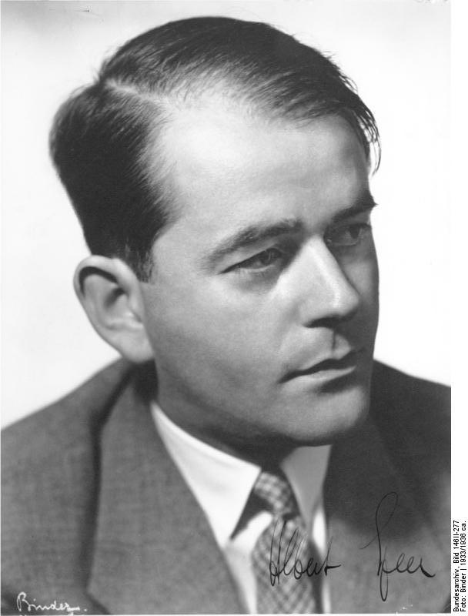**HOW SUCCESSFULLY WAS THE GERMAN ECONOMY MOBILISED FOR WAR?**

Successes

* Military expenditure doubled 1939-41 both in absolute terms & as a % of GNP.
* Food rationing was introduced from the very start of the war.
* By 1941 55% of the workforce was involved in war related projects.
* **Arms production trebled 1941-4** despite increasingly heavy bombing.
* Productivity in the arms industry increased by 60% & ammunition production doubled, both in first 6 months after Speer (right) took over as Armaments Minister in 1942.
* German aircraft production overtook British in 1944.
* Tank & aircraft production rose x6 1941-4.
* There were significant increases in production of resources like explosives & aluminium.
* By 1944 6.5 million **foreign workers** made up nearly 25% of the whole workforce and Fritz Sauckel was tasked with co-ordinating millions of forced labour workers.
* Both before & during the war Germany managed to devote a **higher % of her GNP** to war production than any other country except the USSR.
* Speer achieved what Richard Overy has called a ‘production miracle’ & that if it had not been for Allied bombing, the German economy might well have outproduced the USSR and UK together.

Failures

* Military expenditure rose faster in GB than in Germany (it trebled rather than doubled) & by 1941 the % of the workforce employed in war related projects was higher in GB (60%) than in Germany.
* The increase in war production was much slower than in GB, e.g. British aircraft production trebled 1939-41 while German aircraft production increased by less than 25%.
* Germany had only 1/3 more tanks in 1941 than in 1940 & far fewer than the USSR had.
* The war broke out before the 4 Year Plan (1936-40) was complete & many of the major projects were not expected to be complete until 1942-3 (whereas Germany was at war with both the USSR & the USA by the end of 1941).
* No one person or organisation was in overall charge of the war economy, e.g. the Office of the 4 Year Plan under Göring competed with the Armaments Ministry under Todt as well as the Economics & Labour Ministries. This **confusion & rivalry** was characteristic of Nazi government, contradicting the propaganda image of German efficiency.
* **Quantity was sacrificed to quality** b/c the Army, Navy & Luftwaffe insisted on weapons being produced to their own exact specifications, which inevitably reduced the number which could be produced. The result was that during the most crucial part of the even GB produced more tanks & aircraft than Germany, never mind the USA & the USSR.
* Germany lacked her own supplies of **vital raw materials** like oil & rubber & efforts to produce them artificially had only limited success.
* The shortages Germany suffered from (skilled labour, raw materials, food & consumer goods) reflected this, as did her budget & trade deficits. The need to increase arms production forced the government to spend more than it received & sucked in imports of raw materials Germany didn’t have her own supplies of like oil.
* Germany probably had the capacity to produce even more and could have achieved a level of output close to that of the USSR or the USA but never came anywhere near doing so. From 1940-3 even **GB was able to outproduce Germany in tanks & aircraft**.
* Germany did not even start to mobilise her full potential for war production until after Stalingrad when it was already too late.
* Speer could not always counter the power of the party Gauleiter at a local level and the SS remained a law unto themselves.
* Although territories occupied by the Third Reich were plundered, they were not exploited with real economic efficiency.
* In 1944 Germany produced 1/3 fewer tanks & aircraft than she would have done if there had been no **bombing**.

**To what extent was German civilian morale on the home front weakened, 1939-45?**

**Weakened**

* In December 1940, Goebbels described the popular mood as one of ‘light depression’. This mood became more permanent after the invasion of Russia in June 1941, removing hopes of a short war.
* The **German defeat at El Alamein** (November 1942) was a significant loss, and the **German surrender at Stalingrad** (January 1943) was a strategic disaster and a damaging blow to the confidence of the German people. Several reports revealed considerable nervousness over popular reactions. An SD report highlighted the deepening cynicism in the nation about the political and military situation after Stalingrad: ‘A large section of the nation cannot imagine how the war will end and the telling of vulgar jokes against the state, even about the Fuhrer himself, has increased considerably since Stalingrad’.
* **A.D. Welch** argues that Stalingrad undoubtedly affected the morale of the Germans as it made them question Nazi war aims and resulted in a crisis in confidence.
* The regime was obliged to make **‘defeatism’ a criminal offence** and punishable by death. Despite this, by 1945, half a million Germans were held in concentration camps compared with 100,000 in 1940.
* Peopleresponded to the regime’s propaganda with **increased scepticism**, particularly as letters from soldiers at the front painted a very different picture from official reports.
* More and more people were reluctant to participate in Party activities and even loyal members were less inclined to attend Party meetings. **Party membership fell.**
* **Anglo-American bombing** had a direct impact on the lives of ordinary Germans, bringing the war into their very homes. As a result of the air raids, 400,000 Germans were killed plus 60,000 foreign workers and POWs; 500,000 people were disabled and severely injured; 3.6 million homes were destroyed (20% of total housing)
* On the night of 24 July 1943, a massive raid on **Hamburg** created a firestorm that killed 40,000 civilians. Speer admitted the Hamburg bombing did damage civilian morale, with many civilians blaming Hitler & fleeing in mass panic. The bombing of Dresden 13-15 February 1945 saw 1300 heavy bombers drop over 3900 tons of high-explosive bombs and incendiary devices, killing 35,000 Germans.
* In 1944 absenteeism at the Ford plant in Cologne rose to 25%, which was probably mainly due to bombing.
* It became increasingly difficult for the government to withstand the cumulative effect of the sustained physical suffering and psychological trauma inflicted on the German people. From 1943 onwards, reports from the SD began to show an escalation **in grumbling and complaints**, which illustrated the growing disaffection.
* By **autumn 1944** there was a **real fear of the advancing Red Army** and despair at the **failure of special weapons** like the V-1 pilotless bombs and V-2 long-range rocket.

**Not weakened**

* Despite the difficult circumstances faced by most Germans in the final two years of the war there was no real sign of a decline of morale leading to the collapse of the regime.
* In the face of Allied mass bombing many people came together against the enemy. **Contrary to British hopes**, there was little evidence of a collapse of morale undermining the Nazi war effort. Indeed, GB's own experience during the Blitz (1940-41) showed that bombing did not destroy civilian morale: an opinion poll showed that Londoners were more depressed by the weather than the Blitz and if anything morale was stiffened rather than undermined by it.
* Goebbels and his propaganda machine needed to use all their skills and Goebbels became the public face and voice of the Nazi regime, delivering a famous speech on 18 February 1943 at the Berlin *Sportpalast* in response to the surrender of Stalingrad, rallying the people for ‘total war’.
* **Cinema** was used to distract people from the realities of the war, for example through fantasy action films like *The Adventures of Baron Munchausen* and great patriotic epics like *Kolberg*, based on a historic German battle against Napoleon.
* **‘Active resistance’** failed to topple Nazism and in the end the Third Reich was only destroyed when Germany was militarily defeated.
* The **vast majority** of people remained loyal to their Führer, and Hitler remained much more popular than the Party itself. Attempts on his life – especially in 1944 – were condemned by many people, partly because they felt that Hitler was the only one who could get Germany out of the mess she was facing abroad.

**HOW SERIOUS WAS WARTIME OPPOSITION TO THE NAZI REGIME?**

|  |  |  |
| --- | --- | --- |
|  | **WARTIME OPPOSITION SERIOUS** | **WARTIME OPPOSITION NOT SERIOUS** |
| Communist | Small Communist groups survived into the war years & were particularly active after Hitler’s invasion of the USSR in 1941. They included Red Orchestra, a spy network which infiltrated the govt. & Army & passed on vital info to Moscow & circulated anti-Nazi leaflets. | The KPD (German Communist Party) was largely crushed in the first year of the Nazi regime; the Gestapo crushed the Red Orchestra (Rote Kapelle) in 1942.  The KPD was compromised by the co-operation between Germany & the USSR during the Nazi-Soviet Pact (1939-41) & its subservience to Stalin.  Communist groups were small & isolated & such was the threat of Nazi repression that they generally aimed simply at surviving until they could re-emerge in public after the Soviet defeat of Germany. |
| Christian | Christian opposition became more militant during the war & no longer concerned itself purely with religious issues, e.g. Bonhöffer (Protestant) engaged in political opposition with the conservative Kreisau Circle& Bishop Galen (Catholic, bottom right) spoke out in 1941 against the mass murder of the disabled, forcing the govt. to end it.  A Nazi Gauleiter in 1943 repeated that the influence of the churches was increasing & that they were “in today’s struggle one of the main pillars of negative influence on public morale”.  The fact that over 50% of Protestant clergy were harassed suggests that the Nazis saw them as a threat. | The churches as institutions (as opposed to individuals like Bonhöffer & Galen) did not even criticise the regime, never mind actively oppose it.  Leading clerical opponents like Bonhöffer & Niemöller were put in concentration camps. |
| White Rose Group 1942-3 | They were brave, principled & made an important statement that there were such things as decent Germans.  They were motivated by genuine outrage at Nazi atrocities & circulated leaflets about these. | They were a small isolated group based in Munich University whose protest was shortlived (only a few months in 1942-3) b/c they lacked public support (they were denounced by a caretaker) & their security was lax. |
| Kreisau Circle | This was a group of upper class conservative nationalists who had previously held influential positions: they included a former mayor of Leipzig (Gördeler), a former ambassador to Rome (Hassell) & an army officer (Tresckow).  They planned to assassinate Hitler & establish a conservative govt. which would end the war & restore the rule of law. | They were divided about both aims & tactics (e.g. some of them were against killing Hitler) & it is doubtful whether they could have seized power even if the plot against Hitler had succeeded.  They certainly lacked public support.  They were crushed by Nazi repression after the bomb plot in 1944. |
| Stauffenberg Bomb Plot 1944  (below left) | The Gestapo were aware of the Kreisau Circle before the 1944 bomb plot but still failed to prevent it.  The support the plot enjoyed from army officers like Stauffenberg (below) & Tresckow meant there was a genuine chance of Hitler being overthrown. There was definitely an anti-Nazi subculture of conservative Christian beliefs amongst senior army officers (generally of upper class origins) which the Nazis only really penetrated after the failure of the bomb plot. | Conservatives generally supported the regime until 1938 when it was too securely established to be overthrown.  Even after that Hitler’s stunning successes 1939-41 made opposition difficult.  The army oath of 1933 made most army officers reluctant to support plots against Hitler; b/c of this the plot was doomed to fail if Hitler survived. This led to plot supporters hesitating while Nazi loyalists acted decisively to crush the conspiracy.  This led to a general & brutal crackdown on upper class, conservative & army opposition. |

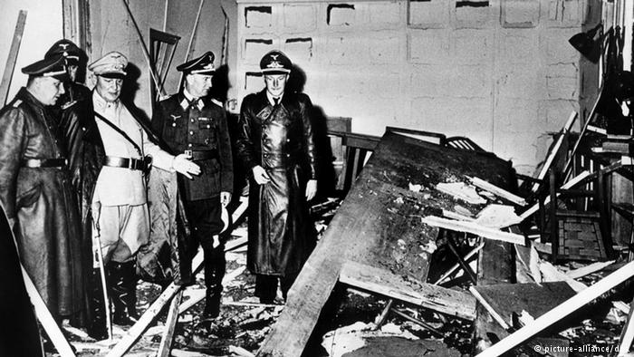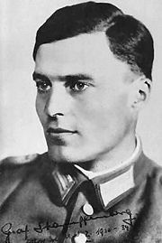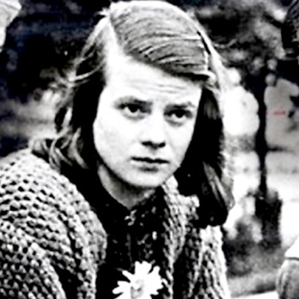 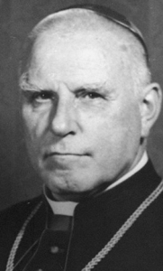

**WHEN & WHY DID THE NAZIS MASS MURDER THE JEWS?**

The Persecution of the Jews before WW2

Nazi policy before WW2 was to ill treat the Jews so they would emigrate:

* In April 1933 Jewish shops & businesses were **boycotted** & Jews barred from the civil service.
* In September 1935 the **Nuremberg Laws** barred Jews from German citizenship & sex with Aryans.
* In November 1938, as a result of **Kristallnacht**, up to 1,000 Jews died & 7,000 Jewish businesses were destroyed. By the beginning of 1939 the aryanisation of Jewish business was complete.

The Outbreak of WW2 in 1939

The conquest of Poland in 1939 brought 2 million more Jews under Nazi control. Unsure what to do with them, the Nazis put them in **ghettos** & made them wear yellow stars for indentification; if found outsde the ghetto, they would be shot. In some ghettos, the Jews were basically left to die slowly of disease & undernourishment; in others they were fed enough to be able to work. The policy was increasingly brutal but confused & not yet genocidal (i.e. aimed at murdering the entire Jewish race).

The Madagascar Plan 1940

Each fresh Nazi conquest 1939-41 brought more Jews under Nazi control, increasing the size of their self created Jewish “problem”. Following their victory over France in June 1940, assuming that GB would soon make peace, the Nazis proposed to move the entire Jewish population in Europe to Madagascar, then a French colony. It could be argued that European Jews could hardly have survived in such a tropical climate, but the policy was still one of emigration rather than genocide; Himmler, later the architect of the Holocaust, said as late as 1940 that to mass murder the Jews would be “Bolshevik and un-German”.

The plan was never implemented b/c the British Royal Navy prevented it.

The Invasion of the USSR in June 1941

**This was when the Holocaust, i.e. the mass murder of Jews as opposed to forced emigration, really started.** The Nazis blamed the Jews for starting Communism so it was entirely logical from their point of view that their “war of annihilation” against Bolshevism should also be a war of annihilation against the Jews. As the German army advanced into the USSR, **Einsatzgruppen** (in effect murder squads) followed behind them, shooting all the Jews they could find. By spring 1942 over 1 million Soviet Jews had been murdered.

There were trial gassings but at this stage **shooting** was still the main method of extermination.

The Wannsee Conference, January 1942

This cannot be seen as the start of the Holocaust b/c by then the mass murder had already started; indeed the deportation of **German** (as opposed to Soviet) Jews to be murdered in the East started as early as October 1941. The significance of the Wannsee Conference was that it was the first time that the murder of the 11 million Jews **all over Europe** was planned.

Looking for a method of mass extermination which was more “efficient” & less traumatic for the killers (not the victims), the Nazis decided to use **gassing** rather than shooting from spring 1942 onwards. A series of **camps** were built in Poland: some, like Auschwitz, were both concentration (forced labour) & death camps; others, like Treblinka, were just death camps.

Hitler’s Role

**Intentionalist** View: the Holocaust happened b/c Hitler wanted it to.

**Structuralist** View: it happened b/c of changing circumstances & Hitler left most of the details to others like Himmler.

Christopher Browning says that from September 1939 to October 1941 Hitler “was an active and continuing participant in the decision-making process. Indeed, not a single significant change in Nazi Jewish policy occurred without his intervention & approval”. He was “the necessary and pivotal decision maker”. Hitler was sometimes consulted even on details like which German cities Jews should be deported from and where they should be deported to. This is the **intentionalist** view.

But Browning also argues “the emergence of the Final Solution was influenced and shaped not only by Hitler’s enduring obsession with the Jewish question but also by the changing circumstances” such as the military situation in the USSR: when victory seemed near, as in July and September 1941, he ordered the “Final Solution” to be accelerated. This is the **structuralist** view. On the other hand, when the military situation deteriorated from late October onwards, the progress of the “Final Solution” did not stop because Hitler was so ideologically committed to it that he was determined to go through with it regardless of the military situation.

It is impossible to imagine the Holocaust without Hitler but it didn’t start until **the invasion of the USSR in 1941:**

1. The Nazis associated the Jews with Communism.
2. Their self created Jewish “problem” escalated as they conquered more territory & millions more Jews came under their control; this meant they felt they needed increasingly radical “solutions” so extermination replaced emigration.

**WHY WAS GERMANY DIVIDED IN 1949?**

Soviet Responsibility

* Despite the agreement with the West over the division of Berlin, the USSR took 80% of the industrial equipment in Berlin, West as well as East, in 1945. Historians like Pulzer & Spilker agree that the different attitudes of the USSR & western Allies towards **reparations** was crucial to the division of Germany.
* The Communist strategy in the Soviet zone was, as East German Communist leader Ulbricht put it, “it must look democratic, but we must keep everything under our control”. This imposition of Communism & **suppression of democracy** (e.g. the SPD was forcibly merged with the KPD to form the SED in 1946) in the Soviet zone made the division of Germany inevitable. It also contradicted Stalin’s claim that he wanted a united democratic Germany.
* The USSR withdrew from the **Allied Control Commission** in 1948 & broke off discussions on the introduction of a single currency for the whole of Germany. They also stopped deliveries of food & raw materials to the West in clear violation of previous agreements.
* The USSR planned to impose its own **currency**, the ostmark, on its zone & the whole of Berlin, West as well as East, in 1948 without consulting the Western powers.
* It was reasonable for the West to introduce the DM to **revive the West German economy** so that Europe as a whole could recover & Germany could pay its way & not need to be subsidised by the occupying powers.
* The Communists **boycotted the Berlin City Council election** in 1948, knowing they would lose, & imposed their own candidate, Friedrich Ebert, as Mayor of East Berlin.
* Stalin’s attempt in the **Berlin Blockade** 1948-9 to starve West Berlin into surrender made division inevitable.
* In view of Stalin’s previous behaviour in Germany & Eastern Europe there was **no reason to believe that his offer of a united democratic Germany in 1952 was sincere**.
* It was the Communists, not the West, who **closed the border** between East & West Germany in 1952 (Ulbricht did so on Stalin’s instructions) & between East & West Berlin in 1961.

Western Responsibility

* The Western powers **introduced their own political & economic systems** into West Germany, merging the US & British zones & introducing the Marshall Plan in 1947 (a programme of economic aid to capitalist countries which was clearly designed against Communism) without agreement from the USSR. This was in defiance of the agreements at Yalta & Potsdam.
* At the **Moscow conference of the Council of Foreign Ministers in 1947** GB & the USA rejected Soviet proposals for a unified German state.
* The Berlin Blockade was provoked by the introduction of the **DM** into West Germany & West Berlin without agreement; indeed 250 million DM were secretly smuggled into West Berlin.
* The West’s determination to **build up West Germany as an ally against Communism** threatened the security of the USSR & made the division of Germany inevitable.
* Stalin wanted a united neutral Germany but the West announced its decision to set up a separate West German state **before** the Berlin Blockade.
* The **FRG** (West Germany) was set up before the GDR (East Germany), which was only set up in reaction to it.
* **Stalin proposed reunification in 1952** but this was rejected by the West.

German Responsibility

* German political leaders were quite prepared to work with the Allies who shared their political and economic objectives, at the expense of German unity
* **Ulbricht** and the SED leadership could only really envisage a united Germany under a communist model.
* In the western zones, the CDU leaders **Adenauer** and Erhard became increasingly committed to a partial German state which was capitalist and pro-Western.

General

* The division was inevitable b/c of **ideological** differences, not just between the USSR & the West but also German politicians like Ulbricht & Adenauer.
* It was caused by **economic** differences, some (Communism v capitalism) based on ideology, others based on national interest (the USSR wanted to keep Germany weak while the West wanted to revive her).

**MODEL ESSAY: Assess the reasons why 2 German States emerged 1945-9**

The emergence of two German states was fundamentally due to the **economic differences** between the USSR and the West, with the West intending to revive the German economy, whereas the East were eager to prevent the revival of an independent Germany.

One of the key aspects which resulted in the division of Germany was the **Western Allies’** lack of trust towards Stalin coupled with West German Chancellor Konrad Adenauer’s favour of maintaining links with the West over allowing Germany to become united. Initially, Stalin desired Germany to be politically neutral and demilitarised throughout the Cold War between the USSR and the USA to eliminate any potential threat from Germany against Russia. As a result of his fear of military and economic alliances between the West German state and the American dominated NATO camp, in 1952 Stalin proposed to withdraw from East Germany “in favour of a united, neutral Germany” as stated by historian Mary Fulbrook, with the removal of foreign troop occupation in return. However Adenauer dismissed this proposal due to the fear of invasion as a result of removing the foreign troops; Stalin’s proposal was written off as a mere propaganda stunt. Therefore this evidently displays the way in which the division between the two German states deepened as Adenauer and the Western allies’ decision to rebuff Stalin’s proposal of a united Germany resulted in the prevention of reunification.

Another aspect which arguably provoked the division of Germany into two separate states is the idea that the USSR were primarily reacting to the initiatives of the Western Allies. The Western powers introduced their own political and economic systems into West Germany, merging the US and British zones. The introduction of the **Marshall Plan** in 1947, a programme of economic aid to capitalist countries which was clearly designed against Communism, was enforced without agreement from the USSR; not to mention that it was in defiance of the agreements at Yalta and Potsdam, therefore creating a pathway for the emergence of two states as the West had not complied with what was agreed. Furthermore, a prime example of the USSR reacting to actions of the Western powers was the introduction of the **Deutschmark** into West Germany and West Berlin without consultation of the USSR; 250 million Deutschmarks were smuggled into West Berlin. As a result, Stalin retaliated by imposing the **Berlin Blockade** upon West Berlin between 1948-9 in order to starve them into surrender. However, the USSR had planned to impose their own currency on the whole of Berlin without consulting the Western Powers in 1948. Historian Wilfried Loth argues that “Stalin really would have preferred a neutral, reunited Germany, and that the USSR ended up with exactly what he sought to avoid”, thus supporting this idea as it suggests that due to the USSR being provoked by the West, Stalin was forced to retaliate, therefore resulting in a division of Germany. In addition, **the FRG (West Germany) was set up prior to the GDR (East Germany) which was only set up as a result of the West’s decision**, therefore evidently displaying the way in which the USSR based the majority of their decisions in reaction to the West, making the division inevitable.

Furthermore, it can be argued that the Western Allies had no true intentions of forming a single, unified German state. A prime example was the Moscow Conference of the Council of Foreign Ministers in 1947 in which the Russians had strongly pressed for a unified German administration to be established, however, the British and the Americans could not decide upon the terms and conditions for the creation of a single German state. In addition **the West’s decision to set up a separate West German state prior to the Berlin Blockade** further enforces the idea that the Western powers favoured the idea of two German states as opposed to a unified one instead. As the West’s determination to build up West Germany as an ally against communism prevailed, the security of the USSR was consequently threatened, thus making the division of Germany inevitable, as whilst it appears that the East favoured a reunified Germany, it appears that the West had no true intentions of this.

On the other hand, a key aspect that resulted in the division was the **suppression of democracy and the imposition of Communism in the Soviet zone**. Amid Germany’s deepening division, the SPD had been forcibly merged with the Communist Party to form the SED in 1946. Through the merge of these parties, the Communist element transformed the SED (Socialist Unity Party) into one that expelled those who rejected the new Moscow-inspired line. Many “committed socialists had to choose between the SED or illegal opposition and probable punishment” as stated by historian Mark Allinson, as the Soviets forbade the SPD from remaining independent. Therefore, this suppression of democracy in the Soviet zone made the division of Germany inevitable as the West further enforced democracy in their zone; not to mention that if they were ever to unite they would have to be democratic. With Communist leader Ulbricht stating “it must look democratic, but we must keep everything under our control”, Stalin’s ‘desire’ for an united democratic Germany is evidently contradictory as his true intentions appear to form Germany into a Communist state, thus resulting in the emergence of two separate German states.

Additionally, the USSR’s resentment of the economic setbacks caused by the German treatment of Russia at the Treaty of Brest-Litovsk in 1918 also played a significant factor in the division. Despite the agreement negotiated with the West over the division of Berlin, the USSR took eighty percent of the industrial equipment in Berlin in both the West and the East in 1945. Due to the loss of twenty five million Soviet lives and the devastation of masses of Soviet territory during the war with Germany, Stalin felt entitled and justified in transferring entire factories, railway stock and even railway track to the USSR as a form of **reparations**. Consequently, Stalin’s excessive exploitation of the reparations became “a major source of tension between the Western Allies and the USSR” as stated by historians Bushnell and Leonard, as his approach to reparations became a major obstacle to immediate economic recovery in the Western and Eastern zones which counteracted the intentions of the Western powers as they wanted to revive the economy. This therefore deepened the division between the two powers, making the emergence of the two states inevitable as the West viewed Stalin’s actions as an exploitation of what was agreed.

Furthermore, as a result of **Stalin’s previous behaviour** in Germany and Eastern Europe, the Western Allies had no reason to believe that his offer of a united democratic Germany in 1952 was sincere. With two thirds of Germany’s territory and nearly three quarters of its population occupied by the Western zones, Stalin feared that the US, British and French zones would join together to form a capitalist, anti-Communist country allied with the West against the USSR, with US and British troops stationed there. This could therefore enable the West to use Germany to propose an attack against Russia in a third world war. From the point of view of the Western Allies, Stalin’s proposition of a united democratic Germany appeared to have ulterior motives as his proposal of withdrawing from East Germany in return for the withdrawal of foreign troops would not only prevent an attack on the USSR but also enable Stalin to invade Germany and transform it into a Communist state. In addition, the suppression of democracy in the Soviet zone alongside appearing to be democratic whilst ensuring control over everything greatly contradicts Stalin’s claim that he wanted an united democratic Germany. Therefore, the Western Allies’ decision to rebuff Stalin’s proposal of an united Germany due to the suspicion of an invasion was reasonable, therefore displaying that it was Stalin’s lack of commitment to his claim of a democratic Germany that made the division of Germany inevitable.

Another significant factor which led to the emergence of two German states were the **differences in economic polices**. With the Western Allies wanting to enforce capitalism within their zone and primarily focused on the revival of the German economy, the Soviet Union on the other hand was eager to prevent the revival of an independent, militaristic Germany and wanted to enforce Communism within their zone. Due to the West’s desire to revive the German economy they introduced the Deutschmark to enable Europe as a whole to recover and allow Germany to pay its way and not need to be subsidised by the occupying powers. However, it was this action that had initiated the retaliation of the USSR through the imposed Berlin Blockade which ultimately resulted in the division of Germany into two states. Therefore, the emergence of two separate German states was inevitable as differences in economic policies between the occupying powers symbolised their wider dissimilarities; any unification that could have happened would show no lasting results due to the difference in intentions both economically and politically.

To conclude, ultimately the emergence of two German states was **fundamentally due to the economic differences** between the the Western powers and the USSR. This is evident as it was the Western Allies’ intention to revive the economy which lead to the introduction of the new Deutschmark in the West, consequently leading to the blockade and ultimately the division of Germany. Despite Stalin’s offer for creating a unified, democratic Germany through his proposal of withdrawing from the East in return for the removal of the occupation of foreign troops, Ulbricbht’s claim that “it must look democratic, but we must keep everything under our control” greatly contradicts Stalin’s claim. This accompanied by Stalin’s previous behaviour therefore justifies the West’s decision to dismiss Stalin’s proposal as propaganda as it suggests that his primary motive was to ensure that Russia would not be attacked and allow for a potential invasion of what would be an independent Germany. In addition, although it appears that it was the Western introduction of the Deutschmark that resulted in the Berlin Blockade and ultimately the division of Germany, Stalin had also planned to impose a new currency within both the West and the East, however the difference is that the West intended to boost the economy for Europe as a whole. This therefore evidently displays the way in which the economic differences between the West and the USSR made the division of Germany inevitable as the West had intended to revive the German economy whereas the USSR were eager to prevent the revival of an independent, militaristic Germany, thus making any unification between the two improbable.

**OLD OCR QUESTIONS ON POST WAR GERMANY**

Please note that the old syllabus, unlike the new, did not include Germany during WW2, the Holocaust or post-1949 East Germany.

1. Assess the reasons why 2 German states emerged 1945-9.
2. Assess the reasons why a divided Germany emerged 1945-9.
3. To what extent was the Soviet Union responsible for the division of Germany 1945-9?
4. Assess the reasons for West Germany’s economic “miracle” in the 1950s.
5. Assess the reasons why Adenauer retained power for so long after 1949.
6. How successful was Adenauer’s foreign policy?
7. To what extent was Adenauer personally responsible for West Germany’s growing strength in the 1950s?
8. Assess the reasons for West Germany’s political stability in the 1950s.
9. To what extent was Adenauer’s foreign policy the main reason why he maintained power 1949-63?
10. How successful was Adenauer as Chancellor 1949-63?
11. To what extent was economic success the main reason for political stability in West Germany in the 1950s?

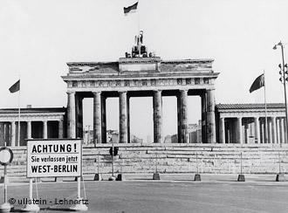

**EAST GERMAN ECONOMIC POLICY**

Successes

* Industrial production doubled during the First 5 Year Plan (1951-5).
* Targets were met 1951-5 in iron, sulphuric acid & cement.
* The EG economy grew by 12% 1958-9.
* Basic foodstuffs like bread, milk & potatoes were cheap & plentiful.
* Accommodation was cheap.
* Provision of consumer goods began to improve after the unrest in 1953.

Failures

* Targets were missed 1951-5 in steel & lignite.
* Quantity was emphasised at the expense of quality.
* Consumer goods were neglected & the rigid EG economy was unresponsive to what consumers wanted.
* Production targets caused worker discontent, leading to emigration & the unrest of 1953.
* Accommodation, though cheap, was in short supply & often of poor quality.
* The EG currency was worthless internationally & worth less than half the official rate (2 Ostmarks to every W German Deutsche Mark).
* Industrial growth declined in the early 1960s even as the targets were being raised.
* Even on the GDR’s own figures productivity was 25-30% lower than in the FRG (W Germany).
* By 1960 the GDR was dependent on imports of industrial machinery & spare parts from the FRG.
* Forced collectivisation 1958-61 reduced food production so much that rationing had to be introduced.

Reasons for Failure

1. 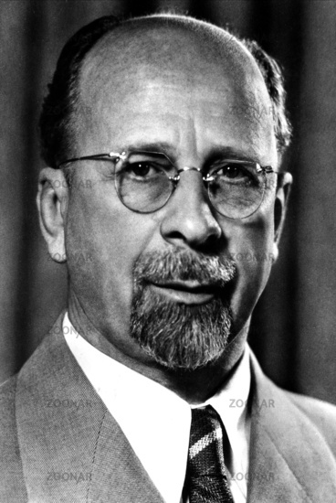**Reparations**. The USSR demanded $ 10 billion in reparations from Germany & in 1945 took away 80% of the industrial equipment in Berlin, west as well as east. Because they wanted to keep Germany weak so it couldn’t invade the USSR again, whereas the West wanted to revive the German economy so Europe as a whole could recover, the USSR took far more in reparations than the West did. Overall the USSR extracted about 23% of East German GNP for reparations. This caused emigration & a fall in living standards in E Germany 1947-52. It was a bad start from which the GDR never fully recovered.
2. **Idelogical Inflexibilty**. Ulbricht (right) stuck to Stalinist economic policies which didn’t work b/c they were dictated by Communist ideology. When farmers resisted collectivisation, they were forced; similarly, the setting of unrealistic targets (without extra pay) provoked serious unrest in 1953, but when it became clear in 1959 that the 2nd 5 Year Plan 1956-60 was failing it was replaced by the even more unrealistic 7 Year Plan 1959-65. By 1961 over 90% of both agricultural & industrial production was state owned. Quality was sacrificed to quantity & there was a massive emphasis on heavy industry with only 2% of industrial investment devoted to consumer goods. Many farmers emigrated to escape collectivisation, causing shortages of all but the most basic foodstuffs & EG had to import grain to feed its livestock. Farmers preferred to work for themselves & had little motivation if forced to work for a collective farm or for the state. The farmers that remained were disinclined to do more than produce for their own needs because fixed procurement prices meant little profit, and conspicuous production invited hasty inclusion in a collective or state farm. The policy of nationalising industry was equally inefficient & unpopular, prompting entrepreneurs & technicians to emigrate to the West, e.g. the owners of the high technology industries like camera, typewriter & electronics from Dresden. By 1952 there was a 700 million mark budget deficit & the GDR imported more even from other Communist countries than it exported. This was clearly caused by Communist policies because in 1939, the area which later formed the GDR produced more per head of population than the area which later formed the FRG.
3. **Emigration.** 3 million E Germans, 1/6 of the GDR's population, emigrated to the West 1949-61 b/c of the higher standard of living there. The rate of emigration rose 1959-61 & most of these "deserters from the Republic" were businessmen or skilled professionals like engineers: 20% of the doctors in the GDR emigrated to the West 1954-61. 50% of the emigrants were under 25 years of age. 70,000 teachers emigrated, including 30,000 Neulehrer (new teachers) who had been trained in the GDR since WW2. Forcible collectivisation led to 1/3 of the wealthier farmers emigrating, leaving over 10% of East Germany's arable land fallow and resulting in food shortages. By 1960, the combination of World War II and the massive emigration westward left East Germany with only 61% of its population of working age, compared to 70.5% before the war. The direct cost of manpower losses has been estimated at $7 billion to $9 billion. In addition, the drain of East Germany's young population potentially cost it over 22.5 billion marks in lost educational investment. Ulbricht was forced to build the Berlin Wall in 1961 to stop the GDR “bleeding to death” economically.

**EAST GERMAN SOCIAL POLICY**

Good Points

* The previous middle class of businessmen & educated professionals was replaced by a new **“Socialist intelligentsia”** of people, often of working class origin, some of them women, who had been educated by the new Communist system & were willing to show commitment to it. Such people were doctors, academics, journalists, engineers, scientists, architects etc.
* By 1963 the old male doctors, most of whom had formerly been members of the Nazi Party, had been replaced by younger doctors, many of them women, educated by the Communist system since WW2.
* Maternity care, work-based nurseries & after-school childcare was provided to enable more **women** to work. EG had a much better record in this respect than either the Nazis or postwar W Germany.
* E Germany had a lower rate of maternal & infant mortality than W Germany.
* The FDGB did represent workers’ interests on particular issues &, like the Nazi DAF, organised subsidised holidays & other leisure activities for workers.
* The SED set up mass organisations for groups like women (the DFD) or to promote cultural pursuits (KB) or sporting activities (the GST & GSTB) to which millions of E Germans belonged.
* The GDR devoted a higher % of its GNP to education compared with the FRG (7% to 5%) & as a result the number of college & university students doubled 1951-8.
* 80% of teachers were sacked b/c of their Nazi past & replaced by young new teachers (Neulehrer),
* Scholarships & opportunities for adult **education** were set up to allow more working class people to go to university.
* The Pioneers & Young Pioneers set up activities, outings & camps which many children enjoyed.
* Wages were more equal than in W Germany & with guaranteed employment & subsidised food & accommodation, everyone had a **decent basic standard of living**.
* Provision of consumer goods improved after the 1953 unrest.
* Fulbrook has described the GDR as “a participatory dictatorship” in which complaints (Eingaben) about practical issues like poor accommodation would be listened to as long as the overall Communist system wasn’t questioned.

Bad Points

* Women tended to be more numerous in less well paid or part-time jobs.
* Independent trade unions & strikes were banned & the FDGB with its leisure activities was in effect bribing workers with their own money.
* Christian youth groups were persecuted & young people discriminated against if they didn’t take the Jugendweihe.
* By 1954 70,000 teachers (including 30,000 Neulehrer) had emigrated to the West.
* Young people from traditionally middle class families were discriminated against, prompting as many as could to emigrate.
* The Communists tried to deny young people access to rock & roll music.
* The **elite** at the top of the SED (Communist Party) had a privileged existence including a residential area exclusive to them with large villas, servants & shops selling western goods which were not available to E German workers
* Members of the **socialist intelligentsia** did better than workers in terms of health, housing, education etc.
* 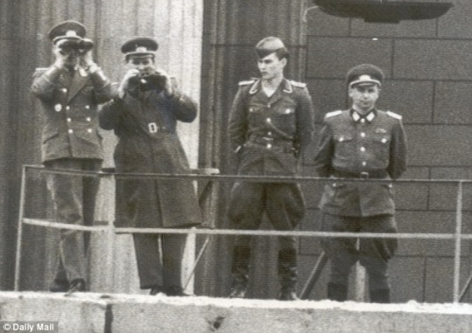**Working conditions** were often appalling, e.g. in the uranium mines in Wismut health & safety standards were dire & threats were used to force workers to work there.
* The **Stasi** (secret police, right) were active in many workplaces (especially the economically most important ones) to suppress dissent.
* Fulbrook has emphasised “the sheer **incapacity of the centralised economy** to deliver the kind of material growth that would make the realisation of such visions practicable in reality ... And the situation becomes worse when problems are not admitted to and addressed, but rather attempts are made to deny them through slogans and propaganda” . The GDR’s record on **housing** was particularly poor & provoked constant complaints.
* The shortage of high quality **consumer goods** (clothes, furniture etc) led to corruption with access to them depending on connections & the possession of western money.
* Because wages were lower than in W Germany, both parents had to work; this led to children complaining of their parents spending too little time with them.
* Because the standard of living was lower than in the West, imported **food** like tropical fruit was scarce or even unobtainable rto most of the population. Meat & sugar were rationed until 1958.
* **Health** provision in E Germany was patchy, limited by economic constraints. The party elite had privileged healthcare denied to everybody else.

**WHY DID WEST GERMANY ENJOY AN “ECONOMIC MIRACLE” (WIRTSCHAFTSWUNDER)?**

Currency Reform & Low Inflation

W Germany had a strong currency, the **Deutsche Mark** (DM, below right) which gave people confidence to invest in industry & enabled rapid but **non-inflationary** growth & a strong central bank, the **Bundesbank,** to ensure lower inflation & therefore a strong currency.

The Rebuilding of Germany’s industrial Base

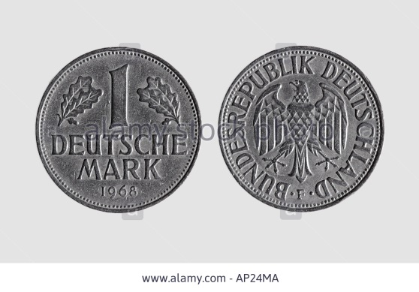The FRG also had good resources of coal & iron in the Ruhr region & **skilled workforce** willing to **work hard** for long hours & low wages until **productivity** improved. Their willingness to save money kept consumption initially low, freeing money for **investment** in industry & making rapid growth possible.

As living standards improved, German companies prospered by catering for the growing domestic market: Bosch, one of WG’s most dynamic companies, produced cars, engines, refridgerators & other kitchen equipment.

Ludwig Erhard (Economics Minister)

Adenauer took little interest in the details of economic policy.

Erhard **cut taxes** drastically, creating incentives to work harder & increasing the demand for W German goods & **abolished price controls** which gave producers incentives to expand production while at the same time keeping inflation low b/c of high productivity & a stable currency.

The Marshall Plan

This was only extended to W Germany after her economic recovery had already started. GB received twice as much aid than W Germany yet her economy performed much worse, which shows that Marshall Aid was **not the main cause** of W Germany’s prosperity. It was clearly less important than the introduction of the DM or Erhard’s policies generally

W Germany actually paid more in reparations than she received from the Marshall Plan.

The Recovery of World Trade

The **Korean War** more than doubled WG exports especially to the USA, but most of her trade was with Europe: this was boosted by the creation of the **OEEC** in 1948, the **ECSC** in 1951 & the **EEC** in 1957.

W Germany’s export performance especially strong in **cars, machinery, electrical & chemical products**. “Made in Germany” was renowned throughout the world as meaning high quality at a competitive price.

Good Labour Relations

The W German policy of co-determination (Mitbestimmung), meaning that companies were legally obliged to consult workers’ representatives about their decisions created a constructive atmosphere in which workers were much more likely to accept improvements in productivity & efficiency & strikes were much less common than in countries like GB & France.

Immigration

By 1961 3 million E Germans had emigrated from the **GDR** (E Germany) & most of them were young, skilled & well educated. There was a significant transfer of technological expertise from East to West Germany b/c of Soviet reparations policy & the repressive policy of state control on the Stalinist model followed by the GDR. In Dresden, for example, the owners of the high technology industries like cameras, typewriters & electronics moved their businesses to the West.

WG’s economic growth & the increasing reluctance of W Germans as they became more affluent to do low paid work created a demand for cheap labour which was filled by **Gastarbeiter** (“guest workers”) from Turkey & Yugoslavia.

Agricultural Efficiency

From 1949 onwards W German agriculture became steadily more efficient b/c the reduction in the number of farms to create fewer but larger ones made **mechanisation** possible. Food production nearly doubled in the 1950s despite a sharp drop in agricultural employment. From the 1960s onwards WG farmers began to benefit from EEC subsidies.

Political Stability

For the first 14 years of its existence (1949-63) the FRG (W Germany) enjoyed remarkable political stability; having the same Chancellor (Adenauer) & the same Economics Minister (Erhard) for all that time ensured continuity of economic policy which was good for confidence & investment. **Political & economic stability reinforced each other**.

**DID THE BASIC LAW OR THE WIRTSCHAFTSWUNDER CONTRIBUTE MORE TO THE FRG’S POLITICAL STABILITY?**

The Basic Law

* Basic human rights were constitutionally guaranteed & enforced by a constitutional court.
* The WG system was based on parliamentary rather than direct democracy.
* It was a federal system which respected regional differences.
* It had a proportional electoral system which combined fairness with strong govt.
* Party pluralism was constitutionally guaranteed but anti-democratic parties could be banned & the 5% rule prevented fragmentation.
* The President’s power was limited so it could not be abused.
* The Bundestag was prevented from dismissing a Chancellor unless he could be replaced.
* E Germans were allowed into WG with a view to eventual re-unification.

The Wirtschaftswunder

1. **The Improvement in Living Standards**. Living standards rose steadily, with average incomes increasing by 400% 1949-63while the working week was reduced to 45 hours spread over 5 days rather than 6.

By 1962 63% of W German households owned a fridge (compared with only 11% in 1955) & 42% had a TV.

Unemployment hit a record low of 0.7–0.8% in 1961.

1. **The social market.** The W German concept of a “Social Market”(combining generous social protection for the poor with a dynamic free market economy) ensured that everyone benefited, fulfilling the title of Erhard’s book, “**Wohlstand für Alle**” (prosperity for all). Although wage demands and pay increases had been modest at first, strong trade unions & the system of **Mitbestimmung** (co-determination) whereby employers had to consult works councils or workers’ committees ensured that workers got their fair share of the growing prosperity. Wages and salaries rose over 80 percent between 1949 and 1955, catching up with growth.

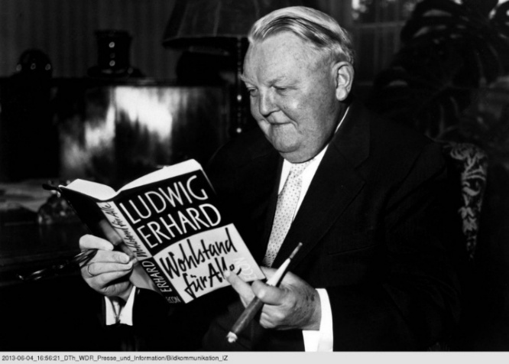W Germany also had a generous **welfare state**, especially in pensions: the pension reform in 1957 raised a n employee’s pension to 60% of his /her final earnings compared with only 29% in GB. This & the increase in sick pay that year contributed to Adenauer’s election victory. Unemployment & child benefits (introduced in 1954) were also particularly generous.

This welfare state was at least as generous as that which existed during the Weimar Republic (in fact the system of unemployment benefit was based on the law of 1927) but could now be afforded b/c of economic growth: the welfare budget nearly quadrupled in the 1950s but increased only slightly as a % of GNP.

Housing was another great success, e.g. 6 million new flats were built 1949-61.

1. **The Political Consequences of this.** A British journalist said of the Germans in 1952, “Prosperity means they have turned away from the Nazi past”. By 1963 the% of Germans who thought that the Federal Republic was the time when things had gone best for Germany rose from 2% in 1951 to 62% in 1963, while the % of those who thought the pre-war Nazi period was best fell from 42% to 10% & those who thought the Kaiser’s time was best from 45% to 16%.

Stewart Easton, a British historian writing in 1968, concluded that “The vast majority of West Germans were satisfied with the West German constitution in a way that was never true of the Weimar Republic. The Nazis were discredited and the Communists gained less support because of the dislike of East Germany … The Republic was consistently prosperous and there was little unemployment in the 1950s. There was no test of democratic institutions such as there was in the Great Depression”.

It also kept the **CDU / CSU** continuously in power 1949-69, **allowing Adenauer to continue as Chancellor for 14 years** (1949-63), almost as long as the Weimar Republic which had 17 Chancellors in the same length of time. Although Erhard was the true architect of the Wirtschaftswunder, Adenauer got most of the political credit for it & this enabled him to cling on to power even after 1961 when he was clearly losing his grip, his CDU colleagues were growing weary of him & the SPD were becoming more credible under the leadership of Willi Brandt.

Conclusion

It could be said that the Basic Law was much more effective in establishing democracy than the Weimar Constitution, but this would be a superficial (shallow) judgement. Just as the Weimar Constitution was not the main reason for the Republic’s failure, neither was the Basic Law the main reason for the FRG’s success; in both cases **economic** circumstances (inflation & the Depression in the Weimar case, the Wirtschaftswunder in the FRG case) were much more important. It could even be said that the 5% rule & the banning of “extreme” parties was undemocratic, though it also helped to reduce opposition to Adenauer’s CDU.

**OTHER REASONS FOR ADENAUER STAYING IN POWER FOR SO LONG**

Adenauer’s Personal Role

Adenauer was already a skilled & experienced politician before he became Chancellor in 1949 as Mayor of Cologne during the Weimar Republic. For most of his chancellorship, this “**Chancellor Democracy**” had the effect of making him indispensable & therefore prolonging his period in office.

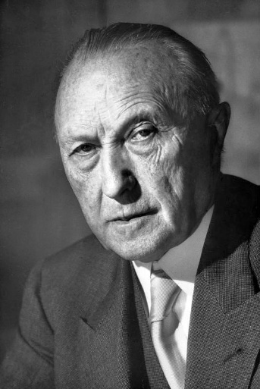This was particularly truebefore the Occupation Statute (Law) ended in 1955 when the FRG’s sovereignty was still limited: during this period Adenauer served as **Foreign Minister as well as Chancellor** b/c he believed that only he could handle W Germany’s relations with her western allies.

He had popular policies like securing the release of **German prisoners of war** from the USSR in 1955.& popular **welfare** measures like supporting home ownership, child benefit, maternity rights & above all generous old age pensions; his pension reform of 1957 certainly contributed to his landslide election victory that year.

**BUT:**

* Even though voters gave Adenauer the credit for the Wirtschaftswunder, in reality **Erhard** was the true architect of it & Adenauer largely left economic policy to him.
* Adenauer’s foreign policy successes were mainly the result of **favourable circumstances** like the Cold War; the US & the British disliked him personally but needed a strong Germany in NATO to resist the Soviet threat.
* In later years Adenauer’s **patronising, authoritarian style** became increasingly irksome even to his political colleagues; he mishandled the Berlin Wall & the Spiegel affair.

Strengths of the CDU

The CDU was a highly successful “broad church” recruiting members of at least 4 former parties from the Weimar era & appealing to both former Nazis & anti-Nazis (Adenauer was personally anti-Nazi but encouraged former Nazis to join his party & take an active political role). **It succeeded in uniting the centre-right in German politics as no party had ever done before**.

Support of other Parties

It was also successful in allying with other parties, especially the **CSU**, a separate party with similar views with which it was permanently allied, & the liberal **FDP** which as a pro-business party felt it had more in common with the CDU than with the Socialist SPD. All Adenauer’s governments were coalitions (multi-party) & he could neither have gained power in the first place nor retained it for so long without other parties’ support.

Weaknesses of the SPD Opposition

The SPD, Adenauer’s main rivals, had difficulty adapting to the success of Adenauer’s policies of the social market economy & integration with the West. Initially they made the mistake of opposing them; in later years they were more ambivalent but also more **divided** about them.

Not until after their 3rd successive election defeat in 1957 did they abandon the **outdated Marxist theories** about class conflict which had little influence on policy but turned off moderate voters.

The SPD never had much appeal to middle class voters & were especially weak in Catholic & rural areas.

Foreign Policy Successes

Adenauer’s domestic position was boosted by a series of foreign policy successes:

* Gaining US recognition & support, shown by the Marshall Plan
* The end of US, British & French occupation in 1952
* The suppression of anti-Communist unrest in the GDR in 1953 increased support for Adenauer in the 1953 election.
* Gaining full sovereignty, the right to have her own army (right) & to join NATO (1955) with US & British support
* Improved relations with her Western European neighbours, through the European Coal & Steel Community (1951), EEC (1957) & the Organisation for European Economic Co-operation (1961), which boosted trade & prosperity
* Bringing Prisoners of War home from the USSR (1955)
* Regaining the Saar (1957).

The Discrediting of Extremism

Stewart Easton, a British historian writing in 1968, concluded that “The vast majority of West Germans were satisfied with the West German constitution in a way that was never true of the Weimar Republic. The **Nazis** were discredited and the **Communists** gained less support because of the dislike of East Germany … The Republic was consistently prosperous and there was little unemployment in the 1950s. There was no test of democratic institutions such as there was in the Great Depression”.

**HOW SUCCESSFUL WAS ADENAUER’S FOREIGN POLICY?**

Successes

* 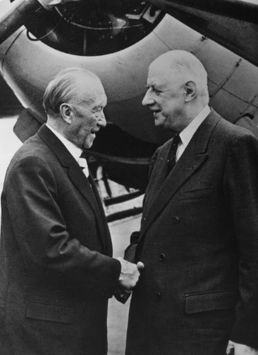Adenauer was highly successful in integrating Germany with her western European neighbours, especially France, the Netherlands & Belgium, as shown by, the formation of the Organisation for European Economic Co-operation (**OEEC**) in 1948, the Schuman Plan in 1950, the European Coal & Steel Community (**ECSC**) in 1951 & the European Economic Community (**EEC**) in 1957.
* His policy of integrating with Western Europe, GB & the USA boosted trade & helped to secure Marshall Aid, contributing to the **Wirtschaftswunder**.
* He established especially close relations with **France**, enabling him to head off French demands for the separation of his native Rhineland from the rest of Germany & regain the Saar. He was particularly close to President de Gaulle (right), with whom he signed the French-German Treaty in 1963 which has put the close friendship between the 2 countries on a permanent footing.
* He also managed to restore Germany’s **international reputation** after the atrocities of the Nazi period, e.g. by agreeing a compensation deal with Israel in 1952.
* At the same time he appeased nationalist opinion at home, e.g. by refusing to accept the Oder-Neisse Line & in 1955 securing the return of **German prisoners of war** (10,000 soldiers & 20,000 civilians) from the USSR.
* He was **probably right to reject Stalin’s offer of a united Germany in 1952**, given the absence of guarantees that there would be genuine democracy in E Germany & that Germany could be military secure without being allied with the West. Adenauer recognised that Stalin’s real aim was to prolong negotiations to delay or prevent WG joining NATO & his policy of ensuring that W Germany’s superior economy (the “**magnet theory**”) would eventually lead to re-unification was proved right in the long term.
* The failure of the European Defence Council (EDC) in 1954 turned out to be a success for Adenauer b/c it allowed him to achieve his ambition of W Germany being allowed its **own army** & to join **NATO** (both of which happened in 1955).
* The ending of the “Occupation Statute” in 1955 meant that Germany gained **full sovereignty** over her own territory except for W Berlin where her former enemies (USSR, France, GB & USA) had continued military rights.
* Despite Khrushchev’s threats **W Berlin** remained completely free of Communist influence. This was confirmed by President Kennedy’s visit & “ich bin ein Berliner” speech in 1963.
* The **Saar** was regained from France in 1957.
* Adenauer succeeded in isolating the GDR (E Germany) through the **Hallstein Doctrine**; the GDR was denied international recognition except in the Communist bloc.

Criticisms

* It could be argued that Adenauer’s policy of integration with the West made re-unification impossible. As Mary Fulbrook has argued, **“Western integration was pursued by Adenauer at the expense of the possibility of a united Germany”.** A British diplomat at the time reported him as saying “he felt that integration with the West was more important than the unification of Germany”. Unification was a distant prospect in 1963 & Adenauer should at least have tested Stalin’s offer in 1952 to see whether he was sincere (& expose him if he was not) rather than simply reject it. *Right: an SPD election poster calling for a united Germany, implicitly criticising Adenauer’s policy.*
* His relations with France were much closer than with the **USA** or **GB**, neither of whom trusted him, e.g. Kennedy thought he was a relic of the past.
* He was helped by **favourable circumstances** beyond his control, e.g. by the Korean War (1950-3) which boosted German exports & (by increasing US hostility to the USSR) led to W Germany being allowed to have its own army & join NATO. In general the USA & GB didn’t trust him but needed W Germany as an ally against the USSR.
* The **Hallstein Doctrine** could only be applied to smaller countries like Yugoslavia (WG cut off diplomatic ties with Yugoslavia in 1957 b/c she had diplomatic ties with the GDR); it had to be ignored as far as the USSR was concerned (b/c the USSR was so important) & was unsustainable in the long term.
* There was nothing Adenauer could do to stop the **Berlin Wall** being built in 1961 & his inadequate response to it weakened his position at home.
* Adenauer’s distrust of US policy towards Berlin & his support for France’s refusal to let GB join the EEC (right) led to criticism from the **“Atlanticists”** in his Cabinet, led by the FDP ministers & Erhard’s supporters in the CDU, who thought he was too close to France at the expense of the USA & GB.