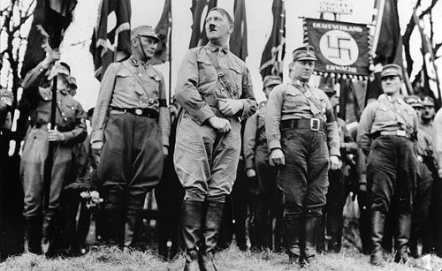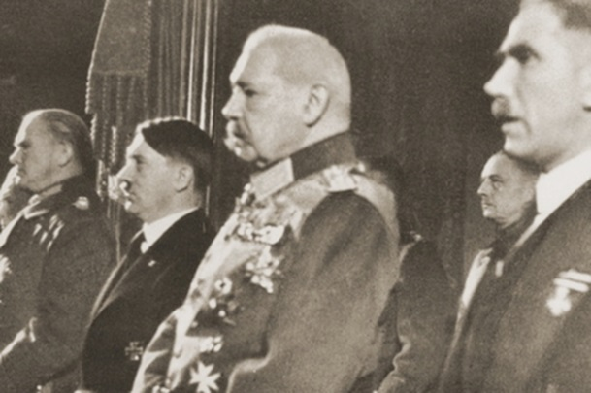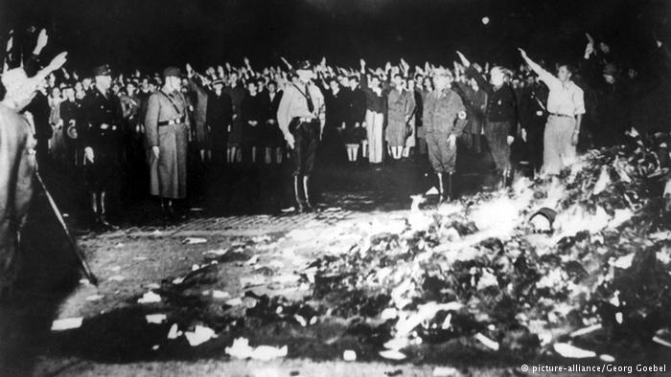

**Timeline of the Decline of Parliamentary Government in Germany**

(Use page40-41 of your lesson materials along with any work done in class. Try to include as much detail as possible and consider the timeline month-by-month where you can)

|  |  |  |
| --- | --- | --- |
| **Date** | **Event** | **Significance** |
| **1930** |  |  |
|  |  |  |
|  |  |  |
|  |  |  |
|  |  |  |
|  |  |  |
|  |  |  |
|  |  |  |
|  |  |  |
|  |  |  |
|  |  |  |

**Key Questions:**

1. Did the Nazi Party ***take*** or were they ***given*** in Germany in 1933?
2. Why was the Nazi Party able to gain public support in Germany
3. Can you identify and explain a ***turning point*** from your timeline in the decline of parliamentary government in Germany?