**The Establishment of the Nazi Dictatorship and its domestic policies, 1933-39**

[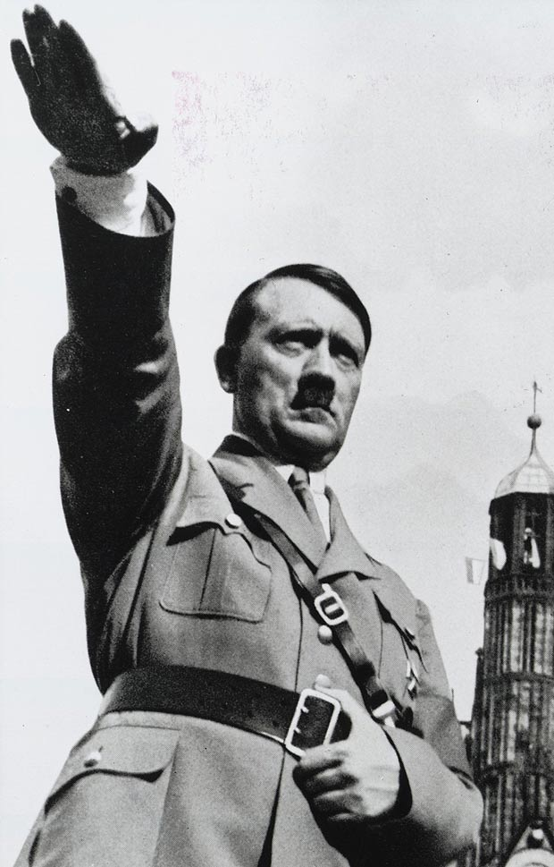](http://www.google.co.uk/url?sa=i&rct=j&q=&esrc=s&frm=1&source=images&cd=&cad=rja&uact=8&ved=0CAcQjRw&url=http://www.thesun.co.uk/sol/homepage/news/4692458/grimy-toilet-seat-from-hitlers-personal-lavatory.html&ei=vJtcVa3ZCIa27gbv24HYBw&bvm=bv.93756505,d.ZGU&psig=AFQjCNHKh5JgfztlsUAmeRiG1D1xQFnSDg&ust=1432218932254827)

**You need to understand the following:**

* Hitler’s consolidation of power: the Reichstag Fire, March Elections and Enabling Act; *Gleichschaltung*, creation of the one-party state, Night of the Long Knives, army oath and death of Hindenburg
* System of government and administration
* Censorship and propaganda
* Machinery of terror: courts, SS, Gestapo, treatment of opposition
* Religious policies
* Economic policies: Schacht’s New Plan, Goering’s 4 Year Plan, public works, conscription, autarky, German Labour Front, ‘Strength through Joy’
* Policy towards women, education and policy towards youth
* Racial policies to 1939

**Exam questions**

**A-level style:**

Which was of **greater importance** in **establishing the Nazi dictatorship**?

(i) The Enabling Act

(ii) The Night of the Long Knives

Explain your answer with reference to both (i) and (ii). [10]

**Old Specification questions:**

1. How successful were the Nazis in their policy of ***Gleichschaltung* (co-ordination)** after 1933? (Ja 09)
2. How successful were Hitler’s **economic policies** to 1945? (Ju 09)
3. “Their use **of terror** was the main reason why the Nazis **retained control** in Germany after 1933”. How far do you agree? (Ja 10)
4. To what extent did the Nazis achieve the aims of their **social policies**? (Ju 10)
5. **Economic recovery** was the **main** reason why the Nazis stayed in power after 1933”. How far do you agree? (Ja 11)
6. How successful was Hitler’s **economic policy** to 1945? (Ju 11)
7. To what extent did Hitler’s consolidation of power after March 1933 depend on **terror**? (Ja 12)
8. How successful were the Nazis in imposing their ideas about **society** on the German people? (Ju 12)
9. “Hitler’s **economic policies** failed to prepare Germany for war”. How far do you agree? (Ja 13)
10. Assess the reasons for the **lack of opposition** in Nazi Germany (Ju 13).

**Recommended reading**

**Textbooks**

# Geoff Layton, *Democracy and Dictatorships in Germany 1919-63* (Access to History series), 2nd edition. This is the OCR endorsed textbook.

* John Hite & Chris Hinton, *Weimar and Nazi Germany*, 2000, Section 2.
* Alison Kitson, *Germany 1858-1990: Hope, Terror and Revival*, 2001, chapters 8-11.

**Books and articles**

* Richard Evans, ‘Hitler’s Dictatorship’, published in History Review March 2005 (accessed via the History Today website).
* Ian Kershaw, *The Hitler Myth: Image and Reality in the Third Reich,* 2001.
* Lawrence Rees, *The Nazis: A Warning From History,* 2006.

*There is a very wide range of relevant literature on Nazi Germany available in the College library.*

**Fiction**

* Hans Fallada, *Alone in Berlin*

**Timeline**

|  |  |  |
| --- | --- | --- |
| **Consolidation** | **1933** | **30 Jan** Hitler becomes Chancellor  **1 Feb** Hitler persuades Hindenburg to dissolve the Reichstag  **4 Feb** Hitler’s government acquires power to ban political meetings and newspapers  **27 Feb** Reichstag Fire  **28 Feb** Decree for the Protection of People and State repeals civil liberties  **5 Mar** Election – Nazis win 43.9% of the votes but still have no majority  **8 Mar** First concentration camps announced by Interior Minister Frick  **23 Mar** Enabling Act passed by the Reichstag  **31 Mar and 7 Apr** Laws for the co-ordination of the states with the Reich  **2 May** Trade unions dissolved  **8 Jul** Concordat between Germany and Vatican  **14 Jul** Nazi party the only official party allowed to exist in Germany |
| **1934** | **30 Jun** Night of the Long Knives  **2 Aug** Death of Hindenburg; army swears an oath of allegiance to Hitler  **10 Aug** Hitler proclaims himself both Chancellor and President and adopts the title ‘Fuhrer’ |
| **Radicalisation** | **1935** | **Mar** Hitler announces that Germany is rearming; return of military conscription  **Sept** Nuremberg Laws deprive German Jews of citizenship |
| **1936** | **Mar** Hitler sends troops into the demilitarised Rhineland  **Sept** 4-Year Plan introduced to prepare the economy for war |
| **1937** |  |
| **1938** | **Mar** Anschluss with Austria  **Sept** Hitler gains the Sudetenland from Czechoslovakia at Munich  **Nov** Kristallnacht |
| **War** | **1939** | **Mar** Hitler seizes Czechoslovakia  **Sept** Invasion of Poland & outbreak of war. |

**Glossary**

|  |  |
| --- | --- |
| Anti-semitism | Hatred of the Jews |
| Aryan | Nazi term for non-Jewish German; technically, somene who speaks an Indo-European language |
| Autarky | National economic self-sufficiency |
| Bolshevism | Russian Communism; government by workers’ councils or soviets |
| *Blut und Boden* | ‘Blood and soil’: nationalist and racist romanticism which glorified the rural role of the peasantry |
| Chancellor | Leader, prime minister of Germany |
| Concordat | Agreement; in this context, the agreement signed by the Catholic Church and the Nazi government in 1933 respecting each other’s role |
| *Führerprinzip* | Leader principle; according to this, ultimate authority rested with Hitler and extended downward; orders would be followed to the letter |
| *Gauleiter* | Leader of a *Gau*, a regional unit of the Nazi party |
| *das Herrenvolk* | The ‘master race’ |
| *Gleichschaltung* | Co-ordination; under the Nazis a policy of bringing everything under state control. |
| *Lebensraum* | Living space; aim of German expansion in the east |
| *Mittelstand* | The German lower middle classes |
| *Reichstag* | German parliament |
| SA/*Sturm-Abteilung* | Storm troopers; Nazi paramilitary organisation |
| SD/*Sicherheitsdienst* | Security service; intelligence service of the SS |
| SS/*Schutzstaffel* | Protective squads; beginning as Hitler’s bodyguard, then the Nazi Party’s police force |
| *Untermenschen* | Used to mean ‘inferior people’ or ‘subhuman’ |
| *Volksgemeinschaft* | ‘People’s community’; the Nazi ideal community |
| *Weltanschaaung* | ‘World view’; a philosophy of life |
|  |  |
|  |  |
|  |  |
|  |  |
|  |  |

**Hitler’s Consolidation of Power**

In January 1933, the Nazis were the **largest party** in the Reichstag. The Nazi Party also held key positions in the **Cabinet**: Hitler was Chancellor whilst Frick was Interior Minister in the Reich and Goering was Interior Minister of Prussia. However, the Party did not possess an overall majority, even if they were supported by the nationalists, and a 2/3 majority was needed to change the Weimar Constitution. Whilst Nazis held key posts in the Cabinet, they numbered only **3 out of 12**, and the **President** could sack any of them at any point. At this stage, their survival was by no means guaranteed. **Within 18 months of being appointed Chancellor of Germany, Hitler had turned himself into a dictator. How did this happen?**

**Activity: How do you think Hitler would try to consolidate his position after his appointment as Chancellor in January 1933?**

Complete the task on p.169-171 of Hite & Hinton.

**Stage One: January – March 1933**

**Control at the centre**: During this period, Hitler gained the power to **bypass the Reichstag** and **enact laws on the authority of his Cabinet**. **Civil liberties** were suspended to enable him to arrest and imprison political opponents.

**Task:** Using Kitson p.151-153/Fulbrook and Williamson p.55-57 and p.63, complete the table below, explaining what happened for each event and how it contributed to Hitler’s consolidation of power.

|  |  |  |
| --- | --- | --- |
|  | **What happened?** | **How did it help to consolidate Hitler’s power?** |
| **The Reichstag**  **Fire** |  |  |
| **The March**  **election** |  |  |
| **The Enabling**  **Act** |  |  |

**Stage Two: April – July 1933**

**Control beyond the centre:** During this period, Hitler attempted to **bring any potential enemies under control**. Organised opposition was now almost impossible.

***Gleichschaltung: ’bringing into line’/’coordination’***

Weimar society was **plural**: a number of different interest groups were allowed to exist within the state, and these groups were potentially quite powerful and could exert pressure on the government in a variety of ways. These included trade unions, the Church, other political parties, the civil service, local government, courts and judges.

Hitler did not want to see his power limited by such groups. The policy of *Gleichschaltung*, therefore, aimed to eliminate such troublesome interest groups. By early 1934, the Nazis were able to create a one-party centralised Reich.

**Task:** Use Kitson p.154-155 to add notes to the spider diagram, explaining how each group was brought under control.

Only two groups survived the policy of *Gleichschaltung*: the **Church** and the **army**.

**Religious policy**

Germany had a strong Christian tradition, represented largely by Catholicism in the south, west, and east, and Protestantism in the north and centre. There was an obvious divide between Cristian beliefs and Nazi ideology which was based on war, violence, and a lack of compassion towards other human beings. Nevertheless, both organisations shared some common outlooks: most notably in respect for traditional cultural values (such as the importance of family life), and in their hostility to communism. There was also, particularly in Lutheran Protestantism, a tradition of respect for the state and nationalism. Anti-Semitism, too, was not totally alien to the Christian tradition.

Hitler wanted to replace Christianity with a new, assertive Aryan faith, and remove the churches as a potential obstacle to his reordering of the German people into committed followers of his totalitarian regime. Nevertheless, he recognised that he was not in a position to embark immediately on the implementation of his full vision: he did not want to alienate the considerable number of Christians in Germany by an outright attack on the churches, and so intended to gain control of, and support from, the Church hierarchies, before gradually reducing their influence.

**Task:** Summarise how the Nazis dealt with a) the Catholic Church and b) the Protestant Church.

**Catholic Church**

**Protestant Church**

Hitler succeeded in neutralising the role of the Catholic Church in politics by signing a **Concordat with the Pope in July**. This agreement exchanged a promise from Hitler that the Church would be left to run its own affairs, including Catholic schools, for a promise from the Pope that the Church would not interfere in political matters.

**The Army**

The other group escaping co-ordination was the **army**. Hitler was too dependent on its support and mindful that it was the only body who could still force him out of power. He was also dependent on a well-trained and highly disciplined force to implement his ambitious foreign policy.

The army retained its own traditions and indeed General von Blomberg banned army officers from joining the Nazi Party. Hitler began to win over the army when he met its senior officers in early February 1933 and promised to respect the army’s traditions and political neutrality, while enthusing them with the prospect of rearmament and re-introduction of conscription.

**By the end of 1933, Hitler’s power was extensive but not total:** he could still theoretically be dismissed by Hindenburg, the army could use its strength to force him from office and the SA could endanger Hitler’s relations with the army by demanding more power for themselves.

**Stage Three: January – August 1934**

**The final stage:** During this period, Hitler brought the **SA** firmly under his control and **won the support of the army**. He became the Führer of Germany after Hindenburg’s death.

***The Night of the Long Knives***

**Video:** ‘The Nazis: A Warning from History. Episode 2 – Chaos and Consent’, E-stream #10830, to 08.43

1. What did Röhm want for the SA?
2. Why were the army horrified?
3. Why did Hitler want to curb the power of the SA?
4. What happened to Röhm?
5. What did the army do?

**Why was Röhm a threat?**

Since the early 1920s there had been tension between Röhm’s view of the SA as the key body for seizing and retaining power, and Hitler’s view of it as having a subordinate role to the party. Hitler needed the support of the traditional elites if he was to solve unemployment and rearm Germany; consequently, in July 1933 he announced the end to the ‘legal revolution’ and began to reassure generals and industrialists that the revolutionary period of the Nazi takeover was at an end. The SA under Röhm, however, believed in a more radical Nazi revolution. Röhm also wanted the SA to form the basis for a new mass Nazi army; but Hitler had already made it clear that the traditional army would be the basis of the new German army.

The problem of the SA became urgent by the spring of 1934 because of Hindenburg’s ill health. It was possible the generals would attempt to block Hitler’s ambitions to succeed Hindenburg if they believed that the SA was threatening their role in rebuilding Germany’s armed forces. The army and conservative elites could even attempt to restore the monarchy after Hindenburg’s death in an attempt to control the Nazi regime.

In addition, Heinrich Himmler was keen for the SS to break away from the formal control of the SA. Goering also resented Röhm and led Hitler to believe he was planning a coup to embark upon a ‘second revolution’ – a social revolution which would see the SA merging with the army with Röhm in ultimate control. In addition, some conservatives, centred around Papen, were increasingly worried about the growing lawlessness and power of the SA. They realised that Hitler was not playing his ‘puppet’ role. Hitler would be in trouble if these groups gained the support of Hindenburg or the army. By acting against the SA, Hitler reassured his conservative supporters and also intimidated his conservative critics. **On the night of 30 June 1934, Röhm and other leaders of the SA were shot by members of the SS.** Hitler also eliminated his critics on the Right: two conservative monarchists in Papen’s office, Herbert von Bose and Edgar Jung, were also murdered, as well as other political enemies of Hitler, including Kurt von Schleicher and Gregor Strasser.

[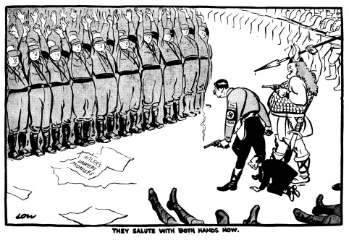](http://www.google.co.uk/url?sa=i&rct=j&q=&esrc=s&source=images&cd=&cad=rja&uact=8&ved=0CAcQjRw&url=http://www.cartoons.ac.uk/record/LSE2086&ei=pHJcVYr-F6Of7gb-54KICg&bvm=bv.93756505,d.ZGU&psig=AFQjCNEdfP_qQ3HyI2TQ-ZJcQULO1N9HxA&ust=1432208394514170)

**Activity:** Read p.160-161 of Kitson. Use the information to analyse the cartoon above:

1. Identify:

* The figures standing behind Hitler
* The victims whose feet appear at the bottom of the cartoon
* The men with both arms raised
* The line of men in the top right hand corner

1. What is meant by ‘unkept promises’? Was this a justified accusation?
2. What is the meaning of the phrase ‘They salute with both hands now’?
3. How accurate is this cartoon as a portrayal of the Night of the Long Knives?

**Task:** Using Kitson p.160-163, complete the table below, explaining what happened for each event and how it contributed to Hitler’s consolidation of power.

|  |  |  |
| --- | --- | --- |
|  | **What happened?** | **How did this contribute towards Hitler’s**  **consolidation of power?** |
| **Night of the**  **Long Knives** |  |  |
| **Army oath** |  |  |
| **Death of Hindenburg** |  |  |

**Activity: What was the most important factor in Hitler’s establishment of a Nazi dictatorship?**

Rank the following factors in order of importance. Write a short paragraph to justify your choice:

*The Reichstag Fire; Night of the Long Knives; Enabling Act; Gleichschaltung; the death of Hindenburg & army oath.*

**The system of government & administration: How chaotic was Nazi government?**

**Video:** ‘The Nazis: A Warning from History. Episode 2 – Chaos and Consent’, E-stream #10830, from 11.58.

1. What was Hitler’s daily regime and style of government like?
2. What sort of image did Hitler project at the Nuremberg rallies?
3. How did this compare with reality, according to Ian Kershaw?
4. Describe how Hitler governed through his ambitious Nazi followers.
5. What was Hitler’s economic priority?
6. How did the Nazis rid Germany of unemployment?
7. What was the purpose of Nazi pageants like the Night of the Amazons?
8. How were Jews treated in the 1930s?
9. According to Robert Gellately, what was the operation of the Gestapo dependent upon?
10. How does this represent a change in historical thinking about the operation of the Nazi regime?
11. What was Goebbels’ role in the Third Reich?
12. How did Goebbels respond to the assassination, in autumn 1938, of the German diplomat Ernst vom Rath by Herschel Grynszpan, and what did this lead to?
13. In what sense was the system of government chaotic?
14. Why was access to Hitler’s mail seen as important & what policy demonstrates this?

In January 1933, this was **the system of government that Hitler inherited**:

* **Federal government**: individual states could decide their own policies in areas like education, leaving the central government in Berlin to deal with issues such as the economy and foreign policy.
* **Collective government**: policies were discussed amongst Cabinet members and a vote taken to decide on policy.
* **Laws** were passed by the Reichstag or sanctioned by the President in times of emergency.

Hitler **transformed** this system.

* The power of individual states was removed.
* **Collective government ended**. The Cabinet rarely met: 72 times in 1933, 19 times in 1934, 12 times in 1935 and 4 times in 1936. After 1938 it didn’t meet at all.
* Laws could be issued on the authority of the Cabinet alone, which in practice meant Hitler himself.
* Hitler **gave power to those he trusted** and who presented him with **good ideas**. This resulted in the creation of Supreme Reich Authorities, specialist agencies whose functions often overlapped with existing ministries.
* Hitler was the **single source of authority for everyone**, no matter if you worked in a ministry or an agency. He was therefore in the best position to co-ordinate policy: but he was not interested in the day-to-day affairs of government and neither did he show much interest in directing the specifics of domestic policy.

***What problems can you foresee with Hitler’s style of government?***

The Third Reich was characterised by a lack of a clear command structure, rival hierarchies and three overlapping centres of power:

1. **The central government together with its ministries and civil service.**
2. **The Nazi Party and the SS.**
3. **The charismatic dictatorship of Hitler, intervening at will.**

**Central government**

Hitler was anxious to emphasise that the new Nazi regime was in many ways linked to the great traditions of the German past. The government became a bewildering mixture of the old and new where freshly Nazi institutions flourished side-by-side with the traditional German organs of state: it was a **‘dual state’**, in which there appeared to be two forms of government at work at the same time: in this case, the pre-1933 ministries, civil service alongside the Nazi party and its organisations. Up to March 1933 the Cabinet met at regular intervals but after the passage of the Enabling Act its importance declined. By 1938, 7 important ministries of state were still in the hands of Conservative-Nationalist ministers. In many ways the power of the central departments of state increased because the Nazis had weakened the power of the federated states.

The civil servants who ran the government departments and their branches retained much of their traditional independence. In April 1933 the civil service was purged of Jews, Socialists and Communists under the **Law for the Restoration of the Professional Civil Service**, but this made up only 2% of the 1.5 million civil servants in the Reich. It was not until 1939 that all new entrants into the civil service had to be members of the Nazi Party.

**Task:** Using Hite & Hinton p.193-194, match up the eight institutions described with the descriptions of their changing role under Hitler’s dictatorship in the table below.

|  |  |  |  |
| --- | --- | --- | --- |
|  | Name of institution | Evidence that the Nazis took control | Evidence that the institution retained independence/was not controlled by Nazis |
| 1. Lost its proper role, rarely met after 1933, and contained only Nazis |  |  |  |
| 1. Central government body which was kept but fell into disuse |  |  |  |
| 1. The old democratic system was replaced by centrally appointed officials |  |  |  |
| 1. A conservative body whose members eventually had to join the Nazi Party |  |  |  |
| 1. Initially kept intact but bypassed by Nazi bodies, and eventually staffed by Nazis |  |  |  |
| 1. Traditionally independent from government and protecting the rights of the individual, this institution was co-ordinated to follow the government’s will more closely |  |  |  |
| 1. Hitler worried about this body as a rival and did not reorganise it until he felt totally established in 1938 |  |  |  |
| 1. This government office developed into a massive bureaucratic machine |  |  |  |

Now write a conclusion to answer this question: **To what extent did the traditional elites maintain their power in Nazi Germany?**

Supreme Reich authorities

Parallel to the traditional departments of state, Hitler created several new departments which combined both party and state responsibilities; their leaders were prominent Nazis who reported directly to Hitler. In that way they could force through their own policies independently of the other departments. For example, Fritz Todt, Hitler’s road-building expert, was able to implement the Autobahn programme, despite opposition from the Ministries of Interior, Finance and Transport. Other supreme Reich authorities were the Labour Service, the Hitler Youth and the Four Year Plan. They challenged the existing ministries and contribute to the intense rivalries in Nazi government.

**The Nazi Party and the State**

**The Party had a number of problems from 1933 which prevented it from becoming all-powerful:**

* A mass of specialist Party organisations had been formed in the 1920s to attract support from different sections of society. These included the Hitler Youth, the SA and the National Socialist Teachers’ League. Once in power, these groups were keen to uphold and advance their own particular interests.
* The party became increasingly splintered. Some institutions were caught between the state and the party – for example, Goebbels’ propaganda machine was a newly formed ministry and the Four-Year Plan Office was added in response to the economic crisis of 1936.
* Membership and administrative structure was established on the basis of the *Führerprinzip*, but it did not work in terms of effective government. The system led to the dominating role of the *Gauleiters* in the regions (for example, Karl Hanke in Lower Silesia and Karl Kaufmann in Hamburg). The *Gau* area normally coincided with the Reichstag electoral district and the Nazi *Gauleiter* normally became the Reich governor, exercising effective control in the province. They believed their only allegiance was to Hitler so tried to preserve their own interests and tended to resist the authorities of the state and the party.

In 1935 **Rudolf Hess** was granted the right to vet the appointment and promotion of all civil servants, and to oversee the drafting of all legislation. By 1939 it had become compulsory for all civil servants to be party members.

Working alongside Hess, **Martin Bormann** correctly analysed the problems confronting the party and created two new departments with the deliberate aim of strengthening the party’s position:

* The **Department for Internal Party Affairs**, which had the task of exerting discipline within the party structure
* The **Department for Affairs of State**, which aimed to secure party supremacy over the state.

**The charismatic leadership of Hitler: ‘Working towards the Führer’**

The cult of Hitler was all-pervasive: his image was projected across Germany; he was regularly compared to Bismarck and Frederick the Great; his birthdays were celebrated with parades and torchlight processions; his actions were often celebrated in religious language, with Biblical echoes.

The key to the Hitler dictatorship was the *Führerprinzip* or the *Führer* principle: the principle that the *Führer* cannot be wrong and must be obeyed at all times. This meant his will was law throughout the Party and, after 1933, theoretically at least, throughout Germany. Yet despite this, he played virtually no part in the day-to-day government of the Reich. He avoided making decisions, stood back and let events take their course. Sometimes he made vague declarations of intent or principle. Ministers and officials had little contact with him, especially when he retreated to his isolated chalet in the Berghof. Consequently, they were compelled to interpret his intentions for themselves, often coming to contradictory conclusions. This became known as ‘working towards the *Führer*’.

**Task:** Read pp186-7 of Hite & Hinton & answer the following questions:

1. [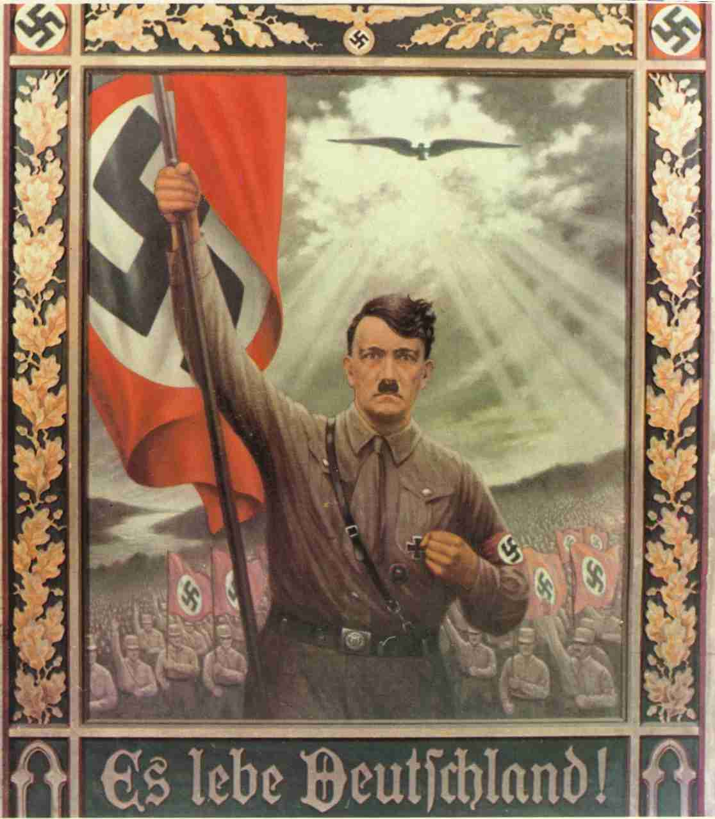](http://www.google.co.uk/url?sa=i&rct=j&q=&esrc=s&source=images&cd=&cad=rja&uact=8&ved=0CAcQjRw&url=http://www.newthinktank.com/2011/08/nazi-propaganda-posters/&ei=HiiIVdyzKYLhywO6_pV4&psig=AFQjCNHjSfGEbWYmD_uaWZo2rKaI37bGig&ust=1435072875737338)What was Hitler’s role in policy making?
2. Why was it so unclear what the “will of the *Führer*” actually was?
3. What was Hitler most interested in & what was the result of this?
4. What effect did the chaotic & competitive nature of Nazi government have on policy?
5. What different reasons are given in Sources 11.7 & 11.9 for the chaotic nature of Nazi government?

**Task:** Study the four examples of decision-making on p.191 of Hite & Hinton and assess what they show about the role of Hitler in the Third Reich. What evidence, if any, do they provide of the following roles for Hitler:

1. The direct initiator of action
2. Controlling policies
3. The overall inspirer of policy
4. Responding to others’ proposals and actions
5. Opting out of a clear decision

**Methods of Control: Censorship, Propaganda and Terror**

[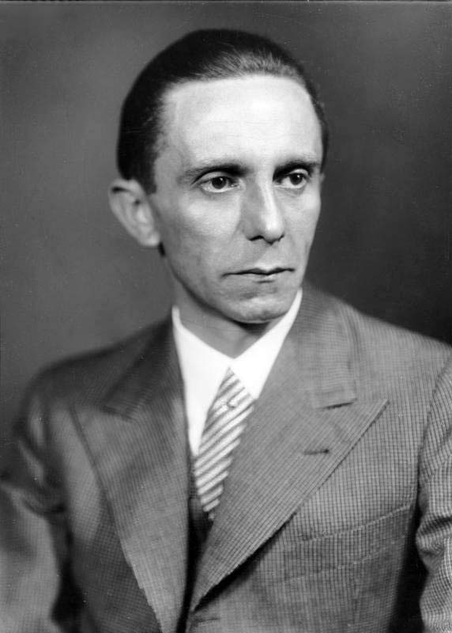](https://www.google.co.uk/url?sa=i&rct=j&q=&esrc=s&frm=1&source=images&cd=&cad=rja&uact=8&ved=0CAcQjRxqFQoTCJuE2-jk38gCFcu6FAodEL0JzQ&url=https%3A%2F%2Fen.wikipedia.org%2Fwiki%2FJoseph_Goebbels&psig=AFQjCNE_FrYqIK28VJJyDOW_jHz_2VKWwg&ust=1445936890107665)

**Censorship and propaganda**

The Nazi regime sought to win over public opinion and create a new Nazi culture which glorified war and the Aryan race. This involved projecting a positive image of Nazi culture and achievements and censoring hostile ideas and inconvenient facts in the media, art, literature and theatre.

The head of the Propaganda Ministry was **Joseph Goebbels** (right). Within the Ministry departments were set up to deal with the press, film , radio, theatre and a programme of ‘popular enlightenment’ to ‘enlighten’ or brainwash the German people into accepting the Nazi ideology.

**Task:** Use Layton, p.166-173, and other sources available to you to complete the following table.

|  |  |  |  |  |
| --- | --- | --- | --- | --- |
|  | Steps taken to bring it under Nazi control | Nazi message it was used to promote | Examples | Extent of success? |
| Radio |  |  |  |  |
| Press |  |  |  |  |
| Drama and music |  |  |  |  |
| Literature and art |  |  |  |  |
| Film |  |  |  |  |

**The court system, SS and Gestapo**

Crucial to the survival of the Nazi regime was its ability to eliminate its enemies and to terrorise the population into obedience. While the existing courts could be used to sentence the enemies of the *Volksgemeinschaft*, these were backed up by a machinery of terror: the SS, the Gestapo and the concentration camps.

**The courts**

* **New laws** were introduced to deal with political offences. E.g. from December 1934 anyone convicted of making ‘hateful’ remarks about the Nazi state and its leaders could be executed.
* **People’s courts** were set up to try communists and other enemies of the regime.
* **Judges** were instructed to be much tougher in sentencing criminals.
* Pressure was placed on lawyers and judges to carry out the wishes of the government. In April 1942 the government announced that it would remove from office ‘judges who clearly fail to recognise the mood of the hour’. This enabled the Nazis to **interfere directly in trials**.
* 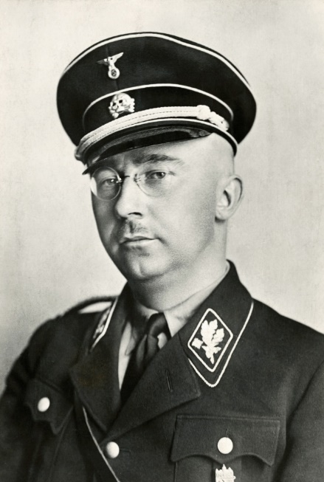In August 1942 **Otto Thierack** was appointed Minister of Justice and the senior officials and the ministry were replaced by men who were more loyal to the Nazis. From now on it became the norm for public prosecutors, who represented the Nazi state, to indicate to the judges beforehand what their verdicts should be.

**The SS *(Schutzstaffel)***

* Created in 1925; originally Hitler’s personal bodyguard.
* 280 members in 1929; by late 1930s it was a vast organisation involved in most aspects of the Third Reich, a ‘state within a state’.
* Alongside the Gestapo, it was the most powerful and feared of the organs of repression in Nazi Germany.
* It was led by **Heinrich Himmler** (right) and under his leadership it took over responsibility for the party’s intelligence and espionage section (SD).
* The SS used the Emergency Power Decree of February 1933 to take suspects into ‘protective custody’, consequently emerging as the chief police arm of the Nazi party. Between 1933 and 1939, 225,000 Germans were convicted and imprisoned for political crimes and by 1939 another 162,000 were in ‘protective custody’ without trial.
* Himmler had loyally supported Hitler against Röhm and as a result the SS was rewarded by being made independent of the SA.
* 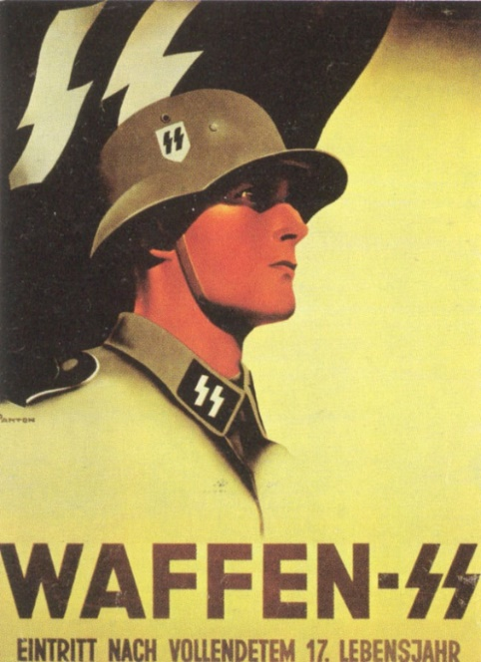In February 1936 Himmler also took control of the Gestapo. It now worked closely with the SS and the SD under the direction of **Reinhard Heydrich.**
* The SS directed its energies against all enemies of Nazism and took over responsibility for running the concentration and extermination camps.
* By 1939 there were 240,000 members organised into divisions. The main branch was the **Waffen-SS**, primarily a military organisation. The **Death’s Head** formations administered the concentration camps and formed panzer units; they were mostly young peasants who were trained to treat the inmates of the camps brutally.

During the Second World War the influence of the SS increased hugely; Himmler was given responsibility for the resettlement of ethnic Germans from Poland and elsewhere back into Germany. He was also responsible for eliminating ‘the harmful influences of such alien parts of the population as constitute a danger to the Reich and the German community’ in the occupied and incorporated territories. Effectively, he had a free hand to deport and later murder Jews, gypsies, Poles and Russians in the concentration camps.

**The Gestapo: the ‘all-seeing, all-knowing arm of state security and law enforcement’?**

* The Gestapo were the **political police** and their aim was to ‘wage war’ against the political and asocial enemies of the state.
* Werner Best, the legal expert at Gestapo headquarters, described the duty of the police to watch over ‘the health of the German body politic’ to recognise ‘every system of sickness’ and destroy all ‘destructive cells’.
* The Gestapo’s power was such that it had **complete freedom to operate outside the law.**
* In September 1939 Himmler amalgamated the SD, Gestapo and the Reich Criminal Police Department into the Reich Security Head Office. New powers enabled the Gestapo to arrest anyone who dared voice doubts about the war or who listened secretly to the BBC’s foreign broadcasts.
* Although the Gestapo was feared, **in reality it was a very small organisation**, in 1939 consisting of about 20,000 men (of these, 3000 were also members of the SS). Most Gestapo officials were office workers who spent their time creating and then updating card indexes in which the particulars of Communists, Social Democrats, ‘deviants’ and grumblers were kept.
* The Gestapo were dependent on **informers** for most of their information.
* These informers could be dedicated Nazis or simply those with a desire to get even with difficult neighbours, or colleagues at work.

**Task:** Use Hite & Hinton p.202-205 to answer the following questions.

1. What roles were played under the Nazi regime by the SS and Gestapo?
2. Explain how Himmler and the SS became so powerful in the Third Reich.
3. What do recent historians’ analyses suggest about the nature of the Nazi state?
4. What evidence is there that the Nazi police forces were not alien institutions imposed upon the German people?
5. Laurence Rees in his book *The Nazis: a Warning from History* writes: ‘I still have the image in my mind of Frau Kraus as we left her, after the interview… a profoundly unexceptional figure and thus a deeply troubling one’. Explain his comment.

**The concentration camps, prisons and the treatment of opposition**

* Established in 1933 and used in the SA’s campaign of violence against Socialists and Communists.
* They were disliked by many Germans, including Hitler’s Nationalist allies, and as a result many were closed over the following year.
* In June 1933 Himmler appointed **Theodore Eicke** as Inspector of the Concentration Camps and he introduced a more disciplined regime.
* **Dachau** became a model for all future concentration camps in Germany. New punishment regulations aimed to stop random personal violence by guards and instituted a disciplined bureaucratic system to ensure that all punishments were recorded and carried out by several SS men rather than by an individual.
* By the time Himmler took over responsibility for all the concentration camps in Germany, there were only 3000 inmates, indicating that the Nazis had virtually eliminated the Communist and Socialist opposition. Himmler therefore closed down all but Dachau, Sachsenhausen, Buchenwald and Lichtenburg, the latter being a camp for women.
* There were, however, still 14,000 political prisoners in the state prisons.
* In February 1936 the SS and Gestapo also started to round up habitual criminals, asocials and homosexuals.
* By July 1937, 57% of the inmates in Dachau were not political prisoners, but tramps and professional criminals.
* In December 1937 a law was passed permitting the arrest and imprisonment of anyone believed to not fit the ‘People’s Community’. This was used to include beggars, gypsies, homosexuals, the long-term unemployed and even traffic offenders.
* By 1939 the concentration camp population had grown to 21,000 and two new camps ant Flossenburg and Mauthausen had been opened for asocials and criminals.

The machinery of terror was a major factor in Hitler’s consolidation of power. In the first 3 years the Gestapo and SS broke the political opposition to the Nazi regime and then were able to move on and deal with the ‘enemies’ of the People’s Community.

In reality there were few Gestapo agents and only four concentration camps in 1939, but their reputation cast a shadow over the German people: they represented what could happen to you if you were reported.

Nevertheless, **full employment, foreign policy successes and a feeling of national unity** also helped to make the Nazi regime **genuinely popular** with many Germans.

In addition, the machinery of terror **did not completely eliminate dissent**. Historians have used the term ***resistenz***, or immunity, to describe how some groups of Germans (for example, Christians) were at times able to block out or restrict the penetration of Nazi ideas. There were many people who rejected elements of National Socialism and who tried for example to avoid giving the ‘Heil Hitler’ salute, or who on saints’ days would hang out a church banner rather than the swastika. In addition, humour and anti-Nazi jokes were used as a low-key expression of resistance to the regime – this was risky, however, and could lead to imprisonment in a concentration camp or even execution for undermining morale. Some individuals went further, however.

**Task:** In small groups, research one of the 5 individuals below. Find out a) how they were involved in resistance to the Nazi regime, and what form this resistance took, b) what happened to them and c) how successful they were. Present your findings in a powerpoint to show to the class.

|  |  |
| --- | --- |
| **[Dietrich Bonhoeffer lived from 1906 to 1945.](http://www.religionnews.com/2014/07/03/dietrich-bonhoeffer-gay-new-biography-raises-questions/rns-dietrich-bonhoeffer/)Dietrich Bonhoeffer** |  |
| **Georg Elser**  [https://static1.squarespace.com/static/53323bb4e4b0cebc6a28ffa2/53573350e4b0758dd79db484/53b5779be4b07e35bb10ace5/1404403882325/toto-elser1-BM-Berlin-ZDF.jpg?format=1000w](http://www.google.co.uk/url?sa=i&rct=j&q=&esrc=s&frm=1&source=images&cd=&cad=rja&uact=8&ved=0CAcQjRw&url=http://www.latino-review.com/news/hirschbiegel-bringing-georg-elser-to-the-screen&ei=lc-TVcXnK8OY7gbkzZ3YAg&bvm=bv.96952980,d.ZGU&psig=AFQjCNG7bQrz8xzmSjFUnzu9tDVMB0Snng&ust=1435836682770863) |  |
| **Claus von Stauffenberg**  [https://upload.wikimedia.org/wikipedia/commons/e/e3/Claus_von_Stauffenberg_(1907-1944).jpg](https://www.google.co.uk/url?sa=i&rct=j&q=&esrc=s&frm=1&source=images&cd=&cad=rja&uact=8&ved=0CAcQjRw&url=https://en.wikipedia.org/wiki/Claus_von_Stauffenberg&ei=us-TVfLEB-2v7AbD4rfYAg&bvm=bv.96952980,d.ZGU&psig=AFQjCNEIfQ77HVyEfixtaeH0_tXMioBOkQ&ust=1435836710005077) |  |
| **http://vignette1.wikia.nocookie.net/wolfenstein/images/2/2f/Kreisau_Circle_Symbol.png/revision/latest?cb=20111104143553The Kreisau Circle** |  |
| **[https://findingtimetowrite.files.wordpress.com/2015/03/sophieschollbundesarchivde.jpg](https://www.google.co.uk/url?sa=i&rct=j&q=&esrc=s&frm=1&source=images&cd=&cad=rja&uact=8&ved=0CAcQjRw&url=https://findingtimetowrite.wordpress.com/tag/sophie-scholl/&ei=7NGTVdTBPIWO7AbuxZb4Ag&psig=AFQjCNE2xvr8jH6_-ws-86A16i0CsqgTlA&ust=1435836803016902)Sophie Scholl** |  |

**How successful was Nazi economic policy?**

When Hitler was appointed Chancellor there were nearly 6 million people unemployed; by 1935 there were only 2 million, and by 1939 there was a shortage of labour. This transformation helps explain not only why Hitler was able to consolidate his position in power, but also why he became so popular. Reducing unemployment was an important Nazi success; but Hitler had broader aims – his top priority was to expand the military might of Germany and prepare the country for war.

**Hitler’s Economic Aims**

1. **Reduce unemployment:** Hitler promised to solve the unemployment problem within four years of taking power.
2. **Rearm:** this would help ‘kick-start’ economic recovery, but it was also an ideological aim.
3. **Autarky:** the Nazis aimed to transform the German economy into a self-sufficient system, which would manufacture and grow everything Germany needed; it was seen as necessary to prevent a repeat of the problems Germany faced in WW1 with the British naval blockade. The rearmament drive created a massive demand for oil and rubber, which Germany did not have her own supplies of. The Nazis therefore tried to produce them artificially to minimise the need for imports:
4. Synthetic oil was made from coal, which Germany did have ample supplies of.
5. Buna (synthetic) rubber was made from acetylene.
6. **Help for *Mittelstand* (the German lower middle classes) and farmers:** the Nazis had aimed much of their electoral propaganda at this group – small shopkeepers hated the big department stores (which they contended were owned by the Jews) because they could sell services and goods more cheaply than they were able to.
7. **Aryanisation** of Jewish owned firms by destroying or taking over their businesses. For example, Hertie, the department store chain in Berlin. This process was completed after Kristallnacht.

[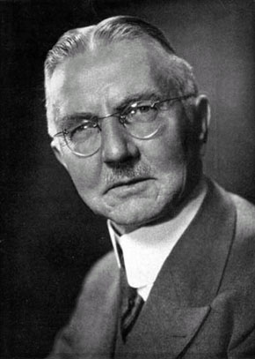](http://www.google.co.uk/url?sa=i&rct=j&q=&esrc=s&frm=1&source=images&cd=&cad=rja&uact=8&ved=0CAcQjRxqFQoTCLLvsojm38gCFQVYFAodoaQFnQ&url=http%3A%2F%2Fgreyfalcon.us%2Frestored%2FThe%2520Nazi%2520Connection%2520to%2520the.htm&bvm=bv.105841590,d.d24&psig=AFQjCNGMT9DcgDA3MEH-8IO-xCc9BiyPiw&ust=1445937224558095)**The Nazi economy can be divided into 3 broad periods:**

* Recovery: 1933-36
* Rearmament: 1936-39
* War: 1939-45 (covered in a later booklet)

**Recovery, 1933-36: Hjalmar Schacht and the New Plan**

**Hjalmar Schacht** (right) was appointed President of the Reichsbank in March 1933 and Minister of Economics 1934-7. A respected international financier because of his leading role in the creation of the new currency in the wake of the 1923 hyperinflation, this indicated the need of the Nazi leadership to work with the powerful forces of the economic elites. Schacht used a policy of **deficit financing** to boost the economy. However, by 1934 the revival of the economy was causing concern because of a balance of trade deficit. The **New Plan** tackled this problem, giving the government strong powers to regulate imports. This helped to overcome the immediate balance of trade problem in 1934 but there was still the problem of increased demand sucking in imports, especially as the pace of rearmament grew.

[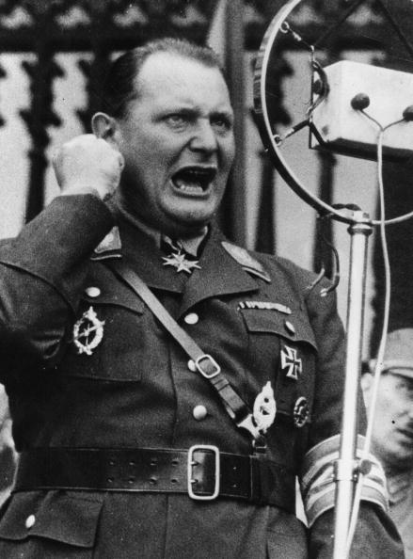](http://www.google.co.uk/url?sa=i&rct=j&q=&esrc=s&frm=1&source=images&cd=&cad=rja&uact=8&ved=0CAcQjRxqFQoTCPLV8LHm38gCFQZvFAodWDcNUQ&url=http%3A%2F%2Fwww.ibtimes.co.uk%2Faurochs-how-hitler-goering-resurrected-extinct-species-make-nazi-super-cows-1482161&bvm=bv.105841590,d.d24&psig=AFQjCNGW1RVORfFZSaaCVj4r2Ex3M9zd8A&ust=1445937309807675)**Rearmament, 1936-39: Goering and the Four-Year Plan**

By 1936 Schacht was becoming increasingly concerned at the distortion of the economy due to rearmament – severe strains due to a **budget deficit** and increasing **balance of payments** problems were occurring. Schacht wanted to encourage exports and slow the increase in arms expenditure. Hitler became impatient with his caution and on 4 September 1936 put **Hermann** **Goering** (left) in charge of a new economic organisation, the **Office of the Four-Year Plan**. This aimed to make Germany ready for war within four years. Priority had to be given to rearmament, and Germany had to made self-sufficient as possible in food and industrial production, a policy known as **autarky**.

**How successful were Nazi economic policies, 1933-39?**

Successful

* Schacht used **Mefo bills** to finance increased public expenditure without causing inflation. These were credit notes issued by the Reichsbank and guaranteed by the government.
* The economic depression reached its low point in the winter of 1932-33 and afterwards the trade cycle began to improve.
* Financial benefits were given to **farmers and small businesses**, stimulating economic growth and rewarding some of the most sympathetic supporters of the Nazis in the 1930-33 elections. Some measures included tariffs on imported produce to protect German farmers and subsidies from the Reich Food Estate.
* The state increased spending on a range of investment projects. **Work creation schemes** like reforestation, land reclamation, motorisation (e.g. building the *Autobahnen*), expanding the housing sector and public buildings contributed to the **fall in unemployment from 6 million 1932 to 1.6 million in 1936 to virtual full employment by 1938**; GB still had over 1 million unemployed 1939. A billion *Reichsmarks* were invested in such schemes.
* The **Reich Labour Service (RAD)** took the young off the unemployment register (400,000 in 1934) and from 1935 conscription removed all 18 to 25 year old males who were required to do military service for two years. The drop in unemployment was also aided by squeezing women out of the labour market by offering young couples who were about to get married an interest-free loan worth up to 1000 *Reichsmarks* for as long as the wife remained at home and did not re-enter the labour market until it was paid off. The loan was not issued in cash but in vouchers that had to be redeemed for goods such as furniture and household equipment.
* **Schacht’s New Plan** enabled the government to have comprehensive control over all aspects of trade, tariffs, capital and currency exchange. In effect imports had to be approved by the government.
* Schacht also made a series of **bilateral trade agreements**, especially with the Balkan states, which supplied much of Germany’s strategic raw material imports.
* **Industrial production** nearly doubled 1933-8.
* Under the **Four-Year Plan**, production of a number of key materials, such as aluminium and explosives, expanded greatly.
* By 1939 Germany was producing more than x4 as many **weapons** as GB and USA combined.
* By 1939 Germany was self-sufficient in **grain, potatoes and sugar.**
* **National income nearly doubled** 1933-8; virtually all Germans’ living standards rose, e.g. farmers’ by 41% 1933-8.

Not successful

* By 1934 imports (mainly of raw materials) rose much faster than exports, creating a **balance of trade deficit** which was persistent.
* Germany’s **gold and foreign currency reserves** were also running low by 1934.
* By 1936 Schacht was becoming increasingly concerned about the distortion of the economy due to rearmament. **National debt more than trebled** 1933-9 because of excessive spending on rearmament.
* From 1937 the German economy was entrusted to **Goering,** who had no economic expertise.
* Production of **rubber, oil and high quality iron ore** fell significantly short of the targets imposed by the Four Year Plan and arms production never reached the levels desired by the armed forces and Hitler.
* Indeed by 1939 Germany still depended on **foreign imports for 1/3 of its raw materials**, especially iron ore, oil and rubber. **Autarky had therefore not been achieved**: another method of ‘self-sufficiency’ was given more stress: conquering other countries to use their resources.
* Not until 1938 did real wages return to their 1928 level; in 1937 workers were drinking less beer and eating less well than in 1927, showing a lower standard of living.
* Economic growth was only impressive compared with the Depression; even by 1937 the German economy was only just above the level reached in 1912.

**Who gained most from the German economy?**

**Activity:** Complete the task ‘Who gained and who lost from the Nazi economy?’ task, on a separate sheet.

**Task:** Complete the following table, using Hite & Hinton p.227-233 and Layton p.194-198

|  |  |  |
| --- | --- | --- |
| **Social group** | **Benefits of Nazi rule** | **Drawbacks of Nazi rule** |
| **Elite and big business** |  |  |
| ***Mittelstand*** |  |  |
| **Workers** |  |  |
| **Peasants & Farmers** |  |  |

**Conclusions:**

1. Helped by the upturn in the economic cycle, Nazi efforts to revive the economy and create unemployment were successful, although their success was exaggerated. By the summer of 1934 unemployment had fallen to 2.5 million, but it remained fixed at that level until conscription and the acceleration of rearmament resulted in a further dramatic fall in 1936. By the summer of 1938 there was virtually full employment.
2. The small farmers and the *Mittelstand* did not benefit as much as they expected to from the Nazi regime. Hitler never closed the department stores and never attempted to weaken the influence of big business and industry. Farmers, however, enjoyed certain real benefits, but became frustrated by the bureaucracy of the Reich Food Estate and the government’s refusal to allow them to charge what they wanted for their crops.
3. As the pace of rearmament accelerated, the economy overheated and sucked in vast quantities of imports which were expensive to pay for. When the New Plan failed, Hitler rejected Schacht’s advice to slow down rearmament and instead announced the Four Year Plan. Regardless of cost, he was determined that Germany should be ready for war by 1940, but when war broke out the country was far from ready for a long war.
4. Despite huge investments, the actual production of war material was disappointing, as much of the investment had gone into constructing barracks rather than tanks.

**How far did Hitler succeed in creating a *Volksgemeinschaft*?**

**[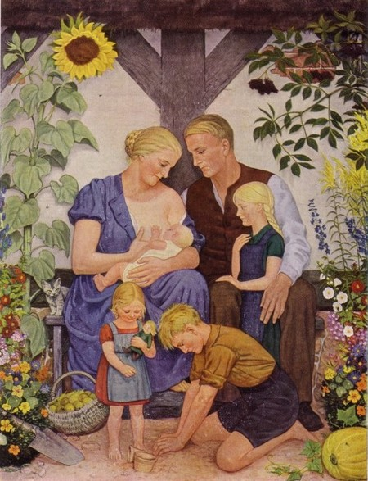](http://www.google.co.uk/url?sa=i&rct=j&q=&esrc=s&source=images&cd=&cad=rja&uact=8&ved=0CAcQjRw&url=http://nordicantisemite.com/2014/08/16/towards-a-healthier-folk/comment-page-1/&ei=DdNdVe-TE4y07gbTnoAQ&bvm=bv.93756505,d.ZGU&psig=AFQjCNEzLbBrVgKMIkqZFCjxTE5pRGhvRQ&ust=1432298634048326)**

**The *Volksgemeinschaft***

Hitler wanted to create a new German nation (***Volksgemeinschaft***, or ‘people’s community’). This meant a new, unified classless community based on blood and race, sharing a common world view or philosophy (***Weltanschauung***). The vision also entailed hostility to ‘outsiders’ who were to be removed: Jews, ‘aliens’, ‘deviants’, the mentally sick and incurably ill. Members of this community would be **healthy, socially useful and politically committed to the regime**, making Germany fit for world domination. The ideal German image was that of the classic peasant working on the soil in the rural community – exemplified in the Nazi concept of **‘Blood and Soil’ (*Blut und Boden*)**. The aim was to create a population indoctrinated with Nazi ideas that would lay the foundation for the thousand year Reich.

**Women**

Nazi policy towards women was largely **reactionary**. The Nazis wanted to reverse many of the recent trends that had increased opportunities for women throughout Europe, such as increased female employment in the non-agricultural sector and a declining birth rate that was partly due to wider access to contraception. In Germany, women had been given the vote and experienced greater cultural freedom in the 1920s, although during the Depression years there were some moves towards discrimination against women in the workplace. By contrast, the Nazis had a clear vision of women as homemakers and childbearers, summarised by their slogan ***‘Kinder, Küche, Kirche’*** (Children, kitchen, church). In the national struggle for survival, women had a vital supportive role to play: to breed genetically pure Germans to ensure the supremacy of the race.

*Familienbildnis*: the ideal German family – a painting by Wolfgang Willrich, 1930s.

However, this vision did come into conflict with other Nazi priorities. During the war for example, more workers and more soldiers were needed, and therefore the government encouraged the utilisation of female labour, and childbirth outside marriage.

**The Family**

The ideal Nazi family was blond, Aryan and had lots of children. The purpose of marriage was “the procreation of genetically healthy children of the same race”. it must be considered reprehensible conduct to refrain from giving healthy children to the nation‘. Consequently, sex was for procreation not pleasure, abortion was outlawed, and contraception was banned for genetically healthy Aryans to boost the birth rate. Because the birth of healthy Aryan children was identified as a priority, however, the status of unmarried mothers improved despite the conservatism of the Party.

**Task:** Using Hite & Hinton p.296-301, complete the following grid assessing the effectiveness of Nazi policies towards women and the family.

|  |  |  |  |
| --- | --- | --- | --- |
| **Area** | **Key measures** | **Successes** | **Limitations & failures** |
| Increased births |  |  |  |
| Improved welfare |  |  |  |
| Reduced employment |  |  |  |
| Reduced education |  |  |  |
| Involvement in  women’s organisations |  |  |  |

**Youth**

While adults could be persuaded or forced into accepting the Nazis, their minds were not as pliable as their children’s. The Nazis wanted to raise a generation of Germans who unquestioningly obeyed them. The Nazis attempted to transform youth on three levels, by

* Ensuring that school syllabuses and teachers lost no opportunity to reflect and reinforce Nazi values
* The creation of new elite Nazi schools
* Putting pressure on children to join the Hitler Youth and the League of German Girls.

**Education**

**Task:** Read Hite & Hinton p.280-281. Complete the table below, giving specific examples of how the Nazis tried in schools to develop the spirit of *Volksgemeinschaft.*

|  |  |
| --- | --- |
| **Aims** | **Methods** |
| Anti-intellectualism |  |
| Anti-semitism |  |
| Indifference to the weak |  |
| Nationalism |  |
| Militarism |  |
| Obedience and discipline |  |
| Hitler worship |  |

**New Nazi schools**

* **The Napolas** (National Political Educational Establishments): boarding schools which were later taken over by the SS. By December 1938, 21 had been founded and a further 20 were created during the war.
* **The Adolf Hitler Schools**: under the control of the Hitler Youth. The original idea was that no one should be appointed to a key position within the Nazi Party unless they had attended one of these schools, but only 10 had opened by 1945.
* ***Ordensburgen***: finishing schools for the future Nazi elite, aiming to create a disciplined, tightly knit group.

**Youth groups and alternative youth groups**

**Task:** In groups, research one of the following youth groups: *Hitler Youth, League of German Maidens, Edelweiss Pirates, Swing Youth, White Rose movement.* Produce a wordless Powerpoint presentation to show the rest of the class. You may like to include some contemporary source material (images, posters, or short written sources) to illuminate the points you are making.

Hitler Youth

[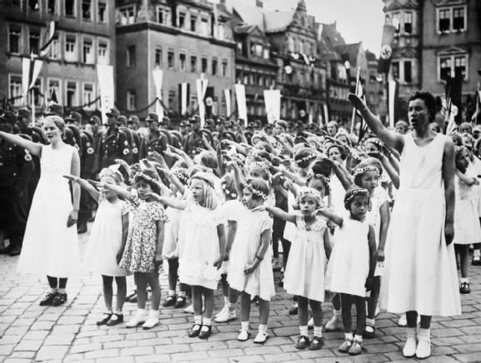](https://www.google.co.uk/url?sa=i&rct=j&q=&esrc=s&frm=1&source=images&cd=&cad=rja&uact=8&ved=0CAcQjRxqFQoTCIXY3Ym0lsYCFekV2wodHQgAsA&url=https://www.pinterest.com/pin/189151253073784762/&ei=vzyBVcX8N-mr7AadkICACw&bvm=bv.96041959,d.ZGU&psig=AFQjCNGHyAE6ftpcTbg-td5CoJJxyA-UqA&ust=1434619445906805)

League of German Maidens (BDM)

The Edelweiss Pirates

[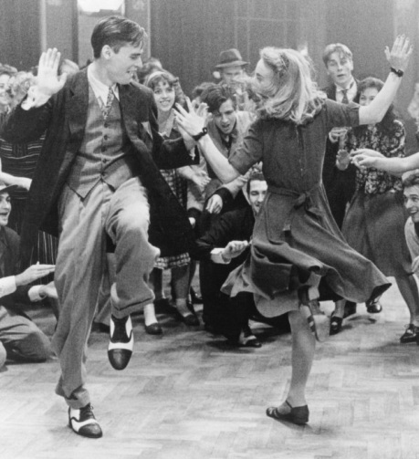](http://www.google.co.uk/url?sa=i&rct=j&q=&esrc=s&frm=1&source=images&cd=&cad=rja&uact=8&ved=0CAcQjRxqFQoTCK6t9eqzlsYCFaSz2wodtKAAtg&url=http://www.mo-berlin.com/im-hungover-and-bored-sundays-6/&ei=fzyBVe7xEaTn7ga0wYKwCw&bvm=bv.96041959,d.ZGU&psig=AFQjCNF4zbX-lLx5-ypiYDT7LtjqYanemQ&ust=1434619386836634)Swing Youth

[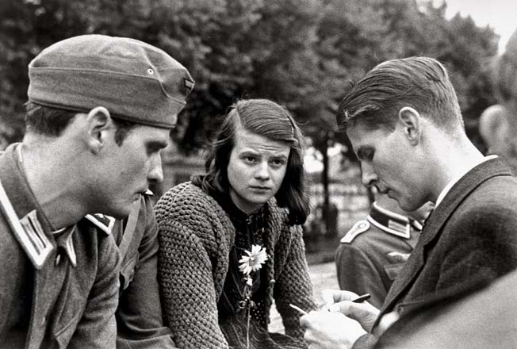](http://www.google.co.uk/url?sa=i&rct=j&q=&esrc=s&frm=1&source=images&cd=&cad=rja&uact=8&ved=0CAcQjRxqFQoTCIbzpdGzlsYCFcWZ2wod8vgAcA&url=http://pbakesenglish.edublogs.org/the-white-rose-movement/&ei=STyBVcaqIsWz7gby8YOABw&bvm=bv.96041959,d.ZGU&psig=AFQjCNH8aQeenMMsXEoUYF0dnFHrttZS7w&ust=1434619332848909)White Rose movement

**Workers**

Hitler claimed that in creating the People’s Community he had ‘broken with a world of prejudices’ and created equality between the ‘workers of the brain and fist’.

**Control**

* **Trade unions and strikes** were banned in May 1933.
* All workers were forced to join the **German Labour Front (DAF)** which aimed ‘to indoctrinate them in the National Socialists mentality’. Their bosses, ‘plant leaders’, had much more power over them.
* **Elected Councils of Trust** were set up in all factories where there were more than twenty workers; after 1935 these were ended because the workers were electing representations considered ‘unreliable’. In theory a Council of Trust could take an employer to a Court of Social Honour provided it had the support of the local Labour Trustee, an official appointed by the Ministry of Labour, but this seldom happened.
* **Trustees of Labour** were set up by the Ministry of Labour to control wages and held wages down in the late 1930s when an increasing labour shortage, especially of skilled labour, created inflationary pressure for higher wages.
* The **Reich Labour Service (RAD)** forced young men aged 19-25 to do 6 months’ labour service.
* Workers had **more deductions from their pay packets**, including higher taxes, DAF membership dues and contributions to Nazi charities like Winter Aid.

**Gaining support**

* **The ‘Beauty of Work’ scheme:** headed by Albert Speer, this attempted to persuade employers to make their factories a more human environment by, for example, installing swimming baths, showers and canteens. By 1939 nearly 70,000 companies agreed to such improvements.
* **Strength Through joy (KDF):** a leisure organisation, the aim of the Strength Through Joy movement was to dispel boredom as from it, according to its head Robert Ley, ‘sprang stupid, heretical, yes in the end criminal ideas…’. It organised concerts and plays for the workers and arranged subsidised cruises or holidays in the German countryside. A popular project of the KDF was the Volkswagen car, started in 1938. Workers were offered a savings scheme to enable them to purchase the car. However, cards would only be delivered after the fginal payment had been made. By 1940, 300,000 people had signed up, but production was halted by the war and the cars were not produced until after it ended. The workers’ money was used to finance the war industries.
* **The National Socialist People’s Welfare Organisation:** This was set up to promote the ‘living, healthy forces of the German people’, meaning that asocials or anyone other than Aryans would be excluded. By 1939 it had over 17 million members and had developed an extensive network of nurseries for children, holiday homes for mothers, and it provided food for large families.
* The number of **paid holidays was increased**, including the May 1st holiday workers had always wanted (Hitler announced this the day before he abolished the trade unions)

**Review: How successful were the Nazis’ attempts to implement their social policies?**

**Task:** Prepare for a class debate on the above question by completing the table below.

|  |  |
| --- | --- |
| **Successful** | **Not successful** |
|  |  |

**Nazi Racial Policies to 1939**

**Outside the *Volksgemeinschaft***

The *Volksgemeinschaft* was composed of a racially homogenous ‘Aryan’ people, *das Herrenvolk*, whose health and racial purity were to be protected at all costs. A series of laws increasingly discriminated against those who were judged to be **‘*untermenschen’****.*

**Who were the *‘untermenschen’*?**

**Task:** Use Layton p.213-215 to make notes on the following groups and how the Nazis dealt with them.

Euthanasia of the disabled:

Asocials:

Homosexuals:

Non-Jewish racial minorities & gypsies:

**The Jews**

*The language to describe the Holocaust does not exist. The more I study, the less I understand.*

* **Nobel Peace Prize winner & Holocaust survivor Elie Wiesel**

[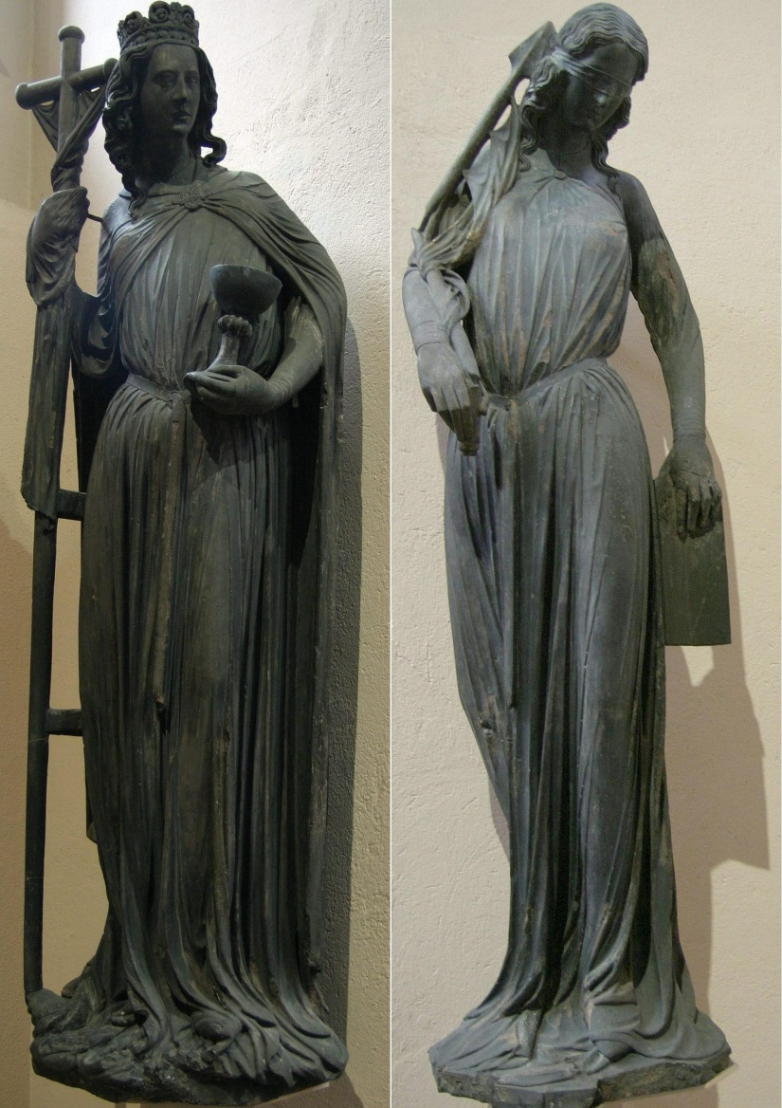](https://www.google.co.uk/url?sa=i&rct=j&q=&esrc=s&frm=1&source=images&cd=&cad=rja&uact=8&ved=0CAcQjRw&url=https://en.wikipedia.org/wiki/Ecclesia_and_Synagoga&ei=9cqHVYLSLuHT7QbxzIOYBg&bvm=bv.96339352,d.ZGU&psig=AFQjCNGrTqC2e_zCgAEC6r26RgVwL5ReXQ&ust=1435049075359981)

Anti-Semitism was not confined to 1930s Germany. Hostility to the Jews, as the ‘Christ killers’, has a long tradition in Christian history, reinforced by resentment at the wealth and position of some Jews and the periodic need for scapegoats to blame for problems, particularly as Jews were scattered across Europe and therefore were always a minority group, making them more vulnerable. In the late nineteenth century an influx of Jews fleeing persecution in Tsarist Russia, combined with the growth of racist views associated with social Darwinism, led to increased anti-Semitic feeling in Germany and other European countries.

**To the Nazis the Jewish ‘threat’ was in a class by itself**. There were only 500,000 Jews in Germany in 1933, and most of them were fully integrated into German society and were patriotic Germans. Nevertheless the Nazis perceived the Jews to be plotting on a worldwide scale the destruction of Germany, and regarded them as the power behind Bolshevism. For most Nazis the Jews had attained the status of mythological demons, upon whom they focused their anxieties about the modern world.

**Ecclesia and Synagoga**, a pair of figures personifying the Church and the Jewish synagogue, found in medieval Christian art. The figures reflect the Christian belief that Jesus was the Jewish Messiah, and that Judaism as a religion was therefore made unnecessary once Christianity was established, and that all Jews should convert. Synagoga's blindfold reflected the refusal of medieval Jews to "see" this point, which was regarded as stubborn.

**The Nazis took anti-Semitism way beyond anything that had gone on before**. Hitler was obsessive in the hatred of the Jews and certainly it coloured all his political aims. Nevertheless, it was not obvious in 1933 exactly what form this attack would take: the Holocaust was the culmination of increasingly radical anti-Semitic policies developing from 1933. Nazi anti-Semitic policy was **gradualist**, and early moves against Jews gave no suggestion of the end result.

**Anti-Semitic policies, 1933-36**

Rather than being led by Hitler, it was the rank and file of the Nazi Party who demanded immediate action against the Jews. Local outbursts, led mainly by the SA, had to be contained during the first delicate months of power in 1933 and a one-day boycott of Jewish shops and professions was intended to serve this very function: it failed, however, to deter Germans from using Jewish shops and businesses, and met criticism at home and abroad. The Law for the Restoration of the Professional Civil Service of 1933 excluded many Jews from public service, but until 1935 there were no further large-scale acts of hostility. In 1935, however, Hitler yielded to pressure from within the Party and approved the Nuremberg Laws.

**The Nuremberg Laws, 1935**

***Reich Citizenship Law:*** deprived Jews of their German citizenship.

***Law for the Protection of German Blood:*** forbade marriage or sexual intercourse between Jews and German gentiles; forbade Jews from hoisting the Reich and national flag.

What impact would the removal of citizenship have on the lives of German Jews?

[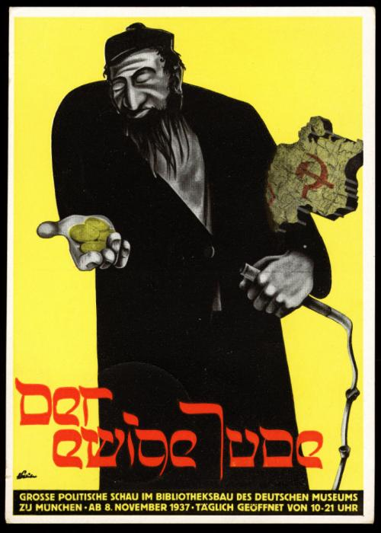](http://www.google.co.uk/url?sa=i&rct=j&q=&esrc=s&frm=1&source=images&cd=&cad=rja&uact=8&ved=0CAcQjRxqFQoTCKqggPPn38gCFYXrFAod7TwFVg&url=http%3A%2F%2Fwww.ushmm.org%2Fconfront-antisemitism%2Fteaching-about-antisemitism%2Feducational-modules-based-on-audio-podcasts%2Fpropaganda-and-media%2Fimage-analysis-activity&bvm=bv.105841590,d.d24&psig=AFQjCNHR2DjG1Z7yyRUTwGvQQz_HSMM1Ng&ust=1445937697740738)The Nuremberg Laws actually ensured that anti-Semitism became more deeply embedded in German society: Jews were increasingly banned from restaurants, libraries, swimming pools and other public places. Sex between Jews and Germans was prosecuted at special courts as cases of ‘racial defilement’.

**Propaganda and indoctrination**

* Posters and signs, for example ‘Jews are not wanted here’.
* Newspapers, for example *Der Angriff*, founded by Goebbels, and *Der Sturmer*, edited by Julius Streicher
* Cinema, for example *The Eternal Jew.*
* Education emphasised Nazi racism, for example studying negative portrayals of Jews in literature and history.

**Increased pressures, 1937-39**

During 1936, outward hostilities towards the Jews were postponed for the duration of the Berlin Olympics. Nevertheless, persecution continued. From 1937, the anti-Jewish campaign seemed to be escalating: Jewish businesses found their contracts drying up, Jews were no longer able to be awarded degrees and in 1938, Jewish doctors, dentists, lawyers, chemists and vets were forbidden to work for Aryans. All Jews had to carry an identification card and if their name did not obviously denote their Jewishness, they had to add ‘Sara’ (for women) or ‘Israel’ (for men) to it.

**The *Anschluss* (union) with Austria, March 1938**

This resulted in violence and humiliation for the 190,000 Austrian Jewish population. Jewish properties and businesses were looted, especially in Vienna, and some Jews were made to publicly wash buildings and pavements. Thousands were also arrested and Jewish houses and businesses were ‘Aryanised’. This encouraged Goering to believe that there were benefits to adopting a similar approach in Germany and on 26 April 1938 he issued a ‘Decree for the Registration of Jewish property’ which demanded that all Jewish property worth more than RM5000 be valued and registered with the state.

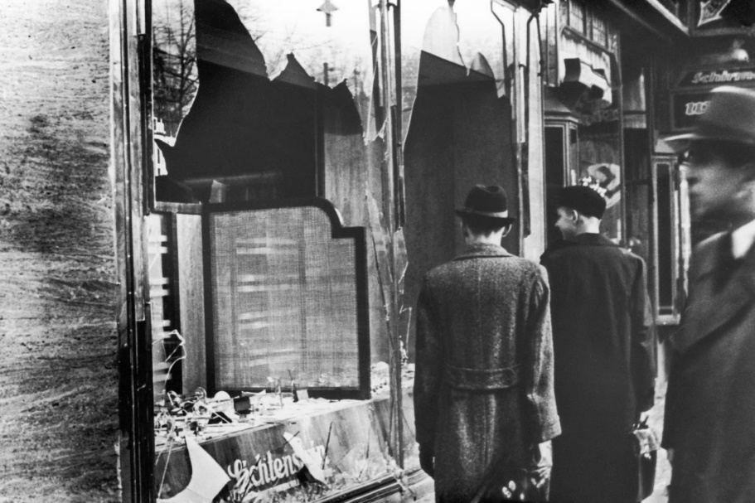***Reich Kristallnacht*, 9-10 November 1938**

**Task:** Use Layton, p.219, to note answers to the following questions:

1. What caused the outbreak of pogroms on *Kristallnacht*?
2. 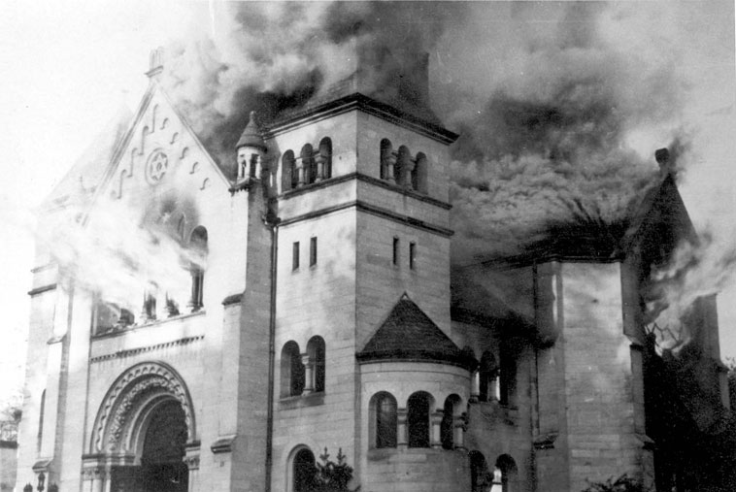What actions were taken during these pogroms?
3. What actions were taken against Jews in the aftermath of the riots?

The Jewish synagogue in Baden-Baden burns during *Kristallnacht.*

1. In what ways can *Kristallnacht* be seen as a turning point in Nazi Jewish policy?

**Forced emigration**

From the start of the Nazi dictatorship some Jews had decided to leave Germany – especially those with influence, high reputation or sufficient wealth. The most popular destinations were Palestine, Britain and the USA, and they included Albert Einstein and Kurt Weill.

After Anschluss, the **Central Office for Jewish Emigration** was established in Vienna, overseen by **Adolf Eichmann**. Jewish property was confiscated to finance the emigration of poor Jews and within six months Eichmann had forced the emigration of 45,000. Nazi persecution in total led to about half the Jewish population leaving before the war but they were forced to leave behind all their belongings.

**Why were the Nazis able to consolidate & maintain their power in Germany?**

|  |  |  |
| --- | --- | --- |
|  | **How did this contribute towards the Nazis’ consolidation and maintenance of power?** | **Evaluation/assessment (‘However…’)** |
| **Use of terror** |  |  |
| **Use of censorship & propaganda** |  |  |
| **Economic recovery & employment** |  |  |
| **Youth indoctrination** |  |  |
| **Foreign policy successes and other benefits of Nazi rule** |  |  |
| **Other factors?** |  |  |