**The Establishment of the Nazi Dictatorship and its domestic policies, 1933-39**

[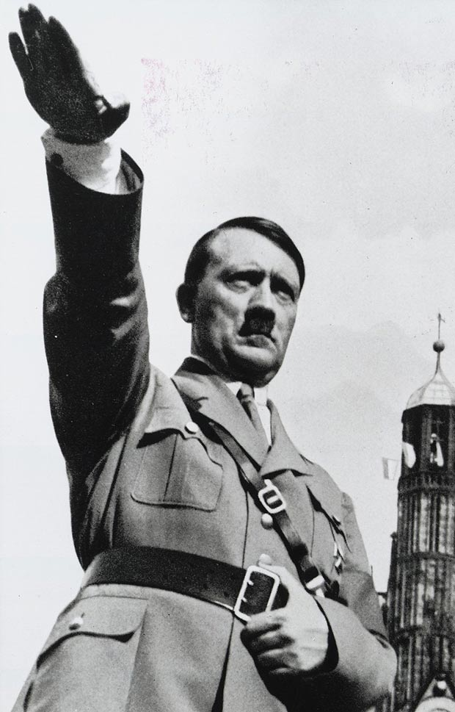](http://www.google.co.uk/url?sa=i&rct=j&q=&esrc=s&frm=1&source=images&cd=&cad=rja&uact=8&ved=0CAcQjRw&url=http://www.thesun.co.uk/sol/homepage/news/4692458/grimy-toilet-seat-from-hitlers-personal-lavatory.html&ei=vJtcVa3ZCIa27gbv24HYBw&bvm=bv.93756505,d.ZGU&psig=AFQjCNHKh5JgfztlsUAmeRiG1D1xQFnSDg&ust=1432218932254827)

**You need to understand the following:**

* Hitler’s consolidation of power: the Reichstag Fire, March Elections and Enabling Act; *Gleichschaltung*, creation of the one-party state, Night of the Long Knives, army oath and death of Hindenburg
* System of government and administration
* Censorship and propaganda
* Machinery of terror: courts, SS, Gestapo, treatment of opposition
* Religious policies
* Economic policies: Schacht’s New Plan, Goering’s 4 Year Plan, public works, conscription, autarky, German Labour Front, ‘Strength through Joy’
* Policy towards women, education and policy towards youth
* Racial policies to 1939

**Exam questions**

**A-level style:**

Which was of **greater importance** in **establishing the Nazi dictatorship**?

(i) The Enabling Act

(ii) The Night of the Long Knives

Explain your answer with reference to both (i) and (ii). [10]

**Old Specification questions:**

1. How successful were the Nazis in their policy of ***Gleichschaltung* (co-ordination)** after 1933? (Ja 09)
2. How successful were Hitler’s **economic policies** to 1945? (Ju 09)
3. “Their use **of terror** was the main reason why the Nazis **retained control** in Germany after 1933”. How far do you agree? (Ja 10)
4. To what extent did the Nazis achieve the aims of their **social policies**? (Ju 10)
5. **Economic recovery** was the **main** reason why the Nazis stayed in power after 1933”. How far do you agree? (Ja 11)
6. How successful was Hitler’s **economic policy** to 1945? (Ju 11)
7. To what extent did Hitler’s consolidation of power after March 1933 depend on **terror**? (Ja 12)
8. How successful were the Nazis in imposing their ideas about **society** on the German people? (Ju 12)
9. “Hitler’s **economic policies** failed to prepare Germany for war”. How far do you agree? (Ja 13)
10. Assess the reasons for the **lack of opposition** in Nazi Germany (Ju 13).

**Recommended reading**

**Textbooks**

# Geoff Layton, *Democracy and Dictatorships in Germany 1919-63* (Access to History series), 2nd edition. This is the OCR endorsed textbook.

* John Hite & Chris Hinton, *Weimar and Nazi Germany*, 2000, Section 2.
* Alison Kitson, *Germany 1858-1990: Hope, Terror and Revival*, 2001, chapters 8-11.

**Books and articles**

* Richard Evans, ‘Hitler’s Dictatorship’, published in History Review March 2005 (accessed via the History Today website).
* Ian Kershaw, *The Hitler Myth: Image and Reality in the Third Reich,* 2001.
* Lawrence Rees, *The Nazis: A Warning From History,* 2006.

*There is a very wide range of relevant literature on Nazi Germany available in the College library.*

**Fiction**

* Hans Fallada, *Alone in Berlin*

**Timeline**

|  |  |  |
| --- | --- | --- |
| **Consolidation** | **1933** | **30 Jan** Hitler becomes Chancellor  **1 Feb** Hitler persuades Hindenburg to dissolve the Reichstag  **4 Feb** Hitler’s government acquires power to ban political meetings and newspapers  **27 Feb** Reichstag Fire  **28 Feb** Decree for the Protection of People and State repeals civil liberties  **5 Mar** Election – Nazis win 43.9% of the votes but still have no majority  **8 Mar** First concentration camps announced by Interior Minister Frick  **23 Mar** Enabling Act passed by the Reichstag  **31 Mar and 7 Apr** Laws for the co-ordination of the states with the Reich  **2 May** Trade unions dissolved  **8 Jul** Concordat between Germany and Vatican  **14 Jul** Nazi party the only official party allowed to exist in Germany |
| **1934** | **30 Jun** Night of the Long Knives  **2 Aug** Death of Hindenburg; army swears an oath of allegiance to Hitler  **10 Aug** Hitler proclaims himself both Chancellor and President and adopts the title ‘Fuhrer’ |
| **Radicalisation** | **1935** | **Mar** Hitler announces that Germany is rearming; return of military conscription  **Sept** Nuremberg Laws deprive German Jews of citizenship |
| **1936** | **Mar** Hitler sends troops into the demilitarised Rhineland  **Sept** 4-Year Plan introduced to prepare the economy for war |
| **1937** |  |
| **1938** | **Mar** Anschluss with Austria  **Sept** Hitler gains the Sudetenland from Czechoslovakia at Munich  **Nov** Kristallnacht |
| **War** | **1939** | **Mar** Hitler seizes Czechoslovakia  **Sept** Invasion of Poland & outbreak of war. |

**Glossary**

|  |  |
| --- | --- |
| Anti-semitism | Hatred of the Jews |
| Aryan | Nazi term for non-Jewish German; technically, somene who speaks an Indo-European language |
| Autarky | National economic self-sufficiency |
| Bolshevism | Russian Communism; government by workers’ councils or soviets |
| *Blut und Boden* | ‘Blood and soil’: nationalist and racist romanticism which glorified the rural role of the peasantry |
| Chancellor | Leader, prime minister of Germany |
| Concordat | Agreement; in this context, the agreement signed by the Catholic Church and the Nazi government in 1933 respecting each other’s role |
| *Führerprinzip* | Leader principle; according to this, ultimate authority rested with Hitler and extended downward; orders would be followed to the letter |
| *Gauleiter* | Leader of a *Gau*, a regional unit of the Nazi party |
| *das Herrenvolk* | The ‘master race’ |
| *Gleichschaltung* | Co-ordination; under the Nazis a policy of bringing everything under state control. |
| *Lebensraum* | Living space; aim of German expansion in the east |
| *Mittelstand* | The German lower middle classes |
| *Reichstag* | German parliament |
| SA/*Sturm-Abteilung* | Storm troopers; Nazi paramilitary organisation |
| SD/*Sicherheitsdienst* | Security service; intelligence service of the SS |
| SS/*Schutzstaffel* | Protective squads; beginning as Hitler’s bodyguard, then the Nazi Party’s police force |
| *Untermenschen* | Used to mean ‘inferior people’ or ‘subhuman’ |
| *Volksgemeinschaft* | ‘People’s community’; the Nazi ideal community |
| *Weltanschaaung* | ‘World view’; a philosophy of life |
|  |  |
|  |  |
|  |  |
|  |  |
|  |  |

**Hitler’s Consolidation of Power**

In January 1933, the Nazis were the **largest party** in the Reichstag. The Nazi Party also held key positions in the **Cabinet**: Hitler was Chancellor whilst Frick was Interior Minister in the Reich and Goering was Interior Minister of Prussia. However, the Party did not possess an overall majority, even if they were supported by the nationalists, and a 2/3 majority was needed to change the Weimar Constitution. Whilst Nazis held key posts in the Cabinet, they numbered only **3 out of 12**, and the **President** could sack any of them at any point. At this stage, their survival was by no means guaranteed. **Within 18 months of being appointed Chancellor of Germany, Hitler had turned himself into a dictator. How did this happen?**

**Activity: How do you think Hitler would try to consolidate his position after his appointment as Chancellor in January 1933?**

Complete the task on p.169-171 of Hite & Hinton.

**Stage One: January – March 1933**

**Control at the centre**: During this period, Hitler gained the power to **bypass the Reichstag** and **enact laws on the authority of his Cabinet**. **Civil liberties** were suspended to enable him to arrest and imprison political opponents.

**Task:** Using Kitson p.151-153/Fulbrook and Williamson p.55-57 and p.63, complete the table below, explaining what happened for each event and how it contributed to Hitler’s consolidation of power.

|  |  |  |
| --- | --- | --- |
|  | **What happened?** | **How did it help to consolidate**  **Hitler’s power?** |
| **The Reichstag**  **Fire** | Reichstag was burnt down, probably by van der  Lubbe (Dutch Communist)  Acting alone  No evidence Nazis did it as is  sometimes alleged | Gave him excuse to persuade H’burg to sign Decree  of the Reich President for the Protection of People &  State which led to arrest of 4,000 Communists  This gave govt. power to:   * arrest people without trial * search private homes * intercept post & telephone calls * restrict freedom of assembly & expression.   This was legal under Article 48 of Weimar Const. |
| **The March**  **Election 1933** | Nazis gained only 44% of  Vote despite widespread espie intimidation of  Communists & Social  Democrats  With DNVP support (8%)  govt. had majority (52%).  KPD & SPD lost votes.  Land (regional) govts.  replaced by Reich  Commissars appointed by  Hitler. | Hitler claimed he had a mandate (public support) for repression against Nazis’ opponents.  Violence by Nazis, with police either helping or doing nothing, against Communists, Social Democrats, anti-Nazi newspapers & Jews.  Hitler & Göbbels planned “Day of Potsdam”, ceremonial opening of new Reichstag in Garrison Church in Potsdam in which Hitler gained conservative support, reassuring H’burg & Army, by promising to respect German traditions.  Goering used his power as Prussian Minister of Interior (controlling police in 2/3 of Germany) to recruit 50,000 extra police from SA & SS; 69 people killed by Nazis during election campaign.  Nazis used control of media & financial backing (3 million marks) from big business to gain support |
| **The Enabling**  **Act** | Gave Hitler power to  pass & enforce  legislation without  consent of Reichstag or  President for 4 years.  Passed R’tag by 444  votes to 94.  All Communist MPs were excluded from R’tag plus  enough Social  Democrats to ensure  Act was passed.  Only SPD voted against  it: all other parties  including Centre) voted for  it. | Freed Hitler from dependence on presidential decrees & in effect  replaced democracy with dictatorship.  Hitler persuaded Centre to vote for it by promising Concordat (agreement) with Pope.  SA inside & outside R’tag threatened MPs into voting for it. Limiting it to 4 years helped to gain support but of course by 1937 its renewal was never in doubt b/c by then Nazi dictatorship fully established.  President, Cabinet & R’tag sidelined  Compensated for Nazis' failure to win majority support in election.  Bracher called it "legal revolution". |

**Stage Two: April – July 1933**

**Control beyond the centre:** During this period, Hitler attempted to **bring any potential enemies under control**. Organised opposition was now almost impossible.

***Gleichschaltung: ’bringing into line’/’coordination’***

Weimar society was **plural**: a number of different interest groups were allowed to exist within the state, and these groups were potentially quite powerful and could exert pressure on the government in a variety of ways. These included trade unions, the Church, other political parties, the civil service, local government, courts and judges.

Hitler did not want to see his power limited by such groups. The policy of *Gleichschaltung*, therefore, aimed to eliminate such troublesome interest groups. By early 1934, the Nazis were able to create a one-party centralised Reich.

**Task:** Use Kitson p.154-155 to add notes to the spider diagram, explaining how each group was brought under control.

**How successful were the Nazis in their policy of *Gleichschaltung* (coordination) after 1933?**

The term *Gleichschaltung* as refers to the ways in which the Nazis sought to ensure control of the state by the (forcible) ‘coordination’ of all aspects of political and social life, especially in the first year of their rule.

Successes:

* The Decree of the Reich President for the Protection of the People & State plus their control of the police enabled the Nazis to terrorise & arrest their oppnents (especially the KPD & the SPD) without legal process.
* The Enabling Act in March 1933 enabled Hitler to pass laws without the Reichstag’s consent; a fresh election in November 1933 created a 100% Nazi Reichstag.
* The Länder were taken over by Reich Governors spring 1933 & abolished altogether in January 1934.
* The Law for the Restoration of a Professional Civil Service in 1933 removed Jews, married women & anti-Nazis.
* All other political parties were banned or forced to dissolve themselves by July 1933, when a law was passed banning new parties & making Germany a one-party state.
* Hitler made a Concordat in 1933 which led to the abolition of the Centre Party & the Catholic trade unions.
* Trade unions were banned in 1933 & all workers forced to join the DAF.
* The Night of the Long Knives & the death of Hindenburg led to the Army swearing an oath of allegiance to Hitler in August 1934.
* Professional groups like lawyers & teachers had to join the Nazi organisation for their profession.
* The Hitler Youth gained increasingly control over young people, especially as church youth groups & schools were banned by 1936.

Failures:

* Hitler had to tolerate a predominantly conservative Cabinet & share power with the DNVP after only getting 44% of the vote in the March 1933 election.
* Hindenburg had the power to remove Hitler & intervened to exempt Jewish WW1 veterans from the Law for the Restoration of a Professional Civil Service.
* The takeover of Jewish businesses had to be delayed to preserve the jobs of their Aryan employees.
* Hitler’s attempt to control the Protestant churches failed & the churches remained independent from Nazi control.
* The Army had the power to overthrow Hitler & its leadership remained predominantly conservative.

Only two groups survived the policy of *Gleichschaltung*: the **Church** and the **army**.

**Religious policy**

Germany had a strong Christian tradition, represented largely by Catholicism in the south, west, and east, and Protestantism in the north and centre. There was an obvious divide between Cristian beliefs and Nazi ideology which was based on war, violence, and a lack of compassion towards other human beings. Nevertheless, both organisations shared some common outlooks: most notably in respect for traditional cultural values (such as the importance of family life), and in their hostility to communism. There was also, particularly in Lutheran Protestantism, a tradition of respect for the state and nationalism. Anti-Semitism, too, was not totally alien to the Christian tradition.

Hitler wanted to replace Christianity with a new, assertive Aryan faith, and remove the churches as a potential obstacle to his reordering of the German people into committed followers of his totalitarian regime. Nevertheless, he recognised that he was not in a position to embark immediately on the implementation of his full vision: he did not want to alienate the considerable number of Christians in Germany by an outright attack on the churches, and so intended to gain control of, and support from, the Church hierarchies, before gradually reducing their influence.

**Task:** Summarise how the Nazis dealt with a) the Catholic Church and b) the Protestant Church.

**Catholic Church**

* Hitler ‘bought’ the support of the Centre Party for the Enabling Act by promising to protect the Catholic church.
* Concordat (14 July 1933) guaranteed the religious freedom of the Catholic church and its right to appoint its own clergy.

**Protestant Church**

* Ludwig Muller, a Nazi, was made Reich bishop; but an alternative church (the ‘Confessing Church’) was set up in 1934 for opponents of this, led by Martin Niemoller & Dietrich Bonhoeffer.
* German Protestants remained divided.

Hitler succeeded in neutralising the role of the Catholic Church in politics by signing a **Concordat with the Pope in July**. This agreement exchanged a promise from Hitler that the Church would be left to run its own affairs, including Catholic schools, for a promise from the Pope that the Church would not interfere in political matters.

**The Army**

The other group escaping co-ordination was the **army**. Hitler was too dependent on its support and mindful that it was the only body who could still force him out of power. He was also dependent on a well-trained and highly disciplined force to implement his ambitious foreign policy.

The army retained its own traditions and indeed General von Blomberg banned army officers from joining the Nazi Party. Hitler began to win over the army when he met its senior officers in early February 1933 and promised to respect the army’s traditions and political neutrality, while enthusing them with the prospect of rearmament and re-introduction of conscription.

**By the end of 1933, Hitler’s power was extensive but not total:** he could still theoretically be dismissed by Hindenburg, the army could use its strength to force him from office and the SA could endanger Hitler’s relations with the army by demanding more power for themselves.

**Stage Three: January – August 1934**

**The final stage:** During this period, Hitler brought the **SA** firmly under his control and **won the support of the army**. He became the Führer of Germany after Hindenburg’s death.

***The Night of the Long Knives***

**Video:** ‘The Nazis: A Warning from History. Episode 2 – Chaos and Consent’, E-stream #10830, to 08.43

1. What did Röhm want for the SA?

*For it to be integrated into the regular army.*

1. Why were the army horrified?

*Because of the behaviour and appearance of the SA & their thuggish approach (e.g. bookburning)*

1. Why did Hitler want to curb the power of the SA?

*To please the army and to please Himmler, who was technically working to Rohm but ambitious. He convinced Hitler that Rohm was plotting a coup*

1. What happened to Röhm?

*He was arrested, imprisoned, and 2 days later shot.*

1. What did the army do?

*Swore an oath of allegiance to Hitler.*

**Why was Röhm a threat?**

Since the early 1920s there had been tension between Röhm’s view of the SA as the key body for seizing and retaining power, and Hitler’s view of it as having a subordinate role to the party. Hitler needed the support of the traditional elites if he was to solve unemployment and rearm Germany; consequently, in July 1933 he announced the end to the ‘legal revolution’ and began to reassure generals and industrialists that the revolutionary period of the Nazi takeover was at an end. The SA under Röhm, however, believed in a more radical Nazi revolution. Röhm also wanted the SA to form the basis for a new mass Nazi army; but Hitler had already made it clear that the traditional army would be the basis of the new German army.

The problem of the SA became urgent by the spring of 1934 because of Hindenburg’s ill health. It was possible the generals would attempt to block Hitler’s ambitions to succeed Hindenburg if they believed that the SA was threatening their role in rebuilding Germany’s armed forces. The army and conservative elites could even attempt to restore the monarchy after Hindenburg’s death in an attempt to control the Nazi regime.

In addition, Heinrich Himmler was keen for the SS to break away from the formal control of the SA. Goering also resented Röhm and led Hitler to believe he was planning a coup to embark upon a ‘second revolution’ – a social revolution which would see the SA merging with the army with Röhm in ultimate control. In addition, some conservatives, centred around Papen, were increasingly worried about the growing lawlessness and power of the SA. They realised that Hitler was not playing his ‘puppet’ role. Hitler would be in trouble if these groups gained the support of Hindenburg or the army. By acting against the SA, Hitler reassured his conservative supporters and also intimidated his conservative critics. **On the night of 30 June 1934, Röhm and other leaders of the SA were shot by members of the SS.** Hitler also eliminated his critics on the Right: two conservative monarchists in Papen’s office, Herbert von Bose and Edgar Jung, were also murdered, as well as other political enemies of Hitler, including Kurt von Schleicher and Gregor Strasser.

[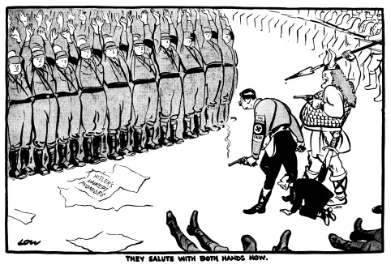](http://www.google.co.uk/url?sa=i&rct=j&q=&esrc=s&source=images&cd=&cad=rja&uact=8&ved=0CAcQjRw&url=http://www.cartoons.ac.uk/record/LSE2086&ei=pHJcVYr-F6Of7gb-54KICg&bvm=bv.93756505,d.ZGU&psig=AFQjCNEdfP_qQ3HyI2TQ-ZJcQULO1N9HxA&ust=1432208394514170)

**Activity:** Read p.160-161 of Kitson. Use the information to analyse the cartoon above:

1. Identify:

* The figures standing behind Hitler

*Göring & Göbbels.*

* The victims whose feet appear at the bottom of the cartoon

*Röhm, Jung, Schleicher, Strasser etc.*

* The men with both arms raised

*The SA.*

* The line of men in the top right hand corner

*The Army & the SS.*

1. What is meant by ‘unkept promises’? Was this a justified accusation?

*This referred to promises to institute a “second revolution” (i.e. a social revolution which would remove the power of the old elite) & to merge the Army with the SA, promises which in fact Hitler had never really made.*

1. What is the meaning of the phrase ‘They salute with both hands now’?

*They’re surrendering for fear of being shot.*

1. How accurate is this cartoon as a portrayal of the Night of the Long Knives?

*Accurate apart from the “unkept promises”.*

**Task:** Using Kitson p.160-163, complete the table below, explaining what happened for each event and how it contributed to Hitler’s consolidation of power.

|  |  |  |
| --- | --- | --- |
|  | **What happened?** | **How did this contribute towards Hitler’s**  **consolidation of power?** |
| **Night of the**  **Long Knives**  **30 June**  **1934** | 400 murdered including Röhm & other SA leaders shot, as were Jung & Bose (conservatives who worked for Vice Chancellor Papen), Schleicher (last Chancellor before Hitler) & Strasser (Nazi who had plotted with Schleicher against Hitler)  SA became less important, used for Nazi rallies & violence against Jews; its ambition of replacing Army  Never fulfilled & increasingly eclipsed by SS, both as instrument of terror & later as military force (Waffen SS) | Intimidated both conservative & radical  opponents into silence  Papen never criticised Hitler again (he had earlier  made speech calling for end to Nazi revolution &  violence & for more freedom of speech) & was later  sent abroad on diplomatic missions  Public, who hated SA hooliganism, were reassured  & their support for Hitler strengthened; they believed his claim to have saved Germany from worse violence)  With both Blomberg (army commander) & Hindenburg publicly thanking him, Hitler had secured Army’s support, vital both for controlling Germany & his foreign policy plans |
| **Army oath**  **2 August**  **1934** | Following Hindenburg’s death, Army  swore “by God” oath of allegiance to  Hitler as “Führer of the German  nation & people”  Chancellor & President rolled into  one; he was now leader of Germany, not just Party | Army support vital both for controlling Germany & his foreign policy plans: it was only institution with  power to overthrow him  Vast majority of officers & soldiers felt bound by “this holy oath” to obey Hitler even if they disagreed with his policies; this greatly inhibited opposition to him in later years |
| **Death of Hindenburg**  **2 August**  **1934** | Following H’burg’s death, office of  President was abolished  As “Führer of the German nation & people” Hitler was now Chancellor & President rolled into one; he was now leader of Germany, not just Party | As President, H’burg had had power to remove Hitler; he also commanded loyalty of Army  His death meant Hitler was now undisputed leader of Germany with no one capable of challenging him; it also led directly to army oath (see above) |

**Activity: What was the most important factor in Hitler’s establishment of a Nazi dictatorship?**

Rank the following factors in order of importance. Write a short paragraph to justify your choice:

*The Reichstag Fire; Night of the Long Knives; Enabling Act; Gleichschaltung; the death of Hindenburg & army oath.*

**The system of government & administration: How chaotic was Nazi government?**

**Video:** ‘The Nazis: A Warning from History. Episode 2 – Chaos and Consent’, E-stream #10830, from 11.58.

1. What was Hitler’s daily regime and style of government like?

*Indolent – he rarely appeared before lunchtime, looked over the papers and had lunch; walked in the afternoon; watched films in the evening. Government was confused. He made decisions without even looking at the relevant files.*

1. What sort of image did Hitler project at the Nuremberg rallies?

*The confident, strong leader, symbol of a powerful and dynamic Germany; all knowing, all powerful; an ordered system.*

1. How did this compare with reality, according to Ian Kershaw?

*Government was disorganised and chaotic; there was no collective government.*

1. Describe how Hitler governed through his ambitious Nazi followers.

*He had the vision; they took the initiative to put his vision into reality, making up the detailed policy and saying they were acting on the will of the Fuhrer.*

1. What was Hitler’s economic priority?

*Rearmament.*

1. How did the Nazis rid Germany of unemployment?

*Through huge work creation schemes like the autobahn programme & armaments manufacture.*

1. What was the purpose of Nazi pageants like the Night of the Amazons?

*To entertain; the project an image of racial purity & the supremacy of the German race.*

1. How were Jews treated in the 1930s?

*Synagogues were demolished; in 1935 the Nuremberg laws outlawed marriage between Jews and non-Jewish Germans and removed their citizenship.*

1. According to Robert Gellately, what was the operation of the Gestapo dependent upon?

*The collaboration of the people & denunciations of ordinary citizens; there were not enough Gestapo officials to make it workable otherwise.*

1. How does this represent a change in historical thinking about the operation of the Nazi regime?

*Used to think that the people were manipulated/brainwashed from above but it seems the system was manipulated from below for people to pursue their own agendas.*

1. What was Goebbels’ role in the Third Reich?

*Propaganda minister; feeding Hitler’s anti-semitism*

1. How did Goebbels respond to the assassination, in autumn 1938, of the German diplomat Ernst vom Rath by Herschel Grynszpan, and what did this lead to?

*He asked Hitler’s permission to let loose the stormtroopers against the Jewish population in Germany, resulting in Kristallnacht, the death of over 800 Jews and the destruction of over 1000 synagogues*

1. In what sense was the system of government chaotic?

*Rivals with ill-defined jobs fought against each other for Hitler’s favour. Hitler’s working day was organised by 5 separate offices all claiming to represent him. Hitler made the system worse by giving 2 people the same or similar tasks.*

1. Why was access to Hitler’s mail seen as important & what policy demonstrates this?

*It meant access to Hitler himself and a chance to formulate policy.*

*The T4 programme: a letter was written by the father of a mentally handicapped child to Hitler, asking his permission to have the child killed. Phillipp Bouhler passed the letter to Hitler. This resulted in the formation of the T4 programme – the selection and murder of disabled babies and children which spiralled out of control.*

In January 1933, this was **the system of government that Hitler inherited**:

* **Federal government**: individual states could decide their own policies in areas like education, leaving the central government in Berlin to deal with issues such as the economy and foreign policy.
* **Collective government**: policies were discussed amongst Cabinet members and a vote taken to decide on policy.
* **Laws** were passed by the Reichstag or sanctioned by the President in times of emergency.

Hitler **transformed** this system.

* The power of individual states was removed.
* **Collective government ended**. The Cabinet rarely met: 72 times in 1933, 19 times in 1934, 12 times in 1935 and 4 times in 1936. After 1938 it didn’t meet at all.
* Laws could be issued on the authority of the Cabinet alone, which in practice meant Hitler himself.
* Hitler **gave power to those he trusted** and who presented him with **good ideas**. This resulted in the creation of Supreme Reich Authorities, specialist agencies whose functions often overlapped with existing ministries.
* Hitler was the **single source of authority for everyone**, no matter if you worked in a ministry or an agency. He was therefore in the best position to co-ordinate policy: but he was not interested in the day-to-day affairs of government and neither did he show much interest in directing the specifics of domestic policy.

***What problems can you foresee with Hitler’s style of government?***

The Third Reich was characterised by a lack of a clear command structure, rival hierarchies and three overlapping centres of power:

1. **The central government together with its ministries and civil service.**
2. **The Nazi Party and the SS.**
3. **The charismatic dictatorship of Hitler, intervening at will.**

**Central government**

Hitler was anxious to emphasise that the new Nazi regime was in many ways linked to the great traditions of the German past. The government became a bewildering mixture of the old and new where freshly Nazi institutions flourished side-by-side with the traditional German organs of state: it was a **‘dual state’**, in which there appeared to be two forms of government at work at the same time: in this case, the pre-1933 ministries, civil service alongside the Nazi party and its organisations. Up to March 1933 the Cabinet met at regular intervals but after the passage of the Enabling Act its importance declined. By 1938, 7 important ministries of state were still in the hands of Conservative-Nationalist ministers. In many ways the power of the central departments of state increased because the Nazis had weakened the power of the federated states.

The civil servants who ran the government departments and their branches retained much of their traditional independence. In April 1933 the civil service was purged of Jews, Socialists and Communists under the **Law for the Restoration of the Professional Civil Service**, but this made up only 2% of the 1.5 million civil servants in the Reich. It was not until 1939 that all new entrants into the civil service had to be members of the Nazi Party.

**Task:** Using Hite & Hinton p.193-194, match up the eight institutions described with the descriptions of their changing role under Hitler’s dictatorship in the table below.

|  |  |  |  |
| --- | --- | --- | --- |
|  | Name of institution | Evidence that the Nazis took control | Evidence that the institution retained independence/was not controlled by Nazis |
| 1. Lost its proper role, rarely met after 1933, and contained only Nazis | Cabinet | Decisions were made which bypassed the Cabinet – they were made by Hitler on an ad hoc basis. |  |
| 1. Central government body which was kept but fell into disuse | Reichstag | Only 7 more laws were passed by the Reichstag after the Enabling Act.  Every four years it renewed the EA.  Mainly used as an applause machine for Nazi leaders’ speeches. |  |
| 1. The old democratic system was replaced by centrally appointed officials | Local government | State governments became agents of the central government.  Real power was exercised by the Reich governor – usually a *Gauleiter.* |  |
| 1. A conservative body whose members eventually had to join the Nazi Party | Civil service | Compulsory to be a Nazi Party member from 1939  Increasing use made of special agencies by late 1930s. | Mainly conservative and transferred reasonably happily to the Third Reich.  Under 5% purged in Law for the Restoration of the Civil Service 1933. |
| 1. Initially kept intact but bypassed by Nazi bodies, and eventually staffed by Nazis | Foreign Office | FP increasingly conducted outside the foreign ministry by individual Nazis.  Key personnel changes occurred in 1938 – von Ribbentrop replaced von Neurath | Bruning’s foreign minister von Neurath remained until 1938 |
| 1. Traditionally independent from government and protecting the rights of the individual, this institution was co-ordinated to follow the government’s will more closely | The courts and legal system | Ordinary courts lost power to the SS and Gestapo  Judges were bypassed increasingly by the new People’s Court and Special Courts  Lawyers were coordinated in the German Lawyers Front. | Established courts remained in place  Some judges defied the government’s wishes in their verdicts  Did not replace the existing legal code with a Nazi one. |
| 1. Hitler worried about this body as a rival and did not reorganise it until he felt totally established in 1938 | Army | Exploited Defence Minister Blomberg’s marriage to an ex-prostitute and the alleged homosexuality of Werner von Fritsch, the Commander-in-Chief of the army, to replace them along with over 100 other generals  Hitler became Commander-in-Chief, taking direct command | Left is structurally unchanged until 1938 |
| 1. This government office developed into a massive bureaucratic machine | Reich Chancellery | Lammers had a major impact on the flow of information to and from Hitler, and thus on policies.  Greatly expanded it role – most laws were drawn up by its official and it coordinated the responses of departments to new legislation. |  |

Now write a conclusion to answer this question: **To what extent did the traditional elites maintain their power in Nazi Germany?**

Supreme Reich authorities

Parallel to the traditional departments of state, Hitler created several new departments which combined both party and state responsibilities; their leaders were prominent Nazis who reported directly to Hitler. In that way they could force through their own policies independently of the other departments. For example, Fritz Todt, Hitler’s road-building expert, was able to implement the Autobahn programme, despite opposition from the Ministries of Interior, Finance and Transport. Other supreme Reich authorities were the Labour Service, the Hitler Youth and the Four Year Plan. They challenged the existing ministries and contribute to the intense rivalries in Nazi government.

**The Nazi Party and the State**

**The Party had a number of problems from 1933 which prevented it from becoming all-powerful:**

* A mass of specialist Party organisations had been formed in the 1920s to attract support from different sections of society. These included the Hitler Youth, the SA and the National Socialist Teachers’ League. Once in power, these groups were keen to uphold and advance their own particular interests.
* The party became increasingly splintered. Some institutions were caught between the state and the party – for example, Goebbels’ propaganda machine was a newly formed ministry and the Four-Year Plan Office was added in response to the economic crisis of 1936.
* Membership and administrative structure was established on the basis of the *Führerprinzip*, but it did not work in terms of effective government. The system led to the dominating role of the *Gauleiters* in the regions (for example, Karl Hanke in Lower Silesia and Karl Kaufmann in Hamburg). The *Gau* area normally coincided with the Reichstag electoral district and the Nazi *Gauleiter* normally became the Reich governor, exercising effective control in the province. They believed their only allegiance was to Hitler so tried to preserve their own interests and tended to resist the authorities of the state and the party.

In 1935 **Rudolf Hess** was granted the right to vet the appointment and promotion of all civil servants, and to oversee the drafting of all legislation. By 1939 it had become compulsory for all civil servants to be party members.

Working alongside Hess, **Martin Bormann** correctly analysed the problems confronting the party and created two new departments with the deliberate aim of strengthening the party’s position:

* The **Department for Internal Party Affairs**, which had the task of exerting discipline within the party structure
* The **Department for Affairs of State**, which aimed to secure party supremacy over the state.

**The charismatic leadership of Hitler: ‘Working towards the Führer’**

The cult of Hitler was all-pervasive: his image was projected across Germany; he was regularly compared to Bismarck and Frederick the Great; his birthdays were celebrated with parades and torchlight processions; his actions were often celebrated in religious language, with Biblical echoes.

The key to the Hitler dictatorship was the *Führerprinzip* or the *Führer* principle: the principle that the *Führer* cannot be wrong and must be obeyed at all times. This meant his will was law throughout the Party and, after 1933, theoretically at least, throughout Germany. Yet despite this, he played virtually no part in the day-to-day government of the Reich. He avoided making decisions, stood back and let events take their course. Sometimes he made vague declarations of intent or principle. Ministers and officials had little contact with him, especially when he retreated to his isolated chalet in the Berghof. Consequently, they were compelled to interpret his intentions for themselves, often coming to contradictory conclusions. This became known as ‘working towards the *Führer*’.

**Task:** Read pp186-7 of Hite & Hinton & answer the following questions:

1. [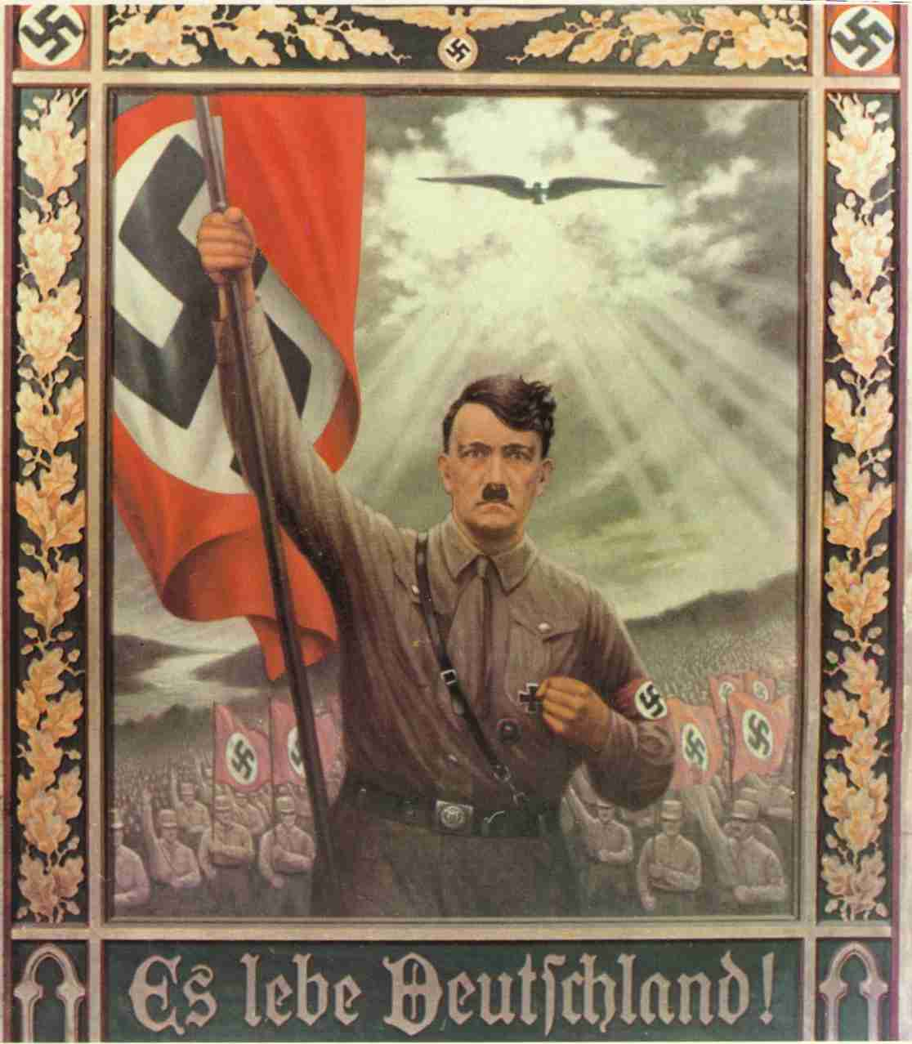](http://www.google.co.uk/url?sa=i&rct=j&q=&esrc=s&source=images&cd=&cad=rja&uact=8&ved=0CAcQjRw&url=http://www.newthinktank.com/2011/08/nazi-propaganda-posters/&ei=HiiIVdyzKYLhywO6_pV4&psig=AFQjCNHjSfGEbWYmD_uaWZo2rKaI37bGig&ust=1435072875737338)What was Hitler’s role in policy making?

He provided the overall vision, which was then interpreted and turned into detailed policies by those around him.

1. Why was it so unclear what the “will of the *Führer*” actually was?

His style was haphazard e.g he often went to bed late and got up late. He was often away from Berlin in the Berghof, his mountain retreat. From 1938 he withdrew even more, concentrating on foreign policy. Much of the decision making was done orally rather than on paper. There were competing offices which all claimed to represent Hitler.

1. What was Hitler most interested in & what was the result of this?

Foreign affairs and building projects. Consequently he left his fellow ministers to decision making.

1. What effect did the chaotic & competitive nature of Nazi government have on policy?

It became increasingly radical and brutal.

1. What different reasons are given in Sources 11.7 & 11.9 for the chaotic nature of Nazi government?

S11.9 suggests that Hitler was simply lazy and that explains the chaotic nature of Nazi government, whereas S11.7 suggests it was a deliberate move on the part of Hitler to prevent anyone else gaining a significant powerbase and challenging his dictatorship.

**Task:** Study the four examples of decision-making on p.191 of Hite & Hinton and assess what they show about the role of Hitler in the Third Reich. What evidence, if any, do they provide of the following roles for Hitler:

1. The direct initiator of action
2. Controlling policies
3. The overall inspirer of policy
4. Responding to others’ proposals and actions
5. Opting out of a clear decision

**Methods of Control: Censorship, Propaganda and Terror**

[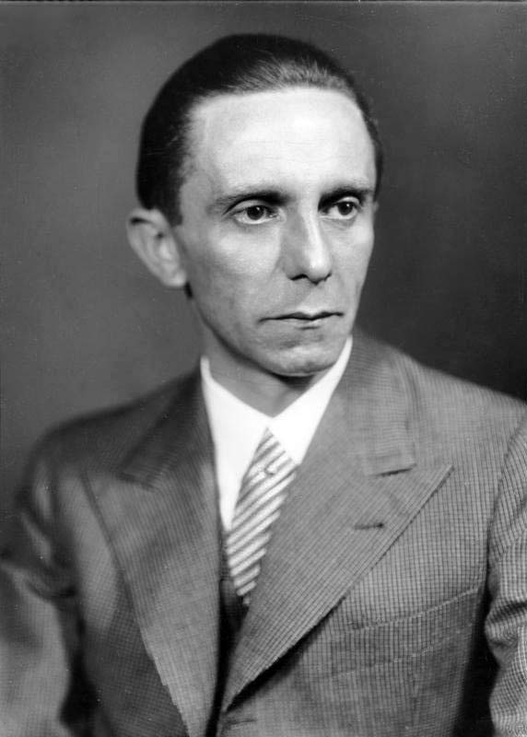](https://www.google.co.uk/url?sa=i&rct=j&q=&esrc=s&frm=1&source=images&cd=&cad=rja&uact=8&ved=0CAcQjRxqFQoTCJuE2-jk38gCFcu6FAodEL0JzQ&url=https://en.wikipedia.org/wiki/Joseph_Goebbels&psig=AFQjCNE_FrYqIK28VJJyDOW_jHz_2VKWwg&ust=1445936890107665)

**Censorship and propaganda**

The Nazi regime sought to win over public opinion and create a new Nazi culture which glorified war and the Aryan race. This involved projecting a positive image of Nazi culture and achievements and censoring hostile ideas and inconvenient facts in the media, art, literature and theatre.

The head of the Propaganda Ministry was **Joseph Goebbels** (right). Within the Ministry departments were set up to deal with the press, film , radio, theatre and a programme of ‘popular enlightenment’ to ‘enlighten’ or brainwash the German people into accepting the Nazi ideology.

**Task:** Use Layton, p.166-173, and other sources available to you to complete the following table.

|  |  |  |  |  |
| --- | --- | --- | --- | --- |
|  | Steps taken to bring it under Nazi control | Nazi message it was used to promote | Examples | Extent of success? |

|  |  |  |  |  |
| --- | --- | --- | --- | --- |
| Radio | Brought all broadcasting under Nazi control by the creation of the Reich Radio Company.  Dismissed 13% if the staff on political/racial grounds & replaced by those loyal to Goebbels  Cheap set produced called the People’s Receiver | Importance of Hitler as Fuhrer |  | In 1932 fewer than 25% of German households owned a radio.  By 1939 70% of German homes had a radio.  Broadcasting in public places – loudspeakers were installed in restaurants and cafes, factories and offices. |
| Press | Nazi publishing house – Eher Verlag bought up numerous newspapers  News agencies were merged into one.  Goebbels introduced a daily press conference at the Propaganda Ministry to provide guidance on editorial policy.  Editors’ Law of October 1933 made newspaper content the sole responsibility of the editor, who had to satisfy the requirements of the Propaganda Ministry. | Incited hatred of Jews and other minority groups  Scandal stories about clergy to discredit the church  Atrocity allegations against countries Germany was about to invade | Volkisher Beobachter – the Nazis’ official newspaper | The Nazis succeeded in muzzling the press – the Frankfurter Zeitung was forced to close in 1943  The circulation of the Party’s official newspaper Volkisher Beobachter grew after 1933 and reached 1.7 million by 1944  Controlled 2/3 of the German press by 1939. |
| Drama and music | Reich chamber of culture established 1933  Mahler and Mendelssohn as Jewish composers were banned as were more modern musical trends  New genres of jazz and dance-band were labelled negroid and decadent | Blood and soil  Glorification of war  Social Darwinism  Superiority of the ‘master race’  Fuhrerprinzip  Anti-modernism  Paganism  Volksgemeinschaft |  | Most aspects of culture effectively Nazified except classical music (non-political so could flourish)  Failed to suppress jazz and swing, which were popular with young people |
| Literature and art | Reich chamber of culture established 1933  Jewish or anti-Nazi writers exiled e.g. Thomas Mann, Bertolt Brecht  Writers, playwrights and artists had to censor themselves or risk being unable to work if they offended Nazis  Writers and artists had to change style to suit Nazi ideas |  |  | Most of Germany’s best writers left leading to a decline in cultural standards, although the Nazis didn’t really care about this |
| Film | Jewish film actors and directors like Fritz Lang were removed then left Germany.  Feature films were used to promote anti-Semitism  Leni Riefenstahl made propaganda films like ‘Olympia’ | Anti-semitism  Fuhrerprinzip  ‘master race’ | The Eternal Jew.  Hitlerjunge Queux (based on the story of a Nazi murdered by communists)  The Adventures of Baron Munchhausen – escapism.  Triumph of the Will – Leni Riefenstahl. | ‘Olympia’ was popular because of interest in sport and ‘Jud Suss’ because it was so melodramatic, overtly propagandistic films like ‘Triumph of the Will’ and ‘The Eternal Jew’ were less popular |

**The court system, SS and Gestapo**

Crucial to the survival of the Nazi regime was its ability to eliminate its enemies and to terrorise the population into obedience. While the existing courts could be used to sentence the enemies of the *Volksgemeinschaft*, these were backed up by a machinery of terror: the SS, the Gestapo and the concentration camps.

**The courts**

* **New laws** were introduced to deal with political offences. E.g. from December 1934 anyone convicted of making ‘hateful’ remarks about the Nazi state and its leaders could be executed.
* **People’s courts** were set up to try communists and other enemies of the regime.
* **Judges** were instructed to be much tougher in sentencing criminals.
* Pressure was placed on lawyers and judges to carry out the wishes of the government. In April 1942 the government announced that it would remove from office ‘judges who clearly fail to recognise the mood of the hour’. This enabled the Nazis to **interfere directly in trials**.
* 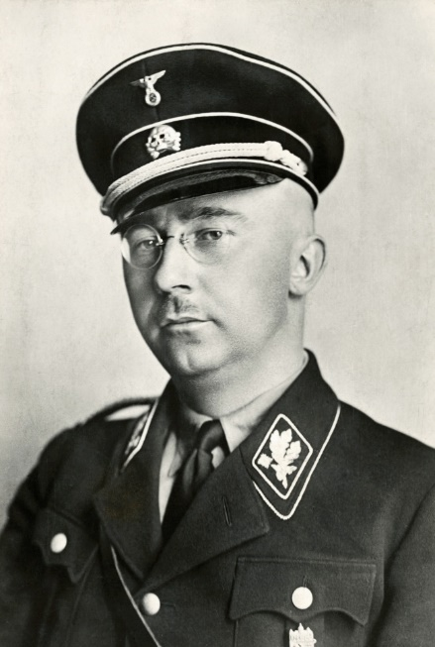In August 1942 **Otto Thierack** was appointed Minister of Justice and the senior officials and the ministry were replaced by men who were more loyal to the Nazis. From now on it became the norm for public prosecutors, who represented the Nazi state, to indicate to the judges beforehand what their verdicts should be.

**The SS *(Schutzstaffel)***

* Created in 1925; originally Hitler’s personal bodyguard.
* 280 members in 1929; by late 1930s it was a vast organisation involved in most aspects of the Third Reich, a ‘state within a state’.
* Alongside the Gestapo, it was the most powerful and feared of the organs of repression in Nazi Germany.
* It was led by **Heinrich Himmler** (right) and under his leadership it took over responsibility for the party’s intelligence and espionage section (SD).
* The SS used the Emergency Power Decree of February 1933 to take suspects into ‘protective custody’, consequently emerging as the chief police arm of the Nazi party. Between 1933 and 1939, 225,000 Germans were convicted and imprisoned for political crimes and by 1939 another 162,000 were in ‘protective custody’ without trial.
* Himmler had loyally supported Hitler against Röhm and as a result the SS was rewarded by being made independent of the SA.
* 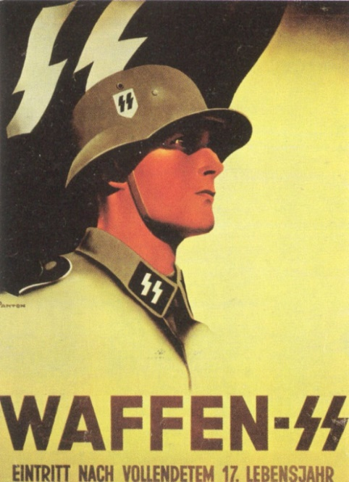In February 1936 Himmler also took control of the Gestapo. It now worked closely with the SS and the SD under the direction of **Reinhard Heydrich.**
* The SS directed its energies against all enemies of Nazism and took over responsibility for running the concentration and extermination camps.
* By 1939 there were 240,000 members organised into divisions. The main branch was the **Waffen-SS**, primarily a military organisation. The **Death’s Head** formations administered the concentration camps and formed panzer units; they were mostly young peasants who were trained to treat the inmates of the camps brutally.

During the Second World War the influence of the SS increased hugely; Himmler was given responsibility for the resettlement of ethnic Germans from Poland and elsewhere back into Germany. He was also responsible for eliminating ‘the harmful influences of such alien parts of the population as constitute a danger to the Reich and the German community’ in the occupied and incorporated territories. Effectively, he had a free hand to deport and later murder Jews, gypsies, Poles and Russians in the concentration camps.

**The Gestapo: the ‘all-seeing, all-knowing arm of state security and law enforcement’?**

* The Gestapo were the **political police** and their aim was to ‘wage war’ against the political and asocial enemies of the state.
* Werner Best, the legal expert at Gestapo headquarters, described the duty of the police to watch over ‘the health of the German body politic’ to recognise ‘every system of sickness’ and destroy all ‘destructive cells’.
* The Gestapo’s power was such that it had **complete freedom to operate outside the law.**
* In September 1939 Himmler amalgamated the SD, Gestapo and the Reich Criminal Police Department into the Reich Security Head Office. New powers enabled the Gestapo to arrest anyone who dared voice doubts about the war or who listened secretly to the BBC’s foreign broadcasts.
* Although the Gestapo was feared, **in reality it was a very small organisation**, in 1939 consisting of about 20,000 men (of these, 3000 were also members of the SS). Most Gestapo officials were office workers who spent their time creating and then updating card indexes in which the particulars of Communists, Social Democrats, ‘deviants’ and grumblers were kept.
* The Gestapo were dependent on **informers** for most of their information.
* These informers could be dedicated Nazis or simply those with a desire to get even with difficult neighbours, or colleagues at work.

**Task:** Use Hite & Hinton p.202-205 to answer the following questions.

1. What roles were played under the Nazi regime by the SS and Gestapo?

The **Gestapo** originated from the Prussian political police, controlled by Göring as Prussian Minister of the Interior until he handed over control to Himmler in 1934.

They focused initially on political opponents of the regime, especially Communists & Social Democrats, & later on Jews.

The **SS** were used as auxiliary (extra) police to enforce the Decree of the Reich President for the Protection of People & State; they had the power to imprison people without trial (“protective custody”); in 1939 162,000 people were in “protective custody”.

1. Explain how Himmler and the SS became so powerful in the Third Reich.

Himmler gained control of the **police** in Bavaria (the 2nd largest German Land after Prussia) in 1933 & opened the first concentration camp at Dachau near Munich.

In 1934 he gained control of the Prussian police from Göring, so in effect he controlled the police in the whole of Germany; in 1936 he officially became Head of the German Police.

In 1939 he officially became Head of Reich Security, controlling **both the SS & the police** (including the Gestapo).

From 1934 onwards Himmler in effect **controlled the Nazi terror machine**: 225,000 were convicted of political crimes 1933-9, but many more were detained without trial.

The SS took over control of the **concentration camps** from the SA & the number of concentration camp prisoners steadily grew b/c of the increasing persecution of Jews, Roma, gays etc.

The **number off SS officers** grew nearly fivefold (50,000 to 240,000) 1933-9.

1. What do recent historians’ analyses suggest about the nature of the Nazi state?

There were only 50,000 Gestapo officers in the whole of Germany, approximately 1 for every 1,500 people, so they lacked the manpower to terrorise the whole population & had to rely on denunciations from ordinary people for most of the cases they pursued.

Many of these denunciations were motivated by personal spite rather than Nazi enthusiasm (e.g. one man falsely alleged that his wife was sleeping with a Jew b/c he wanted to get rid of her) & did not usually target Jews or Communists as the Gestapo wanted.

On the other hand, the fear of denunciation was real & fear of the SS & Gestapo undoubtedly intimidated those who considered opposing the regime.

The Gestapo’s chief victims, Jews & Communists, only constituted about 1% of the population between them so the Gestapo did have the manpower to tackle them. Most of the population supported the regime voluntarily & did not need to be terrorised.

1. What evidence is there that the Nazi police forces were not alien institutions imposed upon the German people?

Gellately found that in Würzburg over half of prosecutions for racial crimes originated from denunciations by ordinary people; he therefore argues that people used the Gestapo rather than the Gestapo using them.

1. Laurence Rees in his book *The Nazis: a Warning from History* writes: ‘I still have the image in my mind of Frau Kraus as we left her, after the interview… a profoundly unexceptional figure and thus a deeply troubling one’. Explain his comment.

Ilse Totzke was denounced by her neighbours, not the Gestapo. Resi Kraus, one of the neighbours who denounced her, was an ordinary young woman, not a Nazi Party member. This was typical, which shows the danger Ilse Totzke was in; she could potentially be denounced by anyone so she could never feel safe.

This also shows how many of the population were willing to help the Nazis persecute anyone who “didn’t fit in”.

**The concentration camps, prisons and the treatment of opposition**

* Established in 1933 and used in the SA’s campaign of violence against Socialists and Communists.
* They were disliked by many Germans, including Hitler’s Nationalist allies, and as a result many were closed over the following year.
* In June 1933 Himmler appointed **Theodore Eicke** as Inspector of the Concentration Camps and he introduced a more disciplined regime.
* **Dachau** became a model for all future concentration camps in Germany. New punishment regulations aimed to stop random personal violence by guards and instituted a disciplined bureaucratic system to ensure that all punishments were recorded and carried out by several SS men rather than by an individual.
* By the time Himmler took over responsibility for all the concentration camps in Germany, there were only 3000 inmates, indicating that the Nazis had virtually eliminated the Communist and Socialist opposition. Himmler therefore closed down all but Dachau, Sachsenhausen, Buchenwald and Lichtenburg, the latter being a camp for women.
* There were, however, still 14,000 political prisoners in the state prisons.
* In February 1936 the SS and Gestapo also started to round up habitual criminals, asocials and homosexuals.
* By July 1937, 57% of the inmates in Dachau were not political prisoners, but tramps and professional criminals.
* In December 1937 a law was passed permitting the arrest and imprisonment of anyone believed to not fit the ‘People’s Community’. This was used to include beggars, gypsies, homosexuals, the long-term unemployed and even traffic offenders.
* By 1939 the concentration camp population had grown to 21,000 and two new camps ant Flossenburg and Mauthausen had been opened for asocials and criminals.

The machinery of terror was a major factor in Hitler’s consolidation of power. In the first 3 years the Gestapo and SS broke the political opposition to the Nazi regime and then were able to move on and deal with the ‘enemies’ of the People’s Community.

In reality there were few Gestapo agents and only four concentration camps in 1939, but their reputation cast a shadow over the German people: they represented what could happen to you if you were reported.

Nevertheless, **full employment, foreign policy successes and a feeling of national unity** also helped to make the Nazi regime **genuinely popular** with many Germans.

In addition, the machinery of terror **did not completely eliminate dissent**. Historians have used the term ***resistenz***, or immunity, to describe how some groups of Germans (for example, Christians) were at times able to block out or restrict the penetration of Nazi ideas. There were many people who rejected elements of National Socialism and who tried for example to avoid giving the ‘Heil Hitler’ salute, or who on saints’ days would hang out a church banner rather than the swastika. In addition, humour and anti-Nazi jokes were used as a low-key expression of resistance to the regime – this was risky, however, and could lead to imprisonment in a concentration camp or even execution for undermining morale. Some individuals went further, however.

**Task:** In small groups, research one of the 5 individuals below. Find out a) how they were involved in resistance to the Nazi regime, and what form this resistance took, b) what happened to them and c) how successful they were. Present your findings in a powerpoint to show to the class.

|  |  |
| --- | --- |
| **[Dietrich Bonhoeffer lived from 1906 to 1945.](http://www.religionnews.com/2014/07/03/dietrich-bonhoeffer-gay-new-biography-raises-questions/rns-dietrich-bonhoeffer/)Dietrich Bonhoeffer** |  |
| **Georg Elser**  [https://static1.squarespace.com/static/53323bb4e4b0cebc6a28ffa2/53573350e4b0758dd79db484/53b5779be4b07e35bb10ace5/1404403882325/toto-elser1-BM-Berlin-ZDF.jpg?format=1000w](http://www.google.co.uk/url?sa=i&rct=j&q=&esrc=s&frm=1&source=images&cd=&cad=rja&uact=8&ved=0CAcQjRw&url=http://www.latino-review.com/news/hirschbiegel-bringing-georg-elser-to-the-screen&ei=lc-TVcXnK8OY7gbkzZ3YAg&bvm=bv.96952980,d.ZGU&psig=AFQjCNG7bQrz8xzmSjFUnzu9tDVMB0Snng&ust=1435836682770863) |  |
| **Claus von Stauffenberg**  [https://upload.wikimedia.org/wikipedia/commons/e/e3/Claus_von_Stauffenberg_(1907-1944).jpg](https://www.google.co.uk/url?sa=i&rct=j&q=&esrc=s&frm=1&source=images&cd=&cad=rja&uact=8&ved=0CAcQjRw&url=https://en.wikipedia.org/wiki/Claus_von_Stauffenberg&ei=us-TVfLEB-2v7AbD4rfYAg&bvm=bv.96952980,d.ZGU&psig=AFQjCNEIfQ77HVyEfixtaeH0_tXMioBOkQ&ust=1435836710005077) |  |
| **http://vignette1.wikia.nocookie.net/wolfenstein/images/2/2f/Kreisau_Circle_Symbol.png/revision/latest?cb=20111104143553The Kreisau Circle** |  |
| **[https://findingtimetowrite.files.wordpress.com/2015/03/sophieschollbundesarchivde.jpg](https://www.google.co.uk/url?sa=i&rct=j&q=&esrc=s&frm=1&source=images&cd=&cad=rja&uact=8&ved=0CAcQjRw&url=https://findingtimetowrite.wordpress.com/tag/sophie-scholl/&ei=7NGTVdTBPIWO7AbuxZb4Ag&psig=AFQjCNE2xvr8jH6_-ws-86A16i0CsqgTlA&ust=1435836803016902)Sophie Scholl** |  |

**How successful was Nazi economic policy?**

When Hitler was appointed Chancellor there were nearly 6 million people unemployed; by 1935 there were only 2 million, and by 1939 there was a shortage of labour. This transformation helps explain not only why Hitler was able to consolidate his position in power, but also why he became so popular. Reducing unemployment was an important Nazi success; but Hitler had broader aims – his top priority was to expand the military might of Germany and prepare the country for war.

**Hitler’s Economic Aims**

1. **Reduce unemployment:** Hitler promised to solve the unemployment problem within four years of taking power.
2. **Rearm:** this would help ‘kick-start’ economic recovery, but it was also an ideological aim.
3. **Autarky:** the Nazis aimed to transform the German economy into a self-sufficient system, which would manufacture and grow everything Germany needed; it was seen as necessary to prevent a repeat of the problems Germany faced in WW1 with the British naval blockade. The rearmament drive created a massive demand for oil and rubber, which Germany did not have her own supplies of. The Nazis therefore tried to produce them artificially to minimise the need for imports:
4. Synthetic oil was made from coal, which Germany did have ample supplies of.
5. Buna (synthetic) rubber was made from acetylene.
6. **Help for *Mittelstand* (the German lower middle classes) and farmers:** the Nazis had aimed much of their electoral propaganda at this group – small shopkeepers hated the big department stores (which they contended were owned by the Jews) because they could sell services and goods more cheaply than they were able to.
7. **Aryanisation** of Jewish owned firms by destroying or taking over their businesses. For example, Hertie, the department store chain in Berlin. This process was completed after Kristallnacht.

[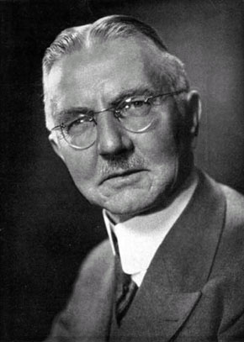](http://www.google.co.uk/url?sa=i&rct=j&q=&esrc=s&frm=1&source=images&cd=&cad=rja&uact=8&ved=0CAcQjRxqFQoTCLLvsojm38gCFQVYFAodoaQFnQ&url=http://greyfalcon.us/restored/The%20Nazi%20Connection%20to%20the.htm&bvm=bv.105841590,d.d24&psig=AFQjCNGMT9DcgDA3MEH-8IO-xCc9BiyPiw&ust=1445937224558095)**The Nazi economy can be divided into 3 broad periods:**

* Recovery: 1933-36
* Rearmament: 1936-39
* War: 1939-45 (covered in a later booklet)

**Recovery, 1933-36: Hjalmar Schacht and the New Plan**

**Hjalmar Schacht** (right) was appointed President of the Reichsbank in March 1933 and Minister of Economics 1934-7. A respected international financier because of his leading role in the creation of the new currency in the wake of the 1923 hyperinflation, this indicated the need of the Nazi leadership to work with the powerful forces of the economic elites. Schacht used a policy of **deficit financing** to boost the economy. However, by 1934 the revival of the economy was causing concern because of a balance of trade deficit. The **New Plan** tackled this problem, giving the government strong powers to regulate imports. This helped to overcome the immediate balance of trade problem in 1934 but there was still the problem of increased demand sucking in imports, especially as the pace of rearmament grew.

[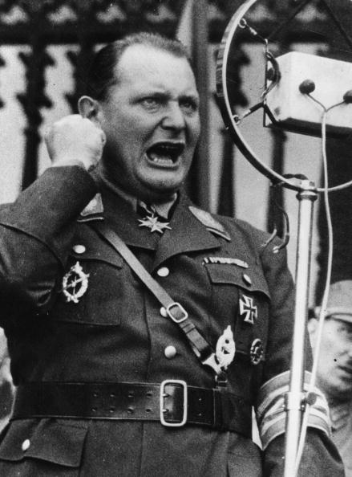](http://www.google.co.uk/url?sa=i&rct=j&q=&esrc=s&frm=1&source=images&cd=&cad=rja&uact=8&ved=0CAcQjRxqFQoTCPLV8LHm38gCFQZvFAodWDcNUQ&url=http://www.ibtimes.co.uk/aurochs-how-hitler-goering-resurrected-extinct-species-make-nazi-super-cows-1482161&bvm=bv.105841590,d.d24&psig=AFQjCNGW1RVORfFZSaaCVj4r2Ex3M9zd8A&ust=1445937309807675)**Rearmament, 1936-39: Goering and the Four-Year Plan**

By 1936 Schacht was becoming increasingly concerned at the distortion of the economy due to rearmament – severe strains due to a **budget deficit** and increasing **balance of payments** problems were occurring. Schacht wanted to encourage exports and slow the increase in arms expenditure. Hitler became impatient with his caution and on 4 September 1936 put **Hermann** **Goering** (left) in charge of a new economic organisation, the **Office of the Four-Year Plan**. This aimed to make Germany ready for war within four years. Priority had to be given to rearmament, and Germany had to made self-sufficient as possible in food and industrial production, a policy known as **autarky**.

**How successful were Nazi economic policies, 1933-39?**

Successful

* Schacht used **Mefo bills** to finance increased public expenditure without causing inflation. These were credit notes issued by the Reichsbank and guaranteed by the government.
* The economic depression reached its low point in the winter of 1932-33 and afterwards the trade cycle began to improve.
* Financial benefits were given to **farmers and small businesses**, stimulating economic growth and rewarding some of the most sympathetic supporters of the Nazis in the 1930-33 elections. Some measures included tariffs on imported produce to protect German farmers and subsidies from the Reich Food Estate.
* The state increased spending on a range of investment projects. **Work creation schemes** like reforestation, land reclamation, motorisation (e.g. building the *Autobahnen*), expanding the housing sector and public buildings contributed to the **fall in unemployment from 6 million 1932 to 1.6 million in 1936 to virtual full employment by 1938**; GB still had over 1 million unemployed 1939. A billion *Reichsmarks* were invested in such schemes.
* The **Reich Labour Service (RAD)** took the young off the unemployment register (400,000 in 1934) and from 1935 conscription removed all 18 to 25 year old males who were required to do military service for two years. The drop in unemployment was also aided by squeezing women out of the labour market by offering young couples who were about to get married an interest-free loan worth up to 1000 *Reichsmarks* for as long as the wife remained at home and did not re-enter the labour market until it was paid off. The loan was not issued in cash but in vouchers that had to be redeemed for goods such as furniture and household equipment.
* **Schacht’s New Plan** enabled the government to have comprehensive control over all aspects of trade, tariffs, capital and currency exchange. In effect imports had to be approved by the government.
* Schacht also made a series of **bilateral trade agreements**, especially with the Balkan states, which supplied much of Germany’s strategic raw material imports.
* **Industrial production** nearly doubled 1933-8.
* Under the **Four-Year Plan**, production of a number of key materials, such as aluminium and explosives, expanded greatly.
* By 1939 Germany was producing more than x4 as many **weapons** as GB and USA combined.
* By 1939 Germany was self-sufficient in **grain, potatoes and sugar.**
* **National income nearly doubled** 1933-8; virtually all Germans’ living standards rose, e.g. farmers’ by 41% 1933-8.

Not successful

* By 1934 imports (mainly of raw materials) rose much faster than exports, creating a **balance of trade deficit** which was persistent.
* Germany’s **gold and foreign currency reserves** were also running low by 1934.
* By 1936 Schacht was becoming increasingly concerned about the distortion of the economy due to rearmament. **National debt more than trebled** 1933-9 because of excessive spending on rearmament.
* From 1937 the German economy was entrusted to **Goering,** who had no economic expertise.
* Production of **rubber, oil and high quality iron ore** fell significantly short of the targets imposed by the Four Year Plan and arms production never reached the levels desired by the armed forces and Hitler.
* Indeed by 1939 Germany still depended on **foreign imports for 1/3 of its raw materials**, especially iron ore, oil and rubber. **Autarky had therefore not been achieved**: another method of ‘self-sufficiency’ was given more stress: conquering other countries to use their resources.
* Not until 1938 did real wages return to their 1928 level; in 1937 workers were drinking less beer and eating less well than in 1927, showing a lower standard of living.
* Economic growth was only impressive compared with the Depression; even by 1937 the German economy was only just above the level reached in 1912.

**Who gained most from the German economy?**

**Activity:** Complete the task ‘Who gained and who lost from the Nazi economy?’ task, on a separate sheet.

**Task:** Complete the following table, using Hite & Hinton p.227-233 and Layton p.194-198

|  |  |  |
| --- | --- | --- |
| **Social group** | **Benefits of Nazi rule** | **Drawbacks of Nazi rule** |
| **Elite and big business** | * Landowners benefited from increased demand for food * Private ownership allowed * Trade unions & strikes banned * Many firms profited from rearmament, e.g. Daimler Benz produced aeroplanes, IG Farben produced artificial oil & rubber (IG Farben alone got over half of govt. investment in industry) * Share prices & dividends more than doubled 1932-40 * Management salaries increased | * Landowners had less political influence than under Hindenburg * Increased state interference, often telling firms what to produce; Thyssen said Nazi Germany like USSR * Steel makers like Thyssen resented competition from state owned Reichswerke Hermann Göring |
| ***Mittelstand*** | * Law to Protect Retail Trade 1933 taxed existing dept. stores & forbade new ones (many of which were owned by Jews) * Benefited from economic recovery; income of skilled craftsmen doubled b/c of this * Loans offered at low interest rates | * Mittelstand continued to decline * Shortages of credit & raw materials * Big business, e.g. dept. stores, profited at expense of small business esp because of costs of small businesses * 500,000 small businesses forced into bankruptcy * Nazi emphasis on rearmament & autarky favoured big rather than small firms * Too much govt. interference |
| **Workers** | * Full employment by 1938 & growing shortage of workers * Skilled workers could get round wage restrictions by receiving Xmas bonuses, free motorcycles etc * Workers better off than before 1933 b/c they had jobs * Strength through Joy organised by DAF provided subsidised leisure activities, e.g. 10 million took KdF holidays 1938, & improved facilities, e.g. factory canteens * By 1939 70,000 companies had improved workplace facilities in line with the Nazi “Beauty of Work” policy * More paid holidays | * Pay increased only b/c longer hours worked; hourly pay virtually static * DAF contributions & donations to Nazi charities deducted from workers’ pay packets * Workers producing consumer goods did less well than those in armaments industry * Until 1938 workers still worse off than before Depression * Trade unions & strikes banned * Works councils elected by workers replaced by Nazi controlled Councils of Trust * Workers forced to join DAF, which then bribed workers (through KdF etc) with their own money b/c all its activities financed by membership dues * RAD (Reich Labour Service) provided jobs for young people but work was compulsory, pay low & workers had to live in barracks * No workers got Volkswagen despite having paid for it |
| **Farmers** | * Many farm debts and mortgages were written off. * Reich Entailed Farm Law 1933 meant farmers couldn’t lose farms even if they went bankrupt * Farmers’ incomes rose by 41% 1933-8 * Autarky (restricting food imports) boosted German agriculture: farmers got guaranteed prices, cheaper fertilisers & machinery | * Too much govt. interference, e.g. Reich Food Estate * % of population earning living from agriculture fell – people were drawn to the towns because wages were higher there * Reich Entailed Farm Law made it harder for farmers to get loans b/c they couldn’t use farms as security * Rearmament prioritised over agriculture |

**Conclusions:**

1. Helped by the upturn in the economic cycle, Nazi efforts to revive the economy and create unemployment were successful, although their success was exaggerated. By the summer of 1934 unemployment had fallen to 2.5 million, but it remained fixed at that level until conscription and the acceleration of rearmament resulted in a further dramatic fall in 1936. By the summer of 1938 there was virtually full employment.
2. The small farmers and the *Mittelstand* did not benefit as much as they expected to from the Nazi regime. Hitler never closed the department stores and never attempted to weaken the influence of big business and industry. Farmers, however, enjoyed certain real benefits, but became frustrated by the bureaucracy of the Reich Food Estate and the government’s refusal to allow them to charge what they wanted for their crops.
3. As the pace of rearmament accelerated, the economy overheated and sucked in vast quantities of imports which were expensive to pay for. When the New Plan failed, Hitler rejected Schacht’s advice to slow down rearmament and instead announced the Four Year Plan. Regardless of cost, he was determined that Germany should be ready for war by 1940, but when war broke out the country was far from ready for a long war.
4. Despite huge investments, the actual production of war material was disappointing, as much of the investment had gone into constructing barracks rather than tanks.

**How far did Hitler succeed in creating a *Volksgemeinschaft*?**

**[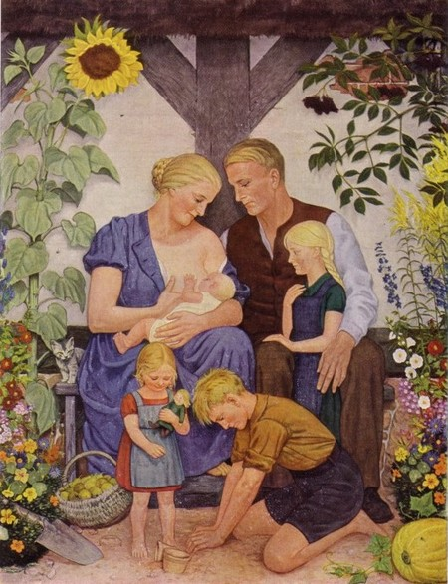](http://www.google.co.uk/url?sa=i&rct=j&q=&esrc=s&source=images&cd=&cad=rja&uact=8&ved=0CAcQjRw&url=http://nordicantisemite.com/2014/08/16/towards-a-healthier-folk/comment-page-1/&ei=DdNdVe-TE4y07gbTnoAQ&bvm=bv.93756505,d.ZGU&psig=AFQjCNEzLbBrVgKMIkqZFCjxTE5pRGhvRQ&ust=1432298634048326)**

**The *Volksgemeinschaft***

Hitler wanted to create a new German nation (***Volksgemeinschaft***, or ‘people’s community’). This meant a new, unified classless community based on blood and race, sharing a common world view or philosophy (***Weltanschauung***). The vision also entailed hostility to ‘outsiders’ who were to be removed: Jews, ‘aliens’, ‘deviants’, the mentally sick and incurably ill. Members of this community would be **healthy, socially useful and politically committed to the regime**, making Germany fit for world domination. The ideal German image was that of the classic peasant working on the soil in the rural community – exemplified in the Nazi concept of **‘Blood and Soil’ (*Blut und Boden*)**. The aim was to create a population indoctrinated with Nazi ideas that would lay the foundation for the thousand year Reich.

**Women**

Nazi policy towards women was largely **reactionary**. The Nazis wanted to reverse many of the recent trends that had increased opportunities for women throughout Europe, such as increased female employment in the non-agricultural sector and a declining birth rate that was partly due to wider access to contraception. In Germany, women had been given the vote and experienced greater cultural freedom in the 1920s, although during the Depression years there were some moves towards discrimination against women in the workplace. By contrast, the Nazis had a clear vision of women as homemakers and childbearers, summarised by their slogan ***‘Kinder, Küche, Kirche’*** (Children, kitchen, church). In the national struggle for survival, women had a vital supportive role to play: to breed genetically pure Germans to ensure the supremacy of the race.

*Familienbildnis*: the ideal German family – a painting by Wolfgang Willrich, 1930s.

However, this vision did come into conflict with other Nazi priorities. During the war for example, more workers and more soldiers were needed, and therefore the government encouraged the utilisation of female labour, and childbirth outside marriage.

**The Family**

The ideal Nazi family was blond, Aryan and had lots of children. The purpose of marriage was “the procreation of genetically healthy children of the same race”. it must be considered reprehensible conduct to refrain from giving healthy children to the nation‘. Consequently, sex was for procreation not pleasure, abortion was outlawed, and contraception was banned for genetically healthy Aryans to boost the birth rate. Because the birth of healthy Aryan children was identified as a priority, however, the status of unmarried mothers improved despite the conservatism of the Party.

**Task:** Using Hite & Hinton p.296-301, complete the following grid assessing the effectiveness of Nazi policies towards women and the family.

|  |  |  |  |
| --- | --- | --- | --- |
| Area | Key measures | Successes | Limitations & failures |
| Increased births | * Marriage loans * Birth grants * Mother’s Cross * Abortion & contraception banned for genetically healthy Aryans * Compulsory sterilisation of genetically unhealthy | * Birth rate rose compared with Depression * 50% more marriages 1934 than 1932 | * Rise in birth rate caused by   economic recovery rather than Nazi policies & still lower than before Depression   * Fewer births per marriage * More divorces after 1938 |
| Improved welfare | * Improved maternity facilities * NSV (Nazi Welfare Organisation) set up * More health offices, especially in rural areas, provided improved sanitation & healthcare | * Child mortality fell * NSV created volunteering opportunities for women. * No of women attending recuperation homes after childbirth doubled 1934-8 |  |
| Reduced employment | * 1933: married women barred from govt. employment * 1936: women banned from being judges or lawyers * No female MPs allowed | * Women successfully barred from having high powered professional jobs, reversing trend during Weimar Republic | * Female employment rose b/c of economic recovery; this reduced birth rate |
| Reduced education | * Schools trained girls to be housewives & mothers rather than learning academic skills * Only 10% of university entrants could be women | * Women’s access to higher education successfully restricted |  |
| Involvement in women’s organisations | * 2 Nazi women’s organisations created: NSF & DFW | * NSF & DFW created opportunities for voluntary activity to middle class women excluded from professional careers * B/c of this many women enthusiastically supported regime despite restrictions it placed on them. |  |

**Youth**

While adults could be persuaded or forced into accepting the Nazis, their minds were not as pliable as their children’s. The Nazis wanted to raise a generation of Germans who unquestioningly obeyed them. The Nazis attempted to transform youth on three levels, by

* Ensuring that school syllabuses and teachers lost no opportunity to reflect and reinforce Nazi values
* The creation of new elite Nazi schools
* Putting pressure on children to join the Hitler Youth and the League of German Girls.

**Education**

**Task:** Read Hite & Hinton p.280-281. Complete the table below, giving specific examples of how the Nazis tried in schools to develop the spirit of *Volksgemeinschaft.*

|  |  |
| --- | --- |
| **Aims** | **Methods** |
| Anti-intellectualism | 2 hours of PE per day at expense of academic subjects  No. of university students halved 1933-9  Reading discouraged  Girls given only limited academic education |
| Anti-semitism | Jewish teachers sacked  In History, Jews blamed for all Germany’s problems  In Biology, students taught Jews had distinctive racial features |
| Indifference to the weak | In Maths students taught to calculate cost of keeping mentally ill people alive &  how many houses could be built with same amount |
| Nationalism | Taught through History (e.g. “stab in the back” myth) & Geography |
| Militarism | Elite youth given military training  Military subjects emphasised in History, Maths & Chemistry (e.g. how  explosives work)  Timetables decorated with military images |
| Obedience and discipline | Students taught to accept Nazi ideas without question rather than think for selves |
| Hitler worship | Every lesson began with “Heil Hitler!” greeting  In History Hitler portrayed as Germany’s saviour  Primary schoolchildren taught to compare Hitler with Jesus |

**New Nazi schools**

* **The Napolas** (National Political Educational Establishments): boarding schools which were later taken over by the SS. By December 1938, 21 had been founded and a further 20 were created during the war.
* **The Adolf Hitler Schools**: under the control of the Hitler Youth. The original idea was that no one should be appointed to a key position within the Nazi Party unless they had attended one of these schools, but only 10 had opened by 1945.
* ***Ordensburgen***: finishing schools for the future Nazi elite, aiming to create a disciplined, tightly knit group.

**Youth groups and alternative youth groups**

**Task:** In groups, research one of the following youth groups: *Hitler Youth, League of German Maidens, Edelweiss Pirates, Swing Youth, White Rose movement.* Produce a wordless Powerpoint presentation to show the rest of the class. You may like to include some contemporary source material (images, posters, or short written sources) to illuminate the points you are making.

The Hitler Youth

This term is used to describe both Nazi youth groups in general & more specifically the group for teenage boys (13-18).

* All boys and girls took a solemn oath of personal allegiance to Hitler.
* Young people were made to feel important by told that they were Ger.’s hope and Ger.’s future etc.
* Uniforms, marching etc also made them feel important.
* Fun activities, e.g. hiking, camping, sport, games, singing etc, were used to draw people in.
* By 1939 membership of Nazi youth groups was legally compulsory.
* Young people were kept so busy with Nazi activities (school on weekdays, youth group activities at evenings and weekends), that they had no time for anything else, e.g. parents, church or dancing to jazz, & it was impossible for them to escape Nazi indoctrination.
* Songs and nursery rhymes were used to make young people aggressive and warlike.
* Young people indoctrinated from a very young age: 6 for boys, 10 for girls.
* Young people from different backgrounds (rich and poor, urban and rural, Catholic and Protestant etc) were encouraged to join together in a **Volksgemeinschaft** (racially pure national community).
* Lectures on Nazi ideology and readings from “Mein Kampf”.
* Boys were prepared for war through sport (teaching fitness & teamwork), war games, military drill (to teach discipline), weapons training etc.

The BDM (League of German Maidens)

Catered for teenage girls (13-18).

* Girls were trained to be housewives & mothers.
* They were made to feel special and have a sense of belonging.
* Comradeship between girls from different social backgrounds.
* They willingly swore an oath of allegiance to Hitler and felt a strong desire to serve him.
* Some girls regretted that they couldn’t fight and die for Hitler.
* Even Jews would have liked to have joined.
* They were indoctrinated at an age when their personalities were still developing and they were in no position to question it.
* Some girls fantasised about having Hitler’s baby.
* They felt proud to be part of the wonderful new Germany and this made them obedient.
* Girls reacted hysterically to hearing Hitler speak at Nazi rallies.

The Edelweiss Pirates

This was the name given to a number of local groups of rebellious teenagers, mainly working class, who tended to keep their hair short & wear tight fitting clothes.

* Some sang songs about getting rid of Hitler.
* The numbers in such groups increased b/c of the increasing youthful rebellion against Nazi attempts to force them to join the Hitler Yth.
* Some EPs beat up HY or had links with the Communist Party.
* The very existence of these groups was an act of rebellion agt. the HY & showed that Nazi control of youth was not complete.
* The Nazis regarded them as undisciplined & “asocial”, i.e. not contributing to the Volksgemeinschaft which the Nazis were trying to build.

BUT:

* Only a tiny minority of Ger youth joined alternative groups & they were confined to certain areas like Hamburg & industrial cities in western Ger; it has been estimated that in 1939 there were only 2,000 EPs in the whole of Ger compared with over 8 million members of the HY.
* They were too young & disorganised to pose a serious political threat.
* For the most part their motivation was not political; they just wanted to have a good time.
* The relatively light sentences (fines or short terms of imprisonment) imposed on a group of “Kittelbach Pirates” in 1936 suggests that they were regarded as a nuisance but not a serious threat.

Swing Youth

These were rebellious teenagers, usually middle class (so they could afford to buy the records & pay to get into dance clubs) who danced & listened to black American jazz & swing music & gave themselves black American names like “Sonny Boy” & “Black Hand”.

They were even less organised & politically motivated than the Edelweiss Pirates but the Nazis hated swing music b/c they saw it as a threat to German culture & moral standards.

The “White Rose” Movement

This was a group of students at Munich University during WW2 led by Sophie Scholl & her brother Hans & assisted by Professor Huber, all of whom were tortured & executed in 1943 for distributing leaflets condemning Nazi atrocities.

Sophie was denounced by a janitor.

**Workers**

Hitler claimed that in creating the People’s Community he had ‘broken with a world of prejudices’ and created equality between the ‘workers of the brain and fist’.

**Control**

* **Trade unions and strikes** were banned in May 1933.
* All workers were forced to join the **German Labour Front (DAF)** which aimed ‘to indoctrinate them in the National Socialists mentality’. Their bosses, ‘plant leaders’, had much more power over them.
* **Elected Councils of Trust** were set up in all factories where there were more than twenty workers; after 1935 these were ended because the workers were electing representations considered ‘unreliable’. In theory a Council of Trust could take an employer to a Court of Social Honour provided it had the support of the local Labour Trustee, an official appointed by the Ministry of Labour, but this seldom happened.
* **Trustees of Labour** were set up by the Ministry of Labour to control wages and held wages down in the late 1930s when an increasing labour shortage, especially of skilled labour, created inflationary pressure for higher wages.
* The **Reich Labour Service (RAD)** forced young men aged 19-25 to do 6 months’ labour service.
* Workers had **more deductions from their pay packets**, including higher taxes, DAF membership dues and contributions to Nazi charities like Winter Aid.

**Gaining support**

* **The ‘Beauty of Work’ scheme:** headed by Albert Speer, this attempted to persuade employers to make their factories a more human environment by, for example, installing swimming baths, showers and canteens. By 1939 nearly 70,000 companies agreed to such improvements.
* **Strength Through joy (KDF):** a leisure organisation, the aim of the Strength Through Joy movement was to dispel boredom as from it, according to its head Robert Ley, ‘sprang stupid, heretical, yes in the end criminal ideas…’. It organised concerts and plays for the workers and arranged subsidised cruises or holidays in the German countryside. A popular project of the KDF was the Volkswagen car, started in 1938. Workers were offered a savings scheme to enable them to purchase the car. However, cards would only be delivered after the fginal payment had been made. By 1940, 300,000 people had signed up, but production was halted by the war and the cars were not produced until after it ended. The workers’ money was used to finance the war industries.
* **The National Socialist People’s Welfare Organisation:** This was set up to promote the ‘living, healthy forces of the German people’, meaning that asocials or anyone other than Aryans would be excluded. By 1939 it had over 17 million members and had developed an extensive network of nurseries for children, holiday homes for mothers, and it provided food for large families.
* The number of **paid holidays was increased**, including the May 1st holiday workers had always wanted (Hitler announced this the day before he abolished the trade unions)

**To what extent did the Nazis achieve the aims of their social policies?**

The Nazis’ vision was to create a ‘*Volksgemeinschaft*’, or people’s community, the desire to create a population indoctrinated with Nazi ideas that would lay the foundation for the thousand year Reich.

Youth & Education

* K. Fischer: “Nazi indoctrination was able to miseducate & misuse an entire generation of young people”.
* Most young people idolised Hitler.
* The vast majority of young people (82% of the entire 10-18 age group by 1939) were members of Nazi organisations; even anti-Nazi parents couldn’t stop their children joining.
* Only a tiny minority were members of alternative youth groups; that in 1939 there were only 2,000 Edelweiss Pirates in the whole of Germany compared with over 8 million members of the HY.
* B/c of their Hitler Youth training, German youths were physically fitter & better trained than their British & French enemies & fought more fanatically than older German soldiers.
* The Hitler Youth & BDM made young people feel important & gave them a sense of community. Melita Maschmann said of the BDM, “Never before or since have I had experience of such a good community”.
* Ian Kershaw has concluded, “Much suggests that the Nazis made their greatest impact on young Germans”.

BUT:

* As time wore on the Hitler Youth lost its “rebellious” appeal & there was increasing resentment of the regimentation in Nazi organisations.
* The very existence of alternative groups like the Edelweiss Pirates & swing groups was an act of rebellion against the Hitler Youth & showed that Nazi control was not complete.
* Nazi youth policy failed to break down social class differences.
* The anti-intellectual trend in Nazi educational policy led to a decline in scientific standards; Jewish physicists exiled from Germany helped the USA to build the atom bomb.

Women

* The birth & marriage rate rose, helped by Nazi incentives & improved maternity services. There were

50% more marriages in 1934 compared with 1932.

* Child mortality fell
* The number of women attending recuperation homes after childbirth doubled 1934-8
* By 1939 12 million women were members of Nazi organisations.
* Women were remarkably supportive of the regime (especially of Hitler personally) despite being excluded from professional careers & having their educational opportunities restricted, reversing the trend towards female emancipation (freedom) during the Weimar Republic.

BUT:

* The rise in the birth & marriage rate owed more to economic recovery than Nazi policies.
* Because of the economic recovery, female employment rose, which reduced the number of births.
* The number of births per family fell.
* There were more divorces from 1938 onwards.

 Workers

* Unemployment fell from 6 million in 1932 to virtually zero in 1938 & young workers were grateful to have jobs.
* Compulsory labour through the RAD ended youth unemployment.
* Trade unions & strikes were banned & the vast majority of workers joined the DAF.
* 10 million people took part in Strength through Joy holidays in 1938.
* By 1939 70,000 companies had improved workplace facilities in line with the Nazi “Beauty of Work” policy.
* There was remarkably little social unrest despite the Nazis limiting the rise in living standards to prioritise “guns over butter” & workers doing less well than other social groups.

BUT:

* Despite all the DAF did, workers remained less supportive of the regime than any other social group, especially older workers who knew they had been better off before the Depression than under the Nazis.
* Unofficial strikes & “go slows” continued despite the ban on strikes, reflecting workers’ resentment at having to work longer hours with only a slight increase in pay even compared with the Depression.
* Skilled workers were able to get round Nazi wage restrictions by being given special bonuses or in some cases motorcycles.

The Churches

* Clergy complained of a reduction in church attendance among young people, partly b/c of the abolition of church schools & the removal of religious instruction from the school curriculum, partly b/c Nazi youth activities deliberately clashed with church events.
* By 1939 3.5 million people had left the churches to join the pro-Nazi “German Faith Movement”.
* The pro-Nazi “German Christians” won two thirds of the vote in the Protestant church elections in 1933.
* Church leaders either supported the regime or at least did not oppose it except where their own interests were directly under attack.

BUT:

* Older people’s loyalty to the churches remained strong; Kershaw concluded that Nazi propaganda “failed categorically” to undermine support for the churches & police reports confirm this.
* Hitler’s attempt to unify & control the Protestant churches by imposing a Reich Bishop in 1933 failed, provoking the breakaway Confessing Church.
* In 1934 his attempt to dismiss 2 popular Protestant bishops, Meiser & Wurm, provoked so much opposition that it had to be abandoned.
* Kershaw has argued that the persecution of the churches was the least popular Nazi policy.

Race

* Many towns, villages & holiday resorts **on their own initiative** put up signs saying “Jews not wanted here” etc & banning them from beaches, swimming pools, parks etc.
* Nazi propaganda succeeded in making Melita Maschmann hate Jews in general even though she liked individual Jews.
* The vast majority of Germans did nothing to help the Jews & accepted legal measures like the Nuremberg Laws; only 9% of Jews from Krefeld recalled ever being helped by Aryans during the Nazi years.
* There was even less public sympathy for gypsies & “asocials”; Nazi propaganda succeeded in convincing most Germans that they were criminals & deviants whose incarceration in concentration camps was essential to protect the public.

BUT:

* The fact that Streicher felt the need to publish in “Der Stürmer” photos of Gers who shopped in Jewish stores shows a lack of public support for the boycott in 1933.
* Street violence against Jews, including Kristallnacht, was generally unpopular; a British diplomat reported that every German he met disapproved of Kristallnacht to some extent.
* Most Germans did not participate in attacks on Jews & were indifferent rather than supportive of them.

**Nazi Racial Policies to 1939**

**Outside the *Volksgemeinschaft***

The *Volksgemeinschaft* was composed of a racially homogenous ‘Aryan’ people, *das Herrenvolk*, whose health and racial purity were to be protected at all costs. A series of laws increasingly discriminated against those who were judged to be **‘*untermenschen’****.*

**Who were the *‘untermenschen’*?**

**Task:** Use Layton p.213-215 to make notes on the following groups and how the Nazis dealt with them.

The Genetically Disabled

The Nazis were strong believers in **eugenics**, i.e. that many diseases & conditions were genetic & could be eliminated from the national gene pool by compulsory sterilisation so defective genes could not be passed on. They hoped thereby to create a pure race from which such genes would be eliminated.

They therefore passed the **Law for the Prevention of Genetically Diseased Offspring** in 1933 which provided for the compulsory sterilisation of those judged to be genetically unhealthy. It applied to conditions like schizophrenia & in some cases blindness.

In total 350,000 people were sterilised as a result of this law.

A further law was passed in 1935 to forbid anyone judged to be mentally or genetically diseased from marrying.

In 1939, after Philipp Bouhler showed Hitler a letter from a father requesting the killing of his mentally disabled son, the **mass murder of mentally disabled children** began. Unusually Hitler gave written authorisation to doctors to carry out such killings at their discretion.

Asocials

“Asocials” was the term used by Nazis to describe anyone who did not contribute to the Volksgemeinschaft, the racially pure people’s community. This included alcoholics, prostitutes, criminals, tramps & the workshy.

They were subjected to forced labour or, if they were judged incapable of this, imprisoned & in some cases sterilised (to stop them passing on their defective genes) or even experimented on.

Homosexuals

Gay men were persecuted for not performing their racial duty to have children; they were seen as “asocial” & deviant.

10-15,000 gays were imprisoned, often in concentration camps.

Gypsies

Gypsies (Sinti & Roma) were persecuted both b/c they were seen as racially “alien” (Like Jews) & b/c of their lifestyle; they were seen as workshy, potentially criminal, & therefore “asocial”.

Along with Jews they were forbidden to marry or have sex with Aryans in the Nuremberg Laws in 1935.

In 1938 Himmler ordered the registration of gypsies as an alien race; his order referred to “the gypsy plague”, seeing them as a threat to the purity of German blood.

From 1939 onwards they were put in concentration camps & later murdered.

**The Jews**

*The language to describe the Holocaust does not exist. The more I study, the less I understand.*

* **Nobel Peace Prize winner & Holocaust survivor Elie Wiesel**

[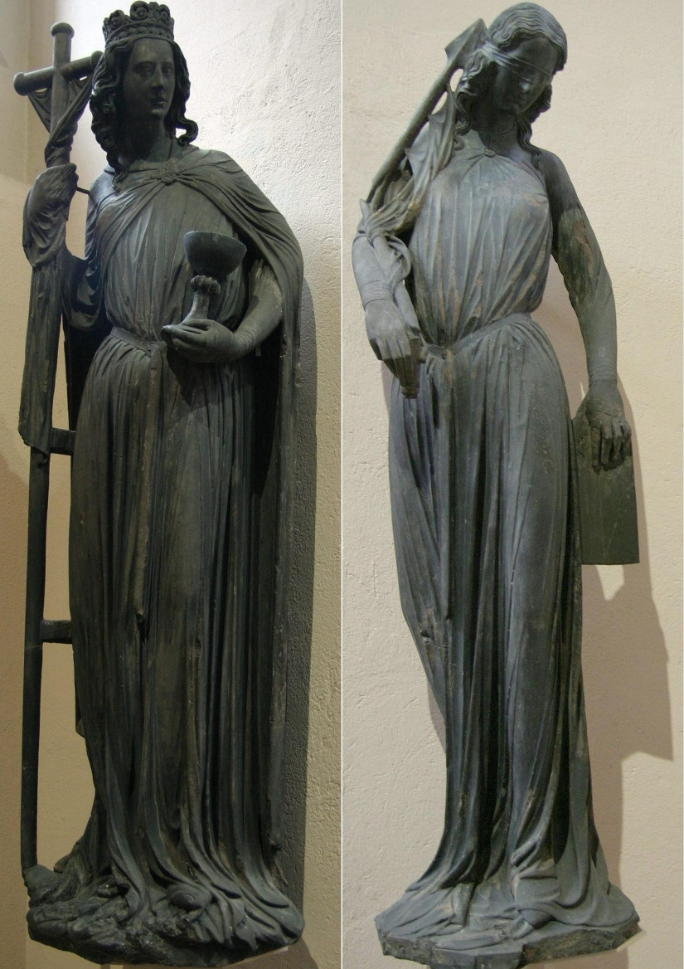](https://www.google.co.uk/url?sa=i&rct=j&q=&esrc=s&frm=1&source=images&cd=&cad=rja&uact=8&ved=0CAcQjRw&url=https://en.wikipedia.org/wiki/Ecclesia_and_Synagoga&ei=9cqHVYLSLuHT7QbxzIOYBg&bvm=bv.96339352,d.ZGU&psig=AFQjCNGrTqC2e_zCgAEC6r26RgVwL5ReXQ&ust=1435049075359981)

Anti-Semitism was not confined to 1930s Germany. Hostility to the Jews, as the ‘Christ killers’, has a long tradition in Christian history, reinforced by resentment at the wealth and position of some Jews and the periodic need for scapegoats to blame for problems, particularly as Jews were scattered across Europe and therefore were always a minority group, making them more vulnerable. In the late nineteenth century an influx of Jews fleeing persecution in Tsarist Russia, combined with the growth of racist views associated with social Darwinism, led to increased anti-Semitic feeling in Germany and other European countries.

**To the Nazis the Jewish ‘threat’ was in a class by itself**. There were only 500,000 Jews in Germany in 1933, and most of them were fully integrated into German society and were patriotic Germans. Nevertheless the Nazis perceived the Jews to be plotting on a worldwide scale the destruction of Germany, and regarded them as the power behind Bolshevism. For most Nazis the Jews had attained the status of mythological demons, upon whom they focused their anxieties about the modern world.

**Ecclesia and Synagoga**, a pair of figures personifying the Church and the Jewish synagogue, found in medieval Christian art. The figures reflect the Christian belief that Jesus was the Jewish Messiah, and that Judaism as a religion was therefore made unnecessary once Christianity was established, and that all Jews should convert. Synagoga's blindfold reflected the refusal of medieval Jews to "see" this point, which was regarded as stubborn.

**The Nazis took anti-Semitism way beyond anything that had gone on before**. Hitler was obsessive in the hatred of the Jews and certainly it coloured all his political aims. Nevertheless, it was not obvious in 1933 exactly what form this attack would take: the Holocaust was the culmination of increasingly radical anti-Semitic policies developing from 1933. Nazi anti-Semitic policy was **gradualist**, and early moves against Jews gave no suggestion of the end result.

**Anti-Semitic policies, 1933-36**

Rather than being led by Hitler, it was the rank and file of the Nazi Party who demanded immediate action against the Jews. Local outbursts, led mainly by the SA, had to be contained during the first delicate months of power in 1933 and a one-day boycott of Jewish shops and professions was intended to serve this very function: it failed, however, to deter Germans from using Jewish shops and businesses, and met criticism at home and abroad. The Law for the Restoration of the Professional Civil Service of 1933 excluded many Jews from public service, but until 1935 there were no further large-scale acts of hostility. In 1935, however, Hitler yielded to pressure from within the Party and approved the Nuremberg Laws.

**The Nuremberg Laws, 1935**

***Reich Citizenship Law:*** deprived Jews of their German citizenship.

***Law for the Protection of German Blood:*** forbade marriage or sexual intercourse between Jews and German gentiles; forbade Jews from hoisting the Reich and national flag.

What impact would the removal of citizenship have on the lives of German Jews?

[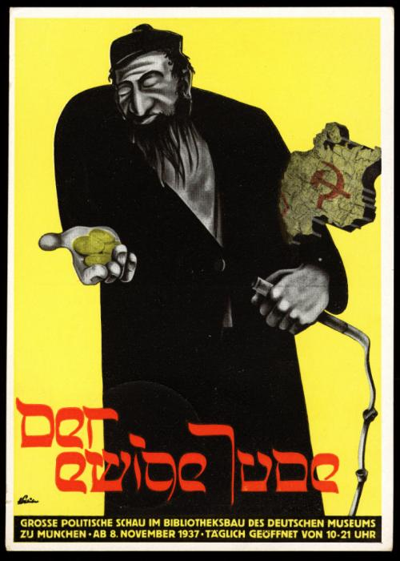](http://www.google.co.uk/url?sa=i&rct=j&q=&esrc=s&frm=1&source=images&cd=&cad=rja&uact=8&ved=0CAcQjRxqFQoTCKqggPPn38gCFYXrFAod7TwFVg&url=http://www.ushmm.org/confront-antisemitism/teaching-about-antisemitism/educational-modules-based-on-audio-podcasts/propaganda-and-media/image-analysis-activity&bvm=bv.105841590,d.d24&psig=AFQjCNHR2DjG1Z7yyRUTwGvQQz_HSMM1Ng&ust=1445937697740738)The Nuremberg Laws actually ensured that anti-Semitism became more deeply embedded in German society: Jews were increasingly banned from restaurants, libraries, swimming pools and other public places. Sex between Jews and Germans was prosecuted at special courts as cases of ‘racial defilement’.

**Propaganda and indoctrination**

* Posters and signs, for example ‘Jews are not wanted here’.
* Newspapers, for example *Der Angriff*, founded by Goebbels, and *Der Sturmer*, edited by Julius Streicher
* Cinema, for example *The Eternal Jew.*
* Education emphasised Nazi racism, for example studying negative portrayals of Jews in literature and history.

**Increased pressures, 1937-39**

During 1936, outward hostilities towards the Jews were postponed for the duration of the Berlin Olympics. Nevertheless, persecution continued. From 1937, the anti-Jewish campaign seemed to be escalating: Jewish businesses found their contracts drying up, Jews were no longer able to be awarded degrees and in 1938, Jewish doctors, dentists, lawyers, chemists and vets were forbidden to work for Aryans. All Jews had to carry an identification card and if their name did not obviously denote their Jewishness, they had to add ‘Sara’ (for women) or ‘Israel’ (for men) to it.

**The *Anschluss* (union) with Austria, March 1938**

This resulted in violence and humiliation for the 190,000 Austrian Jewish population. Jewish properties and businesses were looted, especially in Vienna, and some Jews were made to publicly wash buildings and pavements. Thousands were also arrested and Jewish houses and businesses were ‘Aryanised’. This encouraged Goering to believe that there were benefits to adopting a similar approach in Germany and on 26 April 1938 he issued a ‘Decree for the Registration of Jewish property’ which demanded that all Jewish property worth more than RM5000 be valued and registered with the state.

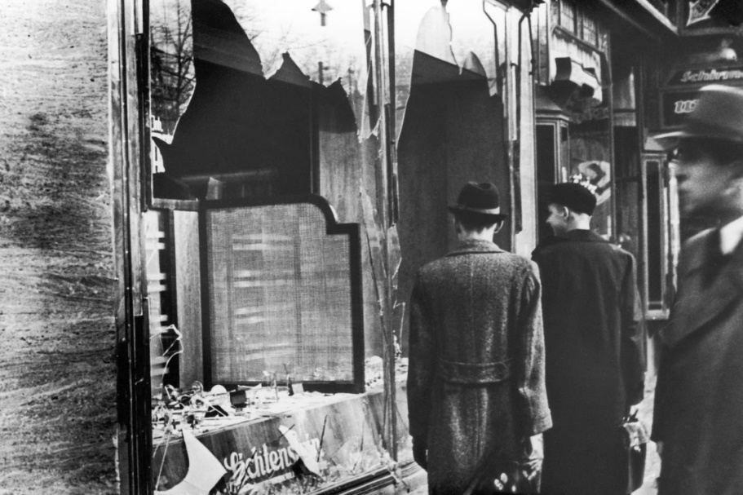***Reich Kristallnacht*, 9-10 November 1938**

**Task:** Use Layton, p.219, to note answers to the following questions:

1. What caused the outbreak of pogroms on *Kristallnacht*?

*The murder of a German diplomat by a Polish Jew provided the excuse but the real reason was that Göbbels had been planning such an attack & was just looking for an excuse. He was desperate to regain Hitler’s favour which he had lost by having an affair with a Czech actress.*

1. What actions were taken during these pogroms?

* *10,000 Jewish shops & businesses attacked all over Germany.*
* *20,000 Jewish men deported to concentration camps & ill treated before being released & ordered to emigrate.*
* *At least 100 deaths on the night, over 1,000 later (Including death caused by ill treatment in concentration camps).*
* *It was portrayed as the spontaneous anger of the German people b/c of the assassination but in fact was organised by the Nazi Party, especially Göbbels, the Gauleiter & the SA.*

1. What actions were taken against Jews in the aftermath of the riots?

*Insurance companies had to pay for the damage but the proceeds were confiscated by the state & the Jews (i.e. the victims, not the perpetrators) had to pay a heavy fine.*

*Göring (who controlled the economy as Head of the 4 Year Plan) took advantage of the situation to issuing the Decree to exclude Jews from German Economic Life which completed the aryanisation of Jewish businesses by the beginning of 1939.*

1. In what ways can *Kristallnacht* be seen as a turning point in Nazi Jewish policy?

*As the name* ***Reichs****kristallnacht suggests, it was the first time violence against Jews had been organised on a* ***nationwide*** *basis; there had of course been violence against Jews before but it had been sporadic & localised.*

*Any Jews who still thought they had a future in Germany now knew better & were desperate to leave; by the outbreak of war in 1939 over half of the Jews who lived in Germany in 1933 had either died or left.*

*K’nacht was also the* ***last*** *outbreak of its kind: thereafter,* ***Himmler*** *& the SS took control of Jewish policy & it took a more “orderly” form with Jews being deported to death camps in the East during WW2.*

**Forced emigration**

From the start of the Nazi dictatorship some Jews had decided to leave Germany – especially those with influence, high reputation or sufficient wealth. The most popular destinations were Palestine, Britain and the USA, and they included Albert Einstein and Kurt Weill.

After Anschluss, the **Central Office for Jewish Emigration** was established in Vienna, overseen by **Adolf Eichmann**. Jewish property was confiscated to finance the emigration of poor Jews and within six months Eichmann had forced the emigration of 45,000. Nazi persecution in total led to about half the Jewish population leaving before the war but they were forced to leave behind all their belongings.

**“THEIR USE OF TERROR WAS THE MAIN REASON WHY THE NAZIS RETAINED CONTROL IN GERMANY AFTER 1933”. HOW FAR DO YOU AGREE?**

Terror

* Control of the police & the Decree of the Reich President for the Protection of People & State enabled the Gestapo & SS to arrest political opponents, especially Communists & Social Democrats, & put them in concentration camps like Dachau.
* The use of “protective custody” & new courts like the People’s Court enabled the Nazis to bypass the traditional courts.
* The willingness of the general public to denounce their neighbours to the Gestapo created a climate of fear & compensated for the Gestapo’s lack of manpower.
* All other political parties, trade unions & strikes were banned.
* The Night of the Long Knives intimidated conservatives like Papen into silence.
* All professions like teachers, lawyers etc were forced to join Nazorganisations.
* The Nazis tried to control every aspect of people’s lives, e.g. the ban on contraception & abortion.

BUT:

* Johnson’s research shows that less than 20% of the population felt threatened by the Gestapo & that most people did not need to be terrorised b/c they supported the regime “voluntarily”.
* Gellately has shown that the Gestapo couldn’t have operated without the support of people willing to denounce their neighbours.

Economic Recovery

* Unemployment fell from 6 million in 1932 to virtual full employment by 1938.
* Farmers’ incomes rose by 41% 1933-8.
* The trade of skilled craftsmen doubled 1936-9.
* Share prices & dividends nearly doubled 1933-9.
* Virtually all Aryans experienced an improvement in their standard of living.

BUT:

* The Nazi priority of “guns over butter” limited the rise in living standards, leaving workers worse off than before the Depression.
* The economic recovery under the Nazis was impressive only compared with the Depression: real wages didn’t reach their pre-Depression levels until 1938.
* The idea of “Volksgemeinschaft” was largely a propaganda myth; in reality Nazi policy favoured big business rather than the workers, widening economic inequality, & no worker ever got the Volkswagen he had paid for.
* Hitler got the credit for the economic successes, though the real architect was Schacht.

Other Policy Successes

* The Nazis were credited with restoring political stability & order after the chaos of the Weimar years; the KPD was suppressed & the SA tamed by the Night of the Long Knives.
* Hitler rearmed Germany & made her respected abroad, achieving a series of foreign policy successes like the remilitarisation of the Rhineland & the conquest of Austria & Czechoslovakia without war.
* Nazi social policies like the Strength through Joy programmed organised by the DAF, the Volkswagen scheme & the promotion of charities like the Winterhilfe created a sense of Volksgemeinschaft.

BUT it can be argued that propaganda was more important than policy successes b/c:

* Young people were easy to indoctrinate b/c they were impressionable.
* The Nazi reputation for restoring law & order was largely a propaganda myth; in fact, as the Night of the Long Knives showed, Hitler had destroyed the rule of law & no one was safe.
* Most of the victims of the Nazi terror were innocent people who posed no threat to society but Nazi propaganda convinced people that they were traitors, criminals & “asocials”.
* Many girls & women idolised Hitler & overall women seem to have been as supportive of the regime as men despite the fact that so many of their rights were taken away; propaganda succeeded in persuading most women that they were better off than they really were.

The Nazification of Government

* The regional governments (Länder) were abolished & replaced by Nazi Gauleiter acting as Reich Governors.
* The judiciary & civil service complied with Nazi policies & were gradually Nazified.
* The Reichstag was Nazified after the one-party election in November 1933.
* The Cabinet was replaced by Hitler’s Reich Chancellery as the centre of government.
* The Army swore an oath of allegiance to Hitler in 1934 & its conservative leadership was purged in 1938.

Censorship & Propaganda

* Radio & newspapers were Nazi controlled & increasingly Nazi owned; editors censored themselves to avoid arrest.
* The sale of cheap radios (Volksempfänger) increased the reach of Nazi propaganda through radio.
* Films like Olympia & Jud Süss promoted Nazi ideology through an entertaining format.
* Youth were indoctrinated both through school & the Hitler Youth; by 1936 church schools & youth groups had been banned.
* Nazi propaganda created what Kershaw called the “Hitler myth”, meaning that Hitler got the credit for all the successes without being blamed for any of the failures.

BUT:

* If people hadn’t been genuinely better off (e.g. if there had still been 6 million unemployed) they wouldn’t have believed the propaganda.
* P’ganda “failed categorically” (Kershaw) to undermine support for the churches.
* Older workers who knew they were worse off than before the Depression were sceptical about the “Volksgemeinschaft” propaganda.

In general propaganda needed a firm base of genuine policy successes to work on & had little effect when it conflicted with people’s deeply held beliefs or real-life experiences. Leif Jerram has argued that the German people never really accepted Nazi ideas & only supported the regime for as long as it was successful.