**GODALMING COLLEGE HISTORY DEPARTMENT**

**Course Information: Revolutions and Rebellions AS and A-level**

The Revolutions and Rebellions A-level course is predominantly a early-modern history course. You will study 4 units – 2 in the lower sixth year and 2 in the upper sixth year. We follow the OCR exam syllabus: <http://www.ocr.org.uk/qualifications/as-a-level-gce-history-a-h105-h505-from-2015/>

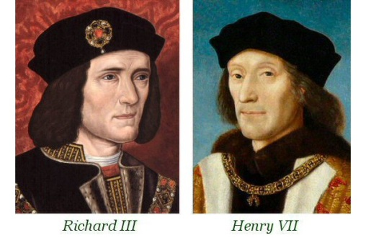**Unit 1: Y135: England 1445-1509: Lancastrians, Yorkists and Henry VII (Enquiry Topic: Wars of the Roses 1445-1461)** (25% of total A level or 50% of AS level)

The Period Study element of the unit is assessed by essays, which will allow learners to develop their use and understanding of historical terms, concepts and skills. The Enquiry is a source-based study involving the critical use of evidence.

You will study:

* **The Wars of the Roses**, including why the wars broke out, the early political actions by Richard, Duke of York to gain control, and the defeat of Richard, Duke of York.
* **Edward IV and Richard III**, including their personalities, relations with the nobility, relations with France, unrest at home, Edward IV’s crisis of 1470-1471, Richard III’s accession, the Princes in the Tower, the Buckingham Rebellion and the reasons for Richard III overthrow.
* **Henry VII,** including the opposition to his rule, relations with the nobility, royal finances, administration of the government, England’s position in Europe under Henry VII, relations with France, Scotland, Spain and Burgundy, agreements with European countries.

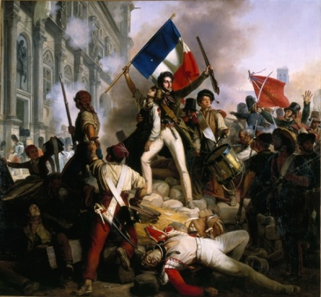**Unit 2: Y243: The French Revolution and the rule of Napoleon 1774-1815** (15% of total A-level or 50% of AS level)

At AS level, you will be required to answer a traditional ‘Period Study’ essay and to evaluate an historical interpretation relating to one of the topics studied.

At A level, you will be required to answer a traditional ‘Period Study’ essay and a shorter question assessing the significance of two events.

You will study:

* **The causes of the French Revolution and the events of 1789**, including structure of the Ancien Régime, personality of Louis XVI, financial and economic problems facing France, the ideas of the Enlightenment, the political developments of 1787-1789, the calling of the Estates General, the ‘Great Fear’ and the October Days
* **The Revolution from October 1789 to the Directory 1795,** including attempts to establish a constitutional monarchy, reforms in the church and state, the significance of the political action 1789-1792, the role of the Jacobins and the Girondins, the ascendancy and fall of Robespierre, the establishment of the Thermidorian regime and the constitution of the Directory.
* **Napoleon Bonaparte to 1807**, including his early life and early successes in Italy and Toulon, his rise to power, the coup of Brumaire, his changes to the government and laws of France, the success and failure of his military campaigns 1799-1807
* **The decline and fall of Napoleon 1807-1815**, including the continental system and the war against Britain, the war in Spain, the Russian campaign, Napoleon’s rule in France after 1807, his campaigns of 1813-1815, his personal failings and reason for fall

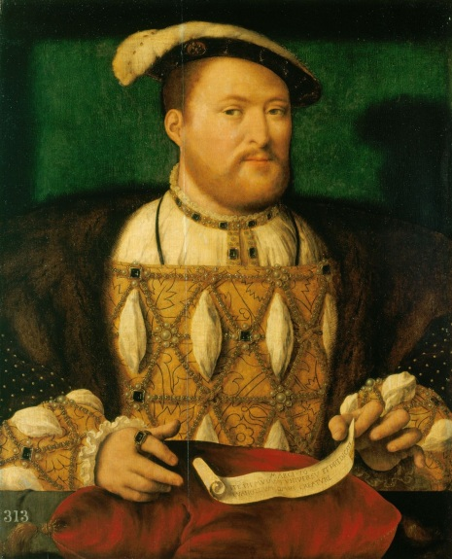**Unit 3: Y306: Rebellion and Disorder under the Tudors 1485-1603** (40% of A-level)

This unit tests your ability to examine a theme over the period studied. You will also study three in-depth topics, and you will use your knowledge of these to evaluate historical interpretations.

You will study:

* **The main causes of rebellion and disorder**, including political factions, religious reasons, taxation, social issues, the motives of rebels, long and short term causes of unrest
* 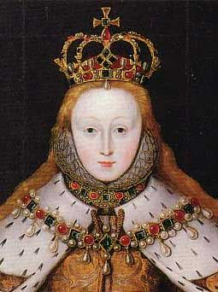**The frequency and nature of disturbances**, including regional variation in rebellion, objectives of the rebellions, size of rebellion, the support of different sections of society, leadership of the rebellion, reasons for success/failure of the rebellions
* **The impact of the disturbances upon Tudor governments** including the response to the rebellions – initial response, pre-emptive measures and military retaliation, the extent to which rebellions posed a serious threat, the impact of the rebellions
* **The maintenance of political stability**, including the role of local and central authorities, attitude and action by: the Crown, the Church, nobility and local officials, popular attitudes towards authority

**Unit 4: Coursework** (20% of A-level)

This comprises one 3000-4000 word essay and it will normally be on a topic you have already studied.