Edward IV and the Readeption of Henry VI 1461 – 1470 and 1471 – 1483

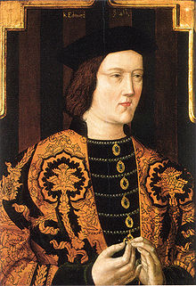

Content you need to know:

Edwards 1st reign

Edward’s personal traits

Edward’s early years as king how effectively did he govern

The Readeption of Henry VI and its causes

Edwards 2nd reign

Government and Edward’s use of Regional Magnates

Finance

Law and order (or lack of law and order!)

Foreign policy

**Past questions on this topic:**

1: Assess the reasons for Edward IV losing the throne in 1470? (OCR textbook)

2: The most important reason for Edward IV losing the throne in 1470 was the actions of the Earl of Warwick’ how far to you agree (OCR textbook)

3: How successful was Edward IV in restoring royal authority by the year 1470 (OCR old spec)

4: How successful was Edward IV’s managing of royal finances (OCR old spec)

5: How successful was Edward IV in restoring order (OCR old spec)

6: Edward IV was more successful in his second reign than his first’ how far do you agree with this view? (OCR old spec)

7: How successful were the domestic policies of Edward IV’s second reign of 1471 – 1483? (OCR textbook)

**Reading list:**

These texts are available in the History Department and in the ILC.

Nicholas Fellows and Sharon Littler; England 1445 – 1509 Lancastrians, Yorkists and Henry VII (OCR textbook)

Ian Dawson; The Wars of the Roses

Charles Ross; Edward IV

**Mark Scheme**

*AO1: Demonstrate, organise and communicate knowledge and understanding to analyse and evaluate the key features related to the*

*periods studied, making substantiated judgements and exploring concepts, as relevant, of cause, consequence, change, continuity,*

*similarity, difference and significance.*

**Generic mark scheme for Section B, Questions 3 and 4: Essay [20]**

**Level 5**

17–20 marks

There is a mostly consistent focus on the question. Generally accurate and detailed knowledge and understanding is demonstrated through most of the answer and is evaluated and analysed in order to reach substantiated judgements, but these are not consistently

well-developed.

There is a well-developed line of reasoning which is clear and logically structured. The information presented is relevant and in the

most part substantiated.

marks

Level 4

13–16 marks

The question is generally addressed. Generally accurate and sometimes detailed knowledge and understanding is demonstrated

through most of the answer with evaluation and some analysis, and this is used appropriately to support the judgements that are

made.

There is a line of reasoning presented with some structure. The information presented is in the most-part relevant and supported by

some evidence.

**Level 3**

9–12 marks

The question is partially addressed. There is demonstration of some relevant knowledge and understanding, which is evaluated and

analysed in parts of the answer, but in places knowledge is imparted rather than being used. The analysis is appropriately linked to

the judgements made, though the way in which it supports the judgements may not always be made explicit.

The information has some relevance and is presented with limited structure. The information is supported by limited evidence.

**Level 2**

5–8marks

The focus is more on the topic than the specific demands of the question. Knowledge and understanding is limited and not well used,

with only limited evaluation and analysis, which is only sometimes linked appropriately to the judgements made.

The information has some relevance, but is communicated in an unstructured way. The information is supported by limited evidence

and the relationship to the evidence may not be clear.

**Level 1**

1–4marks

The answer relates to the topic but not the specific question. The answer contains only very limited relevant knowledge which is

evaluated and analysed in a very limited way. Judgements are unsupported and are not linked to analysis.

Relevant knowledge is limited, generalised and poorly used; attempts at argument are no more than assertion.

Information presented is basic and may be ambiguous or unstructured. The information is supported by limited evidence.

0 marks No evidence of understanding and no demonstration of any relevant knowledge.

Edward IV, the son of the Duke of York, took the throne in 1461 aged 19. Use the reading and pages 26 and 27 of Pendrill as well as page 2 of this booklet to list some of his characteristics and how these could be potential strengths or weaknesses for a king at this time.

|  |  |  |
| --- | --- | --- |
| Characteristic | Potential Strength | Potential Weakness |
|  |  |  |

**Edward IV Part 1: 1st Reign and the Readeption of Henry VI**

[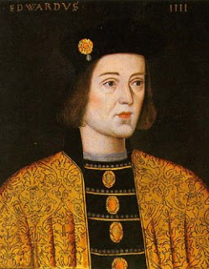](http://bp1.blogger.com/_9pVIP7KsgO0/SANELPrkIyI/AAAAAAAADPc/cJPJElo0s3E/s1600-h/EdwardIVofEngland-Yorkist.j)Edward IV was a complete contrast to the pious schizophrenic and unheroic Henry. The new king was 19, handsome, unusually tall, lean and athletic. Edward was usually good natured and approachable. His appetite for food and women was legendary. It is said that he would make himself vomit in order to enjoy the pleasure of filling his stomach again, and he seduced women of all ranks, married and unmarried. He spent considerable amounts on a luxurious lifestyle and he loved hunting. A visiting dignitary from Bohemia described his court as the most splendid in Christendom and he was the first English king to possess a library and Court circles encouraged the Caxton printing press. Usefully, he also took a personal interest in the details of government and he worked hard at establishing a personal rapport with the mightiest of his subjects. He was also a highly effective military commander – victorious in his first command at Mortimer’s Cross and then steering the Yorkists into triumph at Towton, Hedgeley Moor, Hexham, Barnet and Tewkesbury.

**Key Question which could come up in the exam: Given that he was everything a medieval king should be, how was it that he came to be deposed in 1469?**

**What led to Edward lV’s deposition in 1469-71?**

Initially Edward’s position looked very vulnerable. Many families in the north, secure in their great fortress castles remained loyal to the Lancastrian cause. The House of Lancaster had two figureheads – the king in the north and young Prince Edward in Scotland.

Warwick was successful in the first months of the reign in taking rebel fortresses in the north of England, including the castles of Bamburgh, Alnwick and Dunstanburgh. After the slaughter at Towton, Edward felt he could and should be lenient to Lancastrian families and both Henry Beaufort, Duke of Somerset and Sir Ralph Percy were forgiven and their castles restored to them. However, this policy of leniency did not pay off. By 1462 Percy was back in league with the rebels and was eventually killed on the battlefield of Hedgeley Moor. The Duke of Somerset, despite being shown real friendship by Edward, led the resistance of 1464 which ended in defeat at Hexham in May.

In November 1462 Queen Margaret reopened hostilities by invading the north from Scotland with the support of a small army of French. This did not make her cause very popular in England! Worse still she had promised Louis XI Calais in return for his help. Edward sent a massive force against her and she had to flee by sea.

In October 1463 Edward secured a truce with the French King Louis XI by which it was agreed that France would cease funding the Lancastrian cause. Warwick began to look for a suitable French bride for Edward in order to strengthen the new Anglo-French accord. In December a similar arrangement was made with the Scottish government and Henry VI was obliged to leave Edinburgh and seek refuge at Bamburgh castle. In the spring of 1464 the Duke of Somerset launched one last desperate attempt to revive the House of Lancaster by trying to inspire rebellion in Wales, Cheshire and Lancashire. The Lancastrians were defeated at the skirmish of Hedgeley Moor and decisively at the Battle of Hexham by Warwick’s brother John Neville. Although Henry VI escaped, the most prominent Lancastrian leaders including Somerset were either killed in the fighting or executed shortly afterwards. The Nevilles took full advantage, showing no mercy to their local rivals – executing many of them and destroying their castles. A few pockets of resistance remained but the Lancastrian cause as a whole was shattered. Henry spent over a year in Yorkshire, Lancashire and the Lake district on the run with a single companion, his chamberlain, Sir Richard Tunstall. He was finally captured in July 1465 and brought to London, lashed to his horse and wearing an undignified straw hat. As he rode through the streets he was pelted with rubbish by onlookers.

Having suppressed the Northumbrian revolt in 1464 and finally taken Henry into captivity, Edward’s position looked much more secure.

Task: Using the internet draw the family tree of Richard Duke of York and his children below here. Also try to make note of who each of them marries. This should raise some questions, write them down ready to discuss as a class.

**What drove Warwick and Clarence to abandon Edward’s cause?** **[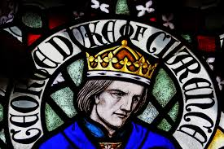](http://www.google.co.uk/url?sa=i&rct=j&q=&esrc=s&frm=1&source=images&cd=&cad=rja&uact=8&ved=0CAcQjRxqFQoTCL_VwujF-8gCFYtyFAodqpgMNg&url=http://history-behind-game-of-thrones.com/warofroses/interview-ashdown-hill&psig=AFQjCNEzVy_s8yfLwcZoAP_dtIwZqSARDg&ust=1446890633766709)**

In the first years of his reign Edward relied on the Neville family. The Earl of Warwick was appointed warden of both the eastern and western Marches in July 1461, where he was more than ably assisted by the best military leader in the family, his younger brother John Neville, Lord Montagu.

1. Edward was lavish in his generous appreciation to Warwick and his family and others who had so valiantly supported him. He created or revived at least thirty five peerage titles, endowing his own brothers with dukedoms, and delegating local authority to powerful but trusted supporters. **The trouble was that he was his own man and while he wanted the Earl’s friendship and advice in the final analysis** **he was not going to allow Warwick to dominate government** and Warwick was not prepared to accept this. In the early years of his reign the comparatively inexperienced Edward allowed Warwick a great deal of freedom in undertaking the whole series of offices to which he was appointed, and foreigners got the impression that the king reigned while the Earl ruled. This was a big mistake!

2. **Warwick was exceptionally grasping**. Warwick was a pretty unattractive character. His temper was short and when thwarted he was sullenly unforgiving. His ambition knew no bounds. Once Edward began to decide on his own policies Warwick found it very hard to accept.

3. The Yorkist nobles became rivals for power, worsened by **the arrival on the scene of the Woodville family**. Edward’s marriage was hugely important and could have brought him political and diplomatic advantages, but Edward plumped instead for a love match with a young widow, Elizabeth Woodville. There was nothing to recommend this marriage but it might not have been such a disaster if it had not been for the fact that the Woodvilles were ambitious and took advantage of their new position, but worse still it impeded Warwick’s plans for a great diplomatic marriage – which offended him – and then continued to aggravate him when he saw Edward making marriages that enabled the Woodvilles to scoop up some of the greatest heirs and heiresses on the marriage market. Several of the marriages are said to have given direct offence to Warwick but even more annoying for the Earl was the fact that they removed all likely candidates for his two daughters, Isabel and Anne. Probably the root of Warwick’s hatred of the Woodvilles was the belief that they had replaced him as the principal influence on the King.

4. **The decline of the Warwick influence** was further marked by two royal decisions. When in June 1467, Edward heard that that Warwick’s brother, Archbishop Neville was seeking dispensation from the pope to marry his niece to the Duke of Clarence, Edward dismissed him from his post as chancellor, and in a matter of months Edward signed an alliance with Burgundy. These setbacks were the final humiliation for Warwick. He was already involved with Louis XI. Now he became trapped through his overweening pride and ambition in the diplomatic web of the arch-intriguer of Europe.

**How important was the involvement of France and Burgundy in this conflict?**

**The involvement of France and Burgundy was absolutely critical to the success or failure of each side throughout the wars.**

[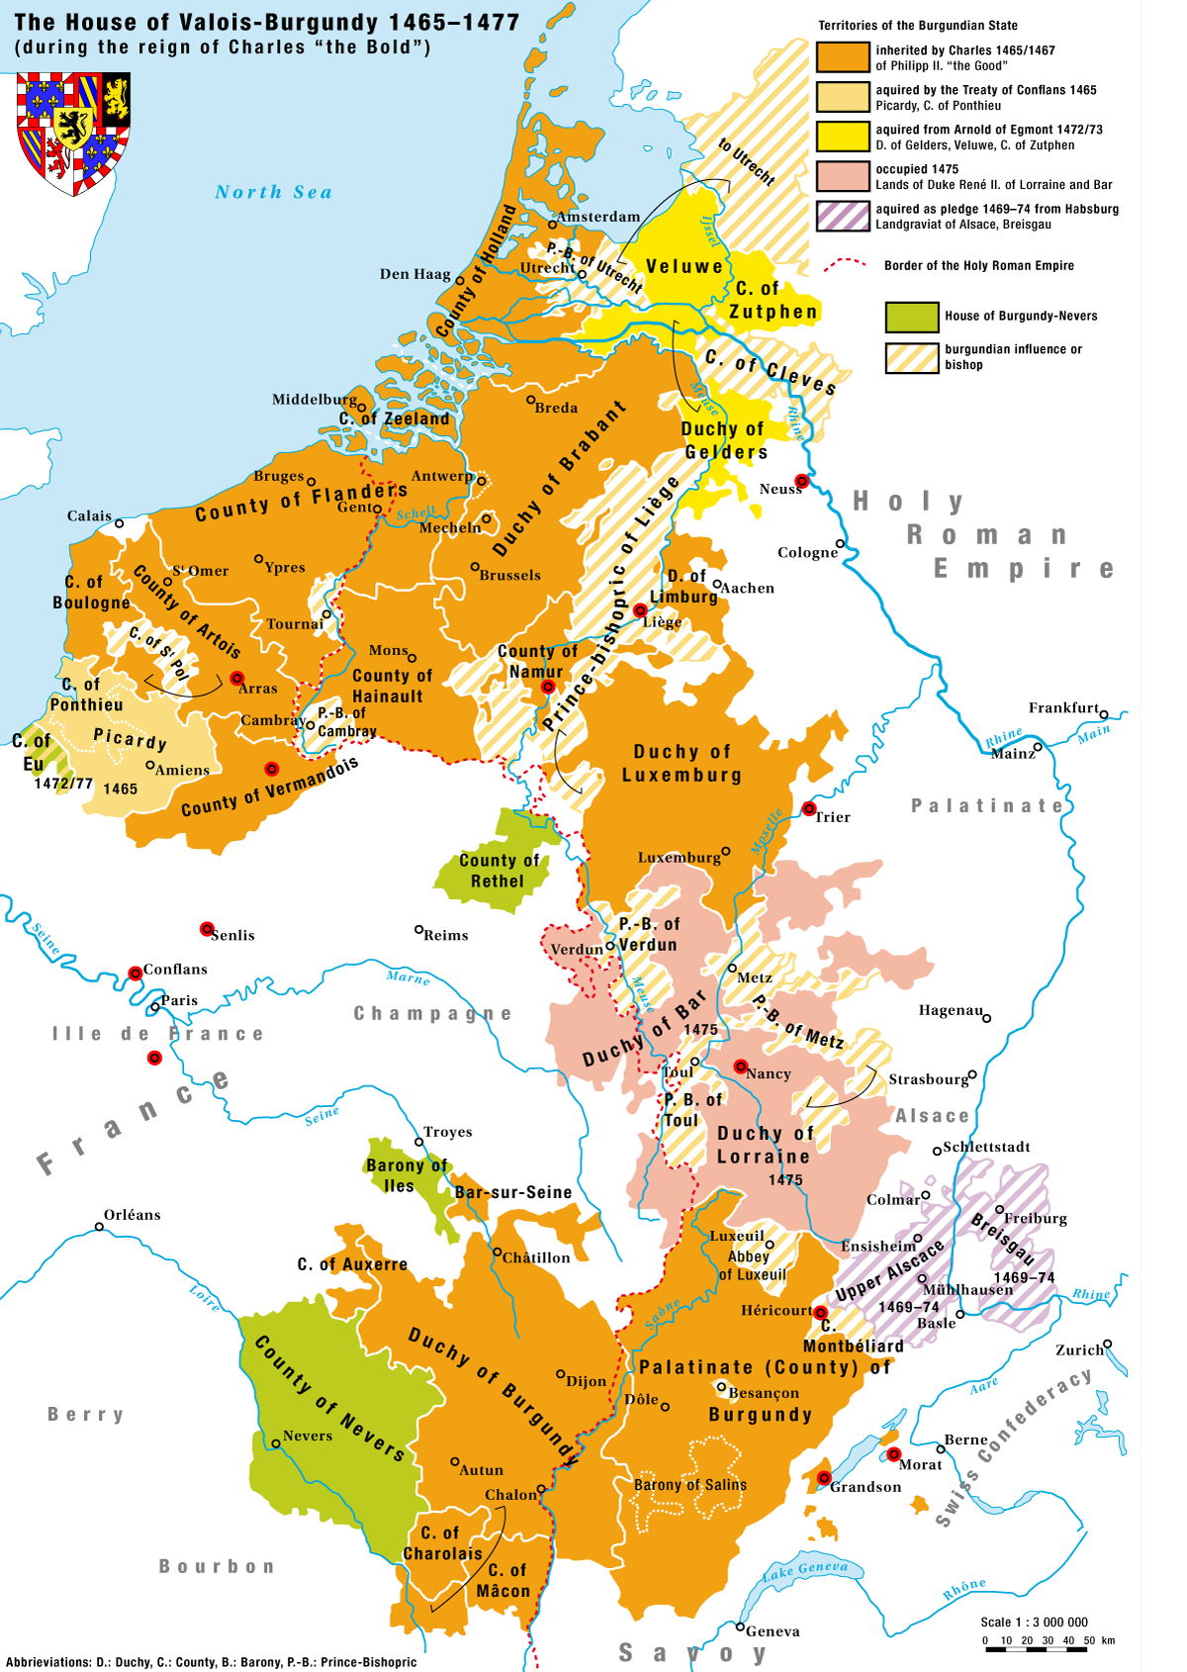](https://www.google.co.uk/url?sa=i&rct=j&q=&esrc=s&frm=1&source=images&cd=&cad=rja&uact=8&ved=0CAcQjRxqFQoTCNPi7KTG-8gCFcXXFAod3tYFmw&url=https://en.wikipedia.org/wiki/Charles_the_Bold&bvm=bv.106923889,d.d24&psig=AFQjCNFi8comjcmjG-fvVrP7brDFks-UaQ&ust=1446890756508391)**1460 – 1467 (which ally for England?)**

1. The Lancastrians were unable to mount an effective domestic rebellion. This was party due to the losses suffered at Towton, but perhaps more to Lancastrian strategy. Margaret of Anjou and her advisers rejected the Yorkist device of stimulating domestic insurrection by exploiting popular discontent. **Instead they relied on foreign support and effectively internationalised the struggle.**

Margaret successfully sought support from France and Scotland, but within a short space of time Edward managed to arrange truces with both countries. Edward would have found the task of holding the throne much harder if Margaret had been luckier in her quest for allies.

2. France and Burgundy were inevitably coming towards a confrontation and would both like it if a newly restored and more powerful England were on their side. France was not permanently going to tolerate the position of near independence which Philip Duke of Burgundy had been able to establish in his French territories as a result of his sovereign’s preoccupation with the 100 years war with the English. When Warwick had been Captain of Calais he had established friendly contact with the dauphin, Louis, who was at odds with King Charles and in exile from his court. Louis was now king and Warwick began to negotiate with him for a treaty – or better still a marriage alliance with France with his old friend. He was therefore embarrassed when he discovered that Edward and made his secret marriage with Elizabeth Woodville as it certainly made him look less influential with the king than he had wanted.

The Woodvilles and English commercial interests favoured Burgundy as an ally over France. Burgundy was the country’s most important cloth market – and after a century of fighting France, popular prejudice favoured Burgundy over France too. Edward knew that his London merchants would want and in November 1467, a commercial treaty was drawn up between England and Burgundy, followed by a marriage treaty in spring 1468 in which Charles the Bold married Edward’s sister Margaret of York. Louis XI “the universal spider” – tried to stir up trouble against Edward in Wales, but this was crushed by Herbert. A far greater danger to Edward lay in the north where Warwick was sulking.

**1468 – 1471**

Louis XI was giving hospitality to Margaret of Anjou and her son Edward, and he offered Warwick a principality forged out of Holland and Zeeland to bring him over to the Lancastrian side.

In 1470 after lose cote field Warwick fled the country – Calais would not let him in so he had to resort to the French. The king arranged an alliance between Margaret and Warwick and financed an invasion for Warwick to restore Henry VI to the throne – because in fact it would mean that he became regent (Henry being too incapable actually to rule!).

However, the English had been at war with France off and on for the past 100 years and tradition, popular prejudice and propaganda all made them deeply suspicious of the French. Also, their principal trading partner was Burgundy. Their natural predilection was to stay on friendly terms with Burgundy. Warwick’s support of France was a political disaster as it pushed Charles Duke of Burgundy in to a close alliance with Edward IV.

France declared war on Burgundy in December 1470 and England followed suit in February 1471 (as they had promised France to do) but Parliament had not authorised this war and the merchants were appalled at all the damage war with Burgundy would do to their trade relations. Needless to say, Warwick therefore dramatically lost support.

**What factors contributed to Henry’s readeption?** (Pickering pages 36- 40)

As early as 1467 Louis was contemplating the possibility of bringing Queen Margaret and the earl of Warwick together in an attempt to overthrow the increasingly pro-Burgundian English king.

At much the same time, Warwick began to engineer the marriage, against the king’s wishes, of his daughter Isabel, to the king’s ambitious brother and heir presumptive George, Duke of Clarence. When Edward became aware of these machinations he was furious and saw them the marriage quite plainly as Warwick attempting to make himself even more powerful. Edward sacked Warwick’s brother as Chancellor and married his sister to the Duke of Burgundy.

Warwick was so affronted that he was susceptible to inducements from Louis XI who even offered the Earl a principality forged out of Holland and Zeeland as an incentive for dismantling the Edward-Woodville regime.

By the spring of 1469 Warwick was in league with Clarence in seeking to undermine the Woodvilles, the one with a view to controlling the king, the other contemplating taking his brother’s place on the throne. Clarence encouraged Warwick to turn against the king and helped spread a rumour that his brother was not Duke Richard’s son but the bastard of an archer called Blaybourne. (His mother Cecily was still alive so this damning allegation was pretty outrageous making out that his own mother was an adulteress).

In July 1469 at Calais, Clarence defied his brother by marrying Warwick’s daughter, Isabel. The marriage coincided with a pro-Warwick rebellion in the north led by Robin of Redesdale.

He was able to obtain support because of certain failings in Edward’s first reign. The king had done little to improve law and order. The troubles in the north and Wales were eventually suppressed, but the general effectiveness of the law was not established and in fact things got worse and the king’s own ‘supporters’ were a principal factor in this decline.

Robin of Redesdale’s manifesto behind which the hand of Warwick was clearly apparent adapted all the old Yorkists’ complaints against Henry VI to the damage of his Yorkist successor. The king, it was alleged had “estranged the lords of the blood (Warwick and Clarence) from his council” ; he had “taken about him a ‘meiny’ of evil counsellors” (the Woodvilles, William Herbert,, Earl of Pembroke and Sir John Fogge) who apparently plundered his estate and “would not suffer the king’s laws to be executed upon whom they showed favour to” and finally that “he had oppressed and grieved the poor commons with taxes and purveyances.”

Warwick arrived at Canterbury on 16 July, with an army made up of men of Kent and soldiers from the Calais garrison he then rode north to join the northern army and do battle with the loyalists, led by the Earl of Pembroke. They met and fought a ferocious battle at Edgecote Hill (near Banbury) and when Pembroke was defeated Warwick had him executed (for treason!!)

Edward IV received news of Pembroke’s defeat 3 days later and knowing that the bulk of his army was shattered, he allowed his supporters to disperse and remained at Olney awaiting the arrival of Warwick’s soldiers. With Edward held in custody, first in Warwick Castle and then Middleham, , Warwick, with Clarence’s support attempted to rule in his name. The Woodville dynasty now suffered the retribution of the Nevilles: following their capture in the Forest of Dean, Earl Rivers and Sir John Woodville were beheaded and Rivers’ wife was accused of witchcraft.

Anarchy was erupting as men who anticipated a return to the bad old days took the law into their own hands and a Lancastrian rising in the north forced Warwick to release the king in mid September, for without him Warwick was unable to gain the supports of the lords or command the loyalty of the Yorkist soldiers. Once Edward was free men began to rally to him. The confusion that Clarence and Warwick had unleashed proved their undoing.

In the spring of 1470, Lord Welles, who was embroiled in a local quarrel in Lincolnshire, released a manifesto in their names. Edward stamped on this at the Battle of Empingham (Lose Cote field) and Warwick and Clarence fled to France. Calais closed its gates to them, and in the end they dropped anchor off Honfleur. They had no one to fall back on, except Louis XI and had lost their bargaining power completely.

**Mistakes and dodgy alliances**

Warwick was out of the country but he still had important potential allies there, notably his brother John Neville. John had not moved against Edward in 1469, but the kind, when he was free again, felt bound to try what conciliation could do in the north; Redesdale had demanded the restoration of the Percy heir, and restored he was in March 1470 to the earldom of Northumberland. John Neville, who had been created earl in Percy’s place in 1464, after his victory at Hexham, was compensated for the loss of this title with a new Marquisate of Montagu, but it did not compensate for the loss of Percy lands. Edward’s move was not very astute. He gained the nominal allegiance of an ex-Lancastrian on whom he could not count in a crisis, and turned John Neville from an unreliable ally into an enemy.

In France Warwick promised to support the Lancastrians and Louis promised money, ships and soldiers. In return Louis would receive English support against Burgundy. The alliance would be an unnatural one because Warwick had on his hands the blood of Somerset, Northumberland, Clifford, Roos and a dozen other close supporters of Margaret but because she was desperate for her son to have an opportunity to get the throne Margaret agreed and even allowed Edward to marry Warwick’s daughter Anne to confirm the alliance. Margaret accepted the fact that her husband was incapable of ruling again and said she would make Warwick Henry’s regent, and Clarence was promised the crown in the event of Prince Edward dying without issue.

As other members of the Neville family rose in the north distracting the king, Warwick and Clarence returned at the head of a French army. Edward was marching south to confront this army when he learned that John Neville had gone over to his enemies and was only a few miles away, coming to take him with a far larger force than his own. So he fled to Burgundy – thrown on the help of Charles of Burgundy as Warwick had been on Louis XI, and the autumn of 1470 became formally the 39th year of the reign of Henry VI.

Task: Add information to the table to explain how each of the factors led to the readeption of Henry VI

|  |  |
| --- | --- |
| Evidence Edward was to blame for the falling out with Warwick and subsequent loss of the throne | Evidence Warwick and other factors were to blame |
|  |  |
|  |  |
|  |  |
|  |  |
|  |  |
|  |  |
|  |  |

**Why was Edward able to regain the throne?**

The ‘readeption’ of Henry brought war with Burgundy, the condition on which Louis XI had supported Warwick’s campaign. France opened the hostilities in December and England followed suit in February to the horror of England’s merchant community. For Warwick the support of France was a political disaster as it pushed Duke Charles into a strong alliance with Edward. With 50,000 crowns donated by Duke Charles Edward was able to start planning his own restoration.

England had entered the war without the consent of parliament and against the wishes of the London merchants. When Edward set sail for England in March at the head of a tiny army, Warwick could no longer rely on widespread public support. Also, the true Lancastrians – who would normally have supported Henry whatever, were confused and alienated by Warwick’s control so that when Edward arrived in Yorkshire the Percies made no move against him and when he got to York the city opened its gates.

Initially there was not a great flocking to either side, but Edward marched south with a couple of thousand men and by the time he confronted Warwick, camped behind Coventry’s city walls with perhaps as many as 7,000 men, Edward’s army had grown to 5,000 – also and significantly his record as a general was impressive. He had never lost a battle. Clarence, whose hopes of a throne had been dashed by Henry’s restoration decided to return to his brother and brought with him 12,000 men. Margaret didn’t trust Warwick and had not sent her son across. Edward and Clarence marched on London and George Neville (Warwick’s brother) paraded Henry VI through the streets in the hope of securing public support and confidence. Not too surprisingly (considering Henry’s lack of charisma) he gained nothing from this ploy and when the mayor and aldermen realized how big Edward’s army was they decided not to resist. Even Neville then realized he was in a hopeless situation and opened the doors to Edward. On 11 April Edward and Clarence entered the city received by cheering crowds and formal greetings from its mayor. Henry was put in the tower and Edward was reunited with his wife, their two daughters and met for the first time his 5 month old son.

[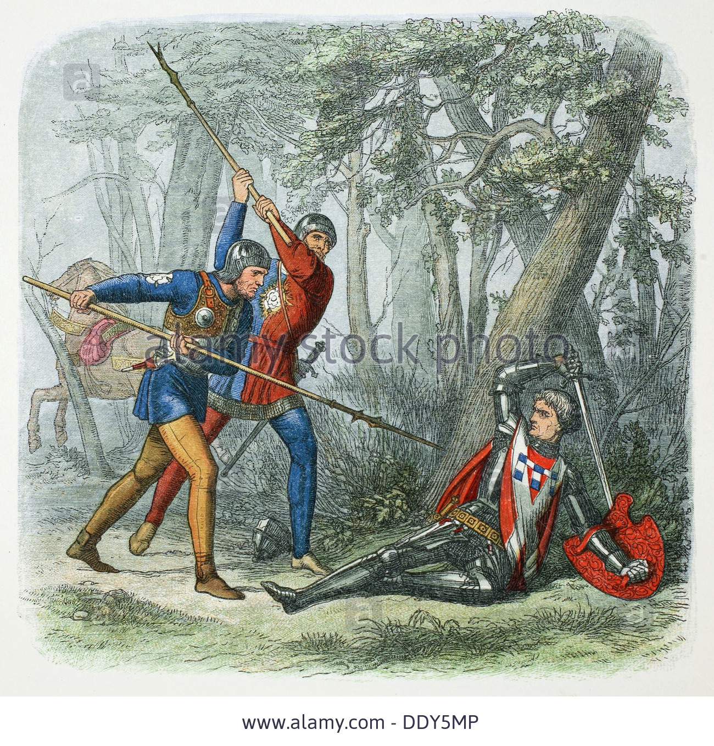](http://www.google.co.uk/url?sa=i&rct=j&q=&esrc=s&frm=1&source=images&cd=&cad=rja&uact=8&ved=0CAcQjRxqFQoTCNDwqt7G-8gCFUdbFAodkFoInw&url=http://www.alamy.com/stock-photo-death-of-warwick-the-kingmaker-battle-of-barnet-1471-1864-artist-james-60218838.html&bvm=bv.106923889,d.d24&psig=AFQjCNFgu_pvSOLOhxGPg-pNq-0gYzjBOQ&ust=1446890869410453)Rather than await Warwick’s arrival Edward decided to ride out and meet his pursuing force. They met at Barnet on Easter Sunday 14April. Both Edward and Warwick were engaged in the thickest of the fighting, choosing as a good medieval leader should, to lead from the front. Warwick’s army was bigger, but there was confusion in his ranks, and a body of archers mistook some of their own for the enemy and fired on them (friendly fire). The Yorkists lost 500 men and around 1,000 of Warwick’s died. The earl himself was killed as he tried to escape from the battle field and his body was brought to London and displayed for three days in St. Paul’s cathedral for public viewing in order to make sure no one believed he had survived.

The day before the battle Henry’s queen, Margaret of Anjou and son, Prince Edward, had finally sailed into Weymouth to raise an army in the south and west against Edward. Margaret heard the news of Warwick’s defeat while resident at Cerne Abbey in Dorset. Initially she abandoned all hope of defeating her husband’s usurper, but as her army swelled with Lancastrian supporters from the southern counties joining her at Cerne, her resolve strengthened. A plan of campaign was developed in which Jasper Tudor would ride ahead and set about raising an army in Wales and she would follow, heading north to Lancashire via Bristol, Gloucester and Chester.

On 23 April, a week after hearing of her landing, Edward left London at the head of a small army in an attempt to engage Margaret before she could join forces with Jasper Tudor. As Margaret headed north Edward tried to block her advance, but Margaret veered north east and avoided him. He finally caught up with her at Tewkesbury on 4 May. Margaret had more troops, but Edward was more experienced and better equipped. Prince Edward was killed and Somerset was taken and executed. Margaret was captured a few days later at Little Malvern priory.

Edward arrived back to triumphal acclaim in London on the 21st May. Towards midnight on the same day, the 50 year old King Henry was put to death in the tower. About 12 years later in John Warkworth’s *Chronicle of the first thirteen years of the reign of King Edward the Fourth:* written before Richard came to the throne he was implicated in Henry’s murder (dodgy precedent).

[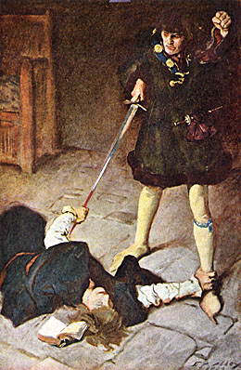](http://www.google.co.uk/url?sa=i&rct=j&q=&esrc=s&frm=1&source=images&cd=&cad=rja&uact=8&ved=0CAcQjRxqFQoTCIHcwpHH-8gCFUfWFAodg_kFWw&url=http://www.illustration-art-solutions.com/edwin-austin-abbey.html&bvm=bv.106923889,d.d24&psig=AFQjCNGeY6mDEiwJp5N4cLvTiHG5TDGjyg&ust=1446890969749453)

And the same night that King Edward came to London, King Harry being in ward in prison in the Tower of London was put to death the 21st day of May on a Tuesday night between eleven and twelve of the clock, being then at the Tower the duke of Gloucester, brother to King Edward, and many other; and on the morrow he was chested and brought to Paul’s and his face was open there that every man might see him. And in his lying he bed on the pavement there; and afterwards at the Black Friars was brought and there he bled new and fresh; and from thence he was carried to Chertsey Abbey in a boat and buried there in Our Lady’s Chapel.

Margaret was spared and after some years of benevolent captivity in England, she was permitted to return to France where she died in poverty.

**Timeline of the Key events of the readeption**

|  |  |
| --- | --- |
|  |  |
|  |  |
|  |  |
|  |  |
|  |  |
|  |  |
|  |  |
|  |  |
|  |  |
|  |  |
|  |  |
|  |  |

**The First Reign of Edward IV, 1461-1470**

**and the**

**Readeption of Henry VI, 1470-1471**

***Use Pendril pp29-34***

1. Give details of how Edward ended Lancastrian resistance between 1461 and 1465.
2. To whom and in which ways was Edward merciful to his opponents?
3. How did Edward widen his power base? Who benefitted in particular?
4. What was Edward’s first mistake? Why was it such a problem? List the reasons.
5. Explain the real reason for the growing disagreements between Warwick and the king.
6. What happened during Warwick’s rebellion of 1469?
7. Why was the domination of the marriage market by the Woodville family a source of friction between Warwick and Edward IV?
8. What other problems did Warwick have as he tried to keep Edward IV a prisoner?
9. Warwick and Clarence fled to France. Why was this dangerous for Edward IV?
10. Describe the complete turnaround of events of 1470.
11. Why was Edward IV able to regain his throne in 1471?
12. At which battle was Warwick killed?
13. What were the consequences of the Battle of Tewkesbury, 1471?

**THE SECOND REIGN OF EDWARD lV, 1471-83**

***Notes taken form Colin Pendrill – The Wars of the Roses and Henry Vll: England 1459-c1513***

**Key Question :Why was Edward so much more successful during his second reign?**

**Key Points**

Edward lV was in a much stronger position in 1471 than he had been in 1461.

* The deaths of Henry Vl and his son, Edward meant that there was no one to challenge Edward’s right to the throne. All the male Lancastrians had died apart from Henry Tudor and he was not regarded at this stage as a great threat to the house of York.
* Edward was a very able king. He acted with a mixture of mercy and firmness to win over or deal with possible opponents
* He expanded his political power base in the country using major noblemen to govern difficult areas for him.
* He provided two legitimate sons to succeed him.
* He launched successful invasions of France and Scotland, underlining his status as a warrior king.
* The two overmighty subjects who had done so much to bring about the political instability of the first reign were eliminated. Warwick was killed at the Battle of Barnet in 1471 and Clarence was eventually executed in 1478. He left an infant son, Edward, Earl of Warwick, but the child was too young to be any threat to the king.
* Leading Lancastrians had also been neutralised. Jasper Tudor and his nephew Henry Tudor were in exile in Brittany. Edmund Beaufort, Duke of Somerset, and his brother John were killed at the battle of Tewkesbury in 1471. Most of the rest of the nobility now threw their lot in with Edward lV, thus putting him in a stronger position than before.

**Edwards use of Regional Magnates to govern the county**

**Gloucester in the North**

[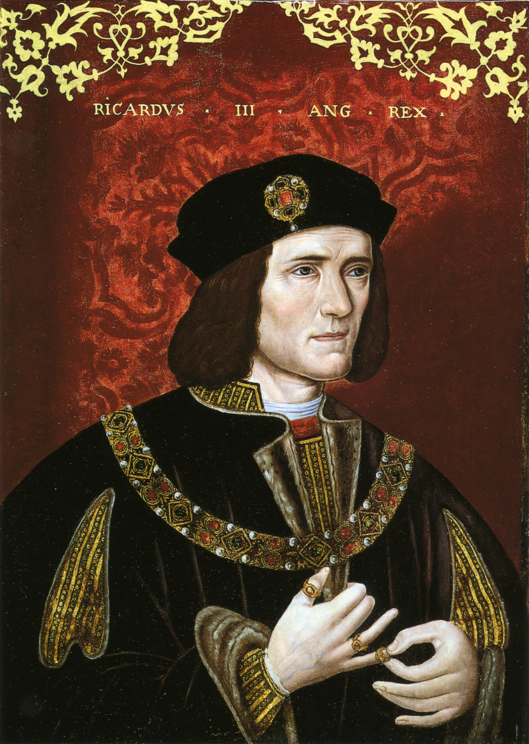](https://www.google.co.uk/url?sa=i&rct=j&q=&esrc=s&frm=1&source=images&cd=&cad=rja&uact=8&ved=0CAcQjRxqFQoTCM783eHH-8gCFQldFAodPA8Fpg&url=https://en.wikipedia.org/wiki/Richard_III_of_England&bvm=bv.106923889,d.d24&psig=AFQjCNFfIf0YHkvKJ7KYNo1FWYanH4Zr4A&ust=1446891143650521)Edward built up a group of powerful magnates, who effectively controlled large areas of the kingdom in the king’s name. In the north of England, the frequent problems and uprisings were largely sorted out by the establishment there of the king’s youngest brother, Richard, Duke of Gloucester. Unlike Clarence, Gloucester had proved to be Edward’s loyal brother. When Clarence rebelled in 1469, Gloucester remained loyal and went into exile with Edward in 1470. Consequently Edward rewarded him lavishly after 1471. He was given the highly advantageous marriage to Anne Neville (Warwick’s daughter). An Act of Parliament granted him most of Warwick’s northern estates and Richard was later granted a special palatinate in Cumberland, which gave him the power to raise troops without the king’s authority. Gloucester’s palatinate meant that he was effectively king in that area and did not need to consult Edward about what to do. The establishment of such a palatinate demonstrated Edward’s complete trust in his youngest brother. In addition Gloucester was allowed to keep any parts of Scotland that he might conquer.

The north of England had been Gloucester’s home for a number of years so he was the natural choice to take charge there. He had distinguished himself in fighting at both Barnet and Tewkesbury. He governed the North very successfully on Edward’s behalf controlling the northern nobility especially Henry Percy, Earl of Northumberland, and the Stanley family who were the great family in southern Lancashire and Cheshire. During Edward’s second reign, Thomas, Lord Stanley, married Lady Margaret Beaufort, who was the mother of Henry Tudor so Edward felt he had special need of his brother to monitor the situation there. ***In your own words explain why this was the case.***

**Hastings in the Midlands**

In the Midlands, Edward’s control was at first less clear-cut, as Clarence proved politically unreliable. However, Edward then entrusted power to his loyal supporter William, Lord Hastings. He had been Edward’s chamberlain in the first reign and in the second reign he was well rewarded with estates confiscated from Clarence in 1474 in Derbyshire and Staffordshire. He was also given large estates in Leicestershire and Warwickshire.

**Edward Prince of Wales and Earl Rivers**

Edward made his eldest son Edward, Prince of Wales, the principal power in the Welsh Marches. Under the control of his uncle, Anthony Woodville, Earl Rivers, the young Edward was sent off to Ludlow to symbolise the existence of royal power in this region.

**The Grey brothers in the South-West**

Edward’s second reign saw the build up of a substantial power base in the south-west of England for Queen Elizabeth’s two sons by her first marriage. Thomas Grey, Marquis of Dorset, was given estates that had previously belonged to the Dukes of Exeter and acquired more land through his marriage to Cecily Bonville, a wealthy heiress. Their son was married to an even wealthier heiress. The Queen’s second son also acquired estates in the area.

**In the second reign, Edward seems to have decided to enlist members of his family and close allies as key regional figures to maintain his authority. In pairs discuss and then list the potential benefits and problems of this policy.**

**How effective was Edward’s use of Regional Magnates to govern the country?**

|  |  |
| --- | --- |
| **Benefits of this system?** | **Problems or potential problems with this system?** |
|  |  |

Draw on this map how Edward IV used Regional Magnates to control England and Wales. Make sure you mark in who he used.



|  |  |  |  |
| --- | --- | --- | --- |
| **Region** | **Evidence of effectiveness in dealing with this area** | **Evidence of limited effectiveness** | **Evidence of failure in dealing with this area** |
| **Wales** |  |  |  |
| **North of England** |  |  |  |
| **Ireland** |  |  |  |

**Use pages 106 – 107 to fill out the table below**

**Improving Royal Finances**

Edward was able to improve the state of royal finances and this was another way in which he could strengthen his position as king. A poor king with subjects wealthier than himself would always be a weak king.

In medieval times, the normal costs of government were borne by the king and he was expected to pay for these from his own income. In other words the king was expected to **‘live of his own’**. The King’s normal income (known as **Ordinary Revenue**) came from three principal sources.

1. **Crown Lands**

The income from the crown lands was the most important source of revenue for the king. With the many forfeitures in 1461 and 1471, the confiscation of Clarence’s estates at the time of his fall, together with Edward’s own lands as Duke of York, Edward lV immediately possessed more land than Henry Vl had done. Of course, many of the newly acquired lands were granted out as rewards to faithful followers, but it is estimated that Crown lands on average, might have brought in about £30,000 a year during Edward’s reign.

There are indications that the revenue from royal lands increased during the second reign. The King appointed commissioners to inspect the collection of revenues in the Duchy of Lancaster. Following this initiative, crown revenues collected in Lancashire by Thomas Lord Stanley increased dramatically. Lands yielding £347 a year for the Crown in 1476 brought in £800 in 1478 and £885 by the end of the reign.

1. **Customs Revenue**

The king received extensive income form customs duties – in the region of £25,000 a year at the start of the reign. Customs duties were taxes on the import and export of goods.

As early as 1466, Edward appointed special commissioners to investigate the collection of customs revenue at the main ports and to report abuses. Further commissions followed in 1473 and 1474.

During Edward’s reign, the collectors of customs were paid more, and more cases of fraud were brought before the courts.

In his second reign Edward made trade treaties with the Hanseatic League in Germany (1473-4), France (1475), and Burgundy (1478). Together with a general upturn in European trade in the 1470s after the depression of the previous decade this all meant that Edward’s income from customs rose to about £35,000 a year during his second reign. Representing a 40% increase since the start of the reign, this was a solid achievement by Edward’s government.

1. **The King’s Prerogative Rights**

The other main source of normal revenue was the exploitation of the king’s special or ‘prerogative’ rights. These were traditional rights that the king enjoyed because he was king.

**Wardship** was the kings right, as feudal overlord, to enjoy the income of a landowner who was a child until he came of age. When he did come of age, the Crown could charge a large ‘entry fine’ before he could possession of his lands and income. In addition, the king could sell his ward’s marriage to highest bidder. For instance, Henry, Duke of Buckingham, was married to Katherine Woodville.

The Crown also took the revenue from bishoprics (the area governed by a bishop, also known as a see or diocese) when there was a vacancy. As a vacancy could only be filled by the king’s nominee, it was useful for the king to delay the appointment of a bishop by months or even years.

The king also enjoyed the income from the profits of justice. He collected fines and other judicial fees.

**Extraordinary Income for the Crown** (as opposed to ordinary income)

In addition to the regular or ‘ordinary’ revenues, there was a range of extraordinary sources of income that Edward could call upon, usually to cover the cost of military action. In order to pacify the country in the first reign and to invade France in the second reign, Edward called on parliament to grant him taxes.

* The usual form of taxation granted by parliament was known as **Fifteenths and Tenths.** Townsmen paid a tenth of their income or of the value of their property whilst those living in the country paid a fifteenth. By this time the taxes had become fixed in value and did not accurately reflect the value of land or property.
* Edward also collected **benevolences** (occasional one-off goodwill payments). In the second reign alone he collected about £100,000 from the laity and £77,000 from the clergy. Benevolences were not popular.

Between 1472 and 1475, Edward gathered more taxes each year than any king since Henry V. Most of these taxes went to fund the French expedition of 1475. As this resulted in a peace treaty and no fighting, Edward made a profit. In addition the invasion itself brought in more cash as in order to pay off the English Louis Xl paid Edward an annual pension which amounted to an extra £85,000 in the last seven years of the reign.

Furthermore as the financial situation improved, so Edward was able to borrow more and he received extensive loans from merchants and other wealthy men.

**Conclusion**

Edward lV did much to improve the state of royal finances, especially during the second reign. He still needed extra taxes to mount the invasion of France but it is notable that he felt wealthy enough to attempt an expedition into Scotland, later in the reign, without asking Parliament for a grant of taxation. Given the weak state of royal finances that he inherited in 1461, and the rising cost and scale of military activity during his reigns, Edward’s improving financial situation was a great asset in stabilising and strengthening royal authority and a powerful legacy for future kings such as Henry Vll.

In one important area Edward’s methods set a very good example for Henry Vll.

Throughout the medieval period, the Exchequer, staffed by paid officials and administrators, was the main agency for receiving royal revenue but, under Edward lV, an increasing part of royal income was paid directly into the **King’s Chamber**. (The literal meaning of the King’s Chamber is the king’s bedroom or suite of rooms that were his private apartments. It made sense for the king to have some money to hand in his chamber, so the King’s chamber gradually became a financial department that received and paid out money).

In times of war, it was normal for king’s to divert more of their income into the chamber so that they had ready money for the many payments associated with warfare.

Under Edward lV the transfer of income and expenditure to the Chamber became more systematic, possibly because he did so much campaigning in his first reign.

This does show that Edward had a close personal interest in, and supervision of, his finances which did not mean that he increased his income in this way but that **he had greater control himself** over them. The financial system of accounting and administration became more efficient, closely supervised as it was by the king. Henry Vll was to continue this practice.

By the end of the reign, aided by a revival in trade, Edward had increased revenue from regular sources to £65,000 or £70,000 a year. Given the debts he had inherited from Henry Vl and the political instability of the first reign, this was a major achievement and the monarchy’s strength was certainly increased in this period by greater financial security.

**Did Edward establish law and order?**

Look at the following sources and answer the questions below.

**Source 1** C D Ross “The Reign of Edward IV” in S B Chrimes, C D Ross and RA Griffiths *15th century England 1399* – 1509.

[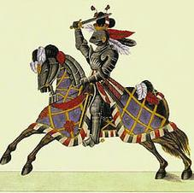](http://www.google.co.uk/url?sa=i&rct=j&q=&esrc=s&frm=1&source=images&cd=&cad=rja&uact=8&ved=0CAcQjRxqFQoTCMHCrJ3I-8gCFYNyFAod3FgORQ&url=http://www.angelfire.com/dragon2/knight_tale/feudal.html&bvm=bv.106923889,d.d24&psig=AFQjCNF1OXKqjuMsjHXyk8HIMJZtlb8Q_g&ust=1446891274289504)The crux of the problem lay in the immunity of the powerful offender, especially those who had the king’s support. There was an inherent conflict between repeated demands for impartial justice and the king’s committed support of the great men to whom he had given rule of the shires. Bitter complaints against their excesses run through the reign. The Commons in 1467 were particularly outspoken linking a rising crime rate with the ‘heavy lordship’ of men standing with the king, against whom redress could not be obtained.... Edward was extraordinarily lavish in delegating local power and influence to his supporters. No man had ever enjoyed the power in South Wales wielded by Lord Herbert in the 1460s. The same is true of Richard of Gloucester in the north in the 1470’s. Professor Chrimes would have us believe that by 1483 “there was no over-mighty subject left in England,” but was not Gloucester (later Richard III) the mightiest of over-mighty subjects? And was not his great north-country connection, built up with royal encouragement, a major factor in enabling him to consolidate his hold on the throne? This was part of the price that Edward IV paid for effective political control during his lifetime.

**Source 2** Margaret Paston writing 27 October 1465

“I was at Hellesdon upon Thursday last past and saw the place there, and in good faith there will be no creature think how foul and horribly it is arrayed but if they saw it. There cometh much people to wonder thereupon, both of Norwich and of other places, and they speak shamefully thereof...

[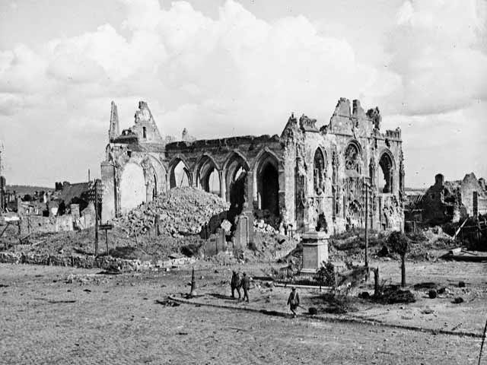](http://www.google.co.uk/url?sa=i&rct=j&q=&esrc=s&frm=1&source=images&cd=&cad=rja&uact=8&ved=0CAcQjRxqFQoTCMX7873I-8gCFUJrFAodozMJtw&url=http://reclaimbeauty.blogspot.com/2015_01_01_archive.html&bvm=bv.106923889,d.d24&psig=AFQjCNGJ6T38ZOFIV0-dSUgdewj9fohmDg&ust=1446891331982509)The Duke [of Suffolk]’s men ransacked the church and bare away all the good that was left there, both of ours and of the tenants, and left not so much but that they stood on the high altar and ransacked the images, and took away such as they might find, and put away the parson out of the church till they had done, and ransacked every man’s house in the town five or six times... If it might be, I would some men of worship might be sent from the King to see how it is, both there and at the lodge, ere than any snows come, that they may make report of the truth...

And at the reverence of God, speed your matters now, for it is too horrible a cost and trouble that we now have daily, and must have till it be otherwise; and your men dare not go about to gather up your livelihood and we keep here daily more than three hundred persons for salvation of us at the place...

It is thought here that if my Lord of Norfolk would take upon him for you, and that he may have a commission for to inquire of such riots and robberies as hath be done to you and others in this country, then all the country will await upon him and serve your intent, for the people love and dread him more than any lord except the king and my lord of Warwick.

**Source 3** David Groessel (Lotherington *The Tudor Years)*

The king’s council retained its important and its functions changed little. There is no doubt that many of Edward’s personal servants were capable and effective, but he did lack a strong personal following in the provinces, such as that built up by Richard of Gloucester in the north, and there was always suspicion and jealousy of the Woodvilles. Edward made no consistent effort to restrain the power of the aristocracy. He still relied on the support of great families in the shires, such as the Stanleys in Lancashire and Cheshire. His failure to restrain aristocratic power can be contrasted unfavourably with the far more assertive Henry VII. If the country was not as lawless as in the reign of Henry VI, this simply reflected Edward’s more powerful personality. No legal checks were placed on the aristocracy and their followings of retainers. In particular nothing was done to control livery or maintenance (intimidating juries by aristocratic retainers).

Questions

1. In source 2, why was the Duke of Suffolk able to organise such extensive acts of violence? (3)

2. To whom did the Pastons look for assistance and what significance is this? (3)

3. The letter makes direct reference to the power of the Earl of Warwick. With whom is his power compared and to whom was it passed on? (4)

4. From these sources how effective is Edward in trying to establish law and order again? (8)

**Edward IV foreign policy**

**Jonathan Lewis points to the centrality of foreign policy in the making and unmaking of English kings in the fifteenth century.**

The Yorkists have suffered from a lack of attention at A Level due, in part, to the fame of their illustrious successors, the Tudors. Traditionally textbooks have looked at them merely to unravel their role in the Wars of the Roses or to discuss the infamy of Richard III. Little has been made of the influence that Edward IV and Richard III had on the establishment of that Lancastrian and Yorkist hybrid, the House of  Tudor, and even less attention has been paid to the role that foreign policy played in the downfall of the Yorkists and the rise of Henry Tudor. This is perhaps most obviously demonstrated in regard to the Yorkist kings’ alienation of France in 1470 and 1485, when Edward lost his throne and Richard his life, both to a pretender supported by a French King anxious to quash any threat from England. This article will demonstrate that one of the main reasons for Henry VII’s success at Bosworth was the foreign policy of Edward IV and his brother Richard III during the period 1461-1485.

**Background**

The Yorkist Kings inherited a dual legacy in foreign policy – both successful, due to the aggressive Henry V, and disappointing, since Henry VI was weak and did not share his father’s love of battle. Not only were the Yorkist kings the latest in a line of monarchs who, according to the recognised expert on their period, Charles Ross, ‘appeared to the French Kings as potential conquerors of their realm, especially when aided by Burgundy’, but they had to appeal to a population disheartened by Henry VI’s weakness in foreign affairs and also to the powerful merchants of London. In addition, Edward IV had to deal with probably the shrewdest king in Europe, Louis XI of France. All of these factors combined to create a situation made all the more volatile by Edward’s choice of wife and his subsequent relationship with the megalomaniac Earl of Warwick.

**Edward IV 1461-1470**

Edward IV was concerned with foreign affairs almost immediately after his coronation on 28th June 1461. As Ross argues, ‘the aged Charles VII of France had shown some favour to the Lancastrian cause’ with his actions towards Jersey in May 1461, when the French established themselves on the island. This seems to indicate aggressive intentions against Edward, especially when combined with Charles’s friendliness towards associates of the Lancastrian Margaret of Anjou such as Pierre de Breze. Edward, like his brother in 1483, was vulnerable to foreign intervention immediately after his usurpation.

The early years of Edward’s reign were made more difficult by relationships with Scotland. For the Scots offered a refuge to Henry VI and Margaret; and, in league with Louis XI, they were involved in the almost farcical attempted invasion of England by Margaret in October 1462. Furthermore, the Scots invaded the North in June 1463, only to be beaten back by Warwick and Lord Montagu. It is fair to assume that such events made Edward IV ever more aware that a major threat to his newly formed dynasty came from foreign support for claimants to the throne.

By late 1463 events became more favourable to the Yorkists, as the Scots came to terms and a truce was signed in October between England, France and Burgundy. Although this point is sometimes overlooked, it is important as it gave Edward time to consolidate his control over the nobility and lessen the threat of a Lancastrian rebellion. (This was a luxury that, later, Richard III never achieved in his short reign  and serves to highlight the importance of foreign policy when internal events were not stabilised and the monarch’s rule not fully established.)

By the mid-1460s Edward IV was more secure on the throne, partially due to the signing of a 15-year truce with Scotland and discussions of a French marriage alliance with Louis. However, it is well documented that Edward decided against such a marriage and, as Ross states, ‘made the first major blunder of his political career’ by marrying Elizabeth Woodville in April 1464. Much has been made of Warwick’s antipathy towards the Woodvilles; but in general historians have exaggerated their [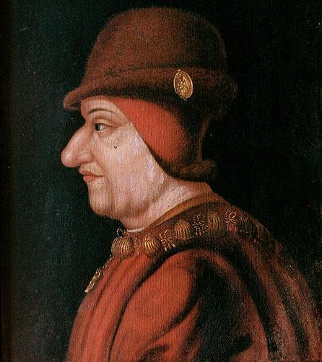](https://www.google.co.uk/url?sa=i&rct=j&q=&esrc=s&frm=1&source=images&cd=&cad=rja&uact=8&ved=0CAcQjRxqFQoTCIWutLna-8gCFcHvFAodm24IFQ&url=https://commons.wikimedia.org/wiki/File:Louis_XI_(King_of_France).jpg&psig=AFQjCNH0gXKWWrzzhJQxAO0SUE_cxzOt6Q&ust=1446896178058583)personal following, and in fact their influence at court was not as significant as their legacy suggests. Indeed Edward continued to grant Warwick land, stewardships and profits from the mines during the 1460s. Although most commentators agree that the pro-Burgundian line in foreign policy upset Warwick, ultimately it was Warwick’s ‘profoundly unreasonable personality’ that led to his part in Henry VI’s brief return to the throne. Attention has focused on Warwick’s role as ‘kingmaker’ during Henry VI’s Readeption in October 1470. However, without the assistance of Louis XI and the role played by foreign policy, it is unlikely that Warwick’s name would be so infamous today.

Edward’s foreign policy can be blamed for Louis’s intervention as, in May 1468, the English king had declared war on France, and he had also completed the diplomatic encirclement of Louis with the treaty of alliance with Aragon. Ross states that by May 1470 Louis XI ’had endured twenty months of the most acute anxiety and strain – the nightmare vision of an active combination of England, Burgundy and Brittany’. It was this feeling that led him to make the unholy alliance with Margaret and Warwick. Whatever the intrigues and events of 1470-71, it is only relevant to this article to note that without Louis XI’s assistance financially, diplomatically and militarily, Edward would have likely remained King in 1470.

Similarly it is to foreign policy and Warwick’s declaration of war against Burgundy that Edward’s restoration can be traced. Although there were other reasons for Henry VI’s unpopularity, Warwick’s inability to keep England neutral, rather than blindly follow France’s lead, forced Charles of Burgundy to assist Edward with money (£20,000) and ships, and gave a focus of discontent to those opposing the Warwick and Lancastrian alliance. Whilst most of the reasons for Edward’s return to the throne can be traced to his actions when in England, the crucial role played by foreign policy was to place him in Yorkshire with a chance to retake his crown. Many factors actually enabled Edward to reclaim the throne, but the support of Charles of Burgundy was vital in giving him the impetus to mount a serious challenge.

**Edward IV 1471-1483**

By 1471 Edward IV had returned to the throne of England with a determination to continue his claim to the French throne. He was furious at the actions of Louis in bringing about the end of his first reign. The official address to parliament in 1472, on the King’s behalf, showed that Edward saw Louis as ‘the principal ground, root, and provoker of the King’s let and trouble’ and the man who wanted by ‘subtle and crafty means’ to disrupt Yorkist rule. It is therefore possible to contend that it was the way Louis XI had blatantly interfered in the affairs of England, and the threat of it happening again, that caused Edward to seek revenge in the 1470s.

It was not until 1475, however, that Edward launched the campaign that gave him his valued pension from the Treaty of Picquigny. The events of 1475 represent perhaps the pinnacle of Edward’s success against the machiavellian Louis XI. Edward gained not only an immediate payment of 75,000 crowns but also an annual pension of 50,000 crowns and very beneficial trade agreements for the cloth trade of Devon and Bristol. Yet even this ’pinnacle’ can be criticised as missing the glory of conquest that monarchs such as Henry V had been able to achieve against France. Certainly England did not gain any French land by the treaty.

Nevertheless Edward enjoyed relative foreign policy harmony until 1477 when Charles of Burgundy died, leaving his daughter as heir. Louis, forever looking for an opportunity to weaken France’s traditional enemies Burgundy and Brittany, invaded Picardy, Artois and the Duchy of Burgundy. Although Edward IV had always opposed a French-Burgundian alliance, some historians have argued that after 1475 and the Treaty of Picquigny he was constrained by his desire to retain his pension from Louis and the economic benefits of a marriage alliance with the dauphin. However, Lander makes the valid point that Edward was aware that the situation in the Netherlands was complex both in terms of legal and political areas and that any intervention would have probably involved England in a long and costly war. This was something Edward, allegedly ever conscious of financial matters, would not have wanted. The Croyland Chronicler adds an additional dimension to this argument when he states ’for collecting vessels of gold and silver … and for building castles, colleges and other distinguished places… not one of his predecessors was at all able to equal his remarkable achievements’. He was the first English King in centuries who actually died solvent. Maybe Edward was concerned with finances abroad so that he could continue to develop the splendour of the crown at home.

Fortunately for Edward the marriage of Mary, Charles of Burgundy’s daughter, to Maximilian, son of the Hapsburg Emperor, Frederick III, in August 1477 made his support a valuable commodity for both France and Burgundy. Edward was still very interested in a successful marriage alliance of his daughter Elizabeth to the dauphin. However, it is more than likely that the cunning Louis XI used the ongoing discussions about marriage as a delaying tactic to win him time with his intrigues with Burgundy. Louis was determined to take advantage of the power vacuum left by Charles’s death and put an end to the threat on France’s borders from an independent Burgundy. Obviously Edward feared this would drastically weaken England’s position, but he was wary of upsetting Louis too much in case he lost his annual pension. By 1480 Edward was starting to accept that Louis was not going to give him the profitable marriage he craved, so he began to move closer to England’s traditional allies against France  – Brittany and Burgundy.

Edward signed a treaty with Burgundy in 1480 that represented the end of patience with the French on the marriage issue and demonstrated his increasing demand for financial gain in the form of an annual pension when engaging in any foreign policy arrangement. Sadly for Edward, however, the first consequence of this treaty was the loss of the French pension instalment due at Michaelmas 1480. Then Louis seemed likely to encourage Scottish activity against Edward’s territory in the North of England. All of these elements continued to accentuate the tradition of suspicion and distrust present in France against England and vice versa.

It is probable, as Ross believes, that Edward’s new pro-Burgundy posture was responsible for the trouble on the Scotland-England border in 1480. The Scots government began to embark on policies that breached the truce signed in 1474 and there was a series of raids across to the English side of the border that seemed to benefit nobody apart from the manipulative Louis XI. Edward, despite a fear that any escalation north of the border might weaken his position on the Continent, nevertheless decided on war with Scotland. This conflict persuaded Edward not to aid Maximilian in his planned invasion of France in the early 1480s, and thus it constituted one reason why Maximilian signed the Treaty of Arras in 1482, which signalled the failure of England’s anti-French foreign policy.

Relationships between Louis XI and Edward had become so strained that Louis made defence preparations for an invasion by England in November 1480. It was the historic fear of England and the English kings’ insistence on seeing themselves as the rightful monarchs of France, coupled with the anti-French policies adopted by Edward after 1480, that help explain why France supported the first realistic challenger to the Yorkist dynasty, Henry Tudor

Edward was ultimately isolated in European affairs due to a combination of the death of Mary of Burgundy in a horsing accident and Maximilian’s need to consolidate his losses by the Treaty of Arras in 1482. By this treaty Margaret of Austria was to marry the dauphin, while France gained Artois and the county of Burgundy. Edward IV not only lost his chance of a French marriage but in addition his cherished pension was stopped by Louis. Louis had outfoxed Edward for the final time, but the legacy of their dealings was an England that France felt demanded and sought revenge.

Contemporaries such as Polydore Virgil certainly spotted this desire for revenge in Edward and it is likely that he was planning an invasion of France again in his final few months alive. This perception in France of continued and escalating English aggression towards her  was one that it was crucial for Richard III to change if he was hold on to his throne. With the benefit of hindsight, we can perhaps see that Richard III’s biggest mistake was not to reassure France of England’s peaceful intentions, especially since his claim to the throne was more tenuous than Edward’s. But Richard had learned little from the recent history of his own dynasty.

**Richard III 1483-85**

Richard’s actions in 1483 not only gained him the throne of England but heightened the importance of Yorkist foreign policy. Although the exact nature of the Princes’ deaths will never be known, most respected historians see the hand of their uncle playing the vital role in their murder. It seems extremely unlikely that they would have been killed without Richard’s blessing, and certainly he was seen as the culprit by contemporaries and thus his already small power-base –  which rested on a fragile balance of domestic acceptance and foreign non-intervention  – was further weakened. Domestically he was forced to rely on trusted Northerners to quash any internal unrest that erupted, such as the Buckingham Rebellion of 1483, but foreign policy was even more complex due in part to the man whom the 1483 rebellion highlighted as Richard’s most likely rival, Henry Tudor.

Under Edward IV, Henry Tudor, Earl of Richmond, was, in Ross’s words, ‘an obscure and penniless exile in Brittany’, but with Richard’s usurpation came a new-found significance to Henry’s rather weak claim to the throne of England. For if Richard could make good his own dubious right to the crown, then Henry also had a feasible claim. Henry moved to prominence with the failed Buckingham Rebellion, as his name became well known in England, and he became the figurehead around whom the opponents of Richard could rally when the time was right. Foreign policy was now vital because, as in 1470-71, European countries could once more influence English affairs by supporting, or threatening to support, a claimant to the throne when a new monarch had not had time to develop his power base. Richard was well aware of this possible threat, for (in Mancini’s words) he sent an emissary to Brittany in 1483 to enquire if ‘there be any intended enterprise out of land upon any part of this realm’.

The first external problem Richard had to face was the problem of Scotland. Despite James III’s enthusiasm for peace with England, Richard supported the pretender to the Scottish throne, Albany.  Unfortunately for Richard, however, Albany’s attempt at invasion resulted in abrupt failure and further antagonised the Scottish King. James then sent a contingent of Scots to France to fight alongside Henry Tudor under the command of Alexander Bruce of Earlshall. It is probable that Richard’s policies towards Scotland were influential in pushing James to improve his relationship with the new king of France, Charles VIII, who succeeded the old fox Louis XI in August 1483. Richard’s actions must surely have heightened French suspicion of the new King. Clearly Richard was not the type of King to avoid bloodshed in domestic or foreign affairs.

Yet it is important not to see Richard as a northern barbarian blundering his way throughout the intrigues of foreign policy. Whilst he made a number of serious mistakes, he did have the intelligence to note that the alliance proposed by Queen Isabella of Castile early in 1483 would have offended the French deeply. Sadly for Richard, this understanding attitude towards French susceptibilities was not made obvious to Charles VIII during the crucial period in 1485 when Henry was in France looking for assistance

Richard turned his attention towards Brittany in an attempt to resolve the vital problem of a rival claimant to the throne of England. Henry Tudor was the most dangerous threat to Yorkist rule and, as he was in exile in Brittany, Richard tried to cultivate a situation where he could control and, if possible, eliminate the threat, as his brother Edward had eventually done with Henry VI. England’s relationship with Brittany was clouded by piracy on both sides but Richard tried hard to stop Henry producing a repeat of the 1483 rebellion. According to Polydore Virgil, Richard was so concerned about Henry that ‘he was vexed, wrested and tormented in mind with fear perpetually’, a quotation clearly supporting the view put forward by Mancini.

After various attempts at inducement, Richard seemed to get the breakthrough he sought: the treasurer of Brittany took control during one of Duke Francis’s mental breakdowns and moved against Henry. Fortunately for the Tudor dynasty, the extensive network of spies got word to Henry just in time and he fled to the court of Charles VIII in October 1484. Richard’s most dangerous rival to the throne was now in the hands of the one man who had the power and influence to decide the fate of the English.

Quite why Charles VIII supported Henry Tudor with 40,000 livres, and possibly 4,000 troops, for an invasion of England, remains debatable. Perhaps the best answer is that he was heavily influenced by a lifetime of deceit and hostility between the two countries. Throughout the reigns of the Yorkist Kings there had been constant threats of invasion. Ross makes the point that in 1484-85 there were numerous rumours in France that Richard was going to mount an invasion, just as his brother was planning before he died. In addition, the French saw Richard’s friendship with Brittany as a typical action to destabilise France, not as a legitimate move to capture Henry Tudor. These factors combined to make Charles VIII think that any move to weaken Richard would be wise for France. Hence, with his invaluable support, Henry landed in Milford Haven in a quest for the throne that would eventually lead him to Bosworth and a famous victory.

**Assessment**

The conclusion has to be that foreign policy was a crucial factor in the downfall of the Yorkist Kings and a very significant influence on the establishment of the Tudor dynasty. It would be foolish to perceive foreign policy as the only factor putting Henry VII on the throne, but it was arguably the most important one in getting Henry Tudor to the shores of Britain with a chance of success. The events of 1485 are well documented and have little to do with Richard’s relationships with foreign countries, but they would not have had the chance to materialise without the assistance of France at the exact dates in question. This is clear with the failed attempt of invasion in 1483 and the changing face of European diplomacy after the treaty of peace signed between France and Brittany on 9th August 1485. This failure in foreign policy cannot solely be traced to Richard III, but was partly the legacy which Edward IV left to his murderous brother in a form of a European poisoned chalice.

**Timeline**

* **1460** Edward IV gains the throne from Henry VI
* **1464** Edward marries Elizabeth Woodville
* **1470** The Readeption of Henry VI
* **1471** Edward IV's recovery of the throne
* **1475** The Treaty of Picquigny
* **1477** Charles the Bold dies
* **1482** The Treaty of Arras
* **1483** Edward IV and Louis XI die (independently!)
* **1485** The Battle of Bosworth and Henry

Use this grid to record what Lewis sees as the successes and failures of Edward IV foreign policy. Then produce a paragraph on the bottom part of the previous page which summarises the main points of the article.

|  |  |
| --- | --- |
| Foreign policy success | Foreign policy failures |
|  |  |

**Glossary**

|  |  |
| --- | --- |
|  |  |
|  |  |
|  |  |
|  |  |
|  |  |
|  |  |
|  |  |
|  |  |
|  |  |
|  |  |
|  |  |
|  |  |
|  |  |
|  |  |
|  |  |
|  |  |
|  |  |
|  |  |
|  |  |
|  |  |
|  |  |
|  |  |
|  |  |
|  |  |
|  |  |
|  |  |
|  |  |
|  |  |