Why did Richard lll take the throne in 1483?
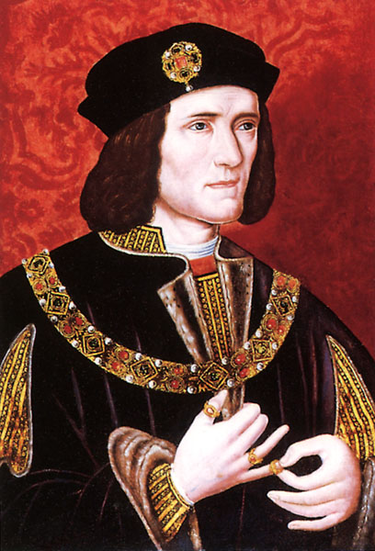
- What were the reasons for Richard lll’s treachery?
(see Cook pages 42 – 46 and Carpenter 206 – 210)

First – how could it be that Edward IV should entrust so much power to anyone that they were in a position where they could usurp his two sons?

Well – Richard had given loyal and devoted service to his brother. He had been extremely successful as a ruler in the north of England, effectively imposing law and order on the region. In gratitude Edward had granted him a palatinate comprising Cumberland and Westmorland. Gloucester thereby became the most powerful northern baron of the middle ages. He also managed to obtain acceptance among the other leading nobles in the region. Evidence that displays how his pre-eminence was accepted is shown by the large number of private disputes submitted to him for jurisdiction.

The Woodvilles were, however, jealous. They feared his influence over the fount of all their new found power, the king. In return Gloucester probably feared their influence over his brother. He seldom came to London and was in the north when Edward died easter 1483.

Edward was aware of the hostility and rivalry between his more powerful nobles, but he had expected to live longer and contain it through his personal strength and vigour. When it became apparent that he was dying he attempted a death-bed reconciliation between Lord Hastings (one of Edward’s most trusted advisers and his chamberlain) and the Marquess of Dorset (Elizabeth’s son by her first marriage – Thomas Grey and therefore Edward’s stepson), but their display of forgiveness and affection was nothing but a show. As soon as Edward actually died all restraint was removed and a ruthless power struggle ensued.

(Notes from Christine Carpenter)
Although his death was unexpected, he lingered for ten days and recovered sufficiently from his first attack to make provision for his son’s minority. Unfortunately we do not know what this was; the only source, Mancini, on whose version much of the conventional account of the usurpation is based was written by a foreigner who did not know England and had to rely on hearsay – according to Carpenter. Cook says that Mancini wrote his account before 1 December 1483, for his patron the Archibshop of Vienne, and that his report is sober and objective. He writes that Richard intended to take the throne soon after the death of Edward IV. Mancini alleges bad feelings between Gloucester and the Woodvilles, which led to Edward’s wishes that his brother act as Protector being overturned by the queen and her family. He shows that many people in London believed this and his importance is as a reporter of opinion. His report has led to the classic interpretation of what happened.

According to Carpenter there is no evidence of tension before Edward IV’s death and recent accounts argue that what Edward wanted was the continuation of a distribution of power that was working well with Richard in the north and perhaps entrust some amount of rule to his oldest son (who was after all already 12). The most important single source for the reign is the Croyland Chronicle, probably written by the Bishop of Lincoln who was Chancellor to Richard which certainly gives him insight into what Richard’s perspective on things was even though he very much disapproved of the usurpation.

Edward’s death produced the first time that the Yorkist throne had to be inherited. That is always an extremely delicate moment for a usurping dynasty and for the new king to be underage was a disaster as it gave opportunities to alternative contenders. Recent memories of a king who had no will and allowed his nobles to control and direct the kingdom were still fresh in many memories and no one wanted to repeat the experience they’d undergone under Henry VI. No one wanted another court clique to dominate as it had done during Henry VI’s reign, and the Woodvilles were in a very strong position to become just such a clique. They were close relatives of the king, and they had a reputation for high handedness and greed. If they established themselves around the throne they might be awkward to remove even once the king was of age. Gloucester had only recently acquired his enormous estate and was perhaps afraid that he would lose his position under a Woodville dominated monarchy.

There is some evidence that Hastings and others feared Woodville ambitions from an early stage in the new reign and that military preparations by some of the family gave them good reasons for doing so. The Woodvilles wanted to bring Edward V to London with an army which provoked a furious row in the Council where Hastings and his supporters opposed the Woodvilles. Dorset was using the royal treasure to equip a fleet under Sir Edward Woodville.

No official letter seems to have been sent to Gloucester telling him of his brother’s death. It appears to have been Hastings who informed him and urged him to come to London to protect his rights. Gloucester wrote a letter of condolence to the queen and another to the council, expressing his willingness to undertake the protectorate. This seems to have reassured the Woodvilles and the male head of the family Anthony, 2nd Earl Rivers (the queen’s brother and the new king’s other uncle) agreed to meet Gloucester on the way to taking Edward V to London. On the 29th April Gloucester entertained his guests that evening and then arrested them on the following morning.

The Woodvilles panicked. The Queen and her other son fled to sanctuary at Westminster and against a background of rumour unease and suspicion Gloucester, Buckingham and Edward V entered London on 4 May. The Council confirmed Gloucester’s position as Protector and according him greater powers than even his father had exercised over Henry VI. However, he could not persuade the Council to attaint Rivers for treason which was a clear sign that the Council would only back Gloucester as long as he promoted the succession of Edward V. A date for the coronation was set (22 June) and it was plain that his protectorate would be shortlived.

- What was Richard Duke of Gloucester’s reputation when his brother Edward died in 1483? (3)
- What has traditionally been given as the main reason for the treachery? (3)
- What steps did he take to protect his position when h e heard his brother had died? (5)
- What was the reason Eleanor Butler was important? What do you think of this?(5)
- How skilful was Richard in manoeuvring for power? (4)

