**The revolution from October 1789 to the Directory 1795**

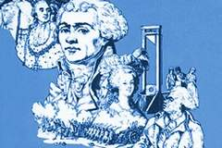

**What do I need to know?**

* Why did it become impossible to set up a constitutional monarchy?
* Reforms in church and state, Sans Cullottes and the different political clubs – ensure you know the ideas held by Girondins and Jacobins and what happened to make overthrow the Girondins?
* What was the significance of the “flight to Varennes”?
* What caused some people to attempt a counter revolution?
* What were the causes of “the terror”
* The impact of Robespierre his rise and fall.
* The establishment of the Thermidorian Regime?
* Why did France find itself at war and how did this go?
* What was the constitution of the Directory?

**Possible exam questions:**

**Interpretation questions:**

**‘The Counter-revolution’s practical effect in French history was as negligible as its mythological and intellectual importance was great.’** *J M Roberts.* Evaluate the strengths and limitations of this interpretation, making reference to other interpretations that you have studied.

**‘The *sans-culottes* have been almost literally a red-herring to divert attention from the basic social problems, both rural and urban of French Revolutionary history’.** *Alfred Cobban* Evaluate the strengths and limitations of this interpretation, making reference to other interpretations that you have studied.

**‘A regime of popular sovereignty in which the object was to conquer tyranny or die for liberty’** *Sophie Wahnich* Evaluate the strengths and limitations of this interpretation, making reference to other interpretations that you have studied.

**Essay style questions:**

Louis XVI’s flight to Varennes was a pivotal moment in the development of the French Revolution in the years 1789-99’ How far do you agree?

Assess the consequences for France of the reforms made to the Catholic Church by the National Assembly.

The *sans-culottes* played a key role in bringing about the collapse of the Legislative Assembly.’ Explain why you agree or disagree with this view.

To what extent was France’s participation in the war entirely responsible for bringing about the overthrow of the monarchy in August 1792?

To what extent was the government by Terror only about defeating the internal and external enemies of the Republic?

**Suggested reading**

Dr Marie Linton, *Robespierre and the Terror (*History Today August 2006)

Andrew Miller *Pure*

Peter McPhee *Living the French Revolution.*

**A constitutional monarchy?**

Until 1789 the French monarchy is usually described as being an absolute monarchy. Please explain what you understand by this,

Louis XVI was an absolute monarch therefore he…

A constitution is a set of rules. Explain why a constitutional monarchy would have been something many of the revolutionaries wanted.

Many of the original revolutionaries were not republicans, but merely wanted Louis to become a constitutional monarch. What is this?

**The Declaration of the Rights of Man and the Citizen**

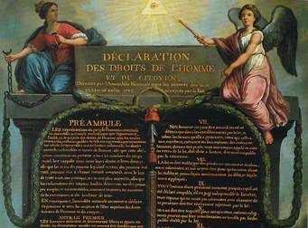

The “Rights of Man and the citizen” is a declaration of the principles on which a new constitution was going to be based. It was regarded as an inspiration to liberals in Europe throughout the 19th century, but looked at closely it can be seen that it was principally representing the interests of those with property.

It is considered by many to have sounded the death knell of the “ancient regime” and announced the intentions for a fairer future. William Doyle says, it “has been looked to ever since by all who derive inspiration from the French revolution, as the movement’s first great manifesto, enshrining the fundamental principles of 1789”.

Look at page 42 in your Rees text book and choose two of the points announced in the document and explain why they seem significant to you and what kind of difference they would make.

1.

2.

Why do these seem particularly significant to you?

What three principles underlay the new political system? (p,51)



**Assignment 1 – you will be asked to research one of the four following topics and provide a wordless powerpoint that will inform the rest of the class answers to the following questions.**

1. Reforms to local Government
2. Reforms to the Church
3. Reform of the economy/ financial system
4. Reform to the Legal System

**Reforms to Local Government**

* France was divided into 83 departments.
* Departments were subdivided into districts and then subdivided again into communes (municipalities).
* Communes were grouped into cantons where primary assemblies for elections were held and justices of the peace held their courts.
* All these administrative divisions except the cantons were run by elected councils.
* In Paris the local government of the city was reformed into 48 Sections.

So this all looks rather democratic, but it became clear that the deputies did not actually intend ordinary citizens to have a future role in government. They introduced a concept of **active and passive citizens**. Active citizens earned more and paid more taxes and were therefore allowed a vote. Men who earned less than a certain amount were called “passive citizens” because it was felt they did not contribute enough tax to justify them having a vote.

But even active citizens varied in how much influence they had. At the lowest level an active citizen paid the equivalent of three days wages in tax and he was able to vote for electors in the second level.

At the second level citizens paid the equivalent of ten days’ labour in local taxes, and they elected members of the canton and department assemblies and could become officials there. They also voted for those in the National Assembly – the third level.

To become a deputy in the National Assembly a citizen had to pay at least a silver mark in taxes – the equivalent of 54 days’ manual labour – and this excluded most Frenchmen from standing as a deputy.

However, it has to be said that although the system was heavily weighted to benefit the wealthy, 61% of French men could take part in some kind of election at a time when in England on 4% of the male population had any kind of vote. At a local level many votes had a vote and had the right to stand for local office. Before 1789 government officials ran local administration. Afterwards locally elected councils totally replaced them.

How effective were these reforms? P. 52 – 54)

Which of the principles referred to on page 51 were achieved?

**Reforms to the Church**

The National Assembly had three main reasons for selling Church land. ( Use p.54 to establish what these were)

1.

2.

3.

Explain what is meant by **biens nationaux**  and who were the main beneficiaries of this?

What did the Constituent Assembly want the French Church to become? (Look at page 58)

Sum up the changes to the church that had happened from 1789 to July 1790 and explain how popular (or unpopular they were).

**Now explain why things started to go wrong.**

How significant was the Civil Constitution of the Clergy on the Revolution and counter Revolution?

1. **Reform of the economy/ financial system**

After the royal administration collapsed in 1789 very few taxes were collected. The Assembly needed money quickly but a new tax system could not be set up immediately as planning would be required before any new systems could be created. Initially it was decided that the existing system of direct and indirect taxation should continue, but this was very unpopular and there were outbreaks of violence. The Government therefore abolished all the unpopular indirect taxes except for external customs.

List and explain the indirect taxes that the Assembly abolished.

What was the underlying aim of economic reform?

1. The deputies wanted…
2. The people actually wanted….

A new financial system came into effect in January 1791.

List and explain the new taxes.

**4 .Reform to the Legal System**

Why were changes made to the French Legal System

1.

2.

3.

4.

What were the main features of the new system (p.57)

**Rural revolution in Brittany**

(p.65)

1. Why did peasants become disillusioned with the Revolution?

1. Explain what was happening in Brittany and why?
2. What were the consequences of these risings?

**Jacobins and Cordeliers**

In the absence of political parties, clubs were established at which ordinary people could discuss the political issues of the day. They educated and informed the general public and acted as pressure groups to influence deputies in the Assembly.

Research Task

Research the Jacobins. (p. 63-64 and the internet).

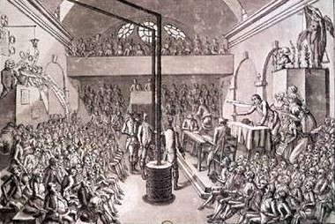

The Jacobin Club (May 1789 - July 29, 1794) was officially

called "The Society of the Friends of the Constitution"

Explain their principle ideas/aims?

Research the Cordeliers (p.64 and the internet)

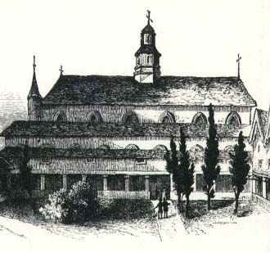

The Cordeliers (May 21, 1790 - March 24, 1794) were officially known as the Society of the Friends of the Rights of Man and of the Citizen. They popularised the motto "Liberty, Equality, Fraternity"

**Who was Maximilien Robespierre? (Write a Sunday Newspaper profile)**

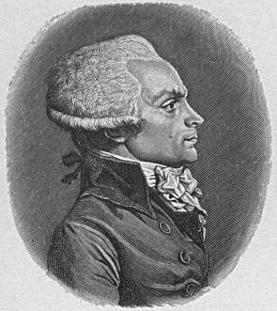

Date of birth

Education

Ideas

Experience

Aims

So explain the difference between the ideology of the Jacobins and the Cordeliers.

|  |  |
| --- | --- |
| **Jacobins** | **Cordeliers** |
|  |  |

**Who was Georges Danton? (Write a Sunday Newspaper profile)**

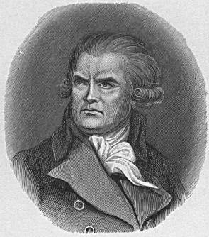

Date of birth

Education

Ideas

Experience

Aims

**How did the actions of the King contribute to the emergence of a republican movement?**

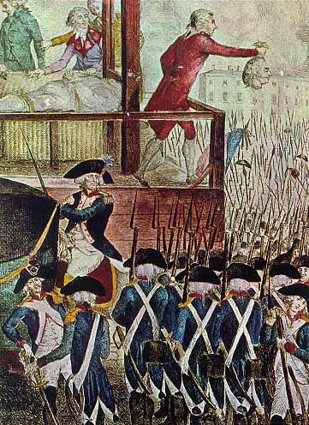

[*https://www.youtube.com/watch?v=SyXcUMftRs8*](https://www.youtube.com/watch?v=SyXcUMftRs8)

*The French Revolution [Documentary] [History Channel]*

40 minutes – **Escape to Varrenes**

1. Why did Louis decide to leave France?
2. How did the King and Queen disguise themselves?
3. Who stops the carriage?
4. What gives the game away?
5. Who show no reverence?
6. Why is the bond broken between the king and his subjects?
7. Why has this taken away the king’s influence?

**Explain the extent to which Louis’ flight to Varennes was a pivotal turning point in the development of the French revolution.**(p.68 – 69)

|  |  |
| --- | --- |
| **Before Louis’ flight** | **As a consequence** |
| * Intentions for government * Louis’ popularity * Foreign powers * Émigrés |  |

What were the effects of events in the Champs de Mars July 17th 1791? (p.69 – 70)

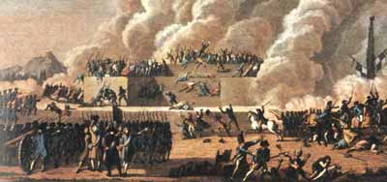

**Essay: Was Louis XVI chiefly to blame for the failure of constitutional monarchy?**

A range of individuals and groups have shared the blame for the failure of the new system of constitutional monarchy – examine and compare. (Enquiring History book on *The French Revolution*  by Dave Martin chapter 6 should help you with this)

* Louis and Marie Antoinette
* National Assembly of Deputies
* Club Monarchique and Émigrés
* Legislative Assembly Deputies
* Sans-culottes
* The Feuillants
* The Jacobins
* The Cordeliers

**The Terror 1793 - 4**

Causes

1. War – threats from other nations
2. Rivalries among revolutionaries
3. Fear of counter-revolution and activities of the royal family
4. Deteriorating living conditions/ economic factors

JIGSAW activity

Divide class into four groups – working on each cause. Then move students so that second group has a representative from each of the first groups arriving to explain what they found out about their cause.

Complete grid. Decide which cause was the most significant and explain why.

|  |  |  |
| --- | --- | --- |
| **Cause** | **Contribution** | **Impact** |
| War |  |  |
| Rivalry |  |  |
| Fear |  |  |
| Economy |  |  |

Extension task – read Dr Marisa Linton’s article “Robespierre and the Terror”.

**The Terror**

*General Lafayette*

***Picture***

***1757 Born at Chavaniac into an ancient noble family.***

***1777 – Used part of his enormous fortune to fit out a ship and sail to help American rebels against England.***

***1787 – Member of the Assembly of Notables, called to help the King. Closely connected with reform.***

***1789 – In the 2nd Estate***

***1790 – Seemed to be supporting repression when he helped supress an army mutiny.***

***1791 – At the Champ de Mars he was responsible for firing on ordinary people.***

***1792 – At the outbreak of war he was appointed commander of the Army of the Centre, but in June he left his post to try and organise the Legislative Assembly against the Jacobins.***

***19th August 1792 – he defected to the Austrians. He returned to France under Napoleon.***

The Terror is the most dramatic phase of the Revolution. Late twentieth century French historians Francois Furet and Denis Richet say that the period from August 1792 to July 1794 was a time when extremist sans-culottes knocked the Revolution off course. They forced the country’s leaders to adopt policies that were contrary to the liberal reforms of the Constituent Assembly. Their support was necessary to preserve the Revolution, but they did not make any permanent gains for themselves or any lasting changes.

**There were two main periods of terror.**

1. The attack on the Tuileries on 10th August 1792 when Louis and his family were imprisoned by the Insurrectionist commune (the body of rebels who controlled Paris). A sign of the changing times was the establishment of an Extraordinary Tribunal on 17th August to try those who had “committed counter-revolutionary offences” – in other words people were being executed for the offence of being a royalist!

Meanwhile the revolutionary war continued. On 19th August the Prussian army invaded France and on the same day when his own army refused to march on Paris and help him overthrow Brissot, French General Lafayette (see profile) defected to the Austrians. It seemed as though Paris might fall and in the panic that ensued, the government ordered the arrest of all suspected counter-revolutionaries. Hundred were imprisoned but rumours spread that they were about to break out and massacre the people and surrender Paris to the advancing Prussians. Marat and other extremists called for them to be killed.

The killing known as the September Massacres started after the fortress of Verdun fell on 1st September leaving Paris unprotected from the Prussian army. Next day crowds surrounded a tumbrel (wagon) of prisoners on its way to the Abbaye prison and murdered them. Groups of sans-culottes then invaded other prisons and set up kangaroo courts. Prisoners were dragged from their cells, tried, then hacked or beaten to death in the prison courtyards. Over five days nearly 1300 prisoners were murdered. Among them were 200 refractory priests, many known royalists but many were just ordinary criminals. The Paris Commune did nothing to stop this violence and none of the revolutionary leaders came out to openly condemn the killings.

Luckily for the revolution, on 20th September the French defeated the Prussians at **the Battle of Valmy**. Two weeks after the explosion of violence known now as “the September massacres” the 749 new deputies of the National convention met for the first time. They were mostly lawyers and professionals, but for the first time there were a few artisans. Among the deputies there was a clear division. Seated on the high benches of the left were those who came to be known as Montagnards and opposing them to the right were Girondins. Both groups had been committed Jacobins but the Girondins were marginally more moderate and wanted the king to be tried for his crimes.

The verdict was never in any doubt, particularly as after he was taken a massive number of letters between Louis and the Austrian royal family were discovered in an **armoire de fer (picture). Louis XVI was executed** on 21st January 1793.

1. The second period began with the journée of 31st May 1793 and ended with the execution of Robespierre and his supporters in July 1794. French armies were again doing badly and the country was threatened by invasion. A seemingly innocuous government committee, **the Committee of Public Safety** became the key to the terror. It had its origins in early attempts to co-ordinate the war effort and was created on 6th April 1793. Two days another important French General absconded and joined the enemy, and after this act of treason by General Dumouriez this body was created to supervise the [Girondin] deputies. On 31 May a rising began which spread rapidly when the news of the overthrow of the Jacobins in Lyons reached Paris on 1st June. On 2 June, 80,000 National Guardsman surrounded the Convention and demanded the expulsion of the Girondins from the Assembly. For the first time armed force was being used against an elected assembly.

To avoid a massacre or a seizure of power by a revolutionary commune, the Convention was compelled to agree to the arrest of 29 Girondin deputies and two ministers. Following the purge of the Girondins, Charlotte Corday assassinated Marat in the belief that it would end the Revolution.

**Why were the Girondins overthrown?** (p.104)

**Stimulus to the terror – the death of Marat**

On 12 July 1793 Charlotte Corday arrived in Paris from Caen with one purpose in mind, to kill Jean- Paul Marat, the radical journalist and revolutionary firebrand. Marat’s journal *L’ami du people* continually called for violence. She bought a long black handled kitchen knife and tried unsuccessfully to see Marat She left a letter and returned that evening with a second letter asking for his help. This time she promised Marat a list of traitors in the Caen area. This gained her admittance.

Marat suffered from the horrible skin condition psoriasis and spent much of his last three years sitting in his bath with a vinegar soaked bandage wrapped around his head and a dressing gown over his shoulders. This gave him relief from the pain and discomfort. This was where Corday found him. As soon as they were alone together she stabbed him, cutting his carotid artery and he quickly bled to death.

Corday was arrested at the scene and imprisoned. She was tried, convicted and executed on 17th July. She was guillotined in a red dress symbolising patricide. She had killed the father of the people. During her trial she said, “I have killed one man to save one hundred thousand.’ She mistakenly believed that Marat’s death would end the violence of the Revolution. Instead her action had the opposition effect. Marat became a revolutionary cult hero and his murder added to the fears of conspiracy and counter-revolution and in fact this fear was a major reason why state violence increased rapidly.

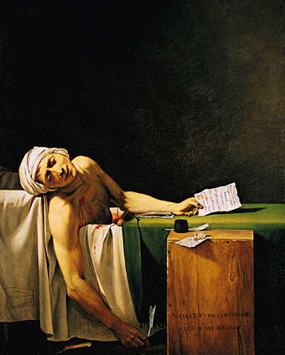**David’s painting Marat breathing his last**;

1. Corday is omitted from the picture as are the crossed pistols, map of France and painted slogan DEATH with which Marat had decorated his wall to symbolise his desire to kill all enemies of the revolution.
2. In Marat’s left hand is Corday’s second letter. David changed her last word which was ‘protection’, to ‘benevolence’ thus emphasising Marat’s generosity and her treachery. David has also got Corday using ‘votre’ instead of the ‘ta’ a citizen would use to link her with the Ancien regime even though she was also a revolutionary. Similarly her letter is dated using the Gregorian calendar while on the packing case David uses the revolutionary calendar Year two.

Do you think this is useful evidence?

**The revolt of the Vendée**

In the early days of March 1793 the revolutionary government’s call to arms provoked violence in the Vendée.

Why did violence break out there? P.94-95

The first riots occurred on 4 March at Cholet, followed by attacks on supporters and officials of the Revolution and seizures of their weapons. On 11 March the towns of Machecoul and Bourgneuf were over-run by armed rebels and between 300 and 500 supporters of the Revolution were massacred. The next day more than 2000 rebels captured St Florent and other towns were attacked. By the 19th March worried local revolutionaries reported to the Minister of War that in the Vendee the Revolution was in trouble.

The Committee saw defeat of the rebels as crucial to the survival of the Revolution. A new law was introduced **the Law of 19th March,** which allowed for armed rebels to be executed within 24 hours of capture. Military commissions sat in judgement, simply verifying a person’s identity and then passing sentence of death. Over 8,700 people were executed. The representative on mission in the area was Jean-Baptiste Carrier who became notorious for the brutality of his treatment of the rebels. For instance on 16th November 90 priests were tied together placed on a boat and taken onto the river Loire and sunk. At least seven more noyades were carried out and several thousand people died before this was stopped in January 1794. Historians differ as to whether this was done with the approval of the Committee and whether Robespierre was horrified by these events. Carrier used phrases such as “civic baptism” to describe his actions and it is certainly true that Robespierre had Carrier recalled to Paris in 1794 to answer for his actions.

Guerrilla fighting continued after the Vendean armies were destroyed and in December General Turreau proposed a scorched earth policy to the Committee for Public safety. Despite not receiving any reply to this proposal, he went ahead on 20th January, burning crops and houses, destroying livestock and killing all adult males. The result was a humanitarian disaster. Undisciplined troops murdered, raped, looted and destroyed the land through until April and thousands died.

How many people died in the Terror March 1793 to August 1794 ?

1. What percentage of the deaths were aristocrats?
2. What proportion of those who died were female?
3. How many of those who were executed had been tried?
4. How many died in battle?
5. How many died in prison?
6. How many died in the Vendée reprisals?
7. In total how many people (approximately) were killed in this year?

What were the motives for these extreme measures? (p.103)

<https://www.youtube.com/watch?v=pGvbEOSFle0>

Robespierre bringing Danton down with subtitles.

The main challenge to the revolutionary government came from within the ranks of its former supporters. Left-wing opposition came from the publisher Jacques Hébert and his followers. He called for property redistribution and getting impatient called for an insurrection in March 1794. He and eighteen supporters were arrested, called foreign agents and were executed. This gave the Committee for Public Safety a chance to strengthen its dictatorship, closing popular societies.

Of greater significance because of the higher profile of its leader, was the opposition of the Right centred around Danton and his friend Camille Desmoulins. Danton had been a former colleague of Robespierre and his supporters were called Indulgents as they wanted to stop the Terror. Danton had a large following in the Convention and was regarded as a serious threat.

RESOURCE TASK A

This resource consists of a section of **Camille Demoulins’ newspaper the Old Cordelier** translated into English. First you should establish what it is saying – possibly write it up in 21st century language. Then you should find 3 extracts which criticise the Committee of Public Safety and then use these to summarise Desmoulins’ criticisms overall.

Oh my dear fellow citizens! Shall we so far debase ourselves as to fall at the feet of such divinities? No, this Liberty descended from Heaven is not a nymph of the Opera, not a red cap, a dirty shirt, or rags and tatters. Liberty is happiness, reason, equality; she is justice, she is embodied in the Declaration of Rights, in your sublime Constitution. Would you have me acknowledge her, fall at her feet, spill my blood for her? Open the prisons of those two hundred thousand citizens whom you call “suspects,” for in the Declaration of Rights there was no prison for suspected persons, but only for felons. Suspicion has no prison, it has the public prosecutor; there are no suspected persons but those who are accused of crime by the law. Do not believe that this measure would be fatal to the Republic, it would be the most revolutionary step you have ever taken.

You wish to exterminate all your enemies by the guillotine! But was there ever greater folly? Can you kill one person on the scaffold without making yourselves ten more enemies amongst his family and his friends? Do you think that these women, these old men, these egotists, these laggards of the Revolution whom you shut up, are dangerous? Of your enemies, none remain to you but the cowards and the sick; the brave and the strong have emigrated; they have perished at Lyons or in La Vendée; the rest do not deserve your anger.

Camille Desmoulins – ‘The Old Cordelier’s’ Newspaper 20/12/1793. This extract is directed against the Committee of Public Safety and the excesses of the Terror

Extract 1 (quote directly) –

Translation (what is Desmoulins’ criticism of the committee of Public Safety) –

Extract 2 (quote directly) –

Translation (what is Desmoulins’ criticism of the committee of Public Safety) –

Extract 3 (quote directly) –

Translation (what is Desmoulins’ criticism of the committee of Public Safety) –

On what basis did Desmoulins criticise the Committee of Public safety?

Out of 10 how much of a threat do you think this would represent to the Committee? ____ (Explain your answer)

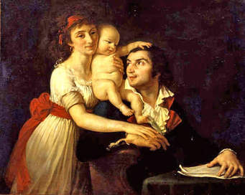Danton’s call for peace and an end to the Terror, was felt to leave a door open for the return of the monarchy so he was brought before the Revolutionary Tribunal on charges based on his political record and was executed with many of his followers. The Terror now seemed to have a momentum of its own. The members of the committees had become brutalised and active in ways that would have shamed them only two years earlier. Desmoulins’ wife tried to organise a demonstration in his support. She was arrested and executed also along with the wife of Hebert though they could not be regarded as posing any threat to the CPS. The effect of these deaths was to create an atmosphere of hatred and suspicion where an unguarded word could result in death. In June and July of that year more people were sentenced to death than in the previous fourteen months so things were getting to a peak. The **Law of 22 Prairial** brought in a reform whereby defendants were not allowed a defence counsel removing any semblance of a fair trial in order to speed up the process.

***Picture of Desmoulins and his family***

This painting was made of Camille Desmoulins , his wife Lucile and their baby son Horace in 1792. A well known radical journalist, Desmoulins’ speech at the Café Foy is credited as triggering the storming of the Bastille but less than five years later both he and his wife were guillotined. They were arrested tried and executed with the approval of the man who was Camille’s old school friend, a guest and witness at their wedding and godfather to their son Maximilien Robespierre.

Look at the profile of Maximilian Robespierre on page 107 and explain how he justified the terror?

Thanks to the Terror] the threats to the existence of the revolution had been removed or brought under control by the end of 1793

The internal threat of the Vendee was over by 1793 and by 1794 the French Army was advancing. The Terror was therefore created by Robespierre’s political agenda rather than threat to the nation

**Duncan Townson Francois Furet**

**Why did the terror take place? Find evidence to support both historians’ points of view.**

|  |  |
| --- | --- |
| **Evidence to support Townson** | **Evidence to support Furet** |
|  |  |

**Which historian do you find more convincing Townson or Furet?**

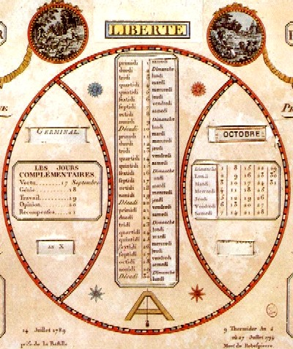

(Notes on the calendar taken from Wikipedia)

The **French Republican Calendar** ([French](https://en.wikipedia.org/wiki/French_language): *calendrier républicain français*) or **French Revolutionary Calendar** (*calendrier révolutionnaire français*) was a [calendar](https://en.wikipedia.org/wiki/Calendar) created and implemented during the [French Revolution](https://en.wikipedia.org/wiki/French_Revolution), and used by the French government for about 12 years from late 1793 to 1805, and for 18 days by the [Paris Commune](https://en.wikipedia.org/wiki/Paris_Commune) in 1871. The revolutionary system was designed in part to remove all religious and royalist influences from the calendar, and was part of a larger attempt at decimalisation in France (which also included [decimal time](https://en.wikipedia.org/wiki/Decimal_time) of day, [decimalisation](https://en.wikipedia.org/wiki/Decimalisation) of currency, and [metrication](https://en.wikipedia.org/wiki/Metrication)).

The Republican calendar year began the day the [autumnal equinox](https://en.wikipedia.org/wiki/September_equinox) occurred in Paris, and had twelve months of 30 days each, which were given new names based on nature, principally having to do with the prevailing weather in and around Paris.

* Autumn:
  + [Vendémiaire](https://en.wikipedia.org/wiki/Vend%C3%A9miaire) in French (from Latin *vindemia*, "grape harvest"), starting 22, 23, or 24 September
  + [Brumaire](https://en.wikipedia.org/wiki/Brumaire) (from French *brume*, "fog"), starting 22, 23, or 24 October
  + [Frimaire](https://en.wikipedia.org/wiki/Frimaire) (From French *frimas*, "frost"), starting 21, 22, or 23 November
* Winter:
  + [Nivôse](https://en.wikipedia.org/wiki/Niv%C3%B4se) (from Latin *nivosus*, "snowy"), starting 21, 22, or 23 December
  + [Pluviôse](https://en.wikipedia.org/wiki/Pluvi%C3%B4se) (from Latin *pluvius*, "rainy"), starting 20, 21, or 22 January
  + [Ventôse](https://en.wikipedia.org/wiki/Vent%C3%B4se) (from Latin *ventosus*, "windy"), starting 19, 20, or 21 February
* Spring:
  + [Germinal](https://en.wikipedia.org/wiki/Germinal_(French_Republican_Calendar)) (from Latin *germen*, "germination"), starting 20 or 21 March
  + [Floréal](https://en.wikipedia.org/wiki/Flor%C3%A9al) (from Latin *flos*, "flower"), starting 20 or 21 April
  + [Prairial](https://en.wikipedia.org/wiki/Prairial) (from French *prairie*, "pasture"), starting 20 or 21 May
* Summer:
  + [Messidor](https://en.wikipedia.org/wiki/Messidor) (from Latin *messis*, "harvest"), starting 19 or 20 June
  + [Thermidor](https://en.wikipedia.org/wiki/Thermidor) (or Fervidor) (from Greek *thermon*, "summer heat"), starting 19 or 20 July
  + [Fructidor](https://en.wikipedia.org/wiki/Fructidor) (from Latin *fructus*, "fruit"), starting 18 or 19 August

Note: On many printed calendars of Year II (1793–94), the month of *Thermidor* was named *Fervidor*.

**Fall of Robespierre**

In the early summer of 1794 Robespierre started to lose support in three key areas: among Catholics, among the sans-culottes and on the Committee of public safety and the committee of General Security.

1. Explain the impact of Robespierre’s new religion. (p124)
2. Why were the Sans Cullottes turning against Robespierre?
3. Explain why members of the two committees began to fall out.

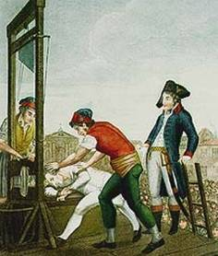

Video on fall of Robespierre

Use all this information to describe why Robespierre fell in a spider diagram.

1. Explain the events of the Coup of Thermidor.
2. Why did Robespierre fall?

**Coup of Thermidor and establishment of the Directory**

There was great delight and relief among many people when Robespierre was executed. Those who overthrew Robespierre were known as the Thermidorians after the month in which the coup occurred. The Thermidorians were a mixed group – members of the two great committees [the Committee of Public Safety (CPS) and the committee for General Security (GGC), ex-terrorists and deputies of the Plain. The Plain now emerged from obscurity to take control. It was made up of the men who had gained from the Revolution by buying biens nationaux (land) or by obtaining government contracts. As regicides these men were firmly attached to the Republic and did not want to see the return of any form of monarchy. They also disliked the Jacobins, who had given too much power to the sans-culottes and had interfered with a free market through the Maximum laws. For them popular democracy, anarchy and they Terror were synonymous.

**Ending the Terror**

Immediately after Thermidor, the Convention set about dismantling the machinery of the Terror. Explain how:

1.

2.

3.

4.

5.

What was significant about the **separation of Church and state?**

**The Uprisings of Germinal and Prairial**

The Thermidorians removed price controls, but this led to a massive fall in the value of the assignat and inflation. In August 1794 the Assignat was 34% of its 1790 value it dropped to 8% in April and 4% in May. The situation was made worse by a poor harvest in 1794. Grain shortages led to a huge increase in the price of bread. The winter of 1794-5 was an unprecedentedly severe one. Rivers froze and factories closed down. A combination of economic collapse and the bitter cold produced an enormous increase in misery suicides and death from malnutrition.

**Germinal**

On 1 April 1795 a large crowd of about 10,000 unarmed people marched on the Convention demanding bread and asking that former members of the CPS, Barère, Collot and Billaud were released. The repression that followed Germinal was light, but Barère, Collot and Billaud were deported to Devil’s island.

**Prairial**

Prairial was a more serious armed rising. On 20th May 1795 a large crowd of housewives, workers and some National Guard units marched on the Convention to demand bread. In the ensuing chaos a deputy was killed and the mood of the crowd became increasingly hostile. The following day forces loyal to the Convention gathered to confront the crowd and a tense situation developed. The Convention’s gunners went over to the rebels and aimed their cannon at the Assembly, but no one was prepared to fire. The crisis was resolved when the and to set up a food commission. Loyal National guards arrived in the evening and cleared the Assembly.

On 22 May (3 Prairial) the Convention took the offensive. The rebel suburbs were surrounded by 20,000 troops of the regular army who forced them to give up their arms and cannon. This time the repression was severe.

Look at page 136 and explain how the rebels were suppressed.

Why did the uprising fail?

2.

3.

4.

What is the significance of Prairial? (p.136)

What is “the White Terror”? (p. 138)

**Another Constitution – Year III or 1795**

The Thermidorians wanted a new constitution which would guarantee the main features of the Revolution of 1789: the abolition of privilege, freedom of the individual and the control of local and national affairs by an elected assembly and elected officials. They also wanted to ensure that a dictatorship like that of the CPS would be impossible. On 22 August a new constitution was agreed. Complete its main features below (using pa. 138)

What were the weaknesses in the new constitution?

1.

2.

3.

4.

**GLOSSARY**

|  |  |
| --- | --- |
|  |  |
|  |  |
|  |  |
|  |  |
|  |  |
|  |  |
|  |  |
|  |  |
|  |  |
|  |  |
|  |  |
|  |  |
|  |  |
|  |  |
|  |  |
|  |  |
|  |  |
|  |  |
|  |  |
|  |  |
|  |  |
|  |  |
|  |  |
|  |  |
|  |  |
|  |  |
|  |  |
|  |  |
|  |  |
|  |  |
|  |  |
|  |  |
|  |  |
|  |  |
|  |  |
|  |  |
|  |  |
|  |  |
|  |  |
|  |  |
|  |  |
|  |  |