Marisa Linton reviews the life and career of one of the most vilified men in history.

Maximilien Robespierre has always provoked strong feelings. For the English he is the ‘sea-green incorruptible’ portrayed by Carlyle, the repellent figure at the head of the Revolution, who sent thousands of people to their death under the guillotine. The French, for the most part, dislike his memory still more. There is no national monument to him, though many of the revolutionaries have had statues raised to them. Robespierre is still considered beyond the pale; only one rather shabby metro station in a poorer suburb of Paris bears his name.

Although Robespierre, like most of the revolutionaries, was a bourgeois, he identified with the cause of the urban workers, the *sans-culottes*as they came to be known, and became a spokesman for them. It is for this reason that he came to dominate the Revolution in its most radical phase. This was the period of the Jacobin government, which lasted from June 1793 to Robespierre’s overthrow in July 1794; the months when the common people became briefly the masters of the first French republic, which had been proclaimed in September 1792. It is also known, more ominously, as the Terror.

The enigmatic figure of Robespierre takes us to the heart of the Revolution, and throws light both on its ideals, and on the violence that indelibly scarred it.

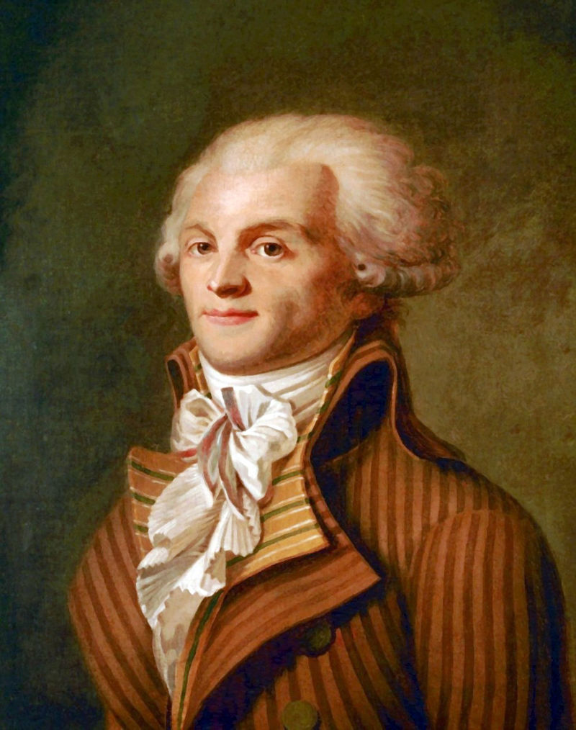*Maximilien Robespierre*

Born in Arras in 1758, Robespierre suffered loss early in his life. His mother died when he was six, and soon after, his father abandoned the family. The children were brought up by elderly relatives who continually reminded them of their dependent situation and their father’s irresponsibility. Maximilien was the eldest, a conscientious, hardworking scholarship boy. As soon as he was able he shouldered the ­burden of caring for his younger siblings. He became a lawyer, leading a quiet and blameless life in his native town. He was best known for defending the poor, and for some rather lengthy and tedious speeches at the local academy.

In 1789, when he was in his early thirties, the Revolution transformed his destiny. He launched himself into the political maelstrom that would immerse him for the rest of his life. He was elected as a deputy for the Third Estate in the Estates General in May, and he witnessed the onset of the Revolution that broke the power of the absolute monarchy two months later. Painstakingly, he worked to forge a reputation for himself as a public speaker in the Assembly. He had his power base in the Jacobin Club, the most important of the revolutionary clubs where people debated events.

From the first, Robespierre was a radical and a democrat, defending the principle that the ‘rights of man’ should extend to all men – including the poor, and the slaves in the colonies. This stance won him a reputation among the *sans-culottes*and the radical left, but the earlier years of the Revolution were dominated by men who had no wish to see power in the hands of the propertyless. Robespierre was undaunted. As a spokesman for the opposition and critic of government, he was tireless and consistent. He was also for a long time a vehement opponent of the death penalty. Why did he later change his mind and become an advocate of Terror? Part of the answer to this question lies in the deterioration of the political situation between 1789 and 1792, and the failure of the attempt to set up a workable constitutional monarchy, under Louis XVI.

From the spring of 1792 onwards France was involved in a spiral of war, revolt and civil war. Counter-­revolutionaries were plotting the restoration of the absolute monarchy with the support of the Holy Roman Emperor Leopold II (succeeded in March by Francis II). The Girondins, then the dominant revolutionary faction in the Legislative Assembly, spearheaded the drive for an aggressive war with the Empire, declaring war in April 1792. The avowed intention of their leader, Jacques-Pierre Brissot, was to polarize French politics, oblige the counter-revolutionaries to emerge into open opposition, and force the monarchy either to capitulate to the revolutionaries or to face its own destruction. In these circumstances, political views hardened, suspicion and fear increased, and the early optimism of the Revolution vanished.

Robespierre himself had long warned of the dangers of provoking counter-revolution. He had tried to oppose the war, because he thought it would divide France and rally support for the counter-revolutionaries. Nor did he believe, as Brissot did, that the ordinary people of Europe would welcome an invading French army, even one that claimed to deliver liberty and equality. ‘No one,’ said Robespierre, ‘welcomes armed liberators.’ He stuck doggedly to this position, though it was deeply unpopular and he became politically isolated.

***

By the summer of 1792, his worst fears were realized. The French army, far from being victorious, was on the verge of defeat and suffered from disorganization and raw and inexperienced troops. Many people thought (not without reason) that Louis was secretly on the side of the Austrian and Prussian armies, which were now threatening Paris itself. Many now felt that Robespierre spoke for them when he declared that the aristocrats were plotting a conspiracy to destroy the Revolution. In August the monarchy was overthrown in a pitched battle at the Tuileries palace. A new government, the National Convention, was formed in September 1792, which promptly declared France to be a republic. By now Robespierre’s ascendancy in the Jacobin club was unrivalled. The Jacobins identified themselves with the popular movement and the *sans-culottes*, who in turn saw popular violence as a political right.

The most notorious instance of the crowd’s rough justice was the prison massacres of September 1792, when around 2,000 people, including priests and nuns, were dragged from their prison cells, and subjected to summary ‘justice’. The Convention was determined to avoid a repeat of these brutal scenes, but that meant taking violence into their own hands as an instrument of government.

When the Convention debated the fate of Louis XVI, now a prisoner of the revolutionaries, Robespierre and his youthful colleague, Saint-Just (1767-94) – also once an opponent of the death penalty – led the way in claiming that ‘Louis must die in order for the Revolution to live’. Robespierre had not abandoned his libertarian convictions, but he was coming to the conclusion that the ends justified the means, and that in order to defend the Revolution against those who would destroy it, the shedding of blood was justified.

In June 1793, the *sans-culottes*, exasperated by the inadequacies of the government, invaded the Convention and overthrew the Giron­dins. In their place they endorsed the political ascendancy of the Jacobins. Thus Robespierre came to power on the back of popular street violence. Though the Girondins and the Jacobins were both on the extreme left, and shared many of the same radical republican convictions, the Jacobins were much more brutally efficient in setting up a war government. A Committee of Public Safety was established to act as a war cabinet. It became the chief executive power, with Robespierre – now moving from opposition to government for the first time – one of its twelve members. Like so many politicians making such a move, Robespierre’s attitude to political power was to change dramatically from this moment. In June the Jacobins drafted a new constitution, the most libertarian and egalitarian the world had yet seen. Yet for some months they hesitated to implement it, as the pressures of war with Austria and Prussia, and of full-blown civil war in the Vendée in the west were compounded by revolts across the country by *départements* rejecting the authority of the radical government in Paris.

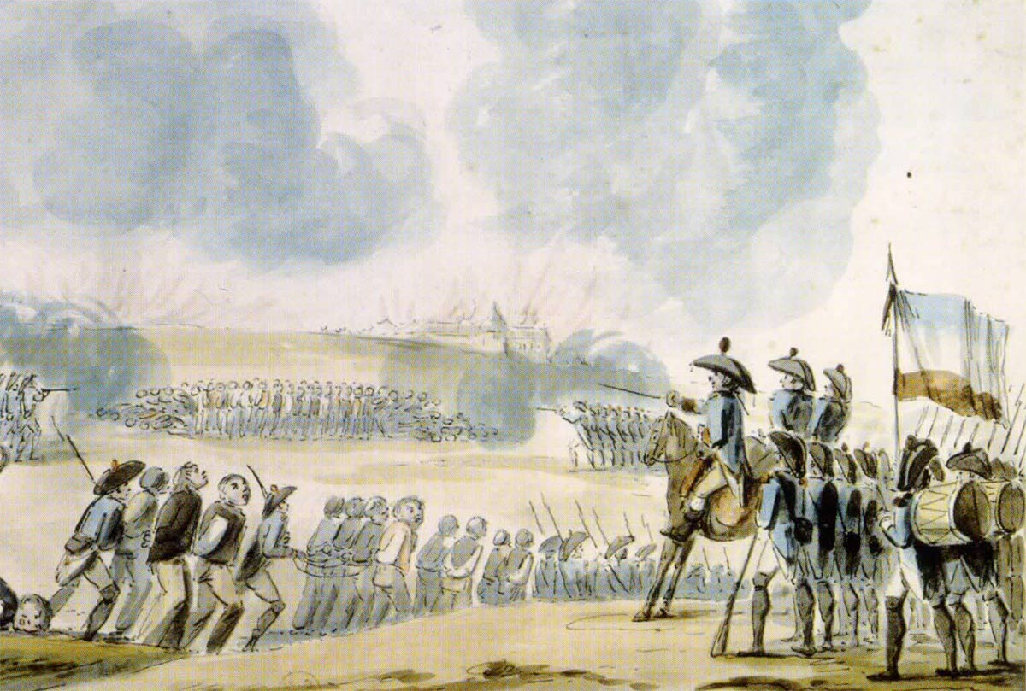*Mass shootings at Nantes, 1793*In September 1793, the impatient *sans-culottes*once again invaded the Convention to exert pressure on the deputies. They wanted economic measures to ensure their food supplies, and the government to deal with counter-revolutionaries. A delegation of the forty-eight sections of *sans-culottes*urged the Convention to ‘make Terror the order of the day!’ The Jacobins responded: the Law of Suspects was passed on September 17th, 1793, giving wide powers of arrest to the ruling Committees, and defining ‘suspects’ in broad terms. In October the Convention passed the Decree on Emergency Government. This authorized the revolutionary government to suspend peacetime rights and legal safeguards and to employ coercion and violence. Saint-Just decreed that the government ‘would be revolutionary until the peace’. The constitution was shelved: the libertarian ideals of the Revolution were suspended, indefinitely.*Sans-culottes*formed armed militias to go out into the provinces to requisition supplies for the armies and the urban populace and to root out counter-revolutionaries. In October Brissot and other Girondin leaders, as well as Marie-Antoinette went to the guillotine.

For the first time in history terror became an official government policy, with the stated aim to use violence in order to achieve a higher political goal. Unlike the later meaning of ‘terrorists’ as people who use violence against a government, the terrorists of the French Revolution were the government. The Terror was legal, having been voted for by the Convention.

***

Robespierre, like a number of the Jacobin government, had been a lawyer. He clung to the form of law partly in order to prevent the *sans-culottes*taking the law into their own hands through mob violence. As fellow revolutionary Danton said, ‘let us be terrible in order to stop the people from being so’. The resort to Terror also emerged out of relative weakness and fear. The Jacobins had only a shaky legitimacy and innumerable opponents throughout France, ranging from intransigent royalists to more moderate revolutionaries who had seen power centralized and their ideas superseded. Many people in France were already indifferent, if not openly hostile, to the Revolution. For many the Revolution now meant requisitioning of supplies, military conscription and the constant threat to their traditional ways of life, churches, even time – for the revolutionaries had even invented a new calendar. Throughout the year of Jacobin rule, it was the sans-culottes who kept them in power. But the price of that support was the blood-letting.

The number of death sentences in Paris was 2,639, while the total number during the Terror in the whole of France (including Paris) was 16,594. With the exception of Paris (where many of the more important  prisoners were transferred to appear before the Revolutionary Tribunal) most of the executions were carried out in regions of revolt such as the Vendée, Lyon and Marseilles. There were wide regional variations.  Because on the whole the Jacobins were meticulous in maintaining a legal structure for the Terror clear records exist for official death sentences. But many more people were murdered without formal sentences imposed in a court of law. Some died in overcrowded and unsanitary prisons awaiting trial, while others died in the civil wars and federalist revolts, their deaths unrecorded. The historian Jean-Clément Martin, suggests that up to 250,000 insurgents and 200,000 republicans met their deaths in the Vendée, a war which lasted from 1793-96 in which both sides suffered appalling atrocities.

Today the civil war in the Vendée is largely forgotten except by specialists. It is of the guillotine that most people think when they hear about the Terror. After so many bloodlettings of the twentieth century, why does that image still have the power to shock us? The historian Lord Acton once famously said that in terms of the time, the deaths under the Terror were relatively few in number (he was thinking of the official death sentences). As Acton pointed out, many millions were to die in Napoleon’s wars for no better reason than his own glory. Yet the aura of the hero still clings to Napoleon, while Robespierre’s name is synonymous with violence and horror.

Perhaps it is because of the stark contrast between Robespierre’s ideals and what he became that the question of the Terror remains shocking. In the mind of Robespierre and many of his colleagues, the Terror had a deeper moral purpose beyond winning the civil war: to bring about a ‘republic of virtue’. By this he meant a society in which people sought the happiness of their fellow humans rather than their own material benefit. France must be regenerated on moral lines. ‘What is our aim?’ he asked in a speech of February 1794:

*The peaceful enjoyment of liberty and equality; the reign of that eternal justice whose laws are written, not on marble or stone, but in the hearts of all men, even in that of the slave who forgets them and of the tyrant who denies them.*

He came to the conclusion that in order to establish this ideal republic one had to be prepared to eliminate  opponents of the Revolution. The  irony of this idea rings through in the same speech, when he justified the Terror. He said:

*If the basis of popular government in peacetime is virtue, the basis of popular government during a revolution is both virtue and terror; virtue, without which terror is baneful; terror, without which virtue is powerless. Terror is nothing more than speedy, severe and inflexible justice; it is thus an emanation of virtue; it is less a principle in itself, than a consequence of the general principle of democracy, applied to the most pressing needs of the patrie.*

Throughout his time in government Robespierre conducted his private life as a man of virtue. Far from living in palaces, amassing treasure, or allying himself with royalty, as Napoleon was to do, Robespierre lived a celibate life as a lodger, occupying simple rooms in the house of a master carpenter. He was known as ‘the Incorruptible’ for, unlike many politicians, he refused to use a public position for private gain and self-advancement. He lived simply on his deputy’s salary. He walked everywhere, never taking a carriage. He enjoyed walks in the country and musical *soirées* with his landlord’s family.

Yet the other side of this benign, if dull, domestic life, was the public role he undertook as a spokesman for the Committee of Public Safety and the guiding hand on the policy of Terror. He had become an astute political tactician, and he used these means finally to achieve political power. He could be accused, justly, of political ambition, but he himself did not see this as inconsistent with his dedication to the Revolution. He had an unshakable belief that his own aims coincided with what was best for the Revolution. He was a man of painful sincerity. He was not a hypocrite. He really did believe that the Terror could sustain the republic of virtue. But he was naturally self-righteous, suspicious and unforgiving. All these qualities came to the fore as it became evident that while the Terror played a key part in winning the war and quelling the counter-revolution, it was having the reverse effect as far as installing the republic of virtue was concerned, undermining any genuine enthusiasm for the Revolution. Even Saint-Just, Robespierre’s most loyal friend on the Committee of Public Safety, could not be blind to the way the Terror, with its neighbourhood surveillance committees and denunciations, encouraged an atmosphere of duplicity, cynicism and fear, even among the Revolution’s most fervent supporters, the Jacobins. ‘The Revolution is frozen’, he wrote dispairingly in a private note in 1794.

Some of the victims of the last months of the Terror were Robespierre’s former friends and colleagues, stalwarts of the Jacobin Club. They included Camille Desmoulins, Robespierre’s comrade from his schooldays. Desmoulins had taken the fateful step of supporting Georges Danton, another former friend of Robespierre, in his call that the Terror be wound down, and the power of the Committee of Public Safety broken. In December 1793  he launched a journal,*Le Vieux Cordelier*, arguing that the Revolution should return to its original ideals. Up to a point Robespierre had supported Desmoulins and his campaign against the more violent extremism of the *sans-culottes*, led by the journalist, Hébert. Robespierre read, and approved, the first two issues of *Le Vieux Cordelier* in proof. But in the third issue of the journal, Desmoulins parodied the notorious Law of Suspects and its wide range of people who could be considered ‘counter-revolutionary’. Under the Roman Empire, he said, para­phrasing Tacitus, people could be condemned as counter-revolutionary for being ‘too rich ... or  too poor ... too melancholy ... or too self-indulgent’. Robespierre saw this satire – rightly – as a veiled attack on the Committee of Public Safety itself. Robespierre tried to persuade Desmoulins to burn the journal publicly in the Jacobin Club. Desmoulins refused, recklessly citing the words of Robespierre’s hero, Jean-Jacques Rousseau, against him: ‘burning is not an answer’. Robespierre was stung, and stopped trying to help his friend. When the Committees decided to arrest Danton and Desmoulins in March 1794, Robespierre used his personal knowledge of the two men to supplement his notes for the official indictment against them. Desmoulins’ wife, Lucille, tried to agitate for his release but she too was accused of conspiracy against the Revolution and followed her husband to the guillotine in April. The letter from her heart-broken mother to Robespierre, begging for his intervention to save her daughter, went unanswered. Robespierre had said that a man of virtue must put the good of la patrie before private loyalty, even to his friends. Never had his own virtue seemed so appalling and inhuman as at that moment.

***

Perhaps he thought so too, and the strain of what he had become was beginning to tell. In the last few weeks of his life he shut himself in his rooms, and did not attend the meetings of the Committee or the Convention. He was losing his grip, both on himself and on power. In his absence it is notable that it was ‘business as usual’ for the Terror: in Paris the executions intensified, based on the notorious Law of 22nd Prairial (June 10th, 1794) which, by depriving the accused of counsel and removing the need for witnesses to substantiate accusations, removed the vestige of justice from the Tribunal.

Robespierre was never the head of the government, nor the only terrorist: he was one man on the Committee – albeit its most high-profile member. Other members of the Committee, together with members of the Committee of General Security (responsible for the police, prisons and most of the arrests), were as much responsible for the running of the Terror as Robespierre. Some of his colleagues were hard, ambitious men, not averse to political corruption unlike Robespierre, and scornful of his dream of a virtuous republic. There were aspects of the Terror with which Robespierre disagreed. He was an opponent of dechristianization – a policy carried out by some militant *sans-culottes*of forcibly closing churches and preventing any kind of religious activity. In June 1794 he organized the festival of the Supreme Being, based on Enlightenment deist beliefs, intended to unify the people around broadly moral and vaguely religious principles. It made him a laughing stock with the atheists among the deputies and failed to conciliate devout Catholics, long since alienated from the Revolution by its anti-clericalism.

Robespierre also deplored the violent excesses of some of the Jacobin deputies sent out ‘on mission’ from the Convention to oversee the implementation of policy in the provinces and with the armies. While many of the deputies on mission were conscientious and restrained, others misused their powers to arrest, intimidate and execute local populations. Robespierre had some of these deputies, including Tallien, Fouché, Fréron, Barras and Collot d’Herbois, in his sights when he went to the Convention for the first time in more than four weeks on the July 26th (8 Thermidor by the revolutionary calendar). It was the turning point. He had already quarrelled with men on both the ruling Committees, and, having rejected the reconciliation which Saint-Just tried to broker, he was left with little alternative but to try to destroy his enemies before they could do the same to him. He made a long speech in which he sought to justify the stand he had taken as a defender of virtue. But he also took the opportunity to demand another purge of suspect deputies. In a fatal miscalculation, he failed to name these men. Not unnaturally, many of the fearful deputies thought he might mean them. ‘The names!’ they shouted. But he refused. His enemies among the Jacobins spent that night in organizing their conspiracy. The next day Saint-Just was shouted down when he tried to speak in his friend’s defence. Robespierre and his closest associates were arrested and, after a futile attempt to rally the *sans-culottes*to defend them at the town hall, they were executed the following day.

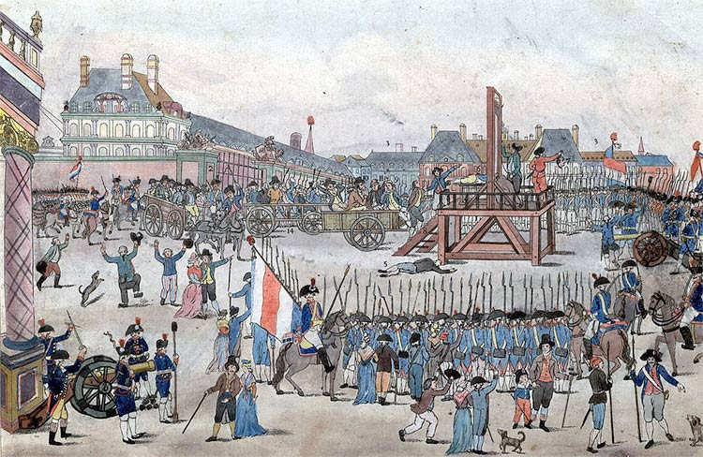*The execution of Robespierre*

The men who overthrew Robespierre were more ruthless and cynical terrorists than he. They included Vadier, Elie Lacoste, Billaud-Varenne and Collot d’Herbois on the Committees, as well as the deputies who had carried out atrocities whilst ‘on mission’. Initially they wanted the Terror to continue. But it rapidly became clear that the public had sickened of it. Since the overwhelming victory over the Austrians in the Low Countries at Fleurus on June 26th, the military justification for it had also diminished. In the reaction after Thermidor, as the coup is known, terrorist politicians rapidly restyled themselves. Members of the Committees now claimed that they had concerned themselves exclusively with the war: it was only the Robespierrists who had been terrorists.

In the popular imagination Robespierre the enigma rapidly became the embodiment of the Terror. Yet he would never have been so influential had he not spoken for a wide swathe of society and government. When he spoke of conspiracies against the Revolution, of the threats to ‘the *patrie* in danger’, and the need for extreme measures, he voiced the fears of many at that time that France was about to be overwhelmed by foreign and internal enemies. The policies of the Jacobin Committees had, after all, been endorsed by the deputies of the Convention. Perhaps this is why he has been so vilified: in holding one individual culpable for the ills of the Terror, French society was able to avoid looking into its own dark heart at that traumatic moment. Robespierre, you might say, took the rap.

**Marisa Linton** is Senior Lecturer in History at Kingston University and the author of *The Politics of Virtue in Enlightenment France* (Palgrave, 2001).

- See more at: http://www.historytoday.com/marisa-linton/robespierre-and-terror#sthash.nYURvlLr.dpuf