**Napoleon’s Rise to Power**

by Michael Rapport Published in History Today Volume 48 Issue 1 January 1998

Michael Rapport describes the last days of the old Revolutionary regime and the circumstances leading to the young general’s triumph at the coup of 18-19 Brumaire.

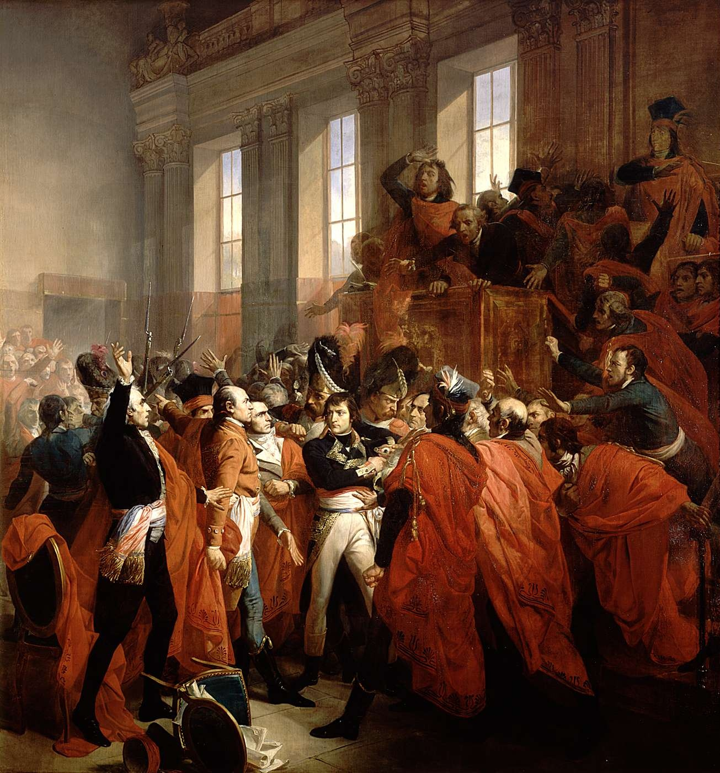

**General Bonaparte during the coup d'état of 18 Brumaire in Saint-Cloud, painting by François Bouchot, 1840**

On October 9th, 1799, at Fréjus in south-eastern France, General Napoleon Bonaparte disembarked from the frigate which had carried him from Egypt, evaded British cruisers and brought him safely back to the French Republic. Bonaparte had been plucked from a disastrous campaign in the East – only a month later, he would be brought to power as First Consul over the ruins of the Directory, the regime which had ruled France for four years.

But this rapid rise was far from assured. Whatever the realities of Egypt, where he had abandoned his command, Bonaparte was considered the Republic’s only undefeated general. In Avignon, en route to Paris, he was greeted in a spontaneous show of popular acclaim. It was his reputation as a victorious commander that had brought him popularity, but it took far more than this to bring him to power. At the same time, the government which he and his partners overthrew in the coup of 18-19 Brumaire, Year VIII (November 9th-10th, 1799) was either hated or treated with indifference by the bulk of the population.

Bonaparte’s ambition, his skill and his popularity cannot be dismissed as factors in his own rise, but more important were the failings of the Directory. In exploiting these weaknesses, opponents of the regime had several options to which they might have turned: Bonaparte was only one of them.

With war raging in Europe and unrest at home, the Directory faced determined opposition from the radical Jacobins on the Left and Royalists on the Right. In western France, the Catholic-Royalist rebellion, the chouannerie, remained a festering wound. Elsewhere in France the dodging of conscription, desertion from the army and brigandage ensured that the regime had a hard task in restoring order to the countryside. Its failure to do so did little to reassure property owners, who of course included some of the peasantry. Much of the peasantry also resented the continuing persecution of the Catholic clergy, which stemmed from the Revolution’s decision to reform the church and to nationalise its property in 1789. Non-jurors or refractories, the clerical opponents of this settlement, became focal points for counter-revolution. Moreover, the Directory had inherited considerable financial problems.

Underlying all these difficulties was the war against the First Coalition (comprising Britain, the Netherlands, Spain, Austria, Prussia and Sardinia and Naples), which had been raging since 1792. Despite its successes against various of these, the Directory was never able to win a lasting peace. Even when Austria was forced out of the war, ceding Belgium and a strong position in Italy and the Rhineland to France at the Treaty of Campo Formio in October 1797, Britain fought on and the ‘peace’ was nothing more than a fragile truce shattered less than a year later by the advent of the War of the Second Coalition. Meanwhile, most of the French population desired an end to the strains and demands of the lengthy conflict.

Support for the Directory was limited to a narrow, if powerful, base. This included those who held the national debt and property owners, particularly those who had bought biens nationaux, or nationalised church land. These people had much to lose, both from a restoration of the monarchy, which might restore to the church its confiscated property, and from a resurgence of Jacobinism which, it was generally believed, would bring about a redistribution of wealth. The Directory was also supported by the army, whose veteran soldiers had imbibed Republicanism and whose commanders and suppliers had gained prestige and wealth under it. By the time of the coup of Brumaire, however, even support from this quarter had largely been eroded. The watershed was the coup of 18 Fructidor, Year V (September 4th, 1797).

Until this point, the Directory had been an experiment in constitutional government. The Constitution of the Year III (1795), provided almost universal male suffrage, a bicameral legislature, consisting of the Council of Five Hundred and the Council of Elders, and a five-member executive, the Directory. Elections of spring 1797, however, reflected the country’s opposition to the regime. A substantial body of the electorate wanted both peace and domestic order – enough to vote 182 Royalists into the legislature. The François de Barthélemy, who may have had monarchist sympathies, was elected onto the Directory. The right-wing deputies, while using legal means, aimed to destroy the entire Republican order by impeaching the Directory and voting for a restoration. This naturally frightened those who still supported the regime and, on September 4th, the Republican majority on the Directory ordered troops under General Augereau (himself sent by Bonaparte) to seize strategic points in Paris and arrest their two moderate colleagues, Barthélemy and Lazare Carnot, and over fifty of the right-wing deputies.

The Fructidor coup foreshadowed the end of the Directory, for three main reasons. Firstly, the policies which followed did not add to the popularity of the regime. Peace negotiations between France and Britain, which had opened in the summer at Lille, were almost immediately broken off. An aggressive foreign policy brought Turkey and Russia into the Second Coalition in September 1798, and the following March, Austria rejoined the conflict. Fructidor therefore helped to rekindle the war, of which most French people were heartily sick, particularly when the Jourdan law on conscription of September 4th, 1798, was voted. This law put all citizens at the disposal of the Republic in times of crisis and drafted young men into the army when volunteers were insufficient in number. Meanwhile, their religious beliefs were also attacked when refractory priests were deported. Finally, the government alienated some of its own supporters by repudiating two thirds of the national debt, which left the state’s creditors, many of whom were small investors, fuming because they were paid off in bonds which rapidly lost their value.

Secondly, the coup showed that the regime would not accept the results of elections. Eight months later, it was the turn of the Jacobins to lose out from this reluctance. After their resurgence in the elections of March 1798, 106 left-wing deputies were deprived of their seats in the coup of 22 Floréal VI (May 11th, 1798). For the supporters of the Directory, the Fructidor coup showed that, while both domestic instability and war threatened the Republic, what was needed was not representative government, but rule by a strengthened executive. Only strong authority could defend civil equality and the sale of church lands from the real threat of counter-revolution on one hand, and, on the other, protect property in general from the lesser spectre of Jacobin egalitarianism. The problem was that such a realignment of political power demanded constitutional amendment, and legally such a progress would take at least nine years to implement. Those who sought such a change, such as Abbé Emmanuel Sieyès and the slippery minister of foreign affairs, Charles Talleyrand, began to think in terms of another coup.

Thirdly, Fructidor exposed the lack of support for the regime and its dependence on the army for its survival. But the army was not the passive instrument of the civil authorities and was becoming, increasingly, a tool in the hands of the generals. The rank and file probably sincerely believed that they were defending the Republic against Royalism, but the esprit de corps fostered by years of campaigning made them look increasingly to their generals. The commanders, however, acted out of a mixture of sincere Republicanism and personal ambition. A restoration might have brought peace, while the war had brought them riches, rank and prestige. At Fructidor, the generals protected their ambitions by defending the Directory, but it was not certain that, in the future, their interests would coincide with those of the government.

The strong government established by the coup of Fructidor lasted until the spring of 1799, when military disaster again exposed the weaknesses of the Directorial regime. In the March elections, a small but vocal rump of Jacobins won seats in the legislature. As the French conquests in Italy were rolled up by the advancing Russo-Austrian forces, the Jacobins and the moderates elected Abbé Sieyès as a Director. With a seat in the executive, Sieyès was able to set about demolishing the regime from within. It was probably he who, on June 16th, managed to prompt the motion in the Council of Five Hundred to expel one Director, Jean Reubell, and to replace him with a Jacobin, Louis Gohier.

Two days later, in the parliamentary coup of 30 Prairial, the Council forced the resignation from the Directory of the two remaining supporters of the regime. Ominously, the help of the army had been enlisted once again: an ally of Sieyès, General Joubert, had implied that he would send in his troops unless the two Directors submitted. They were replaced by Pierre Roger-Ducos, another ally, and a Jacobin general, Jean Moulin. The only original Director now remaining was Paul Barras, whose instinct for political survival led him to side with Sieyès. Prairial set the stage for the coup of Brumaire. The Directory was now in the hands of men opposed to the existing regime, either out of democratic, Jacobin conviction, or for the opposite cause of seeking a strong executive to protect property and stifle internal disorder.

The initial beneficiaries of the Prairial coup were the Jacobins, who persuaded the legislature to execute the Jourdan law on conscription. A forced loan was imposed on the rich and the Law of Hostages made the families of nobles and émigrés responsible for disorders in their localities. To the public, and above all to the well-to-do supporters of the regime, these measures seemed to presage a return to the dark days of the Terror. Meanwhile, the other nightmare was rearing its head: counter-revolution. In the west, the renewal of conscription revived the chouannerie and the south-west witnessed a full-blown Royalist uprising. By mid-summer, France was braced for an invasion by Coalition forces.

Although by the end of October all these threats were subdued, the status quo no longer seemed a viable option. For several months, the government had appeared incapable of protecting its own supporters from counter-revolution, Jacobinism and foreign invasion – and these threats were certain to return. Almost all parties agreed on one thing: the need for strong government. The Royalist version was a restoration of the monarchy, which might at least offer peace, some stability and pacify the outraged Catholic peasantry. It would, however, provoke purchasers of biens nationaux and large parts of the army. The Jacobins favoured a ‘popular’ dictatorship with emergency powers, supported by a rekindling of the militant, democratic fervour which was supposed to have fired the popular defence of the patrie in 1792-93. For most moderates, however, this sounded too much like a return to the bloody anarchy of mob rule and the Terror.

The third option was offered by Sieyès. Like the Royalists and Jacobins, he sought to strengthen the executive, but with a return neither to monarchy nor popular militancy. This compromise, he hoped, would satisfy those who sought order and safety from Jacobin egalitarianism, yet be sufficiently Republican in style, if not in content, to reassure those who feared a restoration of the monarchy. One of the circumstances which favoured Sieyès path was Bonaparte’s return to France.

Soon after Fructidor, Talleyrand and Sieyès approached Bonaparte with the possibility of a constitutional revision, but the general, while in favour of a powerful executive, probably did not think the time was right for a coup. He was not, however, the only possible choice for military muscle. The equally ambitious General Lazare Hoche might have been a candidate, but he had died from tuberculosis in September 1797. Sieyès’ main choice, Joubert, was killed at the battle of Novi on August 15th, 1799. General Bernadotte, who disliked Bonaparte, was a possibility, but it was the Jacobins, and not Sieyès, who approached him in September 1799. Sieyès responded by announcing on September 13th, that he ‘accepted’ Bernadotte’s ‘resignation’, which, of course, the general had never actually submitted. In early October, Sieyès sounded out General Moreau, who was, for the time being, reluctant to join the plot. Bonaparte’s arrival was therefore fortuitous from the point of view of the revisionists, who were running out of viable options.

If the choice of Bonaparte was not inevitable, it was still a good card in Sieyès’ hand. The image of a brilliant general had been largely constructed by Bonaparte himself, who had quickly grasped the political value of propaganda. In Italy, he produced his own newspaper and distributed it both among his troops and in France. Bonaparte made sure he took the credit for the Continental peace brought by the Treaty of Campo Formio. Although he bore much responsibility for the renewal of conflict, Bonaparte was absent from the military disasters which followed in Europe, being far away in Egypt. The Egyptian campaign may have been encouraged by the government in order to remove Bonaparte from Paris, but it is also possible that the general sought to distance himself from a political edifice which he increasingly believed to be rotten. In spite of the terrible military defeat, the Egyptian campaign actually increased Bonaparte’s prestige at home. It captured the popular imagination. Scientists and intellectuals – who saw themselves as the heirs to the Enlightenment – had accompanied Bonaparte to study one of the cradles of civilisation. On his return to Paris on October 16th, he wore not his military uniform, but ‘Egyptian’ dress, complete with scimitar.

Early in November, Bonaparte’s popularity secured him a role in Sieyès’ plot. An army contractor named Collot advanced two million francs to finance the coup. The plan was to provoke a crisis in government by persuading the Directory to resign, then to intimidate the two Councils into appointing a commission charged with drawing up a new constitution. Bonaparte would oversee the troops whose movements, it was hoped, would provide the necessary incentive for the legislators to acquiesce to Sieyès’ demands. Sieyès’ great miscalculation was to assume that the general would play the part of obedient executioner in return for a mere share of the power. That Bonaparte expected more became apparent as the coup d’état unfolded on 18-19 Brumaire (November 9th-10th).

On the night of 17-18 Brumaire, the troops took up their positions and certain sympathetic members of the Council of Elders were summoned and primed for what was to follow. In an early morning session of the Council, these legislators told their colleagues that the Republic was being threatened by a Jacobin conspiracy, which seemed believable because rumours of a plot had abounded. In an atmosphere of growing panic, it was suggested that the Elders use their authority to fix the meeting place of the legislature and order its removal to Saint-Cloud, outside the capital. The decree was passed, and, according to plan, Bonaparte was charged with the safety of the two Councils.

At 11am, Sieyès and Roger-Ducos resigned from the Directory, while Talleyrand visited Barras in order to persuade him to follow suit. Talleyrand had been given money to bribe the Director, but it was not necessary. From his office in the Luxembourg Palace, Barras could see the troops in the gardens outside. He hastily signed his resignation letter. Talleyrand, of course, pocketed the money intended for the bribe. With the resignation of three of the five Directors, France was effectively without a government, as the executive needed a quorum of three. Nonetheless, the two Jacobin Directors, Gohier and Moulin, refused to resign. Moulin escaped, but Gohier was held prisoner by General Moreau.

Ironically it was the Jacobins, who despised the Directorial regime, but who also feared military dictatorship, who were to be the constitution’s last and most determined defenders. The next day, as the Councils assembled at the Château of Saint-Cloud, Bonaparte gathered his troops outside and impatiently paced the anti-chamber of the Council of Elders as they discussed this new political crisis. The deliberations dragged on, Bonaparte began to lose his nerve and sought to bring the affair to a close by storming into the chamber himself, accompanied by a small escort of grenadiers. Reminding the Elders that ‘the Republic has no government’, he demanded that they take steps to ensure its safety. It was from this moment that the plot ceased to be the parliamentary manoeuvre for which Sieyès had hoped, and became a military coup.

Astonished at the appearance of soldiers in their chamber, some deputies began to heckle Bonaparte. When one voice demanded ‘And the Constitution?’, the general uttered the truest words of the entire episode: ‘The Constitution! You yourselves have destroyed it. You violated it on 18 Fructidor; you violated it on 22 Floréal; you violated it on 30 Prairial. It no longer has the respect of anyone’. He withdrew, however, shaken by the hostile reception and walked into the Orangerie, where the Council of Five Hundred was sitting. Here he met opposition fiercer still, particularly from the Jacobins. It was possible that they might persuade the soldiers to abandon their general, who was trying to destroy the Republic for which they had long fought. The legality of Barras’ resignation was being challenged when Bonaparte entered with his soldiers. He was immediately surrounded and jostled by angry deputies, some of whom demanded he be outlawed.

Napoleon’s brother, Lucien, was President of the Council, but was unable to restore order. In the uproar, Napoleon’s face was cut and he only managed to escape when his men forced a passage through the crowd. Bonaparte’s nemesis appeared to be at hand when it was proposed that his outlawry be put to vote. Thinking furiously, Lucien slipped out of the chamber and leapt onto his horse in front of the parliamentary guard. He told them that the majority of the Five Hundred were being terrorised by a group of deputies brandishing daggers. He pointed to Napoleon’s bloody, pallid face as proof. Then, in a theatrical gesture, he seized a sword and promised to plunge it through his own brother’s heart if he were a traitor. The story of the daggers rapidly spread among the rank and file of Bonaparte’s own troops and their drums began to beat. Lucien, as president of the Five Hundred, ordered the troops to expel the violent deputies from the chamber. Grenadiers under the command of General Murat marched into the Orangerie, following his order to ‘Kick all those people out of here!’ The legislators scrambled over one another in order to escape by the large windows, their hats, gowns and sashes flying.

It was only then that Bonaparte, his fortunes revived by this decisive action, returned to the script written by Sieyès. Two commissions, each consisting of twenty-five chastened deputies from the two Councils, were summoned to draw up a new constitution. They rubber-stamped the suggestion that a new provisional government, consisting of three Consuls – Sieyès, Roger-Ducos and Bonaparte – be installed. Although the three Consuls were meant to be equals, the question as to who was to preside was answered by Roger-Ducos, who told Bonaparte that the position was his by right. In recognition of the military force which rescued the coup from disaster, leadership of the brumairiens had fallen from Sieyès to Napoleon.

It was one thing to seize power, but it now had to be secured and consolidated. There was little opposition to the coup. In Paris, the militant crowd had been cowed into submission as early as 1795 and the experience of the Directory had taught public opinion to accept coups. In the provincial departments, some Jacobin administrators tried in vain to organise resistance, but most of the population was tired of revolutionary politics and certainly would not contemplate civil war. Twenty Jacobin legislators were exiled and others were arrested, which firmly established the coup’s anti-Jacobin credentials. Royalists who hoped that Bonaparte would restore the monarchy had their hopes dashed when the Consul immediately rejected that option.

Having reassured the Directory’s former supporters that their stake in the Revolution was safe from the Scylla and Charybdis of Jacobinism and Royalism, the Consuls and the two commissions set about writing a new constitution. It was always certain that Bonaparte, by virtue of his popularity and the role he had played in Brumaire, would have an important role in the new government. Sieyès, however, tried to persuade the commissions that the three Consuls ought to be equals, with each having absolute independence in their particular spheres of responsibility. Brumaire, however, had shown that it was the sword, and not the pen, which was more persuasive in the short term and in the constitution of the Year VIII the commissions accepted Bonaparte’s position. Appointed First Consul on December 13th, the general emerged with almost full executive power, except over the right to make war and peace. Sieyès declared that he refused to serve as Bonaparte’s ‘aide-de-camp’ and turned down his nomination as second Consul.

It was far from certain at this stage that a dictatorship was inevitable. Opposition could and did arise in the legislative process prescribed by the new constitution and Bonaparte inherited some intractable problems from the Revolution. Nonetheless, the new political order provided him with the tools of dictatorship: the Senate and the use of plebiscites. The Senate was appointed by the First Consul and Bonaparte used its power as interpreter of the constitution to issue decrees without having to consult the sometimes troublesome State Council and Tribunate. Just as the new constitution was submitted to a plebiscite (with a deliberately exaggerated ‘yes’ vote), so too was every revision of that constitution which was to give Bonaparte more personal power. Such methods would not have been possible, however, without Bonaparte’s success, both as a general and as a ruler, in resolving some of the difficulties which had plagued the Revolution.

As Bonaparte himself had acidly reminded the Council of Elders, the Directory could only maintain its rule by violating its own constitutional principles against Jacobins and Royalists. After Brumaire, Napoleon merely formalised what the Directory had practised, but was unwilling to admit: strong government with little regard for representative institutions. While governing by coups d’état, the Directory had also failed to provide the stability demanded by its core supporters and so, slowly, they deserted the constitution of the Year III.

The options of a Jacobin government with emergency powers or of a restoration of the monarchy were unpalatable. Sieyès offered a third choice which might have provided the security which the Revolution’s main beneficiaries sought. As in the past, however, coups needed the support of the military and in recruiting Bonaparte to his cause, Sieyès seriously underestimated Bonaparte’s own ambition. The general’s sword was double-edged and, in unleashing the Brumaire coup, Sieyès unwittingly led the Republic on its first steps towards dictatorship.

Michael Rapport is Lecturer in History at the University of Stirling.