**The decline and fall of Napoleon Bonaparte**

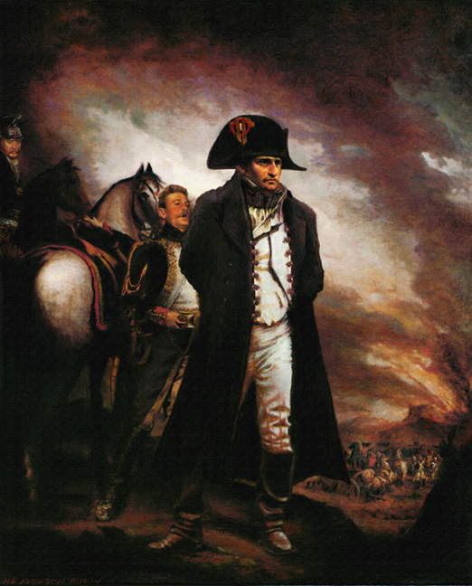

**What do I need to know?**

* What successes Napoleon had up to 1807.
* Why Napoleon felt the need to war against Britain.
* What was the ‘Continental System’ and how did Napoleon intend to use this to fight Britain?
* Why was Napoleon forced to wage war in Spain and Portugal? Why did he end up losing?
* Why did relations deteriorate between Russia and France and lead to War?
* Why was the Russian campaign such a disaster for Napoleon?
* Why was Napoleon unsuccessful in the final campaigns of 1813-1815?
* How important is the battle of Waterloo?
* Why did Napoleon fail in his conquest of Europe?
* What lasting impact did Napoleon have on France?

**Possible exam questions:**

**Essay style questions:**

To what extent was defeat in Russia the main reason for Napoleon’s downfall?

How far do you agree with the view that the Peninsular War played the prime role in Napoleon’s downfall?

To what extent did the French people benefit from Napoleon’s rule?

Assess the reasons for Napoleon’s downfall in 1814.

‘Napoleon was a military genius.’ How far do you agree?

‘The Spanish ulcer was entirely responsible for Napoleon’s downfall.’ How far do you agree?

How successful was Napoleon in preserving the gains of the revolution?

How important a role did Britain play in the defeat of Napoleon?

Which of the following had the greater impact on the course of the Napoleonic wars i) The battle of Trafalgar ii) The Battle of Austerlitz. Explain your answer with reference to both i) and ii).

**Suggested reading**

Dylan Rees and Andrina Stiles, *Napoleon, France and Europe*

Andrew Roberts, *Napoleon the Great*

R.S. Alexander, *Napoleon*

Michael Broers, *Europe under Napoleon 1799-1815*

**Recap – create a timeline of the battles up until 1809. Include a brief description of each of them, as well as the outcome.**

|  |
| --- |
| **1799** |
| **1800** |
| **1801** |
| **1802** |
| **1803** |
| **1804** |
| **1805** |
| **1806** |
| **1807** |
| **1808** |
| **1809** |

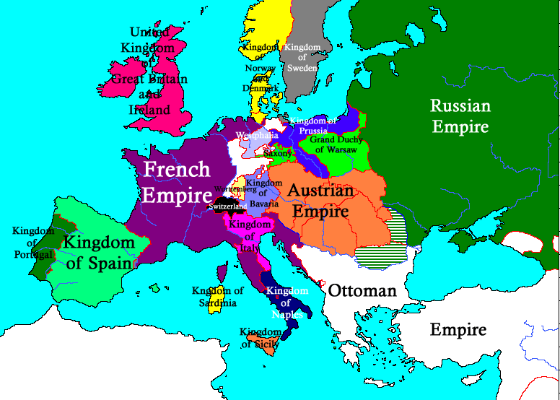

**How did Napoleon treat his conquered territory?**

Provide definitions:

Annexed territory:

Satellite state.

Activity – using the in the next few pages provided to you, complete the following for each conquered area.

|  |  |  |  |
| --- | --- | --- | --- |
| Country/area | Examples | What areas did Napoleon have an impact? | What areas did he not have an impact? |
| Annexed territory |  |  |  |
| Satellite states |  |  |  |

**The annexed territories**

Nice, Savoy, Belgium and the German lands west of the Rhine had been under French control for the longest, being annexed before 1799. This meant they had been quickly incorporated into the French administrative system. They were divided into departments for civil affairs and for military divisions, for the purpose of recruiting soldiers. By the time of the coup of Brumaire, other changes were imposed on these territories, the most important being:

* The abolition of feudalism, particularly the payment of feudal dues.
* Confiscation and sale of property and land belonging to the church.

All states that were annexed and ruled from Paris came to be regarded as territorial extensions of the ‘old France’ and therefore an integral part of the new Napoleonic France. As such all the national institutions flourished there:

* The Concordat
* The Civil Code
* The Imperial University
* The judicial process of civil and criminal courts
* The taxation system

In Piedmont (in Italy), where the feudal system was in decline before the French conquests of 1796-7, it is now thought that the introduction of French law made little real impact and simply gave legal recognition to an existing situation. In the economically developed lands on the west bank of the Rhine the *bourgeoisie* adapted to the new methods, while at the same time retaining old ones. At first they fell in with the wishes of their French rulers. They managed also to defend and maintain their pre-Napoleonic social status, their old trade privileges, local customs and commercial interests.

German and Italian territories that were annexed in the period 1806-9 were subject to French law and influence for a much shorter time. As a result, the effects of the changes introduced by Napoleon do not appear to have been as profound or long-lasting as elsewhere.

**The satellite states**

The satellite states were nominally independent, but in reality had little freedom of action. From the beginning, their rulers were strictly supervised and tutored by Napoleon in the way they should approach their tasks.

When the new Kingdom of Westphalia (modern day Germany) was established in 1807, Napoleon wrote a letter to his brother Jerome suggesting some approaches to governing his new subjects and the benefits of French rule. Jerome was urged to:

* Be a constitutional King and observe the constitution faithfully
* Win the confidence and the affection of the people
* Promote men of talent even if they lacked noble rank
* Abolish all kinds of servitude
* Provide the benefits of the *Code Napoleon,* public trials and the introduction of juries
* Ensure the subjects enjoy a degree of liberty, equality and prosperity

While it appeared that feudalism as a legal status had been abolished in the satellite states, in actuality it survived in many areas in its old form of noble privileges, feudal dues, serfdom and even labour services. The traditional view that Napoleon abolished feudalism in the territories he conquered needs to be modified. At best, his achievements in this direction seem to have been patchy and largely restricted to those countries he first annexed.

Continental research on the subject indicates that part of Napoleon’s reforms remained more theoretical than actual, and that, in effect, he settled for a pragmatic compromise with the traditional feudal structures of the satellite states. It now seems likely that the pre-Napoleonic noble or *bourgeois* classes continued to survive in sufficient numbers for the social structure to remain largely unchanged in much of French occupied Italy, Germany and Poland. This is possibly one reason why the Empire collapsed so quickly in 1814, and why the allies met with little resistance when restoring the old dynasties and regimes at the end of the Napoleonic wars. The old social structure had largely survived the Napoleonic era.

**Napoleon’s expectations from the Empire**

**Task**

Mark the following countries in the map below:

* Kingdom of Italy
* Duchy of Warsaw
* Kingdom of Holland
* Kingdom of Naples

Now mark/signal the answers to the following questions on the map:

* Was it a satellite state or an annexed state?
* Was it/had it been ruled by one of Napoleon’s family at some stage?
* Was it a newly created country/state by Napoleon?

Read the extract from Rees and Stiles and make a note of what requirements Napoleon had requested from each of these countries.

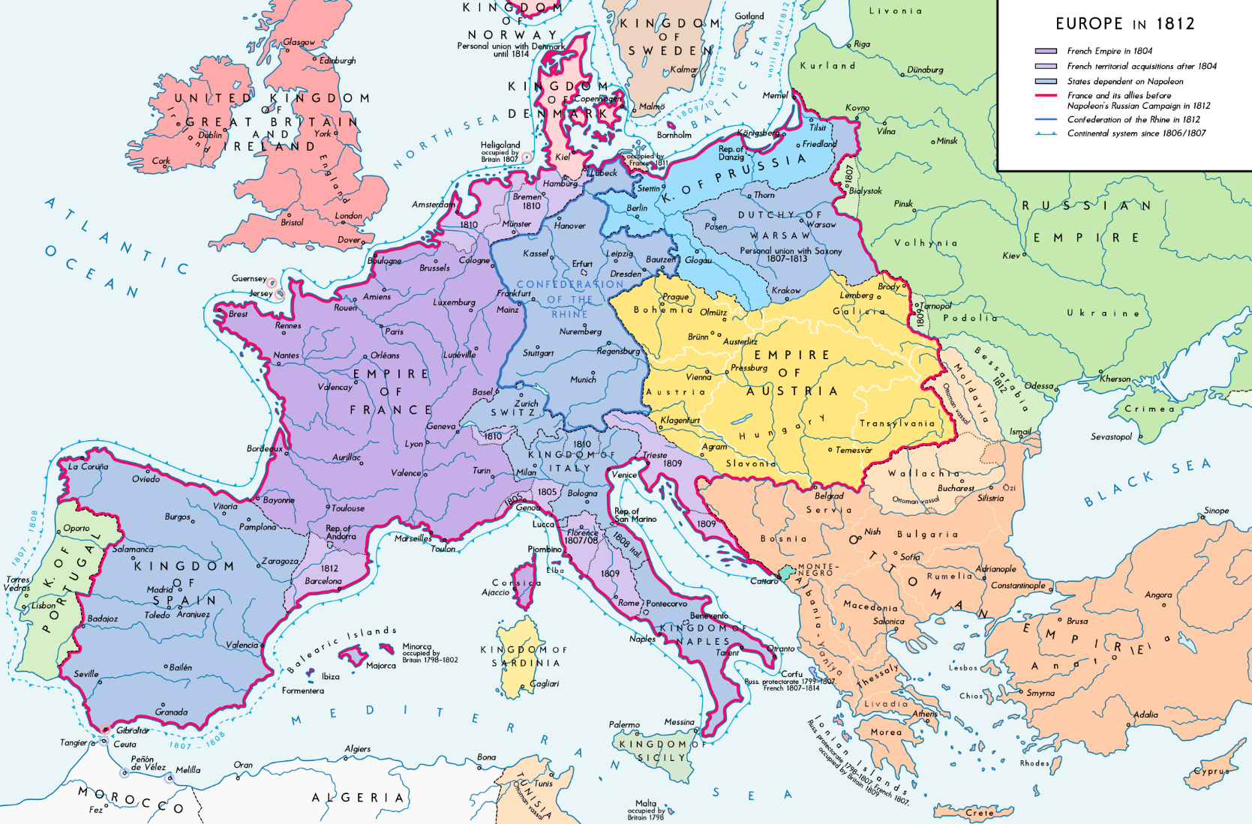

“**Financial and military needs**

The satellite states not only formed a strategically important buffer zone to protect French borders, but fulfilled a number of other valuable functions in the Napoleonic Empire. Napoleon’s relationship with them was rather that of a medieval ‘warrior overlord;, extracting the maximum advantage from them for the minimum return. They provided about a third of the total strength of the *Grand Armeè*, in the form of auxiliary troops, and were used to support and provision the regular army. In addition, as the price of defeat, they had to pay substantial tribute monies that were used to finance Napoleon’s future campaigns.

A striking example of Napoleon’s treatment of a satellite state is the Kingdom of Italy. The military and financial demands made on it in the interests of France ruined its economy. From 1806 onwards, its six million inhabitants had to pay an annual tribute of £1.5 million to the French treasury, as well as making substantial cash contributions towards building ships for the French navy. Napoleon continued to demand more money, even after his representative in Italy told him the Kingdom of Italy couldn’t afford it.

The Kingdom was also forced to recruit and maintain an army of 55,000 men for French service outside Italy. When conscription was introduced the effect on the population of Rome was dramatic. The population fell from 136,268 in 1809 to 112,648 in 1814 largely as a direct result of young men trying to avoid being called up.

**Dynastic and social needs**

As well as their military and financial uses, the satellite states provided for Napoleon’s dynastic and social needs. The distribution of crowns among Bonaparte relatives served two purposes for Napoleon. It enabled him to fulfil his loyalties to his brothers and sisters, with the expectation that in return they would remain loyal to him and so secure his hold over the Empire. Also, in due course he could expect to arrange useful marriage alliances with older royal houses and give his successors the dynastic respectability the family presently lacked.

Alongside this, the completeness of the Revolutionary land settlement left Napoleon with no available land in France for rewarding military or civilian personnel with dotations. The satellite states were exploited to provide the necessary land. Poland (the Duchy of Warsaw), in particular, was despoiled in this way, to the grave detriment of its economy. Even before the formal creation of the Grand Duchy of Warsaw, major endowments of land were made to 26 French marshals and generals. These gifts alone were on a scale that deprived the Duchy treasury of a fifth of its potential revenue from the royal lands. This, ultimately, ended in bankrupting the Duchy.

Napoleon considered it to be an utmost priority of the rulers of the satellite states to put the interests of France above all else. In a typical outburst he scolded his brother Louis, King of Holland, for not doing this:

*‘I hoped that developing in close proximity to France, Holland would possess that affection for France which the French nation has the right to expect of its children, even more so of its princes.’*

He was equally clear when writing to Joseph, King of Naples.

*‘I see that you promise in one of your proclamations not to impose any war taxation and that you forbid Our soldiers to demand full board from their hosts … these measures are too narrowly conceived. … Levy a contribution of 30 millions from the kingdom of Naples… You will gain nothing by too many caresses … if they [the people] detect they have no master over them, they will turn to rebellion and mutiny.*

In no context was the subservient position of satellite states more obvious than with the Continental Blockade.

**Enforcing the Continental Blockade**

The Continental Blockade (also known as the Continental system) had two main purposes:

* To protect domestic markets from foreign competition
* Bring about the defeat of Britain by closing all continental markets to British trade and so bring about the collapse of its economy.

Countries who were forced to implement the Continental Blockade had a mixed view of it. For some, it did seem to bring benefits. Industry in Belgium, such as textiles and manufacturing, generally benefited from access to the large imperial domestic market now that cheaper British goods were unavailable. However the experience of the Kingdom of Italy was an entirely different one. Imperial decrees of 1806 and 1810 abolished the traditional trading links between the Kingdom of Italy and its neighbours. All export trade had to be with France only. At the same time, Italy was ‘reserved’ as a market (more accurately a dumping ground) for French goods of all kinds at high prices. Both Italy and Holland were warned by Napoleon about not enforcing the Continental Blockade. “

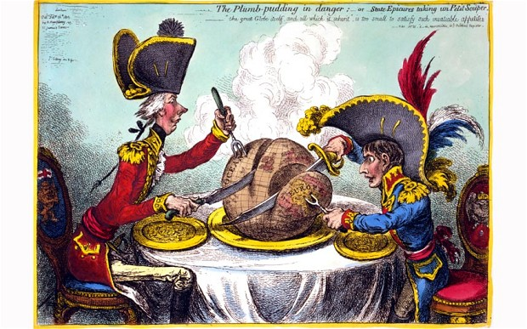

**Napoleon’s Empire**

Napoleon had a long held dream of a universal empire made up of French-controlled vassal states. Metternich, the Austrian Chancellor, certainly thought this dream was the basis of Napoleon’s ambition:

*“Napoleon’s system of conquests was unique. The object of universal domination to which he aspired was not the concentration of an enormous region in the immediate hands of the government, but the establishing of a central supremacy over the states of Europe, after the ideal of the Empire of Charlemagne”*

Charlemagne was an Emperor of the Franks, who ruled a vast empire in the 8th century covering much most of western and central Europe. He is seen by many as reigniting Europe after the Roman Empire fell.

Evidence that Napoleon viewed himself as Charlemagne can be seen from his interaction with the Pope. Napoleon expected to obeyed, as he was Charlemagne’s successor, by the Pope. Chiefly, Napoleon wanted the Pope to implement the Continental Blockade (which we will look at shortly). When it became clear to Napoleon, by 1808, that he was not going to secure an agreement with the Pope he took action. Napoleon, as the new Charlemagne, assumed the right to:

* Quash the donation (which was the gift Charlemagne had given to the Pope of Rome and most of Italy)
* Imprison the Pope
* Annex the Papal States to the Kingdom of Italy.

At the height of his power (1810-1811), Napoleon’s Empire with its satellite, family-ruled kingdoms exceeded the limits of Charlemagne’s Empire.

How does Napoleon’s empire mirror Charlemagne?

Why would he want to do this?

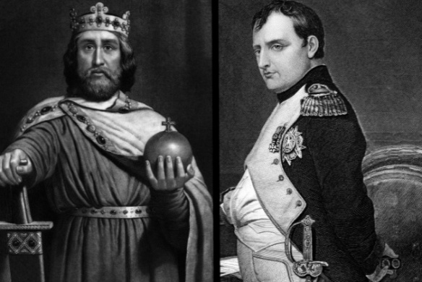

**Britain’s opposition to Napoleon**

Britain was the most consistent opponent to Napoleon throughout the wars. They were the only state that was always at war with France. By 1806 how had Britain proved itself to be a problem for Napoleon and France?

**What options does Napoleon have in fighting Britain? What are the potential issues with these options?**

**Why does he decide on the idea of a Continental Blockade (the Continental System)?**

**The Continental System**

The Continental System was implemented by Napoleon after he had decided that he lacked the naval strength to defeat Britain in a military manner. Although the French had a stronger army in Europe, as they could not get this army to Britain they had to consider other methods. They had been unsuccessful at sea, the Battle of Trafalgar delivering a comprehensive defeat to the navy of France.

One of the main issues that Britain caused Napoleon and his French Empire was the way in which they funded states that opposed France on the continent. This encouragement and aid to countries that opposed France was a major issue for Napoleon. By 1814 Britain was committing to £10 million a year to it’s allies (a similar amount it was spending on it’s navy).

The Continental System was Napoleon’s attempt to use his dominance of the continent to damage the British economy and reduce their abillity to fund opposition to Napoleon on the continent. Trade was a key aspect of Britain’s economy. Being an island nation, it was reliant on imports to feed itself, as well as bringing in tax and boosting their economy. By cutting off trade with Britain, Napoleon was hoping to undermine their economy and reduce their economic strength. In order for Britain to carry on funding allies overseas it would have to use it’s own funds to do so. Napoleon hoped to force Britain to use their currency reserves and damage their economy. Napoleon believed this would force Britain to the negotiation table and lead to them making peace.

**Activity**

Find out what goods or materials the following countries traded with Britain and what Britain traded with them.

|  |  |  |
| --- | --- | --- |
| Country | What did this country trade with Britain? | What did Britain trade with this country? |
| Spain |  |  |
| Russia |  |  |
| Portugal |  |  |
| Italian states |  |  |
| Netherlands |  |  |
| Prussia |  |  |

**Create your own diagram for how the Continental System was meant to work.**

**The war in Spain – ‘the Spanish ulcer’ or the Peninsular war.**

Watch PBS Napoleon documentary 4/4 from the start-5.00

1. How many men did Napoleon initially send across the Pyrenees into Spain?
2. What had Spain been doing that made Napoleon decide to make it part of his Empire?
3. Where did the Spanish people rise up against the French army?
4. What is the type of war being fought in Spain called?
5. How long did Napoleon keep his armies in Spain for?

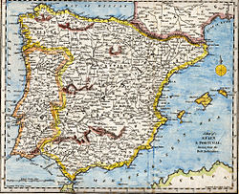

**Add to your map where the Spanish ulcer took place.**

How is the war in Spain linked to Napoleon’s Contiental System?

The Peninsular war (name after the Iberian Peninsular – Spain and Portugal) was one of the first examples of guerilla warfare. Write down your definition of guerilla warfare below.

**Activity – create a wordless powerpoint on one of the following areas. Make sure you are at least answering the questions here in the booklet on your topic.**

**Why the Peninsular war was important for France.**

Why did Napoleon replace the Spanish King with his brother?

How did Murat (the general positioned in Spain) react to uprising in Madrid?

What was Napoleon forced to do? Why was he forced to do this?

**The nature of the war in Spain.**

Why was the war particularly brutal and savage?

How large was the irregular force in Spain (it managed to tie down up to 350,000 French troops)?

How did the arrival of Sir Arthur Wellesley (the future Duke of Wellington) impact on the struggle?



**Why Napoleon lost the Peninsular war.**

The nature of war in Spain:



Mistakes made by Napoleon:



British influence:



**The consequences for France and Napoleon of the Peninsular war.**

How could the Peninsular War be seen as an example of the difference between Britain and France?

Economic consequences:



Political consequences (impact on other countries attitudes to France)



Consequences on the French Empire (in Spain or back at home)



**Early stages/background to the Peninsular war.**

Spain had a Bourbon monarchy (closely related to Louis XVI’s family) and had a rather strained relationship with France. Portugal was a neutral state, although more pro British. Following Portugal’s refusal to join the Continental Blockade, Napoleon sent an army into Spain with orders to invade Portgual and seize control of its ports. Lisbon was captured on 30 November 1807, but the royal family, court and most of the government evaded capture and fled the country. The defeat of Portgual was the prelude to the Peninsular War, a war which would prove to be disastrous for Napoleon for the following reasons:

* About half of all French soldiers who fought in the campaign were lost.
* It failed totally in its primary objective, of enforcing the Continetntal Blockade.
* Despite overruning Portugal in 1807 Napoleon was unable to ensure that the Blockade was enforced along its coastline. The value of British exports entering Europe through Portguese ports actually doubled between 1808 and 1809.

Franco-Spanish relations between 1799 and 1807 were for the most part strained. Napoleon informed Spain that its position was simply that of a French ally whose duty was to supply men and money as and when required. Spain was a country with a large yet rather unstable empire in central and south America, ruled by a weak monarchy and a corrupt administration. The wealth of the country was largely in the hands of the Catholic Church and the aristocrcy. Napoleon believed that Spain could be bound more closely to France without too much difficulty if the grip of these two institutions was loosed. Napoleon’s mistake was in assuming there was a substantial middle class in Spain that would welcome the enlightened reform of the French model. In 1808 Napoleon summoned the Spanish King and his heir to the south of France. The Spanish King was deposed and replaced by Napoleon’s brother Joseph. Napoleon felt that he would be able to control his brother much more effectively than he had been able to do with the King of Spain.

As King of Naples, Joseph had been a popular ruler. When he arrived in Spain he was bitterly dissapointed with his reception. He wrote that: ‘Not a single Spaniard is on my side.’ Napoleon sent one of his most trusted marshals, Murat, with an army to occupy Madrid and impose French rule. The Spanish capital erupted in revolt on 2-3 May 1808, against the French occupation. Murat responded with great ferocitiy and 100 Spaniards were executed in retaliation for the killing of 31 Frenchmen.

The reaction of many of the population was to set up Juntas which were co-ordinated by the clergy and members of the nobiluty. Their aim was to raise guerilla fighters and regular soldiers to fight the French occupiers. A small and comparitively inexperienced French army was defeated at Baylen by a force of Spanish regular troops in July 1808. Encouraged by news of resistance to the French occupation and responding to a Spanish request for help, Britain sent an expereditionary force to the peninsular. It landed in August 1808 amd was able to drive the French out of Portugal.

With the military situation deteriorating in both Spain and Portugal, Napoleon decided to assume personal control of operations in the peninsular. He arrived in the autumn of 1808, with his 270,000 strong Army of Spain, and soon reversed the tide of defeat. British forces were forced to give up the terriroty they held, and were evacuated from Corunna by the Royal Navy.

**The nature of the Peninsular war**

The war in the Iberian Peninsular was brutal and savage, with atrocities committed by both sides. Wounded soldiers were particularly vulnerable and were frequently mutilated and their remains hung from trees. The conflict was characterised by the emergence of what became well established in the 19th and 20th centuries, namely *guerilla* warfare. In 1812, it was estimated that there were between 33,000 and 50,000, which confronted by irregular forces, never quite knew where the next attack was coming from. The arrival of a British force under the command of Sir Arthur Wellesley (the future Dule of Wellington) in Portugal in 1808 had a profound impact on the nature of the struggle in a number of ways:

* As the British army was comparatively small, made uup of only 35,000 men and lacking both artillery and cavalry, it relied heavily on *guerilla* forces.
* Wellesley provied to be a formaidable opponent, and, although a cautious commander, he was able to exploit French weaknesses regarding lack of supplies, while at the same time fully exploiting British nval supremacy to resupply and reinforce his own forces.

**Main events of the Peninsular War**

Early 1809 – Napoleon leaves Spain upon hearing of Austria’s mobilisation.

July 1809 – Battle of Talavera. A blooy and inconclusive battle. The Anglo-Spanish army decided not to advance further into Spain.

September 1810 – Massena, a French general, launches an invasion of Portgual. He forces Wellington to withdraw to defend Lisbon. Wellingto is secure behind the **lines of Torres Verdras**, a powerful defensive line.

September 1810-March 1811 – Massena unsuccessfully tries to dislodge the British.

January 1812 – After French disasters in Russia, Wellington decides to move on the offensive.

April 1812 – Wellington captures Badajoz

July 1812 – Battle of Salamanca. Wellington defeats the French general Marmont at Salamanca. He then captures Madrid

June 1813 – Battle of Vittoria. Another victory for Wellington. Northern Spain is then liberated.

April 1814 – Battle of Toulouse. With victory at Toulouse (in France) the liberation of the Iberian peninsular is complete.

**Why did Napoleon lose the Peninsular War?**

The war in Spain and Portugal was never popular in France. France’s defeat in the Iberian peninsular was due to a number of factors:

* The nature of the war fought in Spain and Portugal did not suit the French army. Both countries were poor and barren and there was little opportunity for French soldiers to live off the land. French supply lines were lengthy and were constantly disrupted by *guerilla* forces.
* Napoleon did not grasp that the *guerilla* war constantly diluted the strength of his armies as they struggled to protect their supply lines and bases.
* The decision by Britain to commit forces to mainland Europe proved to be crucial.
* Napoleon’s decision to leave Spain at the beginning of 1809 was an error. Without his inspirational leadership, and with no other supreme commander, the war was left in the hands of mutually hostile generals.
* The Royal Navy was able to supply food and equipment, and transport troops, without interference to Spain and Portgual. This was a major factor in enabling the British army to remain in the Peninsular and was particularly important during the siege of Lisbon.
* The brilliance of Wellington as a commander.

**Consequences of losing the Peninsular War**

The fiercly fought campaign in the Iberian Peninsular had a number of significant consequences for Napoloeon and France. These were:

* The long drawn-out nature of the campaign, oftern against *guerilla* forces, eroded French military prestige. Maintaining garrisons in Spain proved to be both expensive and a siginificant drain on French military resources. As the war evolved it became increaswingly demoralising – earning its name ‘Spanish Ulcer’
* In addition to weakening France, the Peninsular War relieved the pressure on Britain. The economic damage to the British economy from the Continental Blockade was eased. Access to Spanish markets in Europe and South America helped to boost British exports to £48 million in 1810 (from £38 million in 1808)
* As French forces suffered a growing number of defeats, other countries were encouraged to renew their efforts to resist Napoleon.
* Large numbers of ordinary Spanish people rose in revolt against French rule.
* The Franco-Spanish attack on Portugal prompted Britain to commit military forces to defend its ally.
* Napoleon’s inability to resolve the situation cast doubts on his military and political judgement.

Over the course of the Peninsular War, Britain proved to be a tenacious and formidable opponent. In assessing the significance of the war in Spain and Portugal, the historian Paul Kennedy concludes: ‘the security of the British Isles and its relative prosperity on the one hand, and the overstretched and increasingly grasping nature of French rule on the other, at last interacted to bring down Napoleon’s empire’.

**Extension activity – write a speech as the Duke of Wellington, explaining to Parliament why the Peninsular War is so important and why the British should continue to fund it.**

**The Russian Campaign**

Watch PBS Napoleon documentary 4/4 from 9.40-17.00

1. What happened in the Spring of 1812?
2. How large was the army assembled?
3. After two months how many men were out of action?
4. Where did the Russians turn and face their enemy in battle?
5. What happened on Napoleon’s first night in Moscow?
6. How long did Napoleon wait to hear from the Tsar for peace terms?
7. How low did temperatures fall?
8. What did the Cossacks harass?
9. What rumours did Napoleon hear that forced him to abandon his troops and flee back to Paris?
10. How many men came back?

Create a timeline of the factors that led to a breakdown in relations between France and Russia.

1807 – Treaty of Tilsit

1808

1809

1810

1811

1812 – Invasion of Russia

**Events of the Russian campaign**

|  |  |
| --- | --- |
| Successes for the French | Failures for the French |
|  |  |

**The retreat from Moscow**

**Reasons for Napoleon’s defeat**

Read and rank the reasons for Napoleon’s defeat in 1812 in Russia.



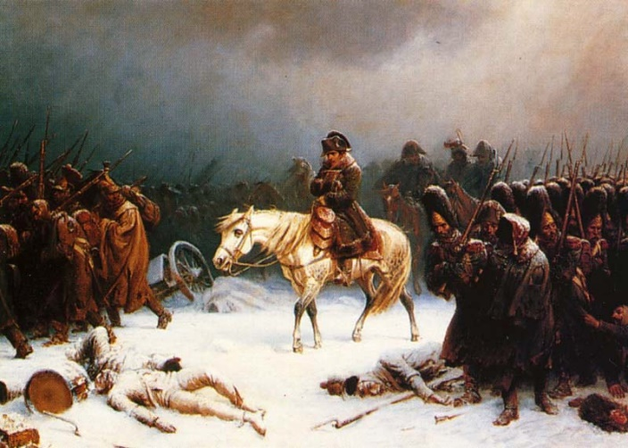

**The invasion of Russia in 1812**

The Franco-Russian agreement made at Tilsit in 1807 was not easy to maintain and both sides felt uncomfortable about the relationship. The main factors that led to conflict were:

* Mutual distrust of each other’s hostile expansionist aims in the Baltic, central Europe and the Balkans.
* Napoleon’s refusal to support the Tsar’s ambitions to seize Constantinople (Istanbul) – he had similar aspirations of his own.
* The Austrian marriage annoyed the Tsar, as did Napoleon’s annexation of the North German coastal state of Oldenburg. Oldenburg’s independence had been guaranteed at Tilsit.
* Alexander attacked Sweden with French encouragement, but then without French agreement seized and annexed Swedish Finland.
* There were arguments over the future of the Grand Duchy of Warsaw.
* The main disagreement arose over the Tsar’s virtual withdrawal from the Continental Blockade. On the last day of 1810, he introduced a new trade tariff that discriminated against France and favoured of Britain.

Napoleon decided on war to restore his dominance and to reinforce the Continental Blockade. The army Napoleon gathered to invade Russia was the largest he ever assembled. It was a very mixed force. The *Grand Armée* of 600,000 consisted of Germans, Swiss, Spanish, Portuguese, Italians, Poles and Lithuanians. Only about 270,000 of the total were Frenchmen. There were a number of issues with the invasion. Whilst Napoleon had clear political goals, he had no clear military goals. Michael Broers says ‘In truth, the defined objectives of the campaign of 1812 did not extend much beyond catching a Russian army and defeating it in the field’. Napoleon had never before commanded such a large force, over such a vast area. During the course of the campaign he uncharacteristically indecisive at critical moments.

**Events of the Russian campaign 1812**

On 22 June 1812, without any declaration of war, Napoleon crossed the River Niemen onto Russian territory. He was unable to use his usual strategy of luring the enemy towards him and forcing a decisive battle early in the campaign. The much smaller Russian armies refused to engage the French, preferring to retreat before them, destroying food supplies as they went. Napoleon was, therefore, drawn ever deeper into Russia, extending his supply lines and increasing the difficulties for his large, slow-moving force of catching up with the enemy. Medical supplies and food were short, and disease struck down 60,000 men even before the campaign had properly begun. The Russian army’s scorched earth tactic meant that Napoleon found it difficult to feed his men – they were unable to live off the country – and over 1000 cavalry horses died from eating unripe corn in the fields.

By the time Napoleon reached Vitebsk, his army was demoralised. It had already suffered the same number of casualties, either from disease or by being picked off by skirmishing Cossacks (mounted Russian soldiers), as would be normally expected from normal battles. By mid-August the central army group commanded by Napoleon had lost nearly 100,000 men. Pressing on to Smolensk, they found the city had already been destroyed by the retreating Russians and that no food or shelter was available there. The recently appointed Russian commander, the one-eyed Kutusov, urged on by the Tsar, now decided to stand fight, and waited with an army of about 120,000 west of Moscow near the village or Borodino. There, on 7 September 1812, in a day long battle of great ferocity both sides suffered heavy casualties. After a prolonged artillery duel and fierce fighting the French lost 30,000 men, and Kutusov’s army 50,000. The next day, the Russians began an orderly withdrawal, enabling Napoleon to claim victory. In his Order of the Day, Napoleon parodying Henry V at Agincourt, declared: ‘Let them say this of you: He was present at the great battle under the walls of Moscow.’ In reality the walls of Moscow were still 60 miles away.

On 14 September 1812 Napoleon’s advance guard rode into a largely deserted Moscow. The rest of the army followed, ‘all clapping their hands and showing, Moscow, Moscow’. Two days later, two-thirds of the city was in ruins, burnt down by fires started on the orders of the Russian governor to destroy food and ammunition supplies. The Tsar refused to negotiate despite the loss of Moscow.

The unusually mild autumn tempted Napoleon to linger in Moscow for over a month. He ignored the warnings of bad weather to come, and only the eventual realisation the army would starve to death if he stayed longer caused him to order a withdrawal. Laden with loot and slowed down by their wounded, the army began the retreat on 19 October 1812. Napoleon ordered them to take a route to the south of the one by which they had come, in the hope that there he would food and shelter for his army, which now numbered only 107,000. The Russian army, however, soon pushed the French north again and back onto their original route. This forced them to march over the battlefield of Borodino, still strewn with the stripped and decaying bodies of their own dead.

**The retreat from Moscow 1812**

The retreat from Moscow was one of the great military disasters of modern European history. By the time Napoleon reached Smolensk in mid-November, there were only 50,000 left in the *Grand Armée* itself. Sickness and skirmishers, famine and exhaustion had taken their told, and the winter had only just begun to bite. In snow and intense cold, the army, now further depleted, left Smolensk and marched west. The Russians reached the River Beresina before the French and demolished the bridges. Thus prevented from escaping, Napoleon’s army faced destruction. That any of the *Grand Armée* survived at all was due to the discovery of a ford and the building of two temporary bridges across the river. Of the 40,000 men who got safely across these temporary bridges, some 25,000 survived to reach Germany at the end of the year.

**Reasons for Napoleon’s defeat in 1812**

Despite the version of events put out by Napoleon in his famous 29th Bulletin, that it was the snow and ice, the intense cold and the frostbite that destroyed the *Grand Armée,* this was not so. The army, together with its auxiliaries, was destroyed long before winter arrived in the first days of November. Twice as many men (35,000) were lost on the retreat in a week of fair weather in late October as were lost in a week of snow and ice on the road from Smolensk to the Beresina in mid-November. Even more instructive is the fact that 350,000 (more than half the total French forces) died **before** they reached Moscow.   
There were a number of reasons why Napoleon and the *Grand Armée* failed so catastrophically in Russia. These are:

* Bad management and poor supply arrangements. There was no fodder for the horses, nor frost nails for their shoes, and no bandages for the wounded. Many supplies proved inadequate or non-existent.
* Lack of local knowledge, and over-confidence. The maps which the army had were inadequate, covering little more than a few miles inside the Russian border. Napoleon significantly underestimated the task confronting him. He allowed himself nine weeks to defeat Russia and return in triumph to Germany.
* His army had only summer clothing and enough food for three weeks (he intended to be comfortable ensconced in Moscow as Emperor of the East by then).
* There was unusual confusion in the French army command. General Caulincourt wrote after leaving Moscow, ‘never was a retreat worse planned, or carried out with less discipline; never did convoys march so badly … to lack of forethought we owed a great part of our disaster.’

The fragility of the imperial government was exposed by the Malet conspiracy of 22-3 October 1812, when a plot by a former general almost succeeded in persuading some key officials that the Emperor was dead and a provisional government needed to be formed. But the ruse failed to convince everyone and the plotters were arrested and summarily executed.

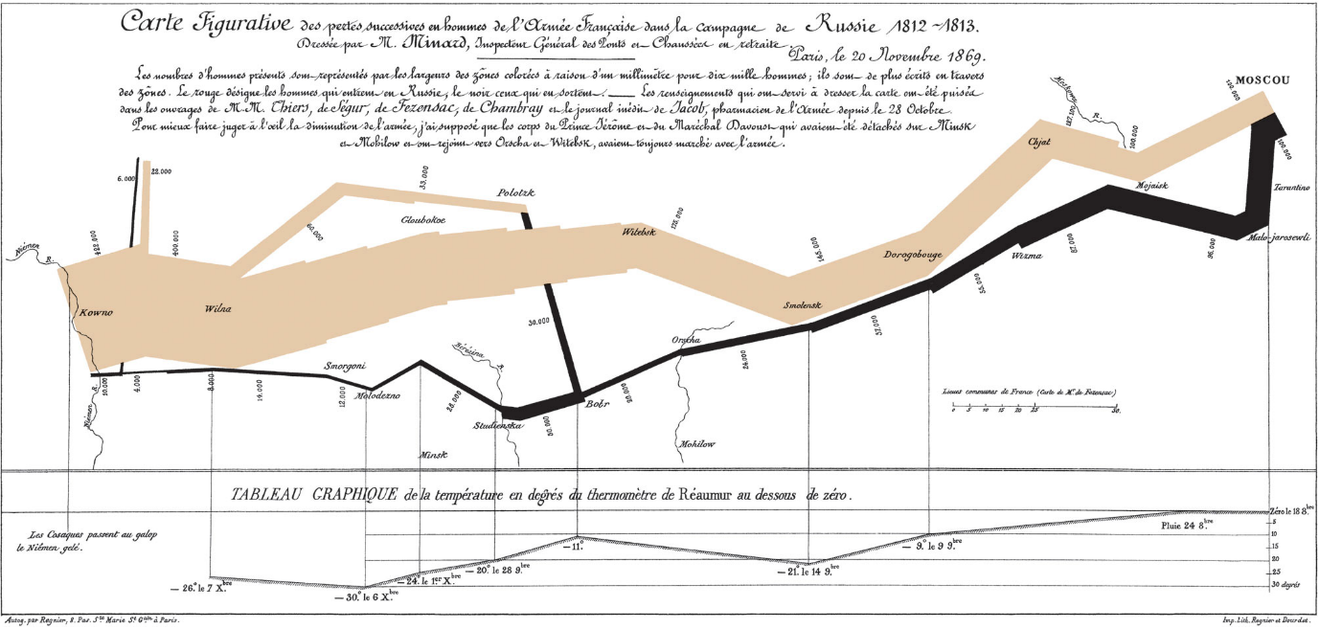

Charles Minard's map of Napoleon's disastrous Russian campaign of 1812, created in 1869

**Comparing the Spanish and Russian campaigns**

Activity – create a pie chart for both of the unsuccessful campaigns, looking at why they were unsuccessful.

Peninsular War

Russian Campaign

Extension activity – carry out a discussion between two leading historians, debating which of the two campaigns was nore important to Napoleon’s eventual loss, the Peninsular War or the invasion of Russia. Create a script imagining how this discussion would go. (Optional – use flip cams to record this debate).

**The campaigns of 1813-1815**

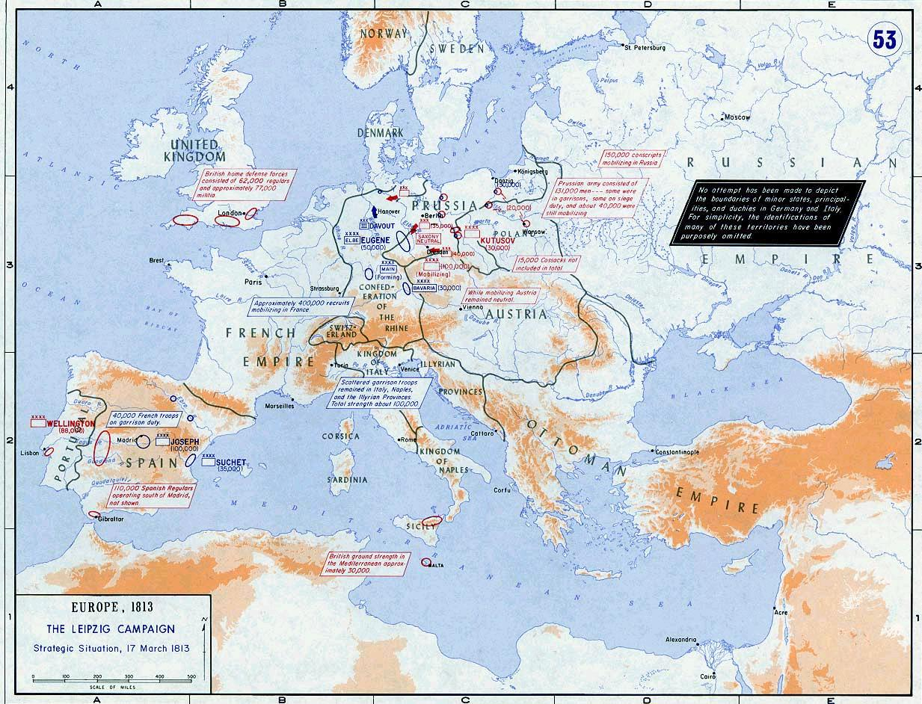

Mark on the map the countries that are now against France, as well as those still on it’s side.

Create a report on the different countries actions in the final years of the wars, year by year. Include what battles they took part in, what diplomatic actions they took and anything else you think is important.

|  |  |  |  |
| --- | --- | --- | --- |
|  | 1813 | 1814 | 1815 |
| France |  |  |  |
| Britain |  |  |  |
| Russia |  |  |  |
| Prussia |  |  |  |
| Austria |  |  |  |

How has the situation changed for Napoleon from 1806 to 1814?

Militarily:

Politically:

Economically:

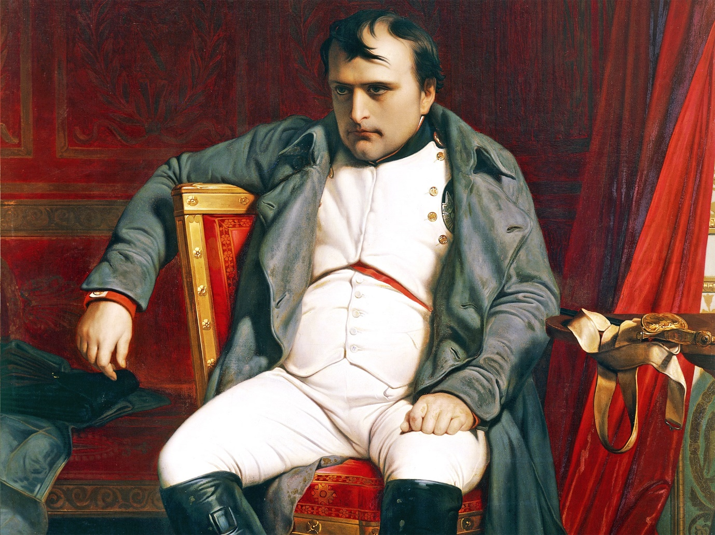

**The Hundred Days campaign**

**The Battle of Waterloo**

Watch the clip from the Battle of Waterloo. Does the battle deserve it’s place in British (and European) history? Would it have made much difference if Napoleon had won?

**Napoleon’s military decline**

|  |  |  |
| --- | --- | --- |
| Factor | Why a factor | Specific examples or evidence |
| Changing nature of warfare |  |  |
| Miitary improvements amongst opposition |  |  |
| Peninsular War and Russian invasion |  |  |
| Leadership weakness |  |  |

**Carousel activity**

One third of you plan an essay with the teacher

One third watch Andrew Roberts Napoleon documentary

One third complete the abive grid using the extract from Rees Stiles

**How much did Napoleon uphold the ideals of the revolution?**

The revolution was based on the three principles of Liberty, Equality and Fraternity. When considering the extent to which Napoleon upheld the revoltuion, it would make sense to compare him to these three ideals.

|  |  |
| --- | --- |
| Liberty | |
| Evidence he did uphold | Evidence he didn’t |
| Conclusion | |

|  |  |
| --- | --- |
| Equality | |
| Evidence he did uphold | Evidence he didn’t |
| Conclusion | |

|  |  |
| --- | --- |
| Fraternity | |
| Evidence he did uphold | Evidence he didn’t |
| Conclusion | |

**Liberty**

During the Hundred Days, Napoleon, in the course of a long conversation with Benjamin Constant, the liberal thinker who had been one of his most persistent critics, defended his past illiberal actions on the grounds of political necessity: ‘I am not an enemy of lierty’, he said, ‘[but] I set it aside when it obstructed my way.’ And set it aside he did, restricting liberty of action and freedom of experession, moudling thought and belief, and imposing absolute political authority. This was achieved in a number of ways:

* Through his law codes, particularly the Criminal and Penal Codes, which were much closer to the practices of the *ancien regime,* than to those of the Revolution
* The use of censorship and propaganda, the practice of indoctrination in the *lycees* and via the imperial catechism
* The activities of the spy network and of the police

These all played a part in the establismnet and maintenance of the Napoleonic state – at the expense of liberty. In 1814, when Napoleon was facing the Allied invasion of France – the first time foreign troops had been on French soil since 1792 – his advisers begged him to call on the memories of those Revolutionary days and rally the people to the country’s defence. ‘How can I’, said Napoleon, ‘when I myself have destroyed the Revolution?’

**Equality**

The Revolution abolished a range of special privileges enjoyed by numerous groups and individuals and institutions. In place of privilege, the Revolution set out to embed the principle of equality in French society and the French state. Among the special privileges that were abolished were:

* All feudal rights and dues
* The tax exemptions of the hurch and the nobility
* The privileged estates themselves – the nobility was abolished in 1790
* The dominant role of the Catholic Church within the state
* Royalty
* Inequality before the law

The abolition by the Revolution of feudal dues and services was confirmed by Napoleon, and equality before the law was more or less preserved in his Civil Code. The rights to the ownership of property in general were also safeguarded. However, the Napoleonic era broke with the gains made during the Revolution in the following ways:

* The creation of the Legion of Honour and the new imperial nobility marked a clear break by Napoleon with the Revolution. The creation of an elite was considered contary to the idea of equality. The historian Jean Tulard considered that the formation of a new imperial nobility in 1808 was a decisive turning point, which marked the beginning of the end of the Napoleonic Empire since it represented a violation of the egalitarian principles of the Revolution.
* In the army, promotion for a conscripted peasant was difficult, and the chances of reaching any rank higher than that of lieutenant were extremely remote. While a number of Napoleon’s generals were from military families of noble origin, the majority came from the *bourgeoisie.*
* Taxation was another area of inequality. The Directory had revived the pre-Revolutionary practive of levying indirect taxes, but it was the Empire that expanded them to provide the major part of revenue needed to pay for war. On the grounds of good financial practice, the burden of taxation was shifted from direct to indirect taxation – that is from the well-to-do property owners to the consumers, the amjority of who were poor. Taxes on salt and a state monopoly on tobacco were also reinstated, which was reminiscent of the *ancien regime.*
* Not suprisingly, therefore, several of his institutions represent a pragmatic compromise between the Revolution and the *ancien regime* – the Concordat, for example, officially abandoned the Revolutionary anti-clerical line and the strict separation of Church and State, while at the same time obtaining official Papal recognition that the sale of church lands was irrevocable.

**Fraternity**

One of the basic aims of the Revolution was to spread its ideals and principles beyond the frontiers of France. This goal was enshrined in the Decree of Fraterinity, issued on 19 Novermber 1792. The French promised support to the citizens of any country wishing to overthrow their rulers. Napoleon certainly sought to import some of the key structures of the Revolution into the territories he occupied. The French legal system, which established equality before the law and an end to feudalism, was introduced with various degrees of success into many parts of the Empire. Yet the fraternity of Napoleonic Empire came with a price. As the Italians found between 1796 and 1797, the benfits of the new structures had to be paid for in indemnities. Being an aly of France also meant that levies of troops had to be provided for the *Grand Armee.* The friendship of the Empire proved to be very much a two edged sword; it brought benefits but at a high cost.

While the Napoleonic era marked a break with the Revolutionary period, there was also a measure of continuity with it. Under the Emperor there was a return to a much more authoritarian style of government. Many of the most significant gains made since 1789 were, however, maintained.

Overall, do you think that Napoleon did preserve the gains of the revolution?

**Did the French people benefit from Napoleon’s rule?**

Activity – prepare for a debate on this question

|  |  |
| --- | --- |
| **For** | **Against** |
| Government | Government |
| Social impact | Social impact |
| Economic impact | Economic impact |
| Cultural impact | Cultural impact |

**Government and administration**

Some features of the new political structure suggested parallels with the *ancien regime.* These were:

* The Council of State, chosen by the First Consul – this was similar to the old Royal Council by which the kings of France had governed.
* Napoleon retained the *departements* of the Revolution, but reintroduced the 40,000 pre-1789 communes as his basic territorial and electoral unit.
* The role of the prefect was similare to that of the *intendant* of the *ancien regime.*

Once the Consulate was made hereditary it became to all intents and purposes a monarchy. In 1804, Napoleon became ‘by the grace of God and the Constitution, Emperor of the French’. He seems to have decided against adopting the title ‘King of France’ in deference to revolutionary sensibilities, and to avoid a direct comparison with the monarchical past. In any case, his ambitions had outgrown the idea of a mere kingdom; he already saw himself at the head of a ‘universal empire’. However, by retaining ‘*Republique francaise’* on official documents until 1804 and on the reverse of his coins until 1809, Napoleon was demonstrating to the people that his government, both Consulate and Empire, was a continuation of the Revolution.

On the other hand, when in 1804, after his consecration by the Pope, Napoleon took the crown from the alter, raised it above the congregation and placed it on his own head, he that sovereignty no longer belonged to the people as in republican days but had been transferred absolutely to him and his heirs for ever. Indeed, on the eve of the Austrian marriage in 1810 (to Marie Antoinnette’s niece), Napoleon, entertaining what he called a ‘garden of kings’, presented himself to toehm as a fellow monarch welcoming his royal neighbours. By 1804, Napoleon considered that sovereignty of the people did not imply their right to a say in government. What Napoleon believed it meant was the right of the people to have a rule who governed them as the majority wished to be governed. In a way, the Napoleonic Empire was similar to an absolute monarchy under another name.

It would be easy, however, to exaggerate the repressive nature of Napoleon’s rule and to forget that he did maintain the great gains of the Revolution. He confirmed in the Constitution and the Civil Code the end of feudalism in France the equality of Frenchmen before the law, as well as confirming the sale of church land, via the Concordat.

**Social impact**

As knowledge of social conditions is patchy and inconclusive, assessing the impact of Napoleon’s rule on French society is difficult. Where local studies have been undertaken they appear to indicate that agricultural wages rose slowly in the years 1800-15. Wages for the most part did not keep pace with rents, which rose sharply due to the increased demand for land. The reasons for this increased demand are uncertain. It may have been a consequence of the increase in population. There was no ‘agricultural revolution’ during the period 1800-1815, and farming continued at a subsistence level (producing only enough food to survive). Until 1811, harvests were good and food was cheap and plentiful. It was not until the bad harvest of 1811, followed by the extra conscription burdens of 1812-14, that Napoleon was faced with an y serious social unrest. Despite the good harvests and the end of feudalism, there seems to have been at least as much rural poverty in the later years of the Empre as there had been before 1789.

Napoleon was very committed to ensuring that he maintained the support of the main beneficiaries of the Revolution, such as the *bourgeoisie* who had bought land. His social policies were conservative in relation to the rural and urban poor since he did not wish to upset the *bourgeoisie* by introducing costly reforms that they would have to pay for. He liked to speak of how the French people loved him as the ‘people’s king’ or as the peasnts’ friend, but it is difficult to see why either he or they should have believed it. He did nothing for the mass of the people except conscript their sons for the army while taxing them heavily for the privilege. After 1815, the propaganda produced by Napoleon’s supporters carefully crafted the mythical figure of the ‘Emperor of the common man’ as a reaction to the Bourbon favouritism towards the aristocracy.

In the urban areas, conditions for workers were bad. Two measure combined to limit their freedoms:

* The Le Chapelier Law which banned trade unions was reaffirmed in 1803.
* The introduction of the *livret* (an internal passport) threatened works right to seek a new employment.

Napoleon seems to have regarded the urban workers with the gravest suspicion, believing them to be troublemakers who needed firm handling and close police supervision.

In a much wider social context, Napoleon’s long wars did have an impact on the population of France, but to a much lesser extent than was at one time believed. Of the two million men who found themselves in the army between 1800 and 1814 the number killed (dying of wounds, disease, huner or cold, or who simply went missing believed killed) has been estimated at 916,000. This figure is usually quoted as representing about seven per cent of the total population of France; but that is misleading because the losses were not spread evenly across the population. They fell heavily on the young men of marriageable age – a devastating 38 per cent of men born in the years 1790-5 were killed, the majority of them between 1812 and 1814. To the extent that his must have left many young women without husband, and reduced further the already decline birth rate, these losses contributed to some extent to the slow growth of the population in 19th century France.

**Economic impact**

Opinions differ over whether or not the French economy expanded or stood still under Napoleon. In 1785 the economic development of Britain and France was comparable. But over the next 15 years, while undustrial development in Britain was forging ahead, the upheavals of the Revolution were holding back the French economy. The picture from the industrial sector during the Empire is mixed.

Some sectors of the French economy were probably on the edge of an industrial revolution by 1800. The cotton industry was certainly expanding. Two factors that contributed to this were:

* Mechanisation, through the introduction of imitation British spinning machines, such as the ‘mule-jennies’
* The protectionist effect of the Continental Blockade on domestic production that removed the competition from British cotton cloth.

There was a dramatic growth in the number of cotton – spinning firms in Paris, wehre between 1808 and 1811, 57 were in operation, employing over 12,000 workers. French imports of raw cotton more than doubled between 1803 and 1807, and a shortage of supplies from French colonies was made up until 1811 by overland shipments from the Eastern Mediterranean. There was no similar advance in any of the other textile industries. Linen and hemp manufacturers found themselves facing declinin g demand and the silk and woollen industries suffered also from the fashionable preference for cotton dress materials during the Empire.

A number of other industries expanded slowly in the Napoleonic period. The chemical industry did make some progress, developing artificial dyes and new bleaching materials for the cotton spinners and weavers, and experimenting with the production of artifical sode for the soap manufactuers of Marseilles. The iron industry benefited from the demand for armaments needed for Napoleon’s wars, but failed to modernise itself, preferring the old method of smelting the ore with charcoal rather than coal.

The econom of the countryside was equally stagnant. Despite official encouragement, land clearing and drainage made little headway. Crop yields did not increase and labour methods remained primitive. Landowners did not reinvest their rents in the land and no new agricultural techniques were develped. Any agricultural expansion that took place was simply an extension of the cultivated area. The only other development of any siginificance was a government programme for the growing of sugar-beet and chicory to fill gaps left by the colonially produced sugar and coffee, which were no longer available because French maritime trade was being blockaded by Britain.

**Cultural impact**

Napoleon’s cultural legacy to France was not great. He was not particularly concerned with the arts, literature, sculpture, painting or drama, except in so far as they could be used for propaganda purposes to glorify himself. His regime imposed censorhsip on books and periodicals and he closed won most of the theartres in Paris. Napoleon did make some chances to the appearance of the city. He added or commissioned a small number of munuments and buildings in the classical style – among them the Arc de Triomphe Du Carrousel (1808), the column in the Place Vendome (1814) and the planned rebuilding of La Madeleine church as a Greek temple. In gerneral, however, Paris reamined in appearance the city of Louis XVI.

One cultural feature that did have impact relates to the style and fashion of the period 1800-15. The name given to it is ‘Empire’. This is seen at its most distinctive in the context of interior decoration where it directly reflects Napoleon’s own interests. Its inspiration was from the classical world of ancient Greece and Rome. Napoleon was also very interesed in Egypt, where he campaigned in 1799 and concerned himself as much with deciphering the country’s ancient heritage as with the process of conquering it. Inalid furniture, decorated with mythological gifures of all kinds and military emblems, was very much the rade, as were the new, tall looking-glasses seen everywhere. Antiquity, with a touch of the east, dominated not only furnishings but with the Empre style of dress favoured by everyone in society except Napoleon. Without regard to fashion he continued to wear, except on state occasions, a battered hat, a long grey overcoat and the green jacket of the Imperial Guard.

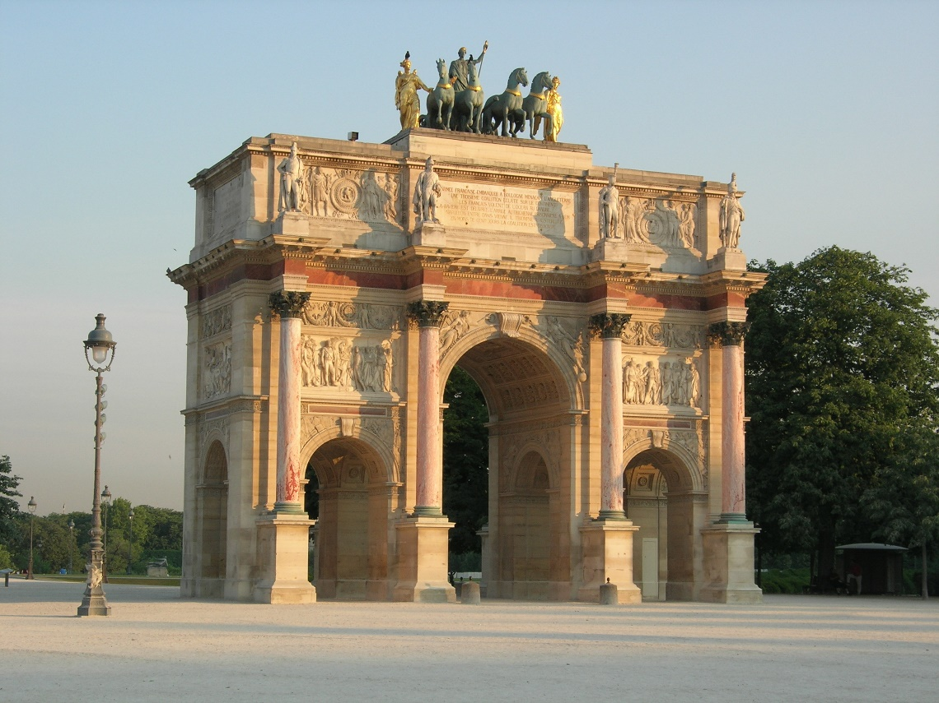

*The Arc de Triomphe Du Carrousel*

**GLOSSARY**

|  |  |
| --- | --- |
|  |  |
|  |  |
|  |  |
|  |  |
|  |  |
|  |  |
|  |  |
|  |  |
|  |  |
|  |  |
|  |  |
|  |  |
|  |  |
|  |  |
|  |  |
|  |  |
|  |  |
|  |  |
|  |  |
|  |  |
|  |  |
|  |  |
|  |  |
|  |  |
|  |  |
|  |  |
|  |  |
|  |  |
|  |  |
|  |  |
|  |  |
|  |  |
|  |  |
|  |  |
|  |  |
|  |  |
|  |  |
|  |  |
|  |  |
|  |  |
|  |  |