Higher English Reading List
EnGlish

Warning! This list is not definitive! It is just ‘a’ list. In addition to this you need to also be marking yourself out as someone with an independent turn of mind – so pursue other avenues of reading and celebrate them on your UCAS form. This could be literary genres such as magic realism (often linked to writers from South America, like Gabriel Garcia Marquez or other transcultural texts) or could be particular authors – Kurt Vonnegut or Margaret Attwood, for example.
Dates:- are you ok with the 15th Century being the 1400s? Easy to get this confused!
Text | Notes | Historical Background
Beowulf – oral tradition, great new version by Seamus Heaney | Beowulf is a mixture of Germanic and Norse derived words – it is written before the Norman Conquest, so French derived words are absent. | Germanic Tribes started arriving on these islands in 450AD and English is based on their language. From 800AD onwards Vikings, speaking Norse conquered half of England
Middle Ages 14th and 15th Centuries
1350 Sir Gawain and the Green Knight Anon  1387 Chaucer – Canterbury Tales | you may be doing ‘The Pardoner’s Tale’ in the second year if you do English Literature, so pick another one. ‘The Wife of Bath’s Prologue and Tale’ is often popular. Chaucer was writing in the Middle English period – hard to read but not impossible once you get the hang of it. | The Age of Chivalry was still around at least in people’s imaginations– lords and ladies, knights in shining armour, courtly love etc. One of Chaucer’s stories is called ‘The Knight’s Tale’
16th and 17th Century
Sir Phillip Sydney’s poetry. Also Wyatt  1516 Utopia, by Thomas More  1552 The Faerie Queen, by Edmund Spenser | Poetry was an aristocratic pursuit on the whole. You needed money to write and you wrote often within prescribed forms – eg the love sonnet. Writers who were not aristocratic would have patrons to support them | 1509 Henry VIII became king. England was a Catholic country before Henry came to the throne. Protestantism begins with him.  1547 Death of Henry  1558 Elizabeth 1st became queen  Colonisation of New World. Trade, travel, discovery all had major influence on language.  1590s is often described as the beginning of Early Modern English
1589 The Spanish Tragedy, by Thomas Kyd  1587 Tamberlaine the Great, by Christopher Marlowe  1604 Dr Faustus, Marlowe  1564-1616 Shakespeare’s dates: histories, comedies, tragedies, sonnets, ‘late plays’  1572-1637 Ben Jonson:  Eg Volpone  1612 John Webster – The Duchess of Malfi | The Age of Shakespeare. An amazing growth in drama, in playhouses, particularly in London Shakesepeare wrote his histories and many of his comedies, plus some tragedies during the reign of Queen Elizabeth (1558-1603). His ‘big’ tragedies Hamlet, King Lear, Macbeth and Othello were all in the first decade of the 17th Century. Watching them in the theatre and/or on film is hugely beneficial to reading them – but you should read them too… Don’t forget his sonnets. Note that he had many contemporaries who wrote plays that have also stood the test of time.  Later Jacobean tragedies (ie in the reign of King James) were sometimes called ‘tragedy of blood’ | 1603 Death of Queen Elizabeth 1st  Accession of James of 1st – England still a protestant country but old superstitions still in evidence  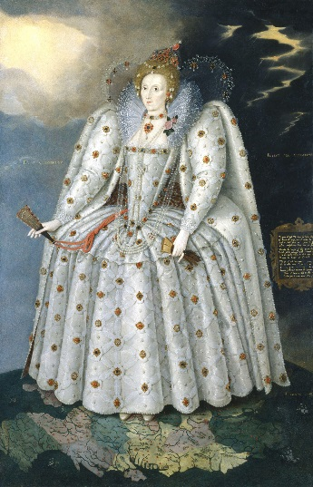
1572-1631 – John Donne  1621-1678 – Andrew Marvell  The ‘Metaphysical Poets’ – Donne, Herbert, Crawley, Vaughan, Herrick, Marvell writing in this period  1675 Pilgrim’s Progress, by John Bunyan  1667 – Paradise Lost by John Milton | Donne’s early love poems and later religious sonnets are a good way in to this period.  Marvell’s ‘To His Coy Mistress’ and ‘The Garden’ are also famous  Paradise Lost is a fascinating text in that Milton was a republican, a parliamentarian (he didn’t believe in monarchy or divine right etc). He was a puritan and yet Satan is the most engaging character in the poem | 1611 ‘King James Bible’. This is a highly influential text from here on in. It is often seen as more poetic than later versions of the bible. It actually had language which was already archaic in 1611.  1642 English Civil War – interregnum – no monarch for a period of 9 years. Puritan version of protestant religion was practiced by those in power and theatres were closed due to their perceived immorality
Restoration Comedy  1660-1710 Vanbrugh, Congreve, Farquhar  1700 The Way of the World  1677 All For Love, Dryden | When the monarch was brought back, so was theatre. Plays were aristocratic in theme and setting, witty and wordy, even though they were about scandal. The period is often called ‘The Comedy of Manners’ although this type of comedy goes on right through the 18th Century and on into the 19th (see The Rivals below) | 1660 the restoration of the monarchy  First time women were allowed to perform on a public stage
18th Century
1719 Robinson Crusoe, by Daniel Defoe | Fictional autobiography of title character who spends years on a remote tropical island… Possibly the beginning of realistic fiction as a genre. Influenced Swift:- | The 18th Century is often seen as the Age of Enlightenment, sometimes called The Age of Reason where scientific thought and the scientific method became more established in intellectual life.
1646-1717 Alexander Pope: Windsor Forest (1713), The Rape of the Lock (1714), The Dunciad | Pope, like Swift and other writers of this period, is noted for his satirical writing – satire being the exaggeration of a portrayal to the extent that the subject becomes laughable. | This way of seeing the world is opposed to superstition.  It is sometimes linked to Neoclassicism – the rediscovery of classical (ancient Roman and Greek) culture and art
1719 Robinson Crusoe, by Daniel Defoe  Moll Flanders (1722) | Fictional autobiography of title character who spends years on a remote tropical island… Possibly the beginning of realistic fiction as a genre and the novel is beginning to emerge as a form. Influenced Swift:-
1707-54 Henry Fielding:  Tom Jones (1749)  Joseph Andrews  1759 The Life and Opinions of Tristram Shandy, Gentleman, Laurence Sterne | In this period, as the novel was finding its level as a form, there are many interesting and playful uses of the form which appear, perhaps most notably Tristram Shandy which has a blank page, a black page, and general air of playfulness which you might associate more with modern novels
1726, Gulliver’s Travels, Jonathan Swift  1748 Clarissa, Samuel Richardson | Gulliver’s Travels is a satire on human nature in which Swift uses people like the Lilliputians to send up those around him, particularly those in power. It is written as a diary but is sending up the ‘traveller’s tale – a popular form of the time
1752-1840 Fanny Burney
Evelina 1778
1730-1774 Oliver Goldsmith
She Stoops to Conquer (1773)
The Vicar of Wakefield
1775 The Rivals  1777 School for Scandal, Richard Brinsley Sheridan | Famous comedy of manners – The Rivals introduced Mrs Malaprop, who famously ends up making a fool of herself for not realising how she is mistaking one word for another
Samuel Johnson 1709-84  Dictionary  Lives of the Poets  1791 James Boswell’s Life of Samuel Johnson | Johnson’s dictionary is regarded as the first proper dictionary in English, with well sourced examples and definitions rather than the simple word lists of previous dictionaries. Boswell’s ‘Life meanwhile is often seen as the first proper biography.
The Romantic Period 1798-1830s
1789 Songs of Innocence and Experience, William Blake  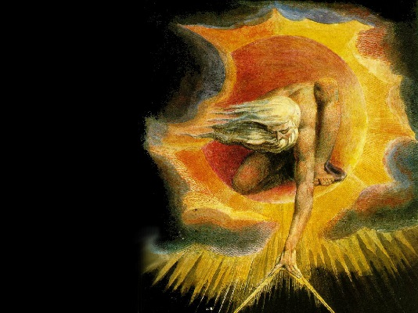  The Ancient of Days, William Blake | Blake was a for-runner of the Romantic period – a visionary poet and artist who had the radical idea that childhood is a time of protected innocence and had his own brand of non-conformist spirituality. He was also a supporter of the French Revolution in its less bloody time, as were Wordsworth and Coleridge | 1789 French Revolution begins with storming of Bastille on 14th July. No revolution in England but plenty of fear of it in government.  The Industrial Revolution was well underway by this time.
1798 The Lyrical Ballads, William Wordsworth and Samuel Taylor Coleridge  Includes Coleridge’s ‘The Rime of the Ancient Mariner’ and Wordsworth’s ‘Daffodils’ and ‘Lines Written a few miles above Tintern Abbey’  1798 Wordsworth begins writing The Prelude | Arguably one of the most important single publications in literature, seen to start the Romantic movement. Hugely different to, for example, the work of Pope – ordinary rural people make a strong appearance and the writing is designed to be simple and accessible.
19th Century
The ‘second generation’ of the Romantic Poets:  Keats (1795-1821)  Shelley (1792-1822)  Byron (1788-1824)  Odes, Belle Dames Sans Merci, Keats  Ozymandias, Ode to the West Wind, To a Skylark, Shelley  Childe Harold’s Pilgrimage, Byron | All these writers have had a significant effect on the development of poetry ever since this period. They broke rules, revered nature, explored emotion, superstition, politically radical anti-authoritarian and sometimes atheistic ideas, had their own brand of spirituality which was often far from established religion, and more.
1818 Frankenstein, Mary Shelley | Mary Shelley was the daughter of Mary Wolstencraft, a campaigner for the rights of women and Percy Shelley’s lover and then. She was only 18 when she began Frankenstein. | Scientific experimentation into the properties of electricity to restore life was probably a partial inspiration for this novel.
Jane Austen (1775-1817)  Pride and Prejudice  Northanger Abbey  Emma |  | 1815 Battle of Waterloo
Mrs Gaskell (1810-1865)  Charles Dickens (1812-63): Our Mutual Friend, Bleak House… etc:  1860 Great Expectations  Anthony Trollope (1815-82)  Charlotte Bronte 1816-1855:  1847 Jane Eyre  Emily Bronte 1818-1848:  1848 Wuthering Heights  Ann Bronte 1820-1849  George Elliot (Mary Ann Evans) 1819-1880:  1871 Middlemarch  Thomas Hardy 1840-1928:  1891 Tess of the d’Urbervilles  Hardy’s poetry: ‘Beeny Cliff’, ‘The Darkling Thrush’ (1900) | The 19th Century is often seen as the age of novel and these writers show off its range and development.  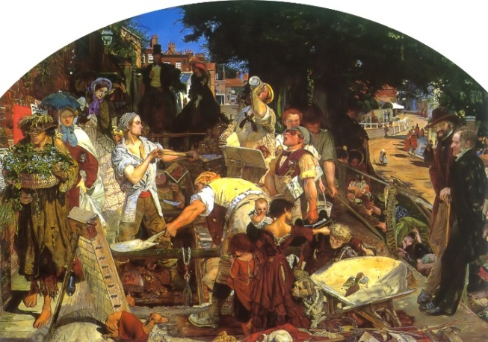  These novels offer a  fascinating insight  into Victorian society, in terms of roles of men and women, social hierarchies, beliefs and so on. | 1848 The Pre-Raphaelite movement is formed
Elizabeth Barrett Browning (1806-61)  1850 Sonnets from the Portuguese  Robert Browning (1812-1889): ‘My Last Duchess’, ‘Porphyria’s Lover’, ‘Meeting at Night’, ‘The Laboratory’, ‘The Bishop Orders His Tomb at Saint Praxed’s Church’, ‘Andrea Del Sarto’  Alfred Lord Tennyson (1809-92)  1834 Morte D’Arthur  1842 The Lady of Shallot  1850 In Memoriam  Christina Rossetti (1830-1894)  1862 ‘Goblin Market and other Poems’  1867 ‘Dover Beach’, by Matthew Arnold  Gerard Manley Hopkins (1844-89)  1877 ‘The Wind Hover’  1880 The Portrait of a Lady, (novel) by Henry James  Oscar Wilde:  1890 The Picture of Dorian Gray (novel)  1895 The Importance of Being Earnest (play)  1899 Heart of Darkness, Joseph Conrad  Norway  Henrik Ibsen (1828-1906)  A Doll’s House1879  Hedda Gabler 1891  Sweden  Johan Strindberg  Miss Julie (1888)  Russia  Tolstoy (1828-1910), novelist  War and Peace  Anna Karenina 1877  Anton Chekhov, playwright  The Cherry Orchard 1904 | Whilst the novel was undergoing an extremely fertile period, poetry was arguably a more prominent form in terms of literary culture.  Tennyson was the poet laureate for most of the reign of Queen Victoria. He showed a fairly typical passion for writing about myths and legends, but he did also cover many contemporary events and In Memoriam written about the death of a friend provides an interesting insight into Victorian attitudes to death and religion.  ‘Dover Beach’ is often seen as an important poem to capture the kinds of doubt that were prevalent amongst believers in Christianity. Some critics attribute this to the arrival of Darwin’s writing on evolution. Hardy’s poem ‘The Darkling Thrush’ is often marked out for similar reasons.  Wilde’s work, particularly ‘Earnest, satirised the repressive class system of his time in a resurgence of the comedy of manners genre.  Conrad’s novel is often included in discussions about colonialism and literature and used as a background to post-colonial literature (mostly texts from 2nd half of 20th C). Pairs well with Things Fall Apart.  Henrik Ibsen, a Norwegian writer, is often credited for writing the first realistic naturalistic plays, which were a real contrast to the melodrama that was popular in, for example, Victorian England. Strindberg builds on Ibsen’s use of the dramatic form.  Tolstoy is often seen as the greatest Russian novelist and Chekhov the greatest playwright. The Cherry Orchard is often studied as a work which predicts the Russian Revolution of 1917 and the death of the old Russian aristocracy | Queen Victoria reigned from 1837-1901 and presided over a period of incredible change. The British Empire reached is greatest extent during her reign. The industrial revolution reached a peak.  1845 IK Brunel’s first iron steamship to cross the Atlantic  1851 The Great Exhibition  1859 Charles Darwin publishes On the Origin of Species offering what the Bishop of Oxford called ‘the dregrading notion’ that man was descended from apes, not from Adam.
20th Century
DH Lawrence (1885-1930)  Sons and Lovers (1913)  The Rainbow (1915)  W B Yeats  ‘The Second Coming’, ‘An Irish Airman Foresees His Death, ‘He wishes for the cloths of heaven’  Wilfred Owen (1893-1918)  ‘Strange Meeting’, ‘Dulce et Decorum Est’, ‘Anthem for Doomed Youth’  Seigfried Sassoon (1886-1967)  ‘Base Details’, ‘The General’, ‘The Working Party’, ‘Aftermath’  James Joyce (1882-1941)  The Dubliners  Ulysses  T S Eliot (1888-1965)  1917 ‘The Love Song of J Alfred Prufrock’  1922 ‘The Waste Land’  ‘The Four Quartets’ (1945)  Virginia Woolf (1882-1934):  To The Lighthouse  1925 Mrs Dalloway  American Fiction  1927 The Great Gatsby, F Scott Fitzgerald  1929 The Sound and the Fury, William Faulkner  1940 For Whom the Bell Tolls, Ernest Hemmingway  Evelyn Waugh (1903-1966)  Decline and Fall (1928)  A Handful of Dust (1934)  Brideshead Revisited (1945)  W H Auden (1907-1973)  ‘1st September 1939’, ‘O Where Are You Going?’, ‘If I Could Tell You’, ‘As I Walked Out One Evening’  George Orwell (1903-1950)  Animal Farm (1949)  1984 (1948) | ‘On or about December 1910 human nature changed’ (Virginia Woolf)  The Modernist period is seen by critics to start around 1910 in terms of English literature, by others to be triggered by the First World War.  It is a period of inventiveness in terms of form and language, perhaps because previous forms were ‘inadequate’ (see Randy Malamud, The Language of Modernism, 1989).  Joyce and Woolf are known for the way they pioneered the ‘stream of consciousness’ narrative technique. Eliot is known mostly for his poetry and ‘The Waste Land’ is seen by many critics to typify fragmented modernist forms as well as concerns about moral and spiritual certainty in the post-war world. Eliot himself rejected comments of this kind.  Both The Great Gatsby and The Sound and the Fury are often considered modernist works. ‘Gatsby is often cited as the great American novel  Waugh’s novel A Handful of Dust borrows its title from ‘The Waste Land.’  Orwell’s 1984 is often seen as an allegorical warning against totalitarian communist rule. It is seminal in terms of dystopian fiction. Orwell himself was a socialist, however. | Modernist period a time of innovation in terms of technology. Clean, sharp lines in modern architecture.  1903 Emmeline Pankhurst, ‘suffragette’, founds Women’s Social and Political Union  1914-18 The First World War, known as ‘The Great War’  1936-39 The Spanish Civil War. A number of writers and artists supported the republican side against the nationalist and fascist General Franco – including George Orwell and the American writer Ernest Hemmingway  1939-1945 The Second World War
1953 Waiting for Godot, Samuel Beckett  1956 Look Back in Anger, John Osborne  1957 The Birthday Party, Harold Pinter  1966 Rosencrantz and Guildenstern Are Dead  American Drama  Long Day’s Journey Into Night, Eugene O’Neill 1941  A Streetcar Named Desire, Tennessee Williams 1948  Death of a Salesman, Arthur Miller 1949 | The post-war period is often marked out by critics as a time of radical changes in modern drama. Waiting for Godot is seen as the starting point: it is absurdist both in philosophical terms, covering the idea that life, itself, is pointless and absurd, but also in dramatic terms – two tramps inhabit the same bit of road, in front of a barren tree, for the whole play waiting for someone called Godot who never arrives. Stoppard and Pinter tend to be grouped under the absurdist label.  Look Back in Anger, meanwhile, belongs to the ‘kitchen sink’ form of realistic drama – the idea that life in all its harsh reality is represented on stage, kitchen sink and all… | 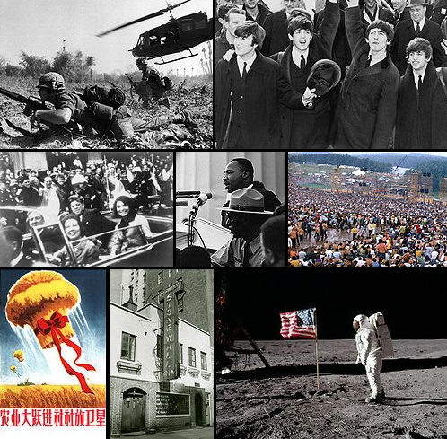  The 1960s is usually characterised as a time of cultural shifts in Europe and America, including the birth of modern feminism, Beatlemania, the Vietnam War, the assassination of JFK…
1958, Things Fall Apart, Chinua Achebe | Things Fall Apart is one of the most widely read African novels and is often included in post-colonial literature courses at university. The title is taken from a WB Yeats poem. It makes an interesting pairing with Heart of Darkness, by Joseph Conrad.
1964, The Whitsun Weddings, Philip Larkin  Sylvia Plath (1932-1963), poet and novelist  The Bell Jar (novel), Ariel (poetry collection)  Ted Hughes (1930-1998)  ‘Thrushes’, ‘Jaguar’, ‘The Horses’, ‘The Thought Fox’  1966, Death of a Naturalist, (poetry collection), Seamus Heaney | Larkin is often seen as part of a movement of English poets who did not, on the surface at least, write in a consciously ‘poetic’ style.  Sylvia Plath was an American writer who lived and worked in England. She had a stormy relationship with Ted Hughes – evidence suggests it was both destructive and intensely productive in terms of work, although she often felt that she was in his shadow.  Ted Hughes was Poet Laureate from 1984 until his death. He is known for poems which explore the raw quality of nature and what civilized humans have lost.  Heaney, who knew Hughes well, received the Nobel Prize for Literature in 1995 | Parallel Lists…  American Fiction  1927 The Great Gatsby, F Scott Fitzgerald  1929 The Sound and the Fury, William Faulkner  1940 For Whom the Bell Tolls, Ernest Hemmingway  1951 On The Road, Jack Kerouac  1951 Catcher in the Rye, J D Sallinger  1982 The Color Purple, Alice Walker  American Poetry  Robert Frost (1874-1963)  Collected Poems 1931  France  1856 Madame Bovary, Flaubert  1942 The Outsider, Camus
Angela Carter  The Bloody Chamber  Nights at the Circus  Wise Children  Salman Rushdie  Midnight’s Children  One Hundred Years of Solitude, Gabriel Garcia Marquez  Waterland, Graham Swift  Enduring Love, Ian McEwan, 1997  Catch 22, Kurt Vonnegut  Carol Ann Duffy – any of her poetry | Carter is sometimes bracketed under the post-modern umbrella (see below). She is also sometimes described as a magic realist – writers like Rushdie and Marquez who push the bounds of realistic to their limits.  In the latter part of the 20th Century certain novelists became recognised for writing what critics call post-modern fiction. McEwan and Vonnegut fit this criteria. The writers tend to play with the form and with the reliability of the narrator; the include alternative endings so the reader has to decide the outcome (not the writer).  Duffy is the current Poet Laureate and many critics think she will endure and be part of the canon, if such a term exists in the future.

