**Instructions**

Give students handout.

Divide students into three groups.

First read first three pages on ancient Iran up to end of Nineteenth century.

Second read next two on the early Twentieth century.

Third read Islamic Revolution to the end.

In their groups come up with five points that sum up their sheets.

Prompt questions could be:

How peaceful a country was it?

How cultural a country as it?

What other countries influenced it?

What part did it play in world politics?

What sense might its people have of their history and heritage, from what you’ve read?

Jigsaw this, then in new groups ask the questions again, as a whole this time.

Feedback to class.

What might a citizen of Tehran be feeling about their country when the novel begins?

**Some facts and historical highlights of Iran’s history**

**Persepolis** literally meaning "city of Persians",[ was the ceremonial capital of the [Achaemenid Empire](https://en.wikipedia.org/wiki/Achaemenid_Empire) (ca. 550–330 BCE).

Persepolis is situated 60 km northeast of city of [Shiraz](https://en.wikipedia.org/wiki/Shiraz,_Iran) in [Fars Province](https://en.wikipedia.org/wiki/Fars_Province) in [Iran](https://en.wikipedia.org/wiki/Iran). The earliest remains of Persepolis date back to 515 BCE. It exemplifies the [Achaemenid style](https://en.wikipedia.org/wiki/Achaemenid_architecture) of architecture. [UNESCO](https://en.wikipedia.org/wiki/UNESCO) declared the ruins of Persepolis a [World Heritage Site](https://en.wikipedia.org/wiki/World_Heritage_Site) in 1979.

Ancient Iran to late Nineteenth Century

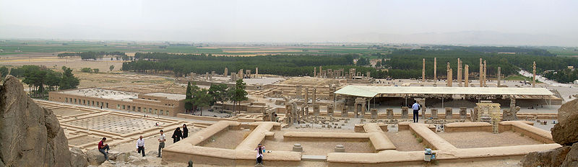

A panoramic view of [Persepolis](https://en.wikipedia.org/wiki/Persepolis).

The **history of** [**Iran**](https://en.wikipedia.org/wiki/Iran), commonly also known as [**Persia**](https://en.wikipedia.org/wiki/Name_of_Iran) in the [Western world](https://en.wikipedia.org/wiki/Western_world), is intertwined with the history of a larger region, also to an extent known as [Greater Iran](https://en.wikipedia.org/wiki/Greater_Iran).

Iran is home to one of the world's oldest continuous major civilizations, with historical and urban settlements dating back to 4000 BC

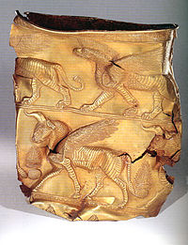A gold cup at the [National Museum of Iran](https://en.wikipedia.org/wiki/National_Museum_of_Iran), dating from the first half of 1st millennium BC.

[Hegel](https://en.wikipedia.org/wiki/Georg_Wilhelm_Friedrich_Hegel), a famous German philosopher, named the Persians as the *first Historical People.*

The first of the [Persian](https://en.wikipedia.org/wiki/Persian_people) empires ranged from the [Balkans](https://en.wikipedia.org/wiki/Balkans) to [North Africa](https://en.wikipedia.org/wiki/North_Africa) and also [Central Asia](https://en.wikipedia.org/wiki/Central_Asia), spanning three continents, from their seat of power in [Persis](https://en.wikipedia.org/wiki/Persis) ([Persepolis](https://en.wikipedia.org/wiki/Persepolis)). It was the largest empire yet seen and the first world empire.

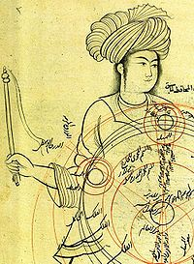

An extract from a medieval manuscript by [Qotbeddin Shirazi](https://en.wikipedia.org/wiki/Qutb_al-Din_al-Shirazi) (1236–1311), a Persian Astronomer. The image depicts an epicyclic planetary model.

Once a major empire of [superpower](https://en.wikipedia.org/wiki/Superpower) proportions, having conquered far and wide, Iran has endured invasions too, by the [Greeks](https://en.wikipedia.org/wiki/Greeks), [Arabs](https://en.wikipedia.org/wiki/Muslim_conquest_of_Persia), [Turks](https://en.wikipedia.org/wiki/Seljuq_Turks), and the [Mongols](https://en.wikipedia.org/wiki/Mongols). Iran has continually reasserted its [national identity](https://en.wikipedia.org/wiki/National_identity) throughout the centuries and has developed as a distinct political and cultural entity.

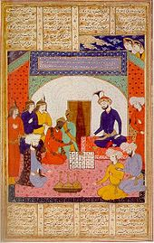 Persian manuscript describing how an ambassador from India brought [chess](https://en.wikipedia.org/wiki/Shatranj) to the Persian court in the 9th century.

There was an [Islamic conquest of Persia](https://en.wikipedia.org/wiki/Islamic_conquest_of_Persia) (633–656)which was a turning point in Iranian history. [Islamicization in Iran](https://en.wikipedia.org/wiki/Islamicization_in_Iran) took place during 8th to 10th century and led to the eventual decline of the [Zoroastrian](https://en.wikipedia.org/wiki/Zoroastrianism) religion in [Persia](https://en.wikipedia.org/wiki/Iran). However, the achievements of the previous Persian civilizations were not lost, but were to a great extent absorbed by the new [Islamic](https://en.wikipedia.org/wiki/Islam) polity and civilization.

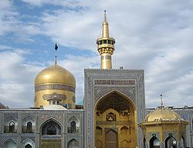

Imam Reza shrine the greatest religious site in Iran, which was built in the 9th century and the pilgrimage site for all Muslims since then.

Iran was once again reunified as an independent state in 1501, which [established](https://en.wikipedia.org/wiki/Safavid_conversion_of_Iran_from_Sunnism_to_Shiism) [Shi'a Islam](https://en.wikipedia.org/wiki/Shi%27a_Islam)[7] as the official [religion](https://en.wikipedia.org/wiki/Religion) of their empire, marking one of the most important turning points in the [history of Islam](https://en.wikipedia.org/wiki/History_of_Islam).[

Iran has been a monarchy ruled by a shah, or emperor, almost without interruption from 1501 until the 1979 [Iranian revolution](https://en.wikipedia.org/wiki/Iranian_revolution), when Iran officially became an [Islamic Republic](https://en.wikipedia.org/wiki/Islamic_Republic) on 1 April 1979.

In the course of the first half of the 19th century, Iran irrevocably lost many of its territories including [Georgia](https://en.wikipedia.org/wiki/Georgia_(country)), [Dagestan](https://en.wikipedia.org/wiki/Dagestan), [Azerbaijan](https://en.wikipedia.org/wiki/Azerbaijan), and [Armenia](https://en.wikipedia.org/wiki/Armenia) to its rapidly expanding and emerged neighboring rival, the [Russian Empire](https://en.wikipedia.org/wiki/Russian_Empire).[11]

Early Twentieth Century

A new era in the History of Persia dawned with the [Constitutional Revolution of Iran](https://en.wikipedia.org/wiki/Constitutional_Revolution_of_Iran) against the Shah in the late 19th and early 20th centuries. The Shah managed to remain in power, granting a limited constitution in 1906 (making the country a [constitutional monarchy](https://en.wikipedia.org/wiki/Constitutional_monarchy)).

The discovery of [petroleum](https://en.wikipedia.org/wiki/Petroleum) in 1908 by the British in [Khuzestan](https://en.wikipedia.org/wiki/Kh%C5%ABzest%C4%81n_Province) spawned intense renewed interest in Persia. Control of Persia remained contested between the United Kingdom and Russia,

During World War I, the country was occupied by British, Ottoman and Russian forces but was essentially neutral

In 1921, a military [coup](https://en.wikipedia.org/wiki/Iranian_coup_of_1921) established [Reza Khan](https://en.wikipedia.org/wiki/Reza_Khan), an officer of the [Persian Cossack Brigade](https://en.wikipedia.org/wiki/Persian_Cossack_Brigade), as the dominant figure for the next 20 years. In 1925 Reza Shah became the king of Iran.

[Reza Shah](https://en.wikipedia.org/wiki/Reza_Shah) ruled for almost 16 years until September 16, 1941, when he was forced to [abdicate](https://en.wikipedia.org/wiki/Abdication) by the [Anglo-Soviet invasion of Iran](https://en.wikipedia.org/wiki/Anglo-Soviet_invasion_of_Iran). He established an [authoritarian government](https://en.wikipedia.org/wiki/Authoritarianism) that valued [nationalism](https://en.wikipedia.org/wiki/Iranian_nationalism), [militarism](https://en.wikipedia.org/wiki/Militarism), [secularism](https://en.wikipedia.org/wiki/Secularism_in_Iran) and [anti-communism](https://en.wikipedia.org/wiki/Anti-communism) combined with strict [censorship](https://en.wikipedia.org/wiki/Censorship) and [state propaganda](https://en.wikipedia.org/wiki/State_propaganda).[ Reza Shah introduced many socio-economic reforms, reorganizing the army, government administration, and finances.

In August 1941, [Iran](https://en.wikipedia.org/wiki/Imperial_State_of_Iran) was invaded by [Soviet](https://en.wikipedia.org/wiki/Soviet_Union), British and other [Commonwealth](https://en.wikipedia.org/wiki/Commonwealth_of_Nations) armed forces. The purpose was to secure Iranian [oil fields](https://en.wikipedia.org/wiki/Oil_field).

[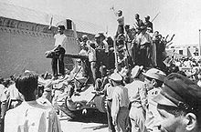](https://en.wikipedia.org/wiki/File:Operationajax.jpg)

Tehran men celebrating the [1953 Iranian coup d'état](https://en.wikipedia.org/wiki/1953_Iranian_coup_d%27%C3%A9tat)

[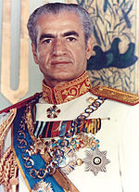](https://en.wikipedia.org/wiki/File:Mohammad-reza-shah.jpg)

Shah [Mohammad Reza Pahlavi](https://en.wikipedia.org/wiki/Mohammad_Reza_Pahlavi)

A new, young Shah [Mohammad Reza Shah Pahlavi](https://en.wikipedia.org/wiki/Mohammad_Reza_Shah_Pahlavi) came to power in 1941. Initially he took a very hands-off role in government, and allowed [parliament](https://en.wikipedia.org/wiki/Parliament) to hold a lot of power. Some elections were held in the first shaky years, although they remained mired in corruption.

1953 Shortly thereafter on August 19 a successful coup was headed by retired army general [Fazlollah Zahedi](https://en.wikipedia.org/wiki/Fazlollah_Zahedi), organized by the United States (CIA).

Iran was ruled as an autocracy under the shah with American support from that time until the revolution.

Modernization and economic growth proceeded at an unprecedented rate, fueled by Iran's vast petroleum reserves, the third-largest in the world. However the reforms, including the [White Revolution](https://en.wikipedia.org/wiki/White_Revolution), did not greatly improve economic conditions and the liberal pro-Western policies alienated certain [Islamic](https://en.wikipedia.org/wiki/Islam) religious and political groups.

In early June 1963 [several days of massive rioting](https://en.wikipedia.org/wiki/Movement_of_15_Khordad) occurred in support of [Ayatollah](https://en.wikipedia.org/wiki/Ayatollah) [Ruhollah Khomeini](https://en.wikipedia.org/wiki/Ruhollah_Khomeini) following the cleric's arrest for a speech attacking the shah.

Iranian Revolution and the Islamic Republic (1979)

The **Iranian Revolution**, also known as the **Islamic Revolution**, was the [revolution](https://en.wikipedia.org/wiki/Revolution) that transformed Iran from an absolute [monarchy](https://en.wikipedia.org/wiki/Pahlavi_dynasty) under [Shah](https://en.wikipedia.org/wiki/Shah) [Mohammad Reza Pahlavi](https://en.wikipedia.org/wiki/Mohammad_Reza_Pahlavi), to an [Islamic republic](https://en.wikipedia.org/wiki/Islamic_republic) under Ayatollah [Ruhollah Khomeini](https://en.wikipedia.org/wiki/Ruhollah_Khomeini), one of the leaders of the revolution and founder of the Islamic Republic. Its time span can be said to have begun in January 1978 with the first major demonstrations, and concluded with the approval of the new [theocratic](https://en.wikipedia.org/wiki/Theocratic) Constitution—whereby Ayatollah Khomeini became [Supreme Leader](https://en.wikipedia.org/wiki/Supreme_Leader) of the country—in December 1979.

Khomeini served as leader of the revolution or as [Supreme Leader of Iran](https://en.wikipedia.org/wiki/Supreme_Leader_of_Iran) from 1979 to his death on June 3, 1989.

Iran's rapidly modernising, capitalist economy was replaced by populist and Islamic economic and cultural policies. Much industry was [nationalized](https://en.wikipedia.org/wiki/Nationalized), laws and schools Islamicised, and Western influences banned.

The Islamic revolution also created great impact around the world. In the non-Muslim world it has changed the image of Islam, generating much interest in the politics and spirituality of Islam, along with "fear and distrust towards Islam" and particularly the Islamic Republic and its founder.

**Iran–Iraq War (1980–1988)**

[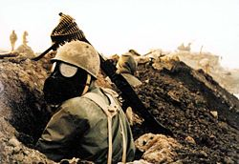](https://en.wikipedia.org/wiki/File:Chemical_weapon1.jpg)

An Iranian soldier with gas mask during the Iran–Iraq War.

During this political and social crisis, [Iraqi](https://en.wikipedia.org/wiki/Iraq) leader [Saddam Hussein](https://en.wikipedia.org/wiki/Saddam_Hussein) attempted to take advantage of the disorder of the Revolution

Tens of thousands of Iranian [civilians](https://en.wikipedia.org/wiki/Civilians) and [military](https://en.wikipedia.org/wiki/Military) personnel were killed when Iraq used [chemical weapons](https://en.wikipedia.org/wiki/Chemical_weapons) in its warfare.

[Iraq was financially backed](https://en.wikipedia.org/wiki/International_aid_to_combatants_in_the_Iran%E2%80%93Iraq_War) by [Egypt](https://en.wikipedia.org/wiki/Egypt), the Arab countries of the [Persian Gulf](https://en.wikipedia.org/wiki/Persian_Gulf), the Soviet Union and the [Warsaw Pact](https://en.wikipedia.org/wiki/Warsaw_Pact) states, the United States (beginning in 1983), France, the United Kingdom, Germany, [Brazil](https://en.wikipedia.org/wiki/Brazil), and the [People's Republic of China](https://en.wikipedia.org/wiki/People%27s_Republic_of_China) (which also sold weapons to Iran).

Starting on 19 July 1988 and lasting about five months the [government](https://en.wikipedia.org/wiki/Islamic_Republic_of_Iran) systematically executed thousands of political prisoners across Iran. This is commonly referred to as the [1988 executions of Iranian political prisoners](https://en.wikipedia.org/wiki/1988_executions_of_Iranian_political_prisoners) or the 1988 Iranian Massacre.

The main target was the membership of the [People's Mojahedin Organization of Iran](https://en.wikipedia.org/wiki/People%27s_Mojahedin_Organization_of_Iran) (PMOI), although a lesser number of political prisoners from other leftist groups were also included such as the [Tudeh Party of Iran](https://en.wikipedia.org/wiki/Tudeh_Party_of_Iran) (Communist Party).

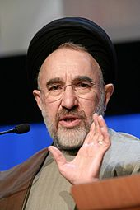

A ruling cleric of the theocracy.