# Year 1 Christmas Questions

**Q1.**

The tables below show two versions of the same segment of a program.

|  |  |  |  |
| --- | --- | --- | --- |
|  | **Version A** |  | **Version B** |
|  | if x > 0:     y = y + 2 else:     y = y - 1 |  | 00011100 00110000 00101010 10010010 11101010 00000010 00101100 10010001 |

(a)     Shade in **one** lozenge to indicate which version, **A** or **B**, in the tables above represents object code.

|  |  |  |
| --- | --- | --- |
|  | Version A | Version B |

**(1)**

(b)     Describe **two** differences between a compiler and an interpreter.

........................................................................................................................

........................................................................................................................

........................................................................................................................

........................................................................................................................

**(2)**

(c)     Explain what intermediate code is **and** why some compilers will produce intermediate code as the final output.

........................................................................................................................

........................................................................................................................

........................................................................................................................

........................................................................................................................

**(2)**

**(Total 5 marks)**

**Q2.**

Explain the role of the operating system and state the important tasks which are carried out by most operating systems.

Beyond those of a standard operating system, describe the additional operational characteristics that you would expect a real time operating system to have.

In your answer you will be assessed on your ability to use good English, and to organise your answer clearly in complete sentences, using specialist vocabulary where appropriate.

.................................................................................................................................

.................................................................................................................................

.................................................................................................................................

.................................................................................................................................

.................................................................................................................................

.................................................................................................................................

.................................................................................................................................

.................................................................................................................................

.................................................................................................................................

.................................................................................................................................

**(Total 7 marks)**

**Q3.**

The diagram below shows the classifications of various types of software used on a computer system and some examples of these types.

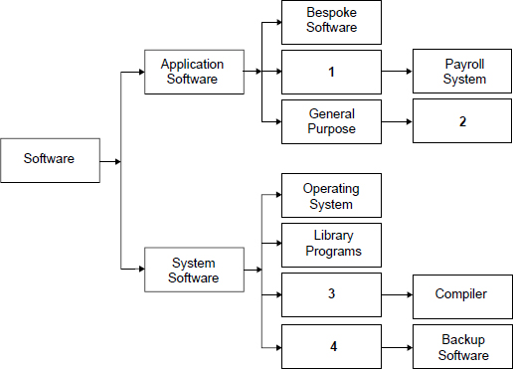

(a)     Complete the diagram by suggesting labels for the boxes numbered **1** to **4** in the diagram.

1 .....................................................................................................................

2 .....................................................................................................................

3 .....................................................................................................................

4 .....................................................................................................................

**(4)**

(b)     (i)      Machine code is the first generation of programming language.

What is the second generation of programming language?

...............................................................................................................

**(1)**

(ii)      A program written in a second generation programming language has been loaded into a computer. In this form it cannot be directly executed on this computer.

What has to be done to make an executable form of the program, which can be directly executed by this computer, and what would be used, typically, to do this?

...............................................................................................................

...............................................................................................................

...............................................................................................................

**(2)**

(iii)     A programmer then finds that when the executable form of the program is transferred unaltered to another computer, the program does not run and an error message is displayed.

Why might the executable form of the program not be able to run on this computer?

...............................................................................................................

...............................................................................................................

**(1)**

**(Total 8 marks)**

**Q4.**

A company operates a Local Area Network (LAN) which is used by its employees.

The diagram below shows the topology of the LAN.

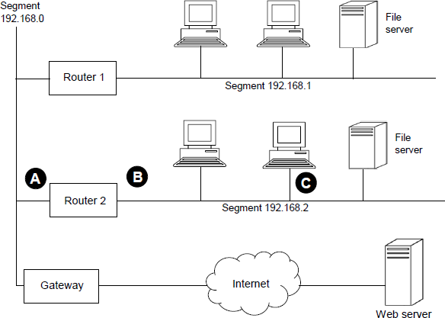

(a)     Suggest suitable IP addresses for:

(i)      the ‘Router 2’ port labelled A ................................................................

**(1)**

(ii)     the ‘Router 2’ port labelled B ................................................................

**(1)**

(iii)    the network adapter card in the computer labelled C ...........................

**(1)**

(b)     The network has been divided into segments.

Explain why networks that use a bus topology are often segmented.

........................................................................................................................

........................................................................................................................

........................................................................................................................

........................................................................................................................

........................................................................................................................

**(2)**

(c)     Previously, employees of the company used word processing and spreadsheet software that was installed locally on each of the individual computers on the network. Now, employees use software with similar features as a service (SaaS). The software runs on a web server and is accessed through the Internet.

(i)      Explain **two** advantages of using software as a service instead of using software installed locally on individual computers.

Advantage 1 .........................................................................................

...............................................................................................................

...............................................................................................................

Advantage 2 ..........................................................................................

...............................................................................................................

...............................................................................................................

**(2)**

(ii)     Explain **one** disadvantage of using software as a service instead of using software installed locally on individual computers.

...............................................................................................................

...............................................................................................................

...............................................................................................................

**(1)**

(d)     One difference between a Local Area Network (LAN) and a Wide Area Network (WAN)is the area that they cover. Describe **two** other differences between a LAN and a WAN.

Difference 1 ...................................................................................................

........................................................................................................................

Difference 2 ....................................................................................................

........................................................................................................................

**(2)**

**(Total 10 marks)**

**Q5.**A school has recently launched a ‘Parent Portal’ which is a website that provides information from the school. By logging on to the portal a parent can access the information that is stored about their son or daughter. This information includes academic reports, discipline records and other personal data.

(a)     A parent recently contacted the school because he was concerned that when he logged on to read his daughter’s report he could access the reports of all the other students.

The school should immediately look into this concern as a law has been broken.  
State the **full name** of the law that has been broken.

........................................................................................................................

**(1)**

(b)     Which principle of the law identified in your answer to part (a) has been broken?

........................................................................................................................

........................................................................................................................

**(1)**

(c)     State another principle of the law identified in your answer to part (a).

........................................................................................................................

........................................................................................................................

**(1)**

(d)     A parent also noted that the website was using HTTP (HyperText Transfer Protocol).

Why should the school be concerned about the use of this protocol and which protocol would you recommend that the school should use instead?

Why concerned ..............................................................................................

.........................................................................................................................

Suggested protocol .........................................................................................

**(2)**

(e)     The process of writing reports and then allowing access to these reports via the parent portal involves the use of many different categories of software.

Below is a list of different categories of software:

Operating system, Utility program, Special purpose application software, Bespoke application software, General purpose application software

Complete **Table 1** by writing the correct category from the list above in the **Category** column next to the appropriate **Software**.

You should **not** use a category more than once.

**Table 1**

|  |  |  |
| --- | --- | --- |
|  | **Software** | **Category** |
|  | Word processor used to write the pupil reports |  |
|  | The parent portal web application which was programmed for this school |  |
|  | The web server software run by the school |  |

**(3)**

**(Total 8 marks)**

**Q4.**

A flight recorder is an electronic recording device placed in an aircraft for the purpose of facilitating the investigation of aviation accidents and incidents. The image below shows an example of a flight recorder. It is a requirement for every commercial aircraft to have a type of flight recorder called a cockpit voice recorder.

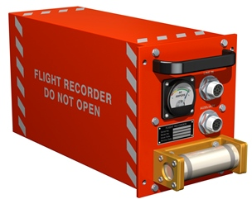

                                                                   © Thinkstock

(a)     Current cockpit voice recorders use solid-state memory chips to store the digital audio data. Alternatively, the data could be stored on a traditional hard disk drive.

Give **two** reasons why cockpit voice recorders store data using solid-state memory instead of using a traditional hard disk drive.

........................................................................................................................

........................................................................................................................

........................................................................................................................

........................................................................................................................

........................................................................................................................

........................................................................................................................

**(2)**

(b)     Audio from the cockpit is sampled at a rate of 8000 Hz and 16 bits are allocated to each sample.

How many kilobytes would be needed to store 360 seconds of audio?  
Show your working.

........................................................................................................................

........................................................................................................................

........................................................................................................................

........................................................................................................................

........................................................................................................................

                                                      Answer ............................................

**(3)**

(c)     Explain why the highest audio frequency in the sampled audio from the cockpit cannot be greater than 4000 Hz.

........................................................................................................................

........................................................................................................................

........................................................................................................................

........................................................................................................................

**(2)**

**(Total 7 marks)**

**Q5.**

(a)     A school has given RFID (radio frequency identification system) tags to each student as a security measure. At each external door there is a reader device against which the student holds the tag to gain entry.

Describe the principles of operation of both the reader and the RFID tag when reading the tag.

........................................................................................................................

........................................................................................................................

........................................................................................................................

........................................................................................................................

........................................................................................................................

........................................................................................................................

**(3)**

(b)     Four statements are given below that relate to the operation of printers.

**1**       Ink is squirted onto the paper to form characters.

**2**       Pins are fired against a ribbon to form characters.

**3**       Toner is attracted to the paper and then fused onto it.

**4**       A pen is lifted up and down to create the image.

In the table below, write the corresponding number for **one** of the possible statements that best describes a principle of operation for the given device.

|  |  |  |
| --- | --- | --- |
|  | **Device** | **Statement Number** |
|  | Laser Printer |  |
|  | Inkjet Printer |  |

**(2)**

(c)     External hard disk drives and CD-ROMs make possible both storage and transport of data.

A difference between the two is that more data can be stored on a typical hard disk drive than on a CD-ROM.

Identify **three** other differences between CD-ROM and hard disk drive storage.

........................................................................................................................

........................................................................................................................

........................................................................................................................

........................................................................................................................

........................................................................................................................

........................................................................................................................

........................................................................................................................

**(3)**

**(Total 8 marks)**

**Q6.**

A supermarket uses many hardware devices as part of its daily operations.

A key component at the checkout area is the bar code reader (scanner).

If a product’s bar code cannot be read by the bar code reader the checkout operator will have to enter the bar code manually.

(a)     Name **two** hardware devices that could be used to manually enter a bar code.

Device 1 ...........................................................................................................

Device 2 ...........................................................................................................

**(2)**

(b)     Most supermarket product bar codes follow the International Article Number standard  
which has 13 digits: 12 of these digits are for data and the last one is a check digit.



Describe the principles of operation of a bar code reader **and** how the software in the bar code reader will use the check digit when processing a product.

In your answer you will also be assessed on your ability to use good English, and to organise your answer clearly **in complete sentences**, using specialist vocabulary where appropriate.

........................................................................................................................

........................................................................................................................

........................................................................................................................

........................................................................................................................

........................................................................................................................

........................................................................................................................

........................................................................................................................

........................................................................................................................

........................................................................................................................

........................................................................................................................

........................................................................................................................

........................................................................................................................

........................................................................................................................

........................................................................................................................

........................................................................................................................

........................................................................................................................

........................................................................................................................

........................................................................................................................

........................................................................................................................

**(6)**

**(Total 8 marks)**

**Q7.**Secondary storage devices include:

Fixed internal hard disk drives, Magnetic tape drives, DVD-R drives and USB flash drives.

For each of the scenarios below, identify the **most appropriate** device from the list above and also explain why this device is appropriate.

You should **not** use the same device more than once.  
You should **not** give the same reason more than once.

To transfer a 100 KB word processed document from one computer to another.

Device .....................................................................................................................

Reason.....................................................................................................................

..................................................................................................................................

To store a backup of the 700 GB of user data stored on a school server.

Device ......................................................................................................................

Reason.....................................................................................................................

..................................................................................................................................

To produce copies of a software executable for distribution to customers.

Device ......................................................................................................................

Reason.....................................................................................................................

..................................................................................................................................

**(Total 6 marks)**