AQA 3.5.1 Photosynthesis

- Photosynthesis is a chemical reaction carried out by photoautotrophs, which converts inorganic compounds (CO_{2/} H₂O) into organic compounds (glucose /amino acids/lipids) using light energy:

Carbon dioxide + Water + Light energy Glucose + Oxygen

6CO₂ + 6H₂O + Light energy C₆H₁₂O₆ + 6O₂

Reduction reaction

- Photosynthesis occurs within the chloroplasts of palisade mesophyll cells where different wavelengths of light are absorbed by different Photosynthetic Pigments. There are 2 main groups of pigment found in plants:

  - Chlorophylls absorb blue and red wavelengths of light:

    - Chlorophyll a found in Reaction Centre of Antenna Complex
    - Chlorophyll b is an Accessory pigment found in Antenna Complex

  - Carotenoids (carotene + xanthophyll Accessory pigments found in Antenna Complex) - absorb blue wavelengths of light

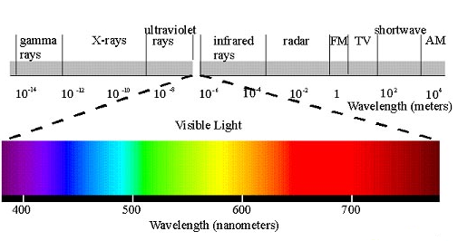

- The Absorption Spectrum is a graph which shows the quantity of light a particular pigment absorbs at each wavelength.
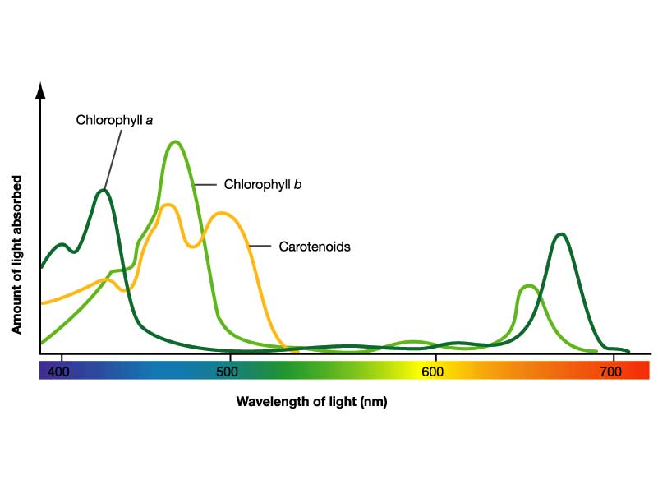

- The Action Spectrum is a graph which shows the rate of photosynthesis at different wavelengths of light:

- Photosynthetic pigments can be separated by Chromatography:

- Take 5 nettle leaves, cut up into mortar
- Add 2 caps of propanone and grind until a dark green liquid is produced
- Mark the origin on the chromatography paper (in pencil) and ensure it is correct length
- Using a capillary tube, put 5-10 spots of the solute mixture onto the origin – dry in between each spot
- *N.B. Line of origin must be above solvent!
- Lower paper into solvent and stand tube in rack
- Allow time for solvent to rise up paper
- Remove the paper immediately and mark on paper where solvent reaches: Solvent Front
- Measure from origin to the top of each colour band (mm)
- Identify components by calculating Rf value:

Rf = distance travelled by spot mm_____
distance travelled by solvent front mm

solute 2 = 80mm solvent front = 120mm

Rf sol 2= 80 = 0.67
120
solute 1 = 42mm

origin

Rf = distance travelled by spot mm
distance travelled by solvent front mm

Band  number | Colour | Distance of band mm | Distance of solvent front mm | Rf value | Pigment name
1
2
3
4

Table of Rf values
Pigment name | Colour | Rf value
Chlorophyll b | Yellow green | 0.45
Chlorophyll a | Blue green | 0.65
Xanthphyll | Yellow brown | 0.71
Phaeophytin | Yellow | 0.83
Carotene | Orange | 0.95

- Structure of a Chloroplast (Overview of photosynthesis)
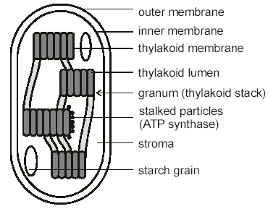

DNA loop

ribosome

- Thylakoid membrane – contains chlorophyll molecules, where Light
Dependent Reaction (LDR) occurs
  - Granum – stacks of thylakoids that increases efficiency of light absorption by chlorophyll molecules
  - Stroma – liquid containing enzymes necessary for Light Independent Reaction (LIR) and Starch synthesis
- Ribosome – Where protein/enzyme synthesis takes place
- DNA loop – Contains genes coding for LIR enzymes

- Photosynthesis occurs in two stages and two sites within the chloroplast:

  - Light Dependent Reaction (LDR) – Thylakoid membrane
  - Light Independent Reaction (LIR) – Stroma

- The reactions are linked because the products of the LDR are essential for
the LIR:

Light energy
Light Dependent Reaction
H₂0 O₂

ATP NADPH₂
Light Independent Reaction
CO₂

Organic molecules

- Light Dependent Reaction (LDR)

- The chlorophyll a and accessory pigments are found in the thylakoid membrane of chloroplasts –they are grouped into clusters called an Antenna Complex
- Within each antenna complex the accessory pigments absorb the photons, then pass the photons of light down to the Chlorophyll a molecules which are situated in the Reaction Centre:

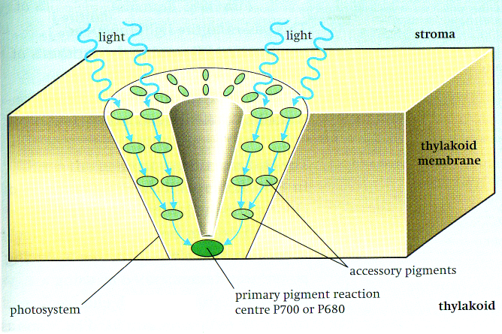

- Antenna complexes can have two types of reaction centre:

  - Photosystem I – arranged around a chlorophyll a molecule with an absorption peak of 700nm, so reaction centre is called P700
  - Photosystem II – arranged around a chlorophyll a molecule with an absorption peak of 680nm, so reaction centre is called P680

  - How is ATP synthesised in LDR? – Non-cyclic Photophosphorylation which involves Photosystem I and II (Z Scheme)

- Light energy is absorbed by Photosystem II and passed on to chlorophyll a (P680)
- The irradiated chlorophyll a molecule (P680) emits 2 electrons
- The High Energy electrons leaves from chlorophyll a and are picked up by an Electron Acceptor
- Which passes the electrons along a chain of electron carriers (electron transport chain) by a series of redox reactions to Photosystem I
- Each electron carrier is at a progressively lower energy level
- Energy is released by electrons (Chemiosmosis) to synthesise ATP from ADP and Pi – called Photophosphorylation

Electron acceptor

Electron acceptor 2e⁻

2e⁻
ETC 2e⁻

ADP + Pi 2e⁻ NADP NADPH₂

ATP

2e⁻
ADP + Pi

ETC ATP 2H⁺

2e⁻

Light
energy
Photosystem I
P700

Light
energy
Photosystem II
P680
2e⁻ H₂O

½ O₂
Key
ETC electron transport chain
Flow of electrons in non-cyclic Photophosphorylation
Flow of electrons cyclic photophosphorylation

  - How is NADP (Hydrogen Acceptor) reduced in LDR?

- Light energy is absorbed by Photosystem I and passed on to chlorophyll a (P700). It emits 2 electrons
- The High Energy electrons leaves from chlorophyll a and are picked up by an a second Electron Acceptor
- Which passes the electrons along a chain of electron carriers (electron transport chain) by a series of redox reactions to Reduce NADP (Hydrogen Acceptor) to NADPH₂
- Photolysis splits water into H⁺ (and e⁻ and O₂)
- The H⁺ Reduces NADP to NADPH₂

What is the role of water? – Photolysis

- Photolysis of water molecules produces O₂ + H⁺ + e⁻
- The H⁺ are needed to reduce NADP to NADPH₂
- And the e⁻ are used to restablise the Photosystem II
chlorophyll a molecules
- O₂ is a waste gas and diffuses out of the stomata

  - How is ATP synthesised in LDR? – Cyclic Photophosphorylation
which involves Photosystem I only

- Light energy is absorbed by Photosystem I and passed on to chlorophyll a (P700)
- The irradiated chlorophyll a molecule (P700) emits 2 electrons
- The High Energy electrons leaves from chlorophyll a and are picked up by the First Electron Transport Chain
- Which passes the electrons along a chain of electron carriers by a series of redox reactions, then returned back to chlorophyll a (P700)
- Each electron carrier is at a progressively lower energy level
- Energy is released by electrons (Chemiosmosis) to synthesise ATP from ADP and Pi – called Photophosphorylation
- No NADPH₂ is synthesised during Cyclic Photophosphorylation

Electron acceptor

2e⁻

2e⁻

2e⁻
ADP

ETC ATP

Light energy

Photosystem I
P700

Key
ETC electron transport chain
Flow of electrons in non-cyclic Photophosphorylation
Flow of electrons cyclic photophosphorylation

- Electron Transport Chain in the chloroplast

In the Z scheme electrons flow along the electron carrier chains they release energy which is then used to synthesise ATP by:

  - During each Redox reaction between carrier molecules energy is released
  - The energy Fuels proton pumps, to pump H⁺ from the stroma into the thylakoid intermembrane space
  - This sets up an electrochemical gradient between the thylakoid intermembrane space and the stroma
  - The reduction of NADP to NADPH₂ (due to the addition of electrons and protons (H⁺) ) occurs in the stroma which lowers the concentration of protons, further contributing towards the maintenance of the electrochemical gradient
  - The H⁺ flow back into the stroma via an electrochemical gradient, releasing electrical potential energy, through ATP Synthase within the Stalked Particles (Chemiosmosis), the energy released is used to synthesise ATP from ADP and Pi.

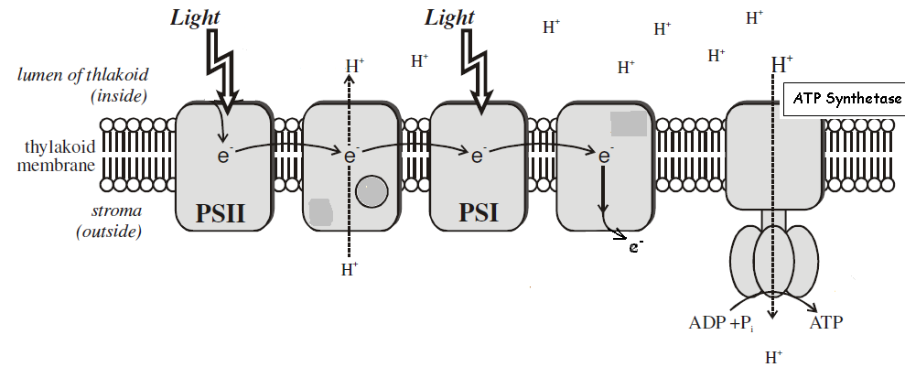
Chemiosmosis

- Light Independent Reaction (LIR)

- Does not require light energy
- But does require products of the LDR to occur i.e. ATP and NADPH₂
- Occurs in the watery Stroma where enzymes are in aqueous solution for reactions to make organic molecules such as glucose, lipids, amino acids

- What are the roles of ATP?

- ATP hydrolysis provides the energy needed in the reduction of Glycerate 3 phosphate using H atoms from NADPH₂, to Triose phosphate
- The CO₂ has been fixed (inorganic to organic compound)
- ATP also provides the energy and phosphate to regenerate Ribulose bisphosphate from Triose phosphate (5 out of every 6 Triose phosphate molecules produced are used for regeneration)

- The role of NADPH₂

- The reduced NADPH₂ donates the H atoms to reduce GP to form Triose Phosphate:

Carbon dioxide (1C)
Rubisco Enzyme

Ribulose bisphosphate (5C) Unstable 6C compound
(RuBP)

Glycerate 3-phosphate (3C x 2)
(GP)

ADP + Pi ATP NADPH₂

ATP ADP + Pi NADP

Triose phosphate (3C x 2)

Glucose, lipids, amino acids
- Lollipop Experiment Summary
Melvin Calvin used this apparatus to discover the sequence in which organic molecules are made during the light independent reaction
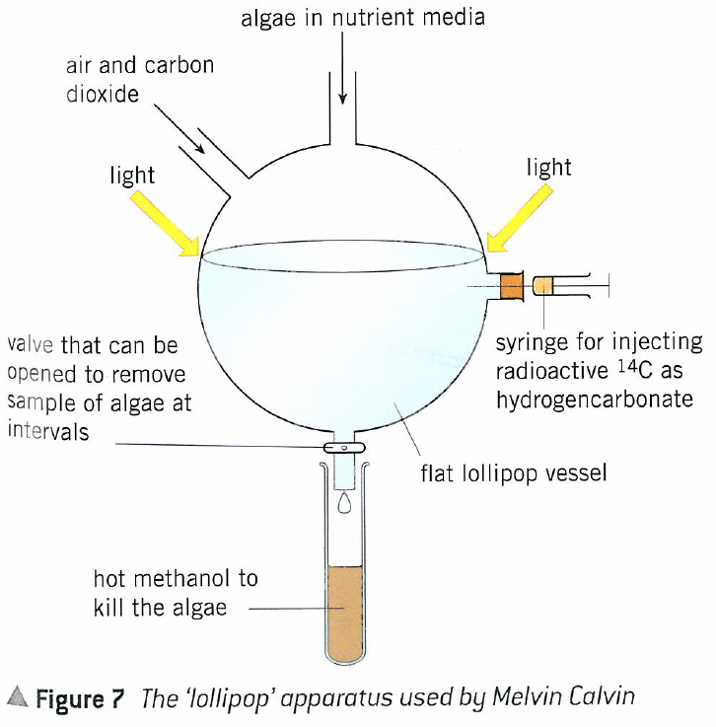

A carbon source (hydrogen carbonate instead of CO₂) made with a radioactive isotope of carbon is added to a flask containing photosynthesizing algae.
Light is shone on the apparatus to ensure that there are plenty of products from the light dependent reaction.
The algae are left to photosynthesise but a sample is taken every 5 seconds by opening the valve at the bottom of the flask.
Samples fall into the hot methanol which instantly kills the algae and stops any further photosynthesis.
The sample can then be analysed and the radioactive components identified. This is done by separating out the molecules on a membrane in a process called 2D chromatography:

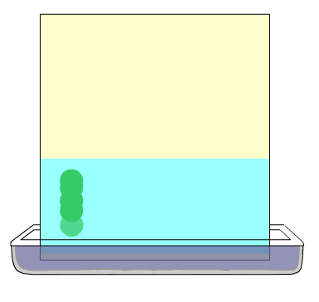
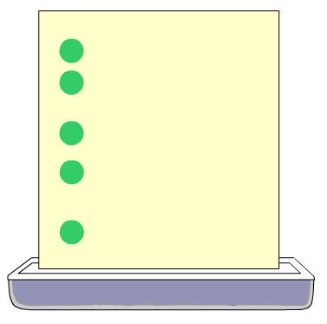
The sample of algae are placed on to chromatography paper and a solvent used to separate out the organic molecules.

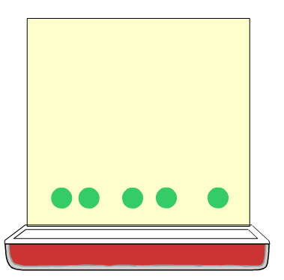
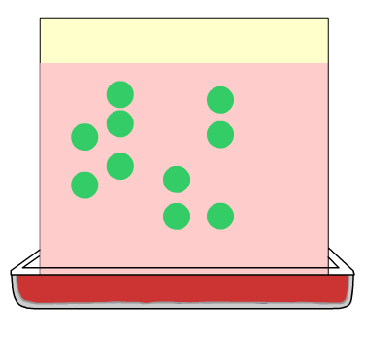
The chromatography paper is taken out of the first solvent, dried, and then rotated through 90º. It can then be placed in a second solvent, and the organic molecules separated out still further.

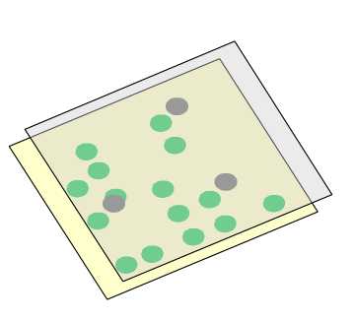
A photographic film can then be placed next to the separated molecules and any that contain the radioactive isotope will cause the film to go black.

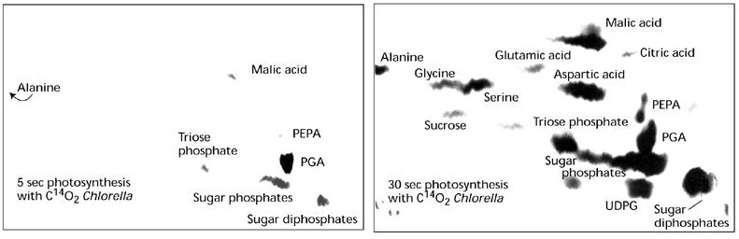
This diagram shows the molecules that contain radioactive carbon after 5 seconds of photosynthesis (left) and 30 seconds (right). In 5 seconds the light independent reaction has barely produced any triose phosphate. Instead the only radioactive compounds are the glycerate-3 phosphate (here labelled as “sugar phosphates”) and some other intermediates.

After a further 25 seconds the radioactive carbon has been incorporated into many more molecules. Much more triose phosphate is visible, as well as sugars and amino acids.
- Light Dependent Reaction Summary

- Plants use the products of the light dependent reaction to synthesise other organic molecules.
- Nitrogen ( which the plant obtains from nitrates) is used for the synthesis of amino acids, proteins and nucleic acids so nitrogen deficiency will cause stunted growth because lack of nucleic acids will hinder cell division:
Contains nitrogen

- Magnesium is required for chlorophyll therefore deficiency leads to chlorosis (chlorophyll a breaks down revealing carotenoid pigments, hence the yellow colour of leaves) and death:
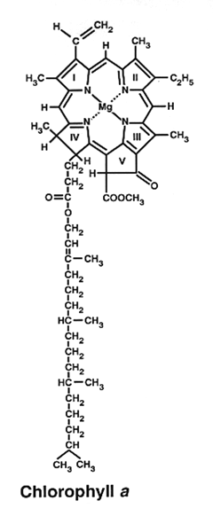
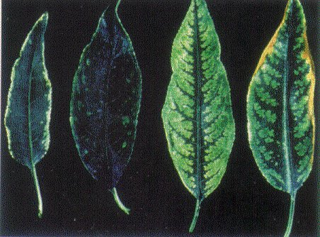

- The law of limiting factors in photosynthesis

  - This is where a process e.g. photosynthesis, is affected by more than one factor, therefore the overall rate is limited by that factor which is closet to its minimum value

    - Temperature Rate of reaction initially increases due to
Rubisco enzymes gaining more kinetic energy, therefore more collisions occur between them and substrate molecules, therefore more enzyme substrate complexes are formed!

Rate of
Photosynthesis (as
O₂ released)

Temperature

Past the optimum temperature the rate of reaction decreases due to enzymes being denatured!

- Light intensity Rate of reaction increases due to the chlorophyll
molecules releasing more excited electrons as part of the LDR. Rate of reaction then plateaus due to limiting factors

Rate of
Photosynthesis (as
O₂ released)

Light intensity

- CO₂ concentration Rate of reaction increases due to more CO₂
available to react with RuBP to form GP in the LIR. Rate of reaction then plateaus due to limiting factors

Rate of
Photosynthesis (as
O₂ released)

CO₂ concentration

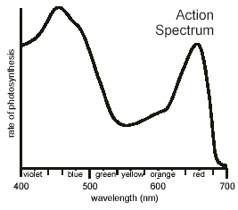
- Light wavelength Chlorophyll absorbs blue/red wavelength of light,
therefore the green wavelength is not absorbed,
therefore fewer electrons are excited as part
of the LDR, therefore the rate of
photosynthesis decreases!

- The compensation point

Carbon dioxide is absorbed by a photosynthesizing plant, but it is also released during respiration. This means that the amount of carbon dioxide absorbed depends on the rate of respiration and the rate of photosynthesis.
- When photosynthesis is occurring slowly or not taking place at all (in low light conditions), the amount of CO₂ absorbed will be smaller than the amount produced through respiration.
- In bright light conditions, the amount absorbed through photosynthesis will exceed that which is produced by respiration.
- The compensation point is reached when the CO₂ produced by respiration exactly matches that absorbed by photosynthesis.
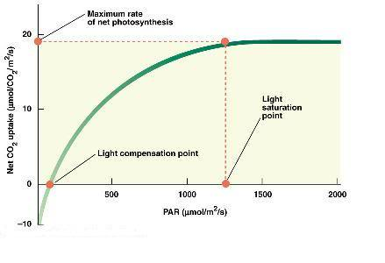
There is no net uptake/release of carbon dioxide.
Light intensity/a.u.

- Agricultural Practice

Agriculture involves producing crops as efficiently as possibly. In order to be profitable, farmers must maximize the rate of photosynthesis, without increasing the costs of growing the plants too much. Placing plants in a greenhouse means that the conditions can be manipulated to ensure that light, CO₂ and temperature are not limiting.
- The atmospheric concentration of CO₂ is 0.04%. By using paraffin burners the level can be raise to 0.1%. Increased CO₂ levels will shorten the growing period (5%–10%), improve crop quality and yield, as well as, increase leaf size and leaf thickness.

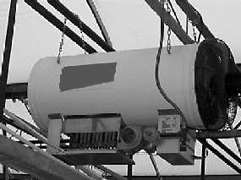
Figure 1: Paraffin burner in a greenhouse
- Heaters can also be used to increase the temperature within a greenhouse. Any increase up to around 25ºC will improve the yield of crops, as the rate of the enzyme catalyzed reactions in photosynthesis will increase, speeding the production of triose phosphate in the Calvin cycle, and hence the production of other organic molecules.
- Artificial lighting can be used in conjunction with the other measures to ensure that photosynthesis occurs as rapidly as possible, even on dull days. Without artificial lamps, light intensity would become the limiting factor, and increasing CO₂ or temperature would have no impact on yield.

