**5.2.2 Respiration**

* There are 72 enzymes catalysed reactions in respiration and they are divided into 4 main stages:
  + Glycolysis (anaerobic respiration) – in cell cytoplasm
  + Link reaction – in the matrix of mitochondria
  + Krebs Cycle - in the matrix of mitochondria
  + Electron Transfer Chain – on the crista/inner membrane of mitochondria

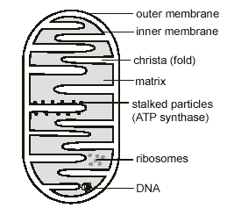Structure of a mitochondrion

* Cristae – contain electron transport chains and the site of oxidative phosphorylation
* Matrix - liquid containing enzymes necessary for Kreb’s cycle
* Ribosome – where protein/enzyme synthesis takes place
* DNA loop – contains genes coding for Kreb’s Cycle enzymes
* ATP Synthase– the site of oxidative Phosphorylation

**Aerobic Respiration**

* + Aerobic Respiration is respiration that uses oxygen
* Glycolysis (cytoplasm of cell)
* The less reactive 6C glucose molecule is **Phosphorylated** by the

hydrolysis of 2 ATP molecules and converted into the more reactive Hexose Phosphate (6C), which then splits into 2 x 3C Triose Phosphate molecules

* The Triose Phosphate molecules are converted to 2 x 3C Pyruvate

Molecules. This happens as the Triose Phosphate is **Oxidised** (Hydrogen Removed by **Dehydrogenase** enzymes), and the Hydrogen is transferred to the Hydrogen Acceptor NAD producing 2 x NADH. 4x ATP Molecules are synthesized, meaning a **net** **2 x ATP** are produced in glycolysis.

Glucose (6C)

# 2 ATP

2 ADP + Pi

Phosphorylated Glucose (6C)

**Anaerobic**  2 X Triose Phosphate (3C)

**respiration**

# 4 ADP + Pi 2 NAD

# 4 ATP 2 NADH

2 X Pyruvate (3C) If no O2 present Lactate or Ethanol is produced

* Link Reaction (matrix of mitochondria)

Pyruvate (3C)

# NAD

CO2

# NADH

Acetate (2C)

+

Coenzyme A (CoA)

Acetylcoenzyme A (2C)

* Each pyruvate molecule diffuses into the matrix of the mitochondria

where it is **oxidised** (removing Hydrogen), resulting in a molecule of **Acetate** (**2C**) being produced

* One molecule of CO2 is produced in a process called **oxidative**

**Decarboxylation** (catalysed by **Decarboxylase** enzyme)

* Acetate (2C) combines with **Coenzyme A** (CoA) molecule forming an

**Acetylcoenzyme A molecule (2C)**

* *N.B. Glucose has to be converted into pyruvate because there are no

carrier/channel proteins in mitochondria membrane to allow mitochondria to enter!

* Krebs Cycle (matrix of mitochondria)

Acetylcoenzyme A (2C)

Coenzyme A

Acetate

6C Acid

NAD

CO2

# NADH

NAD

# 4C Acid

# 

FAD NADH

ADP + Pi FADH 5C Acid

ATP CO2  NAD

NADH

# 

* Each Acetylcoenzyme A molecule (2C) enters the Krebs Cycle where the

Coenzyme A is Regenerated (returns to Link Reaction), and the Acetate is picked up by a 4C Acid to form a 6C Acid

* The cycle involves a number of intermediate Acids which become dehydrogenated when Hydrogen is removed from them (intermediates are 6C, 5C, 4C molecules in the cycle above), releasing energy which is used to Reduce NAD/FAD and synthesise ATP
* Hydrogen Acceptors NAD and FAD become reduced when H atoms are

added to their structure i.e. NADH and FADH

* Decarboxylation occurs from two intermediates in which the 2 carbon

atoms of the Acetate are removed as CO2

* Reduced NAD (and FAD) deliver the hydrogen to the electron transfer chain in the inner mitochondrial membrane so acting as triggers for this system
* Electron Transfer Chain (inner membrane of mitochondria – crista)

[(Electron Transport Chain animation)](http://www.science.smith.edu/departments/Biology/Bio231/etc.html)

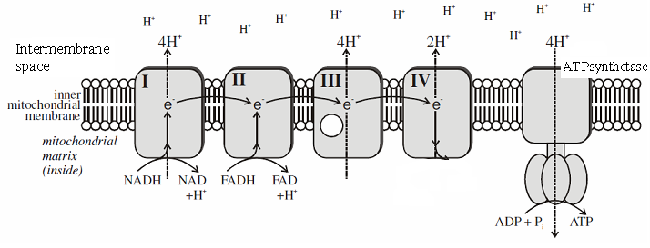

NADH/FADH Re-oxidised

e- + H+ + O2 H2O

NAD/FAD go to Link Reaction/Kreb’s Cycle

* NADH/FADH are oxidised releasing the H atoms, where they split into

H+ and e-

* + Each **High energy** e- is accepted by an electron carrier which becomes reduced
* As each electron carrier accepts and than transfers the e- to the next,

ENERGY is lost from the e-

* This energy is used to fuel Proton Pumps to actively transport the H+ into the inter membrane space, where the concentration exceeds that of the matrix, forming an electrochemical gradient
* The H+ flow back into the matrix via an electrochemical gradient, releasing electrical potential energy, through ATP Synthase within the Stalked Particles (Chemiosmosis), the energy released is used to synthesise ATP from ADP and Pi – called Oxidative Phosphorylation
* The H+ and e- in the matrix reacts with O2 (absorbed from the atmosphere) which is called the terminal acceptor, to form water:

H+ + e-+ O2 H2O

* Each NADH entering the chain provides the energy to synthesise 3X ATP, because the electron carrier system using NADH **uses 3 proton pumps**.
* Each FADH entering the chain provides the energy to synthesise **only** 2X ATP, because the electron carrier system using FADH **uses 2 proton pumps**, therefore fewer protons are pumped into the intermembrane space!
* How many molecules of ATP are made from each glucose molecule?:

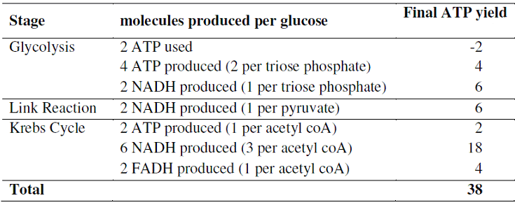

* Alternative Respiratory Substrates
* Not all the energy of the glucose molecule is captured in ATP and there is a

loss of energy as **heat energy**

* Under certain circumstances **lipids** and **proteins** may be used as **respiratory**

**substrates**

* Lipids are hydrolysed into Glycerol and fatty acids. **Glycerol** is converted into **triose phosphate**
* Long fatty acid chains molecules are split into **2C fragments** which enters aerobic respiration as **acetyl co-enzyme A**
* The protein is broken down into its constituent amino acids which are **deaminated** (removal of the NH2 group). They can enter the respiratory pathway at different points depending on the number of carbon atoms they contain. 3-carbon compounds are converted to pyruvate, while 4- and 5-carbon compounds are converted to intermediates in the Krebs cycle.

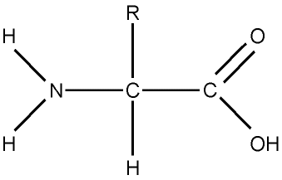

Organic acid

NH3

**Anaerobic Respiration**

* + Anaerobic respiration occurs in the absence of oxygen. There are 2 types:
    - **Facultative Anaerobes** grow better in the presence of oxygen, but can survive without it.
    - **Obligate Anaerobes** only carry out anaerobic respiration. If O2 is present it **inhibits metabolism**, **preventing cell division** from occurring!
  + When Facultative Anaerobes (can do both aerobic and anaerobic respiration) have no oxygen the **NADH/FADH molecules cannot be Re-oxidised**, therefore they cannot accept any more Hydrogen, so under anaerobic conditions the Link Reaction/Krebs Cycle and Electron Transport Chain cannot occur!
  + **Animals** - In the absence of O2:
    - The **Link reaction**, **Krebs cycle and Electron Transport Chain** **cannot occur** as there is **no O2** to act as the **terminal acceptor molecule**
    - **NADH** transfers the **hydrogen** to **reduce** Pyruvate
    - **Pyruvate** is **reduced to lactate**
    - Therefore **NAD is regenerated** and can **accept hydrogen** from **Triose phosphate**
    - Glucose is still oxidised to **pyruvate**
    - Which **allows Glycolysis to continue**
    - However, per 1 molecule of glucose there is a **net production of 2 ATP** **in anaerobic respiration**

2 X Triose Phosphate (3C)

# 4 ADP + Pi 2 NAD

# 4 ATP 2 NADH

2 X Pyruvate (3C) If no O2 present Lactate is produced

* + Build up of lactate in muscle causes cramp. When oxygen becomes available again it is used to break down the lactate in the liver (called the oxygen debt), where it is converted to glycogen. At the end of exercise the oxygen debt is repaid by deep and rapid breathing
  + **Plants/Fungi** - In the absence of O2:
    - There is a **loss of CO2**
    - **Ethanal** is produced
    - Which is **reduced by NADH donating its hydrogen** to **ethanol**
    - However, per 1 molecule of glucose there is a **net production of 2 ATP in anaerobic respiration**

2 X Pyruvate (3C)

Ethanal

# 2 NAD

# 2 NADH

Ethanol

* Respiration Summary

Glucose

e-  H+ H+ H+ H+ H+ H+ H+

Hexose

Phosphate Pyruvate NADH/FADH

e-

Triose phosphate Acetylcoenzyme A

ADP + Pi ATP

H+

# Kreb’s

Cycle O2 + e- + H+ H2O

NAD

NADH

Pyruvate Lactate