## **Energy Flow through ecosystems**

**Definitions**

* Habitat The physical place that an organism lives
* Population The total number of organisms of a single species interbreeding

within in a habitat

* Community The total number of different organisms of all species present in a

habitat

## Energy transfer

* + All organisms require energy to be used in various cell processes e.g. active transport for absorption/nerve impulse induction/muscle contraction/Mass Flow. Light energy from the sun is the ultimate source of energy on the earth.
  + **Photosynthesis** is the route by which **light energy** is converted (Transferred) into **Chemical energy** (organic compounds e.g. glucose) and made available to organisms within an ecosystem. **Photosynthetic efficiency** is a measure of how well a plant is able to capture light energy
  + **Producers** (Autotrophic) carry out photosynthesis, and are therefore found within every ecosystem. However, not all of the light energy reaching the leaf of a plant is used in photosynthesis:

Reflected from leaf surface

Wrong wavelength of light

Transmission of light

* + - Light is **reflected** from the leaf surface
    - Light is **transmitted through the leaf** and doesn’t strike a chlorophyll molecule
    - Light is **not absorbed** i.e. chlorophyll **only absorbs red and blue wavelength of light**
    - Light energy is absorbed by **water (photolysis)**
* Photosynthesis and Respiration
* The total amount of organic compounds produced by photosynthesis is called the **Gross Primary Productivity** (GPP)
* However, the plant must ‘use’ some carbohydrate (glucose) for respiration, therefore the amount of organic material made by a green plant by photosynthesis Less the Respiratory Loss is called the **Net Primary Productivity** (NPP)
* NPP increases a plant’s **Biomass** and is available to the next **trophic level** i.e. primary consumers (as food) *N.B. some of the biomass is used to form inedible material e.g. bark or is biomass in roots which is out of reach of primary consumers!

125 x 100 = 2.43 %

5150

2.43

* Food chains and food webs
* The **feeding relationships** found within ecosystems are described as Food chains and the following names are used in each chain:
* Energy flow is not an efficient process, generally only 10% of the energy in one trophic level is transferred into **Biomass**, and therefore energy available to the next trophic level. Where does the remaining 90% of energy go?:
  + Respiration and then Heat energy
  + Faeces and urine
  + Not all of the biomass is eaten
  + General ‘Detritus’ e.g. fur, feathers, skin, dead leaves

Respiration = Heat Loss

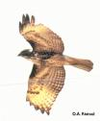

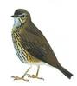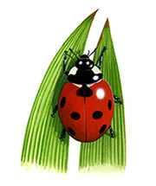

15 KJ

150KJ

1,500KJ

15,000KJ

green plant herbivore carnivore top carnivore

***Producer*** ***Primary Secondary Tertiary***

(1st trophic ***consumer (1o) consumer (2o) consumer (3o)*** level) (2nd trophic (3rd trophic (4th trophic

level) level) level)

Death/Faeces/Urine

Decomposers/Saprophytes

* The net production of consumers (*N*), such as animals, can be

calculated as:

*N* = *I* – *F* + *R*

where *I* represents the chemical energy store in ingested food, *F*

represents the chemical energy lost to the environment in faeces and

urine and *R* represents the respiratory losses to the environment.

* Be aware that mammals/birds in a food chain will pass on less energy to the next trophic level compared to invertebrates as:
* They are **warm blooded**
* Therefore require a **higher rate of respiration** for **heat**

production

* Therefore use up more glucose during respiration, therefore less

is available for Biomass

* *N.B. Carnivores are more efficient at energy conversion than herbivores, because they are able to digest and absorb their high protein diets more efficiently, than carbohydrate diets e.g. cellulose
* Food chains rarely consist of more than 5 organisms due to the loss of energy at each trophic, there is not enough energy available to support the top carnivores/parasites
* Food webs
  + Food chains are an over simplification because an organism may be eaten by several different consumers:

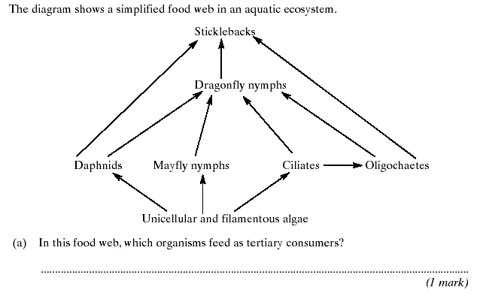

Ecological Pyramids

Sticklebacks and Dragonfly nymphs

* From a food chain (in a food web) we can study the:
  + - Numbers
    - Biomass at each trophic level
    - Energy
  + These can be plotted as horizontal bars to form a ‘stepwise’ pyramid of:
    - Number
    - Biomass
    - Energy
* Pyramid of Number
  + - Units = Number/square m

no. m-2

* + - Many food chains will have a ‘regular’ pyramid shape as seen in fig A, there must be a high number of the grass to support the snails feeding on them in order to provide them with energy
    - 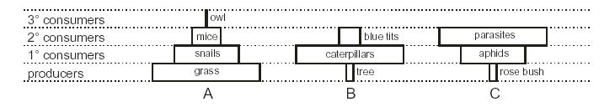Figs B and C show inverted pyramids due to the fact that the **Biomass** of organisms is not taken into account:
      * B has one large producer with a large Biomass, therefore it can support many smaller 1o, therefore having a small biomass, therefore low energy demand
      * C is completely inverted due to the 2o being very small, parasites, therefore having a small biomass, therefore low energy demand
  + Pyramid of Biomass
    - Units = kg m-2
    - Generally all Pyramids of Biomass will have a regular pyramid shape, however there are exceptions to the rule:

Zooplankton

Fish

Phytoplankton

* + - * Zooplankton has a **rapid reproductive cycle**, pyramids of biomass do not take into account changes over **time**
  + Pyramids of Energy
    - Units = KJ m-2 yr-1
    - Pyramids of energy are the most accurate way of representing feeding relationships because:
      * They show how much energy flows into a trophic level over a **set time period**
      * 90% of energy is lost at each trophic level via heat through respiration and excretion
      * They are easy to compare the efficiency of energy transfer between different communities
      * However obtaining data can be difficult!



**Nutrient Cycles**

* There are three important cycles to know:
* Carbon cycle
* Phosphorous cycle
* Nitrogen cycle
* Matter cycles between the **biotic** (organic) environment and in the **abiotic** (inorganic) environment. Simple inorganic molecules (such as CO2, N2 and H2O) are assimilated (or **fixed**) from the abiotic environment by producers, and built into complex organic molecules (such as carbohydrates, proteins and lipids)
* Carbon cycle
* The source of Carbon is the inorganic molecule CO2. The carbon atoms from CO2 are ‘**fixed**’ into complex organic molecules by photosynthesis e.g.
* Starch
* Cellulose
* Glucose
* Sucrose
* Amino acids
* DNA/RNA nucleotides
* ATP
* Lipids
* Some of the carbohydrates (organic molecule) is respired by plants and respiration releases CO2 to the atmosphere
* Animals eat the biomass of plants, and again CO2 is released by respiration to the atmosphere
* Saprophytes will decompose the following organic molecules to produce small soluble molecules, some of which will be respired and therefore more CO2 is released to the atmosphere:
* **Detritus** from living plants/animals:
  + - * ‘Lost’ leaves/petals/twigs/fur/skin
      * Feaces/urine
  + When plants/animals die the biomass is decomposed
* These organic molecules are passed through food chains and eventually returned to the abiotic environment again as simple inorganic molecules by decomposers. Without either producers or decomposers there would be no nutrient cycling and no life:

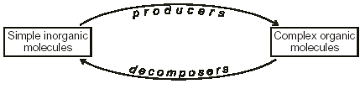

* There are two groups of decomposers:
* **Detrivores** are animals that eat and digest detritus (such as earthworms and woodlice). They break such plant tissue into much smaller pieces with a larger surface area for enzyme action making it more accessible to the **saprophytes**.
* **Saprophytes** (or decomposers) are microbes (fungi and bacteria) that live on detritus by:
  + - * Secreting enzymes
      * For extracellular digestion
      * Giving small/soluble molecules
      * Which diffuse back into the saprophyte’s cells
* Without saprophytes, large complex organic molecules e.g. cellulose in plants, proteins in animals, are not decomposed to **small soluble** molecules
* *N.B. Detritus may not decompose if conditions are:
* **Anaerobic** – no O2 for respiration, therefore no ATP
* **Acidic** – **Denatures** enzymes
* Too cold/hot – low temperatures will mean reacting molecules have low **Kinetic energy**/high temperatures may denature enzymes



* Nitrogen cycle
  + - * + Nitrogen is essential to form the following biological compounds:
    - Amino Acids
    - Which form proteins e.g. enzymes
    - DNA/RNA nucleotides
    - NAD/NADP Hydrogen Acceptors
    - ATP
* **Nitrogen Fixation** 
  + 78% of the atmosphere is nitrogen gas (N2), but this is inert and can’t be used by plants or animals. Nitrogen fixing bacteria reduce nitrogen gas to ammonia which dissolves to form ammonium ions (NH4+).
  + The nitrogen-fixing bacteria may be free-living in soil or water (***Azotobacter***), or they may live in colonies inside the cells of root nodules of **leguminous plants** such as clover or peas (***Rhizobium***). This is an example of mutualism as the plants gain a source of useful nitrogen from the bacteria (they can live in low nitrate conditions), while the bacteria gain carbohydrates/ATP from the plants
  + Nitrogen gas can also be fixed to ammonia by humans using the Haber process, and a small amount of nitrogen is fixed to nitrate by lightning
  + *N.B. Nitrogenous compounds are any molecule that contains N atoms
* **Ammonification**
* **Saprophytes** decompose nitrogenous organic matter e.g. proteins, by carrying out extracellular digestion producing amino acids, and then further breakdown by the removal of the Amino group from an amino acid and a Hydrogen atom is added to form ammonia or ammonia compounds:

#### **H R O**

##### **N C C Organic acid used in respiration**

H H OH

-NH2 NH3

H

* **Nitrification**
* Nitrifying bacteria can **oxidise** ammonia to nitrate in two stages: first forming nitrite ions (NH3 NO2-) carried out by ***Nitrosomonas***
* Then forming nitrate ions (NO2-  NO3-) carried out by ***Nitrobacter***
* These are a chemosynthetic bacterium, which means they use the energy released by nitrification to live, instead of using respiration.
* Plants can only take up nitrogen in the form of nitrate ions by facilitated diffusion/active transport and are used to form amino acids and protein within the plant.
* **Denitrification**
* The anaerobic denitrifying bacteria convert nitrate to N2 which is then lost to the air. This represents a constant loss of “useful” nitrogen from soil, and explains why nitrogen fixation by the nitrifying bacteria and fertilisers are so important
* There is an increase in Denitrification if there is a lack of O2 in the soil (anaerobic conditions) due to:
  + - * Waterlogged – air spaces full of water
      * Compacted – few air spaces
* Framers drain their land and plough fields to try to minimise Denitrification from occurring

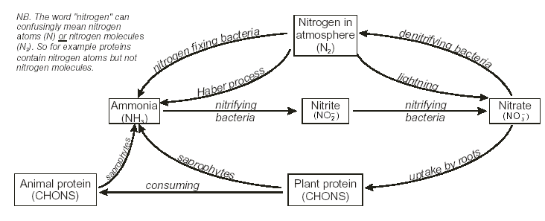

*N.B. If plants are crops and harvested then nitrogenous compounds are removed from the soil (as it is incorporated into the plant tissue), therefore nitrogenous fertilisers must be applied to replace lost compounds!

*N.B. Nitrates are soluble in water, therefore can be **leached** from soil after heavy rainfall

**Phosphorous cycle**

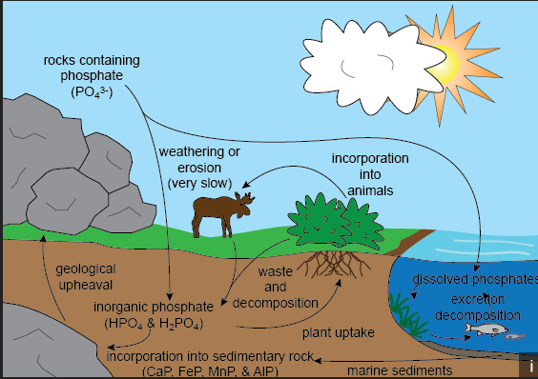

Natural and artificial fertilisers replace the nitrates and phosphates lost by harvesting plants and removing livestock. However, there are environmental issues associated with the overuse of these types of fertlisers.

Natural fertilisers – dead and decaying organic material manure

Artificial fertilisers – ammonia, phosphate, potassium ions

**Nitrates**

**Sources:**

• fertiliser runoff from farmland

• released during decomposition of organic matter

**Effects:**

• • on aquatic environment (cultural eutrophication)

**Control:**

• use of slow release fertilisers

• nitrate control areas

• field not ploughed and fertilisers not applied during wet weather

• buffer strips left uncultivated near rivers

**Phosphates**

**Sources:**

• sewage effluent, silage fluids, fertiliser runoff

**Effects:**

• cultural eutrophication: algal blooms release toxins, shade macrophytes, break normal food

chains and cause deoxygenation when the dead algae decompose.

**Organic pollutants**

**Sources:**

• many plant and animal products: sewage, manure, silage fluids, food-processing waste, effluent

from paper mills and leather tanneries.