**NAME** ............................................ Chemistry Class ..........................

Student Number ……….

Carboxylic acids

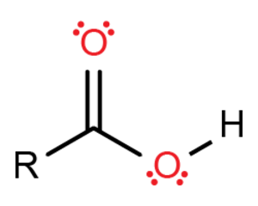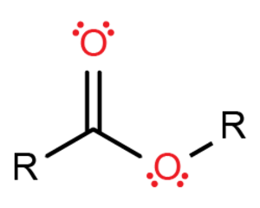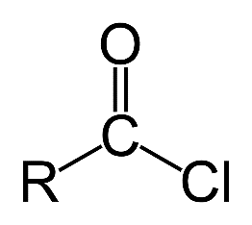

Acyl chloride functional group.

Carboxylic Acid functional group.

Ester functional group.

**Topic 17C: Carboxylic acids**

9. be able to identify the carboxylic acid functional group

10. understand that hydrogen bonding affects the physical properties of carboxylic acids, in relation to their boiling temperatures and solubility

11. understand that carboxylic acids can be prepared by the oxidation of alcohols or aldehydes, and the hydrolysis of nitriles

12. understand the reactions of carboxylic acids with:

i lithium tetrahydridoaluminate (lithium aluminium hydride) in dry ether

ii bases to produce salts

iii phosphorus(V) chloride (phosphorus pentachloride)

iv alcohols in the presence of an acid catalyst

13. be able to identify the acyl chloride and ester functional groups

14. understand the reactions of acyl chlorides with:

i water

ii alcohols

iii concentrated ammonia

iv amines

15. understand the hydrolysis reactions of esters, in acidic and alkaline solution

16. understand how polyesters are formed by condensation polymerisation reactions

Home tutorial videos on Carboxylic Acids and Acyl Chlorides available on Godalming online

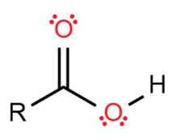**Naming**

The first two members of the homologous series are methanoic and ethanoic acid. They contain one and two carbon atoms, respectively, and their names are derived from methane and ethane.

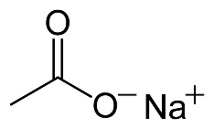The carboxyl carbon atom in the COOH functional group is always numbered carbon 1. This helps when naming branched chained carboxylic acids. See e.g. 4-methylhexanoic acid below and note the naming.

The salts of carboxylic acids are named after the parent carboxylic acid but instead of ending ‘oic acid’ end ‘oate’.

|  |  |  |  |  |
| --- | --- | --- | --- | --- |
| Name | Structural formulae | Displayed formulae | Skeletal formula | Name of sodium salt formed |
| Methanoic acid | HCOOH |  |  | Sodium methanoate |
| Propanoic acid | CH3CH2COOH |  |  | propanoate |
| 4-methylhexanoic acid | CH3CH2CH2(CH3)CH2CH2COOH |  | http://www.pherobase.com/pherobase/gif/4me-6Acid.GIF | 4-methylhexanoate |
| 2-methylpropanoic acid | CH3CH2(CH3)COOH |  | http://www.caslab.com/Chemical-Search/Chemical-Structure/79-31-2.gif | 2-methylpropanoate |
| Benzoic acid | C6H5COOH |  |  | (Sodium) Benzoate |
| ethan-1,2-dioic acid (oxalic acid) | HOOCCOOH  (COOH)2 |  |  |  |
| 2-hydroxypropanoic acid | CH3CHOHCOOH |  |  | 2-hydroxypropanoate |
| *Z-*butenedioic acid | HOOCCHCHCOOH  (CHCOOH)2 |  |  | Z-butenedioate |

**Physical Properties**

Carbon chain length 1-4 very soluble in water. Draw a labelled diagram of the intermolecular forces between ethanoic acid and 2 water molecules to explain why.

[2].

Solubility decreases with increasing chain length. Explain why [1]? The length of the non polar part increases therefore increased London forces between them and increased amount of energy needed to separate them. Not energetically compensated for by the new hydrogen bonds formed between the acid and water. Energy required to overcome h bonds in liquid water is also not compensated for. Compare and explain the following boiling temperatures [3]:

|  |  |  |
| --- | --- | --- |
|  | *T*b /K | *Butanoic acid has the highest b.p. Because each acid group can form 2 hydrogen bonds. It also has the most electrons so will have strongest London forces. Butan-1-ol also forms hydrogen bonds but not as many between molecules (1). It also has less electrons. Butane only has London forces between molecules so has the lowest boiling point as least amount of energy needed to separate butane molecules..* |
| Butanoic acid | 438.6 |
| Butan-1-ol | 390.3 |
| Butane | 272.6 |

MCj02131270000[1]**Benzoic acid demonstration**

What is the appearance of benzoic acid? White powder/crystals

Comment on its solubility in hot water and in cold. Insoluble in cold water

Dissolves in hot water to give a colourless solution, crystallises out as solution cools.

Explain the difference using intermolecular forces. H-bonding with water is not enough when cold to overcome the considerable London forces and H-bonding between benzoic acid molecules. When hot these forces can be overcome and benzoic acid forms H-bonds with water.

**The carboxyl group**

The carboxyl group comprises:-

carbonyl group >C+=O-



a hydroxyl group -O-H+ which accounts for the considerable degree of hydrogen bonding.

**Preparation of Carboxylic Acids.**

Six possible ways to make them.

1. **Oxidation of Aldehyde**
2. **Full oxidation of a primary alcohol**

**Aim:** to plan an experiment detailing how to make a pure sample of ethanoic acid from ethanol.

You are provided with access to laboratory equipment and solutions.

Your starting materials are:- 2.00 cm3 ethanol (density 0.780g cm-3) 2/0.78=2.56 g mol = mass/rmm = 2.56/46 = 0.0557 mol

Solid sodium dichromate, Na2Cr2O7**.**2H2O RMM = 298 g mol-1 2/3 x 0.0557 = 0.0372 mol mass = 11.1 g

6 M sulphuric acid 16 H+ : 2Cr2O7 : 3CH3CH2OH 8 x 0.0372 = 0.2976 mol H+ therefore 0.1488 mol H2SO4 needed. V = n/c = 0.1488/6 = 0.0248 dm3 = 24.8 cm3

Your method should include:-

**Introduction**

* Ionic half equations for the oxidation reaction and the reduction reaction. 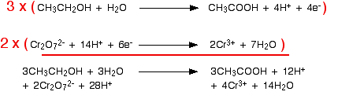
* The balanced full ionic equation thus the molar ratios.
* Calculated moles of ethanol (see above for mass ethanol) and oxidising agent to be used in the experiment.
* Mass of oxidising agent and minimum volume of sulphuric acid needed.

**Method**

* A labelled diagram of the experimental apparatus
* Step by step method referring to the diagram and quantities of reagents.
* 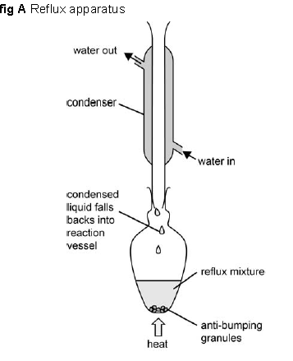How to purify the product.
* A chemical test on the product.
* Safety precautions you would take.

1. Make up the acidified dichromate solution by dissolving the 11.1g in at least 25.00 cm3 6M H2SO4, perhaps adding a little more distilled water to aid dissolving.
2. Mix 2cm3 of ethanol with 5 cm3 of water.
3. Place in pear shaped flask. Place in ice bath
4. Set up the apparatus for reflux (see fig A)
5. Using a pipette slowly add the acidified dichromate solution down the reflux condenser
6. Using a micro burner heat the solution so that it refluxs for approx. 15 min
7. 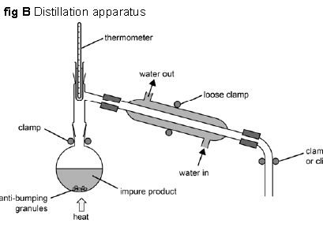Allow the equipment to cool and collect your sample for distilling and testing.
8. Gently distill off the pure ethanoic acid between 116-120 (B.P = 391 K = 118 Celcius).
9. Test the product by adding e.g. sodium hydrogen carbonate or sodium carbonate solution. You should see fizzing.

**3. Hydrolysis of a nitrile RC≡N**

Reagents: dilute HCl (water plus H+ catalyst), Nitrile

Conditions: heat under reflux

Equation with ethane nitrile (using displayed formulae)



+ 2H2O 🡪 + NH3

If heated under reflux with dilute alkali the carboxylate salt is formed:-

CH3CN + OH- + H2O 🡪 CH3COO- + NH3

ethanoate ion

This is then treated with a strong acid to release the carboxylic acid:-

CH3COO- + H+ 🡪 CH3COOH

Write an equation for the reaction of the hydroxynitrile CH3CH(OH)CN with dilute acid.



+ HCl + 2H2O 🡪 + NH4Cl



lactic acid

**4. Hydrolysis of an amide.**

This will be covered in both “organic nitrogen compounds” and “polymers and proteins”.

**5. Hydrolysis of an ester**.

See later pages in this pack.

**6. The Iodoform reaction**.

See previous pack “Carbonyl Compounds”

**Acidity of carboxylic acids**

Write out the reactions between

1. ethanoic acid and sodium: CH3CO2H(l) + Na 🡪 CH3COO-Na+ + ½ H2(g)

……………………………………………………………………………………………...........

1. propanoic acid and potassium hydroxide: CH3CH2CO2H (l) + KOH(aq) 🡪 CH3CH2COO-K+ (aq) + H2O

…………………………………………………………………………………………………...

1. methanoic acid and sodium carbonate:

2H2COOH + Na2CO3 🡪 2H2COO-Na+ + CO2 + H2O

1. ethanoic acid and sodium hydrogencarbonate:

CH3COOH + NaHCO3 🡪 CH3CO O–Na+ + H2O + CO2

* Weak acids when compared to nitric, sulphuric and hydrochloric acids.
* Stronger acids than alcohols, which are considered to be neutral.
* Take part in typical acid reactions – with metals, carbonates and bases to form salts.
* Salts formed from carboxylic acids are known as carboxylates.
* The -OH group of a carboxylic acid **dissociates** in water to form hydrogen ions and carboxylate ions:-



+ H2O + H3O+ (aq)

Although the **carboxylate ion** is drawn with one short double bond and one longer single bond, X-ray diffraction studies show that the two carbon-oxygen bond lengths are identical.

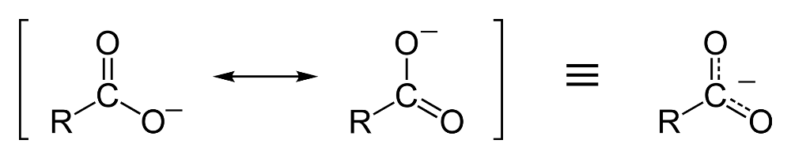The negative charge in this structure is said to be …………… This ………….makes it **more stable** and less likely to become protonated again.

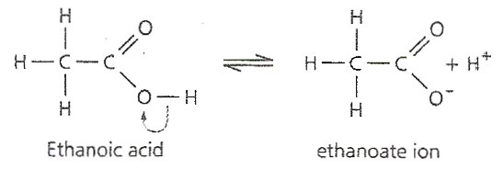The reason why carboxylic acids are more acidic than alcohols is as follows. In addition to the …………………the C=O group pulls electrons away from the –OH group making the H atom more +. The equilibrium is shifted further to the right compared to their corresponding alcohols, favouring the deprotonated salt.

The R- group in R-COOH can **change the strength** of the carboxylic acid. Draw the skeletal formulae of the following molecules that have been put in order of increasing acidity.

|  |  |  |  |  |  |
| --- | --- | --- | --- | --- | --- |
| CH3COOH | C6H5COOH | HCOOH | CH2ClCOOH | CHCl2COOH | CCl3COOH |
|  |  |  |  |  |  |

Explain the increase in acidity of ethanoic 🡪 benzoic🡪 methanoic acids

Ethanoic acid group is the most electron donating, phenyl group medium, H atom least (only 1 electron) therefore ethanoic acid donates electrons to COOH increased charge density 🡪 favours acceptance of H+ proton 🡪 ethanoic acid least acidic.

Explain the increase in acidity of chloroethanoic 🡪 dichloroethanoic 🡪 trichloroethanoic acids.

**Worksheet**Cl substituents are electronegative and withdraw electrons 🡪 decreased charge density on COOH 🡪 favours ionisation 🡪 stronger acid.

**Reducing Carboxylic Acids**

In a similar way to the reduction of aldehydes and ketones, carboxylic acids can be reduced to alcohols. The reducing agent is:-

LiAlH4(s) lithium aluminium hydride (tetrahydridoaluminate(III))

This must be used in a solution of dry ether (ethoxyethane), as it will hydrolyse in water.

* Initially, AlH4- acts as a source of **H- ions which will act as a nucleophile**, attacking the +C in the carboxyl group; a series of reactions then takes place.
* The final product is released by warming with dilute HCl (hydrolysis).

Complete the (simplified) equation for the reduction of ethanoic acid:-

CH3COOH + [4H] 🡪 CH3CH2OH + H2O

ethanoic acid ethanol

Note: Carboxylic acids are **not reduced by H2 and a Pt catalyst (unlike alkenes).**

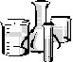**Testing Carboxylic acids:-**

|  |  |  |
| --- | --- | --- |
| **Method** | **Observations** | **Deductions** |
| **TESTS FOR AN ACID**   * 1. To a 1cm3 of **dilute** ethanoic acid, add a small quantity of a solid carbonate (e.g. CaCO3).   CORROSIVE  Equation for reaction:  ethanoic acid  conc. sulfuric acid  sodium hydroxide  Collect the gas evolved into a teat pipette and bubble through a small volume of fresh lime-water. | **Effervescence**  Test tube became warm  2CH3COOH + CaCO3 🡪 (CH3COO-)2Ca2+ + H2O + CO2  **Lime water 🡪 white ppt** | Gas evolved  Exothermic  Limewater 🡪 ppt of CaCO3  So gas was **CO2**  **Acid present** |
| * 1. To a 1cm3 of **glacial** ethanoic acid, add 1cm3 ethanol and 2 drops conc. sulfuric acid. Warm in a water bath then tip onto a saturated solution of Na2CO3 in a small beaker. Smell cautiously.   Equation for reaction: | Exothermic before heating,  effervescence on pouring onto Na2CO3  **fruity smell**  CH3COOH + CH3CH2OH 🡪CH3COOCH2CH3 + H2O  Ethyl ethanoate | Exothermic due to adding conc H2SO4 to aqueous solutions  Effervescence as acids are neutralised  **Esters smell sweet/fruity**  **Ester formed from reaction of carboxylic acid and alcohol**  **So carboxylic acid present** |
| * 1. The following reaction is **not a test** but a useful reaction to know.   To 10 drops **dilute** ethanoic acid add NaOH(aq) drop by drop to excess. Describe the CHANGE in smell.  Equation for reaction:  Evaporate to dryness cautiously. Describe the appearance of the substance left and identify it. | Exothermic  Vinegar smell disappears  CH3COOH + NaOH 🡪 CH3COO-Na+ + H2O  Sodium ethanoate produced  If evaporated to dryness a white solid remains  If HCl added 🡪 vinegar smell  CH3COO-Na+ + HCl 🡪 CH3COOH + NaCl | Enthalpy of neutralisation is exothermic.  Ethanoic acid has reacted  HCl is a stronger acid than ethanoic so protonates the anion |



|  |  |
| --- | --- |
| Method | |
| CORROSIVE  **TEST FOR THE -OH GROUP**  **Working, in a fume cupboard with CARE**, put 1 cm3 concentrated (glacial) ethanoic acid into a test tube. Add a very small quantity of solid phosphorus pentachloride and **replace the stopper.**  Equation for the reaction:-  Collect the gas evolved into a teat pipette and bubble through a small volume of silver nitrate solution.  Equation for the reaction:  Open a bottle of strong ammonia solution and allow the fumes to mingle with those from the experimental mixture.  Equation for the reaction: | |
| Observations  PCl5 pale yellow solid  Added to **dry sample**  Effervescence, exothermic, **steamy fumes** evolved  CH3COOH +PCl5🡪CH3COCl + HCl(g) + POCl3  ethanoyl chloride  **Silver nitrate formed white ppt.**  Ag+(aq) + Cl-(aq) 🡪 AgCl(s)  **White smoke produced**  NH3(g) + HClg 🡪 NH4Cl(s) | **Deductions**  Gas evolved  Possibly HCl(g)  Ppt of **AgCl**  So gas was **HCl**  NH4Cl(s) produced so gas was HCl(g)  So **-OH group present**  **could be water, alcohol or carboxylic acid.** |

**Acyl chlorides**

**Making Acyl Chlorides from Carboxylic Acids**

[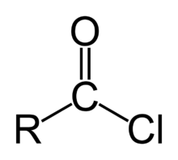](http://en.wikipedia.org/wiki/File:Acyl-chloride.png)If phosphorus(V) chloride (phosphorus pentachloride), PCl5, is added to an alcohol what do you see and what are the products? Include state symbols.

R-OH + PCl5 🡪RCl + POCl3 +HCl

Add PCl5 to a carboxylic acid and you make an acid chloride. Complete the equation, write observations below:

Acyl Chloride functional group

R-COOH + PCl5 🡪 R3COCl + POCl3 + HCl

* Acid chlorides are colourless, fuming liquids with pungent smells.
* They are soluble in several solvents, but react with water.
* They are **lachrymatory** (make eyes water and sting)

Complete the following table:

|  |  |  |  |
| --- | --- | --- | --- |
| **Name** | **Displayed formulae** | **Skeletal formulae** | |
| ethanoyl  chloride  CH3COCl |  |  |
| propanoyl  chloride  CH3CH2COCl |  |  |
| 2-methylbutanoyl chloride  CH3CH2CH(CH3)COCl |  |  |
| benzoyl chloride  C6H5COCl |  |  |
| hexane-1,6- dioyl chloride  ClOC(CH2)4COCl |  |  |

Methanoyl chloride is unstable at room temperature so is not included in the table

Suggest why they have higher boiling points than the corresponding alkane.

CH3COCl has more electrons than CH3CH3 so stronger London forces. Also CH3COCl has permanent dipole forces of attraction so require more heat energy to overcome them.

Do you think they would have higher or lower boiling points than the corresponding alcohol?

Give your reasons. Ethanol B.Pt = 78oC ethanoyl chloride B.Pt. = 51oC.

H-bonds in ethanol require more heat energy to overcome than the permanent dipole-permanent dipole forces between ethanoyl chloride molecules.

**Reactions of acyl chlorides/acid chlorides**

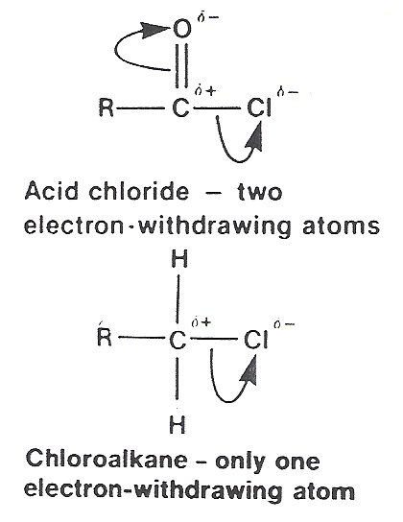Acid chlorides are **very reactive compounds**, (much more so than halogenoalkanes,) and they readily undergo nucleophilic attack because:-

* the C+ atom which is attacked by the nucleophile is in a planar environment and so is much more accessible.
* there are **two** electronegative atoms bonded to the C+, drawing electrons away from the C - Cl bond and weakening it.

MCj02131270000[1]

**e.g. Reactions of ethanoyl chloride**



Your teacher will demonstrate these reactions for you.

Reaction conditions for all are anhydrous conditions and room temp

Complete equations (using **displayed formulae**) for the following reactions, in each case giving, the state symbols, homologous series and the name of the organic product.

**Ethanoyl chloride + water.**

**Test:**- steamy fumes

blue litmus 🡪 red

+NH3 🡪 white smoke

+AgNO3 🡪 white ppt. AgCl

Conditions: anhydrous conditions and room temp





**:**

+ H2O 🡪 HCl(g)

+ H2O

Name of product ethanoic acid Homologous series:ethanoic acid

**Ethanoyl chloride + ethanol, CH3CH2OH,** **an alcohol.**

Conditions: anhydrous room temp



+

**:**

+ CH3CH2OH 🡪 + HCl

Product: Homologous series: Esters Name: ethyl ethanoate

**Acyl chloride + conc. ammonia**

reacts with excess ammonia to form NH4Cl white smoke

Conditions: anhydrous room temp



+

**:**

+ NH3 🡪 + HCl

white solid

Product: Homologous series: Amide Name: ethanamide

Excess ammonia results in:- HCl(g) + NH3(g) 🡪 NH4Cl(s)

**Acyl chloride + amine, e.g. ethylamine, C2H5NH2, a primary amine.**

Conditions:

+

**:**

+ C2H5NH2 🡪 + HCl

Product: Homologous series: N-substituted amide Name: N-ethyl ethanamide

**Acyl chlorides also react with benzene and phenol (see Aromatics pack)**

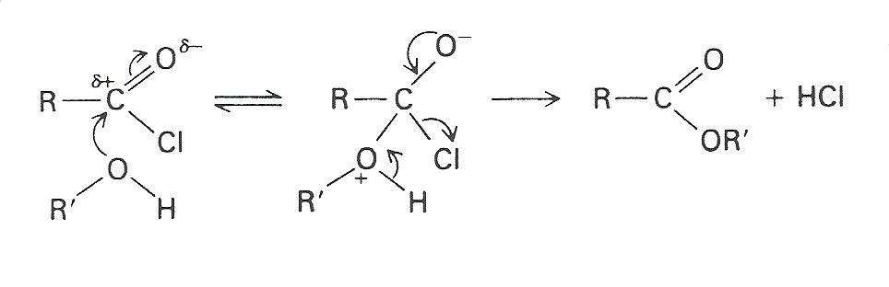***\*Extension work - mechanism***

Circle and correct the two errors in this mechanism

This is not specified on our syllabus but knowledge of the nucleophilic attack and elimination of HCl may help you deduce the product.

* The first step is the nucleophilic attack of the lone pair on the -OH group onto the C+ atom of the C+= O- group, the **addition** step.
* The second stage results in the **elimination** of a molecule of hydrogen chloride.
* The result is a **nucleophilic substitution** reaction
* The reaction is an example of **acylation**, the introduction of an RC=O group into an organic molecule or specifically, **ethanoylation** - the introduction of a CH3C=O group if the acid chloride is ethanoyl chloride

A general [Mechanism of the reaction with a nucleophile](http://www.chemguide.co.uk/mechanisms/addelim/whatis.html#top)

ESTERS

**Properties of esters**

* The esters are a group of volatile compounds. They do not form intermolecular hydrogen bonds and so their melting and boiling points are relatively low.
* They are soluble in organic solvents but despite being polar molecules they are immiscible with water. An important use of esters is as solvents, particularly in the manufacture of adhesives.
* One typical characteristic of the esters is a pleasant smell - esters are responsible for many of the scents of flowers and fruits that we and other animals find attractive. Synthetic esters are used in food flavourings and also in perfume manufacture.

**Naming esters**

Naming esters is straightforward. The alcohol group comes first as a prefix, for example 'propyl' from propanol, 'ethyl' from ethanol. etc. This is followed by the parent acid with the '-oic acid' replaced by '-oate' - ethanoate from ethanoic acid, propanoate from propanoic acid, etc. See below. The parent acid part of the molecule can be identified as the part carrying the -COO group.

E.g. Ethyl propanoate



Acyl Group derived from the carboxylic acid, gives ‘propanoate’

'ethyl' derived from the alcohol

Give the name of: -

|  |  |
| --- | --- |
| HCOOC2H5 | ethyl methanoate |
| C2H5COOCH3 | methyl propanoate |
| C6H5COOCH3 | methyl benzoate |

Write structural and displayed formulae for:

|  |  |  |  |
| --- | --- | --- | --- |
| propyl ethanoate | ethyl ethanoate | pentyl butanoate | phenyl benzoate |
|  |  |  | You do not need to show the H atoms on the benzene ring in a displayed formula |
| Structural  CH3COOCH2CH2CH3 | CH3COOCH2CH3 | CH3(CH2)2COO(CH2)4CH3 | C6H5COOC6H5 |

**Preparation of an ester - esterification**

**Carboxylic acid + alcohol** are **warmed under reflux** with a few drops of conc. **H2SO4 catalyst**.

CH3COOH + CH3CH2OH ⇌ CH3COOCH2CH3 + H2O

Draw out the displayed formulae. [An animation](http://www.ausetute.com.au/images/esterifi.swf) to show the process.

* The conc. H2SO4 is a **catalyst** and protonates the carboxylic acid:-

**1)** protonation of the acid







H+

+

**3)** a series of steps results in the ester

**4)** note the bridging O atom came from the alcohol

**2)** Nucleophilic attack by lone pair on O atom of alcohol





* This is an **equilibrium reaction** and so the yield is often poor. Conc. H2SO4 is also a dehydrating agent and helps to shift the equilibrium to the right hand side.

From an alcohol and an acyl chloride

This reaction is performed at room temperature and results in a **higher yield** as it is goes to completion (i.e.it is not a reversible reaction like the reaction of acid + alcohol above)

Name the reactants and products and draw out the displayed formulae.

CH3COCl + HOCH2CH2CH3 🡪 CH3COOCH2CH2CH3 + HCl

ethanoyl chloride propan-1-ol propyl ethanoate hydrogen chloride



+

 + 🡪 +

**:**

Why does this reaction need to be performed under anhydrous conditions?

Lone pair of electrons on H2O: act as a nucleophile attacking +C 🡪 CH3COOH

**ESTERIFICATION (ester formation)**

Glacial ethanoic acid

Sulfuric acid



CORROSIVE

ethanol

ethyl ethanoate



HIGHLY FLAMMABLE

|  |  |  |
| --- | --- | --- |
| METHOD | OBSERVATIONS | INFERENCE |
| Put 10 drops of ethanol in a test tube. Add 10 drops glacial ethanoic acid and 5 drops concentrated sulphuric acid.  Warm in a water bath for 5 min.  Pour carefully into sodium carbonate solution and smell cautiously.  Comment on the function of the concentrated sulphuric acid and the sodium carbonate.  Write an equation for the formation of the ester and name it. | **Smells of nail polish remover**  Forms a layer on the surface of Na2CO3.  Effervescence  Conc.H2SO4 acts as a catalyst  also protonates the ethanoic acid.  acts as dehydrating agent shifting equilibrium 🡪 ester.  Sodium carbonate reacts with excess acid before you smell the ester  CH3COOH + HOCH2CH3 🡪 | Ester formed so carboxylic acid and alcohol must have been present  Esters are insoluble in water  CO2 released from Na2CO3  2H+ + CO32- 🡪 H2O + CO2  CH3COOCH2CH3 + H2O  ethylethanoate |
| Put 10 drops of methanol in a test tube. Add a small quantity of 2-hydroxybenzoic acid and 5 drops concentrated sulphuric acid.  Warm in a water bath for 5 min.  Pour carefully into sodium carbonate solution and smell cautiously.  Write an equation for the formation of the ester that is known as ‘oil of wintergreen’.  What is its systematic name? | 2-hydroxybenzoic acid is a solid.  Smells of ‘deep heat’, oil of wintergreen    + HOCH3 🡪 | Strong London forces and H bonding  Ester formed so carboxylic acid and alcohol must have been present  + H2O  methyl 2-hydroxybenzoate |

Do their smells live up to the predictions and expectations!– see a list of [odours and flavourings based on esters](http://en.wikipedia.org/wiki/Ester)

Small quantities of esters can be prepared in a test tube by the method on the previous page.

This method is also used to **determine the nature of an unknown organic compound** – if an ester is formed you know that you were reacting a carboxylic acid with an alcohol.

Many esters have **sweet** or **fruity** smells and are found in nature e.g. the smells of apples and pears are due to esters. A wide variety of esters can be made by reacting carboxylic acids with alcohols – many of these have distinctive smells and are used in food and perfumes – for a [list of flavourings](http://en.wikipedia.org/wiki/Ester).

Larger quantities of esters are prepared in quick-fit apparatus.

Look at the [animation](http://www.ausetute.com.au/images/esterifi.swf) again this also gives practical information on the preparation of an ester.

Read the [method for preparing ethyl ethanoate](http://www.rod.beavon.clara.net/ethanoic_prep.htm) including purification and separation of the ester.

Why are esterification reactions a type of condensation reaction? Two molecules are joined by a covalent bond with the elimination of a small molecule, water.

**Reactions of esters**

**Hydrolysis** is a chemical reaction in which water reacts with a compound to produce other compounds; it involves the splitting of a bond and the addition of the hydrogen cation and the hydroxide anion from the water.

Hydrolysis is the opposite of esterification:-

hydrolysis

Ester + water carboxylic acid + alcohol

esterification

**Hydrolysis with an acid**

The **dilute acid acts as a catalyst** in this reversible reaction:-

CH3CH2COOCH3 + H2O **⇌** CH3CH2COOH + CH3OH

methyl propanoate water propanoic acid methanol

Name the reactants and products.

Draw the displayed formula for the reaction between ethyl propanoate and water in the presence of a dilute acid:





+ H2O **⇌** +

**Hydrolysis with dilute alkali**

This reaction goes to completion resulting in a good yield of salt and alcohol.

CH3COOCH2CH3 + NaOH(aq) **🡪** CH3COO–Na+ + HOCH2CH3

ethyl ethanoate sodium hydroxide sodium ethanoate ethanol

Name the reactants and products.

If the organic acid is required, the solution is cooled and excess dilute strong acid (e.g. HCl) is added.

CH3COONa + HCl(aq) 🡪 CH3COOH + NaCl

Draw the displayed formula for the reaction between propyl methanoate and sodium hydroxide.





+ NaOH **🡪** +

How do the two hydrolysis reactions differ?

With acid it is an equilibrium reaction producing acid and alcohol

With alkali the reaction goes to completion producing the sodium salt and alcohol.

**\*Additional practical: Soap manufacture**

Ref <http://www.chemguide.co.uk/organicprops/esters/hydrolysis.html#top>

**Saponification**, a process by which triglycerides are hydrolysed with sodium or potassium hydroxide to produce glycerol and fatty acid salts, called 'soap'.

Lipids that contain fatty acid ester linkages can undergo hydrolysis. This reaction is catalyzed by a strong acid or base. Saponification is the alkaline hydrolysis of the fatty acid esters.

Fat + NaOH or KOH Glycerol + Crude Soap

saponification

Complete the **saponification equation** below using the alkaline hydrolysis of esters section to help you.





+ 3NaOH 🡪2C17H35COO-Na+ + C17H31COO-Na+ +

Why are alkalis used to hydrolyse the fats rather than acids?

Reaction goes to completion resulting in the fatty acid salts rather than the equilibrium mixture with acid hydrolysis The sodium or potassium salts of the fatty acids are collected and refined further to make the soap.

A [brief outline](http://chemistry.about.com/library/weekly/blsapon.htm) of the method is given. You only need to know the saponification equation.

What other product is produced? glycerol (Used in moisturisers)

**Method to make soap**



CORROSIVE

* Put 2 cm3 of castor oil in a small beaker and add 10 cm3 5M sodium hydroxide solution.

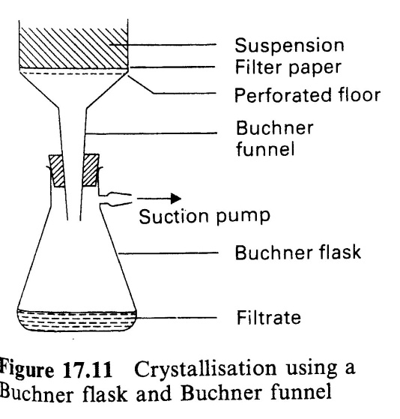

Soap suspension

Sodium hydroxide

* Warm the mixture, stirring with a glass rod until it boils for a few minutes
* Add about 10 cm3 of distilled water and 6 spatula measures of salt (NaCl)
* Bring back to boiling, stirring throughout.
* Allow to cool while stirring. The soap should come out of solution.
* Filter off the soap under reduced pressure using a Buchner funnel and flask
* Wash with a little distilled water while still on the filter and suck dry.
* Test your soap by putting a little in a test tube of distilled water and shaking. A lather should result. **DO NOT TEST IT ON YOUR SKIN** as some sodium hydroxide remains.

**Polyesters**

**Esterification**

When a carboxylic acid is mixed with an alcohol (in the presence of concentrated sulphuric acid which acts as a catalyst,) an **ester** is formed: -

1) Make a model of a molecule of ethanol, an alcohol.

2) Make a model of a molecule of ethanoic acid, a carboxylic acid

3) Remove a hydrogen atom from the ethanol and an OH group from the carboxylic acid (this is very precise) to form a molecule of water. Consider carefully how the remaining fragments will bond together and construct the ester molecule as shown in the equation below:



+ + H2O

Ethanoic acid ethanol ethyl ethanoate ester

This is an example of a **condensation reaction** because two organic molecules have reacted together to form a larger molecule with the elimination of a smaller molecule, water.

The dynamic equilibrium sign indicates that there is continual interchange between reactants and products and that the reaction does not go to completion.

The alcohols and carboxylic acids used to make A-B- polymers have **reactive functional groups in two places** in their molecules: -

4) Make a molecule of an alcohol with two -OH groups, ethan-1,2-diol.



5) Make a molecule of a carboxylic acid with two -COOH groups, hexan-1,6-dioic acid



6) Working in teams of three or four, set out your molecules into the A-B-A-B- format. Eliminate molecules of water between each end of each pair of molecules and thus construct a short unit of a **polyester**, which is a **condensation polymer**.

Draw two repeating units of this polymer: -

**n

**

**Poly(ethylene terephthalate) PET ‘Terylene’** <http://www.ausetute.com.au/images/polymeri.swf> and look at the condensation polymerisation

<http://employees.oneonta.edu/viningwj/modules/CI_polyester_formation_11_10.swf> and look at this animation and answer the questions that follow it.

**Terylene** or **PET** is produced by using benzene-1,4-dicarboxylic acid instead of hexan-1,6-dioic acid. Draw molecules of. -

benzene-1,4-dicarboxylic acid ethan- 1,2-diol

(terephthalic acid)



Draw two repeating units of this polymer.



When drawn into fibres it is usually referred to as a polyester e.g. ‘Terylene’. It is used extensively in clothing and fabrics. It is hardwearing and crease resistant. Polyesters are excellent thermal insulators and are used in synthetic duvets. PET is the same polymer and can be extruded into different shapes and is used to make drinks bottles. Polyesters are non-biodegradable so rather than going to landfill, drinks bottles are now recycled and used to make fleeces!

***Extension:-***

**Homopolymeric esters**

Homopolymer is made from a single type of monomer

The monomer must have a group at one end of the molecule that can react with a group at the other end of the molecule.

Polylactic acid

The monomer is produced by bacterial fermentation.

Draw out a repeating unit of the polymer made from lactic acid





The polymer is biodegradable but is not as strong as Terylene.

Optional demonstration of ‘Polymerisation of lactic acid.’

Biopol another biodegradable polymer used to make disposable cutlery

Draw out the repeat unit of the polymer

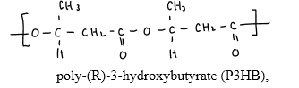

n

3-hydroxybutanoate

Make revision page (See page 2 for help)

**Q1.**Which of the following methods may be used **in a single step** to make carboxylic acids?

   A     Hydrolysis of an ester with an alkali.

   **B**     Reaction of acidified potassium manganate(VII) with an alkene.

**   C     Hydrolysis of a nitrile with hydrochloric acid**.

   **D**     Reaction of an acyl chloride with ammonia.

**(Total for question = 1 mark)**

**Q2.**This question is about butanoic acid, CH3CH2CH2COOH.

(a)  Some reactions involving butanoic acid are shown below.

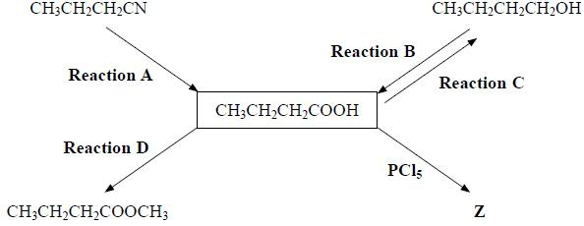

(i)  What type of reaction is **Reaction A**?

Hydrolysis

(ii)  Identify, by name or formula, the reagent which is used with sulfuric acid to carry out **Reaction B**.

**(1)**

K2Cr2O7 / Na2Cr2O7 Potassium Dichromate VI / Sodium Dichromate VI

(iii)  What reagent is used in **Reaction C**?.

**(1)**

LiAlH4 Lithium Aluminium Hydride (in dry ether)

(v)  Write the **displayed** formula for **Z**, the organic product of the reaction of butanoic acid with phosphorus(V) chloride, PCl5.

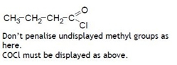**(1)**

**Q3.**The carboxylic acid, propanoic acid, can be prepared by oxidation of the alcohol, propan-1-ol.

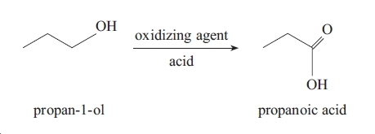

(a) (i) Identify a suitable oxidizing agent you could use in this reaction.

K2Cr2O7 / Na2Cr2O7 Potassium Dichromate VI / Sodium Dichromate VI and Sulfuric Acid H2SO4

**(1)**

(ii) If you carried out this preparation in the laboratory, describe **two** measures you would take to ensure the maximum possible yield of propanoic acid is obtained.

**(2)**

1) Heat under reflux

2) Use excess oxidising agent

(iii) Propanoic acid can be made by a reaction with a nitrile. Give the structural  
formula of the nitrile and write an equation for this reaction.

**(3)**

Structural formula

CH3CH2CN

Equation



**Q4.**Citric acid is found in lemon juice.  
  
 The structure and formula of citric acid are shown below.

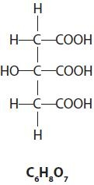

(a)  In the presence of a small amount of moisture, citric acid reacts with sodium hydrogencarbonate as shown in the equation below.



Use the structural formula of citric acid to explain why one mole of citric acid neutralizes three moles of sodium hydrogencarbonate.

**(1)**

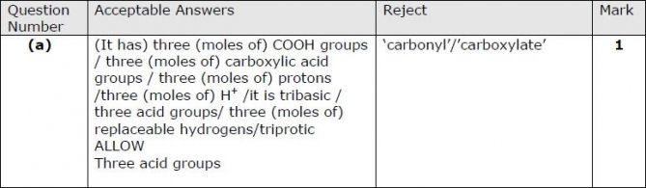

**Q5.**This question is about the reactions of butanoic acid, CH3CH2CH2COOH. It has a foul smell and behaves like a typical carboxylic acid.

(a)  (i)  The addition of sodium carbonate solution is often used as a chemical test to distinguish carboxylic acids, like butanoic acid, from other compounds, such as aldehydes.

Explain why old stocks of aldehydes often react with sodium carbonate solution.

**(1)**

Aldehydes often contain carboxylic acid formed by oxidation (by the oxygen in the air)

(ii)  How would the result of this test distinguish between a carboxylic acid and an old stock of an aldehyde?

**(1)**

A larger volume of sodium carbonate solution is neutralised/ A larger volume of carbon dioxide is formed.

(iii)  Write the balanced chemical equation, including state symbols, for the reaction of sodium carbonate solution with butanoic acid.

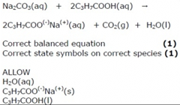

**(2)**

(c)  (i)  What would you see when phosphorus pentachloride, PCl5, reacts with butanoic acid?

Steamy fumes (HCl)

**(1)**

(ii)  Give the structural formula and name of the organic product of this reaction.

**(2)**

Structural formula

CH3CH2CH2CHOCl  
  
  
  
Name

Butanoyl chloride

(d)  (i)  Give the name or formula of the organic product of the reaction between butanoic acid and lithium tetrahydridoaluminate (lithium aluminium hydride).

**(1)**

Butan-1-ol or CH3CH2CH2CH2OH

Do not write in the margin

**1.** Which one of the following organic compounds does **not** exist?

**A** an ester which is a structural isomer of a carboxylic acid C3H6O2

**B** a carboxylic acid which is a structural isomer of an ester C2H4O2

**C** an aldehyde which is a structural isomer of a ketone C3H6O

**D** a ketone which is a structural isomer of an aldehyde C2H4O **√**

**(Total 1 mark)**

2. Name and draw out displayed formulae of the following

1. CH3CHClCOCl

2-chloropropanoyl chloride

1. C2H5COCH(CH3)2

2-propyl propanoate

1. CH3CH2COONa

sodium propanoate

 d) glycerol structure IUPAC name

propan-1,2,3-triol

Total 8 marks

**3.** This question concerns the formation of a polymer.

(a) Which one of the following is a possible formula of the repeat unit of a polymer formed from ethane-1,2-diol and benzene-1,4-dicarboxylic acid.



A

B



(1)

C **√**

D

(b) What type of reaction is this?

**A** addition

**B** condensation **√**

**C** dehydration

**D** neutralisation

(1)

(Total 2 marks)

Do not write in the margin

SP.4.11

SP.4.15

4.. This question is about the pineapple flavouring used in sweets. It is an ester with the formula C3H7COOCH3, which can be broken down into butanoic acid and methanol when mixed with hydrochloric acid.

The following equilibrium is set up:

C3H7COOCH3 (l) + H2O(l)  C3H7COOH(l) + CH3OH(l)

(a) Give the name of this ester.

methyl butanoate

**(1)**

(b) Why does the ester have a comparatively low boiling point compared to the other three substances in the equation?

the other three substances can form  
**intermolecular** hydrogen bonds with themselves but the ester cannot.

Reject Discussion of London Forces.

**(1)**

(c) What is the name given to this type of reaction?

Hydrolysis.

**(1)**

(d) Suggest the reasons why manufacturers choose to use the chemically manufactured pineapple flavouring rather than the natural product and why consumers might prefer to choose the natural product.

QWC

Must cover advantages and disadvantages. Must **not** be contradictory

**Advantages to manufacturers: (any two)**

• not dependent on weather, seasons etc

• consistent taste /concentration/more consistent

• quality

• or alternative ideas

**Disadvantages to consumers : (any two)**

• some people put off by ‘non-natural’ food

• may not taste the same as natural product which may contain  
other impurities

• unable to describe the product as organic

or alternative ideas

Reject cost with no justification

**(4)**

Total 7 marks

Do not write in the margin

SP.4.16

**5.** (b) Chloroethanoic acid, CH2ClCO2H, reacts with methanol, CH3OH, in the presence of a sulphuric acid catalyst.

(i) Draw the **displayed** formula and give the name of the **organic** product formed.

Displayed Formula



ester group **(1)**rest of molecule **(1)** dependent on first mark  
(must be fully displayed)

Name methyl chloroethanoate **(1)**

(3)

(ii) What name is given to the functional group formed in this organic product?

ester(s).

(1)

(iii) What type of reagent is methanol in this reaction? Explain why it is able to behave in this way and describe how it attacks the chloroethanoic acid.  
You may find it helpful to draw a diagram.

nucleophile, **(1)**

as it has a lone pair (of electrons) on the (hydroxyl) oxygen **(1)**

which can attack the **positive carbonyl carbon** on the acid **(1)**

2nd and 3rd marks could be obtained by use of a diagram

Reject attack by CH3O–

(3)

(iv) How would you convert the organic product of the reaction between chloroethanoic acid and methanol back into the original compounds?

(reflux) heat with NaOH(aq) **(1)**(cool) and add HCl(aq) **(1)**

OR  
reflux **(1)** [must be in context]  
with HCl **(1)**

(2)

(Total 9 marks)

Do not write in the margin

S07N.4.Q4

X and Y are isomers with the molecular formula C7H6O2.

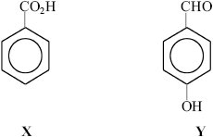

(a) Complete the table with the **observations** you would make when separate samples of **X** and **Y** are warmed gently in test-tubes with the following solutions.

|  |  |  |
| --- | --- | --- |
| Solution | Observation with **X** | Observation with **Y** |
| sodium carbonate | fizzing/ effervescence/ bubbles **(1)** | no reaction / no bubbles **(1)** |
| Brady’s reagent (2,4-dinitrophenylhydrazine) | no change/ (stays) yellow/orange **(1)** | yellow /orange / orange-red or yellow-orange **precipitate /** (crystalline) solid **(1)** |
| potassium dichromate(VI) + sulphuric acid | no change /(stays) orange **(1)** | Goes from orange to green/ brownish green/dull green **(1)** |

(6)

(b) Both **X** and **Y** can take part in reactions in which esters are formed.

(i) Complete the structural formula of the ester which forms when **X** reacts with methanol.

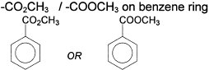

(1)

Do not write in the margin

S04N.4.Q1

(ii) Y reacts with ethanoyl chloride to form an ester.

Draw the displayed formula of ethanoyl chloride.



(1)

(iii) Complete the displayed formula of the ester which forms when **Y** reacts with ethanoyl chloride.

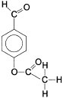(iii) Complete the displayed formula of the ester which forms when **Y** reacts with ethanoyl chloride.

Undisplayed ester + unchanged – CHO (1)  
Correctly displayed for both groups (1) (2)

(iv) When **X** forms an ester with methanol, a catalyst is needed for the reaction to proceed at a reasonable speed when heated gently.

Name a suitable catalyst for the esterification reaction.

sulphuric acid / hydrochloric acid..

(1)

(v) Explain why ethanoyl chloride is reactive enough to form an ester with **Y** at a reasonable speed without a catalyst and without heating.

Cl (and O) electronegative/electron withdrawing **(1)**So C+ is more/ very susceptible to nucleophilic attack/ more +/  
more electrophilic **(1)**.

(2)

Do not write in the margin

(c) Oxidation of Y produces terephthalic acid.



1. What is the systematic name of this molecule? benzene-1,4-dicarboxylic acid

(1)

(ii) Draw out the displayed of ethane-1,2-diol,



(1)

(iii) These two molecules can polymerise. Draw out the displayed structure of two repeating units of the resulting polymer.



n

(2)

(iv) What type of polymerisation is this? condensation

(1)

(v) Give two uses of this polymer and explain why it is suitable in each case.

Clothing – can be drawn into fibres which are strong

Plastic bottles, strong lightweight and impact resistant

(2)

(vi) Suggest, with reasoning, whether a laboratory coat made from a polyester might be damaged by a spillage on it of hot concentrated aqueous sodium hydroxide solution.

Yes, hot conc.alkali would hydrolyse the ester bonds

Resulting in holes in the labcoat.

(2)

Total 22 marks

Modified section

**NAME ...........................……... HOMEWORK DEADLINE .....................**

**Student Number ………… Chemistry Class ………**

Student targets from **previous pack**

Carboxylic acids

|  |  |
| --- | --- |
| **Task** | Mark |
| Notes | /10 |
| Final questions | /68  = % |
| Revision Notes /Summary page | /10 |
| Overall Grade for this work | A B C D E U |

Student comments

Tutor comments

Tutor signature Date

Student targets for **next pack**