**EVALUATION (4 marks)**

The appraisal is your conclusion to the project. It looks at how well your system performs compared to the original objectives as well as any possible extensions. Your appraisal is supported by user feedback which should be a full evaluation of the system.

|  |
| --- |
| **Do the outcomes meet the objectives?** |
| Page  **Guidance** Done No   1. Critical appraisal  ……   You should start by writing a critical appraisal of how well you have met the objectives of the system. Look at the following factors in your appraisal:   * + Effectiveness of the system in meeting the end-user’s needs   + Ease of development   + Ease of maintainability   + Cost of development and maintainability   An important part of the appraisal is to look at the reasons why the initial system objectives have not been met. |
|  |

|  |
| --- |
| **Possible extensions** |
| Page  **Guidance** Done No  87. Activity: System extensions  …… List some of the existing areas of the system that could be  improved and state how these improvements could be made. Remember to try to be realistic and specific in these suggestions. If possible, show evidence from the system of where the extensions would take place, e.g. a screenshot of a menu space where additional menus can be added. |
|  |

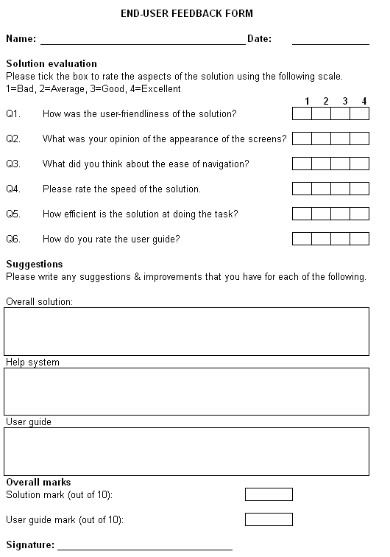

**Independent feedback**

**Guidance**

Page

Done No

88. Activity: User feedback

As a final part to your appraisal, try to obtain some form of user feedback. At its simplest, this should be a questionnaire similar to the one below.

❑

……

Note: You should include specific questions about each part

of the system so that the user can provide detailed feedback.