
PHP and MySQL
F16a.2756

For A Level and Projects

Update v1.1, 15 July 2008

Daren CradDock



ict@zigzageducation.co.uk
POD 2756
www.zigzageducation.co.uk


ZigZag is a large community of over 4000 teachers & educationalists
Review new titles or publish your own work

Fancy being involved? Then register at…
www.publishmenow.co.uk
The Professional Publishing Community

Alternatively email new resource ideas directly to…
publishmenow@zigzageducation.co.uk

Contents
Thank You for Choosing ZigZag Education ii
Teacher Feedback Opportunity iii
Terms and Conditions of Use iv
Teacher’s Introduction 1
Chapter 1 – Introduction 2
Chapter 2 – What are PHP and MySQL 4
Chapter 3 – Getting Ready to Learn PHP and MySQL 6
Chapter 4 – Syntax 11
Chapter 5 – Variables and Constants 17
Chapter 6 – Strings 23
Chapter 7 – Operators 31
Chapter 8 – If … Else 34
Chapter 9 – Looping 42
Chapter 10 – Arrays 47
Chapter 11 – Forms 51
Chapter 12 – PHP Date Functions 57
Chapter 13 – Functions (User Defined) 62
Chapter 14 – Session Variables 67
Chapter 15 – Cookies 71
Chapter 16 – Files 76
Chapter 17 – Uploading Files 84
Chapter 18 – Email 92
Chapter 19 – MySQL Databases 100
Chapter 20 – A Simple Database – Driven Website 127
Appendices 180
Appendix A 180
Appendix B 181
Appendix C 183
Appendix D 184

Thank You for Choosing ZigZag Education
Thank You
for choosing ZigZag Education!
ZigZag is a large community of over 4000 teachers & educationalists

Become a writer or reviewer; we would love to hear from you!
Fancy being involved? Then register at…
www.publishmenow.co.uk
The Professional Publishing Community

Talk to Us!

◉ Found a problem?
We will fix it and send you a free updated copy

◉ Got a suggestion?
If your improvement leads to an update we will send you a new copy for free

♥ Love it as it is?
Let the author and other teachers know what you think


We ♥ your feedback – let us know what you think using the feedback sheet on the next page
£10 ZigZag Voucher for detailed & complete reviews

More resources available from
www.zigzageducation.co.uk
Preview every page online before you buy


0117 950 3199
Real Person
ZigZag Education
Unit 3, Greenway Business Centre
Doncaster Road
Bristol
BS10 5PY

0117 959 1695
Fax


www.
zigzageducation
.co.uk

Teacher Feedback Opportunity
Teacher Feedback Opportunity




£10 ZigZag Voucher for detailed & complete reviews!
Use for problems/areas for improvement/positive feedback

Resource ID & name | 2756 PHP and MySQL for A Level Projects | Your Name
School Name |  | Your Position

Overall, what did you think about this resource?

I particularly like this resource because…

How does it help you or your students?

It is better than some other resources because…

What might you say to a colleague in a neighbouring school to persuade them to use this resource?

How well does it match your specification (& which specification is this)?

Other comments, suggestions for improvements, errors found (please give page numbers) etc.

Resources I would like published:

Resources I might write, or have written, for consideration for publication:

INTERNAL USE ONLY
Feedback logged: ✓◻
Complete & detailed: Y /N
If detailed, £10 sent: ✓◻

fax 0117 959 1695  email feedback@ZigZagEducation.co.uk

post ZigZag Education, Unit 3, Greenway Business Centre, Doncaster Road, Bristol BS10 5PY

Terms and Conditions of Use

Terms and Conditions

Please note that the Terms and Conditions of this resource include point 5.8, which states:

“You acknowledge that you rely on your own skill and judgement in determining the suitability of the Goods for any particular purpose.“

“We do not warrant: that any of the Goods are suitable for any particular purpose (e.g. any particular qualification), or the results that may be obtained from the use of any publication, or expected exam grades, or that we are affiliated with any educational institution, or that any publication is authorised by, associated with, sponsored by or endorsed by any educational institution.”

Copyright information
Every effort is made to ensure that the information provided in this publication is accurate and up to date but no legal responsibility is accepted for any errors, omissions or misleading statements. It is ZigZag Education’s policy to obtain permission for any copyright material in their publications. The publishers will be glad to make suitable arrangements with any copyright holders whom it has not been possible to contact.

Students and teachers may not use any material or content contained herein and incorporate it into a body of work without referencing/acknowledging the source of the material (“Plagiarism”).

Disclaimers
Links to other websites, and contextual links are provided where appropriate in ZigZag Education publications. ZigZag Education is not responsible for information on sites that it does not manage, nor can we guarantee, represent or warrant that the content contained in the sites is accurate, legal and inoffensive, nor should a website address or the inclusion of a hyperlink be taken to mean endorsement by ZigZag Education of the site to which it points.

It is the teacher’s own responsibility to assess the suitability of publications for use in their school. ZigZag Education is not affiliated with DfES, Edexcel, OCR, AQA, WJEC or CCEA in any way nor is this publication authorised by, associated with, sponsored by or endorsed by these institutions unless explicitly stated on the front cover of this publication.

Teacher’s Introduction

You will find this resource useful if:
• You teach A Level Computing or A Level ICT, using any exam board or specification.
• Your students wish to use PHP and MySQL to create database-driven websites for project work.
• You already use ASP and MSSQL (or Microsoft Access) to create database-driven websites but are looking for a free alternative that all students can afford.
• You already use or are planning to use PHP and/or MySQL in the normal course of your teaching

You may also find this resource useful if:
• You have gifted and talented students studying ICT at GCSE level who are interested in learning PHP and MySQL for GCSE coursework.
• You want to create a cost-effective database-driven website for your own needs or for that of your school.
• You wish to learn about PHP and MySQL for your own professional development or interest.

Suggestions on how to use this resource:
For many students, learning about programming can be a steep learning curve. This resource has been carefully designed to initially explain what PHP and MySQL are all about, and then gently guide the reader from the very basics through to more advanced skills and knowledge. Each chapter contains code examples and practical examples for the reader to try. The final chapter contains a tried and tested complete database-driven website example. There is also practical advice for selecting software and website hosting.

This resource can be used either as a stand alone student guide for independent learning (for example, for students wanting to use PHP and MySQL for project work), or as a lesson-by-lesson guide for teachers.

Each chapter starts with a set of learning objectives, and concludes with a summary of the key facts and information covered. Teachers may find it helpful to introduce each chapter to their students, demonstrating the skills shown in the code examples, and then set their students the task of working through the practical examples.
The CD-ROM accompanying this resource contains worked code examples from the chapters as PHP files.

Update v1.1, 15 July 2008
A number of minor grammar and spelling errors were corrected. Some code syntax issues were also fixed. In Appendix D, ‘Glossary of Terms’, the definitions for validate and verify have been swapped.

Chapter 1 – Introduction

About this Resource …

This resource will be useful to you if …
• you want to create an exciting interactive website
• you want to create a database-driven website
• you want to learn about PHP and MySQL
• you want to learn about programming computers
• you want to use PHP and MySQL to create a website for a project

It has been written with the A Level Computing and A Level ICT student in mind, in a structure that can be used for project work with any examination board syllabus.

How to use this Resource
At the start of each chapter in this resource you will find a clear summary of what it is you can expect to learn, shown within a thick bordered table with a shaded heading, as follows:

By the end of this chapter you will know …
~ a. … how to go about obtaining your own web-space.
~ b. … what software you'll need to start using PHP and MySQL.

Explanations and demonstrations of programming codes are within a simple thick bordered table, thus:

Code Example 1.1
<?PHP
echo “<strong>Hello World!</strong><br />”;
?>

You will also find many worked examples and exercises for you to try out for yourself. These tried-and-tested practice examples are designed to help you understand the concepts and use of PHP and MySQL and develop your confidence. They are shown as below:

Practice Example 1.1 – For you to try
<?PHP
echo “<strong>Hello World!</strong><br />”;
?>

Important and useful snippets of knowledge and information appear with an exclamation mark and a drop down shadow, for example:
!
Note:
When writing PHP we always add a semi-colon to the end of each line.

If you are learning PHP and MySQL for the first time you will get the most benefit from this resource by progressing in chapter order. You can also use this resource as a reference to refer to again and again by jumping straight to the relevant chapter.
To get the most from this resource, it would help if you already have a basic understanding of HTML. HTML (Hyper Text Markup Language) is the building-block of most webpages, and PHP and MySQL are often used hand-in-hand with HTML.

This resource is not intended as an exhaustive reference for PHP and MySQL, but rather to serve as an introduction to enable the reader to create dynamic database-driven websites, and to provide a starting point and encouragement for further learning.

This resource is also not intended to give examples of the visual and aesthetic aspects of website design, or to explain the use of other scripting languages such as JavaScript or the use of CSS (Cascaded Style Sheets).

About PHP and MySQL …
The great thing about PHP and MySQL is that they are free! Free to download, free to use, and there is a wealth of free help and examples available on the Internet for anyone who wishes to learn.

PHP can help you to:
1. Create interactive and dynamic websites
2. Learn about computer programming

MySQL can help you to:
1. Create database-driven websites
2. Learn about databases

Chapter 2 – What are PHP and MySQL

What is PHP?
PHP stands for: “Hypertext Pre Processor”. At first glance this seems a bit odd, but perhaps PHP rolls of the tongue more easily than HPP!

PHP is a server side scripting language, which means that a PHP program will execute (run) on a web-server and then send any necessary output to your browser in the form of HTML. A person looking at your webpage will not be able to see any of your PHP program, but only any HTML that your PHP webpage sends out.

Web Server containing PHP webpage
HTML output sent to Browser
Person can only 'see' HTML, not PHP

You can use PHP on either a website or your own computer. See the Appendices at the back of this resource to discover how to obtain and then install PHP on your computer or how to get free webspace with PHP.

Throughout this resource we will demonstrate how to use PHP and MySQL on a website rather than using your own computer as a web-server, because this is the most accessible and straight forward method for most people.

PHP is open source software which means that it is continually being developed and improved upon by many different people throughout the world, rather than a single company or individual. The result is that no one person or company claims ownership of PHP and that any errors, bugs or short-comings are quickly fixed.

PHP is used as an alternative to Microsoft's ASP technology (Active Server Pages). Whereas ASP is based on the programming language Visual Basic, PHP is very similar to Perl and C.

PHP is easy to use and quick to learn! By using this resource you will soon be creating your own database-driven interactive websites.

PHP can help you to do all sorts of clever things with websites, such as sending emails, uploading files, creating login-areas, validating/verifying data and modifying images, to name just a few.

What is MySQL?
MySQL is a very powerful database that can be used with websites. A database is a clever and useful piece of software for storing and organising information. Databases are used for any number of different applications such as creating online guest books, storing login details or product catalogues. Well known websites that use databases include 'Google', 'Amazon' and 'Wikipedia'. A good database will enable you to search for relevant information and return useful results very quickly.

As with PHP, MySQL is open source software and therefore developed by many different people throughout the world. It is free to download and use, unlike its alternative: MSSQL. MySQL is very secure and has a high loading capacity which means that many different users can interrogate (search for information) at the same time without the database suffering any significant loss of performance.

The 'SQL' bit stands for “Structured Query Language”. There is more about this later on in chapter 19. The 'My' bit means just what is says: “My” (yours, mine, ours!). The alternative database to MySQL is MSSQL ('Microsoft' – SQL) which is not free to use. If you want a website with a MSSQL database you will usually have to pay a monthly fee although there are some web-hosts that offer free but limited use of a MSSQL database. MSSQL is often used in conjunction with ASP.

PHP and MySQL are often used hand-in-hand; in fact we use PHP to help us control a MySQL database. With PHP we can …
• create, drop (delete) and empty (clear all data) MySQL databases
• create, drop and empty tables and fields
• copy and move tables and fields
• insert new information
• update existing information
• search for information according to our criteria

As you work through this resource you will learn how to use PHP effectively and successfully, and create your own database-driven website powered by MySQL.

Chapter 3 – Getting Ready to Learn PHP and MySQL

By the end of this chapter you will know …
~ a. …how to go about obtaining your own web-space.
~ b. …what software you'll need to start using PHP and MySQL
~ c. …how to get your PHP webpages onto your web-space.

Throughout this resource we will demonstrate how to use PHP and MySQL on a website rather than using your own computer as a web-server, because this is the most accessible and straightforward method for most people.

a. So the first thing that you are going to need is some web-space …
which simply means somewhere to actually put your PHP webpages and MySQL database so that other people can visit your website on the Internet.

There are two options here, either the 'free' route or the 'paid' route, depending on your needs and budget. If you eventually want to create your own e-commerce or subject-of-interest website for example, then you may consider paying for your own 'domain name' (website address, e.g. www.mysite.co.uk) and webspace. The advantage of this is that you will have fewer restrictions on what you can actually do, and you will not have to put any other advertising on your webpages. Also, you will be able to obtain your own domain name (subject to availability) rather than a long-winded sub-domain name, e.g. www.mysite.co.uk rather than www.afreewebhostforanyone.members/free/yourname/… etc!

Other advantages of paying for a domain name and web-space are technical support, increased amount of storage (usually given in Mb or Gb) and bandwidth. Bandwidth is the amount of data that you are allowed to upload/download to/from your website per month. Every time someone visits your website your files (e.g. homepage) will be downloaded to their computer. If your webpage contains a lot of images or multi-media then your bandwidth may be used up quite quickly. If you anticipate a large amount of visitors then you're going to need a lot of bandwidth. The more bandwidth you need, the greater the cost, but if you're just starting out then don't pay out too much for what you probably won't ever need. Typically bandwidths are around 1 to 10 Gigabytes per month. This should be plenty for most applications, unless you're planning to create a multi-user gaming internet site!

If your budget is limited (e.g. zero!) or you would just like to try out PHP and MySQL for size before committing to any expenditure, or even if you're working on a project, then the 'free' route may be for you. There is more about this later on.

How to pay for your own Domain Name and Webspace (Hosting) …
Using your favourite search-engine search for “PHP MySQL web hosting”. The search results will present you with a huge number of companies vying for your business. The choice is ultimately down to you, but here are a few tips to help point you in the right direction:
• Check the monthly fee, this will vary considerably.
• Use a company based in your own country, e.g. UK.
• Check the hosting package does include: PHP and MySQL.
• Do they offer support by email or telephone? Support is very useful!
• Do they offer a free domain name? (e.g. www.yourwebsite.co.uk)
• Check the hosting package includes: SMTP (for sending emails).
• Check the memory space allowed, and bandwidth.
• Do you have to display advertising? If yes, then avoid!
• Read the 'about us' section. Does this web-host allow offensive/adult content? This might not seem important to you, but you may not want to pay good money to a company that permits this kind of thing.

Other useful Features on Offer may include:
• Free PHP & CGI scripts (may save you time writing code).
• Cron jobs ('chronological' jobs, a very handy feature indeed! With these you can set a PHP file to execute at a predetermined time and day, or every day. Often used to mop up out-of-date data and files.)

How Obtain Free Webspace (Hosting) …
Using your favourite search-engine search for “free PHP MySQL web hosting”. As above, the search results will present you with a huge number of options. Things to consider in your choice are:
• Amount of webspace and bandwidth.
• Advertising required? (Often yes, but not always.)
• Check that PHP and at least 1 MySQL database are available.
• Check restrictions: some companies will delete your free hosting if you don't have any activity (visitors etc.) within a 30 day period. As mentioned previously, with free webspace you may have to put up with a long-winded website address. However, there are ways around this!

Free Redirection and Cloaking …
Some websites offer free domain names. In reality these are actually sub-domains.
For example, www.yourwebsitename.gosurf.com

Where the name of your website (above) yourwebsitename is the sub-domain of the main website www.gosurf.com
(www.gosurf.com is an imaginary website at the time of writing).

This is not the same as webspace. The way it works is this: you obtain a free (better looking) sub-domain name. You must also have already obtained some webspace (perhaps with a different company altogether). When you initially apply to set up your new sub-domain name you will be asked to enter the (long winded) website address of your free webspace. Once this is completed, when a visitor enters your new 'better' website address, they will be automatically redirected to your webpages stored on your free webspace. Cloaking means that the visitor will not be shown your free (long winded) webspace address but only your 'better' address.

Why do Companies give away free Webspace?
Most will require you to add an advertising logo or image on your homepage. Or they may add adverts for you – this is how they generate their income. Some companies do not require advertising, on the basis that if they offer you something for free, you may return to them for business if you decide later on to pay for hosting.

A very good web-hosting company that offers free PHP and MySQL hosting without any advertising required is (at time of writing): www.awardspace.com

After obtaining some webspace you will also need some means of actually creating your PHP webpages

b. Software that you'll need to start using PHP and MySQL.
You can create PHP webpages very easily by using a simple text-editor such as Notepad. Alternatively, any word-processor will do. These are both usually included free of charge with all new computers.

There are also a variety of PHP-editors available, some are free and others require a small payment. The benefit of using a PHP editor is that the best ones will include short-cuts for commonly used code and will automatically highlight parts of your PHP code in different colours. This useful feature makes writing PHP code much easier and will help with debugging any errors. Some editors may also include a built-in debugging-tool to highlight potential errors.

An excellent free PHP-editor is HAPedit, which you can download from the website:
http://hapedit.free.fr/

Screenshot of HAPedit in use:

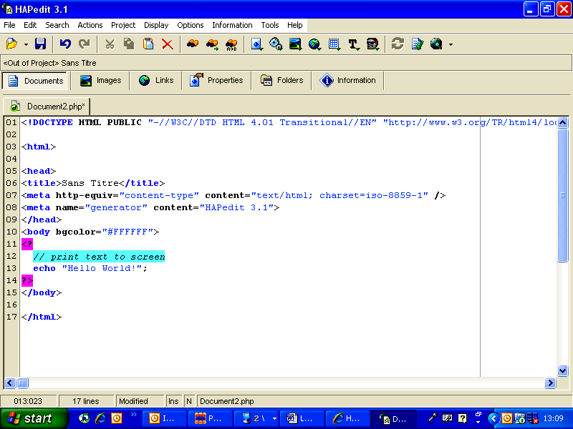

If you have a larger budget at your disposal then possibly the best application for creating websites is Macromedia Dreamweaver. This is used by many professionals to design and publish commercial websites. Dreamweaver has a wealth of features including an excellent WYSIWYG (pronounced: 'whizzy-wig' – 'what you see is what you get') design editor. Once you get the hang of it, Dreamweaver will enable you to quickly and easily create very professional-looking websites.
Screen shot of Dreamweaver:

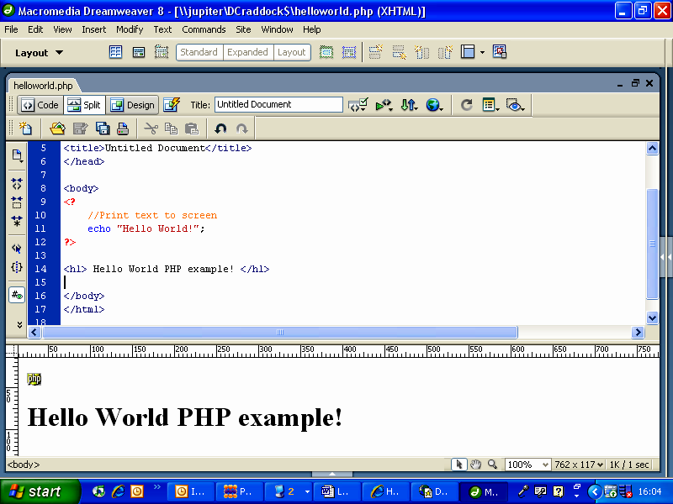

OK, let's imagine that you have obtained some webspace and written your first PHP webpage.
How do you actually put your webpage onto your website for the world to see?

c. How to get your PHP webpages onto your web-space.
In order to 'publish' your webpages so that they can be visited by anyone using the Internet you will need a special bit of software called an FTP client.
FTP stands for File Transfer Protocol.

FTP clients are usually very easy to use, and there are many freely available versions for you to download. Examples of some popular FTP clients include:

Coffee Cup and WinFTP. If you download the free browser Firefox then you can also download a free add-on FTP tool.

Screen shot of free FTP client add-on tool for Firefox:

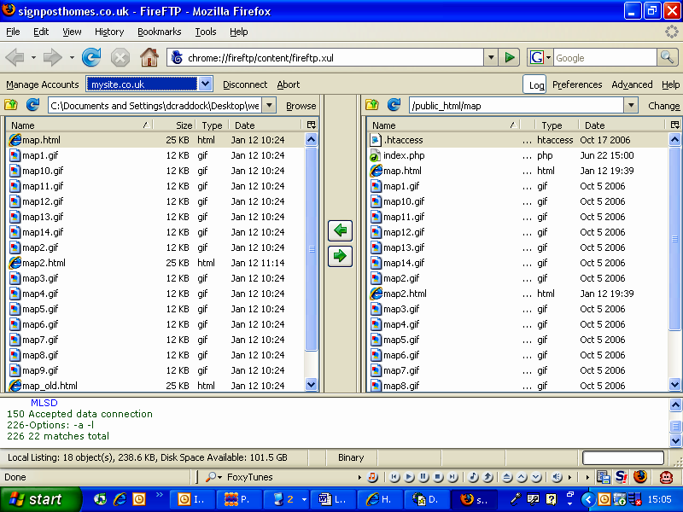
In the picture above, files from your own computer can be accessed on the left-hand side of the screen. The right-hand side shows 'remote' files stored on your website.

Files are easily copied or moved from your computer to your webspace by either dragging-and-dropping across the screen, or by selecting the files and clicking on the green arrows at the centre of the screen.

A good FTP client like the Firefox example above will also enable you to create, move and delete folders and also set CHMOD file permissions (enable read/write access).

OK, let's say that you have obtained an FTP client.

Before you can actually transfer files to your website, you need to set up an FTP connection.
This will usually involve three bits of information, namely:
1. A Host Name, e.g. ftp.mysite.co.uk (very often this is similar to your website address but with the prefix ftp instead of http)
2. A Login Username, e.g. mysite
3. A Password

The following screen shot shows the connection setup when using Firefox FTP:

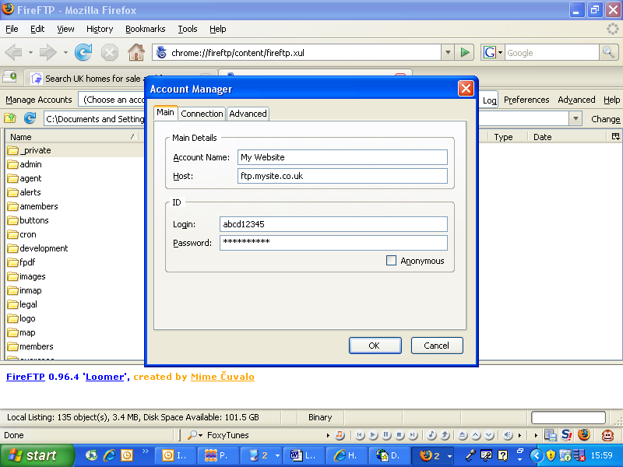

As soon as you've successfully set up a connection you'll be able to start transferring your PHP webpages to your webspace.

Now you have everything you need to start building your exciting PHP and MySQL website!

Summary …
~ …to obtain paid-for web-hosting, including your own domain name, search for “PHP & MySQL web hosting” using your favourite search engine.
~ …to obtain free web-hosting, search for “free PHP & MySQL web hosting” using your favourite search engine.
~ …make sure that your web-hosting includes: PHP & at least 1 MySQL database.
~ …you may also want to check that your hosting includes SMTP for emailing.
~ …download a free FTP program. A good example is found with Firefox browser.
~ …obtain a text-editor for writing your PHP webpages. The best available is Macromedia Dreamweaver (expensive, but has a 30 day free trial). Others include Kompozer (http://www.kompozer.net/) and HAPEdit (http://hapedit.free.fr/).

Chapter 4 – Syntax

Your First “Hello World” PHP Webpage.

By the end of this chapter you will know …
~ a. …how to add a simple PHP script to a webpage.
~ b. …how to use PHP to write information on a webpage.
~ c. …how to add comments to your PHP webpages.

a. How to add a simple PHP script to a webpage.
Reminder: most webpages are constructed using the same basic HTML tags. A tag is an HTML command or instruction that tells an Internet Browser how to display information. As an absolute minimum, a webpage may contain the following tags:

Code Example 4.1
<html>
<head>
<title>My First PHP Webpage</title>
</head>
<body>
</body>
</html>

The tags used above are:<html>, <head>, <title>, and <body>.

The general idea is that after you 'switch a tag on', then you should later 'switch the tag off'. For example look at the <head> and <body> tags above. These are 'switched off' by using </head> and </body> respectively.

We will not go into any further detail on the use of HTML in this resource other than to say that the <head> usually contains initial setting-up information of a webpage, and the <body> is where we put information that will be displayed on a browser.

b. How to use PHP to write information onto a webpage.
Using your favourite text-editor, enter the code exactly as shown below in Practice Example 4.1. Save this as a PHP file with the filename “example4_1.php”, and upload to your website using an FTP client. Note the file extension “.php”; this tells the webserver that the file is a PHP file and needs processing before sending out any HTML.

Practice Example 4.1 – For you to try
<html>
<head>
<title>My First PHP Webpage</title>
</head>
<body>
<?PHP
echo “Hello World!”;
?>
</body>
</html>

!
Note:
Always indent PHP code to make it easier to follow and debug.

If everything goes as expected then you should have seen the text “Hello World!” appear on your browser, as follows:

If this didn't work for you, then try checking the following...
a. Are all HTML tags entered correctly and in the right order?
b. Have you used a semi-colon as shown?

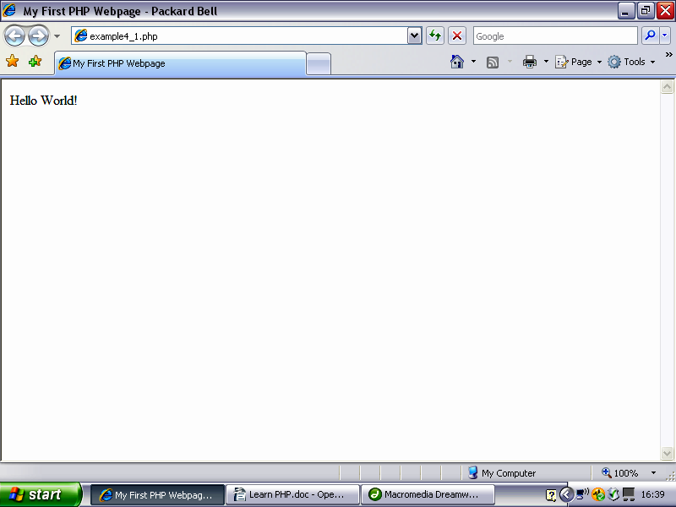

Inserting PHP is easy! Whenever we wish to add PHP we use a special 'half-formed' tag: <?PHP At the end of our PHP code we add ?>

In fact it gets even easier than this. We can use a shortened version of the PHP tag, thus: <? and ?>

It doesn't matter too much which version you decide to use, but to ensure compatibility it’s best to use <?PHP. Whenever a browser comes across the <?PHP or <? tags, it's like saying: “Hey computer, get ready for some PHP!”.
So what's happening here, how does our code work?
Let's have a closer look at our PHP code from Practice Example 4.1 above:

<?PHP
echo “Hello World!”;
?>

echo means “print on the screen”. In this case, the words “Hello World!” will be displayed on a browser. Notice the use of quotes, and a semi-colon at the end.
!
Note:
When writing PHP we always add a semi-colon to the end of each line.

The use of a semi-colon tells PHP that you've reached the end of a particular instruction or command.

The great thing about the echo command is that we can use it to 'dynamically' write HTML to a webpage. For example, let's imagine that you wish to add a blue heading to the top of a webpage. You could do this with PHP as follows:

Code Example 4.2
<?PHP
echo “<h1><font color='blue'>”;
echo “This is my first PHP webpage</font><h1 />”;
echo “<br /><br />”;
echo “This is great!”;
?>

As shown above, you can use PHP to write HTML 'on the fly'. Most Internet Browsers will enable you to 'View Source' which means to look at the HTML. For example, using Microsoft Internet Explorer you can select the View menu at the top of the screen and then click on Source.

A new Notepad window will open containing the HTML of the current webpage. If you try this using the code above you will see the following HTML:

<h1><font color='blue'>This is my first PHP webpage</font><h1 />
<br /><br />This is great

Notice that even though we previously used several lines of PHP code, the HTML is generated in a continuous line.

Now try some of these examples for yourself. In each case write the PHP as shown within a standard webpage (see Code 4.1), save it and then upload the file to your webspace using an FTP client (see chapter 3).

Practice Example 4.2 – Formatting Text
<?PHP
echo “<strong>This text is bold</strong><br />”;
echo “<i>This text is italicised</i><br />”;
echo “<u>This text is underlined</u><br />”;
echo “<u ><i>This text is underlined and italicised </i></ u >”;
?>

Practice Example 4.3 – Adding a Hyperlink to Google
<?PHP
echo “<a href='http://www.google.co.uk'>Google</a>”;
?>

Notice the use of single quotes ' within double quotes “ in Example 4.2 above.

The double quotes enclose everything that you want to echo (print) onto the screen.

Within double quotes we must use single quotes, otherwise PHP will think that you've come to the end of what you want to print on the screen. There is an alternative to using single quotes within double quotes, and that is to use an escape character. This tells PHP to ignore the double quotes and simply print them onto the screen. The standard PHP escape character is \ (backslash).

For Example:

Practice Example 4.4 – Adding a hyperlink to Google, using the escape character
<?PHP
echo “<a href=\”http://www.google.co.uk\”>Google</a>”;
?>

Practice Example 4.5 – Inserting an Image
<?PHP
echo “<img src='pic.jpg'>”;
?>

where pic.jpg is an image of your own choice. You must upload an image to your website before trying this out for yourself.

c. How to add comments to your PHP webpages.
A very useful and important practice when creating webpages, or indeed any computer program or script, is the use of comments or annotation. The benefits are substantial and will enable others to understand how and why your programming and logic works. There may be times when you return to re-develop a webpage, and the more comments you have the easier it will be to make sense of what you've done.

Writing comments is also a useful method of programming from scratch. Start off by thinking about what you intend to achieve. Break this down into the smallest possible sections, then write comments with gaps in-between. It's then a relatively straight forward job to add code in-between the comments. (This is known as Top-Down programming.)

There are two ways of adding a comment in PHP.
1. Single line comments
2. Multi-line comments

How to add a single line comment:

Code Example 4.3
<?PHP
// this adds an image called pic.jpg
echo “<img src='pic.jpg'>”;
?>

As shown in this example above we add a double-slash // to the start of a line. This tells PHP to ignore any code that appears on this line.

We can add any number of single line comments, thus:

Code Example 4.4
<?PHP
// print bold text to the screen
echo “<strong>This text is bold</strong><br />”;
// print italicised text to the screen
echo “<i>This text is italicised</i><br />”;
// print underlined text to the screen
echo “<u>This text is underlined</u><br />”;
// print underlined and italicised text to the screen
echo “<u ><i>This text is underlined and italicised </i></ u >”;
?>

How to add multi-line line comments:

Code Example 4.5
<?PHP
/* this adds an image to the screen, the image is called “pic.jpg” and has a width of 150 pixels */
echo “<img src='pic.jpg' width='150px'>”;
?>
We use the characters /* to indicate the start of a comment, and identify the end of a comment by using */

Here's an example for you to try. Enter the PHP code below, and add your own single or multi-line comments:

Practice Example 4.6 – Inserting comments
<?PHP
echo “<a href=\”http://www.google.co.uk\”>Google</a>”;
echo “<br />”;
echo “<a href=\”http://www.bbc.co.uk\”>BBC</a>”;
?>

Summary …
~ …we add PHP to an HTML webpage by enclosing the PHP code within the symbols <? and ?>, or <?PHP and ?>
~ …to print text, images, HTML or any data to a webpage we can use echo.
~ …echo can write HTML dynamically to a webpage.
~ …remember to use single quotes within double quotes, or use the backslash character to escape double quotes.
~ …use // (double forward slash) to write single line comments.
~ …write multi-line comments in-between /* and */
~ …use comments to explain your PHP code.
~ …use comments to help you write PHP code.

Chapter 5 – Variables and Constants

How PHP Stores Information

By the end of this chapter you will know …
~ a. … the difference between variables and constants.
~ b. … how to use variables in PHP.
~ c. … how to use constants in PHP.

a. Variables and Constants
There are many occasions in programming when we need to temporarily store information, for example someone's date of birth or surname, and then re-use this information later on. There are also occasions when we may find ourselves using the same numerical value repeatedly during the running of a program or webpage (e.g., a fixed conversion factor to convert GB pounds into US dollars, or to convert metric kilometres into imperial miles).

Most programming languages including PHP make use of variables (changing values) and constants (unchanging values) to help us achieve this end. Unlike variables, constants should be defined and declared at the very start of a program or webpage.

Before we do this, we need to think about a suitable name, and also the type of information that we wish to store. For example, imagine we wish to store a user's email address and login password, suitable variable names might be:

user_email and user_password. If we wanted to store a conversion factor to convert kilometres into miles, we could define a constant with the name of km_miles. Variables and constants may both contain a mixture of text and numbers, or indeed other characters such as a dot and @. Names should not begin with a number, or contain spaces.

PHP can cope with most types of information, including text (strings), numbers (integers, floating point numbers) and dates (e.g. dd-mm-yyyy). We don't have to tell PHP what type of information we plan on using; PHP is very clever at this and is able to work this out for itself once you start storing data. We do have to tell PHP whether the information is a variable or a constant, as we'll find out next.

b. How to use Variables in PHP
A valid variable name starts with a letter or underscore, followed by any number of letters, numbers, or underscores. Let's imagine we wish to store an email address, password and person’s age on a webpage. This is how we might do it:

Code Example 5.1
<?PHP
// define variables
$email_address = “me@mysite.co.uk”;
$password = “letmein”;
$age = 37;
?>
Notice that we do not enclose numerical values in quotations. This helps PHP to know that we are storing a numerical value (which could be used during calculations later on) rather than text information.
!
Note:
variables always begin with a dollar sign: $

Dates are a special type of variable, and PHP can do some clever things with dates and times, so we'll look at date variables later on in a different chapter. Now it's your turn to try. Create a new webpage using your PHP editor and insert the following code. Then upload and view your PHP webpage:

Practice Example 5.1 – Using variables
<?PHP
// define variables
$email_address = “me@mysite.co.uk”;
$password = “letmein”;
$age = 37;
// display data on webpage
echo “Email address is: “ . $email_address . “<br />”;
echo “Age is: “ . $age . “<br />”;
?>

Let's have a look at what happens here – there's some new things to learn.

Looking at one line of code from Practice Example 5.1:

echo “Email address is: “ . $email_address . “<br />”;

We already know that echo means 'print to the screen'. There follows some text, namely :”Email address is:”. PHP will print this piece of text (known as a string) directly onto the screen. Next we have a full stop (USA: period), followed by the variable we named as $email_address.

In PHP, we use a full stop to add strings of text or data together. This very useful and important technique is known as concatenation (con – cat – en – ay – tion). Remember though that PHP will not print the text: $email_address onto the screen! The dollar sign reminds PHP that this is a variable. $email_address contains the text: “me@mysite.co.uk”. Following the variable is a second full stop (more concatenation) and then the text “<br/>”, which is HTML code to write a new line break.

So in summary, you will see the following displayed on your webpage:
Email address is: me@mysite.co.uk
Age is: 37

(Notice that we didn't print password in the end, as printing passwords is not really a great idea! But … the variable $password still contains the value “letmein” even though we didn't do anything with it.) The use of variables is one of the most common and important things done with PHP, so to build your knowledge and understanding, try out these practice examples for yourself. In each case add these examples to an HTML webpage, then upload to your webspace in the usual way:

Practice Example 5.2 – More fun with variables
<?PHP
// define variables
$firstname = “Fred”;
$surname = “Bloggs”;
// display data on webpage
echo “Hello “ . $firstname . “ “ . $surname . “<br />”;
?>

Notice the use of a single empty space between quotes in practice example 5.2 above. Why did we include this? Try removing it and see what happens.

Practice Example 5.3 – Adding two numbers
<?PHP
// define variables
$valueA = 23;
$valueB = 64;
$valueC = $valueA + $valueB;
// display data on webpage
echo $valueA . “ +” . $valueB . “ =” . $valueC;
?>

Practice Example 5.4 – Concatenating (adding) two strings
<?PHP
// define variables – note the use of quotes here!!!!!!!
$valueA = “23”;
$valueB = “64”;
// be careful here, there's a full-stop, not a + below
$valueC = $valueA . $valueB;
// display data on webpage
echo $valueA . “ + “ . $valueB .” =” . $valueC;
?>

Practice Example 5.5 – Concatenating (adding) two more strings
<?PHP
// define variables
$valueA = “Hello”;
// valueB is a single empty space!
$valueB = “ ”;
$valueC = “World”;
$valueD = $valueA . $valueB . $valueC;
// display data on webpage
echo $valueD;
?>

c. How to use Constants in PHP
A valid constant name starts with a letter or underscore, followed by any number of letters, numbers, or underscores. This is the same as with variable names. The generally accepted convention with constants, however, is to also write constant names in UPPER CASE. This makes them easier to identify when you're looking at PHP code. Let's imagine we wish to define some conversion constants to help us convert the units of metric kilometres into imperial miles. We could do something like this:

Code Example 5.2
<?PHP
// define constants
define(“MILES_TO_KM”, 1.6);
define(“KM_TO_MILES”, 0.6);
// print constant on screen
echo MILES_TO_KM;
echo “<br />”;
echo KM_TO_MILES;
?>

Notice here that we have to use a special function called define().
The general way the define() works is:
Define (CONSTANT_NAME, CONSTANT_VALUE)

In the previous code example, we have defined two constants, the first we named as MILES_TO_KM. The value of MILES_TO_KM is 1.6, because 1 mile is approximately the same as 1.6 kilometres. Conversely 1 kilometre is equivalent to 0.6 miles, hence KM_TO_MILES has a constant value of 0.6.

OK. So far, so good. A quick reminder: we define constants at the very beginning of a program or webpage.
Let's see how we can put our constants to good use. Try out practice example 5.6 below in the usual manner, by inserting it into an HTML webpage and uploading the file to your own webspace:

Practice Example 5.6 – Defining and using constants
<?PHP
// Simple Miles to Km Conversion Calculator
// define constants:
define(“MILES_TO_KM”, 1.6);
// enter distance in Miles
$miles = 5;
// convert to distance in kilometres, multiply by constant
// note: use * (asterisk symbol) to multiply values
$km = $miles * MILES_TO_KM;
// display result on webpage
echo $miles . “ miles =” . $km . “kilometres<br />”;
?>

If all goes to plan, you should see the following on your web browser:
5 miles = 8 kilometres

Try changing the value of variable $miles in Practice Example 5.6 above.

Practice Example 5.7 – Defining and using constants
<?PHP
// Simple Km to Miles Conversion Calculator
// define constants:
define(“KM_TO_MILES”, 0.6);
// enter distance in Kilometres
$km = 8;
// convert to distance in miles, multiply by constant
// note: use * (asterisk symbol) to multiply values
$miles = $km * KM_TO_MILES;
// display result on webpage
echo $km . “kilometres =” . $miles . “miles<br />”;
?>

You should see the following on your web browser:
8 kilometres = 4.8 miles

Why is the answer not 5 miles? The conversion factor is only an approximation!

Summary …
~ …we use variables in PHP to temporarily store values that may change (vary).
~ …we use constants in PHP to store values that will not change.
~ …variables should have suitable names, consisting of alphanumeric characters and some other characters such as an underscore.
~ …names of constants by convention are given in UPPER CASE.
~ …names of variables and constants should not begin with a number, and must not contain empty spaces.
~ …variables are denoted by adding a dollar sign to the beginning of the name, e.g. $firstname, $result, $date_of_birth.
~ …we assign a value to variables by using the equals assignment. String data should be enclosed in quotes, e.g. $firstname = “Fred”; and numerical data should not be enclosed by quotes, e.g. $num_records = 46;
~ …constants should be defined at the very beginning of a function, program or webpage.
~ …constants are defined using the define() statement, the syntax of which is: define(CONSTANT_NAME, CONSTANT_VALUE) where CONSTANT_NAME is the name of the constant, and the unchanging value is CONSTANT_VALUE. e.g. a constant named MILES_TO_KM used to convert miles to kilometres: define(“MILES_TO_KM”, 1.6);

Chapter 6 – Strings

Dealing with Text

By the end of this chapter you will know …
~ a. …how to define strings.
~ b. …how to concatenate strings.
~ c. …about some useful PHP string functions.

a. How to Define Strings
Strings are essentially a special type of variable. See chapter 5 for detailed information about variables and how to use them. A string can contain any number of characters, including a single character or even no characters at all (known as an empty string). Why the term string? Think of a string of sausages. That is, one sausage after another sausage after another sausage … ad infinitum. In PHP a string can contain many (or none!) characters. In other words a string of characters.

All strings must have a name. By convention, the name of a string should have something to do with the information that you wish to store. Also, string names must begin with a dollar sign character, $. For example, $first_name.

So, to store the name “Fred” we could do the following:

$first_name = “Fred”;

We know that this is a string (and so does PHP) because we've enclosed the information Fred within quotes.

Strings can be defined anywhere within a program or webpage.

b. How to concatenate strings
Concatenation (pronounced: con – cat – en – ay – tion) of strings means “adding strings together”, not in the mathematical sense but rather adding one string to the end of another string. To concatenate two or more strings we use a full-stop (period) character. The best way to show this is by a simple example:

Code Example 6.1
<?PHP
// define strings
$first_name = “Fred”;
$last_name = “Bloggs”;
// concatenate strings
$full_name = $first_name . “ ” . $last_name;
// display full name on screen
echo $full_name;
?>
So far, so good, and much of this has already been discussed in chapter 5.

The reason for having a chapter dedicated to strings will become evident once we examine the huge range of special string functions built into PHP. You may recall that PHP is continually being redeveloped as an open source language by many different programmers throughout the world. As a consequence, it has been designed to simplify common programming tasks by including some clever and useful string handling. In the remainder of this chapter we shall look at some of the more commonly used string functions, but this is by no means an exhaustive list.

c. Useful String Functions

i. strlen (string)
Suppose you wish to know the length of a string, i.e. how many characters it contains. At this stage in your PHP journey you might not see how useful this is, but we'll use this function a lot when we look at loops and databases later on. All PHP functions are given names that help you remember their purpose. The thing to keep in mind about functions, however, is that you INPUT a value, and must have somewhere to store an OUTPUT. The diagram below is a useful way of understanding this:
Function( )
input
output

At this stage we don't need to know how the function works; all we need to know is that it will generate an output that depends on the input.

How to find the length of a string:
Code Example 6.2
<?PHP
// define string
$first_name = “Fred”;
// determine length of string
$length = strlen($first_name);
// display length of string on screen
echo $length;
?>

Let's look at the previous example more closely and see what's happening. First of all, we've defined a string variable and assigned it the value “Fred”.

$first_name = “Fred”;

You can see for yourself that “Fred” consists of 4 characters, and we've stored this in a string variable named $first_name.

$length = strlen($first_name);

The actual string function is strlen() as shown above. This line of PHP code first reads what we've stored in $first_name, then counts the length of this string using strlen(), and finally stores the length of the string in another variable named $length. A human English speaker/reader would instinctively read this line from left to right, but PHP executes (does) the strlen($first_name) bit first, then assigns the resulting value to $length. This is an important concept in programming and is a frequent cause of confusion for many PHP learners! All that remains is to output the length of the string to the screen:

echo $length;

Now it's your turn: try the following Practice Examples for yourself.

Practice Example 6.1 – Find length of string
<?PHP
// define string
$myString = “Hello World!”;
// find length of string and display on screen
echo strlen($myString);
?>

Practice Example 6.2 – Find length of string
<?PHP
// define strings
$first_name = “Julia”;
$last_name = “Royston”;
// concatenate strings and find total length of strings
$full_name = $first_name . “ ” . $last_name;
$length = strlen($full_name);
// display result on screen
echo $full_name . “contains” . $length . “characters.”;
?>

For this example above you should see the following on your browser:
Julia Royston contains 13 characters.

In the final example there are comments only with no PHP. Try and add suitable PHP code yourself! This example does, however, include HTML.

Practice Example 6.3 – Find length of telephone number
<html>
<head>
<title>Find length of telephone number</title>
</head>
<body>
<?PHP
// define string to store telephone number (inc. dialling codes)
// find length of telephone number
// display length of telephone number on screen
?>
</body>
</html>

Your PHP should produce something like the following on your browser:
Telephone No. 01147654321 contains 11 characters.

ii. strpos(string, find)
This next function finds the starting position of one string within another string. For example, imagine we have two strings: “Hello world!” and “world”. The second string (“world”) is contained in the first string, and in fact the “w” (from “world”) is the sixth character, including the space character, in the first string “Hello world!”.

Notice how this function requires two inputs, and the general form (syntax) of using it is: strpos (string, find) where string is the first string, and find is the string of text that you are looking to find in the first string.

Try this next practice example to see this in action:

Practice Example 6.4 – Find position of string within another string
<?PHP
// define strings
$stringA = “Hello World!”;
$stringB = “World”;
// first position of 2nd string within 1st string
$position = strpos($stringA, $stringB);
// display result on screen
echo $position;
?>

The correct output should be: 6

Now try experimenting with practice example 6.4, by using different combinations for $stringA and $stringB. What happens if $stringB is not found within $stringA?
iii. trim(string)
There are many occasions during the use of an interactive website whereby you require a person to enter some information. Humans are far from perfect and will often make typing errors when entering data. The Trim function is very useful, its purpose is to strip off any leading or trailing spaces in a string, but will not remove spaces within a string. For example if your string contained the text:

“ hello word “ (notice the leading and trailing spaces within quotes) then after Trimming you'd be left with just “hello world”. Try this out for yourself with practice example 6.5 below.

Practice Example 6.5 – Using the trim() function
<?PHP
// define string and assign value
$myString = “Hello World!”;
// trim leading & trailing spaces
$trimmedString = trim($myString);
// display result on screen
echo $trimmedString;
?>

iv. str_word_count(string)
Most modern word processors have an inbuilt word-count facility which is useful to check the number of words in an essay or document. The same function is available in PHP, which is useful if you intend to store information in a database where there might be limitations to the amount of information you could store. The next example shows this function in action:

Practice Example 6.6 – Counting words in a string
<?PHP
// define string and assign value
$myString = “The quick fox jumps over the lazy brown dog.”;
// count words in string
$num_words = str_word_count($myString);
// display result on screen
echo $num_words . “words”;
?>

In the example above you should see the output: 9 words.

v. strtolower(string) and strtoupper(string)
These are a similar pair of functions often used to re-format a user's input to ensure that information is stored in a preferred manner. The first, strtolower(string) will transform text into all lower case characters. Conversely strtoupper(string) transforms text into UPPER CASE characters.

Some people seem to prefer to type data in capital letters, but if you intended to use their information to, say, print their name at the top of a form, then it might look unprofessional in capital letters.

On the other hand it is best to show UK postcodes in upper case, so we could make use of strtoupper(string) to ensure that a user's postcode will also be stored in upper case regardless of how they enter their postcode. Try out the example below for using strtoupper(string); you could then easily modify this to experiment with using strtolower(string).

Practice Example 6.7 – Postcode re-formatting
<?PHP
// define string and assign value (postcode)
$postcode = “s17 3dq”;
// convert to uppercase ready for storage
$nuPostcode = strtoupper($postcode);
// display result on screen
echo $nuPostcode;
?>

vi. ucfirst(string) and ucwords(string)
Our final pair of string functions are also related, and again are frequently used to format a user's information in order to present it or store it in a preferred manner. ucfirst(string) is similar in operation to the “Sentence Case” tool built into most modern word-processors. This function will simply ensure that the very first character of a string is UPPER CASE, and all preceding characters will be lower case. ucwords(string) behaves in a similar manner to this, but instead will convert the first character of every word of a string of text into UPPER CASE. This makes it very handy for formatting people's names.

Try experimenting with practice example 6.8 below to see this for yourself. As before, insert the PHP within an HTML webpage, save and upload to your webspace.

Practice Example 6.8 – Formatting people’s names
<?PHP
// define string and assign value (name)
$myName = “fred peter Bloggs”;
// format first character of each word in string
$nuName = ucwords($myName);
// display result on screen
echo $myName . “converts to” . $nuName;
?>
vi. Combining string functions
PHP is a very powerful and flexible programming language and can cope quite happily with complex operations very quickly. There are many practical situations when you might want to perform more than one function on a user's input to a webpage. For example, let's return to the postcode example (6.7). Before we convert all characters into UPPER CASE we might want to first strip off any leading or trailing spaces. This could be important if storage space is limited (e.g. on a database, as we'll see in a later chapter) and so we would want to avoid storing unnecessary empty spaces. Try the example below to see how PHP can handle multiple functions at the same time:

Practice Example 6.9 – Improved postcode re-formatting
<?PHP
// define string and assign value (postcode)
$postcode = “s17 3dq”;
// trim spaces and convert to uppercase ready for storage
$nuPostcode = trim(strtoupper($postcode));
// display result on screen
echo $nuPostcode;
?>

The code snippet below shows how this works. PHP starts from the inside and works its way outwards. In other words, PHP starts with $postcode, then trims off any spaces trim($postcode), and finally converts to UPPER CASE, strtoupper(trim($postcode));

strtoupper(trim($postcode)) ;

This could quite easily work the other way around and give the same effect:

trim(strtoupper($postcode)) ;

Take care when using multiple functions in this way because sometimes the order of using functions may affect the resulting output. Think carefully about what you want to end up with: start from the centre and work your way outwards.

Summary …
~ …strings are a type of variable; string names begin with a dollar symbol $.
~ …strings can be concatenated (added) together.
~ …use strlen(string) function to find the number of characters (length) in a string.
~ …use strpos(stringA, stringB) to find starting position of stringB within stringA.
~ …use trim(string) to remove leading and trailing empty spaces.
~ …use str_word_count(string) to count the number of words within a string.
~ …use strtoupper(string) to convert all characters to UPPER CASE.
~ …use strtolower(string) to convert all characters to lower case.
~ …ucfirst(string) converts the first character of a string into UPPER CASE and all remaining characters into lower case. This is the PHP equivalent of Sentence Case.
~ …ucwords(string) converts the first character of every word in a string into UPPER CASE and all other characters into lower case.
~ …we can combine functions in PHP, provided that we think carefully about the order of functions. E.g. to count the length of a string but without counting any leading or trailing spaces we could use: strlen(trim(string));
~ …this list of functions is not exhaustive. For further information visit: www.php.net

Chapter 7 – Operators

Doing Calculations

By the end of this chapter you will know …
~ a. …how to use arithmetic operators to perform simple calculations
~ b. …how to use assignment operators to give values to variables
~ c. …how to use comparison operators to compare variables
~ d. …how to use logic operators to check the result of two or more conditions

a. How to use arithmetic operators to perform simple calculations
There are many conceivable situations whereby you may need to perform calculations upon data entered by a user into a PHP webpage. For example, you might want to compare someone's age (e.g. 18 ) to a predetermined value to check whether that person is entitled to apply for a particular product such as a new mortgage or financial loan. Another example might be to convert currency from, say, US dollars into Euros or UK Sterling pounds. There might also be other occasions when you want to validate an email address by asking a user to enter it twice, then compare the two entries and check they match.

Let's see how to perform simple calculations first of all. PHP has several operators as follows:

+ | addition | e.g. if $value = 10; then $value + 5 = 15
– | subtraction | e.g. if $value = 10; then $value - 5 = 5
* | multiplication | e.g. if $value = 10; then $value * 5 = 50
/ | division | e.g. if $value = 10; then $value / 5 = 2
% | modulus | e.g. if $value = 10; then $value % 5 = 0
 |  | e.g. if $value = 15; then $value % 4 = 3
(modulus gives the remainder following a division of two values)
++ | increment | e.g. if $value = 10; then $value++ = 11
-- | decrement | e.g. if $value = 10; then $value-- = 9

As always the best way to learn these is through practice. Most people may readily understand addition, subtraction, division and multiplication, so practical example 7.1 below (for you to try for yourself) shows how to use increment and decrement.

Practice Example 7.1 – Using increment and decrement
<?PHP
// define and assign value
$value = 100;
echo “Original value =” . $value . “<br />”;
// increment value
$value ++;
echo “Incremented value =” . $value . “<br />”;
// decrement value
$value --;
$value --;
echo “Decremented value =” . $value . “<br />”;
?>

b. How to use assignment operators to give values to variables
Assignment operators are very easy to use. The basic idea is that:
something = something else.

PHP contains several useful shortcuts for assignments, shown here:

= | e.g. if $value = 10;
+= | e.g. if $value = 10; | then if $value += 5; the result would be: 15
-= | e.g. if $value = 10; | then if $value -= 5; the result would be: 5
*= | e.g. if $value = 10; | then if $value *= 5; the result would be: 50
/= | e.g. if $value = 10; | then if $value /= 5; the result would be: 3
.= | e.g. if $value = 10; | then if $value.= 5; the result would be: 50 (same as *=)
%= | e.g. if $value = 10; | then if $value %= 5; the result would be: 0

c. How to use comparison operators to compare variables
Comparison operators are most commonly used with selective/conditional programming (see chapter 8), and will be explained in further detail then. Here follows a list of the available comparison operators used in PHP:

== | is equal to | e.g. if $valueA = 10; and $valueB = 5; then the result of  $valueA == $valueB is false
!= | is not equal to | e.g. if $valueA = 10; and $valueB = 5; then the result of  $valueA != $valueB is true
> | is greater than | e.g. if $valueA = 10; and $valueB = 5; then the result of  $valueA > $valueB is true
< | is less than | e.g. if $valueA = 10; and $valueB = 5; then the result of  $valueA < $valueB is false
>= | is greater than or equal to | e.g. if $valueA = 10; and $valueB = 5; then the result of  $valueA >= $valueB is true
<= | is less than or equal to | e.g. if $valueA = 10; and $valueB = 5; then the result of  $valueA <= $valueB is false

d. How to use logic operators to check the result of two or more conditions
As with comparison operators, logic operators are used almost exclusively within selection/conditional programming. Further details are given in the next chapter. The most commonly used PHP logic operators are:

&& | and | e.g. if $valueA = 10; and $valueB = 5; then the result of  $valueA >= 7 && $valueB >= 3 is true
(the result is true if one condition is true AND the other condition is also true)
|| | or | e.g. if $valueA = 10; and $valueB = 5; then the result of  $valueA >= 7 || $valueB >= 3 is true
(result is true if one condition is true OR the other condition is true OR both are true)
! | not | e.g. if $valueA = 10; and $valueB = 5; then the result of  !($valueA = $valueB) is true
(the result is true if the condition is NOT true)

Chapter 8 – If … Else

Making Decisions with PHP

By the end of this chapter you will know …
~ a. …how to use IF – ELSE to make decisions
~ b. …how to give further options by using ELSE IF.
~ c. …how to use Switch to handle multiple conditions.

a. How to use IF – ELSE to make decisions
Possibly one of the most useful things that a computer program can do is to make decisions and take appropriate action depending on the result of one or more conditions. For example, you may wish to create a secure area of a website and only allow access if a correct combination of username and password are entered. We could describe this as follows using standard flow chart symbols:
Start

Input username and password
Check Database
Username & password found in database?

Forbid Access
Allow Access
yes
no
Stop

As the diagram above shows, access to a particular area of the website is only allowed IF the username and password match those in a database, ELSE (otherwise) access is forbidden. Notice here the use of the words IF and ELSE. In PHP we use these exact words to make decisions. Let's see how this can be achieved using PHP. The essential format (syntax) of the if-else statement is shown below:

If(condition == true) {
// stuff to do if condition is true;
}
else {
// stuff to do if condition is not true (i.e. false);
}

There are several things to note here:
1. the use of curly braces/brackets
2. the use of the == assignment
3. we don't put a semi-colon after the words if or else
4. PHP code between if and else is indented to make it easier to follow.
The fourth point here is often neglected, particularly by new programmers, but it is standard programming practice and becomes essential when programs become very large and complex. As always the best way to understand programming is to try things out and see what happens. Try the following examples for yourself:

Practice Example 8.1 – Simple comparison making using if-else
<?PHP
// define variables and assign values
$valueA = 10;
$valueB = 13;
// compare values to find the largest value
if($valueA > $valueB) {
echo $valueA . “is greater than” . $valueB;
}
else {
echo $valueB . “is greater than” . $valueA;
}
?>

If you use the values for variable $valueA and $valueB above you should see the following on your browser: 13 is greater than 10

which is correct of course! Try changing the values of $valueA and $valueB and convince yourself that this does actually work. Be careful not to forget the ending curly braces (brackets); this is a common error made even by experienced programmers.

Practice Example 8.2 – String comparison making using if-else
<?PHP
// define variables and assign values
$nameA = “Fred”;
$nameB = “Sally”;
// compare names to see if they match
if($nameA == $nameB) {
echo “These names are the same!”;
}
else {
echo “These names are different!”;
}
?>

As before, try changing the variables and see what happens.

Practice Example 8.3 – Simple login access
<?PHP
// define variables and assign values
$username = “Jonny36”;
$password = “j30Nn6y”;
// check if username & password OK
if($username == “Jonny36” && $password == “j30Nn6y”) {
echo “Welcome, access permitted!”;
}
else {
echo “Sorry, access denied!”;
}
?>

In Practice Example 8.3 notice the use of the logical AND assignment (see chapter 7) which is achieved by using the && characters. In this case the if condition will only be TRUE (and hence allow access) if $username is correct AND $password is correct, otherwise access will be forbidden.

Practice Example 8.4 – Can I join the British Army as a soldier? (aged 16 to 33?)
<?PHP
// set person's age
$age = 37;
// check if allowed to join the British Army
if($age >= 16 && $age <= 33) {
echo “Congratulations, you can join the Army!”;
}
else {
echo “Sorry, you're not the right age!”;
}
?>

b. How to give further options by using else if
In real life situations it is quite likely that there will be more than two possible outcomes of a decision. In this case we can extend the power of if-else by adding else if. As an example imagine that we wanted to show what certification of films that a person would be entitled to watch, perhaps as part of an online cinema ticket booking system. Possible alternatives could be U, PG, 12A, 15 and 18. The syntax for if-else that includes else if is as follows:

If(1st condition == true) {
// stuff to do if 1st condition is true;
}
else if(2nd condition == true) {
// stuff to do if 2nd condition is true;
}
else if(3rd condition == true) {
// stuff to do if 3rd condition is true;
}
else {
// stuff to do if none of the above are true;
}

In fact we could add as many else ifs as we wanted!

Back to our cinema ticket booking system, we could program something like this:

Practice Example 8.5 – Cinema certification checker
<?PHP
// set person's age
$age = 14;
// check allowable certification
if($age < 12) {
// if under 12 yrs old
echo “You can watch U and PG films.”;
}
else if($age >=12 && $age < 15) {
// if between 12 yrs and 15 yrs old
echo “You can watch U, PG and 12A films.”;
}
($age >=15 && $age < 18) {
// if between 15 yrs and 18 yrs old
echo “You can watch U, PG, 12A and 15 films.”;
}
else {
// if 18 yrs and older
echo “You can watch any film!”;
}
?>
PHP is quite a forgiving language, and is quite happy to accept either:
else if(…..) or elseif(…..)

(i.e. whether or not you have an empty space between the words else and if).
In this resource we shall always use and recommend the first of these options.

To complete your understanding of this very powerful and commonly used programming tool it is worth mentioning the use of “nested ifs”. This means an if-else within another if-else. Such statements can become very difficult to follow, and indentation of your code will make debugging (sorting out problems in your code) a much less painful process. So we will conclude this section with a practical example of a “nested if” situation.

Practice Example 8.6 – Using “nested ifs” to check if bank account is overdrawn
<?PHP
// set bank balance of minus £600 !
$balance = -600;
// set overdraft limit of £100
$overdraft_limit = -100;
// check if account is overdrawn
if($balance < 0) {
// account is overdrawn!
echo “Warning: you are now overdrawn!<br />”;
// check if overdraft limit is exceeded (“nested if”)
if($balance < $overdraft_limit) {
echo “And your overdraft limit has been exceeded!”;
}
}
else {
// account not overdrawn
echo “You are in credit!”;
}
?>

Things to note here:
1. be very careful with your use of curly braces; if you get one wrong the code will fail.
2. make sure you indent your code as shown – it becomes much easier to follow.
3. don't forget to always add your own comments/annotation.
4. there is no else if bit here. That's because else ifs are optional.

If you've entered the code correctly then you should see the following on your screen when you run practical example 8.6:

Warning: you are now overdrawn!
And your overdraft limit has been exceeded!

Try changing the values of $balance and $overdraft_limit to help you understand what's happening here. If only we could do this with our real bank accounts!
c. How to use Switch to make multiple conditions
We briefly examined the use of “nested-ifs” in the previous section. It is certainly possible to put nested-ifs within nested-ifs ad infinitum! The resulting code would be extremely difficult to follow. Mistakes are easily made and difficult to trace. In practice it is only worth nesting ifs once within any particular if-else statement. PHP does have an alternative for nested-ifs which is very useful and 'cleaner' for situations where there are many different possible outcomes. The special statement is called Switch, whose essential syntax is:

switch(value) {
case condition 1:
// code if value == outcome 1
break;

case condition 2:
// code if value == outcome 2
break;

default:
// code if value is none of the other outcomes
break;
}

As with using else if within if-else statements, you can add any number of case conditions.

Notice that switch(value) does not make comparisons between an infinite range of values, but can only check a set of predetermined values that you set.

For example, in practice example 8.5 we had:

else if($age >=12 && $age < 15)

which would check if $age contained the value of anything between 12 and less than 15. This could be 12.6, 13.372321, 14.9999999999 etc. an infinite number of possibilities! However switch(value) can only be used to check for a finite set of outcomes.

Now try practice example 8.7 below to see how this works in practice.

Practice Example 8.7 – Cinema certification explanations
<?PHP
// set film certification
$cert = “PG”;
// check allowable certification
switch($cert) {
// explain U
case “U”:
echo “U = Univeral for all ages.”;
break;
// explain PG
case “PG”:
echo “PG = Parental Guidance.”;
break;
// explain 12A
case “12A”:
echo “12A = Under 12s Accompanied by parent.”;
break;
// explain 15
case “15”:
echo “15 = Must be 15 years or older.”;
break;
// explain 18
case “18”:
echo “18 = Must be 18 years or older.”;
break;
// for everything else ….
default:
echo “Sorry, I don't recognise that certification.”;
break;
}
?>

We've used string variables here, but switch works equally well with numbers.

Summary …
~ …use IF-ELSE to make decisions in PHP.
~ …syntax is if(condition true) { 'stuff if true; } else { 'stuff if false; }
~ …add any number of ELSE IFs to enable multiple outcomes:
~ …syntax is:
if(1st condition true) {
// stuff if 1st true;
}
else if(2nd condition true) {
// stuff if 2nd condition true;
}
else {
// stuff if neither 1st or 2nd conditions are true;
}
~ …IF-ELSE statements can be nested within other IF-ELSE statements.
~ …take extra care when nesting IF-ELSE, always indent your code.
~ …use switch(value) for fixed number of possible outcomes
~ …syntax for switch(value) is:
switch(value) {
case condition 1:
// code if value == outcome 1
break;
case condition 2:
// code if value == outcome 2
break;
default:
// code if value is none of the other outcomes
break;
}

Chapter 9 – Looping

Do it again, and again, and again …

By the end of this chapter you will know …
~ a. …for loops to repeat things a fixed number of times.
~ b. …while loops to repeat if and then while a condition is true.
~ c. …do-while loops to repeat at least once and then while a condition is true.

a. How to use FOR loops to repeat things a fixed number of times.
Imagine that you had a list of products to sell on an e-commerce website. Your product details are all stored in a database. If a potential customer searches for all products that cost less than £100, then your webpage should be able to search for such items, count how many are found, and then display the appropriate product information on the screen. This is a common use for the FOR loop whereby the number of times you wish to repeat something (iterate) is known. The correct PHP syntax for using FOR is:

for(initial_value; condition; increment) {
// code to be executed;
}

The initial_value must be a numerical value (rather than a string) and must also be set before the loop is started. Care must be taken with the condition, otherwise the loop may continue executing its commands forever or not at all! Almost without exception the increment usually involves increasing the value of the intial_value by 1 for each time the loop is repeated, although there might be rare occasions when different increments are used (or indeed decremental values).

Practical examples 9.1 and 9.2 below demonstrate two simple but useful applications of the for loop technique. Example 9.2 in particular shows a method that is very commonly used to display the results of a database search.

Practice Example 9.1 – Times table generator using simple for loop
<?PHP
// set times table
$times_table = 7;
// set number of repetitions
$repetitions = 12;
// do times table
echo “The” . $times_table . “times table:<br /><br />”;
// start loop
for($i = 1; $i <= $repetitions; $i++) {
// calculate value
$result = $i * $times_table;
// display on screen
echo $i . “x” . $times_table . “=” . $result;
echo “<br />”;
}
// end of loop
?>
Things to Note:
1. all code within the curly braces of the for loop should be indented.
2. the loop will continue looping while the value of $repetitions <= 12.
3. at the end of each loop, the value of $i increases by 1 ( $i++ ).
4. $i is used to help us calculate the times-tables, e.g. 1 x 7, 2 x 7, 3 x 7 etc.
5. make sure to include echo “<br/>”; to write each result on a new line.

The next practical example demonstrates the use of nested-for loops. This is the same principle that we discovered using if-else statements in chapter 8. It is possible to nest any number of loops although you should take care as it may become very difficult to diagnose problems (which are likely to occur in complex programs). The best thing you can do to minimise problems is to be strict about indenting your PHP code, and use plenty of annotation (comments) to fully describe what you are trying to achieve. This example also serves as a good illustration of how PHP can be used to dynamically generate HTML.

Practice Example 9.2 – Generate an HTML table, using nested for loops
<?PHP
// set number of table rows
$num_rows = 5;
// set number of table columns
$num_cols = 3;
// generate HTML <table> tag with a border thickness of 1 pixel
echo “<table border ='1px'>”;
// start loop to generate rows
for($row = 1; $row <= $num_rows; $row++) {
// generate row HTML
echo “<tr>”;
// start loop to generate columns (nested for loop!)
for($col = 1; $col <= $num_cols; $col++) {
// generate column HTML
echo “<td>Row” . $row . “ Col ” . $col . “</td>”;
}
// end of columns loop
// generate end of row HTML
echo “</tr>”;
}
// end of rows loop
// generate end of table HTML
echo “</table>”;
?>
If you've done this correctly then you should see the following output on your screen:

Row 1 Col 1 | Row 1 Col 2 | Row 1 Col 3
Row 2 Col 1 | Row 2 Col 2 | Row 2 Col 3
Row 3 Col 1 | Row 3 Col 2 | Row 3 Col 3
Row 4 Col 1 | Row 4 Col 2 | Row 4 Col 3
Row 5 Col 1 | Row 5 Col 2 | Row 5 Col 3

Note: the use of single quotes within double-quotes: echo “<table border ='1'>”;

b. How to use WHILE loops to repeat if and then while a condition is true.

For situations where the number of times you wish to repeat something may change or vary, or depends on the result of a further calculation, then PHP has a further method of looping known as the WHILE loop. The idea is that PHP will continue repeating your code but only while a specific condition is true.

!
Note:
while loops can use strings as well as numbers within their conditions

The correct syntax for using the while loop is as follows:

while( condition == true) {
// code to be executed;
}

Note that if the condition is false before the loop begins then any PHP code within the while loop will not actually execute at all. Therefore you should take care when setting initial values and escape conditions. Now try the example below:

Practice Example 9.3 – Reverse a string of text
<?PHP
// assign value of string
$firstname = “fred”;
// count number of characters in $firstname string
$length = strlen($firstname);
// loop to write string in reverse
while($length >= 0) {
// get character at position $length
$character = substr($firstname, $length, 1)
// write this character onto screen
echo $character;
// count backwards to previous character
$length = $length – 1;
}
// end of while loop
?>
Things to Note:
1. the use of strlen($firstname); to find the number of characters in the string.
2. the code within the loop continues while $length >= 1.
3. the value of $length decreases by a value of 1 each time through the loop, first of all looking at the last character in the string (at position $length), and then looping through to the first character (at position 1).
4. the use of the special string function: substr($firstname, $length, 1) which returns 1 character at position $length from the string named $firstname.

c. How to use DO-WHILE loops to repeat at least once and then while a condition is true.
If you need to execute a section of code at least once then you could use the do-while loop. The syntax is similar to the while loop but with the escape condition (the point at which a decision is made whether to continue looping or not) at the end. The syntax is as follows:

do {
// code to be executed;
}
while( condition == true)

You may have realised by now that there may be some situations where it doesn't really matter which type of loop you use, as long as the end result is the same. Here follows some general rules to help you decide which type of loop to use:

1. Does your condition involve numerical values? (e.g. t <= 10)
use any of: for/while/do-while loops
2. Does your condition involve string values? (e.g. $lastname == “”)
use any of: while/do-while loops
3. Do you wish to repeat something(s) a fixed number of times?
use: for loop
4. Do you wish to execute some PHP code at least once?
use: do-while loop
5. Do you wish to execute some PHP code only if a condition is true to begin with, but never actually execute the code if the condition is not true to begin with?
use: while loop

Practice Example 9.4 – Print the first 10 square numbers
<?PHP
// assign initial value of counter
$counter = 1;
// loop to calculate and print square numbers
do {
// calculate square number
$square = $counter * $counter;
// output result onto screen
echo “Square of ” . $counter . “ is” . $square;
echo “<br />“;
// increment counter
$counter++;
}
// continue while counter <= 10
while($counter <= 10)
?>

Summary …
~ …use FOR loops to repeat code a fixed number of times.
~ …use FOR loops for numerical conditions only.
~ …syntax is for(initial_value; condition; increment) { // events; }
~ …use WHILE loops to repeat if and then while a condition is true.
~ …WHILE loops may not actually execute code if condition is never true.
~ …syntax is: while(condition true) { // events; }
~ …use DO-WHILE loops to repeat at least once and then while a condition is true.
~ …syntax is: do { // events; } while(condition true)
~ …DO-LOOPS will always execute code at least once.
~ …use WHILE and DO-WHILE loops if condition is based on value of strings.

Chapter 10 – Arrays

Special Handy Variables

By the end of this chapter you will know …
~ a. …what an array is.
~ b. …how to use numeric arrays.
~ c. …how to use associative arrays.

a. What is an Array?
In chapter 9 we briefly considered the creation of an e-commerce website, whereby a potential customer could search for various products that you sell and then see appropriate product information on the screen. You may wish to keep a record of sales and transactions on your database, including email addresses of each customer for future promotions. You might then consider how you could store a list of email addresses for, say, printing out. (Assume at this stage that your database is secure from hacking and the information on your customers is safe.) So you then write some PHP to create a number of variables to store each email address, thus:

Code Example 10.1
<?PHP
// define strings to store email addresses
$email_address1 ;
$email_address2 ;
$email_address3 ;
$email_address4 ;
…
…
$email_address101 ;
// how many do we need … ?!
?>

You can see the problem here: we might know initially how many customers we have, but this could change by the minute. This also seems to require a lot of PHP code; imagine if we had 10,000 customers or more. If you're thinking that there must be a better solution, then you're right!

This is where arrays come into their own. An array is simply a special kind of variable that can store lots of information by using the same array name. In PHP we define an array by using square brackets, that enclose the number of items (elements) that we wish to store. For example, if we needed to store 10,000 email addresses we could use:

Code Example 10.2
<?PHP
// define strings to store email addresses
$email_address[0] = “fred@mysite.co.uk” ;
$email_address[1] = “sally@mysite.co.uk” ;
$email_address[2] = “joe@mysite.co.uk” ;
$email_address[3] = “anne@mysite.co.uk” ;
…
…
$email_address[101] = “kal@mysite.co.uk” ;
?>

At first sight there might not seem to be any difference here. The clever bit is the use of element numbers in [square brackets]. Arrays are often used in conjunction with loops in order to display lists of information. We will look at how to obtain information from a user in a later chapter, but the next code example shows how we could store an email address (e.g. me@mysite.com) 10,000 times in just 3 lines of PHP code! In reality we wouldn't need to do this, rather we might need to store 10,000 different email addresses. However the principle remains intact:

Code Example 10.3
<?PHP
// start loop
for($row = 1; $row <= 10000; $row++) {
// store email address in array element $row
$email_address[$row] = “me@mysite.com” ;
}
?>

So here we have seen the power of arrays, that is: being able to access lots of information with very little PHP code. Notice in the previous example how we used the variable [$row] within square brackets after the array name, rather than a number such as [0] or [1]. I.e. $email_address[$row]

Every time the for-loop repeats its code, the value of $row increments automatically by 1 each time, thereby enabling us to store information in every array element from:
$email_address[0] to $email_address[10000].

b. How to use numeric arrays.
Numeric arrays are simply those that use numerical values to distinguish each element within them. We have already seen how to use numeric arrays in part (a) of this chapter. Try the following practical example for yourself, and see what happens when you change the values of the initial variables:

Practice Example 10.1 – Using numeric arrays to create “4 Times Table”
<?PHP
// store 'n' string values in an array called arrayTable
$n = 12;
$table = 4;
// loop to store values in array
for($row = 1; $row <= $n; $row++) {
// calculate times table values (e.g. 1 x 4, 2 x 4, 3 x 4, etc.)
$value = $row * $table;
// store value in array
$arrayTable[$row] = $value;
}
// loop to output result onto screen
for($row = 1; $row <= $n; $row++) {
// get value of element stored in array
$value = $arrayTable[$row];
// print on screen
echo $row . “ x” . $table . “ is” . $value . “<br />”;
}
?>

How does Practical Example 10.1 work?
The initial values of $n and $table set the “times table” (e.g. the 4 times table in this case). The first for-loop then stores the results of the 4 times table (i.e. 4, 8, 12, … 48). The second for-loop then looks through the same array and prints out these stored values. The screen should show something like this:

1 x 4 is 4
2 x 4 is 8
… (etc. we’ve skipped a few lines here!)
12 x 4 is 48

Try changing the value of $table to store other times-tables (e.g. 3, 7, 9 etc.)

What happens if we change the value of $n (e.g. to 10)?

c. How to use Associative Arrays.
If you needed to store information about particular objects, entities or people, then you might consider using an associative array. These work in the same way as numeric arrays, but instead of using a numerical value for each element in an array (e.g. 1, 23, 7 etc.) we use a string value. For example, imagine we wished to store the ages of a set of people:

Code Example 10.4a
<?PHP
// store ages in associate array
$person_age['Robert'] = 37;
$person_age['Sanjit'] = 25;
$person_age['Sally'] = 32;
$person_age['Roman'] = 42;
?>

To later print Sally's age we then simply do this:

Code Example 10.4b
<?PHP
echo $person_age['Sally'];
?>

Summary …
~ …arrays are useful for storing lots of similar data.
~ …arrays are defined by giving them an appropriate name.
~ …arrays contain zero or more values, known as elements.
~ …we use [square brackets] to refer to each individual element of an array.
~ …for example: $arrayAge[6] refers to the 6th element of array arrayAge.
~ …arrays are often used in conjunction with loops.
~ …numerical arrays use numerical values to refer to each element, e.g. $arrayAge[6].
~ …associative arrays use string values to refer to each element. e.g. $arrayAge['Robert'].

Chapter 11 – Forms

Getting user Input with GET and POST

By the end of this chapter you will know …
~ a. …how to use HTML forms to enable a user to enter data onto a webpage.
~ b. …how to send data from one webpage to another using the GET method.
~ c. …how to send data from one webpage to another using the POST method.
~ d. …how to use the REQUEST method.

a. How to use HTML forms to enable a user to enter data onto a webpage.
Any website worth its salt will have some means of enabling a user to enter data or make selections on a website. Without this a website is merely a collection of text and possibly some images. This can be very easily achieved these days without any knowledge of HTML by using web-authoring software, and certainly does not require the use of PHP. However, to add interactivity, interest and usefulness, then PHP may be the answer!

HTML forms can contain several different types of 'input', including: text boxes, buttons, radio and option selectors, and lists/menus.

The following code example demonstrates the use of some form inputs:

Code Example 11.1b
<html>
<head>
<title>Simple Use of HTML Forms</title>
</head>
<body>
A Simple HTML Form:
<form name=“frmSimple” method=“post” action=“forms.php”>
<input type=“text” name=“txtFirstname”>Enter Firstname<br />
<input type=“text” name=“txtLastname”>Enter Lastname<br />
<input type=“radio” name=“gender” value=“Male”>Male
<input type=“radio” name=“gender” value=“Female”>Female
<input type=“submit” name=“Submit” value=“Send”>
</form>
</body>
</html>

If you wish to try the previous example out for yourself, then save it with the file name “forms.php” and upload to your webspace. You should then see something like the following on your browser:

Enter Firstname
Enter Lastname
Male
Female
Send

As previously mentioned the purpose of this resource is not to explain the use of HTML. However, there are several parts of this code that do need some explanation:

1. Notice that the form is given a name, and a method and an action. There are two types of method, namely the POST and GET methods. We will look at these in more detail shortly. The action of a form should contain the name of the webpage that you wish to go to once a user has clicked on the submit button. In the example above, the action will return the browser to the same webpage.
2. Notice also that each input of a form has a name. This is vitally important!
3. Don't forget to use 'closing' tags, e.g. use </form> to indicate the end of a form.

There are other types of input, but for a fuller explanation of what these are and how to use them you'll need to refer to an HTML guide, of which there are many freely available on the Internet.

b. How to send data from one webpage to another using the GET method.
There are essentially two ways of sending information from one webpage to another. They are both very similar in the way they work. The first method we'll examine is the “GET” method. In practice you might use this method if you're not too concerned about concealing information, or if you'd like a user to be able repeat an action at a later time (i.e. by copying and pasting a website address and returning to it later). For example, imagine a property website provided a link to one of its properties for sale, and that each property in the website's database was identified by a unique number, e.g. 2398. Let's imagine that the property website's address is: www.allthebestproperties.com

To search for a property, a user might visit a webpage called:
www.allthebestproperties.com/search.php

Now, to find a particular property (e.g. the one with a unique reference number of 2398) we might enter something like: www.allthebestproperties.com/search.php?propertyid=2398

Notice the use of a question mark (?) in the webpage address above. This is an example of using the GET method to send information to a webpage. In this example, we are sending the value of 2398 to a variable called propertyid.

If all goes to plan, the webpage search.php should be programmed to deal with this information (in this example, it should display all the details of property number 2398). The purpose of the question mark (?) is to tell PHP to expect to receive some information.
The great thing about using the GET method is that users can copy and paste a website address (such as the one above) which includes a GET action, and return to it later on, or even email it to a friend! However there is a limit to the amount of information you can send in this way (max. 100 characters). Now it's your turn to try this out. The following practical example contains two different PHP webpages. The first webpage will collect a user's information, then send it using the GET method to the second webpage:

Practice Example 11.1a – Sending data with the GET method, save as “get.php”
<html>
<head>
<title>Sending data with the GET method</title>
</head>
<body>
A Simple HTML Form:
<form name=“frmSimple” method=“get” action=“get2.php”>
<input type=“text” name=“txtFirstname”>Enter Firstname<br />
<input type=“text” name=“txtLastname”>Enter Lastname<br />
<input type=“radio” name=“gender” value=“Male”>Male
<input type=“radio” name=“gender” value=“Female”>Female
<input type=“submit” name=“Submit” value=“Send”>
</form>
</body>
</html>

Practice Example 11.1b – Receiving data using the GET method, save as “get2.php”
<html>
<head>
<title>Receiving data using the GET method</title>
</head>
<body>
Information sent from Previous Webpage:<br />
<?PHP
// get data from previous page
$firstname = $_GET['txtFirstname'];
$lastname = $_GET['txtLastname'];
$gender = $_GET['gender'];
// display data on screen
echo “Your details are:<br />”;
echo $firstname . “ ” . $lastname . “<br />”;
echo “Gender: ” . $gender;
?>
</body>
</html>
The key to sending information from one webpage to another is the use of the GET command: $_GET[variable_name];

Notice the use of the dollar symbol and the underscore character; if you omit these then your program will not work. Notice also in the first webpage (get.php) above that the value of action is get2.php. This tells the form where to send information from the webpage.

!
Note:
•If you close your web-browser, visit a different website or webpage, or simply turn off your computer, then data 'stored' by the GET method will be lost!
•Data 'stored' and 'sent' by the GET method is only temporary!

As long as you use inputs within a form, and give them unique names, then you can use the GET method to send information from one webpage to another.

c. How to send data from one webpage to another using the POST method.
If you need to conceal information from a user or have no need for a user to copy and paste a website address containing information to return to later, then you may consider using the POST method. Another reason for using the POST method instead of the GET method is that there is no limit to the amount of information that you can send (other than any limitations imposed by your browser and computer system).

The following practical example for you to try shows a simple use of the POST method. The key piece of PHP code is $_POST['variable_name']; and is used in exactly the same way as $_GET['variable_name'];

Practice Example 11.2a – Sending data with POST, save as “post.php”
<html>
<head>
<title>Sending data with the POST method</title>
</head>
<body>
Simple Login:
<form name=“frmLogin” method=“post” action=“post2.php”>
<input type=“text” name=“username”>Enter Username<br />
<input type=“password” name=“password”>Enter Password<br />
<input type=“password” name=“confirm”>Confirm Password<br />
<input type=“submit” name=“Submit” value=“Login”>
</form>
</body>
</html>

Notice here the use of a password input type. This will produce a textbox on your browser, but when a user enters characters into the textbox they will only see asterisk characters instead. This is intended to prevent a casual onlooker from seeing your secret password:
**************
Enter Password
e.g:

Use this webpage in conjunction with the following webpage below:

Practice Example 11.2b – Using the POST method, save as “post2.php”
<html>
<head>
<title>Receiving data using the POST method</title>
</head>
<body>
<?PHP
// get data from previous page
$username = $_POST['username'];
$password = $_POST['password'];
$confirm = $_POST['confirm'];
// check if passwords match
if( $password != $confirm) {
// password & confirm do not match! Forbid access
echo “Sorry, error with your password!”;
}
else if($username == “Amy” && $password == “letmein”) {
// password & username OK so allow access
echo “Welcome!”;
}
else {
// incorrect password & username, forbid access
echo “Sorry, wrong password!”;
}
?>
</body>
</html>

This practical example is a very common use of the POST method. You certainly do not want to give away a user's login name and password by displaying it for all to see by using the GET method! However in practice it is not normal to “hard-program” a password (as in example 11.2b above) mainly because a user may wish to change their own password themselves. The best method is to make use of a MySQL database to store usernames and passwords (discussed in a later chapter).

d. How to use the REQUEST method.
An alternative to using either GET or POST is to use the REQUEST method. This is not very commonly used in practice, but can be quite useful because you can use it to access all information sent from a previous webpage including all GET, POST and even COOKIE data (more on cookies in a later chapter).

Use the REQUEST method in exactly the same way as with GET and POST, but with the following PHP code:
$_REQUEST['variable_name'];

Whichever method you use, you'll find that being able to send data from one webpage to another is probably one of the most useful and common uses of PHP.

It is also one of the chief ways in which hackers may try to gain access to your website and files! In a later chapter we will look at some security measures that you can take to protect your information and site. The golden rule is never publish your own or other's personal information, and test, test and test again before advertising and promoting your website for public use.

Summary …
~ …use the GET method to send data between webpages if:
you need to return to a webpage by sending the same data
(e.g. a link to a particular item for sale on an e-commerce site;
you do not need to conceal data from other users;
you only need to send a small amount of data (up to 100 characters)
~ …use the POST method to send data between webpages if:
you do not need to return to a webpage with the same data;
you do need to conceal data from other users;
you need to send a lot of data, e.g. more than 100 characters.
~ …use the REQUEST method to receive all data from a previous webpage.
~ …syntax for GET is: $_GET['variable_name'];
~ …syntax for POST is: $_POST['variable_name'];
~ …syntax for REQUEST is: $_REQUEST['variable_name'];

Chapter 12 – PHP Date Functions

Some Common and Useful PHP Shortcuts

By the end of this chapter you will know …
~ a. …about in-built PHP functions.
~ b. …some common in-built PHP Date functions.

a. About in-built PHP functions.
Functions are at the heart of PHP programming, in fact PHP has over 700 built-in functions! We have already seen some useful Strings functions previously in chapter 6 and in this chapter we'll look at a few of the more commonly used ones.

An in-built function is essential a short-cut to doing something useful in PHP. Functions are created by the writers of PHP and are intended to save you time and make programming easier. All functions have a name which is usually descriptive of what the function actually does, and by definition functions will generate an output according to an input that you (or your PHP program) provide. We can show this by the following simple diagram:

Function Name
Output
Input

Throughout the rest of this chapter we'll examine a few of the in-built PHP Date functions available to you, with practical examples for you to try.

b. Some Common in-Built PHP Date Functions.
First of all, let's look at the Date() function itself.
This is used extensively in many PHP websites and is very useful.
Date() will return a local date and time, and you can set how you would like this date and time to appear.

For example, you might wish to display a date as: 25th December 2008, or the same date as:
25-12-2008, or 25-12-08. (dd-mm-yy).

Or with even more detail:
Thursday 25th December 2008.

Practice Example 12.1 – Simple use of the in-built Date() function
<html>
<head>
<title>Displaying the Date</title>
</head>
<body>
<?PHP
// display today's date as dd-mm-yy
echo Date(“d – m – y”) . “<br />”;
// display today's date as dd-mm-yyyy
echo Date(“d – m – Y”) . “<br />”;
// display full date, e.g. Thursday 25th December … etc.
// note: starts with a lower-case L
echo Date(“l jS F Y”) ;
?>
</body>
</html>

If you try the above on Christmas Day 2008 you'll see something like this:
25 – 12 – 08
25 – 12 – 2008
Thursday 25th December 2008

So Date() returns today's date in almost any format you might need, depending on the special parameters (values) that you use as shown above.
e.g.
d = numerical value of current day of the month, such as 25
m = numerical value of current month, such as 12
S = suffix for the current day of the month, such st, nd, rd, th
F = full name of month such as December

For a full reference see the official php website: www.php.net

There are many occasions whereby you might need to perform calculations with dates, for example to check if a membership has expired, or to find the last time a user logged in to a secure area. For these applications we can use the mktime() function:

Practice Example 12.2 – Using the in-built mktime() function
<html>
<head>
<title>More use of Date functions</title>
</head>
<body>
<?PHP
// get today's date
$todayDay = date(“d”);
$todayMonth = date(“m”);
$todayYear = date(“Y”);
// convert this to Year – Month – Day format
$todayDate = date(“Y-m-d”, mktime(12, 0, 0, $todayMonth, $todayDay, $todayYear));
// find date in 1 calendar month's time
$nextMonthDate = date(“Y-m-d”, mktime(12, 0, 0, $todayMonth + 1, $todayDay, $todayYear));
// calculate difference between the dates (continues onto next line)
$dateDiff = round((strtotime($nextMonthDate) - strtotime($todayDate)) / (60*60*24));
// display the results
echo “Today is” . $todayDate . “<br />”;
echo “Next month is” . $nextMonthDate . “<br />”;
echo “A difference of” . $dateDiff . “days.”;
?>
</body>
</html>

This is a complex example, so let's break it down into more manageable and understandable chunks. First of all, we used:

$todayDay = date(“d”);
$todayMonth = date(“m”);
$todayYear = date(“Y”);

This simply finds the component parts of today's date and stores them separately.

Next we need to recombine these in a special way in preparation for doing other useful things. PHP and MySQL (databases) work in the following date format:
Year – Month – Day.

So the next piece of code re-writes the current date into this format, thus:

$todayDate = date(“Y-m-d”, mktime(12, 0, 0, $todayMonth,$todayDay, $todayYear));

Notice the use of the mktime() function here, which simply “makes a time” out of other bits of information. We use mktime() again to add one calendar month to today's date (the number of days will vary depending on the current month):

$nextMonthDate = date(“Y-m-d”, mktime(12, 0, 0, $todayMonth + 1,$todayDay, $todayYear));

Here we have used +1 to add 1 calendar month to today's date.

Finally we use another two in-built PHP functions, namely round() which rounds a number off to the nearest whole number, and strtotime() which simply converts a string into a time:

$dateDiff = round((strtotime($nextMonthDate) – strtotime($todayDate)) / (60*60*24));

All that remains is to display the results. If you try this out on Christmas Day 2008 you might see the following output on your screen:
Today is 2008 – 12 – 25
Next month is 2009 – 1 – 25
A difference of 31 days.

Notice how the year is automatically incremented as well as the month – clever!

One final example to show you how varied the PHP in-built functions are. The next practical example will calculate the times of sunset and sunrise for a given day and location:

Practice Example 12.3 – Calculating sunrise and sunset
<html>
<head>
<title>Find Sunrise & Sunset Times for Lisbon, Portugal</title>
</head>
<body>
<?PHP
// parameters for Lisbon, Portugal
$latitude = 38.4;
$longitude = 9;
$zenith = 90;
$offset = 1;
// calculate time of sunrise:
$sunrise = date_sunrise(time(), SUNFUNCS_RET_STRING, $latitude, $longitude, $zenith,
$offset);
// calculate time of sunset:
$sunset = date_sunset(time(), SUNFUNCS_RET_STRING, $latitude, $longitude, $zenith,
$offset);
// display results
echo “Sunrise time today:” . $sunrise. “<br />”;
echo “Sunset time today:” . $sunset;
?>
</body>
</html>

Please note: this may not work with some versions of PHP!

Summary …
~ …PHP has over 700 in-built functions!
~ …use the Date() function to return information on the current date and time.
~ …use the mktime() function to perform date calculations.
~ …use the strtotime() function to convert a string into a PHP date.

Chapter 13 – Functions (User Defined)

Write your Own Custom Functions

By the end of this chapter you will know …
~ a. …about custom functions.
~ b. …how to create your own functions.

a. About Custom Functions.
Definition of a function: a set of one or more commands, performed sequentially, that execute on the call of the function's name. A function generates an output from one or more inputs to the function.

In the previous chapter we saw how PHP in-built functions work, but the real power behind PHP and indeed any programming or scripting language is the facility to create your own functions in order to achieve exactly what you want.

As a simple example, imagine that we need to compare two numbers and determine which has the highest value. Our function would therefore require two inputs (the two numbers), and the output could be the value of the highest number:

Function Compare(x,y)
12
x(10)
y(12)

Let's call our function “Compare”, and put in two numbers which we'll call x and y.
As the diagram above shows, if we used the numbers 10 and 12 as our inputs then the function Compare(x,y) should return the value 12 (the greatest value).

The PHP syntax for creating a function is thus:

function function_name($input1, $input2, $input3, ……){
// commands etc.
return $output;
}

Create a new webpage using the code given below in practical example 13.1 and try this out for yourself. The example requires a user to enter two values into an HTML form, and the output will display on the same webpage after clicking a submit button.

Practice Example 13.1 – A simple function. Save as “compare.php”
<html>
<head>
<title>Compare Numbers Function</title>
</head>
<body>
Function to compare two numbers:
<form name=“frmCompare” method=“post” action=“compare.php”>
<input type=“text” name=“num1”>Enter 1st Number<br />
<input type=“text” name=“num2”>Enter 2nd Number<br />
<input type=“submit” name=“Submit” value=“Go Compare”>
</form>
<?PHP
// create Compare function
function Compare($x, $y) {
if($x > $y) {
$output = $x;
}
else {
$output = $y;
}
return $output;
}
// get user inputs
$num1 = $_POST['num1'];
$num2 = $_POST['num1'];
// compare values and display output:
if($_POST['Submit'] == “Go Compare”) {
echo Compare($num1, $num2);
}
?>
</body>
</html>

Things to note about practical example 13.1:
• The action of the HTML form sends the user's data (two numbers) to the same webpage, i.e. compare.php
• The function expects to receive two inputs (which we called x and y) and returns an output.
• Notice how we created the function first in the PHP code before doing anything else. It would work equally well if we created the function at the end, but it is good practice to create and define functions at the start of a program.
• We use an if-then statement to check if the submit button has been clicked, and only then do we compare the two numbers.
• The echo command is used to send the numbers to the function and then display the output onto the screen.

You should see the following on your browser screen:
Enter 1st Number
Enter 2nd Number
Go Compare
Function to compare two numbers

We'll try one further example to show how easy it is to create your own custom functions. Practical example 13.2 requires a user to enter an email address, then checks to see if the email address is valid, and finally returns an output to inform the user whether or not the email address they entered is valid or not.

This means of validation is very simple and certainly not fool-proof, and works by counting the number of @ characters in a string of text. If there is a single @ character then we'll say that this must be a valid email address, otherwise we'll say that the email address is not valid. Clearly this is by no means a complete method of validating email addresses and we'll leave it as an exercise for the reader to develop the function further to create a better validation.

Practice Example 13.2 – Email address validation. Save as “validate.php”
<html>
<head>
<title>Simple Email Address Validation</title>
</head>
<body>
Please enter your email address:
<form name=“frmValidate” method=“post” action=“validate.php”>
<input type=“text” name=“email”>Enter email address<br />
<input type=“submit” name=“Submit” value=“Validate”>
</form>
<?PHP
// validate email address function
function Validate($email) {
// get length of string
$length = strlen($email);
// set initial values
$charac = “ ”;
$numAts = 0;
// loop through each character in string
for($t =0; $t <= $length; $t++) {
// pick a character from string
$charac = substr($email, $t, 1);
if($charac == “@”) {
// found an @!
$numAts = $numAts + 1;
}
}
// check no. of @ characters found
if($numAts == 1) {
return true;
}
else {
return false;
}
}
// get email address and validate
if(Validate($_POST['email'])) {
echo “Email address is Valid!”;
}
else {
echo “Sorry, email address is not valid!”;
}
?>
</body>
</html>

Explanation of Practical Example 13.2:
• The function Validate receives an email address as a string, then counts the number of characters in the string [$length = strlen($email)]
• After setting some initial values, the function then looks at each character in turn [$charac = substr($email, $t, 1)] to see if any character is an @ symbol [if($charac == “@”)], by using a for loop [for($t=0; $t<= $length; $t++) {… ]
• If an @ character is found, then we increment the value of $numAts
• Finally, if $numAts = 1 then the function returns a value of true, otherwise it returns a value of false.
• The if statement at the end of the code does not contain an assignment operator (e.g. if something == true etc.), because the function returns a value of either true or false.

The use of functions will significantly enhance the potential of your PHP programming. The main benefits of using functions are that you only have to write them once in a PHP webpage, and then you can re-use the function again and again. You may even eventually create your own 'library' of functions which you can re-use in other applications, or share with other programmers.

Summary …
~ …all functions must have a name, and generate an output that varies according to one or more inputs.
~ …functions only have to be written once in PHP code and can be used repeatedly
~ …syntax of functions:
function function_name( $input1, $input2, $input3 ….. etc.) {
// statements
return $output;
}
~ …functions can be re-used in different applications or even shared with others.

Chapter 14 – Session Variables

Storing Data to be used Repeatedly

By the end of this chapter you will know …
~ a. …about session variables.
~ b. …how to use session variables to share data between PHP webpages..

a. About Session Variables.
Have you ever bought something from a business on the Internet? Many businesses including retailers, supermarkets and banks make their services available on the Internet so that customers can buy their products and services 24 hours a day, from any computer with Internet access. Popular examples include Amazon and eBay. The popularity of online-purchases is increasing. This is due to improved security, which means that customers feel safe in making financial transactions over the Internet, and also because you can order something from the comfort of your own home and have it delivered to your door, without having to leave your house!

Most e-commerce websites make use of a “shopping basket”. The idea is that you can search through their website and “add” items to your basket as you find them. When you have finished shopping, you can then visit a “checkout” where you'll see all the items in your basket ready for purchase. So how can a website remember your items in your shopping basket? The answer is by using session variables.

Session variables are a special way of storing information that you enter or select on a website for the purpose of re-using later on. Examples include: your login username, personal details such as name or email address, preferences, or as previously mentioned, a list of product details that you wish to purchase.

A few important things to know about Session Variables:
• Your session “ID” is stored in a 'cookie' on your computer.
• All other session data is stored temporarily on the web server.
• When you close your browser information stored in session variables is lost.
• When you create a session variable, it “exists” for as long as your user visits your website. However, if a user leaves a webpage inactive for a long period then information in session variables may be lost.

How to start a “Session”:
We must first tell PHP that we wish to start a session. This must be done before any HTML is sent to a browser! The following example shows how we tell PHP to start a new session using the command session_start();

Code Example 14.1
<?PHP session_start(); ?>
<html>
<head></head>
<body></body>
</html>

!
Note:
you must include session_start() at the beginning of every PHP webpage in which you want to use session variables.

How to End a “Session”:
It is good practice to destroy a session when you're done, perhaps to prevent unauthorised access to your details. We can do this as follows:

Code Example 14.2
<?PHP
session_start();
session_destroy();
?>
<html>
<head></head>
<body></body>
</html>

How to Store Information in a Session Variable:
To create a session variable and store information we use the following syntax:
$_SESSION['variable_name'] = information;

Let's imagine we wish to store a user's name and email address which has been entered in a previous webpage by using an HTML form. We could store these as follows:

Code Example 14.3a
<?PHP
// start session
session_start();
// get data from previous webpage
$email = $_POST['emailaddress'];
$name = $_POST['username'];
// store data in session variables
$_SESSION['email'] = $email;
$_SESSION['name'] = $name;
?>
<html>
<head> … etc.

Note that you can use the same name for a session variable as an other PHP variable (e.g. $email and $_SESSION['email'] above).
To print the information stored in a session variable later on:

Code Example 14.3b
<?PHP session_start(); ?>
<html>
<head></head>
<body>
<?PHP echo “Email address:” . $_SESSION['email']; ?>
</body>
</html>

Finally, a practical example for you to try. The following example creates a session variable that stores an integer value of 1 when you first visit the webpage. If you press the 'Refresh' button or re-visit the same webpage then the value of the session variable will increment by 1, thereby showing how many visits you have made to the same webpage:

Enter the code and save the file as “session.php”. Upload to your webspace and try it out. See what happens if you close your web-browser and then re-visit the webpage.

Notice the use of isset(session_name) to see if a session variable already exists:

Practice Example 14.1 – Using session variables. Save as “session.php”
<?PHP
session_start();
if(isset($_SESSION['visits'])) {
// session variable exisits, so increment value
$_SESSION['visits'] = $_SESSION['visits'] + 1;
}
else {
// session variable does not exist, so create
$_SESSION['visits'] = 1;
}
?>
<html>
<head>
<title>Visit Counter</title>
</head>
<body>
<?PHP
// display no. of visits to this webpage in this session
echo “No. of visits to this page:” . $_SESSION['visits'] ;
?>
</body>
</html>

Summary …
~ …use session variables to store temporary data on a web server.
~ …to start a session use: session_start(); before the <html> tag.
~ …to end a session use: session_destroy(); before the <html> tag.
~ …to create a session and store data: $_SESSION['variable_name'] = value;
~ …use isset() to test if a session variable already exists: if(isset($_SESSION['variable_name'])) { … }
~ …session data is lost when a user closes the browser or leaves the webpage unattended for an extended length of time.

Chapter 15 – Cookies

Storing Data to be used on Return Visits to your Website

By the end of this chapter you will know …
~ a. …what cookies are.
~ b. …how to use cookies to store data for return visits to a website..

a. About Cookies.
Have you ever returned to a website that seems to remember your details? For example, if you use a web-based email account and visit the homepage in order to login, you may find that your email address is automatically entered for you. Alternatively you may re-visit a supermarket website to find that your “shopping basket” contains products that you selected during your previous visit.

Many websites make use of small text files stored on your computer to keep track of your visiting details, name and preferences. These files are known as cookies and are usually quite harmless. It is not possible to pass on viruses through cookies, although some organisations use cookies for “data mining” by tracking how often you visit their website, which products you look for and buy etc. These are generally harmless but you may not want your shopping and surfing habits to be tracked!

It is easy to turn cookies off when using a web browser, but most users are quite happy to keep cookies enabled because of the benefit in terms of remembering details and hence saving time. If you are concerned about the use of cookies on your own computer then there are many “Spy Ware” and “Ad Ware” products freely available to help you eradicate any unwanted cookies.

It is worth mentioning that all cookies have an expiry date, after which time they will be automatically deleted from your computer.

b. How to use Cookies to Store Data for Return visits to a Website.
PHP can create, read, amend and delete cookies very easily. All cookies should have a name, expiry date, and some content which is usually in the form of text.

The syntax for setting a cookie is:

setcookie(name, value, expire)

Cookies must be set, read or amended before the <html> tag in a webpage.

How to set a cookie using PHP:

<?PHP
setcookie(“mycookie”, “Hello World!”, time() + 3600)
?>

The code snippet above will create a cookie named “mycookie” that contains the text “Hello World!” and will expire after about 1 hour (current time + 1 hour: time() + 3600)
Retrieving a cookie is just as easy. To read and print our previous cookie we could use the $_COOKIE[“cookie_name”] command:

<?PHP
echo $_COOKIE[“mycookie”];
?>

Notice the use of [square brackets].

The trick to deleting a cookie is quite clever; we simply set the expiration to the past:

<?PHP
setcookie(“mycookie”, “ ”, time() - 3600)
?>

Notice how we use the same cookie name, set empty data (““), and set the expiration to the past (1 hour ago in this case).
!
Note:
Cookies must be set, deleted or read BEFORE the <html> tag!

Cookies can only store up to 4 kilobytes of data which should suffice for most purposes. The number of cookies that you can set will depend on which browser you use. Microsoft Internet Explorer generally allows you to use up to 20 different cookies (all with different names of course), whereas Firefox may allow up to 50. So you will need to think carefully before using cookies on your own websites, bearing in mind that there may be a number of users (albeit very small) who have disabled cookies on their browsers. Therefore do use cookies to enhance the usability of your website but avoid creating a website that is dependent on cookies.

The following practical example 15.1 for you to try keeps a record of how many visits a particular user has visited a webpage, and includes a method for the user to clear the record to zero.

Practical example 15.2 follows, and shows how to store and retrieve more than one cookie at a time.

Practice Example 15.1 – Simple visit counter. Save as “cookie.php”
<?PHP
// check if cookie already exists:
if(isset($_COOKIE ['visitcounter'])) {
// does exist – so get current visit count and add 1
$visits = $_COOKIE['visitcounter'] + 1;
// reset value of this cookie with expiry date of 1 month
// (60 seconds x 60 minutes x 24 hours x 30 days)
setcookie(“visitcounter”, $visits, time() + (60*60*24*30));
}
else {
// does not exist, so create with value of 1
setcookie(“visitcounter”, “1”, time() + (60*60*24*30));
$visits = 1;
}
// reset cookie value if required:
if($_POST['Submit'] == “Clear Counter”) {
setcookie(“visitcounter”, “0”, time() + (60*60*24*30));
$visits = 1;
}
?>
<html>
<head>
<title>Simple Visit Counter using Cookies</title>
</head>
<body>
<?PHP
echo “You have visited this webpage” . $visits . “times.”;
?>
<form name=“frmClear” method=“post” action=“cookie.php”>
Click button to reset Visit Counter:<br />
<input type=“submit” name=“Submit” value=“Clear Counter”>
</form>
</body>
</html>

Practice Example 15.2 – Remember your name with cookies. Save as “recall.php”
<?PHP
// check if cookie already exists:
if(isset($_COOKIE ['name'])) {
// does exist – so get user name and email address
$name = $_COOKIE['name'] ;
$email = $_COOKIE['email'] ;
// reset expiry date to 1 month
setcookie(“name”, $name, time() + (60*60*24*30));
setcookie(“email”, $email, time() + (60*60*24*30));
}
else {
// does not exist, so set name and email to nothing
$name = “ ”;
$email = “ ”;
}
// store cookie values if required:
if($_POST['Submit'] == “Store”) {
// get user details
$name = $_POST['inputName'];
$email = $_POST['inputEmail'];
setcookie(“name”, $name, time() + (60*60*24*30));
setcookie(“email”, $email, time() + (60*60*24*30));
}
?>
<html>
<head>
<title>Remember me using Cookies</title>
</head>
<body>
<?PHP
echo “Your name:” . $name . “<br />”;
echo “Your email:” . $email . “<br />”;
?>
<form name=“frmStore” method=“post” action=“recall.php”>
<input type=“text” name=“inputName”>Enter Name<br />
<input type=“text” name=“inputEmail”>Enter Email Address<br />
<input type=“submit” name=“Submit” value=“Store”>
</form>
</body>
</html>

Summary …
~ …cookies are small harmless text files stored on your computer.
~ …cookies are often used by websites to store visitor details.
~ …cookies are often used by websites to store visitor preferences.
~ …to create a cookie: setcookie(cookie_name, cookie_value, expiry);
~ …example of setting a cookie that will expire after 1 hour:
setcookie(“mycookie”, “hello”, time() + 3600);
~ …expiry date can be set thus: time() + number_of_seconds;
~ …to read information stored in a cookie: $value = $_COOKIE['cookie_name'];
~ …to delete a cookie, set the expiry to a time in the past: setcookie(“mycookie”, “”, time() - 3600);
~ …cookies must be created/read/deleted before the <html> tag.
~ …some browsers limit the number of cookies that you can create.
~ …you can usually store up to 4 kilobytes of data in each cookie.
~ …visitors to a website can disable the use of cookies on their browser.
~ …use cookies to enhance usability of a website.
~ …never create a website that depends on the use of cookies.
~ …never store private or financial data in a cookie (e.g. passwords).

Chapter 16 – Files

Writing, Reading and Appending Files

By the end of this chapter you will know …
~ a. …how to create files using PHP.
~ b. …how to write to and append files.
~ c. …how to read files.
~ d. …how to delete files.
~ e. …how to create and delete folders (directories).
~ f. …how to change permissions of files and folders..

a. How to Create Files using PHP.
The ability to create files with PHP adds a whole new dimension of possibilities to what you can achieve with a website. In previous chapters we have seen how to store temporary data on a user's web-browser using cookies, and even how to store temporary data on a web-server (where your website is hosted/stored) using session variables. Both of these methods, although very useful are temporary (as already mentioned).

Imagine we wanted to add a “hit-counter” to a website that recorded the total number of hits made to a website. We couldn't do this with cookies because cookies are stored on the visitors computer. Session variables are not the answer either because they are temporary and data is lost as soon as a visitor closes their browser.

The solution is to create a file on the web-server (where the website is hosted), in which we can read and write data (e.g. the number of hits). Such a file will store the data permanently, or at least until we decide to delete the file.

Another powerful use of manipulating files with PHP is being able to remove out-dated or no longer needed files such as photographs. For example, a guest book on a website may include the name and email address of its members with a small photograph. If a member wanted to remove or update their photo, then we could use PHP to do the job.

Important Things to Note:
When we create a file in PHP we need to consider the path of the file, in other words where exactly the file will be stored. If we do not set a path then the file will be created in the same location (folder/directory) as the PHP webpage itself.

Also, we must have permission to create, read or remove files! This is a common source of difficulties for those new to using PHP. More about permissions later on.

The general syntax for dealing with files is thus:

$file = fopen(file_name, file_mode);

where file_mode determines whether we want to write to a file (or create one if it does not already exist), append a file (add data to an existing file) or read from it.

The fopen() command returns a value (in this case to $file) which we can use to check if the command has executed successfully or not.

The fopen() modes of use are as follows:

Modes | Description
r | Read only from beginning of the file.
r+ | Read/Write from beginning of the file.
w | Write only. Will create a new file if it doesn't already exist.
w+ | Read/Write. Will create a new file if it doesn't already exist.
a | Append. Will create a new file if it doesn't already exist.
a+ | Read/Append. Preserves file content by writing to the end of the file.
x | Write only. Creates a new file. Returns FALSE and an error if file already exists
x+ | Read/Write. Creates a new file. Returns FALSE and an error if file already exists

When we've finished using a file we should always close it afterwards. We do this by using the fclose() function thus:

fclose($file);

where $file should be the same as that we used to open the file. $file contains the “handle” (unique number) of the file, necessary because we can actually open more than one file at a time.

b. How to Write to and Append Files.
Opening and closing a file is not useful in itself unless we can actually read or write to the file. The PHP syntax for writing to an open file is:

fwrite(file, data_string);

Where file is the handle of the file ($file) and data_string is the data to be written.

Let's look at how to actually create a file and write information to it. We'll open a new file called “test.txt” (a text file) and store the information: “Julia Bloggs” in the file:

Code Example 16.1
<?PHP
// open file named test.txt ready for writing to
$file = fopen(“test.txt”, “w”);
// write data to this file
fwrite($file, “Julia Bloggs”);
// don't forget to close the file!
fclose($file);
?>

To add more data to the end of our file (append) we could do something like this:

Code Example 16.2
<?PHP
// open file named test.txt ready for appending to
$file = fopen(“test.txt”, “a”);
// add data to this file
fwrite($file, “Joseph Bloggs”);
// don't forget to close the file!
fclose($file);
?>

Note the different mode used above – “a” tells PHP to append data to an existing file, or create a new file if it does not already exist.

c. How to Read Files.
Perhaps more important than all the aspects of files we’ve looked at so far is reading the contents of a file – which we now need to do. The two main ways of reading data from a file with PHP are reading line-by-line, or one-character-at-a-time.

Whichever method we use, in practice we create a loop that searches through a file until it reaches the End-Of-File (EOF). Detecting the end of a file is easy by using the feof(file) command. The following code will print some text once it reaches the end of the file (EOF):

If(feof($file)) { echo “End of the file!”; }

Reading a File Line-by-Line:
The PHP command for reading a single line in a file is fgets($file). So to loop through our earlier file named “test.txt” we could do the following:

Code Example 16.3
<?PHP
// open file for reading (“r”)
$file = fopen(“test.txt”, “r”) or exit(“Sorry, can't open file!”);
// loop through file until end
while(!feof($file)) {
// read line and print on screen
echo fgets($file) . “<br />”;
}
// close file when done
fclose($file);
?>

Notice the use of: or exit(“Sorry, can't open file!”);
This text will appear if PHP is unable to open the file successfully.

Reading a File one-Character-at-a-Time:
The PHP command for reading a file one character at a time is fgetc($file). So to loop through our earlier file named “test.txt” we could do the following:

Code Example 16.4
<?PHP
// open file for reading (“r”)
$file = fopen(“test.txt”, “r”) or exit(“Sorry, can't open file!”);
// loop through file until end
while(!feof($file)) {
// read character and print on screen
echo fgetc($file) . “”;
}
// close file when done
fclose($file);
?>

d. How to Delete Files.
Take extra care when using PHP to delete files. Once they're gone, they're gone! Good practice is to test your code carefully with dummy files.

Another very good idea is to check if the file actually exists before trying to delete it. This simple measure will prevent errors occurring in your webpages. The PHP command for checking whether a file exists (or not) is:

file_exists(file_path);

where file_path should include the full path and name of the file. This in-built PHP function returns true if the file exists and false if it doesn't.

To delete a file we use: unlink($file);
So for a complete and safe method for deleting a file:

Code Example 16.5
<?PHP
$file_path = “test.txt”;
// check if file exists
if(file_exists($file_path)) {
// delete file
unlink($file_path);
}
?>

The code snippet above will therefore only delete the file “test.txt” if the file exists, otherwise the PHP will do nothing.

e. How to Create and Delete Folders.
There may be occasions when you need to create or delete a folder (directory) on a web-server, for example to create an area where subscribing members of a website could store photographs. In this case it would make sense to give each new folder the same name (or number) as the member.

The basic PHP function to create a folder is simply: mkdir(folder_name);

For example, to create a new folder called myphotos:

mkdir(“myphotos”);

We could take this a step further and create a folder within a folder (and then ad infinitum!). The next example shows how to create two new folders within our first:

mkdir(“myphotos/landscapes”);
mkdir(“myphotos/buildings”);
Deleting a folder is just as easy, except that PHP can only delete EMPTY folders! Therefore, to delete a non-empty folder we'd first have to delete all files within the folder, and then delete the folder itself. To delete an empty folder:

rmdir(folder_name);

f. How to Change Permissions of Files and Folders.
If you've experienced any difficulties so far reading, writing or deleting files, the most likely reason is that you don't have permission to do so! Setting permissions is very easy to do. You may wish to change permissions for the following reasons:
• To enable visitors to your website to upload (write) files.
• To enable visitors to remove (unlink) files.
• To enable visitors to change (append) files.
• To forbid visitors access to files (e.g. images).

In PHP (as with other programming languages) we use CHMOD – which means
“Change Mode” (and is pronounced CHUH – MOD) to change permissions of files and folders.

The basic PHP syntax is: chmod(file, mode);
where file is the name and path of the file. Mode should be a 4 digit number:

1st digit – is always zero.
2nd digit – permissions for the owner (that is, you the website owner and PHP).
3rd digit – permissions for the owner's user group.
4th digit – permissions for the rest of the world (that is, visitors to your website).

The possible values for each of these numbers (except the 1st digits) are:
1. execute permission
2. write permission
4. read permission

We can also use combinations, e.g. for read and write permission, 2 + 4 = 6.

To set read and write permission for you (the owner) and nobody else for the file”test.txt” use: chmod(“test.txt”, 0600);

To set read and write permission for you (the owner) and read only permission for everyone else for the file”test.txt” use: chmod(“test.txt”, 0644);

To set all permissions for you (the owner) and read and execute for everybody else for the file”test.txt” use: chmod(“test.txt”, 0755);

To set all permissions for you (the owner) and read only for the owner's group for the file”test.txt” use: chmod(“test.txt”, 0740);

Finally, a practical example for you to try. This example is a simple page hit counter that permanently records the number of hits to a webpage. It does not record unique visits by each user (by generally accepted definition, a single “visit” may include multiple “hits” of the same webpage) as each user may refresh the webpage many times and thereby artificially increase the number of hits.

The algorithm for our simple hit counter is as follows (an “algorithm” is a step-by-step description of a program or function):
1. Check if hit-counter file exists.
2. If it does exist, read the current stored value (no. of hits so far) and increment by 1, then write new value to file.
3. If it does not exist then create a hit-counter file and write a value of 1.
4. Display no. of hits on webpage.
5. If user requests reset, then write value of 0 to file if it exists, or create new file.

Note that this example is given in two parts, first the PHP code and then HTML.

Practice Example 16.1a – Simple hit counter. PHP part. Save as “hits.php”
<?PHP
// reset counter to zero if requested
if($_POST['Submit'] == “Reset”) {
$file = fopen(“counter.txt”, “w”);
fwrite($file, “0”);
fclose($file);
$hits = 0;
}
// check if file “counter.txt” already exists:
else if(file_exists(“counter.txt”) {
// does exist – so open file for read, get current value and add 1
$file = fopen(“counter.txt”, “r”);
$hits = fgets($file) + 1;
fclose($file);
$file = fopen(“counter.txt”, “w”);
fwrite($file, $hits);
fclose($file);
}
else {
// doesn't exist – so create file, set value to 1
$file = fopen(“counter.txt”, “w”);
fwrite($file, “1”);
fclose($file);
$hits = 1;
}
?>

Practice Example 16.1b – Simple hit counter. HTML part. Save as “hits.php”
<?PHP … include PHP from example 16.1a … ?>
<html>
<head>
<title>Simple Hit Counter</title>
</head>
<body>
<?PHP
echo “Number of hits: “ . $hits . “<br />”;
?>
<form name=“frmReset” method=“post” action=“hits.php”>
Click button to Reset hit-counter<br />
<input type=“Submit” name=“Submit” value=“Reset”>
</form>
</body>
</html>

It is possible to improve this example further by only recording unique visits, by making use of session variables and the if-else statement. We will leave this as an extension project for the reader.

Summary …
~ …to open a file use: $file = fopen(filename, mode); to write to a file, mode = “r”, to read a file mode = “w”.
~ …to close a file use: fclose($file);
~ …to check if a file or folder exists use: file_exists(file_path);
~ …to delete a file use: unlink(file_path);
~ …to read a file line by line: fgets($file);
~ …to read a file one character at a time: fgetc($file);
~ …to check for the end of a file: feof($file); (returns true or false).
~ …to create a folder: mkdir(folder_name);
~ …to delete an empty folder: rmdir(folder_name);
~ …use CHMOD to change permissions of a file or folder: chmod(file, mode); e.g. chmod(“test.txt”, 0600); gives read/write permission to owner only.
(1 – execute / 2 – write / 4 – read permission)
(1st no. – zero / 2nd no. – owner / 3rd no. – owners group / 4th no. – world)

Chapter 17 – Uploading Files

Including Clever Image Functions

By the end of this chapter you will know …
~ a. …how to upload a file from a user’s computer to a web-server.
~ b. …how to check for file types.
~ c. …some useful PHP functions to manipulate images..

a. How to upload a file from a user’s computer to a web-server.
In the previous chapter we found out how to create our own files on a web-server. A more common requirement for many modern websites is to enable a visitor to a website (perhaps a subscribing member) to upload their own files, most often images or photographs.

Before we learn how to do this, we should consider the following:
• What permissions should we allow? (You'll need at least “write” permissions to a folder before you can upload a file).
• What hazards should we protect against? (Viruses? Incorrect file types, e.g. a document file (e.g. .doc) instead of an image file (e.g. .jpg)?)
• Maximum size of file? (Large files will take a long time to upload. A large number of small files will also require a lot of storage space.)

Uploading a file to a website is actually quite straightforward. There are essentially two parts to uploading a file, namely the use of an HTML form with a special file-upload input, and some PHP code to handle the file and storage. Good practice is to put the HTML form and the PHP code on two different webpages.

So first of all let's see how to create a simple HTML form to enable file uploading. We'll jump straight into a practical example so you can see how it works:

Practice Example 17.1a – HTML form for file upload. Save as “upload.php”
<html>
<head>
<title>File Uploader</title>
</head>
<body>
Browse for a file to upload:
<form enctype=“multipart/form-data” name=“frmUpload” method=“post” action=“upload2.php”>
Select a file to upload:<br />
<input type=“file” name=“file1”><br /><br />
<input type=“submit” name=“submit” value=“Upload File”>
</form>
</body>
</html>
Three things to Observe here:
• The use of enctype=“multipart/form-data” in the <form> tag. Without this the file upload simply won't work! This tells PHP to get ready to transfer data in binary format rather than text/string format.
• The new form input type “file”. This is a very clever piece of HTML that produces a “browse” textbox and button, and allows you to search for any file stored on your computer or network.
• The action of the form tells the webpage to send the file to another webpage which we'll name: upload2.php

Try this out for yourself. The “file” HTML form input produces a textbox and button which a visitor to your webpage can use to find and select a file to upload. You should see something like this on your web browser:
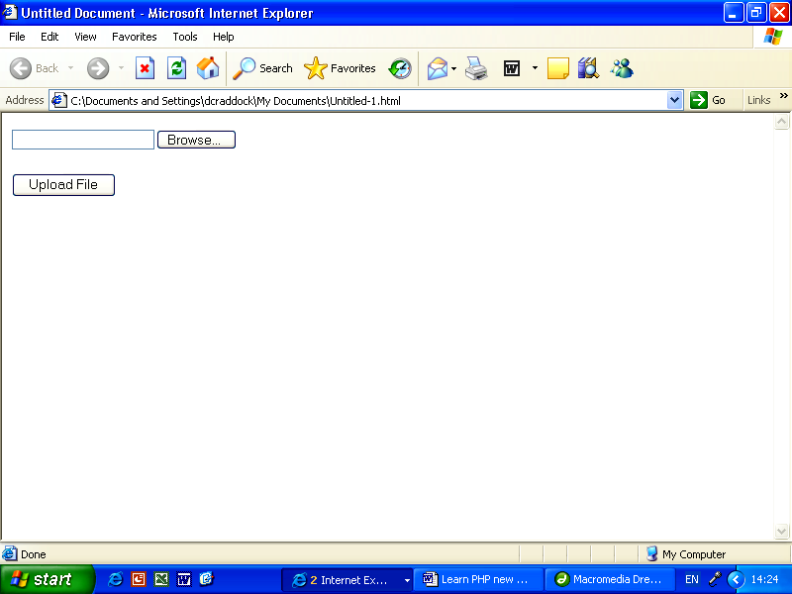

The textbox displays the full path of the file you select to upload. Click the “Browse…” button to search for a different file, or click the “Upload File” button to begin uploading.

Internet Browsers are very complex and clever applications, and as we've seen here it's easy to create a useful feature (browse for a file) with just a few lines of HTML. It is worth pointing out that this first HTML webpage does not actually upload files, but simply enables a user to browse for a file, and then send the file name and full path to another webpage.

This simple example only shows how to browse and select a single file for uploading. With a bit of copy-and-pasting it's possible to extend this to enable uploading of many different files at the same time. For example, imagine that we wanted to upload up to 5 different photographs together (perhaps photos of a property for an estate-agents website, each photo showing a different aspect of the property). All we need to do is add further file inputs to the form with different names:

Amendment to Practice Example 17.1a – To enable multiple file uploads
<form enctype=“multipart/form-data” name=“frmUpload” method=“post” action=“upload2.php”>Browse for files to upload:<br />
<input type=“file” name=“file1”><br/>
<input type=“file” name=“file2”><br/>
<input type=“file” name=“file3”><br/>
<input type=“file” name=“file4”><br/>
<input type=“file” name=“file5”><br/><br/>
<input type=“submit” name=“submit” value=“Upload File”>
</form>

Now that we've been able to browse and select a file(s), let's see how to upload the file(s) using PHP and store them on a web-server (where your website is located).

Practice Example 17.1b – PHP file upload. Save as “upload2.php”
<html>
<head>
<title>Uploaded File</title>
</head>
<body>
<?PHP
if ($_FILES[“file1”][“error”] > 0) {
echo “Sorry, the file could not upload.<br />”;
echo “Error message: “ . $_FILES[“file1”][“error”];
}
else {
echo “Upload: “ . $_FILES[“file1”][“name”] . “<br />”;
echo “Type: “ . $_FILES[“file1”][“type”] . “<br />”;
echo “Size: “ . ( $_FILES[“file1”][“size”] / 1024) . “ Kb<br />”;
echo “Temp file: “ . $_FILES[“file1”][“tmp_name”] . “<br />”;
if (file_exists(“upload/” . $_FILES[“file1”][“name”])) {
echo $_FILES[“file1”][“name”] . “ already exists.”;
}
else {
move_uploaded_file($_FILES[“file1”][“tmp_name”], “upload/” . $_FILES[“file1”][“name”]);
echo “Stored in: “ . “upload/” . $_FILES[“file1”][“name”];
}
}
?>
</body>
</html>

This PHP code makes use of the $_FILES array which requires two parameters, namely the name of the file (i.e. “file1”) and then either:
V[“name”] – the name of the file, [“type”] – the file type (e.g. .jpg), [“size”] – the size of the file in bytes, [“tmp_name”] – the name of the temporary copy of the file on the web-server and [“error”] – the error code (which is zero if there is no error in uploading the file).

The PHP upload code works like this:
• First, check to see if there is a problem with uploading the file.
if ($_FILES[“file1”][“error”] > 0)
If you are going to have a problem uploading, then it will most likely happen here! Check you have permission to upload files.
If there is a problem then this will be displayed on screen:
echo “Sorry, the file could not upload.<br />“;
• If there is not a problem then the next bit of PHP reports on the various attributes of the file:
… echo “Size:“ . ( $_FILES[“file1”][“size”] / 1024). “Kb<br />“; etc.
Note: this is optional! Delete if you wish.
• Next, check to see if this file already exists! Otherwise you would overwrite an existing file with the same name:
if (file_exists(“upload/”. $_FILES[“file1”][“name”]))
• Finally, assuming everything else is OK, move the temporary file to its final destination. Note, when uploading a file it is only stored temporarily on the web-server! We must state where (in which folder) we want the file to go.
move_uploaded_file($_FILES[“file1”][“tmp_name”], “upload/” . $_FILES[“file1”][“name”]);
So in this example, we upload the file to a folder called “upload/”.

b. How to Check for File Types.
!
Note:
take care when uploading files to a web server.

Before we allow indiscriminate file-uploads we should always check the file type. Allowing .exe files (executable programs) makes your website vulnerable to viruses and all sorts of unwanted and nuisance software. Your web-host will not thank you for this, as a virus may cause problems for not only your website but any other websites owned by others on a web-server or network!

There is a simple way to block certain file types, but with so many different types of file it's much easier to only “allow” a few types of file and block everything else, rather than to create a huge list of file types that we wish to “block”.

The following example shows how we can simply extend practical example 17.1b to “filter” certain file types before uploading them:

Practice Example 17.1c – Check file types – extension to ex. 17.1b
<html>
<head>
<title>Uploaded File</title>
</head>
<body>
<?PHP
if ((($_FILES[“file”][“type”] == “image/gif”) || ($_FILES[“file”][“type”] == “image/jpeg”) || ($_FILES[“file”][“type”] == “image/pjpeg”)) && ($_FILES[“file”][“size”] < 500000)) {
if ($_FILES[“file”][“error”] > 0) {
echo “Error: “ . $_FILES[“file”][“error”] . “<br />”;
}
else {
// rest of code to handle uploading of files …..
}
}
else {
echo “Sorry, wrong file type! Please only upload gif and jpeg images.”;
}
?>
</body>
</html>

In this extension the PHP only allows files of type .gif or .jpeg to be uploaded, and also blocks any files that are over 50 kilobytes in size: ($_FILES[“file”][“size”] < 500000)

With a bit of simple modification you could filter almost any type of file. An alternative method (and perhaps better) is to make use of the in-built PHP function explode. This works by splitting a string of text (e.g. “myfile.doc”) into an array, by setting a delimiter. If we set dot “.” (full-stop/ period) to be the delimiter then the resulting array would contain the file name (e.g. “myfile”) and the file type (e.g. “doc”). All we need to do then is to look at the last element in the array which should contain the file type (extension).

The next snippet of code shows how this can be done:

<?PHP
// check for jpg files
// get name of file
$filename = $_FILES['file']['name'];
// split string into an array, delimiter is dot (.)
$pieces = explode(“.”, $filename);
// look at last element in array
if($pieces[1] != “jpg”) {
// if file type not jpg
echo “File not .jpg! Could not upload.<br>”;
}
else {
// all ok, so can upload file ….
}
?>

c. Some useful PHP Functions to Manipulate Images.
Imagine that we wanted to enable uploading of photographs but have a limit to the amount of memory space available. Unformatted Photographs can take up a huge amount of memory space! Fortunately PHP has some handy in-built image manipulation functions that can be used to resize an uploaded image to almost any size. We can also check the orientation of images by checking whether the width has a greater value than the height. The following snippet of code can be used to modify practical example 17.1 further. This code uses special functions (imagesx and imagesx) to determine the size of the temporary file, then recreates a new image file with a width of 300 pixels (imagecreatetruecolor, imagecopyresampled and imagejpeg ).

Code Example 17.1
// set file path and name
$file_name = “upload/” . $_FILES[file]['name'];
// set file path and name
$file_name = “upload/” . $_FILES[“file1”]['name'];
// open temporary unresized image
$newimage = @imagecreatefromjpeg($_FILES[“file1”]['tmp_name']);
// Get original width and height
$width = imagesx($newimage);
$height = imagesx ($newimage);
// show height and width
echo “Image has a width of “ . $width . “ pixels.<br>”;
echo “Image has a height of “ . $height . “ pixels.<br>”;
// check orientation of image (compare height with width)
if($height > $width) {
echo “Height of image is greater than width!<br>”;
}
// set new width to 300 pixels, and height in proportion
$new_width = 300;
$new_height = $height * ($new_width/$width);
// show height and width
echo “Image has a new width of” . $new_width . “ pixels.<br>”;
echo “Image has a new height of” . $new_height . “ pixels.<br>”;
// resample image to new size
$image_resized = imagecreatetruecolor($new_width, $new_height);
imagecopyresampled($image_resized, $newimage, 0, 0, 0, 0, $new_width, $new_height, $width, $height);
// save resized image
imagejpeg($image_resized, $file_name);
echo “Image uploaded successfully.<br><br>”;
// generate HTML link to see uploaded/resized image in a new browser window
echo “<a href=” . $file_name . “ target='_blank'>Click here to see uploaded/resized image (will open in a new browser window).</a>”;

Notes for Using Code Example 17.1:
Before you try this example, please check the following:
1. This PHP file is intended to REPLACE the file: “upload2.php”. Therefore, either RENAME this file with the name: “upload2.php”, OR
change the FORM tag in file “upload.php” to this:
<form enctype=“multipart/form-data” name=“frmUpload” method=“post” action=“code_example17_1.php”>
(just do one or the other, not both!).
2. Create a new folder/directory named “upload” in the same location in which you place this file.
3. Make sure to set the CHMOD (change mode) PERMISSIONS for your folder named “upload”, setting them to read/write access for ALL users (CHMOD 0777). If you don't do this, then you will not be able to upload files to the “upload” folder, but will see an error message instead.

Summary …
~ …use an HTML form to browse for a file to upload.
~ …use enctype=“multipart/form-data” within the <form> tag.
~ …use a “file” form input element to enable searching of a file.
~ …$_FILES[“file”][“name”] returns the name of a file for uploading.
~ …$_FILES[“file”][“size”] returns the size of a file for uploading.
~ …$_FILES[“file”][“type”] returns the type of a file for uploading.
~ …move_uploaded_file($_FILES[“file”][“tmp_name”], “upload/” . $_FILES[“file”][“name”]);
transfers a temporary file to a location on a web-server.
~ …always check the file type before uploading to avoid viruses.
~ …check the file size before uploading to make best use of memory space.
~ …resize image files if necessary before storing on a web-server.

Chapter 18 – Email

Using SMTP to Send Emails from your Webpages

By the end of this chapter you will know …
~ a. …how to use PHP to send an email from a webpage.
~ b. …how to create a “feedback form”.
~ c. …how to make your PHP email more secure.

a. How to use PHP to Send an Email from a Webpage.
There are lots of reasons why you might conceivably want to send an email from a webpage such as confirming a registration or sending a message or help request. You could also send an email to yourself if an error occurred on a webpage and you wanted notification of this. The underlying objective behind each of these reasons is to provide some kind of automatic response, that is, a round-the-clock useful service to visitors of your website.

What you need to start emailing with PHP:

1. PHP Email System
Before you can start emailing you will need to obtain and install an email system on your website. Check also that your website hosting supports “SMTP”. Your website hosting package may already include a PHP emailing system, so you will need to check this with your hosting provider. If not, then a quick search using your favourite Internet search-engine for “PHPMailer” should bring up some useful results. PHPMailer is a free (at the time of writing) PHP email class and set of functions that you can use on your own website. Once downloaded and uncompressed (unzipped) you'll be left with two files, namely class.phpmailer.php and class.smtp.php.

Simply upload these two files to your webspace and you're ready to go. The practical examples given in this chapter will all rely on the use of PHPMailer, but can be easily adapted for use with other email systems.

2. Email Account
The next thing you'll need is an email account, and also the password and host name of your website hosting provider. If in doubt, ask your hosting provider and they should happily provide you with this information. Your provider may also be able to provide you with code examples and support if you are having difficulties using PHP email on your website. Depending on the level of features your website has you may be able to create email accounts and set up passwords as you require.

If you are trying this out for the first time then it would be a good idea to set up some temporary email accounts rather than trying to send PHP emails to your friends or colleagues who might become annoyed at receiving strange and random test emails!

Once you have uploaded the PHPMailer files class.phpmailer.php and class.smtp.php to your website then try the following example:

Practice Example 18.1 – Simple PHP email
<html>
<head>
<title>Send an Email</title>
</head>
<body>
<?PHP
// link to PHPMailer
require(“class.phpmailer.php”);
$mail = new PHPMailer();
// tells the class to use SMTP
$mail -> IsSMTP();
// SMTP server
$mail -> Host = “mail.mywebsite.co.uk”;
$mail -> From = “myname@mywebsite.co.uk”;
$mail -> FromName = “Joe Bloggs”;
$mail -> AddAddress(“yourname@mywebsite.co.uk”);
// turn on SMTP authentication
$mail -> SMTPAuth = true;
// SMTP username
$mail -> Username = “myname+mywebsite.co.uk”;
// SMTP password
$mail -> Password = “letmein”;
// set Subject heading
$mail -> Subject = “Test”;
// set main body message
$message = “Hello there!”;
$mail -> Body = $message;
// send email
$mail -> Send();
?>
</body>
</html>

Things to note from this example:
• Use the require() function to make a link to PHPMailer. (without this the email simply will not happen!)
• This webpage must be uploaded to the same location as the files class.phpmailer.php and class.smtp.php
• Replace myname@mywebsite.co.uk with your own valid email address.
• Replace yourname@mywebsite.co.uk with another valid email address that you have access to (you could make these the same).
• Authentication means that you need to send the email account password. Without this, some email accounts (e.g. AOL emails) may not accept your email and disregard it as SPAM (unsolicited, unwanted nuisance mail).
• You can send this email to more than one email account by adding further email addresses, using: $mail -> AddAddress(“email_address_goes_here”);
• If in doubt, contact your website host to find out what you should put for host and username entries.

Tip …
You can add multiple lines of text to the main body of an email. Text should “wrap” automatically to the next line, but to add a new line (e.g. to create spacing between paragraphs) then concatenate “\n” to your body text. For example:

$message = “Dear Mrs Smith,\n\n\n”;
$message = $message . “Thank you for your email …… blah de blah …”;

The code snippet above includes three lots of the \n characters, thereby adding three new lines. The resulting email would appear something like:

Dear Mrs Smith,
Thank you for your email … blah de blah …

Take care however, when using email in this way. A new email will be sent each time you refresh or re-visit this webpage!

It is worth noting that much of the code given in practical example 18.1 is reliant on the use of the PHPMailer system. For example: $mail -> Subject = “Test”;

This is not an inbuilt PHP function, but rather a custom function written by the creators of PHPMailer. If you do not include the code require(“class.phpmailer.php”) or don't upload the PHPMailer files then this email will not work.

b. How to Create a Feedback Form.
Practical Example 18.1 can only serve as a simple tool for learning how to send emails with PHP; it has few genuine applications. A more common use of PHP email is in the provision of a feedback or contact form. Many businesses and organisations make use of such forms for the following reasons:
• No need to display email address on webpage (prevents SPAMMERS from harvesting your email address from your website).
• Visitor does not need to copy/paste or re-type your email address, no need to start their own email client software.
• You can ensure that a visitor sends exactly the right kind and format of information that you require, by using text boxes, options, drop-down menus.
• Makes website more user-friendly, visitors are more likely to return to your website and tell their friends about it if they receive a good service.
Implementing a feedback/contact can be done either on a single webpage or across two or more webpages. Depending on the amount of information you require, the golden rule is to minimise the number of clicks, amount of typing and scrolling down the page. (Modern website visitors scan webpages very quickly and will not appreciate lengthy explanations and masses of inputs).

The following practical example shows how a simple email “Request a Brochure” form can be implemented onto a single webpage. This example does not include any JavaScript validation, and it is left as an exercise for the reader to consider how to check a user's inputs before sending off an email (there are many hundreds of freely available code examples on the Internet, simply search for “javascript form validation” using your favourite search-engine).

Practice Example 18.2 – Request a Brochure Form
<html>
<head>
<title>Request a Brochure</title>
</head>
<body>
<?PHP
// get user data
$email = $_POST['email'];
$name = $_POST['name'];
$street = $_POST['street'];
$town = $_POST['town'];
$postcode = $_POST['postcode'];
// only send email if user clicks submit button and enters postal details
if($_POST['submit'] == “Send” && $street != ““ && $postcode != “ ”) {
// set up PHPMailer
require(“class.phpmailer.php”);
$mail = new PHPMailer();
$mail -> IsSMTP();
// SMTP server
$mail -> Host = “mail.mywebsite.co.uk”;
$mail -> From = “myname@mywebsite.co.uk”;
$mail -> FromName = “Joe Bloggs”;
// send email to customer
$mail -> AddAddress($email);
// send COPY of email to business
$mail -> AddAddress(“myname @mywebsite.co.uk”);
$mail -> SMTPAuth = true;
$mail -> Username = “myname+mywebsite.co.uk”;
$mail -> Password = “letmein”;
$mail -> Subject = “Brochure Request Confirmation”;
// set main body message
$message = “To” . $name . “\n\n”;
$message = $message . “Thankyou for your brochure request”\n\n”;
$message = $message . “Your brochure will be sent to:\n\n”;
$message = $message . $street . “\n” . $postcode . “\n\n”;
$message = $message . “Please contact us if it doesn't arrive within “;
$message = $message . “14 days.”;
$mail -> Body = $message;
// send email
$mail -> Send();
echo “Thank you – request sent OK!<br /><br />”;
}
else {
// error – no details entered! Do not send email
echo “Please enter your details.<br /><br />”;
}
?>
<h2>Brochure Request Form:</h2>
<form method=“post”>
<input type=“text” name=”name”>Enter your name<br />
<input type=“text” name=“email”>Enter your email address<br />
<input type=“text” name=“street”>Enter your house number and street name<br />
<input type=“text” name=“town”>Enter your town<br />
<input type=“text” name=“postcode”>Enter your postcode<br />
<input type=“submit” name=“submit” value=“Send”>Click to Request Brochure
</form>
</body>
</html>

In this example, an email is only sent if the submit button is clicked, AND the visitor enters their postal contact details. Note also that this example sends an email both to the website owner and to the visitor's email address. This is good practice and enables you to see how many people have (in this example) requested a brochure, and also reassures the visitor that their request has been sent successfully. If you enter the code correctly then the HTML form should look like the following on your browser:

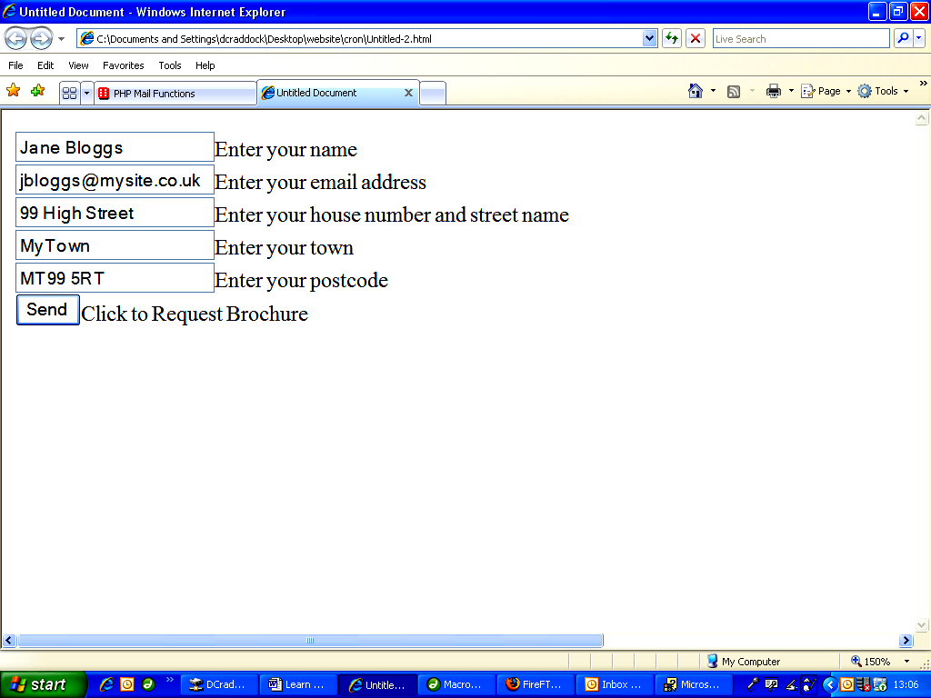

A limitation to this example however is that a visitor may refresh the webpage and hence send multiple emails. There are several ways to prevent this, such as forcing the form inputs to be empty each time the webpage reloads. Furthermore, it is possible for a visitor to enter an incorrect email address (in this case they will not receive a confirmation email themselves) or even add multiple email addresses. This latter case will cause people to receive SPAM and take up your valuable bandwidth, so we'll see how to prevent this in the next part of this chapter.

c. How to make your PHP email more secure.
What would happen if you entered the following text in the “Enter your email address” input box above?

bob@mysite.com%0ACc:sally@mysite.com%0ABcc:anne@example.com,person3@mysite.com,khyber@mysite.com,jim@example.com%0ABTo:cathy@mysite.com

This would effectively force your PHP email code to send carbon-copy emails to more than one person at a time. Known as “email-injection”, this technique is used by email spammers to use vulnerable websites to send unsolicited email! It's not difficult to prevent, but you might be surprised at how many websites neglect to include the simple methods required to stop it.

The following practical example 18.2b is an extension and slight modification to example 18.2, and simply consists of a custom-function named “CheckSpam” to validate the email address input by checking for the inclusion of the text “to:” or “cc:” or “bcc:” (bcc is blind carbon copy).

It works by inputting a string (email address), and performing a case-insensitive (either UPPER or lower case text) expression match. If it finds the text “to:” or “cc:” or even “bcc:” then the function will return a value of false, and will not send an email.

The CheckSum function makes use of the inbuilt eregi(search, string) function which checks to see if a piece of text (search) is found within another string (string).

Practice Example 18.2b – Request a Brochure Form – Improved security
… start of HTML code …
<body>
<?PHP
// function to check for and reject email injection
function CheckSpam($input) {
if(eregi(“to:”, $input) || eregi(“cc:”, $input) || eregi(“bcc:”, $input)) {
return false;
}
else {
return true;
}
}
$email = $_POST['email'];
// validate email address
if(CheckSpam($email)) {
$name = $_POST['name'];
$street = $_POST['street'];
$town = $_POST['town'];
$postcode = $_POST['postcode'];
// only send email if user clicks submit button and enters postal details
if($_POST['submit'] == “Send” && $street != “" && $postcode != “") { etc. etc. etc. …
$mail -> Body = $message;
// send email
$mail -> Send();
echo “Thank you – request sent OK!<br /><br />”;
}
else {
// error – no details entered! Do not send email
echo “Please enter your details.<br /><br />”;
}
}
else {
echo “Invalid email address! Request not sent.<br /><br />”;
}
?>…. Rest of HTML code …

Summary …
~ …to activate email use an email class such as PHPMailer.
~ …upload email-enabled webpages to the same location as PHPMailer files.
~ …PHPMailer requires a sender email address, host name, password, recipient email address, authentication, subject text and main body text.
~ …use an HTML form to produce feedback and contact reply forms.
~ …always validate email address input text to prevent email-injection attacks.
~ …send copies of emails to both sender and receiver.

Chapter 19 – MySQL Databases

Create, Setup and Connect to MySQL

By the end of this chapter you will know …
~ a. …how to create and then connect to a MySQL database.
~ b. …how to create a table.
~ c. …how to add, amend and delete information using SQL.
~ d. …how to create users and set permissions.
~ e. …about phpMyAdmin.

a. How to Create and then Connect to a MySQL Database.
Any website that does something really useful will most likely make use of a database. The most popular websites rely entirely on the use of databases and could not function without one. Examples of established popular websites (at the time of writing) that rely on databases are:

Amazon.co.uk (shopping), eBay.co.uk (auction site), upmystreet.com (local information), multimap.com (maps and directions), Google.co.uk (search engine).

There are thousands of others of course, but the one thing they all have in common is that they have a database (or several databases).

In chapter 2 we discovered what databases are. As a quick recap – a database is simply a means of storing information in a structured way, and enables us to search for stored information and produce meaningful results. The great thing about using a database on a website is that we can store information that doesn't disappear once a visitor leaves the site. Information can be stored for as long as we need it. Better still, because a database stores information in a structured manner, we can search for exactly the information that we want, and display it in the way we want to very quickly indeed.

Examples of how we could use a database on a website:
• Keep track of members' usernames and passwords, so that a member would need to type in both before being allowed access to a part of a website.
• Store information of products for sale; visitors could search for products using specific criteria such as maximum price, colour etc.
• Create a guest book or forum whereby visitors could share advice, experience and information.

There are many other applications of course; the only limit is your imagination!
MySQL is a free database for websites. Free to download, free to use. Check with your website host that you have at least one MySQL database enabled on your website. If not then you may want to upgrade your hosting or look for a new host. There are many hosting companies that offer either free use of a MySQL database or paid hosting for a reasonable monthly or annual fee. You can download MySQL yourself (for free) from: http://www.mysql.com/downloads/index.html

Assuming that you do have a MySQL database, before you can do anything useful it is necessary to “connect” to it. The reason for this is that you may have more than one database on your website, and your web-server needs to know which one (if any) that you wish to use. Connecting to a MySQL database is very easy and only requires two lines of PHP. However, you do need to know the server-name, and have a username and password for the database. Also your database will have a name. You may be able to set the name yourself, but more often than not your host will generate a database name for you. To find these out contact your website hosting provider.

The reason for having a username and password is that we can set different access rights to your database. For example, you might want to create an “administrator” account for someone (yourself?) to have full access to your database and be able to search, amend and delete data. You might then want to create a “general” account for everyone else, with access to search data only.
!
Note:
this is a very useful technique for protecting data on your database. Full administration rights might enable someone (e.g. a hacker) to access sensitive or private data on your database, or even to delete all the data!

For example purposes, let's say that our server-name is “localhost”, and that we have created a username of “general” with a password “letmein” (not a good password but easy for us to remember). Let's name our database as “myMySQL”. As before, contact your website hosting provider for help on creating a username and password for your MySQL database. The method for doing this may vary according to your provider. A good hosting provider will be very happy to provide you with this information.

PHP has many inbuilt functions for using MySQL databases. To connect to our MySQL database we use the function: mysql_connect(server_name, username, password) as follows:

<?PHP
$dbh = mysql_connect (“localhost”, “general”, “letmein”);
mysql_select_db (“myMySQL”);
?>

Note the use of the variable $dbh above. This is required because the function mysql_connect returns an output, and we must have somewhere for this output to go. We're not going to do anything with this output at the moment, but must still have somewhere for it to go anyway. Think of functions like a washing-basin. You can turn on the taps and fill the basin with water to have a wash (this is the input) but without a plug-hole there's nowhere for the waste water to go afterwards (this is the output). So, mysql_connect connects to our database with a pre-determined username and password, whereas mysql_select_db makes sure that we're connecting to the correct database (as you may have more than one) using the database name.

Equally important as connecting to a MySQL database is disconnecting. Always disconnect from a database when you've finished to keep things tidy and prevent errors. To disconnect from all databases simply use:

mysql_close();

CPanel
In practice you might not actually have administration rights to create a database by using PHP! However, most web-hosting companies will provide you with two very useful pieces of software when you purchase (or obtain for free) your own webspace (check that PHP and MySQL are enabled). The first is called CPanel, and is used to help you administer just about every aspect of your website, including email, FTP, domain names and MySQL databases.

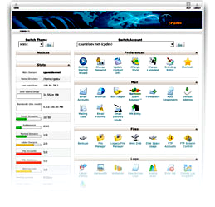
Screenshot of CPanel Software:
Official website: www.cpanel.net. CPanel comes with full help and support and is very easy to use. If you have MySQL enabled with your website, then you can use CPanel to very quickly and easily create a database username and password, and then create a new database. Once you've done this, you can then link your username to the new database. The reason for doing this is that you might want to restrict the operations that a user can perform on the database.

Using CPanel to create a New User and Create a New Database:
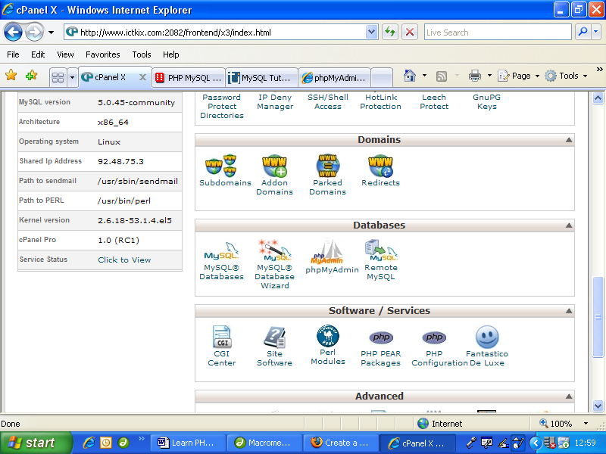
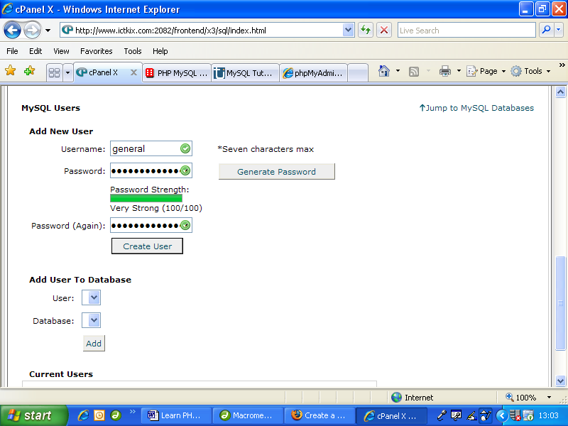
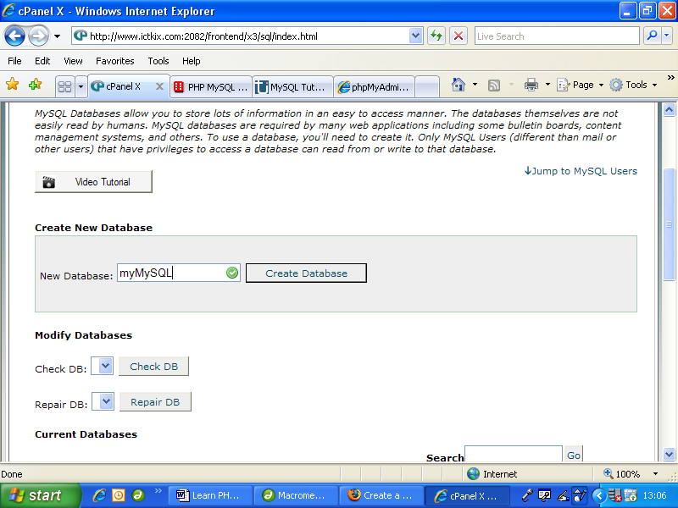
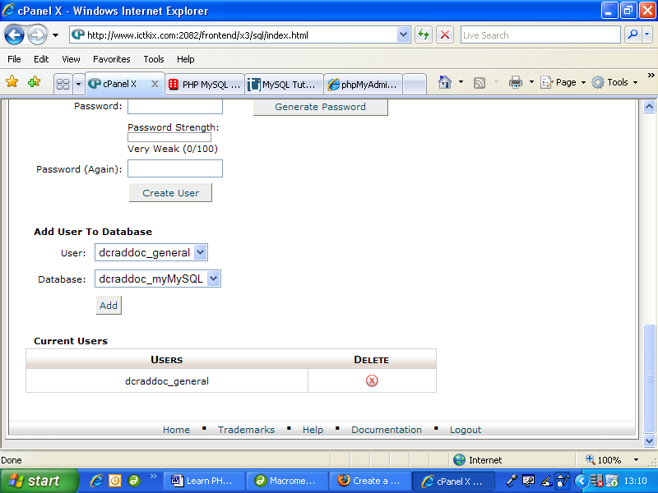
First of all, select the MySQL Databases option in CPanel.

Next, create a new user, adding a username and password.

Then create your new database by adding the database name.

Once this has been successfully completed, you should then be able to link your user to the database. Notice that CPanel might append your username (as shown here). Don't worry about this, but make sure you keep a note of the username and database name that CPanel gives you.

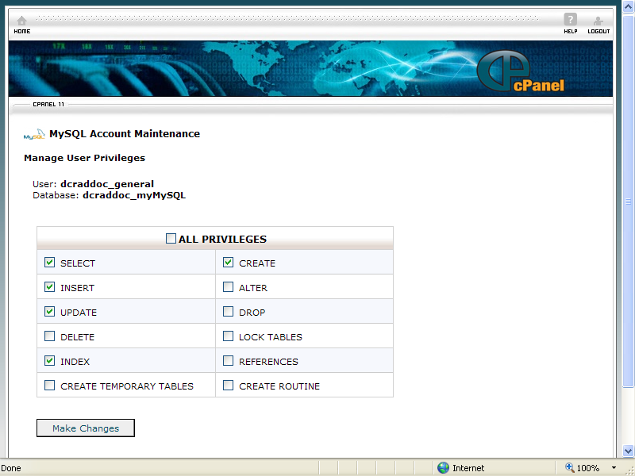
During the process of linking a user to a named database, CPanel may require that you set database privileges.
What you select is your own choice, but you might be ill-advised to permit “DROP” privileges, because the action of dropping a database (or table) will permanently delete the database (or table), including all data! (Data is often more valuable than the database itself.)

It's possible to amend the privileges of a particular user later on.

As previously discussed, some website applications might require the creation of multiple users, each with a different password, according the status or function of the person accessing the database. If you do not have access to CPanel, then the PHP code for creating a new database is as follows:

How to create a new database named: myMySQL:

Code Example 19.1
<?PHP
// create connection
$dbh = mysql_connect(“localhost”,”username”,”password”);
if (!$dbh) {
// error with connection
die('Sorry, could not connect: ' . mysql_error());
}
// create new database named myMySQL
if (mysql_query (“CREATE DATABASE myMySQL”, $dbh)) {
// database creation successful
echo “Database created successfully”;
}
else {
// error creating database
echo “Error creating database:” . mysql_error();
}
// disconnect from database
mysql_close ($dbh);
?>

We have made an assumption here that our database named myMySQL already exists. This may not be the case, but creating a MySQL database in PHP is very easy. We use the CREATE DATABASE database_name command to create a new database, but we have to put this command inside the mysql_query() function. In fact, as we'll find later on, we send almost every command through the mysql_query() function.

Things to Note Above:
• In this code example 19.1 we have at last made use of the returned output from the mysql_connect function, and we use it to check if the connection was successful (returns true) or unsuccessful (returns false).
• The die command prints text on the screen if there is an error. mysql_error contains information about the error. If PHP comes across the die command then once it has printed the text it will stop there and will not execute any other PHP code within the current webpage. This is a handy feature and may prevent unwanted, unprofessional-looking error messages appearing on your website!
• Don't forget to disconnect at the end using mysql_close.

Now we've completed the 'house-keeping' tasks, we're ready to set up our database and do something useful with it.

PHPMyAdmin
The second piece of software that is often supplied with PHP and MySQL website accounts is phpMyAdmin. As with CPanel it's very easy to use after a little practice, and will enable you to create and amend tables.

Screenshot of phpMyAdmin software: Official website: www.phpmyadmin.net
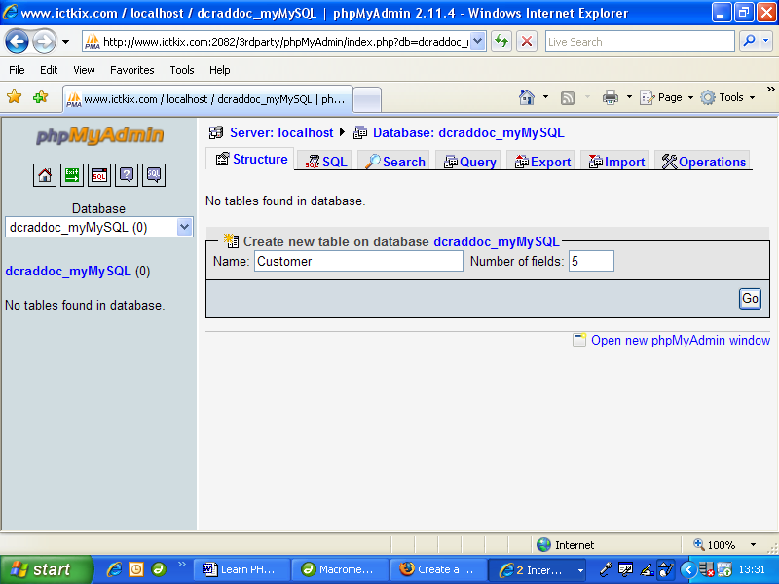

As shown in the screenshot above, creating a new table is as simple as entering the name of the table and number of fields, and then clicking on the “Go” button!
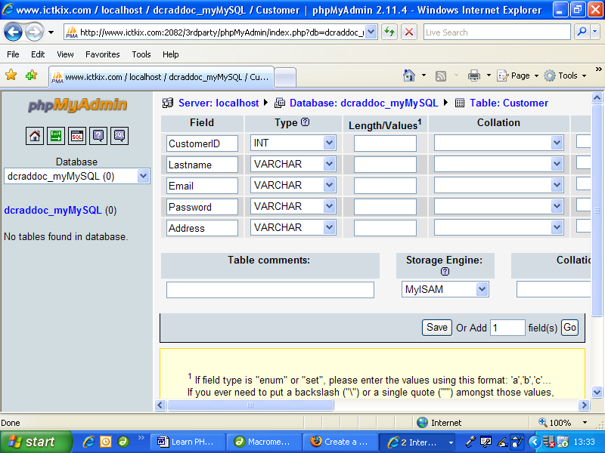

Throughout the rest of this resource we will look at how to create and amend tables by using PHP.

b. How to Create a Table.
Tables are the basic building blocks of a database. You can generally add any number of tables to a MySQL database, the only limitation being the maximum amount of data storage that you are allowed on a web-server. A table in itself does not require much memory space, but as you begin to add data to a table the amount of memory required can soon mount up.

Within a table we can add fields, otherwise known as columns. Think of a field as a “category name”. To add useful information to a table we create records. A record is a set of data on a single person or object. Records are also known as rows. As an example look at the table below:

Table | Fields
Rows | MemberID | Lastname | Firstname | Email
Rows | 10 | Smith | Annabel | a.s@aol.com
Rows | 11 | Wordsworth | William | Words_w@wordz.com
Rows | 12 | Bloggs | Fiona | fiblog@btworld.co.uk
Rows | 13 | Matthews | Matthew | Matty7469715m@hotmail.com
(note: all names and email addresses are fictitious!)

Things to Note:
• There are 4 records (rows) representing data of 4 different people.
• Each record contains data across 4 fields (columns).
• Each record has a unique ID field. This is necessary because it is possible to have more than one person with the same name, so we need a foolproof means of identifying records later on.
• We have not specified a data-type for each field. In the example above, fields Lastname, Firstname and Email could be defined with a varchar data type (means “variable character” and is a general type for strings), whereas UniqueID might use an Integer (whole number) data type.

Before we create a new table, let's have a quick look at the
data types that are available to us in MySQL:

Numeric Types | Description
int(size)  tinyint(size)  bigint(size) | Used for integer whole number values (positive or negative), e.g. 99 or -24. The size parameter relates to how large a value you wish to store.
decimal(size,d)  double(size,d)  float(size,d) | Used for real numbers with that may contain a fractional part, e.g. 34.56 The size parameter limits the max. number of digits to the left of the decimal point, and the d parameter limits the max. number of decimal places.
Text Types | Description
char(size) | Used for strings of a fixed length (can contain letters, numbers, and special characters). The fixed size is determined by size.
varchar(size) | Used for string values that may vary in length (can contain letters, numbers, and special characters). The maximum length is determined by size.
tinytext | Used for variable strings with a maximum length of 255 characters.
longtext | Used for variable strings with a maximum length of 4294967295 characters.
Date Types | Description
date(yyyy-mm-dd) | Used for date.
datetime(yyyy-mm-dd hh:mm:ss) | Used for date and/or time.
This is not an exhaustive list, but contains the data types that you are likely to need for most applications. For a complete list visit: www.mysql.com

We must decide on an appropriate name for our table, and then specify the fields with corresponding data types. It often helps if we sketch a diagram like the table above beforehand, so we know exactly how many columns to add. (Remember, columns are fields. We add rows later on when we add useful data to our table.)

The following PHP code will create a new table called Member in our database myMySQL (note: standard practice is to name tables in the singular, so our new table will be named Member rather than Members)

How to Create a new Table Named “Member” in our “myMySQL” database:

Code Example 19.2
<?PHP
// connect to myMySQL database
$dbh = mysql_connect(“localhost”,”myMySQL”,”letmein”);
if (!$dbh) {
die('Sorry, could not connect: ' . mysql_error());
}
mysql_select_db(“myMySQL “, $dbh);
// Create new table in myMySQL database
// including field names and data types
$sql = “CREATE TABLE Member (
MemberID INT(4) NOT NULL AUTO_INCREMENT,
LastName VARCHAR(15) NULL,
FirstName VARCHAR(15) NULL,
Email VARCHAR(30) NULL,
PRIMARY KEY(MemberID)
)”;
mysql_query($sql, $dbh);
mysql_close($dbh);
?>

The MySQL command to create a new table is: CREATE TABLE table_name.
We then specify all fields and their corresponding data types within parentheses as shown. It is good practice to indent your code to make it easy to follow.

To add a field we simply state the field name followed by the data type. Fields are separated by a comma. e.g. LastName VARCHAR (15), FirstName VARCHAR (15)

Primary Key Fields:
The odd-one-out above is the MemberID field.

Remember that we previously saw how every record (in this case, every member) should have a unique record-number used to identify each individual member. This is necessary because some members may have the same name. We have used the field name MemberID for this purpose (ID stands for identification). In database terminology we say that this is the Primary Key Field. The great thing about using key fields is that once we know the value of a member's key-field, we can then have access to all the other stored data of that member in our database.

Key fields are used to link information in tables. For example, we might later create another table to record purchases made by each member. Rather than storing a member's full details all over again every time a member makes a purchase (unnecessary repetition of data, known as “data-redundancy”), we only need to store a member's MemberID number, which is their unique identifier.

Question: So how do we ensure that every member has a unique ID number? Do we have to assign a number ourselves? Do we need to remember or look-up the last highest value and add one each time we add a new member?

Answer: No! MySQL takes care of all this for us (phew!). Look at the following lines of code that we used within the creation of our Member table:

MemberID INT(4) NOT NULL AUTO_INCREMENT,
PRIMARY KEY(MemberID),

The first line above tells the MySQL database that we wish to add a new field with the name MemberID. The data type is INT (integer), and NOT NULL means it must have a value (e.g. at least zero, but never empty). AUTO_INCREMENT means that every time we add a new member, the MySQL database should automatically assign a new value which will be an integer number. MySQL does this by looking at the value of the previous record (which may be a value of zero or above) and then incrementing this by a value of one.

The second line tells the database that the MemberID field should be the primary key field to uniquely identify each record.

Finally, let's create two more tables. The first of these will contain details of DVD movies, and the second will record which members have borrowed which DVDs. So in essence we will have created a very simple DVD-Rentals database which could be easily modified for almost any purpose.
!
Note:
we have only created the structure of a table, and have not yet entered data.

The structure of the table named “DVD” will look like:

DVD | Fields
Records | DVD_ID | Title | Genre | Rental (£ per day)
Records | 415 | Hitch | Rom-Com | 1.99
Records | 748 | The Hulk | Action | 2.99
Records | 86 | The Simpsons | Kids | 1.99
Records | 172 | Casino Royale | Action | 2.99

The reason for having a third table to record which members have rented which DVD movies is to prevent duplication of data, otherwise every time a member rented a movie we would have to store the member’s full details and the full details of the movie all over again. It is beyond the scope of this resource to explain good database design, but it is very common and good practice to create databases in this way (this is known as “normalising” in database terminology). So the structure of our third table to store details of rentals may look like:

Rental | Fields
Records | DVD_ID | MemberID | Return Date | Returned?
Records | 748 | 11 | 2008 – 03 – 12 | Yes
Records | 748 | 12 | 2008 – 03 – 16 | No
Records | 172 | 12 | 2008 – 04 – 24 | No
Records | 415 | 10 | 2008 – 02 – 02 | Yes

You could easily add additional fields later on to suit your own requirements.

Notice in the Rental table that one member can rent more than one DVD (Member 12 in this case), and that one DVD can be rented by more than one member (but not at the same time hopefully!). The table also seems to have two primary key fields. In fact the primary key field is known as a compound key, i.e. both the DVD_ID and MemberID fields comprise the key field for this table. This is not a perfect setup, however, as it will allow a member to rent the same DVD more than once at the same time! To solve this problem we should really add a unique Rental_ID field, thus:

Improved Rental table with primary key field Rental_ID:

Rental | Fields
Records | Rental_ID | DVD_ID | MemberID | Return Date | Returned?
Records | 1002 | 748 | 11 | 2008 – 03 – 12 | Yes
Records | 1003 | 748 | 12 | 2008 – 03 – 16 | No
Records | 1004 | 172 | 12 | 2008 – 04 – 24 | No
Records | 1005 | 415 | 10 | 2008 – 02 – 02 | Yes

Now to actually create these tables using PHP:
How to Create a new table named “DVD” in our “myMySQL” database:

Code Example 19.3
<?PHP
// connect to myMySQL database
$dbh = mysql_connect(“localhost”,”myMySQL”,”letmein”);
if (!$dbh) {
die('Sorry, could not connect: ' . mysql_error());
}
mysql_select_db(“myMySQL”, $dbh);
// Create new DVD table in myMySQL database
// including field names and data types
$sql = “CREATE TABLE DVD (
DVD_ID INT(4) NOT NULL AUTO_INCREMENT,
Title VARCHAR(15),
Genre VARCHAR (15),
Rental DECIMAL(2, 2),
PRIMARY KEY(DVD_ID)
)”;
// go and create table
mysql_query($sql, $dbh);
// disconnect from database
mysql_close($dbh);
?>

For the Rental field above (which we use to record the rental fee) we have used the decimal data type, setting two place values and two decimal places (total of 4 significant figures, e.g. capable of storing information such as: 1.99, 2.99 etc.).

How to create a new table named “Rental” in our “myMySQL” database:

Code Example 19.4
<?PHP
// connect to myMySQL database
$dbh = mysql_connect(“localhost”,”myMySQL”,”letmein”);
if (!$dbh) {
die('Sorry, could not connect: ' . mysql_error());
}
mysql_select_db(“myMySQL”, $dbh);
// Create new Rental table in myMySQL database
// I ncluding field names and data types
$sql = “CREATE TABLE Rental (
Rental_ID INT(4) NOT NULL AUTO_INCREMENT,
DVD_ID INT(4),
Member_ID INT(4),
Return_Date DATE,
Returned VARCHAR(3),
PRIMARY KEY(Rental_ID)
)”;
// go and create table
mysql_query($sql, $dbh);
// disconnect from database
mysql_close($dbh);
?>

A field in a table that is also a primary key field from another table is known as a foreign key field. These provide the links (known as “relationships” in database terminology) between tables (tables are also known as “entities).

!
Note:
the data type of a foreign key field in a table must be the same as the data type used in the originating table. Eg note the type used for DVD_ID and Member_ID.

c. How to add, amend and delete information using SQL.
Now we have created the necessary tables including structure, data types and relationships we can begin to add data. To do this we will use a special programming language called SQL – Structured Query Language. SQL is a common language used by many databases and is very easy to learn and use. We use SQL to:
• INSERT new records to a table,
• SELECT records from a table using criteria and look at the results,
• UPDATE existing records in a table, and
• DELETE existing records.
Let's begin with Inserting data into our newly created tables, first of all adding information of our members. The SQL syntax for inserting a new record into a table is:
INSERT INTO table_name (field1, field2, …) VALUES (value1, value2, … )
The command INSERT INTO is not case sensitive.

In practice we first write our SQL statement and store it as a string variable, and then execute the SQL by using the mysql_query function. So to insert information of our first member would look like:

Inserting a member's information into Member table:

Code Example 19.5a
<?PHP
// connect to myMySQL database
$dbh = mysql_connect(“localhost”,”myMySQL”,”letmein”);
if (!$dbh) {
die('Sorry, could not connect: ' . mysql_error());
}
mysql_select_db(“myMySQL”, $dbh);
// generate SQL statement
$sql = “INSERT INTO Member (Lastname, Firstname, Email)
VALUES ('Smith', 'Annabel', 'a.s@aol.com')” ;
// execute sql statement to insert new record
mysql_query($sql, $dbh);
// disconnect from database
mysql_close($dbh);
?>

and for the next member:

Code Example 19.5b
<?PHP
// connect to myMySQL database
$dbh = mysql_connect(“localhost”,”myMySQL”,”letmein”);
if (!$dbh) {
die('Sorry, could not connect: ' . mysql_error());
}
mysql_select_db(“myMySQL”, $dbh);
// generate SQL statement
$sql = “INSERT INTO Member (Lastname, Firstname, Email)
VALUES ('Wordsworth', 'William', 'w@wordz.com')” ;
// execute sql statement to insert new record
mysql_query($sql, $dbh);
// disconnect from database
mysql_close($dbh);
?>
Things to Note:
• Always use single-quotes within double-quotes when generating an SQL string.
• We never insert a value for the primary key field (MemberID in this case). MySQL will do this for us automatically.
• It is not necessary to insert values for every field. Eg.. we might not know the email address for our second member above. In this case we could do either of the following:
“INSERT INTO Member (Lastname, Firstname) VALUES ('Wordsword', 'William')” or,
“INSERT INTO Member (Lastname, Firstname, Email) VALUES ('Wordsword', 'William', '')”
(notice the empty string for the value of Email in the latter example).

The important thing when using INSERT is to ensure that the order of the values is the same as the stated fields. This is often a cause of errors for those new to MySQL. Another common cause of errors is the incorrect use of quotes within a string, so take extra care with these.

This method of inserting members' details individually by “hard-programming” their details is never done in practice. A more flexible method is to use an HTML form to enable a user to input details and then insert a new record using POST values, thus:

Using an HTML form to enable insertion of new members:

Code Example 19.6
<html>
<head>
<title>Form to insert a New Member</title>
</head>
<?PHP
// get new member's details from HTML form
$lastname = $_POST['lastname'];
$firstname = $_POST['firstname'];
$email = $_POST['email'];
// only add member if data entered by user and submit button clicked
if($lastname != “ ” && $firstname != “” && $_POST['submit'] == “Add”) {
// connect to myMySQL database
$dbh = mysql_connect(“localhost”,”myMySQL”,”letmein”);
if (!$dbh) {
die('Sorry, could not connect: ' . mysql_error());
}
mysql_select_db(“myMySQL”, $dbh);
// generate SQL statement using POSTED values from HTML form
$sql = “INSERT INTO Member (Lastname, Firstname, Email)
VALUES ('“ . $lastname . “', '“ . $firstname . “', '“ . $email . “')”;
// execute sql statement to insert new record
mysql_query($sql, $dbh);
// disconnect from database
mysql_close($dbh);
echo “New member added!<br />“;
}
else {
echo “Please enter member's details.<br />”;
}
?>
<body>
Enter details of new member:
<form method=“post”>
<input type=“text” name=“lastname”> Enter Lastname<br />
<input type=“text” name=“firstname”> Enter Firstname<br />
<input type=“text” name=“email”> Enter Email Address<br />
<input type=“submit” name=“submit” value=“Add”>
</form>
</body>
</html>

The key to this is the concatenation of the SQL string, being created by a combination of preset SQL and data collected (by POST method) from the HTML form.

As it stands, this code is very unsafe and would make the information on your database very vulnerable to attack from hackers. This is because of the way that the SQL string is generated. A well known method of hacking into database-driven websites is the use of SQL Injection Attack!

How to prevent SQL Injection Attack:
MySQL contains many inbuilt commands which can be exploited. SQL Injection Attack works by artificially extending or interrupting an SQL string, and can enable a hacker to find, change, and even delete any data on your database or even delete the database itself! The MySQL command to delete a database is simply: DROP database_name, and can easily be executed on your database.

Without going into further detail on how this hacking method works, the best way to protect against it is to never allow invalidated inputs from an HTML form. We can do this by only allowing specific characters “through” our PHP code, by creating a special filter function. Always push “free text” inputs through such a filter. An example is given below. It is a simple function that reads every character in a string and strips out unwanted characters, only allowing alphanumeric characters to pass through (i.e. a to z, A to Z, 0 to 9). It strips out back-slashes and quotes, which could otherwise be used to “comment-out” SQL:

Code Example 19.6
<?PHP
function cleanString($input) {
// function to filter through A-Z, a-z, 0-9 only
$output = “”;
$length = strlen($input);
for($i=0; $i<=$length; $i += 1) {
$character = substr($input, $i, 1);
// check for valid characters
if( ($character>=chr(48) && $character<=chr(57)) ||
($character>=chr(65) && $character<=chr(90)) ||
($character>=chr(97) && $character<=chr(57))) {
$output = $output . $character;
}
}
return($output);
}
// get user input from HTML form and filter using function:
$lastname = cleanString($_POST['lastname']);
…
…
?>

You would be surprised at how many 'professional' fee-charging websites are vulnerable to this kind of unwanted attack. It is beyond the scope or indeed ethos of this publication to describe how to implement an SQL injection attack, but the means of doing so is readily found by a simple search on the Internet.

!
Note:
Always test your PHP and MySQL code thoroughly before publicly launching a website – particularly if you intend to charge a fee for services.

So now we know how to insert data into a database, let's find out how to perform a search QUERY to see if the data is really there! The whole point of giving a table structure is to make it fully searchable. If we only ever intended to store data and then never look at it again, there would be no need to create any form of structure. But we do want to find our data again!

For each select Query we state:

Required Details:
• which tables we want to search
• the fields from each table that we wish to get data from optional details:
• search criteria such as max/min values of a field
• the order in which we wish to present the results (if any)
• a limit to the number of records we wish to look at (if any found)

The basic syntax for a select query is:
SELECT field_name1, field_name2 …… FROM table_name

To select ALL the fields from a table we use the * (asterisk) character.
E.g. SELECT * FROM table_name

For example, to select all the records from our Member table and display the results in an HTML table:
SELECT * FROM Member

The code to achieve this is given below.

Code Example 19.7
<html>
<head>
<title>List of all Members</title>
</head>
<?PHP
// connect to myMySQL database
$dbh = mysql_connect(“localhost”,”myMySQL”,”letmein”);
if (!$dbh) {
die('Sorry, could not connect: ' . mysql_error());
}
mysql_select_db(“myMySQL”, $dbh);
// generate SQL select statement
$sql = “SELECT * FROM Member”;
// execute sql statement
$result = mysql_query($sql, $dbh);
// no. of records found
$num=mysql_numrows($result);
?>
<body>
List of all Members:<br />
<?PHP
echo “There are” . $num . “ current members.<br /><br />”;
// list members only if there are 1 or more
$i=0;
while ($i < $num) {
$lastname = mysql_result($result, $i, “Lastname”);
$firstname = mysql_result($result, $i, “Firstname”);
$email = mysql_result($result, $i, “Email”);
// display results:
echo “Member No.” . ($i + 1) . “<br />”;
echo $firstname . “” . $lastname . “,” . $email . “<br />”;
$i++;
}
// disconnect from database
mysql_close($dbh);
?>
</body>
</html>

The screen output from this code would look something like:

List of all Members:
There are 4 current members.
Member No. 1
Annabel Smith, a.s@aol.com
Member No. 2
William Wordsworth, Words_w@wordz.com
Member No. 3
Fiona Bloggs, fiblog@btworld.co.uk
Member No. 4
Matthew Matthews, Matty7469715m@hotmail.com

Things to note from previous code example:
• We use $num=mysql_numrows($result) to return the number of records found (which may be zero). A returned value of -1 indicates that there is an error counting the number of records.
• Any records found from our select query are stored temporarily in a record set. We access the record set by using the mysql_result function, e.g.
$lastname = mysql_result($result, $i, “Lastname”)
In this example, when $i = 0, we find the value of Lastname from the first record found. Then when $i = 1, we find the value of Lastname from the second value found, and so on until we reach the last record found when $i = $num.
• A while loop is used to loop through all found records (if any), and then display the results onto the browser screen.

To display only a few of the fields after performing a select query requires only a slight modification to the SQL string. For example, if we wanted a list of email addresses only for the purposes of sending out a newsletter to all members, the SQL might look like this:

<?PHP
// connect to myMySQL database
$dbh = mysql_connect(“localhost”,”myMySQL”,”letmein”);
if (!$dbh) {
die('Sorry, could not connect: ' . mysql_error());
}
mysql_select_db(“myMySQL”, $dbh);
// generate SQL select statement
$sql = “SELECT Email FROM Member”;
// execute sql statement
$result = mysql_query($sql, $dbh);
// no. of records found
$num=mysql_numrows($result);
?>

Notice how the field name “Email” is used within the SQL statement rather than the asterisk (* - which returns all fields from a record):
$sql = “SELECT Email FROM Member”;

Alternatively, to find last names and first names only:
$sql = “SELECT Lastname, Firstname FROM Member”;

The required field names are separated by commas as shown. But take note – you can only extract information from a query that you've already specified in the SQL select statement. For example, if we used:
$sql = “SELECT Email FROM Member”;

then the following PHP code below would generate an error:

$lastname = mysql_result($result, $i, “Lastname”);
$firstname = mysql_result($result, $i, “Firstname”);
$email = mysql_result($result, $i, “Email”);

We should not try to extract the Lastname or Firstname fields in this case, because we have not specified these fields in the SQL select statement earlier. Rather, we should only try to read the Email field, thus:

$email = mysql_result($result, $i, “Email”);

Question: So why bother specifying individual fields during a SELECT query? Why not simply use asterisk (*) to return data from all the fields?

Answer: Imagine that you have details of thousands of members stored on your database. If you execute a general SELECT query such as:

SELECT * FROM Members then somewhere along the line the web-server will try to temporarily hold a huge amount of information, much of it not required. The amount of memory space required may exceed your allocation, or at least will slow down the performance of your website because the web-server will be desperately trying to process so much data. In all likelihood you will be sharing a web-server with many other website-owners, so making such a demand on the web-server will also impede the performance of other websites. Your website hosting provider may not thank you for this! So the answer is, only SELECT data from fields that you intend to use later on. Only use SELECT * if your table contains a few fields, or if this query is executed infrequently or during off-peak times of the day.

So far we have only selected data from the Member table. We can select data from any other table in exactly the same way. For example, to generate a list of all the DVD movies available:

<?PHP
// connect to myMySQL database
$dbh = mysql_connect(“localhost”,”myMySQL”,”letmein”);
if (!$dbh) {
die('Sorry, could not connect: ' . mysql_error());
}
mysql_select_db(“myMySQL”, $dbh);
// generate SQL select statement
$sql = “SELECT * FROM DVD”;
// execute sql statement
$result = mysql_query($sql, $dbh);
// no. of records found
$num=mysql_numrows($result);
?>

Using the WHERE clause to refine SELECT queries:
So far our queries have generated lists of members or movies. In practice this might not be very useful. We have simply selected every record from a table without specifying any criteria. A more useful exercise would be to select records that either meet specific criteria or can be found to lie within boundaries set by such criteria.

For example, imagine that we wanted to find all the details of our member Annabel Smith. We don't need to know information about any other member, just Annabel's.

We extend our original SELECT statement with a condition, using the WHERE command. MySQL knows what WHERE means, and the general SQL syntax is:
SELECT Field_name(s) FROM Table_name WHERE Field_name = some_value
At the moment we don't know all of Annabel's details, but we do know her name! So to find Annabel's details we could use:
SELECT * FROM Member WHERE Firstname = 'Annabel'

If we execute this query, we should be rewarded with Annabel's full details! To see what this might look like in terms of code:

Code Example 19.8
<?PHP
// connect to myMySQL database
$dbh = mysql_connect(“localhost”,”myMySQL”,”letmein”);
if (!$dbh) {
die('Sorry, could not connect: ' . mysql_error());
}
mysql_select_db(“myMySQL”, $dbh);
// generate SQL select statement
$sql = “SELECT * FROM Member WHERE Firstname ='Annabel'”;
// execute sql statement
$result = mysql_query($sql, $dbh);
// no. of records found
$num=mysql_numrows($result);
if($num >= 1) {
// extract results from record set
$id = mysql_result($result, 0, “MemberID”);
$lastname = mysql_result($result, 0, “Lastname”);
$firstname = mysql_result($result, 0, “Firstname”);
$email = mysql_result($result, 0, “Email”);
// display results on screen
echo “Results for Annabel:<br />“;
echo “MemberID:” . $id . “<br />”;
echo “Firstname:” . $firstname . “<br />”;
echo “Lastname:” . $lastname . “<br />”;
echo “Email:” . $email;
}
// close database connection
mysql_close($dbh);
?>

If all goes to plan then we should see the following output on the browser's screen:

Results for Annabel:
MemberID: 10
Firstname: Annabel
Lastname: Smith
Email: a.s@aol.com

Things to note from this example:
• We have extracted the MemberID field here, which is an integer number automatically generated by the MySQL database. It might not be obvious why we would bother doing this, but MemberID is the primary key field and therefore the link to other data in other tables.
• Notice the difference here in the way we extract data from the query:
$id = mysql_result($result, 0, “MemberID”); does not use $i but 0 (zero).
This is because we do not need to loop through a list of found records, but rather only want to extract data from the first record – which is record number 0 (zero).
• We have chosen to select all the fields (SELECT *) from the Member table. We could just have easily selected just one or two fields instead.

Question: What if there is more than one person with the first name 'Annabel'?
Answer: Imagine that we added a new member with the following details:

Firstname: Annabel
Lastname: Waters
Email: awaters@mysite.com.uk

Our Query of:
SELECT * FROM Member WHERE Firstname = 'Annabel'
would in fact return two records, because we now have two members with the same firstname! To get around this problem we could improve our original SQL statement thus:

SELECT * FROM Member WHERE Firstname = 'Annabel'
AND Lastname ='Smith'

Notice the use of the AND keyword here. MySQL understands AND, and in our example will now only return the record whose field Firstname = 'Annabel' AND whose field Lastname = 'Smith'.

MySQL also recognises the keyword: OR

For example, to search for any members with the names 'Annabel' OR 'William':

SELECT * FROM Member WHERE Firstname = 'Annabel'
OR Firstname ='William'

We can use different Operators with the WHERE clause, including:
= (equal to), != (not equal to), > (greater than), < (less than),
<= (less than or equal to), >= (greater than or equal to),
BETWEEN (between two inclusive values), LIKE (pattern search).

Two final examples to see how we can combine WHERE and different operators:

1. How to find all DVD movie rentals between the dates of 1st January 2008 and 31st December 2008:
SELECT * FROM Rental WHERE
Return_Date BETWEEN '2008 – 01 – 01' AND '2008 – 12 – 31'
(Note the single quotes surrounding each date above).

Recall: Rental Table:

Rental | Fields
Records | Rental_ID | DVD_ID | MemberID | Return Date | Returned?
Records | 1002 | 748 | 11 | 2008 – 03 – 12 | Yes
Records | 1003 | 748 | 12 | 2008 – 03 – 16 | No
Records | 1004 | 172 | 12 | 2008 – 04 – 24 | No
Records | 1005 | 415 | 10 | 2008 – 02 – 02 | Yes

2. How to find all movies which contain the word “the” within the movie title:
SELECT * FROM DVD WHERE Title LIKE '%the%'

Recall: DVD table:

DVD | Fields
Records | DVD_ID | Title | Genre | Rental (£ per day)
Records | 415 | Hitch | Rom-Com | 1.99
Records | 748 | The Hulk | Action | 2.99
Records | 86 | The Simpsons | Kids | 1.99
Records | 172 | Casino Royale | Action | 2.99

LIKE is interesting, and asks MySQL to look for data within a field that matches the string following the LIKE keyword. Notice the use of percent (%) characters above, either side of the search text “the”. These are optional, and tell MySQL that we are looking for Titles that contain the string “the” but may have any other text either side of the string. If we omit the percent characters (i.e. LIKE 'the') then MySQL will only look for DVD Titles that contain the exact text “the” and no other text.

So, for the DVDs in our table above;
SELECT * FROM DVD WHERE Title LIKE '%the%' will return the movies:
“The Hulk” and “The Simpsons”, whereas:
SELECT * FROM DVD WHERE Title LIKE 'the' will return nothing.

Boolean SELECT queries:
There is a little known but more effective method than LIKE for searching for patterns in fields. It is beyond the scope of this resource to explain how it works, but as an example to improve our previous query:
SELECT *, MATCH(Title) AGAINST ('the' IN BOOLEAN MODE) as relevance FROM DVD WHERE MATCH(Title) AGAINST('the' IN BOOLEAN MODE) ORDER BY relevance DESC

Note: this method only becomes effective when there are more than three records in a table.
How to UPDATE data in a MySQL database:
Now we know how to create a database, create tables within the database, add records and search for specific records, the next stage is to find out how to amend stored data.

Using our previous DVD-Rentals example, imagine that one of our members changes their email address. A poor method would be to extract the existing data from the member's record and write it down, delete their record and then create a new record by re-entering their up to date details. In practice this would be very time consuming and impossible to implement if there were thousands of members.

Instead we use the SQL UPDATE command. This is where the members' Primary Key Field MemberID comes in handy. The SQL syntax for updating a record is:
UPDATE Table_name SET field_name1 = new_value, field_name2 = new_value2, field_name3 = new_value3, … etc.
WHERE field_name = some_value

The idea is that we want to change the information in at least one field.

Let's say that our member Fiona Bloggs has changed her email address.

Her existing record details are:

12 | Bloggs | Fiona | fiblog@btworld.co.uk

So we know that her MemberID is 12. To UPDATE her email address to the new value of “bloggs.fiona@blogsrus.org” we could use:
UPDATE Member SET Email ='bloggs.fiona@blogsrus.org'
WHERE MemberID ='12'

MySQL looks through the table named “Member”, then searches through the records until it finds the one with a MemberID of 12, then replaces the existing value of the Email field with the new value of “bloggs.fiona@blogsrus.org”.

We could have done a similar thing by specifying the member's last name, e.g.
UPDATE Member SET Email ='bloggs.fiona@blogsrus.org'
WHERE Lastname ='Bloggs'

But … this would update ALL records with a last name of 'Bloggs'! Remember, the only truly safe way of updating an individual record is to specify the primary key field. There may be occasions however when you do want to change more than one record. As an example, suppose that we had five different copies of the same movie with the title “The Sand of Music”. Looking through our database we realise that there has been a typing error and the titles should actually be “The Sound of Music” (not “Sand”!). We could correct every title with a single SQL command:
UPDATE DVD SET Title = 'The Sound of Music”
WHERE Title = 'The Sand of Music'

We implement an UPDATE command in almost exactly the same way as we execute a SELECT query by using the mysql_query command as follows:

How to Implement an UPDATE SQL Command:

Code Example 19.9
<?PHP
// connect to myMySQL database
$dbh = mysql_connect(“localhost”,”myMySQL”,”letmein”);
if (!$dbh) {
die('Sorry, could not connect: ' . mysql_error());
}
mysql_select_db(“myMySQL”, $dbh);
// generate SQL UPDATE statement
$sql = “UPDATE DVD Set Title ='The Sound of Music'
WHERE Title = 'The Sand of Music'”;
// execute sql statement
$result = mysql_query($sql, $dbh);
// close database connection
mysql_close($dbh);
?>

UPDATEs are in fact easier to implement than SELECTs because there are no records or data to return or display afterwards!

How to DELETE a record:
Always take the greatest of care when deleting records because this is an irreversible process! MySQL does not have a “recycle bin” so always test your code thoroughly on dummy data and records. Deleting records is very similar to updating; the best way to do it is to specify the primary key field of the record that you wish to delete.

It is also possible to delete whole tables, or even the database itself!

The SQL syntax to delete a single record from a particular table is:
DELETE FROM Table_name WHERE field_name = some_value

Returning to our DVD-Rentals database, to permanently delete Fiona Bloggs' record from the Member table:
DELETE FROM Member WHERE MemberID = '12'

We can delete multiple records in a table by specifying a value of a field that is more than one record have in common. For example:
DELETE FROM DVD WHERE Title = 'The Sound of Music'
would delete all five records with the title of 'The Sound of Music'.
!
Note:
DELETION of records from a table in a MySQL database is irreversible!

The implementation of DELETE is almost identical to UPDATE. As before we need to use the mysql_query function to execute the DELETE command as follows:

How to implement a DELETE SQL command:

Code Example 19.10
<?PHP
// connect to myMySQL database
$dbh = mysql_connect(“localhost”,”myMySQL”,”letmein”);
if (!$dbh) {
die('Sorry, could not connect: ' . mysql_error());
}
mysql_select_db(“myMySQL”, $dbh);
// generate SQL DELETE statement
$sql = “DELETE FROM DVD WHERE Title ='The Sound of Music'”;
// execute sql statement
$result = mysql_query($sql, $dbh);
// close database connection
mysql_close($dbh);
?>

We can also combine SQL statements to DELETE records that meet specific criteria. For example, to delete all DVD rentals made between 1st January 2008 and 1st March 2008 the SQL command might be:
DELETE FROM Rental WHERE Return_Date
BETWEEN '2008 – 01 – 01' AND '2008 – 03 – 01'

Finally, now we know how to INSERT new records, UPDATE and DELETE existing records according to specific criteria using the WHERE clause, all that remains is to ORDER the results of a query in a useful manner.

MySQL uses the ORDER BY keywords to arrange the results of a search into a useful order. For example, you may want to sort a list of names into alphabetical order, or view a list of DVD-Rentals in order of date. It is also possible to change the direction of order into either ascending (A to Z, or 1 to 9) or descending (Z to A, or 9 to 1) order. If we use the ORDER BY keywords without specifying a direction then the default direction will always be in ascending order.

The SQL syntax for ordering the results of a query is:
SELECT field_name(s) FROM Table_name ORDER BY field_name

So, we have to choose which field (or fields) in which to order the records.
For example, to list the members in our database in order of lastname:
SELECT * FROM Member ORDER BY Lastname
To order the members in descending order:
SELECT * FROM Member ORDER BY Lastname DESC

We can take this a step further by sorting records by more than one field. For example, to order our members by Lastname and then Firstname:
SELECT * FROM Member ORDER BY Lastname, Firstname

As you can see, we simply add further fields separated by a comma. SQL will sort the records depending on the order in which we specify the fields. To explain this, if we wanted to arrange the records by Firstname and then Lastname:
SELECT * FROM Member ORDER BY Firstname, Lastname

Finally, we can combine ORDER BY with WHERE. To return a list of members with a surname of Bloggs, arranged in order of Lastname and then Firstname, whose MemberIDs are between the values of 1 and 100:
SELECT * FROM Member WHERE MemberID
BETWEEN ‘1’ AND ‘100’ ORDER BY Lastname, Firstname

In practice, a search query may produce many hundreds or even thousands or records as a result. This may cause a “time-out” error and therefore a poor browsing experience for visitors to your website.

As an example, imagine that you have created a social networking website whereby registered members can search for their friends or family by entering search criteria such as surname or address. A common surname might be “Smith”, so the results of a search query for any members with the surname of “Smith” might generate hundreds of possible records.

MySQL contains a useful command to restrict the number of records displayed, which may result in a much faster return of results. The command is LIMIT. This command is often used to create pagination.

Pagination is useful for when you want to display, say, the first 10 records of a search query, then allow a visitor to click a link to view the next 10 records, and then the next 10, or even to go back and see the previous 10 records.

Many search engines such as Google rely on this technique very heavily, as they often return hundreds of thousands or even millions of possible results from a simple search.

The syntax for LIMIT is:
SEARCH * FROM Table_name LIMIT x, y

Where x is the starting record and y is the ending record. So to show only records 10 to 20 from our Member table:
SELECT * FROM Member ORDER BY Lastname, Firstname LIMIT 10, 20

Summary …
~ …always connect to a MySQL database first, e.g.
$dbh = mysql_connect(server_name, username, password);
mysql_select_db(database_name);
~ …always disconnect from a database when done: mysql_close($dbh);
~ …MySQL uses SQL (Structured Query Language) to create tables, insert update and delete records.
~ …use the mysql_query() function to execute SQL.
~ …create a new database by using:
mysql_query(“CREATE DATABASE database_name”);
~ …create a new table by using SQL:
CREATE TABLE table_name(field1 datatype1, field2 datatype2 …)
~ …every table should have a primary key field, the unique identifier for each record in the table. To set a field as a primary key:
Field_name Int NOT NULL AUTO_INCREMENT,
PRIMARY KEY(Field_name),
This makes Field_name a primary key whose value increments automatically each time a new record is inserted.
~ …to INSERT a new record into a table using SQL:
INSERT INTO Table_name (Field1, Field2, Field3 …)
VALUES(Value1, Value2, Value3 … )
~ …to UPDATE an existing record using SQL:
UPDATE Table_name SET field_name1 = new_value,
field_name2 = new_value2, field_name3 = new_value3, ….. etc.
WHERE field_name = some_value
~ …to DELETE an existing record using SQL:
DELETE FROM Table_name WHERE field_name = some_value
~ …to SEARCH for an existing record (or records) using SQL:
SELECT field_name(s) FROM Table_name
WHERE field_name1 = new_value ORDER BY field_name
LIMIT X, Y
(where X=starting record no., Y=ending record no. e.g. LIMIT 0,10 will only show the first 10 records found, regardless of how many were found by the search.)

Chapter 20 – A Simple Database – Driven Website

DVD and Video Rental Database example.
One of the best ways to learn about computer programming is to look at examples that other people have created and try modifying the examples to see what happens.

This chapter contains the PHP and HTML required to create a simple but complete database-driven website. The idea is that a local DVD and Video rental shop (which could be extended to include rental and purchase of computer games) wishes to use an online rental-booking system, to enable them to book DVD and video rentals of their customers.

The basic elements of such a system might be as follows:

DVD Rental System
Secure Login
Book a Rental
Check Late Returns
Select DVD
Select Customer
Book DVD

This diagram (known as a “Jackson Structured Diagram” or “Top Down Design”) explains that the owner of the DVD shop will want to have a secure method of logging-in, and then be able to book a DVD rental or check for late returns.

If a booking is required, then the owner must first select the DVD to be rented, select the customer (from a database, assuming that customer details have already been entered) and then actually make the booking.

This leads us to realise that additional facilities are required to enable the entry of new DVD and Video records, and to add or amend customer details.

So our next stage is to create a database that can store DVD, customer and rental details. After this, we can create the necessary webpages to enable the shop owner to go about his business.

The fields used in this example are given below. These can be easily changed to suit your needs.

Structure of Database
We will need at least four database tables as follows:

Customer Table:
Field Name | Data Type | Size in Bytes
CustomerID (Primary Key) | Int | 4
Lastname | Varchar | 15
Firstname | Varchar | 15
Password | Varchar | 6
Address1 | Varchar | 15
Address2 | Varchar | 15
Address3 | Varchar | 15
Postcode | Varchar | 8
Phone | Varchar | 15
Email | Varchar | 30

DVD Table:
Field Name | Data Type | Size in Bytes
DVD_ID (Primary Key) | Int | 4
Title | Varchar | 15
Certificate | Varchar | 5
Director | Varchar | 20
Genre | Varchar | 15
Synopsis | Varchar | 1000
RentalAmount | Varchar | 4
BeingRented | Boolean | 1

Rental Table:
Field Name | Data Type | Size in Bytes
RentalID (Primary Key) | Int | 4
DVD_ID | Int | 4
CustomerID | Int | 4
BkDate | DateTime | 8

Staff Table:
Field Name | Data Type | Size in Bytes
StaffID (Primary Key) | Int | 4
Lastname | Varchar | 15
Firstname | Varchar | 15
Username | Varchar | 10
Password | Varchar | 6

The Customer table stores customer details including contact details and a security password. The DVD table stores details on individual DVDs and Videos, and is capable of storing more than one film with the same title (because of the unique primary key field, as rental shops will often have several copies of the same films).

The Rental table records DVDs rented by Customers, by the date rented. Finally the Staff table is used to store the Usernames and Passwords of staff to only allow authorised logging-in to the online booking system.

So now we can use PHP to create these tables.

Note: these examples assume that you have already created a MySQL database named: DVDShop, with the password: letmein. (See chapter 19 for details.)

Create Customer Table:
Code Example 20.1
<?PHP
// connect to DVDShop database
$dbh = mysql_connect(“localhost”,”general”,”letmein”);
if (!$dbh) {
die('Sorry, could not connect: ' . mysql_error());
}
mysql_select_db(“DVDShop”, $dbh);
// Create new Customer table in DVDShop database
// including field names and data types
$sql = “CREATE TABLE Customer (
CustomerID int(4) NOT NULL AUTO_INCREMENT,
Lastname varchar(15),
Firstname varchar(15),
Password varchar(6),
Address1 varchar(15),
Address2 varchar(15),
Address3 varchar(15),
Postcode varchar(7),
Phone varchar(15),
Email varchar(30),
PRIMARY KEY(CustomerID)
)”;
// go and create table
mysql_query($sql, $dbh);
// disconnect from database
mysql_close($dbh);
?>
Create DVD Table:
Code Example 20.2
<?PHP
// connect to DVDShop database
$dbh = mysql_connect(“localhost”,” general”,”letmein”);
if (!$dbh) {
die('Sorry, could not connect: ' . mysql_error());
}
mysql_select_db(“DVDShop”, $dbh);
// Create new DVD table in DVDShop database
// including field names and data types
$sql = “CREATE TABLE DVD (
DVD_ID int(4) NOT NULL AUTO_INCREMENT,
Title varchar(15),
Certificate varchar(5),
Director varchar(20),
Genre varchar(15),
Synopsis varchar(1000),
RentalAmount varchar(4),
BeingRented Boolean,
PRIMARY KEY(DVD_ID)
)”;
// go and create table
mysql_query($sql, $dbh);
// disconnect from database
mysql_close($dbh);
?>

Create Rental Table:
Code Example 20.3
<?PHP
// connect to DVDShop database
$dbh = mysql_connect(“localhost”,” general”,”letmein”);
if (!$dbh) {
die('Sorry, could not connect: ' . mysql_error());
}
mysql_select_db(“DVDShop”, $dbh);
// Create new Rental table in DVDShop database
// including field names and data types
$sql = “CREATE TABLE Rental (
RentalID int(4) NOT NULL AUTO_INCREMENT,
DVD_ID int(4),
CustomerID int(4),
BkDate date,
PRIMARY KEY(RentalID)
)”;
// go and create table
mysql_query($sql, $dbh);
// disconnect from database
mysql_close($dbh);
?>

Create Staff Table:
Code Example 20.4
<?PHP
// connect to DVDShop database
$dbh = mysql_connect(“localhost”,” general”,”letmein”);
if (!$dbh) {
die('Sorry, could not connect: ' . mysql_error());
}
mysql_select_db(“DVDShop”, $dbh);
// Create new Staff table in DVDShop database
// including field names and data types
$sql = “CREATE TABLE Staff (
StaffID int(4) NOT NULL AUTO_INCREMENT,
Lastname varchar(15),
Firstname varchar(15),
Username varchar(10),
Password varchar(6),
PRIMARY KEY(StaffID)
)”;
// go and create table
mysql_query($sql, $dbh);
// disconnect from database
mysql_close($dbh);
?>

In the Staff table there are two fields that will be used to enable a member of staff to login to the booking system, namely Username and Password (up to 6 characters have been allowed here for Password and 10 for Username, but you can change these easily enough).

The sections of code given above need only be executed once to create the required database tables, and can then be discarded. Each section can be implemented within its own separate webpage, or you can combine them all within a single webpage to create the tables quickly.

Website Structure
The next diagram gives an overview of all the webpages for this DVD Rental Shop website, and how they all link together

index.php
(homepage)
checkid.php
(id check)
menu.php
(main menu)
adddvd.php
(add new DVD)
amendddvd.php
(select DVD)
amenddvd2.php
(amend DVD)
doadddvd.php
(add new DVD)
addcust.php
(new customer)
doaddcust.php
(new customer)
amendcust.php
(select customer)
amendcust2.php
(amend customer)
addstaff.php
(add new staff)
doaddstaff.php
(add new staff)
booking.php
(select film and customer)
booking2.php
(confirm film and customer)
booking3.php
(book film for customer)
return.php
(select film and customer)
return2.php
(set film as returned)

A user would initially start at the homepage (index.php), which requires the entry of a username and password. These are then checked against data previously stored in the MySQL database (using checkid.php), and if access is authorised then the user will be taken to the main menu webpage (menu.php). If access is forbidden the the website will automatically navigate back to the homepage.

From this point the authorised user can add or amend films, customers and staff, and also make film bookings and remove previous film bookings as required.

The full HTML and PHP code for all the webpages described above are given as follows. All PHP code is shown in bold type, whereas HTML is not emboldened.

1. Login webpage: index.php

Purpose:
To enable only authorised access to the DVD Shop booking system. Users must enter a username and corresponding password before access to the rest of the system is allowed. This will only be possible if the username and password are already stored in the MySQL database. Note: when using this for the first time, you may need to use phpMyAdmin (or write a PHP program) to initially add a username and password to begin with.

On clicking the 'Login' button, the data entered in the text boxes by the user is passed to the next webpage, namely checkid.php (using the POST method) which searches the MySQL database to see if the entered username and password are already stored on the Staff table. If so, then checkid.php will redirect the browser to the main menu webpage (menu.php). If the username and/or password are incorrect or are not present on the database, then checkid.php will redirect the browser back to index.php.

The webpage index.php also contains some Javascript that is used to validate a user's input before being transmitted to a web server. The validation is very limited and attempts to ensure that the user does not send “empty” (null) data.

Screenshot:

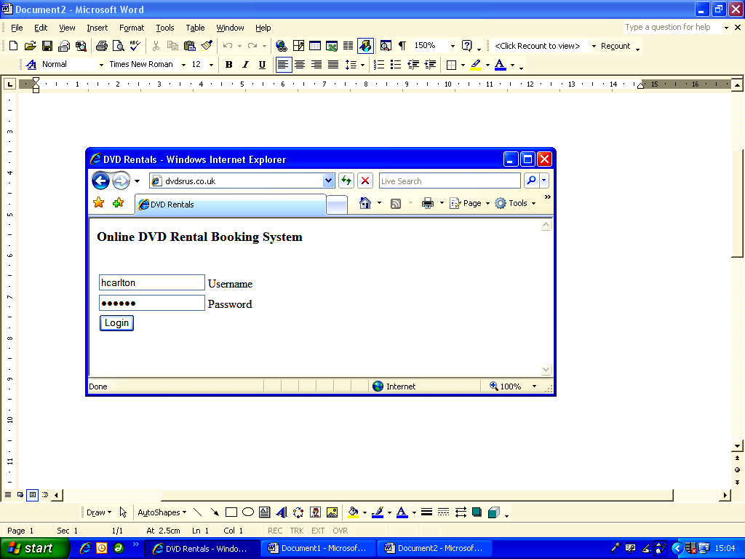

Code for index.php:
<?PHP
session_start();
session_destroy();
header(“Cache-control: private”);
?>
<html>
<head>
<title>DVD Rentals</title>
<script language=“JavaScript”>
function Validate() {
var username = document.frmLogin.txtUsername.value;
var lenusername = username.length;
var password = document.frmLogin.txtPassword.value;
var lenpassword = password.length;
if(username < 1) {
alert(“Please enter your username.”);
document.frmLogin.txtUsername.value = “”;
return false;
}
else if(lenpassword < 1) {
alert(“Please enter your password.”);
document.frmLogin.txtPassword.value = “”;
return false;
}
else {
frmLogin.Submit.disabled = true;
return true;
}
}
</script>
</head>
<body>
<h3>Online DVD Rental Booking System</h3>
<br />
<table>
<form name=“frmLogin” action=“checkid.php” method=“post” onSubmit=“return Validate()”>
<input type=“hidden” value=“agentlogin” />
<tr>
<td><input name=“txtUsername” type=“text” id=“txtUsername” maxlength=“30” /> Username</td>
</tr>
<tr>
<td><input name=“txtPassword” type=“password” id=“txtPassword” maxlength=“6” /> Password</td>
</tr>
<tr>
<td><input type=“submit” name=“Submit” value=“Login” /></td>
</tr>
</form>
</table>
</body>
</html>

2. Authorise Login Webpage: checkid.php

Purpose:
To check if username and corresponding password exist in MySQL database. If yes, then browser is redirected to main menu, otherwise browser is redirected back to index.php webpage.

Code for checkid.php:
<?PHP
session_start();
header(“Cache-control: private”);
$username = trim($_POST['txtUsername']);
$password = trim($_POST['txtPassword']);
if($username != “” && $password != “”) {
// connect to database
$dbh = mysql_connect(“localhost”,”general”,”letmein”);
mysql_select_db(“myMySQL”, $dbh);
// create sql
$sql = “SELECT * FROM Staff WHERE Username ='” . $username . “' AND Password ='“ . $password . “'“;
$result=mysql_query($sql);
// no. of records found
$num=mysql_numrows($result);
if($num==0) {
// close database connection
mysql_close();
// login failure so redirect to login page
header(“Location: index.php”);
}
else {
// login OK so continue:
$_SESSION['StaffID'] = mysql_result($result,0,”StaffID”);
// go to main menu page
header(“Location: menu.php”);
}
// close database
mysql_close();
}
else {
$_SESSION['StaffID'] = “”;
header(“Location: index.php”);
}
?>

3. Main Menu webpage: menu.php

Purpose:
To provide links to all apects of the system, including add/amend DVD, add/amend customer details, booking out a film, and logging off.

Screenshot:

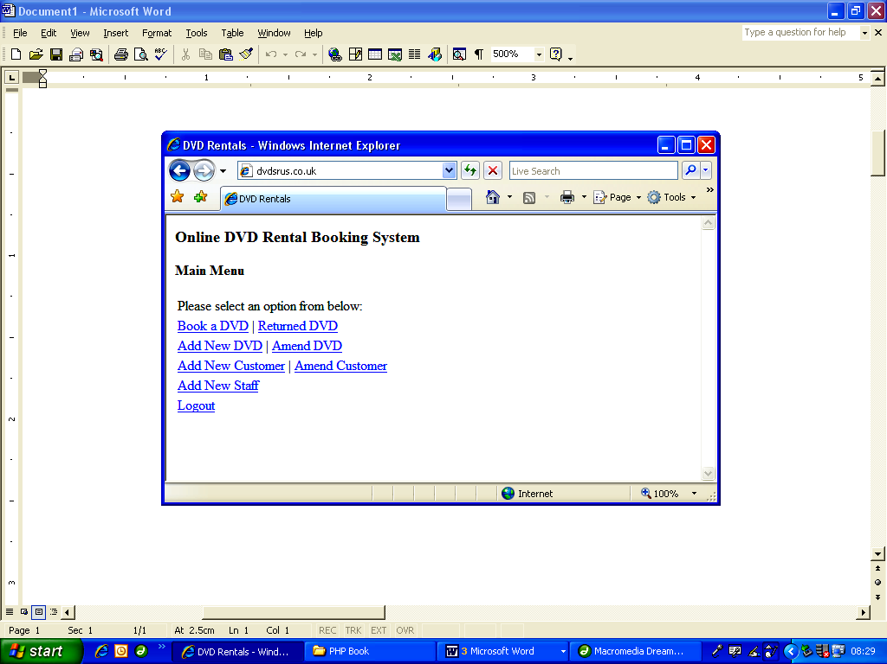
Code for menu.php:
<?PHP
session_start();
header(“Cache-control: private”);
if($_SESSION['StaffID'] == “”) {
// not logged in, so redirect to login page
header(“Location: index.php”);
}
?>
<html>
<head>
<title>DVD Rentals</title>
</head>
<body>
<h3>Online DVD Rental Booking System</h3>
<h4>Main Menu</h4>
<table>
<tr>
<td>Please select an option from below:</td>
</tr>
<tr>
<td><a href=“booking.php”>Book a DVD</a> | <a href=“return.php”>Returned DVD</a></td>
</tr>
<tr>
<td><a href=“adddvd.php”>Add New DVD</a> | <a href=“amenddvd.php”>Amend DVD </a></td>
</tr>
<tr>
<td><a href=“addcust.php”>Add New Customer</a> | <a href=“amendcust.php”>Amend Customer</a></td>
</tr>
<tr>
<td><a href=“addstaff.php”>Add New Staff</a></td>
</tr>
<tr>
<td><a href=“index.php”>Logout</a></td>
</tr>
</table>
</body>
</html>
4. Add New DVD webpage: adddvd.php

Purpose:
To enable the addition of details of new DVDs to the database, and to enable them to be recorded as either out on loan or available to rent. It is possible (and very likely) that a DVD shop will have multiple copies of the same film title, but each individual DVD must be given a unique id (MySQL does this – using the primary key field) and entries for each DVD must be made into the database.

This webpage does not have any Javascript or PHP validation, therefore as it stands, it's possible to add a new DVD record with blank field entries (e.g. no title or synopsis). It is left as an exercise for the reader to develop this webpage further to include suitable validation and verification.

On clicking the “Add DVD” button, the DVD details are sent (using the POST method) to webpage adddvd2.php.

Screenshot:

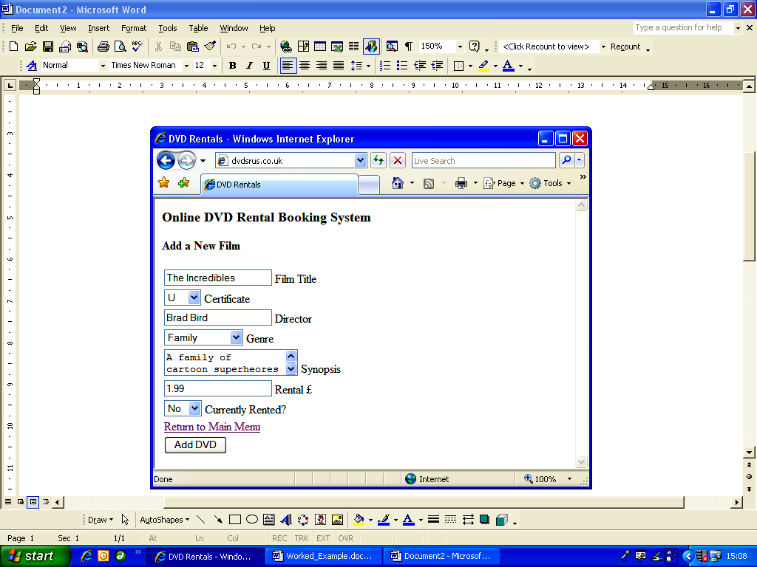

Code for adddvd.php:
<?PHP
session_start();
header(“Cache-control: private”);
if($_SESSION['StaffID'] == “”) { header(“Location: index.php” ); }
?>
<html>
<head>
<title>DVD Rentals</title>
</head>
<body>
<h3>Online DVD Rental Booking System</h3>
<h4>Add a New Film</h4>
<table>
<form name=“frmAddDVD” action=“doadddvd.php” method=“post”>
<input type=“hidden” name=“method” value=“add”>
<tr>
<td><input name=“txtTitle” type=“text” id=“txtTitle” maxlength=“15” />Film Title </td>
</tr>
<tr>
<td><select name=“txtCertificate” id=“txtCertificate”>
<option value=“U” selected>U</option>
<option value=“PG”>PG</option>
<option value=“12A”>12A</option>
<option value=“12”>12</option>
<option value=“15”>15</option>
<option value=“18”>18</option>
</select>Certificate</td>
</tr>
<tr>
<td><input name=“txtDirector” type=“text” id=“txtDirector” maxlength=“20” />Director </td>
</tr>
<tr>
<td><select name=“txtGenre” id=“txtGenre”>
<option selected>Family</option>
<option>Comedy</option>
<option>Action</option>
<option>Thriller</option>
<option>Childrens</option>
<option>Romance</option>
<option>SciFi</option>
<option>Horror</option>
<option>Western</option>
<option>Documentary</option>
</select>Genre</td>
</tr>
<tr>
<td><textarea name=“txtSynopsis” id=“txtSynopsis”></textarea>Synopsis </td>
</tr>
<tr>
<td><input name=“txtRental” type=“text” id=“txtRental” maxlength=“6” />Rental &pound; </td>
</tr>
<tr>
<td><select name=“txtCurrent” id=“txtCurrent”>
<option value=“0” selected>No</option>
<option value=“1”>Yes</option>
</select>Currently Rented?</td>
</tr>
<tr>
<td><a href=“menu.php”>Return to Main Menu </a></td>
</tr>
<tr>
<td><input type=“submit” name=“Submit” value=“Add DVD” /></td>
</tr>
</form>
</table>
</body>
</html>

5. Amend Exisiting DVD webpage: amenddvd.php

Purpose:
To enable the amendment of details of exisiting DVDs in the database.

This first webpage enables the user to select a film from a list of all available films currently stored on the database. On selecting a film, the film's unique identifier is POSTed to the next webpage to enable amending of details.

Screenshot:

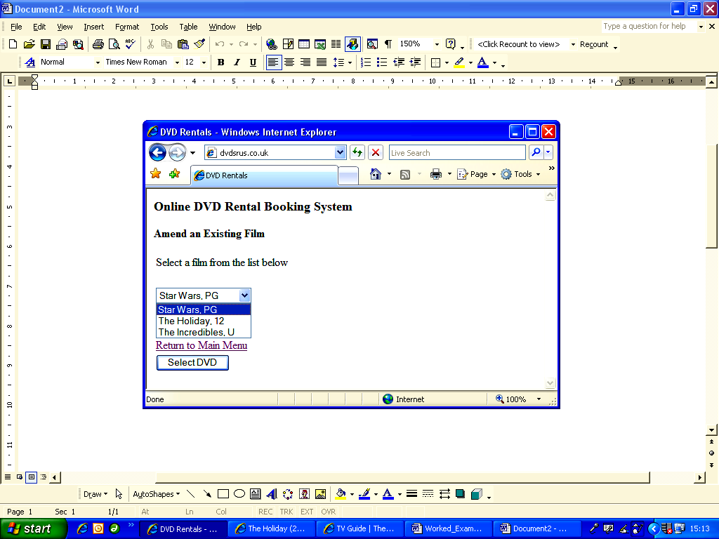

Code for amenddvd.php:
<?PHP
session_start();
header(“Cache-control: private”);
if($_SESSION['StaffID'] == “”) { header(“Location: index.php” ); }
?>
<html>
<head>
<title>DVD Rentals</title>
</head>
<body>
<h3>Online DVD Rental Booking System</h3>
<h4>Amend an Existing Film</h4>
<table>
<form name=“frmAmendDVD” action=“amenddvd2.php” method=“post”>
<tr>
<td>Select a film from the list below </td>
</tr>
<tr>
<td>&nbsp;</td>
</tr>
<tr>
<td><select name=“selectDVD”>
<?PHP
// connect to database to obtain list of all DVDs
$dbh = mysql_connect(“localhost”,“general”,“letmein”);
mysql_select_db(“myMySQL”, $dbh);
// create sql to list films in order of Title
$sql = “SELECT * FROM DVD ORDER BY Title”;
$result=mysql_query($sql);
// no. of records found
$num=mysql_numrows($result);
if($num >= 0) {
$i=0;
while ($i < $num) {
// get DVD details
$dvd_id = mysql_result($result,$i,“DVD_ID”);
$title = mysql_result($result,$i,“Title”);
$cert = mysql_result($result,$i,“Certificate”);
// add details to HTML listbox:
echo “<option value='“ . $dvd_id . “'>“ . $title . “, “ . $cert . “</option>”;
$i++;
}
}
else {
// no films found:
echo “<option value=''>No films found!</option>”;
}
mysql_close();
?>
</select></td>
</tr>
<tr>
<td>&nbsp;</td>
</tr>
<tr>
<td>&nbsp;</td>
</tr>
<tr>
<td><a href=“menu.php”>Return to Main Menu </a></td>
</tr>
<tr>
<td><input type=“submit” name=“Submit” value=“Select DVD” /></td>
</tr>
</form>
</table>
</body>
</html>

6. Amend Exisiting DVD 2 webpage: amenddvd2.php

Purpose:
To enable the amendment of details of exisiting DVDs in the database.
This next webpage enables the user to amend the details of the selected film. On submission of data, the amended details are then POSTed to the doadddvd.php file.

Screenshot:

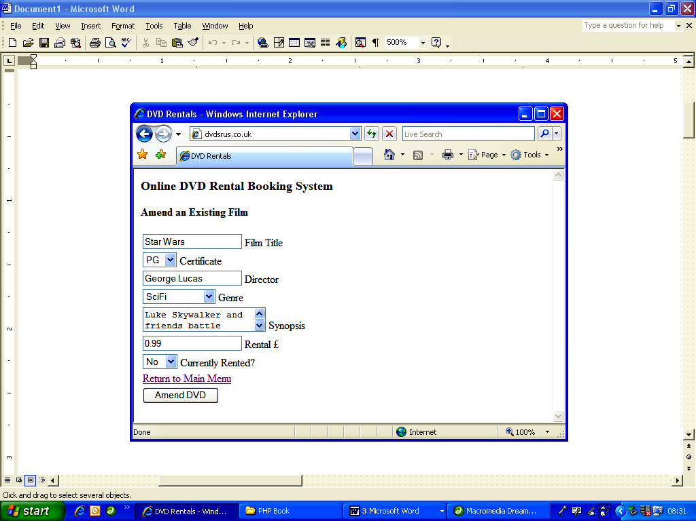

Code for amenddvd2.php:
<?PHP
session_start();
header(“Cache-control: private”);
if($_SESSION['StaffID'] == “”) { header(“Location: index.php” ); }
// get DVD id from previous page
$_SESSION['$dvd'] = $_POST['selectDVD'];
// connect to database to obtain DVD details for selected DVD
$dbh = mysql_connect(“localhost”,”general”,”letmein”);
mysql_select_db(“myMySQL”, $dbh);
// create sql
$sql = “SELECT * FROM DVD WHERE DVD_ID ='“ . $_SESSION['$dvd'] . “'”;
$result=mysql_query($sql);
// no. of records found
$num=mysql_numrows($result);
if($num != 0) {
$title = mysql_result($result,0,”Title”);
$cert = mysql_result($result,0,”Certificate”);
$genre = mysql_result($result,0,”Genre”);
$director = mysql_result($result,0,”Director”);
$synopsis = mysql_result($result,0,”Synopsis”);
$rental = mysql_result($result,0,”RentalAmount”);
$current = mysql_result($result,0,”BeingRented”);
}
// close database
mysql_close();
?>
<html>
<head>
<title>DVD Rentals</title>
</head>
<body>
<h3>Online DVD Rental Booking System</h3>
<h4>Amend an Existing Film</h4>
<table>
<form name=“frmAmendDVD” action=“doadddvd.php” method=“post”>
<input type=“hidden” name=“method” value=“amend”>
<tr>

<td><input name=“txtTitle” type=“text” id=“txtTitle” maxlength=“15” <?PHP echo “value='“ . $title . “'”; ?> />
Film Title
</td>
</tr>
<tr>
<td><select name=“txtCertificate” id=“txtCertificate”>
<option value=“U” <?PHP if($cert==“U”) { echo “selected”; } ?>>U</option>
<option value=“PG” <?PHP if($cert==“PG”) { echo “selected”; } ?>>PG</option>
<option value=“12A” <?PHP if($cert==“12A”) { echo “selected”; } ?>>12A</option>
<option value=“12” <?PHP if($cert==“12”) { echo “selected”; } ?>>12</option>
<option value=“15” <?PHP if($cert==“15”) { echo “selected”; } ?>>15</option>
<option value=“18” <?PHP if($cert==“18”) { echo “selected”; } ?>>18</option>
</select>Certificate</td>
</tr>
<tr>
<td><input name=“txtDirector” type=“text” id=“txtDirector” maxlength=“20” <?PHP echo “value='“ . $director . “'“; ?> />
Director
</td>
</tr>
<tr>
<td><select name=“txtGenre” id=“txtGenre”>
<option value=“Family” <?PHP if($genre==“Family”) { echo “selected”; } ?>>
Family</option>
<option value=“Comedy”<?PHP if($genre==“Comedy”) { echo “selected”; } ?>>
Comedy</option>
<option value=“Action”<?PHP if($genre==“Action”) { echo “selected”; } ?>>
Action</option>
<option value=“Thriller” <?PHP if($genre==“Thriller”) { echo “selected”; } ?>>
Thriller</option>
<option value=“Childrens” <?PHP if($genre==“Childrens”) { echo “selected”; } ?>>
Childrens</option>
<option value=“Romance” <?PHP if($genre==“Romance”) { echo “selected”; } ?>>
Romance</option>
<option value=“SciFi” <?PHP if($genre==“SciFi”) { echo “selected”; } ?>>
SciFi</option>
<option value=“Horror” <?PHP if($genre==“Horror”) { echo “selected”; } ?>>
Horror</option>
<option value=“Western” <?PHP if($genre==“Western”) { echo “selected”; } ?>>
Western</option>
<option value=“Documentary” <?PHP if($genre==“Documentary”) { echo “selected”; } ?>>
Documentary</option>
</select>Genre</td>
</tr>
<tr>
<td><textarea name=“txtSynopsis” id=“txtSynopsis”> <?PHP echo $synopsis; ?> </textarea>Synopsis </td>
</tr>
<tr>
<td><input name=“txtRental” type=“text” id=“txtRental” maxlength=“6” <?PHP echo “value='“ . $rental . “'“; ?> />Rental &pound; </td>
</tr>
<tr>
<td><select name=“txtCurrent” id=“txtCurrent”>
<option value=“0” <?PHP If($current==“0”) { echo “selected”; } ?> >No</option>
<option value=“1” <?PHP If($current==“1”) { echo “selected”; } ?> >Yes</option>
</select>Currently Rented?</td>
</tr>
<tr>
<td><a href=“menu.php”>Return to Main Menu </a></td>
</tr>
<tr>
<td><input type=“submit” name=“Submit” value=“Amend DVD” /></td>
</tr>
</form>
</table>
</body>
</html>

7. Do Add New/Exisiting DVD webpage: doadddvd.php

Purpose:
To add new film details or amend details of an exisiting film.

Code for doadddvd.php:

<?PHP
session_start();
header(“Cache-control: private”);
if($_SESSION['StaffID'] == “”) { header(“Location: index.php” ); }
// get new film details:
$title = trim($_POST['txtTitle']);
$certificate = $_POST['txtCertificate'];
$director = trim($_POST['txtDirector']);
$genre = $_POST['txtGenre'];
$synopsis = trim($_POST['txtSynopsis']);
$rental = trim($_POST['txtRental']);
$current = trim($_POST['txtCurrent']);
// connect to database and add new film details
$dbh = mysql_connect(“localhost”,”general”,”letmein”);
mysql_select_db(“myMySQL”, $dbh);
// check if needing to add a new dvd, or amend exiting dvd
if($_POST['method'] == “add”) {
$sql = “INSERT INTO DVD (Title,Certificate,Director,Genre,Synopsis,RentalAmount,BeingRented) “;
$sql = $sql . “VALUES ('“ . $title . “','“ . $certificate . “','“ . $director . “','“ . $genre . “','“ . $synopsis;
$sql = $sql . “','“ . $rental . “','“ . $current . “')”;
}
else if($_POST['method'] == “amend”) {
$sql = “UPDATE DVD SET Title ='“. $title . “', Certificate ='“ . $certificate . “', Director ='“ . $director . “',”;
$sql = $sql . “Genre ='" . $genre . “', Synopsis ='“ . $synopsis . “', RentalAmount ='“ . $rental . “', “;
$sql = $sql . “BeingRented ='“ . $current . “' “;
$sql = $sql . “WHERE DVD_ID ='“ . $_SESSION['$dvd']. “'“;
}
$result=mysql_query($sql);
mysql_close();
// redirect to main menu page:
header(“Location: menu.php”);
?>
8. Add New Customer webpage: addcust.php

Purpose:
To enable the addition of details of new Customers to the database. This webpage does not have any Javascript or PHP validation, therefore as it stands, it's possible to add a new customer record with blank field entries. It is left as an exercise for the reader to develop this webpage further to include suitable validation and verification.

On clicking the “Add Customer” button, the customer details are sent (using the POST method) to webpage addcust2.php.

Screenshot:

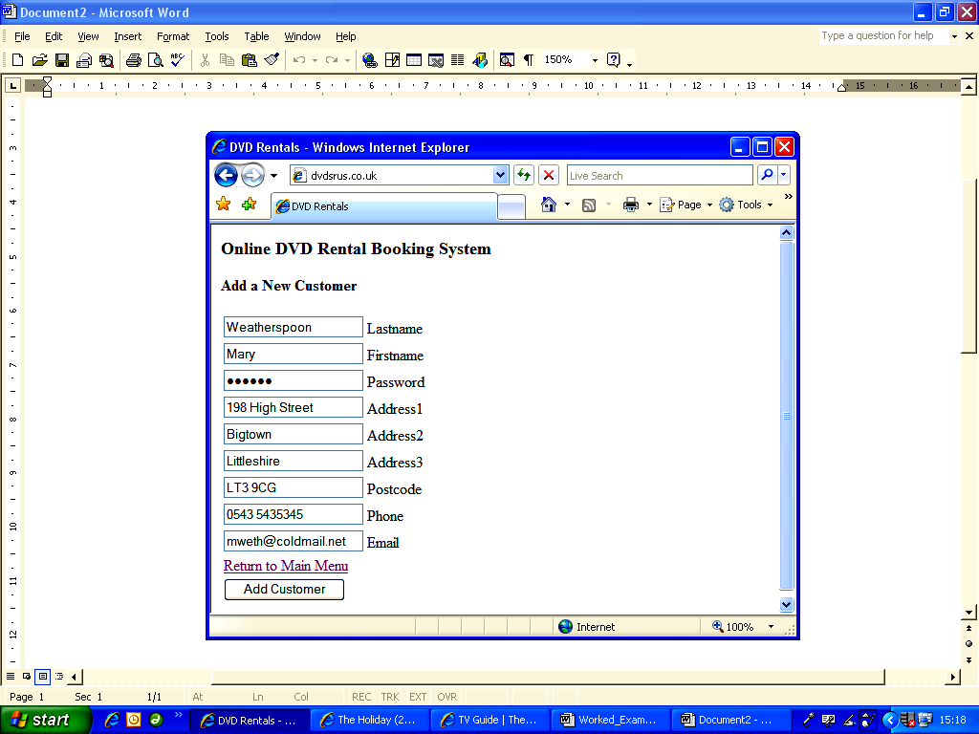

Code for addcust.php:
<?PHP
session_start();
header(“Cache-control: private”);
if($_SESSION['StaffID'] == “”) { header(“Location: index.php” ); }
?>
<html>
<head>
<title>DVD Rentals</title>
</head>
<body>
<h3>Online DVD Rental Booking System</h3>
<h4>Add a New Customer </h4>
<table>
<form name=“frmAddCustomer” action=“doaddcust.php” method=“post”>
<input type=“hidden” name=“method” value=“add”>
<tr>
<td><input name=“txtLastname” type=“text” id=“txtLastname” maxlength=“15” /> Lastname</td>
</tr>
<tr>
<td><input name=“txtFirstname” type=“text” id=“txtFirstname” maxlength=“15” /> Firstname</td>
</tr>
<tr>
<td><input name=“txtPassword” type=“password” id=“txtPassword” maxlength=“6” /> Password</td>
</tr>
<tr>
<td><input name=“txtAddress1” type=“text” id=“txtAddress1” maxlength=“15” /> Address1</td>
</tr>
<tr>
<td><input name=“txtAddress2” type=“text” id=“txtAddress2” maxlength=“15” /> Address2</td>
</tr>
<tr>
<td><input name=“txtAddress3” type=“text” id=“txtAddress3” maxlength=“15” /> Address3</td>
</tr>
<tr>
<td><input name=“txtPostcode” type=“text” id=“txtPostcode” maxlength=“8” /> Postcode</td>
</tr>
<tr>
<td><input name=“txtPhone” type=“text” id=“txtPhone” maxlength=“15” /> Phone </td>
</tr>
<tr>
<td><input name=“txtEmail” type=“text” id=“txtEmail” maxlength=“30” /> Email </td>
</tr>
<tr>
<td><a href=“menu.php”>Return to Main Menu </a></td>
</tr>
<tr>
<td><input type=“submit” name=“Submit” value=“Add Customer” /></td>
</tr>
</form>
</table>
</body>
</html>

9. Amend Exisiting Customer webpage: amendcust.php

Purpose:
To enable existing customers to be selected from a list ready for amending.

Screenshot:

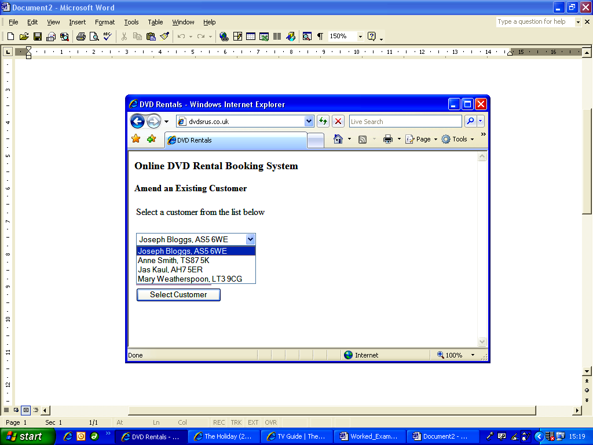

Code for amendcust.php:
<?PHP
session_start();
header(“Cache-control: private”);
if($_SESSION['StaffID'] == “”) { header(“Location: index.php” ); }
?>
<html>
<head>
<title>DVD Rentals</title>
</head>
<body>
<h3>Online DVD Rental Booking System</h3>
<h4>Amend an Existing Customer</h4>
<table>
<form name=“frmAmendCust” action=“amendcust2.php” method=“post”>
<tr>
<td>Select a customer from the list below </td>
</tr>
<tr>
<td>&nbsp;</td>
</tr>
<tr>
<td><select name=“selectCust”>
<?PHP
// connect to database to obtain list of all Customers
$dbh = mysql_connect(“localhost”,”general”,”letmein”);
mysql_select_db(“myMySQL”, $dbh);
// create sql
$sql = “SELECT * FROM Customer”;
$result=mysql_query($sql);
// no. of records found
$num=mysql_numrows($result);
if($num >= 0) {
$i=0;
while ($i < $num) {
// get Customer details
$custid = mysql_result($result,$i,”CustomerID”);
$first = mysql_result($result,$i,”Firstname”);
$last = mysql_result($result,$i,”Lastname”);
$postcode = mysql_result($result,$i,”Postcode”);
// add details to HTML listbox:
echo “<option value='“ . $custid . “'>” . $first . “ ” . $last . “,”;
echo $postcode . “</option>”;
$i++;
}
}
else {
// no customers found:
echo “<option value=''>No customers found!</option>”;
}
// close database
mysql_close();
?>
</select></td>
</tr>
<tr>
<td>&nbsp;</td>
</tr>
<tr>
<td>&nbsp;</td>
</tr>
<tr>
<td><a href=“menu.php”>Return to Main Menu </a></td>
</tr>
<tr>
<td><input type=“submit” name=“Submit” value=“Select Customer” /></td>
</tr>
</form>
</table>
</body>
</html>

10. Amend Exisiting Customer 2 webpage: amendcust2.php

Purpose:
To enable selected customer details to be amended.

Screenshot:

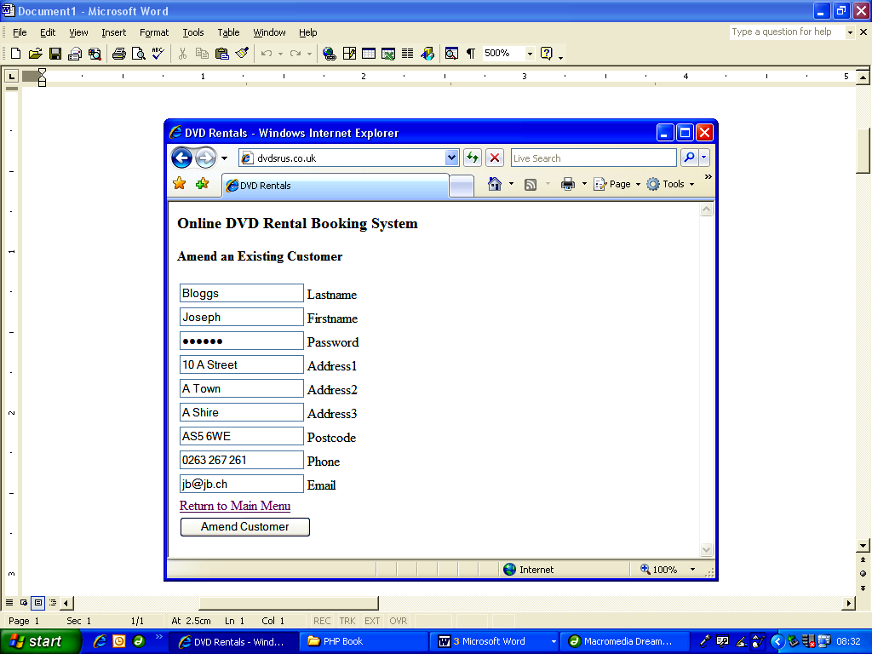

Code for amendcust2.php:
<?PHP
session_start();
header(“Cache-control: private”);
if($_SESSION['StaffID'] == ““) { header(“Location: index.php” ); }
// get Customer id from previous page
$_SESSION['cust'] = $_POST['selectCust'];
// connect to database to obtain DVD details for selected DVD
$dbh = mysql_connect(“localhost”,”general”,”letmein”);
mysql_select_db(“myMySQL”, $dbh);
// create sql
$sql = “SELECT * FROM Customer WHERE CustomerID ='“ . $_SESSION['cust'] . “'“;
$result=mysql_query($sql);
// no. of records found
$num=mysql_numrows($result);
if($num != 0) {
$lastname = mysql_result($result,0,”Lastname”);
$firstname = mysql_result($result,0,”Firstname”);
$password = mysql_result($result,0,”Password”);
$address1 = mysql_result($result,0,”Address1”);
$address2 = mysql_result($result,0,”Address2”);
$address3 = mysql_result($result,0,”Address3”);
$postcode = mysql_result($result,0,”Postcode”);
$phone = mysql_result($result,0,”Phone”);
$email = mysql_result($result,0,”Email”);
}
// close database
mysql_close();
?>
<html>
<head>
<title>DVD Rentals</title>
</head>
<body>
<h3>Online DVD Rental Booking System</h3>
<h4>Amend an Existing Customer</h4>
<table>
<form name=“frmAmendCustomer” action=“doaddcust.php” method=“post”>
<input type=“hidden” name=“method” value=“amend”>
<tr>
<td><input name=“txtLastname” type=“text” id=“txtLastname” maxlength=“15” <?PHP echo “value='” . $lastname . “'”; ?> />Lastname</td>
</tr>
<tr>

<td><input name=“txtFirstname” type=“text” id=“txtFirstname” maxlength=“15” <?PHP echo “value='” . $firstname . “'”; ?> />Firstname</td>
</tr>
<tr>
<td><input name=“txtPassword” type=“password” id=“txtPassword” maxlength=“6” <?PHP echo “value='“ . $password . “'“; ?> />Password</td>
</tr>
<tr>
<td><input name=“txtAddress1” type=“text” id=“txtAddress1” maxlength=“15” <?PHP echo “value='” . $address1 . “'“; ?> />Address1</td>
</tr>
<tr>
<td><input name=“txtAddress2” type=“text” id=“txtAddress2” maxlength=“15” <?PHP echo “value='“ . $address2 . “'“; ?> />Address2</td>
</tr>
<tr>
<td><input name=“txtAddress3” type=“text” id=“txtAddress3” maxlength=“15” <?PHP echo “value='“ . $address3 . “'”; ?> />Address3</td>
</tr>
<tr>
<td><input name=“txtPostcode” type=“text” id=“txtPostcode” maxlength=“8” <?PHP echo “value='“ . $postcode . “'”; ?> />Postcode </td>
</tr>
<tr>
<td><input name=“txtPhone” type=“text” id=“txtPhone” maxlength=“15” <?PHP echo “value='” . $phone . “'”; ?> />Phone </td>
</tr>
<tr>
<td><input name=“txtEmail” type=“text” id=“txtEmail” maxlength=“30” <?PHP echo “value='“ . $email . “'“; ?> />
Email </td>
</tr>
<tr>
<td><a href=“menu.php”>Return to Main Menu</a></td>
</tr>
<tr>
<td><input type=“submit” name=“Submit” value=“Amend Customer” /></td>
</tr>
</form>
</table>
</body>
</html>

11. Do Add/Amend Exisiting/New Customer webpage: doaddcust.php

Purpose:
add new or amend exisiting customer details in database.

Code for doaddcust.php:
<?PHP
session_start();
header(“Cache-control: private”);
if($_SESSION['StaffID'] == “”) { header(“Location: index.php” ); }
session_start();
header(“Cache-control: private”);
if($_SESSION['StaffID'] == “”) { header(“Location: index.php” ); }
// get new customer details:
$lastname = trim($_POST['txtLastname']);
$firstname = trim($_POST['txtFirstname']);
$password = trim($_POST['txtPassword']);
$address1 = trim($_POST['txtAddress1']);
$address2 = trim($_POST['txtAddress2']);
$address3 = trim($_POST['txtAddress3']);
$postcode = trim($_POST['txtPostcode']);
$phone = trim($_POST['txtPhone']);
$email = trim($_POST['txtEmail']);
// connect to database and add new customer details
$dbh = mysql_connect(“localhost”,”general”,”letmein”);
mysql_select_db(“myMySQL”, $dbh);
// check if needing to add a new customer, or amend exiting customer
if($_POST['method'] == “add”) {
$sql = “INSERT INTO Customer(Lastname,Firstname,Password,Address1,Address2,”;
$sql = $sql . “Address3,Postcode,Phone,Email) “;
$sql = $sql . “VALUES ('“ . $lastname . “','“ . $firstname . “','“ . $password . “','“ . $address1 . “','“;
$sql = $sql . $address2 . “','“ . $address3 . “','“ . $postcode . “','“ . $phone . “','“ . $email . “')”;
}
else if($_POST['method'] == “amend”) {
$sql = “UPDATE Customer SET Lastname ='“. $lastname . “', Firstname ='“ . $firstname . “', Password ='“ . $password . “',”;
$sql = $sql . “Address1 ='“ . $address1 . “', Address2 ='“ . $address2 . “', Address3 ='“ . $address3 . “',”;
$sql = $sql . “Postcode ='“ . $postcode . “', Phone ='“ . $phone . “', Email ='“ . $email . “' ”;
$sql = $sql . “WHERE CustomerID ='“ . $_SESSION['cust'] . “'”;
}
$result=mysql_query($sql);
// close database
mysql_close();
// redirect to main menu page:
header(“Location: menu.php”);
?>
12. Add New Staff webpage: addstaff.php

Purpose:
add new staff details

Screenshot:

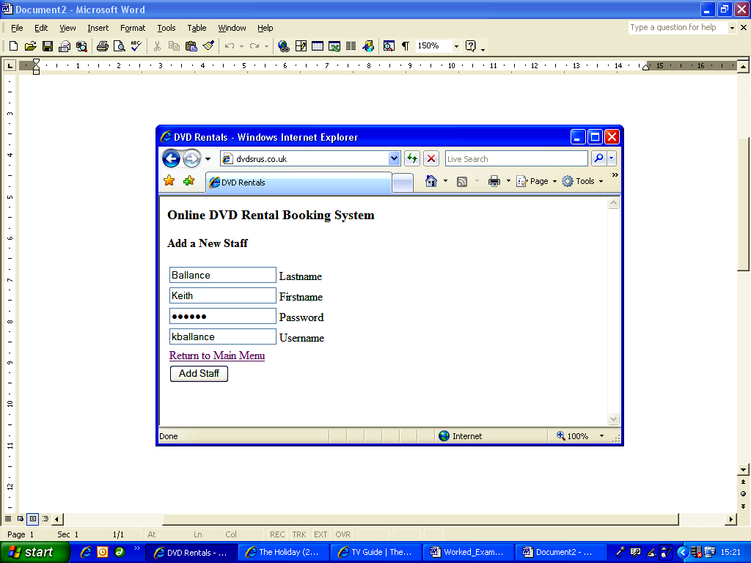

Code for addstaff.php:
<?PHP
session_start();
header(“Cache-control: private”);
if($_SESSION['StaffID'] == “”) { header(“Location: index.php” ); }
?>
<html>
<head>
<title>DVD Rentals</title>
</head>
<body>
<h3>Online DVD Rental Booking System</h3>
<h4>Add a New Staff </h4>
<table>
<form name=“frmAddStaff” action=“doaddstaff.php” method=“post”>
<tr>
<td><input name=“txtLastname” type=“text” id=“txtLastname” maxlength=“15” /> Lastname</td>
</tr>
<tr>
<td><input name=“txtFirstname” type=“text” id=“txtFirstname” maxlength=“15” /> Firstname</td>
</tr>
<tr>
<td><input name=“txtPassword” type=“password” id=“txtPassword” maxlength=“6” /> Password</td>
</tr>
<tr>
<td><input name=“txtUsername” type=“text” id=“txtUsername” maxlength=“10” /> Username</td>
</tr>
<tr>
<td><a href=“menu.php”>Return to Main Menu </a></td>
</tr>
<tr>
<td><input type=“submit” name=“Submit” value=“Add Staff” /></td>
</tr>
</form>
</table>
</body>
</html>

13. Do Add New Staff webpage: doaddstaff.php

Purpose:
Add new staff details to database.

Code for doaddstaff.php:
<?PHP
session_start();
header(“Cache-control: private”);
if($_SESSION['StaffID'] == ““) { header(“Location: index.php” ); }
// get new staff details:
$lastname = trim($_POST['txtLastname']);
$firstname = trim($_POST['txtFirstname']);
$password = trim($_POST['txtPassword']);
$username = trim($_POST['txtUsername']);
// connect to database and add new staff details
$dbh = mysql_connect(“localhost”,”general”,”letmein”);
mysql_select_db(“myMySQL”, $dbh);
// create sql
$sql = “INSERT INTO Staff(Lastname,Firstname,Password,Username) “;
$sql = $sql . “VALUES ('“ . $lastname . “','“ . $firstname . “','“ . $password . “','“ . $username . “')”;
$result=mysql_query($sql);
// close database
mysql_close();
// redirect to main menu page:
header(“Location: menu.php”);
?>

14. Book a Film webpage: booking.php

Purpose:
Enable a film and corresponding customer from available lists to be selected, ready for marking as being booked-out.

Screenshot:

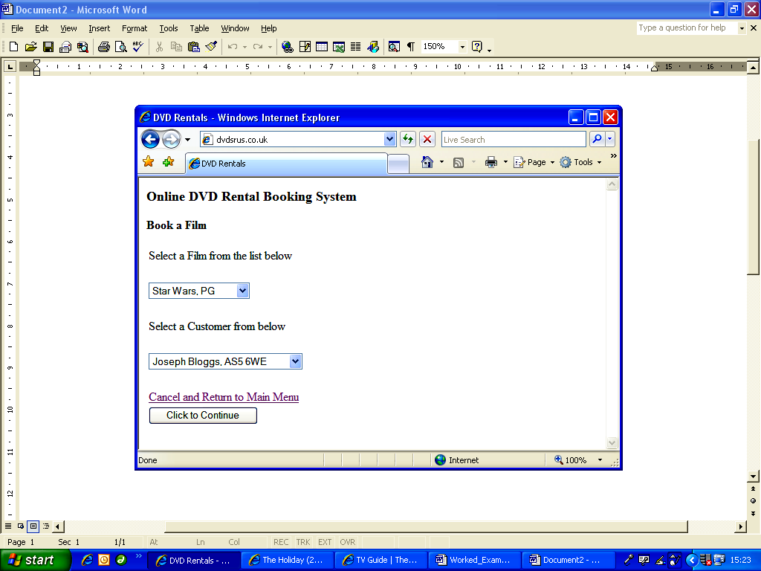

Note: this webpage will indicate if there are currently no films available for rent:

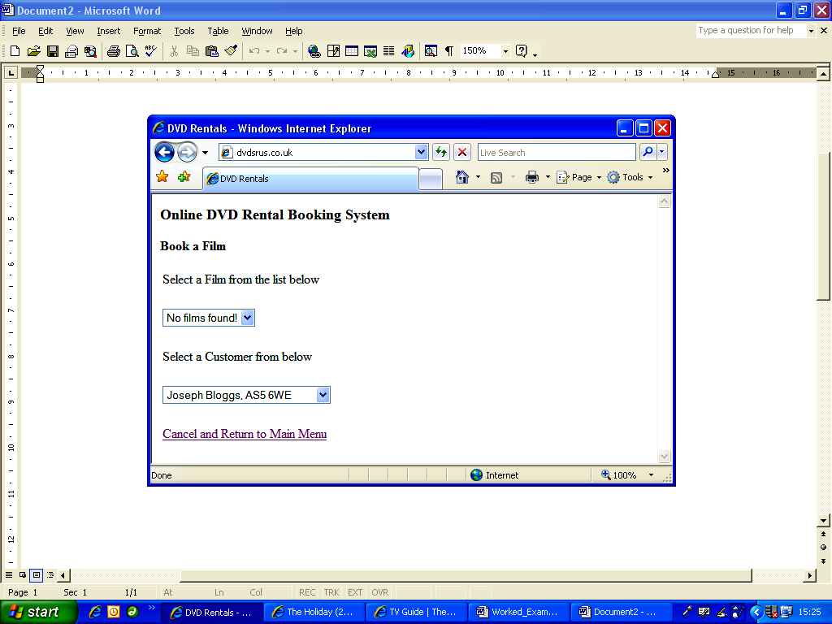

Code for booking.php:
<?PHP
session_start();
header(“Cache-control: private”);
if($_SESSION['StaffID'] == ““) { header(“Location: index.php” ); }
?>
<html>
<head>
<title>DVD Rentals</title>
</head>
<body>
<h3>Online DVD Rental Booking System</h3>
<h4>Book a Film </h4>
<table>
<form name=“frmBooking” action=“booking2.php” method=“post”>
<tr>
<td>Select a Film from the list below </td>
</tr>
<tr>
<td>&nbsp;</td>
</tr>
<tr>
<td><select name=“selectDVD”>
<?PHP
$flag = 1;
// connect to database to obtain list of all DVDs WHERE VALUE OF 'BEINGRENTED' FIELD = 'NO'
$dbh = mysql_connect(“localhost”,”general”,”letmein”);
mysql_select_db(“myMySQL”, $dbh);
// create sql to list films in order of Title
$sql = “SELECT * FROM DVD WHERE BeingRented ='0' ORDER BY Title”;
$result=mysql_query($sql);
$num=mysql_numrows($result);
if($num > 0) {
$i=0;
while ($i < $num) {
// get DVD details
$dvd_id = mysql_result($result,$i,”DVD_ID”);
$title = mysql_result($result,$i,”Title”);
$cert = mysql_result($result,$i,”Certificate”);
// add details to HTML listbox:
echo “<option value='“ . $dvd_id . “'>“ . $title . “, “ . $cert . “</option>”;
$i++;
}
}
else {
// no films found:
echo “<option value=''>No films found!</option>”;
$flag = 0;
}
?>
</select></td>
</tr>
<tr>
<td>&nbsp;</td>
</tr>
<tr>
<td>Select a Customer from below </td>
</tr>
<tr>
<td>&nbsp;</td>
</tr>
<tr>
<td><select name=“selectCustomer”>
<?PHP
// create sql to list customers in order of lastname and then firstname
$sql = “SELECT * FROM Customer ORDER BY Lastname, Firstname”;
$result=mysql_query($sql);
// no. of records found
$num=mysql_numrows($result);
if($num > 0) {
$i=0;
while ($i < $num) {
// get customer details
$cust = mysql_result($result,$i,”CustomerID”);
$lastname = mysql_result($result,$i,”Lastname”);
$firstname = mysql_result($result,$i,”Firstname”);
$postcode = mysql_result($result,$i,”Postcode”);
// add details to HTML listbox:
echo “<option value='“ . $cust . “'>“ . $firstname . “ “ . $lastname . “, “ . $postcode . “ </option>”;
$i++;
}
}
else {
// no customers found:
echo “<option value=''>No customers found!</option>”;
$flag = 0;
}
// close database
mysql_close();
?>
</select></td>
</tr>
<tr>
<td>&nbsp;</td>
</tr>
<tr>
<td><a href=“menu.php”>Cancel and Return to Main Menu </a></td>
</tr>
<?
// only display if at least 1 DVD and at least 1 customer
if($flag == 1) {
?>
<tr>
<td><input type='submit' name='Submit' value='Click to Continue' /></td>
</tr>
<? } ?>
</form>
</table>
</body>
</html>

15. Confirm Film Booking details webpage: booking2.php

Purpose:
To confirm the previously selected details (film and customer) before marking the film as being rented and storing details on the MySQL database.

Screenshot:

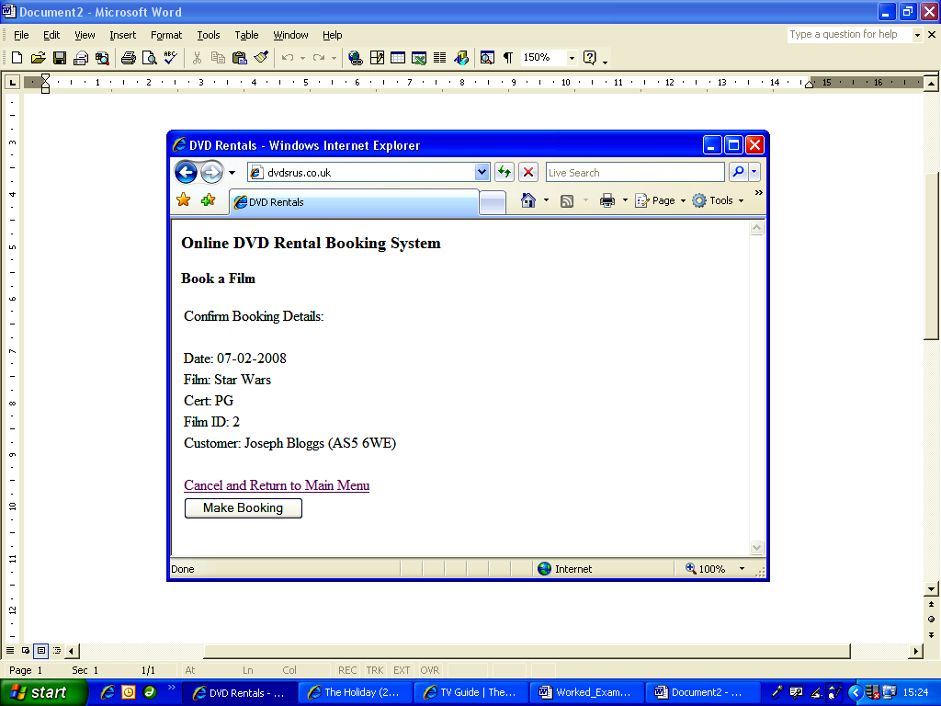

Code for booking2.php:
<?PHP
session_start();
header(“Cache-control: private”);
if($_SESSION['StaffID'] == “”) { header(“Location: index.php” ); }
// get film and customer details and store as session variables:
$_SESSION['filmid'] = $_POST['selectDVD'];
$_SESSION['customerid'] = $_POST['selectCustomer'];
// connect to database
$dbh = mysql_connect(“localhost”,”general”,”letmein”);
mysql_select_db(“myMySQL”, $dbh);
// create sql to get film details
$sql = “SELECT * FROM DVD WHERE DVD_ID ='“ . $_SESSION['filmid'] . “'“;
$result=mysql_query($sql);
// get DVD details
$title = mysql_result($result,0,”Title”);
$cert = mysql_result($result,0,”Certificate”);
// create sql to get customer details
$sql = “SELECT * FROM Customer WHERE CustomerID ='“ . $_SESSION['customerid'] . “'“;
$result=mysql_query($sql);
// get DVD details
$lastname = mysql_result($result,0,”Lastname”);
$firstname = mysql_result($result,0,”Firstname”);
$postcode = mysql_result($result,0,”Postcode”);
// close database
mysql_close();
?>
<html>
<head>
<title>DVD Rentals</title>
</head>
<body>
<h3>Online DVD Rental Booking System</h3>
<h4>Book a Film </h4>
<table>
<form name=“frmBooking” action=“booking3.php” method=“post”>
<tr>
<td>Confirm Booking Details: </td>
</tr>
<tr>
<td>&nbsp;</td>
</tr>
<tr>
<td>Date: <?PHP echo date(“d-m-Y”); ?> </td>
</tr>
<tr>
<td>Film: <?PHP echo $title; ?> </td>
</tr>
<tr>
<td>Cert: <?PHP echo $cert; ?> </td>
</tr>
<tr>
<td>Film ID: <?PHP echo $_SESSION['filmid']; ?> </td>
</tr>
<tr>
<td>Customer: <?PHP echo $firstname . “ “ . $lastname . “ (“ . $postcode . “)”; ?> </td>
</tr>
<tr>
<td>&nbsp;</td>
</tr>
<tr>
<td><a href=“menu.php”>Cancel and Return to Main Menu </a></td>
</tr>
<tr>
<td><input type=“submit” name=“Submit” value=“Make Booking” /></td>
</tr>
</form>
</table>
</body>
</html>

16. Do Book Film webpage: booking3.php

Purpose:
Record a film as being out on loan, and create a record that links the rented film with the customer, and store other details such as rental amount and date.

Code for booking3.php:
<?PHP
session_start();
header(“Cache-control: private”);
if($_SESSION['StaffID'] == ““) { header(“Location: index.php” ); }
// get booking details:
$film = $_SESSION['filmid'];
$customer = $_SESSION['customerid'];
// NOTE: Date must be stored as: Year - Month - Day, because this is the required
// format used by the MySQL database.
$bkdate = date(“Y-m-d”);
// connect to database and add new film booking details
$dbh = mysql_connect(“localhost”,”general”,”letmein”);
mysql_select_db(“myMySQL”, $dbh);
// create sql
$sql = “INSERT INTO Rental(DVD_ID,CustomerID,BkDate) “;
$sql = $sql . “VALUES ('“ . $film. “','“ . $customer. “','“ . $bkdate . “')”;
$result = mysql_query($sql);
// mark DVD as being out on loan
$sql2 = “UPDATE DVD SET BeingRented ='1' WHERE DVD_ID ='“ . $film . “'“;
$result2 = mysql_query($sql2);
// close database
mysql_close();
// redirect to main menu page:
header(“Location: menu.php”);
?>

17. Return Film webpage: return.php

Purpose:
Select a film from a list of all currently rented-out films (if any) in preparation for recording a film as being returned.

Screenshot:

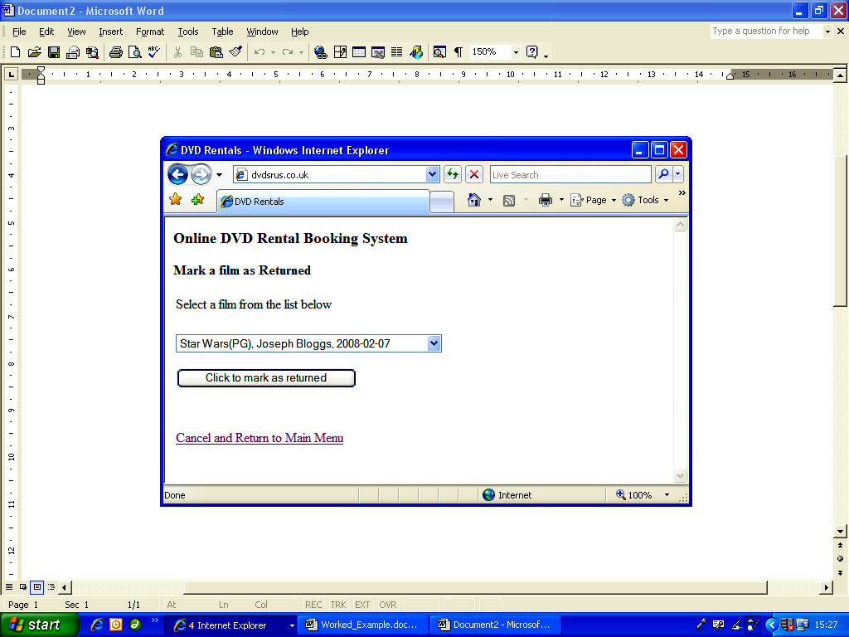

Code for return.php:
<?PHP
session_start();
header(“Cache-control: private”);
if($_SESSION['StaffID'] == ““) { header(“Location: index.php” ); }
?>
<html>
<head>
<title>DVD Rentals</title>
</head>
<body>
<h3>Online DVD Rental Booking System</h3>
<h4>Mark a film as Returned </h4>
<table>
<form name=“frmReturn” action=“return2.php” method=“post”>
<tr>
<td>Select a film from the list below </td>
</tr>
<tr>
<td>&nbsp;</td>
</tr>
<tr>
<td><select name=“selectRental”>
<?PHP
// connect to database to obtain list of all Rentals
$dbh = mysql_connect(“localhost”,”general”,”letmein”);
mysql_select_db(“myMySQL”, $dbh);
// create sql to list films in order of Date
$sql = “SELECT * FROM Rental ORDER BY BkDate”;
$result=mysql_query($sql);
// no. of records found
$num=mysql_numrows($result);
if($num > 0) {
$i=0;
while ($i < $num) {
// get details
$rentalid = mysql_result($result,$i,”RentalID”);
$film = mysql_result($result,$i,”DVD_ID”);
// get film details:
$sql2 = “SELECT * FROM DVD WHERE DVD_ID ='“ . $film . “'“;
$result2=mysql_query($sql2);
$title = mysql_result($result2,0,”Title”);
$cert = mysql_result($result2,0,”Certificate”);
$cust = mysql_result($result,$i,”CustomerID”);
// get customer details
$sql3 = “SELECT * FROM Customer WHERE CustomerID ='“ . $cust . “'“;
$result3=mysql_query($sql3);
$lastname = mysql_result($result3,0,”Lastname”);
$firstname = mysql_result($result3,0,”Firstname”);
$bkdate = mysql_result($result,$i,”BkDate”);
// add details to HTML listbox:
echo “<option value='“ . $rentalid . “'>“ . $title . “(“ . $cert . “), “ . $firstname;
echo “ “ . $lastname . “, “ . $bkdate . “</option>“;
$i++;
}
echo “</select>“;
echo “<br /><br /><input type='submit' name='Submit' value='Click to mark as returned' />“;
}
else {
// no films found:
echo “<option value='None'>No films currently being rented!</option>“;
echo “</select>“;
}
mysql_close();
?>
</td>
</tr>
<tr>
<td>&nbsp;</td>
</tr>
<tr>
<td>&nbsp;</td>
</tr>
<tr>
<td><a href=“menu.php”>Cancel and Return to Main Menu </a></td>
</tr>
</form>
</table>
</body>
</html>

18. Do Return Film webpage: return2.php

Purpose:
Using details from return.php, record the selected film as being returned.

Code for return2.php:
<?PHP
session_start();
header(“Cache-control: private”);
// Return to homepage if unauthorised access
if($_SESSION['StaffID'] == ““) { header(“Location: index.php” ); }
// connect to database
$dbh = mysql_connect(“localhost”,”general”,”letmein”);
mysql_select_db(“myMySQL”, $dbh);
// get rental details from previous page:
$rental = $_POST['selectRental'];
// get film id
$sql = “SELECT DVD_ID FROM Rental WHERE RentalID ='“ . $rental . “'“;
$result = mysql_query($sql);
$film = mysql_result($result,0,”DVD_ID”);
// update film as no longer out on loan
$sql2 = “UPDATE DVD SET BeingRented ='0' WHERE DVD_ID ='“ . $film . “'“;
$result2 = mysql_query($sql2);
// remove record from Rental table
$sql3 = “DELETE FROM Rental WHERE RentalID ='“ . $rental . “'“;;
$result3 = mysql_query($sql3);
// close database
mysql_close();
// redirect to main menu page:
header(“Location: menu.php”);
?>

Further Extensions
It could easily be conceived that the owner of a DVD Rental shop may wish to do other things such as:
• Remove details of older films.
• Remove customer details (perhaps they've moved to a different area).
• Remove staff details.
• Upload images of films to improve userbility.
• Obtain a list of all films that are overdue.
• Calculate how much to charge an overdue rental.

We'll look at how you might achieve three of these additional features, the rest will be left as a challenge for the reader.

How to Remove an Older Film:
First, the user should be presented with a list of all available films, and be able to select the film to be removed. The following PHP code snippet could be inserted within an HTML table, and will produce a list of all films not currently out on loan:

Code Example 20.5
<select name=“selectDVD”>
<?PHP
// connect to database to obtain list of all DVDs WHERE VALUE OF 'BEINGRENTED' FIELD = 'NO'
$dbh=mysql_connect (“localhost”, “DVDShop”, “letmein”);
mysql_select_db (“database”);
// create sql to list films in order of Title
$sql = “SELECT * FROM DVD WHERE BeingRented ='No' ORDER BY Title”;
$result=mysql_query($sql);
// no. of records found
$num=mysql_numrows($result);
if($num <= 0) {
$i=0;
while ($i < $num) {
// get DVD details
$dvd_id = mysql_result($result,$i,”DVD_ID”);
$title = mysql_result($result,$i,”Title”);
$cert = mysql_result($result,$i,”Certificate”);
// add details to HTML listbox:
echo “<option value='“ . $dvd_id . “'>“ . $title . “, “ . $cert . “</option>“;
$i++;
}
}
else {
// no films found:
echo “<option value=''>No films found!</option>“;
}
?>
</select>
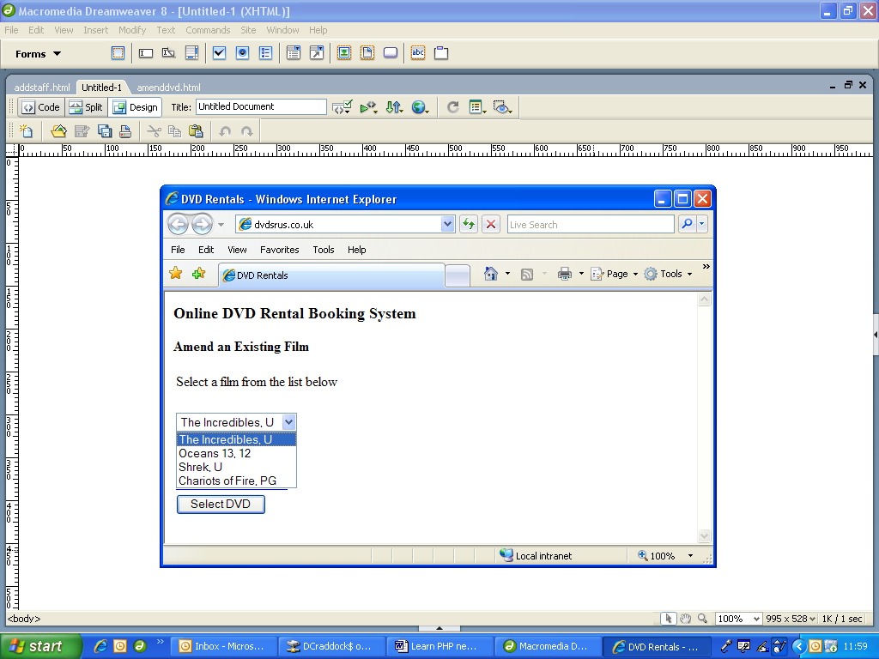
The result would be a drop-down selection box, thus: On selecting a film, the selection box sends the unique ID of the selected film, which can be used to delete it later on.

This output (unique film ID record number) can then be posted to another PHP webpage for permanent deletion from the database:

Delete Selected Film:
Code Example 20.6
<?PHP
// connect to database and add new film booking details
$dbh=mysql_connect (“localhost”, “DVDShop”, “letmein”);
mysql_select_db (“database”);
// get film id from previous page:
$film = $_POST[selectDVD];
// delete from database
$sql = “DELETE FROM DVD WHERE DVD_ID ='“ . $film . “'“;
$result=mysql_query($sql);
// close database
mysql_close();
?>

How to obtain a list of all overdue films and calculate payments:
Another useful feature would be to get a list of any films that are overdue, and even to determine how overdue they are so that the shop owner can calculate how much to charge a customer. We could write some simple PHP to do this calculation for us.

The following PHP code snippet could be inserted in an HTML table to perform these tasks. The basic steps to achieve this are as follows:
• Search for all film rentals that were taken out two days ago or more (this assumes that films are rented for one day only).
• For each overdue film found, calculate number of days late, and
• multiply this by the rental amount for the film.
• Display list of all overdue films (title etc.), with customer name, date due back, and total payment due:

Find all overdue films and calculate payment owed by customer:
Code Example 20.7
<?PHP
// connect to database
$dbh=mysql_connect (“localhost”, “DVDShop”, “letmein”);
mysql_select_db (“database”);
// get todays date
$todayDay = date(“d”);
$todayMonth = date(“m”);
$todayYear = date(“Y”);
// calculate date two days ago
$twodaysago = date(“Y-m-d”, mktime(12, 0, 0, $todayMonth, $todayDay - 2, $todayYear));
// generate sql to find all rentals taken out two days ago or more:
$sql = “SELECT * FROM Rental WHERE BkDate >= '“ . $twodaysago . “'“;
$result = mysql_query($sql);
// no. of records found
$num = mysql_numrows($result);
if($num <= 0) {
$i=0;
while ($i < $num) {
// get DVD details
$film = mysql_result($result,$i,”DVD_ID”);
// get customer details
$cust = mysql_result($result,$i,”CustomerID”);
// date rented out
$outdate = mysql_result($result,$i,”BkDate”);
// get further film details
$sql2 = “SELECT * FROM DVD WHERE DVD_ID = '“ . $film . “'“;
$result2 = mysql_query($sql2);
$title = mysql_result($result2,$i,”Title”);
$cert = mysql_result($result2,$i,”Certificate”);
$price = mysql_result($result2,$i,”RentalAmount”);
// get further customer details
$sql3 = “SELECT * FROM Customer WHERE CustomerID = '“ . $cust . “'“;
$result3 = mysql_query($sql3);
$last = mysql_result($result3,$i,”Lastname”);
$first = mysql_result($result3,$i,”Firstname”);
// no. of days late
$dateDiff = round((strtotime($outdate) - strtotime($twodaysago))/(60*60*24));
// calculate payment due for this overdue film, product of no. days late and rental:
$fee = $dateDiff * $price;
// display fee as currency (GBP with two decimal places)
$cfee = “£” . number_format($fee);
// display results:
echo “<h3>List of all overdue films</h3>“;
echo “Film: “ . $title . “, Cert: “ . $cert . “, Due Back On: “ . $outdate . “<br />“;
echo “Customer: “ . $firstname . “ “ . $lastname . “<br />“;
echo “Number of days late: “ . $dateDiff . “<br />“;
echo “Film fee per day: “ . $price . “<br />“;
echo “Total Amount due: “ . $cfee . “<br /><br />“;
$i++;
}
}
else {
// no films found:
echo “<option value=''>No films overdue!</option>“;
}
?>

The output from this PHP code may look something like this:

Film: The Incredibles, Cert: U, Due Back On 21-07-2008
Customer: Anne Smith
Number of days late: 2
Film fee per day: £1.50
Total Amount due: £3.00

Appendices

Appendix A

Installing PHP and MySQL on your Own Computer
Note: this is intended for intermediate and advanced users with full administrative rights to a computer system.

The main advantage of installing PHP and MySQL on your own computer or network is that you do not need to obtain (and hence pay for) website hosting and domain names whilst developing your website. Once you have set up a database and created some webpages, you can then run them from your own computer or network and test them thoroughly before launching your finished website 'live'.

The downside is that you may have no technical support if things go wrong, other than the use of related websites and online forums where you can ask others for advice and help. Also, it might not always be a straightforward job to upload your database and webpages to webspace later on. Always test your websites online thoroughly before advertising them publicly, to avoid problems and customer/visitor dissatisfaction later on!

Things you will need:

• Apache Server:
To run PHP and MySQL on your own computer system or network you must first set up your computer as a Web Server. The purpose of a Web Server is to run PHP scripts, serve out HTML webpages and link to any databases. Many PCs have a Microsoft server called IIS (Information Interchange Service) which comes free with later versions of Windows operating systems. There is a free open-source alternative called Apache Server that was designed and written specifically for use with PHP and MySQL. You can download a free copy of Apache at: http://httpd.apache.org/download.cgi

Download your own copy and then follow the instructions to install on your computer or network. To find out more about Apache Server and for support and forums, visit: http://www.apache.org/

• PHP:
PHP is a scripting language. The latest version (at time of writing) is PHP5, which can be downloaded from: http://www.php.net/downloads.php

Download your own copy and then follow the instructions to install on your computer or network. To find out more about PHP and for support and forums, visit: http://www.php.net/

• MySQL:
This is a powerful, free open-source database server, designed to work hand in hand with PHP. The latest version is MySQL5 and can be downloaded from: http://dev.mysql.com/downloads/index.html

Download your own copy and then follow the instructions to install on your computer or network. To find out more about MySQL and for support and forums, visit: http://www.mysql.com/

Appendix B

Free PHP and MySQL Web Hosting
Note: this is intended for beginners and intermediate users with use of a computer with Internet access, or for those who do not have full administrative rights to a computer or network.

The main advantages of obtaining free space to develop a website are (obviously) the cost, but also simplicity. There is no need to download PHP, MySQL, Apache or any other web server software, and very little technical knowledge is required.

You may, however, need FTP (File Transfer Protocol) software to enable you to upload and manage your webpages (see chapter 3), but this may not be essential as many hosting companies provide online file management systems, whereby you can upload webpages, files and images to your webspace simply by using your web browser.

How to obtain free PHP and MySQL web hosting
There are many companies that provide free website hosting as well as paid hosting, and more seem to become available all the time. Some will require that you accept advertising on each of your webpages, or your homepage (often done automatically for you), and many have a 30, 60 or 90 day inactivity limit. This latter limit will mean that if your website receives no visitors or you do not manage your files within this time period, then your account will be automatically deleted, sometimes without giving you any notice. This enables them to free up unused webspace on their servers.

There is a huge variety of types of free hosting available, but if you want to use PHP and MySQL then you need to search for these options specifically.

A good starting point would be to do a search using your favourite search-engine using the phrase: “free PHP MySQL hosting” and see what links appear.

Once you have found some hosting providers that seem to suit your requirements, you can narrow your options by checking the following:
• Amount of webspace and bandwidth.
• Advertising required? (Often yes, but not always.)
• Check that PHP and at least 1 MySQL database are available.
• Check restrictions: some companies will delete your free hosting if you don't have any activity (visitors etc.) within a 30 day period.

If you need to use PHP to send emails from a webpage, then you will also need to check for SMTP availability.

Free Domain Name
Once you have signed up for a free hosting account, you will often be given a website domain name (URL, website address). These are often long winded sub-domains, such as: www.afreewebhost.members.free/yourusername/index.php.

You might be happy with this, but there are ways of obtaining a better looking shorter website address. To achieve this, search for “free url redirection cloaking”.

Your search-engine will then produce a long list of companies that offer you a free and hopefully shorter website address (URL) which you can use to “point” (redirect) to your own free website address.

For example, if that you sign-up with http://www.shorturl.com/
you can set up a free URL in the form of: yourname.shorturl.com

The idea is that if someone enters your URL (e.g. yourname.shorturl.com) they will be automatically redirected to your actual free website

(E.g. www.afreewebhost.members.free/yourusername/index.php)

However, on arrival to your free website, your long-winded website address will then be visible in the “address” box at the top of your browser.

It's possible to get around this by using “cloaking”, which is a simple but clever technique of opening your free website in a “frame”, unbeknown to your visitor, which keeps your new, shorter URL visible to visitors of your website.

A popular redirection website can be found at: http://www.dot.tk/

As long as your desired URL is available, you can set up (for free) something like: www.yoursite.tk

Publishing your Website
Once you have obtained your free webspace and domain name, you're ready to go! Your hosting provider will give you full instructions on how to use their file managing system and how to use FTP software. To publish your website on the Internet you must upload all files, including images, to your webspace. Take extra care here when using images. A webpage with images that works on your own computer will not work on the Internet if you are not careful how you link images to your webpages!

Take care also with the use of copied text and images, and ensure that you are not infringing on someone else's copyright.

Your hosting provider will also have restrictions on the content of your website, and may close your website if it contains violence, weapons, race hatred, pornography etc. Take extra care with the information that you publish on a website. Never advertise your personal details, including contact information, unless you want people to contact you, and certainly never advertise the details of others without their express permission.

Good practice is to include a “terms of use” page including terms and conditions that visitors must agree to (automatically by default) in using your website, such as copyright of your own work, and non-acceptance of damage to/loss of data, equipment, person etc. as a result of using your website!

Above all, before publicly launching a website, test, test, and test again!

Appendix C

Web Browsers
Perhaps one of the greatest causes of headaches for website designers is the fact that there are so many different types of web browser, and worse still that each type of browser is often available in different versions!

There are two main reasons why new versions of browsers are released: to improve security (preventing hackers infiltrating your computer or network, and improved immunity to viruses), and also to support new technologies to improve the display of information and the user experience.

The different types of browser software generally come under three categories:
Microsoft browsers, Apple browsers, and Open-Source browsers. (There are other types, such as those designed for mobile devices.)

The problem for designers arises because each type of browser displays information and interprets display parameters in a different way. Therefore, your website may work perfectly well on Microsoft Internet Explorer (MSIE) version 6, but not on Safari (for Apple computers) or even MSIE version 5!

The good news for PHP and MySQL programmers, however, is that your PHP code is executed on a web-server, NOT on a browser, and will therefore work on almost any computer system (provided that your code is error free!). Your web-server will run your PHP code, and then serve HTML data to a browser.

New browser types and versions are appearing all the time, so a list given here would become out of date very quickly. However, the most popular browsers at the time of writing are:

• Microsoft Internet Explorer (for PCs only)
• Firefox (for PCs and Apple computers)
• Safari (originally for Apple computers but now available for PCs)
• Opera (for PCs and Apple computers)

A quick search using your favourite search-engine will provide you with links to download any of these browsers, all of which can be downloaded and used free of charge.

A good website designer would download as many different browsers as possible, and test their website thoroughly on a wide range of browsers before publicly launching a website, particularly with commercial websites.

That said, it is virtually impossible to make an all-singing all-dancing website that works perfectly well on every type and version of browser software, so many designers stick to getting it right for just one or two browsers. The fact is, the majority of people who use the Internet do so using Microsoft Internet Explorer (approximately 50%), although other browsers such as Firefox are increasing in popularity (around 35% and rising).

One final point worth raising is accessibility: where possible, always strive to make your website accessible to as wide an audience as possible, including those with visual and other impairments or disabilities.

In summary, when creating a new website: test, test and test again. And then get someone else to test it!

Appendix D

Glossary of Terms
Apache … | Open source web-server software, often used in conjunction with PHP and MySQL, free to download and use. Being open source it is not owned by any one group or individual, and is continually developed and improved upon.
Array … | Special type of variable often used to store mutilple items of related information.
ASP … | “Active Server Pages” – webpages that use a scripting language called VBScript (based on the Visual Basic programming language) developed by the Microsoft Corporation, similar in function and purpose to PHP.
Bandwidth … | The amount of information (data) per second that can be transmitted/transferred from one computer to another, or across a network. Generally speaking the greater the available bandwidth, the greater the amount of data that can be transmitted within a given amount of time.
Browser … | Software used to view webpages on the Internet. There are many different browser types and versions, most of which are free to download and use. A browser interprets HTML and other information (received from a web-server) into a visual display on a computer screen.
Bug … | Name given to an error or problem with computer software.
Byte … | A quantity of data, usually referring to a group of 8 “bits” of electronic data. A bit (Binary digIT) is the smallest possible piece of information used by computers. A single bit can contain a value of either zero or one.
C … | A powerful programming language, used to create useful software such as operating systems.
CGI … | “Common Gateway Interface” – a program that runs from a web-server, and used to generate a response depending on a user’s input. Often used to create useful features in websites such as “hit counters” (records the number of times a website is viewed).
Character … | Known as a “data type”, usually referring to the storing in computer memory of a single character of data, e.g. “T”, or “S”, or “6”.
CHMOD … | Derived from “change mode”, refers to the setting or changing of file permissions such as read, write or execute.
Cloaking … | Technique used to mask a long-winded URL (often one that has been obtained with a free website hosting account) with a shorter and easier to remember URL.
Code … | The general term given to any line or section of programming instructions, in any programming language.
Comments … | Notes written alongside code, made by the programmer to explain the purpose of each section of code. Very useful when debugging or sharing code.
Concatenation … | Adding two or more strings together to form a new string. For example, to concatenate the strings “hello” and “world” would produce a new string containing the text: “helloworld”. Similarly, “34” and “63” would become “3463” (not 97!).
Condition … | A situation that occurs as a result of a calculation or event. For example, a program might produce a result of “Grade A” on the condition that the input was the value “90%”, or result in “Grade C” on the condition that the input was “60%”. Conditions are often True or False.
Constant … | A value within a program that remains unchanged throughout the lifetime of the program. For example, a program that calculates VAT (value added tax) may use a constant to refer to the amount of tax to be used.

Cookie … | A small and harmless text file generated by a website and stored on the computer used to visit the website. Often used to remember visitor details for when a visitor returns to the website, such as name or email address.
Cron job … | “Chronological Job” – Special program on a web-server that executes at a specific time of the day, week, month or year. Often used to automatically remove outdated files from a web-server, and also to automatically generate and send “email alert” messages such as newsletters to subscribers.
CSS … | “Cascading Style Sheets” – A standardised technique used on websites to control the way that data is displayed. A well designed website will have a single CSS file of which all other webpages link to. To change the appearance of the entire site, all that’s needed is to change the settings on the CSS file rather than having to change each individual webpage.
Data Type … | Computers store different types of data in different ways. Common data types are Integer (whole numbers), Floating Points, Strings (text), Boolean (true/false), Currency and Date/Time. The reason for having different types is twofold: to make efficient use of memory space, and to enable different types of processing on the data; e.g. the process of adding a value to a Date (such as 14 days) is different to adding a value to an Integer or String.
Database … | Software used to store related information in a structured way. A good database will enable quick and efficient searching of stored data to produce useful results. MySQL and MSSQL are powerful databases designed to be used in conjunction with websites.
Debug … | The process of finding and correcting an error (bug) in a computer program.
Decrement … | Reduce the value of a variable by the value of one.
Directory … | Otherwise known as a “folder”. A place within computer memory to store related files.
Domain … | Otherwise known as “website domain” or “domain name”, usually referring to the characters at the tail end of a website address. Common domains include:  .com, .co.uk, .org., .org.uk, .net
Download … | Term used to describe the transfer of a file or data from a website (or web server) to a computer.
E-commerce … | “Electonic-Commerce” – using the Internet to buy and sell products/services. An e-commerce website will often include a product list or catalogue with images of products/services for sale, and also a “basket” (list of items customer wishes to purchase) and “checkout” (secure means of payment, either using a credit/debit card or a third party online bank).
Email … | “Electronic-Mail” – sending of text or HTML messages, sometimes with attachments (useful files such as a word-processed document or image), to one or more recipients.
Execute … | To ‘run’ or ‘start’ a computer program or section of code.
Field … | Database terminology – otherwise known as an “attribute” or “column”, a field represents a category of information. For example, a doctor may have records of each patient; each record may contain fields such as name, date of birth, address.
Float … | A “data type” – also known as “floating point”, referring to real numbers that may contain a fractional part. Examples of float values: 12.234, -56.023, 7.
Folder … | See “Directory”.

Form … | HTML tag used to contain input elements such as buttons, text boxes, radio buttons and combo boxes.
Forum … | In computing terminology refers to an online facility for enabling people to post comments, questions and discuss issues. Often used to provide support.
FTP … | “File Transfer Protocol” – set of rules that computers must comply to in order to transfer files and data across the Internet or any network. Often refers to the uploading and downloading of files to/from a website. There are many types of FTP Clients available (FTP software) to make file transfer easy to do.
Function … | In computing terms, refers to a named group of one or more commands that together do something useful. By definition, a function should receive at least one input, and generate an output. Some programming languages such as PHP contain in-built functions that perform useful common tasks.
GIF … | “Graphical Interchange Format” – type of image that contains a limited set of colours in order to produce a small file size, hence often used on websites. Mostly used for pictures and clip art, not usually for photographs.
Guest Book … | An area on a website whereby visitors can leave their name and comments for others to read. Requires the use of a database or file read/write access in order to store data. Open to abuse by visitors, guest books may require frequent monitoring.
Hacker … | Term given to any person who attempts to infiltrate online websites and systems, for the purpose of extracting valuable or sensitive information, or to maliciously cause damage and harm.
Hits … | Number of times a particular website or webpage has been viewed. Not the same as “Visits”, which refer to the number of unique visits to a website by different people regardless of how many different webpages they look at while during a session.
Hosting … | Renting webspace from a hosting company for the purpose of storing a website.
HTML … | “Hyper Text Markup Language” – a programming language that consists of simple commands called tags used to display textual and graphical information on a browser. Almost all webpages on the Internet contain at least some HTML.
Hyperlink … | Otherwise known as a “link”, mostly used as a means of navigating from one webpage or website to another. Often (but not always) displayed in blue underlined text.
ID … | “Identification” – prefix often used in databases for naming primary key fields.
Increment … | Increase the value of a variable by the value of one.
Integer … | A “data type” referring to whole numbers, negative or positive (or zero).
Internet … | “International Network” – originally invented by British scientist Tim Berners-Lee in 1989 – a global network of connected computers used for sharing information, also known as the world-wide-web (www).
Jackson Structured Diagram … | Standardised method of designing and describing a computer system, otherwise known as “Top Down” designing. Basic concept is to break down a problem or need into progressively smaller parts, then by solving each part the whole system is created.
Javascript … | Scripting language used to make webpages more engaging and interactive. Derived from the Java programming language. Often used to save time by validating user inputs before sending to a web-server for processing. Javascript is mostly embedded within HTML webpages. Most modern browsers support Javascript, and users can disable Javascript on their browser if not required.

JPEG … | “Joint Photographic Experts Group” – type of image frequently used on websites, actually refers to a type of file compression. JPEG (or JPG) images are compressed in order to reduce file size. Often used for photographic images.
Link … | See “Hyperlink”.
Loop … | Programming concept, referring to the process of doing one or more things repeatedly. There are different types of loop, including the repetition of something for a fixed number of times, or repeating until or while a specific condition is true.
MSSQL … | “Microsoft SQL” – (see SQL) powerful proprietory database produced by the Microsoft Corporation. Often but not exclusively used on websites, in conjunction with ASP. MSSQL is not free; most website hosting companies will charge a monthly payment.
MySQL … | “My SQL” – Open source version of MSSQL; a powerful, free to download and use database. Most often used in conjunction with PHP on websites.
Nested … | Programming term referring to a piece of code “nested” (embedded) within another piece of code.
Network … | Two or more computers connected together in order to share information and resources.
Normalise … | Database term referring to the good design of a database in order to avoid duplication of data and redundant use of memory.
Online … | The correct definition actually refers to a computer or device having direct communication to a processor, but modern usage refers to a user or computer being actively connected to the Internet. A person may be referred to as “being online” when they are using the Internet.
Open Source … | Software that has been created and thereafter continually modified by many different people for no payment. Mostly free to download, use or modify on the condition that it is not sold. There are many excellent open source alternatives to common applications such as office type software. Enjoying an increase in popularity and provides healthy competition for paid-for software. PHP, MySQL and Apache are all open source.
Operator … | Simple mathematical function, including addition(+), subtraction(-) etc.
Path … | String referring to the location and name of a file stored on a computer or network. For example, the path of a text file named “test.txt” stored in the “My Documents” folder on a hard drive (“C:”) might look like:  C:\My Documents\test.txt
PC … | “Personal Computer” – term originally coined by computer company IBM to refer to a standard computer for general use. (Not to be confused with “Program Counter”, which is a special register within a processor.)
Perl … | Programming language often used to perform useful functions on web servers.
Permissions … | Refers to the access rights that a person or computer/network has on a folder or file, including read, write or execute rights. It is possible for the owner or administrator of a file to change its permissions.
PHP … | “Hypertext Pre-Processor” – (confusingly not HPP!) scripting language executed on web servers and generates HTML which is then sent to a web browser.
Primary Key … | Database term, a special field that is a unique identifier for each record, used to distinquish between different records.
Procedure … | Similar to a function, without the requirement to produce an output. A procedure is a named set of one or more programming commands used to perform a useful task.

Program … | A named set of instructions, which may include functions and procedures, designed to make a computer perform a useful task.
Query … | Database terminology – referring to the searching of data within a database in order to produce useful results. For example, a simple library database may contain a query to search for books by a particular author, or another query to generate a list of all overdue books.
Record … | Database terminology – a record is a set of information about a single person or object, and may contain multiple fields. For example, a doctor may have a database containing records of information for each of their patients.
Redirection … | Internet service whereby the entering of a particular URL will result in the redirecting to a different URL. Often used with free web-hosting services that may otherwise have a long-winded and difficult to remember URL. (See “Cloaking”).
Search Engine … | A computer service, usually in the form of a website, that searches for information on the Internet according to the search text that is entered by a user. Popular and successfull search engines include: Google, Yahoo and Ask.
Session … | Referring to the time during which a user visits a particular website. A session is terminated as soon as the user closes their browser, or may sometimes expire automatically after a predetermined period of time following no activity on the website (e.g. if the user leaves their computer). This latter cause is a built-in security feature, often used by online services such as banks to prevent unauthorised access to accounts, if someone has forgotten to log-off their online account.
SMTP … | “Simple Mail Transfer Protocol” – Internet standard set of rules for sending email. A website must have SMTP enabled in order to send emails from a webpage.
SQL … | “Structured Query Language” – easy to learn standardised computer language (fourth generation) used by almost all modern databases for common tasks such as: creating tables, generating queries and inserting/updating/deleting data.
String … | Data type, referring to information that contains any number (including zero) characters. Examples of string data include: “hello”, “23abc”, “6537”, “hello world”.  Strings are most commonly identified by being enclosed by quotation marks.  See also “Concatenation” and “Character”.
Subdomain … | See also “domain”. An area of a website with a similar URL to the main website. Often used to distinguish between commonly used areas of a website. For example, a website with a domain name of: www.mywebsite.com may have a sub domain such as: www.downloads.mywebsite.com
Syntax … | Programming term referring to the “grammar”, or correct structure of a program. Different programming languages may have different syntax for the same functions.  For example, to print text onto a browser screen using VBScript, use:  Response.Write(“hello world”).  Whereas in PHP the same can be achieved using:  Echo “hello world”;  A syntax-error refers to an error with the structure of a program or the incorrect use of a command (e.g. “plint” instead of “print”).
Table … | HTML element used to create a tabular structure on a webpage, for the purpose of presenting data in an ordered manner. An HTML table consists of rows and cells.
Tags … | A tag is an HTML element, identified by being enclosed within greater-than/ less-than characters(<, >). Examples include: <br/> (creates a line break), and <strong>, </strong> (emboldens text).
Upload … | See “Download”. Term usually referring to the transferring of a file from a computer to a website.

URL … | “Uniform Resource Locator” – or “Universal Resource Locator”. Otherwise known as a website address or domain name. A URL is essentially a pointer to a website or file on the Internet. The URL for the Google website is:  http://www.google.co.uk
Validate … | Process describing the checking of data before being sent to a web-server. Checks include correct format and size.
Variable … | In programming terms, a variable contains a value (numerical or otherwise) that may change (vary) throughout the execution of the program. Variables are always named, and some programming languages require that a data-type is also specified.
Verify … | Process describing the confirmation that data is correct or exists. For example, during the online purchase of a product using a credit or debit card, the card details and user details must be validated as matching those stored with the buyer’s bank, before a transaction can be made. Not to be confused with “Validating”.
Web Server  (Server) … | Term referring to software and hardware connected to a network (such as the Internet) that contain webpages and files, and serve out webpages or files on request by visitors to a website.
Webpage … | A single named page of a website. Webpage names are generally identified by ending with .html (or .htm for some older webpages). Webpages that contain PHP end with: .php, whereas ASP webpages end with .asp (or .aspx for ASP.NET).
Website … | A related group of one or more webpages, stored on a web-server, that can be downloaded and viewed by any other person using the Internet, by using the correct URL.
Webspace … | Term referring to the memory storage used by a website webpages on a web-server.
WWW … | “Word Wide Web” – referring to the Internet.
WYSIWYG … | “What You See Is What You Get” – pronounced “whizzy wig”! Used to describe some web-authoring software products that enable the production of webpages without the need for technical or programming knowledge. Users can simply enter text and insert images, and set attributes such as background and font colours. The WYSIWYG application automatically generates the necessary HTML code. Popular examples include Macromedia Dreamweaver (now owned by Adobe), Microsoft Frontpage and Kompozer (which is free to download and use).

