Methods of studying cells

* Every living organism is made up from a cell or cells:
  + Unicellular organisms one cell e.g. Amoeba
  + Multicellular organisms many cells e.g. Human
* Cells can be viewed using a Light Microscope (LM), however, when using under

high magnifications, there is a loss of **Resolution**/**Resolving Power**



* Resolution – this is the ability to distinguish between two points of light close

together

* An Electron Microscope (EM) can be used to increase magnification and have a

high resolving power because an electron beam has a much **shorter wavelength**

than a light beam



**The transmission electron microscope (TEM)**

This microscope consists of an electron gun which produces a beam of electrons that is focused onto the specimen from above by a condenser electromagnet. This beam of electrons passes through a very thin section of a specimen. Parts of the specimen will absorb the electrons giving a dark appearance and some electrons will pass through other parts of the specimen leaving a bright area. The image is produced on a screen and can be photographed to give a photomicrograph.

While a TEM has a resolving power of 0.1nm but this cannot always be achieved as there can be difficulties in preparing the specimen and a higher energy electron beam is needed which can destroy the specimen.

A photomicrograph from a TEM produces a flat, 2-D image. To get over this a series of sections of a specimen can be taken to build up a 3-D image.

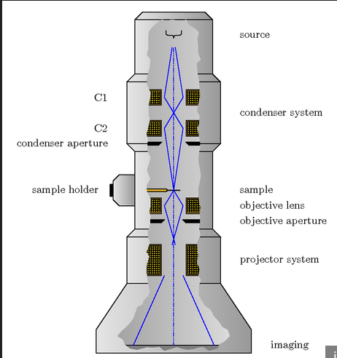 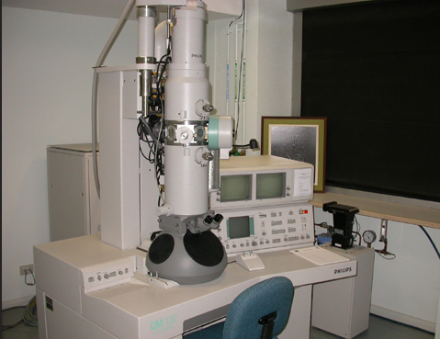

**The scanning electron microscope (SEM)**

The specimen to be used for SEM needs to be extremely thin. A SEM also uses a beam of electrons but the electrons do no penetrate the specimen instead the beam is passed back and forth across a portion of the specimen in a regular pattern. Depending on the contours of the specimen surface the electrons are scattered in a distinctive pattern. This allows a 3-D image to be built up by computer analysis of the scattered electrons. SEM has a lower resolving power than a TEM around 20nm.

* You must be able to compare the advantages/disadvantages of using Electron

Microscopes and LM:

|  |  |  |
| --- | --- | --- |
|  | LM | EM |
| Advantages | * Can view living material * Images are in colour | * Has a high resolving power |
| Disadvantages | * Has a low resolving power | * Samples viewed must   be dead because EM has a  vacuum   * A complex staining procedure is needed and even then specimens in black and white * Specimens must be extremely thin * The image may contain artefacts due to the preparation process |

* Using the EM shows the fine detail or ULTASTRUCTURE of a cell so that the

tiny ORGANELLES e.g. mitochondria are clearly seen ([Interactive Plant Cell Model](http://www.cellsalive.com/cells/plntcell.htm)) and ([Interactive Animal Cell Model](http://www.cellsalive.com/cells/animcell.htm)).

Calculating the size of organelles

* When measuring the real size of organelles we use the Log scale of

Measurement ([Magnification animation](http://www.cellsalive.com/howbig.htm))

* The Log scale:

Metre – 10 0 M 1.0 M

millimetre - 10 -3 mm 0.001 M

micrometre - 10 -6  m 0.000001 M

nanometre - 10 -9  nm 0.000000001 M

To calculate the real size of an organelle you must:

* measure the photograph of the organelle in mm and x1000 to get um
* the measured length must be divided by the magnification of the

photograph:

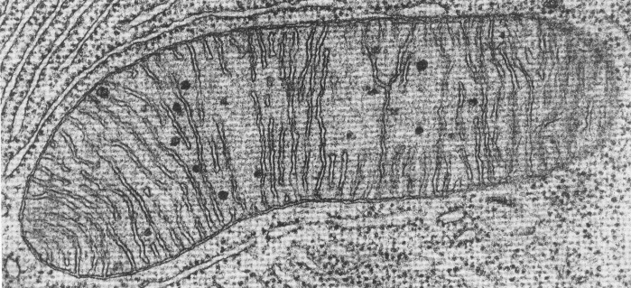

e.g. length of organelle = 44 mm

magnification of photograph = x11, 000

X 11, 000

length in mm (log scale) 44mm x 1000 = 0.000004 m = 4 um

magnification of photograph 11, 000

* To calculate the magnification of an organelle you must:
* measure the actual length of the scale provided in mm
* 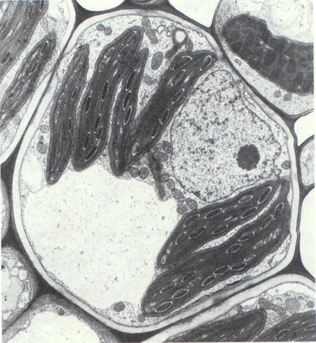multiply this length by x1000
* divide this figure by the scale value

e.g. actual length of scale = 16 mm

scale value = 1um

1 m

actual length of scale x 1000 16 mm x 1000 = x16,000

scale value 1 um

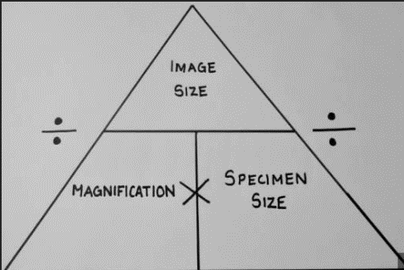

This is a useful calculation triangle to help you remember. Sometimes the specimen (the material put under the microscope) is called the object or the actual size.

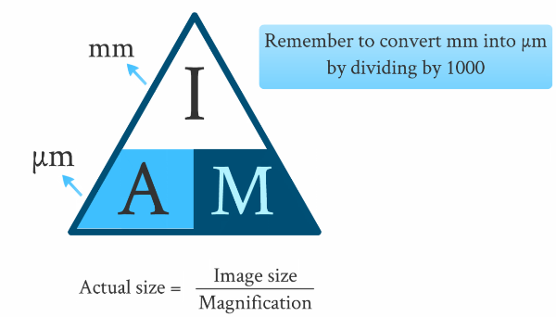

Ensure all your units are the same. You cannot divide mm by m.

**Calibrating a Microscope**

|  |  |  |
| --- | --- | --- |
| |  | | --- | | https://www.microscopeworld.com/images/reticle-grid.jpgEyepiece micrometer means graticule | | To properly calibrate your graticule (scale in the eyepiece) with a [stage micrometer](https://www.microscopeworld.com/p-652-stage-micrometer-mm-or-inches.aspx), align the zero line (beginning) of the stage micrometer with the zero line (beginning) of the graticule.  Now, carefully scan over until you see the lines line up again  In the example above, the eyepiece micrometer (graticule image) is on the top and the stage micrometer image is on the bottom).  The stage micrometer is 1 mm long with 100 divisions so each division of the stage micrometer is one one-hundredth of a mm (0.01mm or 10 μm - remember 1μm is one thousandth of a mm).  (Hint, you move the decimal point over three places to the right to change mm to micrometers).  The eyepiece scale is divided into 100 units These units are worth different values when different magnifications are used. Each eyepiece scale unit is worth more when a low power magnification is used and less when a high power magnification is used.  When the zero marks are lined up, scan across and look for a convenient point where the lines converge again. If you look at the 30 mark on the graticule, you will see pretty close alignment with the stage micrometer. How many divisions? Did you say 20? You are right!  Top = eyepiece micrometer (rotates when you turn the eyepiece)  Bottom – stage micrometer (you move this to make it line up)    And, if each space is 10μm wide, what will 20 spaces on the stage micrometer equal? Answer: 200μm. | |

**Cell fractionation**

This is a method used to isolate organelles from a cell so that they can be studied. Cells are broken up and the different organelles within the cell are separated out.

Method

1. Tissue is placed in a cold, buffered solution of the same water potential as the tissue. The solution is cold to reduce enzyme activity, buffered so that the pH does not change, and the same water potential so that water does not enter or leave the organelles causing them to burst or shrink.
2. **Homogenation.**

Cells are broken up by placing them in a blender (homogeniser) which releases the organelles from the cells. The resultant fluid is called the homogenate. This is filtered to remove and cells that have not broken up of any other debris.

1. **Ultracentrifugation**.
2. The filtered homogenate is put into a machine called a centrifuge which spins tubes of homogenate to create a centrifugal force.
3. The tubes are first spun at a slow speed forcing the heaviest organelles to the bottom of the tube. This includes the nuclei. A thin sediment or pellet forms at the bottom of the tube
4. The supernatant (fluid in the tube) is poured into a new tube leaving just the sediment of nuclei
5. The tube containing the supernatant is the spun in the centrifuge at a faster speed
6. The heaviest organelles are forced to the bottom of the test tube – this will include the mitochondria.
7. 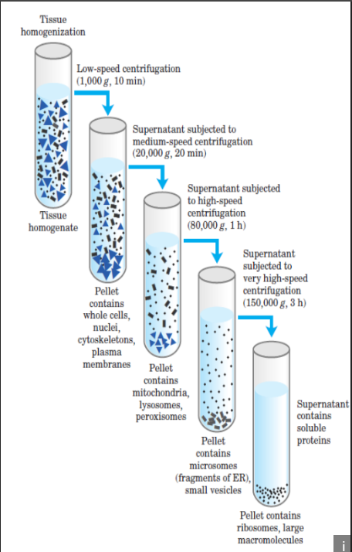The supernatant (fluid in the tube) is poured into a new tube leaving just the sediment of mitochondria.
8. This process is continued in this way so that, at each increase in speed, the next heaviest organelle is sedimented and separated.

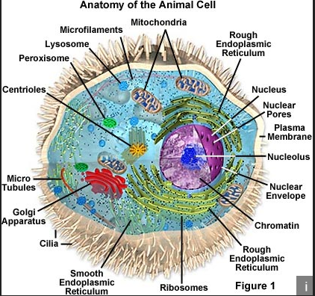**Organelles** [(The Evolution of Organelles tutorial)](http://www.sumanasinc.com/webcontent/anisamples/nonmajorsbiology/organelles.html)

* **The Nucleus**
* Structure:
  + Double membrane (outer and inner) surrounds the nucleus called the **nuclear envelope**
  + Within the nucleus is a granular, jelly-like material that makes up the bulk of the nucleus called the **nucleoplasm**
  + Inside the nucleus is the DNA (called **chromatin** as chromosomes are not visible), which is the genetic material of the cell. Chromosomes consist of protein-bound, linear DNA.
  + The **Nucleolus** is a small spherical region within the nucleoplasm where **Ribosomal RNA** (rRNA) is formed and ribosomes are assembled. There may be more than one nucleolus in a nucleus.
  + The **outer nuclear membrane** forms Endoplasmic Reticulum
  + There are **pores** in the double membrane to allow for movement of **mRNA** and **Nucleotides**
  + Function:
    - DNA forms **Genes**, which control all of the cell’s activities via

**protein synthesis**

* Manufactures ribosomal RNA and ribosomes

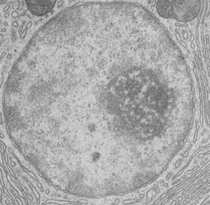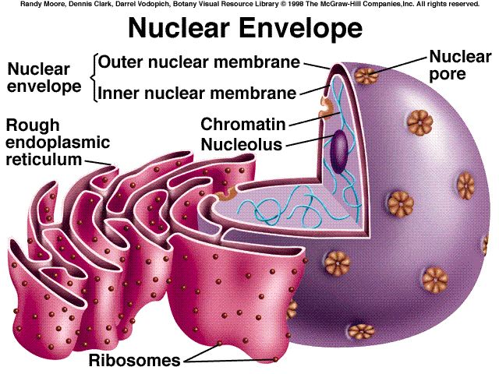

* **Endoplasmic Reticulum (ER)**
  + Structure:
    - Three dimensional sheet-like membrane spreading through the cytoplasm of cells.
    - Consists of **flattened sacs** called **Cisternae**, which extend from the nuclear outer membrane into the cytoplasm (and can link with the Golgi Body)
* Function:
  + - There are 2 types of ER:
      * + Smooth ER (SER) – synthesises stores and transports **lipids,** synthesises stores and transports **carbohydrates**
        + Rough ER (RER) – Ribosomes are attached to ER that

synthesise **proteins** and provide a pathway for the transport of materials, especially proteins, throughout the cell**.**

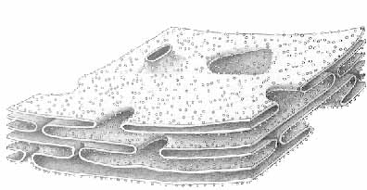

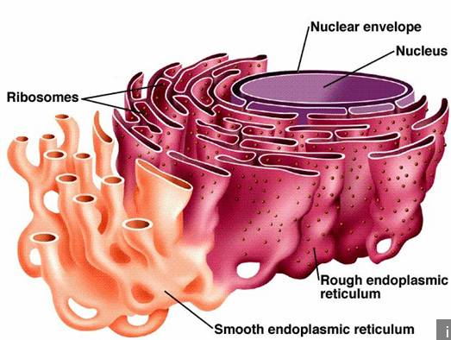

Rough ER

If the function of a cell is to manufacture and store large quantities of carbohydrates, proteins or lipids it will have a very extensive ER. Eg liver and secretory cells – epithelial cells lining the intestine

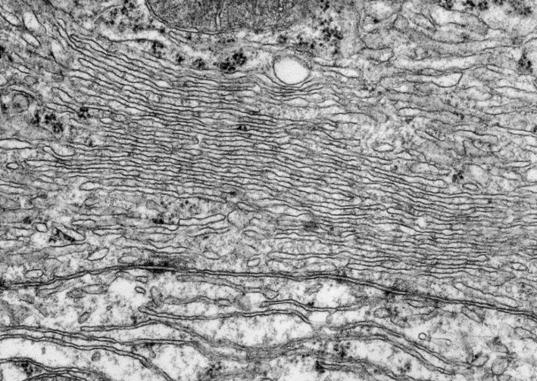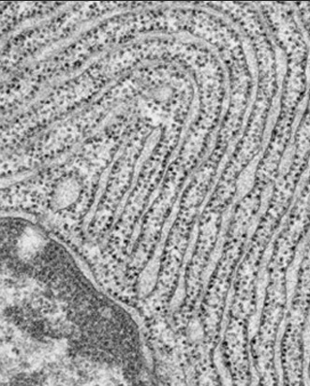

* **Golgi body/apparatus** [(Vesicle Budding animation and tutorial)](http://www.sumanasinc.com/webcontent/anisamples/nonmajorsbiology/vesiclebudding.html)
* Structure:
  + - Found in almost all eukaryotic cells
    - similar in structure to smooth ER
* **Flattened sacs, or cisternae** with small hollow structures called **vesicles.**
* Function:
* **Proteins** made in **RER** are **transported** in **Vesicles** which **Fuse** with Golgi membrane which are secreted into Golgi sacs which are built into more complex molecules such as **Glycoproteins** by adding carbohydrates to proteins
  + - Golgi body produces its own vesicles which are **‘Budded Off’**

from other end of the membrane

* Which move to and **fuse** with the **Cell Surface/Plasma Membrane** and exit cell via **Exocytosis**
* **Form lysosomes**
* **Transport, modify and store lipids**

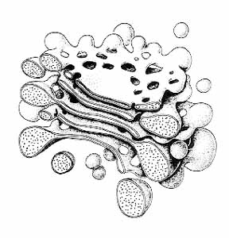

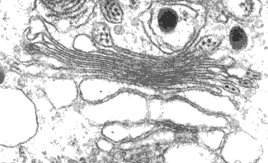

Vesicles

* **Lysosomes** [(Lysosome animation)](http://highered.mcgraw-hill.com/olc/dl/120067/bio01.swf)
  + Structure:
    - * Single membrane sacs produced from the **Golgi Body** which are **Secretory Vesicles** which contain **Digestive Enzymes** such as **lysozymes.**
  + Function:
    - **Phagocytosis** – Vesicles Fuse with the membrane of cell vacuoles and the Enzymes digest the contents, which have been previously enclosed by Phagocytosis
    - Release enzymes to the outside of the cell (exocytosis) in order to destroy material around the cell**.**
    - **Autolysis –** Vesicle break down and digest old/worn out organelles or cells
* **Mitochondrion** (mitochondria – plural)
* Structure:
  + - Rod-shaped organelle 1-10m in length
    - **Cristae** – Selective **Double Internal membrane** sac with highly folded

inner membrane called cristae, to **increase SA** – site of **ATP** synthesis. **Has Inter Membrane Space**

**Matrix** – liquid containing **enzymes** needed for aerobic

respiration

**Ribosomes** – Site of protein/**enzyme synthesis**, needed for

aerobic respiration

**Circular DNA** – Contains **genetic code** for proteins/enzyme

synthesis, needed for aerobic respiration and mitochondria is **Self Replicating**

* Function:
  + - Where aerobic respiration occurs to produce ATP
    - Many found in **muscle tissue** as high amount of energy is

needed for **contraction**





* **Chloroplasts** (plant cells only)
  + Structure:

Disc-shaped organelle typically 2-10m long and 1m diameter

Chloroplast envelope – double plasma membrane

**Thylakoid** - **Double Internal membrane** sac with highly folded

inner membrane called thylakoid, which contains **chlorophyll** molecules

* + - **Granum** – thylakoid membranes form **stacks** called grana for

efficient light absorption

* **Lamellae** – this is the double membrane that links thylakoid

with granum

* + - **Stroma** – Liquid containing **enzymes** for photosynthesis and

synthesising starch from glucose

**Circular DNA -** Contains **genetic code** for proteins/enzyme

synthesis, needed for photosynthesis and chloroplast is **Self Replicating**

* **Starch grains** – sometimes found in chloroplasts
  + Function:
* Site of photosynthesis
* Granal membranes provide large surface area for attachment of chlorophyll, electron carriers and enzymes for the first stage of photsynthesis
* Stroma made up of a fluid that contains all the enzymes needed to make sugars in second stage of photosynthesis
* Contain DNA and ribosomes so can quickly and easily manufacture some for the proteins needed for photosynthesis



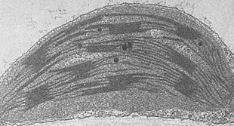

* **Ribosomes**
  + Structure:
    - Small cytoplasmic structures made up from **Two Sub units**, **Large** and **Small**, made from **rRNA** and **Protein**
    - There are two types, depending on which cells they are found in
      * + **80S –** found in eukaryotic cells, around 25 nm in diameter
        + **70S –** found in prokaryotic cells, in mitochondria and chloroplasts, is slightly smaller

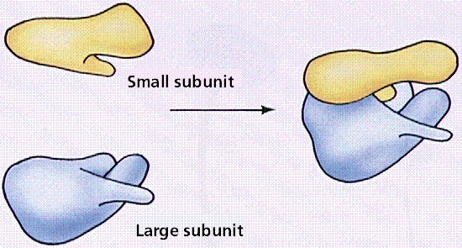

* + - They can be found:
      * + Free in cytoplasm as single units
        + In groups in cytoplasm called polysomes
        + Attached to ER membrane forming Rough ER
        + Found in mitochondria and chloroplasts
  + Function:
    - Protein synthesis (joining amino acids together by peptide

bonds by doing condensation reactions

* **Cell wall**

Found in all plant cells consisting of microfibrils of the polysaccharide cellulose, embedded in a matrix.

* + Structure:
    - **Cellulose** - makes up 50% of cell wall, which forms microfibrils
      * Middle lamella – a thin layer celled the middle lamella, which marks the boundary between adjacent cell walls and cements adjacent cells together
    - **Plasmodesmata** – pores which connect cytoplasm of adjacent cells
* Function:
  + - Provides **strength and rigidity** for cell to prevent the bursting from osmotic pressure of water.
    - Give mechanical strength to the plant as a whole
    - To allow water to move through the plant cells

Cell walls in algae are made of either cellulose or glycoproteins or a mixture of both

The cell walls of fungi do not contain cellulose but are made of a nitrogen –containing polysaccharide called **chitin**, a polysaccharide called glycan and glycoproteins.



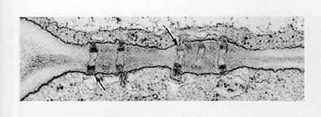

* **Vacuoles**

A fluid-filled sac surrounded by a single membrane

* + Animal cells – vacuoles are **small vesicles** formed in **phagocytosis**
  + Plant cells – Vacuoles are **large** and surrounded by a **Tonoplast**, which

acts as a **Storage Site** for mineral salts, sugars, amino acids, wastes and sometimes pigments.

* Function:
* Support herbaceous plants, and herbaceous parts of woody plants by making cells turgid.
* Sugars and amino acids act as a temporary food source
* Pigments may colour petals to attract pollinating insects

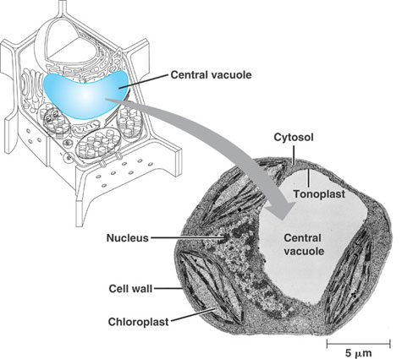

## Cell Differentiation

* As eukaryotic cells evolved into multicellular organisms, there had to be

specialisation of different cells for different functions – this is called **cell differentiation**, where **cells become adapted for their function**. Each specialised cell has evolved more or fewer of certain organelles and structures to suit the role it carries out.

All the cells in a multicellular organism, such as a human, are produced by mitotic division from a fertilised egg (so they are identical initially). Each cell contains exactly the same genes but different genes will be expressed (turned on) in different cells.

The shape of different cells varies as well as the number of organelles e.g. Sperm cells will have many mitochondria whereas a bone cell will have very few.

* Epithelial cell
  + Function:
    - **Absorption** of products of digestion
  + Adaptations:
    - Microvilli – **increases SA** of cell membrane for absorption
    - Mitochondria – **many** to carry out aerobic respiration making

**ATP** for **active transport**

* + - Enzymes – **complete digestion** so the products have **short**

**diffusion pathway** into cell

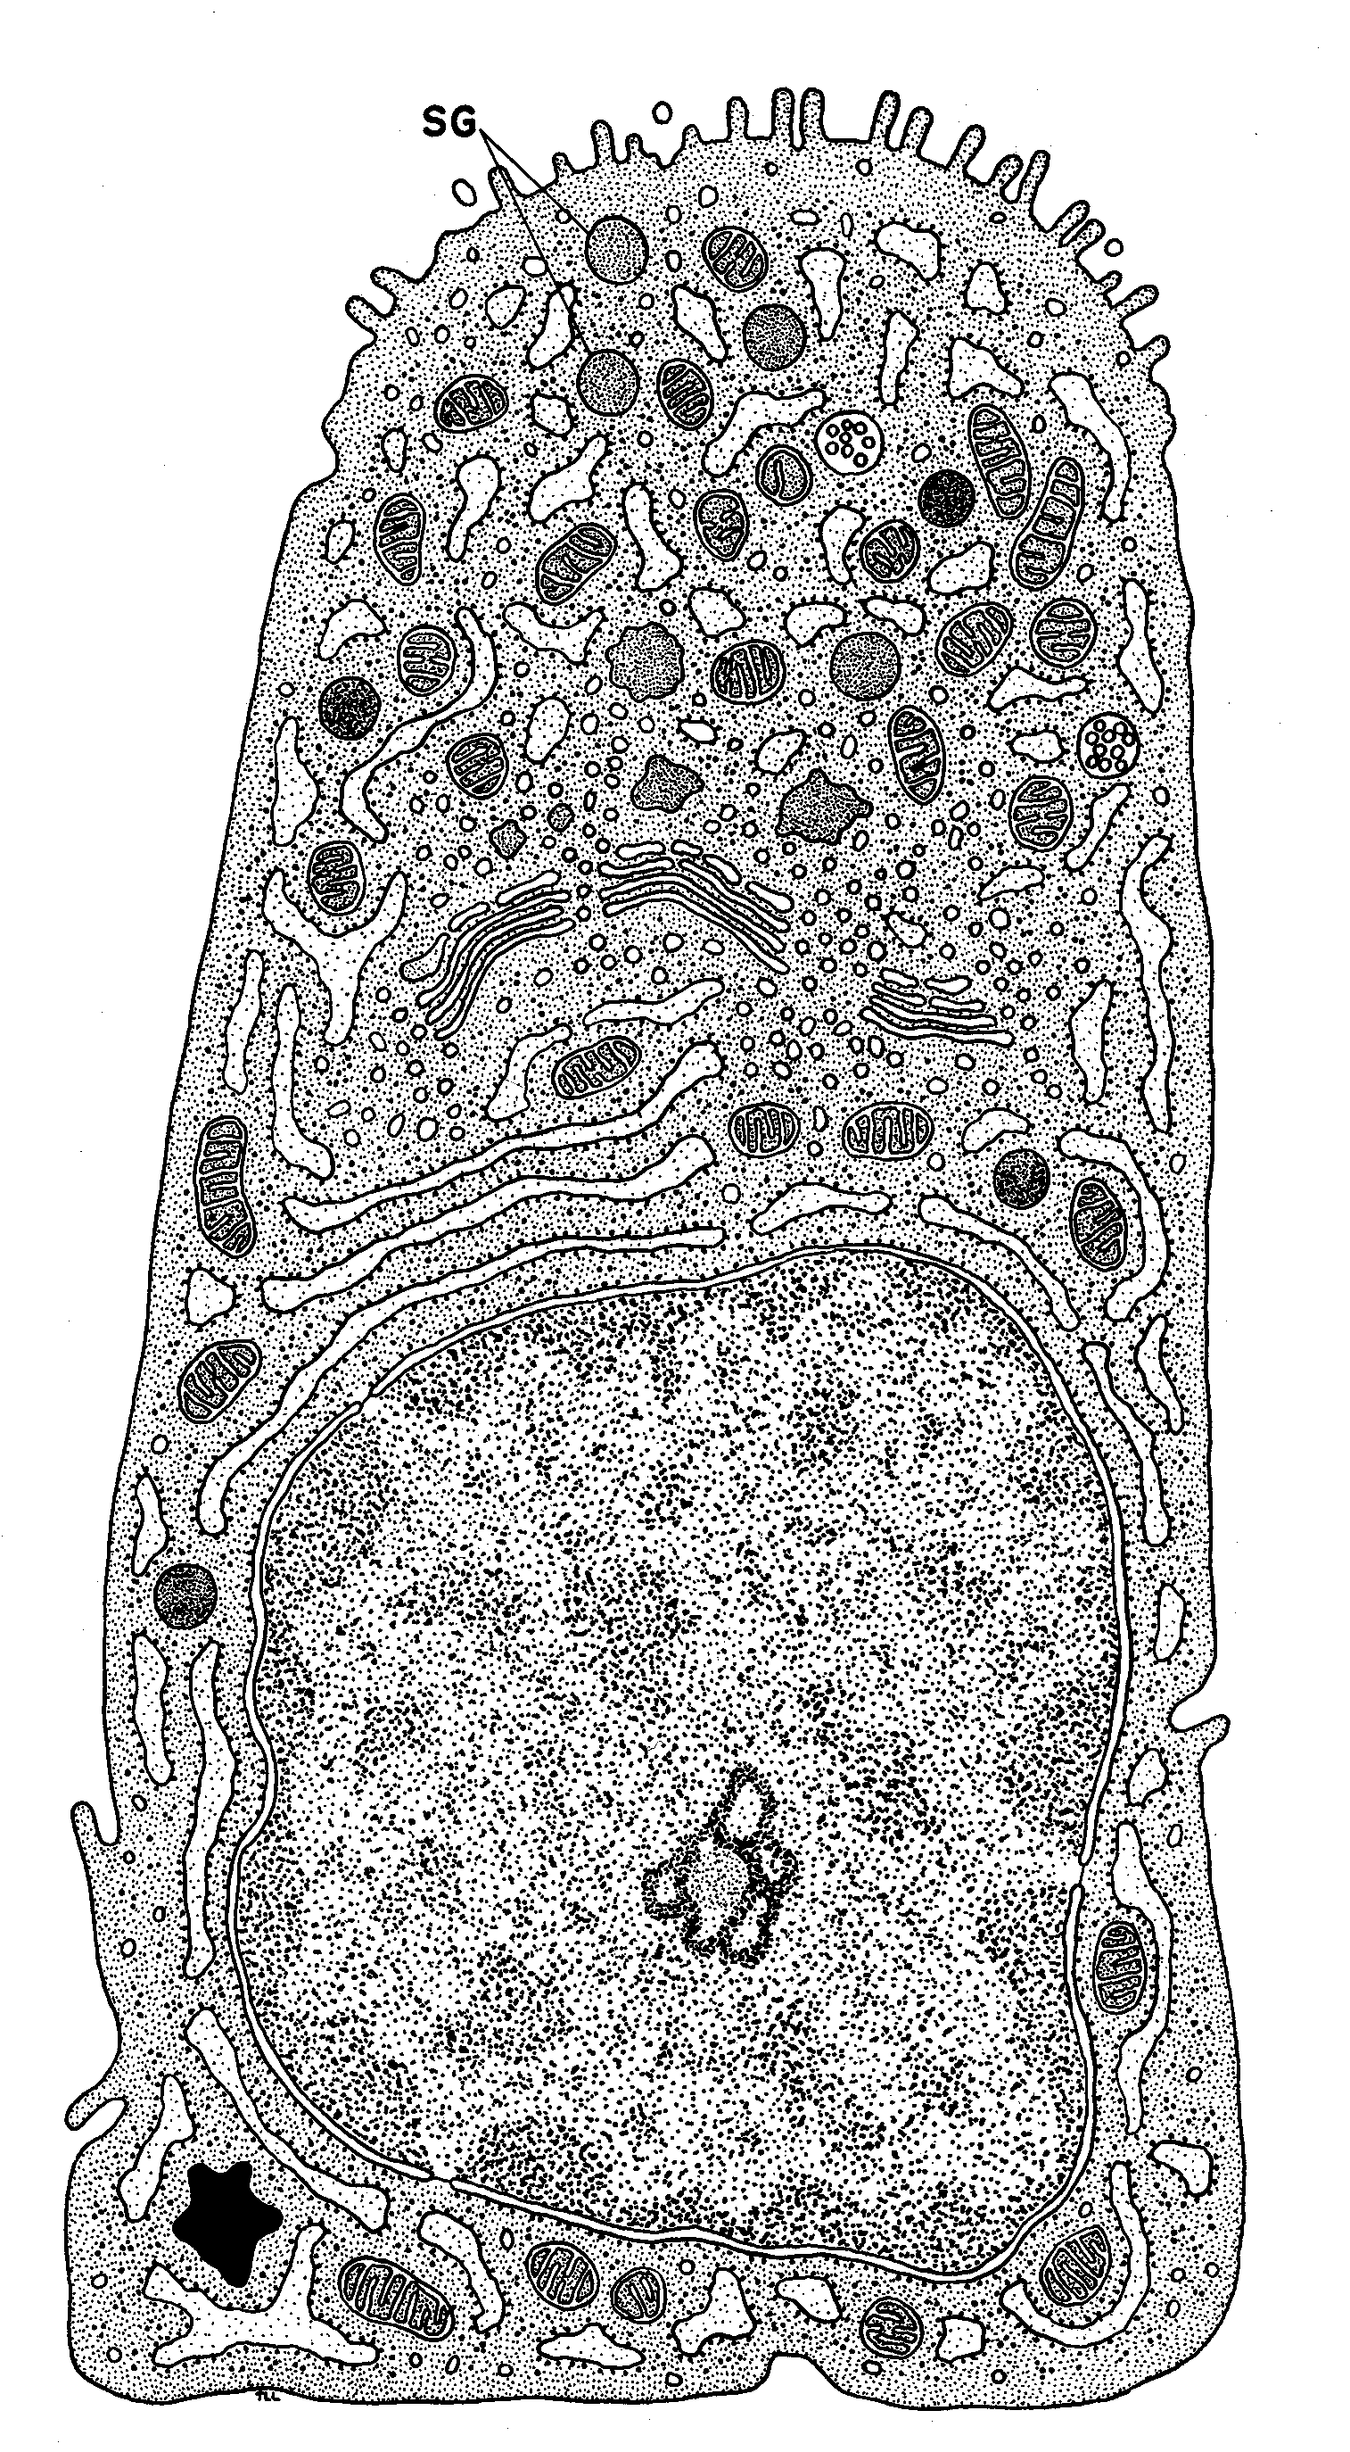

microvilli

many mitochondria

* Tissues and organs
* Tissue is a group of **similar cells** that work together in **one function**

e.g. epithelial cells form epithelium tissue which lines cavities in the

body

* Organs are composed of **different tissues** ALL working together for

**one function** e.g. the stomach’s function is to digest food:

* + - Epithelium tissue – found in animals and consist of sheets of cells. They line the surfaces of organs and often have a protective or secretory function. They are often thin to allow diffusion eg alveoli of lungs or ciliated lining ducts such as trachea. The cilia are used to move mucus over the epithelial surface.
    - Muscle tissue – churns food
    - Nervous tissue – makes muscle contract
    - Xylem – occurs in plants, made up of a number of similar cell types and used to transport water and mineral ions throughout the plant and also gives mechanical support to the plant.

## Prokaryotic and Eukaryotic cells

* Eukaryotic cells are larger and have a nucleus bounded by nuclear membranes (nuclear envelope)
* Unicellular organisms with no nucleus (prokaryotic – before the nucleus) e.g.

bacteria have a different cell structure to all other organisms which have

eukaryotic cells (have a nucleus):

* 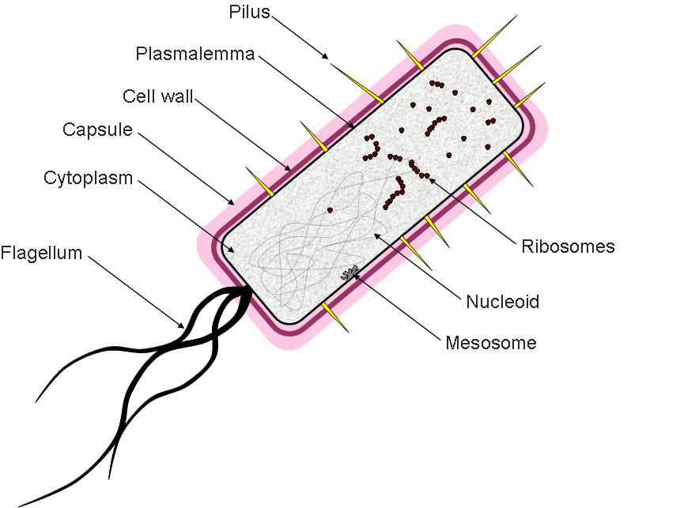Prokaryotic cell ([Bacterial Cell Model](http://www.cellsalive.com/cells/bactcell.htm))

Structure of a bacterial cell

Bacteria are small unicellular organisms that can be found in every habitat in the World. They range between 0.1 to 10m in length.

* Cell wall made of **murein (peptidoglycan) –** physical barrier which excludes some substances and protects again mechanical or osmotic damage
* Some bacteria contain a **capsule** of mucilaginous slime around the wall – protects bacteria from other cells and allows bacteria to stick together
* Inside the cell wall is a **cell-surface membrane** within which is the cytoplasm containing 70S ribosomes
* Food is stored as glycogen granules and oil droplets
* Genetic material stored as a **circular strand of DNA** in the cytoplasm
* Plasmids are additional smaller circular pieces of DNA which can reproduce themselves independently and may give carry antibiotic resistant genes. They are also used as vectors in genetic engineering.
* Differences between prokaryotic and eukaryotic cells

|  |  |
| --- | --- |
| Prokaryotic cell (bacterial cell) | Eukaryotic cell  (animal or plant cell) |
| 1. No organised nucleus – DNA is **free in cytoplasm** | 1) Nucleus with nuclear envelope |
| 2) DNA is **Circular and some DNA maybe in the form of plasmids** | 1. No plasmids and DNA as Linear strands called chromosomes |
| 3) **Small** ribosomes (70 s) | 3) larger ribosomes (80 s) |
| 4) No membrane bound organelles | 4) Membrane bound organelles |
| 5) May have a mucilaginous capsule around cell [(phagocytosis video)](http://www.youtube.com/watch?v=fpOxgAU5fFQ) | 5) No capsule |
| 6) Cell wall made of **Murein (peptidoglycan)** | 6) Where present, cell wall made of Cellulose (or chitin in fungi) |
| 7) Site of Respiration is infoldings of cell membrane called **Mesosomes** | 7) Site of Respiration is Mitochondria |
| 8) Size **1-10 m** | 8) Size **10-100um** |
| 9) no chloroplasts, only bacterial chlorophyll associated with the cell-surface membrane in some bacteria | 9) chloroplasts present in plants and algae |

**Viruses**

* Viruses are acellular, non-living particles
* Smaller than bacteria
* Viruses consist of DNA **or** RNA (not both), enclosed in a **Protein** coat (Matrix)
* The nucleic acids (RNA or DNA) are enclosed in a capsid
* Can only multiply inside living host cells
* Some viruses, like HIV, are surrounded by a lipid envelope
* There are attachment proteins on either the capsid or the lipid envelope, if present, which allow the virus to identify and attach to host cells.

