Cell division can take place by either mitosis or meiosis.

Mitosis produces two daughter cells that have the same number of chromosomes as the parent cell and each other.

Meiosis produces four daughter cells, each with half the number of chromosomes of the parent cell.

Meiosis is covered in section 3.4.3

Within multicellular organisms, not all cells retain the ability to divide.

Eukaryotic cells that do retain the ability to divide show a cell cycle.

Cell Cycle

This is a series of events that starts with the beginning of mitosis and ends when mitosis starts again in the daughter cell. Included in the cycle are:

* The four phases of mitosis: prophase, metaphase, anaphase, telophase (nuclear division)
* The three phases of interphase: G1 – growth pahse,S – DNA replication and G2 – growth phase.

When the cell is not dividing, it is referred to being in Interphase:



* + DNA replicates
  + All ATP made for mitosis
  + All cell organelles replicate
  + Chromosomes are not visible
  + Protein synthesis

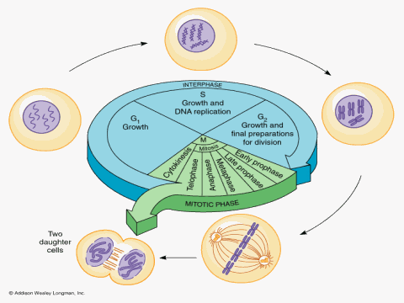

As the cell cycle is a cycle you can remember the order by starting with interphase and ending with mitosis and cytokinesis.

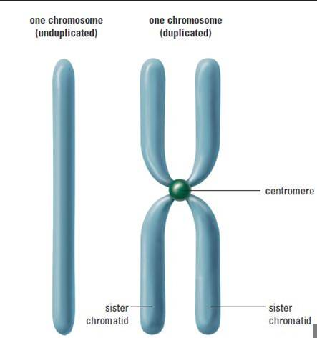

Mitosis

([Mitosis animation](http://highered.mcgraw-hill.com/sites/0072437316/student_view0/chapter11/animations.html)) [(Mitosis tutorial)](http://www.sumanasinc.com/webcontent/anisamples/majorsbiology/mitosis.html) [(Mitosis video)](http://moodle.godalming.ac.uk/learning/file.php/932/Unit%201/1.7%20Mitosis/Notes/AGB-Mitosis.WMV)

* This is the method of cell division where the DNA of a parent cell replicates and produces 2 new Daughter cells each containing an exact copy of the Parent cell’s DNA. In some cases a mutation could occur to change the genetic make-up of a cell but this is a rare event.
* Mitosis increases cell number for:
  + Growth
  + Tissue repair
  + Asexual reproduction
* Mitosis is a continuous process by can be divided into 4 stages called phases:
  + Prophase Cell Prepares to divide, DNA condenses
  + Metaphase Chromatids move to Middle of cell
  + Anaphase Chromatids are pulled Apart
  + Telophase Two new nuclei form, DNA elongates and cell

(Cytokinesis) divides into Two Daughter cells

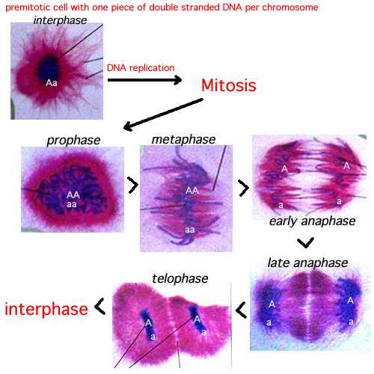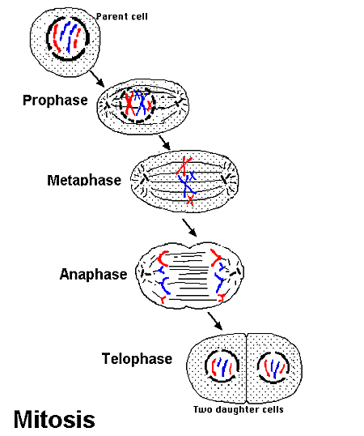

* **Prophase**

The DNA CONDENSES, getting shorter and fatter

* This means the sister chromatids are VISIBLE
* Centrioles migrate to poles *N.B. plant cells do not contain centrioles
* **SPINDLE FIBRES** develop from the centrioles in an animal cell or from the spindle apparatus in a plant cell.
* Nucleolus disappears
* Nuclear envelope disintegrates at the end of this phase
* *N.B. Individual chromatids are distinguishable, BUT are randomly distributed in nucleus and exist as **sister chromatids** connected via a **Centromere**
* **Metaphase**
* Chromatids move to the EQUATOR (middle of cell)
* They attach to the spindle fibres by their CENTROMERES
* No nuclear membrane
* *N.B. Chromatids are aligned at middle of cell
* **Anaphase**
* Centromeres divide in two
* The spindle fibres contract
* Pulling the chromatids apart
* Each chromosome moves to the opposite pole
* *N.B. Chromatids moving apart

The energy for this process is provided by mitochondria, which gather around the spindle fibres

* **Telophase**
* A nuclear membrane forms around each set of chromosomes
* The DNA elongates so chromosomes are not visible
* In plant cells a new cell wall forms to separate cells – in animal cells the membrane ‘pinches’ inwards to separate (CYTOKINESIS)
* *N.B. Nuclear membranes and/or cell separating

**Cell division in prokaryotic cells**

Prokaryotic cells divide by a process called binary fission. In ideal conditions some bacteria can divide every 10 minutes or so.

* The circular DNA replicates and both copies attach to the cell membrane
* The plasmids replicate
* The cell membrane begins to grow between the two DNA molecules and ‘pinches’ inwards to separate the cytoplasm in two
* A new cell wall forms diving the cell into two identical daughter cells (clones/ asexual reproduction)
* Each cell has a single copy of circular DNA and a variable number of copies of the plasmid

**Virus replication**

* Viruses are non-living so cannot undergo cell division. They can only reproduce inside living cells which they do so by taking over the cell’s own ability to make new proteins and nucleic acids
* Viral lifecycle
* Virus attaches to a specific host cell using its attachment proteins. These proteins are complementary to those on the host cell.
* Virus enters the cell by a process similar to phagocytosis
* The attachment protein and the capsid dis-assemble, leaving free viral nucleic acid
* The viral nuclei acid sometimes is incorporated into the chromosomes of the ohost cell
* The viral genes are expressed (transcribed and translated) and viral proteins are made which make more viral particles
* The cell bursts releasing new viral particles which go on to infect new cells

**Root tip squash** – to show stages in mitosis ([Interactive Light micrographs of mitosis](http://www.microscopy-uk.org.uk/mag/indexmag.html?http://www.microscopy-uk.org.uk/mag/artaug99/mitosis2.html))

1. Cut off 2mm off a garlic root tip – This is where **mitosis** is taking place!
2. Put 10 drops of **acetic orcein stain** onto root tip, in watch glass – this is a red dye to stain the DNA and make the **chromatids visible**
3. Add one drop of 1m hydrochloric acid into a watch glass – this is to **soften the cell walls** to let the stain into the cells. Add the root tips.
4. Place the watch glass onto a hot plate for 30 seconds. Leave for about 5 minutes (off hot plate) – **heat speeds up the softening and staining**.
5. Using forceps remove a root tip and place it on a microscope slide.
6. Using the mounted needle gently squash the root tip – this is to form a layer **one cell thick** making it easier to see dividing cells.

**The mitotic index**

The mitotic index (MI) is a value that gives an indication of the turnover of a particular tissue or sample. The more rapidly cells are dividing the higher the MI. The number of cells undergoing mitosis can be found using an optical microscope and counting the number of cells with visible chromosomes

cells with visible chromosomes (at each stage of mitosis)

MI = -----------------------------------------------

Total number of cells in sample

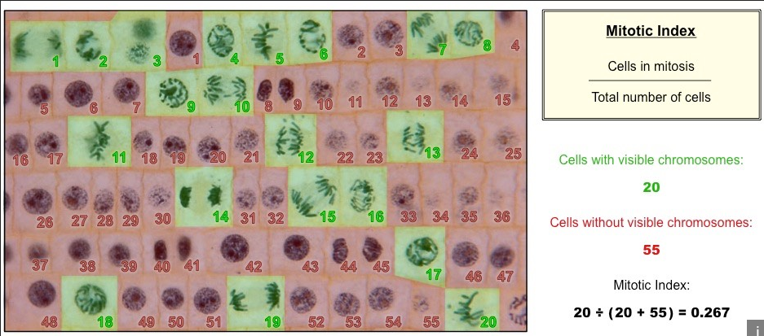

**The Cell Cycle**

Not all cells retain the ability to divide Eukaryotic cells that do retain the ability to divide show a cell cycle.

The cell cycle has 3 phases

1. Interphase – this occupies most of the cell cycle, no division takes place here so sometimes called the resting phase
2. Nuclear division – mitosis producing 2 cells or meiosis producing 4 cells
3. Division of the cytoplasm (cytokinesis)

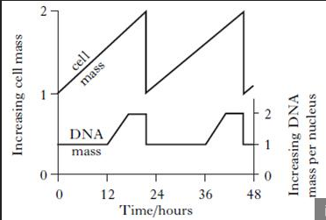The length of the cell cycle varies between different organisms. In mammals a cell cycle usually takes about 24 hours, of which 90% in interphase.

**Cancer and the control of mitosis**

The frequency of cell division in the human body is usually tightly controlled to allow growth or repair of the tissues. Cancer is a group of diseases caused by growth disorders of cells. It is the result of damage to the genes which regulate mitosis and the cell cycle. This leads to uncontrolled cell division and the formation of a tumour. A tumour becomes cancerous when it changes from benign to malignant. Malignant tumours grow rapidly, are less compact and more likely to be life threatening. Benign ones grow more slowly, ae more compact and are less likely to be life-threatening.

**Treatment of cancer**

Broadly speaking there are three treatment for cancer: surgery, chemotherapy and radiotherapy.

1. Surgery involves cutting out the tumour. Unfortunately some tumours can be very difficult to cut out due to their location and it is difficult to tell where the edge of the tumour is. If all cancerous cells are not removed a new tumour can form.
2. Radiotherapy involves treating the tumour with high doses of radiation, usually X-rays which kill cells.
3. Chemotherapy involves the injection of drugs that travel to all parts of the body. An ideal anti-cancer drug will target the tumour cells while leaving normal body cells unharmed, but this is not easy. Drugs used usually disrupt the cell cycle by preventing DNA from replicating or inhibiting the metaphase stage of mitosis by interfering with spindle formation. These drugs affect both cancerous and healthy cells. However, the drugs are more effective against rapidly diving cells and a cancer cell has a particularly high rate of division. Normal cells that divide rapidly are therefore also affected. An example is hair-producing cells which explains why hair loss frequently is seen in patients undergoing cancer treatment.