* + 1. **Cell Membrane and Transport across membranes**

Cell Membranes

* 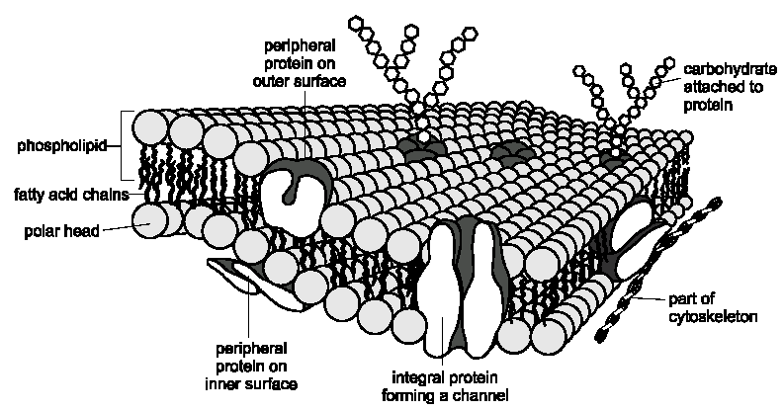All cells are surrounded by a Cell Surface/Plasma Membrane which forms a boundary between the cell cytoplasm and the environment. The membrane appears as a double line approximately 7-8nm wide when viewed with an Electron Microscope:

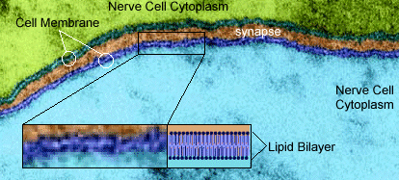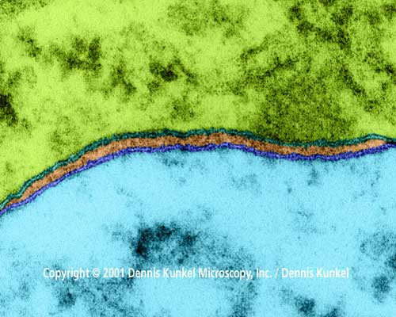

* The entry and exit of substances to cells is controlled by the cell membranes, which is why these membranes are described as **Partially Permeable membrane**. The Major functions of the cell membrane include:
  + Creating a different environment between the inside and the outside of the cell
  + Controls the movement of substances in and out of the cell
* All cell membranes have the same structure which includes the following types of molecules:
* Phospholipids
* Proteins
* Cholesterol
* Glycolipids
* Glycoproteins

* Phospholipids [(Phospholipids animation)](http://www.ngfl-cymru.org.uk/vtc/2008-09/science/wjec-biology/english/Cell%20Membranes%20and%20Transport.ppt#263,1,Cell%20Membranes)

Phosphate head - **Hydrophilic**

Fatty acid tails – **Hydrophobic** = barrier to water soluble/Polar

molecules

* + The phospholipids form a bilayer i.e. 2 molecules with:
    - Fatty acid tail pointing inwards
    - Phosphate heads (positive charge, hydrophilic) pointing outwards to watery surrounding of cell and to watery interior of cell
  + The fatty acid tails are **Hydrophobic** and prevent water soluble molecules
  + from entering/exiting the cell. Importance? They prevent **soluble polar** molecules like enzymes from leaving the cell. [(The unsinkable pygmy gecko - surface tension)](http://www.youtube.com/watch?v=_UWOKjfBmy4)
  + Which molecules can pass through the cell membrane?
  + **Lipid soluble** molecules
  + **Non polar**– not repelled by phosphate head positive charge
  + **Small** – can squeeze between phospholipid molecules in the

membrane e.g. O2, H2O, CO2

* Proteins
* These are interspersed throughout the cell surface membrane. They are embedded in two main ways
  + Occur in the surface of the bilayer **(extrinsic protein)**, never extend completely across it. They act as mechanical support or, in conjunction with glycolipids as cell-receptors.
  + Completely span the phospholipid bilayer from one side to the other **(intrinsic protein)**. Some are **protein channels** which form water filled channels that allow water-soluble ions to diffuse across the membrane. Others are **carrier proteins** that bind to ions or molecules like glucose and amino acids, then change shape in order to move these molecules across the membrane.
* Function of proteins in the membrane:
  + Provide structural support
  + Act as channels transporting water-soluble (polar) molecules across the membrane
  + Allow active transport through carrier proteins
  + For cell surface receptors for identifying cells
  + Help cells adhere together
  + Act as receptors (eg for hormones)
* Cholesterol
* These are found in the phospholipid bilayer of the cell surface membrane. They add strength to the membranes. They are very hydrophobic and play an important role in preventing loss of water and dissolved ions from leaving the cells. They also pull together the fatty acid tails of the phospholipid molecules, limiting their movement and that of other molecules but without making the membrane as a whole too rigid.
  + Functions:
    - Reduce lateral movement of other molecules including phospholipids
    - Make the membrane less fluid at high temperatures
    - Prevent leakage of water and dissolved ions from the cell
* Glycolipids
  + Glycolipids are made of a carbohydrate covalently bonded with a lipid. The carbohydrate portion extends from the phospholipid bilayer into the watery environment outside the cell where it acts as a cell-surface receptor for specific chemicals.
    - Functions
      * Act as recognition sites
      * Help maintain the stability of the membrane
      * Help cells attach to one another and so form tissues
* Glycoproteins
  + Carbohydrate chains attached to an extrinsic protein. They act as cell-surface receptors.
    - Functions
      * Act as recognition sites
      * Help cells attach to one another and so form tissues
      * Allow cells to recognise one another e.g lymphocytes can recognise an organisms own cells.
* Singer and Nicholson in 1972 put forward a model of membrane structure,

which they called the **Fluid Mosaic Model** [(Fluid mosaic model) animation](http://www.ngfl-cymru.org.uk/vtc/2008-09/science/wjec-biology/english/Plasma%20Membranes.ppt#256,1,Plasma%20Membranes) because:

* The **Phospholipids** can move relative to each other i.e. **Fluid**
* The **proteins** are **Scattered** in the phospholipids like a **mosaic**:
* **Cholesterol** is present to **stabilise** the membrane

# Methods of Cell Transport + Taking up Nutrients

([Cell transport animations](http://programs.northlandcollege.edu/biology/Biology1111/animations/transport1.html))

## 4 Methods

### Diffusion Osmosis Active Transport

Simple Facilitated

diffusion diffusion

Passive process Active

(does not use ATP) (uses ATP)

* Diffusion

( [Diffusion Animation](http://www.wisc-online.com/objects/index_tj.asp?objid=AP1903))

* + Molecules move across membranes by the process of **Diffusion**. Diffusion is :

The **Net** movement of molecules

Form an area of **high concentration** to area of **low concentration**

Down a **concentration gradient**

Until an **equilibrium** is reached

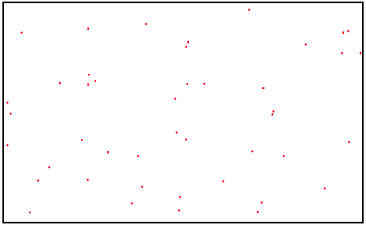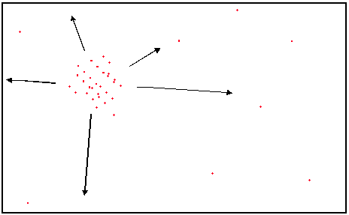

The NET movement of molecules, Down a **concentration gradient**,

from an area of **high concentration** until an **equilibrium** is reached

to area of **low concentration**

* + Factors increasing the rate of diffusion
    - Temperature – Higher temperature means molecules have more

**kinetic energy**, therefore move faster

* + - Surface Area (SA) – Higher the SA, allows more molecules to

move, therefore more diffusion

* + - Diffusion Pathway – The shorter the distance molecules have to

travel, diffusion is faster

* + - Concentration gradient – The **steeper** the gradient, the faster

the molecules move

* + - Molecule size – Small molecules diffuse faster through gaps in

phospholipid bilayer (don’t have to move through special protein channels)

* + - Lipid Solubility – Lipid soluble molecules diffuse faster through

gaps in phospholipid bilayer (don’t have to move through special protein channels)

* **Simple Diffusion** 
  + Small/non-polar/lipid soluble e.g. O2, H2O, CO2 can diffuse from a high to low concentration down a **concentration gradient** until an **equilibrium** is reached, by moving between the phospholipid molecules in the bilayer:

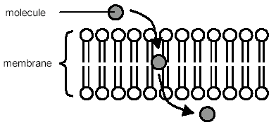

Rate of uptake into cell

External concentration

* **Facilitated diffusion** [(Facilitated diffusion - beetroot practical)](http://www.ngfl-cymru.org.uk/vtc/2008-09/science/wjec-biology/english/Plasma%20Membranes.ppt#303,11,Experiment)
* For molecules that are:
  + - Water soluble e.g. glucose, amino acids
    - Polar e.g. ions – Na+/Cl-/K+
    - Large e.g. glucose, amino acids
  + These molecules move across the membrane down a concentration

gradient until an **equilibrium** is reached, but move through specific **Channel or Carrier Proteins** to get them through the phospholipid bilayer (NO ATP required):

Finite number of channel proteins

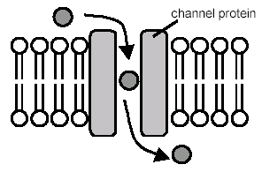

Rate of uptake into cell

External concentration

* Only one type of molecule can pass through the specific channel

protein as the shape of the molecule is **Complementary** to that of

the protein channel.

**Protein Channels**

* Water-filled hydrophilic which span the membrane.
* They allow specific water-soluble ions to pass through
* They are selective and open in the presence of specific ions

**Carrier proteins**

* Proteins which span the membrane
* Allow specific molecules (such as glucose) to to bind with the protein causing it to change shape in such a way that the molecule is released to the inside of the membrane.
* **Osmosis**
  + Osmosis is **Net** movement of water molecules from a high  to a low

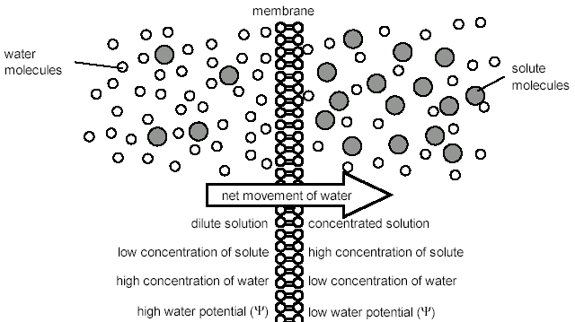 through a partially permeable membrane until an equilibrium is reached:

* + Osmosis can be quantified using **Water Potential**, so that we can

calculate in which direction water will move and how fast – new

terminology to learn:

* Definition “Water Potential is the potential for water to leave/enter a cell by osmosis”
  + - The symbol for water potential is  (Psi – pronounced “sy”)
    - Units for  is are kilo Pascals (kPa)
    - The highest  is for pure/distilled water, where its  is 0
    - Adding solutes to the solution causes fewer free water

molecules so the  is lowered to a negative value e.g. –75 kPa

* + Water molecules will always move from a higher  to a lower  due to

more solute molecules being present (always to the more negative value!):

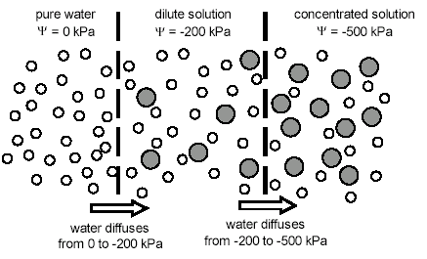

|  |  |  |  |
| --- | --- | --- | --- |
| Solution | |  kPa | ‘Concentration’ of Solution (solutes) |
| Concentration of Water (%) | Concentration of Solute (%) |
| 100 | 0 | 0 | Dilute/weak |
| 50 | 50 | -75 | Medium |
| 10 | 90 | -100 | Concentrated/strong |

* + Osmosis and animal cells
* The concentration of the solution (therefore ) that **surrounds**

a cell will affect the state of the cell, due to osmosis. There are three possible concentrations of solution to consider:

* + - Isotonic solution – A solution of equal concentration/ to the cell. There is still movement of water, but no **Net** movement e.g.

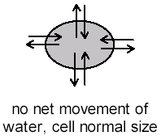

-100 kPa

-100 kPa

* + - Hypotonic solution– A solution that has a lower amount of

solutes/less concentrated solution/higher

concentration of water/Higher or less negative  than the cell e.g.

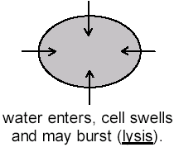

-90 kPa

-100 kPa

* + - Hypertonic solution - A solution that has a higher amount of

solutes/more concentrated solution/lower

concentration of water/Lower or more negative  than the cell e.g.

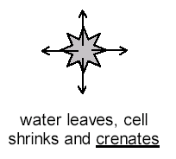

-90 kPa

-100 kPa

* + Osmosis and Plant cells
    - Plants rely on cell turgor for their support, and without enough

water they wilt.

* 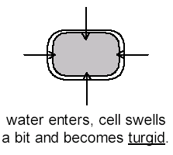Hypotonic solution – Water enters cell increasing its turgidity, when **fully turgid** no more water enters, membrane is pushing against cell wall (Turgid elodea video):
* Hypertonic solution – Water leaves the cell, cell membrane pulls away from the cell wall as the cell plasmolyses (Plasmolysing elodea) :

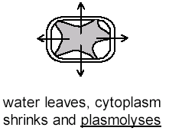

* + - In a plant cell the  is the **Sum/Total** of two factors:
      * + (s) **Solute Potential** is the effect of solutes

lowering the  of the cell sap (**negative value**)

* + - * + (p) **Pressure Potential** is the tendency of water to

leave a cell/system, resulting in an opposite pressure generated by the cell wall (**usually positive value**)

Water Potential of plant cell = Solute Potential + Pressure Potential

 cell = s + p

* + - * + e.g. s =  -1000kPa

p = 900kPa

cell = -100kPa

* + - * + The s of plant cells can be calculated by viewing the percentage of cells which are plasmolysed in varying concentration solutions
        + Where 50% of cells are plasmolysed (**Incipient Plasmolysis**) is the point when s = external solution (solute concentration in cells equals external solution concentration) *N.B. the p will be 0 kPa!
* **Active Transport** 
  + This move molecules or ions:
    - Against the concentration gradient
    - Using ATP

In active transport ATP is used to directly move molecules and to individually move molecules using a concentration gradient which has already been set up by (direct) active transport. This is known as **co-transport**

**Direct active transport**

* + When a molecule binds to the **Specific** **Carrier Protein**, it changes shape (energy from ATP allows this to happen), and the molecule is transported to the other side of the membrane:

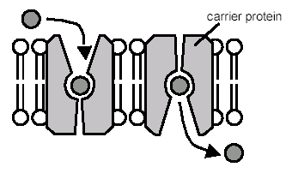

Finite number of carrier proteins

* Only one type of molecule can pass through the specific carrier

protein as the shape of the molecule is **Complementary** to that of

the carrier protein site.

The carrier proteins span the plasma membrane and bind to the molecule or ion to be transported on one side of it.

On the inside of the cell/organelle, ATP binds to the protein, causing it to split into ADP and a phosphate ion. As a result the protein changes shape and opens to the opposite side of the membrane.

The phosphate ion is released from the carrier protein which causes the carrier protein to revert to its original shape, ready for the process to be repeated.

* Sometimes more than one molecule or ion can be moved in the same direction at the same time by active transport.
* Sometimes the molecule or ion is moved into a cell/organelle at the same time but in a different direction (**sodium potassium pump**)
* Factors that affect the rate of active transport
  + - **Oxygen Concentration** – less O2 means less respiration, so less

ATP is made for active transport

* + - **Temperature** – More heat energy gives molecules more kinetic

energy, so that they move faster and are more

likely to collide with the carrier protein

* + - **Number of protein carriers** – There is a limited number of

specific protein carriers for molecules e.g. glucose, so when all are carriers are working at full capacity there is a constant uptake of glucose

* + - Respiratory Inhibitor e.g. Cyanide – This will:
      * + **Stop Aerobic Respiration** from occurring
        + Therefore **no ATP** is synthesised
        + Therefore **no Energy for Active Transport** (see graph below for affect of Cyanide)



**Co-transport**

This is a process where one ion is actively transported into a cell which causes another molecule to be drawn in at the same time. An example of this can be seen in an epithelial cell lining the small intestine. Sodium ions are transported into the epithelial cell through a carrier protein called a symporter causing glucose or amino acids to also be drawn in to the cell.

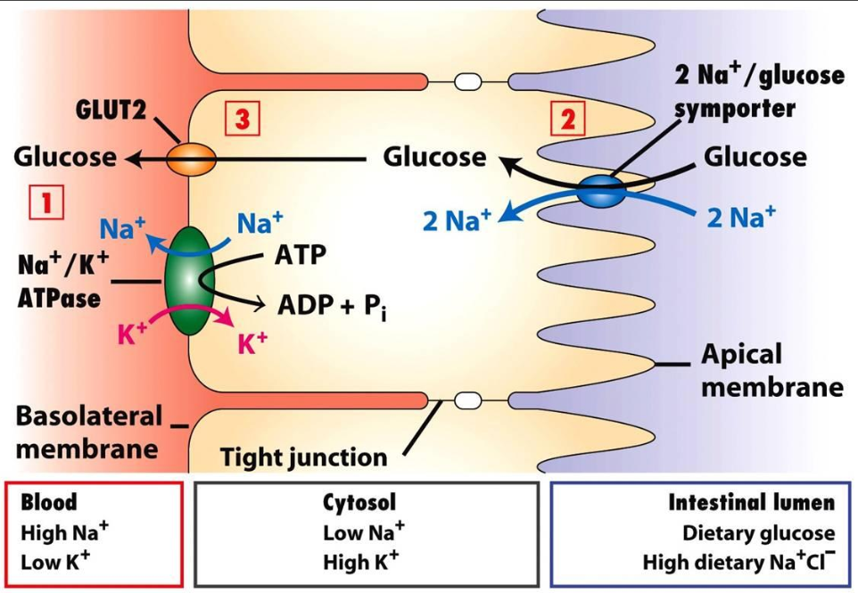

1. Sodium ions are actively transported out of the epithelial cells into the blood by a sodium potassium pump. This maintains a low concentration of sodium ions in the cell.
2. As there is a higher concentration of sodium ions outside the cell (in the lumen of the small intestine) sodium ions diffuse in to the cell down a concentration gradient through a co-transporter carrier protein. As the sodium ions diffuse through this carrier protein glucose (or amino acids) are also drawn in to the cell.
3. Glucose (or amino acids) diffuse out of the epithelial cell into the blood through another carrier protein via facilitated diffusion.

When glucose moves into the epithelial cell it is the sodium ion concentration gradient which powers the movement of glucose (or amino acids) into the cell, not ATP. This is why this is called indirect active transport.

* **Endocytosis**

Endocytosis is the movement of **large materials** in **bulk** **into** a cell

* **Phagocytosis** is the process whereby the cell can obtain **solid particles** which are too big to be absorbed by Diffusion or Active Transport
* The cell membrane **Invaginates** and then **bud off** to form a **Phagosome**. Lysosomes then digest the contents
* **Pincocytosis** is the intake of **Liquids** into the cell and uses the same process as phagocytosis

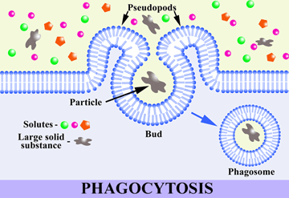

**Exocytosis** [(Exocytosis video)](http://www.linkpublishing.com/video-transport.htm)

* The method of removing/**Secreting** materials from a cell in **Bulk** is called **Exocytosis** (opposite of phagocytosis + pincocytosis), where materials are transported to the membrane in a **Vesicle** (from **Golgi Body**)

