**3.2.4 The Immune system**

1. **Pathogens cause infectious disease:**

A pathogen is an organism that causes disease. The pathogen could be a micro-organism (bacteria, viruses or fungi) or other organisms (tapeworm)

1. **Pathogens enter the body by:**

Nose

Mouth

Break in the skin

Vagina

1. **How pathogens effect the body:**

Damage the gas exchange surface

* Air containing pathogens is breathed in
* Pathogens are trapped in the mucus of the epithelium
* The cilia move the mucus up the trachea to the mouth
* However, some pathogens make it to the alveoli

Damage the skin

* Pathogens enter through a break in the skin
* They enter into the blood stream
* The blood clots at the damage to try and prevent more pathogens entering
* However a few pathogens enter before the blood clot is fully formed

Damage the digestive system

* Food or drink containing pathogens is ingested
* Pathogens are destroyed in the HCl acidic conditions of the stomach
* However, some pathogens make it to the small intestine and invade the cells of the gut wall

1. **What do pathogens do:**

Produce toxins – bacteria release toxins

Damage cells – viruses replicate inside of cells and so they rupture

Ruptures the cells to release nutrients for their own use which starves the cell and so it eventually dies

1. **Line of defence, when a pathogen enters:**

Non-specific 🡪 responds to all micro-organisms 🡪 Physical barrier

🡪 Phagocytosis

Specific 🡪 responds to specific micro-organisms 🡪 B-Lympocytes

T-Lympocytes

1. **Non-specific responses:**

* Skin is composed of dead cells containing the indigestible protein keratin
* Sebum produced by the skin lowers the pH to inhibit growth of pathogens
* Lysozymes in salvia, sweat and tears are anti-bacterial enzymes
* Many ingested bacteria in the stomach are destroyed by acid (HCl)
* A sticky substance, mucus, traps pathogens in the respiratory tract
* Cilia moves away mucus towards the throat to protect gas exchange surfaces

The immune system targets foreign materials and pathogens

Outside Inside

Barrier (eg. Skin) Blood clot Pathogens inside

the body

IMMUNE RESPONSE

Pathogens (eg. Bacteria)

Inflammation Phagocytosis

Lysozymes in salvia, sweat and tears are anti-bacterial enzymes

1. **Immune response**

Body temperature rises – damages pathogenic cells

Inflammation – due to the blood vessels in the affected area become more permeable and so more white blood cells and antibodies can come to the infected area

1. **Recognising your own cells**

It is important that your immune system recognises its own cells to prevent your immune system from destroying its own cells. It needs to distinguish between the body’s own cells (self) and those that are foreign (non-self).

Each type of cell has specific protein molecules on its surface that identify it. The immune system identifies these protein molecules to that it can identify:

* Pathogens – e.g. HIV
* Non-self material – e.g. cells from other organisms of the same species
* Toxins – e.g. those produced by bacteria such as Cholera.
* Abnormal body cells e.g. cancer cells

All the example above have the potential to cause harm so being able to identify these materials is the first step to removing the threat they pose. This does have implications for humans who have tissue or organ transplants. The immune system recognises these as non self even though they have come from individuals of the same species. It therefore attempts to destroy the transplant. This is way is important to match donors and recipients of transplants. The best matches come from individuals who are genetically close (relatives). Immunosuppressant drugs can also be given to reduce the level of immune response.

Specific Lymphocytes are not produced in response to an infection but already exist (10 million different types). As there are so many different types of lymphocyte there is a high probability that when a pathogen enters the body there will be a protein on the surface of a lymphocyte which will be complementary to a protein on a pathogen. As there are so many different types of lymphocytes there are only a few of each type in the body. When an infection occurs, the type of lymphocyte with a protein complementary to the pathogen’s proteins is stimulated to divide to build up its numbers to a level where it can be effective in destroying the pathogen.

1. **How lymphocytes recognise cells belonging to the body**

There are probably around ten million different lymphocytes in the body.

During foetal development these lymphocytes are constantly colliding with other cells and as the fetus develops within the uterus it is protected from most pathogens or foreign materials.

Lymphocytes therefore collide almost exclusively with the body’s own material (self)

Some of the lymphocytes will have proteins on their surface (receptors) which are complementary to the body’s own cells.

These lymphocytes either die or are suppressed

Therefore the only remaining lymphocytes are those that might fit foreign material (non self).

In adults, lymphocytes produced in the bone marrow initially only encounter self- antigens and these lymphocytes undergo programmed cell death (apoptosis) before they differentiate into mature lymphocytes.

**When a pathogen enters the body**

If a pathogen has got through the body’s first lines of defence (physical barriers and lysozymes) then the body’s second line of defence – the white blood cells- are important. There are two main types of white blood cell: **Phagocytes** and **Lymphocytes**.

1. **Phagocytosis**

Type of white blood cell

Found in the blood and in tissues

* Chemical products of pathogens, or dead, damaged and abnormal cells act as attractants causing phagocytes to move towards them – chemotaxis.
* The phagocytic cell has receptors on its cell-surface membrane that’s recognise and attach to chemicals on the surface of the pathogen.
* The phagocytic cell then engulfs the bacterium forming a phagocytic vesicle.
* 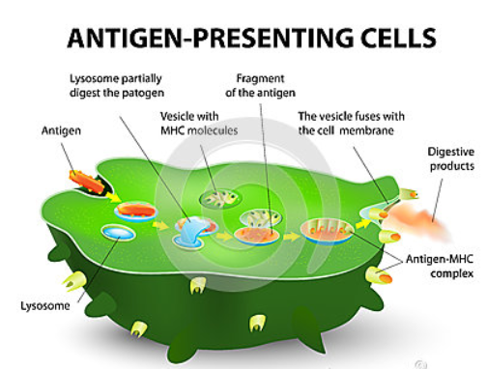A lysosome within the phagocyte fuse with the phagocytic vesicle contents.
* Lysozyme enzymes from the lysosomes digest the bacteria – they are absorbed into the cytoplasm
* The waste products are expelled by exocytosis

The phagocytes present the pathogen’s antigens on the surface to activate other immune systems cells. They are **Antigen presenting cells**.

1. **The specific response:**

* **An Antigen is a molecule that stimulates an immune response**
* Usually proteins (polysaccharides, nucleic acid, lipids can also act as antigens) and other inorganic molecules important for self-recognition
* Self-antigen
  + Only found on the host's own cells and does **not** trigger an immune response
  + As these are proteins, their structure depends on the amino acid sequence
  + The gene for this sequence is highly polymorphic, having several alleles at each loci
  + There is great genetic variability between individuals
  + \ Antigen is different in other people → would cause an immune response
  + There is only 1:4 change that siblings will possess an identical antigen
* Non-self-antigen
  + Found on cells entering the body (e.g. bacteria, viruses, another person's cell)

Phagocytosis is a non-specific response and will occur whatever the infection. The body also has specific responses that react to specific antigens. They are slower in action at first but can provide long-term immunity. This type of response depends on another type of white blood cell called a **lymphocyte**. Lymphocytes are produced by stem cells in the bone marrow. There are two main types of lymphocyte:

T-lymphocytes (T-cells)

Mature in the thymus gland

Cellular response

T-cells have protein receptors on their cell surface which are complementary to antigens

The whole cell attacks the pathogen

T helper cells

Cytotoxic T cells (killer T cells)

Memory cells

B-lymphocytes (B-cells)

Mature in the bone marrow

Humoral immunity

B-cells release antibodies

Antibodies attack the pathogen

1. **The Cellular response**

* T lymphocytes only respond to antigen which are presented on a body cell – an antigen presenting cell. T cells have complementary protein receptors on the surface that bind to the antigens (presented on Antigen presenting cells).

1. **Phagocytes activate T-cells:**

* A pathogen invades the body and is engulfed by a phagocyte
* The phagocyte places antigens from the pathogen on it cell surface membrane
* Receptors on a specific helper T cell (TH) fit exactly onto these antigens
* This attachment activates the T cell to divide rapidly by mitosis and form a clone of genetically identical cells
* The cloned T cells:
  + Develop into memory cells that enable a rapid response to future infections by the same pathogen
  + Stimulate phagocytes
  + Stimulate B cells divide and secrete their antibody
  + 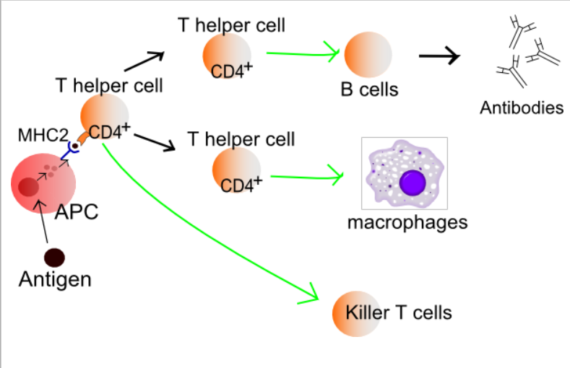Activate cytotoxic T cells (TC cells)

Memory cells which circulate in the blood and tissue fluid in readiness to respond to a future infection by the same pathogen

1. **How cytotoxic T cells kill infected cells**

Cytotoxic T cells kill abnormal cells and infected body cells by attaching to them via their specific protein receptors and then producing a protein called **perforin.** The perforin makes holes in the cell-surface membrane of the infected body cell making the cell membrane of these cells fully permeable to all substances. This causes the cell to die. This type of immune response is particulary useful against viral infections as viruses can only replicate inside cells. The infected body cell is sacrificed to prevent further replication and spread of the virus.

1. **T-cells activate B-cells:**

* A B-cell is another type of white blood cell
* They are covered with antibodies on the surface that bind to the antigens (to form an antigen-antibody complex)
* Each B-cell has a different shaped antibody on its membrane so they all bind with different shaped antigens. Remember B-lymphocytes are not produced in response to an infection but already exist.
* When an antibody on the surface of a B cell attaches to an antigen on the surface of a pathogen the antigen enters the B cell by **endocytosis** and gets presented on its surface (processed).
* TH cells bind to these processed antigens and stimulate the B cell to divide by mitosis forming clones of the original B cell.
* The **cloned B cells** all have antibodies specific to the foreign antigen.
* 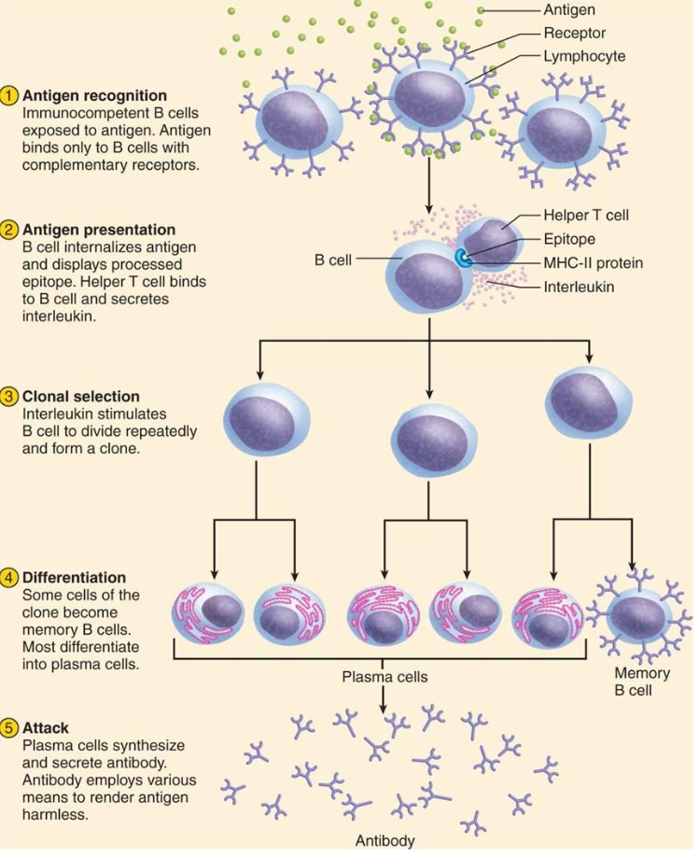This is called clonal selection and accounts for the body’s ability to respond rapidly to any of a vast number of antigens.

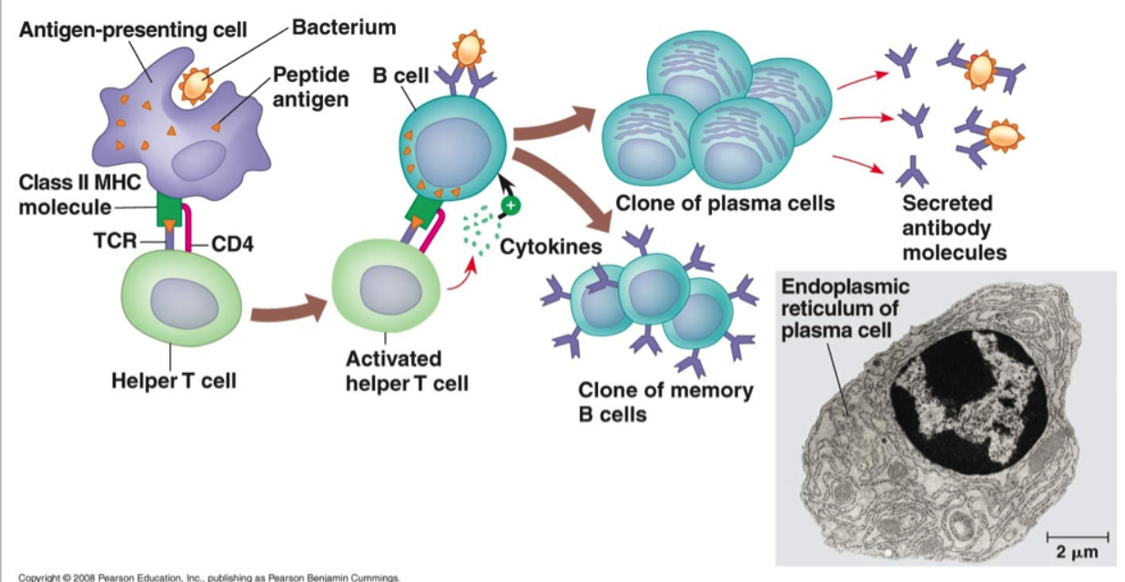

**ANTIGEN**

A protein or carbohydrate that is foreign to the host. Antigens stimulate the production of antibodies

1. **Primary and Secondary response:**

* An antigen enters the body for the first time
* Activates the immune system – primary response
* There aren’t many B-cells so few antibodies can bind to them and so it’s slow
* Eventually the B-cells are replicated into plasma cells and so there are enough antibodies to overcome the infection
  + The T-cells and B-cells produce memory cells. They remain in the body for a long time
  + Memory T-cells remember the specific antigen
  + Memory B-cells remember the specific antibodies
* If the same pathogen enters again the immune system produces a quicker, stronger response – secondary response
  + Memory T-cells divide into the correct type of T-cells to kill the cell carrying the antigen
  + Memory B-cells don’t produce antibodies directly but divide into plasma cells that produce the right antibody to the antigen
* The secondary response removes the pathogen before any symptoms show

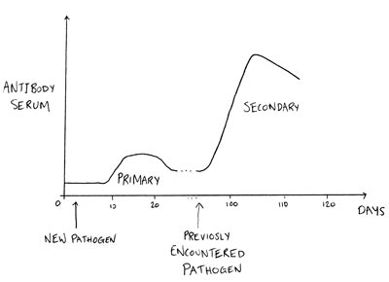

1. **Antibodies**

**ANTIBODY**

A protein made by the host’s B cells in response to a particular antigen.

An antibody is a protein that is made of 4 polypeptide chains of amino acid monomers, linked by peptide bonds. The chains of one pair are long and called **heavy chains**, while the chains of the other pair are short and called **light chains**.

Each antibody is specific due to its variable region – due to the different amino acid sequence. The constant regions are the same in all antibodies.

The antibody binds to a specific antigen to form an **antibody-antigen complex**. The binding site is different on each antibody and is therefore called the variable region.

The rest of the antibody is called the constant region. This binds to receptors on the B cell.

The function of antibodies:

Antibodies do not destroy antigen directly but prepare them for destruction. They do this by:

Causing the cells to agglutinate (clump together). This makes it easier for phagocytes to locate them as they are less spread out.

**Attach to bacterial cells** and act as markers for the phagocytes to engulf the cells.

They bind and neutralise the toxins produced from the pathogen

Antibody + antigen = neutralised pathogen

Plasma cells secrete antibodies that are specific to the antigen

Plasma cells are short-lived

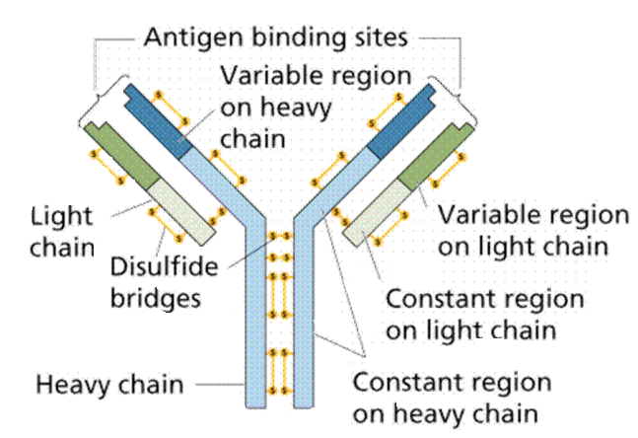

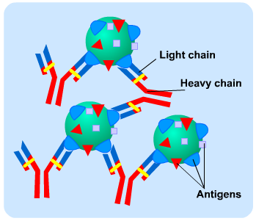

1. **Monoclonal Antibodies**

They are produced from a single group of genetically identical B-cells (plasma cells)

They are very specific (their binding sites have a unique structure that only one antigen will be complementary to)

They will bind to anything – an antigen or another substance as they will target and only bind to this molecule

Monoclonal antibodies can be used in a number of ways:

**Cancer cells**

**Direct monoclonal antibody therapy**

* Different cells in the body have different antigens
* The tumour markers, found on cancer cells, are foreign to the host
* Monoclonal antibodies are made so they will bind to the tumour markers
* They attach to the surface of their cancer cells and block the chemical signals that stimulate uncontrolled growth

**Indirect monoclonal antibody therapy**

* Anti-cancer drugs are attached to the antibodies
* When the antibodies come into contact with the cancer cells they bind, forming an antigen-antibody complex
* The drug accumulates in the body where there are cancer cells
* So there are fewer side effects as they only accumulate near specific cells and less drug can be used
* This is called a Magic bullet.

**Medical diagnosis**

* Monoclonal antibodies can be used to diagnose influenzas, hepatitis and chlamydia infections as well as certain cancers.

1. **Pregnancy testing**

They detect the pregnancy hormone hCG (human chorionic gonadatrophin) in the urine

* An application area contains antibodies for hCG on the blue head
* When the urine is applied to the head, any hCG binds to the antibody on the heads: forming antigen-antibody complexes
* The urine moves up the stick, with the beads
* The test strip contains antibodies to hCG that are immobilised
* I there is hCG the strip turns blue because the immobilised antibodies bind to any hCG.
* If there is no hCG the beads pass through without binding to anything and so don’t turn blue

1. 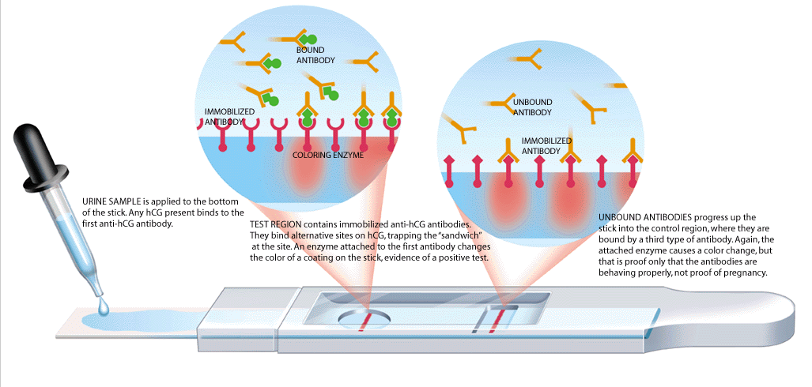**Ethical use of monoclonal antibodies**

* Production of monoclonal antibodies involves the use of mice. They are used to produce both antibodies and tumour cells.
* Monoclonal antibodies have been used to successfully treat a variety of diseases including cancer and diabetes. However, there have been some deaths associated with their use in the treatment of multiple sclerosis. It is therefore important to gain informed consent from the patient before the treatment starts.
* Testing new drugs also presents certain dangers as these need to be tested on volunteers first

1. **Passive and active immunity:**

Passive

Antibodies are ready made

Mother 🡪 child (placenta and milk)

Artificially (injected)

Temporary (they only last until they leave the body)

Active

Individuals make their own antibodies

Long term

A vaccination

Passive immunity can be given by an antiserum that contains particular antibodies (e.g. Snake bites can be treated with an antiera that contains antibodies to neutralise the snake toxin)

It isn’t the same as a vaccine, as vaccines don’t contain antibodies. Antiserum provides instant antibodies to cope.

Antibodies are proteins and should be digested in the baby’s gut – however, it is adapted to absorb the antibodies unchanged

Active Immunity is produced by stimulating the production of antibodies by the individual’s own immune system. Direct contact with the pathogen or its antigen is needed.

**Natural active immunity**

This results from an individual becoming infected with a disease under normal circumstances. The body produces its own antibodies and may continue to do so for many years.

**Artificial active immunity**

This results from immunisation. It involves inducing an immune response in an individual, without them suffering the symptoms of the disease.

1. **Vaccinations:**

* Vaccines contain either a pathogen or one of more of their antigens.
* They stimulate primary response so that when the actual pathogen is encountered, the secondary response is strong enough to prevent the disease developing.

Types of vaccine:

* Live vaccines
  + The pathogens in the vaccine are treated so they only divide a few times, and don’t create the infection
  + Eg. Mumps, rebella
* Dead micro-organisms
  + They don’t cause the disease but contain the antigens to stimulate an immune response
  + Eg. diptheria
* Purified antigens
  + Made by genetic engineering
  + Eg. Hepatitis B

How they work:

* They stimulate B-cells to produce antibodies
* They divide by mitosis to make plasma cells
* More antibodies are therefore made
* The antibodies bind to the antigens and destroy them
* This makes memory cells for secondary response
* Booster vaccines are given later to ensure that memory cells are produced

How they are taken:

* Orally
* Enzymes break down the molecules
* Too large to be absorbed into the blood
* Injected

**HERD IMMUNITY:**

If enough people are vaccinated, those who aren’t will be protected as there are fewer with the disease to come in contact with

To ensure a successful vaccination programme:

* A suitable vaccine must be economically available in sufficient quantities

to immunise most of the vulnerable population.

* There must be few side effects
* Means of producing, storing and transporting the vaccine are necessary.
* There must be means of administering the vaccine properly
* If must be possible to vaccinate the vast majority of the vulnerable population.

1. **Why vaccination may not eliminate a disease**

* Vaccination fails to induce immunity in certain individuals e.g. people with defective immune systems
* Individuals may become infected with the disease immediately after a vaccination before their immunity levels are high enough to prevent it
* **Antigenic Variation:**
* This is when the proteins on its outer coat change due to genetic mutation. As this happens suddenly rather than gradually vaccines will suddenly become ineffective.
* Each new strain of virus has different antigens, so memory cells don’t work.
* Influenza viruses change their antigens frequently so any immunity is not effective and people develop repeated bouts of influenza during their lifetime.
  + There may be so many varieties of a particular pathogen so very difficult to develop a vaccine effective against all of them.
  + Some pathogens can ‘hide’ from the immune system by concealing themselves or living in places which are out of reach e.g. cholera
  + Individuals may have objections to vaccines for religious, ethical or medical reasons. E.g. concerns over the MMR vaccine

1. **Ethical issues:**

* Animal tested
* Animal products used to produce vaccines
* Volunteers are put at risk when they trail vaccines
* People don’t want the side effects and think that they’ll be protected due to herd immunity
* Should vaccination be compulsory to ensure herd immunity achieved?
* Controversy on who gets a vaccination first, during an epidemic
* Should expensive vaccination programmes continue when a disease is almost eradicated?
* How can any individual health risks from vaccination be balanced against the advantages of controlling a disease for the benefit of the population at large?

**The human immunodeficiency virus (HIV)**

The human immunodeficiency virus causes the disease **acquired deficiency syndrome (AIDS).**

1. **Structure of the HIV virus**

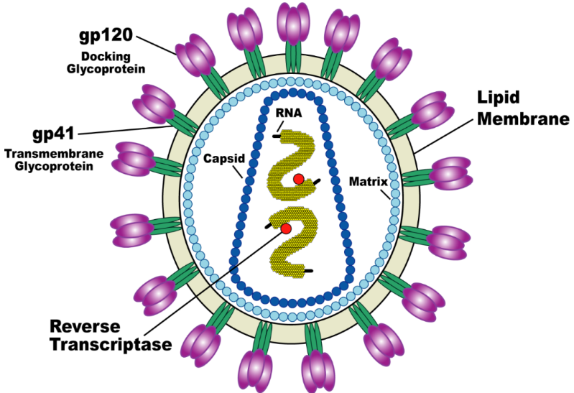

A lipid envelope on the outside of the virus contains peg-like attachment proteins (gp120 and gp41 on diagram above) which allow this virus to attach to a protein called CD4 found on a number of different body cells. HIV most frequently attaches to TH cells.

Inside the lipid envelope is a protein layer called a capsid that encloses two strands of **RNA** and some enzymes. One of these enzymes is **reverse transcriptase** which catalyses the production of DNA from RNA (the reverse of transcription). HIV is a **retrovirus**.

**Replication of HIV**

Like all viruses, HIV cannot replicate itself. It uses genetic material to instruct the host cell’s biochemical mechanism to produce the components required to make new HIV:

* Following infection HIV enters the bloodstream and circulates around the body
* Attachment proteins on the HIV virus readily binds to the CD4 protein on the host cell’s surface membrane, most frequently on TH cells.
* The protein capsid on the virus fuses with the cell-surface membrane. The RNA and enzymes of HIV enter the helper T-Cell.
* The HIV reverse transcriptase convert’s the virus’s RNA into DNA
* The newly made DNA is moved into the helper T-cells nucleus where it is inserted into the cell’s DNA
* The HIV DNA in the nucleus create mRNA using the cell’s enzymes (RNA polymerase). This mRNA contains the instructions for making new viral proteins and the RNA to go in the new HIV virus
* The mRNA leaves the nucleus via the nuclear pores and uses the cell’s cell protein synthesis mechanisms to make HIV particles
* The HIV particles break away from the helper T cell with a piece of its cell surface membrane surrounding them which forms their lipid envelope.

Once infected a person is said to be HIV positive. The HIV virus often goes into dormancy and so only leads to AIDS many years later.

**How HIV causes the symptoms of AIDS**

HIV specifically attacks helper T cells. Over time, HIV can destroy so many of these cells that the body can’t fight off infections and disease. These special cells help the immune system fight off infections. Untreated, HIV reduces the number of CD4 cells (T cells) in the body. This damage to the immune system makes it harder and harder for the body to fight off infections and some other diseases. Without a sufficient number of helper T cells, the immune system cannot stimulate B cells to produce antibodies or cytotoxic T cells to kill cells infected by pathogens. Opportunistic infections or cancers take advantage of a very weak immune system and signal that the person has AIDS.

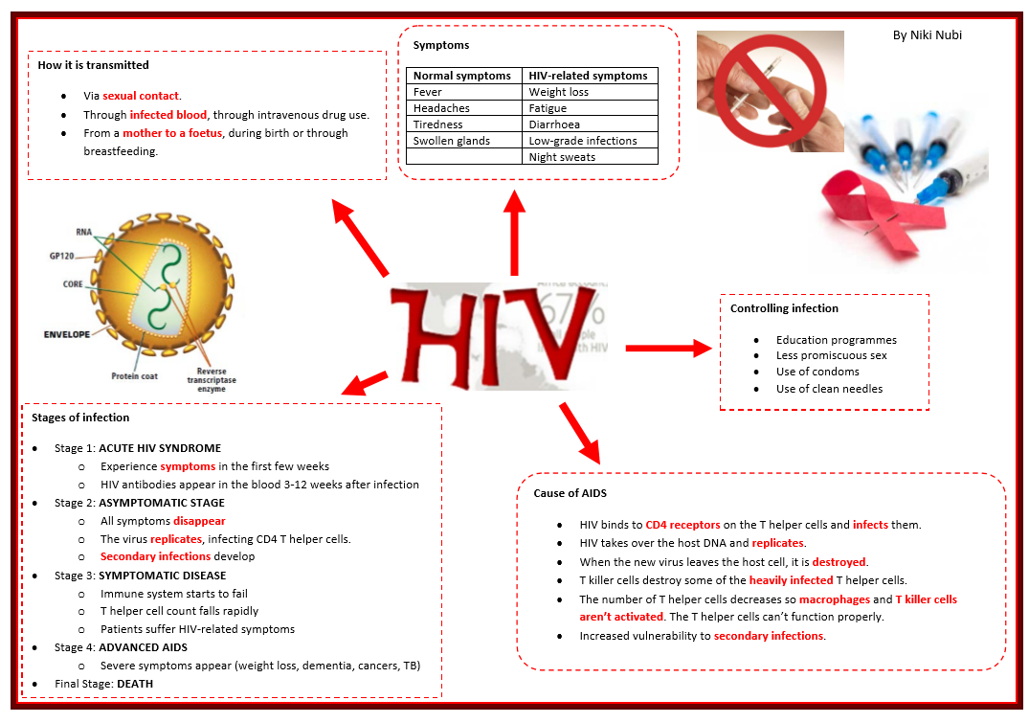Many AIDS sufferers develop infections of the lungs, intestines, brain and eyes, as well as experiencing weight loss and diarrhea. It is these secondary diseases that ultimately cause death.

**The ELISA test**

ELISA stands for **enzyme linked immunosorbent assay**. It uses monoclonal antibodies to detect the presence of a protein in a sample as well as the quantity of the protein in a sample. It is very sensitive so can detect very small amounts of a molecule.

The procedure is as follows:

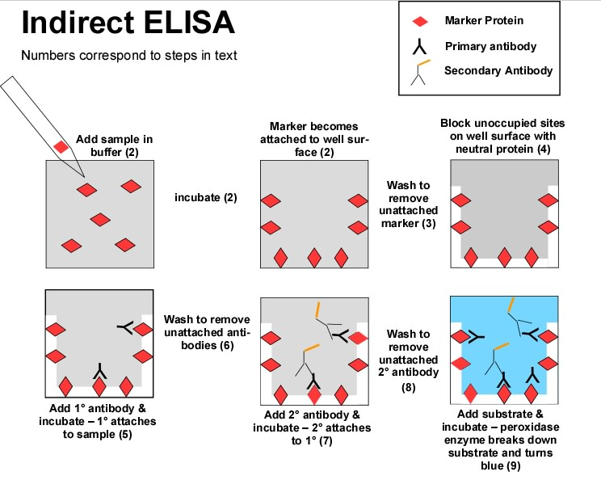

1. The sample is added to a surface (e.g. a slide) to which all the antigens is the sample will attach.
2. The surface is washed to remove any unattached antigens
3. Add the antibody which is specific to the antigen we are trying to detect and leave the two to bind
4. Wash the surface to remove any unattached antibody
5. Add a second antibody with an enzyme attached to it, which binds to the first antibody
6. Add the colourless substrate of the enzyme. The enzyme acts on the substrate to change it into a coloured product
7. The amount of antigen present is relative to the intensity of colour that develops

**Why antibiotics are ineffective against viral diseases like AIDS**

Antibiotics work against bacteria but not viruses so therefore have no effect against viruses.

One way antibiotic work is by preventing bacteria from making cell walls. Cell walls in bacteria are very important as they prevent the bacteria from bursting due to osmosis. Bacterial cell walls are made of **murein (peptidoglycan)** which is tough and not easily stretched. When water enters bacteria by osmosis the cell expands and pushes against the murein cell wall. As this is inelastic the cell wall prevents any further entry of water. Antibiotics such as penicillin prevent the bacteria form forming peptide cross links in bacterial cell walls. This weakens the cell walls making them unable to withstand pressure. As water enters naturally by osmosis the cell bursts and the bacteria dies.

Viruses rely on host cells to carry out their metabolic activities and therefore lack their own metabolic pathways, enzymes and cell structure. As a result antibiotics are ineffective because there are no metabolic pathways, enzymes or cell structures for them to disrupt.