**Practical Skills – Use of a light microscope and drawing cells**

Cell staining is a technique that can be used to better visualize cells and cell components under a microscope. By using different stains, one can preferentially stain certain cell components, such as a nucleus or a cell wall, or the entire cell. Most stains can be used on fixed, or non-living cells, while only some can be used on living cells; some stains can be used on either living or non-living cells.

The purpose of microscope drawing is to show accurately the components of individual cells observed using an optical microscope. The drawing should be detailed but should not show more than two or three cells.

Objectives:

* To develop practical skills **d** and **e** begin to demonstrate **competencies 1a, 3b and 4a**
* To use a microscope
* To draw a plant and animal cell
* To follow written instructions

**Method for staining a plant cell**

**Introduction**

The aim is to obtain a very thin cross-section of plant tissue that is cut completely perpendicular to the length of the specimen and to get this section to lie flat on a microscope slide. The section is either stained or left unstained and mounted in water with a coverslip on top, ready for viewing under a microscope. Once under the microscope you should produce a scientific drawing of a vascular bundle with a scale bar.

**Safety notes**

**Your teacher will provide you with a blade – either a scalpel or razor blade. These are very sharp so that you can obtain very thin sections of plant tissue. Handle these blades with care.**

**Wear eye protection when using the Toluidine blue stain.**

**Instructions**

Cut here

Use this bit

1. Obtain a stick of celery (*Apium graveolens* var *dulce*) about 5cm long.
2. Rest the stem horizontally on a white tile and use a blade to cut one end as perpendicular to the length of the stem as possible.
3. Now use the blade to cut very thin slices of the celery from the edge you’ve just cut.
4. Use forceps to gently lift the slices into a small beaker containing tap water and leave to soak for 2 minutes.
5. Use forceps to gently lift the slices into a watch glass containing toluidine blue and leave the slices in the stain for 1 minute.
6. Use forceps to gently lift the slices back into tap water to rinse off excess stain.
7. Place the slices on a microscope slide. Add a drop of tap water and a coverslip onto each slice.
8. View under the lowest magnification.
9. Find the clearest view that shows a variety of structures within the stem and produce a scientific drawing of what you see. Use the graticule to add a scale bar and work out the magnification of your drawing (see “Box 1: Using a graticule” at the end of these practical instructions).
10. View under a higher magnification and find the clearest view that shows one vascular bundle.
11. Produce a scientific drawing of what you see. Use the graticule to add a scale bar and work out the magnification of your drawing.

**Observations**

**Colours shown in sample after staining with toluidine blue**

|  |  |
| --- | --- |
| **Tissue / type of cell wall** | **Colour** |
| Xylem | Green/Blue-green |
| Phloem | Purple/Red |
| Sclerenchyma | Blue-green/ Green |
| Collenchyma | Purple/Red |
| Parenchyma | Purple/Red |
| Lignified cell walls | Green/Blue-green |
| Unlignified cell walls | Purple/Red |

**Task 1**

* Draw and label one or two cells- Look at the table below to see common errors in drawings.
* Give a title to the drawing
* Measure the diameter of the cell using EPU (eye piece units)
* Calculate magnification

**Method for staining an animal cell**

* Gently scrape the inner side of the cheek using a cotton bud, which will collect some cheek cells.
* Place the cells on a glass slide by rubbing the bud onto the slide.
* Take a few drops of Methylene Blue solution using a dropper and add this to the mixture on the slide.
* After 2-3 minutes remove any water stain from the slide usinghttp://amrita.olabs.co.in/fckeditor/editor/images/spacer.gif a blotting paper.
* Take a clean cover slip and lower it carefully onto the mixture with the aid of a needle.
* Using a needle, press the cover slip gently to spread the epithelial cells.
* Remove any extra liquid around the cover slip using a blotting paper.
* Place this glass slide on the stage of the compound microscope and view it.

**Observations**

* A large number of flat and irregular-shaped cells are observed.
* The cells do not have a cell wall. However, each cell has a thin cell membrane.
* A deeply stained nucleus is observed at the centre of each cell.
* No prominent vacuoles are observed in the cells.

**Task 2**

* Draw and label one or two cells-Look at the table below to see common errors in drawings.
* Give a title to the drawing
* Measure the diameter of the cell using EPU (eye piece units)
* Calculate magnification

[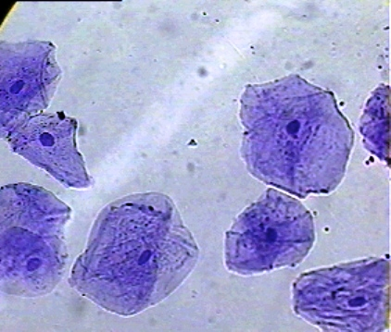](https://www.google.co.uk/url?sa=i&rct=j&q=&esrc=s&frm=1&source=images&cd=&cad=rja&uact=8&ved=0CAcQjRxqFQoTCObni_Kd98gCFUxaFAodeHEDsg&url=https://beautyfromhashes.wordpress.com/lesson-7-cell-ery-no-onions/&bvm=bv.106674449,d.d24&psig=AFQjCNEOIDo8Hv3MIrXSpJWNeOPVpNUvmg&ust=1446742478890986)

**How to measure EPU**

Your microscope is equipped with a scale (called a reticule) that is built into one eyepiece. Look down your microscope and you should be able to see the scale which looks like the following diagram. Each division in the scale equates to one EPU.

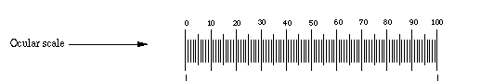

The reticule can be used to measure any dimension in a microscope field since the ocular can be turned in any direction and the object of interest can be repositioned on the stage.

To measure the length of an object note the number of ocular divisions spanned by the object

You need to take two EPU readings. Draw two lines on your drawing that must go through the area you are measuring eg through the centre. Label the lines AB, and CD as shown below. Make a note of your measurement in EPU for each line.

Give the measurement lines a BAR at the end, not a cross.

A

B

C

D

You need to write a key to explain the lines and EPU. Put this at base of page on right hand side. Ensure it is NOT TOO CLOSE to the bottom edge.

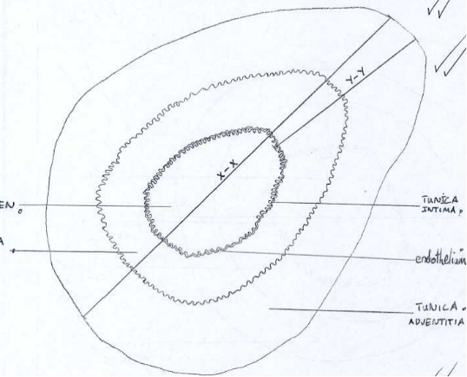 **Key**

A-B = 95 EPU.

C-D = 15 EPU

EPU = eye piece unit

A good drawing

The table shows errors that commonly occur when students begin to practise drawings of biological material. Each would reduce the value of the drawing and result in loss of credit being awarded. Most result from lack of attention or care and are easily solved.

