The Encylopedia of British Football
History of Football

The first description of a football match in England was written by William FitzStephen in about 1170. He records that while visiting London he noticed that "after dinner all the youths of the city goes out into the fields for the very popular game of ball." He points out that every trade had their own football team. "The elders, the fathers, and the men of wealth come on horseback to view the contests of their juniors, and in their fashion sport with the young men; and there seems to be aroused in these elders a stirring of natural heat by viewing so much activity and by participation in the joys of unrestrained youth."
A few centuries later another monk wrote that football was a game "in which young men... propel a huge ball not by throwing it into the air, but by striking and rolling it along the ground, and that not with their hands but with their feet." This chronicler strongly disapproved of the game claiming it was "undignified and worthless" and that it often resulted in "some loss, accident or disadvantage to the players themselves."
One manor record, dated 1280, states: "Henry, son of William de Ellington, while playing at ball at Ulkham on Trinity Sunday with David le Ken and many others, ran against David and received an accidental wound from David's knife of which he died on the following Friday." In 1321, William de Spalding, was in trouble with the law over a game of football: "During the game at ball as he kicked the ball, a lay friend of his, also called William, ran against him and wounded himself on a sheath knife carried by the canon, so severely that he died within six days." There are other recorded cases during this period of footballers dying after falling on their daggers.
Edward II became involved in the debate on football and in 1314 complained about "certain tumults arising from great footballs in the fields of the public, from which many evils may arise." At the time he was trying to raise an army to fight the Scots and was worried about the impact that football was having on the skills of his archers.

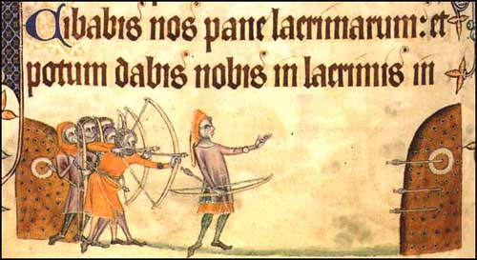
Longbowmen practicing at the butts (Geoffrey Luttrell Psalter, 1325)
In an attempt to make the English the best longbowmen in the world, a law was passed ordering all men earning less than 100 pence a year to own a longbow. Every village had to arrange for a space to be set aside for men to practice using their bows. It was especially important for boys to take up archery at a young age. It was believed that to obtain the necessary rhythm of "laying the body into the bow" the body needed to be young and flexible. It was said that when a young man could hit a squirrel at 100 paces he was ready to join the king's army.
Edward II came to the conclusion that young people were more interested in playing football than practicing archery. His answer to this problem was to ban the playing of the game. His father, Edward III, reintroduced the ban in 1331 in preparation for an invasion of Scotland. Henry IV was the next monarch who tried to stop England's young men from playing football when he issued a new ban in 1388. This was ineffective and in 1410 his government imposed a fine of 20s and six days' imprisonment on those caught playing football. In 1414, his son, Henry V, introduced a further proclamation ordering men to practise archery rather than football. The following year Henry's archers played an important role in the defeat of the French at Agincourt.
Edward IV was another strong opponent of football. In 1477 he passed a law that stipulated that "no person shall practise any unlawful games such as dice, quoits, football and such games, but that every strong and able-bodied person shall practise with bow for the reason that the national defence depends upon such bowmen." Henry VII outlawed football in 1496 and his son, Henry VIII, introduced a series of laws against the playing of the game in public places.
Whereas the monarchy objected for military reasons, church leaders were more concerned about the game being played on a Sunday. In 1531 the Puritan preacher, Thomas Eliot, argued that football caused "beastly fury and extreme violence". In 1572 the Bishop of Rochester demanded a new campaign to suppress this "evil game". In his book, Anatomy of Abuses (1583) Philip Stubbs argued that "football playing and other devilish pastimes.. withdraweth us from godliness, either upon the Sabbath or any other day." Stubbs was also concerned about the injuries that were taking place: "sometimes their necks are broken, sometimes their backs, sometimes their legs, sometimes their arms, sometimes one part is thrust out of joint, sometimes the noses gush out with blood... Football encourages envy and hatred... sometimes fighting, murder and a great loss of blood."
The records show that young men refused to accept the banning of football. In 1589, Hugh Case and William Shurlock were fined 2s for playing football in St. Werburgh's cemetery during the vicar's sermon. Ten years later a group of men in a village in Essex were fined for playing football on a Sunday. Other prosecutions took place in Richmond, Bedford, Thirsk and Guisborough.
Local councils also banned the playing of football. However, young men continued to ignore local by-laws. In 1576 it was recorded in Ruislip that around a hundred people "assembled themselves unlawfully and played a certain unlawful game, called football". In Manchester in 1608 "a company of lewd and disordered persons... broke many men's windows" during an "unlawful" game of football. It was such a major problem that in 1618 the local council appointed special "football officers" to police these laws.
After the execution of Charles I in 1649 the new ruler, Oliver Cromwell, instructed his Major-Generals to enforce laws against football, bear-baiting, cock-fighting, horse-racing and wrestling. Cromwell was more successful than previous rulers in stopping young men from playing football. However, after his death in 1660 the game gradually re-emerged in Britain.
The ball used in football was made from an inflated animal bladder. Two teams, made up of large numbers of young men, attempted to get the ball into the opposition goal. In towns the game was mainly played by craft apprentices. As James Walvin points out in The People's Game (1994): "Overworked, exploited and generally harbouring a range of grievances, they formed a frequently disaffected body of young men, living close to each other... They posed a regular threat of unruliness and not surprisingly, they were readily recruited for football."

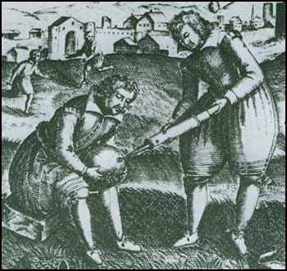
A 17th print showing the inflation of an animal bladder.

According to George Owen (c. 1550) in Wales football was slightly different from the game played in England: "There is a round ball prepared... so that a man may hold it in his hand... The ball is made of wood and boiled in tallow to make it slippery and hard to hold... The ball is called a knappan, and one of the company hurls it into the air... He that gets the ball hurls it towards the goal... the knappan is tossed backwards and forwards... It is a strange sight to see a thousand or fifteen hundred men chasing after the knappan... The gamesters return home from this play with broken heads, black faces, bruised bodies and lame legs... Yet they laugh and joke and tell stories about how they broke their heads... without grudge or hatred."
The gap between the two goals in football games could be several miles. For example, in Ashbourne, Derbyshire, a football game was played annually on Shrove Tuesday. It involved two teams consisting of anyone who lived in the town and the action took place between goals three miles apart.
In 1772 a game in Hitchen resulted in the ball being "drowned for a time in the Priory pond, then forced along Angel Street across the Market Place into the Artichoke beer-house, and finally goaled in the porch of St Mary's Church".
Large football games often took place on Shrove Tuesday. In 1796 it was reported that in Derby, John Snape was "an unfortunate victim to this custom... which is disgraceful to humanity and civilization, subversive of good order and government and destructive to the morals, properties, and lives of our inhabitants."
In the 18th century football was played by most of Britain's leading public schools. There is documentary evidence that football was played at Eton as early as 1747. Westminster started two years later. Harrow, Shrewsbury, Winchester and Charterhouse had all taken up football by the 1750s.

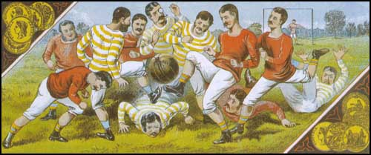
An early game of football.

Thomas Arnold was appointed headmaster of Rugby in 1828. He had a profound and lasting effect on the development of public school education in England. Arnold introduced mathematics, modern history and modern languages and instituted the form system and introduced the prefect system to keep discipline. He modernized the teaching of Classics by directing attention to literary, moral or historical questions. Although Arnold held strong views, he made it clear to his students they were not expected to accept those views, but to examine the evidence and to think for themselves.
Arnold also emphasized the importance of sport in young men's education. Like most headteachers in public schools, Arnold believed that sport was a good method for "encouraging senior boys to exercise responsible authority on behalf of the staff". He also argued that games like football provided a "formidable vehicle for character building".
Each school had its own set of rules and style of game. In some schools the ball could be caught, if kicked below the hand or knee. If the ball was caught near the opposing goal, the catcher had the opportunity of scoring, by carrying it through the goal in three standing jumps.

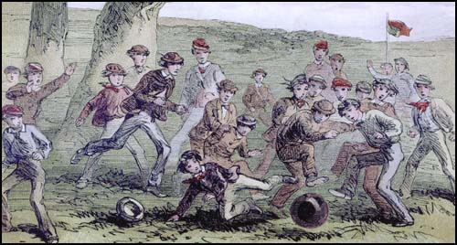
Illustration of a public schools game of football in the 1860s.

Rugby, Marlborough and Cheltenham developed games that used both hands and feet. The football played at Shrewsbury and Winchester placed an emphasis on kicking and running with the ball (dribbling). School facilities also influenced the rules of these games. Students at Charterhouse played football within the cloisters of the old Carthusian monastery. As space was limited the players depended on dribbling skills. Whereas schools like Eton and Harrow had such large playing fields available that they developed a game that involved kicking the ball long distances.
According to one student at Westminster, the football played at his school was very rough and involved a great deal of physical violence: "When running... the enemy tripped, shinned, charged with the shoulder, got down and sat upon you... in fact did anything short of murder to get the ball from you."
Football games often led to social disorder. As Dave Russell pointed out in Football and the English (1997), football had a "habit of bringing the younger element of the lower orders into public spaces in large numbers were increasingly seen as inappropriate and, indeed, positively dangerous in an age of mass political radicalism and subsequent fear for public order."
Action was taken to stop men playing football in the street. The 1835 Highways Act provided for a fine of 40s for playing "football or any other game on any part of the said highways, to the annoyance of any passenger."
In 1840 soldiers had to be used to stop men playing football in Richmond. Six years later the Riot Act had to be read in Derby and a troop of cavalry was used to disperse the players. There were also serious football disturbances in East Molesey, Hampton and Kingston-upon-Thames.
Although the government disapproved of the working-classes playing football, it continued to be a popular sport in public schools. In 1848 a meeting took place at Cambridge University to lay down the rules of football. As Philip Gibbons points out in Association Football in Victorian England (2001): "The varying rules of the game meant that the public schools were unable to compete against each other." Teachers representing Shrewsbury, Eton, Harrow, Rugby, Marlborough and Westminster, produced what became known as the Cambridge Rules. One participant explained what happened: "I cleared the tables and provided pens and paper... Every man brought a copy of his school rules, or knew them by heart, and our progress in framing new rules was slow."
It was eventually decided that goals would be awarded for balls kicked between the flag posts (uprights) and under the string (crossbar). All players were allowed to catch the ball direct from the foot, provided the catcher kicked it immediately. However, they were forbidden to catch the ball and run with it. Only the goalkeeper was allowed to hold the ball. He could also punch it from anywhere in his own half. Goal kicks and throw-ins took place when the ball went out of play. It was specified that throw-ins were taken with one hand only. It was also decided that players in the same team should wear the same colour cap (red and dark blue).

  Guide to Football Grounds | 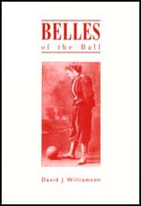  Belles of the Ball

Sometimes public schools played football against boys from the local town. Although these games often ended in fights, it did help to spread knowledge of Cambridge Rules football. Former public school boys also played football at university. Many continued to play after finishing their education. Some joined clubs like the Old Etonians, Old Harrovians and the Wanderers (a side only open to men who had attended the leading public schools), whereas others formed their own clubs.
Football was a very popular sport in Sheffield and in 1857 a group of men established the Sheffield Football Club at Bramall Lane. It is believed to be the first football club in the world. Two former Harrow students, Nathaniel Creswick and William Prest, published their own set of rules for football. These new rules allowed for more physical contact than those established by some of the public schools. Players were allowed to push opponents off the ball with their hands. It was also within the rules to shoulder charge players, with or without the ball. If a goalkeeper caught the ball, he could be barged over the line. At first the Sheffield Club played friendly games against teams in London and Nottingham.
In 1862 a new set of rules were established at Cambridge University. These specified 11-a-side, an umpire from each side plus a neutral referee, goals 12ft across and up to 20ft high. An offside rule was added. A man could play a ball passed to him from behind, so long as there were three opponents between him and the goal. It was also decided that each game should only last one hour and a quarter. The first game under these rules took place between the Old Etonians and Old Harrovians in November, 1862.

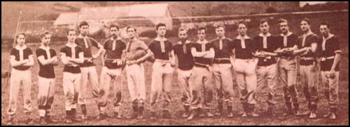
A photograph of the Uppingham team. At that time the team played 15-a-side.

Some public schools refused to accept the Cambridge Rules. At Uppingham School in Rutland, the students played with an enormously wide goal. In 1862, one of the teachers at Uppingham, John Charles Thring, published his own set of rules:
1. A goal is scored whenever the ball is forced through the goal and under the bar, except it be thrown by hand.
2. Hands may be used only to stop a ball and place it on the ground before the feet.
3. Kicks must be aimed only at the ball.
4. A player may not kick the ball whilst in the air.
5. No tripping up or heel kicking allowed.
6. Whenever a ball is kicked beyond the side flags, it must be returned by the player who kicked it, from the spot it passed the flag line, in a straight line towards the middle of the ground.
7. When a ball is kicked behind the line of goal, it shall be kicked off from that line by one of the side whose goal it is.
8. No player may stand within six paces of the kicker when he is kicking off.
9. A player is ‘out of play’ immediately he is in front of the ball and must return behind the ball as soon as possible. If the ball is kicked by his own side past a player, he may not touch or kick it, or advance, until one of the other side has first kicked it, or one of his own side has been able to kick it on a level with, or in front of him.
10. No charging allowed when a player is ‘out of play’; that is, immediately the ball is behind him.
Thring published his rules under the title, The Simplest Game. Some teachers liked this non-violent approach and several schools adopted Thring's rules.
The Football Association was established in October, 1863. The aim of the FA was to establish a single unifying code for football. The first meeting took place at the Freeman's Tavern in London. The clubs represented at the meeting included Barnes, Blackheath, Perceval House, Kensington School, the War Office, Crystal Palace, Forest (later known as the Wanderers), the Crusaders and No Names of Kilburn. Charterhouse also sent an observer to the meeting.
Percy Young, has pointed out, that the FA was a group of men from the upper echelons of British society: "Men of prejudice, seeing themselves as patricians, heirs to the doctrine of leadership and so law-givers by at least semi-divine right."
Ebenezer Cobb Morley was elected as the secretary of the FA. At a meeting on 24th November, 1863, Morley presented a draft set of 23 rules. These were based on an amalgamation of rules played by public schools, universities and football clubs. This included provision for running with the ball in the hands if a catch had been taken "on the full" or on the first bounce. Players were allowed to "hack the front of the leg" of the opponent when they were running with the ball. Two of the proposed rules caused heated debate:
IX. A player shall be entitled to run with the ball towards his adversaries' goal if he makes a fair catch, or catches the ball on the first bound; but in case of a fair catch, if he makes his mark (to take a free kick) he shall not run.
X. If any player shall run with the ball towards his adversaries' goal, any player on the opposite side shall be at liberty to charge, hold, trip or hack him, or to wrest the ball from him, but no player shall be held and hacked at the same time.
Some members objected to these two rules as they considered them to be "uncivilised". Others believed that charging, hacking and tripping were important ingredients of the game. One supporter of hacking argued that without it "you will do away with the courage and pluck of the game, and it will be bound to bring over a lot of Frenchmen who would beat you with a week's practice." The main defender of hacking was F. W. Campbell, the representative from Blackheath, who considered this aspect of the game was vital in developing "masculine toughness". Campbell added that "hacking is the true football" and he resigned from the FA when the vote went against him (13-4). He later helped to form the rival Rugby Football Union. On 8th December, 1863, the FA published the Laws of Football.
1. The maximum length of the ground shall be 200 yards, the maximum breadth shall be 100 yards, the length and breadth shall be marked off with flags; and the goal shall be defined by two upright posts, eight yards apart, without any tape or bar across them.
2. A toss for goals shall take place, and the game shall be commenced by a place kick from the centre of the ground by the side losing the toss for goals; the other side shall not approach within 10 yards of the ball until it is kicked off.
3. After a goal is won, the losing side shall be entitled to kick off, and the two sides shall change goals after each goal is won.
4. A goal shall be won when the ball passes between the goal-posts or over the space between the goal-posts (at whatever height), not being thrown, knocked on, or carried.
5. When the ball is in touch, the first player who touches it shall throw it from the point on the boundary line where it left the ground in a direction at right angles with the boundary line, and the ball shall not be in play until it has touched the ground.
6. When a player has kicked the ball, any one of the same side who is nearer to the opponent's goal line is out of play, and may not touch the ball himself, nor in any way whatever prevent any other player from doing so, until he is in play; but no player is out of play when the ball is kicked off from behind the goal line.
7. In case the ball goes behind the goal line, if a player on the side to whom the goal belongs first touches the ball, one of his side shall he entitled to a free kick from the goal line at the point opposite the place where the ball shall be touched. If a player of the opposite side first touches the ball, one of his side shall be entitled to a free kick at the goal only from a point 15 yards outside the goal line, opposite the place where the ball is touched, the opposing side standing within their goal line until he has had his kick.
8. If a player makes a fair catch, he shall be entitled to a free kick, providing he claims it by making a mark with his heel at once; and in order to take such kick he may go back as far as he pleases, and no player on the opposite side shall advance beyond his mark until he has kicked.
9. No player shall run with the ball.
10. Neither tripping nor hacking shall be allowed, and no player shall use his hands to hold or push his adversary.
11. A player shall not be allowed to throw the ball or pass it to another with his hands.
12. No player shall be allowed to take the ball from the ground with his hands under any pretence whatever while it is in play.
13. No player shall be allowed to wear projecting nails, iron plates, or gutta-percha on the soles or heels of his boots.
In 1866 the offside rule was altered to allow a player to be onside when three of opposing team are nearer their own goal-line. Three years later the kick-out rule was altered and goal-kicks were introduced.

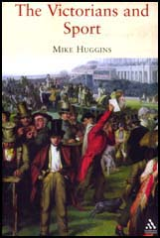  The Victorians and Sport | Football and the English

In 1871, Charles W. Alcock, the Secretary of the Football Association, announced the introduction of the Football Association Challenge Cup. It was the first knockout competition of its type in the world. Only 12 clubs took part in the competition: Wanderers, Royal Engineers, Hitchin, Queens Park, Barnes, Civil Service, Crystal Palace, Hampstead Heathens, Great Marlow, Upton Park, Maidenhead and Clapham Rovers.
Many clubs did not enter for financial reasons. All ties had to be played in London. Clubs based in places such as Nottingham and Sheffield found it difficult to find the money to travel to the capital. Each club also had to contribute one guinea towards the cost of the £20 silver trophy.
The Wanderers won the 1872 final. They also won it the following season with with Arthur Kinnaird getting one of the goals. Other winners of the competition included Oxford University (1874), Royal Engineers (1875), Old Etonians (1879 and 1882) and Old Carthusians (1881).
Charles W. Alcock, the Secretary of the Football Association, was the dominant figure in the early days of the game. As he pointed out: "What was ten or fifteen years ago the recreation of a few has now become the pursuit of thousands. An athletic exercise carried on under a strict system and in many cases by an enforced term of training, almost magnified into a profession."
According to Frederick Wall, the Royal Engineers pioneered the passing game at a time when most clubs placed an emphasis on the long-ball or dribbling. To popularize football, the club toured the industrial areas of England. This included playing games in Derby, Nottingham and Sheffield.
The 1870s saw several changes to Football Association rules. In 1870 eleven-a-side games were introduced with the addition of a goalkeeper. In 1872 the FA published an updated set of laws. This made it clear that "a goal shall be won when the ball passes between the goal posts under the tape, not being thrown, knocked on, or carried." The new rules clearly distinguished between goalkeepers and other players: "A player shall not throw the ball nor pass it to another except in the case of the goalkeeper, who shall be allowed to use his hands for the protection of his goal... No player shall carry or knock on the ball; nor shall any player handle the ball under any pretence whatever."

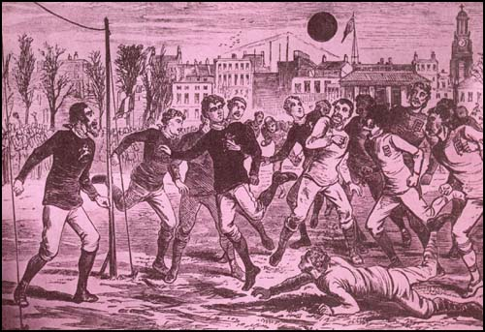
England against Scotland in 1877. Note the lack of crossbars and nets.

1871 also saw the introduction of umpires and a neutral referee. Both sides were allowed to appoint an umpire to whom players could appeal to about incidents that took place on the pitch. However, the FA rule now stated: "Any point on which the umpires cannot agree shall be decided by the referee".
The FA Cup helped to popularize the game of football. Up until this competition only fifty clubs were members of the Football Association and played by their rules. This included teams who played as far away as Lincoln, Oxford and York. The main rival to the FA was the 26-member Sheffield Association. Other football clubs were totally independent and played by their own set of rules. In 1877 the clubs in Sheffield decided to join the FA and by 1881 its membership had risen to 128.

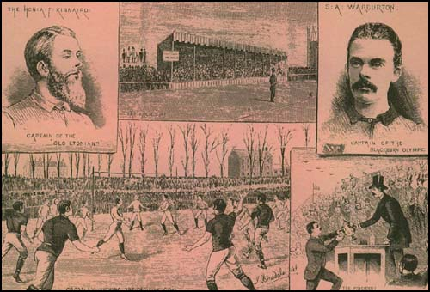
Blackburn Olympic defeating Old Etonians 2-1 in the 1883 FA Cup Final.

The FA continued to adapt the rules of the game. In 1882 all clubs had to provide crossbars. Ten years later goal nets became compulsory. This reduced the number of disputes as to whether the ball had crossed the goal-line or passed between the posts.

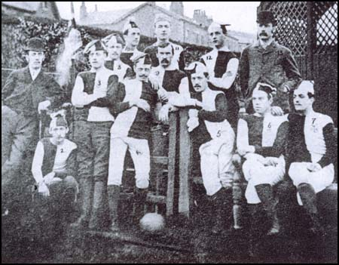
Blackburn Olympic beat Old Etonians 2-1 in the 1883 FA Cup Final.

In January, 1884, Preston North End played the London side, Upton Park, in the FA Cup. After the game Upton Park complained to the Football Association that Preston was a professional, rather than an amateur team. Major William Sudell, the secretary/manager of Preston North End admitted that his players were being paid but argued that this was common practice and did not breach regulations. However, the FA disagreed and expelled them from the competition.
It was well-known that Sudell improved the quality of the team by importing top players from other areas. This included several players from Scotland. As well as paying them money for playing for the team, Sudell also found them highly paid work in Preston.
Preston North End now joined forces with other clubs who were paying their players, such as Aston Villa and Sunderland. In October, 1884, these clubs threatened to form a break-away British Football Association. The Football Association responded by establishing a sub-committee, which included William Sudell, to look into this issue. On 20th July, 1885, the FA announced that it was "in the interests of Association Football, to legalise the employment of professional football players, but only under certain restrictions". Clubs were allowed to pay players provided that they had either been born or had lived for two years within a six-mile radius of the ground.
Blackburn Rovers immediately registered as a professional club. Their accounts show that they spent a total of £615 on the payment of wages during the 1885-86 season. It was revealed that top players such as James Forrest and Joseph Lofthouse were being paid £1 a week.
The decision to pay players increased club's wage bills. It was therefore necessary to arrange more matches that could be played in front of large crowds. On 2nd March, 1888, William McGregor circulated a letter to Aston Villa, Blackburn Rovers, Bolton Wanderers, Preston North End, and West Bromwich Albion suggesting that "ten or twelve of the most prominent clubs in England combine to arrange home and away fixtures each season."
John J. Bentley of Bolton Wanderers and Tom Mitchell of Blackburn Rovers responded very positively to the suggestion. They suggested that other clubs should be invited to the meeting being held on 23rd March, 1888. This included Accrington, Burnley, Derby County, Notts County, Stoke, Wolverhampton Wanderers, Old Carthusians, and Everton should be invited to the meeting.

  Who's Who of Preston North End |   Who's Who of Aston Villa

The following month the Football League was formed. It consisted of six clubs from Lancashire (Preston North End, Accrington, Blackburn Rovers, Burnley, Bolton Wanderers and Everton) and six from the Midlands (Aston Villa, Derby County, Notts County, Stoke, West Bromwich Albion and Wolverhampton Wanderers). The main reason Sunderland was excluded was because the other clubs in the league objected to the costs of travelling to the North-East. McGregor also wanted to restrict the league to twelve clubs. Therefore, the applications of Sheffield Wednesday, Nottingham Forest, Darwen and Bootle were rejected.
The first season of the Football League began in September, 1888. Preston North End won the first championship that year without losing a single match and acquired the name the "Invincibles". Eighteen wins and four draws gave them a 11 point lead at the top of the table. The top goal scorers were John Goodall (21), Jimmy Ross (18), Fred Dewhurst (12) and John Gordon (10).
Major William Sudell, had persuaded some of the best players in England, Scotland and Wales to join Preston: John Goodall, Jimmy Ross, Nick Ross, David Russell, John Gordon, John Graham, Robert Mills-Roberts, James Trainer, Samuel Thompson and George Drummond. He also recruited some outstanding local players, including Bob Holmes, Robert Howarth and Fred Dewhurst. As well as paying them money for playing for the team, Sudell also found them highly paid work in Preston.

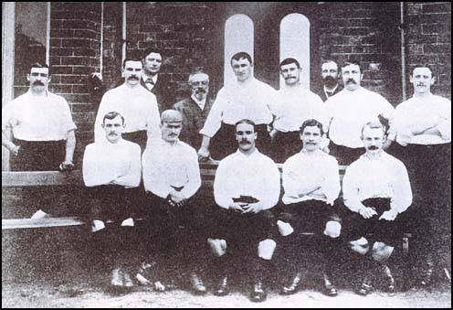
The Preston North End team that won the Football League title in 1888-89: George Drummond,
Bob Holmes, Robert Howarth, William Sudell, John Graham and Robert Mills-Roberts are in the
back row. John Gordon, Jimmy Ross, John Goodall, Fred Dewhurst and Samuel Thompson
are sitting on the bench.

Preston North End also beat Wolverhampton Wanderers 3-0 to win the 1889 FA Cup Final. Preston won the competition without conceding a single goal. The club also won the league the following season. However, other teams began to employ the same tactics as Major William Sudell. Clubs like Derby County, Everton, Sunderland, Aston Villa, and Wolverhampton Wanderers had more money at their disposal and could pay higher wages than Preston. Over the next couple of years Preston lost all their best players and they were never to win the league title again.
Preston North End also won the league the following season. This time it was much closer as they only beat Everton by one point. James Trainer, John Gordon and David Russell appeared in all 22 league games and Jimmy Ross and George Drummond only missed one game.
It was the last time that Preston was to win the Football League. They finished second to Everton (1890-91) and Sunderland (1892-93) but after that they ceased to become a major force in the game. Preston's top players were persuaded to sign for other clubs: John Goodall (Derby County), Jimmy Ross (Liverpool), Nick Ross (Everton), David Russell (Nottingham Forest), Samuel Thompson (Wolverhampton Wanderers), whereas Bob Holmes, George Drummond, Robert Mills-Roberts, James Trainer and John Graham retired from full-time professional football.
In the 1880s football was introduced into most state schools. It could be played on any hard surface and that was especially attractive to those schools that did not have access to playing fields. As a high percentage of the children were physically underdeveloped and undernourished, soccer was considered to be more suitable than rugby.
The game was encouraged by the ruling class. In 1881 Sir William Wynne, MP for Denbighshire, argued: "Much has been said of the British spending their time on drinking... These kinds of sports... keep young men from wasting their time... after playing a good game of football... young men are more glad to go to bed then visiting the public house."
In 1888 it was reported that Nick Ross was receiving £10 a month after he was transferred from Preston North End to Everton. It is estimated that this was nearly twice that of most top players. By the early 1890s leading clubs such as Aston Villa, Newcastle United and Sunderland were paying their best players £5 a week.
In September, 1893, Derby County proposed that the Football League should impose a maximum wage of £4 a week. At the time, most players were only part-time professionals and still had other jobs. These players did not receive as much as £4 a week and therefore the matter did not greatly concern them. However, a minority of players, were so good they were able to obtain as much as £10 a week. This proposal posed a serious threat to their income.
The role of the referee changed in 1891. He moved onto the pitch from the touchline and took complete control of the game. The umpires now became linesmen. 1891 also saw the introduction of the penalty kick. As Dave Russell has pointed out in Football and the English (1997) that this new rule "bitterly upset many amateurs, who argued that the new legislation assumed that footballers could be capable of cheating."

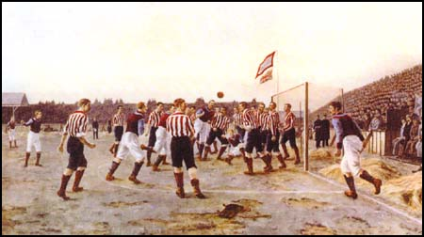
Painting by Thomas Henry of the Sunderland v Aston Villa game played in April 1895.

The shoulder charge was still an important part of the game. This could be used against players even if they did not have the ball. If a goalkeeper caught the ball, he could be barged over the line. As a result, goalkeepers tended to punch the ball a great deal. Until 1892 keepers could be challenged even when they were not holding the ball.
A report published by The Lancet on 24th March 1894 pointed out the dangers of playing football. The doctor who wrote the article warned about the practice of charging a man trying to head a football: "To smash cruelly into him and knock him over unnecessarily and perhaps savagely is clearly a brutality and perhaps savagely is clearly a brutality which is permitted by the rules."
On 23rd November 1896, Joseph Powell of Arsenal went to kick a high ball during a game against Kettering Town. His foot caught on the shoulder of an opponent and Powell fell and broke his arm. One of the men who went to his aid fainted at the sight of the protruding bone. Infection set in and, despite amputation above the elbow, Powell died a few days later when just twenty-six years of age.
The Lancet continued to record details of these incidents and in an article published on 22nd April 1899 that over the last eight years around 96 men had died while playing football and rugby.
In the 19th century it cost 6d to watch a Football League match. This was expensive when you compare this with the price of other forms of entertainment. It usually cost only 3d to visit the musical hall or the cinema. It has to be remembered that at this time skilled tradesmen usually received less than £2 a week.
As Dave Russell points out in Football and the English: A Social History of Association Football in England (1997): "In terms of social class, crowds at Football League matches were predominantly drawn from the skilled working and lower-middle classes... Social groups below that level were largely excluded by the admission price." Russell adds "the Football League, quite possibly in a deliberate attempt to limit the access of poorer (and this supposedly "rowdier") supporters, raised the minimum adult male admission price to 6d".
Men also had the problem of having to work on a Saturday. Although some trades granted their workers a half-day holiday, it did not give them much time to travel very far to see a game. Even a local game caused considerable problems. For example, West Ham United played Brentford in an important game at the end of the 1897-98 season. A local newspaper reported that because of the inadequate transport system supporters had to travel by boat from Ironworks Wharf along the Thames to Kew before catching a train to Brentford. Given these transport problems, it is no surprise that the game was watched by only 3,000 people.
In September, 1898, the South Essex Gazette reported that in a game against Brentford, two West Ham United players, George Gresham and Sam Hay, "bundled the goalkeeper into the net whilst he had the ball in his hands". The goal stood because this action was within the rules at the time.

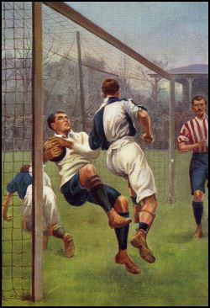
Goalkeeper being legally barged over the
goal line in a game in 1904.

Law 8 of the Football Association stated: "The goalkeeper may, within his own half of the field of play, use his hands, but shall not carry the ball." Leigh Roose, who began playing for Aberystwyth Town in the North Wales Combination League, in 1894, developed a strategy that was within the law but greatly increased the effectiveness of the goalkeeper. Roose began to bounce the ball up to the half-way line before launching an attack with a long kick or a good throw. As Spencer Vignes points out in his book on Roose: "This was perfectly within the letter of the law, though few goalkeepers risked doing it for fear of either leaving their goal unattended or being streamrollered by a centre-forward. It became a highly effective, direct way of launching attacks and Leigh used it to his side's advantage whenever possible."
Leigh Roose, who went on to play for Stoke City, Everton, Sunderland, Celtic, Huddersfield Town, Aston Villa and Arsenal, influenced a whole generation of goalkeepers. For example, Tommy Moore, who played for West Ham United, between 1898 to 1901, often moved up field and started an attack by punching the ball into the opposition half. In a game against Chesham, the game was so one-sided that Moore spent most of the game on the offensive. As the local newspaper reported: "Moore had so little to do that he often left his goal unprotected and played up with the forwards."
It was the railways that eventually provided cheap and fast travel for football supporters. Over 114,000 people watched Tottenham Hotspur play Sheffield United in the 1901 FA Cup. It has been estimated that a large percentage of the crowd travelled to Crystal Palace Stadium via the London & Brighton Railway and Great Northern Railway.

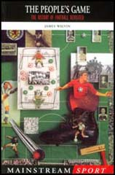  The People's Game | 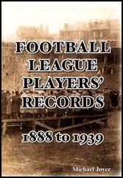  Football League Players' Records

When Chelsea was formed in 1905 it chose Stamford Bridge as its home as it was close to Waltham Green station (now Fulham Broadway). Tottenham Hotspur benefited from its closeness to White Hart Lane railway station. It has been argued that "10,000 spectators could be easily handled by trains arriving every five minutes".
In 1906 a railway station at Ashton Gate was opened to enable people to travel to the Bristol City ground. Manchester United moved to Old Trafford in 1909 to take advantage of the railway network established for the nearby cricket ground. One of the main reasons Arsenal moved to Highbury was because it was served by the London Underground station at Gillespie Road (later renamed Arsenal).
Most experts consider Leigh Roose as the best goalkeeper during the period leading up to the First World War. Frederick Wall, the Secretary of the Football Association described Roose as "a sensation... a clever man who had what is sometimes described as the eccentricity of genius. His daring was seen in the goal, where he was often taking risks and emerging triumphant." Rouse was an entertainer, who carried out pranks to get laughs. This included sitting on the crossbar at half-time.
The Bristol Times reported that: "Few men exhibit their personality so vividly in their play as L. R. Roose.... He rarely stands listlessly by the goalpost even when the ball is at the other end of the enclosure, but is ever following the play keenly and closely. Directly his charge is threatened, he is on the move. He thinks nothing of dashing out 10 or 15 yards, even when his backs have as good a chance of clearing as he makes for himself. He will also rush along the touchline, field the ball and get in a kick too, to keep the game going briskly."
Leigh Roose played like a modern "sweeper" and spent much of his time outside his penalty area. He later wrote about this strategy: "A goalkeeper should take in the position (of the opposing players) at once and... if deemed necessary, come out of his goal immediately. He must be regardless of personal consequences and, if necessary, go head first into a pack into which many men would hesitate to insert a foot, and take the consequent greulling like a Spartan." He added that "the reason why goalkeepers don't come out of the goal more often is their regard for personal consequences." Roose pointed out a good goalkeeper should not "keep goal on the usual stereotype lines... and is at liberty to cultivate originally". According to Roose: "players with the intelligence to devise a new move or system, and application to carry it out, will go far."
In his roundup of the 1901-02 season, the football journalist, James Catton, described Leigh Roose in Athletic News as "the Prince of Goalkeepers". This was a term that had previously been used to describe Teddy Doig. Roose in fact replaced Doig as Sunderland's goalkeeper in 1908. Leigh Roose soon become a strong favourite with the Sunderland fans. They liked the way he set up attacks by running out to the half-way line. Roose told a journalist that he was surprised that not more goalkeepers did not follow his example: "The law states that any (goalkeeper) is free to run over half of the field of play before ridding themselves of the ball. This not only helps to puzzle the attacking forwards, but to build the foundations for swift, incisive counter-attacking play. Why then do so few make use of it?"

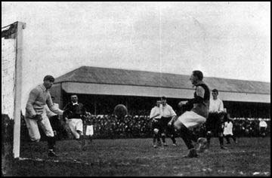
Leigh Roose playing for Stoke City

George Holley, who played for Sunderland with Roose later explained why this strategy was not followed by many other goalkeepers. "He was the only one who did it because he was the only one who could kick or throw a ball that accurately over long distances, giving himself time to return to his goal without fear of conceding."
Several clubs complained to the Football Association about Roose's strategy. Several committee members felt that Roose was ruining the game as a spectacle by his ability to break up creative and attacking play. However, they could not agree about what to do about it.
In June 1912 the Football Association finally decided to change Law 8 that stated: "The goalkeeper may, within his own half of the field of play, use his hands, but shall not carry the ball." It now read: "The goalkeeper may, within his own penalty area, use his hands, but shall not carry the ball." In other words, if a goalkeeper wanted to move around his penalty area while handling the ball, he had to bounce rather than carry it as he went. He was also not allowed to handle the ball outside the penalty area.
In 1923 the FA Cup was moved to Wembley. The ground had been built for the British Empire Exhibition and had excellent railway links. Over 270,000 people travelled in 145 special services to the final that featured West Ham United and Bolton.
The railways had a considerable impact on the attendances of international matches. Only 1,000 people from Scotland travelled to watch the game against England at Crystal Palace in 1897. However, for the match at Wembley in 1936, 22,000 Scots came to London in 41 trains provided by the London Midland and Scottish Railway.

