# Homework 3 Introduction to SQL Answers

1. A second-hand car dealer keeps a record of customers who have purchased cars.

The data held on each table includes the following fields:

**Customer**

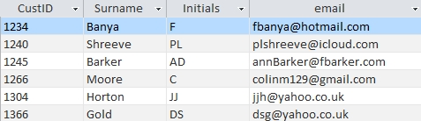

**Car**

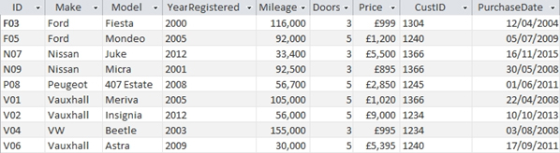

(a) Write the entity descriptions for the entities **Customer** and **Car** in the format

Entity(attribute1, attribute2, ….) [2]

Customer (CustID, Surname, Initials,email)

Car (ID, Make, Model, YearRegistered, Mileage, Doors, Price, *CustID*, PurchaseDate)

(b) Identify primary and foreign keys, where they exist, in both tables. [2]

(Primary keys underlined, foreign key CustID in Car table )

(c) Draw an entity relationship diagram showing the relationship between the two tables. [2]

Customer

Car

(d) Write an SQL statement using keywords SELECT… FROM… WHERE…ORDER BY   
to extract a list of the make, model, year registered and price of all 5-door cars costing less than £2000, sequenced in descending order of price. [4]

SELECT Make, Model, YearRegistered, Price

FROM Car

WHERE Doors = 5 AND Price < 2000

ORDER BY Price DESC

(e) Write an SQL statement using keywords SELECT… FROM… WHERE…ORDER BY   
to extract a list, sequenced by surname and initials, of customer IDs, surnames, initials and email addresses of all customers who purchased cars between 2009 and 2011 inclusive, together with the make of car and price paid. [6]

SELECT Customer.CustID, Surname, Initials,email, Make, Price

FROM Customer, Car

WHERE Car.CustID = Customer.CustID

AND PurchaseDate BETWEEN #01/01/2009# AND #31/12/2011#

ORDER BY Surname, Initials

(Allow variations, e.g.

SELECT Customer.*, Car.Make, Car.Price

FROM Car *(or FROM Customer JOIN Car)*

JOIN Customer

ON Car.CustID = Customer.CustID

WHERE PurchaseDate > #01/01/2009# AND PurchaseDate <= #31/12/2011#)

ORDER BY Surname, Initials

(f) Write an SQL statement to extract all the details of cars with make beginning with “V”.  
 [2]

SELECT *

FROM CARS

WHERE Make LIKE “V*”

(Could list all fields in first line)

(g) The Car database is in Third Normal Form. Explain what this means. [2]

It means that in both tables, all fields are dependent on the key, the whole key and nothing but the key.

Total 20 marks